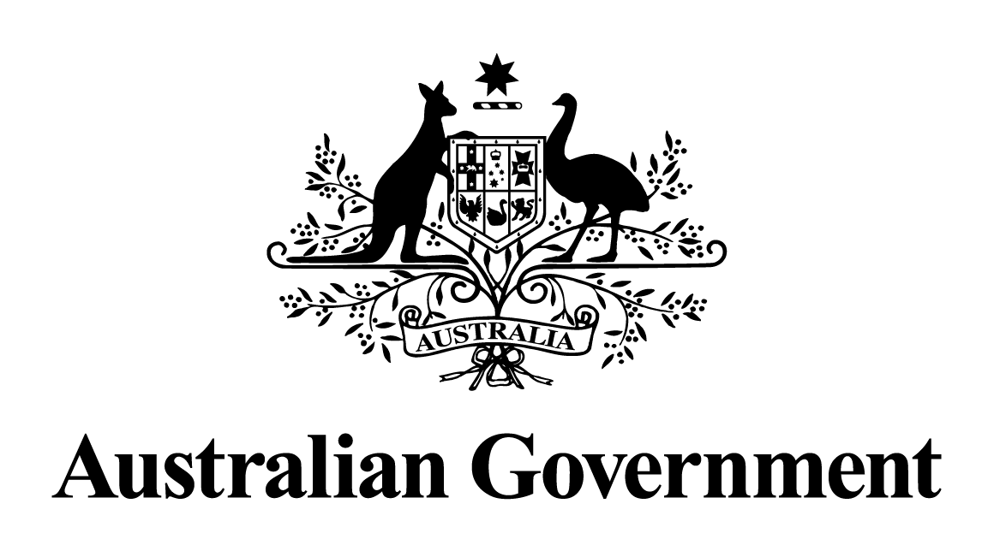
Australian Government response to the
Senate Economics Legislation Committee report:
Treasury Laws Amendment
(Personal Income Tax Plan) Bill 2018 [Provisions]
December 2018

Contents

Response to the Committee’s Recommendations …………………………………………… 3

Response to the Recommendations from the Dissenting Report from Labor Senators............ 4

Response to the Recommendations from the Greens Dissenting Report…..………………….6

Response to the Committee’s Recommendation
Recommendation 1
The Committee recommends that the Senate should pass the Bill.

On 21 June 2018 legislation giving effect to the Personal Income Tax Plan (the plan) received Royal Assent.
The Government’s seven-year plan makes personal income tax lower, fairer and simpler. The plan is affordable and funded, and on 21 June 2018, it was legislated, giving Australians certainty about their future tax relief, now. By growing the economy, the Government can fund this plan and deliver a stronger Budget to ensure the Government continues to live within its means.
The first step of the plan introduces the low and middle income tax offset, a non-refundable offset that will provide tax relief of up to $530, each year, for the 2018-19 to 2021-22 income years. This tax relief will assist over 10 million Australians with cost of living pressures, with around 4.4 million people expected to receive the full $530 benefit for 2018-19.
Those earning up to $37,000 will receive tax relief of up to $200. The tax relief will increase incrementally for those earning between $37,000 and $48,000. The maximum offset of $530 will be available to taxpayers earning between $48,000 and $90,000. The offset then gradually reduces to zero at a taxable income of just over $125,000.
The second step makes the personal income tax system fairer by helping to protect middle income Australians from bracket creep. From 1 July 2018, the top threshold of the 32.5 per cent tax bracket will increase from $87,000 to $90,000. This will provide a tax cut of up to $135 per year to around 3 million people, and prevent more middle income earners from being pushed into the second highest tax bracket of 37 per cent.
From 1 July 2022, the top threshold of the 19 per cent tax bracket will increase from $37,000 to $41,000, providing tax relief of up to $540 per year. The low income tax offset will also increase from $445 to $645. Together these changes lock in the tax relief provided under the low and middle income tax offset after it concludes in 2021-22. In addition, from 1 July 2022 the top threshold of the 32.5 per cent tax bracket will increase from $90,000 to $120,000, providing tax relief of up to $1,350 per year.
The third step simplifies the personal income tax system. From 1 July 2024, the top threshold of the 32.5 per cent tax bracket will increase from $120,000 to $200,000, abolishing the 37 per cent tax bracket completely.
Under the plan, around 94 per cent of all taxpayers are projected to face a marginal tax rate of 32.5 per cent or less in 2024-25. This compares with a projected 63 per cent of taxpayers in 2024-25 without change to current settings.

Response to Labor Senators’ Recommendations
Recommendation 1
That the Government deliver tax cuts in a fiscally responsible way that does not jeopardise the ability for future governments to respond to changes in economic circumstances.

The Government’s plan is affordable and fully accounted for in the forward estimates and medium term fiscal projections, with the underlying cash balance returning to balance in 2019-20 and sustained surpluses thereafter over the medium-term.

Recommendation 2
That the Government ensures that any tax cuts do not risk the ability of future governments to fund important government services.

The Government is guaranteeing the essential services that Australians rely on now and into the future. A stronger economy means that the Government is able to fund essential services.

The Government will maintain, as part of its fiscal strategy, its cap on the overall tax burden, consistent with the long-term average of 23.9 per cent of GDP. Whilst the tax system exists to fund the essential services that Australians expect and are entitled to receive, the cap ensures the Government lives within its means by not imposing an increasing tax burden on Australians over time, which would adversely affect growth.

Recommendation 3
That the Government prioritise legislating tax cuts which:
(a) Are fair and equitable; and
(b) Support low and middle income earners so as to deliver a bigger short term boost to consumption and economic growth.

The tax burden borne by workers has continued to rise. Bracket creep reduces the rewards for effort, undermines the returns to quality education, and blunts the incentive to work hard, take risks, and succeed.

The plan begins with permanent tax relief to middle and lower income earners, to encourage and reward working Australians and to assist with cost of living pressures.

The first step of the plan delivers targeted tax relief of up to $530 to middle and lower income earners through a new tax offset for the 2018-19, 2019-20, 2020-21 and 2021-22 income years. This tax relief will assist over 10 million Australians, with around 4.4 million people receiving the full $530 benefit for 2018-19. It will be in addition to the current low income tax offset.

The Government’s plan will support a progressive tax system that sustains economic growth and rewards effort and provides incentive to get ahead. As outlined in the ATO taxation statistics, in 2015-16, the top 10 per cent paid around 45 per cent of the $186 billion in personal income tax, compared with around 36 per cent 20 years earlier. In 2015-16, the top 20 per cent of taxpayers paid around 61 per cent of personal income tax. Under the Government’s plan, this cohort is projected to continue to contribute a broadly similar share.
By way of illustration of how the Government will maintain a progressive tax system, by the time the full plan is implemented in 2024-25 a single person on an income of $200,000 would have an average tax rate around three times that of a single person on an income of $41,000. They would pay around thirteen times more tax, with the individual earning $200,000 paying $60,007 in tax and the individual earning $41,000 paying $4,767 in tax.

The plan delivers tax relief to low and middle income earners, combats bracket creep and simplifies the system. The plan strikes the right balance between improving the system for all Australians and ensuring that the top earners pay their fair share.
Response to Australian Greens’ recommendation
Recommendation 1
That the Bill be opposed.

On 21 June 2018 the Senate passed legislation giving effect to the plan.

