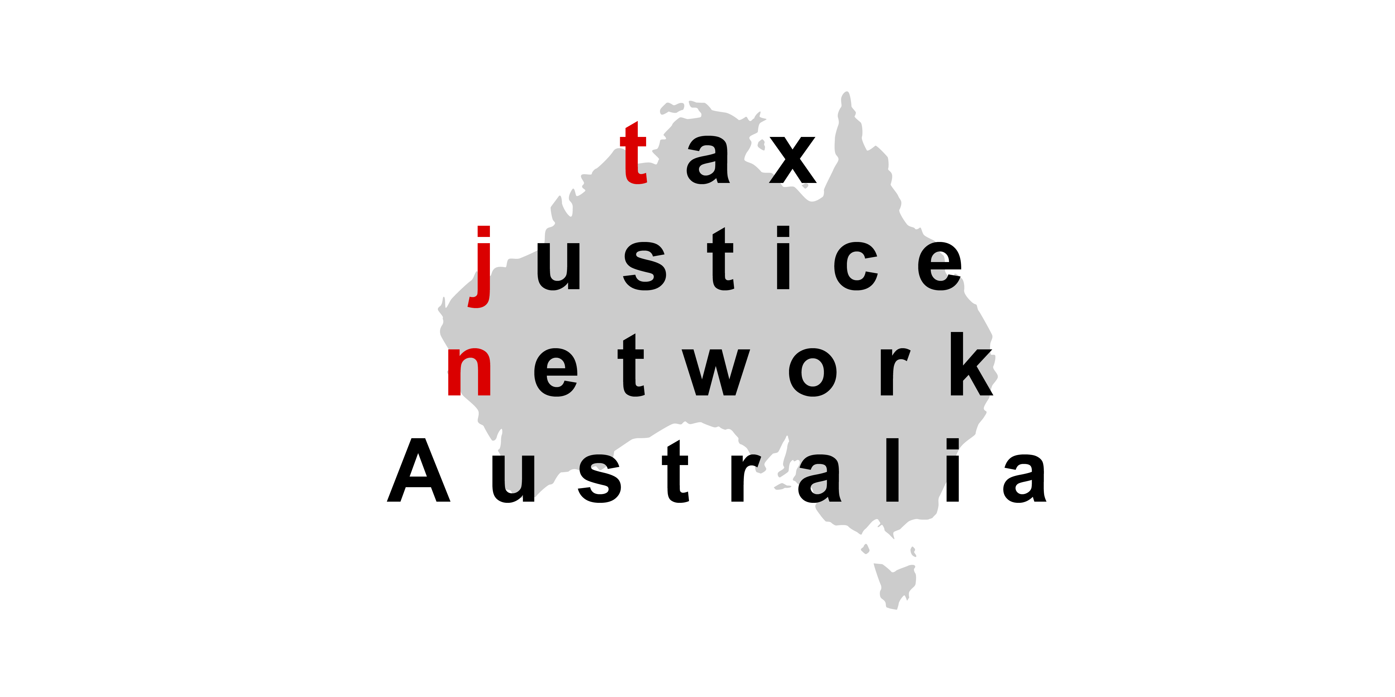
General Manager
Law Design Practice
The Treasury
Langton Crescent
Parkes, ACT, 2600
E-mail: jsct@aph.gov.au

Submission on Information Sharing – Serious Financial Crime
27 May 2015

The Tax Justice Network Australia (TJN-Aus) welcomes this opportunity to make a submission on the proposed Taxation Administration Amendment (Disclosure of Information) Regulation 2015. TJN-Aus supports the regulation in its current form.

TJN-Aus believes the ability of taxation officers to make disclosures to other agencies, tribunals and courts for the purposes of combatting international tax evasion and tax avoidance is vital to the success of such efforts and their effectiveness. The draft regulation provides tightly controlled circumstances under which such disclosures can be made.

TJN globally has seen Project Wickenby as a model that other governments around the world should be following to combat cross-border tax evasion and tax avoidance. Efforts to tackle cross-border tax evasion and tax avoidance require both international co-operation and co-operation between tax authorities and other law enforcement and financial intelligence agencies within each country, which Project Wickenby has provided.

TJN-Aus notes that as of 31 January 2015 Project Wickenby had raised $2.16 billion in tax liabilities and its work had seen 76 people charged, 44 convicted and 69 prosecuted for summary offences. Cash collections by the end of 2014 from Project Wickenby totalled $921 million.

AUSTRAC has reported that Project Wickenby has also resulted in decreased funds flow to the 13 tax secrecy jurisdictions of interest to the task force. They reported a 13% decrease in the value of outwards funds flows from Australia to tax secrecy jurisdictions in 2012-13 compared to 2007-08. The value of outwards funds flows to six of the 13 tax secrecy jurisdictions decreased by more than 30%, for example: Leichtenstein (55% decrease); Vanuatu (51% decrease) and Jersey (30% decrease).

TJN-Aus believes the Fraud and Anti-Corruption Centre needs to be given the appropriate tools and powers to continue the work that Project Wickenby had been undertaking. The Taxation Administration Amendment (Disclosure of Information) Regulation 2015 provides one of those tools.

Background on the Tax Justice Network Australia
The Tax Justice Network Australia (TJN-Aus) is the Australian branch of the Tax Justice Network (TJN) and the Global Alliance for Tax Justice. TJN is an independent organisation launched in the British Houses of Parliament in March 2003. It is dedicated to high-level research, analysis and advocacy in the field of tax and regulation. TJN works to map, analyse and explain the role of taxation and the harmful impacts of tax evasion, tax avoidance, tax competition and tax havens. TJN’s objective is to encourage reform at the global and national levels.

The Tax Justice Network aims to:
(a) promote sustainable finance for development;
(b) promote international co-operation on tax regulation and tax related crimes;
(c) oppose tax havens;
(d) promote progressive and equitable taxation;
(e) promote corporate responsibility and accountability; and
(f) promote tax compliance and a culture of responsibility.

In Australia the current members of TJN-Aus are:
- ActionAid Australia
- Aid/Watch
- Australian Council for International Development (ACFID)
- Australian Council of Trade Unions (ACTU)
- Australian Education Union
- Anglican Overseas Aid
- Baptist World Aid
- Caritas Australia
- Columban Mission Institute, Centre for Peace Ecology and Justice
- Community and Public Sector Union
- Friends of the Earth
- Global Poverty Project
- Greenpeace Australia Pacific
- Jubilee Australia
- National Tertiary Education Union
- Oaktree Foundation
- Oxfam Australia
- Save the Children Australia
- SEARCH Foundation
- Social Justice Around the Bay
- Social Policy Connections
- Synod of Victoria and Tasmania, Uniting Church in Australia
- TEAR Australia
- Union Aid Abroad – APHEDA
- UnitedVoice
- UnitingWorld
- UnitingJustice
- Victorian Trades Hall Council
- World Vision Australia

Dr Mark Zirnsak
Secretariat
Tax Justice Network Australia
c/- 130 Little Collins Street
Melbourne, Victoria, 3000
Phone: (03) 9251 5265
E-mail: mark.zirnsak@victas.uca.org.au

