  - January 2017

Retail Council - 2017-18 Pre-Budget Submission

Submission to 2017/18 Federal Budget

Table of Contents
Section | Page
About the Retail Council | 3
Executive Summary | 4
Retail as an Economic Driver | 6
Specific Budget Priorities for Retailers | 10

List of Tables and Charts
Table/chart label | Page
Table 1. Summary of Specific Retail Council Budget Recommendations | 5
Chart 1: Retail Sales – month (LHS) and annual growth (RHS) (% change) | 7
Chart 2: Long-term average retail sales growth (y/y % change) | 9

Abbreviations
ABS | Australian Bureau of Statistics
RBA | Reserve Bank of Australia

About The retail council
The Retail Council is the voice of Australia’s top retailers driven to achieve sustainable growth of retail in Australia for the benefit of the consumer, the industry and the economy.
Formed in 2006, the Retail Council represents members committed to advancing retail in Australia, fostering economic growth and supporting job creation. They are retail businesses that lead the industry delivering to customers across all types of retail goods and services and are leading employers who contribute to local communities and regional development and strongly interrelate with other Australian industries.
As an authoritative voice of Australia’s top retailers, the Retail Council contributes to the development and support of public policy that would boost productivity, support employment growth, foster a competitive environment and ultimately make the sector stronger.
Retail Council members are part of an industry that is a top ten contributor to Australia’s Gross Domestic Product (GDP) contributing more than $134 billion (or 8%) of total economic activity through more than 127,000 retail operators nationwide and providing jobs to more than 1.25 million Australians.

Executive Summary
The Retail Council welcomes the opportunity to contribute to the Federal Government’s 2017/18 Budget deliberations.
The December Mid-Year Economic and Fiscal Update (MYEFO), saw a deterioration in the Budget position of around $10 billion over the forward estimates as the benefit of policy decisions taken since the election ($2.5 billion) were swamped by a deterioration in the Budget parameters ($12.8 billion) amid lower-than-expected tax receipts due to soft wages and profit growth.
This MYEFO result was a reminder about the need for the Government to focus on structural budget repair. The $2.5 billion improvement as a result of policy changes is a step in the right direction, but more needs to be done. This includes tackling important issues such as restructuring the tax system, investing in productivity boosting assets and minimising growth in recurrent spending.
Structural Budget repair needs to be undertaken to get the Budget on a long-term sustainable footing. We encourage the Government to restart the Tax White Paper process. But the discussion needs to be about more than tax collections. A broader fiscal review should look at the service levels that Australian’s want and how best to pay for these within the mix of the tax system and within the context of Federal-State relations. As MYEFO illustrated, modest changes at the margins are unlikely to achieve the sustainable fiscal outcomes Australia needs in a climate of global shocks and uncertainty.
Against this background of the need for Budget repair without crimping still fragile growth, this submission avoids the usual sector-focused ‘wish-list’ approach. Instead the Retail Council seeks to remind the Government of the importance of retail as an economic driver and employer, especially as the economy continues to move away from its reliance on mining investment. The submission also outlines the broad criteria the Retail Council believes should be used when constructing the 2017/18 Budget and considering which policies and projects should proceed in the broader context of the need for budget repair.
In short, the Retail Council urges the Government to maintain its recent approach of repairing the fiscal position but without putting jobs, incomes and growth at risk.
From the Retail Council’s perspective, a ‘good’ Budget is one that:
- supports higher employment and sustainable wages growth;
- reduces the cost of doing business to allow retailers to reinvest in their businesses and/or lower prices;
- has a clear and consistent communication plan that is cognisant of how the potential impact of Budget decisions are received by households and the likely consequences for confidence; and
- seeks to repair the budgetary position, but not at the expense of undermining Australia’s economic fundamentals.
The Retail Council recognises the need for continued budget repair, but from a retail perspective it is critical that the Federal Budget does not further crimp household incomes, especially for low income earners. Low wages growth is a positive from an inflation perspective but is a potential drag on consumption spending and consumer confidence which are both key metrics for the retail sector. It is important that the Budget does not add downward pressure on household incomes.
Retailers will also judge the Budget on how it impacts on their own business costs so that they can improve offerings to customers. At the time of the 2016/17 Budget, the Retail Council welcomed the Ten Year Enterprise Tax Plan but highlighted our disappointment in the long implementation timeframe. We continue to urge the Government to speed-up the process to maximise the benefit to the economy.
The 2014/15 Budget had a negative impact on consumer confidence. This has been one of the key benefits of the more recent focus on a balanced approach to budget repair. This helps to maintain both business and consumer confidence, which in turn supports household consumption and business investment. The Retail Council urges the Government to focus on communicating the rationale behind specific decisions and the long-term purpose of these decisions, in particular decisions that may initially be unpopular. This approach will allow households to better understand the true extent of any short-term impacts and then balance this against longer-term outcomes.
Retailers understand that the current budget is still in the repair phase of the cycle. Nevertheless, this does not mean that there can be no new spending or revenue decisions. The Retail Council urges the Government to focus on any new initiatives that will support jobs and encourage economic growth. This includes policies that encourage businesses to invest and hire and policies that will lift national productivity.
This submission is focused on a high-level framework for the Budget – as per the four criteria for a ‘good’ budget which Budget decisions can be measured against – rather than specific policy requests. Nevertheless, the Retail Council does have three specific recommendations, the inclusion of which will help the retail sector to underpin stronger economic growth.

Table 1: Summary of Specific Retail Council Budget Recommendations
1. | Reduce the timeframe for the Ten Year Enterprise plan to maximise the employment and investment benefits.
2. | Provide States with competition incentive payments to ensure the Harper Review recommendations that relate to state regulations are implemented.
3. | Maintain funding for the ABS Retail Trade monthly data publication.

Retail as an economic driver
The retail sector has an important role to play in the transitioning of the economy towards more domestic based activity. The low capital-intensive nature of retail means that it cannot fill the void left by the collapse in mining investment. Nevertheless, it will be an important sector in lifting consumption spending and helping the domestic side of the national economy pick-up the pace of growth through the year.
The Retail Council acknowledges that it will be a difficult balancing act for the Government to continue the job of fiscal repair without putting pressure on household incomes, in an environment when wages growth is low. But this balance must be achieved to ensure that the sector can make a contribution to lifting overall economic growth.

Retail as a major employer
The retail sector is Australia’s largest private sector employer, accounting for 10 per cent of Australia’s workforce. Retail directly employs 1.26 million Australians; providing career opportunities for customer service professionals, butchers, bakers, pharmacists, hairdressers, mechanics, financial analysts, information technology and communications specialists, human resources managers and more. In addition, retail supports approximately 500,000 jobs in other sectors across the economy, including food manufacturing, agriculture, transport and construction.
Around half of retail jobs (613,200) are part-time roles which allow flexibility for a modern workforce particularly primary care givers and young people wanting to combine family and/or study commitments with employment. Retail is also the third largest employer of women (behind education & training and health care) – over 687,000 women work in the sector, with around 415,500 working part-time.

Retail as a driver of growth
The retail sector accounted for 4.7% of the Australian economy in 2014/15. This is twice as large as agriculture and a similar size to education, wholesale trade and transport & warehousing.
Growth in retail sales also showed signs of gathering pace in late 2015 and the sector was hoping that 2016 would result in the sector being able to make an even bigger contribution to overall economic growth and employment. However, a dip in sales in mid-2016 saw this momentum lost, possibly due to uncertainty resulting from the unexpected early July election and long campaign. In better news, retail sales rebounded again in the final months of 2016 and retailers are hoping that this will continue into 2017.

Retail sales rose 0.2% in November, which was the fourth consecutive month of gains and lifted annual sales growth to 3.3%. As the black line in Chart 1 illustrates, growth in turnover slowed in the last quarter of 2014 and struggled to recover for most of 2015. On a positive note, from August to November retail turnover rose at a monthly pace of around 0.5% which is in line with the long term monthly average pace of growth. If this can continue into 2017 then the annual growth rate should accelerate back to a pace similar to that experienced in the earlier part of 2014.

Chart 1: Retail Sales – month (LHS) and annual growth (RHS) (% change)

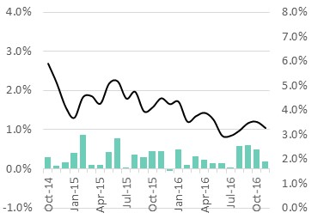

The contribution of the retail sector to the broader economy was also evident in the latest national accounts, for the September quarter 2016. Overall GDP actually fell 0.5% in the quarter and rose 1.8% y/y. But private household consumption spending rose 0.9% q/q (2.5% y/y) and contributed 0.3% points to the quarterly result – making it by far the biggest contributor to economic growth in the quarter.

Retail prospects in 2017
Looking ahead to 2017, there is the potential for the retail sector to provide even greater support to the transitioning economy in 2017.
In its November Statement on Monetary Policy, the RBA was positive about the prospects for household consumption in the immediate future.
“Low interest rates and gains to employment and wealth are expected to continue to support household demand. Consumption growth is projected to increase gradually over the forecast period.”
Looking at specific economic indicators, two of the four key components that underpin retail activity are currently supportive, one is mixed and one is dragging on consumption spending. Consumer confidence showed signs of a sustainable improvement over 2016, notwithstanding the fall in December, and is pointing towards a better retail outlook in 2017. Similarly, interest rates remain at historic lows and are unlikely to rise rapidly even if the RBA starts to tighten monetary policy during 2017/18. But the positive impact of low interest rates is being at least partially offset by rising energy costs and mixed signals from the labour market and insipid wages growth, which is stuck around record lows.
The Westpac Melbourne Institute Index of Consumer Sentiment was above 100 for 8 of the 12 months of 2016 but finished the year at 97.3 points (the lowest level since April). The Budget has an important role to play in carrying forward the green-shoots of a return in confidence seen for most of 2016.
Interest rates are at historically low levels, with the official cash rate at just 1.5% and the average standard variable mortgage rate at 5.3%. At these levels, most households are not currently facing mortgage stress and do have a reasonable amount of disposable income left once mortgage repayments are made. These levels of interest rates are also supportive of investment by small businesses, which flows through to the retail sector via the purchase of goods such as new office equipment and supplies.
But the labour market is currently delivering mixed signals. The headline unemployment rate rose marginally in November, up 0.1% points to 5.7%. This suggests that the labour market is holding up despite the economy’s sluggish growth performance in September. But the headline unemployment rate is masking a shift in the labour market. Since November 2015 the economy has added a net 84,900 new jobs, but these are all part-time. Indeed, the economy has lost 22,200 full-time jobs.
This shift is being reflected in the national underemployment rate, which measures those who have work but would like more work. This is currently at 8.3%, which is down from the record peak of 8.7% in August but still above the decade average of 7.5%. It is still too early to know if this shift is a permanent structural shift as work patterns change towards part-time jobs; or if it is more temporary in nature and reflects the current transition of the economy away from mining (which has mainly full-time jobs) towards service-orientated sectors (where jobs are more likely to be part-time). Whether temporary or permanent, this shift is likely to be influencing available disposable income and acting as a drag on current spending.
Low wages growth is currently the main drag on retail spending. The Wage Cost Index (total hourly rates of pay excluding bonuses) rose only 1.9% in the year to September 2016 – this is a record low annual growth rate since the index began in 1998. Low wage outcomes are good from an inflation perspective but are crimping retail sales. It is important that the Budget does not add downward pressure on household incomes and further hamper customer spending.
Within the context of the Budget it is critically important that new policy initiatives support consumer confidence and employment outcomes and do not further crimp household incomes. If this is achieved, then the retail sector will be able to play an important role in supporting broader economic growth.

Unlocking the potential of retail
Looking beyond 2017, it is clear that the retail sector, with the right policy settings, has the potential to grow even faster and support further employment gains during the economic transition. Chart 2 shows that since 2010 there has been a step-down in ‘average’ retail sales growth. For the first ten years of the century, retail sales averaged annual growth of 6.1% but since the start of 2010 this has slowed to 3.5%.

Chart 2: Long-term average retail sales growth (y/y % change)
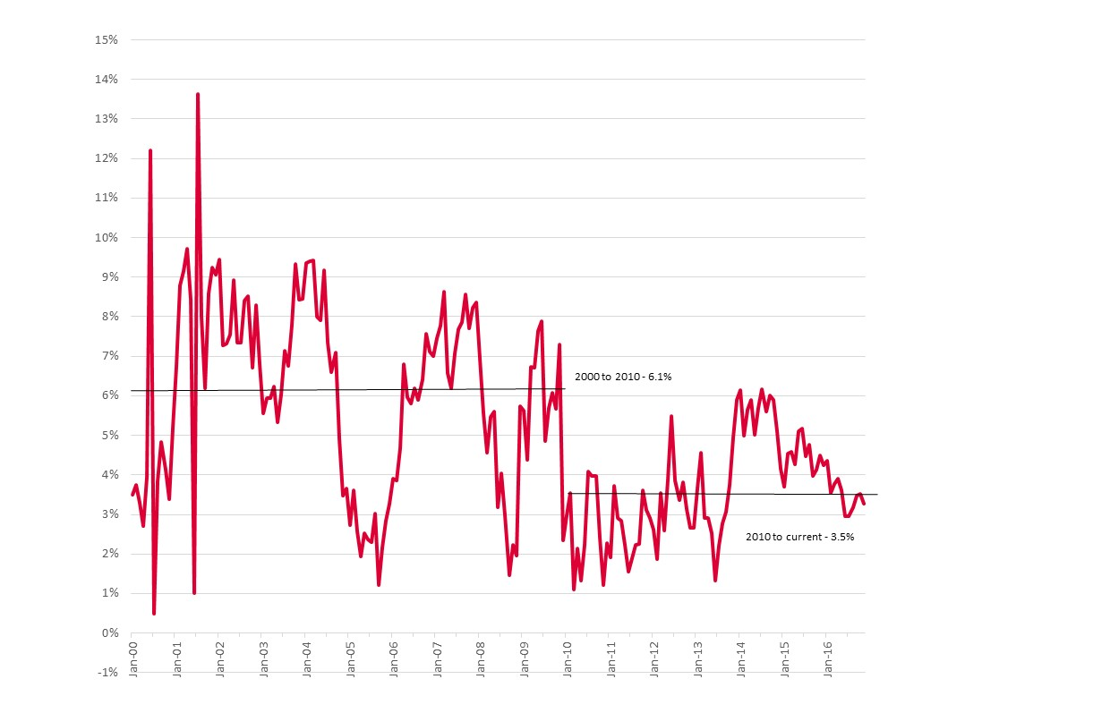
This downward shift in retail sales growth has also been recognised by the RBA. It has noted that there has been a step-down in the long-term growth of consumption spending since the Global Financial Crisis, as highlighted in Chart 2. For this longer-term period the RBA noted,
“Expectations for longer-term growth in household consumption have been lowered slightly relative to the period prior to the global financial crisis, when growth was boosted by strong growth in income, rising labour force participation and rising debt and housing equity withdrawal.”
“How households decide to consume and save out of their income in the future remains a key source of uncertainty in the forecasts.”

This view from the RBA underscores the importance of ensuring that the 2017/18 Budget delivers policy settings that are supportive of households and underpin confidence in the economy going forward. With the right policy settings, that meet the four key criteria outlined earlier, the retail sector will be able to build on the gains of late 2016 and return to the pace of growth seen in the early part of this century, allowing it to make a major contribution to fiscal repair and the economy more broadly in the years ahead.

Specific Budget Priorities for Retailers
- Reduce the timeframe for the Ten Year Enterprise plan to maximise the employment and investment benefits.
At the time of the 2016/17 Budget, the Retail Council welcomed the Ten Year Enterprise Tax Plan but highlighted our disappointment in the long implementation timeframe. The progressive introduction of the 27.5% tax rate means that all companies will not be covered by the lower rate until 2023/24. The tax rate for all companies will then fall to 27% in 2024/25, 26% in 2025/26 and 25% in 2026/27.
The nature of employment growth means that the plan would deliver many more jobs if larger businesses did not have to wait so long to feel the benefit of the tax cuts. For example, in the five years to June 2015 the economy created 580,000 new jobs, but only 30,000 (or 5%) of these were generated by firms with less than 20 staff. In contrast, firms with more than 200 staff created 385,000 new jobs over the same period (66% of total new jobs). While a staff-based measure is not directly comparable to the turnover measure used by the ATO, this comparison still highlights that most new jobs are being created by larger firms. Delivering the initial tax cuts sooner to these larger firms will have greater employment generating benefits than the current timeframe will deliver.
Since the 2016/17 Budget several other countries have announced their intentions to undertake significant company tax rate reductions. For example, President-elect Trump has indicated he intends to reduce the US corporate tax rate from 35% currently to 15%. If done, this would leave US rates (which are currently higher than Australia) well below that of even the projected 2026/27 Australian rate of 25%, thus creating an incentive for companies to locate their operations as much as possible in the US rather than in Australia.
We continue to urge the Government to speed-up the process to maximise the benefit to the Australian economy from this package.
In addition, these tax changes should be part of a broader review into the fiscal system to ensure that it is sustainable into the future.

2. Provide State’s with competition incentive payments to ensure the Harper Review recommendations that relate to state regulations are implemented.
The Retail Council supported the vast majority of the recommendations of the final Harper Review report. Many of these recommendations, however, need to be implemented by state & territory governments rather than the Federal Government. This includes one of the key issues for retailers which is the deregulation of trading hours.
The Retail Council welcomes the Federal Government’s acknowledgment in their response to the Competition Policy Review that:
All governments recognise the benefits that were delivered by the National Competition Payments and are already working together to develop a new national framework between the Commonwealth, states and territories that will identify and facilitate innovative ways to deliver services and promote economic growth.
The 2017/18 Budget is an opportunity to outline the specific details of these new National Competition Payments so that those aspects of the competition reform agenda that relate to states and territories can be advanced as soon as possible.

3. Maintain funding for the ABS Retail Trade monthly data publication.
In its 2016-17 Forward Work Program, the Australian Bureau of Statistics indicated that the agency is currently reviewing the continuation of key publications, including the monthly retail sales report. The ABS is considering whether a quarterly publication, in line with the national accounts timing cycle, will be sufficient.
The clear message from the retail sector is that it will not. Retailers use the monthly ABS report as part of a broad spectrum of indicators to compare how their own business is tracking against sector trends. Retailers are already frustrated at the delay in timing between the end of the month and the release of data – which is generally about 5-6 weeks. Reducing information about the sector to only a quarterly report would acutely undermine the value of the report as a comparison tool.
The monthly retail sales report is also a useful indicator for how households are tracking more generally in the period between major quarterly publications such as the national accounts. As a result, it is widely used by sector analysts There are now very few monthly indicators published by the ABS that can give an insight into the relative health of households from month to month. Housing-related indicators help with information about major purchases and investments and labour force data helps with employment conditions insights, but none of these provide the level of information directly relevant to day-to-day household spending and the contribution they are making to economic growth.

ABS (Nov 2016), 6291.0.55.003 Table 5
ABS (Nov 2016), 6291.0.55.003 Table 5
ANRA (2011) Retail is jobs
ABS (Nov 2016), 6291.0.55.003 Table 5
ABS (Nov 2016), 6291.0.55.003 Table 6
ABS (2016) 5204.0 Australian System of National Accounts Table 5 (As measured by GVA)
RBA (Nov 2016) Statement on Monetary Policy
RBA (Nov 2016) Statement on Monetary Policy
ABS (Nov 2016), 6345.0 Table 1
ABS (May 2016) 8155.0 Table 5

