From: Kelvin Gough [mailto:kelvin@safesuperhomes.com.au]
Sent: Friday, 28 April 2017 10:12 AM
To: Superannuation
Subject: VERY DAMAGING AMENDMENTS TO LRBA LOANS

Hello Michelle Dowdell / Treasury

As an entity, we are endeavouring to promote the Super’n Sole Purpose Test – by amending LRBA loans.

Please don’t cut us off at the knees by passing any proposed legislation, in effect calling cap debit balances a credit.

You will not improve integrity of the Super system, but rather you will damage it immeasurably.

I intend circulating this to Members of the various Financial Planning Associations I belong too.
It is in the Liberal Parties interests to let the status quo remain.

Please think more deeply of those whom you represent.

Kind Regards,

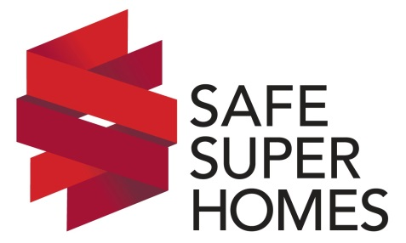 | Kelvin Gough
CEO and MD of Safe Super Homes
Senior Property Investment Advisor
Member of the Tax Institute
Member of Superannuation Professionals
Diploma of Financial Services RG 146
Award Winning Lawyer (Non Practising)
e: kelvin@safesuperhomes.com.au
p: (03) 9702 2595
a: 26 Moondarra Drive, Berwick VIC 3806
 | www.safesuperhomes.com.au

