Retirement Income
Risk Measure

Contents
Introduction 1
Retirement Income Product Design 2
Income Variation Risk 4
Quantification of Income Risk 5
Sample Results 7
Immediate Lifetime Annuity – CPI Indexed 7
Immediate Lifetime Annuity – Partial Indexation 7
Immediate Lifetime Annuity – Non Indexed 7
20% Account Based Pension – 80% Immediate Life Annuity 7
Deferred Annuity / Account Based Pension 8
Account Based Pension – Minimum Drawdown 9
Discussion 10
Presentation of the Results: Relative Risk Measure 12
Summary 17
Attachment: Assumptions 18

Introduction
This paper is an appendix to the Retirement Income Disclosure Consultation Paper, published by the Treasury. The consultation paper proposes a range of standard metrics to help consumers make decisions about the most appropriate retirement income product for their own circumstances. One of those standard metrics is a measure of income variation. The purpose of this document is to define income variation and set out a methodology for measuring the relative income variation associated with alternative retirement income products. The objective of the measure of income variation is that, when it is read in conjunction with the other metrics on the proposed retirement income dashboard, retirees are able to reach a reasonable decision regarding their choice of retirement income product.
Retirement income products can vary considerably. At one end of the spectrum, guaranteed annuities offer a highly predictable income over a defined period. At the other end of the spectrum, account based pensions offer an account that is drawn down (largely) at the discretion of the member until it is exhausted. In between there is the potential for a wide range of products that provide partial guarantees and pooling options. There is then the potential to bundle different products together as a single product, increasing the potential range of product designs that a retiree could purchase. The variability of income that could arise from each retirement income product, or bundle, can vary considerably.
Further, products that appear to be similar may result in different outcomes to retirees. Within each product design, product rules will determine how experience variations are managed and how mortality credits are distributed. The volatility of payments may be reduced in the short term by matching assets through the use of ‘cash buckets’ and/or de-risking through the use of fixed interest assets. The experience of pooled products or group self-annuities (GSAs) may vary due to the design of the pooling mechanism and size of the pool.
The Treasury discussion paper proposes that a measure of income variation be provided in respect of all retirement income products and that this measure is presented on a seven point scale. This paper defines income variation, sets out a proposed methodology for measuring income variation and also an approach for translating that measure to the scale proposed in the discussion paper. The approach proposed for measuring income variation would also produce the data to support the presentation of “income shape” proposed in the Treasury discussion paper.
This paper has been prepared for the purposes of supporting the Treasury’s consultation process. The AGA welcomes comments and feedback on the ideas proposed in this paper. The views expressed in this paper do not necessarily reflect the views of the Australian Government.

Retirement Income Product Design
The potential range of retirement income products is diverse. This section is intended to document a range of possible products, and bundles of products, with a view to illustrating the possible range of income variation that could arise with each product design.
- Term Annuities: Payment guaranteed by a life company for a specified term. Residual risks to the retiree include counterparty, re-investment risk and longevity risk. Inflation risk may also apply if the payment structure is not indexed.
- Lifetime Annuities: Payment guaranteed by a life company for life. Commencement of the annuity may be deferred for a specified period. Longevity risk is mitigated by lifetime annuities and inflation risk may be mitigated if the payment is indexed. A residual risk is the counterparty risk.
- Unit linked annuities: Payments equal a guaranteed number of units cashed (at their then future value) for life. These products may offer investment choice. Commencement of income payments may be deferred. These products mitigate longevity risk. Inflation risk may be mitigated by the payment structure and investment return over the medium term. However, some inflation risk is retained by the member if the investment strategy does not meet its objectives over shorter time frames. Residual risks to the retiree include counterparty and market (investment) risks.
- GSA: A pooled annuity product that can be managed according to a range of product rules. These products may offer investment choice. Commencement of income payments may be deferred. These products mitigate longevity risk through mortality credits. As mortality credits are a function of the experience of the pool, the retiree may retain some exposure to the risk that the pool, on average, survives longer than expected. Inflation risk may be mitigated by the payment structure (supported by the investment return and mortality experience over the medium term). However, some inflation risk is retained by the member, for example if the investment strategy does not meet its objectives over shorter time frames to deliver the expected ‘inflationary’ increases to payments. Market (investment) risk and the risk of unexpected future mortality improvement by the pool are retained by the retiree.
- Account Based Pensions: An account, where the pattern of payments is determined by the member, subject to regulatory minimums. All risks are retained by the member.
Products may be offered in a bundle, in any combination. This may diversify some risks. It may also combine the risk mitigation features of some products with the flexibility of others. The use of the term ‘product’ in this paper is assumed to apply interchangeably with product bundles.
The Treasury discussion paper sets out that this risk measure would be set out alongside a measure of the income the retiree might expect to receive. As the paper notes, some products may be designed with higher levels of expected (or target) income, which may require the acceptance of a higher level of income volatility if that expectation is to be achieved.
Products may introduce risk mitigation features. For example;
- Market risk may be managed (in part) by the introduction of a process to match short term payments. For example, a ‘bucket’ of short term fixed interest investments can provide a stable source of immediate income. The ‘bucket’ is then topped up when market conditions are favourable to ensure continuity of payments in the short term whilst seeking to minimise the realisation of growth assets during a short term market downturn.
- Market risk may be managed (in part) in a unit linked annuity through target date funding. The asset mix underlying the units to be cashed in a specific year could progressively be invested in a matched portfolio as the payment date approaches. This could increase the capacity for the member to plan for their expected income in any given year.
- Longevity risk can be mitigated by participation in a longevity pool. The pool may provide increasing mortality credits as the ability of the account to fund income payments from its own resources reduces.
- Inflation risk can be mitigated by a product that seeks to increase payments over time in line with increases in the cost of living for the retiree.
The range of products, with their own risk profiles and possible mitigating features, combined in an unlimited combination with varying levels of target income provide for an almost infinite set of potential member outcomes in terms of payment patterns and risk profiles. Ultimately these risks are often described as a combination of inflation risk, longevity risk and market risk. It is these risks, and their effect on the volatility of income received by the retiree that we are seeking to measure.
This paper is focussing on income variation. There are other risks that this paper is not seeking to measure, for example:
- Timing risk associated with the date of retirement (or commencement of a retirement income stream product), where a market crash immediately before retirement (or low interest rates in the case of annuity pricing) may reduce the level of retirement income that a member’s lump sum has the capacity to purchase.
- Event/liquidity risk, relating to the member’s access to capital for emergencies. For some retirees, capital may be sourced from a separate investment account that does not impact the retirement income stream. However where capital is accessed from a retirement income stream it will generally reduce the sustainability of income over time. The amount of capital that can be accessed is also likely to diminish over time. The scope of this paper does not intend to measure the access to capital or the market risk associated with the amount that may be available at any time.

Income Variation Risk
In order to define a measure of income risk for a retirement income product, it is necessary to define what this risk is. This provides a focus for what is to be measured. Having measured the risk, we can then consider how to express the result in a meaningful manner.
Industry uses terms like longevity risk, market risk, sequencing risk and inflation risk. All these are relevant to the outcome experienced by members in a retirement income product. However, these terms do not easily translate into use by a lay person and it is difficult to see that presenting a measure of each of these risks would be meaningful to the individual. Never the less it is important that the risk measure captures these key risks.
In order to create a risk measure of income variation then we need to define what the actual payment in any one year is being measured as varying from. In order to create a measure that captures key risks (e.g. longevity, inflation and investment risks) I have chosen to define that variation as the difference between the actual payment received and a benchmark payment. The benchmark payment is the payment that, if it was achieved, would have mitigated fully against these risks. I have therefore defined the benchmark payment as the first year’s annual payment, indexed to inflation (CPI) for the life of the retiree.
Adoption of this definition of the benchmark payment will result in higher risk scores for products that do not provide protection against longevity, inflation or market risks. Some retirees may be in a position to accept some risks, for example; a single retiree with a terminal illness may not require longevity protection or a retiree who is able to plan for reduced future expenditure may not require inflation protection. On balance, I have taken the view that it is better for the risk measure to highlight the presence of risk in the product and for the retiree to then consider their risk appetite in light of their personal circumstances.
Traditional measures of variance (standard deviation) focus on both upside and downside variation. However, behavioural economists commonly point out that individuals are more averse to downside variation than upside variation. Intuitively this would apply to retirement incomes. For this reason, I have chosen to focus on quantifying downside risk and using that to measure the relative ‘income risk’ of various products.
A visual illustration of the risk we are seeking to measure may be illustrated as follows. The benchmark real income is illustrated by the red line and the actual real income is illustrated by the green line.
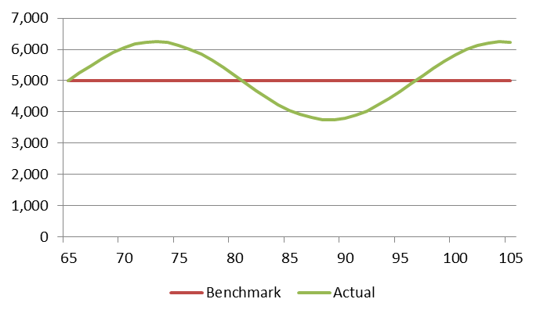
Risk

Quantification of Income Risk
Under this approach, retirement income product providers will be required to determine the income a retiree would receive across multiple (stochastically generated) scenarios in order to derive a distribution of retirement income payments that are reasonably expected from the product being offered.
Assumptions are therefore required to determine the distribution of investment returns, inflation and mortality experience within GSA pools (if applicable). Product providers would need to generate a number of stochastic scenarios and apply each scenario to the product rules to determine the resulting payments under each scenario. For practical purposes, we have projected payments to age 100, when the majority (>98% of those age 65) of a cohort of retirees would have passed away. It is proposed this upper limit would be applied when calculating the risk measure for all products.
The payments from each scenario were then compared against the benchmark income that would be required to protect the retiree against longevity, inflation and market risk. This benchmark income is the income the retiree receives in the first year, indexed to inflation to age 100 using the CPI simulated in each scenario. For a product with a contractual income, this first year payment will be an outcome of the product pricing. For experienced based CIPRs, it is intended that the first year’s benchmark income is the best estimate of sustainable income the retiree would receive under the proposed product (utilising best estimate assumptions). For the purpose of determining the benchmark income in each year, this resulting first year payment would be indexed to inflation to age 100 using the CPI simulated in each scenario. For the purpose of the dashboard, it is not intended to be a nominated payment, which may be artificially reduced for the sole purpose of generating a lower risk measure. It is also intended that the risk measure would be calculated for Account Based Pensions. The application of the minimum drawdown to Account Based Pensions requires particular consideration and this is discussed later in this paper.
Any shortfall (x) between the ‘actual’ payment and the benchmark payment is then expressed as a percentage of the benchmark payment. Any excess over the benchmark payment is expressed as a 0% variation.
The risk measure is then calculated in the same way as a standard deviation.
$$\text{σ= }\sqrt{\sum_{1}^{n}{x^{2}/(n-1)}}$$
As positive variations are set to nil they do not increase the result. The only contribution the positive variations make to the result is that they are counted in the number of observations. This is an adaption of a negative semi-deviation. A higher result is an indication of a greater risk of negative income variations.
I have deliberately chosen not to weight the values of x with the probability of survival to the age in which x occurs in order to retain the sensitivity of the income risk measure to the presence, or otherwise, of longevity protection.
The measure of income risk will be sensitive to the investment strategy of the fund, mortality variations of GSA pools, the degree to which the product design provides for any indexation of income to offset inflation and the effectiveness of any other risk mitigation features embedded within the product.
Not all risks are captured in this analysis. For example:
- Some products may allow a product provider to vary fees. Treasury’s discussion paper contemplates some ongoing disclosure obligations associated with retirement income products, for example a change in fees.
- Operational risk is not quantified in the analysis above. Examples include unit pricing risk and operational risk associated with complex bundling arrangements. These are assumed to be mitigated by operational risk reserves held by prudentially regulated products.
- Mortality pooling risk (related to pool size) should be captured by the above analysis; however for new pools it will be necessary to make certain assumptions about the growth in the pool. Where the expected size of the pool is not realised then the actual risk would be higher than what was initially expected.
The measure is based on the current regulatory environment.

Sample Results
In order to test this approach, we have stochastically modelled the outcomes of a limited range of products, or product bundles.

Immediate Lifetime Annuity – CPI Indexed
For this purpose, a full CPI indexed immediate lifetime annuity is expected to produce the contracted payments for the life of the annuitant. Assuming the life insurance company remains solvent, there will be no negative variations from a benchmark income stream that would provide protection against longevity, inflation and market risks.
We have assumed the initial real income of an indexed lifetime annuity (with reducing liquidity) for a male age 65 was $5,200 per $100,000 invested. In this case the risk measure is nil.

Immediate Lifetime Annuity – Partial Indexation
Not all indexed life annuities provide CPI indexation. Some guarantee a fixed rate of indexation, some guarantee partial indexation. For the purpose of the risk measure, a fixed rate of indexation exposes the recipient to downside variation (relative to the benchmark) when inflation is higher than the fixed rate of indexation. Partial indexation exposes the recipient to downside variation on an annual basis. For this purpose, we have calculated the risk measure assuming a rate of indexation that is 2% less than the simulated CPI.
We have assumed the initial real income of a partially indexed lifetime annuity (CPI-2%) for a male age 65 was $6,720 per $100,000 invested. In this case the risk measure is 28.15%.

Immediate Lifetime Annuity – Non Indexed
A non-indexed immediate lifetime annuity will provide a level nominal payment. In this instance; the payments produce a negative variance against the benchmark income stream that would protect a retiree against longevity, inflation and market risks in any year where inflation is positive. Assuming that the life insurance company remains solvent the size of the risk measure is a function of the absence of inflation protection.
We have assumed the initial real income of a non-indexed lifetime annuity for a male age 65 was $7,232 per $100,000 invested. In this case the risk measure is 36.28%.

20% Account Based Pension – 80% Immediate Life Annuity
Under this option, $100,000 is invested in a bundle comprising 20% to an annuitized account based pension and 80% to a CPI indexed immediate lifetime annuity. The annuitized account based pension is not drawn down based on the minimum drawdown requirements; rather a drawdown rate is calculated at a level which is expected to deliver a level real income to age 105. This product combination is subject to investment risk on the proportion invested in the annuitized account. Experience variations are amortised by resetting the income to deliver a constant real income to age 105 based on the balance of the account at the end of each year.
Where the investment option selected is a balanced option the results of the projection are:

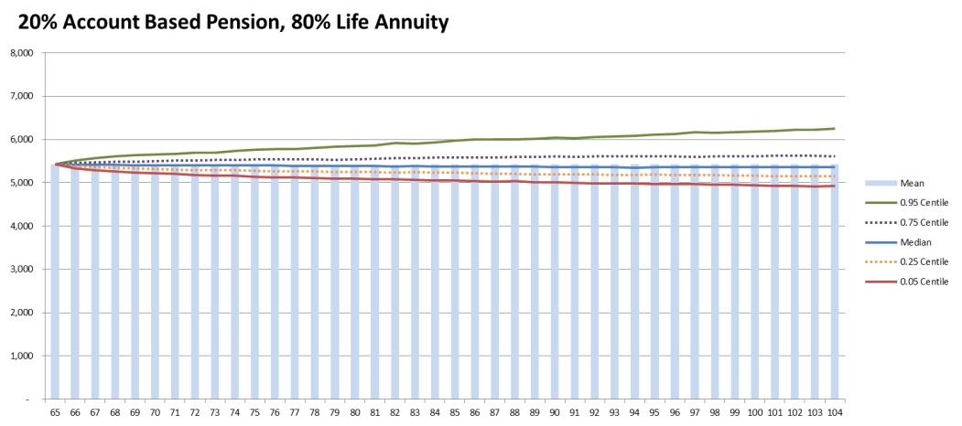
The risk measure, expressed as a percentage of the benchmark annual payment is 2.97%.
The risk measure varies with the investment option selected. The results for a range of investment options are set out in the following table.
Investment Option | Real Income Yr1 | Risk Measure
Capital Stable | 5,298 | 2.09
Balanced | 5,426 | 2.97
Growth | 5,739 | 5.67

Deferred Annuity / Account Based Pension
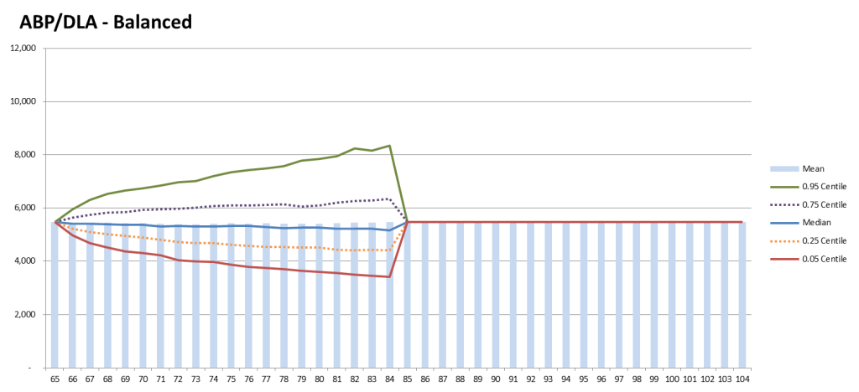
Under this option, $100,000 is invested in a bundle comprising 77% annuitized account based pension and 23% deferred lifetime annuity. The annuitized account based pension is expected to deliver a level real income to age 85. The proportion invested in the annuitized account is selected so that the deferred annuity provides a constant real income for life. This product, when purchased, is expected to provide the benchmark constant real income, however in practice, the income received is subject to investment risk on the proportion invested in the annuitized account. Experience variations are amortised by re-annuitizing the remaining balance of the account at the end of each year for the remaining term to age 85.
Where the investment option selected is a balanced option the results of the projection are:

Clearly this bundle could be better designed by incorporating a separate component of the annuitized account that is amortised to age 105. This would allow greater flexibility to reduce the potentially more extreme outcomes at the end of the deferral period. Never the less, for illustration purposes a basic product has been projected. The initial income is $5,476 and the risk measure is 9.80%.
The risk measure varies with the investment option selected. The results for a range of investment options are set out in the following table.
Investment Option | Products | Real Income Yr1 | Risk Measure
Capital Stable | 78%ABP/22%DA | 5,158 | 7.54
Balanced | 77%ABP/23%DA | 5,476 | 9.80
Growth | 74%ABP/26%DA | 6,198 | 15.05

Account Based Pension – Minimum Drawdown
We have also projected the results for an account based pension drawn down at minimum rates. The illustration below is for an account invested in a balanced portfolio. These products are exposed to investment and longevity risk. The product, as projected, does not offer any risk mitigation or smoothing features, such as short term “bucket” strategies. Further, the retiree does not draw a uniform income in real terms owing to the progressive exhaustion of the account and the effect of the minimum drawdown rules.
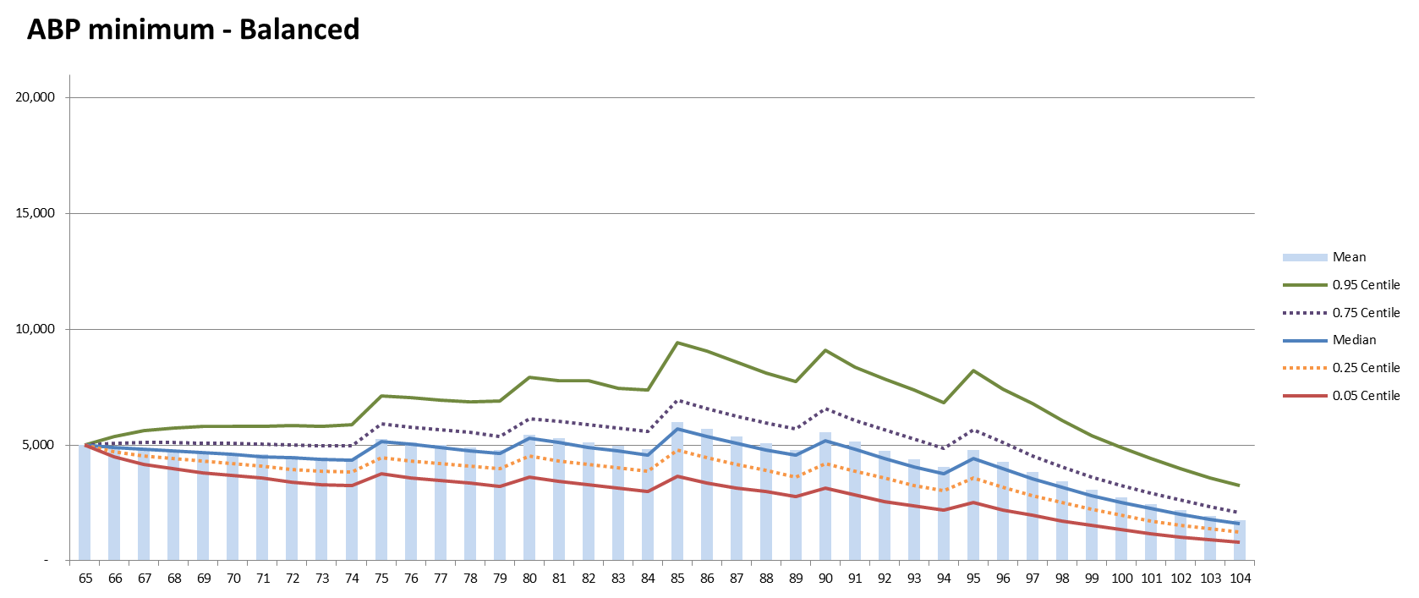
As the benchmark income is set by the initial income, this is a function of the first year’s minimum drawdown factor, being 5% of $100,000 in this example. The risk measure is 20.29%.
The risk measure varies with the investment option selected. However in this case the progression is counter intuitive as the initial income is defined by the minimum drawdown. (In other examples, the initial income is generally set to be the best estimate sustainable payment for the life of the product). As a result, the results for investment options that exhibit higher expected returns (and higher market risk) can result in lower income risk due to the effect of the higher average return. The results for a range of investment options are set out in the following table.
Investment Option | Real Income Yr1 | Risk Measure
Capital Stable | 5,000 | 26.47
Balanced | 5,000 | 20.29
Growth | 5,000 | 14.56
The counterintuitive result produced in the above table may be a matter for further consideration. On the one hand, this may be considered to be a limitation of this approach which may be addressed through a more refined approach to the calculation of the benchmark income for an account based pension. Alternatively, it is interesting to compare these results to the results produced by the ABP/DLA for a similar investment option. This is set out in the following table.
Investment Option | Account Based Pension |  |  | ABP/DLA
 | Real Income Yr 1 | Risk Measure |  | Real Income Yr 1 |  | Risk Measure
Capital Stable | 5,000 | 26.47 |  | 5,158 |  | 7.54
Balanced | 5,000 | 20.29 |  | 5,476 |  | 9.80
Growth | 5,000 | 14.56 | 6,198 |  | 15.05
This comparison shows that, for the capital stable and balanced options, the risk mitigation effects of the DLA result in higher expected income and materially lower income risk to the retiree. For the Growth option, the retiree is targeting a materially lower income in order to achieve a similar outcome in terms of income risk. Whilst the two products are different, when presented side by side, these two metrics do help to illustrate the trade-off between income and risk that the two alternative products offer.

Discussion
This risk measure differentiates between product designs.
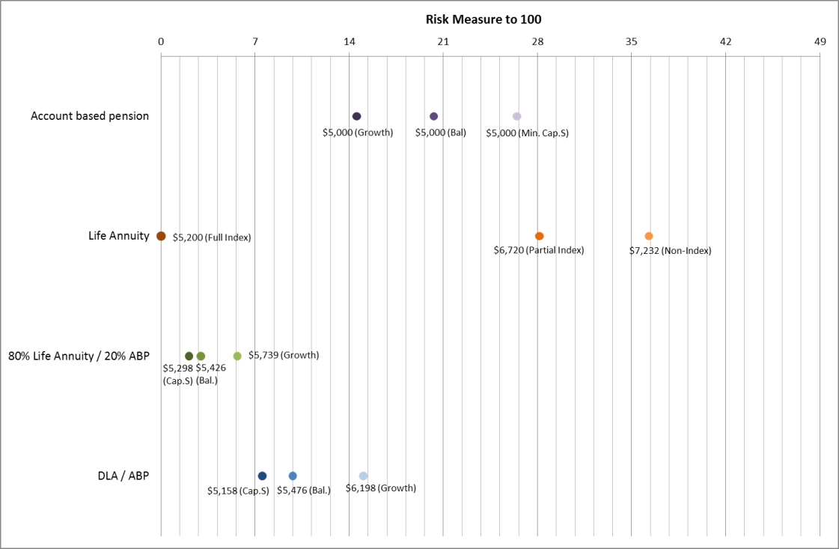
A comparison of the results by product and level of initial income is set out in the following chart.

Perhaps unexpectedly, the non-indexed life annuity is the highest risk example of those presented above. This needs to be presented alongside the point that the product provides the highest initial income; however it does not maintain the real value of that income by providing any inflation protection. The risk measure is calculated against an expectation of a constant real income for life. A product commonly purchased in the current environment, a capital stable ABP is the third highest risk score, albeit with substantially lower benchmark income than the life annuities with the higher risk scores. This suggests that both the income and risk measure need to be presented on a dashboard to allow individuals to make the trade-off that suits their needs.
The examples above are not intended to be exhaustive. It would be possible to apply the same methodology to a wide range of products, including GSAs, unit linked annuities and products with short term matching/bucket strategies. All retirement income plans could potentially have the same income risk measure calculated.
The calculation of the risk measure does require a number of assumptions. Underlying this approach is a stochastic model of investment returns and mortality. Each scenario generates investment returns and mortality experience for each future year and the results are applied to the product rules to determine the resulting income payment in each year under that scenario. This distribution of payments is used to calculate the risk measure. A summary of our assumptions is set out in the Attachment to this paper.
The risk measure ignores the age pension for the purposes of the dashboard. A strategy that runs down a retiree’s assets (e.g. ABP strategies above) could, under the current means test rules for the age pension, be expected to be offset in some way by an increasing age pension. It could be expected that the risk measure of a financial plan that includes the aged pension would be significantly lower than one which does not. For comparison purposes, the risk measure could be recalculated (to take into account the age pension, once it is known that the individual is actually eligible), however it is envisaged this would be presented separately to the proposed dashboard.
Where the dashboard is presenting a reversionary product, then the risk measure is based on the payments to the first life. As the risk measure is calculated assuming the first life survives to 100, this simplifies the calculation. It is expected that any reduction in payment that occurs on the death of the first life would be stated clearly in any dashboard.
As we have calculated the risk measure over a range of products we have observed the risk measure exhibit the following properties:
- The income risk measure is nil when the benchmark income is delivered.
- By examining the total income delivered from product bundles, the income risk measure captures any diversification benefits that may be available from different product components.
- Adding product components with a nil product risk measure to a product bundle will reduce the income risk measure of the bundle.
- Drawing an income that is below the best estimate benchmark income would reduce the income risk measure. This may be a useful strategy in other circumstances, for example balancing risk and income considerations in a financial planning context.
- The income risk measure is not dependent on the amount invested. It is dependent on the negative variations from the benchmark income that would arise from the amount invested.
- The methodology could be applied more broadly to provide a comparable measure of risk to an individual’s broader retirement income plan after considering other elements, such as the income from the age pension or income from assets outside superannuation.

Presentation of the Results: Relative Risk Measure
It is not expected that publishing an income risk measure based on the concept of a negative semi-deviation would be readily understood by the lay person. With this in mind, the Treasury has proposed two methods of illustrating the level of risks that attach to a specific product. These are:
- To translate the risk measure into a seven point scale of income security, and/or
- To present the range of likely payments in graphical form, as illustrated in the previous section.
This section focuses on the adoption of the seven point scale proposed by Treasury, as the graphical illustrations for a range of product bundles have already been provided.
1 | 2 | 3 | 4 |  | 5 | 6 | 7
Average Income Not Secure |  |  |  | Average Income Secure
Any approach that results in a simplified expression of the risk measure implies that we need to define a methodology for consistently converting the risk measures derived by each product to a score on a seven point scale which measures income security.
Exploring the concept presented above further, a product that provides prudentially regulated contractually guaranteed indexed income for life may be defined as having a low potential for disappointment and would (intuitively) achieve an income security score of seven. However; to determine the reference point for higher risk products requires considering a range of products to examine their relative experience.
To consider this further it is instructive to examine the progression of the risk measure across various scenarios.
Scenario ($100,000 initial investment) | Initial Income | Risk Measure
Indexed Life Annuity (Reducing Liquidity) | $5,200 | 0
Non-indexed Life Annuity | $7,232 | 36.28
Partially Indexed Life Annuity | $6,720 | 28.15
80% Life Annuity / 20% ABP (Cap. Stable Option) | $5,298 | 2.09
80% Life Annuity / 20% ABP (Bal. Option) | $5,426 | 2.97
80% Life Annuity / 20% ABP (Growth Option) | $5,739 | 5.67
Deferred Annuity / Account Based Pension (Cap) | $5,158 | 7.54
Deferred Annuity / Account Based Pension (Bal) | $5,476 | 9.80
Deferred Annuity / Account Based Pension (Growth) | $6,198 | 15.05
Account Based Pension (Minimum Rate - Cap. Stable) | $5,000 | 26.47
Account Based Pension (Minimum Rate - Balanced) | $5,000 | 20.29
Account Based Pension (Minimum Rate - Growth) | $5,000 | 14.56

This paper is intended to be illustrative only and further product examples could be completed to fully inform the approach taken.
The scale proposed by Treasury assigns the highest value of seven to products with the highest income security and the lowest risk score. To convert the risk measure to this scale requires a two-step process:
1. Convert the calculated risk measure to a risk score between one and seven
2. Translate the risk score to an income security score as proposed by Treasury
There are any number of approaches that could be taken to convert the income risk measure to a seven point scale. This paper illustrates two approaches:
- A linear approach
- An approach where each increase in score broadly represents a doubling of risk over the previous score.
In both approaches I have reserved the lowest risk score (and the highest income security score) for those products that are prudentially regulated and are not exposed to any market, inflation or longevity risk.
Linear Approach
Under this approach, after setting a risk score of one specifically for those products with a zero risk measure, for products that have a non-zero risk measure, I have simply divided the risk measure by seven, utilising the following conversion:
Risk Score = Integer of (Risk Measure ÷ 7), subject to a maximum value of 7.
To convert the risk score into the seven point income security scale, the following conversion is used:
Income Security Score = 8 – Risk Score
This would result in the following distribution of income security scores.

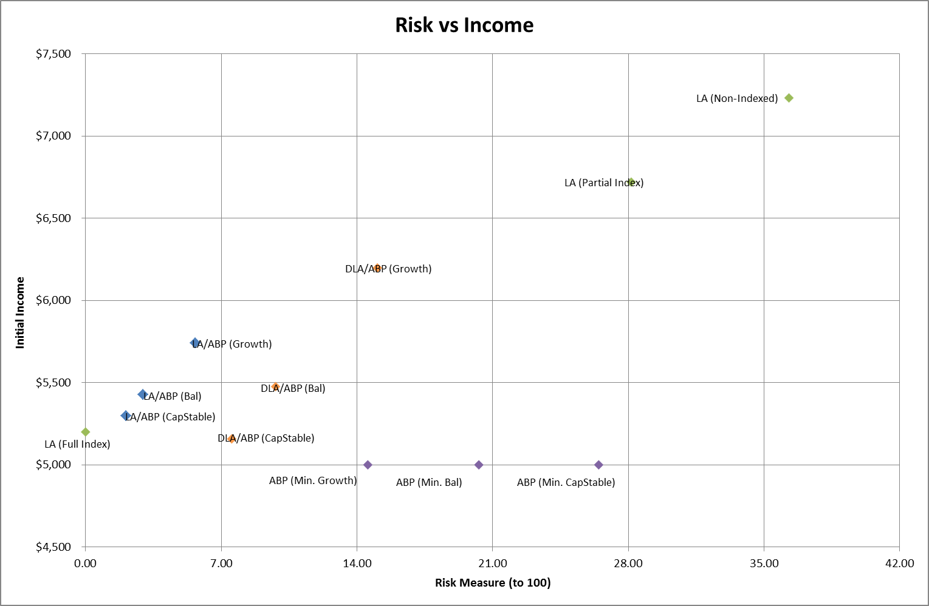
Non-linear Approach
7
6
5
4
3
2
1
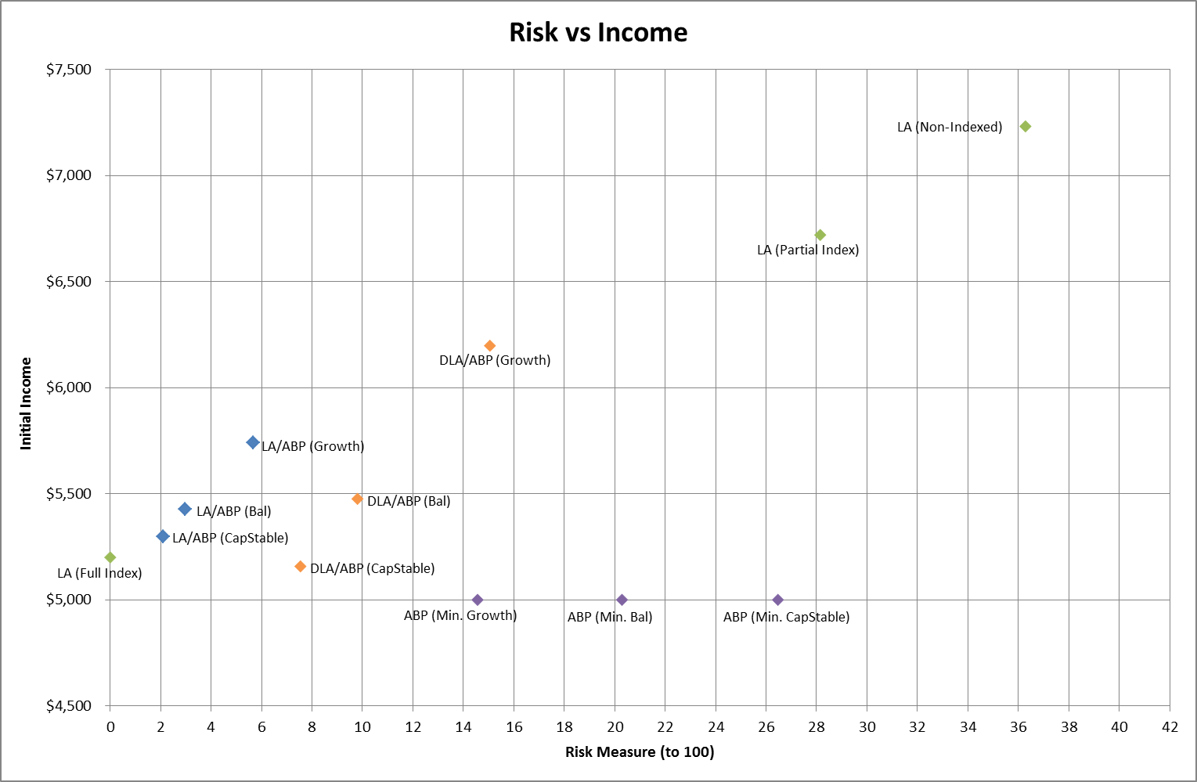
As with the prior approach, I have reserved the risk score of one for those products with a zero risk measure. I have then defined a risk score of two as applying to products with a risk measure greater than nil, but less than or equal to 2.00. A risk score of three applies up to double the maximum risk measure that qualifies for a score of two, i.e. 4.00. A risk score of four applies up to double the maximum risk measure that qualifies for a score of three, i.e. 8.00. The income security score is then calculated as in the above example. The results are illustrated in the revised chart below.
6
7
1
2
3
4
5
This approach provides a more granular income security score for lower risk products; however the bands are broader for higher risk products. Relative risk may be described as a product with an income security score that is lower than another product by one will exhibit twice the income risk as the product with the lower score. This rule of thumb may not apply where the income security score is one, owing to the capped nature of the score.
Discussion
An income security score on a scale of one to seven appears simple to understand, however it is to be acknowledged that it is a simplified approach that will naturally raise some questions:
- How does the typical retiree interpret the results? Is a linear approach simpler to understand than a non-linear approach? Are the bands too broad to provide meaningful differentiation to the retiree? Ultimately some testing of how retirees interpret these scores through the BETA team is likely to be informative.
- Is it appropriate to reserve the highest income security score only for a product exhibiting no volatility, other than counterparty exposure to the prudentially managed provider?
- A minimum security score of one results in all products above a certain risk level all being classified under the same income security score. Is this appropriate?
- A single score does not indicate the contribution that each element of risk (longevity risk, inflation risk and market risk) has made to the overall result. Two products with the same income security score may exhibit different behaviours due to the mitigation, or partial mitigation, of different risks. Would a retiree benefit from some additional illustration of the components that contribute to the overall result?
On balance, both approaches have merit. The choice of either of these approaches, or indeed an alternative approach, should be informed by consumer testing.

7

Summary
This paper discusses a possible methodology for measuring the relative income risk associated with alternative retirement income products.
The paper defines income risk as occurring when income received from a retirement income product falls below a benchmark level of income, which is the income received in the first year, indexed to inflation and received for life. Measurement of variations against this measure therefore captures market risk, inflation risk and longevity risk.
The paper proposes the use of a specific income risk measure as the underlying metric to inform the level of product risk. Recognising that this measure may not be readily understood, the paper also sets out alternative approaches for translating this measure into an income security score, ranging from seven to one, as proposed by Treasury in their Retirement Income Disclosure Consultation Paper.

Guy Thorburn
Australian Government Actuary
7 December 2018

Attachment: Assumptions
In all examples, results are illustrated for a 65 year old male. The following assumptions were used for annuity purchase prices.
Immediate annuity (full indexation) | 5.20%
Immediate annuity (partial indexation) | 6.72%
Immediate annuity (no indexation) | 7.23%
Deferred annuity to age 85 (full indexation) | 23.90%
Investment fee | 0.50%
Admin fee | $100
The account based pension is assumed to have an asset based fee of 0.50% pa and an annual fee of $100 pa. Where the account is drawn down at minimum rates, the following rates were used:
Age | Draw Down Rate | Age | Draw Down Rate
65-74 | 5% | 85-89 | 9%
75-79 | 6% | 90-94 | 11%
80-84 | 7% | 95-110 | 14%
Investment Model
The results in this paper are intended to be illustrative only. They utilise a high level asset model with a limited range of asset classes. The Treasury discussion paper articulates that, should this risk measure be implemented as part of the dashboard, then further consultation would occur on the model to be used and the associated assumptions. Should this be the case then we currently expect to develop a more comprehensive set of assumptions, in discussion with industry and academics to ensure that the assumptions are relevant to the models generally in use. Should this be impractical a more pragmatic approach may be to publish a set of simulated results for providers to apply to specific products. We would welcome readers who choose to calculate risk metrics for their own products to discuss their results with the AGA.
In the interim, should readers be looking to broadly align the expected returns from their own models to those generated by our high level model, the table to the right sets out mean portfolio return (Exempt fund) resulting from our high level simulations. | Asset Class | Mean ‘Exempt’ Portfolio Return
 | Capital Stable | 6.2%
 | Balanced | 7.2%
 | Growth | 9.4%

David Rush, A Product To Meet Changing Needs in Retirement, May 2018

