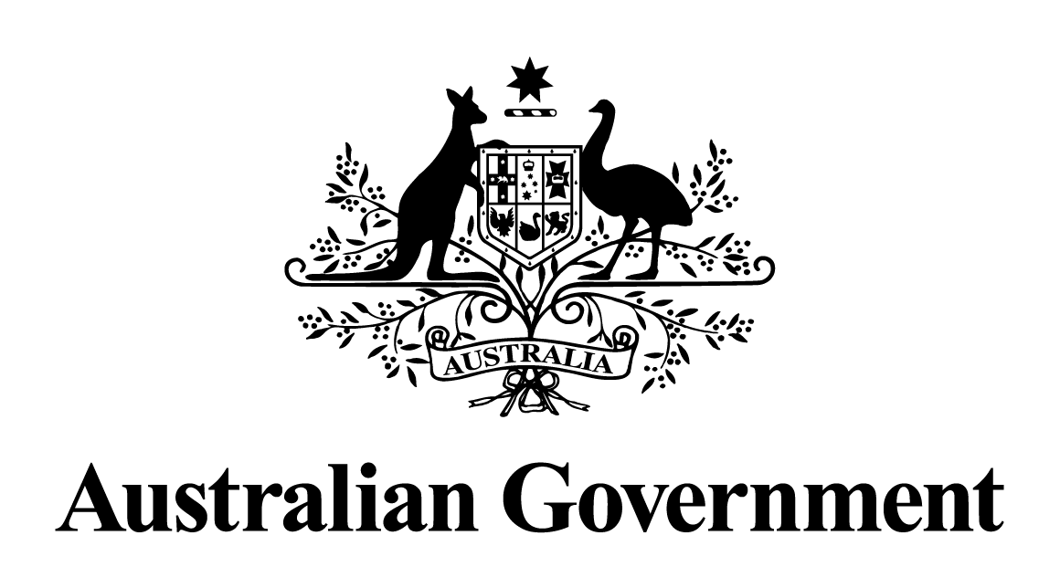

Australian Government response to the
Senate Economics Legislation Committee report:

Reserve Bank Amendment
(Australian Reconstruction and Development Board) Bill 2013

August 2018

Senate Economics Legislation Committee
Reserve Bank Amendment (Australian Reconstruction and Development Board) Bill 2013
Government Response
Recommendation 1
The Committee recommends that the Department of Agriculture and Treasury consult with the banking sector and relevant bodies who have identified deficiencies in the current information available on rural debt. The purpose of the consultation would be to progress a suitable data collection method to ensure that the quality of data available to government on rural debt would provide the information needed for decision makers to make timely and well-informed decisions
The Australian Government agrees with the recommendation.
At a meeting of the Agricultural Finance Forum on 23 September 2014, the then Minister for Agriculture, the Hon. Barnaby Joyce MP, met with senior lenders, finance representatives, industry bodies, farmer organisations and other rural stakeholders to discuss the extent of the rural debt situation, its causes and possible solutions.
There was general consensus that there was a lack of transparent information on debt held by the agricultural sector, and a need to systematically collect data to increase the volume, detail and accuracy of information on debts held by farmers.
The Department of Agriculture and Water Resources, the Treasury and the Australian Prudential Regulation Authority (APRA) are working together to establish an ongoing data collection. This information should assist the government to target its assistance measures for farmers, their businesses and communities more effectively.
Publication of high level debt data will also allow state/territory governments, financial institutions, peak industry and farming organisations to better understand the extent of debt stress, and how their actions can be best targeted to assist farmers.
On 28 March 2017, APRA released a consultation paper on the proposed collection of data on lending to the agricultural sector. The proposed collection will be undertaken on behalf of the Department of Agriculture and Water Resources, and be administered by APRA on an annual basis.
On 28 April 2017, the formal consultation package on the proposed collection concluded. In total 12 submissions were received, comprising Authorised Deposit-taking Institutions, Registered Financial Corporations and peak industry bodies.
On 16 August 2017, APRA released a response to submissions and a finalised reporting standard for the data collection. The first formal collection of data (for the annual period ending 30 June 2017) was received on 12 March 2018.
In addition, APRA has received data on farm debt from entities on a voluntary basis for the annual period ending 30 June 2016. Going forward, annual collections will fall due on 30 September.

