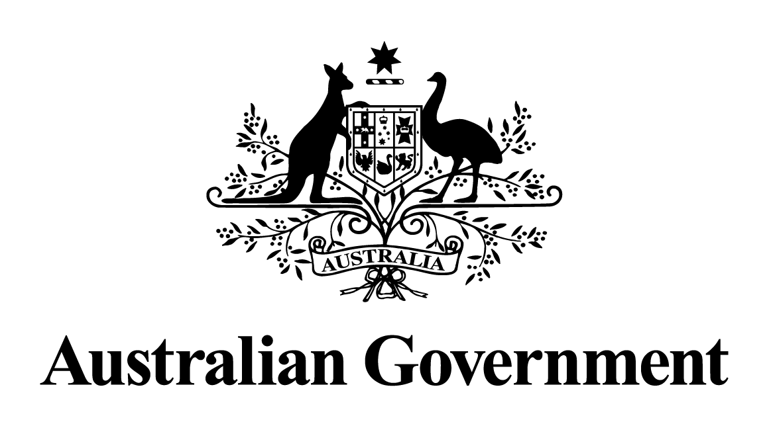
Australian Government response to the
Parliamentary Joint Committee on Corporations and Financial Services report:
Report on the 2016-2017 annual reports of bodies established under the ASIC Act
October 2018

Recommendation 1
The committee recommends that the Government review the adequacy of auditor disciplinary functions.
The Government agrees to this recommendation.
The Government sees merit in ensuring adequate auditor disciplinary functions.
Auditors play a critical role in ensuring that Australian investors can be confident and informed when making investment decisions. Applying disciplinary measures to auditors where they are in breach of their duties is essential to ensuring that auditors act in a manner that meets community expectations.
Currently there are a number of avenues that can be taken to discipline auditors, including the auditor disciplinary functions undertaken by the Companies Auditors Disciplinary Board (CADB), court action, negotiating an outcome with the individual or firm and disciplinary action by industry/professional bodies.
A review of the avenues of auditor disciplinary functions will provide insights into these auditor disciplinary processes and may identify potential areas for improvement.

