Government Response to the Australian Charities and Not‑for‑profits Commission Legislation Review 2018

6 March 2020

© Commonwealth of Australia 2020

This publication is available for your use under a [Creative Commons Attribution 3.0 Australia](http://creativecommons.org/licenses/by/3.0/au/deed.en) licence, with the exception of the Commonwealth Coat of Arms, the Treasury logo, photographs, images, signatures and where otherwise stated. The full licence terms are available from <http://creativecommons.org/licenses/by/3.0/au/legalcode>.

Creative Commons attribution licence 3.0 icon. 

Use of Treasury material under a [Creative Commons Attribution 3.0 Australia](http://creativecommons.org/licenses/by/3.0/au/deed.en) licence requires you to attribute the work (but not in any way that suggests that the Treasury endorses you or your use of the work).

*Treasury material used ‘as supplied’.*

Provided you have not modified or transformed Treasury material in any way including, for example, by changing the Treasury text; calculating percentage changes; graphing or charting data; or deriving new statistics from published Treasury statistics — then Treasury prefers the following attribution:

*Source: The Australian Government the Treasury*

**Derivative** **material**

If you have modified or transformed Treasury material, or derived new material from those of the Treasury in any way, then Treasury prefers the following attribution:

*Based on The Australian Government the Treasury data*

**Use of the Coat of Arms**

The terms under which the Coat of Arms can be used are set out on the It’s an Honour website (see [www.itsanhonour.gov.au](http://www.itsanhonour.gov.au)).

**Other uses**

Enquiries regarding this licence and any other use of this document are welcome at:

Manager  
Media and Speeches Unit  
The Treasury  
Langton Crescent   
Parkes ACT 2600  
Email: [medialiaison@treasury.gov.au](mailto:medialiaison@treasury.gov.au)

# Contents

Contents iii

Foreword 4

Overview 5

Key responses 6

Government response 7

# Related imageForeword

I am pleased to release the Australian Government response to the Australian Charities and Not-for-profits Commission (ACNC) Legislation Review 2018.

Our response forms part of the Government’s wider commitment to guarantee the essential services Australians rely on. Indeed, I am confident our approach will deliver tangible benefits to the more than 57,000 registered charities in Australia, the ACNC, and the wider community.

The panel received more than 170 submissions and met with 215 stakeholders to gauge the effectiveness of the ACNC as the primary regulator of charities in Australia. The Government welcomes the panel’s finding that there is strong support for the ACNC within the sector, and that the legislation underpinning the ACNC has been functioning as intended. However, the panel identified some areas for improvement proposing 30 recommendations.

Since the Government tabled the panel’s report in Parliament in August 2018, I have consulted extensively with the charity sector, the community, and with state and territory ministers to understand their views on the panel’s recommendations.

I believe our response to the recommendations will result in a better balance between reducing red tape for charities so they can focus their resources on supporting their communities, while ensuring the generous Australians who give their time and money to various causes can have trust and confidence in the governance of the charities they support.

Yet I note some of the recommendations require more time and consultation to yield meaningful reform. This includes working towards the harmonisation of regulatory requirements across all jurisdictions.

Finally, we have been reminded over the summer once again of the vital role that our charities play during natural disasters and states of emergency. Charities have stepped up and have mobilised support services to help tens of thousands of people right across our country. I note that this Government response relates solely to the report undertaken in 2018 into the ACNC and is aimed at our charities sector more broadly, and it not a reflection on recent events.

I would like to acknowledge the review panel — Mr Patrick McClure AO (chair), Mr Greg Hammond OAM, Ms Su McCluskey and Dr Matthew Turnour — for their outstanding work and thank everyone who made submissions. The Government is taking clear and decisive action thanks to the panel’s thorough review and comprehensive report.

A vibrant charities sector is important to all Australians, and as evident in this response, the Government will continue to strongly support it.

**Senator the Hon Zed Seselja**

**Assistant Minister for Finance, Charities and Electoral Matters**

# Overview

## The Government response

The Australian Government is committed to a regulatory regime for charities that fosters a vibrant and innovative sector. We support a steadfast, independent and effective regulator. Our response also aims to ensure the sector meets community expectations when it comes to transparency, accountability and good governance.

### **Reducing red tape**

Ensuring charities face minimal red tape — freeing them to focus on serving the community — remains a priority for the Government. Although charities will always have to provide information and work with their regulator, the Government supports opportunities to reduce the complexity of requirements and inefficiencies for charities when engaging with the ACNC and other government agencies.

### **Strengthening trust**

Strengthening trust and confidence in the charities sector is critical not only to its success, but its very existence. While the incidence of misconduct and misappropriation is very limited, it has the potential to undermine the commendable work of the sector. Measures to enhance transparency, clarify permissible advocacy and share information with the public go a long way towards strengthening the trust and confidence the sector needs.

### **Supporting an effective regulator**

The ACNC has been a reliable steward of the charities sector and, in the more than seven years it has been operating, it has become a highly regarded institution. As the independent national regulator of more than 57,000 charities, the ACNC has a responsibility to ensure optimal organisational and governance structures are in place. This will ensure it remains the effective and respected regulator for the charities sector.



# Key responses

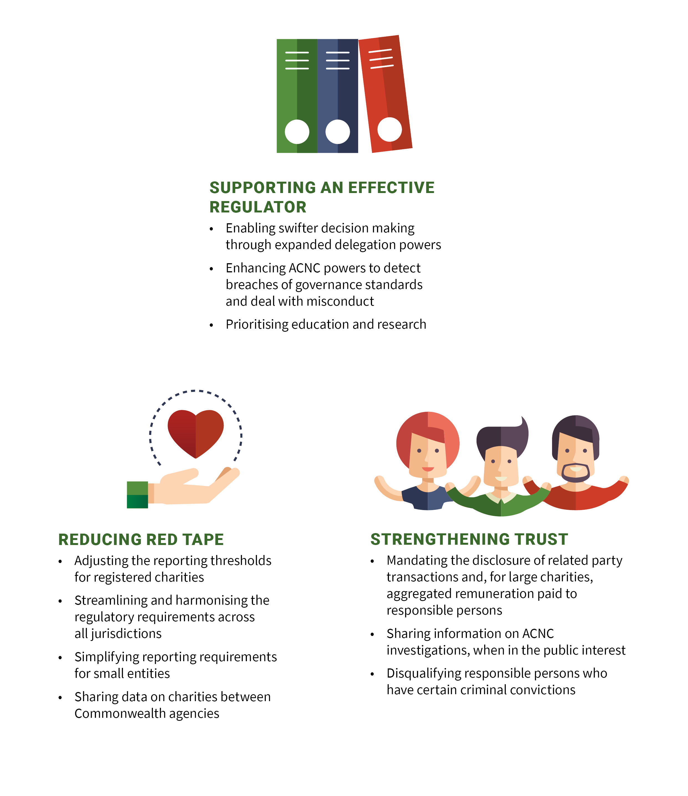

# Government response

## Government response to the recommendations in the Australian Charities and Not-for-profits Commission Legislation Review 2018

| Recommendation | Government response |
| --- | --- |
| ***Part A – Objects, Functions and Powers*** |  |
| 1. The objects in the *Australian Charities and Not‑for‑profits Commission Act 2012* (Cth) (ACNC Act) should not be changed.  The panel found no evidence the current objects are ineffective or deficient and concluded that no additions to the current ACNC objects are warranted. | The Government supports the recommendation.  No change to the current objects of the ACNC is necessary as the objects remain relevant and contemporary. |
| 2. The ACNC Act should be amended to include functions and duties that align with the objects.  The panel recommended that the ACNC Act be amended so it conforms to the legislative model adopted in the UK where the functions and duties of the regulator correspond directly with the objects. | The Government does not support the recommendation.  The Government does not consider these amendments will enhance the ACNC’s effectiveness as a regulator. |
| 3. The ACNC should continue to prioritise its education and research functions, including the use of behavioural insights and incentives.  The panel found the ACNC’s focus on research, guidance and education has been effective as a form of ‘behavioural nudging’ to the charity sector. The panel believes this focus should continue. | The Government supports the recommendation.  The ACNC will continue to put a strong focus on education and research. |
| 4. The ACNC Act should be amended to replace the term ‘responsible entity’ with ‘responsible person’.  The term ‘responsible person’ is used by the ACNC in its guidance material to describe those responsible for governance of charities. The term used in the ACNC Act is ‘responsible entity’. The panel found the misalignment between the ACNC Act and the ACNC guidance material could create confusion. | The Government does not support the recommendation.  The amendment would create a new opportunity for legal uncertainty because the definition of ‘responsible person’ in the ACNC Act would be different to the meaning of the term used in tax law. |
| 5. The powers of the Commissioner to replace a responsible person should be removed.  The panel found the ACNC Commissioner’s powers in relation to responsible persons are broad and subject to less scrutiny than comparable regulators. | The Government does not support the removal of the Commissioner’s power to remove or replace a responsible person.  This power is important as it allows the ACNC Commissioner to act quickly and may prevent the misuse of charitable assets.  However, the Government will mandate additional criteria that the Commissioner will be required to consider when making a decision to remove or replace a responsible person.  The Government will also broaden the power of appeal to allow both the ACNC registered charity and the responsible person the right to appeal a decision relating to a Commissioner’s decision to remove or replace a responsible person.  The additional safeguards and appeal rights will enhance the protections for those responsible persons affected by a decision of the ACNC Commissioner.  The Government will consult on the detail of the changes. |
| 6. An Executive Committee comprising the Commissioner and the Assistant Commissioners should be established, and be responsible for the strategic direction and performance of the ACNC.  The panel found the ACNC should have an Executive Committee structure similar to other comparable statutory organisations. | The Government agrees it is good practice for a regulator to establish an executive committee to manage the strategic direction and performance of the organisation, and notes that the ACNC has an Executive Committee. |
| 7. The ACNC Act should be amended to give the Commissioner broader powers to delegate functions or powers to staff.  The panel found the expansion of the ACNC Commissioner’s delegation powers would facilitate more efficient decision making. | The Government supports the recommendation to allow the Commissioner to delegate functions or powers to staff if satisfied the person performing the delegated functions has an appropriate level of expertise.  The change will enhance the efficiency and quality of the ACNC’s administrative decision-making process.  The Government will implement this recommendation by changes to legislation. |
| 8. The [ACNC] Advisory Board should be empowered to provide advice to the Minister or the Commissioner on its own initiative, and engage directly with the sector.  The panel found the Advisory Board could play a greater role, given its expertise. | The Government supports the Advisory Board proactively reviewing issues of importance to the sector and providing advice to the Commissioner.  There is no legal barrier to the Advisory Board meeting with the Minister. |
| ***Part B – Regulatory Framework*** |  |
| 9. ACNC governance standard 3 should be repealed and ACNC governance standard 5 should be amended to remove the word ‘perceived’ with a view to consistency with the *Corporations Act 2001* (Cth).  The panel found governance standard 3, stipulating that a charity must not commit a serious offence under Australian laws, is not appropriate for the ACNC to enforce. The panel also found that the concept of ‘perceived conflicts’ in governance standard 5 is not clearly defined in law. | The Government does not support the recommendation.  The Government supports the ACNC having the power to take action to deregister an entity where serious offences have been committed and therefore supports the retention of governance standard 3.  The Government considers the requirement for registered entities to disclose perceived conflicts of interest enhances transparency and mitigates the risk of poor behaviour. For these reasons, the Government does not support removing the word ‘perceived’ from governance standard 5. |
| 10. A registered entity should be presumed to comply with the ACNC governance standards if it already complies with other comparable governance requirements.  The panel found a registered entity should be presumed compliant with ACNC governance standards if it self‑assesses that it has complied with comparable governance requirements and makes a declaration to that effect in the Annual Information Statement. | The Government supports the ACNC’s existing approach of reducing regulatory burden for the charity sector by publishing information on whether particular codes of conduct, as enforced by peak bodies, are consistent with the ACNC governance standards.  The ACNC will retain the capacity to monitor and assess an entity’s compliance with the ACNC’s governance standards and retain the power to deregister a charity if it is found non‑compliant with the governance standards. |
| 11. The *Corporations Act 2001* (Cth) should be amended to ‘turn on’ the duties and other provisions previously ‘turned off’.  The panel found an amendment to the Corporations Act would reduce the ambiguity about whether directors’ duties for charitable companies applied and strengthen the rights of members to take action against directors in the case of a breach of duties. | The Government notes the recommendation.  The Government will release a consultation paper seeking the views of the sector on the merits and risks of “turning on” the directors’ duties under the Corporations Act for charitable companies. |
| 12. Registered entities should be required to report based on size, determined on rolling three-year revenue, with thresholds of less than $1 million for a small entity, from $1 million to less than $5 million for a medium entity, and $5 million or more for a large entity.  The panel found that current revenue thresholds for determining minimum reporting requirements are too low. Adjusting the thresholds, so fewer charities are required to provide financial reports, would reduce the compliance burden of registered entities. | The Government supports the recommendation, balancing red tape reduction for charities with transparency.  To avoid unintended consequences for charities, the Government is consulting with states and territories on the appropriate level of revenue thresholds for minimum reporting requirements, before proceeding with legislative change. |
| 13. Minimum reporting requirements for small registered entities should be amended to allow in an Annual Information Statement an option to provide a simplified balance sheet or a statement of resources.  The panel found the ACNC balance sheet reporting requirement in the Annual Information Statement to be inconsistent with the option for small registered entities to report using cash accounting. The panel’s proposed statement of resources would require a description of the assets used by the small registered entity to be provided in the Annual Information Statement. Asset valuations would only be required if practicable to obtain. | The Governmentsupportsthe recommendation.  Over 18,000 charities which currently use cash accounting will now have the flexibility to provide a statement of resources to the ACNC. This will reduce regulatory burden for small charities.  The ACNC will make changes to the Annual Information Statement requirements for small charities. |
| 14. Registered entities should be required to disclose related party transactions.  The panel found that charities should disclose related party transactions as part of their financial disclosures. Related parties include persons or organisations that are connected to the charity, such as family members of responsible persons or subsidiaries of the charity. The recommendation is intended to increase transparency of transactions that pose a higher risk to charitable assets being used for private benefit. | The Government supports all registered entities being required to disclose related party transactions.  To minimise the compliance burden on small charities, the Government will require small registered entities to make a simplified disclosure involving a brief description of a related party transaction.  The Government will implement this recommendation by changes to regulations. The start date for this measure will align with any change to the revenue thresholds for financial reporting requirements. |
| 15. Large registered entities should be required to disclose the remuneration paid to responsible persons and senior executives on an aggregated basis.  The panel found that all large registered entities should disclose the remuneration of responsible persons and senior executives to align ACNC reporting requirements with Australian Accounting Standards Board requirements. This recommendation is aimed at providing greater accountability to donors, beneficiaries and the public by requiring charities to be transparent about remuneration of key management personnel. | The Government supports the recommendation.  Large registered entities will be required to disclose remuneration paid to responsible persons and senior executives on an aggregated basis.  This disclosure will only be required from entities with two or more key management personnel to accommodate privacy concerns.  The start date will align with any change to the revenue thresholds for minimum reporting requirements. |
| 16. If recommendations 12 and 13 are adopted, the necessity for the exemption from financial reporting for basic religious charities should be reviewed, and if recommendations 5 and 10 are also adopted, all exemptions for basic religious charities should be reviewed.  The panel supports a review of basic religious charity exemptions on condition that the Government implements four recommendations aimed at reducing reporting obligations for small charities, streamlining compliance with governance standards, and removing the ACNC’s power to replace responsible persons. | The Government has no plans to review the exemptions for basic religious charities. |
| 17. The Commissioner should be given a discretion to disclose information about regulatory activities (including investigations) when it is necessary to protect public trust and confidence in the sector.  The secrecy provisions of the ACNC Act prevent the Commissioner from making information public about the ACNC’s regulatory activities except to respond to or clarify issues that have already been raised in the public domain by a charity.  The panel found an expansion of the powers to disclose information would increase public confidence that the regulator is actively pursuing misconduct. It will also provide salutary guidance to other charities about poor behaviour. | The Government supports the recommendation.  The change will allow the Commissioner to release information about ACNC regulatory activities in the public interest. It will strengthen public trust and confidence in both the sector and the regulator.  The Government will consult on the detail of the change, including the triggers for and bounds of the Commissioner’s discretion.  The Government will implement this recommendation by changes to legislation. |
| 18. The Commissioner should be authorised to collect the personal details of responsible persons involved in unlawful activity.  The panel found that the ACNC should be able to request details on the criminal records of responsible persons to allow it to detect unlawful behaviour and contraventions of the ACNC Act. | The Government supports the recommendation as it will enhance the ACNC’s capacity to detect breaches of its governance standards and external conduct standards. |
| 19. The ACNC should be resourced to enable the Commissioner to enforce and develop the law where registered entities engage in disqualifying purposes (within the meaning of the *Charities Act 2013* (Cth)).  The panel found the ACNC must be well resourced so that it can enforce the law and prevent the misapplication of charitable assets. The panel also considered there to be benefit in further case law on entities engaging in disqualifying purposes. | The Government supports the recommendation.  The Government provided the ACNC with $1 million of additional litigation funding in the 2018‑19 Budget. This funding will enable the Commissioner to enforce and develop the law where ambiguity exists. |
| 20. Test case funding should be made available to develop the law in matters of public interest, including disqualifying purposes.  The panel found the ACNC should be given test case litigation funding (similar to the ATO model). This would provide registered entities with financial assistance to take matters with broad implications to court with the objective of clarifying contentious areas of law. | The Government does not support the recommendation. The Government will explore legislative options to address uncertainty in the law. |
| 21. The ACNC’s regulatory approach to high‑risk registered entities should be further developed in partnership with the Australian Criminal Intelligence Commission (ACIC), the Australian Transactions Reports and Analysis Centre (AUSTRAC) and other Commonwealth departments and agencies.  The panel found the ACNC should work with other government agencies to develop a regulatory model for high-risk charities to ensure proper monitoring and compliance. | The Government supports the recommendation.  The ACNC is actively building its partnership with ACIC and AUSTRAC.  The ACNC was recently listed as a ‘designated agency’ for the purposes of the *Anti-Money Laundering and Counter-Terrorism Financing Act 2006* (Cth), which will provide it with direct access to AUSTRAC information. |
| 22. The ACNC should be resourced to enhance its access to criminal intelligence databases, use of secondments and information sharing with the ACIC and other agencies.  The panel found additional resourcing to the ACNC to access databases would enhance the ACNC’s capacity to detect charities with links to criminal behaviour and terrorism. | The Government supports the ACNC engaging with ACIC to enhance cooperation and integration.  The ACNC will work with ACIC to consider the merits of developing a memorandum of understanding around the sharing of data. |
| 23. The *Australian Charities and Not-for-profits Commission Regulation 2013* should be changed to disqualify a person from being a responsible person if they have a conviction for terrorism, terrorism financing, money laundering, fraud, importation or distribution of illicit drugs or a child sexual offence under Commonwealth, state or territory law.  The panel found that the current disqualifying criteria for responsible persons is too narrow, limiting the ACNC’s ability to prevent individuals linked to serious criminal activities, including terrorism financing and money laundering, from being responsible persons of charities. | The Government supports the recommendation.  While proven instances of criminal misconduct in the sector remain low, illicit activity could severely damage public trust and confidence in the sector and harm the communities they are working to assist.  This recommendation will enhance the accountability of responsible persons, thereby reducing the risk of charities becoming involved in serious criminal misconduct.  The Government will implement this recommendation by changes to legislation. |
| 24. The ACNC Act should be amended to provide that certain not‑for‑profits with annual revenue of $5 million or more must be registered under the ACNC Act to be exempt from income tax and access Commonwealth tax concessions.  The panel found that the ACNC should be given oversight of not-for-profits with annual revenue of $5 million or more to ensure the largest not-for-profits are complying with their obligations. It is estimated there are 580 such entities. | The Government does not support the recommendation.  The Government considers that eligibility for income tax exemptions and other tax concessions for non-charitable not-for-profits is best regulated by the ATO.  The Government will consider options for tightening the ATO’s existing regulatory framework for not-for-profits and consider any implications for the regulatory scope of the ACNC. |
| ***Part C – Red Tape Reduction*** |  |
| 25. The Australian Consumer Law should be amended to clarify its application to charitable and not‑for‑profit fundraising and a mandatory Code of Conduct for fundraising activities be developed.  The panel found there are substantial inconsistencies across state and territory licensing and reporting requirements, and made a recommendation aimed at reducing red tape for fundraisers. | The Government does not support the recommendation.  The Government notes the findings of the Senate Select Committee Report on Charity Fundraising in the 21st Century, which considered, but did not endorse, recommendation 25 as a regulatory reform model.  The Government will continue to support efforts by the states and territories to harmonise state and territory fundraising laws.  The ACL is not an appropriate mechanism to harmonise laws in the NFP sector. The ACL provides broad, economy-wide protections, including against misleading and deceptive conduct. It is not designed to impose detailed licensing, reporting and conduct requirements in specified sectors, which in the case of fundraisers includes matters such as hours and location of collections, identification requirements for collectors or the issuing of receipts by collectors. Repealing state fundraising legislation and relying on the ACL’s broad protections could leave regulatory gaps.  The ACCC expressed a similar view in its submissions to the Review and to the Senate Select Committee.  Additionally, the ACL does not currently provide a mechanism for a code of conduct. Amending the ACL to provide for a code would require the agreement of the states and territories, and significant changes to state and territory legislation. It is unclear how such a process would achieve a faster reduction in red tape than harmonisation of state and territory laws. |
| 26. The use of the Charity Passport by Commonwealth departments and agencies should be mandated.  The panel found that the Charity Passport is underutilised by government agencies. | The Government supports the ACNC working with Commonwealth agencies to increase the take up of the Charity Passport.  Increased use of the Charity Passport by government agencies will reduce the need for charities to provide the same information to different government agencies multiple times. |
| 27. Responsibility for the incorporation and all aspects of the regulation of companies which are registered entities should be transferred from the Australian Securities and Investments Commission (ASIC) to the ACNC, except for criminal offences.  The panel found registration and regulatory responsibility for companies limited by guarantee registered under the ACNC Act should primarily rest with the ACNC. | The Government supports the ACNC working with ASIC, through the modernising business registers program, to reduce the practical and administrative challenges for registered entities dealing with both regulators. |
| 28. A single, national scheme for charities and not‑for‑profits should be developed.  Inconsistencies and complexities in Commonwealth, state and territory regulation impose three key forms of regulatory burden on charities: registration and reporting obligations under state and territory incorporated association legislation; licensing, reporting and operational restrictions under fundraising legislation; and eligibility requirements for tax concessions.  Advances in technology (such as online fundraising platforms) mean charities are increasingly operating across multiple jurisdictions.  The panel found that a single national scheme for charities and not-for-profits would alleviate these burdens, improving sector outcomes. | The Government notes the recommendation.  The panel’s proposal for a single national scheme involved a referral of powers by the states. Any referral of powers would require agreement of the states.  In light of this hurdle, the Government will continue to work closely with the states and territories (via relevant cross-jurisdictional fora) to streamline and harmonise charities regulation in three important areas.  First, the ACNC has led a cross-jurisdictional process since 2013 which has succeeded in streamlining reporting requirements for charities which are incorporated associations in New South Wales, Victoria, South Australia, Tasmania, the Australian Capital Territory and the Northern Territory. These reforms allow registered charities to report financial and governance information to the ACNC alone. Queensland is moving towards similar reforms.  Second, state and territory officials are also working with the ACNC to explore options to further reduce the regulatory burden on the sector. This includes considering possible cross-border recognition arrangements for charitable fundraisers.  Finally, the Government is consulting with states and territories on the development of a common statutory definition of charity across jurisdictions to replace 45 existing definitions. This will reduce complexity and regulatory burden for charities when seeking tax concessions. |
| ***Part D – Additional Amendments*** |  |
| 29. Review the interface between the ACNC Act and the Corporations Act and consider the additional amendments set out in Appendix B [of the final report].  The panel has suggested a number of technical amendments to resolve certain interactions between the ACNC Act and Corporations Act. This recommendation is aimed at improving administration and simplifying the application of legislation. | The Government supports in principle removing any ambiguity in the interactions between the ACNC Act and Corporations Act. However, the priority now is to implement reforms in response to the panel’s other recommendations before considering further reforms. |
| 30. The ACNC Acts should be consolidated and there should be ongoing five year reviews.  The panel found that it would be preferable for all regulatory provisions applying to the sector to be contained in one Act. The panel also found there should be ongoing reviews because the sector is dynamic and evolving. | The Government does not support the recommendation.  There is no evidence that the ACNC legislation in its current form is causing problems for the charity sector.  If a review of the sector is warranted in future years, this should be a matter for the government of the day. |