Dr Steven Kennedy PSM

Secretary to the Treasury

Post‑Budget economic briefing – opportunities and risks[1]*

Address to the Australian Business Economists

8 June 2022

## Introduction

I would like to acknowledge the Gadigal people of the Eora Nation who are the Traditional Custodians of the Land where we are meeting today. I would like to pay my respects to their Elders – past, present and emerging – and extend my respect to any Indigenous Australians who are with us today.

Today I will be providing a post-Budget briefing on the economy, the fiscal outlook and longer-term budget challenges.

I would like to thank the Australian Business Economists (ABE) for inviting me to speak today and the ABE’s ongoing support of Treasury’s post-Budget briefing.

As some time has elapsed since the Budget and Pre-election Economic and Fiscal Outlook (PEFO), I will also provide a perspective on recent economic developments.

## The economic environment

The most significant economic development since the release of PEFO has been the higher‑than-expected surge in inflation.

Headline inflation reached 5.1 per cent in the March quarter of 2022, the highest rate of inflation in more than 2 decades. Trimmed mean inflation, a measure of underlying inflation, has also increased significantly, reaching 3.7 per cent (Chart 1).

**Chart 1: Inflation**



Note: The measure of underlying inflation is trimmed mean inflation.  
Source: ABS Consumer Price Index and RBA.

In other countries inflation is even higher. For example, the latest outcomes were 8.3 per cent for the US, 9.0 per cent for the UK and 6.9 per cent for New Zealand.

Price increases are reflecting a range of shocks, some temporary and some more persistent. The interaction of these shocks is making the job of understanding and forecasting inflation particularly difficult.

I would like to start by discussing 3 compounding shocks currently affecting global and domestic economies and impacting inflation.

First, the pandemic has generated elevated global demand for goods which has strained global supply chains, increased congestion at ports and seen sharp increases in shipping costs. This pattern of demand is especially evident in the US (Chart 2).

**Chart 2: Global supply chain pressures**

|  |  |
| --- | --- |
| **US consumption** | **Global trade and shipping prices** |
|  |  |

Note: Percentage change from pre-pandemic (Dec-19) levels.  
Source: Refinitiv, CPB and BLS.

Demand for goods has shown some signs of normalising and shipping costs appear to have peaked, although they remain significantly higher than prior to the pandemic.

In addition to the disruption in the patterns of demand, the continuing circulation of COVID‑19 presents additional risks to the overall level of activity.

The second shock arises from the Russian invasion of Ukraine which has generated a sharp increase in oil, energy, and food prices (Chart 3). Russia accounts for 18 per cent of global gas and 12 per cent of global oil supply. Together Russia and Ukraine account for around one quarter of global trade in wheat.

The disruption caused to the supply of these commodities has a direct effect on inflation through higher fuel, energy and food prices for households, and an indirect effect through higher energy and transportation costs. There is the potential for prices to remain elevated for some time given uncertainty about the war and ongoing sanctions.

And it is worth noting that there are deep concerns about the impact of surging food prices on emerging economies, potentially leading to further volatility in global markets.

**Chart 3: Global prices**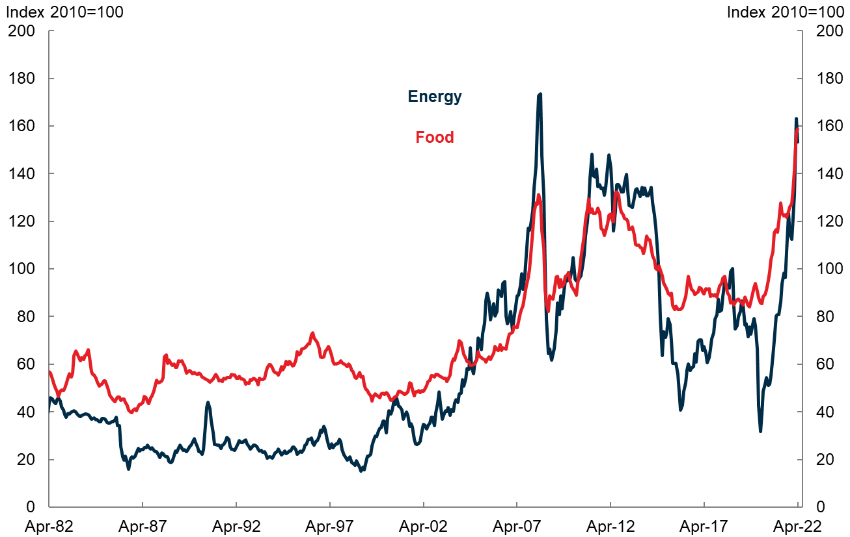

Source: The World Bank.

The third shock is only just emerging. COVID-19 in China is disrupting that economy and this may exacerbate supply shortages in the months ahead (Chart 4).

Recent lockdowns in China to suppress the spread of COVID-19 have begun to place additional pressure on global supply chains. We suspect disruptions as a result of these containment measures will continue until at least 2023, with further outbreaks likely and the central authorities remaining adamant in their approach to managing the virus.

If the Chinese Government persists with an extended zero‑COVID strategy and does not make progress on vaccination and health preparedness for the ongoing presence of many cases, the outlook for the Chinese economy is bleak.

Global supply of manufactured goods would be curtailed, although weaker demand for commodities including energy could see a correction in commodity prices.

**Chart 4: Impact of COVID-19 in China**

|  |  |
| --- | --- |
| **China Purchasing Managers’ Index (PMI)** | **Industrial production in China** |
|  |  |

Source: Refiitiv and NBS.

These shocks are running through economies and interacting with the extent to which some economies are facing capacity constraints, including labour market constraints.

The following charts (Chart 5) illustrate this through a comparison of headline and underlying inflation. They show for the US and the UK, headline and underlying inflation strengthening similarly, reflecting a combination of the shocks interacting with capacity constraints.

Circumstances are different in the EU, where demand is weaker, and underlying inflation has not strengthened to the same degree as headline inflation.

We can see the same influences at play when we compare inflation and wages. Wages are picking up in the US and the UK more so than the EU.

The potential for policy mistakes and significant slowdowns is increasing in countries where shocks and capacity constraints are most acute.

**Chart 5: Inflation**



Note: Underlying inflation is trimmed mean inflation for Australia and the United States and core inflation for United Kingdom and European Union. Core inflation excludes energy, food, alcohol and tobacco.  
Sources: Refinitiv and National Statistical Agencies.

In Australia, headline inflation is not as high as some countries due to global shocks having a smaller impact to date. And we are probably not exceeding capacity constraints to the same extent as some other countries.

Nevertheless, these forces in combination with domestic factors are likely to see inflation rise above 6 per cent, potentially well above 6 per cent and remain there for the rest of this year.

The effects of the shocks on prices can be seen in the following chart (Chart 6) which shows how fuel and new dwellings have contributed to the pick‑up in inflation.

**Chart 6: Contributions to headline inflation** 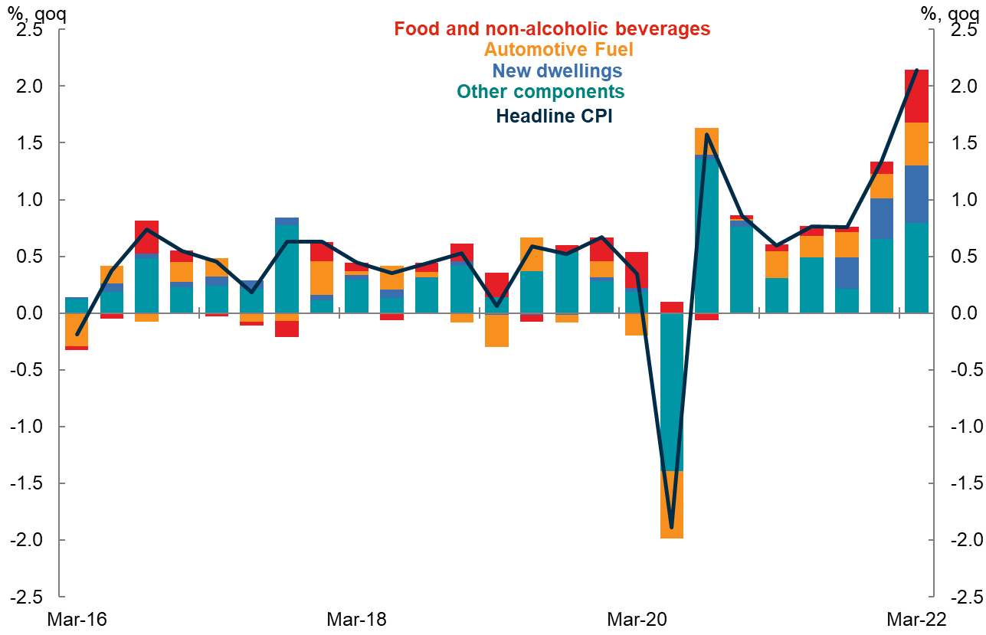

Note: Contributions prior to September quarter 2021 are back-cast using the 2021 CPI expenditure weights.  
Sources: ABS Consumer Price Index and Treasury.

To date, household electricity prices have not been contributing strongly to consumer inflation in Australia, unlike in the US and the UK.

However, Australia’s eastern states have recently seen significant increases in wholesale electricity prices reflecting increased global prices for thermal coal and gas, as well as domestic factors such as reduced generation capacity and increased demand.

This significant pressure in the wholesale electricity system presents a new upside risk to domestic inflation.

COVID‑19 is also continuing to impact the economy and we can see this in workforce absenteeism which increased in April, and although it remains below January levels it is expected to persist at an elevated level across the next few months (Chart 7).

**Chart 7: Estimated COVID-19 related absenteeism**

Sources: CovidBaseAU and Treasury.

It is hard to predict how long these compounding shocks will affect the domestic economy.

At the very least, inflationary pressures are likely to persist throughout 2022 and into 2023. Pressures may begin to dissipate as global consumption patterns normalise. Further, supply issues associated with labour shortages in some sectors, for instance agriculture and accommodation and food services, should moderate as migration picks up.

That said, higher and more persistent inflation outcomes cannot be ruled out and this remains a key risk to the domestic economic outlook.

As in other countries, these shocks are hitting the Australian economy at a time when for the first time in decades it is operating near full capacity.

The unemployment rate declined to 3.9 per cent in March, its lowest level since the 1970s. Underemployment is at its lowest level since 2008. The employment-to-population ratio is at around record highs (Chart 8).

**Chart 8: Labour market**

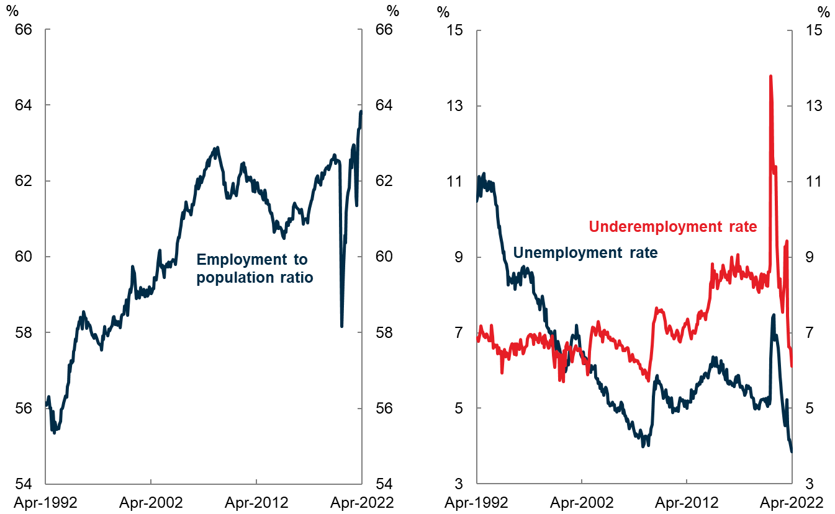

Source: ABS Labour Force.

While the labour market has clearly tightened, recent research has suggested that some spare capacity remains, due to elevated underemployment levels and further scope for an increase in the labour force participation rate.[2]

In the Budget and PEFO, the unemployment rate was expected to decline to 3¾ per cent and stabilise there until 2024‑25. Thereafter, the unemployment rate was assumed to steadily transition towards Treasury’s current assumption of the NAIRU, or Non-Accelerating Inflation Rate of Unemployment, of 4¼ per cent.

If realised, this forecast implies that the economy would be operating at beyond full employment for some years. In this environment, we would expect demand-side inflationary and wage pressure to be building.

To date, we have seen little hard data that shows wages growth lifting, although the latest WPI did show a marked pick up in wage growth for those who received an increase in the March quarter.

There is business liaison evidence to suggest businesses are competing harder for workers and offering higher pay, particularly through bonuses and other non-wage forms of remuneration. Nevertheless, because of the surge in inflation, real wages will be lower than anticipated at PEFO, following on from a number of years of subdued growth.

Just as fiscal and monetary policy worked together to respond to the pandemic, they will need to work together in managing the risks to inflation and the economy more broadly.

Interest rates are at near-record low levels and therefore highly accommodative and should normalise, given the strong level of demand across the economy and the tight labour market.

Typically, monetary policy looks through supply-side shocks unless they are expected to have second round effects and lead to inflation expectations being affected. Second round effects are more likely when the economy is operating beyond its sustainable capacity. With inflation expectations remaining well-anchored, we do not see a significant risk of a wage‑price spiral, but policy makers must always remain vigilant.

## Fiscal outlook

I would now like to turn to the fiscal outlook.

The budget balance is expected to improve over coming years as temporary economic support measures end. This is reducing near term demand pressures. However, significant medium-term spending pressures have emerged over the past 2 years, and this will see spending remain at a higher level than pre-COVID.

Having peaked at 6.5 per cent of GDP in 2020-21, the underlying cash deficit was expected in the PEFO to shrink to 3.4 per cent of GDP in 2022-23, and then to 1.6 per cent of GDP in 2025-26 (Chart 9).

**Chart 9: Key fiscal aggregates**

|  |  |
| --- | --- |
| **Underlying cash balance** | **Commonwealth gross debt** |
|  |  |

Source: Treasury.

Total receipts are expected to increase from 23.8 per cent of GDP in 2022-23 to 25.8 per cent of GDP in 2032-33. Having peaked at 31.6 per cent of GDP in 2020-21, payments are expected to decline to around 26.4 per cent of GDP and remain largely stable across the medium term.

At PEFO, Commonwealth gross debt to GDP was expected to reach 45 per cent in 2024-25, before declining to around 40 per cent by 2032-33.

Economic downturns have tended to occur roughly every 10 years. Australia needs to rebuild fiscal buffers to ensure the Government can respond effectively to future crises. This will help to keep debt on a sustainable path over the longer term.

Strong economic growth and relatively low interest rates are likely to assist in reducing debt to GDP in the period ahead. Interest payments increase debt, while economic growth increases the economy’s capacity to service that debt. When the economy grows quicker than interest payments add to debt, the debt burden will decrease.

The following chart (Chart 10) looks at reductions in debt to GDP that have been achieved from their peak in subsequent years (see Appendix).

It shows how budget surpluses have played an important role in historical episodes of debt reductions, with favourable growth and interest rate dynamics assisting or being neutral.

The current projected reduction in debt to GDP is unusual in that it is relying solely on favourable growth and interest rate dynamics to reduce the ratio. A more prudent course would be for the budget to assist more over time.

**Chart 10: Reductions in Commonwealth debt to GDP** 

Note: Data are in financial years. Debt excludes issuance for the states. The contribution of interest rates less growth captures the combined direct effect of the former increasing debt and of the latter growing GDP, but not their effects on the headline primary balance.  
Sources: ABS National Accounts, AOFM, ATO, Barnard (1986), Butlin (1962), Butlin (1985), Butlin, Dixon, Lloyd (2014), Commonwealth Budget papers, RBA and Treasury.

This would especially be the case if growth and interest rate dynamics become less favourable over time. Indeed, since Budget there has been a significant increase in the interest rate on government debt, with the 10-year yield rising around 120 basis points.

The rise in yields will translate directly into higher interest payments. The impact will build over time as a rise in yields only affects new issuance, including as debt on issue matures and needs to be refinanced. The weighted average term to maturity on the stock of Treasury Bonds is around 7.2 years.

## Long-term challenges for the Budget

I would like to conclude by discussing 3 longer-run challenges facing the fiscal outlook.

### Structural spending

As noted, commitments to additional structural spending and stronger‑than‑expected growth in spending on major programs will see government spending as a share of the economy remain at a higher level than prior to the pandemic.

Excluding temporary direct COVID-19 support, payments as a share of GDP are expected to average 26.4 per cent over the decade ahead, compared with 24.8 per cent in the decades prior to the pandemic (Chart 11).

**Chart 11: Structural spending pressures**

|  |  |
| --- | --- |
| **Government payments** | **Change in payments between 2018‑19  and 2025-26** |
| Source: Treasury. | Note: Excludes NDIS components funded by states and GST payments because there is a corresponding receipt and so no net impact on the UCB.  Source: Treasury. |

Most of the additional structural spending is driven by spending on the National Disability and Insurance Scheme (NDIS), aged care, defence, health and infrastructure. Further pressures exist in all these areas.

In broad terms, the country can look to fund priorities in one of two ways.

First, the Government could identify structural savings in the budget. It is worth noting in this context that the vast majorityof government expenditure is subject to legislation, existing commitments, or contracts, and the remainder supports work to achieve government priorities. It takes time to build support for changes to programs, and given this, ensuring effectiveness of spending for existing and any new programs will be critical.

Second, it can raise additional tax revenues. The larger size of government will need to be balanced against the associated costs, including disincentives associated with some taxes to work or invest. The effects of a larger tax take can be minimised by ensuring the design of the tax system is optimal.

### Personal income tax receipts

The improvement in the budget balance in the medium term relies largely on increases in receipts from personal income taxes (Chart 12).

Inflation and real wages growth will result in higher average personal tax rates over time. Unless other taxes or revenues increase, there is little prospect of having sufficient fiscal space to give this back to taxpayers in the form of tax cuts. This would see average personal tax rates increase towards record levels, increasing the fiscal burden on wage and salary earners.

**Chart 12: Average tax rates and tax receipts** 

Sources: ABS National Accounts and Treasury.

In the light of spending pressures and the pressure on income tax arrangements, there seems to be little case to lower taxes elsewhere including company taxes. In fact, in some countries, such as the UK, governments are increasing company taxes and applying tax measures to highly profitable parts of the economy.

The case for maintaining company tax rates is made even more compelling in Australia’s case, where we are experiencing a record level in the terms of trade and the banking sector is highly profitable. The banking and mining sectors made up around 45 per cent of company tax revenue in the 2019-20 income year.

There is also no case to extend the temporary tax arrangements put in place to support the economy through COVID-19 given the broader strength in the economy.

Ongoing review of the tax base and tax expenditures to ensure the tax system remains adequate to fund spending commitments and is equitable including from an intergenerational perspective will be important given the pressures to raise more revenue over time.

### Productivity

The fiscal projections in the Budget and PEFO rely on an assumption that annual productivity growth will converge to its 30‑year average of around 1.5 per cent.

Productivity growth has slowed in Australia since the mid-2000s. Over the past 20 years, productivity growth has averaged around 1.2 per cent (Chart 13).

**Chart 13: Average labour productivity growth by cycle**



Note: The 2018-21 cycle is incomplete.  
Source: ABS Australian System of National Accounts.

The slowing in productivity growth in Australia reflects global factors. Many advanced economies, such as the US, have experienced lower productivity growth compared with their long-term averages.

We can illustrate this by comparing the level of productivity in Australia with the US (Chart 14).

**Chart 14: Ratio of Australian to US labour productivity**

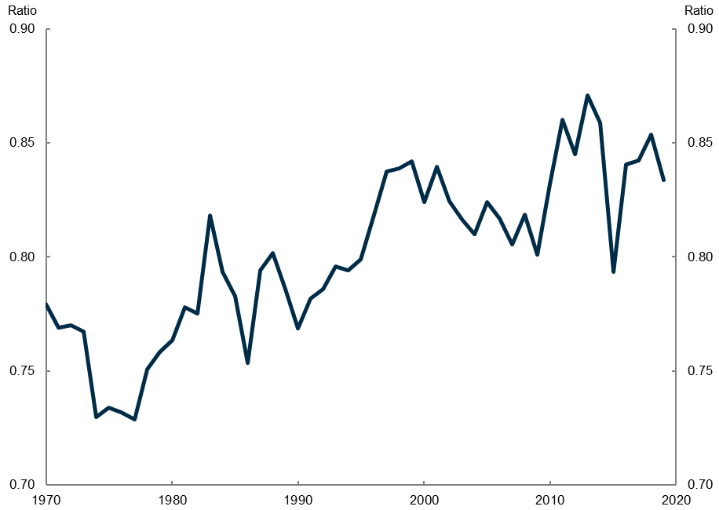

Notes: GDP per hour worked in Australia divided by GDP per hour worked in the US (output-side GDP at chained PPPs in 2017 USD).  
Source: Penn World Table.

Previous periods of domestic reform in the 1980s and 1990s were followed by periods of strong productivity growth. Such reforms appear successful in bringing labour productivity in Australia closer to US levels and we can think of US levels as a proxy for the global frontier. Estimates of labour productivity in Australia compared with the US have been broadly stable since the early 2000s.[3]

As a medium sized open economy, Australia tends to adopt innovations from the global frontier. Domestic policy can help to facilitate this by incentivising innovation and investments. This includes investments in human capital to ensure Australians have the right skills to enable diffusions of frontier technologies and methods. Fostering trade linkages and removing barriers that prevent resources flowing to the most productive businesses can also play an important role.

If we were able to lift productivity growth and move closer to the global frontier that would lead to a permanent lift in the level of income and higher living standards. There is a limit to the extent to which Australian productivity could grow more rapidly than comparable countries, but my guess is that we are not near that limit.

There are fiscal implications if the slowing in productivity over the past 2 decades persists.

For example, if productivity growth averaged 1.2 per cent over the medium term, rather than the 1.5 per cent assumed in the PEFO, GDP growth would be lower, and the real level of GDP at the end of the medium-term would be around 1¾ per cent smaller, with the difference increasing over time. Gross debt to GDP would be around 2 percentage points higher as at 30 June 2033 (Chart 15).

These differences in productivity and their implications for growth and the Budget were examined over longer periods in the most recent Intergenerational Report.

**Chart 15: Productivity assumption**

|  |  |
| --- | --- |
| **GDP growth** | **Commonwealth gross debt** |
|  |  |
| Note: The impact of lower productivity growth is based on scenarios results presented in the 2021 IGR.  Sources: 2021 IGR and Treasury. | |

## Conclusion

The economic environment has shifted significantly since I spoke to you in May last year.

Attention has turned from securing the recovery and driving down unemployment to limiting inflationary pressures arising from an array of shocks in an environment of near full employment.

This shift has been made even more difficult by the most complex international environment in 70 years.

There are no upsides to global growth from the war in Ukraine, COVID-19 crisis in China, and persistent supply chain challenges.

Inflationary pressures have emerged faster and more strongly than most anticipated including in Australia.

Significant pressures are emerging in electricity prices reflecting the interaction of global and domestic factors.

Commitments to structural spending in areas including disability support and aged care are putting sustained pressure on the budget.

The tax system is coming under pressure.

And productivity and real wage growth has been weak for more than a decade.

There are also challenges I have not had time to talk about today such as the required economic transformation to achieve our climate change goals.

A challenging set of issues no doubt.

There is some good news.

Australia has the lowest unemployment rate in nearly 5 decades and the lowest underemployment rate in over a decade.

The challenge now is to keep it at these levels.

And there are many actions we can take to improve outcomes.

While many of the global factors are beyond our control, we can play an active role in shaping relationships with other countries to promote resilience.

Providing higher quality aged care and disability services is improving the lives of many Australians and it is within our control to maintain this improvement while reducing pressures arising from poorly designed policies.

We will need a tax system fit for purpose to pay for these services, that appropriately balances fairness and efficiency. This is achievable.

By improving the quality and efficiency of government services and steadily improving our regulatory systems we can contribute substantially to productivity growth.

And there are few countries in the world with the natural advantages that we have in meeting our climate change goals.

Thank you for the opportunity to speak with you today.

## Appendix

Chart 10 decomposes changes in Commonwealth gross debt to GDP ($d$) into the contributions of interest rates ($r$) less economic growth ($g$), the headline primary budget balance as a share of GDP ($b$), and other factors ($e$):

$$\underset{\begin{aligned}Change in \\ debt to GDP\end{aligned}}{\underbrace{d_{t}-d_{t-1}}}=\underset{\begin{aligned}Interest rate less \\ growth effect\end{aligned}}{\underbrace{\left(\frac{r-g}{1+g}\right)d_{t-1}}}-\underset{\begin{aligned}Headline \\ primary surplus \\ to GDP\end{aligned}}{\underbrace{b_{t}}}+\underset{Other factors}{\underbrace{e_{t}}}$$

The headline primary budget balance excludes interest payments. Other factors, also known as the stock-flow adjustment, are those that affect gross debt but do not appear in the headline primary budget balance, including net financial investments for liquidity purposes, valuation effects and other discrepancies. For example, the creation of the Future Fund and transactions to maintain bond market liquidity contributed to gross debt during the period between 1996 and 2008.

The chart compares the cumulative contributions of these factors during seven periods in which gross debt to GDP declined.

1. * I would like to express my appreciation to David Lancaster and Rachael McCririck for their assistance in preparing this address.
2. Borland, J. (2022), ‘Can Australia Achieve a Soft Labour Market Landing?’. Labour Market Snapshot No. 88, May.
3. Note this does not mean that all sectors have maintained their relative position. For example, Australian manufacturing frontier firms exhibited faster productivity growth than services firms relative to the growth of the global frontier in each industry (Andrews, D., Hambur, J., Hansell, D. and Wheeler, A. (2022). ‘Reaching for the Stars: Australian Firms and the Global Productivity Frontier’. Treasury Working Paper 2022-01, January).