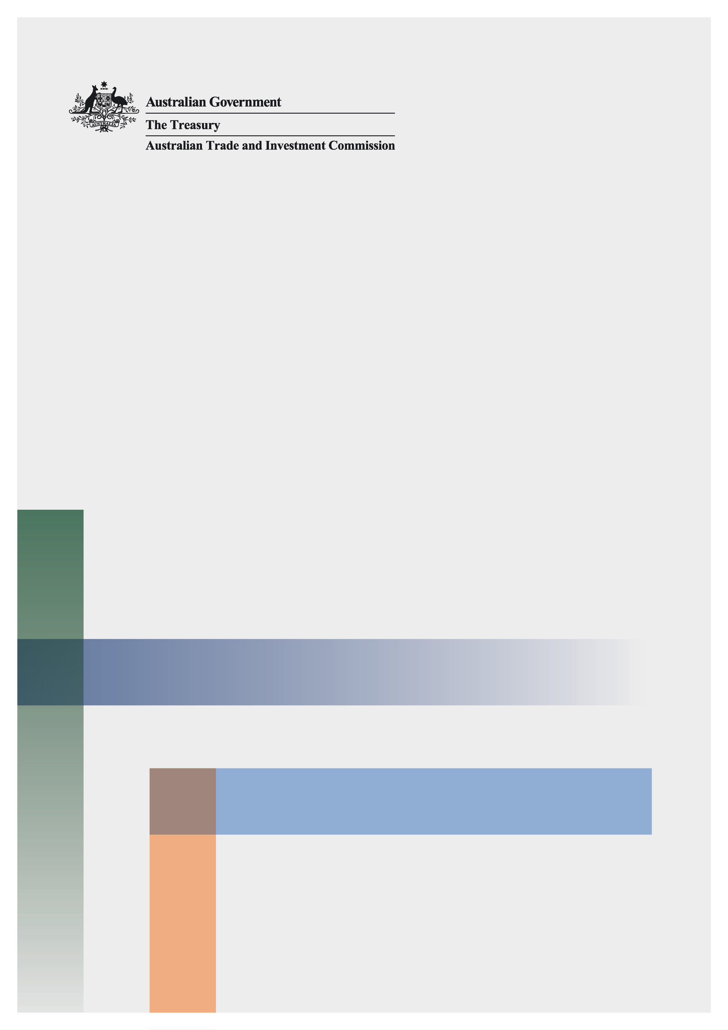

|  |
| --- |
| Notes to participants  In your response to this consultation paper please indicate clearly if you wish your submission to remain **confidential.** Furtherinformationon making a submission is available on page 3. |

Online bookings – restrictions on tourism and accommodation providers setting prices

Consultation paper

25 November 2022

© Commonwealth of Australia 2022

This publication is available for your use under a [Creative Commons Attribution 3.0 Australia](http://creativecommons.org/licenses/by/3.0/au/deed.en) licence, with the exception of the Commonwealth Coat of Arms, the Treasury logo, photographs, images, signatures and where otherwise stated. The full licence terms are available from <http://creativecommons.org/licenses/by/3.0/au/legalcode>.

Creative Commons attribution licence 3.0 icon. 

Use of Treasury material under a [Creative Commons Attribution 3.0 Australia](http://creativecommons.org/licenses/by/3.0/au/deed.en) licence requires you to attribute the work (but not in any way that suggests that the Treasury endorses you or your use of the work).

**Treasury material used ‘as supplied’.**

Provided you have not modified or transformed Treasury material in any way including, for example, by changing the Treasury text; calculating percentage changes; graphing or charting data; or deriving new statistics from published Treasury statistics — then Treasury prefers the following attribution:

*Source: The Australian Government the Treasury*.

**Derivative** **material**

If you have modified or transformed Treasury material, or derived new material from those of the Treasury in any way, then Treasury prefers the following attribution:

*Based on The Australian Government the Treasury data*.

**Use of the Coat of Arms**

The terms under which the Coat of Arms can be used are set out on the Department of the Prime Minister and Cabinet website (see [www.pmc.gov.au/government/commonwealth-coat-arm](http://www.pmc.gov.au/government/commonwealth-coat-arm)s).

**Other uses**

Enquiries regarding this licence and any other use of this document are welcome at:

Manager  
Media and Speeches Unit  
The Treasury  
Langton Crescent   
Parkes ACT 2600  
Email: [media@treasury.gov.au](mailto:media@treasury.gov.au)

# Contents

Contents ii

Consultation Process 3

Request for feedback and comments 3

Online bookings – restrictions on tourism and accommodation providers setting prices 4

Introduction 4

Discussion 4

Consultation questions 6

# Consultation Process

## Request for feedback and comments

You can submit responses to this consultation up until 6 January 2023.

Interested parties are invited to comment on this consultation.

While submissions may be lodged electronically or by post, electronic lodgement is preferred. For accessibility reasons, please submit responses sent via email in a Word or RTF format. An additional PDF version may also be submitted.

Submissions will be shared with other Commonwealth agencies where necessary for the purposes of this review. All information (including name and address details) contained in submissions will be made available to the public on the Treasury website unless you indicate that you would like all or part of your submission to remain in confidence. Automatically generated confidentiality statements in emails do not suffice for this purpose. Respondents who would like part of their submission to remain in confidence should provide this information marked as such in a separate attachment.

Legal requirements, such as those imposed by the *Freedom of Information Act 1982*, may affect the confidentiality of your submission.

Closing date for submissions: 06 January 2023

|  |  |
| --- | --- |
| Email | TandApricingconsultation@treasury.gov.au |
| Mail | Competition and Markets Unit  Market Conduct Division  The Treasury  Langton Crescent  PARKES ACT 2600 |
| Enquiries | Enquiries can be initially directed to TandApricingconsultation@treasury.gov.au |
|  |  |

The principles outlined in this paper have not received Government approval and are not yet law. As a consequence, this paper is merely a guide as to how the principles might operate.

# Online bookings – restrictions on tourism and accommodation providers setting prices

## Introduction

Online booking platforms have become important sources of bookings for many tourism and accommodation providers.

Sometimes an online booking platform may include a condition that means that if a provider is listed on the platform, the provider cannot offer their services to customers through other distribution channels at prices that are lower than those on the platform. These are sometimes known as price parity clauses. These clauses may be included in terms and conditions that providers are required to agree when entering into an arrangement with an online booking platform.

Price parity clauses can reduce competition by discouraging providers from discounting. They may also increase the likelihood that guests will book through the online booking platform, for which an accommodation provider must pay a commission, rather than with the provider directly. Consumers will be adversely impacted if they pay higher rates than they would otherwise be charged, were it not for the restriction.

However, an online booking platform may be encouraged to re-invest in its platform if use of a price parity clause made it less likely that it would be undercut on price.

A related issue is that accommodation providers may receive a lower ranking in the search results for the online booking platform if they offer a lower price through an alternative outlet.

This consultation paper seeks feedback on the use and impact of price parity clauses and similar restrictions.

Consultation will assist the Government to:

* understand the extent to which price parity clauses or similar practices are being used by online booking platforms, and any impact this is having on the ability of Australian tourism and accommodation providers to set their own prices when guests contact them to book; and
* identify if any action, including legislative change, is required to address this.

## Discussion

Online booking platforms (sometimes referred to as online travel agents or OTAs) operate platforms that customers can use to search for, and book, accommodation and other services provided by tourism and accommodation providers. Their market presence can make them an important distribution channel, particularly for tourism and accommodation providers that are less well known by consumers.

In 2016, the ACCC announced that following an investigation two large OTAs, Expedia[1] and Booking.com, each agreed to amend certain types of parity clauses in their contracts with Australian accommodation providers.[2] This included removing contractual requirements for accommodation providers to offer room rates on the OTA’s platform that are equal to, or lower than, those offered on:

* any other OTA; and
* on an accommodation provider’s offline channels.

The ACCC had commenced its investigation after accommodation providers raised a range of concerns, including that parity clauses were anti-competitive because they stopped consumers from getting different prices from competing online sites. The changes meant that accommodation providers would be able to offer lower rates through telephone bookings and walk-ins and offer special rates and deals to customer loyalty groups, in addition to offering deals via the OTAs.[3]

In early 2019 Expedia reportedly decided to waive its ‘narrow-rate’ parity clauses, meaning that listed accommodation providers could also offer lower rates on their own websites.[4]

While recognising these developments, the Government wishes to understand the extent to which price parity clauses or similar restrictions are currently in use. This will assist in understanding the impact that any such clauses or restrictions are having on tourism and accommodation providers as the sector recovers from the impact of the COVID-19 pandemic.

*Potential issues with price parity clauses*

Price parity clauses which prevent providers from offering lower prices on their own website may restrict price competition between different distribution channels. Tourism and accommodation providers may be limited in their ability to tailor their pricing to best meet their commercial interests. Where customers book rooms directly with accommodation providers rather than through an OTA, the accommodation provider avoids paying an OTA a commission, which can be a significant portion of the cost of a room.

If an online booking platform used a wide price parity clause, it could prevent providers from setting lower retail prices on rival platforms that offer more competitive commission rates. This could keep commissions high and lead to consumers paying higher prices than they otherwise would. Such clauses could also prevent or discourage entry from new low-cost platforms and reduce innovation.

Online booking platforms, on the other hand, may be concerned if consumers use their site to find available options, but then book that service directly, at a cheaper price, on the tourism or accommodation providers’ own website. If consumers routinely do this, the commercial attractiveness for online booking platforms to re-invest in their online search platform may be reduced if they are unable to recover the costs of that investment through booking sales on their platform. Price parity clauses may therefore indirectly create benefits for consumers, by helping to reduce their search effort and encouraging online booking platforms to invest in improvements to the quality of their platform.

Another concern that has been raised by accommodation providers is that they may receive a lower ranking in the search results for online booking platforms if they offer a lower price through an alternative outlet.

## Consultation questions

You may choose to answer some or all of the consultation questions that are relevant to you. Please clearly state if you wish your answers to the consultation questions to be kept confidential.

*Tourism and accommodation providers*

1. Please estimate what percentage of your bookings are received through online booking platforms.
2. Please estimate the typical fee or commission charged by online booking platforms.
3. Are price parity clauses or other similar restrictions being included in agreements between online booking platforms and tourism and accommodation providers? If you are able, please indicate what types of clauses are being used.
4. Have you experienced situations in which your listing is ranked lower on search results on an online booking platform than you believe is fair? Why do you think this occurred?
5. Do online booking platforms insist on price reductions for tourism and accommodation providers’ services (for example, sales and discounting offers)?
   * + - 1. If so, how does this impact tourism and accommodation providers?
6. What are the potential consequences if a tourism or accommodation provider does not comply with a price parity clause or other similar restriction?
   * + - 1. Are you aware of any impacts or threatened impacts from non-compliance that has occurred? Are you able to provide details on this?
7. How do price parity clauses influence tourism and accommodation providers’ pricing practices? Do they make it less likely that they will reduce the prices charged to consumers?
8. If price parity clauses were prohibited, would you have any concerns about how this could impact the relationship between tourism and accommodation providers and online booking platforms, or listing on relevant sites?
9. Do you have any other concerns about the influence of online booking platforms on tourism and accommodation providers’ ability to set prices for consumers?
10. If the ability to set prices is restricted, what solutions would enable tourism and accommodation providers to set prices with greater freedom?

*Online booking platforms*

1. Do you include one or more price parity clauses, or other similar restrictions, in your agreements with tourism and accommodation providers? If so, what types of clauses are used?
2. What fee or commission do you charge tourism and accommodation providers? If fees or commissions vary, please provide the average fee or commission for tourism providers and for accommodation providers.
3. Please provide a full list of the factors that determine the order of listings in search rankings for your platform.
4. If you include price parity clauses, or other similar restrictions, in your agreements, what benefit does the use of these clauses provide to your business?
5. What are the potential consequences if a tourism or accommodation provider does not comply with a price parity clause?
6. If price parity clauses were prohibited, how would this impact your relationship with tourism and accommodation providers? What broader impacts would this have on your business model and costs?

*All stakeholders*

1. Do you have any other comments relating to restrictions on tourism and accommodation providers setting prices that you would like to be considered as part of this consultation?

1. Expedia brands include Expedia, Wotif, and Hotels.com.
2. ACCC (2 September 2016) [Expedia and Booking.com agree to reinvigorate price competition by amending contracts with Australian hotels](https://www.accc.gov.au/media-release/expedia-and-bookingcom-agree-to-reinvigorate-price-competition-by-amending-contracts-with-australian-hotels) [media release].
3. ACCC (2 September 2016) [Expedia and Booking.com agree to reinvigorate price competition by amending contracts with Australian hotels](https://www.accc.gov.au/media-release/expedia-and-bookingcom-agree-to-reinvigorate-price-competition-by-amending-contracts-with-australian-hotels) [media release].
4. M Lennon (22 March 2019) ‘[Expedia takes first step to end rate parity clauses](https://www.hotelmanagement.com.au/2019/03/22/expedia-takes-first-step-to-end-rate-parity-clauses/)’, *Hotel Management*, accessed 27 October 2022.