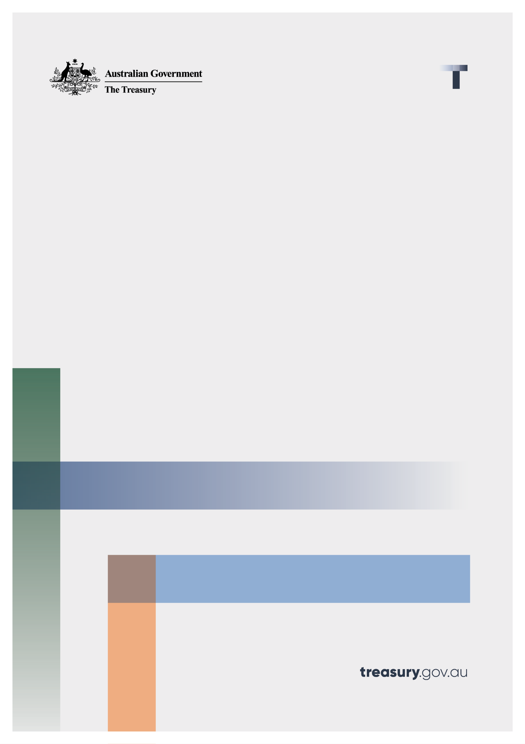

A Strategic Plan for the Payments System

Consultation paper

December 2022

© Commonwealth of Australia 2022

This publication is available for your use under a [Creative Commons Attribution 3.0 Australia](http://creativecommons.org/licenses/by/3.0/au/deed.en) licence, with the exception of the Commonwealth Coat of Arms, the Treasury logo, photographs, images, signatures and where otherwise stated. The full licence terms are available from <http://creativecommons.org/licenses/by/ahh3.0/au/legalcode>.

Creative Commons attribution licence 3.0 icon. 

Use of Treasury material under a [Creative Commons Attribution 3.0 Australia](http://creativecommons.org/licenses/by/3.0/au/deed.en) licence requires you to attribute the work (but not in any way that suggests that the Treasury endorses you or your use of the work).

**Treasury material used ‘as supplied’.**

Provided you have not modified or transformed Treasury material in any way including, for example, by changing the Treasury text; calculating percentage changes; graphing or charting data; or deriving new statistics from published Treasury statistics — then Treasury prefers the following attribution:

*Source: The Australian Government the Treasury*

**Derivative** **material**

If you have modified or transformed Treasury material, or derived new material from those of the Treasury in any way, then Treasury prefers the following attribution:

*Based on The Australian Government the Treasury data*

**Use of the Coat of Arms**

The terms under which the Coat of Arms can be used are set out on the Department of the Prime Minister and Cabinet website (see <http://www.pmc.gov.au/government/commonwealth-coat-arms>).

**Other uses**

Enquiries regarding this licence and any other use of this document are welcome at:

Manager  
Media Unit  
The Treasury  
Langton Crescent   
Parkes ACT 2600  
Email: [media@treasury.gov.au](mailto:media@treasury.gov.au)

# Contents

Contents ii

Consultation Process 3

Request for feedback and comments 3

Background 4

Role of payments 4

The evolving payments landscape 4

The payments system reform agenda 5

A Strategic Plan for the payments system 6

Development and consultation process 6

Feedback on the consultation paper 6

Next steps 7

Part 1: Proposed contents of the Strategic Plan 8

Key principles 8

Efficiency 8

Innovation 8

Accessibility 8

Trustworthiness 9

Key Priorities 10

Promoting a safe and resilient payments system 10

Ensuring the regulatory framework is fit-for-purpose and promotes competition 10

Ensuring alignment with the broader digital economy transformation 10

Modernising payments infrastructure 10

Key initiatives 12

Figure 1 12

Roadmap 13

Draft Roadmap 13

Part 2: Process for reviewing the Plan 14

Attachment A: List of questions for stakeholders 15

Attachment B: Table of supporting initiatives and actions 16

Attachment C: Draft roadmap – Example 23

# Consultation Process

## Request for feedback and comments

The purpose of this consultation paper is to seek input into the Government’s Strategic Plan for the payments system, to ensure that Australians can continue to transact in a safe, secure, and efficient payments environment.

While submissions may be lodged electronically or by post, electronic lodgement is preferred. For accessibility reasons, please submit responses sent via email in a Word or PDF format. An additional PDF version may also be submitted. All information (including name and address details) contained in submissions will be made available to the public on the Treasury website unless you indicate that you would like all or part of your submission to remain in confidence. Automatically generated confidentiality statements in emails are not sufficient for this purpose. If you would like only part of your submission to remain confidential, please provide this information clearly marked as such in a separate attachment.

Legal requirements, such as those imposed by the *Freedom of Information Act 1982*, may affect the confidentiality of your submission

Closing date for submissions: 06 February 2023

|  |  |
| --- | --- |
| **Email** | **paymentsconsultation@treasury.gov.au** |
| Mail | Director – Payments Strategy and Policy Unit  Financial System Division  The Treasury  Langton Crescent  PARKES ACT 2600 |
| Enquiries | Enquiries can be initially directed to Blanche Maynell. |
| Phone | 02 6263 4640 |

The principles outlined in this paper have not received Government approval and are not yet law. As a consequence, this paper is merely a guide as to how the principles might operate.

# Background

## Role of payments

Australia’s payments system is crucial for the smooth operation of the economy. From purchasing groceries in the supermarket to receiving salary or sending money to a friend within Australia or overseas, payments underpin the everyday commerce between consumers, businesses, and government agencies across the country. Payments also provide the link through which Australia interacts with the global marketplace. Around 55 million transactions are made in Australia every day, with a value of around $650 billion.[1]

## The evolving payments landscape

Over time, Australia’s payments system has expanded in size and complexity. New technology, business models and participants are providing increased transaction convenience and more payment methods but are also giving rise to greater complexity and new risks.

The pace of change has accelerated in recent years as consumers have responded to the COVID-19 pandemic, with decreased reliance on physical forms of payments such as cash and cheques, and increased reliance on contactless card payments and online transactions. The trends seen in Australia’s payments system are also occurring internationally, with the growing complexity of payments challenging regulatory settings around the world.

These trends include:

|  |  |  |
| --- | --- | --- |
|  | **Changing payment methods** | An increasing share of payments are now made electronically rather than in cash. Cheque use in Australia has declined significantly over the past decade as users adopt more efficient electronic payment methods.  Payment cards are the most used retail payment method in Australia and debit cards are increasingly preferred to credit cards for many transactions. They are used increasingly in both a physical and digital manner through innovations like tap-and-go, online shopping and mobile wallet transactions.  *In 2021/22, Australians made around 650 electronic transactions per person on average for the year, compared to 300 transactions for the year a decade earlier*.[2] |
|  | New technologies | New technology has changed the way we pay.  It has made payments more convenient, secure, and timely, and has strengthened linkages between Australia’s payments system and systems around the world. Australians have shown they are fast adopters of new payment methods if those methods are proven to meet their needs.  *Since its launch in 2018, the New Payments Platform (NPP) now processes more than 25 per cent of total account-to-account payments.[3]* |
|  | New providers and business models | The provision of innovative payment solutions has been driven by new types of entrants (such as fintechs and big techs), alongside more traditional participants such as banks. New businesses models (such as buy-now-pay-later arrangements) are also challenging the traditional definition of payments.  *The BNPL sector has grown rapidly over the last few years, with over $16 billion in transactions processed in 2021/2022.[4]* |
|  | New risks | While the advent of new players and new technology has provided new payment security innovations, it has also generated new risks which is attracting greater focus from industry and regulators.  *Financial losses from all types of scams surged significantly in 2021, reaching $1.8 billion.[5]* |

## The payments system reform agenda

The Government recognises the regulatory architecture governing payments needs to be updated to reflect the changing landscape. It is committed to maintaining a world-class payments system that serves the needs of its users and participants and supports Australia’s economic growth.

The Government’s vision for the Australian payments system is to maintain its reputation internationally as being safe and efficient, open to competition, while protecting Australians from scams and fraud**.**

To achieve this, the Government will pursue payments system reforms to ensure our regulatory framework is fit-for-purpose now and in the future. This reform agenda includes (but is not limited to):

* Developing a Strategic Plan for the payments system in collaboration with regulators, industry, consumer and business representatives;
* Updating the *Payment Systems (Regulation) Act 1998* (PSRA) to capture the full suite of payment entities and systems, as well as provide the Treasurer with ministerial powers to address payment issues outside the scope of the Reserve Bank of Australia’s (RBA) public interest powers;
* Implementing a tiered licencing framework for payment service providers;
* Reducing small business transaction costs, particularly through least cost routing, or a similar solution;
* Continuing development of international interoperability through cross-border initiatives; and
* Considering developments in the broader digital economy that are related to payments, such as digital wallets, buy-now-pay-later arrangements (BNPL)[6], stablecoins, crypto-assets, central bank digital currencies (CBDCs), the consumer data right (CDR), and connecting with payment-related initiatives underway across the country (e.g. state-based initiatives).

Each of these reforms have independent workstreams that the Government is concurrently progressing. The Strategic Plan will reflect some of these key initiatives and corresponding milestones, and will be updated with additional details through the annual review process.

## A Strategic Plan for the payments system

The first step of the payments system reform agenda is to develop a Strategic Plan (the Plan) for the future of Australia’s payments system. The development of a strategic plan was a key recommendation of the June 2021 Review of the Payments System (the Payments System Review).

The Plan will be a comprehensive, long-term strategy that provides clarity on the Government’s policy objectives and priorities for the payments system. It will support a shared vision for the payments system and facilitate coordinated decision-making between the government, regulators, industry, and consumer and business representatives.

The Plan will provide:

* **Vision and leadership**
  + The Government, through the Plan, will provide leadership to the payments industry and regulators, shaping the future direction of the payments system.
* **Policy direction**
  + The Plan will outline key policy priorities for the payments system, while being adaptable to future challenges and opportunities.
* **Coordination and progress**
  + The Plan will provide a roadmap for initiatives to improve outcomes in the payments system. The Plan will set out the roles and responsibilities of the Government, industry, and regulators in delivering on the initiatives.

## Development and consultation process

The Plan is being developed in collaboration with regulators, industry, and consumer and business advocacy groups.

This consultation paper presents an opportunity for feedback to determine the key objectives and priorities for the payments system, and how the Plan can be used to coordinate action across public and private sector participants. This will ensure the Plan meets its purpose of articulating a shared vision of the payments system.

In developing this consultation paper, Treasury has drawn on findings from several recent reviews examining the payments system regulatory architecture, our regular engagements with stakeholders, payments-focused plans developed by other countries (such as Canada, New Zealand and India), and other international benchmarks (such as Bank of International Settlement core principles).

### Feedback on the consultation paper

This consultation paper is structured in two parts. The first part outlines the proposed contents of the Plan, including key principles and priorities, supported by specific initiatives and a roadmap for their implementation. The second part outlines the process for review of the Plan.

We welcome views on the questions posed in both parts of the paper by **6 February 2023**.

## Next steps

The feedback from this consultation process will be used to finalise the inaugural Strategic Plan. It is intended that the inaugural Plan will be released in the first quarter of 2023.

# Part 1: Proposed contents of the Strategic Plan

To support a well-functioning payments system, the Plan will outline key principles that can be used to guide its future direction. The intention is for these principles to articulate objectives for the payments system, and to guide the Government’s decision-making and policy work.

These key principles are intended to be comprehensive and adaptable to opportunities and challenges, while protecting the interests of Australians.

In developing these proposed key principles, we have considered some international benchmarks such as the Bank of International Settlements (BIS) core principles that apply to individual systematically important payment systems.

## Key principles

### Efficiency

An efficient payments system is one which enables fast transfer of funds, where payments are processed in a seamless manner with minimal friction. Further, efficiency promotes competition between payment service providers and promotes interoperability through increased use of common standards and infrastructure amongst domestic and cross-border payment systems. This results in positive outcomes for consumers and business who rely on the payments system for day-to-day activities.

### Innovation

An innovative payments system is one which is agile, forward-looking and adds value to the user’s payment experience. It is proactive and can quickly reposition itself to realise new opportunities and respond to challenges. Creating an environment that fosters innovation has the potential to enhance the payment experience for consumers and businesses, support competition and trust in the system.

### Accessibility

An accessible payments system is one that is simple, inclusive, where payment services are readily available at low cost and provides consumers and businesses with choices. Further, it avoids unnecessary restrictions on access to payment networks for service providers. Removing barriers to entry, encourages payments service providers to innovate, thereby empowering consumers and businesses with greater choice of payment products and services.

### Trustworthiness

A trustworthy payments system is one that is safe, secure, reliable, and resilient. At a user level, it ensures transactions are processed to intended parties as expected and provides robust protections against fraudulent transactions and scams. At the system-wide level, it supports stability and operational resilience in the broader system.

|  |
| --- |
| Consultation Questions   1. What are your views on the proposed key principles? Are there other principles that should be included? Please provide an explanation. |

## Key Priorities

The Plan will outline the key priorities for the payments system. These priorities will support and promote the key principles identified in the Plan and will be adjusted over time to reflect progress or changing circumstances. They will be developed in collaboration with regulators, industry, and consumer and business advocacy groups to ensure the Plan reflects a shared direction of the payments system.

This section will discuss the proposed key priorities and why they are important. These priorities reflect feedback from stakeholders to date, as well as matters that were considered in the Payments System Review.

### Promoting a safe and resilient payments system

A key priority is promoting a safe and resilient payments system that ensures positive outcomes for all users of the system. To ensure safe and secure operation of the system, there is a clear need to minimise instances of scams and fraud and provide robust protections to consumers. It is also important to strengthen existing regulation to appropriately manage risks to payments infrastructure such as technological outages and cyber-attacks.

### Ensuring the regulatory framework is fit-for-purpose and promotes competition

With the expansion of the payments system to new technologies and business models, there is a need to ensure the regulatory architecture of the payments ecosystem remains fit-for-purpose and regulates participants consistently based on the functions they provide. Further it should promote competition by making it easier for payment service providers to get access to payments infrastructure. The Plan can outline key initiatives and milestones for these objectives including changes to the PSRAand the introduction of a new, tiered payments licencing framework for payment service providers.

### Ensuring alignment with the broader digital economy transformation

As digitisation of payments grows, there is a need to consider how developments in the broader digital economy affect the payments system. Some key developments include the CDR, Digital ID and the emergence of potential new forms of money (such as stablecoins and CBDCs). Where appropriate, there is a need to align regulation with developments in the broader digital economy to minimise duplication of regulatory requirements and costs. For example, if payments are introduced as an action in the CDR, aligning requirements for CDR payment initiation accreditation with the payments licence will make it easier and less costly for service providers to obtain these authorisations.

### Modernising payments infrastructure

There is a need to ensure the payments system supports and facilitates the growth and development of modern payment infrastructure that is efficient, safe, secure and reliable. The Plan can cover issues such as supporting the transition to more modern and efficient payment systems and promoting interoperability amongst domestic and cross-border payment systems.

|  |
| --- |
| Consultation Questions   1. What are your views on the proposed key priorities? Do they provide enough certainty on what the key priorities are for the Government? Are there other matters that should be included? Please provide an explanation. |

## Key initiatives

The Plan proposes to set out the specific initiatives that correspond to a particular key priority for the payments system. The Plan will clearly articulate the respective roles and responsibilities of the Government, industry, and regulators in relation to each of these initiatives and provide a roadmap for their implementation. As part of the Plan’s annual review process, progress in implementing the initiatives would be identified and milestones updated accordingly.

Based on initial feedback received from industry, a range of initiatives have been identified that correspond to and will support delivery of each priority.

**Attachment B** outlines a list of the supporting initiatives, the rationale for including them in the Plan, and some actions that the Plan could commit to. Finalisation of these initiatives (and the approach) will be informed by this consultation process. A summary of key initiatives and priorities is also at Figure 1.

Figure 1



|  |  |
| --- | --- |
| **Key priorities** | **Supporting Initiatives** |
| **Promote a safe and resilient system** | * Reduce the prevalence of scams and fraud * Strengthen defences against cyber attacks * Supervision of systematically important payment systems |
| **Ensure regulatory framework is fit-for-purpose and promotes competition** | * Implement changes to PSRA, including a Ministerial designation power * Introduce a tiered payments licensing framework for payment service providers * Enable greater collaboration between payments regulators * Promote competition by facilitating proportionate, objective, and transparent access to payment systems * Reduce small business transaction costs, by supporting the availability of least-cost routing |
| **Alignment with the broader digital economy transformation** | * Ensure the payments system is aligned with developments in the broader data ecosystem such as the CDR * Explore the policy rationale for an Australian CBDC, including investigating the economic, legal, regulatory and technological considerations associated with an Australian CBDC |
| **Modernise payments system infrastructure** | * Support the transition to more modern infrastructure * Maintain adequate access to cash for those that rely on it * Promote interoperability with international standards and arrangements for cross-border payments |

## Roadmap

The Plan will include a roadmap on how the initiatives will be implemented. The intention is that the roadmap will articulate key deliverables, the timing of these deliverables and the roles of the Government, industry, and regulators.

### Draft Roadmap

The Government recognises the importance of developing the Plan in collaboration with industry and regulators to ensure it can articulate a shared vision for the payments system.

**Attachment C** provides a draft roadmap that outlines key milestones for which the Government and regulators have primary responsibility for and will support the delivery of key initiatives. However, to complete the Plan, we require feedback on the key milestones from industry in delivering key initiatives. Finalisation of the milestones and deliverables on the key initiatives will be informed by this consultation process.

|  |
| --- |
| Consultation Questions:   1. What are your views on the proposed key supporting initiatives? Are there other initiatives that could be included in the Plan? Please provide an explanation. 2. Do you have any feedback on the proposed approach for any of the initiatives (as outlined in Attachment B)? Please provide an explanation. 3. What are the key milestones for particular key initiatives that you would like to see included in the Plan? Are there any conflicts between milestones or pressure points that need to be taken into account in revising the roadmap? |

# Part 2: Process for reviewing the Plan

The Government proposes to review the Plan annually to ensure the priorities and initiatives remain relevant as circumstances change and to provide report on progress.

The Government will engage with, and coordinate action between, private and public sector participants through regular updating of the Plan.

The following sets out the proposed arrangements:

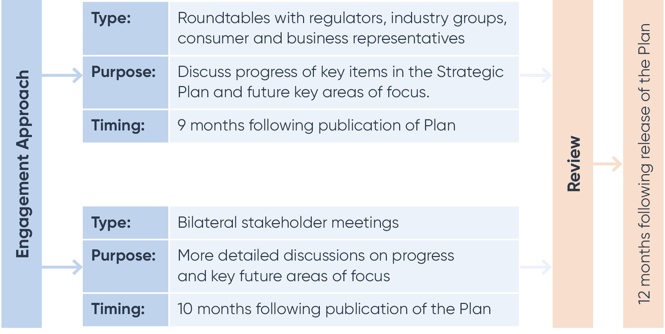

|  |
| --- |
| Consultation Questions:   1. What are your views on the proposed review process and engagement arrangements? Please provide an explanation. 2. Are there any other sections or topics that you would like to see added to the Plan? Please provide an explanation. |

|  |  |
| --- | --- |
| **Key principles** | 1. What are your views on the proposed key principles? Are there other principles that should be included? Please provide an explanation. |
| Key priorities | 1. What are your views on the proposed key priorities? Do they provide enough certainty on what the key priorities are for the Government? Are there other matters that should be included? Please provide an explanation. |
| Key initiatives | 1. What are your views on the proposed key supporting initiatives? Are there other initiatives that could be included in the Plan? Please provide an explanation. 2. Do you have any feedback on the proposed approach for any of the initiatives (as outlined in Attachment B)? Please provide an explanation. 3. What are the key milestones for particular key initiatives that you would like to see included in the Plan? Are there any conflicts between milestones or pressure points that need to be taken into account in revising the roadmap? |
| Process for reviewing the Plan | 1. What are your views on the proposed review process and engagement arrangements? Please provide an explanation. 2. Are there any other sections or topics that you would like to see added to the Plan? Please provide an explanation. |

# Attachment A: List of questions for stakeholders

# Attachment B: Table of supporting initiatives and actions

| **Description of initiative** | **Actions** |
| --- | --- |
| Promote a safe and resilient payments system |  |
| **Reduce the prevalence of scams and fraud**  Payment scams and fraud continue to present as an important issue in the retail payments system. Industry remains focused on addressing payments fraud, with new initiatives to share information with law enforcement, regulators, and industry peers such as initiatives to detect and prevent scams and providing resources to protect vulnerable consumers. New technologies such as PayID on the New Payments Platform (NPP) are also providing greater security. Initiatives such as AusPayNet’s Card-Not-Present Fraud Mitigation Framework are also continuing to support fraud detection and mitigation.  The ePayments Code[7] provides protections against certain types of financial losses, however, it is currently voluntary and not all payment providers have subscribed to the Code. The Payments System Review recommended the ePayments Code be made mandatory for holders of a payments licence.  The Government has committed to a new long-term, coordinated, whole-of-government approach to reduce scam losses for Australians. This approach brings together resources from the private sector and, governments to enable better collaboration, information sharing and coordinated disruption of scams.  In the October 2022-23 Budget, the Government provided an initial investment of $12.6 million over four years from 2022-23 to combat scams. This funding has enabled the Australian Competition and Consumer Commission to undertake initial steps for the phased establishment of a National Anti-Scam Centre. | It is proposed that the Plan could:   * continue to support and monitor government and industry initiatives that share intelligence to disrupt scams and coordinate scam responses, recognising the private sector is the first line of defence against scams * provide a roadmap for mandating the ePayments Code as part of the new licensing framework, including proposed timing for consultation. |
| **Strengthen defences against cyber-attacks**  Along with other critical infrastructure systems, the payments system is essential for the Australian economy to function effectively. As the threats and risks to Australia’s critical infrastructure evolve in an increasingly digital world, so too must the approach to ensuring the ongoing security and resilience of these assets and the essential services they deliver.  The Government has passed amendments to the *Security of Critical Infrastructure Act 2018* to enhance the regulatory framework for operators of critical infrastructure assets. Operators of certain critical payments system assets will need to comply with certain risk management and other obligations to safeguard the payment systems upon which the Australian economy relies, including from cyber threats.  Following a 2022 cyber security incident involving an Australian telecommunications company, the Government amended the *Telecommunications Regulations 2021* to betterprotect Australians. The updates allow telecommunication companies to temporarily share limited identifier information (such as drivers licence, Medicare and passport numbers of affected customers) with regulated financial service entities and government agencies to detect and mitigate the risks of cyber security incidents, frauds, scams and other malicious cyber activities. | It is proposed that the Plan could:   * highlight security and resilience as objectives for payments policy, and support Government’s agenda on cyber security including through implementing the requirements under *the Security of Critical Infrastructure Act 2018*. |
| **Supervision of systemically important payment systems**  The RBA, in its role as supervisor of systemically important payment systems, promotes the safety and resilience of financial market infrastructures and payment systems. As part of this work, the intention is that the RBA will also fulfil its role as regulator of payments systems that are critical infrastructure assets under the risk management program obligation of the *Security of Critical Infrastructure Act 2018.* In 2023, the RBA is planning to broaden its work on safety and resilience to include additional payment systems, including the NPP. |  |
| **Ensuring the regulatory framework is fit-for-purpose and promotes competition** |  |
| **Implement changes to the *Payment Systems (Regulation) Act 1998* (PSRA)**  The Payments System Review recommended the PSRA be modernised to ensure that the regulatory framework governing the payments system and its participants is fit-for-purpose and the RBA is able to respond to developments that are in the public interest. These include updates to ensure appropriate coverage of all entities that play a material role in Australia’s payments system. A ministerial designation power was also recommended by the Payments System Review to empower the Treasurer to intervene where it is in the national interest to do so. | It is proposed that the Plan could:   * provide a roadmap implementing reforms to the PSRA, including proposed timing for consultation and legislation. |
| **Introduce a payments licensing regime**  The Payments System Review recommended establishing a new functions-based licensing framework for payment service providers. The current regulatory framework is based on historical concepts of payment products and payment services. A functional approach is required to describe the role that a service plays in the payments system, allowing regulation to be agnostic to the technology, business model or the store of value utilised. | It is proposed that the Plan could:   * provide a roadmap for the implementation of the new licensing framework, including proposed timing for consultation and legislation. |
| **Enable greater collaboration between payment system regulators**  As payments system participants extend beyond the traditional banks, it is increasingly necessary for there to be effective collaboration between payment regulators. In line with the Payments System Review recommendations, an inter-agency payments forum has been established, designed to strengthen collaborations and information-sharing among payment regulators, improve consistency and certainty in regulatory outcomes, and better align with the strategic direction. | It is proposed that the Plan could:   * continue to support and endorse the inter-agency payments forum in its efforts to strengthen collaboration and communication. |
| **Promote competition by facilitating transparent access to payment systems**  Australia’s payment systems operators have in many cases required payment participants seeking access to hold an Authorised Deposit-taking Institution licence.  With the fragmentation of the payments value chain and the disintermediation of payment services, the Government supports opening access to Australia’s payment systems to payment service providers that do not hold an ADI licence, provided these participants are subject to requirements that can mitigate operational, financial and systemic risks.  The RBA is developing common access requirements in consultation with the operators of payment systems which will form part of the payments licence to facilitate access for licensees to those systems.  Facilitating greater access to payment systems through the provision of clear, objective, proportionate and transparent access requirements will support greater competition between payment service providers and encourage development of more payment innovations for consumers. | It is proposed that the Plan could:   * support the RBA’s work with payment system operators to develop common access requirements for payment systems, with a view to implementation through the new licensing framework. |
| **Reduce small business transaction costs**  Stakeholders have raised concerns that merchant costs are too high due to ‘tap and go’ payments not being automatically routed down the cheapest payment rails. Reviews from the Productivity Commission and Parliamentary Joint Committee on Corporations and Financial Services have found that Government or RBA intervention may be necessary to address this issue.[8]  Consistent with the findings from these Reviews, the Government is committed to reducing small business transaction costs by implementing least-cost routing (LCR) or a similar solution.  The Government recognises that LCR is currently broadly available for in-person debit card transactions but has only recently become available for some online debit transactions, and is not yet available for mobile wallet debit transactions.  The Government supports the targeted actions being taken by the RBA that align with the Government’s commitment – namely the setting of industry expectations to ensure that LCR is available and enabled for small business, and engagement with industry on their compliance with these expectations. The Government expects LCR to be widely available and enabled by mid-2023 for in person ‘tap and go’ debit card and online debit card payments and supports the expectation set by the RBA that LCR for mobile wallet debit transactions be made available by the end of 2024.  Further, new payment developments such as the NPP have scope to reduce small business transaction costs. | It is proposed that the Plan could:   * support the RBA’s approach in improving the availability and enablement of LCR, and note that stronger Government intervention remains possible if the RBA’s expectations are not met * note that the PSRA’s expanded regulatory perimeter could enable the RBA to mandate LCR for digital wallets * note a range of policy measures to promote competition, innovation, and transparency. |
| **Alignment with the broader digital economy transformation** |  |
| **Ensure the payments system is aligned with developments under the Consumer Data Right framework**  The CDR gives consumers control over their data, making it easier for them to access their data and use this to make informed decisions. For example, Open Banking is helping Australians make better use of their money by making it safe to use transaction data to simplify complex financial decisions and take advantage of data-enabled innovations.  The Inquiry into the Future Directions for the Consumer Data Right (the Inquiry)[9] recommended strengthening and deepening the CDR’s functionality and use through the implementation of third-party action initiation. This would enable consumers to instruct a firm to initiate actions on their behalf and with their consent. Introducing action initiation in the CDR is part of the Government’s commitment to expand the CDR across the economy and grow the opportunities for consumers to make use of their own data for their benefit.  The Inquiry proposed payments to be the first action to be introduced in the CDR. This would empower consumers and businesses to both control their data and authorise, manage and facilitate payments securely via the CDR. The independent CDR Statutory Review[10] also recognised the importance of action and payment initiation to the CDR for its potential to deliver efficiency and convenience for consumers.  CDR payment initiation would create a new channel for a consumer to instruct their financial provider (via a third party) to make a payment, with the making of the payment and transfer of funds relying on existing payment systems and remaining outside the scope of CDR. This would enable flexibility to utilise and build on existing developments in the payments landscape, such as PayTo.  To enable this to work effectively, the interaction between the CDR framework and payment systems should be considered to optimise efficiency and interoperability. Key areas of interaction include the participants themselves and the obligations they face, such as CDR accreditation and payment licence requirements, and how consumers engage with each system.  The Government has introduced proposed changes to primary legislation to enable action initiation in the CDR[11]. If passed, the proposed legislation will provide a pathway to bring individual action types, such as payments, into the CDR. Any subsequent introduction of payment initiation will be subject to further consideration and consultation. | It is proposed that the Plan could:   * discuss the interlinkages between CDR and payments system, such as payment initiation * note the importance of aligning with work underway to expand the CDR to enable action initiation * highlight the importance for ongoing alignment between an evolving CDR framework and both existing and emerging payment systems and regulatory requirements. |
| **Explore the policy rationale for a central bank digital currency (CBDC) in Australia, including investigating the economic, legal, regulatory and technological considerations associated with an Australian CBDC.**  As new technologies and the broader digitalisation of the economy drive innovation in payments, central banks around the world have begun investigating the potential implications of issuing a CBDC. For the RBA, CBDC research constitutes a strategic priority in its work to understand the implications of digital innovation for competition, efficiency, and stability in the Australian payments system.  The RBA has concluded two research projects, Project Atom and Project Dunbar, that involved developing proofs-of-concept for the use of wholesale CBDC to settle transactions. Currently, the RBA has partnered with the Digital Finance Cooperative Research Centre (DFCRC) on a limited-scale CBDC pilot that will explore potential use cases and economic benefits of an Australian CBDC, whether retail or wholesale.  The Government supports work to explore the policy rationale for a CBDC in Australia and has tasked the Treasury to work with the RBA on this policy question. The findings of the pilot, which is scheduled to conclude around mid-2023, are expected to provide a valuable contribution to this joint work. | It is proposed that the Plan could:   * provide an update on proposed work to explore the public policy case for issuing a retail or wholesale CBDC in Australia. |
| **Modernise payments system infrastructure** |  |
| **Support the transition to more modern payments infrastructure**  A key part of modernising our payments infrastructure is considering how we collectively (between industry and Government) address less functional payments infrastructure in the payments system. Two key legacy systems in Australia are the cheques system and the Bulk Electronic Clearing System (BECS).   * The use of cheques has declined significantly in the past few decades. Less than 1.2 cheque transaction per person were made in 2021/22. Further, cheques accounted for 0.2 per cent of the total number of non-cash retail payments and less than 2 per cent of the total value of non-cash retail payments[12]. This decline is expected to continue with the ongoing transition to more accessible, low cost, secure and more efficient payment methods. * BECS was developed decades ago, and its capability reflects the limitations of the time in which it was created. Over time, the payments system has expanded, and the industry has invested in new infrastructure that offer faster and more secure payment options.   Industry has noted that continued usage and upkeep of these systems can be costly and diverts resources from investment in newer, more efficient, and innovative technologies. | Consistent with the recommendation from the Payments System Review, it is proposed that the Plan be used to coordinate action between the public and the private sector participants (including consumer and business advocacy groups) to support a smooth the transition to more modern and efficient payment alternatives.  It is proposed the Plan could:   * support industry-led efforts to transition away from legacy systems where appropriate; raise public awareness and promote the use of safer and more efficient alternatives, particularly with consumers and businesses that rely on legacy payment systems to ensure a smooth transition * provide details about steps the Government (in collaboration with its agencies and state counterparts) can take, as a large user of these payment systems, to drive migration of payments it sends and receives from legacy systems to alternatives * monitor the ongoing use of the systems, assess risks and report on progress in subsequent plans. |
| **Maintain adequate access to cash**  Cash continues to be an important method of payment that is widely accepted by merchants, used as a store of value, available offline in the event of a crisis such as a bush fire or flood, and which supports financial inclusion. Nonetheless, use of cash as a method of payment has been declining for many years due to changing consumer preferences and advances in technology. This long-run trend has been reinforced by changes in payment behaviour arising from the COVID-19 pandemic. The Government notes the findings of the RBA’s Review of Banknote Distribution Arrangements[13], namely that the declining volume of banknotes being transported is putting pressure on the wholesale distribution network, and the recommendations from the Regional Banking Taskforce, which has highlighted the importance of regional cash access.  The Government also notes that overseas jurisdictions are undertaking work to address similar issues. For example, the United Kingdom announced regulation to ensure wholesale cash infrastructure remains effective and resilient. | It is proposed the Plan could:   * articulate principles that will inform the Government’s response to providing consumers with adequate access to cash, which seeks to acknowledge the trade-offs between efficiency and accessibility * align with work underway to support innovation being undertaken across the ecosystem in payment methods. |
| **Support international efforts to enhance cross-border payments**  The Government supports the G20 Cross-Border Payments Roadmap (the G20 Roadmap)[14] and its purpose of addressing the challenges of cost, speed, transparency, and access in regard to cross-border payments.  The G20 Roadmap is complex, ambitious and represents a long-term commitment, where the final measures are expected to be implemented in 2027. Therefore, the Government supports the prioritisation of key workstreams.  Effective implementation of priority aspects of the G20 Roadmap could assist Australia with replacing existing systems that are expensive, slow, and opaque with more modern infrastructure for facilitating cross-border payments. Further, ensuring that the NPP and other payment systems are interoperable with major payment systems in other countries could yield efficiency gains  Australia supports research in assessing the use cases of CBDCs, including for cross-border payments.  Australia is also assisting with the maintenance of strong payment linkages to Pacific nations and initiatives to put downward pressure on costs, which would support financial inclusion. | It is proposed the Plan could:   * discuss Government priorities associated with the implementation of the G20 Roadmap * highlight industry efforts to deliver on Australia’s commitment to the G20 to enhance cross-border payments * support engagement with Pacific nations and foster financial inclusion. |

# Attachment C: Draft roadmap – Example

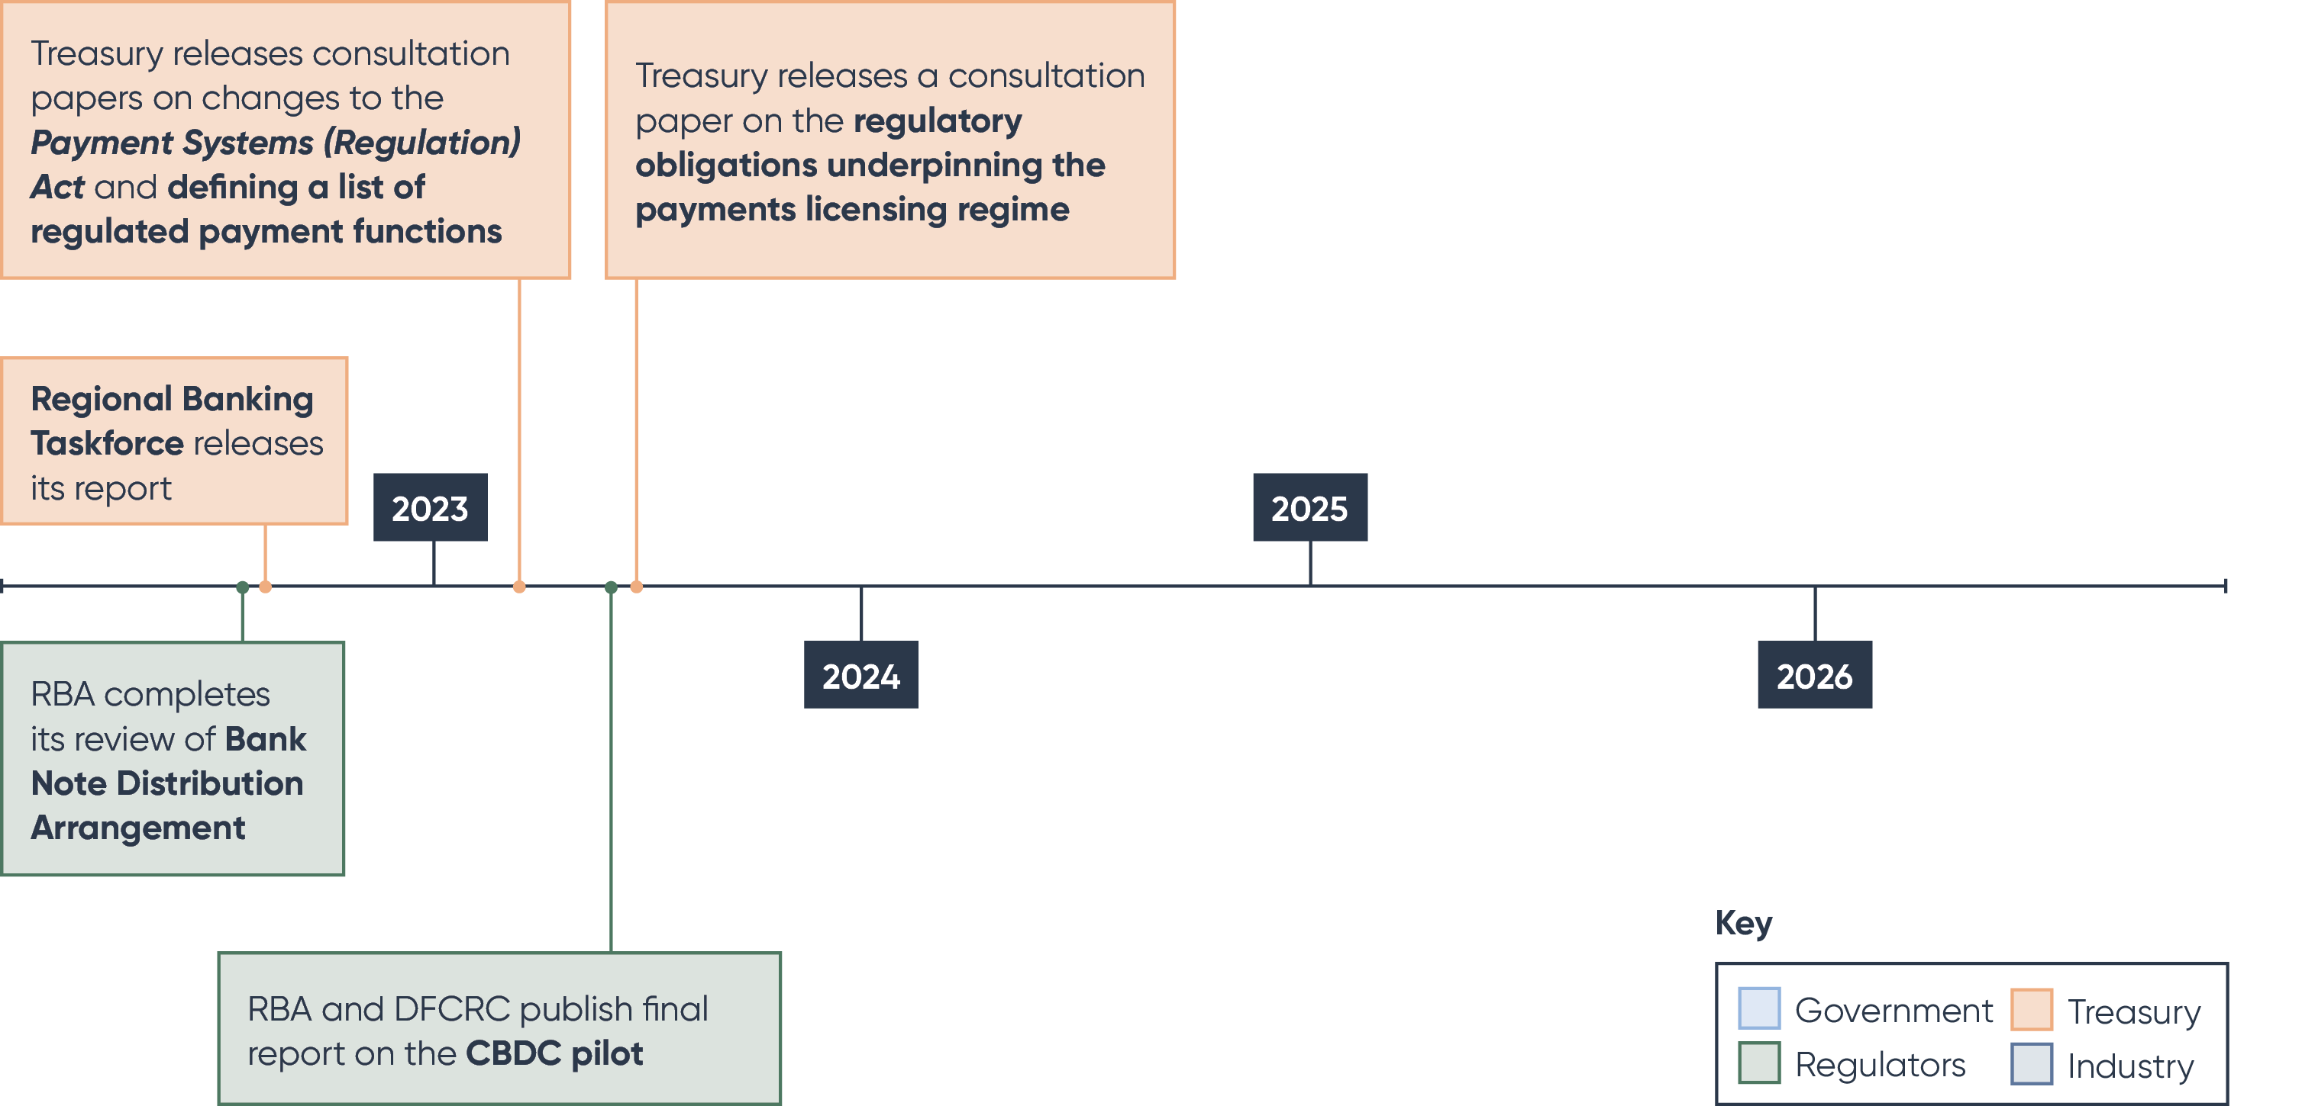

1. Payments System Board (PSB), Annual Report (2020), available at <https://www.rba.gov.au/publications/annual-reports/psb/2020/pdf/2020-psb-annual-report.pdf>, p.39.
2. PSB Annual Report 2022, available at <https://www.rba.gov.au/publications/annual-reports/psb/2022/pdf/psb-annual-report-2022.pdf>, p.16.
3. PSB Annual Report 2022, available at <https://www.rba.gov.au/publications/annual-reports/psb/2022/pdf/psb-annual-report-2022.pdf>, p.20.
4. PSB Annual Report 2022, available at <https://www.rba.gov.au/publications/annual-reports/psb/2022/pdf/psb-annual-report-2022.pdf>, p.18.
5. Australian Competition and Consumer Commission Targeting Scams Report July 2022, available at <https://www.accc.gov.au/system/files/Targeting%20scams%20-%20report%20of%20the%20ACCC%20on%20scams%20activity%202021.pdf>, p.10.
6. The Government has released an options paper seeking feedback on the future regulatory framework for BNPL arrangements under the *National Consumer Credit Protection Act 2009*.
7. Australian Securities & Investments Commission, ePayments Code, available at <https://asic.gov.au/regulatory-resources/financial-services/epayments-code/>
8. Productivity Commission Inquiry Report on Competition in the Australian Financial System 2018, available at <https://www.pc.gov.au/inquiries/completed/financial-system/report>; and Parliamentary Joint Committee on Corporations and Financial Services: Mobile Payment and Digital Wallet Financial Services 2021, available at <https://www.aph.gov.au/Parliamentary_Business/Committees/Joint/Corporations_and_Financial_Services/Mobileanddigitalwallet/Report>.
9. Inquiry into Future Directions for the Consumer Data Right Final Report 2020, available at https://treasury.gov.au/publication/inquiry-future-directions-consumer-data-right-final-report
10. Statutory Review of the Consumer Data Right Final Report 2022, available at https://treasury.gov.au/publication/p2022-314513
11. Treasury Laws Amendment (Consumer Data Right) Bill 2022, introduced in the House of Representatives on the 30 November 2022.
12. PSB Annual Report 2022, available at <https://www.rba.gov.au/publications/annual-reports/psb/2022/pdf/psb-annual-report-2022.pdf>, p.16.
13. RBA Review of Banknote Distribution Arrangement Conclusions Paper 2022, available at https://banknotes.rba.gov.au/resources/banknote-distribution-consultation/conclusions-paper/
14. Financial Stability Board, Enhancing Cross-Border Payments: Stage 3 Roadmap 2020, available https://www.fsb.org/2022/10/g20-roadmap-for-enhancing-cross-border-payments-consolidated-progress-report-for-2022/