

A Strategic Plan for
Australia’s payments system
  - Building a modern and
resilient payments system
June 2023
© Commonwealth of Australia 2023
This publication is available for your use under a Creative Commons Attribution 3.0 Australia licence, with the exception of the Commonwealth Coat of Arms, the Treasury logo, photographs, images, signatures and where otherwise stated. The full licence terms are available from http://creativecommons.org/licenses/by/3.0/au/legalcode.
Use of Treasury material under a Creative Commons Attribution 3.0 Australia licence requires you to attribute the work (but not in any way that suggests that the Treasury endorses you or your use of the work).
Treasury material used ‘as supplied’
Provided you have not modified or transformed Treasury material in any way including, for example, by changing the Treasury text; calculating percentage changes; graphing or charting data; or deriving new statistics from published Treasury statistics – then Treasury prefers the following attribution:
Source: The Australian Government the Treasury.
Derivative material
If you have modified or transformed Treasury material, or derived new material from those of the Treasury in any way, then Treasury prefers the following attribution:
Based on The Australian Government the Treasury data.
Use of the Coat of Arms
The terms under which the Coat of Arms can be used are set out on the Department of the Prime Minister and Cabinet website (see http://www.pmc.gov.au/government/commonwealth-coat-arms).
Other uses
Enquiries regarding this licence and any other use of this document are welcome at:
Manager
Media Unit
The Treasury
Langton Crescent
Parkes ACT 2600
Email: media@treasury.gov.au

Table of contents

Foreword 1
Strategic Plan on a page 2
The Government’s Vision 3
Role of payments in the Australian economy 4
The evolving payments landscape 4
The Government’s key principles 8
The Government’s key priorities and initiatives 10
The Government’s roadmap 30
Next steps 32
Annexure 1: Regulatory Framework 33

Foreword
New digital products are changing the way we make payments and the way businesses provide payment services.
The Government’s vision is for a modern, world-class and efficient payments system that is safe, trusted and accessible, and enables greater competition, innovation and productivity across the economy.
We are pursuing reforms so that our regulatory framework is fit-for-purpose now and into the future.
Our agenda focuses on:
- Promoting a safe and resilient system;
- Updating the payments regulatory framework;
- Modernising payments infrastructure;
- Uplifting competition, productivity and innovation across the economy; and
- Australia as the leader in the global payments landscape.
In addition, the Government recognises effective planning and coordination amongst regulators and industry is required to ensure Australia can capitalise on the opportunities and manage the risks of new payment methods and services.
The Strategic Plan for Australia’s Payments System outlines the Government’s vision for the sector. It presents the Government’s key priorities and initiatives for the payments system and a roadmap of key milestones.
The Plan will help coordinate action between the public and private sectors and provide certainty for industry investment and support for new entrants to navigate the regulatory landscape.
The Government has worked closely with stakeholders in financial institutions, technology companies, industry associations, consumer groups and government agencies to develop and finalise the Plan. We will continue to engage closely with stakeholders to implement the Plan’s initiatives.
To ensure it remains relevant in the face of changing circumstances, the Government will review and publish an updated strategic plan every 18 months.

The Hon Jim Chalmers MP
Treasurer

The Hon Stephen Jones MP
Assistant Treasurer
Minister for FinanciaL Services

Strategic Plan on a Page

Vision for the payments system:
A modern, world-class and efficient payments system that is safe, trusted and accessible, and enables greater competition, innovation and productivity across the economy.

Principles to guide the future direction of the payments system:

Trustworthiness, Accessibility, Innovation, and Efficiency

Key priorities and supporting initiatives:

Promoting a safe and resilient system
- Reducing the prevalence of scams and fraud
- Strengthening defences against cyber-attacks
- Supervising systematically important payment systems

Updating the payments regulatory framework
- Implementing changes to the Payment Systems (Regulation) Act 1998 (PSRA)
- Establishing a new payments licensing framework
- Promoting competition by facilitating transparent access to payment systems
- Enabling greater collaboration between payment system regulators
- Reducing small business transaction costs

Modernising payments infrastructure
- Phasing out cheques
- Upgrading systems
- Maintaining access to cash

Uplifting competition, productivity and innovation across the economy
- Aligning payments system objectives and the Consumer Data Right (CDR) framework
- Supporting the broader use of Digital ID
- Uplifting digital and technological skills
- Building public trust and confidence and supporting adoption of artificial intelligence (AI)

Australia as a leader in the global payments landscape
- Creating a regulatory environment that attracts and enables innovation
- Facilitating cross-border payments
- Exploring the policy rationale for a Central Bank Digital Currency (CBDC) in Australia

A Strategic Plan for Australia’s Payments System

The Government’s Vision

A modern, world-class and efficient payments system that is safe, trusted and accessible, and enables greater competition, innovation and productivity across the economy.
The Government’s Vision | 3

Role of payments in the Australian economy
Australia’s payments system is essential for the smooth operation of the economy. From purchasing groceries in the supermarket to receiving a salary or sending money to a friend within Australia or overseas, payment is the one financial service that underpins the everyday commerce between consumers, businesses, and government across the country.
A payment system enables the transfer of value. The ability to transfer value safely, efficiently and effectively is fundamental to the operation of the Australian economy.
Payment systems:
- support financial stability by minimising risks related to financial transactions
- facilitate the smooth flow of payments underpinning economic activity
- promote financial sector development by fostering consumer and business confidence in the use of money and payment services
- enable access to transaction accounts for safely storing value, and making and receiving payments
- provide a link through which Australians interact with the global marketplace.
Given the critical role of payments in facilitating economic interactions, an effective payments system can help drive economic growth, attract foreign investment, and serve as the foundation for Australia’s digital economy. With so many payments made daily, even relatively small inefficiencies can have significant implications for the broader economy. Conversely, advances in payments innovations can unlock immense productivity benefits and foster greater competition in the economy.

The evolving payments landscape
The digital revolution over the past two decades has transformed the way Australians make and receive payments. As a result, Australia’s payments system has expanded in size and complexity, with new technologies, business models and participants offering greater transaction convenience and choice.
The pace of change has accelerated in recent years, partly driven by consumer responses to the COVID-19 pandemic. Transactions are continuing to shift from in-person to online forms of shopping and there is an increasing demand for near-instant and seamless payment experiences. There is less reliance on physical forms of payments such as cash and cheques, and increasing reliance on contactless card payments. The trends observed in Australia’s payments system mirror those happening globally, and the growing complexity of payments presents challenges to regulatory frameworks worldwide.
Innovative payment services are revolutionising the industry. Traditionally, participants in the payments chain were limited to the provider of the underlying infrastructure (such as a card scheme) and the banks. New entrants are often technology-focused businesses (fintechs and big techs) focused on elements of the payments chain, such as online payments processing, digital wallets, or point-of-sale payment acceptance technologies. This has led to disintermediation, where multiple specialised providers are involved to complete a payment. Digital platforms are also increasingly involved in payment services. These businesses can leverage their existing customer bases and connectivity to provide payment services in addition to their traditional offerings.
New entrants to the payments system have observed the complexity in navigating the regulatory framework that governs payments. The regulatory framework comprises the Government, regulators with specific mandates, and industry bodies who coordinate industry initiatives and maintain key payment systems. See Annexure 1 for a summary of the regulatory framework.

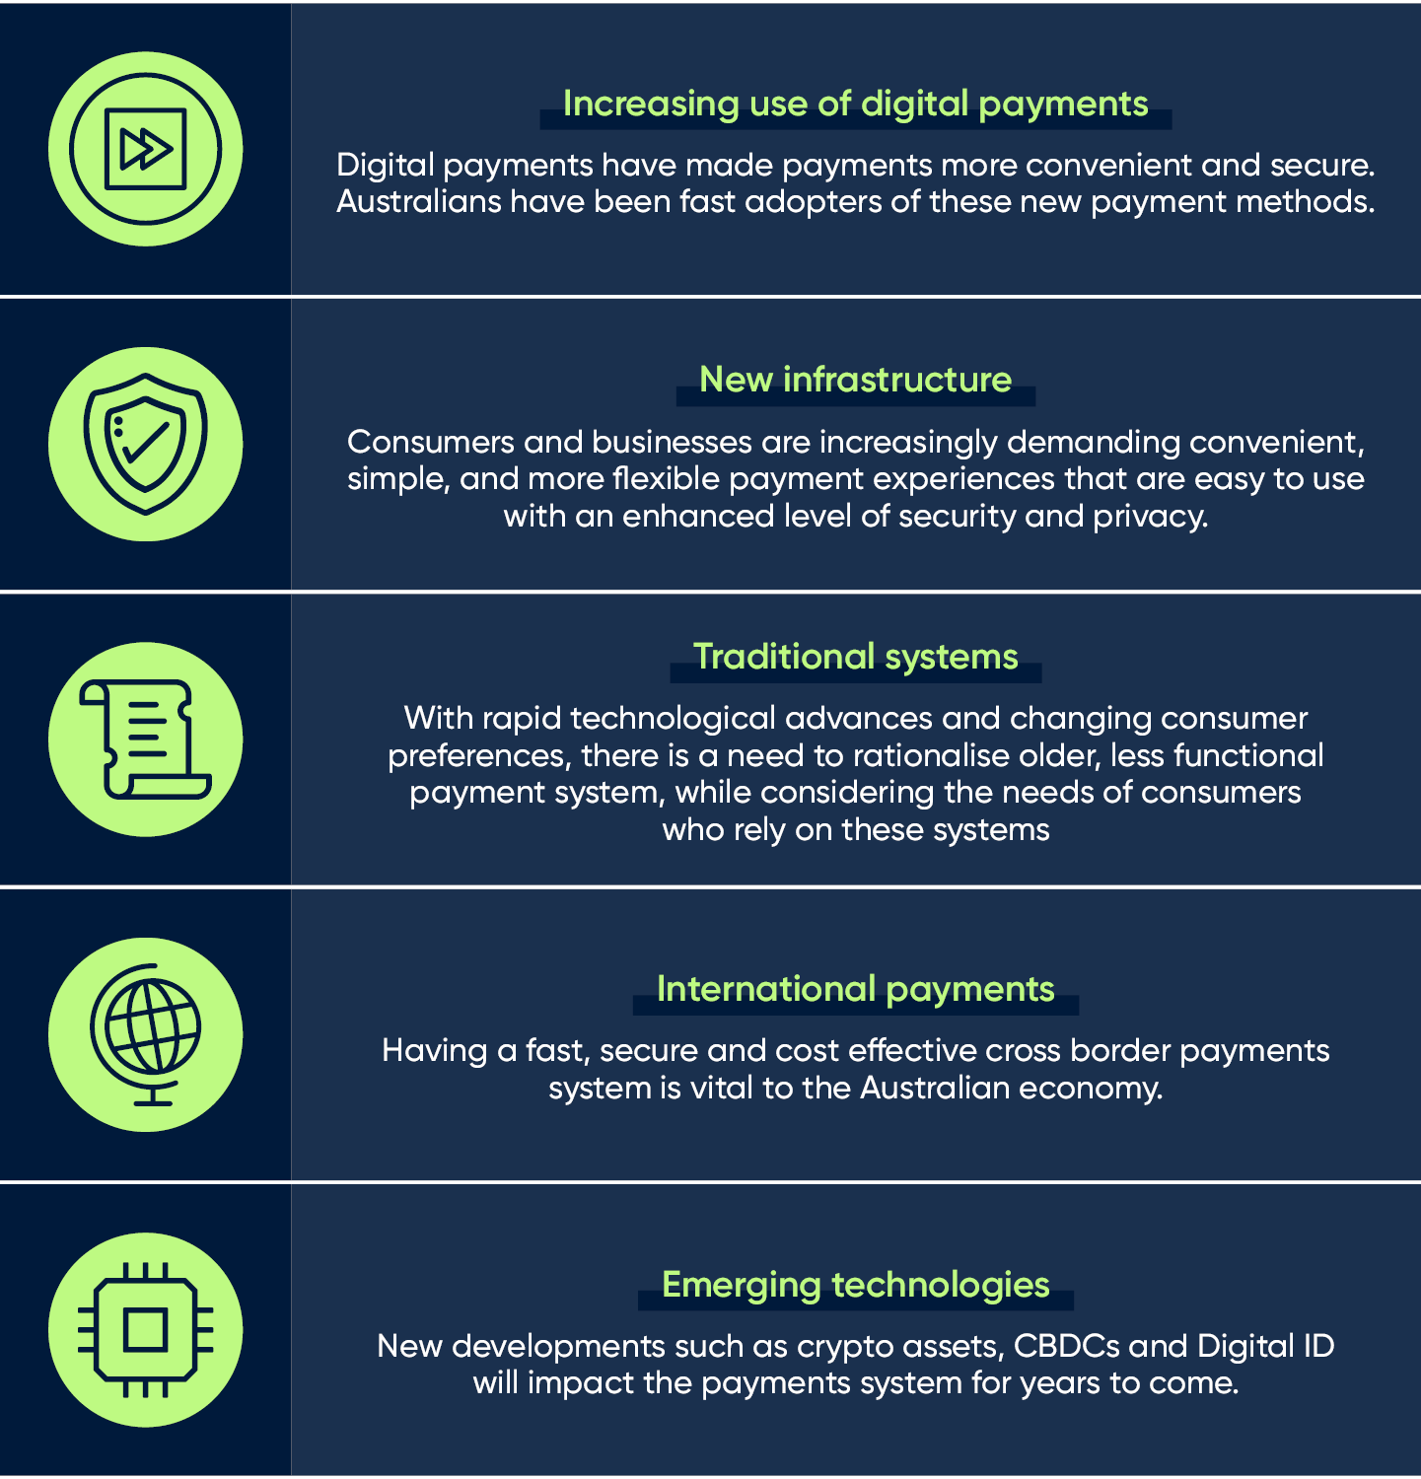

Increasing use of digital payments

The Australian payments system is increasingly digitised due to consumer preferences for frictionless transactions and evolving technology. Card based payments make up about 75 per cent of non-cash retail payments, with 25 per cent of that volume coming via mobile wallets.
Online debit and credit card payments have also grown over the past decade, a trend that heightened through the COVID-19 pandemic and has since normalised at a higher rate than pre-pandemic.

There has also been growth in Stored-Value Facilities (SVFs), a payment service that allows consumers to store funds to make future purchases.
Some retailers have expressed concerns that their costs to accept card payments are increasing. In particular, the RBA has noted that, on average, small businesses pay twice as much to process the same transaction as large businesses.

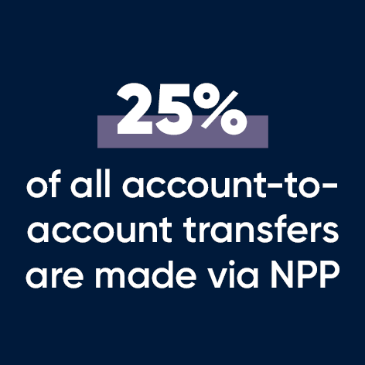
New payment infrastructure and emerging technology
The infrastructure underpinning the shift to digital payment methods has facilitated the increased volumes experienced to date, and will need to accommodate the growing needs of end-users for speed and reliability.
Use of new payment infrastructure such as the New Payments Platform (NPP) has increased and is expected to facilitate further innovation in retail payments. The NPP allows domestic payments to take on a faster and more data rich form, providing security and flexibility to a variety of payments.
The NPP provides services such as PayID and PayTo, which enhance consumer and business interactions.
The NPP has seen significant uptake from Australian businesses and consumers with:
- almost 13 million Pay IDs created
- over 25 per cent of all account-to-account transactions use the NPP
- over 100 payment providers offering NPP services to almost 90 million customer accounts
- the NPP processed more than a billion transactions in the past year (2021-22)
Australia’s payments system is increasingly reliant on this infrastructure operating smoothly and, as such, it is important that our payment systems are resilient to outages, malfunctions and external shocks. Cyber-attacks are a growing threat and will become a more routine part of our lives for years to come. It is essential that the Australian payments system ensures cyber security and privacy settings are appropriately calibrated to meet these threats.

Traditional payment methods
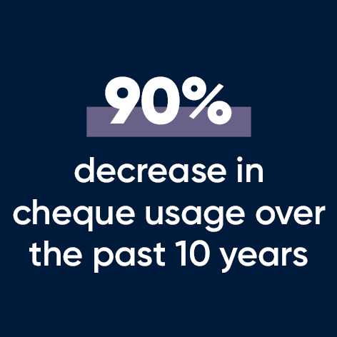
As the Australian payments system continues to evolve and consumers’ needs change, there has been a shift away from traditional payment methods. There has been an almost 90 per cent decline in cheque volumes in the last 10 years, with cheques now comprising only 0.2 per cent of non-cash retail payments in Australia. Cash use has also reduced significantly, with the share of retail payments made in cash falling from 27 per cent in 2019 to 17 per cent in 2022. However, cash in circulation is rising, indicating Australians’ demand for cash for the purposes of storing value, potentially for uncertain circumstances, remains high.
Despite these changes, some individuals, businesses and institutions rely on these traditional payment methods for a variety of reasons. These include personal preference, legislative requirements, lack of internet connectivity in rural and regional Australia, as well as technological capability. The cash system also provides resilience to the Australian payments system in times of natural disaster, crises and network outages. While consumers’ preference for everyday payments is trending towards digital, it is important that the payments system continues to include, and be accessible to, all Australians.

International payments
Australia is a highly active trading nation, with international trade activity being equivalent to almost half the value of total GDP in 2022. Cross-border payments are critical in supporting economic growth and achieving Australia’s economic and development goals. Australia has deep connections with its Pacific neighbours and it is important we can ensure improvements to the cost, speed, transparency and accessibility of cross-border payments that underpin our trade networks and support the economic goals of neighbouring countries.

The Government’s key principles
Consistent with the Government vision for the payments system, the following core principles will guide the future direction of the payments system. These principles are aimed at protecting and promoting the interests of the users of the system and provide a framework for discussing the impact of particular policies or initiatives.
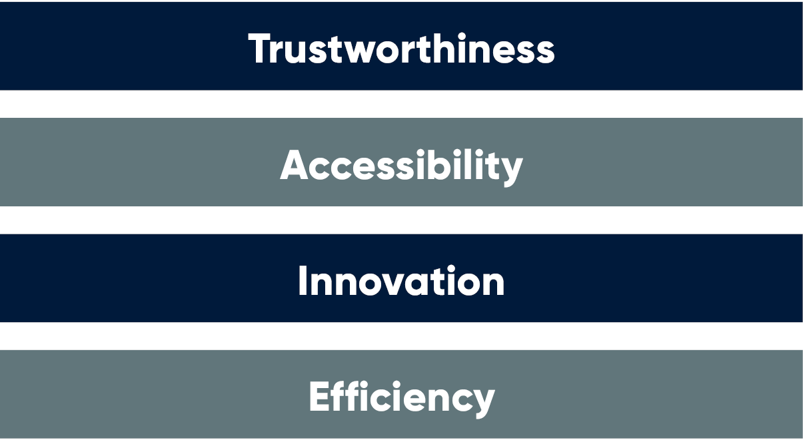

These principles, when applied in respect of a payment system or a particular initiative, can be complementary and mutually reinforcing. That is, specific actions, decisions or policies could promote more than one of these principles. However, some actions could give rise to conflict between principles. For example, maintaining intelligent friction to improve the trustworthiness in a system may be desirable (such as deliberately slowing down payments to increase security checks within a transaction). This would lead to an appropriate reduction in efficiency.
Together, these core principles will help achieve greater productivity and growth in our payments system and will drive Australia’s efforts, both domestically and internationally, in delivering a world-class payments system. Competition is essential to the proper functioning of the payments system and provides a mechanism for achieving the above principles.

Trustworthiness

A trustworthy system that is safe, reliable and resilient to fraud and other threats
Trustworthiness is a broad concept encompassing systemic resilience, reliability and consumer safety. Given the important role the payments system plays in the Australian economy, there is a clear public interest in ensuring that core functions within the system are resilient, reliable and safe. Participants and systems that pose risks to safety should be appropriately managed, and fair and sufficient protections should be in place for all users of the system. At an individual level, this requires transactions being processed correctly with robust protections against fraudulent transactions and scams. At a system-wide level, operational resilience that encompasses the mitigation of traditional operational risks, cyber risks and third-party service risk is also essential.

Accessibility

An accessible system that is readily available, competitive and offers choice to customers
Consumers and businesses should be able to access payment services to allow them to conduct day-to-day transactions and meet their individual needs. Ensuring services are readily available and systems are easy to use can also facilitate greater financial inclusion, with new entrants developing innovative new payment services and offering greater choice to payment users. Increased accessibility and choice for consumers and businesses is underpinned by a competitive payments system. A payments system that encourages all types of payment participants to compete in a level and fair manner is fundamental to enabling payment participants to make more informed decisions on their products and services. Catering to consumer preferences through competing services can lead to increased choice, financial inclusion, transparency, and consumer satisfaction.

Innovations

An innovative system that is agile, adaptable to challenges and forward-looking
With the pace of change in technology and consumer expectations, the payments system must be able to quickly respond to new opportunities. Creating an environment that fosters innovation and promotes competition has the potential to improve payment services while also supporting the other design principles. This requires the regulatory framework to facilitate competition and innovation while preserving financial stability. The payments system should enable efficient investment in solutions that will enhance the payment experience for consumers and businesses. This in turn drives positive outcomes in terms of efficiency, trust and accessibility, creating opportunities for further innovation and enhancing productivity in the economy.

Efficiency

An efficient payments system that is fast, seamless and low-cost
An efficient system is one in which competitive pressures drive down payment costs. Efficiency in payment systems is productivity enhancing as it empowers industry to allocating resources effectively to innovate, and respond to new developments and changing consumer preferences. An efficient payments system provides end-users with certainty by ensuring payments are made and received in a timely, seamless, and predictable manner, with users appropriately informed about where their payment is going, when it will arrive and the associated costs.

The Government’s key priorities and initiatives

Promoting a safe and resilient system
A key priority of the Government is providing a safe and resilient payments system that protects payment system participants and ensures Australians can reliably transact in a safe and secure manner. To ensure safe operation of payments and maintain public confidence in the system, there is a clear need to minimise instances of scams and fraud and provide robust protections to consumers. It is also important to strengthen existing regulation to appropriately manage risks to the smooth functioning of payments infrastructure and to reduce the likelihood of operational outages and cyber-attacks.

Reducing the prevalence of scams and fraud
Action on scams is a priority for the Government as the prevalence of scams has been increasing. In 2022, Australians lost a record $3.1 billion to scams, as government, law enforcement, consumer advocacy groups and the private sector look to improve collaborative efforts to support the community in the fight against scams. Payment redirection scams, also known as ‘business email compromise’ scams, are the scam that caused the highest losses to businesses in 2022, with combined losses of $224 million. Reported card fraud also increased by 5.7 per cent in 2021 to $495 million.
We have committed to a long-term, coordinated, whole-of-government approach to reduce scam losses for Australians. This approach brings together resources from the private sector and governments to enable better collaboration, information sharing and coordinated disruption of scams. It involves the establishment of the National Anti-Scam Centre, which will work across regulatory and industry boundaries, bringing needed coherence and focus to fragmented initiatives.
The Government will also consider options to bolster consumer protections in the process of developing the new payments licensing framework. This work will complement the Government’s broader scams agenda including the development of new industry codes.
The Government also supports further investment and rollout of new technologies to combat scams. Examples of this include confirmation of payee services, which are already enabled when customers choose to pay using the existing PayID service on the New Payments Platform.
Next Steps
- The Government is establishing the National Anti-Scam Centre, and will consult on options for developing new industry codes across sectors, including for banks, telecommunications, and digital platforms in 2023.
- The Government is bolstering consumer protections through the new payments licensing framework.

Strengthening defences against cyber-attacks
Cyber incidents are a growing threat to Australia’s infrastructure. Recent cyber incidents have shown that the damage can be wide-reaching and deeply detrimental, impacting many individuals and resulting in theft of personal information. Such incidents impacting a payment system have the potential to cause major economic disruption, personal harm through financial and information theft as well as reducing public confidence.
The Government plays an important role in managing cyber risk through design of legislation and regulation and coordinating with industry. The Security of Critical Infrastructure Act 2018 was recently updated to enhance the regulatory framework for operators of critical infrastructure assets. The changes require operators of certain critical payments systems to comply with risk management obligations aimed at safeguarding critial infrastructure. The systems that have been prescribed as ‘critical’ are the Mastercard debit and credit card systems, the Visa debit and credit card systems, the eftpos card system and the NPP. The RBA has been specified as the relevant Commonwealth regulator of the payment system operators’ risk management program obligations.
In February 2023, the Government announced the establishment of a National Coordinator for Cyber Security, supported by a National Office for Cyber Security within the Department of Home Affairs, to ensure a centrally coordinated approach to deliver the Government’s cyber security responsibilities. The Government also announced its development of the 2023-2030 Cyber Security Strategy to facilitate a nationally coordinated approach towards making Australia the most cyber secure nation in the world by 2030.
The Council of Financial Regulators (CFR) ‘Cyber & Operational Resilience Working Group’ continues to pursue initiatives aimed at improving the cyber and operational resilience of the Australian financial system.
Industry also has a role to play in ensuring payment systems are safe and secure. It is important that participants in the payments industry invest in resilient and secure infrastructure, systems and customer services. The Government will continue to monitor the payments industry’s cyber safety and preparedness, and assess whether more needs to be done to ensure that the industry is well-placed to protect against future cyber incidents.
One example is the requirement for continued uplift in system-wide security standards and practices relating to the security standards and encryption methods for card payment systems.
AusPayNet has commenced planning for an industry-wide program to migrate the Australian card payments system to the safer Advanced Encryption Standard, together with improvements to cryptographic key management practices. AusPayNet plans to develop a program of work for this migration over the next 18 months, with a view to initiating an industry migration program in 2025. The migration would be a large-scale industry effort requiring an estimated 6 to 7 years to complete.
Next Steps
- The Government is releasing its Cyber Security Strategy 2023-2030 in 2023.
- Industry will begin migration to the Advanced Encryption Standard in 2025.

Supervision of systematically important payment systems
Cyber-attacks are just one operational threat to our payment systems and infrastructure. The movement towards more electronic payments means our payment systems and wider economy are susceptible to system outages, malfunctions and flow-on impacts resulting from external shocks to other core infrastructure such as telecommunications networks. With a higher share of payments being made electronically, our economy is more reliant on payment systems being operationally resilient and secure in the face of cyber threats as well as operational and technology risks.
Outages in payment systems can cause significant inconvenience to customers and more generally disrupt activity across parts of the real economy. According to the RBA, the frequency and duration of operational outages to retail payment services provided to customers has increased in recent years. Online banking and NPP real-time payments infrastructure were the least reliable services during the year to June 2022, with many providers reporting multiple unplanned outages to these services during the year. The average cumulative downtime per provider during this time was around 18 hours for online banking services and 13 hours for real-time payments.
In response, the RBA and Payments System Board are engaging with industry and expanding system resilience supervision to include payment systems where an outage could cause significant economic disruption and damage confidence in the financial system.
Next Steps
- The RBA is extending its supervision from systemically important systems to also include prominent payment systems, i.e. NPP, Visa, Mastercard and eftpos.
- The RBA will in 2023 consult industry on the development and implementation of an updated framework for monitoring safety and resilience of prominent payment systems.

Updating the payments regulatory framework
New payment services and technologies are testing the limits of the current regulatory framework for the payments system. Several recent reviews have identified regulatory gaps. These gaps can contribute to increased risks of consumer and business harm, future systemic instability and decreased private sector investment in innovative products and services.
In response to these risks, the Government will update the Payment Systems (Regulation) Act 1998 (PSRA) and introduce a new payments licensing framework. Reforming the regulatory framework will promote innovation and support competition in the sector while also ensuring there are consistent protections for consumers.

Implementing changes to the Payment Systems (Regulation) Act (PSRA)
The Government’s updates to the PSRA will ensure regulators and the Government can address new risks to the payments system as the provision of payments evolves and increases in complexity. These changes will involve:
- Expanding the regulatory perimeter of the PSRA by updating existing definitions of ‘payment system’ and ‘participant’ to ensure that all entities that play a role in facilitating or enabling payments are appropriately regulated.
- Introducing new Ministerial powers that can be exercised in the ‘national interest’ to ensure Government can respond to issues beyond the remit of independent regulators.
Next Steps
- The Government is consulting on updates to the PSRA and the introduction of a new Ministerial designation power to inform the development of exposure draft legislation for these changes.
- The Government will introduce legislation to implement the PSRA changes and introduce a new Ministerial designation power by end 2023, subject to consultation outcomes.

Establishing a new payments licensing framework and promoting competition by facilitating transparent access to payment systems
The Government is consulting on the elements of a new licensing framework for payment service providers. Further consultation to facilitate the development of legislation will occur later in 2023.
The new licensing framework aims to deliver the following benefits to consumers and businesses:
- ensuring consistent and appropriate regulation of payment service providers based on the payment function they provide;
- improving regulatory certainty for payment service providers;
- supporting a more level playing field for payment service providers seeking access to payment systems;
- better targeting regulatory obligations based on the level of risk posed to end-users;
- streamlining the process for businesses that require multiple licenses; and
- better aligning Australia’s payments regulatory framework with international jurisdictions.
The development of a new, modernised payments licensing framework is a significant undertaking and, given the breadth and detail of these reforms, will span a number of years involving a number of different agencies. The Government intends to introduce legislation for the new payments licensing regime in 2024, including implementing the recommendations made by the Council of Financial Regulators on the regulation of stored-value facilities. Subject to the passage of legislation, detailed elements of the payments licensing reforms will be subject to further consultation. They include supporting regulations for the ePayments Code, common access requirements, and mandatory industry standards.
Next Steps
- The Government is consulting on the new licensing framework for payment service providers. This will be followed by a second round of consultation in late-2023 on the obligations under the new licensing framework.
- The Government will introduce legislation for the new payments licensing regime in 2024, subject to consultation outcomes.

Enabling greater collaboration between payments system regulators
Payment service providers may have to engage with and report to several regulators, depending on the type of services they offer. Payment service providers have commented on the lack of transparency in the current governance and regulatory structure, with uncertainty regarding which regulators to approach on different issues. These sentiments were echoed by the Payments System Review, which recommended greater collaboration between regulators and better alignment of regulatory approaches to payments system issues.
The Government acknowledges that some industry stakeholders seek a single point of engagement with regulators and Treasury to navigate the complex governance structure.
As part of its enhanced payments function, Treasury established the Inter-Agency Payments Forum (IAPF) in July 2022 to improve communication and regulatory approaches regarding payments system issues. The forum consists of five key regulatory participants in the payments system: the Reserve Bank of Australia (RBA), the Australian Prudential Regulation Authority (APRA), the Australian Securities and Investments Commission (ASIC), the Australian Competition and Consumer Commission (ACCC) and the Australian Transaction Reports and Analysis Centre (AUSTRAC).
The IAPF is not intended to be a decision-making body. Rather, it is a forum for relevant regulators to collaborate on payments-related issues on a regular basis and avoid conflict of regulation.
Next Steps
- The Inter-Agency Payments Forum (IAPF) will strengthen collaboration and communication between payment system regulators.

Reducing small business transaction costs
Greater use of debit cards is putting upward pressure on businesses’ payment costs. The growth in contactless payments, including through mobile wallets, has resulted in most debit card transactions being automatically routed to the international Visa and Mastercard networks, where previously many of these payments were made over the domestic eftpos network. On average, the international networks cost around 20 basis points more to accept for in-store payments. Online transactions are also typically more expensive to process and the growth in online commerce has further added cost pressures for businesses. Further, the RBA estimates that smaller businesses pay twice what large businesses pay to process the same transaction.
The Government has committed to lowering small business transaction costs through least-cost routing (LCR),which allows businesses to select the lowest cost payment network for debit transactions – or similar. For in-store payments, LCR is now available to 85 per cent of merchants. However, it is only enabled for approximately half of all merchants, suggesting the payments industry has more work to do to promote LCR benefits. Availability of LCR for online and mobile wallet transactions is much lower.

The RBA has been prioritising greater implementation of LCR for in-store, online and mobile payments. The RBA has:
- set an expectation that most service providers have LCR ready for online payments by end of 2022. Most providers who did not meet this deadline have committed to meeting it in first half of 2023.
- started publishing institution-level data on LCR availability and take-up in 2023.
- set an expectation on industry for LCR to be available for mobile wallet transactions by the end of 2024.
The Government supports the actions being taken by the RBA and notes the progress that has been made on making LCR available to more merchants. The broader reforms to the regulatory framework in the PSRA will also strengthen the RBA’s ability to regulate mobile wallet providers by ensuring payments regulations can be applied to the full range of payment systems and participants.
The Government will continue to actively monitor LCR availability and adoption across payment methods. If necessary, the Government will take further action (for example, through specific legislative requirements) to ensure greater take-up of LCR if the RBA’s expectations are not met on time.
Next Steps
- The RBA will continue to publish institution-level data on LCR availability and take-up.
- The Government is consulting on updates to the PSRA and will introduce legislation to expand the payments regulatory perimeter and bring into scope modern payment systems and participants such as mobile wallet providers by the end of 2023, subject to consultation outcomes.
- The majority of payment service providers to enable LCR for online payments by mid 2023, in line with the RBA’s expectations.
- Mobile wallet providers, and other industry participants as necessary, to enable LCR on mobile wallet transactions by the end of 2024, in line with the RBA’s expectations.
- The Government will continue to monitor payment costs for small businesses and will directly intervene if necessary.

Modernising payments infrastructure
A key priority for the Government is to ensure the payments system fosters the development of modern, efficient payment infrastructure that promotes greater financial inclusion and delivers a seamless user experience. This involves providing policy direction on issues such as the future of legacy systems like cheques and the Bulk Electronic Clearing System (BECS), and maintaining adequate access to cash.

Phasing out cheques
The Government intends to enable greater choice for Australians in the way they transact for goods and services. The Government will focus on removing legislative and other barriers that entrench payment by cheques as well as phasing out government cheque usage by the end of 2028, with the eventual wind-down of the cheques system in Australia by no later than 2030. This will be subject to further consultation with industry and stakeholders to determine the feasibility of this end-date and an appropriate transition plan.
There has been a rapid decline in the use of cheques in the past 10 years, which now comprise only 0.2 per cent of non-cash payments in Australia. This has been driven by growing availability of card and electronic payments and consumer preferences for more efficient and low-cost digital payments. This consumer-led migration is consistent with the global trend towards digitisation, with some countries successfully managing the complete closure of their cheque systems.
As cheque use declines, the per-transaction cost of supporting the cheque system will continue to increase. Banks and financial institutions are taking steps to withdraw from the cheque system, such as ceasing issuance of cheque books for new customers. At the same time, many merchants are ceasing to accept cheques as a means of payment.
Although cheques represent a narrow segment of our payments system today, they continue to be issued in relatively large numbers by some corporates and Government entities. They also continue to be used by certain cohorts of the population, particularly older Australians and those living in regional or rural areas or with limited digital proficiency or connectivity. Some types of businesses also rely more heavily on cheques (for example, charities and other not-for-profit organisations who take a large proportion of donations through cheques from their donors).
As an advanced economy with well-developed digital insfrastructure, Australia is well-placed for an eventual withdrawal from the cheque system. Many stakeholders have indicated a strong desire to end the cheque system, with habit and legislative barriers being the most cited reasons for its continued use. However, with the increased adoption of faster, safer, and more seamless technology, there are now strong and readily accessible payment alternatives to cheques. These alternatives will also help deliver greater financial inclusion outcomes such as more clear and targeted customer communication and real-time access to information to assist those cohorts of the community that are more susceptible to vulnerability. Transitioning away from cheques will help achieve greater efficiency, productivity and security in Australia’s payments system. It will remove barriers that entrench specific payment methods and promote payment neutrality, giving Australians greater choice in choosing how they pay.
However, the Government is committed to ensuring that all Australians are supported in a transition away from cheque use. As banks and financial institutions continue to reduce cheque-related services and parts of the economy cease accepting cheques as a way to pay, it is important to ensure that the transition is appropriately managed. The Government has a role to play in managing the transition away from the cheques system, coordinating a whole-of-economy approach in a manner that provides appropriate support, and minimises adverse impacts to consumers and businesses.
In the short term, the Government will consult with industry and stakeholders to identify challenges, develop solutions and supports for affected users, and implement the changes required to ultimately close the cheques system. This would involve staged reforms, rather than a single change at the end of the proposed period. To this end, four main workstreams have been identified for ensuring a smooth transition away from the cheques system.
- The Government will work to reduce Commonwealth usage of cheques by working with agencies and departments with high cheque usage to develop a transition plan away from reliance on cheques. This includes identifying products, such as health services or tax payments, that will need viable and alternative forms of payment with the same level of reach and convenience as cheques.
- The Government will support industry in promoting the use, and removing barriers to adoption of, alternatives to cheque products, especially for institutional and commercial uses of cheques that cannot be serviced through existing digital channels. Industry’s development of education and outreach programs to assist cohorts that are greater users of cheques will also be required.
- The Government will explore changes to Commonwealth legislation that entrench the use and acceptance of cheques with a view to amending legislation. The Government aims to ensure that legislation mandating cheque use will become payment neutral in the future. As part of this process, the Government will consider the ongoing role of the Cheques Act 1986.
- The Government will also work with state and territory counterparts to encourage a coordinated approach to transitioning away from the cheques system. This includes encouraging state and territory governments to amend legislation that mandates the usage of cheques in certain industries such as gaming and insurance.
Next Steps
- Treasury will in 2023 commence engagement with relevant Commonwealth, state and territory government agencies, on transitioning away from the use of cheques.
- The Government will enable greater choice for Australians by removing barriers that entrench payment for goods and services by cheques.
- Treasury will in 2023 commence exploring changes to the Commonwealth legislation that entrenches the use and acceptance of cheques.
- The Government will release a consultation paper on the future of cheque use in Australia, and the support required to retire the cheques system, by the end of 2023.

Upgrading Systems
One of the legacy payment systems operating in Australia is the Bulk Electronic Clearing System (BECS). BECS is a long-running electronic funds transfer system that facilitates the processing of Direct Entry payments, such as direct debits and direct credits, between individual accounts held at different Australian financial institutions. Over the decades, BECS has served as one of the key elements of the nation’s payment infrastructure, enabling businesses, governments, and individuals to make both one-off and recurring payments.
While BECS continues to play a significant role, particularly in processing direct debits and bulk payments, recent years have seen the development of modern payment systems. A key new system in Australia is the NPP, which was launched in February 2018. The NPP was developed via industry collaboration with the RBA to enable households, businesses, and government agencies to make simply addressed payments, with near real-time funds availability to the recipient, on a 24/7 basis.
In addition, there is a strategic focus within the global payments industry on developing account-to-account payments products and services (e.g. Mastercard’s Pay by Account service) and related solutions such as Mastercard Send and Visa Direct. Together with the NPP, these offer modern alternatives to Direct Entry payments.
Modern payments systems such as the NPP offer several key advantages over BECS, including:
- Faster, 24/7 payments: BECS processes payments on a periodic basis only on business days. Modern systems such as the NPP offer 24/7 availability with funds transferred in near real-time.
- Data-rich payments: Modern systems such as the NPP enable relatively data-rich payments that can benefit users (e.g. automated reconciliation) and support financial institutions in meeting financial crimes transaction monitoring obligations.
- Safer payments: BECS payments lack the ability for a payer to confirm the payee’s details. Modern tools such as the NPP’s PayID addressing service allow customers to check and confirm a payee’s name, helping reduce mistaken payments and some types of scams.
The transition from BECS to modern payment systems like the NPP presents both an opportunity and a challenge for the Australian financial sector, requiring development of institution-level business cases for investment prioritisation and transformation planning to ensure a seamless and efficient transition.
Banks and financial institutions have already made significant progress in processing certain types of retail payments on the NPP. In this context, AusPayNet, the industry body which administers BECS, is currently consulting industry and key users on the future of BECS, including feasible timeframes or preconditions for transitioning different transaction types onto alternative payment systems. The Government supports this industry-led process, encourages participation, and expects this work to conclude by the end of 2023 so that it can inform industry initiatives and the next strategic plan.
The most significant challenge in transitioning away from BECS is likely to be bulk payments that are made by businesses and government. Transitioning these payments onto the NPP requires capacity upgrades for the financial institutions that act as NPP Participants. The industry has already commenced preparing for these larger payment files to be processed via the NPP. NPP Participants are now required to prepare for this increased volume by ensuring their infrastructure meets at least 50 per cent of BECS capacity by end of 2023.
In addition, some large business and government users have heavily embedded BECS into their processes, such as payroll, superannuation and social security payments. NPP Australia and NPP Participants may need to provide additional support to transition these bulk payments away from BECS. The Government encourages NPP Australia and NPP Participants to consider how this process could be made as efficient as possible for users of bulk payments in minimising the cost of internal systems changes required to make the transition. Progress on this front would strengthen both the system-wide policy case and the institution-level business cases for users of bulk payments to transition away from BECS. Treasury will continue to engage with NPP Australia and NPP Participants, with progress informing the approach to be taken in the next strategic plan.
In contrast, much of the required capability and capacity for transitioning consumer-facing payments, such as individual account-to-account ‘push’ payments and direct debits, has been or is in the process of being rolled out. There is a clear benefit to industry prioritising the transition of consumer-facing payments onto the NPP, both from an efficiency standpoint (for example, speed of transfers and 24/7 availability) and from a safety standpoint (the NPP enables payee confirmation through PayID).
To monitor progress, the RBA is requiring financial institutions to report on their work to connect all remaining relevant accounts to the NPP. The Government also encourages industry to make further progress on minimising outages on the NPP by strengthening its resilience.
Next Steps
- The Government is supporting an industry-led, phased transition away from BECS.
- Industry, through the ongoing work led by AusPayNet, to settle on a transition plan away from BECS by the end of 2023.
- NPP Australia and NPP Participants to consider how the process of transitioning bulk payments away from BECS could be made as efficient as possible for users in minimising the cost of internal systems changes. Treasury will engage with NPP Australia and NPP Participants in the lead-up to the next strategic plan to take stock of progress.
- Following completion of AusPayNet’s work, Treasury will commence engagement with relevant Commonwealth, state and territory government agencies and other key users of BECS bulk payments on their needs and readiness to transition away from BECS. This, together with the work of AusPayNet, NPP Australia and NPP Participants, will inform the next strategic plan.
- Industry will by mid-2023 make PayTo available on most NPP enabled accounts, in line with October 2022 NPP Roadmap.
- Financial institutions will report on progress to the RBA on their work connecting all relevant accounts to the NPP.
Transitioning direct debits to the NPP is a major milestone in modernising consumer-facing payments. In June 2022, the NPP began rolling out its PayTo service. PayTo is a modern alternative to direct debits on the Direct Entry system that gives payers greater control and transparency in relation to their recurring payments and will enable a range of new and existing payment use cases. Reaching a critical mass of PayTo-enabled consumer accounts is a priority, and will help facilitate further innovation in payment services using PayTo. The Government expects industry to meet the timeline outlined in the October 2022 NPP Roadmap that PayTo be available on most NPP-enabled accounts by mid-2023.

Maintaining access to cash
Cash is an important payment method for certain groups in Australia and plays a vital role in their inclusion in the wider economy. Cash is still widely accepted as a means of payment by merchants, used as a store of value, and provides resilience to the payments system during outages where digital forms of money cannot be used.
The use of cash as a method of payment has declined substantially in the last decade and this trend accelerated during the COVID-19 pandemic. According to the Reserve Bank’s Consumer Payments Survey, 13 per cent of payments were made using cash in 2022 whereas, in 2019, this share was 27 per cent. At the same time, financial institutions are reducing the number of branches and ATMs they operate across the country. APRA reports that over the 5 years to June 2022, bank branches have declined by 30 per cent in major cities, and 29 per cent in regional and remote areas. The number of ATMs in Australia have declined by approximately 25 per cent since the peak in 2016.
The Government understands the important role cash still plays in our payments system and supports Australians having continued access to cash. The Government will work with the relevant agencies across the public sector and with industry to ensure that Australia has a sustainable cash distribution network that maintains adequate access to cash. Currently, Australians have good access to cash services with an estimated 95 per cent of the population living within around 5km of a cash access point as of June 2022. However, there are some communities in Australia that are facing a reduction in cash services more acutely, particularly those in regional and remote areas. These Australians typically have to travel further to access cash and are particularly vulnerable to the removal of cash access points, bank branches and cash distribution facilities.
The declining transactional use of cash has led to a per unit increase in costs in distributing cash across the country. Australia’s two largest Cash-in-Transit (CIT) service providers, Armaguard and Prosegur, have responded to these financial pressures in recent years by downsizing or closing some facilities and reducing the frequency of CIT services.
More recently Armaguard and Prosegur have applied for ACCC authorisation to merge their cash distribution and management, device monitoring and maintenance and ATM businesses to help create a more efficient and financially sustainable business. Merger authorisation includes both a competition assessment and public benefits assessment. The ACCC is expected to make a decision by 14 June 2023. The applicants have submitted that the merging of the businesses could help operations by achieving synergies. These synergies will better enable continued provision of CIT services across Australia in an environment where both providers reported incurring heavy financial losses due to declining demand.
Regardless of the decision made by the ACCC on this application, the Government will closely monitor developments regarding access to cash for Australians, in close consultation with relevant regulators. This is to ensure that as cash reliance declines and the the CIT industry undergoes transition, the market can operate both efficiently and fairly, that the potential for disruptions that could impact cash access are identified early and minimised, and that Australians continue to have access to cash.
The RBA is working to reduce impediments to improved efficiencies in cash distribution operations. This includes introducing transparent and standard contractual arrangements for the distribution of banknotes by the RBA as well as the establishment of a banknote distribution industry forum to facilitate more timely changes to make the distribution of cash more effective, efficient, resilient and sustainable.
The Government notes the Senate Standing Committees on Rural and Regional Affairs and Transport Inquiry into Bank Closures in Regional Australia, in particular its investigation of the effect bank closures and the removal of face-to-face cash services are having on cash access. The Senate inquiry will report by 1 December 2023.
The Government notes industry’s role in supporting the Bank@Post network which provides access to banking services through Australia Post outlets, including in 1,800 locations in rural and remote areas. The use of this network is supporting communities at a time of transition towards greater use of electronic payments, but may not fully address issues around access to cash for all Australians.
The Government also notes work being done overseas to maintain access to cash and ensure infrastructure supporting cash access and availability is effective, sustainable and resilient. Initiatives in the UK include widespread adoption of cash at point of sale without a purchase, ensuring cash facilities are available in all communities and that there is broad coverage of free-to-use ATMs.
Next Steps
- The Government will support Australians having continued access to cash.
- The Senate Standing Committee on Rural and Regional Affairs and Transport will by 1 December 2023 release its report on Bank Closures in Regional Australia.
- Treasury will in 2023 commence engagement with relevant Commonwealth government agencies and industry on options for maintaining adequate access to cash for as long as Australians want to use cash.

Uplifting competition, productivity and innovation across the economy
As the Australian payments system becomes increasingly digitised, the Government is taking action to unlock productivity and support innovation enabled by the broader digital economy transformation. The Government has introduced legislation into the Parliament to extend the Consumer Data Right (CDR) to action initiation, which would enable consumers to instruct accredited third parties to initiate actions, such as payments, on their behalf. In addition, stakeholders have identified Digital ID as a key digital economy initiative that could help build trust in the payments system. The Government and the RBA are also working together to explore the policy case for an Australian central bank digital currency (CBDC). Further, the Government is working to uplift digital and technological skills across the economy, to ensure Australians can fully take advantage of productivity enhancing technologies. The Government is also taking steps to build public trust and confidence in, and adoption of, AI which is a transformative digital technology that will help to drive productivity growth in Australia.

Aligning payments system objectives and the CDR framework
The CDR enables consumers to safely access certain data about them held by businesses and share this data with accredited third parties. For example, in banking, the CDR is helping Australians make more informed choices by making it safe to use transaction data to simplify complex financial decisions and take advantage of data-enabled innovations.
The CDR has potential to further drive competition, innovation and efficiency across the economy. The Government is committed to strengthening the CDR framework, focusing on improving data quality and driving participation in banking and energy, and implementing the CDR in non-bank lending. The Government will also undertake detailed policy and design work on action and payment initiation, focusing on building a strong foundation for future implementation and identifying the highest-priority actions for Government to bring into the CDR to maximise consumer benefits.
While both the CDR and payment systems continue to evolve, the Government is committed to aligning developments under the CDR framework with its broader objectives for the payments system. This includes working with stakeholders to understand how best the CDR framework might work with broader developments and investments in the payments landscape, including for example PayTo and the payments licensing reforms, to unlock benefits for consumers.
Next Steps
- The Government will continue working with stakeholders on the potential interaction between the CDR framework and the payments system.
- Under the CDR action initiation framework, the Government will carry out an assessment and publicly consult before bringing any action types, such as payments, into the CDR.

Supporting the broader use of Digital ID
Digital ID will be a voluntary, secure and trusted way to verify a person’s identity online, while minimising collection and retention of personal information. Once a Digital ID has been created with a provider, it can be reused across connected services without the need to repeatedly provide identity information to those services. The recent Optus, Medibank and Latitude data breaches highlight the risks posed by current approaches to identity verification and the need to reduce the proliferation of identity documents by enabling solutions such as Digital ID.
Digital ID will be a key enabler of the digital economy, driving greater efficiency in online interactions by streamlining identity verification processes. Currently, Digital ID can be used to access more than 125 government services using the ATO’s Digital ID solution, myGovID. Digital ID can also be used in the private sector and solutions are continuing to develop, such as Australian Payments Plus’ ConnectID solution, Australia Post’s Digital iD, and Mastercard’s ID product.
The Government is prioritising reform and enabling legislation to modernise Australia’s ID system and ensure a nationally coordinated approach. The Government is investing $26.9 million in 2023-24 to expand Digital ID – helping to increase efficiency and consumer protection, reduce fraud, and make it easier for people to access services online.
Next Steps
- The Government will continue to design the policy and legislative foundations to transition to an economy-wide Digital ID ecosystem with an independent regulator.

Digital skills
The Government is working to uplift digital and technological skills, to ensure Australians take full advantage of the digital transformation of the economy. Increasing digital skills underpins the successful adoption and use of digitalisation initiatives in the payments system, as well as supporting productivity, innovation and workforce participation in the broader economy.
The Government is committed to working with industry and others to deliver 1.2 million tech-related jobs by 2030. To meet this goal, the Government has prioritised tackling digital skill shortages by investing in local training and skills development along with attracting talent from overseas. This has included prioritising technology and digital courses for the 480,000 fee-free TAFE and vocational education places that the Government has committed to provide. The newly established Jobs and Skills Australia and Jobs and Skills Councils will also provide a source of advice on workforce and training needs and priorities, industry intelligence and will work collaboratively to address digital skills and workforce challenges.
Next Steps
- The Government is identifying opportunities to build the digital skills needed for the Australian economy.
- The Government will consider a report by the Digital and Tech Skills Working Group, established at the Jobs and Skills Summit, on an ‘earn-while-you-learn’ model of training (akin to a ‘digital apprenticeship’). The Working Group is expected to provide the report to the Government in June 2023.

Building public trust and confidence and supporting adoption of AI
The safe and responsible deployment and adoption of AI presents significant opportunities for Australia to improve economic and social outcomes. AI is already being employed in the banking and payments industries and has great potential to drive innovation, improve security and enhance consumer outcomes. In its recent 5-year Productivity Inquiry report, the Productivity Commission (PC) identified AI as one of the transformative digital technologies that can help to drive productivity growth in Australia.
While global investment in AI is increasing, adoption rates of AI across Australia remain relatively low. One factor influencing adoption is the low levels of public trust and confidence of Australians in AI technologies and systems.
The Government is taking steps to build the public trust and confidence in AI and support its adoption. Most recently, the 2023-24 Budget provided funding to extend the National AI Centre and its role in supporting responsible AI usage through developing governance and industry capabilities.
In addition, the Australian Government’s new Responsible AI Adopt program will provide $17 million to establish centres to help small to medium enterprises (SMEs) adopt AI technologies responsibly. This will elevate and power their businesses to better compete in international and interstate markets
Next Steps
- On 1 June 2023, the Government released a discussion paper entitled ‘Safe and responsible AI in Australia’. The Government will consult on how it can support the safe and responsible use of AI, and ultimately increase community trust and confidence.

Australia as a leader in the global payments landscape
There are many examples of Australians being leaders in the adoption of new payment technologies and innovations. Australians make card payments more frequently than in many comparable economies. Together with the RBA, the Government has also supported the development of the NPP, which means Australians now can make near real-time 24/7 payments across the economy.
To maintain Australia’s momentum in the global payments landscape, the Government will target payments system issues where industry inertia and coordination problems can hold back innovation. The Government is commited to overcoming coordination challenges by setting widely accepted strategic objectives through its future iterations of the strategic plan, acting as a focal point for collective action and putting the spotlight on the payments industry to cooperate in the public interest on key issues.
To facilitate cooperation in payments innovation, the Government will host an industry roundtable for the payments system. This will provide a platform for Government and industry to cooperate on payment innovations and will inform the next iteration of the strategic plan.
As a leader in the global payments landscape, the Government is also supporting international efforts to enhance cross-border payments. Faster, cheaper, more transparent and more inclusive cross-border payment services would deliver widespread benefits for Australians and its global partners, supporting economic growth, international trade, global development and financial inclusion.
The digital revolution has reshaped the economy and has raised interesting questions regarding the future of money. While this debate is one that has been echoed internationally, Australia is at the forefront of change and actively exploring the case for a central bank digital currency (CBDC).

Creating an environment that attracts and enables innovation
The need to coordinate can result in innovation being slower than desirable and, in some cases, new technologies may not be implemented at all. The diverse range of new payment participants also makes system-wide cooperation more difficult.
The Government recognises its role in encouraging greater cooperation in payments innovation. An effective payments system can help drive economic growth, attract foreign investment, and serve as the foundation for Australia’s digital economy. With so many payments made daily, even relatively small inefficiencies or disruptions can have significant implications for the broader economy.
An industry stakeholder roundtable will provide an opportunity for industry to highlight areas of priority where Government can assist in facilitating industry coordination, within the limitations of competition laws.
Next Steps
- The Government will host an industry stakeholder roundtable for the payments system.

Facilitating cross-border payments
Cross-border payments sit at the heart of international trade and global economic activity. Cross-border payments are vital for Australians to stay connected and support family and friends overseas.
Across the globe, cross-border payments lag domestic payments in meeting expectations for services to be cheap, fast, accessible and transparent. Countries in the South Pacific face particular challenges in relation to the cost and accessibility of banking services. Individuals in Australia experience high charges for sending money home to family and friends in South Pacific nations.
G20 countries, including Australia, have endorsed a roadmap for making cross-border payments cheaper, faster, more transparent and more accessible. The roadmap outlines specific targets to be achieved by 2027. These include:
COST | Retail: Global average payment cost <1 per cent with no corridor exceeding 3 per cent  Remittance: Global average payment cost <3 per cent with no corridor exceeding 5 per cent  Wholesale: no target set
SPEED | Retail and Remittance: 75 per cent of cross-border payments to provide availability of funds for the recipient within one hour from the time the payment is initiated  Wholesale: 75 per cent of cross-border wholesale payments to be credited within one hour of payment initiation
ACCESS | Retail: All end-users to have at least one option for sending or receiving cross-border payments  Remittance: more than 90 per cent of individuals must have access to cross-border electronic remittances  Wholesale: all financial institutions to have at least one or more options for sending and receiving cross-border payments
TRANSPARENCY | All: must provide total transaction costs (including sending and receiving fees, intermediary fees, FX rate and currency conversion charges), the expected time to deliver funds, tracking of payment status and terms of service
Some progress is being market-driven with a number of cheaper digital non-bank money transfer operators entering the market and pushing costs down. There has also been an improvement in transparency through improved online calculators that show the total cost, including all fees and FX mark ups, following the publishing of the ACCC’s guidance on foreign currency and money exchange. In addition, some of Australia’s largest banks are now waiving fees on some transactions in the South Pacific corridors.
The Government supports the joint work of regulators and industry towards achieving the 2027 G20 targets. The delivery of the NPP International Payments Business Service is aimed at speeding up payment times by processing the final Australian dollar leg of inbound cross-border payments over the real-time payments infrastructure, the NPP. Industry has committed to providing this service by 1 December 2023 for NPP Participants and by 30 April 2024 for NPP Identified Institutions.
AusPayNet, the RBA and industry are working to adopt the ISO20022 messaging format for the High Value Clearing System (HVCS) to replace the SWIFT messaging format. Australians will be able to utilise richer, internationally harmonised messaging that is expected to lower costs and speed up payment times. Full migration to ISO20022 for the HVCS is scheduled to be completed by the end of 2025.
Direct links with other countries’ real-time payments infrastructure will be another way to achieve better outcomes for cross-border payments. Singapore and Thailand became the first countries to achieve this and it has reduced costs to consumers. Similar projects are being explored internationally and the RBA will conduct further explorations with industry in 2023 to investigate the economic, business and technical issues involved with linking fast payment systems across countries.
Next Steps
- NPP participants will by 1 December 2023 join the NPP International Payments Business Service to enhanced the speed and efficiency of incoming cross-border payments, in line with the October 2022 NPP Roadmap.
- NPP Identified Institutions will by 30 April 2024 provide international payment service functionality via the NPP to enhance the speed of inbound cross-border payments, in line with the October 2022 NPP Roadmap.
- The RBA and industry will in 2023 explore issues associated with directly linking fast payment systems with other jurisdictions.
- AusPayNet, the RBA and industry will by end of 2025 fully migrate the HVCS to the ISO20022 standard.
- Treasury will monitor ACCC guidance on ‘Transport pricing of foreign currency conversion services’ to deliver full fee transparency, including FX margins.

Exploring the policy rationale for a central bank digital currency (CBDC) in Australia
CBDC is a new digital form of money issued by a central bank and denominated in the national unit of account. Like cash, it represents a direct liability of the issuing central bank. Importantly, any Australian CBDC is expected to coexist with cash, not replace it.
As part of a broader research program into the future of public and private digital money in Australia, Treasury and the RBA with the Digital Finance Cooperative Research Centre (DFCRC) are working together to explore the policy case for an Australian CBDC.
In March 2023, the RBA and the DFCRC announced the use cases selected for testing in the pilot; use cases will be provided by diverse industry participants such as major banks, fintechs and technology providers. Use case providers will test new business models and technology solutions that leverage CBDC to solve real problems, with a focus on applications in financial services, payments, and tokenised markets. A report on the project will be published around the middle of 2023.
In addition, Treasury and the RBA are continuing their research on how an Australian CBDC could operate and assessing what impacts it might have on the economy and financial system. It is important that any future Australian CBDC complement current forms of money and does not destabilise the broader financial and payments systems.
Next Steps
- The RBA and DFCRC will publish a report on the outcomes of the CBDC pilot in mid-2023.
- Treasury and the RBA will release a paper in mid-2024 that takes stock of the work to date by the Treasury and the RBA on CBDC in Australia, and outlines the forward workplan for Treasury and the RBA on CBDC in the broader context of the future of digital money in Australia.

A Strategic Plan for Australia’s Payments System

The Government’s Roadmap
The Government’s Vision | 30

The Government’s  Key Priorities | Supporting Initiative | 2023 |  | 2024 |  | 2025 onwards
The Government’s  Key Priorities | Supporting Initiative | Jan–Jun | Jul–Dec |  |  | 2025 onwards
Promoting a safe and resilient system | Reducing the prevalence of scams and fraud | 2023: The Government to establish the National Anti-Scam Centre and consult on options for new industry codes.
Promoting a safe and resilient system | Reducing the prevalence of scams and fraud | Mid-2023: The Government to consult on a new payments licensing framework which will consider options to bolster fraud protections.
Promoting a safe and resilient system | Strengthening defences against cyber-attacks |  | End-2023: The Government to release its  2023–2030 Australian Cyber Security Strategy. |  |  | 2025: Industry to begin migration to the Advanced Encryption Standard (AES).
Promoting a safe and resilient system | Supervising systematically important payment systems | 2023: The RBA to consult industry on updated supervision framework.
Updating the payments regulatory framework | Implementing changes to the Payments System (Regulation) Act  (PSRA) | Mid-2023: The Government to consult on PSRA updates and a new Ministerial designation power. | By end-2023: The Government will develop draft legislation, consult and intends to introduce legislation.
Updating the payments regulatory framework | Establishing a new payments licensing framework  Promoting competition by facilitating transparent access to payment systems | Mid-2023: The Government to consult on the list of functions to underpin the new payments licensing framework. | Late-2023: The Government to consult on the obligations to be imposed under the new licensing framework. | 2024: The Government intends to introduce legislation for the new licensing framework. |  | 2025–26: Consultation on introducing supporting regulations for mandating the ePayments Code, common access requirements and mandatory industry standards.
Updating the payments regulatory framework | Enabling greater collaboration between payment system regulators | Treasury to continue to host the Inter-Agency Payments Forum.
Updating the payments regulatory framework | Reducing small business transaction costs  Supporting the RBA to increase LCR availability and take-up for merchants | 2023: RBA to publish institution-level data on LCR availability and take-up.
Updating the payments regulatory framework |  | Mid-2023: RBA expectation on industry that most service providers have LCR ready for online payments. |  | End-2024: RBA expectation on industry that LCR to be available for mobile transactions.
Modernising payments infrastructure | Phasing out cheques  Managing the transition | Mid-2023: Treasury to commence engagement with relevant Commonwealth and state government agencies | End-2023: the Government to release a consultation paper on the future of cheque use in Australia. |  |  | By 2028: Remove legislative and other barriers that entrench the use of cheques, and phase out Government usage of cheques.  No later than 2030: Government end-date by which it intends for the cheque system to be wound down.
Modernising payments infrastructure | Upgrading systems – Bulk Electronic Clearing System  Managing the transition | Mid-2023: PayTo to be available on most NPP-enabled accounts. | End-2023: AusPayNet’s expected to conclude its work with industry on the future of BECS. | 2024: Treasury commences engagement with key users of BECS bulk payments, and with NPPA and NPP-participants on progress to make it easier to transition bulk payments on the NPP.
Modernising payments infrastructure | Maintaining access to cash  Ensuring adequate access | Mid-2023: ACCC expect to finalise its decision on the proposed merger of Armaguard and Prosegur. | End-2023: Senate Committee report on Bank Closures in Regional Australia expected to be released.
Uplifting competition, productivity and innovation across the economy | Aligning payment system objectives and the Consumer Data Right (CDR) framework | 2023: The Government to continue engaging with stakeholders on the potential interaction between the CDR framework and the payments system.
 | Supporting the broader use of Digital ID |  | By end-2023: The Government will develop draft legislation, consult and intends to introduce legislation.
 | Uplifting digital and technological skills | Mid-2023: Government to consider Digital and Tech Skills Working Group report on a digital apprenticeship model. | Government to continue to identify opportunities to build the digital skills needed by the Australian economy.
 | Building public trust and confidence and supporting adoption of Artificial Intelligence (AI) | Mid-2023: Consultation following release of AI discussion paper
Australia as a leader in the global payments landscape | Creating an environment that attracts and enables innovation  Facilitating Government and industry cooperation on payment innovations. |  | 2023-24: The Government will host an industry stakeholder roundtable for the payments system.
Australia as a leader in the global payments landscape | Facilitating cross-border payments  Supporting international efforts to enhance cross-border payments |  | End-2023: NPP participants will process the final Australian dollar leg of inbound cross-border payments over the NPP. | Apr-2024: NPP identified institutions to process the final Australian dollar leg of inbound cross-border payments over the NPP. |  | 2025: Expected adoption of the ISO20022 messaging format for the High Value Clearing System.
Australia as a leader in the global payments landscape | Exploring the policy rationale for a CBDC in Australia | Mid-2023: RBA and DRCRC to publish a report on the outcomes of the CBDC pilot |  | Mid-2024: Treasury and the RBA to release a paper containing a stocktake and forward workplan.

Key: | Government-led initiative | RBA-led initiative | Industry-led initiative | Other

Next steps
The Government is committed to delivering on its vision for the Australian payments system and ensuring the Strategic Plan is agile and responsive to advances in payments technology and changes in consumer demand. To meet these commitments, the Government will review and publish an updated strategic plan every 18-months. This will see the Government commence a review by mid-2024 of the Strategic Plan’s key priorities, initiatives, and roadmap. To support the review, the Government will host a payments system industry stakeholder roundtable.
In response to stakeholder feedback, Treasury will also continue to provide a forum for ongoing industry stakeholder engagement on payments system issues. These engagements will support the ongoing provision of strategic advice to the Treasurer on payments-related matters by facilitating communication and coordination on the Government’s key initiatives for the payments system.

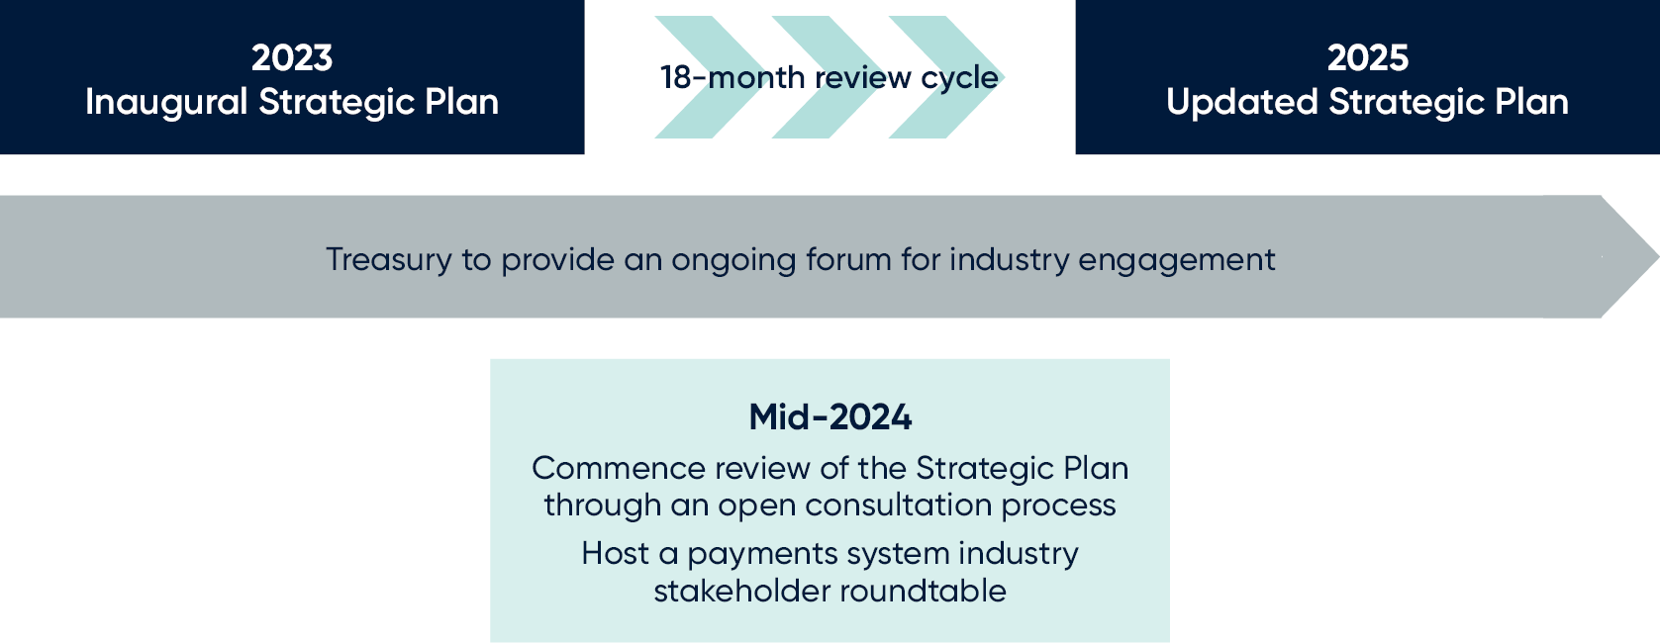

The 18-month review cycle is based on feedback from stakeholders that an annual review of the Strategic Plan would not be desirable. In arguing for a longer review cycle stakeholders noted the long timeframes required for Government to complete stakeholder consultation processes and noted several industry and Government payments system initiatives had long implementation timeframes where limited change may be observed year-to-year.

Annexure 1: Regulatory Framework
The regulatory framework for Australia’s payments system is determined by the Government, regulators, and key industry bodies. This section briefly outlines the role of the Government, the mandates of each regulator, and the role key industry bodies play in coordinating industry initiatives and maintaining key systems.

The Government
The Government designs and, through the Parliament, implements laws that determine the regulatory architecture for the payments system. Besides its rule-making function, the Government is uniquely positioned to provide high-level strategic direction for the payments system due to its role in setting system-wide policy.
The Government has a role in setting the overarching direction for the payments system by influencing the focus of agencies and regulators. A clear overarching direction from Government is critical for the payments system as the range of activities undertaken by businesses in the payments system cuts across the remit of several regulators. This feature of the payments system necessitates policy and regulatory responses to be coordinated and aligned.

Regulators

The Reserve Bank of Australia (RBA) and the Payments System Board (PSB)
The RBA is the primary payments system regulator, covering the wholesale, retail and commercial payments systems. The RBA’s payments system policy is determined by the PSB, which sits within the RBA.
The RBA’s regulatory powers are set out under the Payment Systems (Regulation) Act 1998 (PSRA), Payment Systems and Netting Act 1998, and Cheques Act 1986. In determining the RBA’s payments system policy, the PSB must exercise its responsibility in a way that best contributes to:
- controlling risk in the financial system;
- promoting the efficiency of the payments system; and
- promoting competition in the market for payment services, consistent with the overall stability of the financial system.
The responsibilities of the PSB are broad, covering both the high-value wholesale payments system and retail and commercial systems, which have high transaction volumes but are of lower value.
The Payment Systems (Regulation) Act 1998 (PSRA) is the primary regulatory framework governing payment systems. It authorises the RBA to impose regulatory requirements on participants in designated payment systems where it is in the public interest to do so. Intervention and regulatory action is generally preceded by industry consultations to explore non-regulatory solutions first. Regulation is developed by the RBA closely with industry and relevant parties.

Australian Prudential Regulation Authority (APRA)
APRA is responsible for prudential regulation, including the licensing of Authorised Deposit-taking Institutions (ADIs). APRA, alongside the RBA, also has the power to authorise the provision of Purchased Payment Facilities (PPFs), which are facilities that store funds for the purpose of making payments.
Specifically, APRA supervises providers of PPFs that have payment obligations of over $10 million (with deposit-like features), which are redeemable in the Australian currency and are ‘widely available’ (more than 50 users). The provision of PPFs is treated as ‘banking business’ and providers are regulated as a special class of ADI.

Australian Securities and Investments Commission (ASIC)
ASIC’s role in regulating the payments system includes licensing financial service providers and overseeing the ePayments Code to ensure consumer protection for electronic payments. ASIC licenses entities that deal in a financial product. Most relevantly for payment service providers, ‘non-cash payment’ facilities are a defined type of financial product under the Corporations Act 2001.
A person makes a non-cash payment if they make payments, or cause payments to be made, other than through the physical delivery of Australian or foreign currency in the form of notes or coins. ASIC updates the contents of the ePayments Code and undertakes targeted compliance. The currently voluntary Code provides important consumer protections in relation to electronic payments, including ATM, eftpos, credit and debit card transactions, online payments, and internet and mobile banking. The Code provides key consumer safeguards and sets out the circumstances in which a financial institution will be liable to reimburse customers who lose money to an ‘unauthorised transaction’.

Australian Transaction Reports and Analysis Centre (AUSTRAC)
AUSTRAC has a role as a payments regulator under Australia’s Anti-Money Laundering and Counter-Terrorism Financing (AML/CTF) Act 2006. AUSTRAC regulates ‘designated financial services’ under the AML/CTF Act and imposes reporting requirements on entities in the financial system that provide those services. Designated financial services required to register with AUSTRAC include remittance services, digital currency token services, and the issuance of stored-value cards that have stored-value above a certain threshold.

Australian Competition and Consumer Commission (ACCC)
The ACCC has a wide remit on competition, consumer, and merger matters – as dictated by the Competition and Consumer Act 2010. In the payments system, the ACCC generally uses its powers to investigate potentially anti-competitive behaviour, while also playing a role in assessing and authorising mergers (as seen with the eftpos, BPAY and NPPA merger in 2021).
The ACCC is also progressing the Digital Platform Services Inquiry report which is being delivered in bi-annual interim reports until 2025. The 5th Interim Report released in November 2022 made recommendations to address consumer and competition issues, including recommending a new competition framework for designated digital platforms to be subject to service specific codes. Treasury consulted on these recommendations and the government is considering their response to the report. The next interim report is due to be submitted to the Treasurer in September 2023 and will consider potential competition and consumer issues and benefits from the expanding ecosystem of digital platform providers in Australia.

Reserve Bank of Australia (RBA), Payment Systems Board Annual Report 2022 (2022) RBA website.
NewPayments Platform Association (NPPA), NPP October 2022 Roadmap (2022) NPPA website.
RBA, Payment Systems Board Annual Report 2022 (2022) RBA website.
As above.
As above.
RBA, Payments Data [C5.1 Cheques – Original Series] (2023) RBA website.
RBA, Payment Systems Board Annual Report 2022 (2022) RBA website.
RBA, RBA Bulletin (March 2023) Payments The Cash-use Cycle in Australia (2023) RBA website.
RBA, Payment Systems Board Annual Report 2022 (2022) RBA website.
Australian Bureau of Statistics (ABS), Australian National Accounts (2022) ABS website.
Australian Competition and Consumer Commission (ACCC), Targeting scams: Report of the ACCC on scams activity 2022 (2022) ACCC website.
Australian Payments Network (AusPayNet), Australian Payment Fraud 2022 (2022) APN website.
Treasury, Review of the Australian Payments System – Final report (2022) Treasury website; Council of Financial Regulators (CFR), Regulation of Stored-value Facilities in Australia: Conclusions of a Review by the CFR, (2020) CFR website; Senate Select Committee on Australia as a Technology and Financial Centre, Select Committee on Australia as a Technology and Financial Centre Final report (2021) Australian Parliament House website; Parliamentary Joint Committee on Corporations and Financial Services Parliamentary Joint Committee on Corporations and Financial Services: Mobile Payment and Digital Wallet Financial Services (2021) Australian Parliament House website; and RBA, Review of Retail Payments Regulation Conclusions Paper (2021) RBA website.
Stored value facilities are facilities that enable funds to be stored for the purpose of making future payments. CFR recommended changes to how stored value facilitates are regulated, including reducing the number of responsible regulators and simplifying requirements commensurate with risks to consumers and the payments system. See CFR, Regulation of Stored-value Facilities in Australia: Conclusions of a Review by the CFR, (2020) CFR website.
RBA, An Efficient, Competitive and Safe Payments System (2022) RBA website.
As above.
RBA, Payment Systems Board Annual Report 2022 (2022) RBA website.
For example, this would include considering how to improve the experience and outcomes for customers who disclose domestic and family violence. See Centre for Women’s Economic Safety, Designed to Disrupt: Reimagining banking products improve financial safety (2022) Centre for Women’s Economic Safety website.
RBA, Speech: The Shift to Electronic Payments – Some Policy Issues (2023) RBA Website.
Australian Prudential and regulation Authority (APRA), Media Release: APRA launches public consultation on banks points of presence data (2023) APRA website.
AusPayNet, Device Statistics: Number of ATMs and POS devices in Australia (2023) APN website.
RBA, The Cash-use Cycle in Australia (2023) RBA website.
See Australia Post, Bank@Post (2023) Australia Post website.
RBA, Speech: The Shift to Electronic Payments – Some Policy Issues (2023) RBA website.

