

Modernising individual tax residency

Consultation paper

July 2023

© Commonwealth of Australia 2021

This publication is available for your use under a [Creative Commons Attribution 3.0 Australia](http://creativecommons.org/licenses/by/3.0/au/deed.en) licence, with the exception of the Commonwealth Coat of Arms, the Treasury logo, photographs, images, signatures and where otherwise stated. The full licence terms are available from <http://creativecommons.org/licenses/by/3.0/au/legalcode>.

Creative Commons attribution licence 3.0 icon. 

Use of Treasury material under a [Creative Commons Attribution 3.0 Australia](http://creativecommons.org/licenses/by/3.0/au/deed.en) licence requires you to attribute the work (but not in any way that suggests that the Treasury endorses you or your use of the work).

*Treasury material used ‘as supplied’.*

Provided you have not modified or transformed Treasury material in any way including, for example, by changing the Treasury text; calculating percentage changes; graphing or charting data; or deriving new statistics from published Treasury statistics — then Treasury prefers the following attribution:

*Source: The Australian Government the Treasury*

**Derivative** **material**

If you have modified or transformed Treasury material, or derived new material from those of the Treasury in any way, then Treasury prefers the following attribution:

*Based on The Australian Government the Treasury data*

**Use of the Coat of Arms**

The terms under which the Coat of Arms can be used are set out on the Department of the Prime Minister and Cabinet website (see [www.pmc.gov.au/government/commonwealth-coat-arm](http://www.pmc.gov.au/government/commonwealth-coat-arm)s).

**Other uses**

Enquiries regarding this licence and any other use of this document are welcome at:

Manager  
Media and Speeches Unit  
The Treasury  
Langton Crescent   
Parkes ACT 2600  
Email: [media@treasury.gov.au](mailto:media@treasury.gov.au)

# Contents

Contents iii

Consultation process 1

Request for feedback and comments 1

Individual tax residency 2

Background 2

The Board of Taxation’s review of the residency rules 2

The former Government’s 2021-22 Budget announcement 2

Consultation objectives 2

Key features of the Board’s proposed model 3

Introduction 3

The Board’s two-step approach 4

Design features that Treasury seeks input on 5

A 45-day threshold 5

The Factor Test 6

The Ceasing Long-Term Residency Rule 9

Overseas Employment Rule 10

Double tax treaty interactions 11

Other matters 11

Appendix 1 – Flowchart from the Board’s report 12

Appendix 2 – Consultation questions checklist 14

# Consultation process

## Request for feedback and comments

While submissions may be lodged by email or by post, email is preferred. For accessibility reasons, please submit responses sent via email in a Word or Rich Text Format (RTF) format. An additional PDF version may also be submitted. All information (including personal information such as name and address details) contained in submissions will be made available to the public on the Treasury website unless you indicate that you would like all or part of your submission to remain in confidence. Automatically generated confidentiality statements in emails are not sufficient for this purpose. If you would like only part of your submission to remain confidential, please provide this information clearly marked as such in a separate attachment.

All submissions will be published on the Treasury website unless they have been marked as confidential.

Legal requirements, such as those imposed by the *Freedom of Information Act 1982*, may affect the confidentiality of your submission.

Closing date for submissions: 22 September 2023

|  |  |
| --- | --- |
| Email | individualtaxresidency@treasury.gov.au |
| Mail | Assistant Secretary, Personal and Small Business Tax Branch  Personal and Indirect Tax and Charities Division  The Treasury  Langton Crescent  PARKES ACT 2600 |
| Enquiries | Enquiries can be initially directed to the Personal Rates and Thresholds Unit |
| Phone | 02 6263 2111 |

The details of the framework outlined in this paper have not received Government approval and are not yet law. Consequently, this paper is merely a guide as to how the framework might operate.

# Modernising individual tax residency

## Background

### The Board of Taxation’s review of the residency rules

1. In May 2016, the Board of Taxation (the Board) commenced a self-initiated review, including extensive consultation of individual tax residency. In August 2017, the Board presented its findings to the former Government in *Review of the Income Tax Residency Rules for Individuals* (the 2017 report), concluding that the rules are no longer appropriate and require modernisation and simplification.
2. The former Government responded to the 2017 report in May 2018 by asking the Board to undertake further consultation to ensure that the new rules could be appropriately designed and targeted. In September 2018, the Board released its *Review of the Income Tax Residency Rules for Individuals: Consultation Guide (*the 2018 consultation guide)*.* The Board conducted a series of roundtable consultations and received written submissions in response to the 2018 consultation guide.
3. In 2019 the Board released its final report *Individual Tax Residency Rules – a model for modernisation* (the 2019 report) to the former Government. The 2019 report made 22 recommendations, the principal recommendation being to replace the income tax residency rules for individuals with the Board’s proposed model. The Board sought to ensure that the model’s design was consistent with the principles of adhesive residency, certainty, simplicity, and integrity. The 2019 report also identified aspects of the Board’s proposed model that could benefit from further consideration and testing.

### The former Government’s 2021-22 Budget announcement

1. On 11 May 2021, the former Government announced that it would replace the individual tax residency rules with a new, modernised framework, based on the model recommended by the Board in its 2019 report. The 2021-22 Budget measure is estimated to have an unquantifiable impact on receipts, but is not designed to raise more tax. Rather, the new framework simplifies the tax system and reduces compliance costs for individuals and employers.
2. The primary test for establishing residency will be a simple ‘bright line’ test – a person who is physically present in Australia for 183 days or more in any income year will be an Australian tax resident. Individuals who do not meet the primary test will apply secondary tests to determine their residency status. These tests will be based on measurable, objective criteria.

## Consultation objectives

1. The objective of this consultation process is to inform the development of robust principles that will underpin an enduring framework for individual tax residency and to seek community feedback. The outcomes of consultation will help to inform the Government’s decision on whether to proceed with this measure.
2. Given the Board’s 2019 report was prepared before the COVID-19 pandemic, this consultation process also provides an opportunity to test whether the new framework produces appropriate outcomes in all circumstances.
3. This consultation paper builds on the Board’s 2019 report, which can be found at <https://taxboard.gov.au/consultation/reforming-individual-tax-residency-rules-a-model-for-modernisation>.
4. When drafting your submission, you may answer all the discussion questions raised below or only the questions relevant to you. The consultation questions appear at the end of each relevant section throughout the paper and again in Appendix 2.

## Key features of the Board’s proposed model

### Introduction

1. The former Government’s 2021-22 Budget announcement noted that the new, modernised framework for individual tax residency would be based on the model proposed by the Board in its 2019 report.
2. The Board sought to ensure that the model’s design was consistent with the following four principles[1]:
   1. **Adhesive residency**: It should be harder to cease being a tax resident than it is to become a tax resident. Once an individual has spent sufficient time in Australia and made enough connections to become a tax resident, it is appropriate for the individual to remain a tax resident until those connections are scaled back to such an extent that they no longer benefit from their connection to Australia enough to justify being taxed as a resident. Adhesive residency is a feature of the existing rules (e.g. the domicile test) and is consistent with international practice.
   2. **Certainty**: The rules that determine whether an individual is a tax resident should be straightforward, providing clear and consistent outcomes for most individuals. Unlike the existing rules, there should be clear thresholds for confirming when a person becomes, and ceases to be, a tax resident.
   3. **Simplicity**: Even individuals with complicated fact patterns should know with certainty whether they are a tax resident. The rules should balance the time spent in Australia against other connections to Australia and remove opportunities for subjective interpretation.
   4. **Integrity**: Individuals who have close ties to Australia should not be able to manipulate the system to pay less than their fair share of Australian income tax.
3. In accordance with these principles, the Board’s model has the following features[2]:
   1. Physical presence is the primary measure of residency – moving Australia to closer alignment with international practice.
   2. The rules focus on Australian connections – such that, for the most part, two individuals with identical physical presence and other connections to Australia have the same residency outcomes.
   3. The rules apply only objective criteria, removing any requirement to test intention or undertake broad, holistic examinations of all relevant facts and circumstances.
4. The Board designed its model to maintain existing outcomes where appropriate, so as to minimise disruption and revenue implications.

### The Board’s two-step approach

1. The Board’s proposed model adopts the following two-step approach:

#### Step 1 – Primary tests

1. **The 183-day Test:** The Board proposed that the primary test would be a simple 'bright line' test – a person who is physically present in Australia for 183 days or more in any income year would be an Australian tax resident[3]. The benefits of such a test include:
   1. It would be clear that most individuals who are physically present in Australia are tax residents.
   2. For globally mobile individuals, this would be a major simplification of the existing rules, providing certainty and aligning Australia with international practice.
   3. Limiting the day count to an income year, without having to consider other factors, would provide certainty over the test period, allowing a person’s residency status to be determined at the end of the income year or earlier.
2. To address concerns that an individual would be able to manipulate the 183-day test by spending 183 days in Australia across two income years, the Board proposed secondary tests, based on 45 days of physical presence and other factors, that indicate the individual has a sufficient connection with Australia to be treated as a resident for tax purposes.
3. **The Government Officials Test:** This test would replace the outdated Commonwealth superannuation test. It would ensure that government (including federal, state and territory) officials deployed overseas in the service of an Australian government are tax residents throughout their deployment. An individual who meets the Board’s proposed Government Officials Test would be a tax resident, despite not meeting the 183-day test or the secondary tests.

#### Step 2 – Secondary tests – Commencing/Ceasing Residency

1. An individual who is not a tax resident under Step 1, would need to consider Step 2. The applicable test under Step 2 would depend on whether the individual was a tax resident in the previous income year.
2. An individual who was not a tax resident in the previous income year would need to apply the **Commencing Residency Test** to determine whether they have become a tax resident in the current income year.
3. An individual who was a tax resident in the previous income year would need to apply one of three rules under the **Ceasing Residency Test** to determine whether they have ceased being a tax resident in the current income year.
   1. The **Overseas Employment Rule** would apply to long-term residents who take up an employment opportunity overseas for over two years.
   2. The **Ceasing Short-Term Residency Rule** would apply to individuals who have been tax residents for less than three income years, being the current year and the two immediate prior years.
   3. The **Ceasing Long-Term Residency Rule** would apply to individuals who have been tax residents for three or more income years (being the current year and the two immediate prior years).
4. The Board designed the secondary tests to streamline and simplify the existing rules and remove inconsistent outcomes. To achieve this, the tests employ targeted, objective criteria, with no requirement to test intention or undertake broad, holistic examinations of all relevant facts and circumstances.
5. The Commencing Residency Test and the Ceasing Residency Test are set out in the flowchart in Appendix 1.

## Design features that Treasury seeks input on

1. The new framework will provide a set of clear rules that encapsulate what it means to be a tax resident of Australia. These rules will be based on the key features of the Board’s model discussed above.
2. Although outcomes will be different for some individuals under the new framework, the new framework is not intended to raise more tax, or to treat more people as either residents or non-residents than under the existing framework. However, residency applies in a tax law environment where some people may pay more tax as a resident than they would if they were a non-resident and vice versa. This is because, while tax residents benefit from the tax-free threshold, lower tax rates, and certain tax concessions (such as the CGT discount and the main residence exemption), they may be taxable on their worldwide income (subject to the temporary resident concessions and the operation of Australia’s double tax agreements). On the other hand, whereas non-residents are taxed only on their Australian sourced income, they are taxed at higher non-resident rates with no tax-free threshold, and do not have access to all tax concessions.
3. The intention is to formulate broad principles that will ensure a modern, robust and enduring framework. This will mitigate against the need for a list of complex rules that will need to be adjusted through time to address newly identified issues.
4. These design goals are important to keep in mind when responding to the consultation questions below.

### A 45-day threshold

1. Under the Board’s proposed model, the secondary tests would require an individual to be physically present in Australia for a minimum of 45 days in an income year before commencing residency, or a maximum of 45 days in an income year before ceasing residency.
2. Setting a standard day count for all secondary tests introduces simplicity into the framework.
3. The Board recommended 45 days as the threshold for the following reasons:
   1. 45 days is longer than the normal annual leave period of 4 weeks.
   2. A 45-day period would ensure that tourists and other short-term visitors did not become residents. This view was based on 2018 migration data showing that the median stay in Australia for tourists and other short-term visitors was 11 days and the vast majority of short-term visitors (which includes visiting Australians) stayed in Australia for less than two months.
   3. Comparable jurisdictions use a similar day count for certain aspects of their residency rules:
4. In New Zealand, an individual ceases to be a tax resident if they spend 325 days or more outside New Zealand in a 12-month period (i.e. less than 40 days in New Zealand).
5. Under the United Kingdom’s (UK) Statutory Residence Test, an individual is automatically treated as tax non-resident if the individual was not a UK tax resident in any of the three prior tax years and spent less than 46 days in the UK in the tax year in question.
6. Under the Board’s model, an individual would not become a tax resident merely by being physically present in Australia for 45 days. The individual would also have to meet at least two of the four factors outlined in *The Factor Test* below.
7. The Board favoured applying the same day count across all the secondary tests (and to a single income year) for simplicity and certainty, acknowledging there would be trade-offs with flexibility.
8. The 45-day threshold was proposed by the Board in 2019, before the COVID-19 pandemic. This consultation process provides an opportunity to test whether the 45-day threshold is appropriate in all circumstances.
9. A strict day count ensures that residency outcomes are clear, the rules are administrable, and disputes are avoided. Allowing days to be excluded in certain circumstances may undermine these benefits.

|  |
| --- |
| **Consultation questions**   1. How many days in an income year should an individual with strong connections to Australia be able to spend in Australia before they are considered a tax resident? 2. Do you consider that days spent in Australia under certain circumstances should be disregarded for the purposes of the 45-day count? If so, why should days be excluded in some circumstances and not others. Who would decide? |

### The Factor Test

1. The existing residency rules require a holistic examination of an individual’s facts and circumstances, with particular importance being given to an individual’s intention. This creates uncertainty, increases the likelihood of disputes, and raises compliance costs. These issues were key in persuading the Board to recommend modernising the residency rules.
2. Although the new framework is based on the principle that residency should depend primarily on physical presence, the Board recognised the need for a second level of testing that relies on both physical presence and objective and identifiable facts and circumstances. This testing of facts and circumstances is called the Factor Test. The Factor Test focusses on a limited number of specific connections an individual may have to Australia.
3. As the Board explained in its 2019 report, ‘The Factor Test applies for arriving individuals who have spent significant time in Australia (45 to 182 days), and short-term residents who have only spent minimal time in Australia in a single income year. In both of these circumstances, two factors are required to establish that the individual is a resident.’[4]
4. The Factor Test is intended to simplify the operation of the law significantly while mirroring the existing rules to a certain extent. After analysing relevant case law, the Board identified that the Courts relied on four primary factors (excluding intention) in determining an individual’s residency status under the existing rules and accordingly set these as the four factors for the Factor Test.
5. In other words, the Board selected the four factors for the Factor Test because of their proven relevance to residency. An individual who meets any of these four factors has a stronger connection to Australia than someone who does not.
6. In line with the guiding principles of simplicity and certainty, and the strong relevance of the four factors to residency, the Board considered that these factors should be relatively simple to satisfy. This will minimise circumstances where residency hinges on disputes about the existence of factors.
7. In accordance with the adhesiveness principle, under which it should be harder to cease being a resident than it is to become a resident, the Board recommended that a short-term resident remain a resident while they retain at least two factors and that a long-term resident remain a resident until they have spent less than 45 days in Australia for three consecutive income years. These tests are designed to perform a similar function to the current domicile test but are much easier to apply. They depend on a person’s connections to Australia, not their connections to a place overseas.
8. The Board designed the Factor Test to produce outcomes similar to the current rules but in a simpler, more streamlined way. They do not require a holistic examination of all relevant facts and circumstances, nor do they depend on an individual’s intention. Similarly, they do not rely on complex common law concepts or technical terms. They test Australian connections only, such that two individuals with the same connection to Australia are treated similarly. They also align broadly with the rules in the residence articles in Australia’s double tax treaties.
9. During their initial consultation process, the Board considered a points-based test, but decided against this approach in favour of the Factor Test. The Board opted for the Factor Test over a points-based test because the Factor Test is simpler for individuals to apply in a self‑assessment system.
10. The four factors proposed by the Board are: the right to reside permanently in Australia, close family ties in Australia, access to Australian accommodation, and Australian economic interests. These four factors are explained below.

#### Right to reside permanently in Australia

1. Under the Board’s model, an individual would meet this factor if they have a permanent right to reside in Australia for immigration purposes. This includes citizenship and permanent residency.
2. The right to reside in Australia (whether through citizenship or permanent residency) indicates a strong connection to Australia. Including this as a factor is consistent with the principle that residency should be adhesive.

#### Australian family

1. Under the Board’s model:
   1. An individual would meet this factor if their spouse, or any of their children under the age of 18, lived in Australia on an ongoing basis at any time during the income year.
   2. This factor would not include other family relationships, such as parents of adult children, adult siblings, or grandchildren.
2. The family factor is intentionally crafted to be based on identifiable and objective family relationships. In this way the factor identifies individuals with strong connections to Australia, without requiring an investigation into the quality and nature of the individual’s relationships.

#### Australian accommodation

1. Under the Board’s model, an individual would meet this factor if they had a legal right or arrangement to access accommodation at any time during the income year, with the following qualifications:
   1. The accommodation must be residential in nature.
   2. It would include a licence to occupy residential accommodation.
   3. It would include property owned by an individual who moved overseas and retained access to the property, regardless of having an intention to sell or rent it.
   4. It would exclude property owned but rented out for the entire income year (refer to Australian economic interests below).
   5. It would exclude a mere expectation of living with a parent or other relative when visiting Australia for short periods. However, an individual could still meet the factor notwithstanding the absence of a legal right to accommodation, if the nature of their arrangement was such that accommodation was available to them.
2. In addition, to aid simplicity and avoid disputes about the existence of accommodation, where an individual has a legal right to accommodation, the factor would be met, irrespective of whether the individual considers the accommodation to be available to them.

#### Australian economic interests

1. Under the Board’s model, an individual would meet this factor if they had any of the following Australian economic connections:
   1. Employment in Australia – they commonly (not infrequently) carried out their employment duties in Australia, regardless of whether their employer was an Australian resident or a foreign resident.
   2. Active participation in the carrying on of a business in Australia - they controlled (directly or indirectly), or played a significant role in, the operations or management of a business in Australia.
   3. Direct or indirect interests in Australian assets – they had an interest in taxable Australian property, a bank account with an Australian bank with significant cash deposits, an interest in a family trust, or they received Australian social security payments in the preceding income year.

|  |
| --- |
| **Consultation questions**   1. Could any of the four factors be defined differently to better achieve the design goals whilst remaining objective and identifiable? 2. Are there other factors better suited to identifying individuals strongly connected to Australia in an objective, simple and certain way? 3. How would any additional factors affect the proposed Factor Test, in particular the operation of the two-out-of-four aspect of the rule?   *Commencing residency*   1. Does having three points of connection (i.e. being physical present in Australia for more than 45 days in an income year, together with two factors) strike the right level of connection to commence residency?   *Ceasing short-term residency*   1. Does maintaining two points of connection to Australia (i.e. meeting two factors) strike the right level of connection to maintain residency in income years during which an individual is physically present for less than 45 days? 2. If not, how should the Ceasing Short-Term Residency Rule operate to strike the appropriate balance between adhesive residency, certainty and simplicity? |

### The Ceasing Long-Term Residency Rule

1. Under the Board’s proposed model, a long-term resident would cease to be a tax resident if they spent less than 45 days in Australia in the current income year, and less than 45 days in Australia in each of the two preceding income years.
2. The rationale behind this test is that, consistent with the existing rules (in particular the resides and domicile tests), residency should be harder to lose for long-term residents than for short‑term residents, given their stronger connection with Australia. However, the proposed rules will be much easier to apply than either the resides test or the domicile test, which require a holistic assessment of all relevant facts and circumstances, including the individual’s intention and their connections to both Australia and overseas jurisdictions. Instead, this test relies simply on day counts over three income years.
3. The Board explained in its 2019 report, ‘By replacing the current rules with a clearer standard, the long-term resident test clearly identifies individuals with more enduring ties to Australia and increases the level of adhesiveness while allowing those individuals to conclusively determine when they break residency.’[5]
4. A three-year standard is consistent with comparable overseas jurisdictions. For example, the Republic of Ireland’s Ordinarily Resides Test produces similar outcomes. The UK’s Statutory Residency Test and Norway’s residency rules also include tests using a three-year period, while India adopts a four-year test period.
5. The Board recommended against incorporating the Factor Test into the Ceasing Long-Term Residency test on the basis that a person who leaves Australia permanently could remain a resident forever if they retained sufficient factors, despite never setting foot in Australia again.
6. Under the Board’s proposed model, an individual would be a long-term tax resident if they were a tax resident for three or more consecutive years. To avoid inappropriate outcomes for temporary visa holders, the Government is considering treating ‘temporary residents’ as long‑term residents only if they have been a tax resident for six or more consecutive years. This is on the basis that a student visa can be granted for up to five years, and that skilled temporary visas are generally granted for four years. A temporary visa holder may be a ‘temporary resident’ for tax purposes if their spouse is not an Australian citizen or a permanent resident for migration purposes.

|  |
| --- |
| **Consultation questions**   1. Does the Ceasing Long-Term Residency Rule strike an appropriate balance between increasing adhesiveness of residency for individuals with enduring ties to Australia while also providing a clear pathway to non-residency?   *Temporary residents*   1. Is it appropriate to only treat a ‘temporary resident’ as a long-term resident if they have been a tax resident for six or more consecutive years? (Note that other individuals will be treated as long-term residents if they have been a tax resident for three or more consecutive income years.) |

### Overseas Employment Rule

1. The outcome of the existing tax residency rules can be uncertain, and the consequences significant, for the many Australians assigned to work overseas in any given year. It is possible under the current rules to cease being a tax resident immediately upon departing Australia if the Commissioner is satisfied that the individual has settled permanently in another country and abandoned their residence in Australia. However, whether this is the case is often far from clear.
2. Uncertainty about residency status can increase the costs of individuals taking up overseas employment opportunities. This creates a barrier for employees wanting to leave Australia temporarily in order to return with the benefit of deeper skills and professional experience gained overseas.
3. During consultation, the Board received feedback that the rules should provide certainty for Australian expatriates assigned overseas for over two years during their employment with Australian and multinational employers, but without departing too significantly from the current rules. As a result, the Board developed a streamlined test, referred to as the Overseas Employment Rule.
4. The Board’s Overseas Employment Rule recommended a mechanism for long-term Australian tax residents to immediately cease being a tax resident, irrespective of the strength of their connection to Australia, where they depart Australia to take up overseas employment, whether as part of a secondment or with a different employer. Under the proposed rule, the individual will cease to be a tax resident once they depart Australia if:
   1. the individual is a long-term resident, i.e. a person who has been an Australian tax resident for the three consecutive income years prior, or a temporary resident who has been a tax resident for at least six income years;
   2. the individual has accepted an offer of overseas employment for a period of more than two years from when the employment commences;
   3. accommodation is available in the place of employment for the duration of the employment contract; and
   4. the individual returns to Australia for less than 45 days in each income year during the term of their overseas employment.
5. In the 2019 report, the Board highlighted that additional integrity measures could be developed for the Overseas Employment Rule. As such, the following integrity measures have been developed for further consideration:
   1. Not allowing the rule to be used where the employer and the individual are associates. This will prevent overseas employment arrangements being established simply as a pathway to immediately becoming a non-resident.
   2. Requiring individuals to notify the ATO that they have elected to apply the overseas employment rule. This will provide the ATO with visibility of individuals who may be inappropriately applying the rule.
   3. Treating individuals who apply the overseas employment rule and are subsequently found ineligible, as never having ceased to be a tax resident under this rule. This makes the Overseas Employment Rule more robust and prevents people from benefiting by ceasing residency through misuse of the rule. Note that individuals will eventually cease residency under the Ceasing Long Term Residency Rule if they limit the amount of time they spend in Australia in accordance with that rule.

|  |
| --- |
| **Consultation questions**   1. The Overseas Employment Rule allows individuals with enduring connections to Australia to immediately cease being a tax resident, thereby reducing the tax and compliance burden for those individuals and their employers. Do the settings strike the appropriate balance between facilitating the skill development of Australians through international experience while maintaining sufficient integrity? 2. The effect of the Overseas Employment Rule is to cause the individual to become a non-resident (and provide certainty for employees and their employers) rather than to exempt the overseas employment income. Is this the appropriate outcome? |

### Double tax treaty interactions

1. Despite the Board’s recommendation that the new rules align domestic tax residency with outcomes under double tax agreements, the Government is not planning to adopt this recommendation at this stage. Although such a rule may help eliminate manipulation of the tax system, it would likely make it more complicated for many taxpayers with otherwise simple tax affairs.

### Other matters

|  |
| --- |
| **Consultation question**   1. There will be a need for transitional rules when moving from the existing residency rules to the new framework. How would you suggest these transitional rules operate? For example, how should the Overseas Employment Rule apply to individuals who are already part-way through their overseas employment at the time the new residency rules come into effect? 2. Do you have any other insights or observations to make about the framework? |

1. Appendix 1 provides a flowchart illustrating the Board’s proposed model. Please note this flowchart is an extract from the Board’s 2019 report. It does not reflect Government policy or any changes canvassed in this consultation paper.
2. Appendix 2 contains a list of all the consultation questions.

# Appendix 1 – Flowchart from the Board’s report

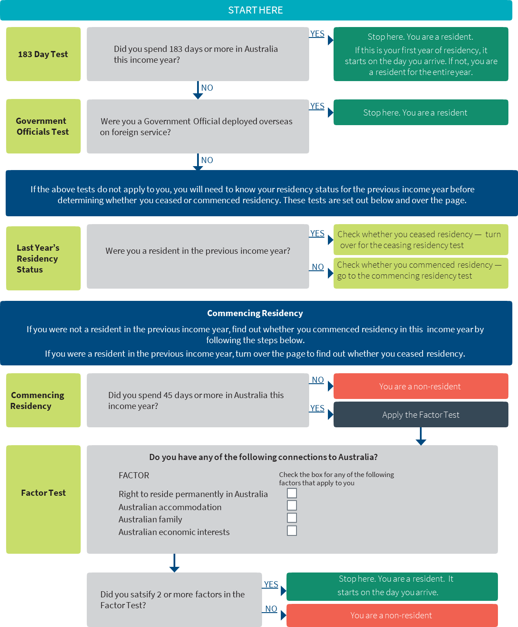

**NOTE: This flowchart is an extract from the Board’s 2019 report. It does not fully reflect Government policy or any changes canvassed in the consultation paper**

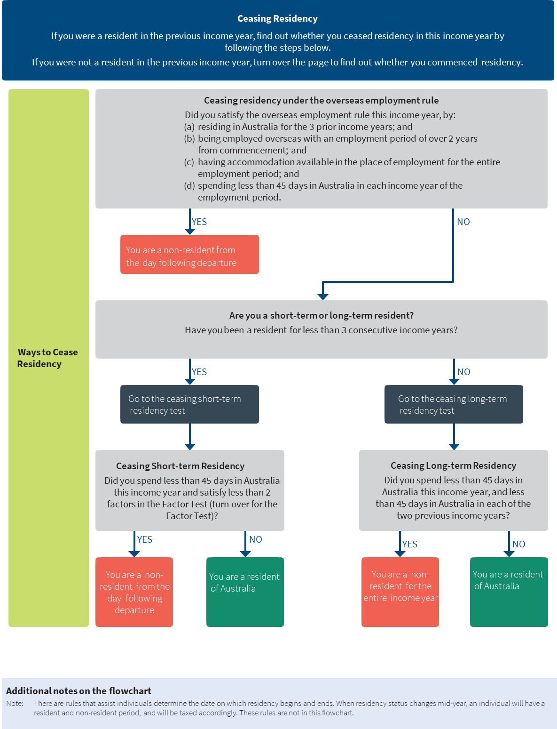

**NOTE: This flowchart is an extract from the Board’s 2019 report. It does not fully reflect Government policy or any changes canvassed in the consultation paper**

# Appendix 2 – Consultation questions checklist

*45-day threshold*

1. How many days in an income year should an individual with strong connections to Australia be able to spend in Australia before they are considered a tax resident?
2. Do you consider that days spent in Australia under certain circumstances should be disregarded for the purposes of the 45-day count? If so, why should days be excluded in some circumstances and not others. Who would decide?

*Factor tests*

1. Could any of the four factors be defined differently to better achieve the design goals whilst remaining objective and identifiable?
2. Are there other factors better suited to identifying individuals strongly connected to Australia in an objective, simple and certain way?
3. How would any additional factors affect the proposed Factor Test, in particular the operation of the two-out-of-four aspect of the rule?

*Commencing residency*

1. Does having three points of connection (i.e. being physical present in Australia for more than 45 days in an income year, together with two factors) strike the right level of connection to commence residency?

*Ceasing short-term residency*

1. Does maintaining two points of connection to Australia (i.e. meeting two factors) strike the right level of connection to maintain residency in income years during which an individual is physically present for less than 45 days?
2. If not, how should the Ceasing Short-Term Residency Rule operate to strike the appropriate balance between adhesive residency, certainty and simplicity?

*Ceasing long-term residency*

1. Does the Ceasing Long-Term Residency Rule strike an appropriate balance between increasing adhesiveness of residency for individuals with enduring ties to Australia while also providing a clear pathway to non-residency?

*Temporary residents*

1. Is it appropriate to only treat a ‘temporary resident’ as a long-term resident if they have been a tax resident for six or more consecutive years? (Note that other individuals will be treated as long-term residents if they have been a tax resident for three or more consecutive income years.)

*Overseas employment rule*

1. The Overseas Employment Rule allows individuals with enduring connections to Australia to immediately cease being a tax resident, thereby reducing the tax and compliance burden for those individuals and their employers. Do the settings strike the appropriate balance between facilitating the skill development of Australians through international experience while maintaining sufficient integrity?
2. The effect of the Overseas Employment Rule is to cause the individual to become a non-resident (and provide certainty for employees and their employers) rather than to exempt the overseas employment income. Is this the appropriate outcome?

*Other matters*

1. There will be a need for transitional rules when moving from the existing residency rules to the new framework. How would you suggest these transitional rules operate? For example, how should the Overseas Employment Rule apply to individuals who are already partway through their overseas employment at the time the new residency rules come into effect?
2. Do you have any other insights or observations to make about the framework?

1. Page 8 of the 2019 report
2. Page 5 of the 2019 report
3. From either 1 July or their date of arrival, depending on whether they were a tax resident in the previous income year.
4. Page 80 of the 2019 report
5. Page 49 of the 2019 report