Employment behaviour of firms reliant on temporary migrants
Prepared by Phillip Womack
Summary
Australia’s international border closure led to a 25 per cent decline in the number of temporary migrants in Australia. This article uses Single Touch Payroll (STP) and visa data from February 2020 through to December 2022 to show that firms with higher temporary migrant workforce shares experienced greater initial declines in jobs following the COVID-19 shock and recovered more slowly. This trend is only partially explained by industry and regional exposure to lockdowns. Sectors significantly affected included accommodation and food services, administrative services (such as building cleaning) and some retail segments (such as fuel). These industries were highly impacted by lockdowns and also relied on temporary migrants for more than 10 per cent of their workforces. Even when comparing firms in the same industry and region, firms that were more reliant on temporary migrants faced bigger declines in employment and took longer to recover.
Firms adjusted by finding alternative sources of labour and using labour more intensively. Firms with high reliance on temporary migrants increased employment of other workers, partially offsetting the declines in the number of temporary migrants. Increases in monthly average pay were observed, likely driven by increases in hours worked but also potentially increased hourly wages. These increases were more significant for temporary migrant workers, who continued to have lower average pay than other workers. Once borders opened, employment recovered across all firms and the average pay of migrants normalised.
Finally, greater turnover declines were observed for firms that were highly reliant on temporary migrants, suggesting these firms struggled to adjust to lower supply of temporary migrants. All firms have responded since borders reopened by hiring more temporary migrants with the average pay of domestic workers increasing by more than temporary migrants.
- Temporary migrant workers
  - The prolonged closure of Australia’s international border led to a sharp decline in temporary migrant workers
The number of temporary migrants in Australia declined by 25 per cent between March 2020 and December 2021 (Chart A1, Appendix). This was driven by a 44 per cent decrease in the number of student visa holders and an 84 per cent decrease in working holiday visa holders. Many temporary visa holders transferred to bridging visas which increased by 30 per cent. Through Treasury’s Business Liaison Unit and ABS Business Conditions and Sentiments survey, firms have reported this decline in temporary migrants over the COVID-19 period was a key obstacle to attracting the workers they needed. This note explores how firms highly reliant on migrants prior to COVID-19 responded to this shock.
Firms had a number of options for how they could respond to the sharp decline in temporary migrants:
- Increase number of employees – Replace lost workers through employment of other labour
- Increase hours per employee – Replace lost workers through increasing the use of already employed labour
- Improve wages and conditions – Offer increased pay to attract more labour or more productive labour
- Substitute capital for labour – Increase capital investment or utilisation
- Decrease output – Decrease production, due to insufficient supply of labour.
Where the decline in temporary migrants had a modest impact on total labour supply, firms could be expected to accommodate the shock by hiring local workers or increasing the hours worked by existing workers (options 1 and 2). However, highly exposed segments of the economy may have struggled to increase labour supply sufficiently, and instead found they needed to improve wages and conditions, substitute capital for labour or decrease total production (options 3, 4 and 5).
How firms chose to adapt to insufficient labour supply at given wages will have impacted how the economy recovered. Improvement in wages and conditions in affected firms could put upward pressure on wage growth across the economy, and substitution towards capital stock could increase the productivity of existing workers. However, if firms can’t make these substitutions easily or expect the shock to be temporary, they may instead temporarily decrease output, which would have slowed Australia’s recovery.
  - High frequency administrative data can be used to unpack changes in employment, total pay and turnover
Single Touch Payroll data, Australian Taxation Office (ATO) Business Activity Statements and Home Affairs visa data was used to analyse how many temporary migrants were employed in each firm prior to COVID-19, and how these firms responded to the decline in temporary migrants. The total number of employees, turnover and total pay to each employee was observed for each firm. However, the number of hours worked by each employee, or their hourly wage, was not observed.
Over the three-year period analysed, new firms were founded, existing firms exited the market and individuals changed visa statuses. To provide a consistent basis for comparison of firms, this analysis focuses on firms that reported payroll data on February 2020 and December 2022 – the first and last periods studied. A firm’s reliance on temporary migrant workers was defined in this analysis as the percentage of their headcount that were temporary migrant workers in the first period, allowing for individual visa status to change over the period.⁵ Finally, the term ‘domestic workers’ is used to refer to all workers who are not temporary migrants – that is, Australian citizens and Permanent Residents.
The differences in performance of firms with high and low reliance on temporary migrants was also examined. The experience of firms with zero to 10 per cent of workers who were temporary migrants is most representative of the average firm’s experience. This category contains 88 per cent of Australian firms and 87 per cent of employees. We compare this cohort’s performance to the performance of firms where (10-40], (40-70], or (70-100] per cent of workers were temporary migrants prior to COVID-19. This comparison was made to understand how firms with different levels of exposure to the decline in temporary migrants adjusted to the shock.
  - Industries, regions and firms that were highly reliant on temporary migrants experienced above average declines in employment
A small group of subsectors and firms were acutely impacted by the fall in temporary migrant workers. Across the economy, 16 per cent of firms relied on temporary migrants for more than 10 per cent of their workforce (Chart A2, Appendix). These firms were concentrated in specific industries and regions. The industries most reliant on temporary migrants were Hospitality, Agriculture, and Administrative Services (Chart 1.1). The impact of the border closure can be observed in headline employment charts for some industries – including Agriculture, Forestry and Fishing – as the number of temporary migrant workers declined at a time when total jobs increased by around 460,000 (Chart A3, Appendix). But in other highly impacted sectors – Accommodation and Food Services – the impact of the border closure was harder to isolate, as the total number of jobs in the sector also declined. At a geographic level, urban areas had a larger share of temporary migrants than regional and remote areas, due to the large number of student visa holders living in cities (Chart A4, Appendix).
        - Pre-COVID-19 temporary migrant share of jobs, by sector and temporary visa type
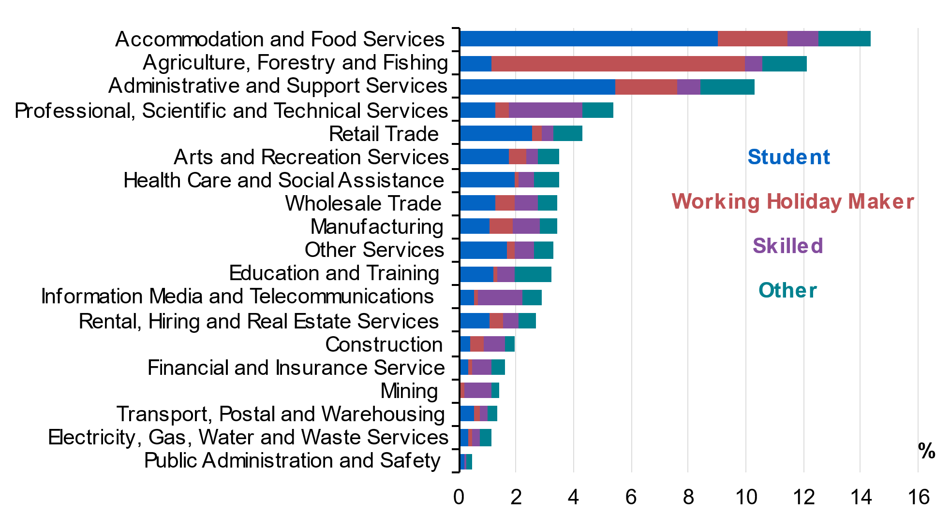
Source: Treasury analysis of tax and visa microdata. Notes: Based on jobs in February 2020, and will reflect any seasonal effects associated with this time of year (which may be particularly pronounced in agriculture).

  - Firms adjusted to this shock by finding alternative sources of labour and decreasing turnover
I now explore the experiences of firms with different levels of reliance on temporary migrants prior to COVID-19 to understand the impact that the decline in the number of temporary migrants in Australia had on business operations. In particular, this analysis examines how these firms adjusted total jobs and average pay through the course of the pandemic. In later analysis (Charts 1.6 and 1.7) we control for firm characteristics that might have given rise to different exposure to lockdowns to try to isolate the effect of border closures.
Chart 1.2 shows that the firms most reliant on temporary migrants saw larger falls in employment and slower recoveries over Feb 2020 to December 2022. While all cohorts of firms examined recovered to above pre-COVID-19 levels by December 2022, the more migrant intensive firms still had lower employment levels for temporary migrants, offset by increased employment of domestic workers (Chart 1.3).
- Change in jobs by firm reliance on temporary migrants, indexed to February 2020 | - STP jobs change, month ending December 2022 compared to February 2020
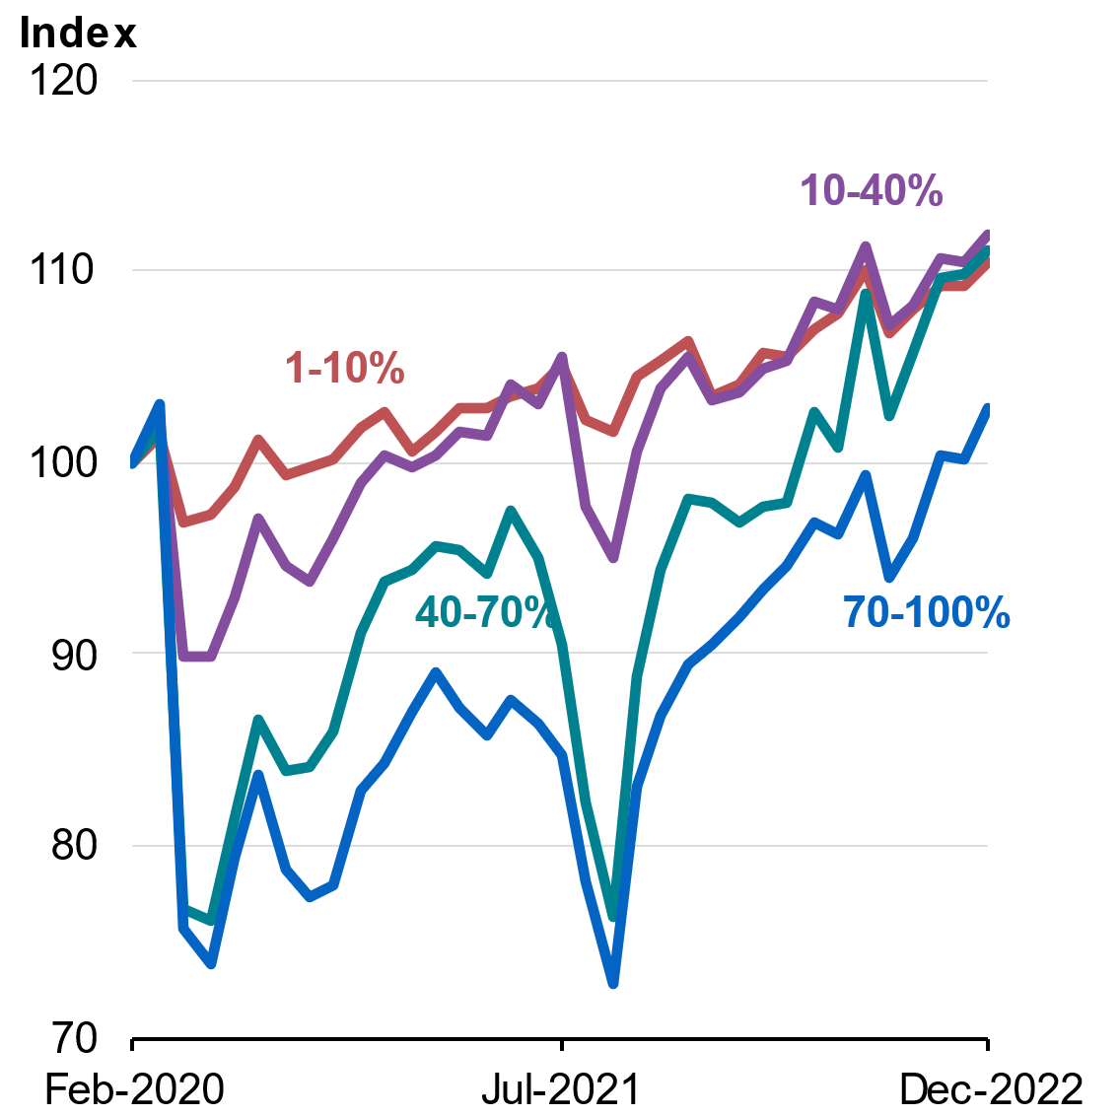 | 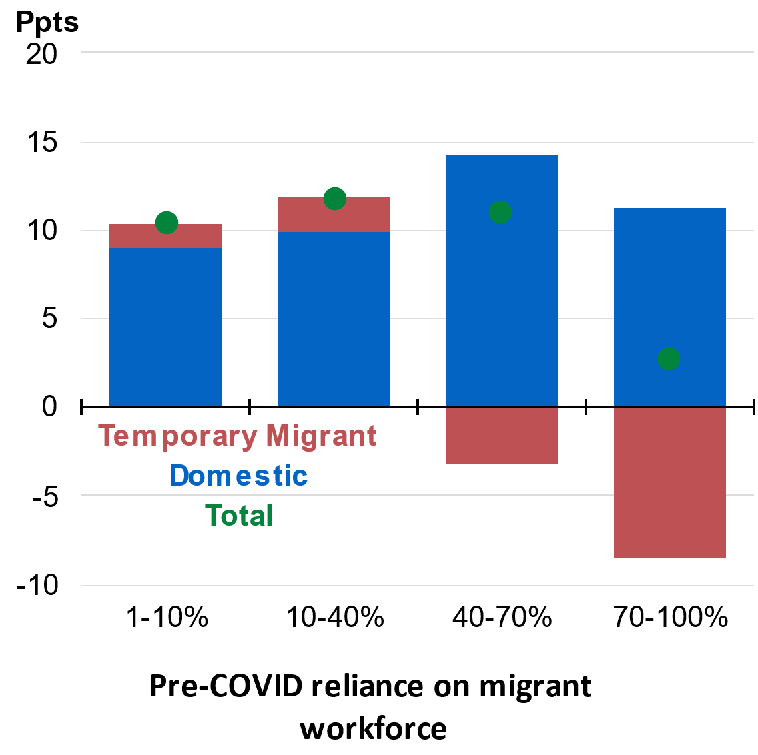
Source: Treasury analysis of tax and visa microdata.  Note: Chart compares cohorts of firms with different reliance  on temporary migrants: 0-10%, 10-40%, 40-70% or 70-100% reliance. | Source: Treasury analysis of tax and visa microdata

In Charts 1.4 and 1.5 I split the time period in two – the period while the border was closed (from February 2020 to November 2021) and the subsequent reopening (from November 2021). In Chart 1.4, Panel A shows that firms that were highly reliant on temporary migrants prior to COVID-19 adjusted by increasing employment of domestic workers while borders were closed. Chart 1.4, Panel B shows that the remaining temporary migrants experienced growth in average pay, especially in highly reliant firms. This is likely explained by an increase in hours worked but could also be due to increased hourly wages.
Once the borders reopened, firms of all levels of migrant reliance were able to hire more temporary migrants. This occurred in the context of temporary visa changes introduced as a response to COVID-19 workforce shortages. Student visa work hours restrictions were temporarily relaxed and then removed until 30 June 2023, and the Pandemic Event Visa allowed people to remain temporarily in Australia if they were working or had a job offer to work in any sector in the economy, with no restrictions on hours. This supports the idea that the growth in average pay was as a result of an increase in hours worked. However, once the borders reopened in November 2021, in the period through to December 2022 there was a large increase in the number of jobs for temporary migrants across firms of all migrant shares with larger increases among firms with previously higher migrant shares (Chart 1.5, Panel A). On the pay side, this resulted in the average pay of temporary migrants declining, particularly among migrant reliant firms (Chart 1.5, Panel B).
        - Changes while border closed (November 2021 compared to February 2020), by firm pre-COVID-19 temporary migrant workforce shares
Panel A: STP jobs change | Panel B: STP average pay change
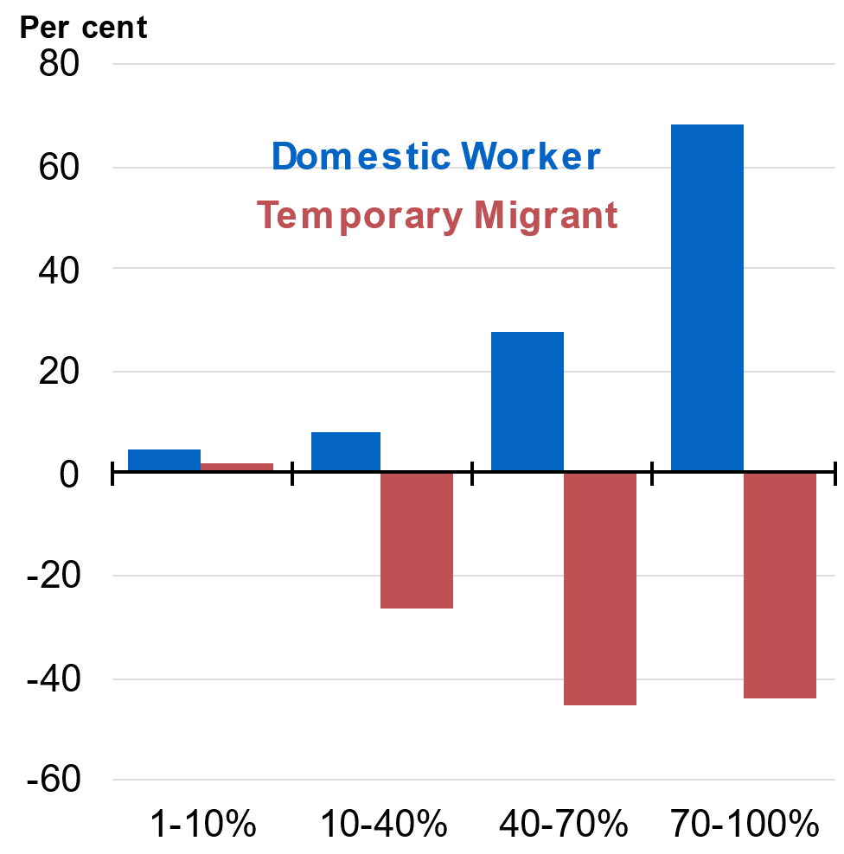 | 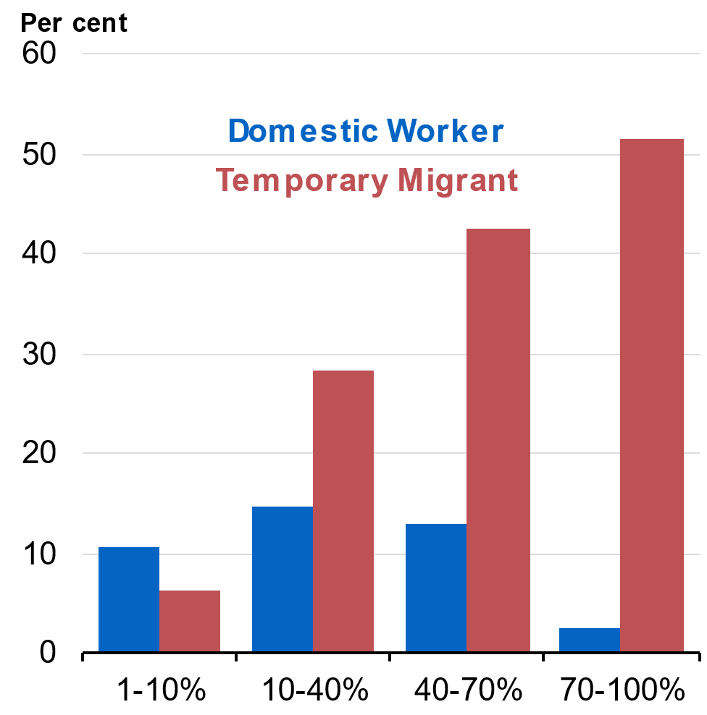
Source: Treasury analysis of tax and visa microdata. | Source: Treasury analysis of tax and visa microdata.
        - Changes after border reopened (December 2022 compared to November 2021), by firm pre COVID-19 temporary migrant workforce shares
Panel A: STP jobs change | Panel B: STP average pay change
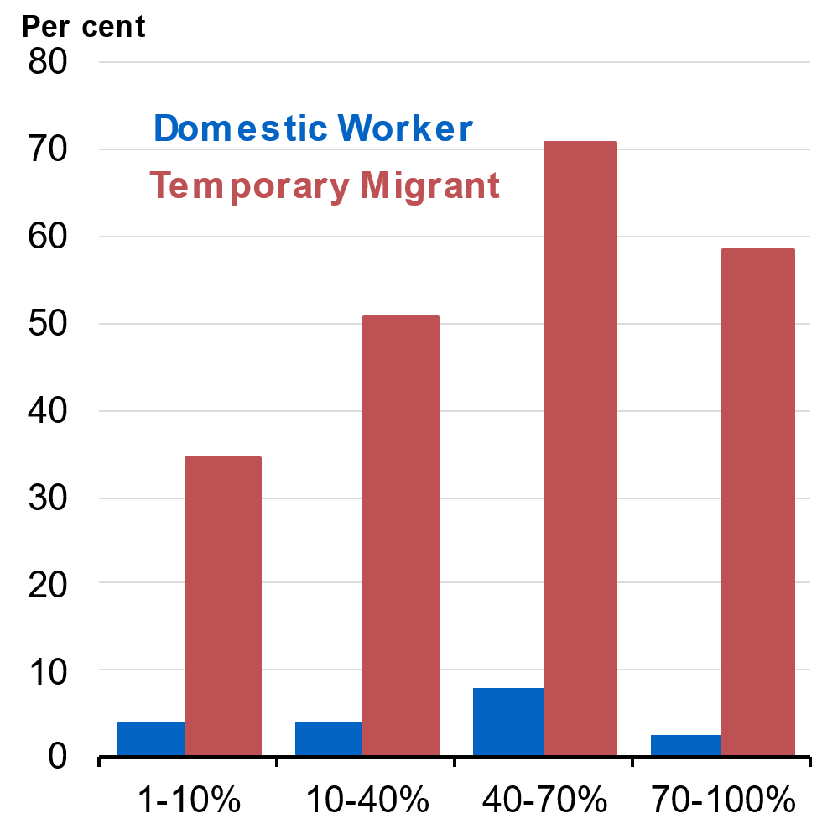 | 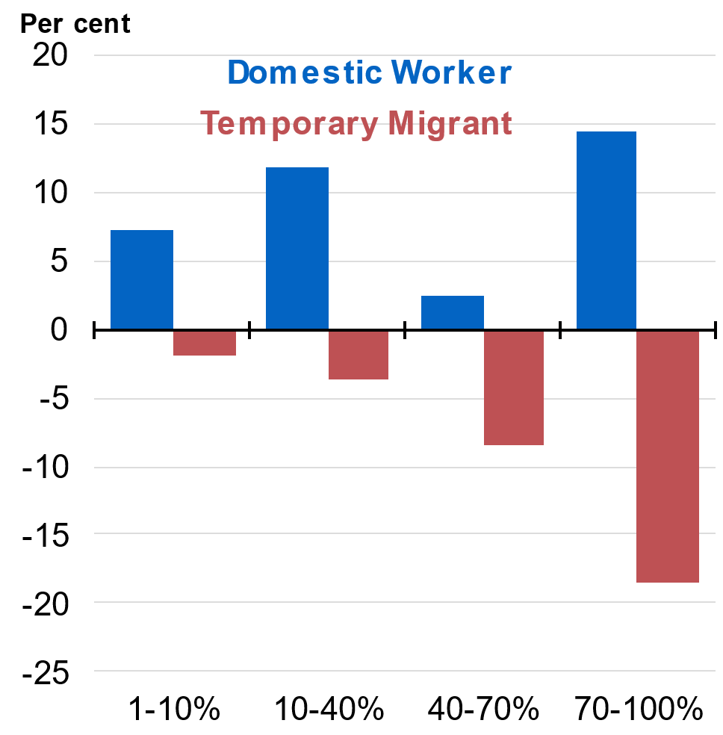
Source: Treasury analysis of tax and visa microdata. | Source: Treasury analysis of tax and visa microdata.

Charts 1.6 and 1.7 compare changes in employment and turnover over time for firms with different levels of reliance on temporary migrants prior to COVID-19 – after controlling for industry, location, and firm size. By controlling for these characteristics, it is possible to assess similar firms operating in the same industry within the same local labour market area and, therefore, likely exposed to similar lockdown restrictions and changes in demand.
In firms where more than 40 per cent of employees had been temporary migrants, employment declined by more than 20 per cent in early 2020 and recovered more slowly prior to the Delta outbreaks in late 2021 (Chart 1.6). The turnover of these firms also decreased by around 18 per cent (Chart 1.7). This indicates that firms highly reliant on temporary migrant workers partly compensated for the decline in workers through finding other sources of labour or capital, but some also responded by decreasing their output.,
- Change in employment, by firm temporary migrant reliance | - Change in quarterly turnover, by firm temporary migrant reliance
Source: Treasury analysis of tax and visa microdata.  Note: This analysis controls for firm-level characteristics  including industry, location and firm size.  This analysis uses an older version of the dataset, which  has slightly different definitions for domestic and migrant workforce. This analysis also focuses only on firms that reported payroll data on 1 March 2020 and 7 November 2021. Therefore, it is not directly comparable to Charts 1.2 to 1.5. | Source: Treasury analysis of tax and visa microdata.  Note: This analysis controls for firm-level characteristics  including industry, location and firm size.  The analysis uses an older version of the dataset, which  has slightly different definitions for domestic and migrant workforce. This analysis also focuses only on firms that reported payroll data on 1 March 2020 and 7 November 2021. Therefore, it is not directly comparable to Charts 1.2 to 1.5.

  - Australian firms have recovered strongly from the closure of the international border
The story of this data is that Australian firms appear to have responded flexibly to the shock caused by the COVID-19 border changes and other associated policy changes – from a labour market perspective. The COVID-19 imposed border closures created labour shortages (particularly in some industry and region combinations) and Australian firms reallocated their labour mix to address these issues. Once the border reopened, the return of temporary migrants helped most firms that relied heavily on migrants to recover their labour headcount to pre-COVID-19 levels. The average pay of migrant workers normalised, which countered the large rises before the border reopened.

Appendix

Chart A1: Number of temporary migrants, by visa class
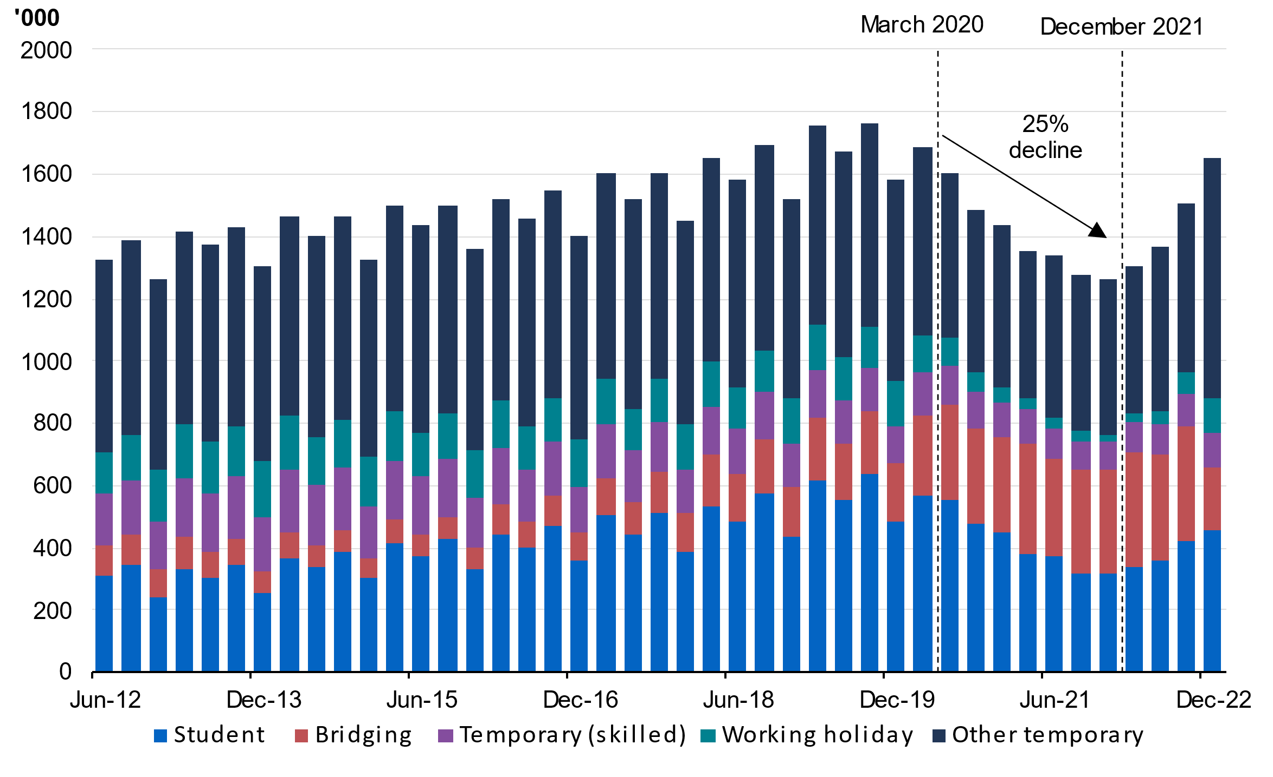
Source: Number of Temporary visa holders in Australia, Department of Home Affairs (30/06/2023).

Chart A2: Distribution of firms and jobs fortnight ending 1 March 2020, by firm temporary migrant reliance
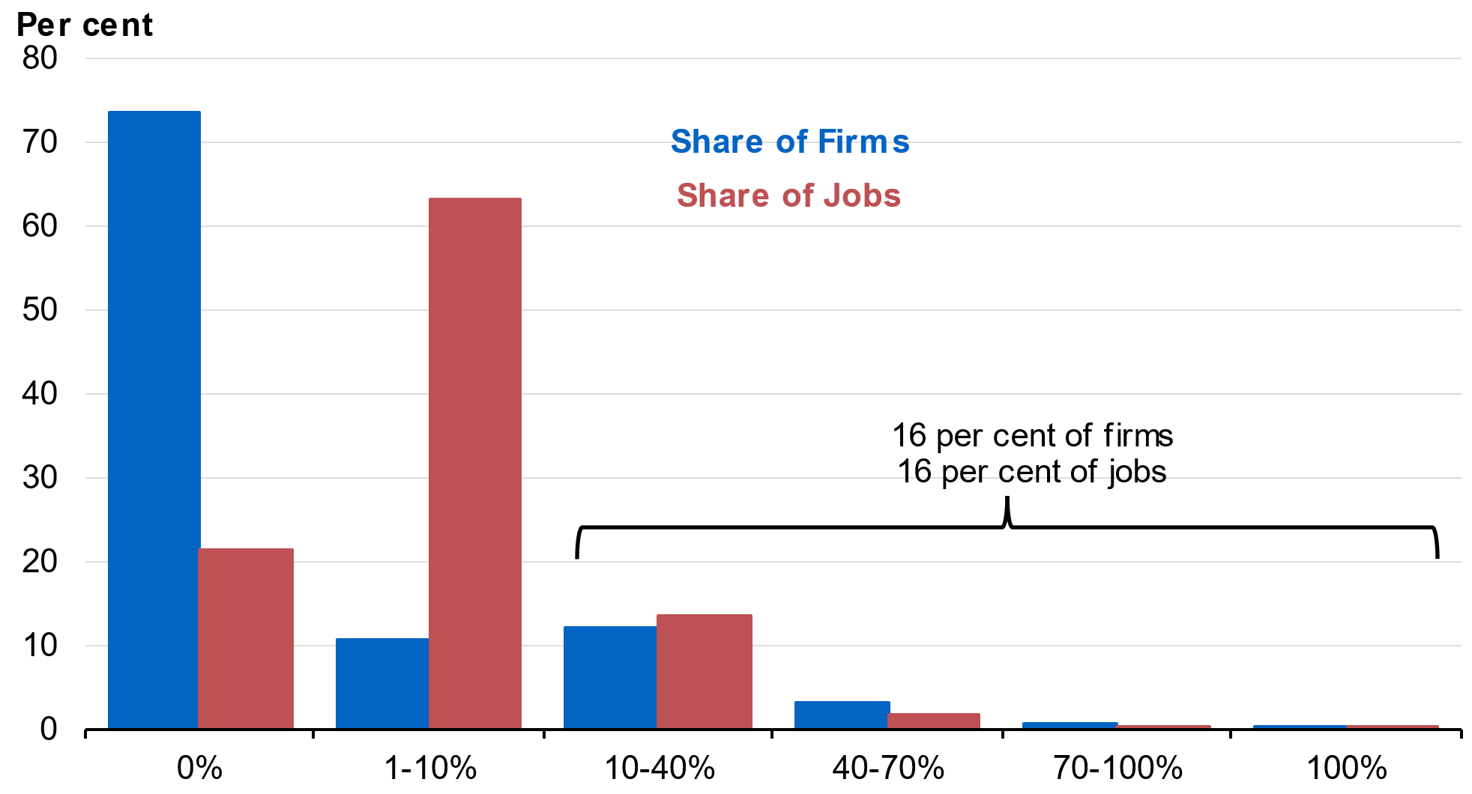
Source: Treasury analysis of tax and visa microdata.

Chart A3: Change in jobs by Industry, February 2020 to November 2021
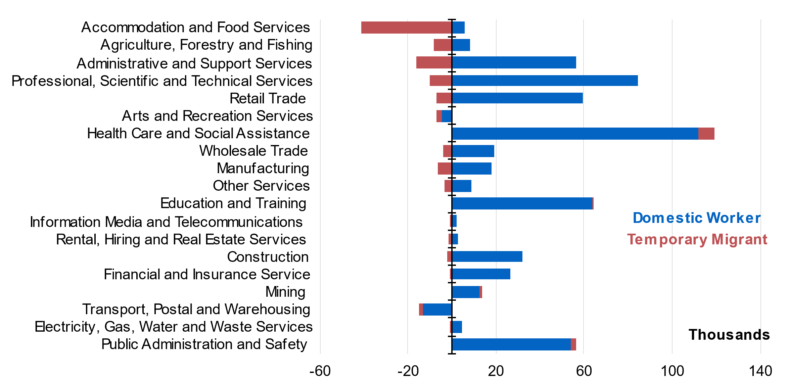
Source: Treasury analysis of tax and visa microdata.

Chart A4: Share of jobs filled by temporary migrants by remoteness and visa type, February 2020
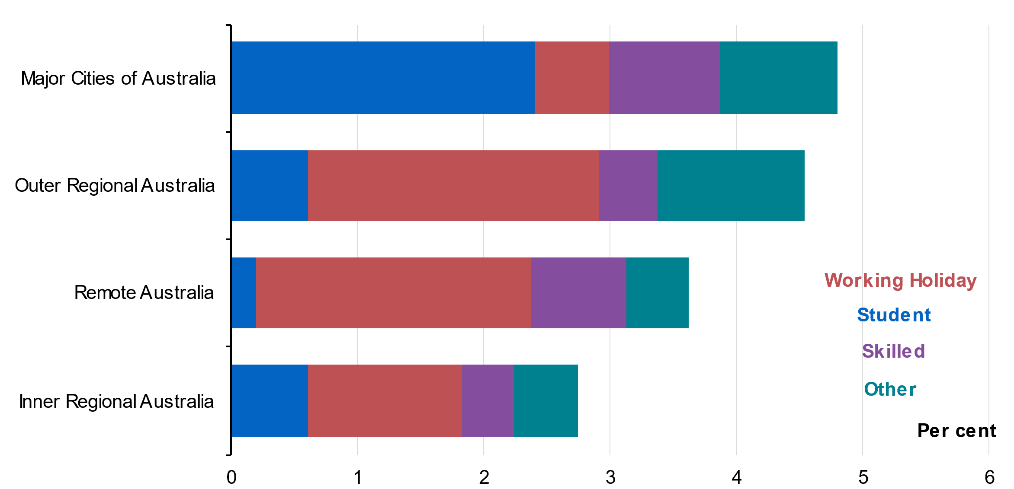
Source: Treasury analysis of tax and visa microdata. Note: Location of workers is determined by firm location.

This article is based on internal work co-authored with Lucille Danks, Nathan Deutscher and Lachlan Vass while working for the Australian Treasury. I would also like to thank Joseph Walters, Grace Nagle, Will Mackey, Jonathan Hambur, Dan Ledda, Rebecca Cassells, Paul Cotterill, Anna Brown, Patrick Fazzone, Aaron Van Bridges, Shaheen Iqbal, Simon Ricketts and Damien White for their feedback and assistance for the note. The views expressed are those of the author and do not necessarily reflect those of the Australian Treasury or the Australian Government.
Number of Temporary visa holders in Australia, Department of Home Affairs as of 31/12/2021. Excludes New Zealand citizens, Visitors and Crew and Transit.
For example, greater use of machines to assist in fruit picking: https://www.abc.net.au/news/rural/2020-11-28/clive-the-robot-fruit-picker-goulburn-valley/12928460.
This may understate the number of jobs lost in some industries, where more jobs were lost through firm exits than were created through the establishment of new firms.
Robustness checks have been completed to ensure the trends reported are not driven by seasonality effects.
See Chart A2, Appendix, for a distribution of firms, total jobs and temporary migrant jobs by firms’ reliance on temporary migrant workers pre-COVID-19. This gives a sense of the relative importance of each grouping, and its contribution to total jobs.
STP data covers around 99 per cent of employers with 20 employees or more. However, employees of small businesses are under-represented, with over 80 per cent of those employing 19 people or less.
This analysis excludes pay from allowances.
Changes in capital investment are not directly analysed in this note due to data limitations.
The JobKeeper payment was in place from 2020 Q2 – 2021 Q1 and this may have affected turnover results for this period.

