File Name: 2012/67

28 September 2012

General Manager
Benefits and Regulation Unit
Personal and Retirement Income Division
The Treasury
Langton Crescent
PARKES ACT 2600

Email: Superamendments@treasury.gov.au

Dear General Manager,

PORTABILITY OF SUPERANNUATION BETWEEN AUSTRALIA AND NEW ZEALAND

The Association of Superannuation Funds of Australia (ASFA) would like to provide this submission with respect to the call for comments on the above exposure draft of legislative amendments to establish a trans-Tasman retirement savings portability scheme and the accompanying explanatory material.
About ASFA
ASFA is a non-profit, non-political national organisation whose mission is to protect, promote and advance the interests of Australia's superannuation funds, their trustees and their members. We focus on the issues that affect the entire superannuation industry. Our membership, which includes corporate, public sector, industry and retail superannuation funds, plus self-managed superannuation funds and small APRA funds through its service provider membership, represent over 90% of the 12 million Australians with superannuation.
General comments on the provisions as drafted
ASFA is supportive of the proposal to facilitate the movement of retirement savings between Australia and New Zealand.
The Superannuation Legislation Amendment (New Zealand Arrangement) Bill 2012: Portability of superannuation between Australia and New Zealand amends the income Tax Assessment Act 1997 to specific the manner in which such transfers are to be treated for the purposes of paying income tax in Australia. The legislation also amends the Superannuation (Government co-contribution for Low Income Earners) Act 2003 and the Taxation Administration Act 1953 to cover necessary reporting arrangements and to ensure that a transfer from New Zealand does not give rise to a Government co-contribution entitlement.

ASFA considers that the provisions as drafted will be effective in achieving the intended outcomes.

Comments on the proposed implementation arrangements
ASFA notes that implementation of the arrangements with respect to benefits being transferred to New Zealand Kiwi Saver Schemes will be dependent on the making of amending regulations to the Superannuation Industry Supervision Act 1994. Some necessary amendments include:
- The creation of a new condition of release with respect to the transfer of benefits to a Kiwi Saver scheme
- Amending regulations to give effect to the restriction in paragraph 6 of the 16 July 2009 Arrangement with respect to Australian Sourced retirement savings from an Australian untaxed source or an Australian defined benefit scheme.
Importantly, to give effect to Paragraph 7 of the 2009 Arrangement that the portability arrangements will be voluntary for providers, amending regulations will be needed prescribing a transfer from an overseas superannuation fund (which would include a Kiwi Saver scheme) as an exception to the rule that a MySuper product must accept all types of contributions. (NB. ASFA suggests that the exclusion be worded in terms of transfers from overseas retirement plans as a precondition of a fund accepting a transfer from a UK fund is that they have agreed to become a Qualifying Registered Overseas Pension Scheme (QROPS). Absent the exclusion, MySuper would effectively require Australian funds to become QROPS and agree to comply with the associated UK legislative requirements.)
Separately to the above, ASFA has concerns around the complexity of the administration arrangements which require transferred amounts to be separately recorded and tracked. Implementing this from an Australian fund perspective will require amendments to database structures and significantly an amendment to the about-to-be-released data standards for rollovers. Whilst acknowledging that accepting these contributions will be voluntary, in practice we consider that market forces will eventually result in all funds considering it necessary to accept these transfers and thus implementing the necessary changes at considerable cost.
Due to the complexity of the changes and the significant amount of already-scheduled IT development work, it would not surprise if a significant number of Australian superannuation funds decided to not accept Kiwi Saver transfers until some-time post mid-2014. Where an Australian account contains a Kiwi Saver component, the member will only be able to rollover those amounts to other funds which accept Kiwi Saver amounts. This will have implications for the operation of the ATO’s new electronic portability form.
A further issue that has not been addressed in the explanatory material is the disclosure obligations of product providers. Where a fund agrees to accept transfers from Kiwi Saver schemes is the obligation on the product provider to advise the member of the implications of the transfer (e.g. the inability of the member to access the transferred amount until age 65) or can the provider rely on the disclosure that was provided when the member joined the Kiwi Saver scheme?
ASFA requests that the Explanatory Material be amended to address the above issues, where relevant, and specifically to make mention of how the Government intends to give effect to paragraph 7 of the Arrangement (voluntary on funds) in light of the current requirement that a MySuper product must accept all types of contributions. ASFA suggests that the second dot point in paragraph 1.9 be expanded to include a statement of intent to specify a transfer from an overseas superannuation as a type of contributions that a MySuper product need not accept.
Finally, it is unclear as to what mechanism will prevent the transfer of a superannuation benefit from a non-complying superannuation fund to a Kiwi saver scheme and then back to a complying Australian fund.

* * * *
If you have any queries or comments regarding the contents of our submission, please contact our principal policy adviser, Robert Hodge via e-mail to rhodge@superannuation.asn.au or on (02) 8079 0806.

Yours sincerely
Margaret Stewart

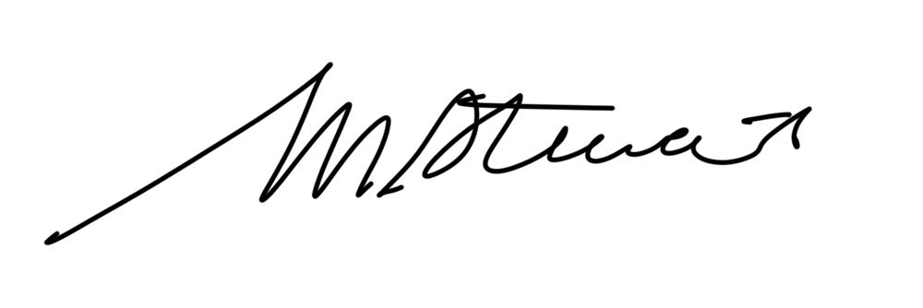

General Manager, Policy and Industry Practice

