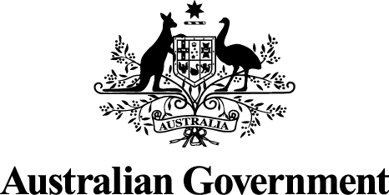
Addressing the high cost of home and strata title insurance in North Queensland
Discussion Paper
9 May 2014

© Commonwealth of Australia 2014
ISBN 978-0-642-74972-7

This publication is available for your use under a Creative Commons Attribution 3.0 Australia licence, with the exception of the Commonwealth Coat of Arms, the Treasury logo, photographs, images, signatures and where otherwise stated. The full licence terms are available from http://creativecommons.org/licenses/by/3.0/au/legalcode.
Use of Treasury material under a Creative Commons Attribution 3.0 Australia licence requires you to attribute the work (but not in any way that suggests that the Treasury endorses you or your use of the work).
Treasury material used ‘as supplied’.
Provided you have not modified or transformed Treasury material in any way including, for example, by changing the Treasury text; calculating percentage changes; graphing or charting data; or deriving new statistics from published Treasury statistics — then Treasury prefers the following attribution:
Source: The Australian Government the Treasury.
Derivative material
If you have modified or transformed Treasury material, or derived new material from those of the Treasury in any way, then Treasury prefers the following attribution:
Based on The Australian Government the Treasury data.
Use of the Coat of Arms
The terms under which the Coat of Arms can be used are set out on the It’s an Honour website (see www.itsanhonour.gov.au).
Other Uses
Inquiries regarding this licence and any other use of this document are welcome at:
Manager
Communications
The Treasury
Langton Crescent Parkes ACT 2600
Email: medialiaison@treasury.gov.au

Consultation Process

Request for feedback and comments

Interested parties are invited to comment on the issues raised in this discussion paper.

While submissions may be lodged electronically or by post, electronic lodgement is preferred. For accessibility reasons, please submit responses sent via email in a Word or RTF format. An additional PDF version may also be submitted.

All information (including name and address details) contained in submissions will be made available to the public on the Treasury website unless you indicate that you would like all or part of your submission to remain in confidence. Automatically generated confidentiality statements in emails do not suffice for this purpose. Respondents who would like part of their submission to remain in confidence should provide this information marked as such in a separate attachment.

Closing date for submissions: Monday, 2 June 2014
Email: | insuranceconsultation@treasury.gov.au
Mail: | Manager  Insurance and Superannuation Unit  Financial System and Services Division  The Treasury  Langton Crescent  PARKES ACT 2600
Enquiries: | Enquiries can be directed to Glen McCrea
Phone: | 02 6263 2559

Contents
Foreword vii
Summary ix
1. the high cost of insurance in North Queensland 1
1.1 Premium levels in North Queensland 1
1.2 Factors contributing to the high cost of insurance in North Queensland 3
2. Competition in North Queensland insurance markets 7
3. Addressing the high cost of insurance in North Queensland 11
3.1 Increasing consumer awareness 11
3.2 Promoting resilience 19
3.3 Expanding North Queensland home and strata title insurance markets 20

Foreword

Over the past few years many policyholders across Australia have faced significantly increased premiums for home, contents and property insurance.
This problem is particularly acute in North Queensland where large and destructive cyclones pose a serious threat to communities and businesses. Strata title property in North Queensland has been subject to some of the largest premium increases, rising by over two hundred per cent between 2007 and 2012. Homeowners in North Queensland are paying premiums around two and a half times higher than their fellow Queenslanders who live in the south of the state.
The Government has announced measures to respond to this problem, including new Australian Government Actuary (AGA) studies into strata building and home insurance pricing.
This discussion paper canvasses further policy options to address the high cost of home and strata title insurance in North Queensland.
This discussion paper calls for business and community input on options to:
- Help consumers to compare insurance products by developing an insurance information and comparison website (or an insurance ‘aggregator’).
- Promote resilience of strata title buildings by facilitating engineering assessments of strata title properties in North Queensland.
- Expand North Queensland insurance markets by encouraging participation by foreign insurers.
We welcome views on the advantages and disadvantages of each option proposed in the discussion paper and how these could be best implemented.
The Government is committed to working with the insurance sector to reduce its regulatory burden while also promoting certainty. This will benefit all Australians. Regulation is not the default position for this Government and will only be imposed where unavoidable.
While committed to deregulation, the Government recognises the importance of the insurance industry in helping Australians to manage risk. Appropriate regulation that complements industry but fills any gaps in private sector efficiency may sometimes be necessary, after the costs and benefits of any such regulation are assessed.
This discussion paper asks for comments on the regulatory impacts that should be taken into account when considering the proposed policy measures. For instance, do the proposed measures impose broad regulatory costs, such as opportunity costs and competition impacts, that should be considered? Where possible, respondents are asked to provide an estimate of the costs incurred in complying with proposed regulation.
The deadline for submissions is 2 June 2014. Further consultation will then be undertaken on any exposure draft legislation and regulations which may be developed following consultation on this paper, and a subsequent Regulation Impact Statement.
We look forward to working with the community and the insurance industry to get the best deal for consumers of insurance policies in North Queensland and across Australia.
Senator the Hon Mathias Cormann
Minister for Finance
Acting Assistant Treasurer

Summary
Insurance is a means of spreading or sharing risk. By purchasing an insurance policy, a consumer can transfer financial risk to his or her insurer in exchange for a regular fee or ‘premium’. Insurance companies are able to diversify risks across a large population. Because the number of insured individuals is so large, insurers can use statistical analysis to project what their claims costs will be. That calculation, together with business costs, taxes and potentially, profit, make up the components of insurance premiums.
In recent years the projected cost of claims for property insurance has risen, in part because of the adverse claims experience brought about by natural disasters. Growth in property insurance prices has outstripped growth in the consumer price index in Australia substantially since 2009. The problem has, however, been particularly acute in certain regions. North Queensland is one such region.
To some extent at least, the disproportionately higher increase in prices in North Queensland reflects the region’s heightened vulnerability to risk. The key risk in the region is from cyclones, but flood risk is relevant in some parts of the region also.
To the extent that insurance premiums in the region reflect the underlying risk, there are grounds for maintaining that they are not inequitable. As a general principle, charging insurance premiums commensurate with the insurable risk is fair, equitable and allows for the efficient allocation of risk and capital. Appropriately priced insurance forces governments, communities and individuals to give attention to the question of mitigating against risk.
However, residents in all areas should be entitled to enjoy the benefits of an efficient market that ensures that prices paid are no more than necessary to reflect the underlying risk. The peculiar risk characteristics of the North Queensland region and the associated lack of participation in its property insurance markets give rise to questions about whether those markets are as efficient as they could be.
In order to ensure that the North Queensland property insurance markets function as effectively as possible, attention should be given to: (a) where possible, reducing the underlying risk; (b) encouraging participation in the markets by insurers; and (c) ensuring that consumers are equipped with the knowledge and ability to compare insurance products and prices and select the most appropriately priced product that meets their needs.
This paper begins by outlining some of the reasons for the high cost of insurance in the North Queensland region, including the greater exposure to natural perils, especially cyclones. It goes on to consider the structure and dynamics of the property insurance markets in the region. Finally, it canvasses a range of options that have been identified in the public debate and in discussions between the Federal and Queensland Governments.
Views are sought on whether one or more of these options would be effective to address the problem of the high cost of insurance in North Queensland. Other options are also welcomed for consideration.
Box 1
Compliance costs
To improve the quality of regulation, the Government is committed to ensuring all regulatory measures undergo a Regulation Impact Assessment to establish the precise impact of regulation on businesses, not-for-profit organisations and individuals. This assessment includes the quantification of compliance costs associated with regulation. To inform this analysis, the Government welcomes information from interested parties.
Where possible, submissions are encouraged to identify whether the proposal would generate additional compliance costs (or savings) compared to the status quo. Note that for new regulation, the base case would be the scenario where there is no regulation. For proposals that amend regulation, the base case would be the previous, non-amended regulatory situation. There are several different types of compliance costs that parties should consider.
- Administrative costs—costs incurred primarily to demonstrate compliance with the regulation or to allow government to administer the regulation (for example, keeping records, filling in forms, conducting internal audits and inspections, making an application or conducting tests).
- Substantive compliance costs—costs that directly lead to the regulated outcome (for example, training, providing information to third parties, inputs to comply with a plan or test, operations, purchase and maintenance of plant and equipment and installing safety devices).
- Delay costs—expenses and loss of income incurred through having to complete an application requirement or wait for an application approval (for example, waiting for approval of a building permit).
Respondents are invited to use the Business Cost Calculator (http://bcc.obpr.gov.au/) to estimate costs. The Government would appreciate being provided with the input parameters to the cost calculator as well as the final result.
Focus Questions
- The Government has committed to identifying (in dollar terms) measures that offset the cost impost to business of any new regulation. What suggestions do you have for how the regulatory compliance burden of any options in this discussion paper can be reduced?

the high cost of insurance in North Queensland

Premium levels in North Queensland
Over recent years, community concerns around the affordability of insurance have increased. This is unsurprising when the recent history of insurance prices in Australia is closely examined. Since 2009, home contents insurance prices have risen at twice the rate of the consumer price index, while home buildings insurance prices have risen at six times the rate of the consumer price index (Figure 1).
Figure 1: Insurance prices and Consumer Price Index
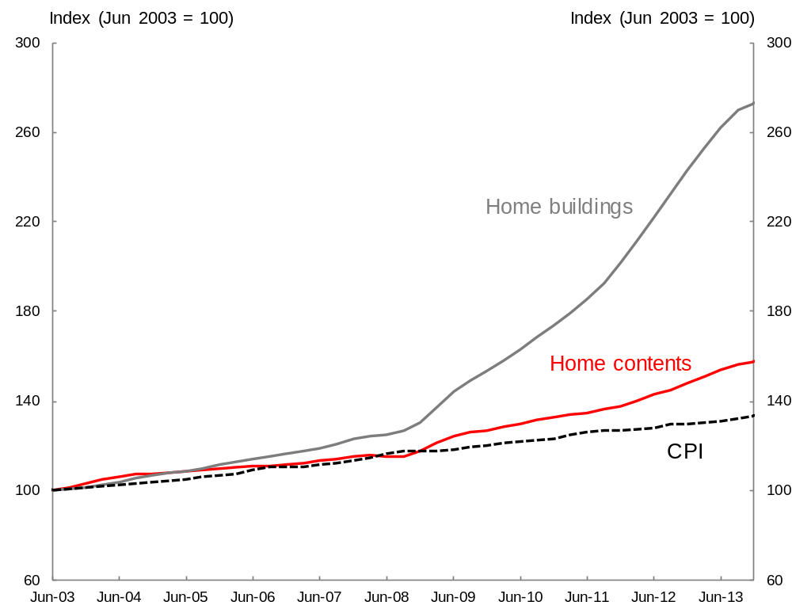
Source: Insurance Council of Australia/Treasury
Increases in home building insurance prices have not, however, been uniform across Australia. Geographic regions which are subject to elevated natural peril risk, such as cyclones and flooding, have experienced larger than average increases. One of the most acutely affected regions is North Queensland.
Average premiums for combined home and contents insurance in North Queensland are around 2.5 times those in Queensland’s southern cities. Average premiums for combined home and contents insurance for a sum insured of about $300,000 for building and $80,000 for contents can range from around $3,000 to around $6,000 per year (for properties with no or negligible flood risk — properties with such risk can attract significantly higher premiums).
Between 2007 and 2012 average increases in North Queensland strata title property insurance prices were around 200 per cent (Figure 2).
Figure 2: North Queensland gross strata title premium rates (index: 2007 rates = 100)
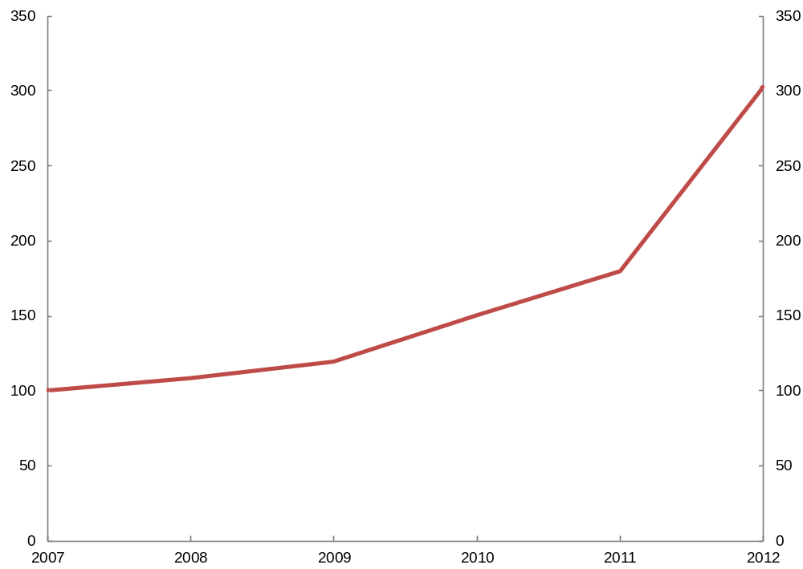
Source: Australia Government Actuary

Affordability of home and strata title insurance in North Queensland
The cost of insurance is an important factor in the financial decisions of households and businesses. High insurance premiums can add to the ongoing costs faced by property owners and renters and can put pressure on household and business budgets. This increases the risk that people and entities may choose to underinsure, not to insure at all or not to live in certain areas.
In relation to strata title buildings, state Government law effectively makes insurance of buildings to full replacement value compulsory, leaving little room for non or underinsurance, but adding considerably to the cost of owning or renting apartments and potentially affecting the value of such dwellings.
In relation to home insurance, the purchase of replacement value cover (or any cover at all) is not mandatory but under or non-insurance is hardly an optimal solution. Underinsurance can have a number of consequences. While underinsurance may allow policyholders to pay lower premiums, parties who underinsure will not have sufficient cover in the event that they make a claim following a natural disaster. This can put households and businesses at risk of financial hardship when they are faced with high out-of-pocket costs in order to rebuild or buy new property.
Focus Questions
- Is home and/or strata title insurance in North Queensland unaffordable, having regard to the price compared to the risks insured?
- What impact is the high cost of insurance in North Queensland having on the local economy?

Factors contributing to the high cost of insurance in North Queensland
Queensland has historically enjoyed a comparatively high share of insurance claim payouts compared to insurance premiums paid. This has been the case both prior to the natural disasters of recent years and since (Figure 3).
Figure 3: Claims incurred as a proportion of gross written premium by State
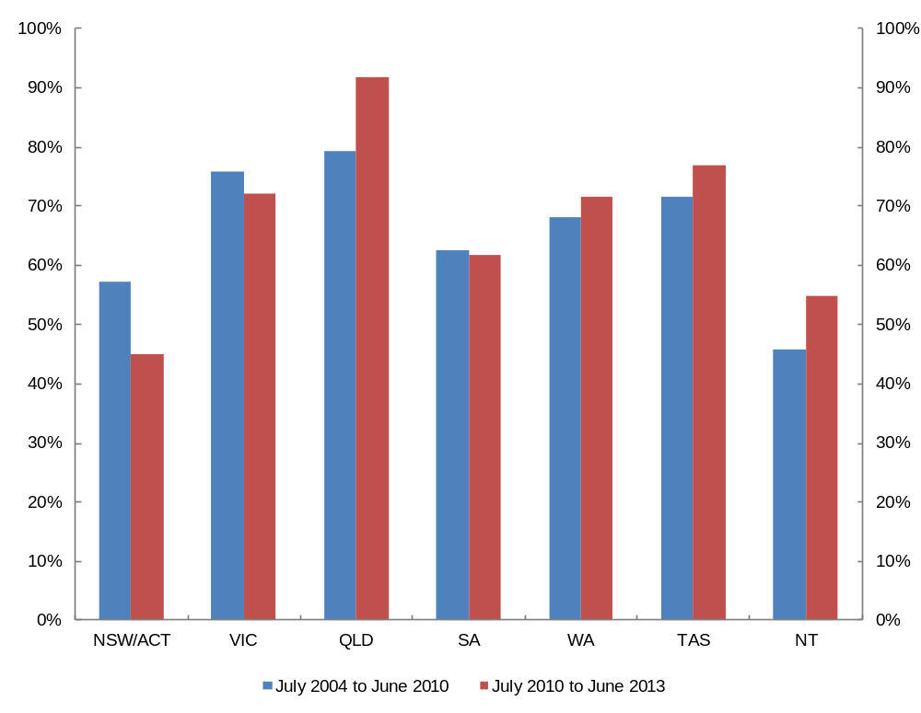
Source: APRA General Insurance Supplementary Statistics, June 2013.
While Queensland has long been exposed to natural hazards, the frequency of extreme weather events and their level of destructiveness appear to have risen significantly since 2006, as is evident in the AGA’s report of 2012. These events caused significant damage with total insurable losses estimated at approximately $3.4 billion.
Against that background, some increase in insurance premiums in Queensland since the recent disasters is unsurprising.
North Queensland is assessed by insurers as being at a higher risk of certain types of peril, especially cyclone, than other parts of the state. This is consistent with the region’s history of severe weather events. Some of the more significant events affecting North Queensland in the last decade include Tropical Cyclone Larry (2006), the Mackay floods (2008), Tropical Cyclone Yasi (2011), and the storms and floods of Tropical Cyclone Oswald (2013).
The occurrence of disasters and the associated insurer losses have been reflected in a fall in insurer profitability since 2006. For example the AGA’s 2012 study showed that profitability for strata title insurance providers in the region over the 2007-2012 period was poor, with base profitability of around minus 30 per cent of premium. This means that for every $100 of premium earned by strata property insurers (including the return on the invested premium), around $130 was spent on claims, commissions and operating expenses.
These results have led insurers and reinsurers to reassess the risk of providing property insurance in North Queensland. Accordingly, as assessment of the level of risk has increased, so have reinsurance prices, and ultimately insurance cover for households. On top of this insurers are now allocating a greater share of the cost of their catastrophe reinsurance cover to North Queensland policies, again in line with their assessment of risk.
The level of cyclone risk, as well as storm risk, has a big impact on premium prices in North Queensland. Storm and cyclone risk now accounts for over half of an average North Queensland home insurance premium, far more than for other Queensland regions (Figure 4).
Figure 4: Portion of average Brisbane and Mackay home insurance premium by peril
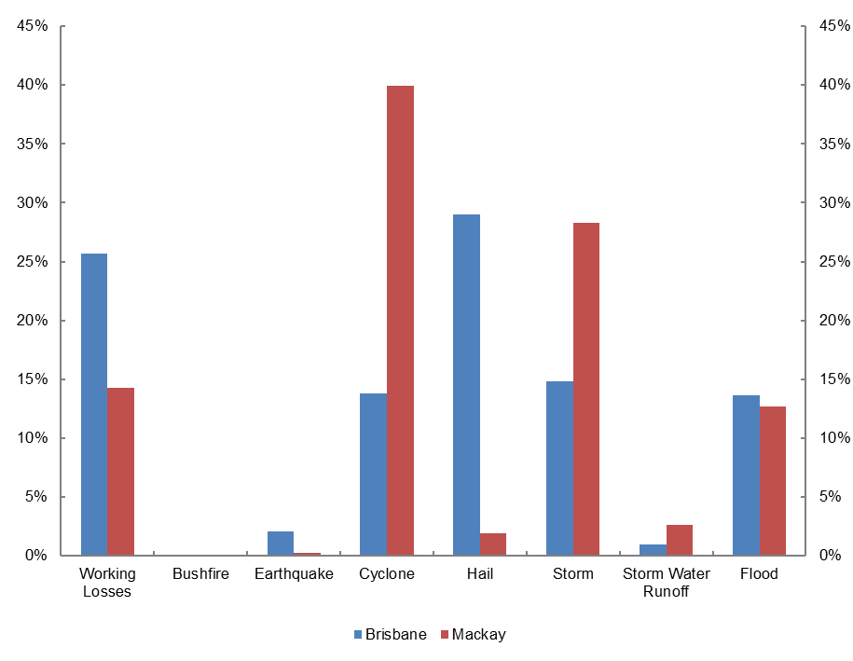
Source: Data provided by industry
In addition to rising claims and the reassessment of risk by insurers and reinsurers, the introduction of flood cover as standard in many home and contents policies, increasing levels of sums insured and increases in the cost of rebuilding have also contributed to increases in property insurance premiums over recent years. These factors go a considerable way towards explaining the high cost of insurance in North Queensland.
However, in order to be sure that the additional price paid for insurance by North Queenslanders does not exceed that justified by the underlying risks, it is necessary that there be a healthy level of competition in the local insurance markets.

Competition in North Queensland insurance markets
The main insurers active in the North Queensland home insurance market are Suncorp (including Vero and APIA), Insurance Australia Group (NRMA and CGU), and RACQ. Other brands with some presence include Allianz, Coles Insurance, Woolworths Insurance, CommInsure, and Westpac Insurance. There are many other insurers active in the Australian market that do not operate in the North Queensland market.
Box 2
Who’s who in insurance — authorised insurers, brands, brokers and representatives
In order to carry on the business of insurance in Australia, insurers must be authorised by APRA. However, authorised insurers can and do sell their products directly or indirectly under their own names, the names of their subsidiaries or brands, through brokers or underwriting agencies, or under the names of third party financial services licensees acting as representatives. For example, Shannons is a company offering motor vehicle insurance for motoring enthusiasts. Shannons is not itself an authorised insurer but is an authorised representative of AAI Limited (an authorised insurer) and, like Shannons, a Suncorp Group company.
There may be instances where many companies appear to be in competition with each other in a certain insurance market, but they are ultimately selling insurance for one underwriter in return for a commission or other remuneration arrangement. Whilst there may be scope in some of these cases for competition between providers, relationships between the representatives and the ultimate insurer are likely to limit the extent or intensity of that competition.
There are around 100 authorised general insurers in Australia. A snapshot of some of those insurers and their distribution networks is provided below. (This list is illustrative only — some of these insurers will have much broader networks of representatives selling their products.)

Table 1: Examples of brands or representatives that sell products issued by major insurers
Insurance Australia Group (IAG) | Suncorp | QBE | Allianz | Auto and General Insurance
Bupa  CGU  HBF  NRMA Insurance  RACV  SGIC  SGIO  Strata Unit Underwriters  Swann Insurance | AAMI  Apia  Bingle  CIL  GIO  InsureMyRide  Just Car Insurance  Longitude Insurance  Resilium  Shannons  Vero | Anchorage Marine  BeyondCover  CHU  Elders Insurance  Insurance Box  Roaming Insurance | 1Cover  American Express Travel Insurance  Allianz Global Assistance  Aussietravelcover  Fast Cover  HSBC Insurance  National Seniors Insurance | 1300 Insurance  1Cover (Car Insurance)  1st for Women  Australia Post (Car Insurance)  BestBuy  Budget Direct  Cashback  Dodo Insurance  GE Money
Only two insurers — IAG (CGU/SUU) and Suncorp (Longitude/Vero) — are at present actively writing new strata title insurance policies in North Queensland. Over recent years, insurers of strata property in the region have exited the market or limited their exposure by only offering renewal business, as in the case of Zurich.
The comparatively low number of insurers active in the North Queensland markets (especially for strata insurance), coupled with the comparatively higher property insurance prices in those markets, have led to speculation that the markets suffer from a lack of competition and, as a consequence, that there is ‘price gouging’ by insurers. In the case of strata title insurance, in his 2012 report, the AGA agreed that competition in the North Queensland market was ‘limited’.
A lack of competition need not, however, be a driver a higher prices. Players in a market with a weak competitive structure can nevertheless price competitively if the market has a high level of contestability (that is if it has low entry and exit barriers). In this circumstance the threat of competition or entry to the market from other players drives competitive behaviour by the existing market players.
However, the peculiar risks to which North Queensland is vulnerable — cyclone in particular — may reduce contestability by raising barriers to entry to the region’s property insurance markets to a level higher than that of the markets in southern regions. This is primarily due to an asymmetry of information between firms in the market with a more sophisticated understanding of the region’s risks and those with a lesser degree of sophistication in that regard.
Understanding the region’s significant exposure to natural perils, especially cyclones, and pricing for it accurately can be a very difficult challenge. This, coupled with the high loss potential associated with cyclones, raises significant hurdles for insurers seeking to enter the market, and deters existing providers from seeking to increase their market share. This view is supported by the observed behaviour of insurance firms in respect of North Queensland.
Some insurers are reticent to increase their risk exposure to the region, while others prefer to limit their exposure to instances where they are seeking to preserve commercial relationships of significance to their national business. For example, insurers who have commercial relationships with banks may choose to continue to offer insurance through their related bank in North Queensland but otherwise not actively seek to increase their exposure to the region. As the AGA noted in his 2012 study, one significant Australian company (QBE) largely avoids the North Queensland region altogether. Many of the recent entrants into the Australian insurance market are also simply not offering home and contents insurance in North Queensland.
A recent example of insurer reticence to take on risk in North Queensland can be found in the ‘One Big Switch’ campaign, which signed up some 70,000 people to negotiate for a discount on home insurance policies. Whilst apparently having some success in attracting a discount provider for some regions (Coles/Wesfarmers Insurance), the campaign failed to attract an insurer that was prepared to offer discounts for properties located in high risk areas including North Queensland.
It seems reasonable, against that background, to conclude that the degree of contestability in North Queensland property insurance markets is lower than for markets in most other Australian regions. It does not necessarily follow that insurance prices are unreasonably high in North Queensland. In his 2012 report, the AGA did not conclude that prices in the region are unreasonably high when assessed against the underlying risk.
Nevertheless, where there are questions over the level of competition or contestability in the markets, a higher degree of confidence that regional consumers are not paying prices that are unreasonable could be achieved if transparency around insurance pricing is enhanced, and reasons for differences in prices are made clear. Options for doing this are discussed below.
Focus Questions
- Is there a lack of competition or contestability in the North Queensland property markets? Is this driving higher prices?
- To what extent is the level of competition or contestability in North Queensland insurance markets affected by uncertainty around the level of risk in the region?

Addressing the high cost of insurance in North Queensland
Due to North Queensland’s level of exposure to risks from natural perils, it may be that its property insurance prices will remain at levels above those of areas less subject to risks. However, there may be measures that can be taken to ensure that premiums in the region are not unreasonably priced.
The most reliable and sustainable means of reducing insurance prices is to reduce the level of underlying risk. In relation to the key risk in North Queensland — cyclone — this means increasing the resilience of buildings, so that less damage is likely to occur if a cyclone hits. The insurance industry is taking some measures in this regard and there is potential for involvement by Government. This option will be discussed further below.
Another way of responding to high prices is to ensure that the insurance markets in North Queensland operate as efficiently as possible. Conditions necessary for this to occur include that consumers have the information they need to make efficient decisions about insurance policies that will suit their needs and the prices of offer for those policies. Options for ensuring this is the case are also outlined below.
The options identified in this discussion paper can be categorised into three broad strategic approaches:
- Increasing consumer awareness
- Promoting buildings’ resilience to natural disasters
- Expanding insurance markets

Increasing consumer awareness

Development of an insurance website/aggregator
Websites that compare different insurance products provided by different insurance providers, typically on price or on product features, have come to be known as insurance ‘aggregators’. The advantage of aggregators is that they reduce transaction costs for consumers by facilitating comparison of features, and sometimes also price, on one website, removing the need for consumers to undertake extensive research on different insurers’ websites.
Where they are used to compare on price, aggregators are considered to increase competition and put downward pressure on prices. They have been particularly successful in the United Kingdom and have been cited as a factor in putting downward pressure on premiums in the motor vehicle insurance market.
Aggregators emerged in the UK in the early 2000s and quickly became popular as they allowed price-conscious customers to minimise their search time for the cheapest price, and gave insurers another complementary sales channel for their business. As a result, the percentage share of UK private motor insurance sold over the internet (with the majority through aggregators) grew from 2 per cent in 2001 to 51 per cent in 2008. Evidence suggests that this percentage has risen further in recent years. In the midst of the success of aggregators in the UK, there has been some regulator concern about the model. The Financial Conduct Authority in the UK has recently initiated a review of price comparison websites for insurance. One concern it has is that:
‘Price comparison websites are a valuable tool for shopping around, but consumers may not be getting the best deal if they focus solely on price instead of the level of insurance cover’.
There are a variety of insurance comparison websites provided by private companies in Australia. These websites include ratings websites (that provide ‘scores’ or ‘awards’ to different insurers), simple features comparisons, and full ‘live quote’ offerings (but only for motor vehicle and private health insurance products). There are currently no home and contents or strata insurance comparison websites operating in Australia to compare the prices of products from multiple underwriters (authorised insurers).
This discussion paper seeks views on whether the development of a website that facilitates comparison of insurance product features and/or prices would empower consumers and reduce transaction costs in a region such as North Queensland or more broadly.
Such a website might take the form of:
- A range of information on insurance products and potentially a periodic report comparing prices offered in the relevant region.
- An aggregator that enables indicative or sample quotes based on basic information supplied by consumers, who would need to be redirected to individual insurers to obtain an individual quote and complete their purchase.
- A ‘live quote’ aggregator providing consumers with a price specific to their property after answering a series of detailed questions, and enabling instant online purchasing.

Consumer information site — price and features comparison
Consumers may often be unaware of the potential benefits in shopping around for insurance, both from the point of view of price, and from that of securing the best combination of terms and conditions (policy features) that suit them.
Benefits from shopping around on price could be demonstrated by publishing quotes on offer from different insurers in respect of particular properties. An example of this approach can be found in the price information published by the Victorian Fire Services Levy Monitor as part of its monitoring of insurance prices following the removal of the Fire Services Levy.
Figure 5: Fire Services Levy Monitor Premium Survey
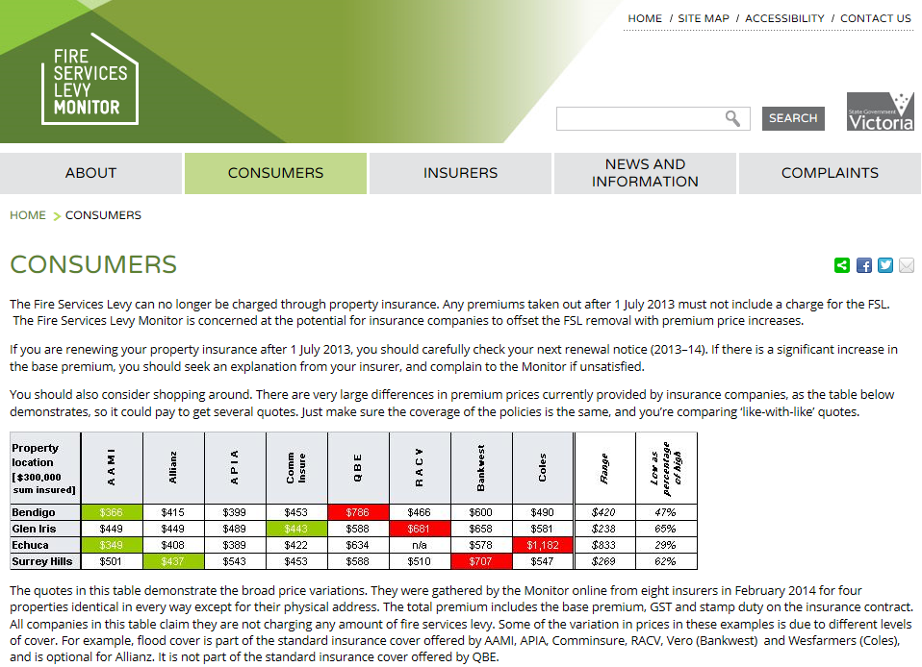
Source: http://www.firelevymonitor.vic.gov.au/home/consumers/.
The Fire Services Levy Monitor is empowered to collect information on insurance pricing under its enabling legislation.
It is important that any website enables comparison not only of price, but of the features of different insurance products. If consumers do not understand the terms and conditions of different products, they may be lured by lower prices into a policy that doesn’t adequately cover their risk. They could, for example, purchase a policy that didn’t cover certain perils, such as flood, when they were subject to that peril.
There are a variety of more or less complex comparisons of price and features that could be undertaken periodically and published on a dedicated consumer information website. The website could also facilitate the provision of general information on insurance purchasing, including pitfalls. A question arises as to what extent the private market already provides such services. It is not the role of Government to compete with private industry. There are existing commercial providers of policy features comparison tools, including some broker-specific services (for example, LMI Group) and others available to the general public (for example, CANSTAR). Choice, a not for profit consumer group, also has an insurance comparison feature. Some of these sites take price into account in formulating their recommended selections but do not enable onsite price comparisons.
Focus Questions
- Do existing insurance comparison websites in Australia adequately enable consumers to compare the features of products offered by multiple insurers?
- What characteristics should an insurance comparison site have to make it useful for consumers?
- If insurers were required to provide information to enable simple price and features comparison for insurance products, what would be the compliance costs to business?

Website to provide indicative or sample prices
A second option is to develop a website that would enable provision of indicative or sample quotes based on basic information supplied by consumers, who would need to be redirected to individual insurers to obtain an individual quote and complete their purchase.
For example, a consumer could be provided with a ‘sample price’ based on a postcode, sum insured (selected from pre-set ranges) and building construction type. These ‘sample prices’ would provide an indication of the prices that different insurers may be willing to offer. Consumers would need to contact the insurer to obtain an accurate quote. In some circumstances (for example, where a home was at high flood risk) the final price offered by an insurer may still differ significantly from the ‘sample price’.
To obtain sample prices, insurers would need to provide the relevant information to the entity responsible for running the website. Sample prices would need to be updated periodically by insurers to reflect changes in pricing or terms and conditions. The compliance costs associated with this type of aggregator would vary depending on the volume of information required to be provided by insurance companies. However, compliance costs are expected to be far less than the live quote option below.
The Texas Department of Insurance in the United States provides a service similar to this on its ‘HelpInsure.com’ website. This website also provides a service that allows consumers to have their details forwarded to local insurers and brokers.
Figure 6: Sample Prices — Texas Department of Insurance ‘HelpInsure.com’
Questions for Consumers
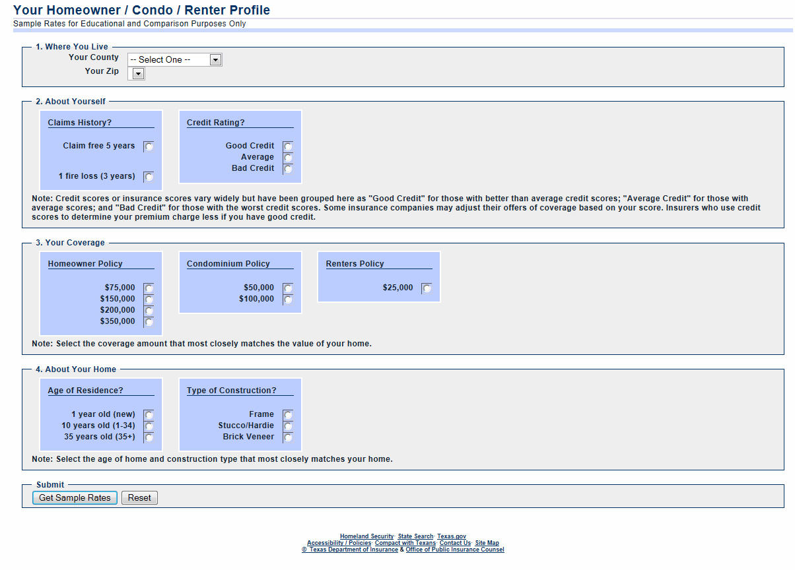
Source: https://apps.tdi.state.tx.us/helpinspublic/Start.do?type=res.
Sample Rates Results
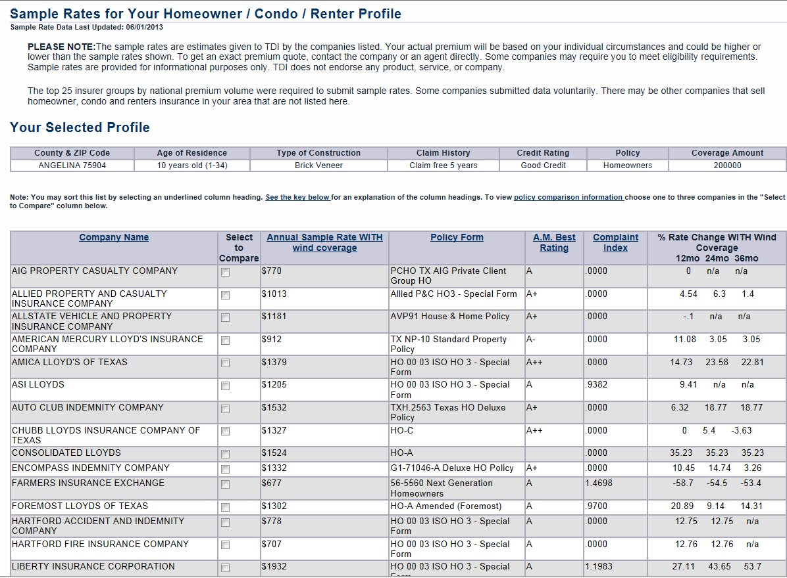
Source: https://apps.tdi.state.tx.us/helpinspublic/Start.do?type=res.
Another example of a website that offers sample pricing and features comparison is that provided by the Private Health Insurance Ombudsman (www.privatehealth.gov.au). The site works by gathering answers to a short list of questions and then listing a range of comparative prices. Consumers can then select a shortlist of insurers that interest them and proceed to a page that compares features in more detail (see below). Consumers need to go to the relevant insurer’s site to complete the purchase.
Figure 7: Private Health Insurance Ombudsman website
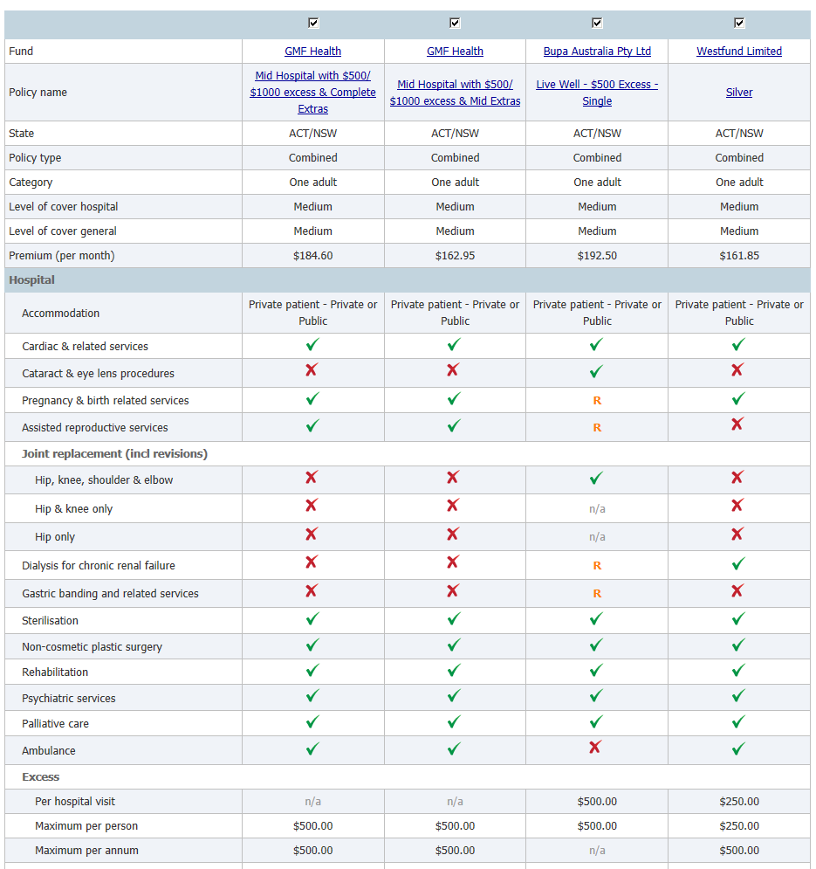
Source: www.privatehealth.gov.au
Focus Questions
- Are there any impediments to adopting an insurance comparison website model that provides indicative or sample quotes to potential customers to either the home or strata title insurance markets in North Queensland?
- Would participation in an insurance comparison website that provides indicative or sample quotes to potential customers result in compliance costs for business?
- Would the creation of an insurance comparison website that provides indicative or sample quotes and other policy information to consumers be effective in enhancing transparency in insurance markets in North Queensland?

Live quote aggregator
A live quote comparison website would provide consumers with a price specific to their property after answering a series of detailed questions, and consumers could then proceed to complete the purchase without leaving the site. This is the model of aggregator that has become the dominant mode of sale in the UK car insurance market.
This option would require substantial investment in information technology to provide a platform for the live quote model. Given the IT infrastructure requirements for a live quote website, the compliance costs for this option are expected to be greater than the other options above. However, this kind of site seems to have been effective in generating intense price competition in other markets.
A website of this kind would require careful development to ensure that it avoided generating the same kind of concerns that some similar sites have generated in Australia and overseas.
Focus Questions
- What are the risks, if any, associated with live quote aggregator websites?
- What design features should be incorporated into any live quote aggregator to minimise the risks?
- What would be the compliance costs associated with insurers participating in a live quote aggregator website?
- Are there any impediments to adopting a live quote aggregator model to either the home or strata title insurance markets in North Queensland?
- What measures, if any, would be required to ensure that an adequate number of insurers participated in a live quote aggregator site.
For all options:
- Are there any confidentiality and privacy implications that need to be considered in implementing an insurance comparison website?
- Are there other website options (apart from the consumer information model, indicative or sample quote model, and live quote aggregator model) that would be more appropriate to address the issues identified in this paper?

Online comparison options and strata title
Some of the most significant premium increases in North Queensland have been in relation to strata title property. State Government legislation currently requires that all strata buildings hold building insurance that provides full-replacement cover. Insurance for strata properties is often obtained by a strata manager or insurance broker (with insurance cover for contents being the responsibility of individual lot owners within the strata group).
Strata title property insurance is notably more complex than property insurance for stand-alone dwellings. This type of insurance requires a more detailed and granular assessment of individual property risk. Even after insurers are provided with answers to a detailed set of questions, they may need to undertake further analysis and investigations (for example, to determine the extent of pre-existing damage to a complex).
Due to these complexities, the use of online quotes for strata title property insurance is currently very limited. Even where insurers do provide this service, they typically require review by an underwriter and further investigations before a price can be provided (that is, they do not provide ‘live’ quotes).
Focus Questions
- Should an insurance comparison site include a comparison of strata insurance property products?
- How can the additional complexities of strata title property insurance be overcome?
- Could an insurance price or features comparison website be effective in smaller markets like that for strata title property insurance in North Queensland?

National or regionally specific solution
The aggregator options in this paper are directed toward the North Queensland home and contents insurance market. As outlined above, this region has suffered the greatest price rises in recent years. However, some of the aggregator options outlined in this paper may provide benefits to all consumers if they were made available across Australia, and may help avoid any concerns about the effectiveness of a North Queensland specific solution.
Focus Questions
- What are the implications of providing any aggregator for home and contents, and potentially strata title insurance;
  - nationally; or
  - only for North Queensland or other regions acutely affected by affordability problems?

Facilitating a site
As set out above, there are some sites of these general types currently operating in the private market. However, participation by insurers is not extensive and they do not appear to be highly active in markets such as those in North Queensland. For that reason it may be necessary for an appropriate site to be facilitated by a government agency.
ASIC already has insurance information on its MoneySmart website, which could potentially be expanded to include more detailed information, and potentially price information. Alternatively, such a site could be facilitated by the Australian Competition and Consumer Commission (ACCC).
Alternatively the Government could tender for a private operator to provide a site.
An arrangement for a Government site could be in place for a limited time, perhaps being wound down on private markets operators becoming more active.
Focus Questions
- If an insurance comparison website is to be facilitated by government, should it be attached to ASIC or ACCC, another agency, or under contract with a private operator? Would there be any difference in the cost of compliance for business in each of these cases?

Promoting resilience
Another possible option to bring about reduced insurance prices in North Queensland is to mitigate against the risk sought to be insured and so enhance the resilience of strata buildings. In some areas subject to flooding, such as Charleville in Queensland, flood levees have led to considerably lower insurance premiums. Mitigation against the key risk in North Queensland — storm/cyclone — is more difficult. Nevertheless, there may be some scope to bring about modest reductions in price where resilience measures are put in place.
In an October 2013 study, James Cook University’s Cyclone Testing Station made a recommendation for engineering-based inspections of strata properties in North Queensland every seven to 10 years. The study found larger, multi-storey buildings have a higher incidence of claims and higher claims costs than low-rise buildings. This is because they have more windows and doors exposed to weather events.
The strata building inspections would have the aim of identifying any site-specific factors that might affect building performance in future severe storm weather events, including identifying possible works to be carried out to make the building more resilient. Given that past insurance claims for strata properties in North Queensland has been a driver of rising insurance premiums, reducing the risk of potential damage from cyclones for a property (by undertaking the necessary mitigation work identified in the assessment) may enable a body corporate to negotiate a lower insurance premium with their insurer.
In another development, CGU Insurance has announced its own program for enhancing strata building resilience in North Queensland. The project will commence in April 2014 and will focus on improving building resilience to severe weather. CGU will fund building risk assessments to be undertaken by a specialist building consultant across all of the properties insured by CGU and its wholly-owned subsidiary, Strata Unit Underwriters (SUU), in North Queensland. The assessments will cover risks such as building construction type and method, exposure to direct wind-driven rain, as well as other hazards and possible defects.
Recommendations from the assessments will be provided to strata property owners and managers on repairs that could be made to improve a property’s resilience and risk rating. Body corporates that carry out the remedial works may potentially be re-rated so that customers receive premium discounts.
CGU is also collaborating with JCU in relation to the two entities’ parallel projects on strata title building assessment.
Focus Questions
- What, if any, is the role for government/s in promoting resilience in North Queensland?
- Are there other options for enhancing resilience that should be considered?

Expanding North Queensland home and strata title insurance markets
Some of the options outlined above, especially those directed at lowering or spreading risk, could encourage new entrants into the market as well as more confidence about risk levels and so more intense competition for market share among existing market players.
A further possibility to bring more entrants to the North Queensland markets would be to attract foreign insurers. It is possible for foreign insurers to participate in the Australian market in various ways. First, they may be authorised by APRA to operate a local branch or Australian incorporated subsidiary. Second, they may, in certain limited circumstances, write business in Australia directly without any authorisation from APRA. In this latter instance, they are referred to as unauthorised foreign insurers (UFIs). The current circumstances in which UFIs may write business in Australia include:
- purchases by ‘high value’ insureds (those with $200 million revenue or gross assets or with 500 staff);
- insurance for atypical risks (including risks arising from war, nuclear or biological hazards, space debris, and certain aircraft and marine vessels risk); or
- where a broker has certified that a risk cannot reasonably be placed with an Australian insurer, including on the basis that the price offered by Australian insurers is substantially less favourable.
A potential measure to make participation in North Queensland markets more attractive to foreign insurers would be to relax the above requirements to enable easier access by unauthorised foreign insurers.
Foreign insurers who choose to operate in Australia through an APRA authorised branch or subsidiary are required to comply with Australian prudential standards. This includes the fundamental requirement that the insurer must hold assets in Australia that at least match their local liabilities. In addition, branches are required to hold assets in Australia that are greater than their local liabilities to the value of the prudential capital requirement. The opportunity to carry on business in Australia as an unauthorised foreign insurer has the attraction of being free from the restraint of local prudential standards including capital requirements. The insurer will likely be subject to a home prudential regime in the jurisdiction in which they are licensed but may be subject to lesser capital standards than authorised Australian insurers.
Unauthorised foreign insurers may therefore enjoy a costs advantage over local insurers, perhaps enabling them to offer lower priced insurance. However, as well as giving foreign insurers a potential competitive advantage over local insurers, important consumer protections, including the Financial Claims Scheme, would not apply in respect of insurance purchased through UFIs.
Focus Questions
- Would the relaxing of restrictions on unauthorised foreign insurers be likely to result in more insurers entering the North Queensland strata or home insurance markets?
- What would be the costs or consequences for locally authorised insurers if unauthorised foreign insurer restrictions were relaxed?
- Are there risks associated with relaxing restrictions on unauthorised foreign insurers, and how could these risks be minimised?

Box 3
Notes on insurance pricing
Consumers, including those in North Queensland, sometimes complain of large discrepancies in quoted premiums between two properties that appear on face value to share the same characteristics, but have one or two distinguishing features. The conclusion sometimes drawn in these circumstances is that insurers are setting their prices on the basis of nothing more than one feature (such as postcode for example). The arbitrariness of this apparent pricing practice understandably infuriates consumers.
It may well be the case, however, that significant differences in prices are not always the result of arbitrary pricing practices but rather one or more of a range of other considerations taken into account by insurers. Different insurers calculate the risk of a claim in different ways. As a result, insurers can charge different premiums for the same risk. Also, the premium charged to a customer can go up or down over time, depending on how the above factors change. In setting a premium, insurers take into consideration a range of factors including:
- the level of cover sought under a policy and the excess that applies;
- the likelihood of a claim being made (which takes into account a range of factors, including claims history) and the anticipated cost of that claim;
- an insurer’s own business costs, including reinsurance costs/expenses associated with estimating, collecting and managing each insurance policy/as well as marketing and other administration costs;
- government taxes and charges; and
- discounts or bonuses an insurer may offer.
Importantly, advances in technology have provided insurers with greater access to better quality risk data, notably in relation to flood risk. This enables insurers to adopt much more sophisticated risk assessment methods that provide a substantially more granular assessment of individual property risk than has been the case in the past.
Pricing down to the household or property level means insurers are assigning individual customers with their own risk profile, rather than treating them as a postcode or demographic group. The result is that in many cases, property owners are paying for their individual risk as opposed to sharing the cost of the risk with other policyholders. Accordingly, insurance costs for properties subject to natural peril risk have increased significantly relative to those with little or no exposure to such risks.

Based on information provided to Treasury on a confidential basis.
Australian Government Actuary, 2012, Report on investigation into strata title insurance price rises in North Queensland.
Building Units and Group Titles Act 1980 (QLD), s.55.
Insurance Council of Australia, Historical Disaster Statistics.
Base profitability is profitability (before tax) as a percentage of premium (excluding any taxes and charges), but before allowing for any reinsurance expenses and recoveries.
Products sold under Bupa’s general insurance arm are issued by CGU.
Products sold under HBF’s general insurance arm are issued by CGU.
IAG’s short-tail personal insurance products are distributed in Victoria under the RACV brand. These products are manufactured by Insurance Manufacturers of Australia Pty Ltd, which is owned 70 per cent by IAG and 30 per cent by RACV.
In 2012 Vero changed its company name to AAI Limited, but it continues to trade under the name ‘Vero Insurance’ and ‘Vero Enterprise’.
Strata Unit Underwriters (SUU) is an underwriting agency and a subsidiary of CGU.
Longitude is an underwriting agency. Its policies are underwritten by AAI Limited.
See for example ‘Insurance companies accused of “gouging” Queenslanders’, Brisbane Times, 17 March 2014.
Australian Government Actuary, 2012, Report on investigation into strata title insurance price rises in North Queensland.
ibid.
Lachlan Harris, ‘Spare a thought for Aussies who can’t afford to cover their home’, http://www.onebigswitch.com.au, 16 April 2014.
Australian Government Actuary, ibid.
Accenture, 2010, The evolution of aggregators.
See http://www.fca.org.uk/news/the-fca-launches-review-into-price-comparison-websites.
One site, Compare the Market, enables comparison of prices offered by three distributors — Budget Direct, Dodo Insurance and Virgin Money — for policies issued by one underwriter — Auto and General Insurance Company Limited. Budget Direct is a trading name of an Auto and General Insurance related company. Dodo and Virgin receive commissions for Auto and General products sold under their business names.
Fire Services Levy Monitor Act 2012.
CGU media release, 1 April 2014, http://www.cgu.com.au.

