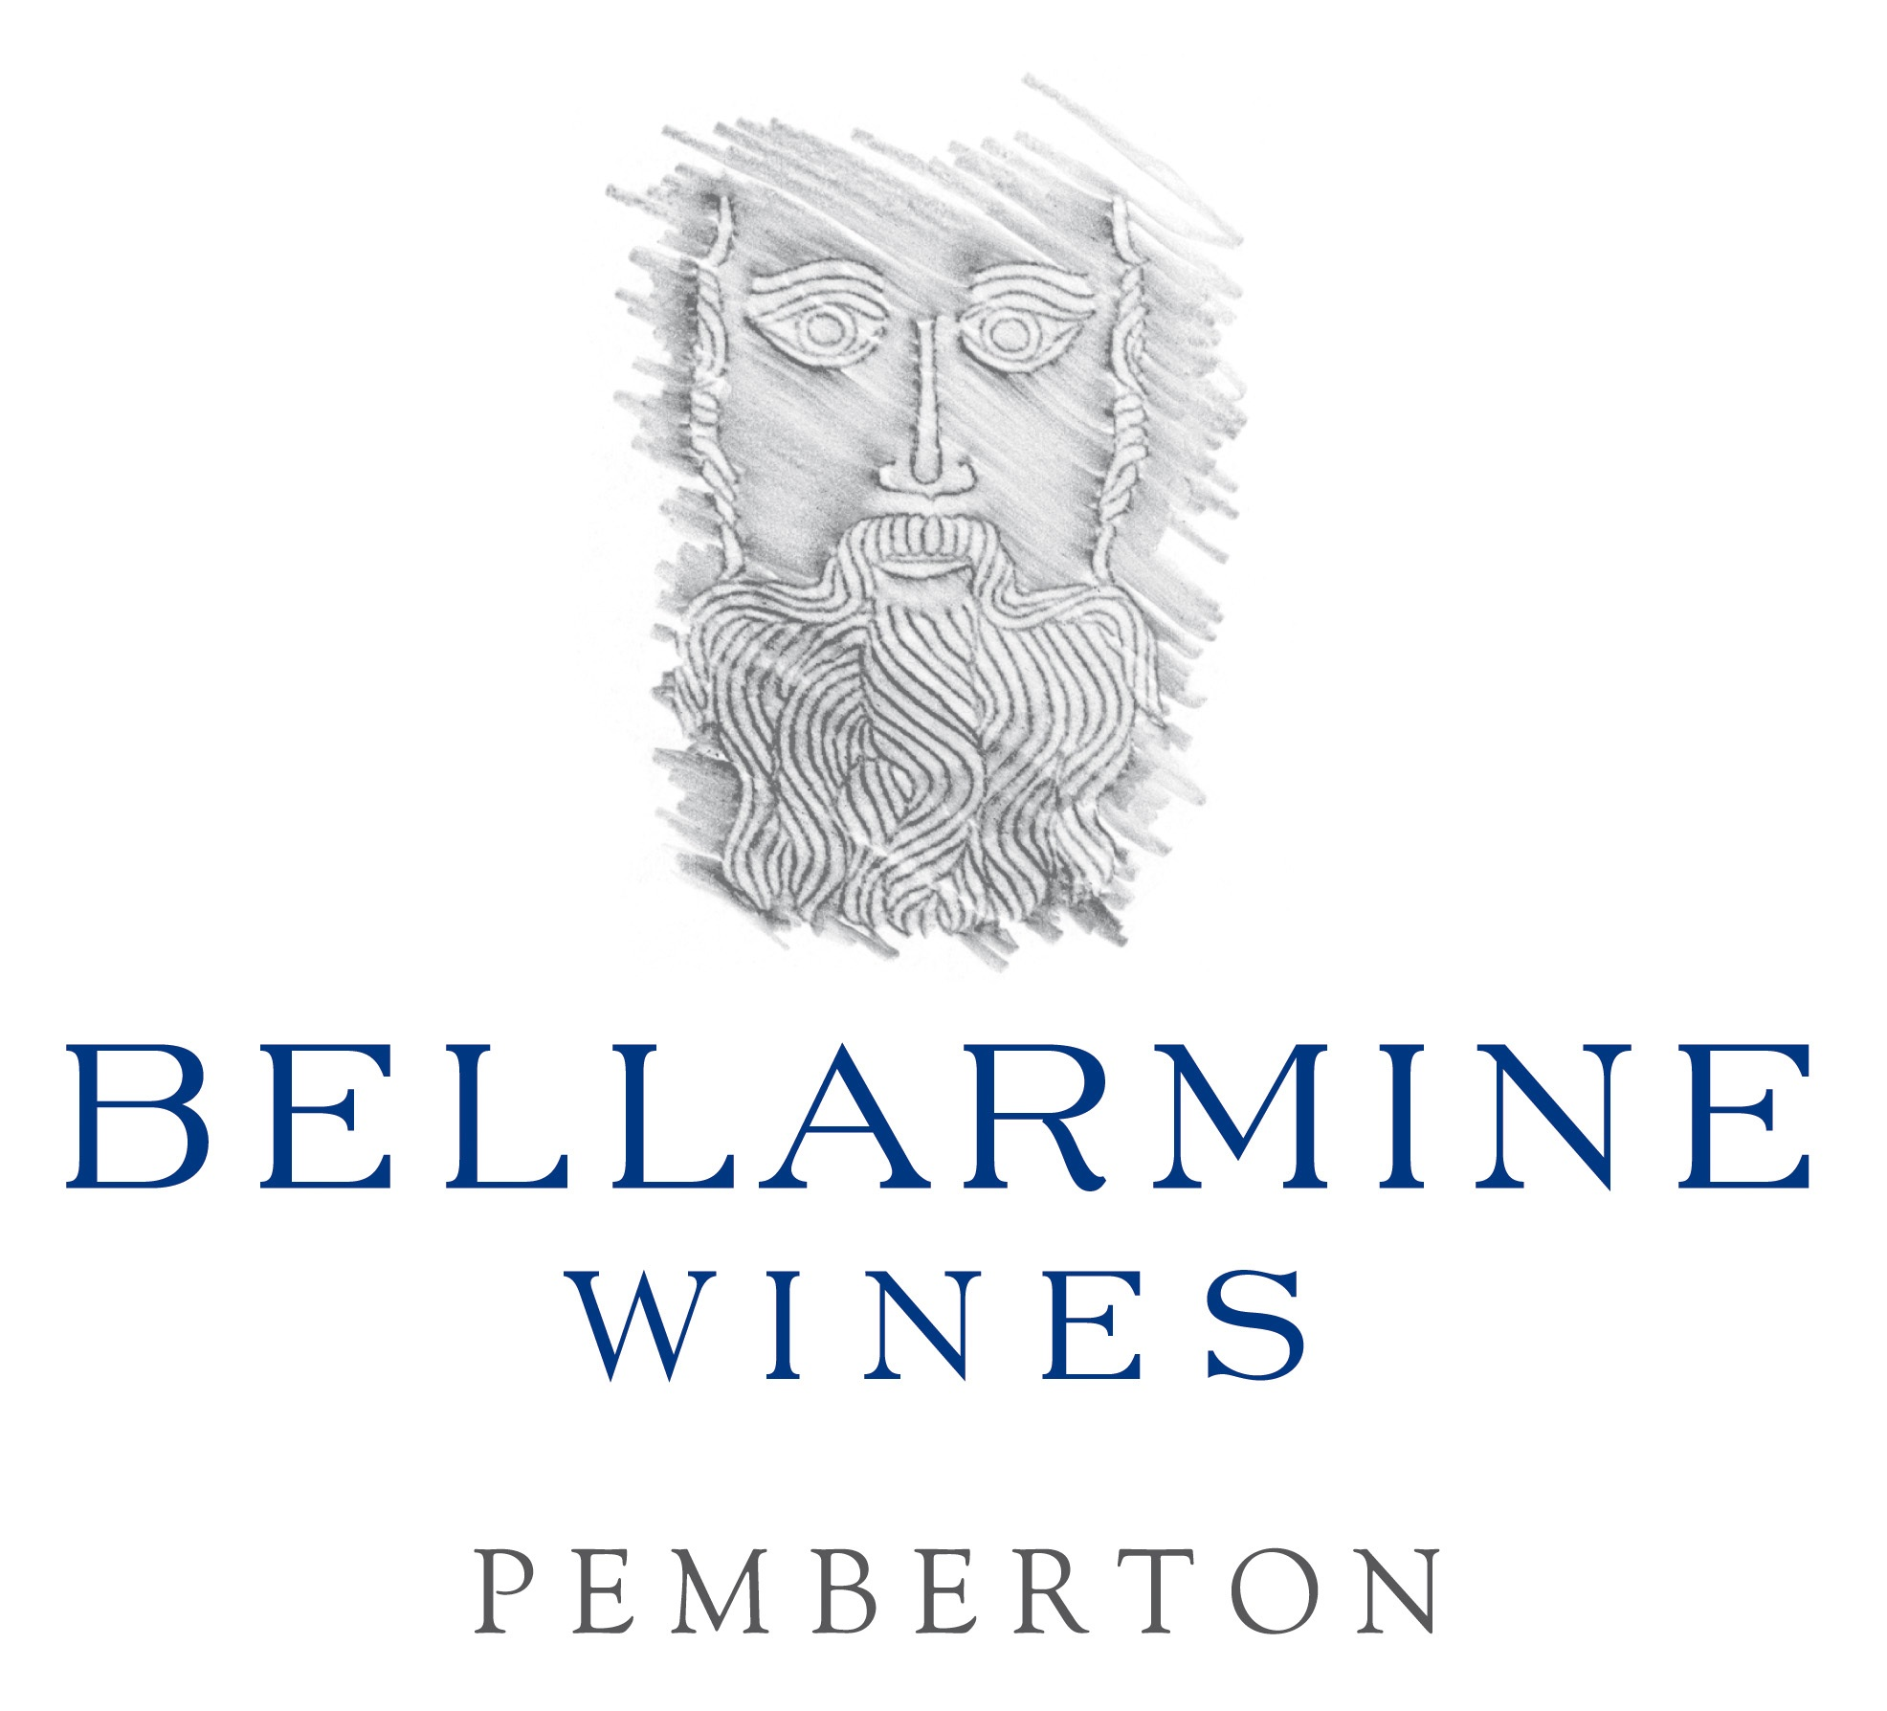
www.bellarmine.com.au

4th October, 2016
Response to WET Rebate Reform Implementation Paper

To Whom It May Concern,
In regards to the WET Rebate Reform Implementation Paper, I am writing to you on behalf of our small wine business, Bellarmine Wines. Our vineyard is located in Pemberton, South-Western Australia. We are listed in James Halliday’s book as one of Australia’s Top 100 Wineries. We are mentioned in the World Wine Atlas written by Jancis Robinson and Hugh Johnson as being outstanding producers of Riesling.

The company since its inception in 1999 has strived to become successful financially. We are currently being audited by the ATO on WET rebate claims. In this process the ATO has asked us why we continue to operate a business that is operating at a loss.
Here is a copy of my response to that question as I feel it is relevant to your considerations on the WET rebate and its fairness to small wine producers.

The property was purchased in 1999 and the vineyard planted in 2000 and 2001. It takes 4 years for vines to start to produce a crop for making into wine. At the time of the initial investment by the German owners, the wine industry in Australia was in a buoyant phase with optimism over its future. By the time production started this phase had already started to change into a downturn. The large financial outlay in planting the vineyard and purchasing and setting up the property had already been made by the owners who were and still are keen to see a return on their investment.

In 2008, when I started managing the business, the owners aim was to try and convert from a loss to break even within 2 years. This was hampered by the Global Financial Crisis and increasing competition from overseas with wine imports into Australia, as well as increased competition with the large Australian wine companies having a domino effect and keeping wine prices low in Australia. In this highly competitive market, it was forecast that by the turn of 2010 into 2011 the market would improve however this has not occurred as more and more people join the industry and Coles and Woolworths take up more and more market share. Sales of imported wines, including those from New Zealand where they are offered the same WET rebate as Australian producers, have increased steadily.

It is a very tough environment for small Australian wine businesses. Since I started managing the company, we have reduced costs dramatically and kept sales improving gradually. The owners are keen to follow through and see a return on the business and meantime are content to send money to cover the interest payments to the bank. This is a payment each month of $30,000. Without such a large bank debt, which is now slowly being paid down, the company would break even.

In the meantime, the company provides rural employment to 4 people directly as well as employing local contractors and local businesses. Bellarmine Wines is the highest rated winery in the Pemberton region with a red 5 star rating from well-known wine writer and judge, James Halliday. Bellarmine is featured in James Halliday’s recent book, “Top 100 Australian Wineries.” We sell domestically as well as exporting to China, the U.K. and Germany.

The Australian government seems to be encouraging big company domination in all markets - milk, fresh produce, and wine. It is very sad that we do not receive the support that wineries in the EU have enjoyed - there they have been given funding for building new state of the art wineries, protection from imported wines in the market and subsidies when times are tough to protect what is in effect something highly worth protecting - Australia’s reputation as a producer or some of the world’s leading wines. It is short-sighted and unfair to alter or take away this limited support to small and medium sized Australian wine businesses. In our case, without the WET rebate, we would have no choice but to rip out the vineyard and close the company down. 4 jobs lost, many others affected and no more world class Rieslings from Pemberton, Western Australia.

I ask that you please consider carefully your duty of care to small and medium wine producers of Western Australia and Australia and follow the Wines of Western Australia recommendations in their report “WET Reform Position Paper 18th August,2016.”

Regards

Diane Miller
Director/Winemaker/Operations Manager

