6 February 2012

The Manager

Corporate Reporting and Accountability Unit

Corporations and Capital Markets Division

Australian Treasury

Langton Crescent

PARKES ACT 2600 [corporatereportingreforms@treasury.gov.au](mailto:corporatereportingreforms@treasury.gov.au)

Dear Sir/Madam

**Proposed Amendments to the Corporations Act**

The Group of 100 (G100) is an organization of chief financial officers from Australia’s largest business enterprises with the purpose of advancing Australia’s financial competitiveness. The G100 is pleased to provide comments on the proposed amendments to the Corporations Act.

**Our principal concern is that clarity is achieved in respect of the tests for the payment of dividends and the status of related franking credits.**

***TEST FOR PAYMENT OF DIVIDENDS***

1. ***Dividends Test***

**The G100 was a strong supporter of proposals to amend the dividend rules and replacing the outdated capital maintenance doctrine as applied to the payment of dividends with a test based on solvency. We believe that the tests introduced in the legislation are unnecessary because of the existing requirements under which directors must make a statement on solvency and the penalties which apply to directors where a company is trading while insolvent. This approach is best reflected in the discussion of Option 2 regarding adoption of a solvency test. An advantage of such an approach is that directors need not be tied to the requirements of accounting standards in making a judgment whether the company’s assets will exceed its liabilities after the dividend is declared. This is because directors, when declaring a dividend, are required to have regard to the most recent financial statements prepared in accordance with Section 295 in conjunction with considering other factors such as current valuations of assets which are not reflected in the financial statements.**

**The G100 believes that the franking status of dividends should be clarified in the legislation rather than directors and their advisors having to rely on rulings and fact sheets issued by the Australian Tax Office. The G100 believes that where a company pays a dividend, whether sourced from profits or revaluations of assets, that dividend should be capable of being franked if the company has franking credits.**

**-2-**

1. ***Other related issues***

**Use of ‘declared’: The G100 supports the adoption of a solvency test and considers that the reference to ‘declared’ in respect of dividends should be retained.**

**Capital maintenance: The G100 does not consider there to be a need for change.**

**Group companies: The G100 considers that clarification may be helpful to ensuring the flow of dividends within a company group.**

***OTHER AMENDMENTS***

1. ***Parent entity financial statements***

**The G100 supports amendments which would provide companies with the flexibility to prepare parent entity financial statements where required by a regulator or where in the judgment of directors parent entity financial statements better meet the needs of shareholders and other users instead of the currently required summary of parent entity information.**

1. ***Changing financial year***

**The G100 supports the proposed amendment to remove the inconsistency between sub section 323D(2A) and sub section 323D(2).**

Yours sincerely

**Group of 100 Inc**

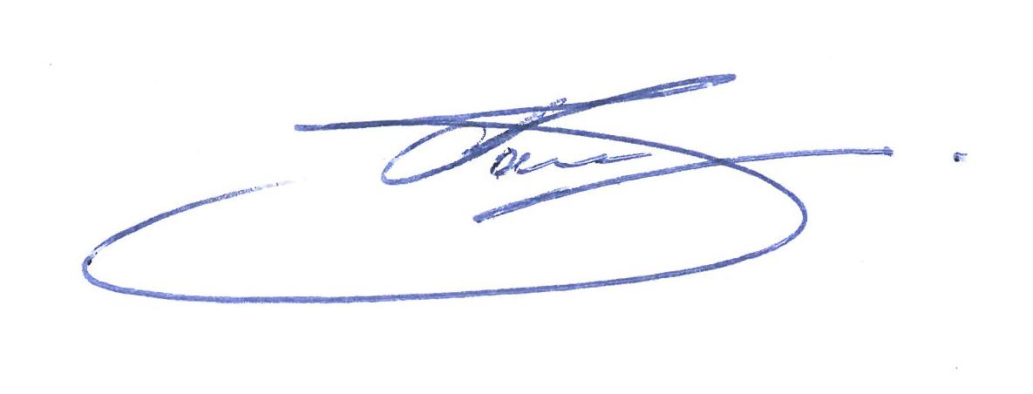

**Terry Bowen**

President