Removing the tax advantages available to multiple entry consolidated groups

Issues Paper  
May 2013

© Commonwealth of Australia 2013

ISBN 978-0-642-74906-2

This publication is available for your use under a [Creative Commons BY Attribution 3.0 Australia](http://creativecommons.org/licenses/by/3.0/au/deed.en) licence, with the exception of the Commonwealth Coat of Arms, the Treasury logo, photographs, images, signatures and where otherwise stated. The full licence terms are available from <http://creativecommons.org/licenses/by/3.0/au/legalcode>.

CC by_grey

Use of Treasury material under a [Creative Commons BY Attribution 3.0 Australia](http://creativecommons.org/licenses/by/3.0/au/deed.en) licence requires you to attribute the work (but not in any way that suggests that the Treasury endorses you or your use of the work).

*Treasury material used ‘as supplied’.*

Provided you have not modified or transformed Treasury material in any way including, for example, by changing the Treasury text; calculating percentage changes; graphing or charting data; or deriving new statistics from published Treasury statistics — then Treasury prefers the following attribution:

*Source: The Australian Government the Treasury.*

*Derivative material*

If you have modified or transformed Treasury material, or derived new material from those of the Treasury in any way, then Treasury prefers the following attribution:

*Based on The Australian Government the Treasury data*.

**Use of the Coat of Arms**

The terms under which the Coat of Arms can be used are set out on the It’s an Honour website (see [www.itsanhonour.gov.au](http://www.itsanhonour.gov.au)).

**Other Uses**

Inquiries regarding this licence and any other use of this document are welcome at:

Manager

Communications

The Treasury

Langton Crescent Parkes  ACT  2600

Email: [medialiaison@treasury.gov.au](mailto:medialiaison@treasury.gov.au)

About this paper

This paper outlines the process for developing the implementation details of the Government’s announced policy to remove the tax advantages available to multiple entry consolidated groups.

Further information

|  |  |
| --- | --- |
| Mail: | Manager  Corporate Tax Unit  The Treasury  Langton Crescent  PARKES  ACT  2600 |
| Email: | [MECgroupreview@treasury.gov.au](mailto:MECgroupreview@treasury.gov.au) |
| Enquiries: | Enquiries can initially be directed to Chris Lyon |
| Phone: | 02 6263 3102 |

Contents

Foreword v

Removing the tax advantages available to multiple entry consolidated groups 1

1. Overview 1

2. Review process 1

2.1 Membership of the tripartite working group 1

2.2 Indicative timeline 1

3. Terms of reference 2

4. Policy implementation 3

5. Key issues to consider 3

5.1 Overview of consolidation 3

5.2 Ability to restructure some assets sales to avoid capital gains tax (cgt) 4

5.3 Choice between retaining or resetting the cost bases of a joining entity’s assets 5

5.4 Choice between applying the pooling method or exit cost setting method 6

Foreword

It is important that Australia secures a fair, competitive and sustainable tax base for the future prosperity of this nation. Left unchecked, profit shifting and international tax avoidance is a threat to Australia’s sovereignty.

International tax rules that give multinational corporations access to tax arrangements that are not available to domestic enterprises provides them with an unfair advantage. It also means other taxpayers either face a larger tax burden or accept a lower level of government services.

The Government is committed to taking what action it can within the current international tax rules to protect the integrity of Australia’s corporate tax base. International tax reform is also increasingly on the agenda of G20 Finance Ministers and Leaders.

The OECD report Addressing Base Erosion and Profit Shifting outlines the underlying causes and challenges and highlights the need for a comprehensive approach. The report also acknowledges the need for unilateral action, including the need for immediate action from tax administrators to address compliance issues.

There is a limit to what any one country can do acting alone to reform international tax rules. Achieving fundamental reform will require international cooperation to reach a broad consensus on the way forward. Australia is at the forefront of G20 efforts in this area.

The OECD will present an ‘action plan’ to G20 Finance Ministers in July this year. As G20 chair in 2014, Australia can play a prominent role in determining and driving this reform agenda.

One example of action that the Government is taking to protect our corporate tax base is our policy to ensure that foreign-owned multiple entry consolidated groups and Australian consolidated groups compete on a level playing field.

This issues paper provides an overview of the process for developing the implementation details of the policy, and preludes a discussion paper that will be released later this year that canvasses various implementation options. This approach to developing the implementation details demonstrates our commitment to a thorough and multi-phased consultation process. We will always endeavour to engage in a genuine process of consultation to identify and prevent unintended consequences.

These are important and necessary reforms that will improve the integrity of Australia’s tax system, I welcome your participation in this process.

**The Hon David Bradbury MP**

**Assistant Treasurer**

Removing the tax advantages available to multiple entry consolidated groups

# Overview

The Government will improve the efficiency and equity of the tax system by removing any systemic tax advantages available to foreign-owned multiple entry consolidated (MEC) groups, and those groups capable of forming MEC groups, that are not available to Australian‑owned ordinary consolidated groups.

The measure will be implemented from 1 July 2014. A tripartite working group (involving the Treasury, the ATO and the private sector) will be established to consider how the measure could best be implemented.

The purpose of this issues paper is to:

* outline the tripartite review process, membership details and indicative timeline;
* outline the terms of reference for the review;
* provide preliminary details regarding policy implementation; and
* provide a brief overview of the key issues that the review will consider.

# Review process

## Membership of the tripartite working group

The working group will be chaired by the Treasury and include members from the Australian Taxation Office (ATO) and private sector tax specialists. The private sector members will be engaged in a private capacity, drawing on their personal and individual knowledge of the tax system. The private sector members will be contracted by the Treasury.

## Indicative timeline

July 2013 – Discussion paper released

October 2013 – Public submissions on discussion paper due

February 2014 – Report provided to the Treasurer

# Terms of reference

Objective

The working group will consider how to best implement the policy objective of removing the systemic tax advantages available to foreign-owned MEC groups, and those groups capable of forming MEC groups, that are not available to Australian‑owned ordinary consolidated groups.

Scope

The working group will restrict its consideration to amendments that would remove the systemic tax advantages available to foreign-owned MEC groups, and those groups capable of forming MEC groups, that are not available to Australian‑owned ordinary consolidated groups.

Criteria

The working group will take into account the following when assessing different implementation options:

1. the degree to which each option would achieve the policy objective;
2. the degree to which each option would minimise foreseeable unintended consequences;
3. how efficiently and effectively each option could be implemented and subsequently administered;
4. the degree to which each option would minimise business compliance costs; and
5. the timeframe necessary to implement any proposed legislative change.

Timing

The working group will deliver its report to the Treasurer in February 2014.

Consultation

The working group will release a discussion paper in mid-2013 seeking the business community’s views on potential options for achieving the policy objective. The working group will meet with stakeholders if, and as, it becomes necessary throughout the course of the review.

Support

The working group will be supported by staff from the Treasury and the ATO.

# Policy implementation

The method of implementation that the Government decides upon will apply from 1 July 2014. Depending on what action the Government decides to take, some changes may apply from each affected taxpayer’s income year commencing on or after 1 July 2014, while other changes may apply to transactions that take place on or after 1 July 2014.

To protect the integrity of the corporate tax system, the Government reserves the right to take earlier legislative action, including from date of announcement (14 May 2013), if it becomes aware of any aggressive tax minimisation practices over the course of the tripartite review. The Government will consider any evidence of aggressive tax practices to include, but not be limited to, a significant number of:

* foreign-owned ordinary consolidated groups transitioning to MEC group structures;
* MEC groups flattening their structures (for example, by incorporating new tier-1 companies or by lifting low-level subsidiaries up to the tier-1 level); and
* foreign-owned ordinary consolidated groups transferring subsidiaries to MEC groups with the same ultimate owner.

# Key issues to consider

## Overview of consolidation

The 1999 Review of Business Taxation recommended that a tax consolidation regime replace the old grouping provisions, noting the benefits that a tax consolidation regime would deliver in terms of improved efficiency, integrity and simplicity for the tax system. The then Government largely accepted the Review’s recommendations and implemented the consolidation regime in 2002.

The Review of Business Taxation also recommended that economic groups with no clear head company in Australia should be allowed to consolidate during a transitional period without restructuring and be known as MEC groups.

However, during implementation the then Government decided to allow MEC groups to retain their unique structures indefinitely by making the MEC group provisions a permanent fixture of the consolidation regime. This decision was made primarily in response to concerns raised around potential stamp duties and foreign tax liabilities that could result for MEC groups as they restructured to conform to an ordinary consolidated group structure.

While the Government considers that the consolidation regime is generally operating well, it has become apparent that the flexibility granted to MEC groups has resulted in some unintended consequences. The Board of Taxation wrote to the Government in June 2012 to express concerns around the tax advantages that MEC groups receive over ordinary consolidated groups. The Government has investigated these concerns further and has identified three clear circumstances under which MEC groups can receive tax advantages. These are outlined below.

The tripartite working group will also consider any other tax advantages that it can identify that are available to foreign-owned MEC groups, and those groups capable of forming MEC groups, but are not available to Australian‑owned ordinary consolidated groups.

## Ability to restructure some assets sales to avoid capital gains tax (cgt)

In many cases, MEC groups can undertake relatively simple restructuring to avoid CGT on the sale of non‑taxable Australian real property (non-TARP) assets that are currently within the Australian tax net because they are owned by an Australian-resident taxpayer. MEC groups can achieve this by moving assets to a tier-1 company and then selling the shares in the tier-1 company, rather than simply selling the underlying asset. As long as less than 50 per cent of the value of the tier-1 company is derived from TARP assets, the sale is eligible for the non‑resident CGT exemption. In comparison, an ordinary consolidated group would not be able to receive the non-resident CGT exemption on the sale of the shares in a subsidiary, because the shares would be owned by the Australian-resident head of the group.

Example: mec group restructuring asset sale to avoid cgt

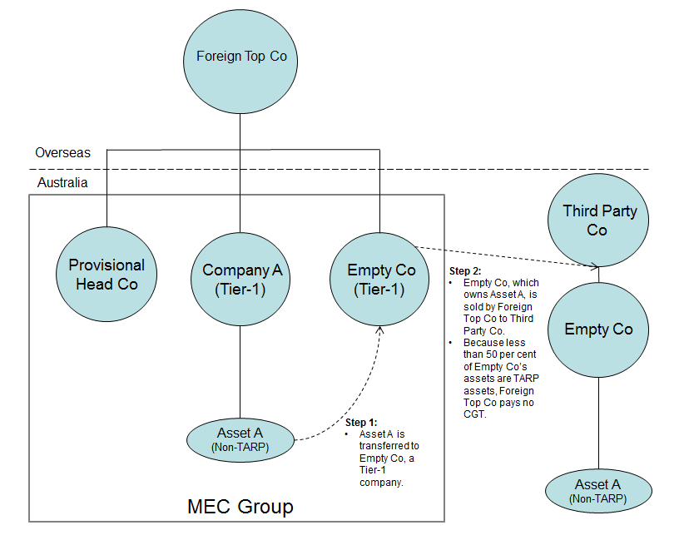

In this example, the MEC group wishes to sell Asset A (one of many assets that Company A holds), which would normally attract a CGT liability. To avoid this, the MEC group transfers Asset A to Empty Co, a tier-1 company in the group owned directly by Foreign Top Co. The value of Empty Co is now derived entirely from non-TARP assets. As a result, the MEC group can sell the shares in Empty Co without being subject to tax on the increased value of Asset A, because the disposal of the shares in Empty Co is covered by the non-resident CGT exemption.

## Choice between retaining or resetting the cost bases of a joining entity’s assets

MEC groups can choose between retaining or resetting the cost bases of a joining entity’s assets. They can do this by electing to either bring a new entity into the group at the tier-1 level (by ensuring that some or all of the membership interests in the entity are directly owned by a non‑resident member of the corporate group), or at a lower level in the group (by ensuring that the entity is directly owned by an existing member of the group). At the tier-1 level, the cost bases of the assets belonging to the incoming entity are retained. At lower levels, the cost bases of the assets are reset. A MEC group can therefore choose to bring an entity into the group at the level that results in the most favourable tax outcome. In comparison, ordinary consolidated groups cannot choose whether to retain or reset the cost base of the assets belonging to incoming entities.

Example: mec group avoiding cgt by retaining the cost base of a joining entity’s asset

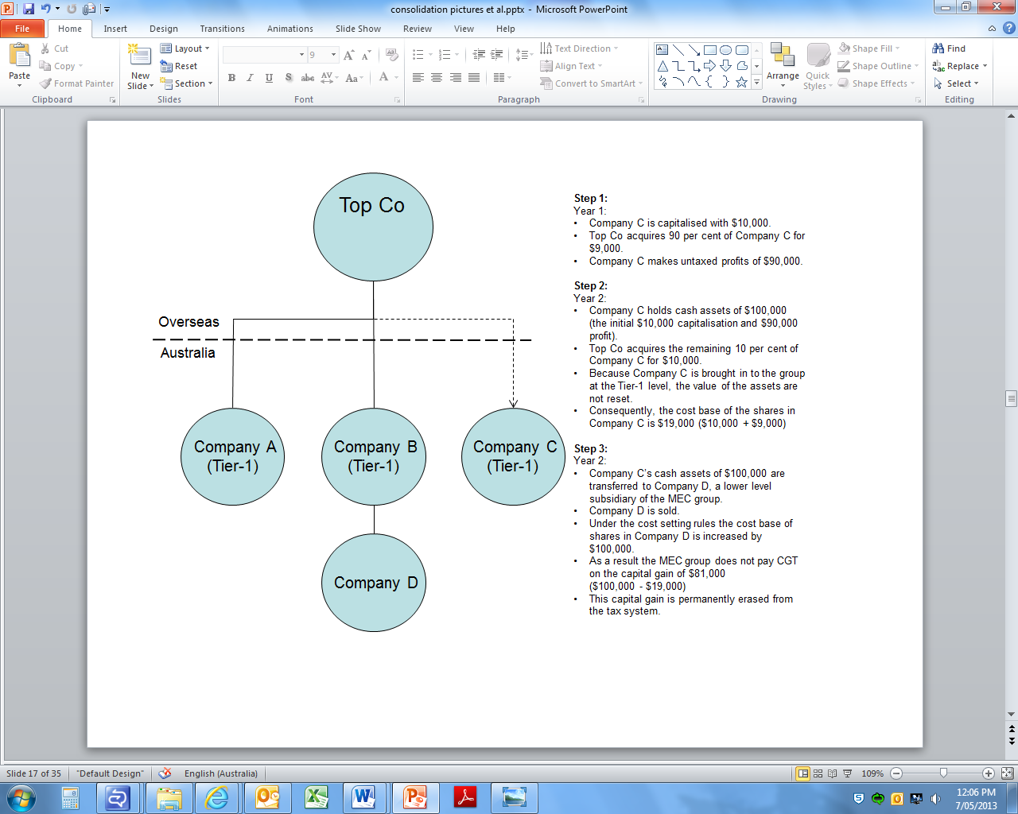

Top Co chooses to directly purchase Company C, so that Company C joins the MEC group as a tier-1 company. This means that the cost bases of the assets in Company C are retained as it enters the group. As Top Co purchased Company C progressively over time, some of the increase in the value of Company C is not fully represented in the cost base of the assets, which is set at $19,000. The MEC group then transfers the cash in Company C to Company D, before selling Company D. Under the exit cost setting rules, the cost base of the shares in Company D is increased by $100,000, resulting in the capital gain of $81,000 being permanently erased from the tax system.

## Choice between applying the pooling method or exit cost setting method

MEC groups can choose between applying the pooling method or exit cost setting process for calculating the value of the membership interests in a leaving entity. They can do this by electing to either sell an entity at the tier-1 level (by ensuring that some or all of the membership interests in the entity are directly owned by a non-resident member of the corporate group), or at a lower level in the group (by ensuring the entity is directly owned by an existing member of the group). At the tier-1 level, the cost base of the membership interests in the entity being sold is calculated using the pooling method. At lower levels, the cost base of the membership interests is calculated using the exit tax cost setting process. A MEC group can therefore choose the method that minimises its CGT liability on the sale of the entity. In comparison, ordinary consolidated groups must always use the exit tax costing setting process for the sale of an entity.

Example: MEC groups minimising CGT liability by using the pooling rules

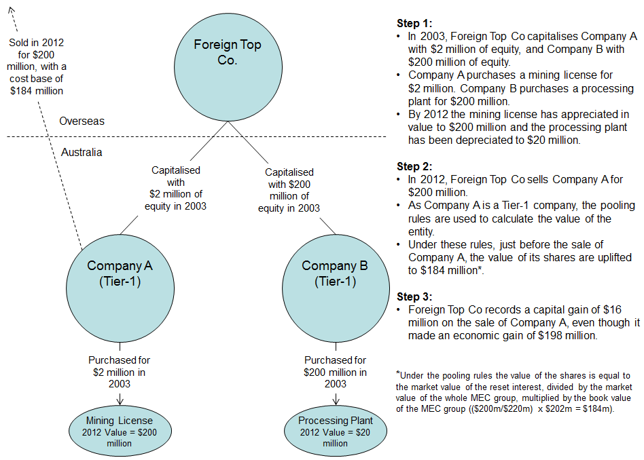

The MEC group is able to sell Company A as a tier-1 company by ensuring that it is directly owned by Foreign Top Co. This enables the MEC group to use the pooling rules to determine the value of the membership interests in Company A. In this case, the MEC group is able to record a capital gain of $16 million, even though it made an economic gain of $198 million.