Reforms to Address Corporate Misuse of the Fair Entitlements Guarantee Scheme
Submission
1. Background
1.1 The consultation paper dated May 2017 in relation to the Corporate Misuse of the Fair Entitlements Guarantee (“FEG”) Scheme (“Consultation Paper”) identifies the following issue of central concern:
“Costs of the FEG Scheme have been increasing due to the adoption of sharp corporate practices by select employers and parties associated with them, resulting in cost shifting to the Scheme and through it, to taxpayers.”
1.2 Those sharp practices include, relevantly for the purposes of this submission, the following:
(a) utilising fraudulent or unlawful phoenix company activities and arrangements;
(b) the adoption of deliberate practices by certain company directors, company officers, and some advisors in seeking to unfairly manage an insolvency to the detriment of creditors.
1.3 The Consultation Paper identifies a number of law reform initiatives intended to discourage and penalise those activities. It is not necessary for the purposes of this submission to identify those initiatives in detail. It is sufficient to say that they are supported.
2. Additional Law Reform Initiatives
2.1 It is submitted that, in addition to the adoption of law reform initiatives which discourage the “sharp corporate practices” identified in the Consultation Paper, it is also appropriate to explore other law reform initiatives which will mitigate the effect of corporate failures on the FEG Scheme.
2.2 Such law reform initiatives may be as much concerned with creating a legislative environment which facilitates the preservation of either companies or their businesses and secures the ongoing engagement of the company’s employees as discouraging and penalising those “sharp corporate practices”.
2.3 It is submitted that one such law reform initiative was identified by the Productivity Commission in its report on the Inquiry into Barriers to Business Entries and Exits (“Productivity Commission Report”). Reference is made in this regard to Recommendation 14.3 of the Commission’s Report:
“Recommendation 14.3:
Provision should be made in the Corporations Act 2001 (Cth) (“Act”) for 'pre-positioned' sales.
Where no related parties are involved, there should be a presumption of sale such that administrators can overturn sales only if they can prove that the sale was not for reasonable market value (in accordance with s420A of the Act), or if it would unduly impinge on the performance of the administrators' duties. Administrators or liquidators should be able to rely on the pre-appointment sale process as evidence.
If sales are to related parties, there is no presumption favouring sale and the administrator's or liquidator's examination of the sale process continues as normal. The administrator's review should include checks that the sale has met existing regulatory requirements for related party transactions.
In both cases, s439A of the Act should be amended to include requirements to disclose information of the sale to creditors.
Where the sale (whether given effect before or after the insolvency appointment) is the result of advice received under the safe harbour defence, that defence should also apply against voidable transactions actions from administrators or liquidators.”
2.4 For the purposes of this submission, “pre-positioned” sales (which are also known as “pre-packs” and will be described in this submission in that way) are defined:
“A process of arranging the sale of a company’s business before the formal appointment of a liquidator, who will finalise the sale as soon as possible after their appointment.”
2.5 The Australian Government did not support Recommendation 14.3 of the Productivity Commission for these reasons:
“Currently, a liquidator or administrator will assess any contract for sale entered into prior to the administration but not yet completed, to determine whether it is in the interests of creditors to honour it. A liquidator may elect to honour a contract for sale, or to allow the counterparty to lodge a claim in the administration. Any presumption in favour of a sale would fetter the liquidator's ability to carry out this function.
The Government does not believe that this would be a desirable policy outcome.
The Government notes also that the UK's non-legislative 'pre-pack' administration has attracted considerable criticism because of perceptions that it may facilitate fraudulent phoenix activity.”
2.6 It is accepted that fraudulent or unlawful phoenix activity is both to be discouraged and that its practice brings the process of liquidating companies into disrepute. It is for that reason that the recommended law reform initiatives in the Consultation Paper are supported.
2.7 Further criticisms of pre-packs were identified by Teresa Graham CBE who undertook a review into pre-pack administrations for the British Government, the final report of which is dated June 2014 (“Graham Review”). The Report of the Graham Review concluded (at page 20), relevantly, that pre-packs suffered from the following “negatives”:
“• Pre-packs lack transparency
• Marketing of pre-pack companies for sale is insufficient
• More could be done to explain the valuation methodology
• Insufficient attention is given to the potential viability of the new company
• The regulation - and monitoring of that regulation - of pre-pack administration could be strengthened.”
2.8 Against those criticisms, though, the Graham Review concluded that pre-packs delivered the following “positives”:
“• Pre-packs can preserve jobs
• Pre-packs are cheaper than an upstream procedure
• Deferred consideration is, by and large, paid (and in particular where it is due within 6 months) - old company creditors are not unduly harmed by the presence of deferred consideration in a pre-pack deal
• Where comparing like with like, pre-packed new companies are, on average, more likely to succeed than business sales out of trading administrations
• Pre-packs may bring some limited benefit to the overall UK economy from overseas companies relocating their pre-pack activity to the UK.”
2.9 It is to be noted that, in particular given the context of this submission, the Graham Review concluded that pre-packs can save jobs. As to that matter, the work of the Graham Review was supported by research undertaken by the University of Wolverhampton.
2,10 That research involved a sample of nearly 500 companies which entered into pre-pack administrations in 2010. In relation to the finding that pre-packs can preserve jobs, the Report of the Graham Review says (at 24-25):
“Pre-packs preserve jobs
7.9 Employment preservation, however, is an area where I have been able to test the assertion that pre-packs are good for jobs. I was keen that the academic research should look at prospects for the old company employees of the sample companies.
7.10 A large number of SIP16 statements cited the preservation of employment as one of the reasons to pre-pack. The benefit is often reported by administrators as the preservation of the jobs themselves, but more usually as achieving a reduction in the likely preferential and unsecured creditor claims were the employees to be made redundant as a result of old company's insolvency. This may have been because the legislation does not cite 'saving jobs' as a statutory objective but does stress that the administrator must act in creditors' interests. Saving jobs is important for other creditors, including floating charge holders, as part of what the old company would otherwise have owed to its employees would be classed as preferential and so paid in priority to floating charge creditors and unsecured non-preferential creditors.
7.11 Despite this, the information regarding employment preservation reported in the SIP16 statements was often poor. It would appear that where all of the jobs had been saved, this was reported to creditors . However, where less than 100% employment preservation had been achieved, the information given in these statements became more opaque.
7.12 The veracity of these figures cannot be confirmed and neither can the length of the 'new' employment. It is not possible on the data presented to provide comment on the extent of employment preservation in the 51 cases categorised as 'some'. Nonetheless it appears that, the claim by proponents of pre-packs that they preserve jobs is a correct one.
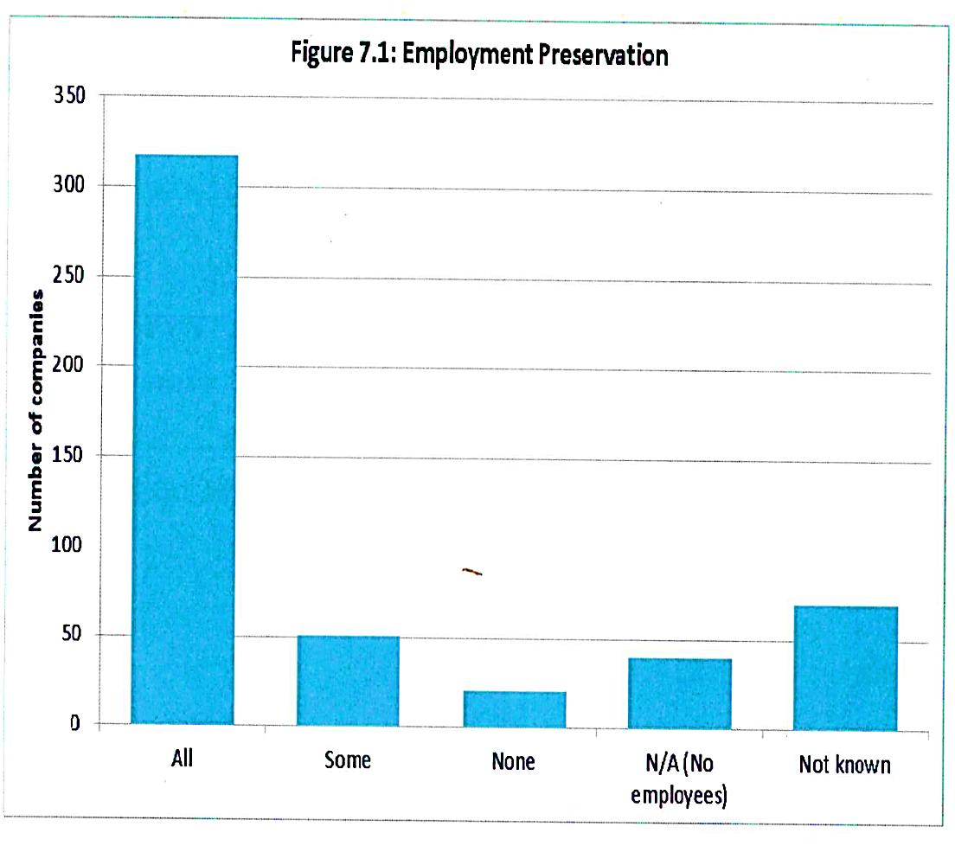
2.11 If similar results could be achieved in Australia, then it is submitted that the principal policy objective identified in the Consultation Paper could be significantly advanced.
2.12 More recent analysis of the UK experience with pre-packs may be found in the 2016 Annual Review of the Pre Pack Pool which is attached as Annexure 1.
2.13 Beyond experience in the UK, it is to be noted that;
(a) pre-packs are possible under Chapter 11 of the US Bankruptcy Code;
(b) amendments were made to the New Zealand Companies Act, 1993 (ss386A, 386C, and 386,D) which facilitate pre-packs; and
(c) whilst the outcomes of its deliberations are not yet known, UNCITRAL has established Working Group V (Insolvency) to consider regimes appropriate for micro and small to medium enterprises.

3 Benefits from Pre-packs
3.1 To put the prospective benefits to be derived from pre-packs into context, an important consideration is in the analysis of the results of the current insolvency regimes.
3.2 Taking the most recently available data from ASIC, in 2015 – 2016:
(a) 9,465 companies entered external administration;
(b) of that number, 8,168 had assets of less than $100,000;
(c) of that number, 2,381 had assets of between $20,000 and $100,000;
(d) of that number, a further 519 had assets of between $100,000 and $250,000; and
(e) of that number:
(i) 6,202 had less than 5 FTE staff; and
(ii) a further 1,253 had between 5 and 19 FTE staff.
3.3 A study conducted by Mark Wellard; “A Sample Review of Deeds of Company Arrangement Under Part 5.3A of the Corporations Act” which was published in 2014 reviewed a number of voluntary administrations conducted in 2012 and 2013. That study concluded:
“The typical cost (in insolvency practitioner fees) of a voluntary administration which precedes a “small company” DOCA [Deed of Company Arrangement] is around $31,500, while a typical amount of remuneration charged by a Deed Administrator for the administration of a DOCA is $28,700.” [A small company DOCA is described as a Deed under which assets of a value of less than $1.5 million are administered]
3.4 In these circumstances, it is reasonable to conclude that, if a voluntary administration followed by a DOCA is the approach adopted for restructuring a company and either preserving the company or its business, a very substantial proportion of the proceeds of realisation of its assets will be applied to satisfy both the remuneration of the administrator as well as the costs and expenses associated with the administration. Accordingly, it is submitted that, if a company or its business is to be restructured and its employees provided with continuing employment rather than being made redundant and the associated costs being imposed on the FEG Scheme, a less expensive process than that involved with voluntary administration is required.
3.5 Such a process was identified by the Productivity Commission in Recommendation 15.1 and Recommendation 14.4 in its Report which read:
“Recommendation 15.1:
The Corporations Act 2001 (Cth) should be amended to provide for a simplified 'small liquidation' process.
- this would only be available for those companies with liabilities to unrelated parties of less than $250,000.
- to access small liquidations, directors should be required to lodge a petition to the Australian Securities and Investments Commission (ASIC) and verify that their books and records are accurate.
- the primary role of the liquidator would be to ascertain the funds available to a reasonable extent, given a reduced timeframe. Requirements for meetings, reporting and investigations should be reduced accordingly.
- the pursuit of unfair preference claims should be limited to those within three months of insolvency and material amounts. The duty to pursue unfair preference should be explicitly removed unless there is a clear net benefit and it will not impede conclusion of the liquidation.
- creditors would be able to opt out of the process and into a standard creditors' voluntary liquidation, and ASIC would be able to initiate further investigation if it has concerns of illegality.
Liquidators for these processes would be drawn from a panel of providers selected by tender to ASIC. Panel membership would be for a period of up to five years, with ASIC able to conduct tenders at regular intervals to ensure that demand can be met.
ASIC should be empowered to hear complaints of practitioner misconduct and if the complaint is upheld, replace the liquidator. ASIC should be enabled to take disciplinary action, if warranted, against the discharged liquidator, including the suspension from participation in the panel or revocation of their registration.”
Recommendation 14.4
“The small liquidation process detailed in recommendation 15.1 should include provision for small pre-positioned sales, consistent with recommendation 14.3.
In the context of small businesses, the requirements of s420A of the Corporations Act 2001 (Cth), and investigations of related parties, should be applied proportionately in relation to determining the relevant market for the sale, advertising effort and reasonable price.”
4 Pre-packs; Should they be a Policy Concern?
4.1 It is submitted that, in the context of the principal issue being addressed by the Consultation Paper, it is appropriate to test whether balance can be struck between the benefits which can be reasonably calculated to be available from permitting pre-packs; particularly saving jobs, with the “costs” associated with the possibility of facilitating fraudulent phoenix activity and the other negatives identified by the Graham Review.
4.2 Those costs need to be calculated having regard to:
(a) the law reform initiatives proposed in the Consultation Paper which are advanced as mitigants to such activities; and
(b) the legislative environment which could be adopted to support pre-packs.
4.3 It is submitted that, in addition to the adoption of the Productivity Commission’s Recommendation 14.3, consideration should also be given to the adoption of its Recommendation 15.1. If that Recommendation were adopted and it was only pre-packs which:
(a) involved a sale whether to a party related to the company’s directors or a third party;
(b) are undertaken under the supervision of an insolvency practitioner drawn from the panel contemplated by Recommendation 15.1;
(c) concern the assets of a company whose total assets are valued at a prescribed amount being somewhere between $100,000 and $250,000 and
(d) are at a price at least equal to an independent valuation of the assets being sold which was obtained by that insolvency practitioner
to which Recommendation 14.3 of the Productivity Commission (in its legislative form) applied, that would also militate against fraudulent or unlawful phoenix activity or, at the very least, mitigate its adverse effect given the limitation on the value of the assets (however ascertained) involved and the process of determining the minimum sale price.
4.4 Where a pre-pack is undertaken in that way and for so long as the insolvency practitioner’s involvement is limited to:
(a) advising as to the options available to the company, given its financial circumstances;
(b) the supervision of the sale process; and
(c) obtaining the independent valuation
that person should be able to act as liquidator or voluntary administrator for the company as the case requires.
4.5 The protection against fraudulent or unlawful phoenix activity would be further fortified if the supervisory regime contemplated by Recommendation 15.1 extended to ASIC being able to conduct audits of the matters conducted by insolvency practitioners on the panel.
4.6 It is submitted that these initiatives taken collectively are calculated and can be reasonably expected to militate against fraudulent or unlawful phoenix activity for the reasons that:
(a) there is the requirement for the involvement of an independent insolvency practitioner;
(b) those independent insolvency practitioners can only be selected from a panel established by ASIC;
(c) their activities can be effectively scrutinised; and
(d) the sale is required to be undertaken at a price which is at least equal to the value of the assets being sold as determined by an independent valuer.
4.7 It is accepted that the use of a valuation to test price may be less rigorous an approach to establishing “true” value than a marketing process. However, when undertaking the appropriate cost benefit analysis, if pre-packs are only available in the case of sales when the assets being sold are valued at less than, say, $100,000, the deficiency, in terms of the adverse impact on creditors, would be minimal. Moreover, for reasons explored below, it is possible that creditors may receive a better return than would be the case if, say, there was a voluntary administration followed by the execution of a Deed of Company Arrangement. Without there being at the same time a pre-pack.
5. Policy “Costs” of Pre-packs: Can they be Mitigated?
5.1 The “costs” of permitting pre-packs has been identified as the facilitation of “fraudulent phoenix activity”. To the extent that that is a legitimate concern, it is submitted that, given the identifiable benefit which can accrue from pre-packs, particularly in relation to job-saving, the issue is how that cost can be mitigated.
5.2 There is a number of mitigants:
(a) pre-packs should only be permitted when the value of the company’s business is less than a prescribed amount, probably somewhere between $100,000 and $250,000;
(b) pre-packs can only be negotiated under the supervision of an independent registered liquidator drawn from a panel of the kind contemplated in Recommendation 15.1 of the Productivity Commission Report which was considered above;
(c) the independent registered liquidator should be permitted to act as liquidator or administrator of the company in the event of a voluntary administrator being appointed or it being wound up;
(d) the registered liquidator should be required to provide creditors with a certificate containing the information detailed in paragraph 9 of the Statement of Insolvency Practice 16 issued by the UK Institute of Chartered Accountants which is attached as Annexure 2; and
(e) in addition, the registered liquidator should certify that the sale price was at least equal to the amount determined by an independent valuer of the assets which are the subject of the sale.
6 Conclusion
6.1 For the reasons explored above, it is submitted that it would be possible to further alleviate the burden on the FEG Scheme of the redundancy of employees consequent upon the liquidation of their employer by permitting pre-packs to be undertaken:
- under the supervision of an independent insolvency practitioner;

- in the context of “small to medium sized companies”;

- at a price which is no less than the independently determined value of the assets being sold; and

- otherwise, subject to the “checks and balances” described in this submission.

