Manager, CIPRs
Retirement Income Policy Division
The Treasury
Langton Crescent
PARKES ACT 2600

22 /06 / 2018

Submission – Retirement Income Covenant Position Paper

Dear Sir / Madam

We appreciate the opportunity to comment on Treasury’s position paper. The development of sound policy to enable retirees access to a stable, adequate income during their retirement is a critical social and economic issue. We applaud the efforts of Government and the consultative approach taken in the development of this policy framework.

About Allianz Retire+

Allianz Retire+ Powered by PIMCO (Allianz Retire+) launched in May 2018 as a new business for the Allianz Group in Australia, focused on bringing the next generation of retirement income solutions to the Australian market.

Allianz Retire+ is a new life insurance business which combines the scale and technical expertise of Allianz’s global life insurance business with PIMCO’s global investment management experience. Allianz Retire+ represents a long term commitment by the Allianz Group to the Australian retirement income market.

The focus of our business is purely on providing solutions for retirees. We recognise the need for competition and innovation in this space, and aim to bring the best of Allianz’s global expertise to the retirement income market in Australia. We plan to launch our initial product later this year, and are hiring the relevant expertise as well as developing the regulatory and technology infrastructure to support this.

Overview

We strongly support the policy direction proposed with respect to the Retirement Income Covenant Position Paper (the Paper). The focus of the superannuation system in Australia has been on the accumulation phase of retirement savings, however the system has now reached a maturity which requires an increasing focus on decumulation. Generating an income stream in retirement is the ultimate objective of superannuation savings. The development of a policy framework which increases consumer and industry focus on retirement income, rather than simply accumulated value, is timely and welcome.

We believe the intentions of the proposed framework are sound:
- To increase the availability and use of products that manage longevity risk; and
- To balance the competing demands for income, flexibility and risk management.

Further we support the principles espoused for the certification requirements being “principles based to ensure product neutrality and to avoid limiting future innovation in the retirement income product market”.

We believe that the ongoing development of retirement income policy should consider additional factors, which have been outlined below. We particularly highlight the following:
- Sequencing of returns risk can have a significant impact on retirement incomes, and should be specifically considered in the development of CIPRs;
- Variability of actual income, and of retirees’ income needs, are critical factors not currently addressed by the Paper. The focus on expectations, at the time of offer, of a broadly constant income does not address volatility. The design of a retirement income strategy by Trustees should also consider this risk, and member engagement should also enable members to understand the risks associated with product options, rather than focusing solely on expected income.
Longevity is not the only risk in retirement

Retirees face a range of economic risks in retirement:

- Investment risk – the risk that investment markets return less than expected or that negative investment returns reduce the assets available for consumption in retirement.
- Sequencing of returns risk – the risk that negative investment market movements occur at a time close to retirement, reducing the assets available for consumption in retirement. The timing of negative returns is a significant risk which can reduce the duration of lifetime savings by a significant amount.
- Inflation risk – the risk that inflation grows at a faster rate than the assets, thereby reducing the real value of the assets
- Longevity risk – that the retiree outlives their assets.
Retirees also face further complexity, including highly uncertain expenditure patterns as health deteriorates and the need for assistance or care increase.

Currently retirees typically manage all these risks through an Account Based Pension (ABP), and through a conservative investment strategy in retirement. The Paper, and the initial CIPR paper, outline why this typical ABP strategy does not generate good outcomes for retirees.

The Paper’s description of the features of a CIPR, particularly the description of the “A+ Retirement Flagship CIPR”, recognises that the delivery of a lifetime income requires a combination of products or solutions over the duration of an individual’s retirement.

It does not, however, reflect that:
- The income needs of retirees also change over time (noting that broadly constant income is a core design feature of CIPRs); or
- The investment risk appetite of retirees may (or should) be higher in the early years of retirement.
The example CIPR, combining an ABP and a deferred lifetime annuity, does little to protect retirees from market risk, particularly the sequencing of returns risks which is exacerbated in a draw down phase. Failure to adequately address these topics undermines the ability of a CIPR to help retirees manage longevity risk.
We also recommend that inflation risk be a core consideration in the retirement income covenant. While this risk is less significant in a stable, low inflation environment, retirement income policy should not be predicated on such an environment continuing.

Design limitations

Failure to address sequencing risk

The design of CIPRs, focusing on the expectation (at the time of offer) that the product should provide a “broadly constant income”, has a number of limitations.

The value of a CIPR should not be measured with reference to its expected outcomes at the time of offer, but rather its ability to deliver such an income stream over the lifetime of the customer.

Marketing CIPRs purely on the basis of expected incomes may encourage investment strategies – particularly in the ABP phase – which do not take into account the volatility of expected returns, thereby increasing retirees’ exposure to sequence of returns risk. We believe sequencing risk is given inadequate focus in the discussion of retirement incomes.

The following chart illustrates the significance of sequencing risk to consumer outcomes. Two scenarios are presented with identical investment and withdrawal profiles, but with differing retirement dates. The customer who retired in 1995 experienced strong market growth in their first decade of retirement. As a result, the customer continued to enjoy a strong capital position 40 years into retirement. The customer who retired in 2005, however, suffered market losses early in drawdown phase, and as a result their retirement savings expire fully within 25 years.

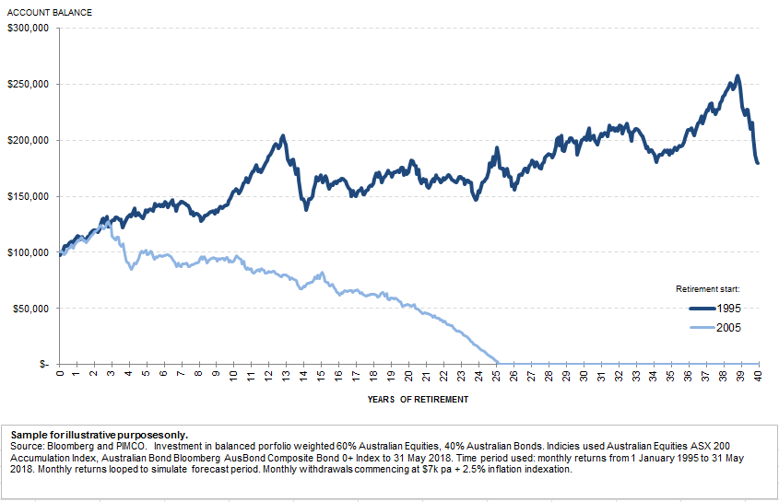

We believe the design of CIPRs, and the retirement income covenant, should specifically take into account the risk that sequencing of returns can have a significant negative effect on outcomes for consumers.

Product Neutrality – Pooled v Guaranteed Products

We believe product regulation should create a level playing field in order to enable a competitive and innovative market. As such we agree with the supporting principle that Trustees should be able to offer CIPRs developed by third parties. We believe an active and competitive market is essential to spurring innovation.

We believe, however, that the creation of CIPRs to include a non-guaranteed pooled product within the superannuation fund may be inconsistent with the principle of product neutrality unless there is clear consideration, and communication, of the relative risks associated with these products when compared to a guaranteed product. A guaranteed product is required to be offered by a life insurance company, whose products are subject to stringent prudential capital requirements, in order to support the guarantee and protect member interests. In contrast a non-guaranteed product is able to be offered by any party and does not have the associated stringent prudential capital requirements. A simple comparison of expected incomes without clear communication of the risks inherent in each product may create a bias towards higher income, riskier products with potentially adverse outcomes for investors.

The design of a CIPR with expectations of broadly constant income, but without any implication for a failure to actually deliver a broadly constant income, appears to undermine the incentive for development of guaranteed products, as the differing capital profile would result in significantly different “headline” returns.

Whilst we recognise the need to balance the “competing objectives of high income … and risk management” we remain concerned that the focus on expected income at the time of offer, rather than on actual customer outcomes, does not strike this balance appropriately. We believe that the risk of volatility of incomes should be specifically considered by Trustees in the development of a retirement income strategy for members.

Whilst the product offering between guaranteed and non-guaranteed CIPRs would differ, we question whether this difference would be readily understood by consumers.

We also note that the extensive use of pooled products would be inconsistent with the direction of consumer protection policy in Australia, as it would encourage retail consumers to enter into long term financial products without the protection of supporting capital.

Lack of homogeneity in fund membership

We recognise the need to balance the competing needs of personal advice and scaled access to mass customised solutions. However, designing a single solution for all members presents a range of challenges for Trustees. While members in accumulation mode have a common goal, to maximise the amount available at retirement, members in decumulation mode will often have very different goals. For instance expenditure patterns over retirement, life expectancy and the desire to leave a legacy will all differ significantly between members. The development of a single solution focused on the collective needs of “members as a whole” may result in the delivery of solutions that are sub-optimal for many or all members individually. Few, if any, funds would present a sufficiently homogeneous membership profile for a single product to meet the needs of all members.

Consumer choice

A pooled (non-guaranteed) CIPR solution may also work contrary to the “choice of funds” concept on which the superannuation system is based. For instance, pooled solutions may create an arbitrage opportunity for members to join funds with a typically lower life expectancy (for instance industry funds associated with the heavy construction sector). Allowing choice of pool may operate to the detriment of existing members and therefore undermine the effectiveness of the pooling process itself.

Member Engagement

We are very supportive of the proposal to provide tools which support retirees to accurately assess the information available to them. We are also aware that Treasury understands the range of behavioural economic biases that make this a challenging task, such as the inability of consumers to effectively value future income. We note that a paper will be issued in relation to simplified standardised disclosure for retirement products and would appreciate the opportunity to comment on this future paper.

As noted above there are many risks associated with retirement income in addition to longevity risk. Member engagement needs to include meaningful information which represents a simple articulation of these risks. This should include the likelihood of achieving the projected income, the range of possible outcomes and an indication of worst case outcomes.

Additionally consideration needs to be given to the ability of consumers to make choices later in retirement, when the effects of cognitive decline are taking place. This includes considering:
- How information is displayed to members
- Which decisions are required to be made at various stages of retirement.

We believe the design principles around member engagement will be critical to ensuring the success of CIPRs in achieving their policy objectives and would appreciate the opportunity to further engage with Treasury in this stage of policy development.

Encouraging Innovation

In creating policy to encourage the development of a vibrant retirement income market, consideration should be given to factors which have prevented the development of this market.

Minimising Sovereign Risk

Superannuation represents a lifetime investment, and therefore requires regulatory certainty for both consumers and for product providers. However the frequency and extent of change to superannuation policy settings over successive governments has been inconsistent with a long term, mandated savings scheme.

The development of new, long term products requires regulatory certainty. In order to encourage innovation in retirement income product development, a bi-partisan and stable approach to superannuation policy is desirable.

Financial Literacy

Financial literacy within the Australian community is not adequate having regard to the complexity of the superannuation, tax and social security systems. We believe consumer choice will spur innovation, but that consumer choice is hampered by this combination of high complexity and low financial literacy.

Creating Simplicity

The Paper rightly calls out the impact of cognitive decline as an important factor in the development of CIPRs. The complexity of the regulatory environment affecting retirement incomes is likely to be overwhelming for some retirees, especially if further decisions have to be made later in retirement. This is clearly a significant issue for consumers, however complexity is also a significant issue hindering innovation in product development.

Legislative Framework

Our experience launching Allianz Retire+ has illustrated that the rigidity of the legislative framework hinders innovation. We believe that legislative changes could lend support to innovation within this sector.

For instance, s12A of the Life Act creates a discretionary power to declare products to be life insurance. However, s12A also indicates that the discretion should be exercised after considering whether the product is “similar in nature to other life insurance products”. This inherently restricts the application of such exemptions in a manner that inhibits significant innovation to product design. We recommend that encouraging innovation should be considered an equally relevant factor in exercising discretionary powers.

Whilst CIPRs may be developed outside of the life insurance regime, we note that the interaction between SIS and tax regulations affecting retirement income place significant, and complex, restrictions on the categories of product which are effective in delivering efficient outcomes to customers.

Productivity Commission report

We believe it is important to consider the retirement income covenant, and measurement of effectiveness of retirement products, in conjunction with the Productivity Commission’s desire to have improved efficiency in superannuation. While the Productivity Commission has expressed a desire to improve efficiency in terms of investment returns and number of accounts, we believe that efficiency is also important in the transition from accumulation into decumulation.

Consideration should be given to how CIPRs are factored into the default fund choice, particularly given the inertia in relation to members changing funds. When considering how CIPRs can be evaluated for a member in the fund compared to the ABP, consideration should also be given to evaluating CIPRs across funds.

Conclusion

We believe the Government’s focus on developing policy settings which address the needs of retirees for stable and adequate incomes from their superannuation savings is commendable. We support the direction and the strategic intent of the Paper.

We believe the ongoing development of policy should have regard to the matters described above and would welcome the opportunity to discuss our observations with you in greater detail.

Yours sincerely

Matthew Rady
Chief Executive Officer

