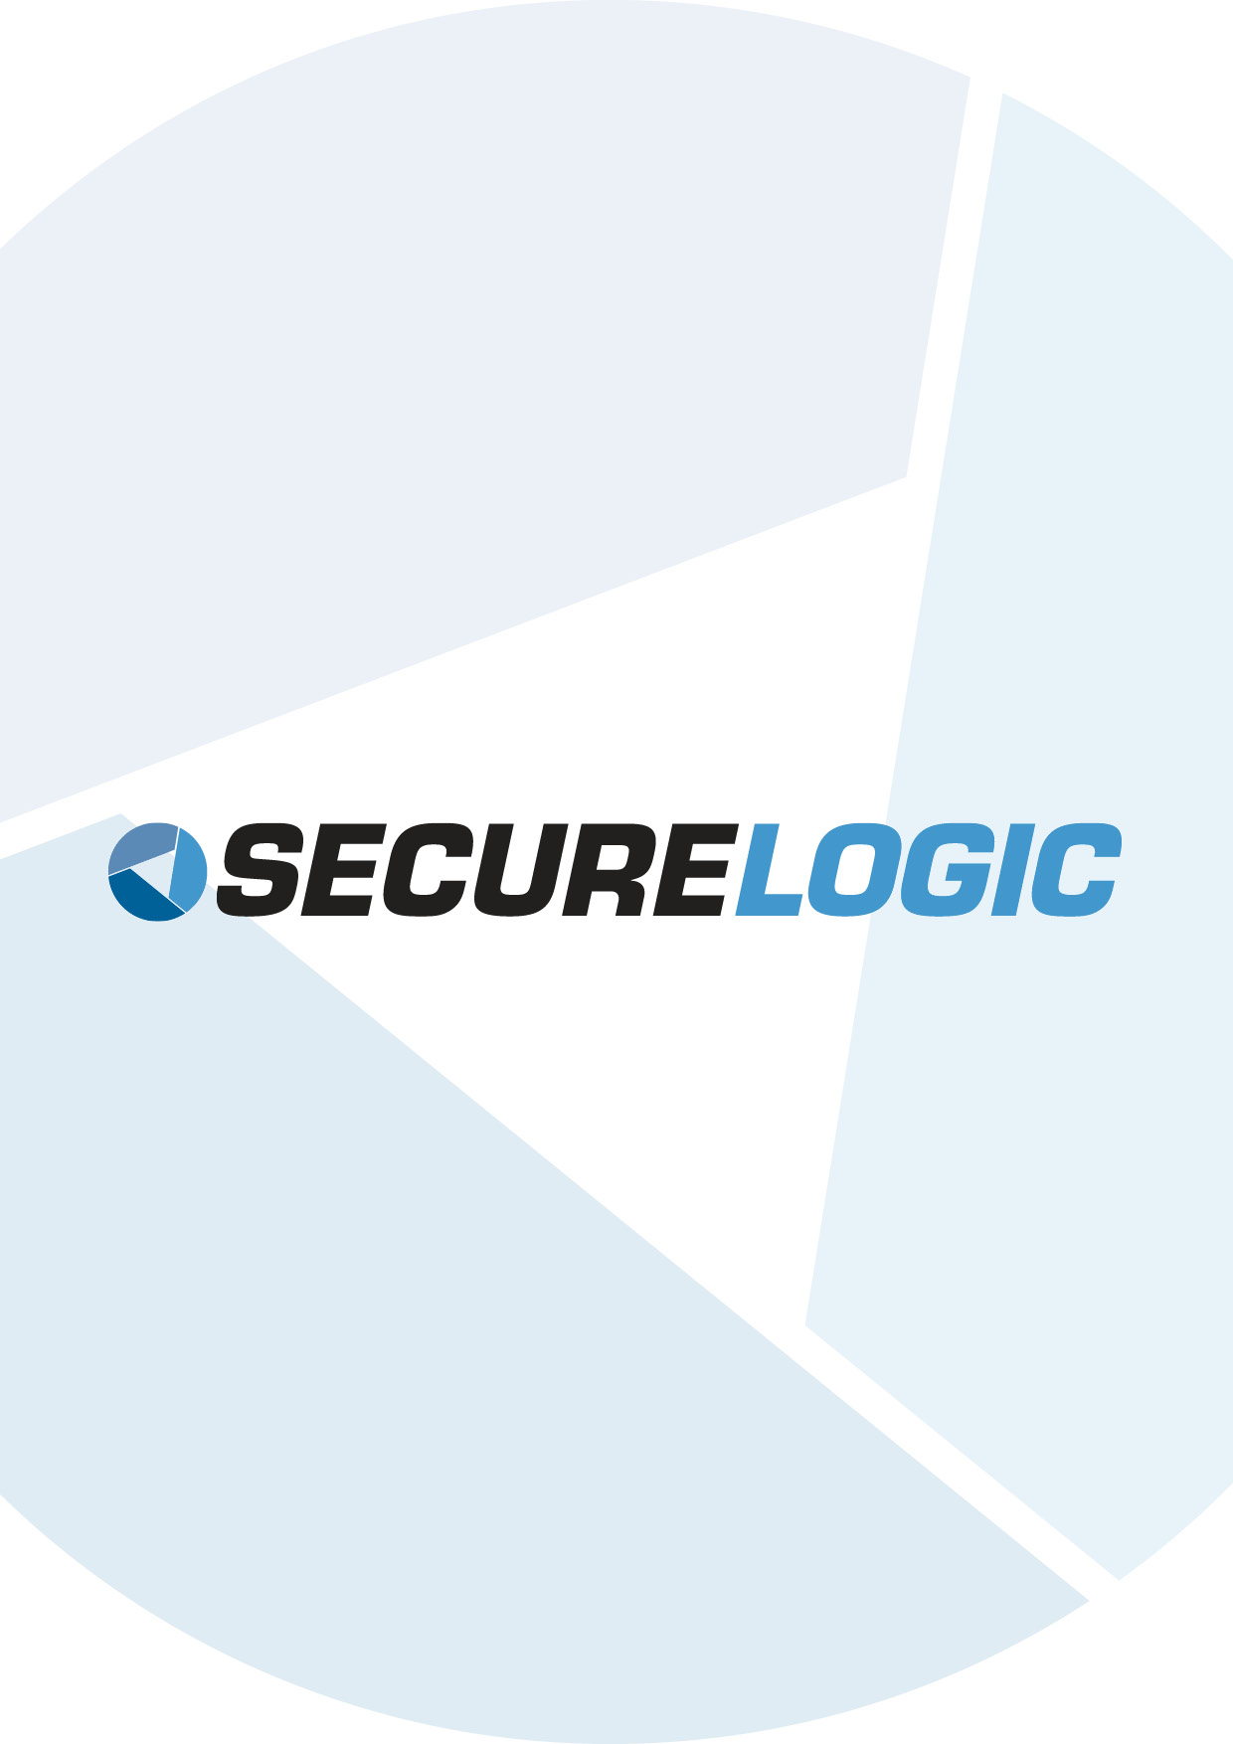

Input into the Draft Privacy Impact Statement (Consumer Data Right) Bill 2018

Manager
Consumer Data Right Team
Structural Reform Group
The Treasury
Langton Crescent
Parkes ACT 2600

Email: data@treasury.gov.au

Secure Logic appreciates the opportunity to provide input into the Draft Privacy Impact Statement (https://treasury.gov.au/consultation/c2018-t350370/)

In general, Secure Logic views that the exposure draft legislation provides sound privacy protection of consumer data rights in support of the Open Banking initiative.

Impact on Privacy: Vulnerable and Disadvantaged Individuals
Secure Logic recommends for special considerations to be given to people with learning disability in respect to their right to consent and the authorisation process. Individuals in this group who experience difficulty in understanding the extent of privacy in authorising the use and disclosure of their sensitive information may proceed without full awareness of the risks.

Data Security and Transfer Standards
Secure Logic completely agrees with the fact that CDR may lead to increase in risks pertaining to malicious data thefts. It notes that a data security and transfer standard will be developed by the Data Standards Body. Secure Logic is of the view that references from various compliance standards and its requirements such as PCI-DSS and ISO27001 in each respective area should also be considered as a baseline when developing the software, data security and transfer standards for CDR.

Rights to Withdraw Consent or Delete
Secure Logic recommends additional clauses to be provided surrounding the enforcement of the consumer’s rights to withdraw consent or delete. It is observed that intricate details of the collection, authorisation and use of CDR data are discussed throughout the Draft. Furthermore, offences regarding various violations in these areas are well-documented. On the other hand, while the statement on the rights to rescind consent exists, the Draft is scarce in mentioning specific provisions and consequences of non-compliance which are required to ascertain that data recipients follow through on their due obligations in the withdrawal, deletion and data de-identification process.

Secure Logic strongly supports Open Banking in Australia and is pleased with the Privacy Impact Assessment exercise which increases the focus and rigour on consumer’s data privacy.

Kind Regards,
Santosh Devaraj
CEO of Secure Logic

