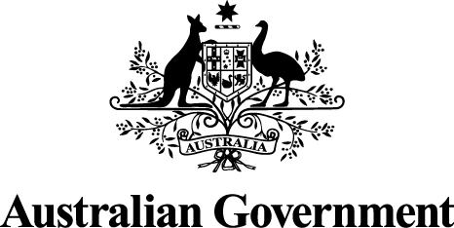
Australian Government Response to the Senate Economics Legislation Committee Report on the Competition and Consumer Amendment (Misuse of Market Power) Bill 2017

November 2017

Australian Government response
Recommendation 1:
The committee recommends that the proposed mandatory factors, as drafted in subsection 46(2) of the bill, be removed.
Response
The Australian Government adopted this recommendation by successfully moving parliamentary amendments to remove the ‘mandatory factors’ from subsection 46(2) (see Hansard, House of Representatives, 27 March 2017, p3264).
Recommendation 2:
The committee recommends that the government undertake a post-implementation review of the reforms to section 46 at least five years after commencement.
Response
The Australian Government supports this recommendation in principle, as it will provide an opportunity to ensure that section 46 is working as intended. The timing of a review will need to take account of the extent to which the courts have had the opportunity to develop jurisprudence on the new provision.
Recommendation 3:
The committee recommends that the bill be passed.
Response
On 14 August 2017, the Senate passed the Competition and Consumer Amendment (Misuse of Market Power) Bill 2017 (see Hansard, pp5568-69).
Dissenting report by Labor Senators
Recommendation 1:
That the Senate should not pass the Competition and Consumer Amendment (Misuse of Market Power) Bill 2016.
Response
On 14 August 2017, the Senate passed the Bill (see Hansard, pp5568-69).

Additional comments by Senator Xenophon
Recommendation 1:
A 'cost waiver order' should be introduced into market power abuse litigation cases to improve access to justice.
Response
The Australian Government responded to this recommendation in the Senate on 14 August 2017 (Senator Cormann, Hansard, p5561).
Recommendation 2:
A divestiture order must be made available as a judicial remedy for serious or repeat market power abuse offender cases.
Response
The Australian Government responded to this recommendation in the Senate on 14 August 2017 (Senator Cormann, Hansard, p5556).
Recommendation 3:
As per Draft Harper Review Recommendation 25, to mitigate concerns about over-capture a defence should be introduced so that the primary prohibition would not apply if the conduct in question:
- would be a rational business decision or strategy by a corporation that did not have a substantial degree of power in the market; and
- the effect or likely effect of the conduct is to benefit the long-term interests of consumers.
The onus of proving that the defence applies should fall on the corporation engaging in the conduct.
Response:
The Government does not support this recommendation as the proposed defence would be broad, and could increase uncertainty about the operation of section 46. The Government also notes that, on 14 August 2017, Senator Xenophon withdrew a proposed amendment to the Competition and Consumer Amendment (Misuse of Market Power) Bill 2017, which sought to introduce the defence, and acknowledged the defence would be unnecessary (Senator Xenophon, Hansard, p5555).

