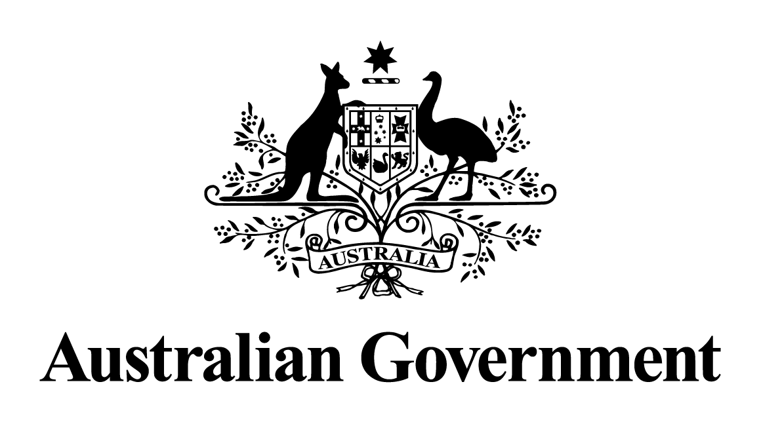

Australian Government response to the
Senate Economics References Committee report:

Australia’s general insurance industry: sapping consumers of the will to compare

December 2017

Government Response to Senate Insurance Inquiry

Government response to the Senate Economics References Committee report: Australia’s general insurance industry: sapping consumers of the will to compare

Recommendations | Government response
Recommendation 1  The committee recommends that the government release its response to the final report of the Northern Australia Insurance Premiums Taskforce. | Agree  The Government has been carefully considering the findings of the Northern Australia Insurance Premiums Taskforce (the Taskforce) and all options available in detail. The Government released its response to the Taskforce on 18 December 2017.  In its assessment of policy options, the Taskforce found that mitigation activities to reduce the risk of damage from cyclones are the only way to reduce premiums on a sustainable basis. The Government accepts this finding, and will not intervene directly in the insurance market.  The issues raised are complex and the Government remains committed to working with all stakeholders to develop solutions that will lead to sustainable reductions in premium levels, promote a competitive insurance market and make a recognisable difference for consumers in northern Australia.
Recommendation 2  The committee recommends that the government conduct a review into competition in the strata insurance market in North Queensland to establish a fact base and explore avenues to improve insurer participation in this region. | Agree  The Government has directed the Australian Competition and Consumer Commission (ACCC) to monitor prices, costs and profits in the insurance market in northern Australia in relation to home, contents and strata insurance. The inquiry commenced on 1 July 2017 and will continue for three years. The Government will provide the ACCC with $7.9 million to ensure it has the resources to conduct this inquiry.  The Government will closely monitor the findings of the ACCC inquiry, which is an important step in ensuring that all relevant factors impacting affordability including federal and state regulations can be considered.
Recommendation 3  The committee recommends that the government strengthen the transparency of general insurance pricing by amending the product disclosure regime in the Corporations Act 2001 to require insurers to:  - disclose the previous year's premium on insurance renewal notices; and  - explain premium increases when a request is received from a policyholder. | Agree  The Government agrees there is merit in further reviewing this recommendation and will task the Commonwealth Treasury with assessing this proposal.
Recommendation 4  The committee recommends that the government initiate a review of component pricing to establish a framework for amending the Corporations Act 2001 to provide component pricing of premiums to policyholders upon them taking out or renewing an insurance policy, as well as an assessment of the benefits and risks to making such a change. | Agree  As for recommendation 3.
Recommendation 5  The committee recommends that the government initiate an independent review of the current standard cover regime with particular regard to the efficacy of current disclosure requirements. | Agree  As for recommendation 3.
Recommendation 6  The committee recommends that the government work closely with industry and consumer groups to develop and implement standardised definitions of key terms for general insurance. | Agree  As for recommendation 3.
Recommendation 7  The committee recommends that the government undertake a review of the utility of Key Facts Sheets as a means of product disclosure, with particular regard to the:  - effectiveness of Key Facts Sheets in improving consumer understanding of home building and contents policies; and  - merit of extending the use of Key Facts Sheets to other forms of general insurance | Agree  As for recommendation 3.
Recommendation 8  The committee recommends that the government complete a detailed proposal for a comparison tool for home and car insurance, consistent with the proposal made in the FSI Interim Report and similar to the structure of the Irish model. The proposal should include a detailed evaluation of the international evidence base of the costs and benefits of comparison services on consumer outcomes, as well as the likely benefits in the Australian context. | Not agree  The Government notes that the Committee’s report provides limited evidence on the benefits that would be generated by a government-funded comparison website.  There are already a number of private sector companies providing these services for insurance products in Australia and there is no clear evidence of market failure in either the insurance industry or comparison website market to suggest that government intervention is warranted.
Recommendation 9  The committee recommends that ASIC undertake a comprehensive review of the efficacy of the North Queensland home insurance (NQHI) website. | Noted  The Government notes that a number of initiatives have been proposed that may impact the insurance market in northern Australia. This includes the ACCC inquiry into the provision of insurance in northern Australia which is also examining the competitiveness of the insurance market in northern Australia.  On this basis, the Government’s view is that ASIC should consider a review of the NQHI website once the final report of the ACCC inquiry is released in order to better understand the issues facing consumers in northern Australia.
Recommendation 10  The committee recommends that the government consider introducing legislation to mandate compliance with the ACCC's good practice guidance for comparison website operators and suppliers. | Noted  The Government notes that the ACCC has a wide range of powers under the Competition and Consumer Act 2010 to take action where it finds evidence of misleading or deceptive conduct.  The Government notes that ASIC also provides guidance on financial services comparison websites.
Recommendation 11  The committee recommends that the government introduce the legislative changes required to remove the exemption for general insurers to unfair contract terms laws. | Agree  The Government notes that the final report of the Australian Consumer Law Review included a proposal to apply unfair contract terms protections to all contracts regulated by the Insurance Contracts Act 1984.  The Government anticipates releasing proposals in early 2018 for removing this exemption for all insurance contracts.
Recommendation 12  The committee recommends that the government strongly consider introducing legislation to require all insurance intermediaries disclose component pricing, including commissions payable to strata managers, on strata insurance quotations. | Noted  The Government will bring the recommendation to the attention of state and territory governments who are best placed to consider the merits of this proposal given their overall responsibility for legislation regulating strata managers.
Recommendation 13  The committee recommends that state and territory governments strengthen disclosure requirements in relation to the payment of commissions to strata managers. | Noted  The Government notes this recommendation and that responsibility for regulating strata managers rests with state and territory governments.
Recommendation 14  The committee recommends that the Australian Government reconsider its response to the Productivity Commission's inquiry on National Disaster Funding Arrangements. | Noted  The Government does not propose to reconsider the Productivity Commission’s recommendation to reduce disaster recovery spending to fund increased investment in mitigation. However, the Government is looking at what more can be done within existing resources. For example, as part of the development of new disaster recovery funding arrangements (see response to Recommendation 15, below), the Australian Government has proposed that the states and territories be able to retain and redirect efficiencies realised (where estimated reconstruction costs are higher than actual reconstruction costs) towards future disaster resilience and mitigation activities.  In addition to the Australian Government’s $26.1 million per year contribution to state and territory disaster mitigation priorities through the National Partnership Agreement on Natural Disaster Resilience 2015-18, the Government also invests in disaster mitigation through other major programmes. For example, the Government’s investment of $75 billion over 10 years in infrastructure includes significant investment in projects that mitigate against natural hazard risks to public assets and infrastructure.
Recommendation 15  The committee recommends that, as a matter of urgency, the Australian Government work with states and territories through the Council of Australian Governments to reform national disaster funding arrangements. | Noted  In November 2015, the Council of Australian Governments’ Law, Crime and Community Safety Council agreed to investigate new disaster recovery funding arrangements. Under the proposed new arrangements, Australian Government funding for the reconstruction of disaster damaged public infrastructure would be based on upfront damage assessments and estimated reconstruction costs (upfront approach)—rather than on a reimbursement of actual costs basis (often occurring years after the disaster) under the current Natural Disaster Relief and Recovery Arrangements.  The upfront approach would afford the states greater autonomy to deliver practical reconstruction solutions, reduce red tape, streamline administration and achieve a more efficient and effective spending of public funds.  The Australian Government has consulted extensively with representatives from state, territory and local government to develop new and improved national arrangements based on the upfront approach. Since December 2016, the states and territories have been working through, testing and refining proposed new disaster recovery arrangements that include the upfront approach, to ensure the proposed arrangements meet the needs of all levels of government. This testing phase will continue throughout 2017, and over the 2017-18 summer season.  Following final consideration by the Australian Government, it is anticipated that new national disaster recovery funding arrangements take effect from 1 July 2018.

