Productivity Commission inquiry into horizontal fiscal equalisation:

Government interim response
  - July 2018

© Commonwealth of Australia 2018
ISBN: 978-1-925504-90-3
This publication is available for your use under a Creative Commons Attribution 3.0 Australia licence, with the exception of the Commonwealth Coat of Arms, the Treasury logo, photographs, images, signatures and where otherwise stated. The full licence terms are available from http://creativecommons.org/licenses/by/3.0/au/legalcode.
Use of Commonwealth of Australia material under a Creative Commons Attribution 3.0 Australia licence requires you to attribute the work (but not in any way that suggests that the Commonwealth of Australia endorses you or your use of the work).
Commonwealth of Australia material used ‘as supplied’.
Provided you have not modified or transformed Commonwealth of Australia material in any way including, for example, by changing the Commonwealth of Australia text; calculating percentage changes; graphing or charting data; or deriving new statistics from published Commonwealth of Australia statistics — then the Commonwealth of Australia prefers the following attribution:
Source: The Commonwealth of Australia.
Derivative material
If you have modified or transformed Commonwealth of Australia material, or derived new material from those of the Commonwealth of Australia in any way, then the Commonwealth of Australia prefers the following attribution:
Based on The Commonwealth of Australia data.
Use of the Coat of Arms
The terms under which the Coat of Arms can be used are set out on the Department of the Prime Minister and Cabinet website (see www.pmc.gov.au/government/commonwealth-coat-arms).
Other uses
Enquiries regarding this licence and any other use of this document are welcome at:
Manager
Media and Speeches Unit
The Treasury Langton Crescent Parkes ACT 2600
Email: medialiaison@treasury.gov.au

Contents
Foreword 2
The role of the GST 3
How does HFE work? 6
HFE has been part of our system since federation 8
The current HFE system was not designed to deal with significant economic shocks 9
Updating the GST system means it can absorb future economic shocks 11
PC recommendations that can and should be pursued immediately 12
The PC also recommends a significant change to the standard of HFE 14
A fairer, reasonable and more sustainable way to distribute the GST 16
The Government’s plan has three steps 20
Appendix A: Recommendations and findings 24

Foreword
Since it was introduced in 2000, every dollar of GST raised has been distributed to the States and Territories (the States) according to a system of Horizontal Fiscal Equalisation (HFE) which is overseen by the independent Commonwealth Grants Commission (CGC).
The CGC distributes the GST to the States using a complex formula that aims to equalise the fiscal capacity of States so that Australians are able to enjoy a broadly similar standard of government services, regardless of where they live.
While this GST distribution system worked in a relatively stable and predictable way in its early years, the mining boom revealed that it does not function well when faced with economic shocks. The effects of the mining boom, particularly on Western Australia, created extraordinary volatility in the GST distribution that, as the independent Productivity Commission (PC) outlines in its report, stretched the HFE formula to its limits.
This level of volatility could not have reasonably been foreseen when the GST was introduced. The economic shocks of the last decade have proved it is in need of an update.
In response to this volatility and resulting declining community confidence in Australia’s HFE system, the Turnbull Government tasked the Productivity Commission to undertake a thorough review of the strengths and weaknesses of GST distribution.
Building on the PC’s extensive work, the Turnbull Government is proposing a fairer, reasonable and more sustainable way to distribute the GST, one that affirms the commitment to the ‘fair go’ principle of HFE.
The Government’s proposed plan would guard against the negative effects of economic shocks through transition to an updated HFE system over eight years from 2019-20. The Federal Government would provide additional support payments from the Commonwealth Budget, boosting the size of the GST distribution pool and ensuring all States are left better off.
This proposal maintains and improves HFE with minimal disruption, now and into the future.
The Turnbull Government is determined to work in cooperation with the States to reach a long-term solution — one that leaves Australia with a more stable and predictable source of revenue for all States, while preserving the best features of our HFE system in terms of equity and leaving all States better off.
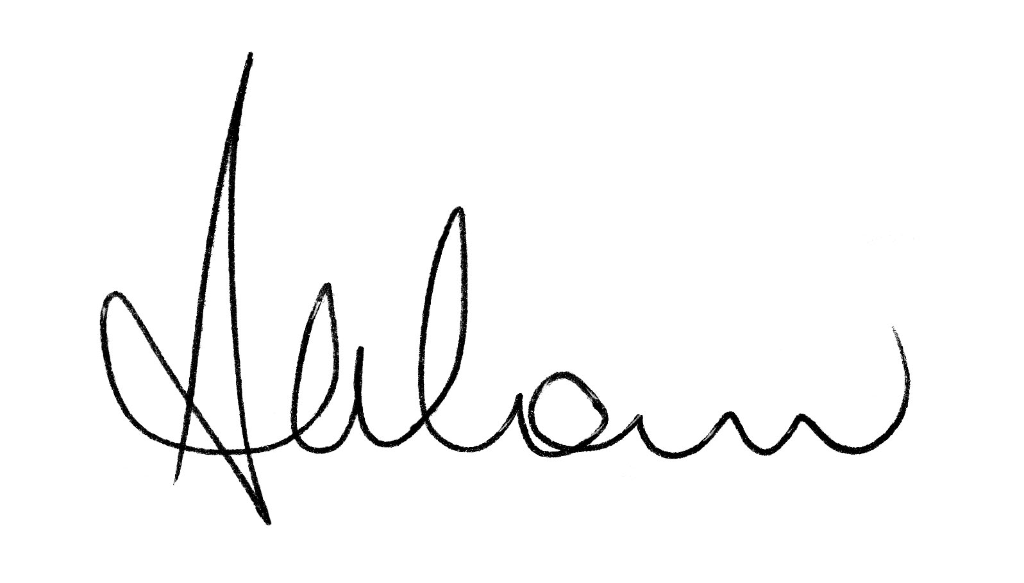
The Hon Scott Morrison MP
Treasurer

The role of the GST
When the Goods and Services Tax (GST) was introduced, it was decided that every dollar collected would be given to the States and Territories (the States) to spend on essential services, as they see fit. Since its introduction, the GST has become an important and increasing source of untied revenue for the States.
Distributing GST revenue amongst the States is an important way the Commonwealth ensures that no Australian is disadvantaged because of the State they live in. Through the system of horizontal fiscal equalisation (HFE) the larger, more financially independent States receive relatively less GST, creating an effective subsidy for the smaller States and Territories. This system of distribution is managed at arms-length from Government by the independent Commonwealth Grants Commission (CGC), which distributes the GST using a complex formula.
The Commonwealth also ensures that living standards for all Australians are maintained through other mechanisms, such as the tax / transfer system, which provides a safety net for all Australians, and through the guaranteeing of essential services Australians rely on such as Medicare.
The aim of using a single GST pool to provide almost all of the Commonwealth’s untied contributions was to replace yearly grants with a stable and growing source of funding that States could rely on. GST funding now accounts for around 25 per cent of State revenues, ranging from around 10 per cent in Western Australia (WA) to almost 50 per cent in the Northern Territory (NT).

Table 1: Recent GST distribution outcomes
 | NSW | VIC | QLD | WA | SA | TAS | ACT | NT
2017-18 GST relativity | 0.87672 | 0.93239 | 1.18769 | 0.34434 | 1.43997 | 1.80477 | 1.19496 | 4.66024
Population^{(a)} | 7,915,069 | 6,385,849 | 4,965,033 | 2,584,768 | 1,728,053 | 524,677 | 415,916 | 246,726
Total GST  received $m^{(b)} | 17,791 | 15,268 | 15,110 | 2,285 | 6,374 | 2,417 | 1,266 | 2,928
2018-19 GST relativity | 0.85517 | 0.98670 | 1.09584 | 0.47287 | 1.47727 | 1.76706 | 1.18070 | 4.25816
Population^{(c)} | 8,052,909 | 6,532,744 | 5,041,416 | 2,617,739 | 1,740,939 | 525,707 | 420,123 | 245,946
GST entitlement $m^{(b)} | 18,442 | 17,261 | 14,794 | 3,315 | 6,887 | 2,488 | 1,328 | 2,805
Average relativity since 2000^{(d)} | 0.90126 | 0.89103 | 1.03502 | 0.72395 | 1.28004 | 1.68175 | 1.20221 | 5.09715
- As at 31 December 2017. Source: Australian Demographic Statistics, Dec 2017 (ABS Cat. No. 3101.0).
- Estimate. Based on GST pool forecasts as presented in the Commonwealth’s 2018-19 Budget.
- Estimate as at 31 December 2018. Based on State population forecasts as presented in the Commonwealth’s 2018-19 Budget.
- Average from 2000-01 to 2018-19. Relativities prior to 2009-10 reflect the CGC’s calculation of a pool comprising of GST only (relativities previously recommended by the CGC were based on a pool comprising of both GST and health care grants).
The Commonwealth will provide an estimated $126.8 billion to the States in 2018-19, supporting approximately half of all their revenues. The majority of this funding will come from untied GST payments ($67.3 billion), which States can spend at their discretion.
The remaining Commonwealth funding to the States will come mainly through $58.6 billion in payments for specific policy areas such as schools, hospitals, housing and infrastructure.

Figure 1: State own-source revenue, GST and other payments from the Commonwealth as a proportion of total State revenue, 2018-19
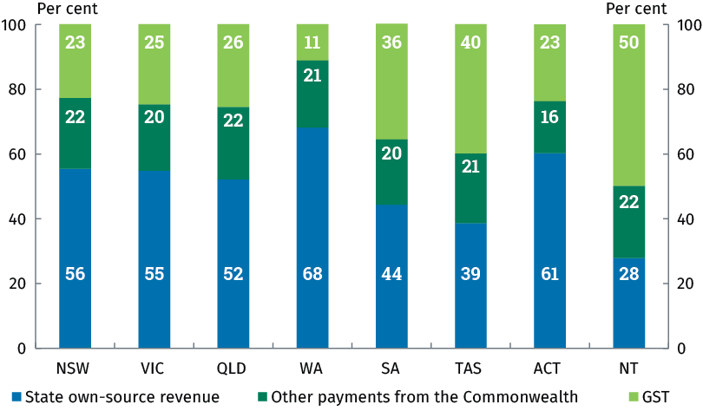
Totals may not sum due to rounding.
Source: Total State revenue figures are sourced from the States’ 2018-19 Budgets, with the exception of SA, which is sourced from its 2017-18 Mid-Year Budget Review. Payments from the Commonwealth figures are sourced from the Commonwealth’s 2018-19 Budget.
The size of the overall GST pool has grown from $24.4 billion when the GST was introduced to $67.3 billion today, an increase of 175.8 per cent. It is projected to grow by a further $43.8 billion or 65 per cent over the next decade.
A strong, growing economy into the future ensures that the GST pool will continue to grow. This is another reason why it is so important to pursue policies that grow our national economy, which was again the focus of this year’s Budget.
The biggest risk to GST distributions in the future is a weaker economy. A growing economy ensures that even if States experience a fall in their GST shares as a result of the CGC’s distribution formula, their nominal distribution can increase because of the larger GST pool generated by a stronger economy.
The Government is also ensuring that States will get more GST by taking action to grow the GST pool by making sure GST is being paid on all the goods and services it should be. This includes ensuring GST is paid on products sold online by large multinational companies.
Measures introduced by the Government since the 2015-16 Budget are estimated to contribute more than $2.0 billion to GST receipts in 2018-19 alone and around $6.5 billion over the four years to 2021-22 (see Table 2).

Table 2: Estimated GST impact of Commonwealth Government measures since 2015-16 Budget, by State
$m | NSW | VIC | QLD | WA | SA | TAS | ACT | NT | Total
2018-19 | 575 | 538 | 461 | 103 | 215 | 78 | 41 | 87 | 2,100
2019-20 | 344 | 325 | 292 | 79 | 128 | 49 | 26 | 57 | 1,300
2020-21 | 393 | 374 | 337 | 96 | 146 | 55 | 30 | 68 | 1,500
2021-22 | 421 | 399 | 364 | 104 | 153 | 58 | 31 | 70 | 1,600
Total | 1,733 | 1,637 | 1,455 | 382 | 642 | 239 | 128 | 283 | 6,500
Totals may not sum due to rounding.

Figure 2: Projected growth in the GST pool
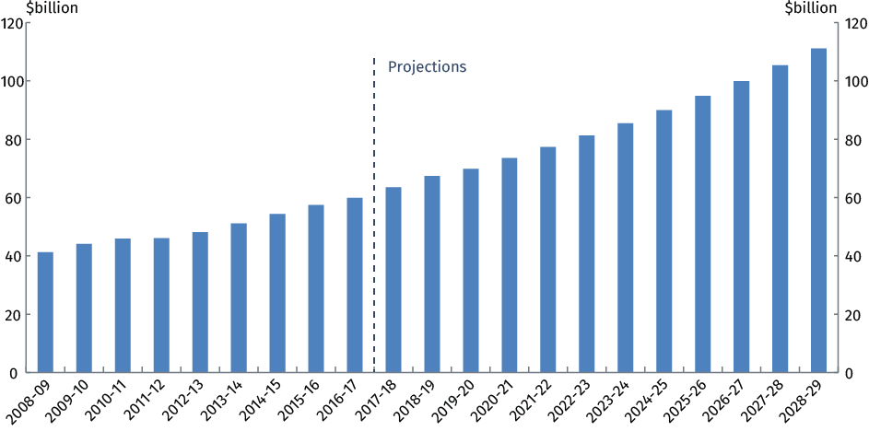
Note: GST pool estimates up to 2016-17 are the total GST cash payments made to the States. GST pool estimates beyond 2016-17 are projections based on Treasury projections of total GST cash receipts.

How does HFE work?
Since the GST was first introduced it has been distributed each year based on the independent recommendations of the CGC.
The CGC develops its recommendations by assessing the ‘fiscal capacity’ of each State. The fiscal capacity of a State represents its capacity to raise revenue and to deliver the services and associated infrastructure required in that State using that revenue raising capacity.
Put simply, the current system of HFE seeks to ‘fully equalise’ the fiscal capacity of all the States by bringing each of their fiscal capacities up to the standard that has been adopted by the CGC, which is to equalise to the fiscal capacity of the strongest State (see Figure 3). This has typically been New South Wales (NSW) or Victoria, however as a result of the mining boom recently this has been WA. This effectively means that fiscally stronger States support those States with less fiscal capacity. This system of equalisation has not been updated since the GST was introduced.

Figure 3: Stages of the HFE process
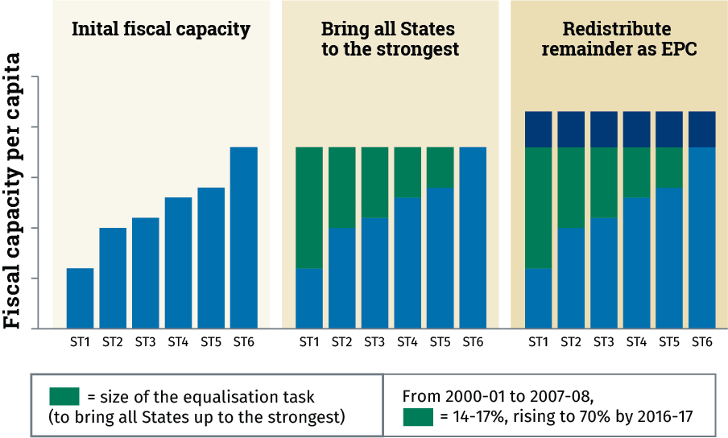
ST1-ST6 represent six hypothetical States.
Source: based on Productivity Commission data, Horizontal Fiscal Equalisation, Report no. 88.
The CGC has developed a complex formula to assess each State’s fiscal capacity across a broad range of indicators – comprising seven individual revenue sources and eleven expenditure categories – and then bring this all together to calculate each State’s overall relative fiscal capacity.
In assessing the States’ relative fiscal capacities, the CGC takes into account material factors affecting each State’s revenue and expenses that are beyond an individual State’s control (e.g. socio-demographic factors, population size, remoteness, indigeneity and natural endowments such as mineral resources).
The CGC then calculates how much GST each State would need to be able to deliver services and infrastructure to the same standard as all other States, if each made the same effort to raise revenue from its own sources and operated at the same level of efficiency.
The CGC’s recommendations are represented as per capita relativities. A relativity above one means that State is effectively subsidised because it receives more than its population share of GST. A relativity below one means that a State receives less than its population share of GST.
While the CGC currently aims to ensure that each State has the capacity to deliver services to the same standard as other States, this does not mean that all States will actually deliver the same level of services. Since the GST is provided as an untied payment, each State retains the autonomy to determine actual expenditure and revenue policies.

HFE has been part of our system since federation
Since Federation, the Commonwealth has needed to provide assistance to various States to ensure the standard of government services was not significantly different across the Commonwealth. The way funding has been distributed to the States has evolved over time.
While the general concept of equalisation has been a critical component of our nation since Federation, the notion of ‘full’ equalisation is a much more recent development. Notably, much of Australia’s HFE history is more appropriately characterised as ‘reasonable’ equalisation.
The introduction of the GST in 2000 marked the most recent development in the evolution to Australia’s current system of equalisation. From this point forward, the sharing of all GST revenue amongst the States has meant that the weaker States are effectively subsidised by the stronger States, rather than entirely through grants from the Commonwealth Government.

Figure 4: HFE since Federation
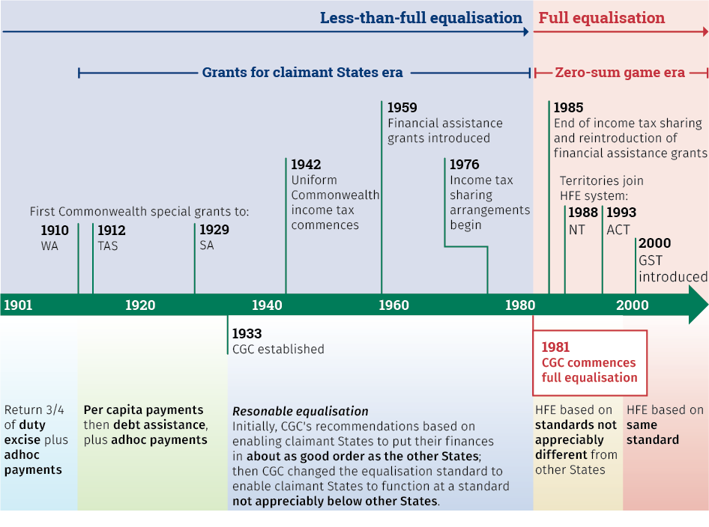
Source: Treasury, Productivity Commission.

The current HFE system was not designed to deal with significant economic shocks
The PC’s report highlights how the GST distribution system can result in perverse outcomes when faced with economic shocks.
In recent years, the effects of the mining boom have created extraordinary volatility in GST distribution outcomes, particularly for WA, undermining community faith in the current system of HFE. The resulting divergence in GST relativities remains in the system today (Figure 5).
As a result of the effects of the mining boom, WA’s relativity fell and eventually reached less than 30 cents in the dollar per person of GST, compared to $1.13 in Queensland and 95 cents in NSW (in 2015-16). A decade ago, before the mining boom, WA was receiving above a full dollar per person of GST.

Figure 5: Divergence in State per capita GST relativities
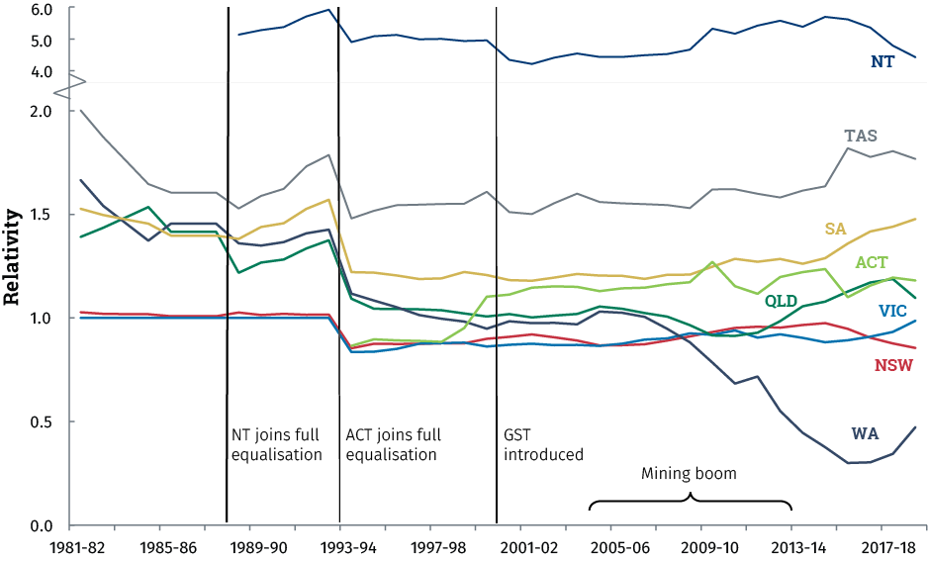
Source: Productivity Commission 2018, Horizontal Fiscal Equalisation, Report no. 88, Canberra.
Due to the unavoidable timing lag in the GST system, this dramatic fall in WA’s relativity occurred well after the peak in the mining boom and as the WA economy was struggling to adjust to lower commodity prices. Between 2006-07 and 2018-19, WA’s GST allocation fell from around 25 per cent of the WA Government’s total revenue to around just 10 per cent. The performance of WA’s mineral sector was effectively subsidising the fiscal position of all other States, and continues to do so. Although WA’s share of the GST has started to increase again from extremely low levels and is likely to continue to slowly increase, it will not return to the levels seen previously in the foreseeable future.
Given that the current HFE system attempts to equalise all States to the assessed fiscal capacity of the strongest State, the fiscal strength of WA meant that a greater proportion of the GST pool than ever before needed to be redistributed among the States, both in dollar terms and as a proportion of the GST pool (Figure 6).
This level of volatility in the HFE system was not and could not have reasonably been foreseen when the GST was introduced at a time when the Australian economy looked very different to how it is today. For most of the first decade following the introduction of the GST, the fiscally strongest State was either Victoria or NSW, as had historically been the case. The diverse and broad-based economies of these States provided a much more stable standard against which to equalise GST revenues, which limited volatility in GST relativities.

Figure 6: The equalisation task
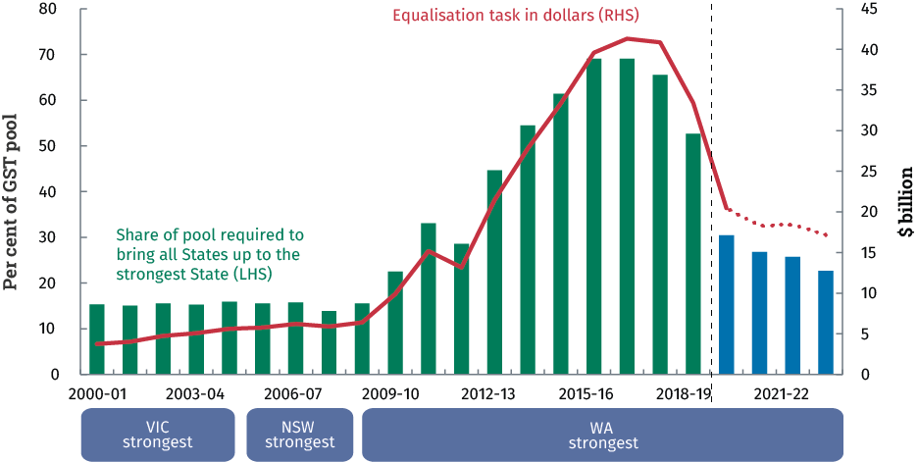
Source: based on Productivity Commission data, Horizontal Fiscal Equalisation, Report no. 88.
At the other end of the GST spectrum, the NT is now also experiencing extreme outcomes from the current distribution system. The NT’s relativity has fallen by 19 per cent in just a two year period, from 5.3 in 2016-17 down to 4.3 in 2018-19. The high costs the NT faces in delivering services to a remote population, coupled with the challenges in raising its own revenue, means it needs a higher level of GST per person to deliver services at a similar standard to other States. The severity of the effects of volatility in the HFE system on the NT has been such that in this year’s Budget the Commonwealth Government stepped in to provide additional funding to ensure the NT Government was able to continue to deliver essential services and infrastructure to a reasonable standard.

Updating the GST system means it can absorb future economic shocks
The way the GST is distributed has not been updated since it was introduced in 2000. After the economic shocks of the past decade, it is timely to look at how this system can be improved.
The current system of HFE was effective when the Australian economy and States’ economies were stable, and effectively meant that the GST was distributed so that all States had their fiscal capacities equalised to be the same as the broad-based, stable economies of either NSW or Victoria (whichever was strongest).
The mining boom was an unprecedented shock to the Australian economy that exposed weaknesses in our system of HFE that could not have been foreseen when the GST was introduced. This shock has affected the GST distribution since 2009-10, effectively covering around half of the period since the GST was introduced. It was in response to this volatility and declining community confidence in Australia’s HFE system that the Government tasked the independent Productivity Commission to undertake a thorough review of the strengths and weaknesses of the current HFE system.
In recent years, to minimise the effects of this extreme volatility in the HFE system, the Government has provided WA with additional funding for much needed road and rail projects that would otherwise have gone unfunded. This year, the Commonwealth also needed to provide the NT with additional funding to assist the NT Government to deliver essential services and infrastructure in response to an almost 20 per cent fall in NT’s share of the GST over just two years.
While these ‘top-up’ GST payments have provided vital short-term relief, they are not a sustainable solution to the volatility we have seen in the HFE system, nor a guard against future economic shocks. In order to reduce volatility in States’ shares of the GST and create certainty, Australia’s HFE system needs to be updated to reflect the modern economy. Building on the invaluable insights provided by the PC in its report, the Government is seeking to explore ways to do this that are fair, reasonable and sustainable. In particular, the Government is aiming to:
- Affirm our commitment to the ‘fair go’ principle of HFE;
- Maintain and improve HFE with minimal disruption, both now and in the future, to deliver essential services;
- Improve the stability of the system, reducing volatility for States’ revenue;
- Ensure all States and Territories are in a better off position.
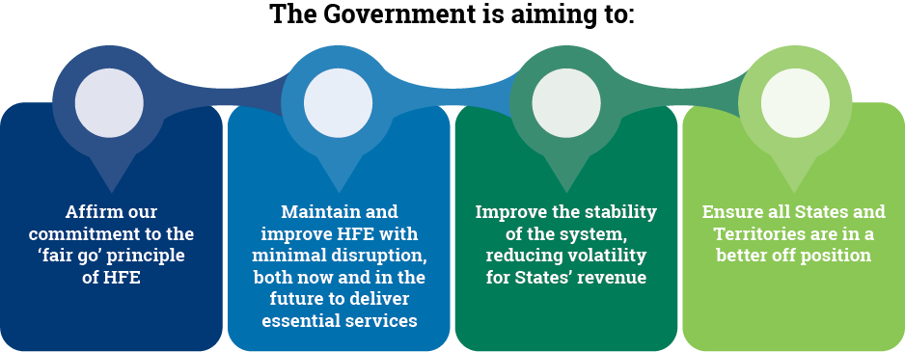

PC recommendations that can and should be pursued immediately
The PC made a number of findings regarding Australia’s HFE system and recommendations to improve the HFE process and simplify the formula to distribute the GST (see Appendix A).
The Government has broadly accepted all the PC’s findings and all but one of its recommendations in full or in principle. The recommendations outlined below propose sensible improvements to the system which the Commonwealth will seek to implement as soon as possible, following consultation with the States. The Government is proposing an alternative way to progress the remaining PC recommendation, which is discussed further below.

Changes to improve the HFE process
The PC finds that the independent and expert CGC is well placed to continue to recommend GST relativities and that it has well-established processes that involve consultation and regular methodology reviews.
However, the PC recommends changes that the Government and the CGC can make to improve the transparency, accountability and accuracy of the current HFE system.
In summary, the PC recommends that the CGC should:
- provide a stronger neutral voice to facilitate better informed public discourse on HFE (Recommendation 6.2)
- strengthen its formal interactions with the Commonwealth and States, including through provisional draft rulings, to enable a more collaborative approach to HFE and more certainty for States and Territories about potential GST distribution changes (Recommendation 6.3)
- make HFE calculations and the underlying data public to increase transparency and understanding of the system (Recommendation 6.6)
The PC also recommends that the Government:
- in consultation with States and Territories, develop guidelines on the exclusion of payments from HFE calculations, to provide greater clarity about which payments are excluded and why (Recommendation 6.4)
- bring an enhanced strategic focus to the CGC’s decision-making framework by nominating specific areas of focus and providing formal input into five-yearly methodology reviews (Recommendation 6.5)
The Government supports each of these recommendations subject to further consultation with the States.

Changes to improve the HFE calculation
The PC recommends changes to how the CGC calculates the distribution of the GST that would result in a simpler system and help reduce what the PC terms the ‘false precision’ that besets the current system.
The PC recommends that the Treasurer direct the CGC to consider simpler and more efficient assessments of State and Territory financial positions (Recommendation 7.1). In particular, the PC recommends that the CGC should adopt significant increases in materiality thresholds and consider using more aggregated revenue and expenditure assessments. The Government supports this recommendation, subject to further consultation with the States.
To further address the false precision in the current system reflected in the presentation of the States’ relativities, the Commonwealth Government also proposes to adopt Recommendation 3.2 of the 2012 GST Distribution Review to round the CGC’s relativities to two decimal places, subject to further consultation with the States.

Broader consideration of issues relating to federal financial relations
The PC recommends that, in addition to updating Australia’s system of HFE, the Commonwealth and the States should explore further meaningful reform of the broader federal financial relations framework, including considering the roles and responsibilities of different levels of government and opportunities to address vertical fiscal imbalance (Recommendation 9.1).
The Commonwealth engages with the States regarding the federal financial relations framework through numerous forums, particularly the Council on Federal Financial Relations (CFFR). The States also discuss such issues through the recently formed Board of Treasurers. The Commonwealth looks forward to continuing constructive engagement with the States on financial issues following the examination of potential improvements to the HFE system.

The PC also recommends a significant change to the standard of HFE

In making recommendations on ways to update Australia’s HFE system, the PC notes that no alternative benchmark for equalisation is unambiguously superior to any other.
The PC notes that finding the right balance involves judgment about whether the perceived benefits – such as enhancing policy neutrality and reducing disincentives for reform – outweigh the potential impact on fiscal equality across the States.
The PC considered a number of options to update HFE throughout its 12 month inquiry process. In its final report, the PC recommends moving to a new equalisation benchmark of the ‘average of all States’ (ETA), instead of the current system of equalising to the strongest State.
The Government has carefully considered the PC’s preferred option and formed the view that it is not the appropriate way forward to update the way the GST is distributed. Implementing the PC’s preferred model of HFE would create a level of disruption with unacceptable transition costs that most States would not be able to reasonably accept or absorb (see Table 3). This model would, in the Commonwealth’s view, move too far from the policy objective of HFE.
The PC’s recommendation to change the HFE standard to ETA is premised on analysis that this change would provide the greatest incentive for a small number of large States to undertake efficiency-enhancing tax reform, particularly a ‘swap’ of stamp duty revenue for increased land taxes. There are other significant obstacles to such a reform, and the limited scope for potential reform provided by the PC’s recommended model — by reducing disincentives to undertake it in only the three strongest States, with no change in the other five States — does not outweigh the significant costs that the States would face.
While the PC’s proposed model for HFE would be less susceptible to economic shocks than the current system, other options could provide similar protection against volatility in GST revenues in a way that is fairer, reasonable and more sustainable.

Table 3: Comparison of relativities: Current system and the PC’s recommended option

NSW | Current system* | PC option
2019-20 | 0.82 | 0.84
2020-21 | 0.82 | 0.84
2021-22 | 0.82 | 0.85
2022-23 | 0.81 | 0.85
2023-24 | 0.81 | 0.86
2024-25 | 0.82 | 0.88
2025-26 | 0.82 | 0.89
2026-27 | 0.83 | 0.90

VIC | Current system* | PC option
2019-20 | 0.96 | 0.95
2020-21 | 0.95 | 0.94
2021-22 | 0.94 | 0.92
2022-23 | 0.93 | 0.91
2023-24 | 0.93 | 0.91
2024-25 | 0.92 | 0.90
2025-26 | 0.91 | 0.90
2026-27 | 0.91 | 0.90

QLD | Current system* | PC option
2019-20 | 1.12 | 1.11
2020-21 | 1.12 | 1.10
2021-22 | 1.14 | 1.10
2022-23 | 1.15 | 1.10
2023-24 | 1.14 | 1.07
2024-25 | 1.12 | 1.05
2025-26 | 1.12 | 1.03
2026-27 | 1.11 | 1.01

WA | Current system* | PC option
2019-20 | 0.59 | 0.63
2020-21 | 0.62 | 0.69
2021-22 | 0.63 | 0.73
2022-23 | 0.66 | 0.78
2023-24 | 0.70 | 0.82
2024-25 | 0.73 | 0.85
2025-26 | 0.75 | 0.88
2026-27 | 0.76 | 0.90

SA | Current system* | PC option
2019-20 | 1.43 | 1.42
2020-21 | 1.43 | 1.40
2021-22 | 1.42 | 1.38
2022-23 | 1.40 | 1.35
2023-24 | 1.39 | 1.33
2024-25 | 1.39 | 1.32
2025-26 | 1.39 | 1.30
2026-27 | 1.38 | 1.29

TAS | Current system* | PC option
2019-20 | 1.81 | 1.80
2020-21 | 1.80 | 1.77
2021-22 | 1.78 | 1.74
2022-23 | 1.75 | 1.70
2023-24 | 1.75 | 1.69
2024-25 | 1.75 | 1.68
2025-26 | 1.75 | 1.67
2026-27 | 1.75 | 1.66

ACT | Current system* | PC option
2019-20 | 1.19 | 1.18
2020-21 | 1.18 | 1.16
2021-22 | 1.16 | 1.12
2022-23 | 1.15 | 1.10
2023-24 | 1.16 | 1.09
2024-25 | 1.16 | 1.09
2025-26 | 1.17 | 1.09
2026-27 | 1.18 | 1.08

NT | Current system* | PC option
2019-20 | 4.55 | 4.54
2020-21 | 4.75 | 4.74
2021-22 | 4.67 | 4.64
2022-23 | 4.84 | 4.80
2023-24 | 4.86 | 4.81
2024-25 | 4.88 | 4.82
2025-26 | 4.90 | 4.83
2026-27 | 4.91 | 4.84

*Current system shows nominal relativities, as presented in the PC final report, based on State and Territory Treasury estimates. All other options are presented as effective relativities, calculated by comparing the proposed nominal GST payments to an equal per capita (EPC) distribution.
Source: Treasury and Productivity Commission projections.

A fairer, reasonable and more sustainable way to distribute the GST
The Government is proposing a plan to update the way the GST is distributed to reflect changes to the economy since the GST was introduced almost 20 years ago. This plan would improve the resilience of the HFE system against economic shocks and reduce volatility in GST relativities amongst the States.
The Government’s plan involves transitioning to a new HFE system over eight years from 2019-20 in a way that is fair, reasonable and sustainable and that would ensure all States are better off.
The Government will commence discussions with the States on its plan and place it on the agenda of a special CFFR meeting in September, at the latest, with a view to coming to a final agreement on transition arrangements by the end of this year. To ensure that the process is as robust as possible, the Government will welcome, and consider, additional information provided by States during this time.

A new reasonable equalisation standard
The Government proposes to accept the PC’s recommendation to move to an updated ‘reasonable’ equalisation standard (Recommendation 6.1). Instead of the PC’s proposed model of equalising States to the average of all States (Recommendation 8.1), the Government’s preferred model involves moving to a benchmark that would ensure the fiscal capacity of all States is at least the equal of NSW or Victoria (whichever is higher).
For much of HFE’s history in Australia, NSW and Victoria have been the fiscally strongest States, due to their broad-based, diverse and stable economies (Figure 7). As a result, these States have historically served as the benchmarks for equalisation. It is only recently that the benchmark has shifted to WA as a result of the mining boom, which, with its reliance on one particular sector, has led to substantial volatility in the HFE system.
Benchmarking all States to the economies of the two largest States would remove the effects of extreme circumstances, like the mining boom, from Australia’s GST distribution system.

Figure 7: Cumulative distribution of all Commonwealth grants to States^{(a),(b)} Difference from EPC distribution of grants, excluding Territories; $2015
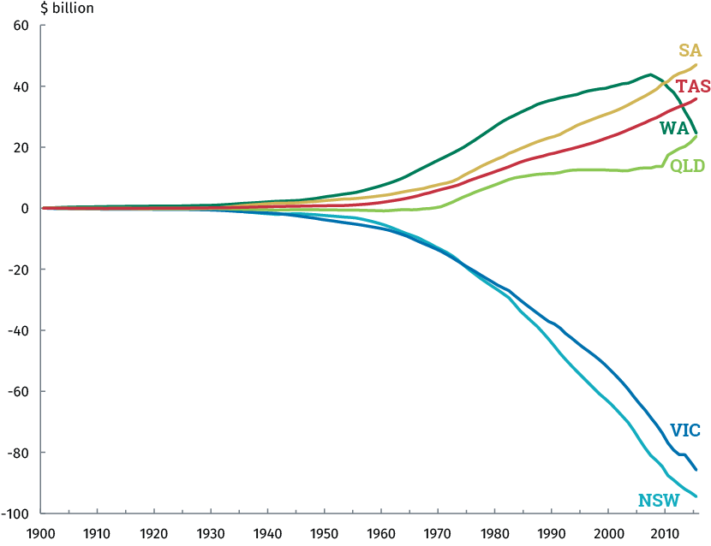
- ‘Commonwealth grants’ includes general revenue assistance (primarily equalisation payments), Specific Purpose Payments (SPPs), National Partnership (NP) payments, and capital grants.
- The years 1994-95 and 1995-96 used estimates (not actual data) for NP and SPP data. No data were available for the 1996-97 SPP and NP components so the averages of past and future years were used.
Source: Productivity Commission 2018, Horizontal Fiscal Equalisation, Report no. 88, Canberra.

A GST relativity floor safety net
In addition to moving to an updated, more stable equalisation standard, the Government proposes to put in place a ‘floor’ below which no State’s relativity can fall. The GST relativity floor would be set within the GST distribution system, rather than by an external ex-gratia payment.
A GST relativity floor would provide an additional safety net to guard against the unlikely event of an economic shock that is extreme enough to introduce significant volatility into the HFE system, even under a new equalisation standard.
The Government is proposing to implement a ratcheting floor over the course of the transition to a new equalisation standard. The floor would initially be set at a relativity of 0.70, before moving up to 0.75. Since these floors are only intended as an additional safety net, they would be implemented at a time where the relativities of all States are expected to be (and remain) above these relativities on current projections.

All States and Territories would be better off
Since all GST revenue is distributed to the States, any change to the distribution such as that being proposed by the Government now, without additional measures, would result in some States being worse off than they otherwise would have been.
While this may be the case in relative terms, in actual dollars received all States are considerably better off than they would have been as a result of measures the Government has taken to enhance the integrity of the GST and increase the size of the GST pool in recent years. To ensure a fair and sustainable transition to a new equalisation standard, the Government would provide an additional, direct boost to the GST pool. This boost would expand the size of the GST pool on a permanent basis.
The size of the boost to the GST pool would be set at a level that ensures no State is worse off as a result of the move to a new equalisation benchmark. This would provide ongoing untied funding for the States to use as they see fit on services such as schools, hospitals and law enforcement.

Table 4: Comparison of State relativities: Current system, the Government’s preferred option and the PC’s recommended option

NSW | Current system* | Govt preferred | PC option
2019-20 | 0.82 | 0.83 | 0.84
2020-21 | 0.82 | 0.82 | 0.84
2021-22 | 0.82 | 0.82 | 0.85
2022-23 | 0.81 | 0.81 | 0.85
2023-24 | 0.81 | 0.81 | 0.86
2024-25 | 0.82 | 0.82 | 0.88
2025-26 | 0.82 | 0.82 | 0.89
2026-27 | 0.83 | 0.83 | 0.90

VIC | Current system* | Govt preferred | PC option
2019-20 | 0.96 | 0.96 | 0.95
2020-21 | 0.95 | 0.95 | 0.94
2021-22 | 0.94 | 0.94 | 0.92
2022-23 | 0.93 | 0.93 | 0.91
2023-24 | 0.93 | 0.92 | 0.91
2024-25 | 0.92 | 0.92 | 0.90
2025-26 | 0.91 | 0.91 | 0.90
2026-27 | 0.91 | 0.90 | 0.90

QLD | Current system* | Govt preferred | PC option
2019-20 | 1.12 | 1.12 | 1.11
2020-21 | 1.12 | 1.12 | 1.10
2021-22 | 1.14 | 1.14 | 1.10
2022-23 | 1.15 | 1.15 | 1.10
2023-24 | 1.14 | 1.13 | 1.07
2024-25 | 1.12 | 1.12 | 1.05
2025-26 | 1.12 | 1.12 | 1.03
2026-27 | 1.11 | 1.11 | 1.01

WA | Current system* | Govt preferred | PC option
2019-20^ | 0.59 | 0.70 | 0.63
2020-21^ | 0.62 | 0.70 | 0.69
2021-22^ | 0.63 | 0.70 | 0.73
2022-23 | 0.66 | 0.71 | 0.78
2023-24 | 0.70 | 0.75 | 0.82
2024-25 | 0.73 | 0.79 | 0.85
2025-26 | 0.75 | 0.81 | 0.88
2026-27 | 0.76 | 0.83 | 0.90

SA | Current system* | Govt preferred | PC option
2019-20 | 1.43 | 1.43 | 1.42
2020-21 | 1.43 | 1.43 | 1.40
2021-22 | 1.42 | 1.42 | 1.38
2022-23 | 1.40 | 1.40 | 1.35
2023-24 | 1.39 | 1.39 | 1.33
2024-25 | 1.39 | 1.39 | 1.32
2025-26 | 1.39 | 1.39 | 1.30
2026-27 | 1.38 | 1.38 | 1.29

TAS | Current system* | Govt preferred | PC option
2019-20 | 1.81 | 1.81 | 1.80
2020-21 | 1.80 | 1.80 | 1.77
2021-22 | 1.78 | 1.78 | 1.74
2022-23 | 1.75 | 1.75 | 1.70
2023-24 | 1.75 | 1.75 | 1.69
2024-25 | 1.75 | 1.75 | 1.68
2025-26 | 1.75 | 1.76 | 1.67
2026-27 | 1.75 | 1.76 | 1.66

ACT | Current system* | Govt preferred | PC option
2019-20 | 1.19 | 1.20 | 1.18
2020-21 | 1.18 | 1.18 | 1.16
2021-22 | 1.16 | 1.16 | 1.12
2022-23 | 1.15 | 1.15 | 1.10
2023-24 | 1.16 | 1.16 | 1.09
2024-25 | 1.16 | 1.16 | 1.09
2025-26 | 1.17 | 1.17 | 1.09
2026-27 | 1.18 | 1.18 | 1.08

NT | Current system* | Govt preferred | PC option
2019-20^ | 4.55 | 4.66 | 4.54
2020-21 | 4.75 | 4.76 | 4.74
2021-22 | 4.67 | 4.68 | 4.64
2022-23 | 4.84 | 4.85 | 4.80
2023-24 | 4.86 | 4.87 | 4.81
2024-25 | 4.88 | 4.89 | 4.82
2025-26 | 4.90 | 4.91 | 4.83
2026-27 | 4.91 | 4.93 | 4.84

*Current system shows nominal relativities, as presented in the PC final report, based on State and Territory Treasury estimates. All other options are presented as effective relativities, calculated by comparing the proposed nominal GST payments to an EPC distribution.
^These years include top up payments from the Commonwealth to WA and/or NT under the Government’s preferred option. Source: Treasury and Productivity Commission projections.

The Government’s plan has three steps
The GST distribution system cannot be moved to an updated equalisation standard overnight. The Government’s plan seeks to transition Australia’s HFE system over eight years in a fair, reasonable and sustainable way that leaves no State worse off. At the end of this eight year period in 2026-27, Australia would have a HFE system that better protects against economic shocks and provides a more stable and predictable source of revenue for all States going forward.

Step one: short-term transition payments
The States’ GST relativities are likely to remain volatile for the next few years, as the system rebalances and WA’s relativity improves from its current very low levels. Beginning to transition the HFE system to a new standard during this period would only add to volatility and create a level of disruption that would not be acceptable.
To assist with the transition to the new system, the Commonwealth would provide short-term funding over the three years from 2019-20 to 2021-22 to ensure that no State receives less than 70 cents per person per dollar of GST. This funding would be untied, meaning recipient State Governments would be able to spend it as they see fit to deliver services in their State, including schools, hospitals and infrastructure. WA is expected to be the only State with a relativity below 0.70 during this time.
Over the same period, the Government would also ensure that the NT keeps at least their current share of GST, as it did in this year’s Budget. This recognises the unique circumstances faced by the NT in dealing with the current volatility in the GST distribution given their small size, remoteness and relatively large Indigenous population.

Step two: phasing in a new HFE system
Under the Government’s plan, the HFE system would begin transitioning to an updated equalisation standard — the stronger of NSW or Victoria — over six years from 2021-22 to 2026-27.
In 2022-23, a within-system GST floor would be introduced to ensure no State can receive any less than 70 cents per person per dollar of GST for their State. No State’s relativity is expected to fall below 0.70 after 2022-23 on current projections under the new equalisation benchmark. Two years later, in 2024-25, this floor would be raised to 75 cents per person per dollar of GST. No State’s relativity is expected to fall below 0.75 after 2024-25 on current projections under the new equalisation benchmark.
To ensure all States are better off both during and following the transition to the new equalisation standard, the Government would permanently boost the GST pool in addition to GST collections by making supplementary untied payments sourced from its other revenues. The Government’s preferred method for this expanded GST pool is outlined in Box 1.
Boosting the GST pool with additional Commonwealth payments, moving to a new equalisation benchmark and inserting a relativity floor in the HFE system would be brought together in a new Intergovernmental Agreement between the Commonwealth and the States. The Government will be consulting with the States on this agreement and any alternative transition arrangements that may be proposed.

Box 1: Government preferred approach for boosting the GST pool
The Commonwealth Government would inject an additional $600 million into the GST distribution in 2021-22, the first year of transition to the new equalisation standard. The Commonwealth’s contributions in the following years would be equivalent to indexing this injection at the same rate of growth as GST collections in those years. That is, the expanded GST pool would continue to grow at the same rate as the GST collections each year.
This would be followed by a second injection of $250 million in 2024-25. At this point, the HFE system would be over half way through the transition to the new equalisation standard and the Government would have introduced a within-system 0.75 relativity floor. Future Commonwealth payments into the pool would then be indexed to grow in line with GST collections on a permanent basis.
This arrangement would increase the size of the untied GST distribution by $7.2 billion from 2021-22 to 2028-29. This would leave all States and Territories better off under a new, more stable equalisation standard, with additional funding that State Governments can use to deliver essential services.

Table 5: Every State and Territory will be better off
Additional Top-ups

$m | NSW | VIC | QLD | WA | SA | TAS | ACT | NT | Total
2019-20 | 0 | 0 | 0 | 814 | 0 | 0 | 0 | 69 | 883
2020-21 | 0 | 0 | 0 | 585 | 0 | 0 | 0 | 0 | 585
Total | 0 | 0 | 0 | 1,399 | 0 | 0 | 0 | 69 | 1,468
Impact of boost to GST Distribution Pool^

2021-22 | 78 | 84 | 87 | 568* | 41 | 17 | 7 | 24 | 905*
2022-23 | 30 | 45 | 61 | 421 | 31 | 14 | 5 | 24 | 631
2023-24 | 14 | 32 | 51 | 495 | 28 | 13 | 5 | 25 | 664
2024-25 | 70 | 84 | 101 | 575 | 50 | 22 | 9 | 37 | 948
2025-26 | 85 | 96 | 112 | 580 | 54 | 23 | 10 | 39 | 999
2026-27 | 74 | 85 | 105 | 663 | 53 | 23 | 10 | 40 | 1,053
Total | 351 | 425 | 518 | 3,303* | 257 | 112 | 46 | 189 | 5,201*

^This includes the impact of moving to the updated equalisation benchmark.
* This includes a further top up payment of $305 million in 2021-22 to ensure WA’s relativity of 0.70 is maintained. Totals may not sum due to rounding.

Table 6: Expanding the base
$m | Estimated GST Pool | Commonwealth  Boost | Boosted GST Pool | Additional Funding  Due to Boost
2018-19 | 67,320 |  | 67,320 | 0
2019-20 | 69,790 |  | 69,790 | 0
2020-21 | 73,510 |  | 73,510 | 0
2021-22 | 77,270 | 600 | 77,870 | 600
2022-23 | 81,250 |  | 81,881 | 631
2023-24 | 85,450 |  | 86,114 | 664
2024-25 | 89,950 | 250 | 90,898 | 948
2025-26 | 94,770 |  | 95,769 | 999
2026-27 | 99,900 |  | 100,953 | 1,053
2027-28 | 105,340 |  | 106,451 | 1,111
2028-29 | 111,080 |  | 112,251 | 1,171

Figure 8: Projected GST distribution pool
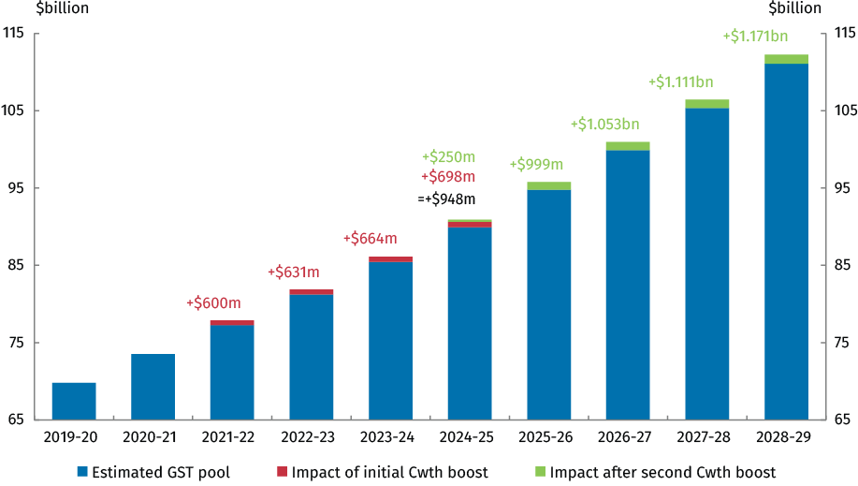

Step three: completing the transition to a new, more stable equalisation standard
By 2026-27, the system would have fully transitioned to the new, more stable benchmark in a way that is fair, reasonable and sustainable for all States and Territories. The Commonwealth Government would continue to boost the GST pool to ensure that all States and Territories would be better off, with additional funding every year from 2021-22 to deliver essential services. A 0.75 within-system relativity floor would be a permanent feature of the HFE system.
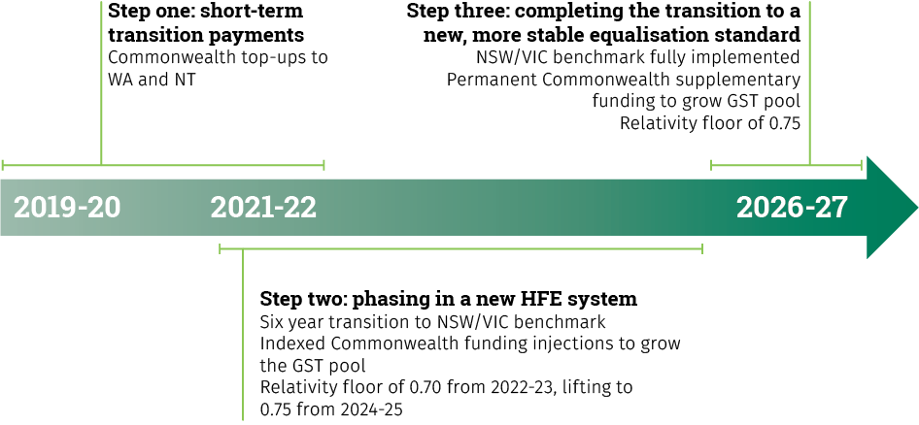

Consultation with the States
Consultation with the States is an important part of our Federal Financial Framework. The Government will be consulting with all States and Territories on its plan to transition the HFE system to a new equalisation standard in the coming months.
These consultations will be progressed through CFFR. The Government will convene a special meeting of CFFR to discuss this proposal no later than September this year.
As a first step, the Government will seek agreement to implement the majority of the PC’s recommendations that can and should be implemented immediately. The Government hopes to agree details of the new HFE benchmark and boosted GST pool by the end of 2018.

Appendix A

Productivity Commission’s Final Report: Recommendations
Recommendation | Interim response
Recommendation 6.1: The objective of the HFE system should be refocused to provide the States with the fiscal capacity to provide services and associated infrastructure of a reasonable (rather than the same) standard.  The Commonwealth Government should set this revised objective of HFE.  The Treasurer should present the revised objective to the Council on Federal Financial Relations.  Following this, the Treasurer should reissue  the terms of reference to the CGC for the 2020 methodology review to reflect the new objective.  The terms of reference for all future relativity updates and five-yearly methodology reviews should reflect this revised objective.  The Intergovernmental Agreement on Federal Financial Relations and the Commonwealth Grants Commission Act 1973 (Cwlth) should also be amended to reflect the revised objective. | Accept, subject to consultation with the States.  The Government agrees the HFE objective should be refocused to provide States with the fiscal capacity to provide services and associated infrastructure at a reasonable standard, rather than the same standard.  Defining the HFE objective in this way would recognise that there is false precision in the current system. The current system does not actually achieve full equalisation due to data limitations, time lags, and other anomalies. Importantly, reasonable equalisation would reduce volatility in the GST system, which has been greatly exacerbated by the mining boom.  The Government agrees that the objective of HFE should be defined in consultation with the States, and included in the terms of reference issued to the CGC for calculating the GST relativities.  The Government notes that while the Intergovernmental Agreement on Federal Financial Relations and legislation could also be amended to include the HFE objective, these are not necessary prerequisites to including the objective in terms of reference to the CGC.
Recommendation 6.2: The CGC — through its Chairperson and Commission members — should provide a strong neutral voice, to facilitate a better informed public discourse on the HFE system. | Accept, subject to consultation with the States.  The Government supports the CGC adopting a greater public educational role. As the subject matter experts, the CGC could help improve understanding of the system which is currently very low, and mitigate the potential for misunderstandings to develop.
Recommendation 6.3: The CGC should strengthen its formal interactions with the State and Commonwealth Governments. In particular, when requested by a State Government, it should provide provisional ‘draft rulings’ on the HFE implications of a policy change. | Accept, subject to consultation with the States.  The Government notes that the CGC already has strong relationships with the States, including through written papers, informal staff engagements, and formal State visits. Nonetheless, the Government supports the CGC further strengthening these interactions, including by providing States with draft rulings.  Draft rulings could provide the States with greater transparency and certainty on the GST impacts of reform, and may further encourage States to pursue beneficial reforms.
Recommendation 6.4: The Commonwealth Government, in consultation with the States, should develop clear guidelines detailing the basis on which Commonwealth payments are to be quarantined from HFE by the Commonwealth Treasurer (so that they do not unnecessarily erode the efficacy of the CGC’s relativities and compromise the objective of HFE).  The guidelines should strike a balance between enhancing accountability and transparency, while not unduly affecting the Treasurer’s ability to quarantine payments in exceptional circumstances that are in the national interest. | Accept, subject to consultation with the States.  The Government supports the development of guidelines that provide an equal playing field for all States. However, the Government notes that there are also sometimes exceptional circumstances where the Commonwealth must act in the national interest.
Recommendation 6.5: The Commonwealth Government should strengthen the CGC’s decision-making framework. In particular:  - the Commonwealth Treasury should provide input, including public submissions, to the CGC’s five-yearly methodology review process, drawing upon its community-wide perspective  - the Commonwealth Treasurer should nominate specific areas of focus for the CGC in the terms of reference for the five-yearly methodology reviews, following (as is currently the case) consultation with the States. | Accept, subject to consultation with the States.  The Government supports the Commonwealth Treasury providing the CGC with more input, where this would contribute additional value to the CGC.  The Government also agrees to consider whether there are specific areas that the CGC should focus on during methodology reviews, when developing these terms of reference.
Recommendation 6.6: The CGC should immediately and systematically make the data provided by the States publicly available on its website, along with the CGC’s calculations on these data. | Accept, subject to consultation with the States.  Consistent with our ‘open data’ policy, the Government supports the public dissemination of more data. However, such data must be released responsibly, and address concerns such as privacy, commercial sensitivities and/or the possibility for the data to be misinterpreted.
Recommendation 7.1: The Commonwealth Treasurer should direct the CGC (in accordance with the refocused HFE objective) to:  - examine simpler and more aggregated revenue and expenditure assessments that use more policy-neutral indicators, consistent with achieving a reasonable standard of services  - adopt significant increases in materiality thresholds, which would assist in determining and applying more policy-neutral category level indicators.  This initial direction should be embedded in revised terms of reference for the CGC’s 2020 methodology review. | Accept, subject to consultation with the States.  The Government agrees there is merit in exploring the use of more policy-neutral indicators. These indicators would simplify the HFE system and could reduce disincentives for States to pursue beneficial policy reforms.  The Government also agrees there is merit in raising the materiality thresholds within assessments, which would simplify the system and ensure that only the most important factors are considered in assessing State’s relative fiscal capacities.  The Government notes that the CGC is currently undertaking a major methodology review, which could provide an ideal opportunity to thoroughly explore these issues.
Recommendation 8.1: The Commonwealth Government should transition Australia’s system of HFE towards equalisation to the average (pre-GST) fiscal capacity of all States, with the remaining GST revenue distributed on a per capita basis. | Support instead adopting an alternative benchmark that would ensure the fiscal capacity of all States is at least the equal of NSW or Victoria (whichever is higher), subject to consultation with the States.  The Government agrees that the HFE system should strive for reasonable equalisation, but we do not consider that the ETA benchmark is in the national interest.  ETA, even with an extended transition, would result in very significant redistributions of the GST away from the fiscally weakest States, compromising the principle of HFE and the ability of States to provide essential services to their citizens.  The Government’ preferred approach is to equalise to the stronger of the two largest States (NSW or Victoria). The Government will consult on this new benchmark with the States. Any new benchmark adopted should improve the system’s ability to deal with external shocks, and provide the States with greater certainty and predictability in their year-on-year GST payments.
Recommendation 9.1: Improvements to the HFE system can only go so far.  The Commonwealth and State Governments, through the Council on Federal Financial Relations and recently formed Board of Treasurers, should work towards meaningful reform to federal financial relations.  In the first instance, the process should:  - assess how Commonwealth payments to the States — both general revenue assistance and payments for specific purpose — interact with each other, given the significant reforms to payments for specific purposes that have occurred in recent years  - develop a better-delineated division of responsibilities between the States and the Commonwealth and establish clear lines and forms of accountability. Policies to address Indigenous disadvantage should be a priority.  Following this, options to address the vertical fiscal imbalance should be considered and advanced. | Accept in-principle, subject to consultation with the States.  Commonwealth-State relations are fundamental to the smooth operation of our country. To ensure this relationship continues to remain effective, we should constantly review and refine it.

GST Distribution Review Final Report, October 2012: Recommendation
Recommendation 3.2 on rounding relativities: To ensure the system does not appear to be falsely precise, the Panel recommends that relativities produced from the CGC’s process be rounded to two decimal places in the annual Updates and Reviews. | Accept, subject to consultation with the States.  In addition to the PC’s Recommendations, the Government agrees that implementing this additional recommendation from the 2012 GST Distribution Review would further address false precision in the system.

Productivity Commission’s Final Report: Findings

The Government broadly accepts all the Productivity Commission’s findings.
Finding 2.1: Australia achieves a high degree of horizontal fiscal equalisation and to a much greater extent than other countries. It is the only OECD country with a federal government that seeks to fully eliminate disparities in fiscal capacity between sub-national governments.
Finding 3.1: Most State tax reforms would have limited impacts on the GST distribution. However, there are circumstances where the GST effects can be material — such as for a State undertaking large scale tax reform — and act as a significant disincentive for States to implement efficient tax policy. These disincentives are likely to be exacerbated where the State is a first mover on reform or where there is uncertainty about how significant tax changes will be assessed by the CGC.
Finding 3.2: Changes in State service delivery policies can impact on GST payments, but the impacts
are mostly trivial. HFE is unlikely to directly discourage — nor encourage — States from improving the efficiency of service delivery or addressing their structural disadvantages, given the broader and more significant benefits of doing so to the community. Accountability for policy outcomes — which is
lacking — is a much greater driver of expenditure choices.
Finding 3.3: The potential for HFE to distort State policy is pronounced for mineral and energy resources. While there is limited direct evidence that GST effects have influenced specific policy decisions, the incentive effects for some States are palpable and have the potential to undermine State policy neutrality.
However, making adjustments to the HFE system specifically to add incentives (rather than remove disincentives) for desirable resource exploration policies, or to singularly remedy disincentives for mining taxation, would not advance policy neutrality, would be a source of additional complexity, and come at the expense of fiscal equality.
Finding 4.1: Features of Australia’s HFE system can exacerbate the fiscal impact of economic cycles when States experience large economic shocks. Such a situation recently occurred in Western Australia.
However, offsetting cyclical influences on State budgets is not the primary objective of HFE, and options to improve contemporaneity do not offer unequivocal improvements.
- Reducing the length of the assessment period would have mixed impacts across States, and may ultimately have little effect on State budget fluctuations.
- The two-year data availability lag cannot be substantially reduced without introducing additional scope for volatility and dispute.
The most effective response to a lack of contemporaneity lies with the States themselves, and with the necessity for State Treasuries to factor the assessment period and GST lag into their budget management processes (which most do).
Finding 4.2: Volatile State revenues can contribute to uncertainty in budgeting processes. Compared with other sources of State Government revenue, GST payments are relatively stable and in some cases may offset volatility from other revenue sources.
Finding 5.1: Taken together, the available evidence suggests that fiscal factors (including those related to HFE) are unlikely to play a major part in interstate migration decisions. Other factors, such as differences in work opportunities between States and personal reasons, are bigger drivers of interstate migration.
Finding 6.1: While Australia’s HFE system has a number of strengths, it also has several deficiencies. In particular, it can provide disincentives for desirable tax and resource development policies, and, to the extent that States do not reap much of the rewards of their own policy efforts, can detract from fairness.
Many of these concerns are due to the pursuit, above all else, of comprehensive equalisation of fiscal capacities. It is likely that opportunities are being missed to more fairly reward States for their policy efforts, and to improve efficiency and enhance the wellbeing of the Australian community over time.
Finding 7.1: The use of externally defined benchmark costs in the HFE system to assess State expenditure on service delivery would encourage greater efficiency, but faces daunting practical difficulties and a high degree of scope for dispute.
Finding 7.2: Using a single broad indicator to assess States’ fiscal capacities offers considerable potential to improve policy neutrality and simplify the HFE system. However, a single indicator that accurately reflects the underlying revenue-raising capacities and expenditure needs of each State remains elusive and arguably does not exist.
Finding 7.3: The use of more policy-neutral revenue and expenditure indicators, along with significantly higher materiality thresholds, offers considerable scope to secure greater efficiency and simplify the HFE system (and therefore improve transparency and accountability), while also achieving a high degree of fiscal equality in overall State fiscal capacities.
The Commission has identified one prospective candidate — in the stamp duty tax base. But there is only limited scope to secure greater policy neutrality through this approach where it matters most — in the mining assessment.
Finding 7.4: Discounting mining (or other revenue categories) in the HFE process — or removing it entirely — is not justified and would come at a high cost to fiscal equality.
Finding 7.5: The CGC’s proposal to discount revenues such that a State retains at least 50 per cent of the own-source revenue impacts of a tax or royalty rate change (net of GST payments) is an incomplete approach to mitigate policy non-neutrality in HFE. It would only address policy influence on average tax rates, not on tax bases, and only for Western Australia for the foreseeable future.
Finding 8.1: An equal per capita approach to the distribution of GST revenue is incapable of providing States with the fiscal capacities to deliver a reasonable standard of services. It is thus inimical to the fiscal equality rationale underpinning HFE.
Finding 8.2: An equal per capita with top-up funding approach for distributing GST revenue could provide all States with the fiscal capacity to deliver a reasonable standard of services, depending on the level of top-up funding. While this would meet the fiscal equality rationale underpinning HFE, the top-up funding would always be subject to the vagaries of the Commonwealth budget. It should only be considered in the context of broader reform to federal financial relations that generate compensating benefits.
Finding 8.3: The introduction of a relativity floor would blunt the equalisation task and introduce greater incentives for policy effort for the beneficiary State(s) — Western Australia for the foreseeable future. But a floor represents a band-aid solution, as it is not well targeted to broader efficiency and fairness problems.
Finding 8.4: No alternative benchmark for equalisation is unambiguously superior to any other. All have costs and benefits that are difficult to comprehensively identify, let alone quantify. Determining which alternative benchmark is most likely to provide the greatest net benefit — the right balance — involves judgment about whether the benefits of greater policy neutrality (efficiency) and reward for policy effort and risk taking (fairness) outweigh the fiscal equality impacts.
Overall, equalising to the average (pre-GST) fiscal capacity of all States is judged to provide a better balance than the current benchmark and is thus a preferred alternative.
- It offers the greatest incentives for some States (but not all) to undertake efficiency-enhancing tax reform and broadly reduces policy non-neutrality with respect to the mining revenue assessment.
- It is less susceptible to fiscal outliers and therefore provides a more stable basis for deriving GST relativities.
The impacts on fiscal equality are expected to be modest and manageable, especially when implemented through a carefully designed transition.
Finding 9.1: There are many ways a new equalisation benchmark could be phased in. The most effective transition approach is one that:
- enables States to manage their budgets during the current forward estimates period and plan for changes over the longer term
- is fiscally sustainable for all governments, in that it is funded through the GST pool (in effect, by the States that benefit from the change) and not from outside the pool
- delivers the benefits of the new benchmark in a timely manner.
Either a four year or eight year transition path to ETA is judged to be manageable for the States.
A four year transition would deliver the benefits of reform more quickly, but an eight year transition provides greater latitude to deal with unexpected changes in the future fiscal circumstances of the States. By delaying the full implementation of ETA, both approaches are effectively funded from within the GST pool by the States that stand to benefit the most.
An eight year transition would also provide more time for State and Commonwealth Governments to negotiate broader reforms to federal financial relations, which could potentially alleviate any residual ongoing adverse fiscal impacts on States from the new benchmark.

