GST Distribution Review
Second Interim Report

2012
© Commonwealth of Australia 2012
ISBN 978-0-642-74820-1
This publication is available for your use under a Creative Commons Attribution 3.0 Australia licence, with the exceptions of the Commonwealth Coat of Arms; the Treasury logo; photographs; images; signatures; text quoted from State or Territory Governments, Australia’s Future Tax System review, review of National Competition Policy Reforms, Cliff Walsh, Jeff Petchey, Julie Smith and Christine Fletcher or submissions made during the public consultation process; data, statistics or projections from State or Territory Governments, Australia’s Future Tax System review, KPMG, Bev Dahlby or Neil Warren; and where otherwise stated. The full licence terms are available from http://creativecommons.org/licenses/by/3.0/au/legalcode.

Use of GST Distribution Review material under a Creative Commons Attribution 3.0 Australia licence requires you to attribute the work (but not in any way that suggests that the GST Distribution Review endorses you or your use of the work).
GST Distribution Review material used ‘as supplied’.
Provided you have not modified or transformed GST Distribution Review material in any way including, for example, by changing the GST Distribution Review text; calculating percentage changes; graphing or charting data; or deriving new statistics from published GST Distribution Review statistics — then GST Distribution Review prefers the following attribution:
Source: The Australian Government, GST Distribution Review
Derivative material
If you have modified or transformed GST Distribution Review material, or derived new material from those of the GST Distribution Review in any way, then the GST Distribution Review prefers the following attribution:
Based on The Australian Government, GST Distribution Review data
Use of the Coat of Arms
The terms under which the Coat of Arms can be used are set out on the It’s an Honour website (see www.itsanhonour.gov.au).
Other Uses
Inquiries regarding this licence and any other use of this document are welcome at:
Manager
Communications
The Treasury
Langton Crescent Parkes ACT 2600
Email: medialiaison@treasury.gov.au

Table of Contents
Foreword from the Panel v
Introduction vii
1 The tax system in Australia 1
1.1Revenue raised by States 2
1.2 A brief history of taxation in Australia 3
1.3 Incidence and bases of tax 5
1.4 Impact of taxes on behaviour 5
1.5 Tax reform and the GST 7
1.6 The AFTS review 8
1.7 The Tax Forum and beyond 11
2 The assessment of revenues in the current HFE system 13
2.1 State revenues assessed by the CGC 14
2.2 The CGC revenue assessment process 17
2.3 Determining the average revenue policy 18
2.4 Revenue raising capacity 20
2.5 Revenue raising effort 22
2.6 GST distribution outcomes 24
2.7 Case study — insurance tax 25
3 Does HFE provide a disincentive to State tax reform? 29
3.1 The effects of tax policy changes on GST shares 29
3.2 State views on the effect of GST share changes 34
4 State mineral royalties and the Commonwealth’s resource tax reforms 39
4.1 How Australia has charged for its non-renewable resources 40
4.2 The AFTS review and resource charging 44
4.3 The MRRT and the extension of the PRRT 49
4.4 How the MRRT and PRRT interact with State royalties 52
4.5 What incentives are created by the interaction between MRRT, PRRT and State royalties? 55
4.6 The need for a negotiated outcome 64
4.7 What form might an agreement take? 71
5 HFE and State tax reform 77
5.1 Promoting State tax reform 77
5.2 The benefits of an agreement on State tax reform 80
5.3 Are incentives for reform necessary? 83
5.4 Providing incentives for State tax reform 86
6 Drawing the ideas together 91
6.1 Context of the Panel’s report 91
6.2 State taxes and the distribution of GST 92
6.3 Royalties and the Commonwealth’s resource tax reforms 92
6.4 HFE and State tax reform 94
6.5 Concluding remarks 94
Appendix A: Terms of Reference 97
Appendix B: Key developments in taxation 101
Appendix C: The AFTS findings regarding State taxes and mineral royalties 103
Appendix D: Policy Transition Group’s recommendation on State royalties 107
Appendix E: The effect of different royalty rates over 10 years of an MRRT project 109
Appendix F: State royalties on MRRT and PRRT commodities 111
Glossary 113
Acronyms 119
References 121

Foreword from the Panel
It is apparent from submissions on the second Issues Paper that many States and Territories are concerned about the Review’s extended Terms of Reference. Most say that the Review should not be examining the use of the GST distribution system to promote efficiency in tax design or reform, and some fear that the Review has been compromised by the new Terms. Resource taxation is a particularly sensitive point.
State tax reform was brought up at the 2011 National Tax Forum and there were concerns about the potential for the equalisation system to affect incentives for States to reform their taxes, but this is not a consensus view. Some States do not see the current GST distribution system as an impediment to reform, and some go so far as to say that it already encourages cooperative tax reform.
We therefore believe it is important to be clear about the Panel’s intentions in relation to the extended Terms of Reference. As the starting point, States can be assured that we will make up our own minds and come to our own conclusions about the issues before us, and that we will not treat our Terms of Reference as an undue constraint. However, we all need to recognise that, for reasons of history and constitutionality, under our Federal system the States’ taxing powers are relatively limited and their spending responsibilities exceed what they can raise by a considerable amount. By contrast, the Commonwealth’s revenue greatly exceeds its own spending ‘obligations’.
This fiscal imbalance is set to become even more acute in future. As the population ages, the States’ spending responsibilities, particularly on health, are likely to grow faster than their ability to raise revenue from their existing taxes. The answer is not as simple as merely increasing rates of existing State taxes — at some stage the structure of State tax systems will need to be reformed. This process needs to be a cooperative national one in order to reap maximum benefits from it.
So, while the Commonwealth continues to have the stronger position on fiscal matters and continues to grant (that is, give) the States billions of dollars each year, it is reasonable to expect it to have some involvement in tax reform directions, even at State level. As such, it is important that the Panel has the opportunity to examine the full range of options relating to the interaction between horizontal fiscal equalisation and tax policy issues.
For these reasons, and because almost everyone acknowledges that the only solution likely to succeed is a cooperative one, we encourage States to engage fully with the Panel, and the States and Commonwealth to engage productively with each other, to solve these challenging problems. We trust that the reports of this Panel make a contribution to that objective.
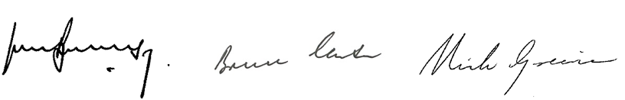The Hon. John Brumby Mr Bruce Carter The Hon. Nick Greiner AC

Introduction

What has the Review been asked to do?

The initial Terms of Reference
On 30 March 2011 the Commonwealth announced a review of Australia’s system of distributing the GST amongst the States and Territories (collectively referred to as ‘the States’). The Panel conducting the Review has been asked to consider whether the current arrangements for distributing the GST will ensure Australia is best placed to respond to the expected significant structural changes in the economy and will maintain public confidence in the financial relationships within the Federation.
The Panel’s first interim report, released by the Treasurer on 23 April 2012, outlines the Panel’s thoughts on the matters set out in the initial Terms of Reference, taking into account the various positions and ideas put forward by States, academics and other interested parties in response to the initial issues paper.

Supplementary Terms of Reference
Supplementary Terms of Reference were issued on 17 November 2011, asking the Panel to examine and make recommendations on possible changes to the form of equalisation to achieve the following objectives:
- ensuring that HFE does not provide a disincentive to State tax reform
- utilising HFE to provide incentives and disincentives to promote future State policy decisions which improve the efficiency of State taxes and mineral royalties
- examining the incentives for States to reduce Minerals Resource Rent Tax (MRRT) or Petroleum Resource Rent Tax (PRRT) revenue through increasing State mineral royalties.
This second interim report therefore outlines the Panel’s thoughts on these matters, again taking into account such views as have been put by States and others in their submissions responding to the supplementary issues paper released in December 2011.
The Panel believes that State tax reform must be pursued, and that the supplementary Terms of Reference properly fit as part of a broader discussion of long-term tax reforms. However, the Panel believes that meaningful reform will only be achieved through cooperation between the States, with the support and assistance of the Commonwealth.

The context for tax reform
Before embarking on an examination of various ideas about how Australia’s equalisation system might affect the tax reform process, it is important to take stock of where we are and how we got here.
The Constitution provides the Commonwealth with exclusive rights to impose customs and excise duties — the largest taxes at the time of federation — and sets out its powers with respect to other taxes. At federation the six States lost their ability to impose tariffs and, as a transitional measure, the Constitution required the Commonwealth to pass three-quarters of the net revenue from customs and excise duties to the new States for ten years.
Over time, the relative ability of the Commonwealth to raise revenue has grown. Although between 1915 and 1942 income taxes were levied by both the States and the Commonwealth, income tax was ceded to the Commonwealth in 1942 as a war-time measure in exchange for Commonwealth grants to the States. More recently, in 1997, the High Court declared State business franchise fees to be invalid, representing a major loss of revenue autonomy for the States.
The largest taxes (including personal and corporate income tax) are imposed under Commonwealth legislation. The States raise the majority of their revenues from taxes on payrolls, land, certain transactions (such as land and other property sales) and gambling. They also impose royalties on minerals extracted in their jurisdiction.
The stronger tax raising capacity of the Commonwealth has led to a large ‘vertical fiscal imbalance’ (VFI) between the levels of government — the revenue raised by the Commonwealth is considerably larger than its own-purpose outlays and, by contrast, the States’ own-purpose outlays greatly exceed their own-source revenue. This imbalance would be larger but for action taken to reduce it from time to time, including:
- transferring tax powers to the States (for example, payroll tax was transferred to the States in 1971-72)
- shifting expense responsibilities to the Commonwealth (for example, the Commonwealth took financial responsibility for tertiary education in 1974)
- dedicating specified Commonwealth taxes to the States (for example, since its inception in 2000-01, revenue from the GST has been transferred to the States).
The report from the Australia’s Future Tax System (AFTS) review in 2009, the National Tax Forum in 2011 and various State reviews have all laid the groundwork for further reform, including at State level.
AFTS recommended a longer term shift from existing State taxes to broader land taxes, a business cash flow tax, road user charges and a resource rent tax.
State taxes were one of six significant areas addressed by the 2011 National Tax Forum. A main outcome from the forum was that New South Wales and Queensland (initially, now New South Wales and South Australia) agreed to lead the creation of a State tax reform plan, looking at some of the more inefficient State taxes. The first iteration of the plan is due to be completed by the end of 2012.
The thrust of the national tax reform debate is that, in the long term, it may be better if:
- taxes are able to be rationalised, removing the ‘worst’ ones and placing greater reliance on the ‘best’ ones
- States are able to match their expenditures more closely with their own revenues and become less dependent on the Commonwealth, while the Commonwealth matches its revenue more closely to its own needs.
While acknowledging the broader reform agenda, there are limits to what will be covered in this Review. We have not been asked to express a view on the preferred direction of tax reform — that is, which taxes to remove and which to expand — or on inter-governmental tax sharing arrangements. We have not been asked to find a ‘cure’ for VFI. Our role is to examine the interaction of State royalties and the Commonwealth’s resource tax arrangements and consider ways that the GST distribution system can be made to complement desirable tax reforms, or at least not act as an impediment.

The Panel’s approach

The consultation process
To date the Panel has met with and consulted States (including Premiers, Treasurers and Shadows, as well as officials), the Commonwealth Grants Commission, academics with known interest in Commonwealth-State financial arrangements and others.
Following the release of this second interim report, consultations will continue. A round of further meetings is planned for the end of June, and any submissions prompted by our interim reports or these consultations will be examined. The Panel will draw together its recommendations in a final report later this year.

The structure of this report
In the Panel’s view, it is not possible to fully understand the options for, and ramifications of, changes to the equalisation system to assist reform without first having a good understanding of how Australia’s tax and HFE systems currently operate. Therefore, the first two Chapters address these subjects, but only in sufficient depth to allow the reader to grasp the essence of the key issues.
Chapter 3 considers whether the current GST distribution approach provides disincentives to State tax reform, while Chapter 4 reviews the interaction of State mining royalties and the Commonwealth’s resource tax reforms and examines how these systems might best work together.
Chapter 5 begins the process of considering whether changes can be made to the GST distribution arrangements to provide incentives for State tax reform (or disincentives for the absence of it). Chapter 6 draws the various ideas together.
The Panel’s considered but preliminary views are presented in boxes throughout the report. Largely in the absence of specific proposals put forward by the States, the views outline the Panel’s current thinking. The Panel encourages the States to respond to our preliminary views and assist us to refine and develop them.

How to respond to the interim reports
Interested parties are invited to provide final submissions on the approaches and proposals outlined in the two interim reports by 27 July 2012.
Provide your comments and ideas
By email: gstdistributionreview@treasury.gov.au
By post: The Secretary
GST Distribution Review
The Treasury
Langton Crescent
PARKES ACT 2600
All submissions will be available for reading and downloading from the Review website at http://www.gstdistributionreview.gov.au unless confidentiality is specifically requested.

The tax system in Australia
This Chapter provides a basic outline of the tax system in Australia, briefly explaining the classes of revenue collected by different levels of government, the economics of taxation, and setting out information on recent tax reforms.
In Australia, taxes are defined as ‘compulsory, unrequited [meaning one sided or unreturned] transfers to the general government sector’. Taxes fund general government expenditure and provide public services, but also serve other purposes, such as deterring certain types of behaviour.
The Australian tax system is a federal one — Commonwealth, State and local governments all levy taxes of different kinds. The revenue raised by different taxes in Australia is illustrated in Figure 1.1.
Figure 1.1: Ranking of Australian taxes by revenue raised, 2009-10
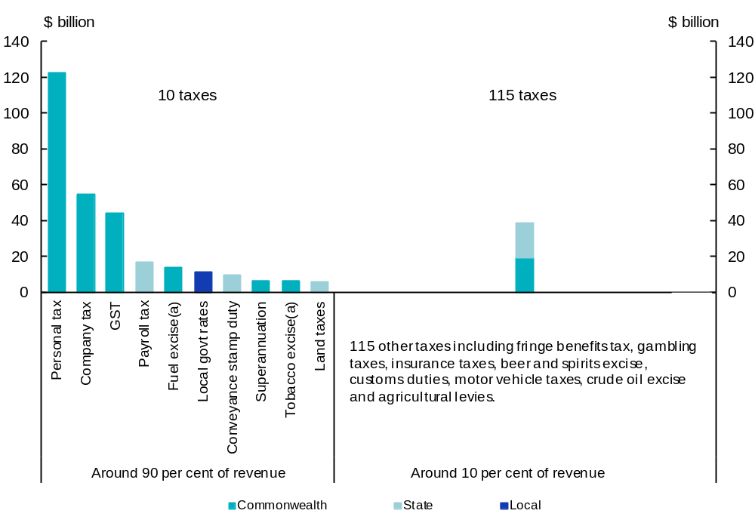
- Fuel excise and tobacco excise includes excise equivalent customs duties on these products.
Source: Australia’s Future Tax System, Report to the Treasurer, Overview, page 12.
At the last count, the Commonwealth levied 99 taxes, the States levied 25 and local governments were responsible for one. Ninety per cent of total tax revenue is raised from 10 taxes, with the remaining 115 accounting for only 10 per cent of tax revenue.
The ability of different levels of government to impose taxes is subject to the Australian Constitution. The High Court’s interpretation of the Constitution has been pivotal in assigning taxing powers between the Commonwealth and States.

Revenue raised by States
States raise revenue from a variety of sources, both through taxes and by non-tax means. The amount raised by the States from various sources will depend on local economic conditions. For example, revenue from payroll tax depends on a number of factors, which can change from year to year, such as employment rates and business growth. Hence, the relative importance of a specific source will change over time, reflecting the changing economic circumstances of States.
As shown in Table 1.1, the largest components of State tax revenue are payroll taxes and conveyance duties.

Table 1.1: State own-source revenue, 2010-11
$ million | NSW | VIC | QLD | WA | SA | TAS | ACT | NT | Total
Payroll tax | 6,399 | 4,354 | 3,023 | 2,623 | 951 | 286 | 286 | 164 | 18,086
Conveyance duty | 4,045 | 3,910 | 1,933 | 1,140 | 784 | 145 | 272 | 102 | 12,331
Motor vehicle tax | 2,444 | 1,503 | 1,768 | 946 | 495 | 139 | 119 | 47 | 7,461
Land tax | 2,289 | 1,398 | 1,042 | 516 | 576 | 75 | 110 | - | 6,006
Gambling tax | 1,757 | 1,652 | 945 | 191 | 404 | 95 | 53 | 50 | 5,147
Insurance tax | 2,035 | 1,456 | 546 | 468 | 371 | 65 | 60 | 33 | 5,034
Other taxes(a) | 1,448 | 584 | 718 | 656 | 250 | 55 | 344 | 1 | 4,056
Royalties | 1,240 | 58 | 2,722 | 4,213 | 161 | 49 | - | 155 | 8,597
Sales of goods and services(b) | 4,838 | 5,944 | 4,172 | 1,754 | 1,879 | 362 | 428 | 205 | 19,582
Interest income | 468 | 420 | 2,365 | 320 | 168 | 40 | 180 | 80 | 4,041
Dividends and  income tax equivalents | 2,110 | 408 | 1,232 | 1,066 | 403 | 159 | 266 | 26 | 5,670
Other non-tax revenue(c) | 2,656 | 1,762 | 1,219 | 454 | 389 | 80 | 137 | 46 | 6,743
Total | 31,729 | 23,449 | 21,685 | 14,347 | 6,831 | 1,550 | 2,255 | 908 | 102,754
(a) The taxes in this category differ from State to State and include a range of minor taxes.
(b) Includes use of government provided services such as hospitals, and public safety user charges.
(c) Includes revenue from fines, regulatory fees, licences etc.
Source: ABS Taxation Revenue Australia, 2010-11, cat. no. 5506.0, ABS Government Finance Statistics, Australia, 2010-11, cat. no. 5512.0 and State financial statements.
As can be seen from Table 1.1, apart from taxes, States raise revenue from sales of goods and services and collect a variety of non-tax revenues, such as fines and regulatory fees. Royalties are a relatively large source of revenue for Western Australia, Queensland and the Northern Territory, but comprise a much smaller share of revenue for the other States.
States are responsible for the delivery of a variety of services, such as health care and education and States’ expenditure is much larger than their own-source revenue. The funding gap between State expenses and own-source revenue is largely made up by transfers from the Commonwealth, including GST payments totalling $46 billion in 2010-11 and other Commonwealth grants totalling $53 billion in 2010-11.
Figure 1.2 shows the main State expenses compared to own-source revenue.
Figure 1.2: Total State expenses and revenue, 2010-11
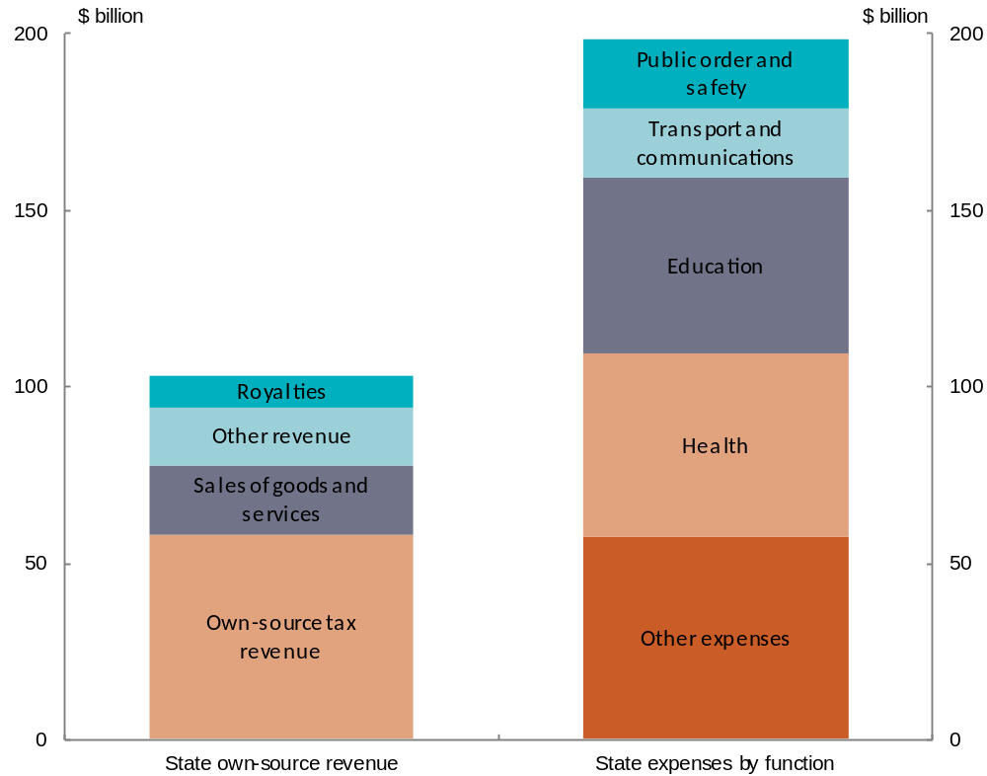
Source: ABS Taxation Revenue Australia, 2010-11, cat. no. 5506.0, ABS Government Finance Statistics, Australia, 2010-11, cat. no. 5512.0 and State financial statements.

A brief history of taxation in Australia
When the Commonwealth of Australia was established in 1901, the Constitution gave the Commonwealth exclusive power to impose duties of customs and excise and duties on goods traded between States were removed. Over time, the mix of taxes imposed by the States and Commonwealth has changed, with the Commonwealth either taking over or relinquishing some tax bases. Key developments affecting States include changes to income tax, land tax, payroll tax, franchise fees and the GST.
Tasmania was the first State to introduce income tax in 1880 and by 1907 all States had some form of income tax. The Commonwealth first introduced income tax in 1915. Between 1915 and 1942 income taxes were levied by both the States and the Commonwealth. Income tax was ceded to the Commonwealth in 1942 as a war-time measure in exchange for Commonwealth grants to the States.
Land tax is another field in which the Commonwealth and the States had concurrent taxes in the past. Victoria introduced the first land tax in 1877. South Australia was the first State to tax the unimproved value of land in 1884 with most of the other States following suit over the next two decades. The Commonwealth introduced land tax in 1910. Concurrent State and Commonwealth land taxes were in place until 1952, when the Commonwealth abolished its land tax. Currently, the Northern Territory is the only State that does not impose a land tax.
In 1971, after the States requested access to income tax to supplement their tax base, the Commonwealth passed authority over payroll tax to the States. Initially payroll tax was uniformly applied, but over time various States have changed both the rate and the base to which their payroll taxes apply. This has led to payroll tax being applied to a narrower base than in 1971.
In 1997, the High Court declared business franchise fees levied by the States to be invalid, resulting in a major loss of revenue for States. Victoria estimated that it would have raised $1.2 billion from business franchise fees in 1997-98 and that more than $5 billion overall would have been collected by the States that year. To replace the lost revenue, at the request of the States, the Commonwealth increased taxes on petrol, alcohol and tobacco, and passed the revenue from the increases to the States. The resultant payments to States were known as revenue replacement payments.
Because of a constitutional constraint, the Commonwealth was required to impose uniform rates of taxes on petrol, alcohol and tobacco across all States. This led to higher rates of taxation in a few States than was previously the case. Some States, such as Queensland, returned the extra revenue to consumers for a time to avoid price rises. Revenue replacement payments ceased in 2000 with the introduction of the GST.
In 2000, the introduction of the GST (partly to replace the Commonwealth’s Wholesale Sales Tax) — with the arrangement that the States receive the GST revenue — gave the States another broad revenue base. The GST arrangement was also used to implement a range of tax reforms that saw the removal of several inefficient State taxes, such as financial institutions duties and stamp duties on marketable securities, as well as other minor taxes, such as bed taxes.
A timeline of major changes to the tax system is included in Appendix B.

Incidence and bases of tax
Ultimately all taxes are borne by individuals regardless of the entity or product that the tax is applied to. For this reason, economists will often refer to the ‘economic incidence’ of a tax — meaning where the burden of the tax ultimately lies — by way of comparison with the ‘legal incidence’ of a tax — meaning who has the legal obligation to pay it.
For example, the economic incidence of a tax on company profits can fall on the shareholders (through lower profits), workers (through lower wages) or consumers (through higher prices), even though the company is the legal ‘taxpayer’. Similarly, although the GST is liable to be paid by GST registered enterprises, the economic incidence of GST also falls on the consumer of the product or service on which the GST is levied. Where the individual (whether shareholder, worker or consumer) is a foreign resident, the tax consequences may differ from those for a domestic resident. For example, overseas consumers of Australian goods do not always pay GST, and are usually subject to personal taxes in their country of residence.
While individuals ultimately bear the burden of all taxes, they use their income (in the broadest sense of that term) to pay these taxes. This income is derived from earnings on three factors of production — labour, capital and land (including natural resources).
Earnings from land, capital and labour are subject to a number of taxes. Once these taxes have been paid, the remaining income is saved, or used to consume goods and services, which may also be taxed. Hence, economists generally agree that consumption taxes, such as fuel, tobacco and alcohol taxes, and transaction taxes such as stamp duties also target earnings from the three factors of production.

Impact of taxes on behaviour
Taxes affect the behaviour of individuals and firms by creating incentives that would otherwise not be present. For example, when goods are taxed more heavily and prices go up, individuals may shift consumption away from them. Taxes can also have an impact on work incentives, through income tax, or on savings behaviour, through taxes (or tax concessions) on capital income. A tax on capital income may reduce investment in firms. Firms may also avoid certain projects or investments if the returns to capital from them are highly taxed compared with other projects.
The behavioural effects of a tax lead to efficiency losses referred to as the ‘dead weight loss’ or ‘excess burden’ of a tax. Figure 1.3 illustrates the excess burden of a tax using demand and supply curves. In this example, before the introduction of the tax, markets are in equilibrium with demand for the good equal to its supply. Introducing a tax increases the price paid by consumers, lowering their demand for the good, which in turn lowers the return received by suppliers of the good.

Figure 1.3: Excess burden (or dead weight loss) of a tax
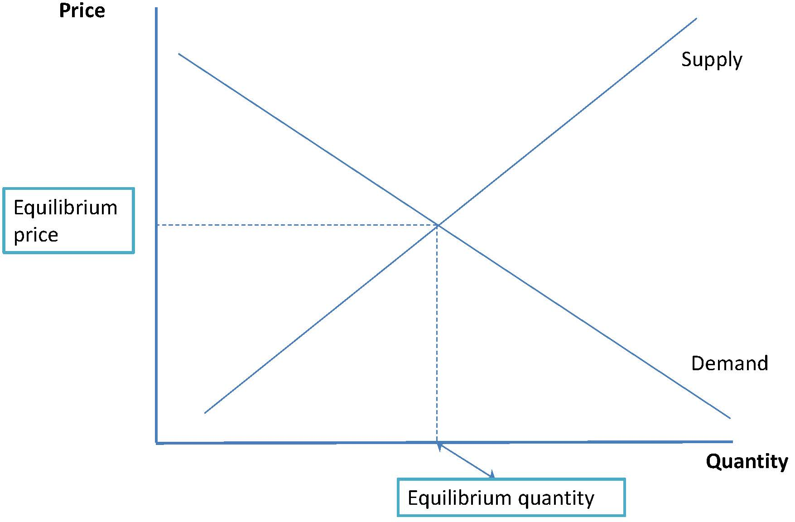
Before the introduction of a tax:
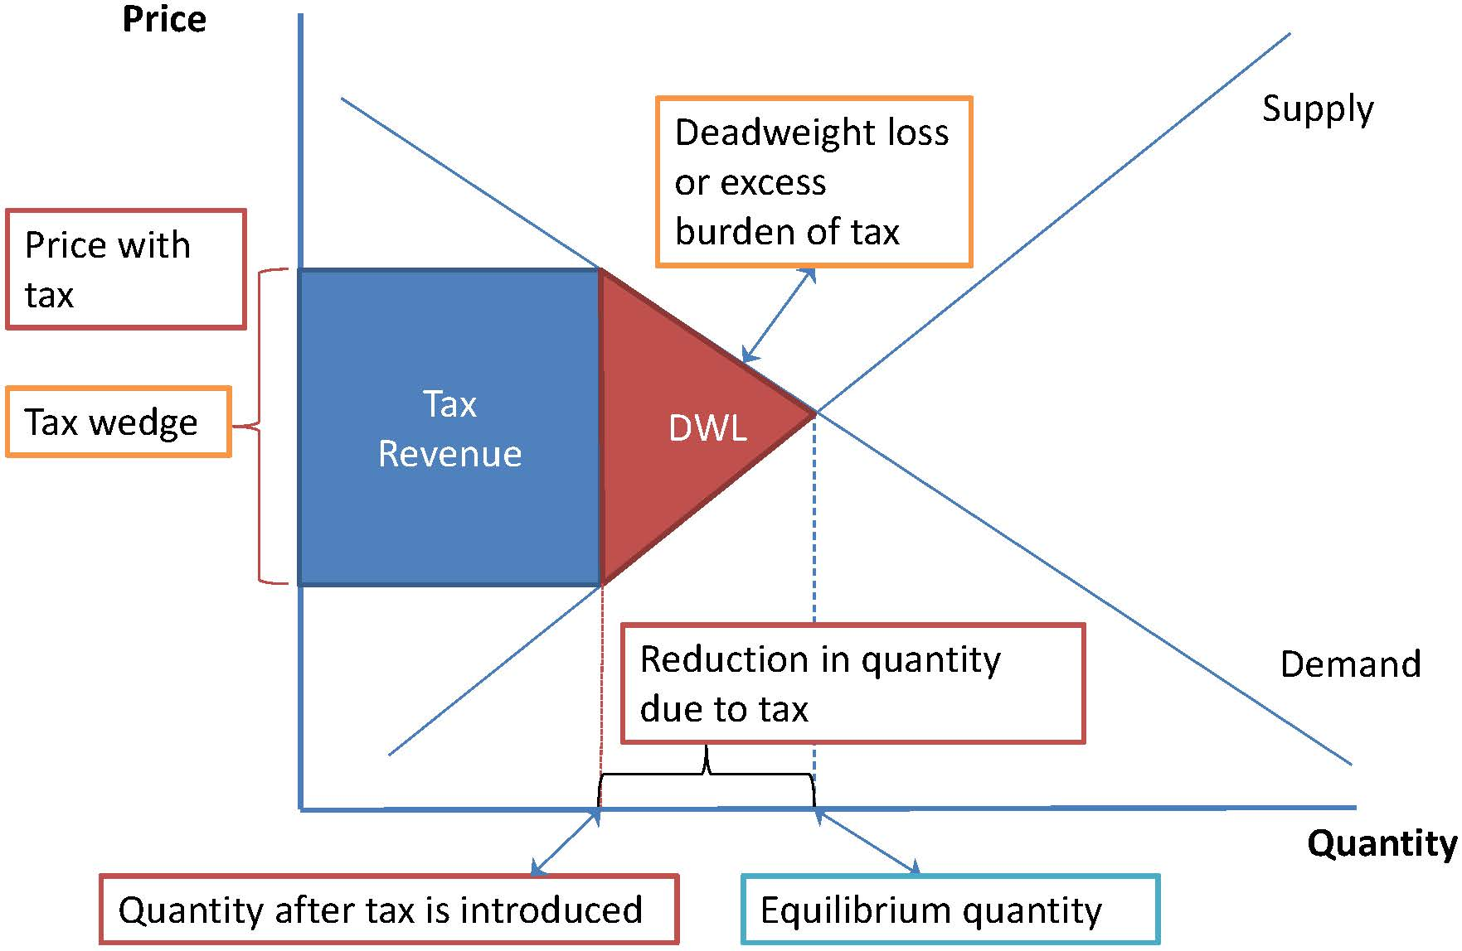
After the introduction of a tax:
The excess burden is a result of the fact that the loss to consumers and producers is greater than the revenue collected by the tax. Even if all tax revenue is returned to individuals, society as a whole would be worse off because the tax has distorted individual and firm behaviour. The size of the excess burden depends on factors such as the tax rate and the price responsiveness of demand and supply.
Taxes with lower excess burdens are regarded as more economically efficient.
Estimates of the average excess burden of major Australian taxes and resource royalties are shown in Figure 1.4.

Figure 1.4: Average welfare loss from selected taxes
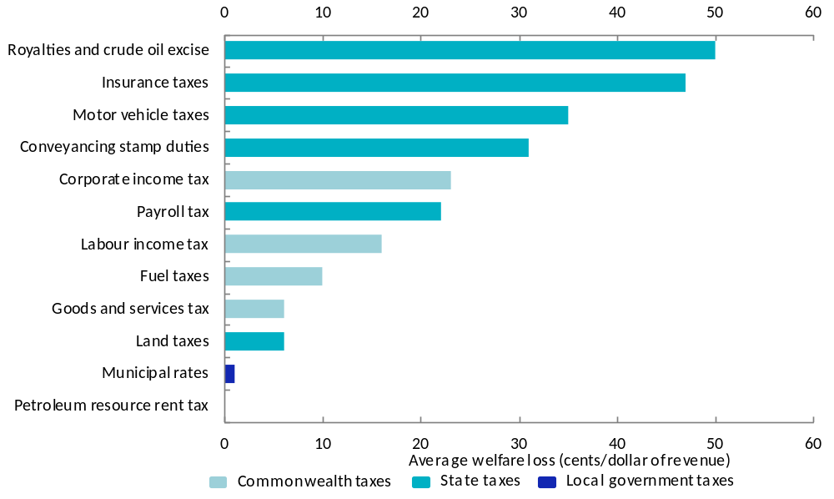
Source: KPMG Econtech (2009), CGE Analysis of the Current Australian Tax System, 2009 for the AFTS review, page 44.
Figure 1.4 suggests that several State taxes are amongst the least efficient and that considerable welfare gains may arise from replacing them or improving their design.

Tax reform and the GST
A significant reform to State taxes took place in 2000 with A New Tax System (ANTS). The Commonwealth introduced the GST (replacing the Commonwealth’s Wholesale Sales Tax), and allocated the revenue from it to the States, on certain conditions. In exchange for revenue from the GST, the States agreed to abolish a number of their least efficient taxes.
A timetable for phasing out 10 State taxes was outlined in the Intergovernmental Agreement (IGA) on the Reform of Commonwealth-State Financial Relations, signed by the Commonwealth and all States in 1999. From 2000, GST grants replaced financial assistance grants and revenue replacement payments from the Commonwealth. The Commonwealth provided transitional budget support to the States following the introduction of the GST and State tax reform. Revenue collected by the GST was to be distributed to the States on the basis of HFE, as had been the case with financial assistance grants. In return, the States abolished accommodation tax, financial institutions duty, quoted marketable securities and debits tax by 1 July 2005. It was agreed that the relevant Ministerial Council would review the need to retain non-quoted marketable securities duty, lease duty, mortgage duty, credit arrangement and rental duties, cheque duty and real non-residential property conveyance duty by 2005.
At the Ministerial Council meeting on 23 March 2005, the Commonwealth proposed a timetable for the abolition of the duties listed in the IGA. The timetable was rejected by the States. States proposed their own timetables which differed for each jurisdiction. In 2008 the States and the Commonwealth signed a new IGA which gave the States until 2013 to abolish the taxes (other than real non-residential property conveyance duty) listed in the original agreement.

The AFTS review

AFTS background
The AFTS panel was commissioned by the Commonwealth in 2008 to conduct a ‘root and branch review’ of Australia’s tax and transfer system, including State taxes. The review was tasked with making recommendations to position Australia to deal with the demographic, social, economic and environmental challenges of the 21st century. The review panel was chaired by Dr Ken Henry AC, and included Dr Jeff Harmer, Professor John Piggott, Heather Ridout and Greg Smith.
The final report was delivered to Government in December 2009. Of the 138 recommendations contained in the final report, around 20 related to State taxes.

AFTS findings — general
The AFTS review found the broad architecture of the tax and transfer system was sound, but would face substantial challenges in the future. The system needs to be robust, yet flexible enough to adapt to changing circumstances.
The AFTS broad vision for Australia’s tax system was that:
- revenue raising should concentrate on four robust, efficient, broad-based taxes on:
  - personal income
  - business income
  - rents, including rents from natural resources
  - consumption
- narrowly based taxes should only be used where they improve social outcomes or market efficiency through better price signals
- administration of the tax system needs to be more transparent and responsive to problems experienced by taxpayers.
In considering the mix of different taxes within this architecture, AFTS concluded that a good tax system should be based on the principles of:
- equity — meaning that individuals in similar circumstances should pay the same amount of tax and those with greater capacity should bear more of the tax burden
- efficiency — meaning that losses to social welfare and the administration and compliance costs of taxation should be minimised
- simplicity — meaning that the system should be easy to understand and simple to comply with, so that minimal resources are used to navigate it
- sustainability — meaning that the tax system should enable governments to meet changing revenue needs without resorting to inefficient taxes
- policy consistency — meaning that tax policy should be consistent with the broader policy objectives of government.
While all these principles are relevant when considering State tax reforms, the principle of efficiency is often highlighted due to the relative inefficiency of some State taxes, when compared with possible alternative taxes and tax designs.

AFTS findings — State taxes
In relation to State tax reform, AFTS said that:
- States should have autonomy over how their revenue is raised.
- Existing State taxes are inefficient and increases in State tax rates are not a sustainable way of funding services in the future.
- States would be better placed to meet future cost pressures if they had access to a more efficient and sustainable revenue source, such as a broad based cash flow tax. This may be used to abolish a number of existing State taxes. Tax base sharing options could also be considered, such as allowing States to levy a flat surcharge on personal income tax.
- State tax reform should be coordinated through intergovernmental agreements between the States and the Commonwealth to provide the States with revenue stability and to facilitate good policy outcomes.
As shown in Table 1.2, AFTS recommended a long term shift from existing taxes to a broader land tax, business cash flow tax, road user charges and resource rent tax.

Table 1.2: Summary of AFTS findings on State taxes
State tax | Reform direction
Payroll tax | Payroll tax should be replaced by a tax that better captures the value-add of labour. This could be a broad-based wages tax or, preferably, a cash flow tax.
Conveyance duty | The removal of duty should be achieved through a switch to more efficient taxes, such as those levied on broad bases (including consumption and land).
Land tax | Land tax should be levied using an increasing marginal rate scale applying to the per-square-metre value of the land. The tax should be calculated per land holding, not on an entity’s total holding. There should be no specific exemption for principal place of residence or primary production.
Insurance tax | All specific taxes on insurance products, including the fire services levy, should be abolished.
Motor vehicle tax | State taxes on motor vehicle use and ownership, including motor vehicle registration transfer (stamp) duty and taxi licence fees, should be replaced with efficient user charges where possible.
Gambling tax | Options for reducing conflicts in policy-making between regulation and revenue-raising should be explored.
Resource royalties | Most existing output-based royalty and resource rent tax arrangements imposed on non-renewable resources should be replaced by a single rent-based tax. The Commonwealth and the States should negotiate an appropriate allocation of the revenues and risks from the resource rent tax.
Source: Australia’s Future Tax System, Report to the Treasurer, Part 2, Detailed Analysis, page 680.
The AFTS review also made a number of observations in respect of the impact of the current HFE system on State tax reform, namely:
- A multilateral tax change will change the relative revenue raising capacities of States, which will lead to a change in GST shares.
- Tax reform might be revenue neutral in an aggregate sense, but may not be revenue neutral for individual States.
- In theory, no State would have a financial incentive to resist or favour a revenue neutral tax reform if all States apply the same revenue raising effort.
- In practice, States have, and are likely to continue to have, different tax policies. HFE will not compensate a State for revenue lost from a change in tax mix where it does not apply the average policy. States may experience difficulties if they do not have the same ability to raise marginal revenue from the new tax base as from the old.
- The States will need to consider whether, and to what extent, differences from average policy should be reflected in their replacement taxes.

The Tax Forum and beyond
The Commonwealth convened a Tax Forum in October 2011, to discuss priorities and directions for further tax reform.
The Tax Forum covered a broad sweep of topics across six sessions: personal tax, transfer payments, business tax, State taxes, environmental and social taxes, and tax system governance. Changes to the Commonwealth’s announced resource tax reforms and to the rate and base of the GST were excluded. Reforms also had to be consistent with the Commonwealth’s fiscal policy.
More detailed consultation continues on many of the outcomes of the Forum:
- The State tax reform plan is examining some of the more inefficient State taxes. The first iteration of the plan is due by the end of 2012.
- The Not-for-profit Sector Tax Concession Working Group is examining how existing taxation support for the sector can be provided in fairer, simpler and more effective ways.
- The Business Tax Reform Working Group is examining how the business tax system can be improved.
- The Superannuation Roundtable has the Commonwealth working with industry, community groups and other stakeholders to implement reforms to superannuation.
- There are ongoing consultations between Treasury, the Australian Taxation Office and the Council of Small Business of Australia on ways to reduce small business compliance costs.
Work is also being done by individual States to review their tax systems.
Two States have recently completed reviews of their tax systems — the New South Wales Financial Audit (the Lambert Report) and the ACT Taxation Review.
In relation to the tax system, the Lambert Report finds that:
The revenue base of the State, particularly the tax base, is in the main narrowly based, volatile and economically inefficient. There are substantial opportunities to reform the tax base to achieve greater efficiency, equity and simplicity.
The report makes a number of recommendations in relation to tax reform, including:
- abolishing insurance duty (funded by a lowering of the payroll tax threshold)
- broadening the payroll tax base and reducing the payroll tax rate
- abolishing transfer duty and replacing it with a replacement tax on land value
- a feasibility study on congestion charging, with road user charges replacing vehicle taxes
- giving companies that develop new mines a choice between being charged royalties and being subject to a New South Wales resource rent tax.
The ACT Tax Review contains 27 recommendations, including:
- replacing (over 10-20 years) stamp duty on conveyances with increased land taxes
- broadening the land tax base (achievable by abolishing the existing land tax and replacing lost revenue through higher general rates)
- abolishing general insurance and life insurance duties
- retaining payroll tax, pending a nationally agreed reform in this area
- retaining motor vehicle transfer duty, pending a nationally agreed shift to a road user charge system
- considering increasing gambling taxes, following the completion of the mandatory pre-commitment trial period being pursued in cooperation with the Commonwealth.

The assessment of revenues in the current HFE system
One of the purposes of HFE is to assist States that are not as able to raise own-source revenues as others. These revenue raising ‘disabilities’ represent circumstances outside a State’s direct control, such as a comparative lack of mineral endowments, fewer large businesses operating in the jurisdiction, or lower land values and house prices.
Under the current approach to fiscal equalisation, GST shares are distributed so that States receive their population share of all ‘differentially assessed’ own-source State tax (and mining) revenue raised, if they apply average revenue raising policy. Not all revenue sources are differentially assessed by the Commonwealth Grants Commission (CGC), for reasons explained below.
Applying its principle of examining ‘what States collectively do’, the CGC considers State revenue raising capacities according to each head of revenue raised by any State and compares that to the average State policy. The CGC considers whether there are likely to be material differences between States in their capacities to raise particular revenues and then decides whether these differences can be reliably measured. Where both these conditions are met, the CGC makes an assessment of the amount of revenue that each State could raise from the head of revenue, if it followed ‘average’ policy. This is known as a ‘differential assessment’.
Where the CGC does not believe it can effectively make a differential assessment for some reason, those State revenues are allocated on a population share basis, known as an equal per capita (EPC) assessment. The effect of an EPC ‘assessment’ is to treat States as if they each have the same per capita capacity to raise revenue from these sources.

State revenues assessed by the CGC

Revenues differentially assessed
In its 2010 Review, the CGC decided that reliable assessments, producing material differences in the GST distribution, could be made for the following State own-source revenues:
- Payroll tax — a broad based tax on wages and related benefits paid by employers.
- Land tax — a tax imposed by all States except the Northern Territory on the ownership of land used for income producing purposes.
- Stamp duty on conveyances — a tax on the transfer of ownership of property, based on the value of property transferred, paid by the purchaser.
- Insurance tax — a tax imposed on insurance premiums.
- Motor taxes — various charges including the annual motor vehicle registration, traffic improvement and number plate fees, stamp duties collected when new vehicles are registered and ownership of used vehicles is transferred.
- Mining revenue — mining royalties levied on mining production and fees collected for exploration permits.

Revenues not differentially assessed
Where the CGC thinks that calculating the average policy cannot be done, or would not give the right result, it groups revenues in an Other (or miscellaneous) revenue category. This category covers:
- revenues for which a reliable and material assessment cannot be developed
- revenues collected only in a minority of States (that is, revenues that are not part of the average revenue raising policies)
- a balancing item to ensure that the total revenue included in the CGC assessments equals the total in the Australian Bureau of Statistics Government Finance Statistics (ABS GFS).
The following classes of revenue are included in the Other revenue category:
- taxes that are to be abolished under the Intergovernmental Agreement
- gambling revenue
- fees and fines
- user charges (such as property titles user charges and public safety user charges) — but not those associated with admitted patients, housing and functions usually performed by public trading enterprises
- contributions by trading enterprises
- interest and dividend income.
Further explanation for the treatment of these revenues, which collectively comprised $47.5 billion in 2010-11, or about the same as the GST revenue, is given below.

Gambling revenues
In the 2010 Review, gambling revenues raised by States ceased to be differentially assessed because the CGC judged that it could not develop a reliable and material assessment for those revenues.
In its first submission to the GST Distribution Review, Western Australia said:
… it is ironic that Western Australia is penalised for increasing royalties (by pricing minerals more appropriately) but would keep all of the additional gambling revenue if it lifted its socially-responsible ban on poker machines.
Gambling revenue was differentially assessed prior to the 2010 Review. In the 2004 Review, the measure of capacity to raise gambling revenue was Household Disposable Income (HDI), discounted by 50 per cent because factors other than gamblers’ incomes influenced the level of gambling activity. Queensland, South Australia and Tasmania were assessed to have below average capacity to raise gambling revenue.
The GST share effects of gambling revenue in the 2009 Update are shown in Table 2.1.
Table 2.1: Effects on GST distribution from the gambling revenue assessment, 2009 Update
 | NSW | VIC | QLD | WA | SA | TAS | ACT | NT | Total
Gambling revenue ($m) | -32 | -15 | 48 | -2 | 13 | 9 | -22 | -0 | 70
Gambling revenue ($pc) | -5 | -3 | 11 | -1 | 8 | 18 | -62 | -1 | 3
Source: CGC, 2009 Update Report supporting tables, Tables F-1 and F-2.
Further analysis by the CGC in the 2010 Review indicated that the relationship between HDI and gambling was weaker than presumed in the 2004 Review, suggesting that a discount of more than 50 per cent was required. The CGC also found that the literature identified personal income as not being a good indicator of gambling expenditure, providing only limited guidance in determining which socio-economic and behavioural factors influence gambling activity. In part, this was due to a disproportionate amount of gambling expenditure being undertaken by a small proportion of problem gamblers.
In addition, the CGC found that the link between gambling expenditure within a State and gambling revenue raised by a State was becoming less clear as a result of growth in on-line gambling, which facilitates gambling by interstate and overseas residents.
The States that would benefit from an EPC assessment of gambling revenue supported gambling revenue not being differentially assessed, while States that would benefit from a differential assessment (Queensland, South Australia and Tasmania) did not. These three States argued that the CGC should make a differential assessment of gambling revenue because substantial revenues were collected (around eight per cent of State own-source revenue) and there were differences in the capacities of States to collect them. However, the CGC did not agree that either of the approaches suggested by the three States would produce a reliable assessment. Further submissions on the treatment of gambling revenue would ordinarily be reviewed by the CGC in the course of its regular methodology reviews.

Remaining revenues not differentially assessed
The remaining revenues in the CGC’s Other category are a mixture of:
- revenues which it is not average policy to raise
- revenues for which the CGC believes an EPC assessment to be the appropriate outcome
- revenues that are equalised elsewhere in the system.
Where States have agreed to abolish taxes, no differential assessment of them is made by the CGC from the year those taxes no longer represent average policy.
Where there are no underlying drivers that vary across States, such as when levying fees, fines and certain user charges (such as property titles user charges and public safety user charges), the revenue raised depends solely on the policy discretion of States. In these cases, the CGC considers an EPC assessment appropriate.
An alternative explanation for an EPC treatment of such user charges (based upon the views of academics such as Professor Cliff Walsh and others) is that where:
… state fiscal activities correspond to the benefit taxation principle where residents are taxed according to the benefit received … there is no need to equalise on horizontal equity grounds.
User charges for admitted patients and housing are treated differently to other user charges, because the CGC concludes that there are underlying drivers affecting the ability of States to raise these charges. For example, some demographic groups are more likely than others to have private health insurance, and public housing user charges will vary with the need to provide public housing. These user charges are netted off their corresponding expenses and therefore the net impact on States’ budgets is included in the HFE calculation in that way.
Revenues from contributions from Public Trading Enterprises, along with other interest earnings and dividends, are equalised through the net lending assessment and consequently no further equalisation need be applied to them.

The CGC revenue assessment process

Tax bases and rates
For the six own-source revenues that are differentially assessed (payroll tax, land tax, stamp duty on conveyances, insurance taxes, motor taxes and mining revenue), the CGC aims to assess each State’s relative revenue raising capacity. To do this, the CGC works out the appropriate tax base for each State for each revenue head and, using the total revenue raised by States for that revenue source, the average rate to apply to that base.
Tax bases are measured using the value of transactions, assets or goods that would be taxed by that State under the average tax policy. For example, the tax base for stamp duty on conveyances is the value of property sold in a State and the base for mining revenue is the value of the State’s mining production.
Once the CGC has established the appropriate tax base and average rate, it calculates how much revenue that State could raise if it applied the average tax rate to its tax base. This is called its ‘assessed revenue’.
If a State’s assessed share of the revenue raised is greater than its population share of the revenue, it has above-average revenue raising capacity for that particular revenue source, and this will act to decrease its GST share. Conversely, having a below-average revenue raising capacity will increase its GST share.

Policy neutrality
As explained in the Panel’s first interim report, the CGC aims to make its assessments in a policy neutral way. Policy neutrality is intended to ensure that neither the actual policies of an individual State, nor interstate differences in policies, directly affect GST shares. It is also intended to ensure that the GST distribution process does not provide the States with direct incentives to vary their policies. However, the policies of each State will have some effect on the averages.
A further aspect of the policy neutral approach is that the CGC makes no explicit or implicit judgments about what States could or should do. No revenue source is treated differently to any other on the grounds of it being more or less economically efficient, fairer, or otherwise worthier. The tax mix constructed by the CGC reflects the actual average mix of taxes across the States, not a theoretical optimised version. Similarly, no account is taken of the potential changes in the level of activity that would be caused by the differences between the tax rates actually imposed by the States and the average tax rate (tax elasticity effects).
Policy neutrality can be difficult to achieve where one State has much more than its per capita share of a revenue base. The CGC tries to deal with such cases by grouping together similar activities that have similar tax treatments, but this approach is not always successful in achieving policy neutrality, and can sometimes produce unintended consequences. The Panel’s first interim report noted the potentially perverse effects which might follow royalty rate changes in the current mining assessment.

Determining the average revenue policy
At the simplest level, the average policy is encapsulated in the State average per capita revenue for each tax. Those averages are a weighted average of the per capita revenues of each State, where the weights are determined by the State populations. While this ensures the policies applicable to each person have the same weight in determining the average, the policies applied by the more populous States have a greater impact on it.
The average per capita revenues can be considered as reflecting the outcome of applying the average policies to the average circumstances. They seek to capture the average tax rates, average concessions, average anti-avoidance efforts and the average level of taxable activity as defined by the average scope of the tax base.
Determining the average policy for any particular revenue head is easier when all States are active in the field on a similar basis and the activity can be measured accurately. However, determining the average policy is more difficult when some States do not impose the tax, States impose it on different terms, or there are measurement comparison problems. In these cases, the CGC aims to distil the main thrust of State polices from their often disparate policies in as neutral a way as possible.
The CGC does this by first applying a threshold test. The CGC considers that it is not average policy to impose a tax unless a majority of States do so, and the tax affects a majority of the aggregate tax base or relevant population. If that threshold is not met (that is, average policy is not to raise the tax) revenues are not differentially assessed (that is, they are assessed EPC). If the threshold test is met, the CGC bases the average policy on the average observed effective tax rate.
Some examples of the CGC’s approach are outlined below:
- The imposition of land tax is considered to be the average policy because it is imposed in all States except the Northern Territory and the average is derived by treating the Northern Territory as if it levied the tax at a zero rate. In this way the Northern Territory’s policies do not directly affect its GST share, and its budget bears the burden of its decision not to levy land tax.
- For taxes that the Commonwealth and the States have agreed to phase out, the tests are based on the tax policies expected to apply in the year the relativities are to be used. If it appears the tax would not apply in a majority of States and to a majority of the aggregate tax base in the application year, the CGC concludes that the average policy is not to impose the tax. Any revenue raised from the tax during the assessment years is not assessed differentially and States continuing to raise these revenues are treated as making above average efforts to raise revenue.
- If only a few States raise a tax but all, or the vast majority, of the tax base is located in those States, such as with royalties on iron ore, the CGC’s usual approach is to group that activity with activities in other States which receive a similar tax treatment. Under this approach, disparate mining activity is grouped across commodities in the mining revenue assessment.
If it is average State policy to exempt a particular group of taxpayers, this will be reflected in the CGC’s assessment of the appropriate tax base.
Where some, but not all, States exempt transactions from a tax, the exemption is treated as average policy only if it applies in a majority of States and they have a majority of the tax base. If an exemption forms part of average policy, but the definition of the exemption varies between States, its level is often determined using a weighted average of the exemptions in all States, with the weights reflecting each State’s contribution to the aggregate tax base. This happens, for example, with the exemptions from payroll tax for employers with small payrolls.
In some cases the tax base is not treated as a whole, but is segmented, with different average rates calculated for each segment. This approach is referred to as a value distribution adjustment (VDA) and is used by the CGC in cases such as property taxes, where States have progressive tax scales.
The accuracy of the CGC’s assessments depends upon the available data. The CGC makes a judgement as to the ‘fitness for purpose’ of data used in its assessments, in particular the reliability and comparability of data across States. Where the CGC has concerns about the ‘fitness’ of data, it may introduce a discount. For example, the land tax assessment includes a discount due to some concerns over the reliability and comparability of State Revenue Office data used in the assessment. The effect of a discount is to reduce the size of any GST redistributions arising from an assessment.
Despite the CGC’s carefully considered assessments, the results may not be always intuitive. For example, given their similarity in other ways, it may be expected that New South Wales and Victoria would have a similar level of insurance activity. However, the Australian Prudential Regulation Authority (APRA) data used in the insurance tax assessment shows a large difference in the level of insurance activity between these States. The CGC considers that Victoria’s lower per capita premium revenue is consistent with Victoria having lower property values and motor vehicle premiums.

Revenue raising capacity
Revenue raising capacities are calculated by the CGC for each revenue head for each of the three assessment years included in an Update of relativities. Each revenue head contributes to the derivation of the overall relativity applying to a State in an assessment year and, consequently, the average relativity used to distribute GST revenue in the application year.
States’ capacities vary across revenue heads. Even within a particular revenue head, a State’s revenue raising capacity can change as its underlying circumstances change relative to other States. This means that if circumstances in other States change, one State’s revenue raising capacity may vary, even though there is no change to its own circumstances.
Revenue raising capacities are also expressed as a percentage of the average revenue raising capacity, known as revenue raising capacity ratios. For example, from Table 2.2, it can be seen that New South Wales had a revenue raising capacity ratio of 110.4 per cent of the average for insurance tax in 2010-11.
Table 2.2 shows the revenue raising capacity ratios for each differentially assessed revenue head for each assessment year included in the 2012 Update.
Table 2.2: Assessed revenue raising capacity ratios, 2012 Update
 | NSW | VIC |  | QLD |  | WA |  | SA |  | TAS |  | ACT | NT | Average
 | % | % |  | % |  | % |  | % |  | % |  | % | % | %
Payroll tax
2008-09 | 106.4 | 102.1 |  | 88.9 |  | 118.0 |  | 81.6 |  | 71.1 |  | 100.9 | 81.1 | 100.0
2009-10 | 105.8 | 101.1 |  | 89.4 |  | 122.7 |  | 77.8 |  | 72.2 |  | 106.4 | 83.5 | 100.0
2010-11 | 104.9 | 99.9 |  | 90.1 |  | 131.8 |  | 75.8 |  | 67.9 |  | 89.7 | 84.1 | 100.0
Land tax
2008-09 | 100.9 | 93.5 |  | 110.3 |  | 144.4 |  | 59.2 |  | 43.2 |  | 61.4 | 69.4 | 100.0
2009-10 | 99.2 | 95.2 |  | 112.8 |  | 137.2 |  | 62.2 |  | 46.5 |  | 62.5 | 70.0 | 100.0
2010-11 | 97.5 | 103.5 |  | 106.7 |  | 133.8 |  | 62.9 |  | 46.2 |  | 59.7 | 69.7 | 100.0
Stamp duty on conveyances
2008-09 | 96.5 | 97.6 |  | 120.7 |  | 101.9 |  | 72.3 |  | 62.9 |  | 115.6 | 104.6 | 100.0
2009-10 | 100.4 | 102.5 |  | 98.7 |  | 125.2 |  | 65.0 |  | 59.8 |  | 131.6 | 91.8 | 100.0
2010-11 | 105.4 | 115.2 |  | 88.1 |  | 100.6 |  | 68.0 |  | 55.3 |  | 125.0 | 78.9 | 100.0
Insurance tax
2008-09 | 113.4 | 98.1 |  | 92.2 |  | 88.7 |  | 96.1 |  | 76.1 |  | 91.5 | 80.5 | 100.0
2009-10 | 111.8 | 93.8 |  | 95.2 |  | 96.3 |  | 98.3 |  | 78.1 |  | 92.4 | 79.5 | 100.0
2010-11 | 110.4 | 93.2 |  | 96.4 |  | 98.7 |  | 99.7 |  | 77.9 |  | 90.3 | 85.3 | 100.0
Motor taxes
2008-09 | 87.0 | 102.1 |  | 105.5 |  | 128.1 |  | 99.2 |  | 105.0 |  | 86.6 | 91.2 | 100.0
2009-10 | 88.1 | 103.3 |  | 102.3 |  | 126.2 |  | 100.7 |  | 104.7 |  | 88.2 | 91.4 | 100.0
2010-11 | 88.7 | 103.8 |  | 101.3 |  | 124.9 |  | 100.8 |  | 104.8 |  | 87.8 | 92.0 | 100.0
Mining revenue
2008-09 | 52.2 | 6.0 |  | 203.9 |  | 360.9 |  | 26.2 |  | 23.9 |  | 0.0 | 122.3 | 100.0
2009-10 | 47.8 | 3.9 |  | 159.8 |  | 451.9 |  | 36.9 |  | 29.0 |  | 0.0 | 157.2 | 100.0
2010-11 | 42.6 | 2.3 |  | 141.0 |  | 505.8 |  | 41.9 |  | 27.0 |  | 0.0 | 126.2 | 100.0
Total revenue
2008-09 | 96.0 | 91.2 |  | 110.4 |  | 132.0 |  | 84.2 |  | 79.8 |  | 88.9 | 95.8 | 100.0
2009-10 | 96.9 | 93.6 |  | 102.9 |  | 135.7 |  | 85.0 |  | 81.4 |  | 94.8 | 96.8 | 100.0
2010-11 | 95.6 | 93.1 |  | 101.0 |  | 146.5 |  | 84.6 |  | 79.1 |  | 88.5 | 94.4 | 100.0
Note: The ACT has no mining activity, and so is assessed as having no capacity to raise mining revenue. All States are assessed to have the average capacity to raise Other revenue.
Source: CGC 2012 Update data downloads, Table S3-1.
The above average revenue raising capacities of States, as assessed by the CGC, can be summarised as:
- Queensland and Western Australia are the only States to have above average capacity to raise revenue overall, predominantly, but not exclusively, due to their capacity to raise mining revenue. With the exception of the Northern Territory, other States have substantially below average capacity to raise mining revenue.
- In Western Australia, virtually all own-source revenue bases are relatively strong. Queensland also has stronger than average land values and property sales (although these have declined substantially), but weaker than average payrolls.
- New South Wales has a relatively strong payroll base, but relatively weak motor vehicle base. Victoria has revenue bases relatively close to the national average in most areas. South Australia and Tasmania are relatively weak across most categories, especially property sales, payrolls and land values. The Australian Capital Territory has relatively strong property sales, but a lower share of the land tax base and no capacity to raise mining revenue.
- The Northern Territory has a strong mining base, but below average capacity to raise revenue overall, due to its revenue raising capacity across all taxes other than mining being below average.

Revenue raising effort
An additional revenue raising ratio, often quoted in conjunction with revenue raising capacity, is revenue raising ‘effort’. Revenue raising effort is the ratio of actual revenue per capita to assessed revenue per capita. A ratio greater than 100 for a State indicates the State raises more revenue than if it had applied average policies (‘above average effort’). A ratio below 100 indicates ‘below average effort’.
Greater effort may reflect a State having a higher rate of tax than average, or it may reflect the State including additional taxpayers compared with the average, for example, by having a lower than average payroll tax threshold. Lower effort may reflect the inverse situation, that is, lower than average tax rates or additional taxpayers excluded from paying tax.
As the GST distribution reflects average effort, any above average effort by a State has no adverse effect on its GST share (other than indirectly through the effect on the average policy calculation). Conversely, a State’s budget bears the burden of below average effort, as the HFE system assumes that State makes the average revenue raising effort.
The revenue raising effort ratios (expressed as percentages) for the assessment years included in the 2012 Update are shown in Table 2.3.
Table 2.3: Assessed revenue raising effort ratios, 2012 Update
 | NSW | VIC |  | QLD |  | WA |  | SA |  | TAS |  | ACT |  | NT |  | Average
 | % | % |  | % |  | % |  | % |  | % |  | % |  | % |  | %
Payroll tax
2008-09 | 108.4 | 92.9 |  | 91.1 |  | 110.1 |  | 89.2 |  | 93.4 |  | 98.5 |  | 107.3 |  | 100.0
2009-10 | 106.9 | 96.2 |  | 88.7 |  | 108.8 |  | 93.2 |  | 97.8 |  | 95.2 |  | 105.3 |  | 100.0
2010-11 | 104.7 | 97.5 |  | 92.3 |  | 103.4 |  | 95.0 |  | 103.5 |  | 110.0 |  | 106.1 |  | 100.0
Land tax
2008-09 | 122.3 | 103.6 |  | 67.4 |  | 78.1 |  | 146.4 |  | 143.4 |  | 155.7 |  | 0.0 |  | 100.0
2009-10 | 123.0 | 94.7 |  | 78.2 |  | 73.2 |  | 146.0 |  | 147.8 |  | 168.5 |  | 0.0 |  | 100.0
2010-11 | 120.5 | 98.4 |  | 80.2 |  | 71.4 |  | 140.0 |  | 118.2 |  | 189.1 |  | 0.0 |  | 100.0
Stamp duty on conveyances
2008-09 | 92.9 | 118.0 |  | 79.7 |  | 104.0 |  | 135.3 |  | 111.5 |  | 113.1 |  | 107.8 |  | 100.0
2009-10 | 95.1 | 110.3 |  | 82.7 |  | 105.0 |  | 129.9 |  | 99.6 |  | 111.7 |  | 111.2 |  | 100.0
2010-11 | 96.5 | 107.1 |  | 88.4 |  | 97.4 |  | 126.6 |  | 95.8 |  | 110.1 |  | 103.5 |  | 100.0
Insurance tax
2008-09 | 76.9 | 110.9 |  | 89.5 |  | 148.3 |  | 154.7 |  | 82.8 |  | 85.2 |  | 110.4 |  | 100.0
2009-10 | 77.1 | 118.0 |  | 84.0 |  | 137.8 |  | 151.9 |  | 83.7 |  | 93.0 |  | 112.7 |  | 100.0
2010-11 | 76.9 | 117.7 |  | 83.8 |  | 137.5 |  | 151.6 |  | 83.5 |  | 92.8 |  | 112.4 |  | 100.0
Motor taxes
2008-09 | 117.7 | 82.2 |  | 105.7 |  | 98.7 |  | 87.8 |  | 74.7 |  | 116.0 |  | 70.2 |  | 100.0
2009-10 | 115.9 | 81.6 |  | 112.1 |  | 97.0 |  | 83.3 |  | 76.2 |  | 112.9 |  | 68.9 |  | 100.0
2010-11 | 117.1 | 79.7 |  | 113.5 |  | 96.5 |  | 83.7 |  | 73.3 |  | 110.6 |  | 66.4 |  | 100.0
Mining revenue
2008-09 | 90.7 | 37.6 |  | 98.3 |  | 105.5 |  | 94.7 |  | 65.7 |  | 100.0 |  | 219.3 |  | 100.0
2009-10 | 96.8 | 74.7 |  | 96.1 |  | 104.4 |  | 70.4 |  | 89.6 |  | 100.0 |  | 151.1 |  | 100.0
2010-11 | 94.2 | 101.7 |  | 98.9 |  | 104.4 |  | 52.7 |  | 83.7 |  | 100.0 |  | 128.6 |  | 100.0
Other revenue
2008-09 | 93.5 | 103.2 |  | 114.3 |  | 56.7 |  | 119.0 |  | 96.4 |  | 199.0 |  | 95.1 |  | 100.0
2009-10 | 94.3 | 100.9 |  | 116.1 |  | 60.7 |  | 121.7 |  | 76.1 |  | 188.1 |  | 94.3 |  | 100.0
2010-11 | 95.9 | 97.9 |  | 116.9 |  | 68.5 |  | 111.9 |  | 77.7 |  | 191.7 |  | 82.9 |  | 100.0
Total revenue
2008-09 | 99.2 | 100.9 |  | 99.9 |  | 88.2 |  | 114.2 |  | 95.4 |  | 154.5 |  | 107.4 |  | 100.0
2009-10 | 99.5 | 99.8 |  | 101.8 |  | 88.8 |  | 115.2 |  | 84.8 |  | 147.0 |  | 98.9 |  | 100.0
2010-11 | 99.8 | 98.4 |  | 104.4 |  | 90.9 |  | 108.2 |  | 84.3 |  | 154.6 |  | 90.2 |  | 100.0
Notes: The Northern Territory does not levy land tax, and so is considered to have no effort. The Australian Capital Territory raises no mining royalties and has no activity. It is considered to make the average effort. Other revenue effort for the Australian Capital Territory also includes revenue from municipal rates. (CGC, 2010 Report on GST Revenue Sharing Relativities — 2010 Review, Volume 2, Chapter 9, page 140).
Source: CGC 2012 Update data downloads, Table S3-1.
In summary, the above average revenue raising efforts made by States, as assessed by the CGC, are:
- South Australia and the Australian Capital Territory are the only States to have higher than average effort for total revenues. South Australia has above average effort in land tax, stamp duties, insurance tax and other revenue, while the Australian Capital Territory has above average effort in land tax, stamp duties, motor taxes and other revenue.
- New South Wales has above average effort in payroll tax, land tax and motor taxes, with below average effort in the remaining revenue heads.
- Victoria has above average effort in stamp duties and motor taxes.
- Queensland has above average effort in motor taxes and other revenue.
- Western Australia has above average effort in payroll tax, insurance tax and mining revenue, and in stamp duties for two of the three assessment years.
- Tasmania has above average effort only in land tax.
- The Northern Territory has above average effort in payroll tax, stamp duties, insurance tax and mining revenue.
The CGC warns that considerable caution is needed in interpreting revenue raising capacity and effort ratios. It says that the actual revenues for each State may not be strictly comparable between States because States sometimes classify similar revenues differently. The CGC also says that the assessed figures for each State may not capture all influences on State revenue raising capacities (for example where the CGC was not able to reliably assess some influences, such as in gambling revenue).

GST distribution outcomes
Table 2.4 below shows the GST distribution effects of the revenue assessments for the 2012 Update.
Table 2.4: GST share distribution effects, 2012 Update
 | NSW | VIC | QLD | WA | SA | TAS | ACT | NT | Redist
 | $m | $m | $m | $m | $m | $m | $m | $m | $m
Mining | 1,640 | 2,300 | -1,316 | -3,364 | 458 | 159 | 155 | -31 | 4,711
Payroll tax | -366 | -53 | 435 | -506 | 316 | 133 | 4 | 36 | 924
Stamp duty | -38 | -175 | -38 | -131 | 302 | 119 | -52 | 12 | 434
Land tax | 20 | 48 | -135 | -272 | 191 | 83 | 43 | 21 | 407
Motor tax | 325 | -61 | -49 | -228 | -1 | -9 | 17 | 7 | 349
Insurance | -141 | 45 | 40 | 21 | 5 | 19 | 5 | 7 | 141
Total | 1,441 | 2,104 | -1,063 | -4,485 | 1,274 | 506 | 172 | 52 | 5,549
Notes: Other revenues have no effect on the GST distribution. The effects of each assessment are measured individually and collectively. The sum of the individual effects does not equal the collective (total) effect.
Source: CGC 2012 Update data downloads, Table S4-1.
Table 2.4 shows that mining revenue has by far the largest effect on the GST shares, redistributing some five times more GST than the category with the next largest GST effect, payroll tax. In turn, the effect of payroll tax is more than twice that for the category with the next largest effect on the GST distribution, stamp duties on conveyances. Insurance tax has the least effect on the GST distribution.

Case study — insurance tax
To explain the concepts developed in this Chapter in operation, this section describes how the CGC assessed each State’s capacity to raise insurance tax in 2010-11.
All States license insurance companies to write insurance policies in their jurisdictions. Tax is generally levied on insurance premiums, although the rates of tax, coverage and concessions vary across jurisdictions. For example, Table 2.5 shows the insurance taxes applying to premiums for a number of classes of insurance.
Table 2.5: General insurance tax rates by class of business, 2010-11
 | NSW | VIC | QLD | WA | SA(a) | TAS | ACT | NT
 | % | % | % | % | % | % | % | %
General | 9 | 10 | 7.5 | 10 | 11 | 8 | 10 | 10
Motor vehicle | 5 | 10 | 5 | 10 | 11 | 8 | 10 | 10
CTP(b) | - | 10 | Flat | 10 | 11 | Flat | - | 10
Workers’ compensation | - | - | 5 | - | - | - | - | -
Fire Services levy(c) | Yes | Yes |  |  |  |  |  | No
Note: Basic tax rates only shown. States may impose additional fixed charges.
(a) South Australian rates apply per $100 or part thereof.
(b) Queensland levies a flat $0.10 per policy, Tasmania $6 per policy.
(c) Queensland, Western Australia, South Australia and Tasmania have property levies for fire services. Victoria is moving to a full property levy from 1 July 2013.
Source: NSW Treasury, Interstate Comparison of Taxes 2010-11 Office of Financial Management Research and Information Paper.

The assessment
The CGC starts by determining the appropriate revenue base, and the average rate to apply to that base.
The revenue base for insurance taxes (usually termed insurance duty) is the total premiums paid for life, general and compulsory third party insurance, measured using APRA data. The CGC chooses these types of insurance because taxing these is the ‘average policy’ of States. Some forms of insurance (such as workers’ compensation and reinsurance) are generally not taxed, so they are not included. Fire and emergency services levies collected by insurance companies are considered to be more in the nature of a user charge than a tax, and are assessed in the Other revenue category.
To work out the ‘average rate’ the CGC divides the total duty collected by the revenue base (in this case, total premiums paid).
Total duty collected by States (ABS GFS data) = average rate
Total premiums paid (APRA data)
The CGC then applies this average rate to each State’s revenue base — the premiums paid in that particular State — to work out each State’s assessed revenue, and consequently its revenue raising capacity.
Table 2.6 shows the revenue raising capacity calculation for insurance taxes for 2010-11.
Table 2.6: Calculation of assessed revenue and revenue raising capacity for insurance tax, 2010-11
 | NSW | VIC | QLD | WA | SA | TAS | ACT | NT | Total
Actual revenue ($m) | 918 | 912 | 546 | 468 | 371 | 49 | 45 | 33 | 3,342
Revenue base ($m) | 10,456 | 6,783 | 5,706 | 2,978 | 2,146 | 517 | 426 | 255 | 29,267
Average tax (%) |  |  |  |  |  |  |  |  | 11.42
Assessed revenue ($m) | 1,194 | 775 | 652 | 340 | 245 | 59 | 49 | 29 | 3,342
Population (mill) | 7.3 | 5.6 | 4.5 | 2.3 | 1.6 | 0.5 | 0.4 | 0.2 | 22.4
Assessed revenue ($pc) | 164.45 | 138.83 | 143.52 | 146.96 | 148.52 | 116.00 | 134.46 | 127.01 | 148.91
Revenue capacity | 1.10439 | 0.93230 | 0.96381 | 0.98692 | 0.99738 | 0.77902 | 0.90301 | 0.85292 | 1.00000
GST effect ($m) | -113 | 56 | 25 | 5 | 1 | 17 | 5 | 5 | 0
Note: The figures show a single year outcome. The actual outcome on GST shares experienced by States for insurance tax will be the average of three assessment years.
Source: CGC Assessment System online, 2012 Update calculations.
The assessed revenue for each State is calculated as the product of the revenue base in each State and the average rate of tax. Using State population data, assessed revenue is converted to a per capita result. The revenue raising capacity is the State’s assessed revenue per capita divided by the average revenue per capita. New South Wales has an insurance tax capacity greater than 1 (decreasing its GST share), whereas all other States have capacities less than 1 (increasing their GST shares).

Calculating ‘effort’
Where rates of tax (and definition of tax bases) are the same, all States will receive, after equalisation, a population share of the total tax amount collected by States. The outcome of revenue equalisation for an individual State can be expressed as P + E, where P is that State’s population share of the assessed tax and E is the above (or below) average effort of the State in the tax.
E is determined by comparing the amount raised by a State with its assessed revenue, that is, the amount that would be raised in the State if it applied the ‘average tax rate’.
E = Actual revenue (A) - Assessed revenue (AR)
A State’s ‘assessed revenue’ is how much it could raise if it applied the average policy. A State’s capacity to raise revenue above (or below) the average is called its ‘assessed difference’.
Since,
Assessed revenue = P + Assessed difference (AD)
then,
E = A - (P + AD)
and thus,
P + E = A - AD.
The effect of revenue equalisation on State budgets can therefore be expressed in two ways corresponding to the left and right hand sides of the preceding equation. It can sometimes be useful when considering the GST share effects of tax mix changes to consider the matter from both perspectives.
Table 2.7 shows the presentations of the (P + E) and (A - AD) sides of the equation.
Table 2.7: Presentation of the insurance tax assessment, 2010-11
 | NSW | VIC | QLD | WA | SA | TAS | ACT | NT | Total
 | $m | $m | $m | $m | $m | $m | $m | $m | $m
Actual revenue (A) | 918 | 912 | 546 | 468 | 371 | 49 | 45 | 33 | 3,342
Assessed difference (AD) | 113 | -56 | -25 | -5 | -1 | -17 | -5 | -5 | 0
Budget result (A - AD) | 805 | 968 | 571 | 472 | 372 | 66 | 50 | 38 | 3,342
Population share (P) | 1,081 | 831 | 676 | 345 | 246 | 76 | 54 | 34 | 3,342
Relative effort (E) | -276 | 137 | -106 | 128 | 126 | -10 | -4 | 4 | 0
Budget result (P + E) | 805 | 968 | 571 | 472 | 372 | 66 | 50 | 38 | 3,342
Notes: The figures show a single year outcome.
Source: Secretariat calculations, derived from CGC 2012 Update data downloads, Table S2-7.
The GST share effect of the assessment is the opposite of the assessed difference. For example, New South Wales is assessed to have the capacity to raise $113 million more than the average (population share) revenue raised by insurance tax in 2010-11. Therefore, the HFE system reduces its GST share by $113 million.

Does HFE provide a disincentive to State tax reform?
The supplementary Terms of Reference ask the Panel to examine and make recommendations on possible changes to ensure that HFE does not provide a disincentive to State tax reform. As the Panel’s first interim report notes, while most changes in tax policy have little influence on GST shares, some can have a large impact, which could discourage States that would lose GST.
While submissions generally acknowledge that tax policy changes have some effect on GST shares, they differ on whether this provides a disincentive to State tax reform. This Chapter therefore deals with the issue of how changes in tax policy affect GST shares and then examines the more controversial question of how changes in GST shares might affect State decisions.

The effects of tax policy changes on GST shares
The effects on GST shares of different tax policy changes are relatively simple to calculate, but they vary significantly depending on the nature of the change, so it is difficult to generalise about them.
As Chapter 2 notes, and as dealt with in detail in the Panel’s first interim report, to ensure that all States end up with the same per capita revenue raising capacity, States with below average ability to raise revenue receive a larger GST share than States with above average ability to raise revenue. The size of the adjustments to GST shares is based on how much revenue is raised on average and how much a State’s ability to raise revenue differs from the average. Accordingly, tax policy changes affect a State’s GST share to the extent that they influence either a State’s assessed revenue raising capacity or the average amount of revenue raised.
A simple way to think about the effects of tax policy changes on GST shares is that HFE aims to provide States with their population share of total State revenue assuming that all States apply the same policies to their assessed tax bases. The effect of a tax policy change on a State’s GST share depends on whether the change increases or decreases the difference between a State’s population share of revenue and its share of the total assessed tax base.
For example, if any State increased its motor tax rates, because Western Australia has 10.3 per cent of the Australian population, but its share of the assessed motor tax base is 12.9 per cent, it would lose $2.60 of GST for every additional $100 of motor tax raised. However, if Western Australia increased its own motor tax rate and this caused the number of motor vehicle registrations to fall so that its assessed share of the tax base fell back to the average, at that point it would no longer lose GST.
In practice, because of the averaging process, the effect of a tax policy change on a State’s GST share would not normally be felt at all until two years later and the full effect would not be felt for five years. Examples like this assume nothing else changes.

The effect of unilateral tax policy changes
Although most changes in tax policy have little influence on GST shares, some can have a large effect. Based on the 2010-11 relativities in the 2012 Update from the Commonwealth Grants Commission (CGC), the direct effects of unilateral increases to tax rates or coverage are less than $4 for each additional $100 of own source revenue, except in relation to mining (see Table 3.1). If States decreased their tax rates or coverage the size of the effect would be the same, but the signs reversed.
Table 3.1: Effect on GST payments of a unilateral tax increase relative to change in tax amount, 2010-11
(%) | NSW | VIC | QLD | WA | SA | TAS | ACT | NT
Mining revenue | 18.58 | 24.28 | -8.30 | -41.84 | 4.27 | 1.65 | 1.61 | -0.27
Payroll tax | -1.58 | 0.01 | 2.00 | -3.28 | 1.78 | 0.73 | 0.17 | 0.16
Stamp duties | -1.75 | -3.77 | 2.41 | -0.07 | 2.35 | 1.01 | -0.40 | 0.22
Land tax | 0.80 | -0.86 | -1.35 | -3.49 | 2.72 | 1.22 | 0.65 | 0.31
Motor taxes | 3.65 | -0.93 | -0.26 | -2.57 | -0.06 | -0.11 | 0.20 | 0.08
Insurance tax | -3.38 | 1.68 | 0.73 | 0.13 | 0.02 | 0.50 | 0.16 | 0.15
Other revenue(a) | 0.00 | 0.00 | 0.00 | 0.00 | 0.00 | 0.00 | 0.00 | 0.00
Notes: These figures show a one year GST effect and ignore any potential elasticity effects or the impact of value distribution adjustments within assessment categories.
(a) Where any source of revenue is not differentially assessed, increasing revenue collected from that source will have no impact on any State’s GST share.
Source: CGC 2012 Update, Secretariat calculations.
Table 3.1 can be viewed from two perspectives — from the point of view of the State implementing the tax policy change and from the point of view of the remaining States that have not changed their tax policies. For the State implementing the change, the net budget impact is the sum of the change in own source revenue collections and the change in GST share. For the remaining States, the net budget impact is simply the change in GST share.
For example, if South Australia raised its tax rates to increase its overall tax collections by $100, its GST share effect would vary depending on which tax it chose to raise the additional $100 from. South Australia would receive an extra 2 cents in GST if it raised the additional $100 from insurance tax (for a total of $100.02), up to an extra $4.27 if the additional $100 was raised as mining revenue ($104.27). However, South Australia would have a negative GST share impact of 6 cents if it raised the $100 from motor taxes, resulting in its total revenue increasing by less than the $100 ($99.94).
Further, if South Australia increased its stamp duties collections by $100 it would receive an additional $2.35 in GST. The other States would experience GST share changes ranging from a reduction of $3.77 for Victoria to an additional 22 cents for the Northern Territory.
Changes in mining revenue have the largest GST share effects because State revenue raising capacities in mining differ markedly from their population shares. As a first approximation, for every additional $100 of mining revenue from increased royalty rates, Western Australia’s GST share will fall by $42 and Victoria’s will increase by $24.
Aside from the particular problems caused by the two-rate structure of the CGC’s mining assessment, unilateral changes to royalty rates can have a much greater influence on States’ GST shares than other tax policy changes. This, in part, is why the Panel’s first interim report also considers options such as discounting the mining assessment.

Elasticity effects of unilateral tax policy changes
In addition to the direct effects outlined in Table 3.1, differences in tax policy may affect a State’s GST share if they influence the relative size of States’ tax bases. If a tax base is relatively elastic (meaning that the level of activity is relatively sensitive to price changes), an increase in the tax rate could have a significant effect on a State’s GST share (unless tax policy changes are undertaken multilaterally).
The size of these elasticity effects are hard to calculate, as the CGC noted in its submission on the Review’s initial Terms of Reference:
The Commission is aware that tax policies, especially tax rates, may affect the size of a tax base and that State tax rates differ across States and from the average. In this context, there may be a conceptual case for building tax elasticity effects into the measures of relative revenue raising capacity. This would require adjusting the actual level of taxable activity in each State for its responses to the State’s above or below average tax rates. Elasticity adjustments were made for State business franchise fees prior to their abolition and for mining royalties up to 2004. However, they were not extended to other taxes or continued beyond 2004 due to a lack of reliable data to measure them. Consequently, under current methods, revenue capacities are measured using data on the observed level of activity in each State.
An attempt by researchers in 2002 to calculate the size of elasticity effects in respect of land tax found that if a single State increased its rate it was likely to receive a GST increase of between two and three cents for each additional dollar of land tax.
New South Wales, Tasmania and the Australian Capital Territory argue that elasticity effects could have a significant effect on a State’s GST share if that State abolished an inefficient tax unilaterally. For example, the Australian Capital Territory says:
- a policy action by a State to significantly reduce the tax rate for conveyancing would lead to an increase in the number of property transactions. Since the measure of revenue raising capacity (RRC) is the total value of property transferred, a reduction in conveyance duty rates would result in a higher measure of RRC and consequently a reduced GST share; or
- if a State were to unilaterally abolish conveyance duty in favour of a broad based land tax, for example, and the State had an above average RRC for conveyance duty, the State would be negatively affected by the HFE process. This is because the State would still be assessed to have an above average capacity to raise conveyance duty, as it would be standard policy for the States to collect conveyance duty, with the State not receiving its actual revenue (as if the tax was no longer assessed by the CGC).
While calculating and adjusting for specific elasticity effects are strictly matters for the CGC, the Panel’s general approaches to addressing disincentives to State tax reform are set out in Chapter 5.

The effect of multilateral tax policy changes
Multilateral tax reform can have a larger effect on GST shares than unilateral tax policy changes, but the effect on State budgets depends on the nature of the tax reform. Since multilateral tax reform is likely to involve a tax mix switch, it could be misleading to look at the GST effect of the reduction or abolition of inefficient taxes without also considering the GST effect of the increase in replacement taxes. For example, looked at in isolation, if all States abolished their insurance taxes, Tasmania would lose $17 million in GST share due to having a lower than average capacity to raise insurance tax (on top of its $49 million loss of own source revenue). However, if all States replaced insurance taxes with, say, a small business payroll tax that raised exactly the same amount, Tasmania would receive $10 million in GST share, due to differences in its assessed capacity to raise these taxes. Therefore, the net effect for Tasmania of replacing insurance taxes with a small business payroll tax would be a reduction in its GST share of $7 million (see Table 3.2).
A tax mix switch could be approached either on a revenue neutral or a net budget neutral basis. Tables 3.2 and 3.3 show the effects of two approaches to tax mix switches. The tax mix switch examples are: moving from insurance duty to a broad based payroll tax and moving from stamp duty on property conveyances to a hypothetical broad based land tax.
If States seek to raise the same amount of revenue from the new tax as from the old, changes in GST shares can have a significant impact on State budgets (see Table 3.2).
Table 3.2: Budget impact of a dollar-for-dollar tax mix switch, 2010-11
 |  | NSW | VIC | QLD | WA | SA | TAS | ACT | NT
Switch from insurance duty (total revenue $3.3 billion) to:
Small business payroll tax | GST | 85.0 | -66.1 | 25.7 | -39.4 | 24.8 | -7.4 | -20.7 | -1.8
Small business payroll tax | State taxes | 0 | 0 | 0 | 0 | 0 | 0 | 0 | 0
Small business payroll tax | Net | 85.0 | -66.1 | 25.7 | -39.4 | 24.8 | -7.4 | -20.7 | -1.8
Switch from stamp duty (total revenue $12.3 billion) to:
Hypothetical broad based urban land tax | GST | 454.9 | -91.4 | -43.3 | -246.4 | -138.0 | 6.6 | 36.5 | 21.2
Hypothetical broad based urban land tax | State taxes | 0 | 0 | 0 | 0 | 0 | 0 | 0 | 0
Hypothetical broad based urban land tax | Net | 454.9 | -91.4 | -43.3 | -246.4 | -138.0 | 6.6 | 36.5 | 21.2
Notes: The figures show a one year GST effect. Results will vary depending on the year chosen and whether the CGC’s averaging period is used.
Source: Secretariat calculations — see also footnote 7.
On the other hand, if States were to maintain the same tax rate and coverage relative to other States, there would be no net budget impact, as States that receive a smaller GST share would receive more own-source revenue and vice versa (see Table 3.3). Maintaining relative tax rates and coverage requires States to increase or decrease the amount of locally collected tax revenue that they raise.
Table 3.3: Budget impact of an effort neutral tax mix switch, 2010-11
 |  | NSW | VIC | QLD | WA | SA | TAS | ACT | NT
Switch from insurance duty (total revenue $3.3 billion) to:
Small business payroll tax | GST | 85.0 | -66.1 | 25.7 | -39.4 | 24.8 | -7.4 | -20.7 | -1.8
Small business payroll tax | State taxes | -85.0 | 66.1 | -25.7 | 39.4 | -24.8 | 7.4 | 20.7 | 1.8
Small business payroll tax | Net | 0 | 0 | 0 | 0 | 0 | 0 | 0 | 0
Switch from stamp duty (total revenue $12.3 billion) to:
Hypothetical broad based urban land tax | GST | 454.9 | -91.4 | -43.3 | -246.4 | -138.0 | 6.6 | 36.5 | 21.2
Hypothetical broad based urban land tax | State taxes | -454.9 | 91.4 | 43.3 | 246.4 | 138.0 | -6.6 | -36.5 | -21.2
Hypothetical broad based urban land tax | Net | 0 | 0 | 0 | 0 | 0 | 0 | 0 | 0
Notes: The figures show a one year GST effect. Results will vary depending on the year chosen and whether the CGC’s averaging period is used.
Source: Secretariat calculations — see also footnote 7.
Regardless of how tax reform is pursued, under the usual HFE arrangements there will be gains and losses. While gains will equal losses across the system, they will affect States differentially, with some getting a reduction in GST share and others an increase. In practice, where a State’s GST share is reduced, that State would generally view itself as a ‘loser’, notwithstanding that it could avoid the budget impact by maintaining its pre-existing relative tax effort and collecting more from the replacement taxes.

State views on the effect of GST share changes
It is clear from the analysis above that changes in State tax policy can have a large effect on GST shares in certain circumstances, particularly with major multilateral tax reform.
While a significant reduction in its GST share might be thought to constitute a major disincentive for any State to embark on tax reform, in practice the story is much more complex than simply one in which States that would gain GST share are motivated to change and States that would lose GST share are dissuaded from acting.
State opinion is divided on how changes in GST shares affect State decisions. South Australia, Tasmania, and the Northern Territory argue that the current form of HFE does not provide a disincentive. South Australia and Tasmania go as far as to suggest HFE may even promote reform. New South Wales, Victoria, and Western Australia disagree, believing that the current form of HFE discourages tax reform.
Queensland says:
[T]o the extent [changes in GST as a result of policy decisions] exist, they should be considered undesirable and it is preferable that they be addressed.
The Australian Capital Territory says:
In general, major State tax reform is likely to be pursued through national agreements and common time frames across States and Territories. In such circumstances, HFE would not be a disincentive for tax reform. … It is, however, possible that HFE provides a disincentive if a State/Territory sought to pursue major reform of its own accord in some circumstances.

Do other factors have more influence on tax reform than GST share effects?
A number of factors other than changes in GST shares drive State tax policy decisions, in particular, the political constraints associated with large changes in the gross incidence of taxation. In this regard, the Northern Territory says:
In reality, states’ taxation policies including decisions to undertake tax reform are not driven by GST revenue considerations, but by a range of other factors including budgetary implications; the broader economic environment; implications for economic growth and living standards; maintaining competitiveness with other states and internationally; and constraints on which taxes are available to the states. The fact that most of the tax reform undertaken by states and territories in the last decade has been unrelated to the Intergovernmental Agreement on Federal Financial Relations (IGA) tax reform initiatives is indicative that tax reform is not driven by GST considerations nor does it require Commonwealth intervention.
Similarly, South Australia says:
As pointed out by Walsh (2011) for the incentive effect to have a practical impact it must mean that politicians are motivated by GST grant share effects at the expense of community preferences as to the mix and design of taxes levied.
The significance of changes in GST shares to State tax policy decisions is probably diminished further by the delay in changes to GST being felt — because of the averaging period, any change in GST will not occur until several years after a tax policy change has been implemented. These mitigating factors may explain why States do not necessarily appear to act in accordance with the apparent GST share incentives.
Figure 3.1 shows a simple analysis of the relationship between GST share change incentives and effort in different tax categories.
Figure 3.1: Correlation between effort and average policy incentives in tax categories, 2010-11
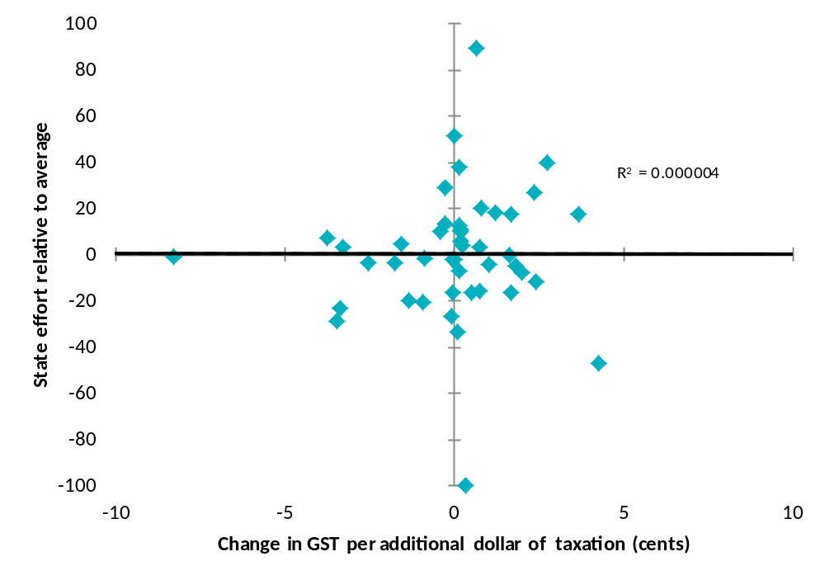
Source: Secretariat calculations.
Mirroring the analysis in the Panel’s first interim report, there does not appear to be a clear relationship between revenue raising effort and a State’s GST share incentives.
As a case in point, the recent New South Wales Financial Audit (the Lambert Report) recommended a switch from insurance taxes to payroll tax.
Insurance taxes are among the State’s most inefficient taxes. Combined revenue from insurance taxes is expected to be $1,526 million in 2010-11, with an average deadweight loss of 32 cents per dollar of revenue. Every extra dollar raised through an equal proportionate rate increase to all insurance taxes carries a marginal excess burden of 41 cents …
There is no obvious alternative source of revenue for [insurance taxes]. Removing them will require some combination of either spending cuts or tax increases. Among existing taxes, two potential sources for significant revenue increases are the GST and payroll tax …
Lowering the payroll tax threshold has a marginal excess burden of -8 per cent, while an increase in the GST has a marginal excess burden of +8 per cent. Overall, it is preferable to replace insurance duty by lowering the payroll tax threshold.
Despite the Lambert Report’s recommendation and even though New South Wales would gain GST share by switching from insurance tax to any other tax (see Table 3.1), it has not chosen to do so.
South Australia says:
A very pertinent case in point is the payroll tax tax-free threshold. All states have a tax-free threshold, and the taxable proportion of wages is determined using a weighted average threshold. Because of the relatively weaker small business share of NSW and Victoria, those states would gain GST share if they abolished their tax free thresholds. It can’t be GST share effects holding them back.
Similarly, by removing concessions on royalties for iron ore fines that it provided to certain companies Western Australia risked significant reductions in both GST share and net budget position, but this did not prevent it from acting. Western Australia notes that it chose to proceed with the royalty change because it considered the fiscal equalisation system so broken the case for reform would not be ignored.

Does the current system already encourage tax reform?
Tasmania argues that changes in GST shares under present arrangements actually promote State tax reform in some circumstances:
Because the CGC is guided by ‘what states do’ in establishing its assessment methods, cooperative state tax reform can have an impact on the CGC’s assessments. For example, if all states agreed to implement a new tax to address increasing costs associated with the ageing population, this would lead to a new CGC assessment of this tax. If there were differences between the states in capacity to raise revenue from the new tax, then the assessment would redistribute some GST revenue so that, ultimately, all states could enjoy the same benefits from the new tax, if they applied average effort and efficiency.
The fact that the new tax would be subject to equalisation would actually increase, rather than decrease, the likelihood that states would jointly undertake tax reform. The equalisation process ensures that, in the long run, each state has the capacity to raise its population share of any revenue source. This means that, provided it applies average tax rates to its own base, every state has an equal incentive to apply a particular tax. In this sense, HFE ensures that all states always have an incentive to introduce a new tax, regardless of expected differences in revenue raising capacity. This may seem counter-intuitive until it is considered that, without HFE, states would have unequal incentives to introduce a new tax as some states would be able to raise more revenue from it than others.
This logic is just as applicable to the decision to abolish or reduce taxation. If all states elect to abolish an inefficient tax, they will each bear similar costs in terms of overall lost revenue (own-source revenue plus or minus their net GST redistribution), but they will all gain the local economic benefits associated with the reform.
In practice, states apply varying rates to their tax bases and this will mean that their incentives to introduce or abolish a tax will not be perfectly equal. However, HFE ensures that the incentives will be more equal than would otherwise be the case.
Similarly, South Australia says:
State GST shares would be altered by [an agreed multilateral tax mix switch], but the effects would be the mirror of the changes in each States’ relative revenue raising capacity resulting from the tax mix switch. Ignoring differences in relative tax effort (which are a policy choice), such a scenario would leave State shares of combined own source tax revenue and GST grants unchanged.
In other words, changes in GST shares offset changes in a State’s revenue raising capacity so that a State does not have to change its tax rate relative to other States just because the tax mix changes.
On this analysis the key issue is ensuring that States can achieve the same overall budget outcome while maintaining the same relative tax effort. It does not seem to matter if a State has to raise more own source revenue to compensate for a reduction in GST share. Others would argue that the dollar amount that a State needs to raise and its relative effort compared with that for the abolished tax would both be relevant to whether or not a State was willing to pursue a tax reform.
The Panel’s view on the effect of the current HFE system on tax reform
Under current arrangements, any change by a given State to the design of its taxes or to the tax mix used to raise a set amount of revenue is likely to produce changes in GST shares. Major multilateral changes — as could be expected during a tax reform exercise — are almost certain to produce significant shifts in GST shares. Simply put, for any given tax reform, the present system will result in ‘winners’ and ‘losers’ and so could be thought of as creating incentives and disincentives.
Some States argue that the present HFE system actually removes disincentives for tax reform by offsetting differences in State revenue raising capacity, but others disagree.
While there is no hard evidence to prove whether GST share effects influence State tax decisions, the Panel doubts that these effects are the deciding factor. Nevertheless, we conclude that there is value in exploring alternatives that would allow any potential disincentives from the current system to be minimised.

State mineral royalties and the Commonwealth’s resource tax reforms
The supplementary Terms of Reference for the Review require the Panel to examine the interaction between State mineral royalties and the Commonwealth’s resource tax reforms. Specifically, the Panel has been asked to ‘examine the incentives for States to reduce Minerals Resource Rent Tax (MRRT) or Petroleum Resource Rent Tax (PRRT) revenue through increasing State mineral royalties’.
In considering this issue, the Panel must be guided by the findings of the Australia’s Future Tax System (AFTS) review relating to mineral royalties, and that ‘the MRRT and PRRT provide a more efficient approach to charging for Australia’s non-renewable resources than mineral royalties’.
The Panel’s first interim report (Chapter 6) outlines how State mining revenues are currently equalised between the States, and invites comments on the merits of several possible refinements to this existing approach. This Chapter deals only with the MRRT and PRRT, focussing on the interaction between these taxes and existing royalties.
The Panel’s examination of the interaction between State mineral royalties and the MRRT and PRRT consists of four parts:
- How Australia has charged for its non-renewable resources, including the roles of the States and Commonwealth (section 4.1).
- The findings of the AFTS review (section 4.2).
- The Commonwealth’s recently enacted resource tax reforms, including how the MRRT and PRRT will interact with existing State royalty regimes and the incentives that these interactions produce (sections 4.3, 4.4 and 4.5).
- The Panel’s views on how the interaction between the MRRT, PRRT and State royalties could be improved (sections 4.6 and 4.7).
Opportunities to use the GST distribution process to encourage improvements in the efficiency of State taxes and mineral royalties (along with options for removing the GST share effects of any proposals) are discussed in the following Chapter.
As with all of the topics covered in this interim report, the Panel encourages interested parties to comment on its analysis of this particularly difficult and contentious issue.

How Australia has charged for its non-renewable resources
Historically, responsibility for Australia’s onshore mining industry has largely rested with the States. This includes responsibility for:
- the regulation of the industry
- the allocation of exploration and production rights
- the charging arrangements through which the industry pays for the use of the community’s valuable non-renewable resources.
Responsibility for the development of offshore petroleum resources has exclusively been the Commonwealth’s.
In their submissions to the Review, several States have reiterated their strong support for the continuation of this division of responsibilities.
Western Australia says:
[I]t is a well accepted fact that States have a constitutionally based right to levy royalties. While royalties might be characterised as serving a similar purpose to taxation, they are, in reality the price paid by the extractive industry for the resource which is constitutionally owned by the people of the State in which the resource is located.
New South Wales notes that:
Mineral resources are the property of the states. A mining right is, in essence, a contract between a state and the proponent of a mining project specifying the rights, obligations, terms and conditions for the development of the project, and the framework for ongoing relations and cooperation between the parties.
Royalties are payments to the owners of the mineral resources in exchange for the right to extract them.

Mining royalties have been a long-standing revenue source for state and, before federation, colonial governments. New South Wales has been levying mining royalties since 1884, nearly two decades before federation.
This position is supported by the New South Wales Minerals Council, which says:
The Crown, and therefore the people of [New South Wales], owns the majority of mineral assets in [New South Wales]. A royalty is the price charged by the Crown for the transfer of the right to extract a mineral resource … [Given this], and in the absence of any agreement between the Commonwealth and the States to reform these arrangements, it remains the right of the States to charge for the transfer of the right to extract a mineral resource, and set the price for that charge.
The belief that the States’ long-standing power to levy royalties should not be interfered with is strong, especially in the resource States. For example, the Leader of the Opposition in Western Australia endorses the Western Australian Government’s submission on the supplementary Terms of Reference, and says:
Western Australia has the sole constitutional right to levy royalties on its minerals. The WA Labor Party, when in Government, reserves its right to alter the rates upon which royalties will be set. Ultimately it is the people of Western Australia who are the owners of the minerals.
It is also apparent from their submissions that most States have interpreted the supplementary Terms of Reference as a precursor to an attack on their ability to freely decide their mineral royalty policies. For example, Western Australia says:
It is obvious that it is inherent in the new terms of reference that a State should be penalised by the Commonwealth Government for changing royalty rates applicable in that State.
New South Wales shares this view:
[The supplementary terms of reference] appear to be motivated by the Commonwealth Government’s desire to influence an outcome of its MRRT/PRRT policies.
The Panel is mindful of the depth of concern amongst the States regarding their historical role in charging for the right to mine under their soils. For this reason, the Panel assures the States that it approaches this issue from a starting point that recognises this long-standing responsibility, with the expectation that they will continue to exercise this function into the future. However, the Commonwealth similarly has a well-established position in the field of taxation. The challenge is therefore to find a way to reconcile these two competing interests.

State mineral royalties
All States (except for the Australian Capital Territory, where no mining takes place) collect royalties in return for granting the right to private businesses to exploit mineral resources within their jurisdictions. With limited exceptions, these take the form of output-based royalties imposed as a percentage of the value (or, less commonly, the volume) of production.
The applicable royalty rate for a given commodity is determined differently in each State, as is the taxing point in the production chain and the scope of allowable deductions. Within each State, different commodities are often subject to different charging arrangements (see Appendix F).

The amount of royalty revenue differs greatly across the States
As discussed in Chapter 6 of the Panel’s first interim report, the geographical distribution of Australia’s most valuable mineral deposits is uneven. The resources subject to the MRRT, namely iron ore and coal, are overwhelmingly located in the three large resource States (Western Australia, Queensland and New South Wales).
As shown in Table 4.1, virtually all of Australia’s identified iron ore is located in Western Australia (97 per cent). Although coal is distributed somewhat more evenly, differences in quality have resulted in 96 per cent of all black coal being extracted in only two States, Queensland (52 per cent) and New South Wales (44 per cent).
Table 4.1: Proportion of key minerals and extraction by State
Commodity | NSW | VIC | QLD | WA | SA | TAS | ACT | NT
Coal identified resources (%) | 21 | 4 | 38 | 3 | 33 | 0 | - | -
Black coal production (%) | 44 | - | 52 | 2 | 1 | 0 | - | -
Iron identified resources (%) | 0 | 0 | 1 | 97 | 1 | 0 | - | 0
Iron ore production (%) | - | - | - | 97 | 2 | 1 | - | 0
Source: Derived from AGSO, National Mineral Deposits Dataset.
Note: A dash (-) indicates the State has none of that type of mineral or does not extract that mineral, whereas a zero indicates the State has a relatively small amount of that mineral. Totals may not sum to 100 due to rounding.
The concentration of resources in a few States is reflected in the distribution of royalties collected. Table 4.2 shows that in 2011-12, the three large resource States are expected to account for more than 95 per cent of the $11.1 billion in total royalty revenue.
Table 4.2: Estimated mining royalty revenue by State
Year | NSW | VIC | QLD | WA | SA | TAS | ACT | NT | Total
2011-12 ($m) | 1,768 | 46 | 3,445 | 5,494 | 203 | 48 | 0 | 144 | 11,148
2012-13 ($m) | 2,128 | 46 | 3,651 | 5,937 | 232 | 55 | 0 | 122 | 12,172
2013-14 ($m) | 2,215 | 47 | 3,436 | 6,956 | 225 | 56 | 0 | 134 | 13,069
2014-15 ($m) | 2,351 | 49 | 3,674 | 7,255 | 258 | 54 | 0 | 134 | 13,774
Source: Secretariat calculations. Royalties are from State Budget papers, and grants in lieu are based on Commonwealth estimates published in the 2012-13 Budget.
Note: These figures include Commonwealth payments to Western Australia and the Northern Territory in lieu of royalty payments from, respectively, the North West Shelf project and from uranium mining. They also include payments to Western Australia to compensate it for the loss of royalty revenue resulting from the removal, in 2008, of the exemption of condensate from crude oil excise.
This pattern of extraction shows the significance of iron ore and coal royalties to the large resource States. Iron ore accounts for the bulk of Western Australia’s royalty revenue (around $4.1 billion in 2011-12). Around 95 per cent of New South Wales’ royalties and more than three-quarters of Queensland’s (around $2.6 billion out of an estimated $3.4 billion in 2011-12) are from coal.
State oil and gas royalty collections have constituted only a fraction of those from iron ore and coal. For example, in 2010-11 Queensland collected $52.1 million in petroleum royalties, and Western Australia around $26 million., This total is likely to increase sharply in coming years, particularly in Queensland following the completion of several proposed projects to recover coal seam gas from the Surat and Bowen basins for conversion to liquefied natural gas for export. The previous Queensland Government expected the first royalty payments from these projects to commence in 2013-14 and estimated that the projects could ultimately contribute $850 million in royalties a year.
Notwithstanding the uneven distribution of resources across the States, the system of HFE means that all States, including those without large mining or petroleum industries, have a genuine stake in the performance of those industries. As discussed in Chapter 6 of the Panel’s first interim report, the principle that royalty revenues should be distributed across the Federation enjoys strong support, even though there is debate over the desirable extent of this redistribution and over some aspects of the way this principle is currently implemented. Equally, all States have a stake in ensuring that the supply chains for the resource industries work well, and that appropriate infrastructure is provided. Chapter 6 of the Panel’s first interim report therefore also explores whether economic development costs associated with expanding mining industries are fully recognised by the current HFE system.

Commonwealth resource taxes
In addition to the income tax arrangements that apply across all industries, the Commonwealth has specifically charged for the right to recover petroleum from Commonwealth waters, through the PRRT and crude oil excise regimes.
The PRRT, which is levied at a rate of 40 per cent on the positive annual net cash flow of a petroleum project, has applied to certain offshore petroleum projects since 1 July 1986. Before the introduction of the PRRT, offshore petroleum projects were subject to output-based royalties and excise arrangements levied by the Commonwealth. These arrangements were largely replaced upon introduction of the PRRT, although the Bass Strait project remained subject to Commonwealth royalties until it was brought into the PRRT system from 1 July 1990.
The North West Shelf project has (until 1 July 2012) remained outside the PRRT regime, and has continued to pay crude oil excise and an offshore petroleum royalty. The offshore petroleum royalty is collected by the Commonwealth, which retains one-third, with the remaining two-thirds transferred to Western Australia, pursuant to a long-standing agreement between those governments.
The amount of revenue collected each year from these petroleum taxes is highly variable, and heavily influenced by commodity prices and exchange rate levels, as well as the profile of investment (which is immediately deductible under the PRRT). In recent years, gross PRRT collections have averaged around $1.5 billion a year.
Crude oil excise is payable on production from individual prescribed production areas, and is calculated as a percentage of the volume-weighted average of realised free-on-board prices. Higher excise rates apply to higher levels of production, with the rates dependent on the project area’s dates of discovery and start of production.
The Commonwealth extended the crude oil excise regime to cover condensate produced from non-PRRT areas from 13 May 2008. The Commonwealth estimated this would have an ongoing gain to revenue of around $2.5 billion over the then forward estimates period (around $625 million a year by 2011-12).
Table 4.3: Commonwealth resource tax collections to 2011-12
Revenue ($m) | 2005-06 | 2006-07 | 2007-08 | 2008-09 | 2009-10 | 2010-11 | 2011-12 (e)
PRRT | 1,917 | 1,510 | 1,686 | 2,184 | 1,251 | 806 | 1,510
Crude oil excise and condensate | 362 | 525 | 470(e) | 1,060(e) | * | * | *
Source: PRRT revenue is taken from 2012-13 Budget Paper 1 (Cwth), Table C1.
Crude oil excise and condensate figures are from 2008-09 Budget Paper 1 (Cwth), Table C1. Since 2009-10, estimates of revenue from crude oil and condensate excise have no longer been published separately, as this would risk the disclosure of sensitive commercial information in relation to the tax affairs of potentially identifiable businesses.
Notes: The Commonwealth also collects, but does not retain, uranium royalties on behalf of the Northern Territory.
(e) Denotes the figure is an estimate, rather than an actual amount.

The AFTS review and resource charging
As outlined in Chapter 1, in 2008 the Commonwealth established the AFTS review to examine ways in which the existing tax and transfer system could be improved over the medium-term. The taxation of Australia’s non-renewable resources was one of the issues canvassed in detail in this report.
The AFTS review recommended two major shifts in the way Australia charges for the use of its non-renewable resources:
- an increase, overall, in the taxation of non-renewable resources
- a shift away from royalties based on the value or volume of output, and towards rent-based taxation, particularly for the most valuable commodities.

Higher taxes on non-renewable resources
The AFTS review’s conclusion that taxes on the use of Australia’s non-renewable resources should be increased can be seen as the product of several other assessments made by that panel, namely that:
- overall tax burdens in Australia may need to increase, over the medium term, owing to a combination of factors including an ageing population, high population growth, and increasing expectations in relation to public services
- this revenue should be raised primarily from four robust and efficient broad based taxes, on personal income, business income, private consumption, and economic rents from natural resources and land
- in an era of continuing globalisation, decisions about where to work and invest are likely to become more sensitive to tax settings.
Taken together, these judgments lead to one of the conclusions that runs through the AFTS review — that, as well as improving the tax bases themselves, over time there should be a shift between the tax bases. Overall, the taxation of consumption and of immobile factors of production, such as land and natural resources should be increased, in order to enable the lowering of taxes on more internationally mobile factors of production, namely capital and labour.
In addition to these longer-term considerations, the AFTS review concluded that Australia’s resource charging arrangements were inadequate, both from an efficiency perspective, and in that they ‘fail to collect an appropriate return for the community from allowing private firms to exploit non-renewable resources’.

A shift towards rent-based resource taxation
The AFTS review recommended a fundamental overhaul of the way resource revenue is collected, and who it is collected by. It called for the replacement of all existing resource charging arrangements with a single, uniform resource rent tax imposed and administered by the Commonwealth.
One of the stated motives for this recommendation, as well as for the particular form of resource rent tax preferred by the AFTS panel, was to remove the effect of existing royalty and excise regimes — which it saw as distortionary and highly inefficient — on investment and production decisions. The AFTS panel noted that distortions are caused in large part because output-based royalties are levied on projects without due regard to their overall profitability. Because some costs are not recognised, output-based royalties and excise taxes can result in some economically viable projects not proceeding, or closing earlier than is desirable.
These concerns were reflected in modelling published in the AFTS review report that found existing royalties and the crude oil excise to be the most economically inefficient of Australia’s major taxes (that is, a small increase in royalties or excise would reduce overall welfare by more than would a similar increase in any other tax).
The AFTS report concluded that a well-designed resource rent tax will be more economically efficient than a royalty applied on the basis of value or volume. However, the AFTS panel also acknowledged that other factors, such as the size, variability and timing of receipts to government, and administration and compliance costs are relevant when evaluating any particular resource charging regime. In particular, the perceived stability and predictability of royalty revenue was recognised as highly valued by the States. These considerations were emphasised in several States’ submissions to the GST Distribution Review.
Western Australia identifies fairness, timing and stability of royalty revenues, economic impact, net revenue retention after HFE, sovereign risk, simplicity, transparency and the legislative environment as important factors that inform its royalty policy settings:
Overall, Western Australia’s royalty regime is considered to strike a reasonable balance between the sometimes competing objectives of maximising economic efficiency, fairness, revenue stability, simplicity, and transparency, while also considering the legislative environment practicalities.
Queensland makes similar points:
Even if it were accepted that a mining royalty is not as efficient as a resource rent tax (a matter not without dispute), it could be argued that a mining royalty regime can be assessed as very strong when measured against other criteria. It can be more equitable, because it gives a return to the State as the resource is being exploited; simpler, because it is based on readily available measures of volumes and prices rather than a complex calculation of economic rent; and more stable, because volumes and prices are less susceptible to fluctuations than profitability … [T]aking a State perspective, a mining royalty may arguably be a more desirable mechanism for resource charging than a resource rent tax.
South Australia says:
Ad valorem royalties ensure that the community always receives some return from the grant of exclusive extraction rights over its mineral assets. Modelling undertaken for the AFTS Review suggests that ad valorem royalties are highly inefficient, but the size of the welfare loss is highly contingent upon the level of commodity prices (as prices rise, the difference between the excess burdens of gross income (royalties) and net income mining tax structures diminish.
The Northern Territory says that its royalty policy settings are designed to ‘ensure that the regime compensates the whole community for allowing the private extraction of the Territory’s non-renewable resources’, while also seeking to:
- maintain and foster the resource developer’s capacity to pay including sharing the benefits between the resource developer and the community fairly
- apply a uniform royalty regime across all royalty payers in equal situations and to be competitively neutral across competing resources
- avoid distorting commercial decisions regarding the levels of capital and other outputs devoted to economic activities which should be made in response to market signals
- minimise compliance and administration costs for business and government
- achieve consistency with broader environmental, social and fiscal objectives such as environmental, social and infrastructure objectives
- maintain competitiveness of the Territory within Australia and internationally.
The Panel’s view on the design of resource taxation regimes
The Panel accepts the finding of the Australia’s Future Tax System (AFTS) review that well-designed rent-based taxes are likely to be more economically efficient than royalties applied on the basis of value or volume, particularly in periods of low commodity prices or high costs.
The Panel also agrees with the AFTS review’s assessment and States’ views that other factors, such as the size, variability and timing of the return received by government, as well as relative administration and compliance costs, are important considerations when evaluating any particular resource charging regime.
The Panel is mindful of the depth of concern amongst States regarding their historical role in charging for the right to mine under their soils. However, the Commonwealth has a similarly well-established position in the field of taxation. The challenge is therefore to find a way to reconcile these two competing interests.

Allocating the revenues and risks of resource taxation
The approach adopted by the AFTS panel was to first make recommendations for the design of Australia’s future tax system based on the quality of particular taxes, and then to consider how responsibility for these taxes might best be assigned between the different levels of government.
The AFTS conclusion that the Commonwealth would be best placed to administer the resource rent tax follows to some degree from the nature of the proposed reforms themselves. In the event that resource projects were to be taxed uniformly across the country, it would be more administratively efficient to have a single tax authority, rather than one in each State. An even more pragmatic concern was that under the resource rent tax proposed in the AFTS review (and also under the MRRT) losses are transferrable between (Australian) commonly owned projects. If the resource rent tax were to be levied by each State (and not the Commonwealth), it is not clear how a transfer between, say, a loss-making project located in one State, and a highly profitable project located in another, would be treated.
Although the AFTS panel concluded that the resource rent tax would be best imposed and administered by the Commonwealth, it was equivocal about how the additional expected revenues (as well as the increased volatility) should be shared between governments. The AFTS review urged the Commonwealth and State governments to ‘negotiate an appropriate allocation of the revenues and risks from the resource rent tax’. This recommendation reflects the reality that resource tax reform along the lines proposed in the AFTS report can only succeed with the support of at least the major resource States, as well as the Commonwealth, and that States would not forego their royalty revenue without receiving an alternative revenue stream as replacement. Recognising this, as well as the premium placed by the States on revenue stability and predictability, the AFTS review canvassed an alternative approach whereby the new rent tax would apply in parallel with State royalties.
Under this dual approach, royalties would have continued to be levied by States, but would have been fully refundable to the resource companies (like other costs in the AFTS model). This approach would have continued to provide States with a stable revenue stream (with the added volatility risk associated with the rent tax being assumed by the Commonwealth), while ensuring that State royalties would no longer bias investment or production decisions. However, the benefits associated with reductions in administrative and compliance costs flowing from the introduction of a single standardised regime would have been lost.
Importantly, the AFTS report recognised that a guarantee to refund royalties would need to be accompanied by a Commonwealth-State agreement in relation to royalty policy, ‘to ensure that the [Commonwealth] does not automatically fund future increases in royalties’. No such agreement has yet been concluded.
The desirability of a negotiated outcome between the Commonwealth and the States in relation to the revenues and risks of resource tax reform is returned to later in this Chapter (see Section 4.6), following an examination of how the resource tax reforms ultimately pursued by the Commonwealth (the MRRT and extension of the PRRT) will interact with existing royalty regimes.
The findings and recommendations of the AFTS report in relation to State taxes and resource charging arrangements are reproduced in full at Appendix C.

The MRRT and the extension of the PRRT
On 2 May 2010, the Commonwealth Government released the AFTS review report and announced a suite of measures in response. One measure, the Resource Super Profits Tax (RSPT), adopted the AFTS review’s call for a greater use of profits-based taxes on all resource projects, as well as an overall increase in their amount of tax paid.
The RSPT model provided for the refunding of State royalties, so as ‘to reduce the impact of State royalties and negate concerns that the [RSPT] is a “double” tax’. The Commonwealth indicated that ‘the refundable credit will be available at least up to the amount of royalties imposed at the time of announcement, including scheduled increases and appropriate indexation factors’.
On 2 July 2010, the Commonwealth announced a revised set of resource tax arrangements. The RSPT model was replaced with the MRRT, applying only to iron ore and coal projects. The scope of the existing PRRT was to be extended to cover all onshore and offshore oil and gas projects. Legislation giving effect to these arrangements was passed by the Commonwealth House of Representatives on 23 November 2011 and by the Senate on 19 March 2012, with only minor adjustments. The new arrangements will commence from 1 July 2012.
Both the MRRT and the extension of the PRRT will apply alongside existing resource taxes. That is, iron ore and coal projects will remain subject to royalties levied by State governments, and onshore petroleum projects (and the North West Shelf project) will remain subject to existing royalty and excise arrangements. Existing resource taxes will be creditable against MRRT and PRRT liabilities.
The introduction of the MRRT is estimated to generate around $13.4 billion in net revenue in its first four years. The extension of the PRRT is unlikely to give rise to significant collections over the forward estimates period, largely due to the starting base arrangements which prevent any retrospective application of the tax.
Table 4.4: Estimated revenue from the Commonwealth’s resource tax reforms
Revenue ($m) | 2012-13 | 2013-14 | 2014-15 | 2015-16
Resource rent taxes (PRRT and gross MRRT revenue) | 7,160 | 8,190 | 7,380 | 8,200
Net revenue from the introduction of the MRRT(a) | 3,000 | 3,500 | 3,200 | 3,700
(a) This represents the net impact on revenue across several different revenue heads. This includes the offsetting reductions in company tax (through deductibility) and interactions with other taxes.
Source: Commonwealth Government, 2012-13 Budget, Budget Paper No.1, Statement 5, Table 9.
The key features of the PRRT and MRRT are set out in the following boxes.
Key features of the PRRT
- The PRRT is levied on the taxable profits of petroleum projects at a rate of 40 per cent.
  - Taxable profits are calculated by deducting eligible project expenses from the assessable revenues derived from the project.
  - Previously it has applied only to offshore petroleum projects (other than the North West Shelf project). From 1 July 2012, the PRRT will be extended to all oil and gas projects, including those located onshore.
- Existing projects transitioning into the PRRT are provided with additional deductions that recognise investments made prior to the announcement of the Commonwealth’s resource tax reforms.
- Like for the MRRT, all State and Commonwealth resource taxes are creditable (but not refundable) against current and future PRRT liabilities from a project.
- The PRRT is a project-based tax. Losses (including unused royalty allowances) from one project cannot generally be used to offset income from another project.
  - The exception is exploration expenditure, which is transferable to other petroleum projects, subject to a number of conditions.

Key features of the MRRT
- The MRRT will apply to iron ore and coal projects, at an effective rate of 22.5 per cent (a headline 30 per cent rate, reduced by a 25 per cent extraction allowance).
- The ‘valuation point’ is typically soon after the point of extraction. Only the value of the resource at this point is subject to the MRRT and only expenditure occurring up to this point is deductible for the purposes of the MRRT.
- There will be no MRRT liability for taxpayers with low levels of resource profits. Those with annual group mining profits of less than $75 million will be fully relieved of their MRRT liability that year.
- MRRT payments are deductible against income tax.
- MRRT losses are transferable to offset MRRT profits the taxpayer has on other projects of that commodity (that is losses from iron ore (coal) projects are only transferable to other iron ore (coal) projects). Any remaining MRRT losses are carried forward at the uplift rate of Long Term Bond Rate plus 7 per cent. Unused losses (except for some rehabilitation costs) are not refundable upon closure of the project.
- Investments made prior to 2 May 2010 are recognised through a ‘starting base allowance’.
  - Taxpayers can use the market value of the project (as at 2 May 2010), including the value of the resource, in which case the starting base is applied on a straight-line basis over the shorter of the life of the mine or until 2037. Unused starting base amounts are uplifted in line with the Consumer Price Index.
  - Alternatively, taxpayers can use the project’s book value as at 2 May 2010 (excluding the value of the resource). Book value starting bases are written-off over five years, and are uplifted at the Long Term Bond Rate plus 7 per cent.
- All other resource charges (including State royalties) are fully creditable, but not transferable between projects or refundable. Unused royalty credits are carried forward at the uplift rate of Long Term Bond Rate plus 7 per cent.

How the MRRT and PRRT interact with State royalties

Dual resource charging regimes for iron ore, coal, oil and gas
From 1 July 2012, iron ore and coal producers will be subject to the MRRT imposed by the Commonwealth, as well as to State-based royalties. Similarly, oil and gas producers first becoming subject to the Commonwealth’s PRRT will remain subject to existing royalties and excise arrangements.
Other mineral resources, such as copper, gold, uranium and nickel, are not subject to the MRRT. They remain subject only to the relevant State royalty regimes.

Other resource charges are creditable against MRRT and PRRT liabilities
One outcome sought by the AFTS review was the removal of the effect of royalties and excises on production and investment decisions. Under the model proposed this would have been achieved either through the removal of all State royalties (as well as the Commonwealth’s crude oil excise), or by fully refunding to the resource companies any royalty or excise payments (the approach contemplated by the RSPT).
Under the MRRT and PRRT, royalty and excise payments are not refundable, but are taken into account in determining the MRRT or PRRT liability of a project, through allowing a credit for royalties paid. Crediting royalties has the same effect as refunding them where the taxpayer’s MRRT liability remains positive for the year in question.
Table 4.5 shows the way royalties are taken into account under the MRRT compared with refundability of royalties, where MRRT is payable.
Table 4.5: Comparison of refundability and creditability of royalties, where MRRT is payable
Project parameters ($m) | Royalties are refundable | Royalties are creditable, not refundable
MRRT revenue | 500 | 500
MRRT expenditure, excluding royalties | 100 | 100
Royalty payments | 50 | 50
Royalty allowance (payment/22.5%) | N/A | 222.2
MRRT profit | 400 | 177.8
MRRT payable @ 22.5% | 90 | 40
Less MRRT royalty refund | 50 | N/A
Net MRRT payable | 40 | 40
Total resource charge (royalty plus MRRT) | 90 | 90
Under the crediting approach, the royalty payments actually made ($50 million in Table 4.5) are converted into a pre-MRRT equivalent by dividing by the effective MRRT rate of 22.5 per cent. The resulting ‘royalty allowance’ then reduces the size of the project’s profit that is subject to the MRRT. The same result is obtained if, instead of reducing MRRT profits by the grossed-up royalty amount, the royalty payment is disregarded for the purposes of calculating MRRT payable and then refunded at the end of the calculation. In the above Table, whichever of these approaches is taken, the net MRRT payable is $40 million, giving a total resource charge of $90 million.
Table 4.6 repeats this analysis for a situation where MRRT is not immediately payable. All parameters are the same as before except for MRRT expenditure, which now totals $500 million rather than $100 million (perhaps as a result of investment made in expanding the mine). In this case, crediting royalties will produce a different outcome to refunding them. The project will make an MRRT loss this year of $222.2 million (wholly attributable to the effect of royalties in this example), which is able to be carried forward to offset future MRRT profits from the project. As the full value of royalties paid is not needed to reduce the MRRT liability to zero, the unused amount is carried forward for future use, uplifted at the long term bond rate (so that it maintains its real value) plus 7 per cent (a premium which reflects the possibility that the allowance may never be used). If royalties were refundable instead of creditable, then, in this example, the Commonwealth would immediately reimburse the taxpayer the $50 million in royalty payments it has made to a State. This project would face no net resource charge this year.
Table 4.6: Comparison of refundability and creditability of royalties, where MRRT is not immediately payable
Project parameters ($m) | Royalties are refundable | Royalties are creditable, not refundable
MRRT revenue | 500 | 500
MRRT expenditure, excluding royalties | 500 | 500
Royalty payments | 50 | 50
Royalty allowance (payment/22.5%) | N/A | 222.2
MRRT profit | 0 | -222.2
MRRT payable @ 22.5% | 0 | 0
Less MRRT royalty refund | 50 | N/A
Net MRRT payable | -50 | 0
Total resource charge (royalty plus MRRT) | 0 | 50
Unused allowance available for future years (and uplifted at long term bond rate + 7 per cent) | N/A | 222.2

The MRRT will operate as a ‘top-up’ tax on highly profitable projects
The MRRT (and the PRRT for those projects also subject to excise or royalties) effectively acts as a ‘top-up’ tax on the most highly profitable projects, while leaving the amount paid by less profitable projects unchanged.
This interaction between the MRRT and State royalties is illustrated in Figure 4.1, which shows how the amount of royalty and MRRT payments vary with the profitability of a project. In this example, the project’s revenue is held constant, with mining expenditure (as measured for MRRT purposes) decreasing from left to right, so that the project’s profitability (revenue minus expenditure) increases from left to right in the chart.
Figure 4.1: Project profitability, royalties and MRRT for a single year
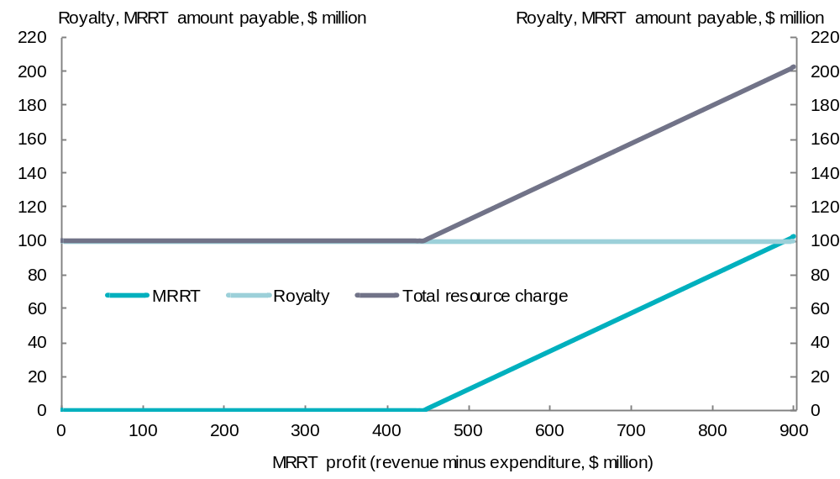
This Figure shows that no MRRT is payable when profitability is relatively low. For example, if the project’s MRRT revenue is $1 billion and it makes $100 million in royalty payments, it would only pay MRRT if profitability was such that it would have paid more than $100 million in MRRT in the absence of any royalty regime. For each extra dollar of profitability beyond this point, the project’s MRRT liability (and the total amount paid for the use of the resources) will increase by 22.5 cents.

What incentives are created by the interaction between MRRT, PRRT and State royalties?
In its supplementary issues paper, the Panel asked whether ‘States have an incentive to reduce MRRT or PRRT revenue through increasing State mineral royalties?’
Western Australia says that if such an incentive exists, it is a second-order issue:
First and foremost, States’ decisions to increase royalties on State-owned minerals will be driven by the objective of ensuring fairer returns to the community, rather than by any malicious intent of depriving the Commonwealth of revenue from its proposed MRRT (through the royalty–crediting arrangements). States cannot increase royalties with impunity, as they need to have regard to the impact on less profitable operations.
A resource-rich State such as Western Australia with substantial infrastructure spending needs may nonetheless have an incentive to increase, say, iron ore royalties to help compensate for the already large net redistribution of wealth out of the State (including through the HFE process) and inadequate support from the Commonwealth’s Budget.
Western Australia also suggests that ‘to the extent there is any incentive, this is attributable to the poor design of the MRRT and lack of collaboration with the States’, and points out that the full crediting of royalties could provide a disincentive to reduce royalty rates:
[T]he terms of reference reflect a one-sided view which overlooks that the royalty-crediting arrangements could equally discourage States from reducing mineral royalties. To the extent that this would result in an offsetting increase in MRRT, there would be no benefit to the mining industry and an increase in [vertical fiscal imbalance].
New South Wales says:
Making future state royalty payments fully deductible under the MRRT is not consistent with the normally accepted principles of revenue base sharing. These principles demand that the taxes applied by different governments to the common tax base should be independent and separately visible so as to foster individual government accountability. By making state royalty payments fully deductible, the MRRT could reduce the transparency of royalties on large iron and coal projects.
The key issues are transparency and accountability. The outcome in this case is a feature of the design of the MRRT. It has no relationship to HFE.
Tasmania says that States do not have an incentive to reduce MRRT or PRRT revenue, but acknowledges that this may be one consequence of State royalty policy decisions made for other reasons:
States have the incentive to maximise revenue at low economic or other cost. In so doing, states do not have an interest, or an incentive, to reduce the revenue of other governments, such as the Commonwealth. However, in pursuing the objective to maximise their mining revenue, an indirect consequence can be a reduction in MRRT or PRRT revenue.
The Northern Territory notes that its circumstances may be different from the other States, given that it already has a profit-based royalty system in place:
The design of the profit-based royalty system in the Territory means that there are no incentives for the Territory to increase its mineral royalty rate for the purpose of reducing MRRT and/or PRRT revenue.

The interaction of the MRRT and extension of the PRRT does create an incentive for States to increase royalties — in certain circumstances
The Panel accepts the proposition that when States determine their royalty policies on iron ore, coal, and onshore oil and gas, the existence of the MRRT and PRRT will not necessarily be the only consideration, and sometimes not even a major one. States will continue to determine their royalty policy settings having regard to matters such as industry and regional development, and the timing, stability and predictability of expected revenues. However, notwithstanding that other factors play a role, the Commonwealth’s commitment to fully credit all royalty payments against its own resource taxes has created a situation whereby the States can increase their revenue at the expense of the Commonwealth. It is even conceivable the States could erode the Commonwealth’s entire onshore resource rent tax base, if they were minded to do so.

The incentive to increase royalties is strongest where profitability is highest
The size of the incentive for States to increase their royalty revenue at the expense of the Commonwealth’s MRRT and PRRT revenue is a function of the amount of MRRT and PRRT payable. All else being equal, States will have a stronger incentive to increase royalties on highly profitable projects that pay a large amount of MRRT than they would for more marginal projects that pay little MRRT (or none at all).
On highly profitable projects, a reduction in State royalty payments would be offset by an equal increase in MRRT payments. As long as the project continues to pay some MRRT, a change in State royalties leaves the project no better or worse off overall. In these circumstances, the only substantive effect of an increase or decrease in royalties is the transfer of revenue between the Commonwealth and the States.
This is illustrated by Table 4.7. The numbers used in this example for mining revenue, expenditure and carried forward losses are drawn from Example 2.1 in the Explanatory Memorandum to the Minerals Resource Rent Tax Bill 2011. In that example, the project is shown as paying $37.5 million in royalties, as well as $35.3 million in MRRT, a total resource charge of $72.8 million for the year.
Table 4.7: The effect of different royalty payments for an MRRT project
State royalty payment | $37.5m | $50m | $70m
Mining revenue | $500m | $500m | $500m
Mining expenditure (ex. royalties) | ($120m) | ($120m) | ($120m)
Mining profit | $380m | $380m | $380m
Royalty allowance (payment/22.5%) | ($166.7m) | ($222.2m) | ($311.1m)
Uplifted mining loss allowance(a) | ($56.5m) | ($56.5m) | ($56.5m)
MRRT profit | $156.8m | $101.3m | $12.4m
MRRT liability (to Commonwealth) | $35.3m | $22.8m | $2.8m
Total resource charge (royalty plus MRRT) | $72.8m | $72.8m | $72.8m
Note: The numbers here for mining revenue, mining expenditure and mining loss allowance follow ‘Example 2.1: The basic MRRT calculation’, from the Explanatory Memorandum to the Minerals Resource Rent Tax Bill 2011, page 16.
(a) In this example, losses are uplifted at 13 per cent each year. That is, it is assumed that the long term bond rate is 6 per cent per annum, and therefore the long term bond rate plus 7 per cent is 13 per cent.
If the State were to increase its royalty rate, so that its total royalty payment from the project increased by $12.5 million to $50 million, this would result in a reduction in MRRT payments of $12.5 million. If royalties were increased by a further $20 million (to $70 million) MRRT revenue would fall by another $20 million. In all three cases, the total resource charge (royalties plus MRRT) paid by the project would be $72.8 million. The amount of royalty levied determines only how this total is shared between the States and the Commonwealth (see Figure 4.2).
Figure 4.2: MRRT and State royalties for a stylised MRRT-paying project

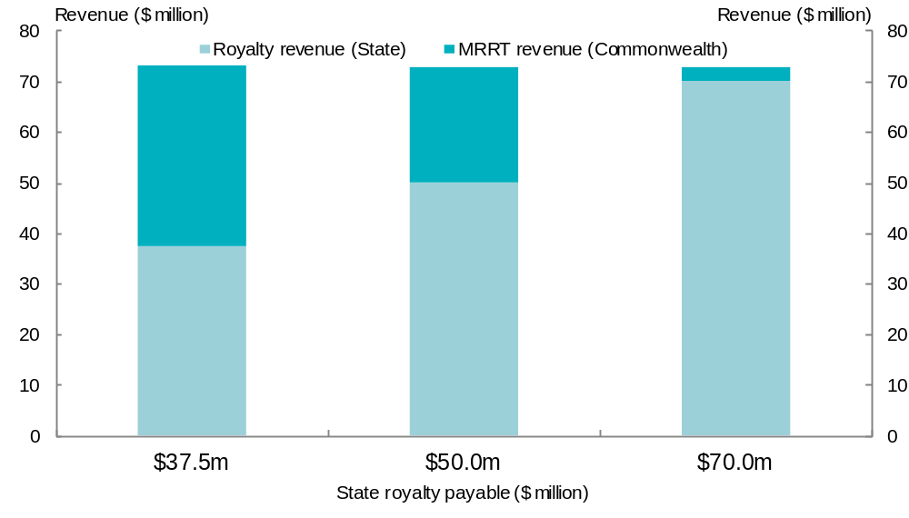

The incentive to increase royalties is less where profitability is lower
In the previous example the State where the project is located could increase its royalty revenue by $32.5 million, with the result that Commonwealth revenue would be reduced by $32.5 million and the project itself would be no better or worse off overall (except for an adverse cash-flow effect to the extent that royalty payments occur substantially in advance of MRRT payments).
However, such a ‘dollar-for-dollar’ trade-off will not occur in every case. The MRRT is only payable on a project once all of the initial investment has been recouped, including a generous return on that investment. As such, a project will typically have a profile of changing MRRT liabilities over time. New projects may not pay MRRT until several years after they have commenced production. Projects which are insufficiently profitable may not pay any MRRT over their lifetime. These are intended features of resource rent taxes such as the MRRT and PRRT.
Where an iron ore or coal project has commenced production, but is not yet sufficiently profitable to be liable for MRRT, the interaction between royalties and the MRRT does not result in a simple trade-off between State and Commonwealth revenue. If the starting point is that no MRRT is payable, it follows that any increase in State royalty is not immediately offset by the Commonwealth.
Table 4.8 adjusts the previous example so that it represents a project with higher costs. Annual mining expenditure is now $300 million instead of $120 million (all other parameters are unchanged). In this case, a royalty payment of $37.5 million is enough to ensure the project incurs an MRRT loss for the year. If State royalties on the project were increased, to say $50 million or $75 million, then this is (at least initially) borne by the project, rather than the Commonwealth through reduced MRRT revenue.
Table 4.8: The effect of different royalty payments for a project not paying MRRT
State royalty payment | $37.5m | $50m | $70m
Mining revenue | $500m | $500m | $500m
Mining expenditure (ex. royalties) | ($300m) | ($300m) | ($300m)
Mining profit | $200m | $200m | $200m
Royalty allowance (payment/22.5%) | ($166.7m) | ($222.2m) | ($311.1m)
Mining loss allowance (earlier loss x 1.13) (a) | ($56.5m) | ($56.5m) | ($56.5m)
MRRT profit/loss | -$23.2m | -$78.7m | -$167.6m
MRRT liability (to Commonwealth) | 0 | 0 | 0
Total resource charge (royalty plus MRRT) | $37.5m | $50m | $70m
(a) This assumes a long term bond rate of 6 per cent per annum, so that the long term bond rate plus 7 per cent is 13 per cent.
Figure 4.3: State royalty revenue, for a non-MRRT paying project
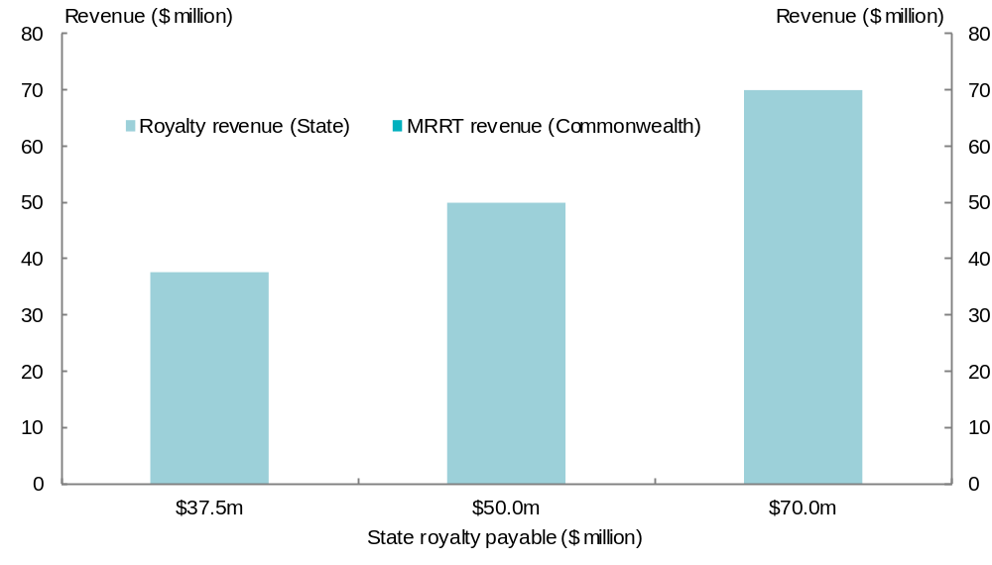

… but as long as the project is expected to pay MRRT at some point, there will be an incentive to increase royalties PgPage
The previous two examples show, in a stylised way, the effect of a State’s decision to change its royalty policy on the profitability of affected mining projects as well as on MRRT revenue. The first example shows that, in a year where an affected project would still face an MRRT liability after a royalty increase, the State may be able to claim additional revenue at the expense of the MRRT without adversely affecting the project’s profitability overall. The second example shows that, if a project is not paying any MRRT to begin with in a particular year, a State increasing its royalty rate will receive this money at the expense, at least initially, of the project’s profitability, rather than at the expense of the Commonwealth.
In practice, mining projects will typically have a profile of MRRT liabilities that varies significantly over time. Initially, a new project will be in an MRRT loss position for several years as it outlays the capital expenditure needed to establish the project, and then begins to recoup this investment once the mine starts production. For this reason, even projects that are ultimately very highly profitable will be unlikely to pay any MRRT during their first few years.
Royalty payments are able to be carried forward and uplifted at the government’s long term bond rate plus 7 percentage points. For example, when the long term bond rate is 6 per cent, unused royalty credits are uplifted by 13 per cent before being carried forward to offset future MRRT liabilities. Because of this, States will generally be able to increase royalties and secure revenue at the expense of MRRT collections without making affected projects any worse off overall, provided that the project ultimately becomes profitable enough to face an MRRT liability. Put another way, whether States can now increase their royalty revenue without making mining projects worse off depends not on whether a particular project pays MRRT in any given year, but whether it will pay MRRT at some future point.
The charts at Appendix E show that a decision by a State to increase its royalty rate will:
- increase State royalty revenue each year
- delay the collection of MRRT revenue from the project and decrease the amount of MRRT payable once the project starts paying the tax
- not change the total resource charge faced by the project each year, once its MRRT liability has been fully phased-in
- not make the project any worse off over its life, if the appropriate discount rate is taken to be the long-term bond rate plus 7 per cent.

Increases in iron ore and coal royalties since the announcement of the Commonwealth’s resource tax reforms
The previous section examined whether the introduction of the MRRT and the extension of the PRRT creates an incentive, in theory, for States to increase royalty rates and, if so, under what circumstances. This section notes that, in practice, four States have increased their iron ore or coal royalties since the Commonwealth’s resource tax reforms were first announced in May 2010 (see Table 4.9).
Table 4.9: Increases in royalties since 2 May 2010
State | MRRT commodity | Date of announcement | Date of effect | Estimated increase in State revenue (to 2014-15) | Estimated effect on MRRT revenue
SA | Iron ore, coal | 16 September 2010 | 1 July 2011 | N/A(a) | Unlikely to be material(a)
WA(b) | Iron ore (fines) | 19 May 2011 | Increased in two stages, from 1 July 2012  and 1 July 2013 | Over $2b | Material (no estimate separately published)
TAS | Iron ore, coal | 16 June 2011 | 1 January 2012 | N/A(c) | Unlikely to be material
WA | Iron ore (magnetite) | 20 July 2011 | 2011-12 | $60m in 2011-12, increasing to around $160m a year by 2014-15 | Unlikely to be material
NSW | Coal | 6 September 2011 | 1 July 2012 | $944m | Not yet reflected in MRRT estimates
(a) South Australia estimated this royalty change, which applied to all commodities, would increase total royalty revenue by $65 million between 2011-12 and 2013-14. The contribution of iron ore and coal projects to this figure has not been published separately.
(b) Prior to this general increase in the rate on iron ore fines, the Western Australian Government agreed with BHP Billiton and Rio Tinto to remove a concessional royalty rate (of 3.75 per cent) that had applied to their operations so as to align it with the standard rate of 5.625 per cent, with effect from 1 July 2010. That change was estimated to raise an additional $340 million in royalties in 2010-11.
(c) Tasmania’s royalty increase, to a cap of 5.5 per cent of net sales, is estimated to increase its revenue by around $3.6 million a year, or $12.6 million by 2014-15. The contribution of iron ore and coal projects to this figure has not been published separately.
Two of the increases, those by South Australia and Tasmania, apply to all commodities, not just to the relatively small amount of iron ore and coal mined within their jurisdiction. These increases are unlikely to materially reduce MRRT revenue.
In July 2011, Western Australia announced the imposition of a five per cent royalty on magnetite concentrates (as well as uranium oxide concentrates), which it estimates will raise approximately $160 million a year by 2014-15. As a form of iron ore, magnetite is subject to the MRRT. However, it is not expected to account for much, if any, MRRT revenue, at least over the forward estimates period. One reason for this is that unlike conventional haematite projects, magnetite ore requires substantial (and expensive) processing in order to produce a saleable product. The value added downstream of the MRRT valuation point will not be subject to the tax. Further, those magnetite projects that commence production in coming years will not face any prospect of an MRRT liability until their upfront costs have been recouped. Because magnetite projects are not expected to account for any significant amount of MRRT revenue, at least initially, the impact of Western Australia’s decision to impose a magnetite royalty is unlikely to have a material effect on MRRT revenue over the forward estimates period. However, it is possible that it could lower MRRT revenue over the longer-term, particularly if iron ore prices remain high.
The remaining two announced changes in royalty arrangements are likely to have an impact on MRRT revenue collections. These are Western Australia’s decision to increase the rate payable on iron ore fines, and New South Wales’ decision to selectively impose a higher coal royalty rate on certain companies.

Western Australia’s decision to increase the royalty rate on iron ore fines
On 19 May 2011, the Western Australian Government announced it would increase the royalty rate on iron ore fines. The rate is to increase in two stages, from 5.625 per cent to 6.5 per cent on 1 July 2012, and to 7.5 per cent from 1 July 2013. This increase will result in the royalty rate for iron ore ‘fines’ being the same as for iron ore ‘lump’.
Table 4.10: Western Australia’s estimates of additional revenue due to iron ore royalty rate changes
 | 2011-12 | 2012-13 | 2013-14 | 2014-15 | Total to 2014-15
Royalty rate — iron ore ‘fines’ | 5.625% | 6.5% | 7.5% | 7.5%
Change in Royalty income ($m) |  | 378 | 824 | 817 | 2,019
Impact on GST share ($m) |  |  |  | -96 | -96
Net revenue impact ($m) |  | 378 | 824 | 722 | 1,923
Source: Government of Western Australia, 2011–12 Budget, Economic and Fiscal Outlook, Budget Paper No. 3, page 75.
Western Australia expects the higher rate to generate around $2 billion in extra royalties by 2014-15. Like other royalty revenue, this additional amount will be taken into account by the Commonwealth Grants Commission (CGC) in its assessment of the States’ relative fiscal capacities.
For the reasons outlined above, the Commonwealth’s decision to fully credit all State royalties means that an increase in those royalties will reduce the amount of MRRT revenue collected. Because iron ore projects located in Western Australia form a large part of the MRRT tax base (iron ore projects are estimated to account for around three-quarters of MRRT revenue, and around 97 per cent of iron ore production is in Western Australia), changes in Western Australia’s iron ore royalties can potentially have large effects on MRRT revenues.
To the extent that miners affected by royalty increases face an MRRT liability, they might be expected to be largely indifferent to paying the higher royalty (because their MRRT liability is reduced by the same amount), potentially enabling a State to increase its revenues at the Commonwealth’s expense, without incurring the political pain ordinarily associated with increasing taxes and charges.
Western Australia strongly denies that its decision to increase royalties was motivated by a desire to increase its own revenue at the expense of the Commonwealth’s MRRT collections. Instead, it says that this increase, like all of its royalty policy decisions, was based solely on its own assessment of the appropriate price to charge firms for the use of the Western Australian community’s resources:
First and foremost, States’ decisions to increase royalties on State-owned minerals will be driven by the objective of ensuring fairer returns to the community, rather than by any malicious intent of depriving the Commonwealth of revenue from its proposed MRRT (through the royalty-crediting arrangements). States cannot increase royalties with impunity, as they need to have regard to the impact on less profitable operations.
This position is supported by the Leader of the Opposition in Western Australia:
The recent amendments to the WA State Agreement Acts to increase the iron ore ‘fines’ royalty rates … were supported by the Labor Opposition. These increases were due to the fact that the argument for ‘fines’ to be treated differently from iron ore ‘lump’ were no longer relevant.
The Commonwealth Treasurer says that both Commonwealth and State governments ‘share a responsibility to ensure the taxation of Australia’s resources preserves our international competitiveness’ and that ‘the MRRT is a more efficient way to provide Australians with a return on their mineral wealth than revenue-based royalties’. The Commonwealth Treasurer also points out that:
[Western Australia’s] decision means it will be much harder for the [Commonwealth] to finance additional infrastructure projects in Western Australia funded by the MRRT.

New South Wales’ decision to selectively increase royalties on coal
In its 2011-12 Budget, the New South Wales Government announced its intention to increase coal royalties to raise an estimated $944 million by 2014-15 ($235 million in 2012-13, $244 million in 2013-14 and $465 million in 2014-15).
Unlike the other States that have altered their royalties since the announcement of the MRRT, the New South Wales Government has explicitly justified its policy in terms of its broader fiscal relationship with the Commonwealth. It has presented the increased royalty as a response to ‘the negative financial impacts on [New South Wales] of the [Commonwealth’s] carbon tax’.
Further, the New South Wales Government has expressly stated its intention that the increased royalty be funded out of Commonwealth revenue rather than by the mining industry, and has indicated it will tailor its royalty regime to achieve that outcome:
The increase will only apply to firms that are subject to the [Commonwealth’s proposed MRRT]. As the [Commonwealth] has committed to compensate mining companies for any royalties that are paid to state governments, the increase in royalties will not be an additional tax burden on mining companies.
NSW legislation to implement the royalty supplement will be prepared after the [Commonwealth] finalises its carbon tax and MRRT legislation. The royalty supplement is intended to protect NSW revenue from [Commonwealth] Government changes, while minimising the financial impact on NSW coal mining.
The Panel’s view on whether the interaction between the MRRT, PRRT and State royalties creates an incentive for States to increase royalties
The Commonwealth’s decision to fully credit State royalties under the MRRT and PRRT has created an opportunity for States to seek to increase their revenue at the expense of the Commonwealth.
While States will no doubt continue to determine their royalty policies based on a range of considerations, one State has already expressly cited this incentive as the basis for its royalty increase.

The need for a negotiated outcome

The current position is not sustainable
The introduction of the MRRT and the extension of the PRRT go some way to implementing the reform directions proposed in the AFTS review. These changes will increase the overall return to the Australian community from the exploitation of its most valuable non-renewable resources, and do so in a relatively economically efficient way. However, other important aspects of the AFTS review’s recommendations are yet to be actively pursued, including that the Commonwealth and the States negotiate how to share the revenues and risks of Australia’s resource taxes.
The importance of an agreement between the two levels of government was highlighted by the Policy Transition Group. This Group, co-chaired by the Commonwealth Minister for Resources, Energy and Tourism and Mr Don Argus AC, advised the Commonwealth on the design and implementation of the MRRT and PRRT extension and considered the interaction between existing royalties and the new resource rent taxes. The Policy Transition Group’s advice on this issue is reproduced at Appendix D.
Both the AFTS report and the Policy Transition Group recognised that an unsustainable dynamic would be created by the introduction of a resource rent tax at the Commonwealth level that fully recognised royalty payments made to the States — unless the States and the Commonwealth were able to agree on how to share the risks and rewards of resource taxation. With the passage of the MRRT and PRRT legislation, and the continued absence of an accommodation between the Commonwealth and the States, the harmful and unsustainable situation warned against has eventuated. The States and the Commonwealth now each lay claim to part of the same tax base. It is not surprising that one State has already announced its intention to seek to erode the MRRT revenue base, nor that the Commonwealth has responded by threatening to reduce other funding to that State if it proceeds.
This situation is not sustainable. The States make the point that it is the manner of the Commonwealth’s entry into the field of resource taxation that has created a tension between the two levels of government. However true this observation might be, it does not contribute to a resolution of the problem with which both levels of government now find themselves. The States need to assess the likelihood and nature of the Commonwealth’s response in the event that its MRRT and PRRT revenue base continues to be eroded by States’ actions — whether or not that erosion is the deliberate objective of a State decision to increase royalties.
For these reasons, it is likely that there will be a point at which the Commonwealth will act to ensure its resource tax base is supported. The fiscal imbalance between the Commonwealth and the States means that there are a number of other funding mechanisms that the Commonwealth could employ to seek to influence States’ decisions, if it chose to do so.
The Panel’s view on the unsustainability of the current interaction between the MRRT, PRRT and State royalties
The Panel accepts the States’ position that the new incentive that exists for them to increase royalties is the product of the way in which the Commonwealth has designed its own resource tax reforms.
However, if it is unreasonable for the Commonwealth to expect the States to relinquish their discretion over royalty policy, it is equally unrealistic for the States to expect the Commonwealth to allow them to capture the revenue stream generated by the Commonwealth’s undertaking of a significant and challenging reform. The current situation is not sustainable and needs to be resolved.

How could the problem be fixed?
In its supplementary issues paper, the Panel asked, if States have incentives to reduce MRRT or PRRT revenue by increasing their royalties, how these should be removed.
Submissions recognise there are three broad ways of resolving the current impasse between the Commonwealth and the States:
- The Commonwealth could unilaterally seek to penalise States that increase royalties on MRRT and PRRT commodities.
- The Commonwealth could revisit its design of the MRRT and PRRT.
- The Commonwealth and States could agree on how to share the resource tax base.
The Panel considers the third of these options to be clearly the best outcome. Before focusing on that in more detail though, it is important to recognise some of the implications of the other two approaches.

Unilateral Commonwealth penalties for States
In their submissions States indicate they would strongly oppose any Commonwealth attempt to penalise States that choose to increase royalties.
Western Australia says:
[A]ny move by the Commonwealth Government to penalise a State from exercising its constitutional right not only raises significant constitutional law issues, but also can only be to the detriment of the Australian community, federation and nation.
New South Wales considers that:
… the interrelationship between the revenue potential of the Minerals Resource Rent Tax (MRRT) and Petroleum Resource Rent Tax (PRRT) and state mineral royalties arises solely because of the design of the MRRT/PRRT and has nothing to do with the GST or fiscal equalisation … New South Wales requests the Review Panel make no recommendations linking HFE and the distribution of GST revenue to the adoption of particular state policies in relation to taxation or mineral royalties.
The Northern Territory agrees:
The proposal that there should be a cap on state royalty rates to avoid reducing Commonwealth MRRT or PRRT revenue is entirely inappropriate. This would place further constraints on states’ revenue raising capacities, exacerbating the increasing level of vertical fiscal imbalance in Australia. The Territory strongly supports the continued autonomy of state governments to determine state mineral royalty rates and that the Commonwealth should not penalise a state through the GST distribution for exercising this autonomy.
Tasmania also considers that it would not be appropriate to use the GST distribution to influence States’ royalty settings:
The GST distribution would be a highly inappropriate tool for imposing such sanctions, given that it would interfere with HFE’s equity objectives, increase complexity, reduce transparency, and set an undesirable precedent in Commonwealth-State relations.
There will be occasions where states will adjust mineral royalty and other tax rates in line with their policy and revenue needs, regardless of the presence or not of the MRRT or other incentives. It is important that states are still provided with flexibility to adjust their own taxation systems in these circumstances.
The States are unanimously of the view that the Commonwealth should not adjust the GST distribution system to influence States’ royalty policy decisions. Most States, and in particular the major resource States, would firmly oppose any Commonwealth attempt to interfere with their traditional role in charging for the use of their mineral resources.
Such an approach would also risk perverse unintended outcomes. An inevitable consequence of one State suffering a lesser GST share by way of penalty would be that other States would receive more GST than otherwise. Whenever a large resource State was penalised, other States, including those with little or no mining of their own, would receive a corresponding unintended ‘reward’.
In theory, it would be open to the Commonwealth to use one of the other fiscal levers at its disposal, rather than the GST distribution process, to penalise States for increasing royalties. For example, while the Australian Capital Territory agrees with others that a State’s share of the GST pool should not be dependent on its royalty policies, it also recognises the importance of protecting the MRRT revenue base, and suggests:
… that the Federal Government continue to influence the policies of the mining States outside HFE, such as through direct Commonwealth payments and the use of infrastructure payments.
The Panel’s view on the Commonwealth penalising States for increasing royalties
The Panel agrees with the States that it would not be desirable for the Commonwealth to adjust the GST distribution system to penalise States for increasing their royalties. Not only might this not achieve the Commonwealth’s goals, the zero-sum nature of the GST distribution system would result in a corresponding unintended reward for other States.
As pointed out earlier, while the Commonwealth continues to provide significant non-GST revenues to the States, there are other means at the Commonwealth’s disposal to prevent States from eroding its resource rent tax revenue base. However, use of these means would be an unfortunate alternative to a cooperative solution.

Revisiting the design of the MRRT and PRRT
A second way of removing the incentive for States to increase their royalty rates at the expense of MRRT and PRRT revenue would be for the Commonwealth to credit royalties only up to a certain amount, rather than all royalties. This would sever the link between prevailing State royalty policies and the MRRT and PRRT revenue base.
Some States are attracted to this option. They consider that the Commonwealth’s exposure to losing revenue if States increase their royalties is solely an issue for the Commonwealth — and is within its competence to solve without needing the involvement of the States.
For example, Tasmania says:
If this problem requires addressing, the logical solution is to address problems with the design of the MRRT. As simple solution would be to cap, at current levels, the state royalty rate that can be treated as a credit for MRRT purposes. Under this scenario, the burden of any increase in state royalty rates then falls upon the taxpayer rather than the Australian Government, although this would have efficiency implications.
New South Wales also suggests that the Commonwealth should reconsider this element of the MRRT’s design, on the basis that it breaches normally accepted principles of revenue base sharing:
These principles demand that the taxes applied by different governments to the common tax base should be independent and separately visible so as to foster individual government accountability. By making state royalty payments fully deductible, the MRRT could reduce the transparency of royalties on large iron and coal projects.
Queensland points out:
If the [Commonwealth] has a concern that the States’ use of their sovereign right to increase royalty charges on the exploitation of their mineral resources will detract from their resource rent revenues, it is open to the [Commonwealth] to redesign their taxes or undertake negotiations with the States. The HFE process should not be used to generate specific policy outcomes that can be achieved through more appropriate means.
South Australia suggests that breaking the link between royalty payments and the credit under the MRRT and PRRT could be part of a broader agreement between the Commonwealth and the States that would involve lower royalties and a ‘more revenue effective design of mining rent tax to ensure no overall loss in expected value of revenue’. South Australia considers this approach could promote greater overall efficiency, while restoring full accountability to the States for their policy settings:
While there would be potential risks to miners from increased State royalties, this is no different to the pre-MRRT situation where States were required to balance mining investment certainty considerations with the need to ensure that the community was receiving an adequate return from mining investments.
Western Australia does not accept there should be changes to the royalty crediting arrangements:
The best way to address concerns about any such incentives (or disincentives) would be for the Commonwealth Government not to proceed with its flawed mining tax regime — if the regime proceeds, Western Australia would not support any change to the crediting of royalties against the MRRT and PRRT, which has now been settled with the mining industry and reduces the risk of total resource charges exceeding mineral rent.
As discussed above, the treatment of royalties is one of the policy areas the Commonwealth Government adjusted between announcing the RSPT and signing a Heads of Agreement with key parts of the mining industry. One change was to make royalty payments creditable against MRRT (and PRRT) liabilities, rather than guaranteeing a full refund. The other change was from recognising royalties ‘at least up to the amount of royalties imposed at the time of announcement, including scheduled increases and appropriate indexation factors’ to an approach that ‘[a]ll State and Territory royalties will be creditable against the resource tax liability but not transferable or refundable’.
The Policy Transition Group recommended that in this context ‘all’ should be taken to mean ‘all current and future’ royalties, although it should be noted that this is not the only possible interpretation of this part of the Heads of Agreement between the Commonwealth Government and representatives of the mining industry. The Commonwealth accepted the Policy Transition Group’s recommendation and drafted the MRRT and PRRT laws to give effect to it.
It is theoretically open to the Commonwealth to revisit this aspect of the design of the MRRT and PRRT. If it was willing to break the link between future State royalties and the allowance provided for royalties against its taxes, this could be achieved in any of several ways. For example, the royalty allowance currently available against MRRT and PRRT liabilities could be replaced by a uniform allowance that was not tied to the specific amount of royalties paid by a given miner. This uniform allowance could conceivably be calculated with reference to the average (or highest or lowest) rate of royalties that applied at a point in time, such as the announcement of the Commonwealth’s resource tax reforms (2 May 2010), the announcement of the MRRT (1 July 2010), the commencement of the MRRT (1 July 2012) or some other date.
Tasmania’s suggestion of ‘capping’ the royalty credit at the current level applying in each State also has some logic to it. However, on the face of it, this approach would appear to be at a higher risk of breaching the Constitutional prohibition against Commonwealth tax laws that discriminate between States than a uniform allowance regardless of location. To the extent that State royalties are currently not uniform, capping at any particular ‘current’ level would result in different credits being available to operations in different States.
Another implication of this option is that, to the extent that actual royalties levied by States exceeded the amount credited by the Commonwealth, this would increase the overall level of tax payable by mining projects. By ensuring that State royalties ‘bite’ over a certain level, there is a risk that investment and production decisions will be undesirably distorted, undermining part of the initial rationale for the introduction of a resource rent tax. The flip-side of this argument is that severing the link between State policies and credits against Commonwealth resource taxes would have the benefits of ensuring that States retain their policy autonomy in this area and are once again made fully accountable for the consequences of their royalty settings.
The Panel’s view on revisiting the design of the MRRT and PRRT
The Panel considers that the Commonwealth unilaterally revisiting the design of the MRRT and PRRT is a fall-back position available to the Commonwealth in the event that it is unable to secure an agreement with the States. As the royalty allowance forms part of the MRRT and PRRT laws, any amendment would be subject to passage through the Commonwealth Parliament.

The Commonwealth and the States could agree to share the risks and rewards of resource taxation
Several States are of the view that a robust solution to the problem caused by the interaction between State royalties, MRRT and PRRT must be based on an agreement between the Commonwealth and the States.
South Australia says:
Ideally there would be agreement between all governments as to the preferred ‘all-up’ mining tax structure from a national viewpoint. The assignment of components and allocation of revenues from that structure would then be an important, but secondary issue.
Western Australia highlights the benefits of cooperation between governments in securing economic reform:
The Commonwealth could have instead achieved one of its MRRT objectives —an improved return to the community from natural resources when commodity prices are high — by working with, rather than against, the States.
Queensland agrees that cooperative reforms are best secured through negotiations between the Commonwealth and the States, and offers the 2008 Intergovernmental Agreement on Federal Financial Relations as a useful model.
Historically, it has been processes and agreements such as these that have successfully achieved worthwhile and enduring policy changes in the Australian federation. They allow for more measured approaches to tax policy changes that can balance social, economic and budgetary considerations.
Unlike some other aspects of the Review, the interaction between State royalties and the Commonwealth’s resource tax reforms clearly presents a readily identifiable, and immediate, problem.
The Panel’s view on the need for the Commonwealth and the States to reach an agreed outcome on resource taxation
The Panel’s role is not to pass judgement on the evolution of the Commonwealth’s resource tax reforms or the merits of individual States’ royalty policy decisions. The Panel considers, though, that the current situation is both undesirable and ultimately unsustainable and strongly endorses the advice of the Australia’s Future Tax System review and the Policy Transition Group that the risks and rewards of Australia’s resource tax arrangements be the subject of a negotiated agreement between the Commonwealth and the States.

What form might an agreement take?
The Panel concedes that it is easy for outsiders to urge governments with widely differing perspectives to reach an agreement on a complex issue such as resource taxation, but that it is more difficult to propose even the contours of a possible solution, much less the matters of detail that would ultimately need to be settled.
Nevertheless, the Panel considers it may be worthwhile to set out, at a high level, some possible options for how the resource taxation recommendations of the AFTS review might be advanced, given the developments since that report. This high level design discussion is intended to illustrate the feasibility, at least in theory, of a negotiated outcome between the Commonwealth and the States. However, while the Panel is firmly of the view that an agreement should be pursued, ultimately this — along with the parameters of any agreement — is a matter for the governments concerned.

What have States suggested?
As previously discussed, the States generally consider that this Review is not the appropriate forum to canvass measures designed to influence State royalty policy decisions. Accordingly, most States have not outlined their preferred basis for an agreement between the Commonwealth and the States on these issues. For example, New South Wales says:
[The supplementary Terms of Reference] appear to be motivated by the Commonwealth Government’s desire to influence an outcome of its MRRT/PRRT policies. Given the underlying cause is not related to GST, New South Wales recommends the Review Panel make no recommendations linking the distribution of GST revenue to the adoption of particular State policies.
These points are echoed in the Western Australian submission:
Western Australia considers it inappropriate that in the new terms of reference it is inherent that a State should be penalised by the Commonwealth Government for changing royalty rates applicable in that State, which unfortunately may also compromise the independence of the Review Panel.
South Australia is the only State so far that has outlined what a Commonwealth-State agreement on mining taxation might look like. While it considers that States’ royalty settings are likely to remain relatively stable over time:
Nonetheless if the policy commitment to uncapped crediting of state royalties against MRRT (rather than permitted as a mere deduction against the calculation of the MRRT base ) creates undesirable revenue shifting incentive effects between the States and the Commonwealth, a solution may be for the States to receive the MRRT revenues.
South Australia provides some more detail about how this option might work in practice.
If the Commonwealth were to assign the MRRT revenues to the States this could be shared among jurisdictions on a per capita basis. Existing royalties would continue to be assessed by the CGC, achieving a per capita sharing at the national average royalty rate but allowing States policy flexibility to generate additional (or less) revenue from choices about their own effective royalty rates. The assignment of MRRT revenues to the States would require an offsetting reduction in some other Commonwealth payments to the States — most likely a National Specific Purpose Payment (NSPP), although there may be other options in respect of a re-allocation of roles and responsibilities. From the States perspective this would involve replacing a stable revenue stream (NSPP), with a potentially volatile one (MRRT). Some form of ‘no worse off’ guarantee would need to be considered as was the case with the IGA reforms, at least for a transitional period.
As South Australia acknowledges in its submission, although this approach would remove tension between the Commonwealth and the States, it would result in a situation where ‘increases in royalty rates by an individual jurisdiction would … be to the financial detriment of other States [and] … management of this would be a challenging political exercise’.
If the Commonwealth and the States are inclined to move cooperatively towards further improving resource taxation, several other options may also merit further investigation:
- the complete removal of States’ royalties on MRRT and PRRT commodities, in return for replacement payments from the Commonwealth
- a reduction in royalties on MRRT and PRRT commodities to a lower, uniform rate, in return for replacement payments from the Commonwealth
- an undertaking by the States not to further increase royalties on MRRT and PRRT commodities, perhaps in return for a Commonwealth commitment on future funding.

Royalties could (theoretically) be removed
As discussed earlier in this Chapter, the AFTS review considered that Australia as a whole would be better off if State mineral royalties were to be replaced by a well-designed resource rent tax. Although differing from the particular model proposed by the AFTS review, the MRRT represents a significant shift towards taxing the most valuable commodities using a more profits-based approach.
Additional revenue from the introduction of the MRRT, although highly sensitive to currency fluctuations and commodity prices amongst other things, is currently estimated to be around $13 billion over its first four years. While this higher level of taxation on the most profitable projects is consistent with the direction proposed in the AFTS review, the retention of royalties alongside the MRRT and PRRT means that less profitable projects do not receive a reduction in their overall tax burden. The economics of these projects will therefore continue to be influenced by the royalties that (the AFTS review found) could significantly distort production and investment decisions, to the detriment of the community over time.
Given the importance of iron ore and coal royalty revenue to the States, either directly or indirectly through the HFE system, the States would not countenance their removal (if at all) unless the Commonwealth was to provide them with an alternative revenue stream. The discussion in the AFTS review suggests two ways this could be done:
- All (or part) of MRRT revenue could be allocated in proportion to each State’s share of gross MRRT receipts, calculated before the transfer of losses from non-tax-paying projects. This would ensure that a State’s share of net revenues is not diminished because of loss-making projects in another State.
- The Commonwealth could make regular payments to the States based on notional royalties applied to State-based production data.
Of these two options, the first could provide States with more revenue, but the second would provide greater certainty and predictability. An arrangement along these lines would have the benefit of reducing the compliance and administration costs associated with operating parallel resource charging regimes. It would also remove the effect of royalties on marginal projects, as recommended by AFTS.
The removal of the effect of royalties on marginal projects would come at a net cost to revenue overall, at least initially. The amount of MRRT revenue received by the Commonwealth would increase as a result (because highly profitable projects would pay an extra dollar of MRRT for every dollar not paid in royalties), but by less than the full amount given up by the States (because less profitable projects would then pay neither royalties nor MRRT). There would also be timing effects associated with a substitution from State royalties to MRRT, although their overall direction is not clear. Royalties would ordinarily begin to be collected earlier in a project’s life than a profits-based tax such as the MRRT. However, removing royalties would mean that part of project costs would no longer be uplifted at a rate of 7 percentage points above the long-term bond rate faced by the Commonwealth.
At least one State has already ‘ruled out’ relinquishing its royalties, even in the event they were to be compensated financially. Western Australia says:
… Western Australia would not under any circumstances support the finding of the [AFTS] review that State royalties should be replaced by a Commonwealth tax.
These concerns might be reduced somewhat if the Commonwealth were to guarantee that no State would be worse off overall (or would be even better off, fiscally) as a result of giving up their royalty revenue. However, even in those circumstances, it is difficult to see the States agreeing to remove their royalties altogether.

Royalties could be reduced to a single, uniform rate
A second approach could be for the States to reduce royalties on MRRT and PRRT commodities to a single, uniform rate, rather than removing them completely. Such a ‘hybrid’ structure could be thought of as splitting the resource charge into two parts:
- a standard royalty component that represents a minimum payment for the right to mine the commodity (irrespective of how profitably the mining activity is conducted)
- a variable component that depends on the profitability of the particular project.
This structure would represent an improvement over the situation prior to the introduction of the MRRT. As the AFTS review concluded, by themselves existing State royalties are too blunt an instrument to simultaneously secure an adequate return from highly profitable projects while avoiding damage to less profitable ones. One result of the bluntness of the royalty instrument has been a tendency to undercharge for the right to exploit Australia’s most valuable non-renewable resources. A hybrid structure could combine the best features of the value-based and profits-based approaches. To the extent that States currently seek to use variable royalty rates as a proxy for the average profitability of different commodities, this would no longer be necessary.
Under this hybrid approach, the Commonwealth could agree to make additional payments to the States, sourced from the increase to MRRT revenue generated by the royalty reductions, so that no State was disadvantaged. Relative to removing royalties altogether, this approach would result in States retaining a component of royalty revenue, while not increasing MRRT revenue by as much.
The retention of State royalty regimes would mean that the compliance and administration costs associated with parallel resource charges would remain.

Royalties on MRRT and PRRT commodities could be fixed
Even if States were not willing to set their royalties at a single rate on MRRT and PRRT commodities, a more limited agreement might be possible, by States undertaking not to increase royalties above a certain level. For each commodity, this level could be fixed in several ways, including:
- the prevailing royalty rates in each State at the time any agreement is reached (or when the Commonwealth’s resource tax changes were first announced in May 2010)
- the average, or highest, royalty rate across the States at the time any agreement is reached (or in May 2010).
An undertaking by the States along these lines would address the Commonwealth’s concern that future increases in royalties would reduce MRRT and PRRT revenue and dilute the overall benefits of its changes to resource taxation. It would also provide certainty to the mining industry. Fixing royalties would prevent the erosion of the MRRT and PRRT revenue base.
However, the States might only be willing to give such an undertaking that would reduce their policy autonomy in return for some additional benefit. That would be a matter for negotiation between the Commonwealth and the States.
The Panel’s summary view on resource taxation within the Federation
The Commonwealth has designed the MRRT and the extension of the PRRT in a way that is intended to minimise the economic effects of State royalties, consistent with the AFTS review’s findings that these royalties are relatively inefficient. However, this design has also provided the States with an opportunity to erode the MRRT and PRRT revenue base by increasing royalties.
The Panel considers that an agreement between the Commonwealth and the States on the taxation of resource projects would secure, and build upon, the benefits of the resource tax reforms already undertaken.
The Panel believes there are potential solutions which could benefit all parties. For example, a reduction in the rate of ad valorem royalties on iron ore, coal and petroleum, with greater use made of resource rent taxes to deliver a return to the community would:
- secure the MRRT and PRRT revenue base, allowing the Commonwealth to return to the States the value of foregone royalty revenue
- produce a more efficient system overall, by reducing the distortions to production and investment decisions that can be caused by royalties
- be expected to deliver a tangible fiscal dividend over time.
Any such fiscal dividend would be available to be shared between the two levels of government.

HFE and State tax reform

Promoting State tax reform

State tax reform is worth pursuing in the national interest
The Panel and all jurisdictions see merit in pursuing State tax reform as a means of advancing the Commonwealth and State economies. Meaningful reform should place the whole Federation in a better position to deal with future challenges, such as an ageing population and the changing sources of wealth and growth over the course of the ‘Asian century’. For example, the recent New South Wales Financial Audit 2011 says:
Fundamental tax reform, such as replacing inefficient taxes with more efficient taxes, is necessary to remove economic distortions, promote economic growth, underpin productivity improvements, reduce complexity and enhance the sustainability of increased levels of service delivery.

AFTS on State tax reform
Findings on State taxes in the AFTS report and the outcomes of State tax reviews are useful starting points for a discussion between States and the Commonwealth on identifying a preferred future tax mix and establishing a preferred tax reform path.
As noted in Chapter 1, AFTS recommended replacing some less efficient State taxes with more efficient ones. A broader based land tax, for example, could replace the existing land tax and stamp duty on conveyances. Motor taxes could be replaced with an improved road user charging system. Insurance taxes could be replaced in a number of ways, including an improved payroll tax, and the payroll tax itself could be replaced with revenue from a business cash flow tax.
Whatever the final shape and direction of reform, the recommended general trend can be summarised as:
- placing more reliance on a few main taxes and less on smaller ‘nuisance’ taxes
- replacing less efficient taxes with more efficient ones (which usually means replacing high impact narrow-based taxes that inhibit economic activity, with broader-based, lower-rate ones)
- raising more revenue from less mobile tax bases and raising less revenue from the more mobile tax bases.
While AFTS was prevented from examining the rate and base of the GST, it is worth pointing out that the business cash flow tax has much the same economic incidence as a GST with a broader base. Similarly, the payroll tax and the GST have much the same economic incidence, with overlapping, but not identical bases.

The National Tax Forum
At the 2011 National Tax Forum, the Treasurers from New South Wales and Queensland agreed to work with the Council for the Australian Federation to develop a State tax reform plan. The first iteration of the plan is due to be completed by the end of 2012. Since then, the South Australian Treasurer has replaced the Queensland Treasurer in this process. Following discussion by Treasurers, the plan will be taken to COAG for agreement and implementation.

State tax reviews
Various States have considered or conducted reviews in recent years. Western Australia conducted a review of its tax system that reported in May 2007. New South Wales released its review on 22 February 2012. The Australian Capital Territory released its report on 7 May 2012. Tasmania cancelled its State Tax Review in November 2011, partly due to the challenging economic circumstances facing the State and recognising that the best prospect for State tax reform would be through a cooperative approach with the Commonwealth and other States.
The Panel’s view on pursuing State tax reform
The Panel sees merit in pursuing State tax reform as a means of advancing the national economy. Meaningful reform should place both the Commonwealth and States in a better position to deal with future challenges.

A potential impediment to State tax reform
As explained in Chapter 3, under the current system for sharing GST, tax reforms of virtually any sort will have GST share effects.
The case study below demonstrates those effects, using the example of replacing insurance taxes. The Panel expresses no view of whether this sort of change of tax mix should be the first reform priority — this case study has been developed merely to show how GST effects might get in the way of reform, and how they could be overcome. Insurances taxes have been used as there seems to be some consensus — from last year’s tax forum and elsewhere — that they could be a target for replacement.

A case study of tax reform
All States license insurance companies to write insurance policies in their jurisdictions, although tax rates, concessions and coverage vary. Insurance tax is one of the six revenue categories differentially assessed by the CGC. In the current assessment, New South Wales is assessed as having a higher capacity to raise insurance tax revenue than the other States, reducing its GST share, with increases for other States.
If insurance taxes were to be abolished, and States replaced the revenue from other sources, possibilities for replacement include increasing an existing, more efficient tax, or introducing a new, more efficient tax.
As noted in Chapter 2, States have different assessed revenue raising capacities for each tax. Therefore, if a State changes the mix of taxes it uses to raise revenue, there will be GST share effects. The effects for two possible reform directions are examined below.

Increasing an existing tax
Revenue raised from insurance taxes could be replaced by another State tax that is more efficient, for example, payroll tax. For comparison purposes, in this instance, States would collect the same amount of tax.
Using the example of replacing insurance tax with additional payroll tax, Figure 5.1 shows that States with a lower revenue raising capacity in payroll tax than insurance tax (for example, New South Wales) would experience an increase in GST share from the switch. On the other hand, States with a higher revenue raising capacity in payroll tax than insurance tax (for example, Western Australia) would experience a decrease in GST share from such a switch.

Introducing a new efficient State tax
In practice, States have limited options for introducing new efficient taxes that raise significant revenue. Again for the purposes of illustrating GST share effects only, revenue currently raised from insurance taxes could be replaced by a small State personal income tax.
Figure 5.1 shows some States have a higher revenue raising capacity in income tax compared with insurance tax. These States would have a negative GST share effect, while the States with lower revenue raising capacity in income tax compared with insurance tax would have a positive GST share effect.
Figure 5.1: Revenue raising capacity, 2009-10
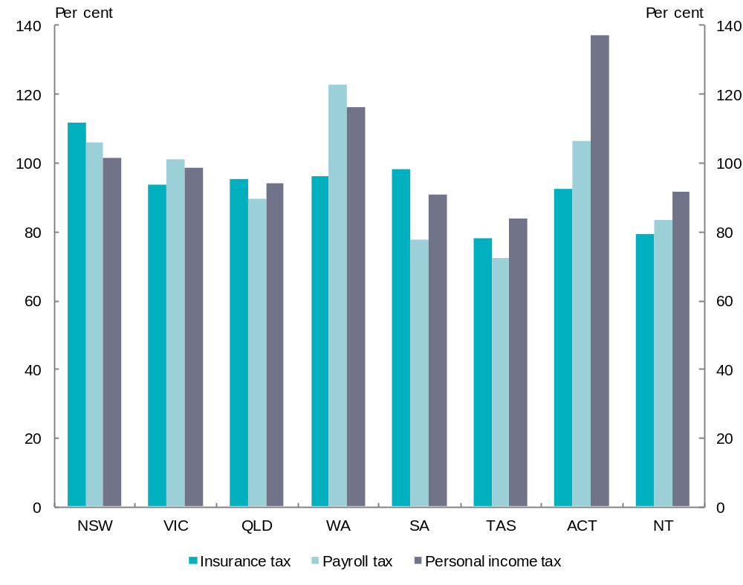
Note: Insurance tax and payroll tax revenue raising capacity ratios sourced the CGC’s 2012 Update Report and personal income tax revenue raising capacity ratios derived from ATO data.
Source: Secretariat calculations.

The benefits of an agreement on State tax reform
Of the States that raised State tax reform in submissions, all agree that the ideal way to achieve reform is through a multilateral negotiation or discussion that includes the Commonwealth. Many States also identify the approach taken in implementing the A New Tax System (ANTS) reforms as a model for future State tax reform.
For example, the Northern Territory says:
The cooperative and multilateral approach taken to reform of state taxes as part of the introduction of the GST should act as blueprint for future reforms.
AFTS recommendation 119 also urged the use of intergovernmental agreements between the Commonwealth and State Governments to coordinate State tax reform by providing the States with revenue stability and facilitating good policy outcomes.
Any effective intergovernmental agreement on State tax reform would identify what taxes would be abolished, amended, or reformed, the timeline for achieving the reforms, and the means to address any GST share effects — if they are considered important. While State tax reform does not strictly require Commonwealth involvement, the Panel would encourage the Commonwealth to be actively engaged in any proposed reforms as State tax reform will be important in positioning the federation to respond to future challenges. The Commonwealth’s role could be as a neutral facilitator in deliberations among States on the direction and pace of reform.

Addressing GST share effects arising from State tax reform
As demonstrated above, State tax reform will have GST share effects — some States will gain GST share and others lose GST share solely due to tax reform. If States are concerned about them, the GST share effects of any reform will need to be addressed.
There are a variety of ways the GST share effects of tax reform could be minimised, neutralised, or compensated for.

Minimising GST share effects
The Panel’s first interim report canvassed a number of ways in which the current system could be modified to break the nexus between the precise mix of taxes adopted by States and GST shares. These approaches include:
- ‘Equalising’ to a minimum (or lower than average) standard
  - Equalising to the standard of the State with the lowest level of taxes would reduce the impact of tax switches on State GST shares because it would reduce the size of the GST transfer for any given tax mix. However, if applied as a general rule, it would give States that have a high capacity a strong incentive to significantly reduce their tax rates.
- ‘Equalising’ to an external standard
  - Instead of focussing exclusively on ‘what States collectively do’ and the circumstances in which they operate, the standard of tax and expenditure policy could be determined with reference to an external standard of what States should do and the circumstances they should operate in.
- Broader indicators
  - The Panel is attracted to the use of broader indicators as they could offer significant simplification and may equalise to a similar extent as at present. However, the Panel has not yet identified appropriate indicators, and seeks further State advice.

Compensating for GST share effects
The Panel notes how the impacts of substantial reforms have been dealt with in the past, such as in ANTS and the National Competition Policy (NCP) reforms.
Under ANTS, where GST was introduced and some State taxes abolished, States were given a guarantee that:
…[T]he budgetary position of each individual State and Territory will be no worse off than it would have been had the reforms … not been implemented.
The NCP process in the mid-1990s to the mid-2000s made use of the fiscal benefits of reform. In its review of the NCP the Productivity Commission noted:
An important feature of the institutional framework has been the financial incentives — so called competition payments — made by the Australian Government to the States and Territories to ‘return’ the fiscal dividend from their implementation of agreed reform commitments.
Victoria points out that a fiscal benefit is likely to accompany any significant tax reform in the future, saying:
The last major national tax reform, the GST … led to increases in Commonwealth tax revenues such as personal income tax and company tax [.] …. This is likely to occur again if significant national tax reform is undertaken.
If either of these approaches were adopted, States with a negative GST share effect would receive a payment from the Commonwealth to compensate them.
As long as the reform process led to quantifiable fiscal benefits for the Commonwealth, these approaches would not breach the Commonwealth’s injunction that it will not fund State tax reform.

Neutralising GST share effects
If all States agreed that tax reforms would facilitate a desirable national change, GST share effects could be neutralised, at least on a transitional basis. Neutralising would reallocate GST payments between States to ensure tax reform did not result in any State having a GST share effect, negative or positive.

Addressing the GST share effects of a mining tax agreement
The options for minimising, neutralising or compensating for GST share effects of State tax reforms are also available in the context of changes in State mineral royalties. As discussed in Chapter 4, the Panel’s view is that the Commonwealth and States should seek to reach agreement on how to allocate the components of the mining tax and royalty revenue between them. The Panel has identified some options that the Commonwealth and States could pursue to reach an agreement on resource charging arrangements. Because all States ultimately share in royalty revenues through the equalisation process, they all have a stake in ensuring any agreement does not involve a shift in revenues from the States to the Commonwealth, and would require a guarantee they would be no worse off following any agreed policy change in this area.
This has implications for how any additional MRRT and PRRT revenue collected by the Commonwealth is returned to the States (see Chapter 4). One option would be for the Commonwealth to add to the GST pool the total amount the amount of royalty revenue foregone by the States. This would ensure that collectively the States’ budget positions were maintained. However, by essentially ‘fast-tracking’ the equalisation of some mining revenue, this would produce a different outcome relative to the current system, and options for minimising, neutralising or compensating for these GST share effects might need to be considered.
To avoid the need for action to address GST share effects of a mining tax agreement, the replacement revenue stream from the Commonwealth could be provided to States in proportion to the amount of royalty revenue each State would forego as part of any agreement. This would ensure that each State’s budget position would not be made worse off. To achieve this, the CGC would have to be instructed to include this revenue in its mining assessment.
While, ultimately, the States and Commonwealth will need to determine whether and how to deal with any GST share effects that arise from State tax reform, the Panel notes that GST share effects can be addressed in a variety of sensible ways.
The Panel’s view on promoting State tax reform
The Panel considers the optimal way to pursue State tax reform is on a multilateral basis — amongst the States and including the Commonwealth — to maximise the benefits of reforms. This multilateral, cooperative approach would allow any GST share effects to be identified and appropriately dealt with.
The Panel notes the work underway on State tax reform and encourages the Commonwealth to assist States in their deliberations.

Are incentives for reform necessary?
While, in an atmosphere of cooperation, incentives for reform might be thought unnecessary, the Panel has examined possible ways to ensure that everything goes according to plan. Past attempts at reform have not always come easily and day-to-day politics can derail any difficult task. Implementing reform may take a number of years, during which governments, local circumstances and anticipated GST share effects may change. Indeed, the ANTS agreement (referred to above) was differentially executed by jurisdictions and the original plan was not fully implemented after more than a decade.
It might therefore be beneficial to reinforce any initial agreement with incentives and disincentives, to ensure it is followed through. In the absence of any other obvious sources of funds, it seems sensible that the GST distribution could be made to support, rather than detract from, the agreed direction.
As a result, the paragraphs below consider how the GST distribution could be used to provide incentives for States to implement agreed tax reforms. In particular, they address the issues raised in the supplementary Terms of Reference that asks the Panel to make recommendations on possible changes to the form of equalisation:
[To] utilise HFE to provide incentives and disincentives to promote future State policy decisions which improve the efficiency of State taxes and mineral royalties.

State views on using the GST distribution to support State policy decisions
The Supplementary Issues Paper relating to the additional Terms of Reference posed the question as to how the GST distribution could be designed in order to provide incentives and disincentives for certain State policy decisions. No State agrees that the GST distribution should be actively used to provide incentives or disincentives for State policy decisions. Reasons given for saying HFE should not be used to promote reform include that it would undermine equalisation objectives, State autonomy and policy neutrality. States also say that such a path would contradict the untied nature of GST payments, reduce transparency, complicate HFE and increase uncertainty.
For example, New South Wales says:
Linking the GST distribution process to state policy implementation introduces risks that, by making it more complex, less transparent and more uncertain in its outcome, would reduce confidence in the financial relationships within the Australian federation.
South Australia says:
Loading the equalisation system with multiple objectives would significantly undermine its ability to achieve any of those objectives fully or satisfactorily.
Western Australia does not agree with using the GST distribution process to create incentives or penalties, but says:
… if such actions were to be contemplated, they should be recommended by fully independent bodies and limited to where there are no other signals or mechanisms for government to improve policy.
Queensland says:
…better mechanisms to drive policy change already exist. The Queensland and New South Wales Treasurers are already driving a process of state tax reform … [and the] Intergovernmental Agreement … already provides a mechanism to drive and manage reform.
The Northern Territory rejects the notion that part of the GST pool could be used to provide a reward. It says:
The notion that part of the GST pool could be quarantined for distribution on a rewards basis is inconsistent with the untied nature of GST revenue as agreed under the IGA. The proposal to provide financial incentives or disincentives undermines states’ autonomy, and would reduce state governments’ abilities to tailor tax policies according to the needs of state constituents and prevailing economic conditions of the state. The Territory is therefore strongly opposed to any change in the form of HFE that would provide incentives or disincentives for certain state policy decisions.
The Panel notes that the concerns expressed by States about using the GST distribution to promote reform appear to relate to a unilateral or imposed use of GST shares to force an external view of reform upon them. The Panel agrees that, if this was in contemplation, most of the States’ concerns would be entirely valid. However, in an environment where the reform direction has been agreed between the Commonwealth and States, using the GST distribution to encourage States to pursue the chosen reform direction must surely be a benefit. Further, given the tendency for tax reform to have staged implementation over a number of years, incentives may prove valuable.
As most States have not proposed any specific measures that could be used for this purpose, to respond properly to its Terms of Reference, the Panel has considered the issue independently. This process has identified a number of ways the GST distribution could be used to encourage States to implement agreed tax reform.
No doubt the Panel’s preliminary analysis and views can be further developed with full input from the States.

Providing incentives for State tax reform

Factors that shape the range of possibilities
The range of measures to encourage States to implement agreed tax reform canvassed below has been shaped by a number of factors.
- The Terms of Reference for this Review specify that the GST will be distributed as untied payments. This prevents any restrictions being placed on how States use their GST payments. Therefore, no such options have been considered.
  - However, the Panel does not consider that making some GST payments ‘conditional’ on certain actions, such as achieving an agreed reform milestone, would be equivalent to tying GST payments. These approaches have therefore been examined.
- The Terms of Reference specify that GST will be distributed on the basis of equalising payments. This means that the GST will continue to be the source of funds to equalise State fiscal capacities.
  - However, in the Panel’s view, this requirement does not rule out including other goals alongside HFE in the GST distribution, for example, facilitating tax reform.
- The Terms of Reference specify that State tax reform will not be financed by the Commonwealth Government. This allows the GST, a Commonwealth tax passed on in full to the States, to be used to facilitate State tax reform. In that vein, the Panel has accepted that other Commonwealth revenue intended for the States, for example, payments for specific purposes (PSPs), could be used to facilitate State tax reform, provided the net budget position of the Commonwealth is not affected.
- The Commonwealth Treasurer has said that the GST rate and base will not change. Therefore, the Panel has not considered options that would require a change in the GST rate or base to generate additional funds to facilitate State tax reform.

Overview of incentives for States to follow through on agreed reforms
Figure 5.2 shows the types of measures that could be used to encourage States to follow through on reform. The incentives have been categorised into two broad groups — those that utilise the GST distribution process directly and those that do not. Incentives that utilise the GST distribution process would be ‘funded’ entirely from the GST. Incentives outside the GST distribution process would be ‘funded’ by using other Commonwealth revenue that is typically allocated to the States in the form of PSPs, or the fiscal benefits of tax reform, provided there is no negative impact on the Commonwealth.
Figure 5.2: Overview of incentives for States to pursue tax reform
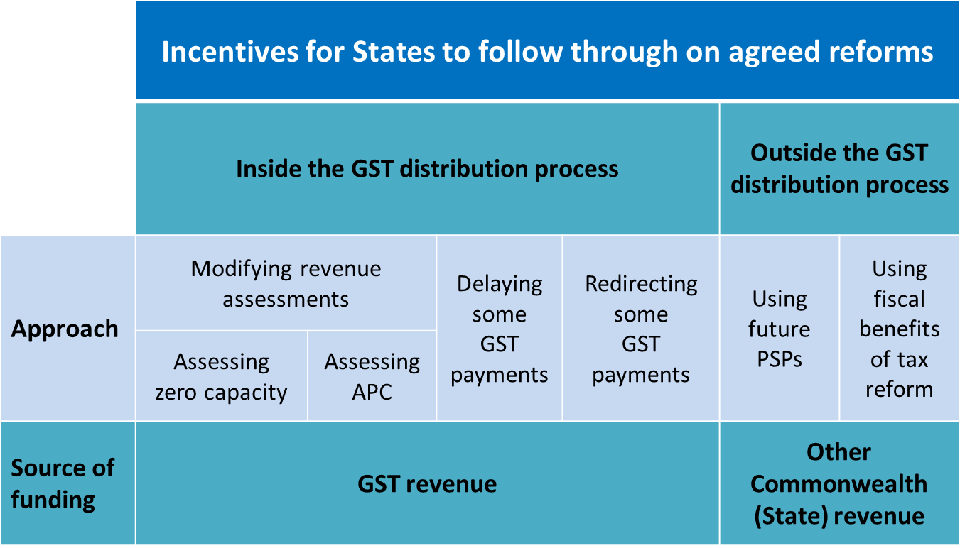
The mechanisms behind each of these incentives are explained briefly below. All proceed from the premise that the direction and timetable for reform has been agreed between States and the Commonwealth, but that encouragement to remain committed to the plan is required over time.

Modifying the existing revenue assessments
Incentives could be created by modifying the existing revenue assessments. The methods used to measure assessed revenue could be altered to reward States that undertake agreed reforms and penalise States that are slower to act. There are two basic methods that could be used:
- Assessing the revenue raising capacity of a State that abolishes an agreed tax as if it had no capacity to raise revenue from that tax.
- Assessing a State’s revenue raising capacity for tax to be abolished on the basis that what they actually raise from that tax represents their capacity. This is referred to by the CGC as an actual per capita (APC) assessment.
Both methods are similar in that States that abolish the agreed tax would be assessed as having no capacity to raise revenue from the tax. The difference is in how the assessed revenue of States that retain the tax would be measured. (This influences the size of penalties for departing from the agreed plan, but not rewards.) If the APC method of assessment is used, the more a State relies on the tax that is to be abolished, the more they are penalised. Where States have agreed to reduce an existing tax the size of the incentives created using these alternative methods could be scaled to provide appropriate rewards.
These methods differ from the usual CGC revenue assessments that assess revenue until the average policy is not to levy the tax. The alternative methods could be used when it is no longer average policy to levy a tax, but they would only be used for a limited time as States transition to the new policy.
Using these alternative methods would increase the GST shares of States that abolish the agreed tax and reduce the GST shares of States that retain the tax. If only one or two States met the agreed timetable for reform, the rewards (and penalties) could be significant. The size of the rewards would be determined by which States, and how many States, abolish the agreed tax. If all but one State abolished the agreed tax, the State that retained the tax would receive a significant penalty.
Table 5.1 illustrates the penalties that would arise for each State, if it were the only State to retain insurance tax after the agreed abolition date.
Table 5.1: Illustrative penalty for a State retaining insurance tax
 | NSW | VIC | QLD | WA | SA | TAS | ACT | NT | TOTAL
Insurance tax revenue | 918 | 912 | 546 | 468 | 371 | 49 | 45 | 33 | 3,342
Penalty for retaining the tax
$ million | -621 | -685 | -436 | -419 | -344 | -48 | -44 | -32 | na
$ pc | -86 | -123 | -96 | -181 | -209 | -95 | -123 | -141 | na
Source: Secretariat calculation showing a one year GST effect using 2010-11 data and ignoring second round effects including the removal of the current insurance assessment. Assuming the penalty would only be required for one year, the amount would be diluted through the three year average process.

Delaying some GST payments
Another way States could be encouraged to stick to the agreed timetable would be for the Commonwealth to delay the payment of a small portion of GST until agreed milestones are met. GST payments would be calculated in the usual way, but some portion of the payment would be delayed if States did not act as they had agreed to.
Delaying some GST would provide an incentive for States to act, through the threat of a temporary penalty. The size of the delayed payment could be tailored to reflect the nature of the agreed reform. For example, a percentage of a State’s population share of the GST pool could be delayed, or it could be a percentage of a State’s GST payment. While some GST payment would be contingent on States reaching agreed milestones, funds would continue to be untied — there would be no conditions attached to the expenditure of the payment once it is made.

Redirecting some GST into a reward pool
Another approach is for a portion of GST revenue, or a portion of the annual growth in GST revenue, to be set aside to reward States that implement tax reform on the agreed schedule. The GST set aside would be shared amongst the States that implement reforms. If everyone acted as agreed, there would be no effect. However, if any jurisdiction failed to act, they would not be entitled to share in the pool. To be effective, the reward payments would be quarantined from the equalisation process, so that States retain the full benefit of the reward.

Using anticipated future Commonwealth payments
As noted in Chapter 5 of the first interim report, PSPs — that is, Commonwealth funding other than general revenue assistance — totalled $51.6 billion in 2010-11. Assuming this is to continue, at least to some degree, a small fraction of this revenue could be made contingent upon, or be used to fund reward payments for, tax reform. As with the previous option, to be effective the reward payments would have to be quarantined.

Sharing the fiscal benefits States for tax reform
The fiscal benefits of State tax reform could be used to reward States for tax reform. This was the approach adopted when NCP reforms were implemented in the mid-1990s to the mid-2000s. To the extent that significant State tax reform and reform of State mineral royalties could lead to increases in Commonwealth tax revenues, the additional revenue could be used to provide rewards for States that undertake reform without affecting the Commonwealth budget.
The Panel’s view on providing incentives for State tax reform
When the States and the Commonwealth have agreed on the desired specifications and pace of reform, it may be necessary to provide incentives to ensure that the agreement is acted upon by all parties. There are various ways that the GST distribution or related mechanisms can be used to facilitate this process.
Measures that could be adopted include modifying the current revenue assessments, delaying GST payments until milestones are met, or using a small part of the GST or other Commonwealth funds intended for the States to make reward payments.
To the extent that reform results in tangible fiscal benefits these should be shared.

Drawing the ideas together
This Chapter draws together the key thoughts and ideas in this report, with a view to helping guide the next round of submissions.
While the Panel has indicated its initial views on many issues, as with the first interim report, these views do not represent a final position. Most options are still being actively weighed and considered and the Panel welcomes submissions from any interested persons on the matters contained in the Panel’s two interim reports. The Panel is particularly interested in States’ views on all issues.

Context of the Panel’s report
The Panel has been asked to consider possible changes to the form of equalisation to:
- ensure that HFE does not provide a disincentive to State tax reform
- provide incentives and disincentives to promote future State policy decisions which improve the efficiency of State taxes and mineral royalties
- examine the incentives for States to reduce MRRT or PRRT revenue through increasing State mineral royalties.
The Panel has examined these questions in the light of its broader review of the GST distribution process which considers whether current arrangements for distributing the GST will ensure that Australia is best placed to respond to future challenges.
These challenges include the rise of China and India, deterioration in global economic growth and demographic change.
- The rise of China and India and the associated mining boom are bringing about profound structural changes to the Australian economy. These changes will — as noted in the first interim report — continue to have very different impacts on States, leading to an increase in the degree of divergence in State fiscal capacities.
- The ageing population and projected lower GST growth will both continue to place a strain on State government budgets.
The Panel believes that State tax reform will play a key role in helping Australia face these challenges. However, the Panel is equally convinced that meaningful reform in this area will only be possible if States work together and are supported in their endeavours by the Commonwealth.
The key questions for the Panel are whether the GST distribution system could be an impediment to such reform, what changes could be made to avoid it being an impediment, and how it might be used to actively support reform efforts.

State taxes and the distribution of GST
Chapter 1 of this report has briefly touched on the theory and history of taxation to explain ‘how we got where we are’. There are several observations that emerge from this examination of history:
- The first is that the revenue raising powers and spending obligations of the State and national levels of government are unevenly distributed, making the collective entity interdependent in many ways.
- Secondly, the taxes that we have at both levels of government were not designed at one time as the ‘ideal’ set — they have grown up over time and morphed in response to various economic and political pressures, with the result that the combined product is probably less efficient and certainly less coherent than it could be.
- Thirdly, in the not too distant future, something will need to be done about the design and composition of State taxes (and probably the Commonwealth’s too) to ensure that the Federation can continue to grow and develop as changing circumstances take hold.
Chapter 2 examines how the current HFE system treats State revenues, how the Commonwealth Grants Commission (CGC) determines ‘average policy’ and why some State revenues are not separately assessed. A question to be considered by the Panel in its final report is whether bringing States to the same revenue raising capacity if they apply the ‘average’ policy is the right answer.
Chapter 3 looks at the effect on GST shares of tax changes in the current HFE system in order to determine whether it provides a disincentive to State tax reform. The Chapter examines the GST effects of both unilateral and multilateral tax reform.
The Panel has concluded that any alteration to the tax mix or to tax design is likely to produce changes in GST shares, and that major multilateral reforms are almost certain to produce significant changes in GST shares. In this sense, any tax reform is therefore likely to result in some GST share ‘winners’ and some ‘losers’ — but whether these GST share effects actually influence State tax decisions is less clear.
While doubting that GST share effects are the deciding factor in State decisions on tax reform, the Panel has concluded there is value in exploring alternatives that would allow any potential disincentives from the current system to be eliminated or minimised.

Royalties and the Commonwealth’s resource tax reforms
Chapter 4 outlines how Australia has charged for its non-renewable resources in the past and re-examines the findings of the AFTS review. The Chapter considers the Commonwealth’s recent reforms in this area, how they will interact with existing State royalties and the incentives that these interactions produce.
The Panel concludes that the Commonwealth’s decision to fully credit State royalties under the MRRT and PRRT has created a new incentive for States to increase royalties, in that they can potentially increase their revenue without affecting investment within their State. This situation is ultimately unsustainable. Rather than taking sides and assigning blame, the Panel sees merit in both the States’ and the Commonwealth’s positions. In other words, while it would be unreasonable to expect the States to completely relinquish discretion over royalty policy without some strong incentive, it is equally unrealistic to expect the Commonwealth to allow States to capture the revenue stream generated by the Commonwealth’s undertaking of a significant reform. So the question becomes: what, if anything, can be done to improve the situation?
This report canvasses three broad approaches:
- The Commonwealth could act unilaterally to ‘penalise’ States that increase royalties.
- The Commonwealth could revisit the design of MRRT and PRRT.
- The Commonwealth and the States could reach an agreement on how to share the resource tax base.
The first two approaches are inherently problematic. The third approach (the States and Commonwealth reaching an agreement) is clearly the best way forward.
While reiterating that any such agreement is a matter for the governments concerned, the Panel has shown, at a high level, some possible forms that such an agreement might take. Again, three broad approaches are considered:
- The removal of State royalties on MRRT and PRRT commodities, in return for replacement payments from the Commonwealth.
- A reduction in royalties on MRRT and PRRT commodities, in return for replacement payments from the Commonwealth.
- An undertaking by the States not to further increase royalties on MRRT and PRRT commodities beyond those applying at a particular time, in return for possible Commonwealth commitments on future funding.
While there are pros and cons of all three approaches, the second approach offers the most potential. This type of agreed ‘hybrid’ structure could offer the best of both worlds — providing the benefits of both the value-based and profits-based approaches. The standard royalty component would represent a charge for the right to mine the commodity, and the variable component (MRRT, PRRT) would depend upon and reflect the profitability of the particular mining project.
The Panel concludes that an agreement on resource taxation between the Commonwealth and the States offers the potential to build upon the benefits of the resource tax reforms in a manner that could benefit all parties.

HFE and State tax reform
In Chapter 5 the Panel highlights the importance of State reform as a means of advancing the Commonwealth and State economies. This conclusion naturally leads to the subsequent question of ‘what constitutes tax reform?’ While it is not this Panel’s role to make findings in that regard, it notes the work done by AFTS, the National Tax Forum and various State tax reviews. A case study illustrates how any changes to the State tax mix will inevitably have some effect on State GST shares. The existence of these effects means that there is the potential (however slight) for the budget impacts of the GST distribution system to be an impediment to tax reform.
The Panel considers the best way to pursue State tax reform is on a multilateral, cooperative basis — where both the outcomes and pace of reform are agreed by all parties. This would allow the (inevitable) GST share effects to be identified and dealt with, and may also allow for the inclusion of additional incentives for compliance (if required). Chapter 5 canvasses a range of potential incentives that could be helpful, including some within the GST distribution process (for example, modifying the existing revenue assessments) and some outside of it (for example, sharing the fiscal benefits of tax reform).

Concluding remarks
Meaningful tax reform — both of State taxes and the resource-charging system — will place Australia in a better position to deal with future challenges.
Vertical fiscal imbalance is a fact of our Federation, and is likely to become more acute in the future. An uncertain global outlook, an ageing population and structural change will place a strain on State budgets, and thus make substantial reform of State taxes increasingly important — not just for the help it can give to States trying to fund community services, but also for the benefits it will bring to the national economy.
These same challenges equally make it critical that Australia’s system of charging for its natural resources is both appropriate and sustainable. Reform options exist that could ensure Australian governments (and Australian citizens) get the ‘best of both worlds’ — a stable, minimum payment for the right to mine a commodity, and an additional revenue stream in times of high profitability.
The Panel’s view on the direction of future work
The Panel recognises that reforms to State taxes and improvements to the way the nation charges for and taxes its resources will involve consideration of a wide range of significant and complex issues, many beyond the scope of this Review.
Whatever decisions governments make regarding what reform is required and when, the Panel firmly believes that the best chance of genuine reform lies in a cooperative national approach, involving the agreement of all States and the participation of the Commonwealth. This is the case both for State tax reform and changes to the resource-charging system.
While virtually any reforms will have an effect on the GST distribution, if changes are made as part of agreed multilateral reform, these effects can be identified and dealt with. Indeed, it may even be the case that the GST distribution system can be used to help facilitate reform.
The Panel hopes that the proposals outlined in this report make a valuable contribution to the broader discussion of long-term tax reform, and entreats States to engage with each other and the Panel on these matters. In particular, the Panel seeks the States’ views on:
- the three broad approaches towards a possible agreement between States and the Commonwealth on resource-charging, outlined in section 4.7
- the proposals to minimise GST share effects of, or create positive incentives for, tax reform outlined in Chapter 5.

Appendix A: Terms of Reference
Issued on 30 March 2011 and additional terms (6A and 6B) issued on 17 November 2011. The additional terms (6A and 6B) are also referred to as the Supplementary Terms of Reference (in text box below).

Objectives and scope
1. Australia is facing a number of long-term trends that are driving pronounced and challenging structural change in the economy, including:
- the rise of China and India, and continuing globalisation;
- the challenge of mitigating and adapting to climate change;
- population growth and demographic change; and
- the continuing effects of innovation and technological change.
2. In addition, Australia has ongoing challenges in tackling the entrenched disadvantage of many Australians, especially Indigenous Australians.
3. These trends and challenges are likely to have differing impacts on the ability of States and Territories (the States) to deliver broadly equivalent levels of services and infrastructure to their residents, in ways that maximise sustainable growth and improvements in quality of life for all Australians.
4. In this context, the Review will consider whether the distribution of the GST and the current form of horizontal fiscal equalisation will ensure that Australia is best placed to respond to these challenges and public confidence in the financial relationships within the Australian Federation is maintained.
5. In considering any possible changes to the form of equalisation, the Review will have regard to the following:
- efficiency, including the effect of alternate approaches on the allocation of resources in the national economy and on the States’ reform, service delivery and investment decisions to best meet the requirements for growth;
- equity, including the extent to which alternate approaches would affect States’ fiscal capacities to provide for Australians’ access to government services, regardless of where they reside;
- simplicity, including the extent to which alternate approaches would provide for reduced complexity and increased transparency; and
- predictability and stability in the determination of States’ GST shares so as to better support long term decision making and reform by Governments.
6. The Review will be guided by the following:
- that the long-standing practice of equalisation between the States has served Australia well;
- that the GST will continue to be distributed to the States on the basis of equalising payments to the States, consistent with the principle that jurisdictions should have equal capacity to provide infrastructure and services to their citizens;
- as per the current arrangements, all the GST revenue will be distributed to the States as ‘untied’ payments;
- that the Commonwealth Grants Commission (CGC) will continue to make recommendations on the distribution of the GST; and
- it is not intended that the Review will consider detailed methodological and data issues, however, the Review will seek the assistance and advice of the Commonwealth Grants Commission on technical matters as required.
6A. The Review should examine and make recommendations on possible changes to the form of equalisation to achieve the following objectives:
- ensure that HFE does not provide a disincentive to State tax reform,
- utilise HFE to provide incentives and disincentives to promote future State policy decisions which improve the efficiency of State taxes and mineral royalties, and
- examine the incentives for States to reduce Minerals Resource Rent Tax or Petroleum Resource Rent Tax revenue through increasing State mineral royalties.
6B. In considering this issue, the Review will be guided by the following:
- the findings of the Australia’s Future Tax System Review relating to existing State taxes and mineral royalties,
- the Minerals Resource Rent Tax and Petroleum Resource Rent Tax provide a more efficient approach to charging for Australia’s non-renewable resources than mineral royalties, and
- State tax reform will not be financed by the Australian Government.

Composition and consultation
7. The Review would be undertaken by two or three eminent people.
8. The Treasurer will bring the final report to the Council of Australian Governments (COAG) for consideration before a final decision is made on new arrangements by the end of 2013.
9. The Review will be supported by a Secretariat in the Commonwealth Treasury. It is expected that the Review will second a number of staff with particular expertise, including officials from State Treasuries and the CGC. A Heads of Treasuries Advisory Committee, consisting of all States, will provide advice to the Review.
10. The Review will consult the public and State Governments and seek written submissions.

Timing
11. The Review is to provide an interim report to the Treasurer by March 2012 and a final report by August/September 2012.
12. The GST shares will be distributed in 2011-12 and 2012-13 based on the current arrangements.

Appendix B: Key developments in taxation
Year | Detail
1805 | First import duties and charges levied in the colony of New South Wales to build a gaol and orphanage in Sydney.
1819 | UK legislation provides retrospectively for the Governor to levy existing duties and to levy equivalent excise on production of spirits within the colony up to 10 shillings a gallon.
1823 | With the end of military government UK government gives the Governor (advised by Council) the power to tax, constrained by requirement of local purposes only.
1825 | Proclamation dated 4 February 1825 levied duties on spirits and tobacco and ad valorem tariff of 5 per cent on foreign goods.
1851 | New South Wales first introduces death duties. New South Wales levies probate and administration fees on the value of personal estate.
1852 and 1853 | Introduction of gold licence fee in New South Wales and Victoria.
1877 | Land tax first imposed (in Victoria) to break up large holdings.
1880 | First income tax introduced with Tasmania’s withholding tax on dividends, annuities and rents. By 1907 all States had introduced income tax.
1884 | First general income tax and land tax based on unimproved value introduced in South Australia.
1894 | Tasmania introduces general income tax.
1895 | Victoria introduces on all income derived by a person and on the revenue of companies.
1901 | Commonwealth of Australia established with Constitution giving the Commonwealth concurrent power with the States to levy taxes (section 51 (ii)) and exclusive power to impose duties of customs and excise (section 90). Uniform national tariff introduced (section 88).
1902 | Queensland introduces general income tax.
1910 | Commonwealth introduces land tax on unimproved values. Land Tax Office (predecessor of the Australian Taxation Office) established in November within The Treasury to administer the tax.
1915 | Commonwealth introduces income tax.
1936 | Unified Commonwealth and State income tax return introduced following recommendation of Ferguson Royal Commission (1932-34).
1941 | Payroll tax introduced to pay for child endowment.
1942 | Committee on Uniform Taxation (chair Richard C. Mills) recommends that the Commonwealth become the sole income taxing authority for the duration of the war.  System of uniform tax introduced by which grants to the States from the Commonwealth replaced state revenue from income tax and state income taxes no longer collected.
1952 | Commonwealth land tax abolished in favour of States.
1971 | Commonwealth passes payroll tax to States after they request access to income tax.
1973 | States start to introduce business franchise fees.
1977 | Queensland abolishes death and gift (estate) duties. Act takes effect from 1 January 1977. Other States follow.  Through a series of amendments from 1976-1980 to the Stamp Duties Act 1920, New South Wales abolishes death duties. The first amendment is the Stamp Duties (Amendment) Act 1975, no. 75 and the last is the Stamp Duties (Further Amendment) Act 1980, no. 161. Abolition takes effect on or after 31/12/1981.  Victoria abolishes death duties.
1979 | Commonwealth abolishes death and gift duties to take effect from 1 July 1979.  Tasmania abolishes death duties. Act is gradually applied during 1979 and 1980.  Western Australia abolishes death duties.
1980 | South Australia abolishes death and gift duties (to take effect from 1 January 1980).
1982 | Financial Institutions Duty begins to be introduced in all States except for Queensland.
1997 | The constitutional validity of business franchise fees on tobacco was challenged through the High Court. The High Court’s decision effectively declared all State business franchise fees to be constitutionally invalid. As a stop gap measure, the Commonwealth agreed to impose its own tax on petrol, alcohol and tobacco, with the proceeds (known as Revenue Replacement Payments) paid back to the States.
1999 | The Australian Government and the States sign the Intergovernmental Agreement on the Reform of Commonwealth-State Financial Relations. The essence of the agreement is that the States will receive all the revenue from the goods and services tax which will replace Financial Assistance Grants, Revenue Replacement Payments and a number of financial transaction taxes.
2000 | A 10 per cent goods and services tax was introduced replacing various taxes such as sales tax. About 30 related Acts also passed (nos 56-86 of 1999). Most Acts commenced on 1 July 2000.
2000 | Abolition of accommodation taxes in New South Wales and the Northern Territory on 1 July 2000.
2001 | Abolition of Financial Institutions Duty and Quoted Marketable Securities Duty in all States on 1 July 2001.
2005 | Debits tax abolished on 1 July 2005 (some States had abolished debits tax before this date). The States also begin/continue to undertake the abolition of other financial transaction taxes listed for review in the Intergovernmental Agreement, including cheque duty, non-quoted marketable securities duty, lease duty, rental duty and mortgage duty.
2008 | The Australian Government and the States sign the Intergovernmental Agreement on Federal Financial Relations.
2010 | Release of the final report of the Australia’s Future Tax System Review.
2012 | The Commonwealth’s Minerals Resource Rent Tax will commence from 1 July 2012.

Appendix C: The AFTS findings regarding State taxes and mineral royalties
The Review’s Terms of Reference call for the Panel to be guided by the findings of the Australia’s Future Tax System review (AFTS review) relating to existing State taxes and mineral royalties. Selected key findings and recommendations of the AFTS review in relation to State tax reform and charging for non-renewable resources are reproduced below.
Principle: The assignment of tax responsibility in a federation should take into account the revenue needs of each level of government. Each level of government should have access to tax revenue it can use to finance significant marginal expenditure decisions.
Principle: To the extent that there is a choice about the assignment of taxes in the federation, the Australian government should have control of taxes with more mobile tax bases and taxes used for redistribution and macroeconomic stabilisation. The States should have control of taxes on more immobile bases.
Principle: Tax base sharing or centrally administered State taxes can provide the States with the capacity to raise revenue sustainably and with some autonomy.
Principle: The assignment of tax responsibility should take into account how different arrangements affect the complexity of the tax system and its capacity to respond to changing circumstances.
Principle: To ensure that governments face a hard budget constraint, any intergovernmental grants should be transparent and not easily subject to discretionary changes.
Finding: Many of the current State taxes are inherently of poor quality while other State taxes need to be reformed. Increasing the rates of tax on existing State taxes would not be a sustainable way of funding services in the future.
Finding: If the States required additional fiscal autonomy, they could raise revenue from sharing the personal income tax base. This could be done by the States levying a flat rate surcharge on income tax payable to the Australian government or a flat rate of tax on income above the tax-free threshold. The Australian government would need to reduce its rates of personal income tax and the States would receive lower revenue from grants or an existing revenue sharing arrangement. Any tax base sharing arrangement would need to be designed so that it was consistent with national objectives for redistribution and workforce participation and avoiding additional complexity.
Recommendation 119: Reforms to State taxes should be coordinated through intergovernmental agreements between the Australian government and the States to provide the States with revenue stability and to facilitate good policy outcomes.
Findings of the Australia’s Future Tax System review regarding mineral royalties.
Principle: Concessions should not be provided to encourage exploration and production at a faster rate than the commercial rate or to encourage exploration in specific geographical areas.
Principle: For non-renewable resources that are expected to generate significant amounts of economic rent, a rent-based tax is the most suitable charging mechanism, as the potential economic efficiency and revenue gains are likely to outweigh the higher administration and compliance costs of this tax compared with output-based royalties and income-based taxes.
For non-renewable resources expected to generate low rent and where the administration and compliance costs are likely to outweigh the potential efficiency and revenue gains from a rent-based tax, output-based royalties may be an appropriate charging mechanism.
Finding: Australia’s current resource charging arrangements fail to collect an appropriate return for the community from allowing private firms to exploit non-renewable resources, mainly because these arrangements are unresponsive to changes in profits.
Finding: Australia’s current resource charging arrangements and the mechanisms for allocating exploration permits distort investment and production decisions, further lowering the community’s return from the exploitation of its non-renewable resources.
Recommendation 45: The current resource charging arrangements imposed on non-renewable resources by the [Commonwealth] and State governments should be replaced by a uniform resource rent tax imposed and administered by the [Commonwealth] government that:
- is levied at a rate of 40 per cent, with that rate adjusted to offset any future change in the company income tax rate from 25 per cent, to achieve a combined statutory tax rate of 55 per cent
- applies to non-renewable resource (oil, gas and minerals) projects, except for lower value minerals for which it can be expected to generate no net benefits. Excepted minerals could continue to be subject to existing arrangements if appropriate
- measures rents as net income less an allowance for corporate capital, with the allowance rate set at the long-term Australian government bond rate
- requires a rent calculation for projects
- allows losses to be carried forward with interest or transferred to other commonly owned projects, with the tax value of residual losses refunded when a project is closed
- is allowed as a deductible expense in the calculation of income tax, with loss refunds treated as assessable income.
Recommendation 46: The resource rent tax should not provide concessions to encourage exploration or production activity at a faster rate than the commercial rate or in particular geographical areas, and should not allow deductions above acquisition costs to stimulate investment.
Recommendation 47: Existing projects should be transferred into the proposed system with an adjustment, as appropriate, to the starting base for the allowance for corporate capital. The Australian government should set out a time-frame to implement the resource rent tax and provide guidance at the time of announcement on how existing investments and investment in the interim will be treated under the resource rent tax.
Recommendation 48: The Australian and State governments should negotiate an appropriate allocation of the revenues and risks from the resource rent tax.
Recommendation 49: The Australian and State governments should consider using a cash bidding system to allocate exploration permits. For small exploration areas, where there are unlikely to be net benefits from a cash bidding system, a first-come first-served system could be used.
Recommendation 50: The Australian and State governments should abolish fees and stamp duties on the transfer of interests in a resource project except those related to administrative costs.

Appendix D: Policy Transition Group’s recommendation on State royalties
To reflect the fact that State and Territory mining royalties will apply alongside the Minerals Resource Rent Tax (MRRT), the royalties entities pay on iron ore and coal are to be credited against the MRRT liability of a project.
The recognition of State and Territory royalties under the MRRT raises a number of important issues. Generally speaking, the current State and Territory royalties levied on coal and iron ore are set at rates that the industries can afford to pay, at least during normal times, and provide the States and Territories with a relatively stable revenue stream. On the other hand, royalty regimes are inherently less flexible during a downturn and can unnecessarily damage the industries and prevent optimal resource extraction. Further, by their nature the royalty regimes do not capture the economic rents during a boom period.
Through the implementation of the MRRT, Australia has the opportunity to substantially improve the overall outcome for the taxation of coal and iron ore in this country. It provides a way to meet the needs of the States and Territories and captures more of the profits at the peak of the resources cycle, in a way royalties alone cannot, for the benefit of all Australians.
Recognising this objective, as well as the importance of preserving Australia’s international competitiveness, the Policy Transition Group’s recommends that there be full crediting of all current and future State and Territory royalties under the MRRT so as to provide certainty about the overall tax impost on the coal and iron ore mining industries. Equally, the MRRT should not be used as a mechanism to enable States and Territories to increase inefficient royalties on MRRT taxable commodities. Accordingly, the PTG also recommends the [Commonwealth], State and Territory Governments put in place arrangements to ensure that State and Territory Governments do not have an incentive to increase royalties on coal and iron ore. This would limit their negative impacts, while allowing the [Commonwealth’s] taxation regime to maximise the return to the community during the highpoint of the resources cycle, so achieving the balanced outcome described above.
The PTG notes that some royalties are struck in agreements between State or Territory governments and mining companies and that some of those royalties can only be varied by mutual agreement. In those circumstances the mining company party to the agreement can, at the very least, significantly influence the royalty payable by it. Responsibility to maintain the integrity and competitiveness of the resource taxation regime is therefore a shared one between the [Commonwealth], State and Territory Governments and, importantly, the companies involved.

Appendix E: The effect of different royalty rates over 10 years of an MRRT project
Consider a new iron ore project which is established after the commencement of the Minerals Resource Rent Tax (MRRT). Assume that $600 million of (MRRT deductible) upfront expenditure is incurred before production commences. Once production commences, MRRT revenue each year is $500 million and annual MRRT expenditure is $100 million. For simplicity, assume also there is no starting base allowance attached to the project, and that no losses are transferred into or out of the project from other MRRT projects. The long term bond rate is taken to be 6 per cent per annum.
The charts below show how, for this project, royalty revenue and MRRT payable by the project vary over its first ten years for different royalty rates.
A decision by a State to increase the royalty rate faced by this project will:
- increase State royalty revenue each year
- delay the collection of MRRT revenue from the project and decrease the amount of MRRT payable once the project starts paying the tax
- not change the total resource charge faced by the project each year, once its MRRT liability has been fully phased-in
- not make the project any worse off over its life, if the appropriate discount rate is taken to be the long-term bond rate plus 7 per cent (13 per cent in this example).
Figure E1.1: Royalty rate = 2.5 per cent of MRRT revenue
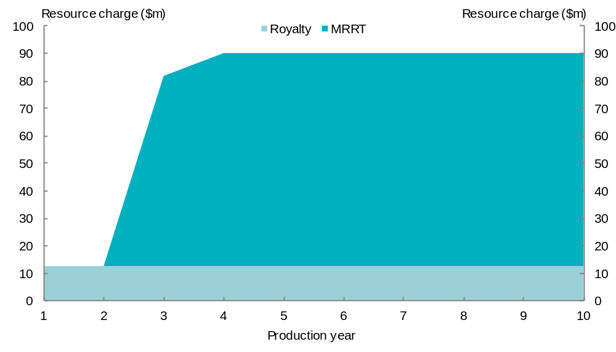

Figure E1.2: Royalty rate = 5 per cent of MRRT revenue
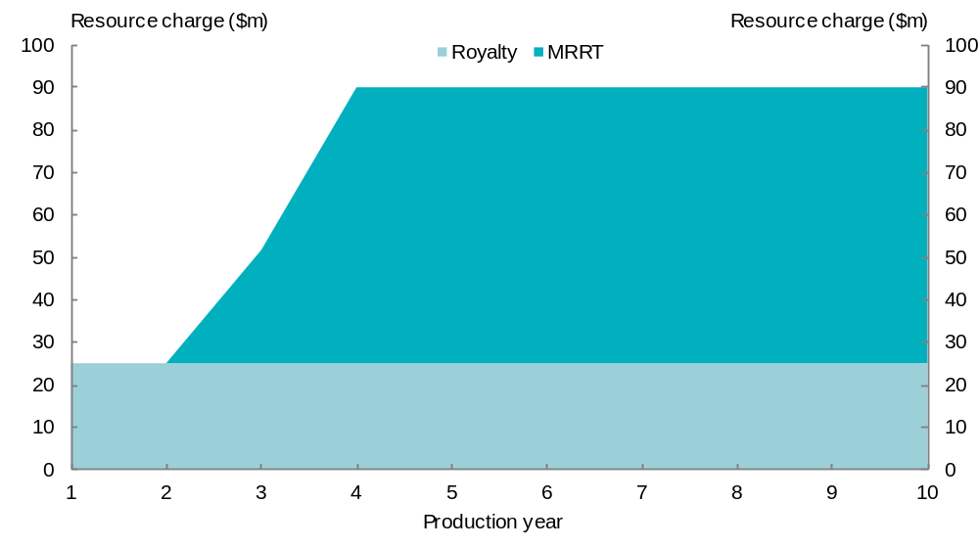
Figure E1.3: Royalty rate = 7.5 per cent of MRRT revenue
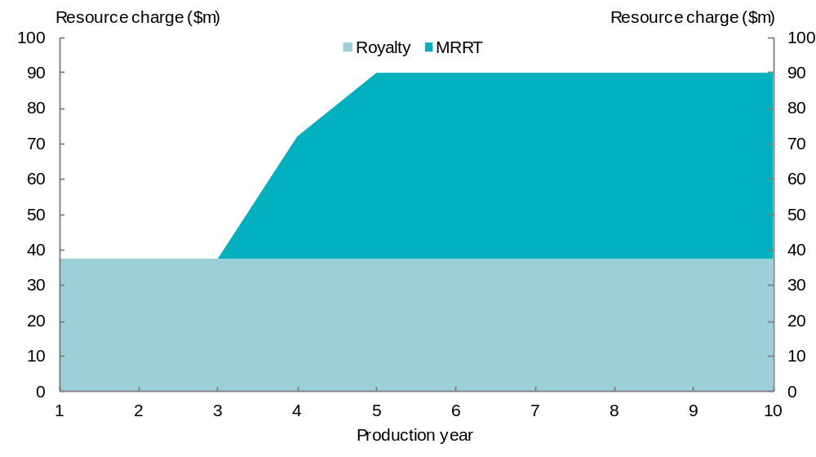
Figure E1.4: Royalty rate = 10 per cent of MRRT revenue
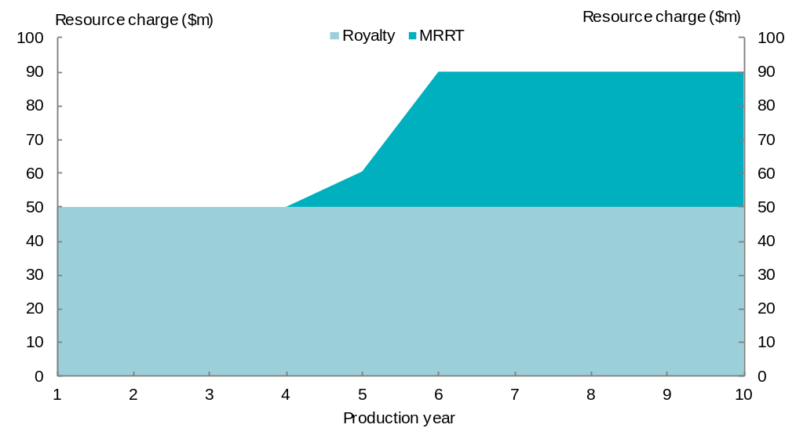

Appendix F: State royalties on MRRT and PRRT commodities

Table F1.1: Petroleum royalty rates
 | NSW | VIC | QLD | WA | SA | TAS | NT
Rate | 10.0% at the well head(a) | 10.0% at the well head | 10.0% at the well head | 10.0% or 12.5%(b), at the well head | 10.0% at the well head | 12.0% at the well head | 10.0% at the well head
Royalty system | AV | AV | AV | AV | AV | AV | AV
Source: Overview of State Taxes and Royalties, Western Australia, 2011–12, Western Australia Department of Treasury, December 2011, page 67.
- Nil for the first five years, increasing to 10 per cent at the end of the 10th year.
- Except for under the Barrow Island Royalty Variation Agreement Act 1985, which applies a royalty rate of forty per cent to resource rents calculated on a similar basis to the Petroleum Resource Rent Tax. The 10 per cent rate applies to the primary production licence. A rate of 12.5 per cent applies to secondary licences taken up.
Note: the Australian Capital Territory does not levy any royalties on petroleum. AV stands for ad valorem.

Table F1.2: Iron-ore royalty rates
 | NSW | VIC | QLD | WA | SA | TAS | NT
Rate | 4.0% of the ex-mine value (value less allowable deductions) | 2.75% of net market value of ore mined | $1.25 per tonne plus 2.5% of value above $100 per tonne | Beneficiated:  5.0%  Fines(c):  5.625%  Lump:  7.5% | 5.0% of net market value(a) | 1.6% on net sales plus profit up to maximum of 5.0% of net sales | 20.0% of net value of mine’s production value(b)
Royalty system | AV | AV | Mixed | AV | AV | Hybrid | Profit
Source: Overview of State Taxes and Royalties, Western Australia, 2011–12, Western Australia Department of Treasury, December 2011, page 67.
- New mines are eligible for a concessional rate of 2.0 per cent for the first five years.
- The first $50,000 of net value is exempt.
- Iron-ore fines rate will increase from 5.625 per cent to 6.5 per cent from 1 July 2012 and to 7.5 per cent from 1 July 2013.
Note: the Australian Capital Territory does not levy any royalties on iron-ore. AV stands for ad valorem.

Table F1.3: Coal royalty rates
 | NSW (a)(d) | VIC | QLD | WA | SA | TAS | NT
Rate | Deep underground:  6.2%  Underground:  7.2%  Open cut:  8.2% | Brown coal (lignite):  $0.0588 per GJ(b) adjusted by CPI  Other than brown coal:  2.75% | 7% where the value of the coal produced does not exceed $100/t. 10% on the value of the coal exceeding $100/t. | If exported: 7.5%  Otherwise  $1/t. (adjusted annually) | 5%(c) | 1.6% of net sales plus profit to a maximum total royalty of 5% of net sales. | 20.0% of net value of mine’s output
Royalty system | AV | Quantum rate for brown coal otherwise ad valorem | AV | AV for export coal, otherwise quantum rate | AV | Hybrid | Profit
Sources: New South Wales Department of Primary Industries website, http://www.dpi.nsw.gov.au/minerals/resources/royalty/royalty-rates, accessed May 2012.
Queensland Office of State Revenue website, http://www.osr.qld.gov.au/royalties/index.shtml, accessed May, 2012.
South Australian Legislation website, http://www.legislation.sa.gov.au/LZ/C/A/MINING%20ACT%201971/CURRENT/1971.109.UN.PDF, accessed 7 May 2012.
Western Australia: Mining Amendment Regulations (No. 4) 2000
Victoria: Mineral Resources Development (Amendment) Regulations 2006
Department of Resources, Energy and Tourism website, http://www.ret.gov.au/resources/Documents/resource_taxation/Royalty%20Regime%20Summary.pdf, accessed May 2012
- Royalty is also payable on coal in coal reject if the coal reject is used or disposed of for the purpose of producing energy. The rate of royalty on the coal in coal reject is no more than half the rate applicable to coal.
- Gigajoule (a measure of energy).
- New mines are eligible for a concessional rate of 2.0 per cent for the first five years. Existing mines paying the 1.5 per cent concessional rate are subject to this rate until the end of their five year term.
- The New South Wales Government has indicated that it will increase coal royalties payable by companies subject to the Minerals Resource Rent Tax (MRRT). Details of how this will be implemented, including the new rate, have not yet been announced.
Note: the Australian Capital Territory does not levy any royalties on coal. AV stands for ad valorem.

Glossary
Actual per Capita assessment method (APC)
The assessed expense or revenue for each State is set equal to its actual expense or revenue. Typically, the CGC uses this assessment when the policies of all States are the same or and any differences in expenses or revenue are due to differences in State circumstances.
Adjusted budget
A representation of State budgets used by the CGC to calculate the average per capita revenue and expenses.
Ad valorem royalties
These are based on the value of the commodity being mined. The method of calculating value can be complicated and differ across jurisdictions.
Application year
The year in which relativities are applied. For example, in the 2012 Update, the application year is 2012-13.
Assessed differences (also known as needs)
The financial impact on a State of its disabilities. They are measured, for example, as the difference between assessed expenses and average expenses, average revenue and assessed revenue. Assessed differences can be either positive or negative.
Assessed expenses
The expenses a State would incur if it were to follow average expense policies, allowing for the disabilities it faces in providing services, and assuming it provides services at the average level of efficiency. Assessed expenses exclude differences from the average due to policy choices under the control of a State.
Assessed investment
The expenditure on new infrastructure a State would incur if it were to follow average policies, allowing for disabilities it faces in providing infrastructure, and assuming it requires the average level of infrastructure to deliver the average level of services. Assessed investment excludes differences from the average due to policy choices under the control of a State.
Assessed net lending
The transaction-based change in net financial worth that a State would require to achieve the average net financial worth at the end of each year. The CGC's method for calculating assessed net lending assumes that each State has the average net financial worth at the start of each year.
Assessed revenue
The revenue a State would raise if it were to apply the average policies to its revenue base, and raised revenue at the average level of efficiency. Assessed revenue excludes differences from the average due to policy choices under the control of that State, for example a higher or lower tax rate applied by a State compared to the average.
Assessment years (period)
The financial years used in a review or an update to calculate relativities. The CGC uses data for three financial years. For example, the relativities recommended in the 2012 Update are based on the average of three annual relativities calculated for the most recent completed financial years at the time the relativities are released (2008-09 to 2010-11).
Average (or Australian average)
The benchmark against which the performance or characteristics of a State are assessed. It is an average derived from the policies or financial data of all States, and hence may be a financial average or a policy average.
Broader indicators
Indicators that could be used to assess State fiscal capacities at a level lower than a total budget level that is at a category and or disability level.
Category
A classification of State general government transactions relating to distinct services or revenue sources, used for analytical purposes.
Commonwealth payments
Payments to States made by the Commonwealth, including general revenue grants, National specific purpose payments, National partnership payments and Commonwealth own-purpose expenses.
Current fiscal equalisation system
The process and methods adopted by the CGC in its 2010 Review to examine State fiscal capacities.
Equal per Capita assessment method (EPC)
Each State’s assessed expense or assessed revenue in a category is set equal to the Australian average per capita amount. Such an assessment means that no ‘needs’ are assessed for any State and that there is no impact on the relativities.
Disability
An influence beyond a State's control that requires it:
- to spend more (or less) per capita than the average to provide the average level of service; or
- to make a greater (or lesser) effort than the average to raise the average amount of revenue per capita.
Distribution
State shares of GST as determined by the relativities.
Fiscal capacity
The fiscal capacity of a State is a measure of its ability to provide average services, including infrastructure, to its population if it raised revenue from its own revenue bases at average rates and received its actual Commonwealth payments, excluding the GST.
Global indicators
Indicators which could be used to assess State fiscal capacities at the total budget level.
Goods and services tax (GST) revenue or pool
The funds made available by the Commonwealth for transfer to the States as untied financial assistance.
Government Finance Statistics
Government Finance Statistics produced by the ABS that measure the financial activities of the governments. GFS statistics are used by the CGC to compile the adjusted budget.
Lag
Describes the impact of averaging State fiscal capacities over three years, and the two year delay in data availability. Alternatively, the lag can be described as the difference between the GST distribution in an application year based on historical data and a fully contemporary GST distribution.
Material, materiality test, materiality threshold
A test used to assist decisions on when a separate category of State activity or disability should be assessed or when data should be adjusted. The materiality levels are defined in terms of the amount of GST redistributed per capita for any State. Different thresholds are used for each. An assessment or data adjustment is said to be material if it exceeds the threshold set for it.
See the Assessment Guidelines, Attachment A of the 2010 CGC Review Report, Volume 1.
National partnership payments (NPPs)
Commonwealth payments to States that support the delivery of specified projects, facilitate reforms, or reward those jurisdictions that deliver on nationally-significant reforms. Some Specific purpose payments under the previous federal financial arrangements have become National partnership payments.
Payments for Specific Purposes (PSPs)
Payments made by the Commonwealth to States for specific purposes, namely National Specific Purpose Payments, National Partnership Payments and other general revenue assistance apart from the GST — see also Commonwealth payments.
Policy neutral assessment
An assessment unaffected by the policies of individual States, other than through the influence of those policies on the averages.
Relativity
A per capita weight assessed by the CGC for use by Treasury in calculating the share of the GST revenue a State requires to achieve horizontal fiscal equalisation.
Revenue base
A measure of the transactions, activities, or assets that are taxed by the States. Differences between the revenue bases of each State are used by the CGC to determine the relative capacities of each State to raise a particular type of revenue.
Revenue effort
The difference between the actual rate of tax, exemptions, concessions and scope of the revenue base in a State, compared with the average rate of tax, exemptions, concessions and scope of the revenue base. It is measured as actual revenue, less assessed revenue.
Revenue raising capacity ratio
A ratio which indicates the capacity of a State to raise revenue, relative to the average. It is measured by dividing assessed revenue per capita by average revenue per capita.
Revenue raising effort ratio
A ratio which indicates the actual effort made by a State to raise revenue, relative to the average effort. It is measured by dividing actual revenue per capita by assessed revenue per capita.
Review of methodology
The process in which the CGC reconsiders the methods used to calculate State relativities, according to terms of reference given to it. From 1988 onwards, reviews have usually been done every five years. By contrast, an update is conducted every year other than a review year and updates the relativities using the methods determined in the last review and the latest financial data.
Specific purpose payments (SPPs)
Commonwealth payments to States for specific purposes which enable national policy objectives to be achieved in areas that may be administered by States.
State(s)
Unless the context indicates otherwise, the term ‘State(s)’ includes the Australian Capital Territory and the Northern Territory.
Tax elasticity effect
Where tax changes affect a State’s assessed capacity, for example where a tax increase causes assessed capacity to contract. The size of this effect depends on the elasticity of the tax base and is difficult to calculate with any certainty.
Untied payments
Untied payments to States from the Commonwealth may be spent solely in accordance with State priorities. States receive the GST revenue as untied payments.
Update
The annual assessment of State relativities undertaken by the CGC between reviews. Update assessments incorporate new budgetary developments and the most recent available data. In general, the methods used to calculate the relativities are those adopted in the most recent review.

Acronyms
ABS | Australian Bureau of Statistics
AFTS | Australia’s Future Tax System
ANTS | A New Tax System
APC | Actual per capita
APRA | Australian Prudential Regulatory Authority
CGC  COAG  CTP | Commonwealth Grants Commission  Council of Australian Governments  Compulsory third party
EPC  GFS  GRA | Equal per capita  Government Finance Statistics  General Revenue Assistance
GST | Goods and services tax
HFE | Horizontal fiscal equalisation
IGA | Intergovernmental Agreement
MRRT | Minerals Resource Rent Tax
NPP | National Partnership Payment
PRRT | Petroleum Resource Rent Tax
PSP | Payment for a Specific Purpose
RSPT | Resource Super Profits Tax
SPP | Special Purpose Payment
VDA | Value distribution adjustment

References

Commonwealth publications

Australia’s Future Tax System, Architecture of Australia’s tax and transfer system, Canberra, August 2008.

Australia’s Future Tax System, Report to the Treasurer, Canberra, December 2009.

Australian Broadcasting Corporation, Lateline, 30 March 2011, http://www.abc.net.au/lateline/content/2011/s3178220.htm (accessed May 2012).

Australian Financial Centre Forum, Australia as a Financial Centre — Building on our Strengths, November 2009.

Australian Government, Australia’s Federal Relations, Budget Paper No. 3, 2007-08, Canberra, 2007.

Australian Government, Final Budget Outcome, 2010-11, Canberra, 2010.

Australian Government, Mid-Year Economic and Fiscal Outlook, 2011-12, Canberra, 2011.

Australian Government, Tax Reform: Not a New Tax, A New Tax System, Canberra, August 1998.

Australian Government, The Resource Super Profits Tax: A fair return to the nation, Canberra, May 2010.

Commonwealth Grants Commission, Report on GST Revenue Sharing Relativities — 2010 Review, Volume 1 ⎯ Main Report, Canberra, 2010.

Commonwealth Grants Commission, Report on GST Revenue Sharing Relativities — 2010 Review, Volume 2 — Assessment of State Fiscal Capacities, Canberra, 2010.

Commonwealth Grants Commission, Report on GST Revenue Sharing Relativities — 2010 Review, Volume 3 — Supporting Information, Canberra, 2010.

Commonwealth Grants Commission, Report on GST Revenue Sharing Relativities — 2012 Update, Canberra, 2012.

Explanatory Memorandum, Minerals Resource Rent Tax Bill (Cwth) 2011.

GST Distribution Review, Interim Report, Canberra, March 2012.

House of Representatives Standing Committee on Economics, Advisory Report on the Minerals Resource Rent Tax Bill 2011 and related bills, November 2011.

James, Denis, Federal and State Taxation: A Comparison of the Australian, German and Canadian Systems, Department of the Parliamentary Library, Current Issues Brief No. 5 1997-98, 3 November 1997.

James, Denis, Federalism Up in Smoke? The High Court Decision on State Tobacco Tax, Department of the Parliamentary Library, Current Issues Brief No. 1 1996-97, 13 August 1997.

Senate Select Committee on Scrutiny of New Taxes, Inquiry into a National Mining Tax, Additional Information Received, item 4, Mineral Resource Rent Tax Heads of Agreement, http://www.aph.gov.au/Parliamentary_Business/Committees/Senate_Committees?url=scrutinynewtaxes_ctte/national_mining_taxes/submissions.htm (accessed May 2012).

Parliament of Australia, Parliamentary Library, Law internet resources — History of Tax Law, http://pandora.nla.gov.au/pan/31912/20040710-0000/www.aph.gov.au/library/intguide/law/taxlaw.htm#history (accessed May 2012).

Policy Transition Group, New Resource Taxation Arrangements, Canberra, December 2010.

Productivity Commission, Review of National Competition Policy Reforms, Inquiry Report No. 33, Canberra, February 2005.

Rudd, K (Prime Minister) and Swan, W (Treasurer), Stronger, Fairer, Simpler: A Tax Plan for Our Future, Joint Media Release, 2 May 2010.

Shorten, B (Minister for Financial Services and Superannuation) and Swan, W (Deputy Prime Minister and Treasurer), Joint Press Conference, Sydney, 28 July 2011, http://www.treasurer.gov.au/DisplayDocs.aspx?doc=transcripts/2011/110.htm&pageID=004&min=wms&Year=&DocType= (accessed May 2012).

Swan, W (Deputy Prime Minister and Treasurer), Barnett’s ‘Own-Goal’ on Iron Ore Royalties, Media Release, 19 May 2011.

State and Territory publications

Australian Capital Territory Government, ACT Tax Review, May 2012, http://www.treasury.act.gov.au/documents/ACT%20Taxation%20Review/ACT%20Taxation%20Review%20May%202012.pdf (accessed May 2012).

Department of Treasury and Finance, Western Australian Government, State Tax Review Final Report, May 2007.

New South Wales Government, Budget Statement, Budget Paper No. 2, 2011-12, http://www.treasury.nsw.gov.au/budget_papers/budget_papers_2011-12/bp2/2011-12_budget_paper_2 (accessed May 2012).

New South Wales Government, New South Wales Financial Audit, September 2011., http://www.treasury.nsw.gov.au/__data/assets/pdf_file/0014/21605/NSW_Financial_Audit_Report_Part_2011-_Full_pdf.pdf (accessed May 2012)

New South Wales Government, New South Wales Treasury, Interstate comparison of State taxes, various issues.

Queensland Government, Blueprint for Queensland’s LNG Industry, http://www.industry.qld.gov.au/documents/LNG/Blueprint_for_Queenslands_LNG_Industry.pdf (accessed 8 February 2012).

Queensland Government, Budget Strategy and Outlook, Budget Paper 2, 2011-12, http://www.budget.qld.gov.au/budget-papers/2011-12/bp2-2011-12.pdf (accessed May 2012).

Queensland Government, Office of State Revenue, Revenue Statistics, http://www.osr.qld.gov.au/royalties/statistics.shtml (accessed 8 February 2012).

Tasmanian State Tax Review Panel, Communique, 22 November 2011, http://www.treasury.tas.gov.au/domino/dtf/dtf.nsf/LookupFiles/State-Tax-Review-MR-22.11.2011.pdf/$file/State-Tax-Review-MR-22.11.2011.pdf (accessed May 2012).

Victorian Government, Budget Paper 2, Budget Statement, 1998-99,
http://www.budget.vic.gov.au/domino/web_notes/budgets/budget98.nsf/9b3ce3ea14be6a124a2565ec0033e734/6c8aedfa367adb944a2565ee003b5bbd!OpenDocument, (accessed April 2012).

Western Australian Government, Department of Treasury, Overview of State Taxes and Royalties, Western Australia, 2011–12, December 2011.

Western Australian Government, Economic and Fiscal Outlook, Budget Paper No.3, 2011-12, http://www.treasury.wa.gov.au/cms/uploadedFiles/State_Budget/ Budget_2011_12/2011-12_bp3.pdf (accessed May 2012).

Other publications

Boadway, R, The Theory and Practice of Equalisation, Queen’s Economics Department Working Paper No. 1016, October 2003.

Dahlby, B and Warren, N, The fiscal incentive effects of the Australian equalisation system, ATAX Discussion Paper Series No. 10, 2002.

KPMG Econtech, CGE Analysis of the Current Australian Tax System, 2009, http://taxreview.treasury.gov.au/content/html/commissioned_work/downloads/KPMG_Econtech_Efficiency%20of%20Taxes_Final_Report.pdf (accessed May 2012).

Walsh, Petchey, Smith and Fletcher, Horizontal Fiscal Equalisation in Australia: Economic, Historical and Political Perspectives, South Australian Centre for Economic Studies, December 1993.

Submissions

A list of submissions received by the Review is located at:

http://www.gstdistributionreview.gov.au

The full Terms of Reference for the Review are set out in Appendix A.
The Panel’s first interim report is available on the Review’s website: http://www.gstdistribution review.gov.au/content/Content.aspx?doc=reports.htm.
See footnote 5 and related text in Chapter 1.
See Section 87 of the Commonwealth of Australia Constitution Act 1900.
Walter Hammond and Associates v the State of NSW and others and Ha and anor v the State of NSW and others (1997) 146 ALR 355.
For practical purposes, royalties and taxes are treated here collectively as revenue raising mechanisms, unless they have been specifically distinguished.
Commonwealth Grants Commission, Report on GST Revenue Sharing Relativities, 2012 Update, page 23.
For example, the NSW Financial Audit 2011 (the Lambert Report), released in February 2012, and the ACT Taxation Review released on 7 May 2012.
Thus, for example, the rate and base of the GST are not a matter for this Review.
ABS 2005, Australian System of Government Finance Statistics: concepts, sources and methods, cat. no. 5514.0, ABS, Canberra, page 140.
Taxes on tobacco and alcohol, for example, are generally set at levels that discourage overconsumption of the commodity. In the past, taxes on imported goods were set at levels to encourage purchase of locally produced goods over imports.
Australia’s Future Tax System, Architecture of Australia’s tax and transfer system, page xii.
Of the Commonwealth’s 99 taxes, 67 are agricultural levies. Unlike other taxes, funds raised from these sources are hypothecated to industry research and development or marketing arrangements.
Section 51(ii) of the Commonwealth of Australia Constitution Act 1900 provides that the Commonwealth Parliament has the power to make taxation laws, but not so as to discriminate between States or parts of States. Section 90 gives the Commonwealth exclusive power to levy customs and excise duties, and Section 109 provides that wherever the law of a State is inconsistent with a law of the Commonwealth, the State law is invalid to the extent of the inconsistency.
Australia’s Future Tax System, Architecture of Australia’s tax and transfer system, page 199.
Commonwealth Government, Final Budget Outcome 2010-11, page 67.
Commonwealth Government, Final Budget Outcome 2010-11, pages 63 and 67.
New South Wales abolished land tax in 1906, but reintroduced it in 1956.
James, Denis, Federal and State Taxation: A Comparison of the Australian, German and Canadian Systems, Department of the Parliamentary Library, Current Issues Brief No. 5, 1997-98, 3 November 1997. http://www.aph.gov.au/About_Parliament/Parliamentary_Departments/Parliamentary_Library/Publications_Archive/CIB/CIB9798/98cib05#END, accessed April 2012.
Walter Hammond and Associates v the State of NSW and others and Ha and anor v the State of NSW and others (1997) 146 ALR 355. Franchise fees were characterised by the Court as excises, which may not be imposed by States because of Section 90 of the Commonwealth of Australia Constitution Act 1900.
Victorian Government, 1998-99 Budget Paper 2. http://www.budget.vic.gov.au/domino/web_notes/budgets/budget98.nsf/9b3ce3ea14be6a124a2565ec0033e734/6c8aedfa367adb944a2565ee003b5bbd!OpenDocument, accessed April 2012.
The Commonwealth also legislated to protect States from paying refunds on past collections of business franchise tax.
The Commonwealth’s taxation power cannot be imposed so as to discriminate between States or parts of States, see Commonwealth of Australia Constitution Act 1900, s 51(ii).
Transitional support was necessary to fulfil the Commonwealth’s guarantee that no State would be fiscally worse off as a result of the tax reforms. A determination of each State’s Guaranteed Minimum Amount (GMA), including the impact of taxes forgone, was agreed. Any shortfall between GST payments and GMA was redressed through a Budget Balancing Assistance (BBA) payment.
Commonwealth Government, 2007-08 Budget Paper 3, Appendix E.
Intergovernmental Agreement on Federal Financial Relations, 2008, Schedule B, pages B-1 and B-2.
The AFTS review’s Terms of Reference excluded it from considering increasing the rate or broadening the base of the GST, changing the tax-free status of superannuation payments for over 60s or making recommendations that were not in line with the Commonwealth’s announced aspirational personal income tax goals.
Australia’s Future Tax System, Report to the Treasurer, Overview, page 17.
A business cash flow tax is broadly equivalent to an invoice-credit model GST or a payroll tax without exemptions.
Australia’s Future Tax System, Report to the Treasurer, Detailed analysis, page 669.
The concepts of effort and capacity in the HFE context that are essential to understanding the importance of these observations are discussed in Chapter 2.
Australia’s Future Tax System, Report to the Treasurer, Detailed analysis, page 685.
Joint press conference: Treasurer and Minister for Financial Services and Superannuation, 28 July 2011, http://www.treasurer.gov.au/DisplayDocs.aspx?doc=transcripts/2011/110.htm&pageID=004&min=wms&Year=&DocType=, accessed April 2012.
New South Wales Financial Audit, September 2011, page 23.
New South Wales Financial Audit, September 2011, page 27.
ACT Tax Review, May 2012, pages 6-9.
Material in this Chapter draws heavily from the CGC’s Report on GST revenue sharing relativities — 2010 Review, volumes 1 and 2.
The system also assists States that have higher than average expenditure needs for reasons beyond their control, but this aspect is being disregarded for the purposes of the present discussion on revenues.
Whether differences are material is determined using the materiality thresholds within the CGC’s assessment guidelines. In the 2010 Review, the CGC assessment guidelines stated that a revenue category would be considered for separate assessment if it would redistribute more than $30 per capita for any one State in the reference period.
Term of Reference 4(c) of the 2010 Review required the CGC to ‘consider developing other ways to simplify its assessments, including by reviewing the scope for the use of more general indicators of revenue capacity and expenditure need’.
The definition of taxable remuneration is very broad. It comprises wages, salaries, allowances, commissions, bonuses, employer superannuation contributions, fringe benefits, the value of shares and options (granted to employees, directors, former directors and contractors), payments to some contractors, payments by employment agencies arising from employment agency contracts, remuneration paid by a company for company directors, employment termination and accrued leave.
States generally exempt a person’s principal place of residence and land used for primary production, general government and charitable purposes. Some States offer other exemptions, for example, Tasmania exempts land owned by pensioners.
The concept of taxable property is very broad. It comprises real property (such as land, houses, apartments, shops, factories, offices etc.) and non-real property (such as copyrights, goodwill, patents, partnership interests and options to purchase) and includes duty raised from the sale of major State government owned assets, but excludes duty raised on the transfer of shares and marketable securities.
The main forms of insurance subject to insurance tax are life insurance, general insurance (such as private motor vehicles, occupational indemnity and home and contents) and compulsory third party motor insurance. Some forms of insurance, such as workers compensation insurance and reinsurance, are not subject to insurance tax.
Duty collected on compulsory third party insurance premiums and driver license and permit fees are not included. Revenue from the duty on insurance premiums is assessed in the insurance tax category while driver license and permit fee revenue is assessed in the Other revenue category.
Permit fees tend to be nominal charges, although exploration rights can be sold by tender if the rights are deemed to be valuable and likely to attract competing bidders.
User charges associated with admitted patients and housing are assessed with their associated expenses, so that the net effect of these expenses is included in the HFE calculation.
Western Australian submission to the GST Distribution Review, October 2011, page 22.
CGC, Report on GST revenue sharing relativities — 2010 Review, volume 2, pages 141-142.
Walsh, Petchey, Smith and Fletcher, Horizontal Fiscal Equalisation in Australia: Economic, Historical and Political Perspectives, South Australian Centre for Economic Studies December 1993, Paper 2, page 20. Boadway, 2003, page 4 also states equalisation is primarily concerned with eliminating differences in the net benefits that the public sector provides otherwise-identical households residing in different regions, so-called net fiscal benefits. It is not concerned with reducing differences in real incomes among households.
GST Distribution Review Interim Report, March 2012, pages 9-10.
GST Distribution Review Interim Report, March 2012, pages 96-98.
This may also be referred to as ‘the Australian average’. However, Commonwealth and local government activities are not included. The State averages are calculated as the total revenues or expenses of the States divided by their total populations.
If the Northern Territory imposed the average land tax policy in 2010-11, it would have collected around $43 million.
It is worth observing that this approach can provide a benefit to ‘laggard’ States, to the extent that there will be no negative GST share consequences for them continuing to collect taxes that the majority of States have abolished, while they continue to raise revenue from the tax until it is abolished.
CGC, Report on GST revenue sharing relativities — 2010 Review, volume 1, page 46.
The CGC’s full analysis on this insurance tax assessment outcome can be found on its website: http://www.cgc.gov.au/gst_distribution_review/presentation_on_the_work_of_the_commission.
CGC, Report on GST revenue sharing relativities — 2010 Review, volume 3, Chapter 3, page 33.
The GST distribution effects of the revenue assessments represent the effect of the average of revenue raising capacities across the three assessment years, for each revenue head.
For a more complete description of the assessment of insurance tax, refer to the CGC’s Report on GST revenue sharing relativities — 2010 Review, volume 2, Chapter 6, pages 113-117.
The design of the current CGC mining assessment has the potential to amplify the GST share effects that arise when total mining revenue increases. As the Panel’s first interim report explained, in its 2010 Methodology Review, the CGC introduced a new method for assessing State mining revenue that split mining revenue into three groups, including high royalty minerals (royalty rates above five per cent) and low royalty minerals (less than five per cent). The classification of minerals in this way could cause a large effect on GST shares when total mining revenue increases if the CGC were to move a mineral between groups. Western Australia argues that this could result in it losing more revenue than it gains in royalties or vice-versa. In practice this has not occured because the Terms of Reference for the CGC’s 2011 Update said ‘the classification of iron ore fines should not move between mineral royalty rate groups in between methodology reviews’. In its first interim report, the Panel encourages the CGC and other stakeholders to review the current mining revenue assessment method at the earliest opportunity.
See Chapter 6, page 109.
CGC submission to the GST Distribution Review, August 2011, page 4.
See Dahlby B and Warren N, ‘The fiscal incentive effects of the Australian equalisation system’, ATAX Discussion Paper Series, Number 10, 2002.
Australian Capital Territory supplementary submission to the GST Distribution Review, March 2011, page 2.
Refer to Table 2.7. The assessed difference represents the single year GST effect for 2010-11.
The new tax bases included in Tables 3.2 and 3.3 are indicative only, and have been chosen to represent the broad direction of possible tax reform. A small business payroll tax has been proxied using private sector payrolls below the tax free threshold (large business’ payrolls up to the threshold have not been excluded) using CGC 2012 Update data, whilst a broad based land tax base has been proxied using State Valuer-General data reported in ABS National Accounts data (Cat. No. 5204.0) on land values by land use (excluding rural land values).
The Panel expresses no view on the desirability of these sorts of tax mix switches — these examples merely show possible effects of such switches.
This can be referred to as maintaining overall tax effort. Effort is discussed in section 2.5, page 22.
South Australian supplementary submission to the GST Distribution Review, March 2012, page 2. Tasmanian supplementary submission to the GST Distribution Review, March 2012, page 2. Northern Territory supplementary submission to the GST Distribution Review, March 2012, page 6.
New South Wales supplementary submission to the GST Distribution Review, March 2012, page 6. Victorian submission to the GST Distribution Review, October 2011, page 16. Western Australian supplementary submission to the GST Distribution Review, March 2012, page 7.
Queensland supplementary submission to the GST Distribution Review, March 2012, page 4.
Australian Capital Territory supplementary submission to the GST Distribution Review, March 2012, page 2.
Northern Territory supplementary submission to the GST Distribution Review, March 2012, page 4.
South Australian supplementary submission to the GST Distribution Review, March 2012, page 4.
Effort is an imperfect measure of State policy choices as it reflects differences in efficiency and, to the extent that they may exist, errors in the CGC’s assessments (including data and methodology).
It is not possible to know whether States are affected by GST share effects, that is they may be higher to address ‘lost’ GST share or they may be even higher if it were not for GST share effects.
New South Wales Financial Audit, September 2011, pages 13-6, 13-8 and 13-9.
South Australia adds that assessing payroll tax capacity as if there were no threshold would provide windfall gains to New South Wales and Victoria. South Australian supplementary submission to the GST Distribution Review, March 2012, page 15.
Western Australian submission to the GST Distribution Review, October 2011, page 34.
Tasmanian supplementary submission to the GST Distribution Review, March 2012, page 3.
South Australian supplementary submission to the GST Distribution Review, March 2012, page 4.
GST Distribution Review Terms of Reference, as amended on 17 November 2011, subparagraph 6A(c).
GST Distribution Review Terms of Reference, as amended on 17 November 2011, paragraph 6B.
Levied on iron ore, coal and petroleum projects, but not other mining.
The MRRT is primarily governed by the Minerals Resource Rent Tax Act 2012. The main PRRT law is the Petroleum Resource Rent Tax Assessment Act 1987 (as amended by the Petroleum Resource Rent Tax Assessment Amendment Act 2012).
Western Australian supplementary submission to the GST Distribution Review, March 2012, page 1.
New South Wales supplementary submission to the GST Distribution Review, March 2012, page 11.
New South Wales Minerals Council submission to the GST Distribution Review, March 2012, page 4.
Submission from the Hon. Mark McGowan MLA to the GST Distribution Review, April 2012, page 7.
Western Australian supplementary submission to the GST Distribution Review, March 2012, page 1.
New South Wales supplementary submission to the GST Distribution Review, March 2012, page 4.
The Northern Territory imposes a profit-based royalty of 20 per cent of the net value of the extracted minerals. Queensland’s coal royalty rate varies somewhat with the prevailing price level, which is intended to be a proxy for profitability. Western Australia imposes a resource rent royalty (similar to the PRRT) on the Barrow Island project.
Queensland Government, Office of State Revenue, http://www.osr.qld.gov.au/royalties/statistics.shtml, accessed 8 February 2012.
Western Australian Government, 2011-12 Budget, Budget Paper No.3, Table 10.
Other States also collect oil and gas royalties, including South Australia on gas recovered from the Cooper Basin. The amount of royalties collected by commodity is not published in all cases, including for confidentiality reasons.
Queensland Government, 2011-12 Budget, Budget Paper No.2, page 71.
Queensland Government, Blueprint for Queensland’s LNG Industry, http://www.industry.qld.gov.au/documents/LNG/Blueprint_for_Queenslands_LNG_Industry.pdf, accessed 8 February 2012.
The Commonwealth also imposes a royalty on uranium extracted in the Northern Territory.
Condensate is a form of hydrocarbon that is a liquid at standard temperature and pressure, and is obtained as part of the process of extracting crude oil and or natural gas.
This estimate took into account increased payments from the Commonwealth to Western Australia designed to offset the effect on Western Australia’s finances that the condensate measure would otherwise have had (because excise payments are deductible against the offshore petroleum royalty).
The AFTS review’s recommendations in relation to other State taxes are discussed in Chapter 1.
Australia’s Future Tax System, Report to the Treasurer, Overview, page xvi.
Australia’s Future Tax System, Report to the Treasurer, Overview, page xvii.
Australia’s Future Tax System, Report to the Treasurer, Overview, page 8.
Australia’s Future Tax System, Report to the Treasurer, Detailed analysis, page 228.
Australia’s Future Tax System, Report to the Treasurer, Detailed analysis, page 231.
Australia’s Future Tax System, Report to the Treasurer, Detailed analysis, page 222.
In addition to being critical of the Commonwealth’s specific MRRT and PRRT policies, Western Australia considers that the AFTS report represents ‘an unbalanced analysis’. Western Australia considers that the relative efficiency of rent based taxes and ad valorem royalties remains the subject of debate in the literature, and that this was not properly reflected in the AFTS report. See Western Australian supplementary submission to the GST Distribution Review, March 2012, pages 16-18. New South Wales also refers to modelling that it commissioned prior to the 2011 Tax Forum that showed royalties are among the most efficient State taxes. New South Wales says that ‘the difference to the AFTS results occurs because the efficiency of royalties varies with mineral prices; royalties are relatively efficient when they are a low proportion of profits’. See New South Wales supplementary submission to the GST Distribution Review, March 2012, pages 11-12.
Western Australian supplementary submission to the GST Distribution Review, March 2012, page 14.
Queensland supplementary submission to the GST Distribution Review, April 2012, page 7.
South Australian supplementary submission to the GST Distribution Review, March 2012, page 19.
Northern Territory supplementary submission to the GST Distribution Review, March 2012, pages 17-18.
Australia’s Future Tax System, Report to the Treasurer, Detailed analysis, page 669.
Australia’s Future Tax System, Report to the Treasurer, Detailed analysis, page 231.
Australia’s Future Tax System, Report to the Treasurer, Detailed analysis, page 240.
Commonwealth Treasury, The Resource Super Profits Tax: A fair return to the nation, May 2010, page 31.
However, the PRRT is not being extended to projects within the Joint Petroleum Development Area in the Timor Sea, as these projects are governed by the Timor Sea Treaty.
The low-profit offset was adjusted so that miners with annual group mining profits of $75 million or less (up from $50 million or less in the original announcement) have no MRRT liability. To ensure this offset does not distort production behaviour, it phases out over the next $50 million of profits, that is, from $75 million to $125 million.
Explanatory Memorandum to the Petroleum Resource Rent Tax Assessment Amendment Bill 2011 (and related Bills), page 3.
The Barrow Island project will remain subject to the Resource Rent Royalty. Payments made under this Royalty will be creditable against any PRRT liability incurred by the project.
A similar analysis would yield the same conclusions in relation to the PRRT, albeit with a different effective tax rate.
A third approach, under which royalty payments would be treated only as ordinary deductible expenditure (that is, not refundable or creditable), would result in a greater amount of MRRT being paid. This approach would clearly not remove the effect of State royalties on investment and production decisions.
Because project revenue is held constant, the size of State royalty payments made is also constant, on the assumption that the royalty operates as a fixed percentage of revenue, and is not dependent on the costs (and by extension, the profitability) of the project. For simplicity, this example also assumes that the project has no MRRT starting base or other allowances, and that the low-profit offset is not a relevant consideration.
In this example, this would occur if the project’s revenue minus expenditure was at least $444.4 million (being the royalty payment of $100 million divided by the effective MRRT rate of 22.5 per cent). Because the project’s revenue is $1 billion in this example, it would face a net MRRT liability if its expenditure was less than $555.6 million.
Western Australian supplementary submission to the GST Distribution Review, March 2012, page 13.
Western Australian supplementary submission to the GST Distribution Review, March 2012, page 13.
New South Wales supplementary submission to the GST Distribution Review, March 2012, pages 12-13. Although the word ‘deductible’ is used here, ‘deductible’ and ‘creditable’ have slightly different technical meanings in the context of tax laws, including the MRRT law (see footnote 40).
Tasmanian supplementary submission to the GST Distribution Review, March 2012, page 14.
Northern Territory supplementary submission to the GST Distribution Review, March 2012, page 16.
If the appropriate discount rate is taken to be the long term bond rate plus 7 per cent.
The Commonwealth Treasurer has previously stated he does not share this estimate. “The exchange rate assumptions, for example, that they are using are completely unrealistic. So I think there’s a real doubt to the extent to which their claims of revenue at $2 billion are matched by the facts”, transcript of interview with Fran Kelly, ABC Radio National, 20 May 2011.
Western Australia considers that the way this occurs through the CGC’s current mining assessment is neither equitable nor sustainable. As discussed in the Panel’s first interim report (see page 98), an outcome whereby Western Australia ultimately loses more in GST revenue than it raises directly from the higher royalty would be a ‘perverse and inappropriate result’. The Panel encourages the CGC and other stakeholders to review the mining revenue assessment at the earliest opportunity.
Mr Colin Brown, Commonwealth Treasury, cited in the Advisory Report on the Minerals Resource Rent Tax Bill 2011 and related bills, House of Representatives Standing Committee on Economics, 21 November 2011, page 36.
The Commonwealth, in its 2011-12 Mid-Year Economic and Fiscal Outlook revised down its estimates for PRRT revenue by $150 million in 2011-12 and for MRRT and PRRT revenue by $70 million in 2012-13, reflecting ‘increased state royalties, weaker production expectations and lower commodity price assumptions, partly offset by the lower Australian dollar’, page 41.
Western Australian supplementary submission to the GST Distribution Review, March 2012, page 13.
Submission from the Hon. Mark McGowan MLA to the GST Distribution Review, April 2012, page 7.
The Hon Wayne Swan MP, ‘Barnett’s ‘Own-Goal’ on Iron Ore Royalties’, media release, 19 May 2011.
The Hon Wayne Swan MP, ‘Barnett’s ‘Own-Goal’ on Iron Ore Royalties’, media release, 19 May 2011.
New South Wales Government, Budget Statement 2011-12, page 5-2.
New South Wales Government, Budget Statement 2011-12, page 5-3.
New South Wales Government, Budget Statement 2011-12, page 5-3.
Western Australian supplementary submission to the GST Distribution Review, March 2012, page 2.
New South Wales supplementary submission to the GST Distribution Review, March 2012, pages 11 and 14.
Northern Territory supplementary submission to the GST Distribution Review, March 2012, page 17.
Tasmanian supplementary submission to the GST Distribution Review, March 2012, page 16.
Australian Capital Territory supplementary submission to the GST Distribution Review, March 2012, page 5.
Tasmanian supplementary submission to the GST Distribution Review, March 2012, page 15.
New South Wales supplementary submission to the GST Distribution Review, March 2012, page 12.
Queensland supplementary submission to the GST Distribution Review, April 2012, page 8.
South Australian supplementary submission to the GST Distribution Review, March 2012, page 22.
South Australian supplementary submission to the GST Distribution Review, March 2012, page 21.
Western Australian supplementary submission to the GST Distribution Review, March 2012, page 13.
Commonwealth Treasury, The Resource Super Profits Tax: A fair return to the nation, May 2010, page 31.
Mineral Resource Rent Tax Heads of Agreement, as published by the Senate Select Committee on Scrutiny of New Taxes, Inquiry into a National Mining Tax, Additional Information Received, item 4.
Policy Transition Group Report to the Australian Government, New Resource Taxation Arrangements, December 2010, page 55.
See, for example, the evidence given by Dr Ken Henry and Mr David Parker to the Senate Select Committee on Scrutiny of New Taxes, 22 November 2010, in particular pages 12-17.
See footnote 5 and related text in Chapter 1.
South Australian supplementary submission to the GST Distribution Review, March 2012, pages 19-20.
Western Australian supplementary submission to the GST Distribution Review, March 2012, page 13.
Queensland supplementary submission to the GST Distribution Review, April 2012, page 7.
Including whether aspects of the design of the MRRT and PRRT should be revisited.
Hopefully this situation will be remedied through the next round of Panel consultation.
New South Wales supplementary submission to the GST Distribution Review, March 2012, page 4.
Western Australian supplementary submission to the GST Distribution Review, March 2012, page 19.
South Australian supplementary submission to the GST Distribution Review, March 2012, page 20.
South Australian supplementary submission to the GST Distribution Review, March 2012, page 20.
South Australian supplementary submission to the GST Distribution Review, March 2012, pages 20-21.
Australia’s Future Tax System, Report to the Treasurer, Detailed analysis, page 239.
Australia’s Future Tax System, Report to the Treasurer, Detailed analysis, page 240.
Western Australian supplementary submission to the GST Distribution Review, March 2012, page 5.
NSW Financial Audit 2011, Part C, September 2011, page 13-1.
Australia’s Future Tax System, Report to the Treasurer, Overview, pages 11-13.
State Tax Review Final Report, Department of Treasury and Finance, Government of Western Australia, May 2007.
New South Wales Financial Audit, September 2011.
ACT Taxation Review, May 2012.
Tasmanian State Tax Review Panel Communique, 22 November 2011. http://www.treasury.tas.gov.au/domino/dtf/dtf.nsf/LookupFiles/State-Tax-Review-MR-22.11.2011.pdf/$file/State-Tax-Review-MR-22.11.2011.pdf, accessed 3 April 2012.
Insurance taxes are often regarded as undesirable as they lead to higher premiums, deterring people from taking out adequate voluntary insurance cover. The AFTS report ranked insurance taxes as the second most inefficient tax, and recommended their abolition. Others such as the Australian Financial Centre Forum and the Insurance Council of Australia also recommend insurance taxes be abolished.
See Chapter 2, pages 25-28.
Such a switch was recently recommended in the New South Wales Financial Audit, 2011, page 27.
See Chapter 1, pages 3-4.
Northern Territory supplementary submission to GST Distribution Review, March 2012, page 15.
Australia’s Future Tax System, Report to the Treasurer, Overview, page 103.
In addition, States might mitigate GST effects by phasing in reform, rather than adopting a sudden switch, or spreading them over time. Similarly, States could set different tax rates on the replacement taxes to preserve current tax differences, thereby offsetting GST share effects.
GST Distribution Review Interim Report, March 2012, pages 78-80.
Intergovernmental Agreement on the Reform of Commonwealth-State Financial Relations, 1999.
Productivity Commission, 2005, Review of National Competition Policy Reforms, Productivity Commission Inquiry Report No. 33, February 2005, page XIV.
Victorian supplementary submission to the GST Distribution Review, March 2012, page 5.
This approach fully recognises differences in current policy settings between the States (and making payments based on these differences), while they forego the ability to adjust settings in the future. While these elements might be required to establish any deal in the short-term, it is less clear that entrenching the effect of past policy differences, while also limiting the scope for future policy changes represents a coherent long-term approach. Perhaps the arrangements described in this section could offer a workable transition path from the current situation to a more comprehensive national agreement on resource charging within the Federation.
GST Distribution Review Terms of Reference, paragraph 6Ab, 2011.
New South Wales supplementary submission to the GST Distribution Review, March 2012, Page 10. Victorian supplementary submission to the GST Distribution Review, March 2012, page 2. Queensland supplementary submission to the GST Distribution Review, April 2012, page 5. Western Australian supplementary submission to the GST Distribution Review, March 2012, page 4. South Australian supplementary submission to the GST Distribution Review, March 2012, page 16. Tasmanian supplementary submission to the GST distribution Review, March 2012, page 14. Australian Capital Territory supplementary submission to the GST Distribution Review, March 2012, page 4. Northern Territory supplementary submission to the GST Distribution Review, March 2012, page 14.
New South Wales supplementary submission to the GST Distribution Review, March 2012, page 10.
South Australian supplementary submission to the GST Distribution Review, March 2012, page 16.
Western Australian supplementary submission to the GST Distribution Review, March 2012, page 4.
Queensland supplementary submission to the GST Distribution Review, April 2012, page 7.
Northern Territory supplementary submission to the GST Distribution Review, March 2012, page 14.
GST Distribution Review Terms of Reference, 2011, paragraph 6c.
GST Distribution Review Terms of Reference, 2011, paragraph 6b.
GST Distribution Review Terms of Reference, 2011, paragraph 6Bc.
Statement made by the Commonwealth Treasurer on the ABC’s Lateline program, see http://www.abc.net.au/lateline/content/2011/s3178220.htm
Under the latter approach the delayed payment per capita would be larger for recipient States.
The Terms of Reference for the CGC’s 2012 Update said that reward payments made under National Partnership Agreements should not directly influence the per capita relativities that is, reward payments were quarantined. See Report on GST Revenue Sharing Relativities, 2012 Update, Canberra, page vi.
In late 2011 the Commonwealth Treasurer extended the interim reporting date to allow for the CGC’s 2012 Update figures to be incorporated in this report.
Information for taxes from 1805-1982 (except 1973) sourced from Parliamentary Library’s website on Tax Law: http://pandora.nla.gov.au/pan/31912/20040710-0000/www.aph.gov.au/library/intguide/law/taxlaw.htm#history, accessed April 2012.
James, Denis, Federalism Up in Smoke? The High Court Decision on State Tobacco Tax, Department of the Parliamentary Library, Current Issues Brief No. 1, 1996-97, 13 August 1997.
Walter Hammond and Associates v the State of NSW and others and Ha and anor v the State of NSW and others, (1997) 146 ALR 355.
Intergovernmental agreement on the reform of Commonwealth-State Financial Relations (1999).
A New Tax System (Goods and Services Tax) Act 1999.
New South Wales Treasury, Interstate comparison of State taxes 2000-01, page 22.
New South Wales Treasury, Interstate comparison of State taxes 2001-02, page 14.
New South Wales Treasury, Interstate comparison of State taxes 2005-06, page 22.
Intergovernmental agreement on the reform of Commonwealth-State Financial Relations (2008).
Joint press conference: Treasurer and Prime Minister, 2 May 2010 http://ministers.treasury.gov.au/DisplayDocs.aspx?doc=pressreleases/2010/028.htm&pageID=003&min=wms&Year=&DocType=.
Minerals Resource Rent Tax Act 2012.
The AFTS review also considered some State taxes, such as land taxes, stamp duties, and payroll taxes in detail (see for example Chapters C2 and D3 of its final report). Those findings and recommendations are not reproduced in this Appendix.
Australia’s Future Tax System, Report to the Treasurer, pages 669 to 687.
Policy Transition Group Report to the Australian Government, New Resource Taxation Arrangements, December 2010, pages 16 and 17.

