Retirement Income Review
  - Final Report
  - July 2020

© Commonwealth of Australia 2020
ISBN: 978-1-925832-12-9
This publication is available for your use under a Creative Commons Attribution 3.0 Australia licence, with the exception of the Commonwealth Coat of Arms, the Treasury logo, photographs, images, signatures and where otherwise stated. The full licence terms are available from http://creativecommons.org/licenses/by/3.0/au/legalcode.
Use of Treasury material under a Creative Commons Attribution 3.0 Australia licence requires you to attribute the work (but not in any way that suggests that the Treasury endorses you or your use of the work).
Treasury material used ‘as supplied’.
Provided you have not modified or transformed Treasury material in any way including, for example, by changing the Treasury text; calculating percentage changes; graphing or charting data; or deriving new statistics from published Treasury statistics — then Treasury prefers the following attribution:
Source: The Australian Government the Treasury.
Derivative material
If you have modified or transformed Treasury material, or derived new material from those of the Treasury in any way, then Treasury prefers the following attribution:
Based on The Australian Government the Treasury data.
Use of the Coat of Arms
The terms under which the Coat of Arms can be used are set out on the Department of the Prime Minister and Cabinet website (see www.pmc.gov.au/government/commonwealth-coat-arms).
Other uses
Enquiries regarding this licence and any other use of this document are welcome at:
Manager
Media and Speeches Unit
The Treasury
Langton Crescent
Parkes ACT 2600
Email: media@treasury.gov.au
Version notes
This version of the report was updated on 1 February 2021 to correct minor errors on pages 75 and 501.

Letter of transmittal
24 July 2020

The Hon Josh Frydenberg MP
Treasurer
Parliament House
CANBERRA ACT 2600

Dear Treasurer
In accordance with the terms of reference, we are pleased to present the Final Report of the Retirement Income Review.
The report provides a fact base of the current retirement income system in the context of an ageing society. Its objective is to improve understanding of the system’s operations and the outcomes it is delivering for Australians.
The evidence indicates that the Australian retirement income system is effective, sound and broadly sustainable. But it can be improved.
We thank all the individuals and organisations that gave considerable time and resources to assist the review. In particular, we thank the hardworking secretariat to the review whose support was invaluable.
Yours sincerely

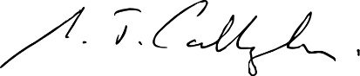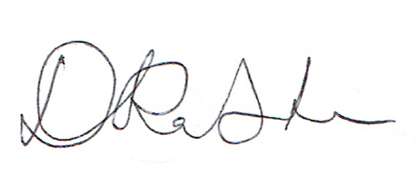

Michael Callaghan Deborah Ralston Carolyn Kay

Table of Contents
Letter of transmittal iii
Table of Contents v
Terms of reference 1
Panel members 1
Foreword 3
Topics not covered 4
Acronyms and abbreviations 5
Glossary 6
Income groups in the review 14
Key observations and overview 15
Key observations 17
Overview and summary 21
COVID-19: A sound retirement income system in volatile times 21
The need to improve understanding of the system 23
The importance of establishing the facts and gathering the evidence 24
The changing nature of retirement 25
What is the retirement income system? 26
The objective of the retirement income system and role of the pillars 27
The performance of the retirement income system 31
Adequacy 31
Equity 39
Sustainability 51
Cohesion 54
1. Outline of Australia’s retirement income system 59
Outline of this chapter 59
Section 1A. What is retirement? 61
Diverse pathways to retirement 61
Trends in the average age of retirement 62
Retirement timing expectations 65
Definition of ‘early retirement’ and ‘late retirement’ 65
Section 1B. Design of Australia’s retirement income system 67
Outline of this section 67
System interactions 68
Overview of the Age Pension 68
Overview of compulsory superannuation 75
Overview of voluntary savings 76
Overview of sources of income for recent retirees 81
International comparison of Australia’s retirement income system 84
Section 1C. The objective of the system and the roles of the pillars 87
Outline of this section 87
The principles of the retirement income system 88
The retirement income system’s objective 90
Key considerations in approaching the elements 95
The roles of the Government, individuals and the private sector 96
The roles of the pillars 97
Section 1D. The changing Australian landscape 105
Outline of this section 105
Demographic trends 107
Labour force trends 110
Economic growth and returns on investments 113
Maturity of the superannuation system 116
Household wealth and debt 118
Housing 121
2. Adequacy 125
Outline of this chapter 125
Section 2A. Achieving a minimum standard of living in retirement 127
Outline of this section 127
Assessing minimum standards 128
Assessing the adequacy of the Age Pension 128
Assessing retirement outcomes against minimum standards 133
Section 2B. Policy scenario: Implications of increasing Commonwealth Rent Assistance 145
Outline of this section 145
The role of Commonwealth Rent Assistance in retirement 146
Effects of higher Commonwealth Rent Assistance on the retirement income system 148
Implications for the retirement income system 155
Section 2C. Maintaining standards of living in retirement 157
Outline of this section 158
Maintaining a stable lifetime standard of living maximises wellbeing 159
The trade-off between working life and retirement income 160
Measuring if living standards are maintained 161
How the system maintains living standards 164
Income needs in retirement 167
How spending needs grow in retirement 168
Assessing outcomes for recent retirees 170
Early release of superannuation 174
Assessing outcomes for future retirees 176
Adequacy for future retirees 179
Impact of different assumptions 184
The retirement income system and the risk of economic shocks 188
Annex — detailed sensitivity analysis 194
Section 2D. Policy scenario: Implications of maintaining the SG rate 205
Outline of this section 206
The impact of maintaining the SG at its current rate 207
Annex — modelling supplement 225
3. Equity 233
Outline of this chapter 233
Section 3A. Income and wealth distribution 235
Outline of this section 235
Tax advantage of saving through superannuation 236
Superannuation contributions 238
The distribution of superannuation balances 242
The distribution of retirement incomes 244
Lifetime Government support provided through the retirement income system 246
Other government benefits provided to people aged 65 and over 248
Do retirees with similar levels of savings receive similar retirement incomes? 251
Annex — stakeholders’ issues with lifetime Government support analysis 254
Section 3B. Gender and partnered status 257
Outline of this section 257
Gender gaps in retirement outcomes 258
Working-life drivers of gender gaps outside the retirement income system 260
Working-life drivers of gender gaps inside the retirement income system 267
Causes of gender gaps in retirement 275
Retirement trends and characteristics by partnered status 280
Poverty and financial stress 283
Section 3C. Home ownership status 287
Outline of this section 287
Home ownership and equity in retirement outcomes 288
Age Pension and the assets test 289
Equity implications of the Age Pension assets test 290
Distribution of Age Pension expenditure 293
Section 3D. SG coverage 297
Outline of this section 297
Coverage of employees by the SG 298
Unpaid SG (the ‘SG gap’) 303
Retirement outcomes for self-employed people 305
Section 3E. Age of retirement 313
Outline of this section 313
Prevalence of voluntary and involuntary retirement 315
Retirement age and reason for retirement among cohorts 316
Unemployment, underemployment and discouraged job seekers 321
Support available to people who retire early 322
The effect of early and/or involuntary retirement on retirement incomes 329
The effect of late retirement on retirement outcomes 333
Section 3F. Aboriginal and Torres Strait Islander people 337
Outline of this section 337
Differences in life expectancies 338
Translation of working-life economic disadvantage into retirement 340
Private savings, including home ownership 346
Issues accessing the retirement income system 348
Section 3G. People with disability 353
Outline of this section 353
Prevalence of disabilities 354
Translation of working-life disadvantages into retirement 354
Poverty and financial stress 358
Disability-specific retirement income system settings 361
Section 3H. Intergenerational equity 363
Outline of this section 363
Funding of the pillars of the retirement income system 364
Generational transfer cost 365
Opportunities to accumulate retirement savings for different generations 368
Inheritances 369
4. Sustainability 373
Outline of this chapter 373
Section 4A. Sustainability 375
Historical costs 376
Projected future costs 387
Cost-effectiveness 393
Potential effects of changing trends 395
Public confidence 398
Annex — estimating superannuation tax concessions 407
Annex — scenario analysis 410
5. Cohesion 413
Outline of this chapter 413
Section 5A. Cohesion 415
Outline of this section 416
Cohesiveness of pre-retirement settings for saving and investment 417
Cohesiveness of the retirement phase 431
Section 5B. Policy scenario: Implications of changing Age Pension means test settings 463
Outline of this section 463
Design of the Age Pension means test 464
Implications of a lower assets test taper rate 465
Merged means test 472
6. Appendices 475
Section 6A. Detailed modelling methods and assumptions 477
Outline of appendix 477
Evidence on the effect of changes in the Superannuation Guarantee on wages growth 477
Evidence on the spending growth needed in retirement 486
Evidence for the adequacy benchmark 494
ASFA comfortable standard as an adequacy objective 499
Retirement income cameo model — assumptions and methodology 501
Benchmarking the review’s cameo model 534
Model of Australian Retirement Incomes and Assets 539
Superannuation, Pension and other Retirement OUTcomes 544
Modelling financial stress 549
Section 6B. An example to illustrate the trade-offs of merging the income and assets tests 553
Impact of the merged means test example 555
Section 6C. Outcomes of research 563
Section 6D. Supplementary equity charts 573
Income and wealth distribution 573
Gender and partnered status 573
Age of retirement 588
Intergenerational equity 593
Section 6E. Consultation process 595
Approach to the review 595
Consultation 595
Submissions 597
References 603

Terms of reference
On 27 September 2019, the Treasurer, the Hon Josh Frydenberg MP, and the Minister for Superannuation, Financial Services and Financial Technology, Senator the Hon Jane Hume, announced the Government had commissioned an independent panel to review the retirement income system.
The review had the following terms of reference.

Retirement Income Review terms of reference
As recommended by the Productivity Commission in its report Superannuation: Assessing Efficiency and Competitiveness, the Government is commissioning an independent Retirement Income Review.
Australia’s retirement income system is based on three pillars:
- a means tested Age Pension;
- compulsory superannuation; and
- voluntary savings, including home ownership.
It is important that the system allows Australians to achieve adequate retirement incomes, is fiscally sustainable and provides appropriate incentives for self-provision in retirement.
The review will establish a fact base of the current retirement income system that will improve understanding of its operation and the outcomes it is delivering for Australians. The Retirement Income Review will identify:
- how the retirement income system supports Australians in retirement;
- the role of each pillar in supporting Australians through retirement;
- distributional impacts across the population and over time; and
- the impact of current policy settings on public finances.

Panel members

Mr Mike Callaghan AM PSM (Chair)
Mr Mike Callaghan AM PSM is Chair of the Commonwealth Grants Commission and Chair of the replenishment of the Asian Development Bank’s Asian Development Fund, and a Non-Resident Fellow at the Lowy Institute.
From 2018 to 2020, he was Chair of the Aged Care Financing Authority. In 2017, Mr Callaghan chaired the Government’s review of the Petroleum Resource Rent Tax and the review of the Economic Impact of the Government’s Regulation Agenda. He also chaired the Northern Australia Insurance Premiums Taskforce. From 2013-2014, he was Director of the G20 Studies Centre at the Lowy Institute.
Mr Callaghan spent 38 years in the Australian Treasury. From 2008 to 2012 he was Deputy Secretary, Macroeconomic Group, Australia’s G20 Finance Deputy and the Prime Minister’s Special Envoy, International Economy. From 2005-2007, he was Deputy Secretary, Revenue Group.
Mr Callaghan spent four years on the IMF Executive Board in Washington DC and served as Chief of Staff to the Australian Treasurer, the Hon Peter Costello.

Ms Carolyn Kay
Ms Carolyn Kay has more than 30 years’ experience in the finance sector as an executive and non-executive director. She also has been and remains a non-executive director of enterprises across a broad range of other sectors.
Ms Kay is currently a member of The Future Fund Board of Guardians and a non-executive director of Scentre Group, and Myer Family Investments. In the not-for-profit sector, she is a non-executive director of The General Sir John Monash Scholarship Foundation and a Trustee of Sydney Grammar School.
As an executive, Ms Kay worked as a banker and lawyer at Morgan Stanley, JP Morgan, and Linklaters & Paines in London, New York and Australia.
Ms Kay holds bachelor degrees in law and arts (University of Melbourne), a Graduate Diploma in Management (AGSM), is a member of Chief Executive Women and is a Fellow of the Australian Institute of Company Directors. Ms Kay was awarded a Centenary Medal for services to Australian society in business leadership.

Dr Deborah Ralston
Dr Deborah Ralston has more than 25 years of board-level experience across commercial and public sectors, with experience in education, banking, superannuation and fintech sectors.
She is currently a member of the Reserve Bank of Australia Payments System Board and is a Professorial Fellow at Monash University. Dr Ralston is also a member of the Steering Committee for the Melbourne Mercer Global Pension Index and the YBF Fintech Hub Advisory Board.
Dr Ralston has held senior executive roles in Australian universities, most recently as Executive Director of the Australian Centre for Financial Studies and as a Professor of Finance with the Monash University Business School. She was the Principal Investigator of the CSIRO-Monash Superannuation Research Cluster, and inaugural Chair of ASIC’s Digital Finance Advisory Committee. In 2018, Dr Ralston was appointed to the Comprehensive Income Products for Retirement Framework Advisory Committee.
Dr Ralston holds a Master of Economics, a Doctor of Philosophy in financial regulation and is a Fellow of CPA Australia (FCPA), and the Australian Institute of Company Directors (FAICD).

Secretariat
Robb Preston (Head of secretariat)
Grace Anthony | Bianca Bauer | Ryan Baxter
Kylie Bourke | Yi Yong Cai | Luke Dorahy
Anne-Line Giudicelli | Tegan Holt | Cate Le Mesurier
Tamara Linehan | Darren Magennis | Rebecca McCallum
Tremayne Mellersh | Joseph Moloney | Sam Pelly
Cameron Robinson | Jonathan Rush | Paul Ryan
Tony Wiskich | William Young

Foreword
The Government commissioned the Retirement Income Review following a recommendation by the Productivity Commission in its report Superannuation: Assessing Efficiency and Competitiveness.
In keeping with its terms of reference, the review has developed an evidence base of the operation of the retirement income system, with the aim of improving the understanding of how the system operates and the outcomes it delivers for Australians. The review was not asked to recommend changes to the system.
The review’s assessment of the evidence regarding the operation of the retirement income system is framed around the panel’s suggestion as to what could be the broad objective for the system, namely, ‘to deliver adequate standards of living in retirement in an equitable, sustainable and cohesive way’.
A consultative and research-based approach was undertaken. The panel invited submissions from the public in response to the consultation paper released in November 2019. Public interest was broad and over 430 submissions were received. The panel and secretariat consulted widely, holding more than 100 meetings with stakeholders, including academics, regulators, industry bodies, superannuation funds and consumer groups. The meetings ranged from large forums to small groups of stakeholders. Details regarding the submissions and consultation can be found in Appendix 6E. Consultation process.
The review conducted its own extensive research and modelling, commissioned analysis from a number of organisations and drew on a wide range of existing research reports, to consider how the system performs today and how it will perform in an ageing society. The review commissioned research by the Monash Centre for Financial Studies at Monash University, Bankwest Curtin Economics Centre at Curtin University, and the Tax and Transfer Institute at ANU. These commissioned reports are available on the review’s website. The review also benefited from data and analysis provided by the Treasury, Australian Government Actuary, Australian Taxation Office, Department of Social Services, Behavioural Economics Team of the Australian Government (BETA), and Rice Warner.
The COVID-19 Pandemic occurred during the review. The approach taken by the review in considering the impacts is outlined below.

The retirement income review in the context of the COVID-19 Pandemic
The economic impacts of the COVID-19 Pandemic were beginning to be observed during the course of the review. However, the pandemic’s full effects and any long-term economic consequences will not be known for some time. Predicting the economic impacts of a pandemic is difficult and outside the scope of this review.
The initial detrimental impact of COVID-19 on financial and labour markets is not reflected in the quantitative analysis of the long-term performance of the retirement income system. Where the COVID-19 Pandemic is likely to affect analysis in the short- to medium-term, this is noted in the relevant chapter.
Short-term factors should not materially affect the analysis of very long term outcomes (e.g. see Box 4A-4 in 4. Sustainability). They may, however, result in substantial short-run deviations from the long-term trends.
Given the uncertainty associated with the effects of the COVID-19 Pandemic, this report includes sensitivity analysis to assess the potential impact of deviations from the assumed long-term trends. For example, 2C. Maintaining standards of living in retirement, and 4. Sustainability, assess the effects of negative short-term shocks to wage growth and investment returns on outcomes for individuals and to the cost and performance of the system. The short-term effects of market volatility for people in or nearing retirement are explored in 2C. Maintaining standards of living in retirement.

Topics not covered
A range of topics were not considered by the review. These included aspects of the retirement income system covered in detail in recent reviews and inquiries. For example, the Productivity Commission considered in detail the issues of superannuation fund performance and efficiency, as well as the competitiveness of the industry, in its report Superannuation: Assessing Efficiency and Competitiveness. That inquiry considered a range of competition, governance and regulatory issues, including the effects of underperformance and high fees on people’s superannuation balances. While this review drew on the Productivity Commission’s report, it did not consider in detail the material covered in that report. Similarly, the Australian Prudential Regulation Authority’s (APRA) regulation of superannuation was covered in-depth in the 2019 APRA Capability Review. The conduct of superannuation trustees and the regulatory architecture of the superannuation system was covered by the 2019 Royal Commission into Misconduct in the Banking, Superannuation and Financial Services Industry. Conditions for early release of superannuation were considered by the Treasury in the 2019 Review of the early release of superannuation benefits. The material covered in these reviews was not included in this review. The role of the retirement income system in delivering indirect macroeconomic outcomes such as increased national savings has not been considered. The role of insurance in superannuation was not considered as its benefits are predominantly paid to working-age people.

Acronyms and abbreviations
ABS | Australian Bureau of Statistics
APRA | Australian Prudential Regulation Authority
ASIC | Australian Securities and Investments Commission
ASFA | Association of Superannuation Funds of Australia
ASX | Australian Securities Exchange
ATO | Australian Taxation Office
AWOTE | average weekly ordinary time earnings
CPI | Consumer Price Index
EMORI | Excel Model of Retirement Income
FTB | Family Tax Benefit
GFC | Global Financial Crisis
GDP | Gross Domestic Product
HILDA | Household, Income and Labour Dynamics in Australia Survey
MARIA | Model of Australian Retirement Incomes and Assets
OECD | Organisation for Economic Co-operation and Development
RBA | Reserve Bank of Australia
SG | Superannuation Guarantee
SIH | Survey of Income and Housing
SMSF | Self-managed superannuation fund
SPRC | Social Policy Research Centre

Glossary
Aboriginal and Torres Strait Islander | A person of Aboriginal or Torres Strait Islander descent who identifies as Aboriginal, Torres Strait Islander, or both.
Age Pension | A means-tested Commonwealth Government income support payment. To be eligible for the Age Pension, a person must be of Age Pension eligibility age or older and meet residency requirements.  The amount of Age Pension an eligible person can receive is dependent on their personal income and assets. As at 1 May 2020, the maximum Age Pension an eligible person can receive per year is $24,552 for singles and $37,014 for couples.  Further information relating to the Age Pension can be found in 1B. Design of Australia’s retirement income system.
Age Pension eligibility age | The age at which a person becomes eligible for the Age Pension. The Age Pension eligibility age for men and women was increased to 65 and 6 months on 1 July 2017. It is scheduled to increase by 6 months every 2 years until it reaches 67 years on 1 July 2023.  Further information relating to the Age Pension eligibility age can be found in 1B. Design of Australia’s retirement income system.
Assets test cut-off value | The maximum amount of assessable assets a person can hold before they are ineligible for the payment. A person who holds assessable assets above the cut-off value will be ineligible for the payment under the assets test.
Assets test free area | The maximum amount of assessable assets a person can hold before their payment is reduced. A person who holds assessable assets of less than or equal to the free area will be eligible for the maximum rate of the payment under the assets test.
Assets test taper rate | The amount a person’s payment is reduced due to holding assessable assets above the assets test free area. Since 2017, the Age Pension taper rate reduces payments by $3 a fortnight for every $1,000 of assets above the assets test free area.
Average weekly earnings | The average weekly before-tax earnings of employees. Includes ordinary time earnings and overtime earnings. Estimates of average weekly earnings are derived by dividing estimates of weekly total earnings by estimates of numbers of employees.
Behavioural bias | Subconscious beliefs and behaviours that are commonly relied on when making a decision.
Cameo modelling/ Excel Model of Retirement Income (EMORI) | Modelling of the outcomes a hypothetical person would likely receive based on a range of assumptions and factors. Cameo modelling shows how these factors affect likely outcomes. Cameo modelling for the review has used The Treasury’s EMORI.  Further detail of the specifics and methodology underpinning the review’s use of cameo modelling and EMORI can be found in Appendix 6A. Detailed modelling methods and assumptions.
Carer Payment | A means-tested Commonwealth Government income support payment for carers who because of the demands of their caring role, are unable to support themselves through substantial paid employment. The maximum rate of Carer Payment is the same as the maximum rate of Age Pension.
Centrelink | The Commonwealth Government agency that manages the administration and payment of income support payments and supplements, including the Age Pension.
Commonwealth Rent Assistance | A Commonwealth Government supplement to other income support payments for eligible people, including most age pensioners, who rent through the private market or community housing.  Further information relating to Commonwealth Rent Assistance can be found in 2B. Policy scenario: Implications of increasing Commonwealth Rent Assistance.
Community Development Program | A Commonwealth Government-supported remote-area employment and community development program. The program has around 30,000 participants, the majority of whom are Aboriginal or Torres Strait Islander people.
Consumer Price Index (CPI) | An index that measures changes in retail prices of a constant basket of goods and services. It is used to track changes in prices for consumer goods and services. Commonly used as a measure for inflation in Australia.
Contributions cap(s) | Limits on the amount of money that can be contributed to a person’s superannuation account in a given period.  Further information relating to the contributions caps can be found in 1B. Design of Australia’s retirement income system.
Deeming rates | Rates used to calculate the assumed income earned on an income support recipient’s assets, including those of age pensioners, irrespective of the actual income earned on those assets.  Assumed income based on these rates (deemed income) is used by Centrelink for means testing to calculate how much of a social security payment, including the Age Pension, a person is entitled to.  Further information relating to deeming rates can be found in 1B. Design of Australia’s retirement income system.
Defined benefit (superannuation) scheme | A scheme in which the member is generally paid a defined amount in retirement based on certain factors (such as years of work and final salary). Usually paid by the member’s previous employer as a regular income for the duration of retirement.
Defined contribution (superannuation) scheme | A scheme in which the member is generally paid a defined contribution to their superannuation account by their employer for the duration of their employment with that employer.
Disability Support Pension | A Commonwealth Government income support payment for people who are deemed unable to support themselves financially (through means testing) and have a permanent physical, intellectual or psychiatric impairment. The maximum rate of Disability Support Payment is the same as the maximum rate of Age Pension.  Further information relating to the Disability Support Pension can be found in 3. Equity.
Discouraged job seeker | A person without employment who is otherwise available and willing to work but is not actively looking for work as they believe they will not find employment.
Division 293 tax | An additional 15 per cent tax on contributions for people whose combined income and contributions exceed the prescribed threshold. Currently the threshold is $250,000. This effectively increases the tax on contributions for these people to 30 per cent.  Further information relating to Division 293 tax can be found in 1B. Design of Australia’s retirement income system.
Drawdown | The amount of wealth withdrawn from savings and assets (including by asset liquidation) to support living standards and consumption.
Effective marginal tax rate | The net effect of taxes imposed and income support removed when a person earns an additional dollar of income.
Equivalisation | Equivalisation is a way to compare households of different sizes and compositions. Equivalisation accounts for larger households being able to share resources, such as housing space. It effectively converts outcomes for multi-person households to be equivalent to outcomes in single-person households.  The report uses the ‘modified OECD’ equivalence scale. This scale determines a household weight with the first adult person counting as one, adds 0.5 for each additional person in the household aged 15 or over, and adds 0.3 for each person aged under 15. For example, a household of two adults and one child aged 10, with income of $180,000, is assumed to have equivalent income to a single-person household with income of $100,000 per year.
Generational transfer cost | The annual cost per working-age person of the Age Pension and superannuation earnings tax concessions retirees receive.
Gig economy | The gig economy provides short-term, temporary or independent contracts through one or a variety of employers.
Gross Domestic Product (GDP) | The total value of goods and services produced in a country. Commonly used as measure of economic growth.
Household(s) aged 65 (and over) | Households with a reference person (the person in the household selected for the study or survey) aged 65 or over.
Imputed rent | The amount that a home owner saves in terms of lower housing costs by not paying rent for housing.
Income/Income distribution | For the purpose of the review, unless otherwise defined, income is defined as a person’s average working-life income (wage deflated). For retirement cameo modelling undertaken for the review, income is disposable (after tax) unless explicitly stated otherwise.  References to income distribution across working lives are determined using income data collected by the ATO.  Lower-income/Lower-end of the income distribution — people earning in the bottom 30 per cent of the income distribution.  Middle-income/Middle of the income distribution — people earning between 30 and 80 per cent of the income distribution.  Higher-income/Higher-end of the income distribution — people earning in the top 20 per cent of the income distribution.  Greater detail of the specifics and methodology underpinning the review’s definition of income can be found below in Income groups in the review and Appendix 6A. Detailed modelling methods and assumptions.
Income test cut-off value | The maximum amount of assessable income a person can receive before they become ineligible for the payment. A person with assessable income above the cut-off value will be ineligible for the payment under the income test.
Income test free area | The maximum amount of assessable income a person can receive before their payment is reduced. A person with assessable income of less than or equal to the free area amount will be eligible for the maximum rate of the payment under the income test.
Intergenerational report | The Commonwealth Government releases an Intergenerational Report every five years, which assesses the long-term fiscal sustainability of Government policies. Intergenerational Reports have previously been released in 2002, 2007, 2010 and 2015. The next report is due to be released in 2021.  Intergenerational Reports provide a basis for considering the Commonwealth’s fiscal outlook over the next 40 years and identifying the implications of demographic, population and workforce participation changes over time.
Investment risk | Investment risk relates to variability in returns and the possibility that returns on investments are below expectations.
JobSeeker Payment | A means-tested Commonwealth Government income support payment for unemployed people who are generally of working age. The JobSeeker Payment replaced the payment formerly known as Newstart Allowance on 20 March 2020.  Further information relating to the JobSeeker Payment can be found in 3. Equity.
Longevity risk | The risk of a person outliving their savings.
Low income superannuation tax offset | A superannuation tax offset available to some lower-income earners that is usually paid directly into their superannuation accounts.  Further information relating to the low income superannuation tax offset can be found in 1B. Design of Australia’s retirement income system and 3. Equity.
Male total average weekly earnings | The total average weekly before-tax earnings of male employees. Includes ordinary time earnings and overtime earnings. Age Pension rates are benchmarked to male total average weekly earnings.
Means tested/testing | Describes a government benefit where the rate is determined by a recipient’s income and/or wealth. Most income support payments are means tested.
Minimum drawdown | The minimum legislated amount that must be withdrawn from a superannuation account when it is in the retirement phase. The minimum drawdown rate is generally determined by the member’s age.  Further information relating to the minimum drawdown and rates can be found in 1B. Design of Australia’s retirement income system and 5A. Cohesion.
Not in the labour force | A person who is not employed and is not looking for employment.
Ordinary Time Earnings | The earnings in respect of ordinary hours of work. It does not include overtime and other payments not related to a person’s ordinary hours. Refer to <www.ato.gov.au/Business/Super-for-employers/How-much-to-pay/checklist--salary-or-wages-and-ordinary-time-earnings/> for a list of what is covered by ordinary time earnings.
Pension Work Bonus | The Work Bonus provides an incentive for eligible pensioners over Age Pension eligibility age to work by allowing them to keep more of their pension when they have income from work.  The Work Bonus increases the amount an eligible pensioner can earn from work before it affects their pension rate. From 1 July 2019, the first $300 of fortnightly income from work is not assessed and is not counted under the pension income test.
Preservation age | The age at which a person can generally access their superannuation if they are retired. The preservation age is 58 as of 1 July 2020 and is scheduled to gradually increase to 60 from 1 July 2024. Further information relating to preservation age can be found in 1B. Design of Australia’s retirement income system.
Real wage growth | The amount by which wage growth exceeds CPI growth.
Retirement  Early  Late | In this report, early retirement is defined as retiring before Age Pension eligibility age.  In this report, late retirement is defined as retiring after Age Pension eligibility age.
Retirement income | Income during retirement, including income streams and withdrawals from superannuation, the Age Pension, and drawdown of non-superannuation assets.  Retirement income projections presented in the report generally relate to disposable (after-tax) income unless otherwise stated.
Retirement Income Covenant | The proposed Retirement Income Covenant to sit in the Superannuation Industry (Supervision) Act 1993, will require trustees to consider the needs and preferences of their members and ensure retirees have greater choice in how they take their superannuation benefits in retirement.
Seniors and pensioners tax offset | An income tax offset generally available to people who are eligible for the Age Pension. The offset effectively raises the tax-free threshold for these people.
Sequencing risk | The risk of lower returns and losses occurring when a person needs to withdraw their capital.
Sham contracting | Sham contracting is an illegal activity where a person working as an employee is told they are an independent contractor (when they are not) and may be required to have an ABN and submit invoices.  Sham contracting may be done intentionally or carelessly by an employer. These types of arrangements are sometimes set up by employers who are seeking to avoid responsibility for paying legal entitlements to employees.
Single Touch Payroll | Compliance regulation set out by the ATO that requires employers to send employee payroll information including salary, wages, pay-as-you-go withholding and superannuation, to the ATO at the same time as their standard pay run.
Social transfers in kind | Subsidised or free goods and services provided by governments to households, such as aged care and health care.
Subjective wellbeing | A person’s own evaluation of their life and wellbeing.
Superannuation coverage | A person is considered to have superannuation coverage if they have a superannuation balance above zero, receive regular income from superannuation, or have received a lump sum superannuation payment in the past two years.
Superannuation death benefits | A payment to a dependent beneficiary or to the trustee of a deceased estate after the member has died.
Superannuation Guarantee (SG) | The minimum amount of money an employer must contribute to a superannuation fund on behalf of an eligible employee. Generally, an employee must meet the $450-a-month threshold before SG is payable. SG is calculated as a percentage of the ordinary time earnings of the employee and is payable on top of the earnings of the employee.  Currently, the SG rate is 9.5 per cent. It is scheduled to increase to 10 per cent as of 1 July 2021, gradually increasing to 12 per cent as of 1 July 2025.  Further information relating to SG can be found in 1B. Design of Australia’s retirement income system.
Superannuation Guarantee (SG) coverage | A person is considered to have SG coverage if they receive the SG from their employer.
Tax concessions  - Contributions tax concessions  - Earnings tax concessions | Reduction in the tax otherwise payable. The superannuation system provides two main tax concessions compared to personal income tax to encourage savings in superannuation.  Contributions made to superannuation below the concessional contributions cap are generally taxed at a flat 15 per cent instead of the person’s marginal income tax rate. For people subject to Division 293 tax, the effective tax rate on their contributions is 30 per cent.  Earnings on superannuation funds in accumulation-phase are taxed at a flat 15 per cent, instead of the person’s marginal income tax rate. Earnings on superannuation funds are tax-free when they are in pension-phase, subject to the transfer balance cap. Funds over the Cap can stay in accumulation-phase and any earnings on those funds taxed at 15 per cent.  Further information relating to tax concessions can be found in 1B. Design of Australia’s retirement income system.
Total and permanent disability insurance | Insurance that pays a benefit if the policy holder becomes totally and permanently disabled.
Transfer balance cap | A limit on how much superannuation can be transferred from accumulation-phase to tax-free pension-phase. The Cap is currently $1.6 million.  Further information relating to the transfer balance cap can be found in 1B. Design of Australia’s retirement income system.
Widow Allowance | The Widow Allowance was paid to women who were no longer partnered, or who became separated, divorced or widowed after turning 40 years of age and who had little or no recent workforce experience. New claims for the Widow Allowance closed on 1 July 2018.
Workers’ compensation schemes | A compulsory statutory form of insurance for all employers that provides a benefit to workers if they suffer a work-related injury or disease.
$450-a-month threshold | Where an employee is paid $450 or more (before tax) in a calendar month by a single employer, the SG must be paid on top of their wages.  Further information relating to the $450-a-month threshold can be found in 1B. Design of Australia’s retirement income system and 3D. SG coverage.

Income groups in the review
The review uses income groups to discuss how the retirement income system delivers different outcomes for certain cohorts. Lower-income earners are defined as those in the bottom 30 per cent of all earners, higher-income earners in the top 20 per cent and middle-income earners are in between.
These groups are used for explanatory purposes. They are not intended to be value judgements about what constitutes a ‘high’ or ‘low’ income. Lower-income earners have their retirement needs met by the Age Pension (2A. Achieving a minimum standard of living in retirement), and the threshold for higher-income earners is the point where, on average, people start to make significant voluntary savings.
Incomes for each group from the cameo modelling are included in Table 1. These incomes are higher than other series, such as the ABS ‘Characteristics of employment’, as they are based on income tax return data from the ATO (ABS, 2019f). This data may not include some people such as those who earn incomes below the tax-free threshold.
The median earner in review modelling has an average income over their lifetime of $68,400, similar to average earnings (ABS, 2020d) and to the average income of a plumber or teacher (ATO, 2019e).
Lower-income earners have average annual earnings over their working life of $48,000 and below. This income is broadly comparable to the average wages of hospitality workers and carers in the aged or disability sectors.
Higher-income earners have average annual earnings over their working life of $112,900 and above. Occupations with average incomes in the upper end of this range include dentists, lawyers, and finance managers.
- Average working-life taxable income by income percentile
Income group | Percentile | Gross income  ($)
Lower-income earners | 10 | 22,100
Lower-income earners | 20 | 36,300
Lower-income earners | 30 | 48,000
Middle-income earners | 40 | 58,100
Middle-income earners | 50 | 68,400
Middle-income earners | 60 | 80,200
Middle-income earners | 70 | 94,500
Higher-income earners | 80 | 112,900
Higher-income earners | 90 | 144,900
Note: Values are in 2019-20 dollars, deflated by average weekly earnings and rounded to the nearest $100. Income is average earnings for the whole of working life (ages 27-67) before tax. Incomes differ from the working-life income target used for replacement rates, which is based on average annual disposable income in the last 10 years of working-life. For more information on how the review has modelled working-life income see Appendix 6A. Detailed modelling methods and assumptions. Source: Cameo modelling undertaken for the review.



Key observations and overview

Key observations
- The Australian retirement income system is effective, sound and its costs are broadly sustainable. This is reassuring in a time of economic uncertainty associated with the COVID-19 Pandemic. But the evidence suggests there are areas where the system can be improved.
- The retirement income system is complex. There is a need to improve understanding of the system. Complexity, misconceptions and low financial literacy have resulted in people not adequately planning for their retirement or making the most of their assets when in retirement. Adding to complexity is the interaction with other systems, such as the aged care and the tax systems. People need better information, guidance and good, affordable advice tailored to their needs.
  - A major misunderstanding is the view that ‘retirement income’ involves the return from investing superannuation balances rather than drawing down those balances to fund living standards in retirement.
- There are competing interests in the system. In what is often a highly contested environment, it is important to gather the facts and establish the evidence so that objective decisions can be made about the direction of policy and what is in the best interests of the community.
- A clear objective for the system, agreed by the Australian community through the Government, is needed to guide policy, improve understanding and provide a framework for assessing performance of the system.
- It is suggested that the objective for the system be developed around the goal:
  - ‘to deliver adequate standards of living in retirement in an equitable, sustainable and cohesive way.’
- What constitutes an ‘adequate, equitable, sustainable and coherent’ retirement income system needs to be clear and preferably legislated. Suggestions of the elements to be covered include:
  - Adequacy
    - The system should ensure a minimum standard of living for retirees with limited financial means that is consistent with prevailing community standards.
    - The system should facilitate people to reasonably maintain their standard of living in retirement.
  - Equity
    - The system should target Government support to those in need.
    - The system should provide similar outcomes for people in similar circumstances.
  - Sustainability
    - The system should be cost-effective for taxpayers in achieving adequate retirement outcomes.
    - The system should be sustainable and robust to demographic, economic and social change.
  - Cohesion
    - The system should have effective incentives to smooth consumption and support people in taking personal responsibility for their retirement incomes.
    - The system should interact effectively with other systems.
    - The system should not be unnecessarily complex for consumers.
- As at June 2019, around 71 per cent of people aged 65 and over received Age Pension or other pension payments. Over 60 per cent of these were on the maximum rate. For most households aged 65 and over, the family home is their main asset. Superannuation makes up a small share of their net wealth. This will change as the superannuation system matures.
- The Age Pension, combined with other support provided to retirees, is effective in ensuring most Australians achieve a minimum standard of living in retirement in line with community standards. Retirees receive health, aged care and other Government services worth more than the maximum rate of the single Age Pension.
- Some groups do not achieve this goal.
  - A significant number of older Australians who are renting in the private market need additional assistance. Increasing the rate of Commonwealth Rent Assistance will only have a small impact. A new approach is required.
- For many who retire involuntarily due to job-related reasons, the adequacy of their living standards before Age Pension eligibility age depends on the level of the JobSeeker Payment. Renters and involuntary retirees experience higher levels of financial stress and poverty than the working-age population.
- The Age Pension is more than a safety net. It plays an important role in supplementing the superannuation savings of retirees and allowing them to maintain their living standards. It also provides a buffer for retirees whose retirement income and savings fall due to market volatility, and for those who outlive their savings.
- Compulsory superannuation allows people to achieve a retirement income that better reflects their pre-retirement income. As the superannuation system matures, people will increasingly fund more of their own retirement. Nevertheless, the Age Pension will continue to supplement the retirement income of a large proportion of people, but to a lesser degree.
- Voluntary superannuation provides the flexibility for people to save more than is mandated by the Superannuation Guarantee (SG) and to make catch-up savings after periods out of the workforce. It also provides an opportunity for those not covered by the SG to make superannuation savings.
- Superannuation savings are supported by tax concessions for the purpose of retirement income and not purely for wealth accumulation. Yet most retirees leave the bulk of the wealth they had at retirement as a bequest.
- The home is the most important component of voluntary savings and is an important factor influencing retirement outcomes and how people feel about retirement. Home owners have lower housing costs and an asset that can be drawn on in retirement. If the decline in home ownership among younger people is sustained into retirement, there will be an increasing number of retirees who rent. The system favours home owners, such as through the exemption of the principal residence from the Age Pension assets test.
- The appropriate adequacy objective for a system based on compulsory superannuation is to balance living standards across a person’s working life and retirement.
- Saving for retirement involves forgoing consumption in working years. With voluntary saving, people decide on this trade-off. When there is compulsory superannuation, the rate should be set at a level that balances pre- and post-retirement living standards for middle-income earners. It is challenging to set a single SG rate that suits all Australians given the variety of people’s circumstances and experiences.
- A rate of compulsory superannuation that would result in people having an increase in their living standards in retirement may involve an unacceptable reduction in living standards prior to retirement, particularly for lower-income earners. This is based on the view, supported by the weight of evidence that increases in the SG rate result in lower wages growth, and would affect living standards in working life.
- Other than for lower-income earners, replacement rates that compare income in retirement with income while working are the most appropriate basis for assessing whether the retirement income system delivers adequate retirement incomes. Replacement rates align with the objective of achieving a reasonable balance between living standards in working life and retirement. The suggested benchmark replacement rate is 65-75 per cent.
- Most recent retirees are estimated to have adequate retirement incomes. Surveys suggest retirees generally have higher levels of financial satisfaction and lower rates of financial stress than working-age people.
- Under the legislated increase in the SG to 12 per cent, the projected replacement rate for future retirees with typical working lives exceeds the suggested 65-75 per cent benchmark rate across most income levels. This assumes people draw down their savings in retirement. If they only draw down their superannuation at the legislated minimum rates, which many people currently do, those in the upper half of the income distribution will not achieve the 65-75 per cent replacement rates.
- More efficient use of savings in retirement can have a bigger impact on improving retirement income than increasing the SG. If the SG remained at 9.5 per cent, and retirement savings were used more efficiently, most people would achieve 65-75 per cent replacement rates. Most would also achieve higher replacement rates than with the SG at 12 per cent and drawing down balances at the legislated minimum rate.
- The focus of superannuation has often been on building larger superannuation balances through increased contributions. But lower fees and higher investment returns will increase superannuation balances. Crucially, there has been insufficient attention on assisting people to optimise their retirement income through the efficient use of their savings.
  - Retirees are generally reluctant to draw down their savings in retirement due to complexity, little guidance, reluctance to consume funds that are called ‘nest eggs’, concerns about possible future health and aged care costs, and concerns about outliving savings. Currently adding to concerns is uncertainty around the impact of the COVID-19 Pandemic.
- Using superannuation assets more efficiently and accessing equity in the home can significantly boost retirement incomes without the need for additional contributions.
  - A range of measures could help people have the confidence to use their assets more effectively, including focusing retirement planning on income streams rather than balances, better quality and more accessible advice and guidance, and advancing the concept of the Retirement Income Covenant so funds guide members into effective retirement strategies.
  - The Pension Loans Scheme is an effective option for accessing equity in the home for both age pensioners and self-funded retirees. The current exemption of the principal residence from the Age Pension assets test is a disincentive to using the equity in the home to support retirement incomes.
- Many stakeholders pointed to inequitable retirement outcomes for various groups, such as women, Aboriginal and Torres Strait Islander people, those with disability and those not covered by the SG.
- The Age Pension helps to reduce income inequality for these groups in retirement compared with working life. But an individual’s superannuation balance, and retirement income, largely reflects the extent of their engagement in the workforce, both income and years worked. Those on higher incomes make more superannuation contributions and have larger superannuation balances. For example, the gap in superannuation balances at retirement between men and women is the accumulation of economic disadvantages faced by women in working life, particularly the gap in earnings and time spent in the workforce.
- Some groups are more adversely affected than others by aspects of the design of the system. Changes raised by stakeholders that could improve the fairness of the retirement income system include removing the $450-a-month threshold when the SG is paid; paying the SG on employer paid parental leave and the Government’s Parental Leave Pay; giving greater visibility of superannuation balances in divorce settlements; extending the SG earnings base to include overtime; and ensuring people receive the SG they are entitled to, such as by paying the SG at the same time as wages and better enforcing sham contracting laws. The impact of some of these changes on people’s retirement incomes may be small.
- While the Age Pension helps offset inequities in retirement outcomes, the design of superannuation tax concessions increases inequality in the system. Tax concessions provide greater benefit to people on higher incomes.
- Government expenditure on the Age Pension as a proportion of GDP is projected to fall slightly over the next 40 years to around 2.3 per cent. Higher superannuation balances reduce Age Pension costs. The cost of superannuation tax concessions is projected to grow as a proportion of GDP and exceed that of Age Pension expenditure by around 2050. This is due to earnings tax concessions. The increase in the SG rate to 12 per cent will increase the fiscal cost of the system over the long term.
- Voluntary superannuation contributions are largely concentrated among those nearing retirement, and particularly at the higher end of the income distribution. The evidence suggests that tax concessions encourage saving in tax-preferred forms, but they may displace other forms of saving and have a limited impact on overall saving.
- There are areas where superannuation tax concessions are not a cost-effective way to help people achieve adequate retirement incomes. In particular, the cost of the earnings tax exemption in retirement will grow faster than the growth in the economy as the system matures and provides the greatest boost to retirement incomes of higher-income earners.
- Many very large superannuation balances were built up under previous high contributions caps and are expected to stay in the system for several decades. At June 2018, there were over 11,000 people with a balance in excess of $5 million. People with very large superannuation balances receive very large tax concessions on their earnings.

Overview and summary
Australians want a secure retirement and the retirement income system is a major influence in determining whether they will have the income to achieve that goal.
This review of the retirement income system was commissioned by the Government following a recommendation by the Productivity Commission. In keeping with its terms of reference, the review has focused on establishing a fact base of the current retirement income system that will improve understanding of its operation and the outcomes it is delivering for Australians.
The review was not asked to make recommendations or propose changes to policy settings.
Decisions to alter policy involve judgements and trade-offs. It is ultimately up to the Australian community — through the Government — to decide on the settings for the retirement income system. The aim of this review is to contribute to more informed decisions by improving understanding of the operation of the retirement income system with supporting facts and evidence.
The panel and secretariat consulted widely, received 426 submissions to the consultation paper it released in November 2019 and held around 100 meetings with stakeholders. Although the review is not making recommendations, a large number of submissions and stakeholders recommended changes to the retirement income system. The review did not examine all the proposed changes in detail, but in keeping with its objective of improving understanding of the system, the review did comment on some of the implications of some of the proposed changes to retirement income policy.

COVID-19: A sound retirement income system in volatile times
During the course of the review, the world was confronted with the COVID-19 Pandemic. It has resulted in many deaths, stretched health facilities, caused significant disruption to people’s lives, resulted in major volatility in financial markets and led to a sizeable reduction in economic activity, a significant rise in unemployment and considerable uncertainty. It is an unprecedented situation and the full impact of the pandemic is not known. No country is immune and while Australia has responded to and is weathering the crisis far better than most countries, it has taken precedence over most aspects of life in Australia. For many, this would include considering the performance of the retirement income system.
Given the immediacy of a major health and economic crisis, many may feel that the retirement income system is not a priority. However, those near to or in retirement are understandably concerned about the volatility of the investment environment and the impact on their retirement savings.
The economic fallout from the COVID-19 Pandemic is another reminder of the need for people and fund managers to allow for the risk of market volatility. While some people are concerned about the impact on their retirement savings, surveys suggest others mistakenly believe their superannuation funds insulate them from market volatility. The returns achieved by superannuation funds may be lower in the short term, but they tend to be less volatile than market returns because professionally managed funds have invested across a range of assets. The crisis has highlighted the importance of diversification of retirement savings. And concerns over the risk of market volatility should not be at the expense of how long-term exposure to the market can boost retirement incomes over time. Most Australians are in a fund with solid returns in the long term. The crisis has also highlighted the value for those in retirement in obtaining sound advice and guidance on how they can best structure their retirement savings and income.
The extent of the COVID-19 Pandemic is far-reaching. But the importance of the retirement income system remains. Given the current level of uncertainty, Australians should be reassured that the retirement income system is effective, sound and its costs are broadly sustainable.
Reviews inevitably focus on identifying shortcomings and areas for improvement. Many of the submissions to this review emphasise what stakeholders think are problems. The overall impression may be that the system is badly flawed. While there are areas where Australia’s retirement income system can be improved, overall, it is well placed to deal with economic volatility and the challenge of an ageing society. It is ranked very highly in international comparisons of retirement income systems.
‘Many countries look to the Australian system, and similarly designed retirement systems, as exemplars in reforming their own systems.’ (CEPAR, 2020, p. 4)
The Age Pension is more than a safety net that supports those who do not have the means to achieve a minimum standard of living in retirement. It supplements the income for about 65 per cent of Australians in retirement. It serves as a buffer, helping offset the decline in retirement incomes for many Australians as a result of market downturns. It also acts as a form of longevity insurance for those who outlive their retirement savings. Given current financial pressures and uncertainty facing many Australians, the existence of a sound and sustainable Age Pension is important.
Australia’s superannuation arrangements are still maturing, although to date they have resulted in around 16 million Australians collectively owning close to $3 trillion in assets. This stock of superannuation assets, which is the fourth largest in the world, is important to funding the economy and delivering retirement incomes. The investment of superannuation assets will play a significant role in the recovery of the Australian economy from the downturn initiated by the COVID-19 Pandemic.
The Government’s measures to cushion the economic impact of COVID-19 included the ability for working-age people in financial stress to access up to $10,000 of their superannuation in 2019-20 and a further $10,000 in 2020-21. The retirement income system is designed to support the retirement outcomes for Australians and not to deal with the challenges people may face in their working lives. However, there will be emergency circumstances where the benefits of giving people early access to their superannuation will exceed those of preserving balances for retirement. Caution is needed because early access can have a significant impact on superannuation balances at retirement for younger people.
Yet if it were not for the existence of compulsory superannuation, fewer people would have savings available when faced with severe financial stress.
The economic impact of the COVID-19 Pandemic is not incorporated in the economic modelling undertaken for this review. But the modelling is aimed at helping assess the capacity of the system to deliver retirement incomes to Australians in the long term. The projections extend to 2060. The models are based on long-term trends in the economy. Economic shocks, such as those caused by the COVID-19 Pandemic, should not materially alter the analysis based on long-term trends. However, the report does look at the impact of developments such as lower wages growth, lower investment returns and short-term financial shocks.
Given the uncertainty and financial pressures confronting governments and individuals across the world, the fact that Australia has a sound retirement income system is a source of reassurance.

The need to improve understanding of the system
The overall task of the review was to help improve understanding of the retirement income system. During the course of the review, it became increasingly evident that there are many aspects of the system where there is a need to improve understanding. These included:
Dealing with complexity. Complexity and uncertainty, a lack of financial advice and guidance, and low levels of financial literacy are impeding people from understanding the system. As a result, some people fail to adequately plan for retirement and make poor decisions about how to use their savings in retirement.
‘There is a need for the retirement income system to be structured and communicated so that people are better able to understand and navigate the system to plan and access optimum and appropriate benefits.’ (COTA, 2020, p. 6)
The nature of retirement income. Most people die with the bulk of the wealth they had at retirement intact. It appears they see superannuation as mainly about accumulating capital and living off the return on this capital, rather than as an asset they can draw down to support their standard of living in retirement. The family home is an underutilised source to support living standards in retirement.
‘Voluminous research has been dedicated towards understanding the accumulation phase of superannuation (savings and investments during an individual’s working life) … In contrast, little attention has been allocated to the retirement (and aged-care) phase.’ (Griffith Centre for Personal Finance and Superannuation, 2020, p. 8)
The nature of retirement. The nature of retirement has changed. For many, the transition from full-time work to permanent retirement is gradual rather than abrupt. Some people retire more than once, others are involuntarily retired. There is no mandatory retirement age for most workers.
‘“Retirement” can no longer be narrowly defined as a fixed point in time at which people leave the paid workforce permanently. Retirement is now a continuum between reduced participation in the paid workforce (for example, through reduced working hours and temporary employment) and leaving it altogether.’ (Australian Council of Social Service, 2020, p. 12)
The objective of the system. The retirement income system lacks an agreed objective. Differing views on the appropriate level of the SG rate stem from different views about the system’s objective.
‘Any conclusions drawn about … whether SG rates are appropriate, and whether retirees are well served are critically dependent upon views as to the objective and adequacy of both Age Pension and superannuation.’
(First State Super, 2020b, p. 8)
Role of the pillars. The ‘pillars’ of the retirement income system are commonly seen as being the Age Pension, compulsory superannuation, and voluntary saving (including housing). Some see housing as a separate pillar. Others would add more pillars, such as labour force participation, social transfers in kind and the JobSeeker Payment (formerly Newstart Allowance). There is no agreed view on the role of the pillars.
‘Retirees do not look at their income needs in the three or four pillar approach favoured by academics and economists. We think there is great merit in looking at this issue in the way retirees practically approach solving their income need requirements because the three pillar model misses important components or downplays other considerations.’
(Chartered Accountants Australia and New Zealand, 2020, p. 2)
Dealing with diversity. The retirement income system covers people in very different circumstances: different incomes, time in the workforce, employment situation, capacity to save, home ownership status, risk preferences, financial literacy, partnership status and life events. While the system may provide adequate retirement incomes for many Australians, there is uncertainty about if and how it can compensate for those who may fall short, such as women, lower-income renters, individuals not covered by the SG, involuntary retirees, Aboriginal and Torres Strait Islander people and those with disability.
‘Dealing with heterogeneity is a major challenge with regard for setting policy ... ’ (Khemka & Warren, 2020, p. 10)

Common misunderstandings and misconceptions about the retirement income system
The views below represent perspectives observed in press articles, surveys and some submissions. These concerns are real and affect how people behave. However, they are generally not supported by evidence.
Adequacy of retirement income/retirement expenditure needs
- ‘I need to preserve my assets in case I get sick or need aged care.’
- ‘I will need to pay for most of my health costs in retirement.’
- ‘I need $1,000,000 in superannuation for an adequate retirement income.’
Retirement income products and investment strategies
- ‘The best investment strategy in retirement is very low risk, such as cash.’
- ‘Investing in real estate is a better investment strategy for retirement.’
Age Pension
- ‘The Age Pension is earned during working life. Taxpayers “pre-pay” for it through their taxes.’
- ‘The Age Pension will become unaffordable. Most people in future won’t receive it.’
Superannuation
- ‘The minimum drawdown rate is what the Government recommends.’
- ‘If I withdraw my money from superannuation, I must spend it.’
- ‘I should only draw down the income earned on my assets — not the capital.’

The importance of establishing the facts and gathering the evidence
Establishing the facts and gathering evidence on how the retirement income system operates is important to improve understanding of the system and help address misconceptions, such as those outlined in the box above. This is the objective of this report.
The retirement income system is, however, a source of considerable public debate. This reflects the system’s importance to the Australian people, the economy and the many firms involved, particularly those in the superannuation industry, which manage nearly $3 trillion in assets and generate fees of more than $30 billion per year.
The stakes are high because changes to the system can have significant implications for all involved: people, in terms of the level of their working life and retirement incomes; and superannuation funds, in terms of the assets they manage and the fee income they generate. As one submission noted:
‘ … a balanced discussion of the retirement income system is bedevilled by narratives that serve vested interest rather than the common good.’
(Centre for Law, Markets and Regulation, 2020, p. 2)
The fact that parties have a direct interest in the system need not mean they are not interested in the ‘common good’. Nevertheless, the public debate over the retirement income system can be very intense. Many comments and statements (particularly in the media) about the way the system operates and the impact of possible changes can be more assertions than evidence based on considered assessments. Yet, they are often presented as if they were indisputable facts.
When it comes to assessing the outcome of changes to the retirement system, this inevitably involves long-term projections of 40 years or more. There are no facts when making long-term projections. The results depend on the calibration of the models used, the nature and comprehensiveness of the data and, most importantly, the assumptions regarding how the economy and retirement income system operate, along with the behaviour of people.
Small changes in underlying assumptions can have a significant impact on the results from modelling exercises. This is not normally highlighted when results are cited as support for a particular position being advanced.
This review focuses on the analysis, data and assumptions that go into long-term projections of the retirement income system. Importantly, it outlines in detail the assumptions incorporated in the modelling and, based on the weight of the evidence, it presents what it considers to be the reasonable assumptions to underpin long-term projections. It also incorporates substantial sensitivity analysis to assess the impact of alternative assumptions.
While the review outlines a comprehensive fact base on the operation of the retirement income system, in some areas, such as long-term projections, there are few ‘facts’ and considerable judgement is required. The review provides the evidence to help assess what judgements are appropriate, and as such, help in understanding the intense and at times divisive debate surrounding the retirement income system.

The changing nature of retirement
Retirement — voluntarily withdrawing from active working life — is a concept that only became entrenched in the 20th century. Little more than a century ago, people never really retired. They worked until they no longer could.
In 1909, the Australian Commonwealth Government introduced a national ‘old age’ pension from age 65 for men and women, later reduced to age 60 for women. At the time, it was accessed by a significantly smaller proportion of the population compared with today because life expectancy was much lower. In 1909, less than 50 per cent of men and around 55 per cent of women lived to 65. As life expectancy in Australia has increased, so have people’s expectations that they will have a substantial period of their lives in ‘retirement’.
There is no mandatory retirement age for most workers. Rather than a fixed ‘retirement age’, there are ages when someone can access their superannuation (preservation age) or when they are eligible to apply for the Age Pension. Once a person accesses their superannuation, there is no barrier to them being in the workforce.
There is also no longer an abrupt transition from being in a job to permanently retiring. People’s pathways to retirement vary. Some transition with reduced hours of work, some retire many times as they leave and rejoin the workforce, and for some their retirement is involuntary due to ill health, caring for others or losing their job and being unable to find another.
The average age of retirement in Australia is currently around 62-65 years, with women tending to retire one to three years before men. However, people are staying in the workforce to older ages. The labour force participation rate of people aged 60-64 has increased by 22 percentage points between April 2000 and April 2020. Improved health outcomes, greater workplace flexibility and higher average levels of educational attainment have all contributed to some people staying in the workforce to older ages; a trend that is likely to continue.

What is the retirement income system?
Views differ as to what constitutes the ‘retirement income system’. The terms of reference for the review referred to a three-pillar system consisting of:
- A means tested Age Pension
- Compulsory superannuation
- Voluntary savings, including home ownership
Several submissions said there were more pillars, with suggestions ranging from work; non-financial arrangements, such as pensioner discounts; JobSeeker Payment (formerly Newstart Allowance) for the involuntary retired; private intergenerational transfers; and income from insurance products purchased to protect against risks such as longevity, ill health and long-term care. These are all sources of income that people may be able to draw on in their retirement.
Many stakeholders believe home ownership should be a pillar in its own right given its significance in influencing the wellbeing and the adequacy of a retiree’s income. This report highlights the importance of home ownership in achieving security in retirement — such as removing the need for income to pay for rental accommodation and providing an asset that can be drawn on to supplement retirement income.
While there are many sources of income and support for people in retirement, not all are explicitly tailored for this purpose. In contrast, the traditional three pillars involve Government measures aimed at supporting people’s income in retirement such as:
- Directly funding eligible people through the Age Pension
- Requiring employers to contribute a proportion of employees’ wages to superannuation
- Encouraging people with tax concessions to make voluntary contributions to superannuation
Notwithstanding this distinction, all sources of income and support people can access in their retirement need to be taken into account in assessing whether their standard of living in retirement is adequate.
One area of considerable support people receive in retirement is subsidised health and aged care services, along with tax offsets and exemptions. For example, while health spending increases as a proportion of overall expenditure for people between ages 55-80, it remains a relatively small share of total expenses in retirement. This is largely due to public expenditure on health absorbing much of the cost of ageing. The same applies for the cost of aged care services.
The concept of a three-pillar retirement income system, along the lines of the Australian system, was popularised by the World Bank in a 1994 report Averting the Old Age Crisis (World Bank, 1994). However, in 2008 the World Bank updated the advice it was giving countries in the design of a retirement income system. It advocated a five-pillar system, with one of the additional pillars covering financial and non-financial support outside formal pension arrangements, such as support people receive from families, other social programs and individual assets such as home ownership (World Bank, 2008).
Many submissions raised the retirement outcomes of involuntary retirees. Older workers who lose their job and cannot obtain another one before they are eligible for the Age Pension may be able to draw down their superannuation when they reach preservation age. Otherwise, they will be relying on social security payments such as JobSeeker Payment. The position of involuntary retirees raises issues around the interface between the broader social security safety net and the retirement income system. This issue is explored in the report.
Irrespective of whether the retirement income system is defined as consisting of three, four, five or more pillars, the most important consideration is whether it is actually operating as a ‘system’. That is, whether all the elements are working together in a cohesive fashion.
Cohesion is particularly important to consider because the retirement income system evolved rather than being designed as an integrated unit. For example:
- The Age Pension was introduced in 1909 and its coverage, settings and means test for eligibility have been changed many times.
- Prior to the 1986 National Wage Case, superannuation was generally limited to public servants and white-collar employees of large corporations. With the National Wage Case guidelines, provision for contributions started to be included in some industrial awards.
- The SG was introduced in 1992. Initially set at 3 per cent of an employee’s ordinary time earnings, it has since gradually increased to 9.5 per cent today and is legislated to gradually reach 12 per cent on 1 July 2025.
- Voluntary contributions to superannuation are encouraged through tax concessions, although capped. The tax arrangements for superannuation and contribution limits have been changed many times.
In 2014, the Parliamentary Library (2014) listed the history of changes to the retirement income system, which ran to about 30 pages.
The cohesion of the retirement income system is explored in depth in this report.

The objective of the retirement income system and role of the pillars
The retirement income system currently has neither an agreed objective nor an agreed role for its pillars. The two are inherently linked. The role of the pillars has to be determined in terms of how they can contribute towards achieving the system’s objective.
Many submissions said the absence of a clear and agreed objective was a significant shortcoming. They endorsed the need to establish an overall objective for the system as well as the role of the pillars.
An agreed objective is needed to anchor the direction of policy settings, help ensure the purpose of the system is understood, and provide a framework for assessing the performance of the system.
While the desirability of having an agreed objective was widely endorsed by stakeholders, there were a range of views as to what should be the objective.
It is not for this review to determine the objective for the system or the role of the pillars. Ultimately, this has to be agreed and endorsed by the Australian community through the Government. If the aim is to achieve consistency in the direction of retirement income policy and improve community understanding, the objective should be settled and not be subject to frequent change. For these reasons, it would be preferable if the objective for the retirement income system was legislated.

System objective
This review outlines some of the issues to take into account in developing the objective for the retirement income system. Specifically, it suggests that it be expanded around the following broad goal:
‘To deliver adequate standards of living in retirement in an equitable, sustainable and cohesive way.’
What this entails needs to be elaborated. Ambiguous, vague statements that are open to interpretation will not give the required guidance.
Towards clarifying what could be covered in the suggested broad outline of the system’s objective, a range of elements are canvassed that flesh out the concepts of adequacy, equity, sustainability and cohesion. It is suggested that these elements be incorporated in a description of the objective of the system.

Adequacy
A key point that needs to be clarified and emphasised is that the retirement income system is aimed at providing income to support living standards in retirement. It is not directed at building wealth per se or facilitating estate planning. While the system is focused on ensuring people have the income to support adequate standards of living in retirement, this cannot be at the expense of an individual’s standard of living during their working life.
The review suggests that delivering adequate standards of living in retirement has two elements:
- The system should ensure a minimum standard of living for retirees with limited financial means that is consistent with prevailing community standards.
There is widespread agreement among stakeholders that the system should provide a safety net so that older Australians achieve a minimum standard of living in retirement and avoid living in poverty. There is also support that this minimum standard be consistent with prevailing community standards.
- The system should facilitate people to reasonably maintain their standard of living in retirement.
The system can facilitate people to maintain their standard of living in retirement through a number of ways. There can be incentives for people to save for their retirement. Saving can also be compulsory, such as the SG, which seeks to counter concerns that people will not voluntarily save enough for their retirement.
Some stakeholders say the objective for the system should incorporate an aspirational component, such as referring to a ‘comfortable’ or ‘dignified’ retirement, or ‘a retirement people want and deserve’. Others point out that such aspirational objectives would involve many people having a higher income in retirement than they had in their working lives. Their concern is that, in a system based on compulsory superannuation, the required level of saving for an aspirational objective may involve an excessive reduction in the standard of living for many people in their working lives. These stakeholders believe the objective should be to smooth consumption between working years and retirement.
The degree to which an increase in the SG rate is considered to impact on wages growth influences how the objective should be framed. If an increase in the SG rate is not considered to reduce wages growth, then the impact of an aspirational retirement income objective on the required level of saving and the impact on the standard of living pre-retirement are not relevant issues.
The relationship between the SG rate and wages growth is a key issue considered in this report. The weight of evidence indicates an increase in the SG rate comes at the cost of lower wages growth. There is a trade-off in smoothing consumption over working life and retirement. As such, the second aspect of the adequacy objective should be expressed in terms of consumption smoothing or maintaining living standards in retirement.

Equity
Stakeholders widely endorsed equity as an important principle of the retirement income system. But there were a range of views as to what this constitutes. Many submissions focused on whether particular groups in the population were achieving equitable retirement outcomes. This report examines retirement outcomes for a range of such groups. It identifies that for many, their retirement outcomes are below others, but this largely reflects factors outside the retirement income system, such as differences in people’s pre-retirement income, wealth and circumstances. In retirement, the Age Pension helps to offset some of the inequities people faced in their working life that affected their ability to save for their retirement.
It is suggested that there are two elements of equity that should be incorporated in the system’s objective:
- The system should target Government support to those in need.
Targeting Government support to those in need is central to the design of Australia’s transfer system. The most important elements of Government support in the retirement income system are the Age Pension and superannuation tax concessions, although retirees have access to other forms of Government support, such as health and aged care services.
- The system should provide similar outcomes for people in similar circumstances.
The income people will have in their retirement will vary in line with the differences in their circumstances. But a central aspect of equity is that people in similar circumstances should have broadly similar retirement outcomes.

Sustainability
There are significant costs to the taxpayer in the retirement income system. The growth in those costs has to be consistent with the Australian economy’s capacity and the community’s willingness to pay. The review suggests two elements of sustainability:
- The system should be cost-effective for taxpayers in achieving adequate outcomes.
From both community support and cost sustainability perspectives, Government expenditure should be efficiently directed towards helping Australians achieve adequate and equitable retirement outcomes.
- The system should be sustainable and robust to demographic, economic and social change.
The objective of achieving adequate retirement outcomes has to be responsive to demographic, economic and social changes. This includes variations in overall economic growth, wages and investment returns. Mechanisms are needed to allow people to deal with such risks to their income in retirement.

Cohesion
Cohesion considers whether the retirement income system’s processes, mechanisms and incentives are all contributing to achieve its objective. All components in the system should complement each other and work in the same direction.
Policy settings should enable people to smooth consumption over their lives in an optimal manner. This means that the system needs to help balance a person’s spending and saving through pre- and post-retirement. This includes assisting people to efficiently draw down their savings in retirement to support their standard of living. The review suggests three elements of cohesion:
- The system should have effective incentives to smooth consumption and support people in taking personal responsibility for their retirement outcomes.
Encouraging people to take responsibility for their retirement income not only involves providing incentives to save, such as tax concessions, but also includes compelling people to save.
- The retirement income system should interact effectively with other systems.
Retirement planning is not confined to the retirement income system. It must effectively interact with other systems, such as health and aged care.
- The system should not be unnecessarily complex for consumers.
The retirement income system should be as simple as possible, although the range of issues covered are such that it will inevitably involve a degree of complexity. The aim, nevertheless, should be to keep the complexity to a minimum. Where complexity cannot be avoided, mechanisms are needed to help people understand and navigate the system, including giving them access to advice and guidance to do so.

Role of the pillars
The role of the pillars will be influenced by what the community decides should be the objective for the system. It will also depend on how the pillars interact and their effectiveness in achieving the system’s objective. The review has provided information on how the pillars operate to help the community, through the Government, decide on the pillars’ respective roles.

The Age Pension
The Age Pension serves two main roles. It provides a safety net for those who do not have the financial means to support a minimum standard of living in retirement. Its second role is to supplement the retirement income of a large proportion of retirees, particularly lower- and middle-income earners, to assist them (in combination with their superannuation and other savings) to maintain their standard of living in retirement. The Age Pension is a backstop for retirees who may outlive their retirement savings (longevity risk) or see the value of their retirement income fall significantly (investment risk). It also plays an important role in reducing income inequality in retirement.
Determining the balance between these roles will depend in part on the relative effectiveness, including cost-effectiveness, of the Age Pension and the other pillars in achieving the system’s objective. For example, is it more cost-effective to help lower-to-middle-income earners maintain their standard of living in retirement through the Age Pension supplementing their savings? Or is it more cost-effective to increase the rate of compulsory superannuation and/or provide more generous superannuation tax concessions?

Compulsory superannuation
Improving the adequacy of retirement incomes is a key role of compulsory superannuation. Compulsory SG savings, in combination with the Age Pension, can allow people to better balance their standard of living pre- and post-retirement than if they could not access the Age Pension. However, the SG is universal and may not suit all Australians given the diversity of experiences and circumstances. It is therefore appropriate that the SG be set with regard to the circumstances of the average income earner with a typical working life.
While there is broad agreement on the need for compulsory savings, there are diverse views around whether the role of compulsory superannuation should be to replace or supplement the Age Pension. There are significant differences in the required rate of the SG if the aim is to replace the Age Pension rather than supplement the Age Pension. As the superannuation system matures, the proportion of retirees on the full-rate Age Pension will fall, though the Age Pension will remain a significant income source for many lower- and middle-income earners.
The sustainability of compulsory superannuation is best assessed by looking at its full budgetary impact and not just the reduction in Age Pension expenditure as the superannuation system matures. The cost of superannuation tax concessions also needs to be taken into account.

Voluntary savings
Voluntary superannuation contributions give people the flexibility to save more for their retirement than is mandated by the SG and to make catch-up savings. This is important for those not covered by the SG, such as the self-employed and those who take extended career breaks. The effectiveness and distribution of tax concessions in encouraging voluntary savings is an important consideration in assessing the role of voluntary savings in the retirement income system.
Housing is an important component of voluntary savings for most people and a major determinant of their retirement outcomes. As home owners generally have lower housing costs in retirement, they tend to have better retirement outcomes than those who rent. The home is also an asset that can be drawn on in retirement.
People also save for retirement outside the superannuation system and through home ownership. This is especially true for older Australians or workers who did not have the benefit of the SG; for example, the self-employed. These savings may take many forms, including financial assets, such as shares and bonds, business assets or bank deposits.

The performance of the retirement income system
To gather information to help improve understanding of the retirement income system, its performance was reviewed against the elements of the suggested objective for the system: adequacy, equity, sustainability and cohesion.

Adequacy

A minimum standard of living in retirement
The Age Pension is commonly thought of as providing the safety net in the retirement income system, ensuring all Australians have a minimum standard of living in retirement. But retirees are also supported by a range of other government services and concessions.
Australian retirees have access to health, aged care and other government services worth more than the maximum rate of the single Age Pension. Older Australians also pay less tax than those in employment with similar incomes, and receive concessions on a range of expenses. Most Australians aged 65 and over also have high levels of home ownership, which reduces their ongoing housing expenses.
In assessing whether Australians in retirement have a minimum standard of living, all these support mechanisms, in addition to the Age Pension, need to be taken into account. There is, however, no one measure to determine whether retirees are achieving a minimum standard of living that takes into account community standards. Judgement is required. To help with that judgement, the review considered a range of indicators of the adequacy of retirees’ living standards.
When all forms of support are taken into account, it appears that most households in retirement are not in financial stress and are not living in poverty (Chart 1). The main exceptions are a number of retirees on the Age Pension who rent in the private market and those who retire before Age Pension eligibility age, particularly those who retire involuntarily.
- Income poverty rates of retirees
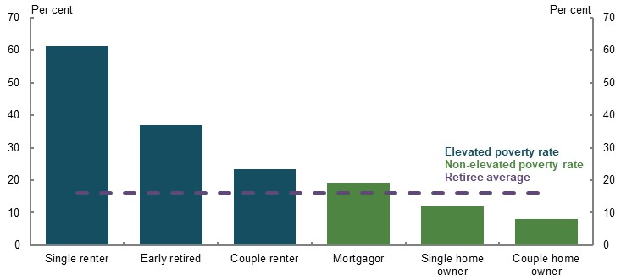
Note: Data relates to 2017-18 financial year. Elevated poverty rate defined as 5 percentage points above retiree average. Retirees are where household reference person is aged 65 and over. There is overlap between some categories, for example, early retired and renter categories. Early retired means aged 55-64 and not in the labour force. Housing costs includes the value of both principal and interest components of mortgage repayments. Source: Analysis of ABS Survey of Income and Housing Confidentialised Unit Record File, 2017-18.

Adequacy of Age Pension
The Age Pension is the main income support for retired Australians with limited financial means. A range of measures suggest the Age Pension has kept pace with community standards. These are:
- With low wages growth in recent years, indexation arrangements have resulted in the maximum Age Pension rate rising faster than wages since 2014. The base rate is currently about 4 per cent above the wages benchmark. For many retirees, the Age Pension provides a higher level of income than they received during their working life.
- In terms of price movements, the Age Pension has increased by 32 per cent since 2010, while the CPI has increased by 20 per cent (Chart 2).
- On international comparisons, the Age Pension is equal to 27.8 per cent of gross earnings, placing Australia eighth out of 36 OECD countries. However, this measure does not take into account the range of other government support Australian retirees receive.
- The maximum rate of the Age Pension is also above available absolute poverty benchmarks, such as the Henderson Poverty Line. Such benchmarks, however, do not indicate whether the Age Pension is keeping pace with community standards.
- Increase in the value of price indices, wages and the Age Pension since 2010
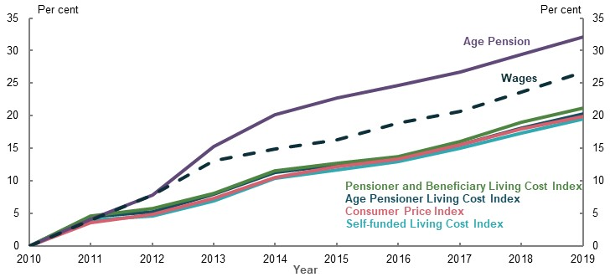
Note: Measures growth in value of indices since 1 July 2010. Wages is based on average weekly earnings, in original terms. Source: Analysis of (ABS, 2020e) (ABS, 2020q), and data provided by the Treasury.

The wellbeing of retirees
Wellbeing indicators offer another basis to assess whether retirees have a minimum standard of living. These indicators incorporate not only the impact of the Age Pension but also other forms of support. These indicators suggest that overall:
- Retirees generally have higher levels of financial satisfaction than working-age people across the income distribution
- Rates of financial stress generally decline as households approach and enter retirement
Two groups, however, have levels of financial stress well above people below age 65: those renting in retirement and those who are involuntarily retired before Age Pension eligibility age.
About one-quarter of retirees who rent privately are in financial stress, primarily because of high housing costs. Commonwealth Rent Assistance covers 75 per cent of rental costs above a minimum threshold and is capped at a maximum amount (around $300 per fortnight for a single without dependent children). Market rents are significantly above this level.
Twenty-eight per cent of early retirees are in financial stress. Renters who retire before Age Pension eligibility age have the highest level of financial stress in retirement.

Income poverty measures
Income poverty measures have limitations because they are solely based on the retiree’s income. The OECD measure of income poverty suggests poverty rates among retirees in Australia are high. But this measure does not make allowance for high rates of home ownership in Australia, which reduces housing costs in retirement and boosts living standards.
While measures of income poverty have limitations, they are useful in identifying those groups falling behind. The incidence of income poverty among older Australians has fallen over the past decade. The changes to the Age Pension in 2009 led to a large reduction in rates of income poverty. However, and consistent with the indications of retirees in financial stress, retiree renters on the Age Pension have income poverty rates well in excess of other retirees and working-age groups.

Increasing Commonwealth Rent Assistance
Because many retired renters achieve poor outcomes in terms of financial distress and income poverty, a number of submissions suggested that Commonwealth Rent Assistance be increased. Several suggested the maximum rate of Commonwealth Rent Assistance be increased by 40 per cent.
The review assessed the impact of such an increase. The maximum fortnightly payment for singles without dependent children is currently $139.60. Payments are indexed to the CPI. A 40 per cent increase in the maximum Commonwealth Rent Assistance payment would not be sufficient to significantly reduce income poverty among retiree renters. It would only narrow the gap in the income poverty rate between renters and home owners by around 11 per cent. Nor would it do much to reduce the inequality between home owners and renters. This reflects that even after the increase, Commonwealth Rent Assistance would be a small proportion of the housing expenses faced by renters compared to home owners. The fiscal cost of such a change in Commonwealth Rent Assistance for Age Pension recipients is estimated at about $0.4 billion in 2019-20. The cost for all Commonwealth Rent Assistance recipients is estimated to be about $1.7 billion in 2019-20.
A larger increase in the maximum rate of Commonwealth Rent Assistance would not have a meaningful impact on reducing income poverty among retiree renters. An alternative approach to assisting lower-income renters in retirement may be required.

Maintaining living standards in retirement
The second element of the adequacy objective of the retirement income system is to maintain living standards in retirement. This involves smoothing consumption over working life and retirement. Saving for retirement involves forgoing consumption during working years to have the income to support consumption in retirement. Most people would not save enough voluntarily for their retirement on their own. Government intervention is required, such as the SG. Without Government intervention, many people would experience a reduction in living standards in retirement.
An individual can choose how much to save for their retirement and as such, how much consumption they are prepared to forgo in their working years. When there is compulsory saving for retirement by all employees, the aim should be to set a rate that balances pre- and post-retirement living standards. A rate of compulsory superannuation that would result in people having an increase in their living standards in retirement may involve an unacceptable reduction in living standards prior to retirement.
The review considered the trade-off between the SG and wages in detail. The weight of evidence suggests the majority of increases in the SG come at the expense of growth in take-home wages. This view is based on empirical research, economic theory, evidence across a number of countries, and the original policy intent of the SG. This is detailed in the report.

How the system currently maintains living standards in retirement
Lower-income earners (defined as bottom 30 per cent of all income earners) primarily rely on the Age Pension to support their standard of living in retirement. For many lower-income earners, living standards improve when they receive Age Pension payments. They may have made SG contributions and will have some superannuation (although balances will tend to be small) to supplement the Age Pension.
Middle-income earners require a combination of superannuation, voluntary savings and the Age Pension to maintain their living standards in retirement. While compulsory superannuation is an important component and its importance will grow as the system matures, it alone is not sufficient to maintain their living standards. It has to be supplemented by the Age Pension. Home ownership is generally an important factor influencing whether these retirees achieve an adequate retirement income.
Higher-income earners (top 20 per cent of all earners) generally do not receive the Age Pension and rely on the SG, voluntary superannuation, along with other savings and their home to maintain their living standards in retirement.

Measuring whether retirement income is adequate
Submissions proposed two ways to measure the adequacy of retirement incomes — a budget standard or a replacement rate.
The budget standard is a level of income required to purchase a basket of goods and services. The ASFA ‘comfortable retirement standard’ is often quoted as an appropriate benchmark. Specifying a dollar amount for a retirement income goal is easy for people to understand.
Using a budget standard as a benchmark for the system has major shortcomings. These include: the standard is designed for a specific group of people (the ASFA standard was originally designed for the top 20 per cent of income earners); they are subjective and the specified basket of goods may not be adequate or preferred by all; and it does not allow for the trade-off between retirement and working life. For example, the ASFA comfortable retirement standard would deliver a middle-income earner a higher standard of living in retirement than in their working life and would require a significant sacrifice in their working life to achieve this retirement standard.
Replacement rates are the most appropriate metric for assessing whether the retirement income system maintains living standards in retirement. They compare income in retirement with income while working and align with the objective of achieving a reasonable balance between living standards in working life and retirement.
The review has used a replacement rate benchmark of 65-75 per cent of disposable working-life income to assess the adequacy of retirement incomes. Evidence suggests this proportion of working-life income will allow most retirees, particularly middle-income earners, to maintain their standard of living in retirement. People generally have lower expenses in retirement, such as having paid off their home, not facing the cost of raising and educating children, and no longer needing to save for retirement.
A 65-75 per cent benchmark is broadly applicable to a wide group of retirees. However, renters require a higher replacement rate than home owners because they have higher housing costs. Lower-income earners need high replacement rates to achieve a minimum standard of living in retirement, and higher-income earners have significant savings and can maintain their standard of living with lower replacement rates.

Rate of growth of spending in retirement
The rate of growth of spending in retirement will influence whether a retiree’s income is adequate for all their retirement years. The evidence points to retirees’ needs growing in line with prices. In projections undertaken for the review, the deflator for incomes in retirement is the CPI.
The outcomes are significantly different if retirement incomes were deflated by wages. Basing replacement rates on wage-linked spending would require a level of saving that would come at a significant cost to living standards in working life.

Outcomes for current retirees
The outcomes for current retirees are influenced by past policy settings, but they give an insight as to whether the system will achieve adequate outcomes.
For retirees aged 65-74 in 2017-18, the replacement rates for middle- to higher-income earners are estimated to be generally adequate. For many lower-income earners the replacement rate is estimated to be above 100 per cent.
Qualitative surveys of retirees’ wellbeing also suggest that many are maintaining their working-age living standards into retirement. The surveys suggest that current retirees:
- Generally feel happier in retirement than in working life
- Typically have the same level of satisfaction with their finances compared to just before retirement and are less financially stressed than employed people
- Are worse off financially in about 30 per cent of cases, with involuntary retirement a major cause

Outcomes for future retirees
Future replacement rates were estimated for people with typical working lives, including individuals overall, singles, couples and women. The assumptions underlying any modelling are important. The assumptions used for this review are outlined in detail in in the report. Substantial sensitivity analysis was undertaken to assess outcomes with different assumptions.
The central case involved SG payments in line with planned legislated increases. The SG is 9.5 per cent to 2020-21, increasing by half a percentage point every financial year until reaching 12 per cent in July 2025. Also estimated were the outcomes if the SG stayed at 9.5 per cent.
Future retirement outcomes were modelled on the basis that retirees use their superannuation assets to fund their living standards in retirement. Importantly, and in line with the policy intent of the retirement income system, it was assumed that retirees will run down their superannuation assets by age 92. It is also assumed that they will not leave bequests and will purchase a longevity product at retirement that provides them with income from age 92.
That people use all their superannuation in retirement is a critical assumption in assessing whether the system can deliver adequate retirement incomes. While this is a usual assumption for most modelling of replacement rates, it is not in line with the way retirees currently behave. Most retirees die with the bulk of their wealth intact. However, the assumption that retirees use their assets more effectively in retirement highlights the outcomes that the system can deliver. One of the alternative assumptions modelled includes outcomes based on how retirees currently use their assets in retirement. Contrasting this outcome with the central case assumption helps to highlight the gains in retirement income that retirees can achieve through using their assets more effectively.
Many people misunderstand the purpose of superannuation, believing that in retirement they should only draw on the return from the investment of their retirement savings and not touch the capital amount. Yet the system is designed on the basis that people should draw down their savings to support them in retirement.
The projected replacement rates vary across income levels but on the basis of the central case assumptions they exceed the 65-75 per cent benchmark across the range of different household types that were modelled (Chart 3). On the whole, they exceed the benchmark replacement rate for people in the bottom 60 per cent of the income distribution.
Such high replacement rates suggest that some people may be saving ‘too much’ for their retirement. This is particularly important for lower- to middle-income earners because most of their superannuation contributions are through the SG and they do not have the option of reducing their contributions.
- Projection of replacement rates
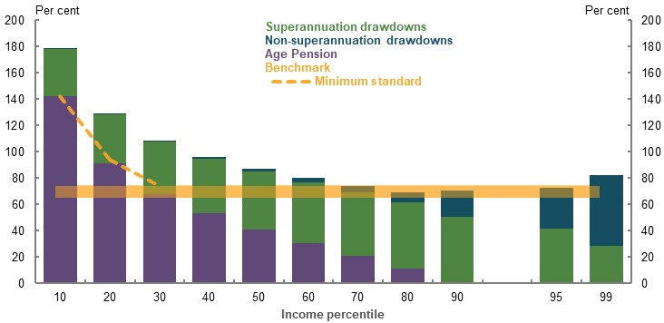
Note: Minimum standard is the maximum rate of Age Pension. Replacement rates are projected for individuals commencing work in 2020 and retiring in 2060. Source: Cameo modelling undertaken for the review.
When tested under different assumptions — such as shorter working life, lower wages and lower investment returns — replacement rates are within or above the 65-75 per cent range for most income levels. A major reason that incomes remain adequate under different assumptions is the Age Pension offsetting any resulting reduction in retirement income for middle-income earners.
Sensitivity testing identified some cases where median- or average-income earners will not achieve the benchmark replacement rate. These include people with working lives less than 30 years and retiring at age 60.
Changes in financial markets, such as the decline in equity values in response to the COVID-19 Pandemic, can impact retirement outcomes. But in a market downturn, the returns achieved by superannuation funds tend to be less volatile than market values because the funds have diversified portfolios. For retirees, the Age Pension is also a significant buffer to investment earnings volatility. A decline in the value of assets and income from investments can be offset to some extent if it results in increasing a person’s eligibility for Age Pension payments under the means test. And history shows that in the long run, the investment of superannuation savings has resulted in solid returns.
If people do not use their retirement savings efficiently, many will not be able to maintain their living standards in retirement even with higher SG contributions. For example, if people draw down their superannuation balances at the legislated minimum rate, as many do, those in the top half of the income distribution will not achieve a 65-75 per cent replacement rate, even with the SG rate going to 12 per cent.

Maintaining the SG rate
A number of submissions called for the SG rate to be maintained at 9.5 per cent. Towards improving understanding of the impact of the legislated increase in the SG rate to 12 per cent, the review considered the implications of maintaining the SG rate at 9.5 per cent.
Projections suggest that maintaining the SG rate at 9.5 per cent would:
- Lead to lower superannuation balances at all income levels than when the SG rate goes to 12 per cent.
- Result in lower- and middle-income earners having replacement rates within or above the 65-75 per cent benchmark if they efficiently drew down their retirement savings (Chart 4). The replacement rates for some higher-income groups are close to the benchmark.
- Replacement rates by SG rate and household type
Individuals | Couples
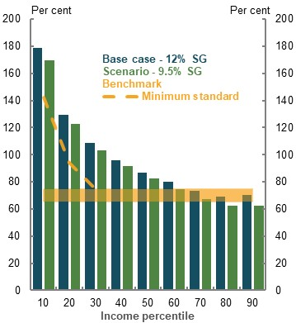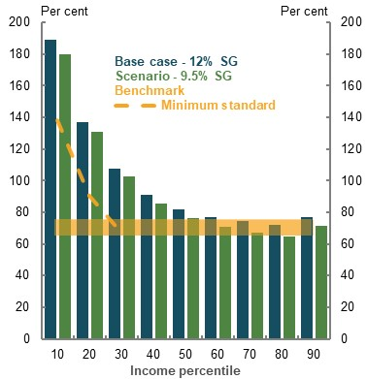
Note: Deflated using review’s mixed deflator. Source: Cameo modelling undertaken for the review.
- Allow people to have higher incomes during their working life while still being able to maintain their living standards in retirement, if they used their retirement savings more efficiently. Incomes during working life are estimated to be 2 per cent higher in the longer run.
- Demonstrate the importance of efficient use of savings in retirement. If the SG rate remained at 9.5 per cent and people made more efficient use of their retirement savings, many would have higher replacement rates than they would have with the SG at 12 per cent and drawing down their balances at the legislated minimum rate (Chart 5).
- Projected replacement rates by SG rate and drawdown strategy
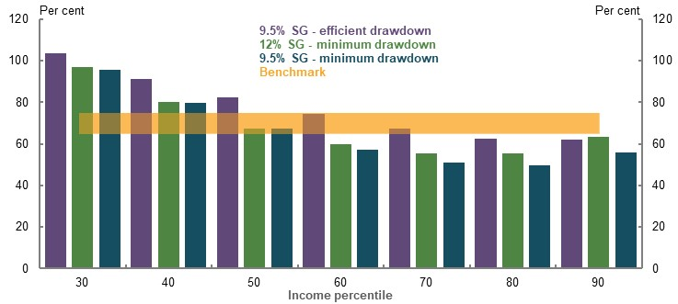
Note: Minimum drawdown based on legislated minimum rates by age. Minimum drawdown rate scenarios do not include people purchasing a longevity product. Efficient drawdown based on review strategy where superannuation assets are fully consumed by age 92 and a longevity product. Source: Cameo modelling undertaken for the review.
- Avoid the increase in inequities associated with an increase in the SG. For example, an increase in the SG benefits men more than women.
- Result in a net increase in tax revenue, rising to around $3 billion per year by 2030. Higher tax receipts from the reduction in superannuation tax concessions would exceed increased Age Pension expenditure until the late 2050s.

Options to boost retirement outcomes
Much of the focus on the retirement income system is currently on the superannuation balances people may need in retirement. Often, the final balance is not spoken of in income terms, and the interaction with the Age Pension in supplementing the retirement income of lower- and middle-income earners is ignored. An area where there is insufficient attention is how the use of a retiree’s assets can significantly influence retirement outcomes.
In addition to increasing superannuation contributions or other savings, people have a number of options to boost their retirement income, including:
- More effectively drawing on superannuation assets. If drawdown rates increase from currently observed rates to those assumed in the central case in the modelling for the review, replacement rates could rise by 11 percentage points for the median-income earner retiring in 2060. In addition, all income levels would achieve replacement rates within or above 65-75 per cent.
- Achieving better-after-fee returns, in particular implementing the recommendations in the Productivity Commission’s report, Superannuation: Assessing Efficiency and Competitiveness, would reduce fees and improve market returns for many people, resulting in higher retirement outcomes.
- Accessing the equity in the home. Using relatively small portions of home equity through the Pension Loans Scheme or similar equity release products can substantially improve retirement incomes for many people.

Equity
The performance of the retirement income system was assessed against the two suggested aspects of equity:
- The system should target Government support to those in need
- The system should provide similar outcomes for people in similar circumstances
The review also considered retirement outcomes for many of the groups identified in submissions as being inequitable. These included women, people who retire involuntarily, those excluded from the SG, renters, people with different income and wealth, those with disabilities, and Aboriginal and Torres Strait Islander people. Intergenerational equity was also considered.

Retirement income system or working-life inequities?
When considering groups of people with low (or lower) retirement incomes compared with others, consideration should be given to whether the retirement income system is exacerbating or compensating for inequities these people experience in their working lives.
A summary of the retirement outcomes of various groups of people follows. The overall assessment is that given superannuation is an employment-based scheme, superannuation balances people take into retirement broadly reflect working-life inequities. An individual’s superannuation balance at retirement will reflect their employment experience: their income, length of time in the workforce, whether working full-time, part-time or casually, and whether they receive the SG. Higher superannuation balances receive larger tax concessions and can support higher retirement incomes.
In retirement, the Age Pension helps to offset some of the inequities people faced during their working life. Those who have not had the same level of engagement in the labour market as others, for whatever reason, generally have a much lower level of superannuation and other savings in retirement. But, they typically receive higher rates of Age Pension as a result of the means test.
Some aspects of the design of the retirement income system, while not targeted at any particular group of people, have a relatively larger impact on some groups over others as the following sections show.

Equity: Income and wealth distribution
Since superannuation is an employment-based scheme, full-time, higher-income and continuously employed people make more superannuation contributions, have higher superannuation balances and achieve higher retirement incomes than lower- and middle-income people. A person’s earnings and length of time in the workforce translates into higher superannuation balances and retirement incomes.
Higher-income earners also receive more superannuation tax concessions than lower- and middle-income earners. They receive the largest tax savings as a percentage of superannuation contributions over their lifetime, along with the largest tax concessions on superannuation earnings.
Most people, but particularly higher-income earners, pay less tax when they save through superannuation compared with other savings vehicles. The taxes on superannuation have a relatively flat structure, while income tax is more progressive.
Higher-income earners make larger contributions to superannuation than lower- and middle-income earners. However, on average, even the highest income earners contribute less than the caps on contributions.
Many very large superannuation balances were built up under previous higher contributions caps and are expected to stay in the system for several decades. At June 2018, there were more than 11,000 people with a balance in excess of $5 million. These people receive very large tax concessions on their earnings. A superannuation balance of $5 million can achieve annual earnings tax concessions of around $70,000.
Voluntary (pre- and post-tax) superannuation contributions are predominantly made by older, higher-income or wealthy people. Average pre-tax voluntary contributions increase with age and peak just before 65. Average post-tax voluntary contributions are much higher for people aged between 60-64 compared with younger people.
With higher-income earners receiving more superannuation tax concessions than lower- and middle-income earners, the superannuation tax concession component of Government support increases inequality of private incomes for people aged 65 and over.
In retirement, however, income inequality reduces due to the Age Pension and benefits from government services, termed social transfers in kind. Because of the means test, people with the lowest lifetime incomes generally receive the largest Age Pension payments. The Age Pension reduces income inequality among retirees because it provides most support as a proportion of private incomes to lower-income earners. Income inequality among retirees is similar to people of working age (Chart 6).
- Income inequality in 2017-18
People aged 25-64 | People aged 65 and over
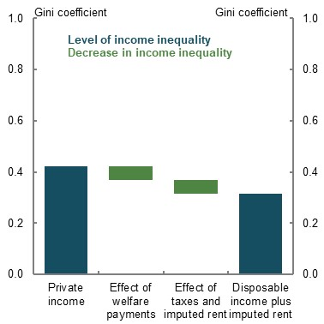 | 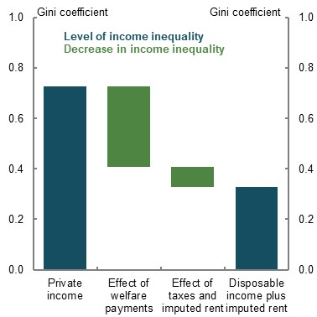
Note: Income inequality is measured by calculating the Gini coefficient. The Gini coefficient is a value between 0 and 1. A value of 0 means that all people have the same incomes (i.e. complete equality), while a value of 1 means all income is received by one person (i.e. complete inequality). Private income refers to income from employment, businesses and investments, such as rent, dividends, royalties and superannuation earnings. Welfare payments include pensions and allowances received by the aged, disabled, unemployed and sick persons, families and children, veterans or their survivors, study allowances for students and all overseas pensions and benefits. Taxes include individual income taxes. Disposable income is equal to private income plus welfare payments less taxes. Imputed rent is the amount that a home owner saves by not having to pay rent for accommodation. All income definitions are equivalised for household size. Age of household is the age of the household’s reference person. Source: Analysis of ABS Survey of Income and Housing Confidentialised Unit Record File, 2017-18.
The way the Age Pension means test operates (separately assessing a person’s level of assets and income to determine their Age Pension payment) results in people with different levels of assets and/or income receiving the same rate of Age Pension in some circumstances. Some assets and income are also treated differently under the means test.
Overall, superannuation tax concessions increase inequity in the retirement income system, while the Age Pension helps offset inequity in retirement. One of the suggested elements of the retirement income system’s objective is that Government support should be targeted to those in need. This would appear to be the case for the Age Pension. However, the combination of a system where people on higher incomes achieve the largest superannuation balances, combined with tax concessions on superannuation contributions and earnings, means that higher-income earners receive more Government support than other income groups over their lifetime (Chart 7).
- Projected lifetime Government support from the retirement income system
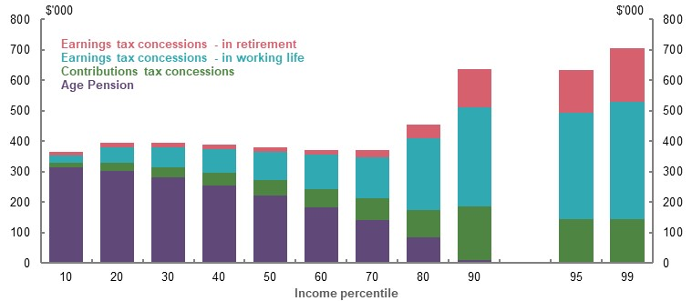
Note: Values are in 2019-20 dollars, deflated using the review’s GDP deflator and uses review assumptions (see Appendix 6A. Detailed modelling methods and assumptions). Income percentiles are based on the incomes of individuals (whether they are single or in a couple). Source: Cameo modelling undertaken for the review.
Increases in the SG rate will increase lifetime Government support for higher-income earners by more than lower- and middle-income earners. Higher-income earners make the largest compulsory contributions. They either do not qualify for, or lose minimal, Age Pension when they retire with higher superannuation balances.
Changes to superannuation tax concessions would have the largest impact on higher-income earners. Further improvements in targeting superannuation tax concessions would improve the equity of the retirement income system.

Equity: Gender and partnered status
Many stakeholders focused on gender inequity in the retirement income system, referring to men having higher superannuation balances at retirement than women, and in turn, having higher retirement incomes than women. In 2017-18, the gap in the median superannuation balance between men and women aged 60-64 was 22 per cent.
The gap in retirement savings and retirement incomes for women is the accumulated result of the economic disadvantages faced by women in their working life — lower wages than men, more career breaks for child-rearing and caring for others, and more part-time work. The financial impacts from divorce and relationship breakdowns are also worse for women.
Across men and women who work full-time, the pay gap is 17 per cent. More than 93 per cent of all primary carer leave is taken by women. Research suggests having children is associated with a reduction in earnings of up to 80 per cent on average over the following 15 years, compared to women with no children.
The higher life expectancy of women means their superannuation balances at retirement need to stretch further.
As the superannuation system matures, a greater number of women (and men) are expected to have larger superannuation balances. Female superannuation coverage is increasing with female labour force participation. In future, the gap between the superannuation balances of men and women will narrow substantially; however, it will not close while a gap remains in earnings and workforce participation.
The gap between the retirement incomes of men and women is narrower than the gap in working-life earnings and superannuation balances. This is primarily due to the Age Pension, which helps offset some of the inequity women face in their working life. And with lower superannuation balances than men, women generally receive higher rates of the Age Pension than men because of the means test (Chart 8).
- Projected gender gaps in working-life earnings, superannuation balances at retirement and retirement incomes, by income percentile
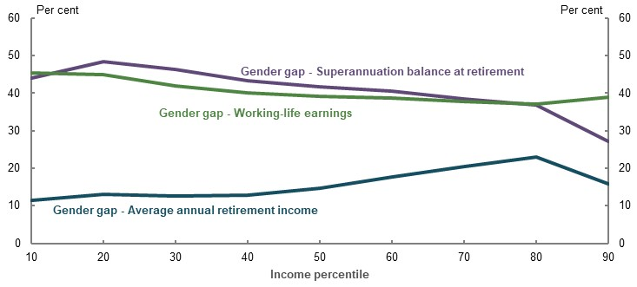
Note: Gender gaps are calculated relative to the relevant figure for men — that is, a 10 per cent gender gap in earnings means that women’s earnings are 90 per cent of men’s earnings. See Box 3B-3 in 3B. Gender and partnered status for details. The chart compares the 10th percentile for men to the 10th percentile for women, and so on. Gaps in superannuation balances at retirement and retirement incomes do not factor in the effect of voluntary superannuation contributions not made through salary sacrifice. If included, these would reduce the gaps between men and women. Calculations are based on values deflated using the review’s mixed deflator. Disaggregation of these gaps can be found in Appendix 6D. Supplementary equity charts. Source: Cameo modelling undertaken for the review.
While most people enter retirement as a couple, this trend is falling. In future there will be more single people in retirement, particularly women. Couples are significantly better off in retirement than single men and women. They have lower rates of poverty and financial stress, higher rates of home ownership and higher levels of wealth than single men and women in retirement.
Stakeholders identified a number of changes to aspects of the retirement income system aimed at reducing the gap in retirement incomes between men and women. These included:
- Removing the $450-a-month threshold when employers are obligated to pay the SG to employees. This would help low-income workers and would assist more women than men. Around 63 per cent of people earning below the $450-a-month threshold are women. Although removing the $450-a-month threshold would have a small effect on retirement incomes, it would improve gender equity in SG coverage.
- Paying superannuation on employer paid parental leave and Government Parental Leave Pay. This would have a small impact on narrowing the retirement income gap between some women and men, improving gender equity in SG coverage. Receiving superannuation on paid parental leave and Parental Leave Pay would reduce, to a small degree, the impacts of career breaks taken by women to raise children.
- Disclosing superannuation balances in divorce settlements. Superannuation is generally able to be divided up in family property settlement following a divorce, although it is challenging to ensure that all superannuation assets are disclosed. A measure was announced in 2018 but has yet to be implemented, whereby the ATO could provide accurate and timely information to courts on superannuation balances.
- Reducing superannuation tax concessions for higher-income earners. Superannuation tax concessions predominantly benefit higher-income earners and there are more higher-income men than women. Reducing superannuation tax concessions for higher-income earners would reduce the degree to which gender gaps in working-life incomes translate into gaps in superannuation balances.
- Increased support for lower-income retirees who rent. This would assist women because more women than men rent in retirement.
- Increasing the SG rate. Increasing the SG rate would not reduce the gender superannuation balance gap and would benefit the retirement incomes of men more than women.

Equity: Home ownership status
The retirement income system does not appear to be delivering an appropriate standard of living for many retiree renters. Owning a home has a positive influence on a person’s standard of living in retirement. Whereas, in retirement, renters have higher levels of financial stress. A significant proportion of retiree households that rent are in income poverty, which is even higher for single retiree renters.
Retiree renters have much higher housing expenditure than retirees who own their home. Consequently, renters have lower disposable income after housing costs. Although Commonwealth Rent Assistance provides additional support to retiree renters, it is far below the level that would bridge the gap in their living standards compared to home owners.
Renters and home owners may have different outcomes in retirement. The question is whether this is influenced by the structure of the retirement income system, or whether it reflects other influences. For example, it may reflect that renters do not have sufficient financial capacity during their working lives to buy a house. Compared to renters, home owners in retirement generally have higher levels of wealth. In addition, some retirees may be renting because of relationship breakdowns.
A key aspect of the retirement income system favouring home owners is that the principal residence is excluded from the assets test for the Age Pension. Regardless of the value of the house, a home owner can receive the same Age Pension as a renter (Chart 9), all other things being equal.
- Distribution of home values among age pensioners who own their home
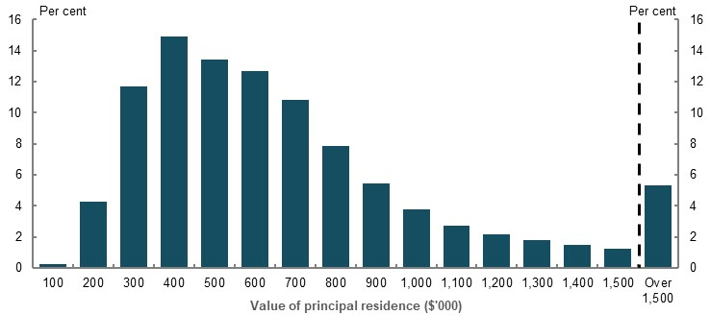
Note: Horizontal axis labels indicate home values up to that amount (e.g. $200,000 includes homes over $100,000 up to $200,000). Source: Department of Social Services analysis of payment data, June 2018.
This suggests that wealthier retirees (in terms of the value of their homes), can receive the same Government assistance as those less wealthy (either retirees who rent or home owners with houses of lesser value).
Renters have a higher assets test free area, although only a small proportion of retirees benefit from the higher threshold. Nevertheless, those renters who hold wealth above the Age Pension assets test free area in forms other than a house receive less support than home owners with the same level of wealth. The renter will receive less Age Pension than the home owner. As such, they will have to self-fund a higher proportion of their retirement income compared with a home owner.
The declining trend in home ownership among Australians has created concerns that an increasing number of retirees may be renting in future. This is an important factor to consider in terms of whether the retirement income system will be able to continue to deliver adequate retirement outcomes. It may also increasingly bring into question whether home owners and renters are treated equally in the retirement income system.
Some stakeholders suggested that if a retiree’s principal residence was part of the Age Pension assets test, this would help equate the treatment of home owners and renters. If the home were included in the assets test, some home owners would no longer be eligible for the Age Pension. Others would receive less Age Pension. In response, home owners may be more inclined to access the equity in their home to fund their retirement. To the extent that this takes place, home owners would be self-funding their retirement income to a greater extent than at present. This would be more in line with what is currently the case for retiree renters with a similar level of wealth as home owners. One of this report’s themes is that a more optimal retirement income system would involve retirees more effectively drawing on all their assets, including the equity in their home, to fund their standard of living in retirement.
Renters on the Age Pension and with low wealth need additional assistance to bring their retirement income more in line with minimum standards of adequacy, which is a suggested objective for the system. This would help reduce levels of income poverty and financial stress.
Many stakeholders called for an increase in Commonwealth Rent Assistance to address the difficulties facing lower-income retirees who rent. About 22 per cent of all recipients of Commonwealth Rent Assistance receive the Age Pension. It is part of the broader social welfare system, and changing the rate of Commonwealth Rent Assistance would affect more than just Age Pension recipients. The review assessed the implications of increasing the rate of Commonwealth Rent Assistance. It would not have a meaningful impact on reducing income poverty among retiree renters.

Equity: SG coverage
The SG is a mandatory entitlement for most employees and does not cover the self-employed (around 17 per cent of the workforce). Around 90 per cent of employees are covered by the SG. Some employees are excluded.
The main exemption is employees who earn less than $450 before tax in a calendar month with an individual employer. About 300,000 people, or 3 per cent of employees, are affected by this exemption. They are mainly young, lower-income, part-time workers — around 63 per cent are female. The exemption means affected workers receive less remuneration for the same hour of work as an unaffected colleague.
The original reason for the $450-a-month threshold was to reduce the administrative burden on employers. But this reason has diminished with the digitalisation of payrolls. Measures have also been taken to reduce the impact of fees and insurance premiums on small balances, which was another reason for the threshold.
Removing the $450-a-month threshold for SG payments would not materially improve retirement outcomes, but would improve equity of the system, particularly for women and lower-income workers.
Another exemption from SG coverage is overtime pay. The salary base for the SG is ordinary time earnings, which excludes overtime pay. Overtime is significant in some industries (such as mining, construction and manufacturing). Forgone SG on overtime can significantly affect the superannuation balances and retirement incomes of the employees affected. Applying the SG to ordinary time earnings is a legacy from the occupational superannuation arrangements prior to the SG. Including overtime pay within the coverage of the SG would improve the equity of the system.
Not all employers meet their obligation and make SG payments to their employees’ superannuation accounts (the ‘SG gap’). The total amount of the SG owed to employees was estimated to be about $2.3 billion in 2016-17. Lower-income workers in accommodation and food services, and construction are particularly affected. Young employees missing out on the SG are significantly impacted because they miss out on the benefits of compounding returns. Generally, those not making required SG payments are smaller employers.
Developments such as Single Touch Payroll require employers to report tax and SG information to the ATO at the same time they pay their employees. This will improve and expedite ATO oversight of SG compliance. On average, non-compliance continues for around 18 months, which reduces employee superannuation balances – especially if the company becomes insolvent and is unable to make good the deficit.
The self-employed are not required to contribute to a superannuation fund on their own behalf. There are approximately 2.2 million self-employed people. Requiring self-employed people to make SG payments on their behalf would boost their superannuation balances and diversify their retirement savings. But it would reduce their ability to invest in their businesses. It would also be difficult to determine the equivalent contribution base for the self-employed.
Self-employed people generally have lower superannuation balances than employees. But many have other assets, such as business assets, which result in them having similar wealth profiles as employees when approaching retirement. Small business owners also benefit from a number of capital gains tax concessions.
Sham contracting may see some employees misclassified as contractors and missing out on the SG. Enforcing sham contracting laws would help these people receive SG payments.
The superannuation balances of gig economy workers may be lower than those of employees because of forgone SG. The difference is likely to be small because the gig economy is not the primary source of income for most people.
Stakeholders identified a number of changes to SG coverage aimed at improving equity within the retirement income system. These include:
- Removing the $450-a-month threshold. This would improve equity of the system, particularly for lower-income women but would not materially improve retirement outcomes.
- Expanding the earnings base that attracts the SG to include overtime. This would boost superannuation balances and retirement outcomes of about 20 per cent of employees, particularly in mining, manufacturing and construction jobs.
- Continuing to ensure people receive the SG they are entitled to, through increased transparency to employees and the ATO of SG obligations and payments.
- Paying the SG at the same time as wages. This would make it easier for employees to monitor SG compliance. While this would reduce the time employers have to meet their SG obligations, it would limit the build-up of SG liabilities.
- Enforcing sham contracting laws to ensure that employees receive their SG entitlements.

Equity: Age of retirement
A large number of people do not choose when to retire (Chart 10). They may lose their job and cannot obtain another. They are effectively forced to ‘retire’ from the workforce earlier than they intended and with less retirement savings than they planned.
Involuntary retirement before Age Pension eligibility age is more common among people with lower wealth and people with lower education levels. It is also more prevalent in blue-collar occupations.
- Proportion of people retiring, by retirement age and reason
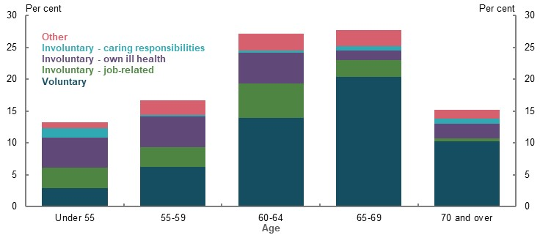
Note: Proportion is of people who retired between July 2013 and June 2019. Assumes the age of retirement is equal to the age of ceasing last job. The reasons for involuntary retirement are split into own ill health, job-related and caring responsibilities. Own ill health is from ‘own sickness, injury or disability’ response. Job-related is from ‘retrenched/dismissed/no work available’, ‘own business closed down for economic reasons’, and ‘unsatisfactory work arrangements’ responses. Caring responsibilities is from ‘to care for children/pregnancy’ and ‘to care for ill/disabled/elderly’ responses. Given the small sample size of the two response options that make up the ‘caring responsibilities’ category, these figures should be used with caution. Source: Analysis of (ABS, 2020p).
People aged 55 and over have similar levels of unemployment and underemployment as people aged 25-54, although they are generally unemployed or underemployed for longer periods than those at younger ages.
A person who retires before Age Pension eligibility age generally has lower levels of retirement savings and wealth, and in turn, lower retirement incomes than if they retired after reaching Age Pension eligibility age. They are also more likely to spend some of their retirement savings before becoming eligible to receive the Age Pension. However, the impact of their lower retirement savings is moderated somewhat through Government pensions and allowances, especially the Age Pension, and social transfers in kind.
JobSeeker Payment is the main income support for many involuntary retirees until they reach Age Pension eligibility age. In some situations, the difference between the Age Pension rate and the standard JobSeeker Payment rate results in a substantial increase in income when an involuntary retiree becomes eligible for the Age Pension. In contrast, significant numbers of involuntary retirees receive the Disability Support Pension or Carer Payment, which delivers roughly the same social security income as the Age Pension.
Increasing the superannuation preservation age or the Age Pension eligibility age would adversely affect a significant number of people who retire involuntarily before these ages.
It is challenging for retirement income settings to cater for people who retire early and involuntarily. Factors to consider include:
- Setting the SG rate high enough to compensate for the possibility of involuntary, early retirement would result in many people being required to save more than they need for an adequate retirement income. This would come at the expense of their standard of living during their working lives.
- Lowering the Age Pension eligibility age only for people in certain industries or occupations who are more likely to retire involuntarily, would be difficult to administer and may lead to inconsistent outcomes between similar people. Moreover, the eligibility age for the Age Pension is currently a major factor influencing when people choose to retire. Lowering the eligibility age for the Age Pension could encourage people to voluntarily retire at an earlier age. This would leave them with lower retirement savings to support them over a longer period of retirement. It would also increase pressure on the sustainability of the Age Pension.
- One of the main equity concerns raised in submissions was that many early, involuntary retirees relied on Newstart Allowance payments, which were significantly below the payment rate of the Age Pension. More generally, many stakeholders said the rate of Newstart Allowance was too low. The JobSeeker Payment has replaced Newstart Allowance and the JobSeeker Payment rate has been temporarily increased as part of the Government’s response to the COVID-19 Pandemic. As the JobSeeker Payment is available to people who are not in full-time work and meet the eligibility requirements, any change to the payment rate would need to consider broader policy objectives.
Using the income support system is a more efficient and targeted way of supporting those who retire early and involuntarily.
Retiring beyond Age Pension eligibility age increases retirement incomes. This is primarily driven by investment returns, compounding returns and fewer years in retirement.

Equity: Aboriginal and Torres Strait Islander people
The working-life inequities of Aboriginal and Torres Strait Islander people translate into inequities in retirement incomes. They also face additional challenges that reduce their ability to engage with the retirement income system.
On average, Aboriginal and Torres Strait Islander people have lower superannuation balances and retirement incomes than the total population.
Lower retirement incomes than the total population reflect working-life disadvantages: lower wages, lower labour force participation, lower private savings and rates of home ownership, lower rates of SG coverage and higher rates of disability and involuntary retirement.
Aboriginal and Torres Strait Islander people also face challenges such as accessing banking and financial services, identification verification and laws that do not recognise kinship structures. These challenges are compounded by mistrust in the system due to historical injustices, and generally lower levels of financial literacy compared to the total population.
Aboriginal and Torres Strait Islander people have lower life expectancies compared with the rest of the population. This means that Aboriginal and Torres Strait Islander people are less likely to reach superannuation preservation age, resulting in unspent retirement savings. Those reaching retirement spend less time on the Age Pension compared with the total population.
In retirement, the Age Pension significantly reduces working-life income inequality between Aboriginal and Torres Strait Islander people and non-Indigenous people. Aboriginal and Torres Strait Islander people are more likely to receive the maximum rate of the Age Pension than non-Indigenous people.
Increasing the preservation age would further increase the already high proportion of Aboriginal and Torres Strait Islander people who die before accessing their superannuation.
Lowering the preservation age for Aboriginal and Torres Strait Islander people would reduce the probability of them dying before accessing their superannuation, but it may encourage those with a similar life expectancy to the general population to retire early, to the detriment of their retirement incomes.
Increases in the SG rate would have limited effect on the retirement incomes of Aboriginal and Torres Strait Islander people and would come at the expense of working-life income. Given a large proportion of Aboriginal and Torres Strait Islander people are not in the labour force, many are not covered by the SG and would therefore not receive the benefit of an increase in the SG rate.
The rate of the Age Pension is an important factor in determining the retirement income outcomes of Aboriginal and Torres Strait Islander people.

Equity: People with disability
People with disability retire with less superannuation and other savings than those without disability. On average, the more severe a person’s disability, the lower their retirement savings.
The lower average superannuation balances of people with disability reflect lower working-life participation and earnings. The age a person acquires their disability therefore affects their retirement savings: those who acquire their disability later in life are more likely to have higher retirement savings than someone who acquires their disability early in life.
The median weekly income in 2018 of those aged 15-64 with disability was $505, compared with $1,016 for a person without disability. Around 53 per cent of people with disability are in the labour force compared with 84 per cent of people without disability. People with disability are more likely to receive income support prior to retirement.
The Age Pension and social transfers in kind to meet health expenses, help improve retirement income equity relative to working life for those with and without disability. Overall, retirees with disability have similar rates of poverty and financial stress as the total retired population.
Increasing assistance to renters would benefit those with disability, as a larger proportion of people with disability rent in retirement compared with the total population. The Age Pension rate and Pensioner Concession Card are also important in determining whether those with disability have adequate retirement incomes.

Equity: Intergenerational
Intergenerational equity covers cost-sharing across generations. In the case of the retirement income system, the issue is the extent to which the cost of meeting the retirement incomes of one generation is being borne by another.
The superannuation system largely supports intergenerational equity. It encourages people to rely on their own savings to meet their retirement income needs.
The significant tax concessions that support superannuation are broadly consistent with intergenerational equity. Under current arrangements, working-age people mostly pay for and benefit from superannuation tax concessions. Retirees can receive superannuation earnings tax concessions, which are taxpayer funded and hence the cost is borne by working-age people.
The Age Pension involves cost-sharing across generations. Unlike some other countries, Australians do not contribute to a national fund to cover the cost of the Age Pension. This cost is borne by the current working population.
While the Age Pension involves a transfer of income from one generation to another, there is a so-called ‘generational bargain’ where today’s working-age Australians expect the generation after them to support them, such as through funding the Age Pension, in the same way they supported the generation that preceded them (Chart 11).
- Total household taxes and benefits by age
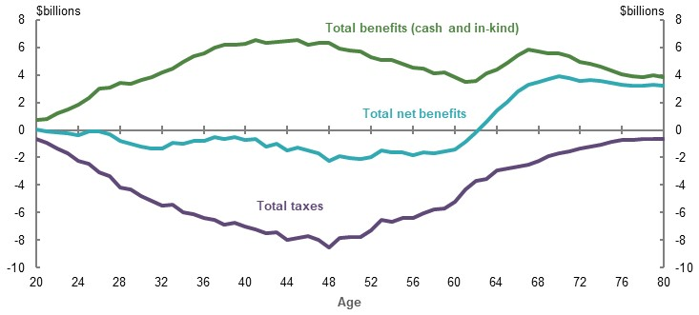
Note: 2015-16 data. Net benefits refers to all taxes paid minus all social transfers (cash and in kind). Source: Replication of (Wood, et al., 2019), which is derived from (ABS, 2018c).
Given the Australian population is ageing and birth rates have fallen, the ratio of working-age people relative to retirees is decreasing. This means the annual cost per working-age person of the Age Pension and superannuation earnings tax concessions retirees receive is expected to rise. This means that successive generations will have to contribute more in dollar terms during their working lives to fund these benefits for retirees.
Whether the cost of the Age Pension and superannuation earnings tax concessions retirees receive is ‘affordable’ to future generations will depend on wage growth. If future real wage growth averages 1 per cent per year, the proportion of income transferred from working-age people to fund these costs is projected to be broadly similar in 40 years’ time. If, however, there is no real wage growth, the cost of the Age Pension and superannuation earnings tax concessions retirees receive as a proportion of the wages of working-age people is projected to rise substantially.
The maturing of the superannuation system will mean more Australians will have higher retirement savings and the proportion of the eligible population receiving the Age Pension will decline. This is expected to reduce the cost of the Age Pension borne by the next generation.
The ability of different generations to accumulate retirement savings has varied:
- Better targeting of superannuation contribution rules has meant older people have had the opportunity to contribute more to superannuation than younger people can.
- Younger people will generally benefit from superannuation contributions across all of their working lives, compared with older people who may have only received superannuation for part of their working years.
- Rising residential property values over recent decades have benefited home owners and increased the wealth of many retirees. A similar growth in property values cannot be assumed for younger home owners. The rise in property prices may preclude some people from becoming home owners.
Inheritances are significant, representing the transfer of wealth from one generation to another. They are not distributed equally and increase inequity within the generation that receives the bequests. Most people die with the majority of wealth they had when they retired. If this does not change, as the superannuation system matures, superannuation balances will be larger when people die, as will inheritances. Superannuation is intended to fund living standards of retirees, not to accumulate wealth to pass to future generations.
Measures stakeholders raised that could impact intergenerational equity included:
- Increasing the SG rate. This would increase the extent of each generation self-funding, as a smaller share of each generation’s retirement incomes would be funded by the Age Pension.
- Encouraging people to spend more of their savings in retirement. This would likely reduce wealth inequality among future generations.

Sustainability
The fiscal cost of the retirement income system is an important factor influencing its sustainability. It has to be consistent with the Australian economy’s capacity to pay.
If Government expenditure on the retirement income system continues to grow faster than the rate of growth of the economy, the sustainability of the system could come into question.
The fiscal cost of the system is best measured as a share of GDP and of the Budget. The two largest costs of the retirement income system are Age Pension expenditure and the cost of superannuation tax concessions. Measuring the cost of superannuation tax concessions is not straightforward because it is not an outlay but revenue forgone. The analysis in this report estimates the cost of superannuation tax concessions by comparing actual revenue received with what might have been received in the absence of the concession, against an income tax benchmark. The rationale for this approach is outlined in detail in the report.
Sustainability not only depends on the capacity of the economy to pay for the cost of the system but also the willingness of the Australian community to do so. This will depend on whether people have confidence in the system and its integrity and believe it to be cost-effective in delivering adequate and equitable outcomes. The system also has to be adaptable to changing circumstances, such as economic shocks.

Future costs of the system
Government expenditure on the Age Pension is projected to fall over the next 40 years from 2.5 per cent of GDP today to 2.3 per cent in 2060.
Around 71 per cent of people over Age Pension eligibility age received Age Pension or other pension payments as at June 2019. Notwithstanding an ageing population, this proportion is projected to fall to 62 per cent in 2060. There is also a shift toward people receiving a part-rate pension (rather than the full-rate pension), rising from 38 per cent of age pensioners today to a projected 63 per cent in 2060. This shift is the result of higher superannuation balances and the impact of the means test, particularly the assets test, in determining eligibility for the Age Pension.
In contrast, as the superannuation system matures, the cost of superannuation tax concessions is projected to grow as a proportion of GDP such that by around 2050 it exceeds the cost of Age Pension expenditure as a per cent of GDP (Chart 12). This is the result of growth in the cost of earnings tax concessions.
The cost of superannuation contributions tax concessions is a function of wages, contribution rates and population growth. However, caps on concessional contributions and tax paid by very high-income earners restrict the growth in the cost of contributions taxes relative to the growth in GDP.
Over the next 40 years, the cost of superannuation earnings tax concessions is projected to grow as a percentage of GDP. The cost of earnings tax concessions is a function of the growth in the size of superannuation balances and the projected rate of return. Both of those are projected to exceed the projected growth in GDP.
- Projected costs of the retirement income system as a per cent of GDP
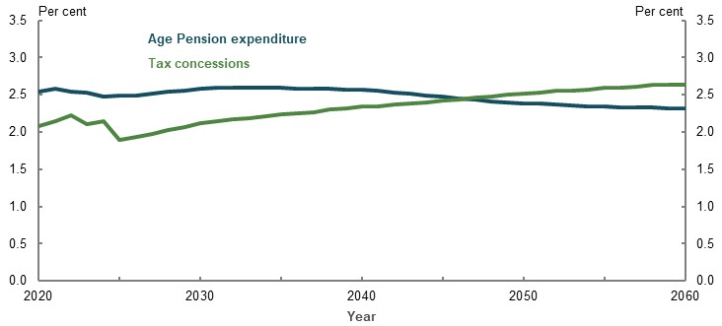
Source: Treasury estimates for the review using MARIA.

Cost-effectiveness
The Age Pension and other pensions, such as service pension, together provide retirement income support to around the bottom 70 per cent in terms of income distribution. It allows those without means to achieve a minimum standard of living in retirement and supplements the income of middle-income earners so they can maintain their living standards in retirement. Age Pension means testing has promoted the sustainability of the Age Pension, with expenditure projected to fall moderately as a proportion of GDP.
To the extent that superannuation tax concessions are contributing to higher superannuation balances of lower- to middle- income earners, they help to reduce Age Pension expenditure. But the main influence behind the growth in superannuation balances is the SG. Tax concessions are largely concentrated among higher-income earners who are close to and above preservation age. Across the income distribution, the lifetime cost of superannuation tax concessions is projected to outweigh the associated Age Pension saving (Chart 13).
- The interaction of tax concessions and Age Pension spending over a lifetime
 | Contributions  concessions only | Earnings  concessions only | Combined
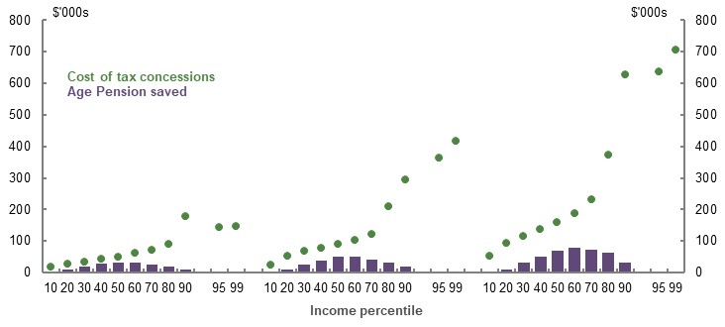
Note: Values are in 2019-20 dollars, deflated using the review’s GDP deflator. See Appendix 6A. Detailed modelling methods and assumptions. Source: Cameo modelling undertaken for the review.

Other costs
Social transfers in kind (such as health and aged care expenditure) provide substantial support to retirees. The cost of social transfers in kind attributed to households aged 65 and over has increased from 2.3 per cent of GDP in 2003-04 to 3.3 per cent in 2015-16. Aged care costs, in particular, are expected to grow as a per cent of GDP as a result of the ageing population.
Another major cost in the system is superannuation fees, for which projections are uncertain, but are expected to grow alongside the growth in balances.

Measures to improve sustainability
Recent changes to superannuation taxation, such as the introduction of the transfer balance cap, have improved the sustainability of the system. A number of submissions called for further changes to superannuation tax concessions to improve the equity and sustainability of the retirement income system.
Changes to contributions tax concessions would increase the system’s cost-effectiveness. While contributions tax concessions are not projected to increase the cost of the system over time, they do not significantly contribute to reducing expenditure on the Age Pension and disproportionately benefit older people with high balances. Changes to contributions tax concessions such as the 2017 reforms, which introduced tighter caps on voluntary contributions, can stem the future flow of earnings tax concessions. Changes to earnings tax concessions would increase the system’s cost-effectiveness and directly contribute to improving its sustainability by reducing the growth in costs relative to growth in GDP. In particular, the cost of the earnings tax exemption in the retirement phase is likely to grow as the superannuation system matures. Extending earnings tax to the retirement phase could also simplify the system by enabling people to have a single superannuation account for life and would improve the sustainability of the system.
Changes to superannuation earnings tax concessions would improve equity, and in turn boost public support for the system.

Cohesion
The retirement income system should be cohesive in that all its drivers, processes and incentives contribute to the achievement of the retirement income system objective.
The system is a combination of Government compulsion, such as the SG, and efforts to encourage people to save for their retirement, such as through additional tax concessions. A coherent system should avoid as much complexity as possible, but to address complexity, it should have the mechanisms, support and incentives that help people to optimise their standard of living in retirement. This includes helping people navigate the retirement income environment through retirement defaults, guidance and facilitating access to affordable advice.
The report considers the experience of the system in this regard in detail. The evidence suggests that all the mechanisms and incentives may not be working as intended, or working well together.
In particular, the effectiveness of superannuation tax concessions in supporting retirement outcomes can be questioned.
In addition, the system focuses on the accumulation of savings for retirement, but insufficient attention is given to how people can best use their savings to support their living standards in retirement, such as drawing on their superannuation balances or accessing the equity in their homes.

Saving for retirement
There are tax concessions for both pre- and post-tax superannuation contributions, and tax concessions on the earnings of superannuation funds. Tax concessions compensate contributors for consumption forgone. They are intended to encourage people to make voluntary superannuation contributions — part of the ‘third’ pillar of the retirement income system.
Most people make concessional contributions at or near the SG rate. Around a quarter of people make voluntary contributions. This highlights the importance of the SG in increasing retirement savings for most people.
Voluntary contributions provide flexibility for those outside the compulsory system to contribute to superannuation, such as the self-employed and those with interrupted working careers. Those making voluntary contributions are generally older people and higher-income earners, although saving in any form is closely related to income and age. The main reason people say they do not make voluntary contributions to superannuation is budgetary constraints — their priority is to meet current expenses.
Tax concessions appear to have a limited impact on increasing voluntary savings. Studies suggest they encourage saving in tax-preferred forms, such as superannuation, but this largely displaces other forms of saving. As a result, there is almost no net increase in saving. Those making the largest contributions — higher-income earners and older people — are less likely to require an incentive to save for their retirement.
The self-employed, who are not covered by the SG, make voluntary contributions and can also save in forms other than superannuation, such as in other financial assets, business assets or investment properties.
Government co-contributions have a limited impact on superannuation contribution rates and household savings.
The high effective marginal tax rate generated by the Age Pension means test could represent a disincentive to save, particularly for middle-income earners, but there is little evidence that the Age Pension means test is affecting how much people save pre-retirement.
Many submissions called for a reversal of the 2017 change in the taper rate for the assets test in the Age Pension. The review canvassed the impact of reducing the taper rate from $3 per $1,000 to $2.25. Such a change would:
- Benefit retirees in the top half of the wealth distribution in the near term
- In future, as the superannuation system matures, boost the replacement rates for middle-income earners, although their replacement rates already exceed the 65-75 per cent benchmark
- Provide a reward for additional saving, although it would lessen the incentive to draw down savings in retirement
- Have a fiscal cost in 2019-20 of $1 billion, which would grow to 0.20 per cent of GDP in the long term

Investing for retirement
The two main assets held by people when they retire are their home and their superannuation. For lower- to medium-income workers, their main asset is their home. But superannuation balances will increase as the superannuation system matures.
Home ownership is an important influence on a person’s standard of living in retirement. Housing costs are generally lower in retirement and the house is an asset that can be drawn on to boost retirement income. Although as noted below, few people do so.
Favourable treatment of a person’s principal residence in the Age Pension assets test may encourage people to overinvest in their home. There are also strong incentives outside the retirement income system encouraging home ownership.
Many people take little interest in the investment returns being achieved by their superannuation fund. The exception is people approaching or in retirement, who are sensitive to fluctuations in their superannuation balances when there is an economic shock such as the one caused by the COVID-19 Pandemic. More generally, the complexity of the system may deter people from taking an interest in the investment performance of their superannuation. This is also influenced by SG payments being compulsorily made by employers and as such, superannuation is outside a person’s area of focus. However, as highlighted in the Productivity Commission’s report Superannuation: Assessing Efficiency and Competitiveness, the investment performance of a person’s fund can have a major influence on their superannuation balance at retirement.

Incentives to work
Discouraging people from retiring early voluntarily can increase retirement incomes. There is no mandatory retirement age for most workers, just ages when people can access their superannuation or are eligible to apply for the Age Pension. The eligibility age for the Age Pension and the preservation age have a strong influence on when people retire. People who are able to choose when they retire generally do so when they feel confident they have the income they think they need for financial security.
The financial incentives to encourage people to continue to work include income tax reductions for people over 65, pension Work Bonus, Work Test for superannuation contributions, and transition to retirement arrangements. The evidence suggests that incentives to encourage people to continue to work have a limited impact on people’s decisions to retire.
In 2018, 4 per cent of people on the Age Pension had declared earnings from work. Nevertheless, workforce participation of Australians over 65 is increasing as more Australians are working past Age Pension eligibility age.
Surveys suggest people over 55 are generally happy to be retired, and a sizeable proportion of people retire before Age Pension eligibility age. However, many of these people retire involuntarily. The main reasons for involuntary retirements are own ill health, caring responsibilities and job-related issues, such as a reluctance to hire older workers — ageism. For people who retire before they want to, financial incentives to keep working are not relevant. Addressing the barriers that force people into retirement — such as reducing employer bias against older workers, retraining older workers and increasing flexibility between work and caring responsibilities — would be more effective in assisting people to stay in the workforce.

Drawing on assets to maximise retirement income effectively in retirement
In a coherent system, mechanisms would not only encourage people to save for their retirement but also to use these savings effectively to support their standard of living in retirement. A common theme throughout this report is that the focus is on the accumulation phase of the retirement income system and insufficient attention is given to the retirement phase. The evidence indicates that retirees tend to hold on to their assets and leave significant bequests, even though surveys suggest people do not prioritise leaving a bequest. If people drew down more on their assets, they could have a higher standard of living in retirement. Alternatively, they need not have saved as much as they did for retirement and could have had a higher standard of living during their working years.
Some retirees do, however, consume more of their assets in retirement than others. For example, non-home owner age pensioners consume their assets faster than other households, and people with low balances draw down their superannuation at a much higher rate than those with larger balances.
Factors that contribute to low drawdown of assets in retirement include:
- Complexity and little guidance on how to maximise retirement incomes
- Reluctance to consume funds that are called ‘investments’, ‘savings’ or ‘nest eggs’
- Adopting the minimum drawdown rates required for a superannuation pension account
- Concern about possible future health and aged care costs
- Concerns about outliving savings
Some of the measures raised in submissions to help people use their retirement savings more effectively to support their standard of living in retirement include:
- Funds providing regular estimates of an individual’s retirement savings being expressed in terms of an income stream rather than balance at retirement
- Educating people that their health and aged care costs are heavily subsidised by the Government
- Emphasising that the Age Pension provides a safety net for people who outlive their savings or when the value of their retirement savings falls significantly
- Amending the minimum drawdown rates so that income is delivered when people are more likely to consume it, namely earlier in their retirement rather than the current drawdown rates, which are highest at ages 85-90
- At retirement, guiding people towards products that deliver an income stream and provide protection against market fluctuations and outliving savings
Few retirees use the equity in their home to support their standard of living in retirement. The options available to do so include reverse mortgages, equity release schemes, home equity loans and downsizing. Reverse mortgages are the main product available, but usage is low.
Two Government measures to encourage retirees to access the value of their home to fund their retirement are the:
- Pension Loans Scheme — This is effectively a reverse mortgage for age pensioners and self-funded retirees, where income from the scheme is not assessable in the Age Pension means test.
- Downsizer contribution — This allows people aged over 65 to contribute up to $300,000 to superannuation if they sell their home.
Use of the Pension Loans Scheme is limited. Between 1 July 2018 and 17 January 2020, more than 9,000 people made downsizer contributions.

Dealing with complexity
The retirement income system is complex and hard to navigate. The broader retirement environment is also complex and involves many uncertainties, as can be seen in the context of the COVID-19 Pandemic. This complexity and uncertainty, combined with a lack of assistance, guidance or advice, and low financial literacy, makes it hard for people to make well-informed choices about their retirement income.
Adding to complexity is the interaction with other systems, such as aged care, the tax system and other benefits available for older Australians.

Reducing complexity
Submissions raised a range of ways to tackle the complexity of the retirement income system. These included simplifying the design of the system by removing the Age Pension means test and creating a universal pension. Another suggestion was to have a one-off means test. There were also suggestions to improve the administration of the Age Pension, such as reducing reporting requirements and using data sharing to pre-fill forms and make application for the Age Pension easier.

A merged means test
Some stakeholders suggested merging the income and assets tests in order to reduce the complexity of the Age Pension means test. It would be challenging to design a merged means test without compromising some of the retirement income system objectives of adequacy, equity, sustainability and cohesion. An example of a merged means test is outlined in the report.

Default products in the retirement phase
The pre-retirement phase of the retirement income system has substantial compulsion and defaults, and as a result, people do not have to make decisions about their superannuation contributions. For example, the SG involves compulsory superannuation contributions, which come with default mechanisms for selecting a superannuation fund and products. A downside of defaults is that people fail to engage with their superannuation. The Productivity Commission (2018a) suggested default settings be set to encourage people to make active choices, but also to protect those who do not.
The retirement phase is more complex than the pre-retirement phase, but little guidance is available to help people choose their retirement income products. To address this, stakeholders suggested:
- Advancing the Comprehensive Income Products for Retirement concept and making available regulated, simple and safe retirement products
- Developing the proposed Retirement Income Covenant under which superannuation trustees would be required to develop a retirement income strategy, and provide guidance to help retirees choose a retirement income product
- Introducing defaults, and while recognising the difficulty of designing an optimal default given that people’s circumstances vary, making pre-selected or ‘soft’ default products available. Alternatively, similar to approaches in some other countries, it could be mandatory that part of a person’s retirement savings be taken as an annuity
- Limiting options offered, such as the UK approach where every defined contribution pension has only four investment pathways

Retirement advice and guidance
Submissions raised a range of proposals aimed at giving people more information, guidance and better advice tailored to their circumstances.
The evidence suggests that most people do not seek advice about retirement income planning. Barriers against seeking advice include cost, small finances and lack of trust.
People need advice and assistance to make better informed decisions. But the advice has to be sound. Assessments by regulators and the Hayne Royal Commission, identified weaknesses and misconduct in financial advice. Reforms are underway to remove conflicts of interest for those giving advice and to improve their education. Superannuation funds are uniquely placed to provide advice and guidance because members have to contact their fund to commence a retirement income product. But funds can have a conflict of interest between the interest of members and maximising funds under management. Funds are also restricted in what they can consider when providing intra-fund advice. Changes would need to be made to the regulatory framework to facilitate funds providing more guidance at retirement.
Automated or digital advice could be more accessible and affordable. The take-up of such advice is currently low, with people lacking trust in this form of advice and thinking it should be free.
There may also be a role for the Government to provide comparison tools to help consumers compare products. Some submissions suggested expanding ASIC’s MoneySmart website and the Financial Information Service.
Overall, in terms of the cohesion of the system, the evidence suggests that:
- The SG is effective in increasing savings for retirement, while tax concessions appear to have a weak influence on overall savings behaviour
- Retirement income projections, greater use of longevity risk management products and more financial advice and guidance would lead to higher drawdown in retirement
- Reducing complexity would lead to better retirement outcomes for individuals
- Carefully designed defaults, guidance from superannuation funds, as well as accessible and affordable advice at retirement, would help people get better outcomes in retirement


- Outline of Australia’s retirement income system

Outline of this chapter
This chapter provides background to the retirement income system and introduces key concepts relied on in this report. The chapter is organised in four parts:
First, it examines how the concept of retirement has changed over time, explores historical trends in when people retire, and defines what is meant by ‘retirement’ for the purposes of this report.
Second, it outlines the design of Australia’s retirement income system and how different parts of the system interact. It includes background on the history of the system and current system settings, as well as an overview of the sources of income for recent retirees and a brief international comparison.
Third, it suggests an objective for Australia’s retirement income system and considers the roles of system participants and pillars.
Finally, it identifies the broad demographic and economic factors that could affect the retirement income system.

What is retirement?
          - Section summary
- People have diverse timings for and pathways to retirement. Many work part time as they transition to retirement. Not all choose when they retire (involuntary retirement). Some retire multiple times.
- For most workers there is not a mandatory ‘retirement age’. Retirement can be triggered by the main ages in the retirement income system, which are when people can access their superannuation (the preservation age) and when they are eligible to apply for the Age Pension.
- The average age of retirement for both men and women has increased over the past two decades. On average, people currently retire around ages 62-65, with women tending to retire one to three years earlier than men.
- The average age of retirement is expected to rise. Legislated increases to the preservation and Age Pension eligibility ages, as well as improved health and higher average levels of educational attainment, are expected to continue to support higher average retirement ages. However, the economic and financial consequences of the COVID-19 Pandemic may have mixed effects on when people retire, particularly in the short term. Falls in the value of retirement savings may influence some people to work longer, while higher unemployment rates may result in some people retiring earlier than they had planned.
- For the purposes of defining ‘early retirement’ and ‘late retirement’, the review uses the Age Pension eligibility age as the ‘standard’ retirement age. This reference point was selected as more people withdraw from the labour force at this age than any other age.

          - Stakeholder views on the concept of retirement
Many submissions referred to the Age Pension eligibility age as the retirement age. No submissions defined any other age as the retirement age. However, a few submissions recognised the changing nature of retirement and that expectations of retirement age can vary between certain occupations and industries. One submission noted:
‘Retirement is now a continuum between reduced participation in the paid workforce … and leaving it altogether.’ (Australian Council of Social Service, 2020, p. 12)
One submission suggested participation in work is an important part of the retirement income system:
‘… if the primary objective or purpose of the retirement income system is to “generate income to support consumption in retirement”, then considerations of the role of work (both pre and post retirement age) should be included as part of the retirement income system.’ (National Seniors Australia, 2020, p. 13)

Diverse pathways to retirement
The concept of retirement has changed over time. In the past, retirement was viewed as an abrupt change from a full-time job to permanently leaving the workforce. Today, switching to part-time employment as people transition to retirement is becoming more common. In 2018-19, 39 per cent of retired Australians stated their last job before retirement was part time (ABS, 2020n). Supporting this, longitudinal analysis shows that, on average, wage income declines after age 55 (Chart 1A-1), partly due to part-time employment.
    - Weekly wage as a per cent of average weekly ordinary time earnings, by age
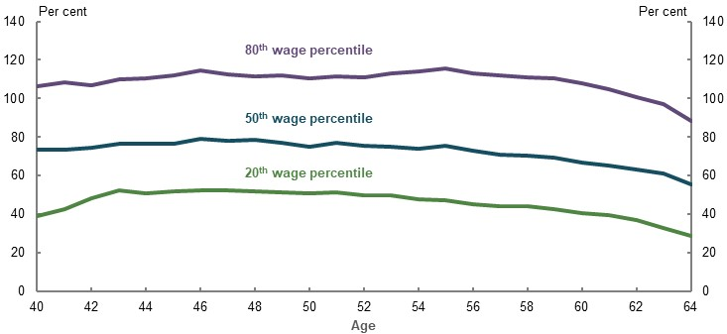
Note: Follows the same cohort from ages 40-64. This cohort was aged 64 in 2017. Uses the June value of average weekly ordinary time earnings in the relevant year (e.g. average weekly ordinary time earnings at age 50 is average weekly ordinary time earnings at June 2003). Uses median wage of the wage percentile. Wage percentiles are calculated using the sum of wages over 2008 to 2017. Source: ATO analysis of ATO Longitudinal Information Files (ALife).
Retirement is not always a single event. A significant number of people who retire re-enter the labour force and potentially retire several times. In 2018-19, 169,000 people aged 45 and over who had previously retired were, at the time of the survey, either in the labour force or were planning to look for, or take up, work in the future. The most common reasons people re-entered or planned to re-enter the labour force after retiring were financial need and boredom/needed something to do (ABS, 2020n).
Few workers have a mandatory retirement age. The main ages in the retirement income system are when people can access their superannuation (preservation age) and when they are eligible to apply for the Age Pension.
Changing careers can be used by people to prolong their working life, pursue an interest or change their work conditions. This practice has always been common in some professions (e.g. professional sports, military personnel), but it is now becoming increasingly common for many older workers (both professional and non-professional) (Shultz & Wang, 2011, p. 2).
Some people also never leave the paid workforce. Around 2 per cent of people aged 70 and over never intend to retire from the paid workforce (ABS, 2020n).
The reasons for entering retirement vary considerably. Common reasons include reaching preservation age or Age Pension eligibility age, the desire to have more leisure time, their own or someone else’s ill health, and difficulties finding appropriate work. The prevalence of, and reasons for, involuntary and voluntary retirement are explored in 3E. Age of retirement.

Trends in the average age of retirement
Although the retirement income system does not mandate retirement at a particular age, retirement broadly takes place between the ages of 50 and 80 (ABS, 2016a). Of those who retired between July 2013 and June 2019, 13 per cent were younger than age 55 and another 15 per cent were aged 70 and over (Chart 1A-2).
    - Proportion of people retiring at particular ages
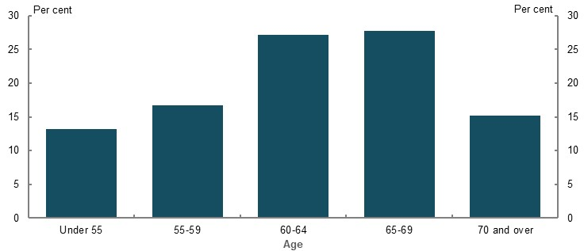
Note: Includes people who retired between July 2013 and June 2019. Assumes the age of retirement is equal to the age of ceasing last job. Source: Analysis of (ABS, 2020p).
While the average age of retirement varies across surveys, it tends to be around ages 62-65, near the Age Pension eligibility age. Women tend to retire one to three years earlier than men, on average. The variability in data is because the definition of retirement is not always consistent across surveys and some people come out of retirement and return to work.
The average age of retirement in Australia has been relatively similar to the OECD average over the past decade (Chart 1A-3).
The average age of retirement changes in response to a wide range of economic conditions and policy influences. For example, Australia saw a trend towards earlier retirement in the 1970s and 1980s, partly due to more people having the financial means to retire earlier and increased retrenchment of older workers in some industries (Productivity Commission, 2015b, p. 56).
More recently, the average retirement age has gradually increased for both men and women (Chart 1A-3). The participation rate of people aged 60-64 rose by 22 percentage points between April 2000 and April 2020. The participation rate for people aged 65 and over also increased by more than 7 percentage points during this period (ABS, 2020j).
Over the past two decades, multiple labour market supply and demand side factors have led people to remain in the workforce longer on average. On the supply side, increased longevity, improved health and growth in average levels of educational attainment are facilitating people to work longer to ensure they have adequate savings for retirement (see 1D. The changing Australian landscape). On the demand side, people are encouraged to remain in the workforce by growth in more flexible and less physically demanding jobs (Debelle, 2019), and employers becoming more willing to employ older workers. Certain policy changes, such as increasing preservation and Age Pension eligibility ages have also encouraged later retirement (see 5A. Cohesion).
    - Average age of retirement, by gender
Men | Women
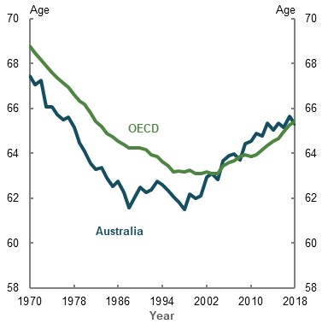 | 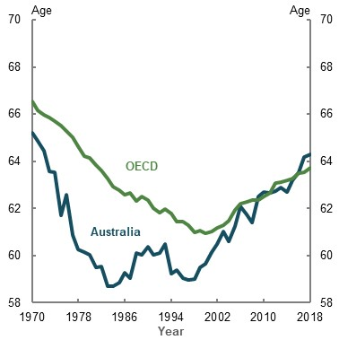
Note: ‘OECD’ includes the average of all members of the OECD in the year. For example, in 2018 there were 36 members of the OECD. The average age of retirement is the average age of all persons withdrawing from the labour force in a given period. Source: (OECD, 2019a).
The economic and financial consequences of the COVID-19 Pandemic are likely to have mixed effects on when people retire, at least in the short term. The impact on retirement savings and income may lead some workers to remain in the workforce for longer than they had originally planned. This occurred after the GFC, with a 2008 survey showing many Australians aged 50-64 planned to postpone retirement (Kendig, et al., 2013). A higher unemployment rate may also increase involuntary retirement as people who lose their job and cannot find another one in a more competitive environment retire earlier than planned. HILDA Survey data from 2001-18 shows people aged 55 and over are three times more likely than those in their 20s to become discouraged and leave the labour force following one year of unemployment (Chomik, R, 2020, p. 4).
Although forecasting is difficult, over the medium term the average age of retirement is expected to continue to increase, for three reasons:
- The average person is expected to be healthier for longer. People born in 2015 could expect to live disability-free for more years than people born in 2003 (Australian Institute of Health and Welfare, 2017). Older people who report themselves as in good health are around twice as likely to participate in the labour force as those in poor health (RBA, 2018).
- Education levels are rising. Between 2006 and 2016, the proportion of Australians holding a post-school qualification increased by 10 percentage points, particularly for women (ABS, 2017a). This trend is likely to continue as the Commonwealth and state and territory governments have set targets to increase the average level of educational attainment (Department of Skills, Education and Employment, 2019). People with higher education levels remain in the labour force until later ages, on average (see 3E. Age of retirement).
- Preservation and Age Pension eligibility ages are increasing to 60 and 67 years, respectively. Evidence suggests that retirement decisions are influenced by changes to the Age Pension eligibility age (see 5A. Cohesion).

Retirement timing expectations
On average, current working-age Australians expect to retire at later ages than current retirees. The average age of intended retirement increased from 62.3 to 65.5 years based on surveys conducted in 2004-05 and 2018-19 of people aged 45 and over (ABS, 2020n; ABS, 2006b).
However, people’s actual retirement age and pathway to retirement can often differ from their expectations. Many people who intend to gradually transition to retirement do not do so (Warren, 2015). One survey indicated 50 per cent of people retired from full-time employment at an earlier age than planned, primarily due to ill health, job-related issues and caring responsibilities. In contrast, 12 per cent of people retired from full-time employment at a later age than they had planned, most commonly driven by the need to boost financial security in retirement or the desire to keep working.

Definition of ‘early retirement’ and ‘late retirement’
In the absence of a mandated retirement age, the Age Pension eligibility age has been used as the reference point for the retirement age since more people withdraw from the labour force at this age than any other age (see 5A. Cohesion). As such, in this report, ‘early retirement’ means retiring before Age Pension eligibility age, and ‘late retirement’ means retiring after Age Pension eligibility age.
For discussion of the outcomes of retiring at different ages, see 3E. Age of retirement.

Design of Australia’s retirement income system
          - Section summary
- Australia’s retirement income system is unique and complex. Its main components are a publicly funded Age Pension, a privately managed superannuation system and voluntary savings.
- The Age Pension is means tested and provides a minimum standard of living in retirement for Australians with limited financial means. The Age Pension also supplements the retirement income of middle-income earners. Age pensioners can currently receive up to $24,552 a year for singles, and $37,014 a year for couples combined, subject to a means test.
- The superannuation system includes both a compulsory element and voluntary contributions. The Superannuation Guarantee (SG) currently requires employers to pay 9.5 per cent of certain wages and salaries into a superannuation fund. The SG rate is legislated to increase by increments until reaching 12 per cent in 2024-25. Voluntary superannuation provides the flexibility for people not covered by the SG to contribute, for people to make catch-up contributions after periods out of the workforce, and for people to make additional contributions.
- Many Australians provide for their retirement through voluntary savings separate to superannuation. Most household wealth for people aged 65 and over is held outside the superannuation system, with owner-occupied housing the largest asset for most retirees. Home ownership supports retirement income by reducing housing expenses and acts as a store of wealth that can be accessed in retirement.
- Free or subsidised health and aged care services support Australian retirees. Retirees also receive a range of other concessions.
- Australia’s three-pillar retirement income system compares favourably in international comparisons. Australia’s Age Pension, compulsory superannuation and private savings, including voluntary superannuation and a high level of home ownership, gives Australians flexibility to achieve retirement incomes that suit their circumstances. Many overseas systems do not perform to a similar standard.

Outline of this section
This section outlines the main elements of Australia’s retirement income system and the interactions between these elements. It also provides an overview of the sources of income for recent retirees and an international comparison of the Australian system.
          - Stakeholder views on the design of the retirement income system
Submissions generally supported the current design of the retirement income system, with most focusing on changes to settings within the existing framework.
Most submissions discussed the system in terms of three pillars: the Age Pension, compulsory superannuation and voluntary savings. A number of submissions referred to additional pillars, such as the JobSeeker Payment (formerly Newstart Allowance) for involuntary retirees, and health and aged care services available to retirees. Some suggested housing should be treated as a separate pillar.
Submissions noted that the system’s multi-tiered structure was directed at alleviating poverty in retirement and allowing retirees to supplement the Age Pension with other savings.

System interactions
The main components of Australia’s retirement income system are the Age Pension, compulsory superannuation and voluntary savings. These income sources are complemented by other systems that support retirees’ living standards (Figure 1B-1).
The interaction between the tax system and the retirement income system is important in determining retirement income outcomes.
Social transfers in kind, which include free or subsidised health and aged care services, are also key to retirement outcomes. They are an important source of support for lower-income retirees but are received across the income distribution, including by higher-income retirees. See Chart 1B-5 for details of the value of social transfers in kind to people of different age groups.
        - Key retirement income system interactions
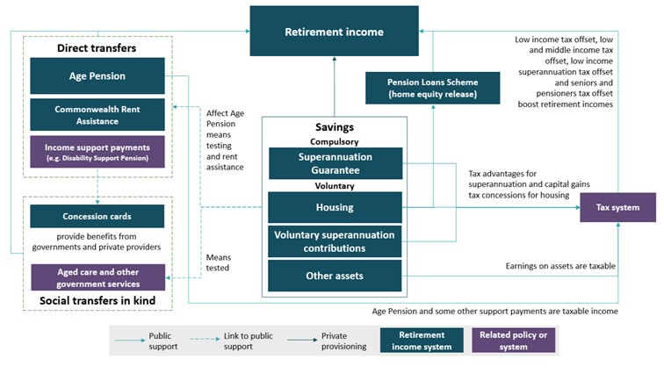

Overview of the Age Pension
The Age Pension is a means-tested payment for older Australians. The Age Pension is not based on past income or contributions, or taxes paid during a person’s working life. When introduced in 1909, the purpose of the Age Pension was to provide a ‘safety net’ of income support, targeted to those most in need, determined by a means test (Groom, 1908; Parliamentary Library, 2011). Its primary function was poverty alleviation.
The Age Pension is the main source of retirement income for people who were lower- to middle-income earners during their working lives. Particularly for middle-income earners, it supplements superannuation and other savings (see Chart 1B-4).

Eligibility
To receive the Age Pension, a person must meet age, residency and means-testing requirements (Table 1B-1).
      - Age Pension eligibility criteria
Criteria type | Eligibility rule
Age | Age pensioners must be over Age Pension eligibility age. From 1 July 2019, the Age Pension eligibility age is 66 years.
Residency | Age pensioners must be Australian permanent residents for 10 years, with at least 5 years being continuous.
Means test | Age pensioners must meet both the income test and the assets test.
Source: (Department of Social Services, 2020e).

Age Pension eligibility age
In 1909, the Commonwealth Government introduced a national ‘old age’ pension age from age 65 for both men and women, before later reducing it to age 60 for women. The eligibility age for women remained at 60 until 1 July 1995, when it started increasing by 6 months every two years, until reaching 65 on 1 July 2013.
Based on legislation passed in 2009, the Age Pension eligibility age for men and women was increased to 65 and 6 months on 1 July 2017. It is scheduled to increase by six months every two years until it reaches 67 years on 1 July 2023.

Age Pension payment rates
The maximum rate of the Age Pension includes the base pension rate, the Pension Supplement and the Energy Supplement (Table 1B-2). Almost all age pensioners receive the Pension Supplement and the Energy Supplement.
      - Maximum Age Pension rates, as at 1 May 2020
Status | Maximum rate of Age Pension
Single, and illness-separated couples | $944.30 per fortnight ($24,551.80 a year)
Member of a couple (each) | $711.80 per fortnight ($18,506.80 a year)
Note: These rates apply for age pensioners, Carer Payment recipients and adult Disability Support Pensioners. Rates are for non-transitional Australian residents and include the Pension Supplement and Energy Supplement. Maximum rates do not include Commonwealth Rent Assistance. Source: (Services Australia, 2019).

Indexation
Age Pension rates (and other adult pensions) are indexed every March and September.
Base pension rates are indexed according to the higher of the six-month growth in the consumer price index (CPI) or the pensioner and beneficiary living cost index. After price indexation, base pension rates are then compared to male total average weekly earnings and are increased if below a set benchmark.
From September 1997, the single base rate of the Age Pension was benchmarked to 25 per cent of male total average weekly earnings (Harmer, 2009, p. 65). From 20 March 2010, the male total average weekly earnings benchmark was revised, effectively benchmarking the single base rate of the Age Pension to 27.7 per cent of male total average weekly earnings (Parliament of Australia, 2009, p. 10).
The Pension Supplement is indexed to CPI growth every March and September. The Energy Supplement is not indexed.

Other components of the Age Pension
Age pensioners can also receive other supplementary payments, such as:
- Commonwealth Rent Assistance
- Carer Allowance and Carer Supplement
- Mobility Allowance
- Pensioner Education Supplement
- Family Tax Benefit (FTB), if they have dependent children in their care

Housing tenure and Commonwealth Rent Assistance
The majority of Age Pension recipients are home owners. In June 2019, 73 per of age pensioners owned their own home, while 14 per cent received Commonwealth Rent Assistance for private rental costs. Five per cent lived in residential aged care and 4 per cent in public housing.
Once a recipient’s rent is above a threshold, Commonwealth Rent Assistance pays 75 per cent of their rent up to a cap. For a single person without dependent children, the threshold is currently $124.60 per fortnight. The maximum Commonwealth Rent Assistance payment is capped at $139.60 per fortnight for rents of $310.73 or more per fortnight. Different rates and thresholds apply to couples, those sharing accommodation or those with dependent children. The maximum payment amounts and rent thresholds are indexed by CPI in March and September each year.
Over time, an increasing proportion of age pensioners have received the maximum rate of Commonwealth Rent Assistance. Single age pensioners receiving Commonwealth Rent Assistance in 2019 received, on average, 85 per cent of the maximum rate; couples received 90 per cent of the maximum. This compares with 70 per cent for singles and 79 per cent for couples in 2001.
In June 2019, around 133,800 single women, 86,800 single men and 79,500 couples received Commonwealth Rent Assistance on top of their Age Pension.

Means testing
Means testing is used to target payments to those in need. All income support payments, apart from pensions paid to people who are blind, are subject to means testing.
The Age Pension has two means tests: an income test and an assets test. A person’s entitlement to the Age Pension is assessed under both tests, with the lower result determining how much they receive.
The income and assets tests assess means in different ways:
- The income test assesses the income a person has from employment, overseas pensions and other sources, including ‘deemed’ returns on financial assets, such as superannuation and bank accounts.
- The assets test assesses financial and non-financial wealth. The assets test recognises that people with significant assets have the capacity to draw down on those assets to support themselves in retirement.
The income and assets tests have two elements:
- A free area, which allows people to have certain levels of income or assets without affecting their Age Pension rate.
- A taper rate, which progressively reduces the Age Pension for people with higher levels of assessable means. Box 1B-3 details the operation of the means tests.

Employment earnings
Few retirees on the Age Pension earn income from employment. The proportion of retirees with employment income has remained steady at around 4 per cent since 2012. This contrasts with the proportion of the wider population of older Australians with earnings, which has been steadily increasing over the same period (see 1D. The changing Australian landscape).
          - Age Pension income and assets testing

Income test
The Age Pension income test provides different free areas based on whether an age pensioner is single or partnered. For each dollar of income over the income test free area in a given fortnight, the single rate of Age Pension is reduced by 50 cents (the taper rate). For couples, their combined rate of Age Pension is reduced by 50 cents.
      - Income test free areas and cut-offs, as at 1 May 2020
Status | Free area  ($, per fortnight) | Cut-off  ($, per fortnight)
Single | 174 | 2,062.60
Couple, combined | 308 | 3,155.20
Note: ‘Cut-off’ refers to the point at which the Age Pension is no longer payable. Cut-offs may be higher if the age pensioner receives Commonwealth Rent Assistance. The deeming rules and the Work Bonus (see below) mean that some pensioners have private income above the cut-off. Source: (Services Australia, 2019).
Age pensioners may also access the Work Bonus. Under the Work Bonus, the first $300 of work income per fortnight is not counted in the Age Pension income test. Any unused amounts of the $300 fortnightly exemption can be built up to a total of $7,800, which can be used to exempt future earnings from the Age Pension income test.

Deeming
Deeming is a set of rules used to assess income from financial investments for social security purposes. Deeming assumes financial investments earn a certain rate of income, regardless of the amount actually earned. The Government periodically adjusts deeming rates to reflect the returns available from financial investments.
Before the deeming rules, many income support recipients maximised their income support payment, instead of their total disposable income, by investing in low interest accounts (Harmer, 2009, p. 137). Deeming was introduced in 1991 to encourage income support recipients to choose investments based on their merit. The aim was to encourage people to seek better returns to maximise their overall income before turning to the community for support. Deeming also increases the predictability in income support payments by reducing payments fluctuations.

Assets test
The Age Pension assets test provides different free areas based on whether an age pensioner is single or partnered and their home ownership status. The value of a person’s assets above the assets test free area reduces their Age Pension by $3 per fortnight for each additional $1,000 in assets.
      - Assets test free areas and cut-offs, as at 1 May 2020
Status | Free area  ($) | Cut-off  ($)
Single home owner | 263,250 | 578,250
Single non-home owner | 473,750 | 869,500
Couple home owners, combined | 394,500 | 788,750
Couple non-home owners, combined | 605,000 | 1,080,000
Note: ‘Cut-off’ refers to the point at which the Age Pension is no longer payable. Cut-offs may be higher if the age pensioner receives Commonwealth Rent Assistance. Source: (Services Australia, 2019).
Most people with assets above these thresholds are assets tested as a result of deeming, unless they have significant income from other sources.
The principal home and some adjacent land have been exempt from the assets test since it was introduced in 1985.

Indexation

The income and assets test free areas are indexed to the CPI every 1 July.

Taxation of the Age Pension
Age Pension payments form part of a person’s taxable income. This is consistent with most working-age income support payments, including the JobSeeker Payment and Parenting Payment. Commonwealth Rent Assistance payments are not taxable.
By accessing various tax offsets, including the seniors and pensioners tax offset, the low income tax offset, and the low and middle income tax offset, age pensioners with incomes up to $33,088 (or $29,783 for each member of a couple) pay no income tax. For singles, the seniors and pensioners tax offset begins to phase out at incomes above $33,088 and is fully phased out at an income of $50,928.

Age Pension coverage and expenditure
In June 2019, around 2,533,000 people, or 65 per cent of people over Age Pension eligibility age received the Age Pension. This compares with around 1,725,000, or 67 per cent, in 1999 (Chart 1B-1).
    - Number of Age Pension recipients
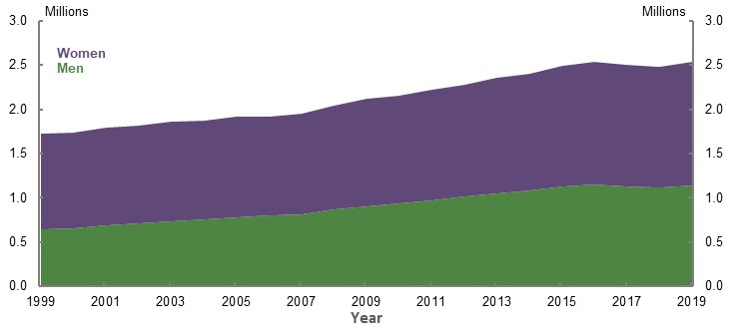
Note: 1999-2013 data includes Age Pension recipients paid by the Department of Veterans’ Affairs. 2014-2019 data does not include recipients paid by the Department of Veterans’ Affairs. Source: Department of Social Services payment data 1999-2019.
The proportion of older Australians receiving the Age Pension increases with age. At 30 June 2019, 42 per cent of people aged 66 received the Age Pension, compared with 80 per cent of people aged 80.
At June 2019, 3 per cent of people over Age Pension eligibility age received a payment similar to the Age Pension from the Department of Veterans’ Affairs. A further 3 per cent received some other income support payment, such as the Disability Support Pension, Carer Payment or Special Benefit. In total, around 71 per cent of people over Age Pension eligibility age receive some kind of income support payment.
Age Pension expenditure has increased in real terms from $24 billion in 2000-01 to $46 billion in 2018-19. It has remained relatively stable as a proportion of GDP (2.4 per cent in 2018-19) and as a proportion of the Federal Budget (9.7 per cent in 2018-19) (see 4. Sustainability).

Concessions
The Australian Government provides concessions to income support recipients and lower-income earners. State and territory governments also provide concessions and subsidised services to older Australians. Subsidised aged care and health services are of particular significance to improving retirement outcomes (see 2A. Achieving a minimum standard of living in retirement).

Pensioner Concession Card
The Pensioner Concession Card is automatically issued to recipients of the Age Pension, Parenting Payment Single, Disability Support Pension and Carer Payment.
People aged over 60 who have been continuously receiving one (or a combination) of the following payments for more than 39 weeks can also receive the Pensioner Concession Card: JobSeeker Payment (formerly Newstart Allowance), Sickness Allowance, Widow Allowance, Partner Allowance, Parenting Payment Partnered or Special Benefit.
People holding a Pensioner Concession Card and their dependants can access:
- Cheaper Pharmaceutical Benefits Scheme-listed medicines
- Reduced out-of-hospital medical expenses after reaching the Concessional Extended Medicare Safety Net threshold
- Bulk-billed general practitioner appointments at the discretion of the doctor
- Free hearing assessments and hearing rehabilitation, including supplying and fitting hearing aids
In December 2019, around 2,649,000 people aged 65 and over held Pensioner Concession Cards (Department of Social Services, 2020b).

Commonwealth Seniors Health Card
The Commonwealth Seniors Health Card gives eligible Australians above Age Pension eligibility age who do not receive an income support payment access to Australian Government health concessions.
The Commonwealth Seniors Health Card is not an automatically issued concession card. A person must claim for the card and must meet the eligibility criteria, including an income test of $55,808 per year for singles and $89,290 per year for couples, with additional allowances for each child recipients have in their care. These thresholds are indexed in September each year in line with the CPI. The Commonwealth Seniors Health Card is not subject to an assets test.
People holding a Commonwealth Seniors Health Card have access to the same Australian Government concessions as those holding Pensioner Concession Cards, except for hearing services.
In December 2019, 386,690 people held a Commonwealth Seniors Concession Card (Department of Social Services, 2020b).

Pension Loans Scheme
The Pension Loans Scheme was established in 1985 to allow eligible age pensioners to receive a fortnightly payment, drawn against real assets, to support their living standards in retirement.
The Government introduced major reforms to the Pension Loans Scheme on 1 July 2019, expanding the scheme to include self-funded retirees. Under these changes, the amount a person could access under the scheme was increased. A pensioner (or their partner) can now top up their pension so their pension plus loan amount can be up to 150 per cent of the maximum fortnightly rate of Age Pension. Self-funded retirees can receive the entire 150 per cent amount as a loan. Pension Loans Scheme payments are not taxable.
Under the scheme, the additional payments above any Age Pension entitlement accrue as a debt secured against real estate the person owns. The interest rate on the debt is currently 4.5 per cent. Safeguards limit the maximum loan that can accrue. The Government generally recovers the debt when the property securing the loan is sold, or from the person’s estate after the person has died. The scheme is voluntary and people can withdraw at any time.

Overview of compulsory superannuation

The Superannuation Guarantee
Employers must pay the SG for eligible employees on a quarterly basis. Generally, the SG must be paid into a superannuation fund the employee chooses. Currently the SG rate is 9.5 per cent, calculated on the employee’s ordinary time earnings. Ordinary time earnings are the amounts earned for ordinary hours of work, not including overtime payments or parental leave. SG contributions are a deductible expense for employers. Compulsory contributions are generally taxed at a rate of 15 per cent, which for most people is a concessional rate compared to how their regular income is taxed (see Regulation and taxation of superannuation, below).
Some Australians are not covered by the SG. Self-employed people, employees who earn less than $450 per month, employees who are under 18 and work less than 30 hours per week, and people who do work of a private or domestic nature for less than 30 hours per week are not covered (see 3D. SG coverage). Higher-income Australians’ earnings are covered by the SG up to a threshold (currently $55,270 of income per quarter) beyond which the SG is not payable.
The SG rate has incrementally increased since its introduction at 3 per cent in 1992. It is legislated to rise in increments from its current rate of 9.5 per cent to 12 per cent by 1 July 2025. While the minimum is 9.5 per cent, some employees receive higher superannuation contributions from their employers, such as those negotiated through enterprise agreements.

Preservation
Superannuation savings cannot generally be accessed until a person reaches their ‘preservation age’ and they meet a condition of release. This is usually on retirement, or in some very limited other circumstances. In line with longer life expectancies, the preservation age is slowly increasing from 55 to 60. The preservation age is 55 for those born before 1 July 1960. It increases to 60 for those born after 1 July 1964.

The role of defaults for compulsory superannuation
Default settings are important in the retirement income system as people generally do not engage with their superannuation. Defaults also assist those with limited knowledge of money management, removing their need to make investment decisions. Defaults, particularly those dealing with contribution levels, are important in the pre-retirement phase as the further people are from retiring, the less they engage.
Most employees can choose the superannuation fund into which their SG is paid. If an employee does not choose a superannuation fund, they are defaulted into a ‘MySuper’ product. Since 1 January 2014, only funds offering a MySuper product have been eligible to receive default superannuation contributions for new employees. MySuper products provide a simple, cost-effective, balanced product for the vast majority of people who are invested in the default option of their current fund.
Another default setting is the provision of insurance. Superannuation fund members receive death and permanent disability insurance by default. Premiums for this insurance are deducted from the member’s superannuation balance. Changes legislated in 2019 mean that only opt-in insurance can be offered where a member is under 25 years of age or their account is less than $6,000, unless that member is in a high-risk occupation. The changes also prevent insurance premiums from being deducted from accounts that are inactive.

Overview of voluntary savings
Voluntary savings make an important contribution to people’s retirement incomes. For those who are not covered by compulsory superannuation for a significant portion of their working lives, such as sole traders and small business owners, or those with extended career breaks, voluntary superannuation contributions provide the necessary flexibility to contribute to the system. More broadly, voluntary savings allow people to choose how much they save for retirement.
Voluntary savings can include business assets, real estate including owner-occupied dwellings, and other financial and non-financial assets. Although these assets supplement retirement incomes, they are often accumulated for purposes unrelated to saving for retirement. The main way Government policy settings affect voluntary saving for retirement is through concessions for voluntary superannuation contributions.
The family home is an important voluntary savings vehicle for most Australians as it reduces accommodation expenses in retirement. On average, equity in the family home represents the largest share of net wealth for Australians aged 65 and over (Chart 1B-2).
    - Average net household wealth by age group, 2017-18
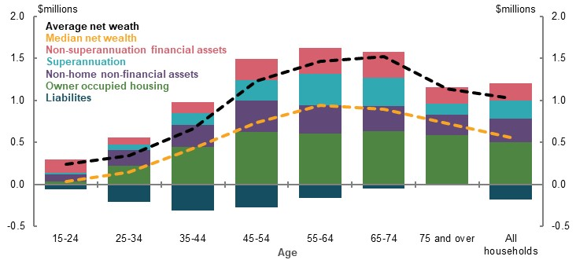
Note: A small number of estimates have high standard errors and should be used with caution. Source: (ABS, 2019k).

Voluntary contributions to superannuation
People can make additional contributions to superannuation. In 2017-18, voluntary contributions made up around 40 per cent of the total contributions to superannuation (Table 1B-5). As superannuation is concessionally taxed, it can be an attractive savings vehicle. However, caps on superannuation contributions limit access to these concessions. These caps have changed over time (Box 1B-4).
      - Superannuation contributions
Contribution type | Amount ($billion) | Per cent
Employer (excluding salary sacrifice) | 62.9 | 62
Concessional — salary sacrifice | 10.9 | 11
Concessional — personal deductible | 5.0 | 5
Non-concessional | 23.1 | 23
Total | 101.9 | 100
Note: Does not include those with no member contribution statement. Does not include ‘other’ superannuation contributions, such as spouse contributions and Government co-contributions. Does not include contributions to defined benefit funds. Source: Analysis of ATO individual income tax returns and member contributions statements, 2017-18.
People make two broad types of voluntary contributions:
- Concessional contributions are made from pre-tax income and taxed at 15 per cent in the fund. Employees may salary sacrifice or make tax-deductible contributions to a superannuation fund. SG contributions are generally concessional contributions. People without access to salary sacrifice arrangements (such as self-employed people) generally make concessional contributions by contributing to a superannuation fund and claiming a tax deduction for the contribution.
- Non-concessional contributions are made from post-tax income.
Currently, people can make up to $25,000 of concessional contributions each year. Since 1 July 2018, people have been able to ‘carry forward’ some of their unused concessional contributions cap for up to five subsequent years if their superannuation balance is less than $500,000.
People can make up to $100,000 in non-concessional contributions each year. People with superannuation fund balances of $1.6 million or more cannot make non-concessional contributions. ‘Bring forward’ arrangements allow people under 65 to make up to three years’ of non-concessional contributions (i.e. $300,000) in one year, provided the contribution does not mean the person’s balance breaches the $1.6 million cap.
From 1 July 2017, the concessional contributions cap was indexed to average weekly ordinary time earnings. It is increased in increments of $2,500. The non-concessional contributions cap is indexed in line with the concessional contributions cap.
People are also subject to age-based contribution rules. From 1 July 2020, those aged 67 and over can only contribute if they meet the ‘work test’ by working more than 40 hours in a 30-day period at some point in the relevant year. Those aged 75 and over cannot make voluntary contributions to superannuation.
People can also contribute to superannuation in a number of specific circumstances. For example, specific rules apply to personal injury payments, proceeds from downsizing a home, and proceeds from selling a small business.
Downsizer contributions allow a person aged 65 or over to make a contribution of up to $300,000 from the proceeds of the sale of their home. Certain conditions apply, including that the home has been held for at least 10 years prior to the sale.
          - Historic changes to contribution rules
Non-concessional contributions were uncapped before May 2006, limited to $1 million between 10 May 2006 and June 2007, $150,000 from 2007-08 to 2013-14, $180,000 for 2014-15 to 2016-17, and $100,000 from 1 July 2017 onwards.
Similarly, concessional contributions caps have changed over time, typically to make them less generous (Chart 1B-3).
    - Changes in superannuation concessional contributions caps
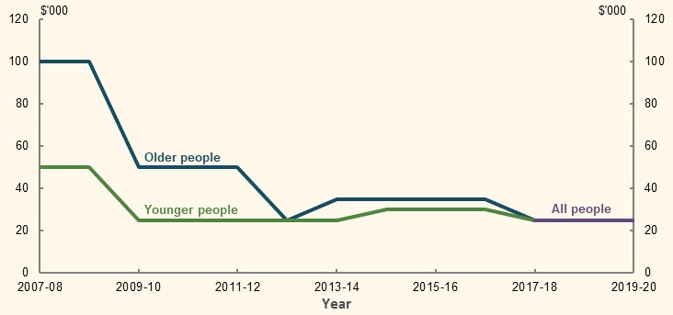
Note: ‘Older people’ are people aged 50 and over in 2007-08 to 2011-12, people aged 59 and over in 2013-14 and people aged 49 and over in 2014-15 to 2016-17. ‘Younger people’ are people younger than 50 in 2007-08 to 2011-12, people younger than 59 in 2013-14 and people younger than 49 in 2014-15 to 2016-17. ‘All people’ are the contributions caps that apply to people of all ages. Source (CEPAR, 2018b).
Prior to 2007, self-employed people received a 100 per cent tax deduction for only the first $5,000 of a contribution (increased from $3,000 in 2002) and 75 per cent of any subsequent contributions. They were also not eligible for the Government co-contribution scheme available to employees. From 1 July 2007, self-employed people under age 75 were able to claim all personal superannuation contributions as a tax deduction, but they were required to earn less than 10 per cent of their income as an employee to make a contribution. From 1 July 2017, the 10 per cent restriction was removed. Today, anyone can make deductible superannuation contributions (both the self-employed and employees who do not have access to salary sacrificing arrangements).
Reforms that took effect from 1 July 2017 generally prevent people with a total superannuation balance above $1.6 million from making post-tax voluntary contributions. Since these reforms, voluntary contributions have declined from 33 per cent of all superannuation contributions in 2015-16, to 25 per cent in 2018-19 (see 1D. The changing Australian landscape).
Small businesses may contribute the capital proceeds of the sale of certain small business assets, subject to certain conditions. This allows small business owners to contribute the assets they have accumulated through their business to their retirement savings. The total lifetime contributions must not exceed $1.565 million in 2020-21. This cap is indexed annually. These contributions do not count for other contributions caps and can be made even if the person has a balance exceeding the transfer balance cap of $1.6 million.

Government contributions and offsets
The Government provides certain contributions and offsets to eligible people, usually those with lower-to-medium incomes. Government contributions and offsets are generally aimed at improving equity for people who would otherwise receive smaller benefits from superannuation tax concessions. They include the low income superannuation tax offset, Government co-contributions for certain lower-income earners and spouse tax offsets.
The low income superannuation tax offset refunds the 15 per cent tax incurred on concessional superannuation contributions to people with a taxable income of less than $37,000. In 2018-19, almost 3 million people benefited from the low income superannuation tax offset, 60 per cent of whom were women. In practice, the offset removes a tax penalty by refunding tax paid on superannuation contributions to ensure lower-income earners pay no more tax than they would if receiving contributions as income.
The Government co-contribution provides up to $500 per year as a 50 per cent matching contribution for any personal non-concessional contributions made by people aged under 71. The rate of co-contribution decreases where a person’s income is above the low-income threshold ($39,837 for 2020-21) to the point where no contribution is payable for those with income above the high-income threshold ($54,837 for 2020-21). In 2018-19, around 376,000 people received co-contributions, 65 per cent of whom were women.
The spouse tax offset provides a tax offset of up to $540 to people who contribute to their low-income spouse’s superannuation. The maximum offset reduces as the spouse’s income exceeds $37,000 and phases out at $40,000.

Using superannuation to fund retirement
Retirees generally have two choices for using their superannuation to fund their retirement:
- Lump sums. Traditionally, the superannuation system paid out lump sums at retirement age. This was influenced by historical features of the retirement income system, such as tax settings that favoured lump sums in the 1970s and 1980s, and the former predominance of employer-based defined benefit schemes that paid entitlements as lump sums.
- Income streams. Current policy settings favour income streams over lump sums, as earnings on funds supporting income streams are tax-free in the retirement phase. Superannuation income streams provide a retiree with a regular payment. This comes in the form of an allocated or account-based pension purchased from the fund when the member’s balance is rolled into a pension account at the point of retirement.
Around 83 per cent of income streams are account-based (Australian Prudential Regulation Authority, 2020a). Account-based income streams offer the benefit of a regular income and the flexibility of access to lump sums of money held in an account where funds can be withdrawn at any time.
People have significant flexibility in how they use their superannuation. Minimum drawdown rates limit the ability of retirees to retain funds in the retirement phase indefinitely in order to remain exempt from tax on investment earnings. Minimum drawdown rates increase with age, from 4 per cent for a person under 65, to 14 per cent for a person over 95. These rates have temporarily been halved for the 2019-20 and 2020-21 income years to allow for reduced superannuation balances following the COVID-19 Pandemic.

Regulation and taxation of superannuation

Regulation
Compulsory superannuation contributions were extended to nearly all employees in 1992. The following year, a regulatory framework was introduced to ensure superannuation funds were managed prudently and in the best interests of their members.
Superannuation funds operate under a trustee model derived from the general law of equity and legislated in the Superannuation Industry (Supervision) Act 1993 (SIS Act). A corporate trustee, or a group of individual trustees, controls the fund’s assets and operates it solely for the benefit of its members and beneficiaries. The trustee has a fiduciary obligation to the members and beneficiaries. The trustee has ultimate responsibility for the entity and an obligation to manage the assets of the entity with competence, diligence, prudence and honesty.
Unlike many other jurisdictions and earlier iterations of the Australian system, most members are now in defined contribution arrangements rather than defined benefit arrangements.
The mandating of contributions and the provision of taxation incentives to encourage superannuation saving necessitates prudential regulation of superannuation entities, which is conducted by APRA.
Trustees of APRA-regulated funds must, among other things, demonstrate that they meet minimum standards of fitness and propriety; possess adequate human, technical and financial resources to meet their trustee responsibilities; and have appropriate risk management arrangements in place.
Prudential regulation does not guarantee that a superannuation entity will not fail, or that superannuation fund members will not suffer investment losses. Rather, it aims to ensure the prudent management of superannuation entities, so they can meet their financial promises to their members and beneficiaries. ASIC regulates the conduct and disclosure obligations of superannuation trustees.
Around two-thirds of the system (in terms of total value of assets) is APRA-regulated. The remainder is held by self-managed superannuation funds (SMSFs), balance of life office statutory funds or exempt public sector superannuation schemes. SMSFs may include up to four members, all of whom must be trustees or directors of the corporate trustee. These funds are exempt from prudential regulation on the basis that there is no difference in interests between trustees and members. The ATO is responsible for regulating SMSFs.

Taxation
Contributions tax applies to superannuation contributions that have not otherwise been taxed. These ‘pre-tax’ or concessional contributions are generally taxed at the flat rate of 15 per cent in the superannuation fund.
Division 293 tax requires people with an adjusted income of $250,000 and over to pay 30 per cent tax, instead of 15 per cent, on concessional contributions. Division 293 tax ensures people with annual incomes of $250,000 and over receive only a 17 per cent tax saving on superannuation contributions above this threshold. This tax advantage is lower than most other income levels. In 2018-19, around 230,000 people paid tax under Division 293, 77 per cent of whom were men.
Earnings tax is paid when superannuation assets grow in value. Earnings on superannuation assets are taxed in the superannuation fund at 15 per cent in the accumulation phase and are tax-free when the assets are in the retirement phase (i.e. they are providing a pension). Capital gains are also taxed at 15 per cent, with a one-third discount for assets held for more than one year.
The effective earnings tax rate may be lower than 15 per cent in the accumulation phase. This is because superannuation assets are eligible for franking credit tax offsets and a one-third capital gains discount if the assets have been owned for at least 12 months. As a result, the effective tax rate in the accumulation phase averages around 7 per cent.
To limit the total value of assets subject to earnings tax exemptions in the retirement phase, people are limited to the amount they can transfer to the tax-free retirement phase by the transfer balance cap. The transfer balance cap is currently $1.6 million. It is indexed each July in line with CPI, in $100,000 increments.

Overview of sources of income for recent retirees
Half of retirees rely on the Age Pension for at least 80 per cent of their income. At June 2019, almost 62 per cent of age pensioners received the maximum rate of pension, with the remaining 38 per cent receiving a part-rate pension.
In 2017-18, the median retiree household had equivalised income of $521 per week, primarily from the Age Pension, with a small supplemental income from superannuation and investments (Chart 1B-4).
Retiree households in the top two income deciles rely more on income from superannuation and investments than Government payments. Higher-income households are also more likely to be earning business or employment income.
    - Equivalised retiree household weekly disposable income, by source
and income decile
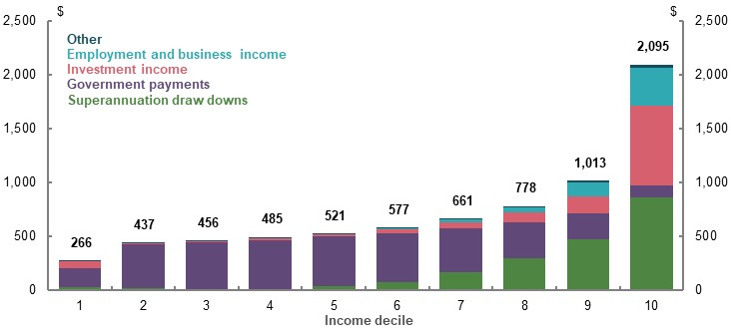
Note: Numbers above the column are total equivalised weekly income for each decile. Government payments include social security payments administered by Services Australia and the Department of Veterans’ Affairs, including compensation payments and family payments. Other includes income such as child support, income from non-superannuation annuities or financial support received from family members. Retirees are defined as households where the reference person is aged 65 or older and is no longer in the labour force. Household wealth has been equivalised using the OECD equivalence scale in order to take account of differences in a household’s size and composition. Low government income at decile one is influenced by households with assets in excess of the Age Pension assets test minimum threshold who may be drawing on assets not well captured in ABS income survey methodology. Average equivalised net wealth for the first income decile is over $900,000. Values are in 2017-18 dollars. Source: Analysis of (ABS, 2019s).

The value of government services for retirees
All Australian households receive support in the form of government-provided services, also referred to as social transfers in kind. The type of service, and degree to which it is used, changes as households age. Younger households receive significant in-kind support through benefits associated with primary, secondary and tertiary education. Older households receive significant social transfers through health services (Chart 1B-5), which are higher as a proportion of their income than other age groups (ABS, 2019k).
    - Average weekly value of social transfers in kind, by age group
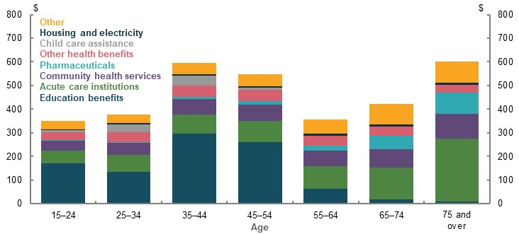
Note: Social transfers in kind are goods and services provided free or at subsidised prices by the Government. Education benefits includes school, tertiary and other education benefits. ‘Other health benefits’ includes private health insurance rebate and other health benefits. ‘Other’ is the residual of total selected social transfers in kind not covered. Values are in 2017-18 dollars. Source: (ABS, 2019k).

Assets of retirees
For most households aged 65 and over, the family home is their largest asset (Chart 1B-6). The home makes up 60-72 per cent of net wealth for households in the 40th to 70th percentile of the wealth distribution.
Excluding the family home, the median retiree household has around $165,000 in net wealth. For most households in retirement in 2017-18, superannuation makes up a relatively small share of net wealth.
Households in the top 20 per cent by wealth have on average more than $500,000 in equivalised wealth outside the home. Their wealth is held across financial, property and superannuation assets.
    - Equivalised household wealth by asset type, for retirees
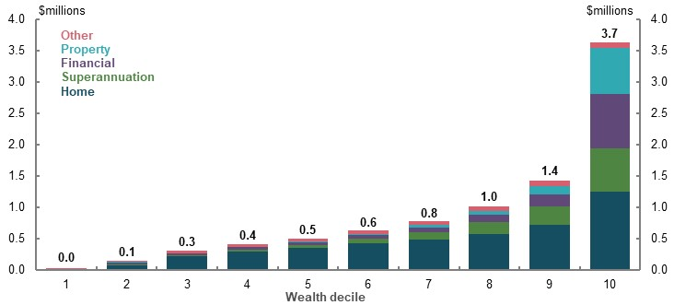
Note: Retirees are defined as households where the reference person is aged 65 or older and is no longer in the labour force. Household wealth has been equivalised using the OECD equivalence scale in order to take account of differences in a household’s size and composition. Values in 2017-18 dollars. Source: Analysis of (ABS, 2019s).

Superannuation wealth for people in or near retirement
While superannuation is a minor source of wealth for most current retirees, it will be an increasingly important asset as the system matures.
Currently, most people approaching retirement have some superannuation. However, they will have received the SG for only part of their working lives, and at a relatively low rate for some of this time. Superannuation balances for people approaching retirement are skewed towards higher-wealth households (Chart 1B-7 and Chart 1B-8). For people approaching retirement in 2017-18, the average superannuation balance for those at the fifth decile of the household wealth distribution was close to $140,000 compared with more than $1 million for the top decile.
- Equivalised superannuation balances of households aged 60-64 | - Superannuation balances of people aged 65-74
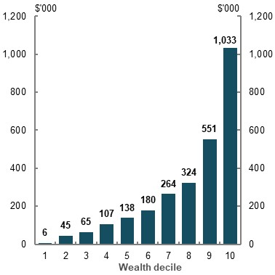 | 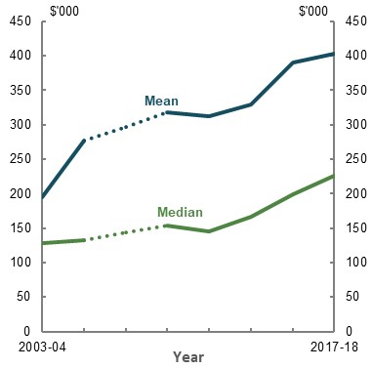
Note: All values are in 2017-18 dollars. Household wealth has been equivalised using the OECD equivalence scale in order to take account of differences in a household’s size and composition. Superannuation balances presented in Chart 1B-8 are on an individual rather than household basis. Data on superannuation was not collected in 2007-08. Source Analysis of (ABS, 2019s); (ABS, 2019k).

International comparison of Australia’s retirement income system
Australia’s retirement income system generally ranks highly in international comparisons of retirement income systems. For example, the Melbourne Mercer Global Pension Index ranked the Australian system third of 37 countries in 2019, behind the Netherlands and Denmark (Mercer, 2019b). It ranks highly on both adequacy and sustainability compared to others as it is more fully funded than most through superannuation contributions. It is also rated highly on integrity, as a result of the regulatory and governance requirements for superannuation funds operating in Australia.
Australia was one of the first countries to adopt a retirement income system with three pillars, comprising a means-tested Age Pension, compulsory superannuation and tax incentives to encourage voluntary contributions to superannuation. The Australian approach has been endorsed by the World Bank as international best practice (Nielson & Harris, 2010).
Australia’s Age Pension is unique. Some countries, mostly those in Scandinavia and Southern Europe, have a basic pension for poverty alleviation that covers a much smaller range of people. Around 71 per cent of Australians over Age Pension eligibility age receive an income support payment. According to CEPAR, Australian pensions involve higher payments and slower rates of withdrawal than most other countries (CEPAR, 2020, p. 4). However, most other countries have publicly funded contributory social security systems that provide benefits higher than basic pensions.
A key consideration in Australia’s retirement income support is housing. Australian levels of home ownership are high by international standards, particularly compared with Europe, where lifelong residence in ‘public housing’ is common for a significant percentage of lower-income earners. For many Australians, the family home is their most significant form of voluntary savings. Home ownership is important in determining the adequacy of retirement income, because most home owners have significantly lower housing costs than a retiree renting on the private market.
Internationally, the two most common retirement income schemes are:
- Government social insurance schemes are operated by many European governments. They involve an extra tax paid every year from employment income, with the promise of a regular payment in retirement. For example, the current rate of National Insurance in the UK for most employees is 12 per cent. Social security contributions are 18.6 per cent in Germany and 9.2 per cent in France. These schemes are often unfunded, meaning the additional tax paid is not separated or quarantined from other government funds to pay for pensions in the future.
- Employer-based defined benefit schemes involve employers providing retirement incomes to their employees. These schemes were the most common type of retirement income system internationally until the early 1990s, and were designed to retain employees. They typically paid a multiple of an employee’s final average salary based on their number of years of service. These schemes placed investment risk on the employer, meaning the employee received the same benefit irrespective of market returns. Following many companies struggling to meet these liabilities, particularly in the UK and US, defined benefit schemes are now less common.
Australia’s compulsory, privately managed superannuation system is unique. The most closely comparable schemes in the US or Canada are not compulsory. Instead, they encourage participation through tax incentives or behavioural ‘nudges’, such as automatic enrolment when starting a new job.
Private management of a pool of funds collected from member contributions places investment risk on the employee and retiree. This differs from employer defined benefit schemes or government social security schemes, and can expose retirees to lower incomes if market returns are low during retirement. However, experience with employer schemes demonstrated that employers do not always manage this risk effectively. Insolvency of some large US and UK firms has led to employees losing both employment and retirement savings. Unfunded government schemes carry a risk of governments reducing benefits in the future if the scheme becomes difficult to afford. This is particularly a risk for countries with ageing populations.
Preservation of retirement savings until retirement age is strictly enforced in Australia. With some small exceptions for ‘early release’, in circumstances of severe financial hardship or on compassionate grounds, superannuation can only be accessed after reaching preservation age. In contrast, overseas systems, for example funds established under section 401K of the US Internal Revenue Code, sometimes allow access to retirement savings earlier in life, but with a tax penalty (10 per cent in the US system).
Australia’s superannuation system provides more flexibility in retirement than most schemes. Retirees can access lump sums to pay for large one-off expenses (e.g. to finalise a mortgage or buy a car) or access an income stream over the longer term. European pension schemes typically provide an income stream, but do not offer access to a lump sum.

The objective of the system and the roles of the pillars
          - Section summary
- The retirement income system needs a clear objective to:
  - Anchor the policy direction of the system
  - Ensure the community understands the role and purpose of the system
  - Provide a framework for assessing the system’s performance
- The Australian community will ultimately have to endorse the system’s objective through the Government. To that end, the following broad objective for the system is suggested:
The retirement income system should deliver adequate standards of living in retirement in an equitable, sustainable and cohesive way
- To expand on this broad objective, the following elements are suggested:
  - The system should ensure a minimum standard of living for retirees with limited financial means that is consistent with prevailing community standards.
  - The system should facilitate people to reasonably maintain their standard of living in retirement.
  - The system should target Government support to those in need.
  - The system should provide similar outcomes for people in similar circumstances.
  - The system should be cost-effective for taxpayers in achieving adequate outcomes.
  - The system should be sustainable and robust to demographic, economic and social change.
  - The system should have effective incentives to smooth consumption and support people in taking personal responsibility for their retirement incomes.
  - The system should interact effectively with other systems.
  - The system should not be unnecessarily complex for consumers.
- The roles of the Government, individuals, the private sector and the three pillars will be influenced by the system’s objective. The role of the pillars will depend on their effectiveness, including cost-effectiveness, in achieving the system’s objective. All support for retirees — such as social transfers in-kind — need to be considered.

Outline of this section
This section suggests an objective for the retirement income system and considers the roles of system participants and pillars.
The objective of the retirement income system is ultimately a decision for the community (Box 1C-2). This section suggests issues to consider in deciding on the objective. The roles of system participants and pillars will stem from the objective the community endorses through the Government.
          - The system’s objective and community endorsement
The retirement income system’s objective should be established and endorsed by the Australian community through the Government. To help determine what this objective should be, and to facilitate this review, the panel has identified a possible objective and nine supporting elements for the system. The roles of system pillars should be determined by the objective, taking into account each pillar’s effectiveness in achieving that objective.
The system objective and roles of the pillars should be endorsed by the community to ensure public support for the system’s purpose and operation. It would be preferable if the objective of the retirement income system was legislated and not subject to frequent change.
The retirement income system and its component parts (the pillars) currently lack a stated objective. A clearly articulated objective is essential for anchoring the system’s policy direction, ensuring the community understands its purpose, and providing a framework to measure system performance. Many submissions endorsed the need to clearly establish the objective of the retirement income system and roles of the pillars (Box 1C-3).
          - Stakeholder input on the importance of the objective for the system
Stakeholders strongly agreed on the need for well-defined system objective. Stakeholders observed the lack of an objective has led to poor public understanding of the retirement income system and a lack of clear policy direction. Stakeholders also suggested that a formal objective would help in assessing the system’s performance.
- A wide range of stakeholders noted the public lacks a common understanding of the system’s objective, at least partly because the Government has not defined one (Committee for Sustainable Retirement Incomes; AMP; Challenger; Financial Planning Association of Australia; National Seniors; Rice Warner).
- Some suggested that a lack of clear roles for each pillar is a key reason people do not understand the overall system’s objective (Actuaries Institute). Others similarly observed that more clearly defining what each pillar is trying to achieve would assist public understanding of an overall system objective (Australian Super). Many submissions singled out the lack of a clear purpose for superannuation as being harmful in assisting public understanding (AIA Australia; AIST; Centre for Law, Markets and Regulation).
- Some noted that a system objective is needed to guide the review’s performance assessment (ASFA; AIST; Business Council of Australia).
- One view was that an objective would guide more coherent policy change, and this would reduce complexity and improve confidence (Business Council of Australia). Similar views were expressed that a clear system objective would help steer policy around pillar roles (Financial Planning Association of Australia).
- Many stakeholders held the general view that the system lacked a clear objective and establishing an objective is an important step (Alliance for a Fairer Retirement System; IOOF; Australian Unity; Dr Gaurav Khemka and Associate Professor Geoff Warren; Grattan Institute).

The principles of the retirement income system
The consultation paper released in November 2019 suggested that the principles for the retirement income system should be adequacy, equity, sustainability and cohesion.
Stakeholders largely endorsed these principles. Several additional principles were suggested, but these are generally captured by the principles outlined in the consultation paper.
- Some stakeholders suggested efficiency, competition or innovation. These can be interpreted as part of the principle of sustainability.
- Several stakeholders suggested certainty and integrity. These can be seen as being part of public confidence under the principle of sustainability.
- A number of stakeholders suggested simplicity. This is covered as part of the principle of cohesion.
- One stakeholder suggested fairness. This is covered under the principle of equity.
- Other stakeholders suggested personal responsibility. This is incorporated in the principle of cohesion.
A number of studies and reviews have previously proposed principles for the system. These previous suggestions are broadly consistent with the principles outlined in the review’s consultation paper, albeit with differences in emphasis.
- Australia’s Future Tax System Review (2009) (the Henry Review) proposed that the system should be broad and adequate, simple and approachable, acceptable (which includes equity), robust and sustainable.
- The Super System Review (2010) (the Cooper Review) contained 10 principles for the superannuation system. These principles mostly pertained to the internal operation of the superannuation system, rather than the outcomes the broader retirement income system produces.
- The Superannuation Charter Group (2013) proposed adequacy, sustainability, certainty and fairness as principles to guide superannuation policy.
- The Financial System Inquiry (2014) (the Murray Inquiry) proposed that superannuation policy should ensure retirement income is the ultimate goal. It also argued that choice, freedom, competition and innovation are important, but behavioural biases must be recognised and accounted for.
- The Productivity Commission (2016) developed a framework of objectives to assess the efficiency and competitiveness of the superannuation system. These objectives spoke to the performance of the superannuation system as a market that sells products and services to consumers, rather than the broader consideration of retirement outcomes.
- The OECD (2018a) emphasised poverty relief, redistribution, sustainability and consumption smoothing.
- The World Bank (2008) proposed that retirement income systems should be adequate, affordable, sustainable and robust.
Some submissions queried whether it was constructive for this review to put forward yet another set of principles. This is a valid point. Rather than successive reviews of the retirement income system proposing a new version of principles for the system, these should be decided by the Government, endorsed by the community and incorporated in the agreed objective of the system.

The retirement income system’s objective

Suggested objective for the system
To deliver adequate standards of living in retirement in an equitable, sustainable and cohesive way.
For this objective to serve as a guide for policy setting and a basis for assessing system performance, it needs to be expressed as clearly as possible. For example, what constitutes ‘adequacy, equity, sustainability and cohesion’ will need to be clarified. A vague, ambiguous objective that is open to interpretation will not provide the guidance required.
A single sentence that attempts to cover the objective for the retirement system cannot encompass all the aspects and goals with the clarity required. The following nine elements provide additional detail on how the broad system objective could be clarified.

Adequacy
Two elements are suggested to meet the objective of an adequate retirement income. Stakeholders broadly agree on the first element but differ as to how the second element should be expressed.

Element 1
The system should ensure a minimum standard of living for retirees with limited financial means that is consistent with prevailing community standards.
Australia’s retirement income system aims to ensure retirees have a minimum standard of living in retirement in line with prevailing community standards and, in particular, to ensure that no older Australian should live in poverty. Broadly, this is consistent with the current settings of the Age Pension, which ensure the maximum rate of the Age Pension moves with the higher of wages or living costs (see 2A. Achieving a minimum standard of living in retirement). Older Australians also receive substantial in-kind support in addition to the Age Pension.
There are trade-offs between the generosity of the minimum standard and the:
- Sustainability of the system
- Incentives for people to take a more active role in funding their own retirement
The Age Pension provides more than a safety net for older Australians who do not have a sufficient level of financial resources to achieve a minimum standard of living. It supplements the savings of lower- to middle-income people and households to maintain their standard of living in retirement. This is the second suggested element of the objective of achieving an adequate retirement income.

Element 2
The system should facilitate people to reasonably maintain their standard of living in retirement.
Stakeholders differ as to whether element 2 should be expressed in aspirational terms or if the aim should be, as stated, for retirees to maintain their living standards into retirement. As outlined subsequently, the weight of evidence supports the second approach. This is often referred to as ‘consumption smoothing’, which balances the trade-off between consumption in working years and consumption in retirement.
For most individuals or households, maintaining living standards in retirement requires them to save while working, so they can draw on those savings in retirement. A tendency to undersave means some intervention (such as from the Government) is needed to encourage retirement saving and therefore maximise lifetime wellbeing.
The amount of income that retirees need to maintain a similar standard of living in retirement as in their working life is generally lower than their pre-retirement income. This is because:
- Expenses typically fall in retirement, increasingly so as individuals and households age. For example, children move out and mortgages are often extinguished
- People no longer need to save for retirement
- In-kind support from the Government subsidises living costs for most retirees
Consumption smoothing is most relevant for middle-income households. This is why the objective of maintaining living standards in retirement is qualified with the word ‘reasonably’. For many lower-income individuals or households, the Age Pension represents an increase in their income in retirement (see 2C. Maintaining standards of living in retirement). In these cases, achieving a minimum standard of adequacy is more relevant than consumption smoothing.
Higher-income earners have additional wealth to draw on and capacity for voluntary saving. There is less of a rationale for policy based on compulsory superannuation contributions to target consumption smoothing for higher-income earners in the same way it would for others.
Some stakeholders proposed that risk management (against longevity, market or inflation risk) should be an explicit goal of the system. Risk management is clearly important. However, it is arguably covered in the adequacy elements. A minimum standard provides some degree of insurance against these risks by providing an income level that retirees do not fall below. A system that enables people to efficiently maintain their living standard throughout retirement also manages longevity risk.

Equity
Retirement outcomes will inevitably be different across the population because they reflect differences in pre-retirement income and wealth, and individual circumstances. Although stakeholders agreed that equity was an objective of the retirement income system, a range of views were offered regarding what constitutes equity. Many submissions focused on whether particular cohorts of the population (such as women, Aboriginal and Torres Strait Islander people, renters, the self-employed, and involuntary retirees) were achieving equitable outcomes in retirement. The retirement outcomes of these groups of people and for people across the income and wealth distribution are considered in 3. Equity.
A key aspect of the objective of equitable retirement outcomes is that Government support is targeted to those in need.

Element 3
The system should target Government support to those in need.
Targeting Government support to those in need is consistent with the broader community consensus on the design of Australia’s transfer system, which is one of the most targeted in the OECD (Whiteford, 2015). Targeted support should not discourage people from saving for their retirement if they can.
The largest and most important elements of Government support are the Age Pension and superannuation tax concessions. But other interventions, such as social transfers in-kind, also affect retirement outcomes (discussed more below).
There is a trade-off between targeting and complexity. Universal Government support would be simpler to administer but would be inconsistent with community preferences. Therefore, targeted support should be designed without unnecessary complexity.

Element 4
The system should provide similar outcomes for people in similar circumstances.
Targeting should ensure that people in similar circumstances receive similar levels of support. Similar circumstances can include similarities in income and wealth levels, and household composition.

Sustainability
Sustainability, which focuses on the costs of the system, has two elements. First, whether the system is cost-effective in achieving adequate outcomes (element 5). Second, whether the system can continue to deliver adequate outcomes in the future (element 6). In both cases, the potential impacts on public confidence and community support are important.

Element 5
The system should be cost-effective for taxpayers in achieving adequate outcomes.
The retirement income system contains a wide range of costs for different parties:
- Government. The Age Pension, superannuation tax concessions and in-kind support for retirees.
- Individuals. The cost of the fees charged by the superannuation industry.
From both a community support and a general cost sustainability perspective, this money should be efficiently directed towards achieving adequate retirement outcomes.
This does not mean solely focusing on identifying ‘waste’ and reducing the overall cost of the system, but identifying whether existing resources could be redeployed to achieve better adequacy outcomes.
This is an important relationship between sustainability, equity and adequacy. If there is scope to reallocate resources to better achieve adequacy objectives, this may imply that Government support could be better targeted.

Element 6
The system cost should be sustainable and robust to demographic, economic and social change.
The first part of element 6 (the system should be sustainable) considers all the different costs of the system. Costs that grow faster than the nation’s ability to pay may lead to public perceptions that the Government is making unrealistic promises. This may undermine public confidence that the system is sustainable. Conversely, public confidence can be enhanced by ensuring people have a personal stake in the system and are supported in taking personal responsibility for their retirement.
The second part of element 6 (robustness to change) considers how achieving the system’s objective might be affected by adverse external forces, such as lower wage growth or reduced investment returns. The system cannot be impervious to broader forces; the examples listed above will naturally affect the adequacy of retirement incomes. Rather, the system needs to be able to weather such forces and, to some extent, offset their impacts.

Cohesion
Cohesion considers whether the processes, mechanisms and incentives that contribute to retirement outcomes are achieving the system’s objective in a well-integrated way. This includes whether the incentives in the system are effective and complementary, whether the system interacts effectively with other systems and whether the system’s processes are easy to engage with, or if they are too complex.
The retirement income system is not a discrete entity. It comprises multiple components that have evolved over a century. Considering whether these components operate in a cohesive fashion is important.

Element 7
The system should have effective incentives to smooth consumption and support people in taking personal responsibility for their retirement incomes.
For the system to help people reasonably maintain their living standards in retirement (element 2), all policy settings should encourage optimal consumption smoothing. In practice, this means incentives must balance a person’s working, saving, investing and spending across their lifetime.
Incentives should encourage and enable people to take responsibility for their retirement incomes. Having people contribute to their retirement income is central to the objective of people maintaining their living standards.
For many people, this encouragement is in the form of compulsory superannuation. But there also need to be incentives for those who are not covered by compulsory superannuation. People should not only be encouraged to take responsibility for saving for their retirement, they should also be encouraged to use their savings to support their living standards in retirement as effectively as possible.
Incentives operate in a complex policy environment, including:
- In accumulation, the tax incentives associated with voluntary savings; in particular, purchasing housing and making voluntary superannuation contributions
- Approaching retirement, the preservation and Age Pension eligibility ages, and also the incentives stemming from the interaction of private savings and the Age Pension means test
- In retirement, the incentives to drawdown savings to finance living standards
These incentives create many trade-offs against other objectives. For example, tax incentives come at a cost to the system. Hence, it is important that the incentives are ‘effective’ (shifting behaviour in the intended direction) rather than just rewarding behaviour that would occur regardless.
The intent of incentives to support personal responsibility is to contribute to retirement incomes, rather than boosting savings in their own right. This is particularly relevant where savings go beyond what is needed for generating retirement incomes that maintain people’s living standards. It is also relevant when people do not effectively draw on their savings to maintain their living standards in retirement and leave the bulk of their wealth as a bequest.

Element 8
The system should interact effectively with other systems.
Many other factors outside the retirement income system influence people’s retirement outcomes. For example, the need to address health issues and to plan for aged care influences people’s savings and spending behaviour in retirement. Wherever possible, these interactions should be effective and not undermine either system’s objectives.

Element 9
The system should not be unnecessary complex for consumers.
Ideally, the retirement income system should be as simple to navigate as possible. Simpler systems are easier to understand and are more likely to lead to good decisions.
However, producing adequate retirement outcomes in an equitable, sustainable and cohesive way requires input from Government, individuals and the private sector; pillars that span income support and the funds management industry; social transfers in kind that draw together services from across different systems; the tax system; and a multitude of trade-offs.
Inevitably, the system will be complex. The issue is not whether the system itself is complex, but rather:
- Whether the system is unnecessarily complex
- Whether effective steps, including regulation, are taken to help people navigate the system to achieve good retirement outcomes
Complexity can arise slowly and unexpectedly, so regular stocktakes as to whether it is necessary are important. Government and the private sector have a role in developing tools or interfaces that bypass complexity and make it easier for individuals and households to engage with the system (see 5A. Cohesion).

Key considerations in approaching the elements
The elements are interrelated. For example, achieving adequate standards of living in retirement is inherently related to equity; namely, do all people have an equal opportunity to obtain adequate standards of living in retirement? Similarly, the standard of living being sought in retirement is closely connected to whether the system is sustainable.
The elements should clearly focus on supporting a standard of living in retirement rather than on wealth accumulation in and of itself. Stakeholders and previous studies overwhelmingly agree that the retirement income system should aim to produce income for consumption in retirement, and not be used as a vehicle for estate planning.
Opinions differ over whether the adequacy elements of the system should be aspirational. Some stakeholders recommended objectives such as achieving a ‘comfortable retirement’, a ‘dignified retirement’ and a ‘…retirement [people] want and deserve’. Often these suggested objectives result in target budget standards comprising a basket of goods and services (rather than replacement rates that compare income in working life with income in retirement). Other stakeholders pointed out that such aspirational objectives would involve many people having a higher income in retirement than they have in their working years, which may reduce their standard of living before retirement.
The degree to which an increase in the SG is considered to affect wages growth is critical to this issue. If the SG is not considered to reduce wages growth pre-retirement, then the impact of aspirational retirement income objectives on pre-retirement income is not an issue.
The report examines this issue in detail, concluding that the weight of evidence suggests increases in the SG have an impact on wages growth. Budget standards do not measure the trade-off between retirement and working-life living standards. While a person can choose how much consumption to forgo to save for retirement, in a system based on compulsory superannuation, it would not be optimal to set a retirement objective that requires inappropriate sacrifices during working life (see 2C. Maintaining standards of living in retirement).
The system should be centred on achieving the best outcomes for individuals. Some stakeholders proposed that the retirement income system should explicitly aim to reduce the share of retirees drawing on the Age Pension. This should not be an aim in itself. The system should prioritise individual outcomes above Government outcomes. If the system specifically aimed to reduce the share of retirees drawing on the Age Pension, optimal retirement outcomes would not necessarily be achieved. For example, such an objective could imply the Age Pension means tests be set so that as few people as possible would qualify. Government costs are best assessed by looking at the fiscal impact of the whole retirement income system. The proportion of the population receiving the Age Pension is only a proxy for the cost of one element of the system. While Government costs are an important consideration, they need to be considered holistically and in the context of the retirement outcomes they produce for individuals.

The roles of the Government, individuals and the private sector
Achieving the objective of the retirement income system requires involvement by the Government, individuals and the private sector. This shared responsibility is reflected in the structure of the system.

The Government
The Government has the foundational role in the system of setting retirement income policy.
The Government guarantees a minimum standard of living in the form of the Age Pension, which also helps many low- and middle-income people maintain their standard of living in retirement. In addition, the Age Pension helps insure against longevity, inflation and market risk. For many age pensioners who do not own their own home, Commonwealth Rent Assistance assists with their retirement outcomes. The Government also provides support via superannuation tax concessions.
The Government compels employees to save a portion of their income via compulsory superannuation. Some stakeholders argue this compulsion implies the Government should take primary responsibility for appropriate default settings for the disengaged and regulating superannuation savings once invested (Productivity Commission, 2018a; Minifie, et al., 2014; 2015; Financial System Inquiry, 2014).
As the custodian of policy, the Government is also responsible for ensuring retirement income policies are sustainable and cohesive.

Individuals
The Government’s role (providing the Age Pension and compelling superannuation payments through the SG) could be seen to suggest that the role for individuals is limited to making voluntary savings for retirement. However, the individual’s role is more substantial than this for several reasons.
Not everyone is covered by the SG. For example, self-employed people need to take a more active role in making retirement savings, particularly if they want to maintain their living standards at a level beyond what the Age Pension provides.
Individuals bear the risks of adverse market outcomes or poor investment performance. Ideally, people should take an active interest in ensuring their finances are well-positioned to manage these risks. Knowledge of the relative performance of their investments or the value of diversification can help people to achieve good retirement outcomes.
Some stakeholders argued individuals have a responsibility to take an active role in managing their superannuation in the accumulation phase, whether compulsory or voluntary. Although this is desirable, it comes with many obstacles. The system is inherently complex and not all working Australians can understand complex financial products. The Productivity Commission (2018a) found a significant share of Australians either cannot or will not actively manage their superannuation. This underlines the importance of strong default settings that protect those who are unable or unwilling to engage.
Defaults can, however, encourage disengagement. Improving financial literacy and understanding of superannuation is important to allow people to take an active and informed interest in their retirement savings. The Productivity Commission (2018a) suggested default settings be set to encourage people to make active choices while also protecting those who do not.
Individuals need to take a more active role when they retire, in particular, using accumulated superannuation balances and other savings to support their standard of living in retirement. This means people need to have the confidence to draw down their savings in retirement. In doing so, they will have to assess products that will help manage market and longevity risks. Here, the private sector plays an important role, particularly in providing financial advice, guidance and information.

The private sector
Private sector participants in the retirement income system include, most notably, employers, superannuation funds and financial advisers.
Employers are required to fulfil their obligations under the Superannuation Guarantee (Administration) Act 1992 (or under industrial agreements in many cases) to make superannuation contributions on behalf of their employees. Some employers are also required to select a default fund for their employees. It has been recommended that this decision should rest elsewhere as employers are not optimally positioned for this role (Productivity Commission, 2018a).
Broadly, the role for superannuation funds is codified in legislation as acting in their members’ best interests with the sole purpose of providing retirement benefits. What this means in practice has been interpreted differently by different parties (Productivity Commission, 2018a; Royal Commission into Misconduct in the Banking, Superannuation and Financial Services Industry, 2019). Changes stemming from the Royal Commission into Misconduct in the Banking, Superannuation and Financial Services Industry aim to ensure these obligations are consistently enforced by regulators.
The private sector also helps to manage risks for individuals and households. With balances at retirement continuing to grow as the superannuation system matures, greater innovation is needed to deliver retirement incomes that meet retirees’ needs. The proposed Retirement Income Covenant would require superannuation funds to play a larger role in longevity and market risk management for members in retirement. The role of quality advice and guidance in helping individuals manage these risks will become increasing important (see 5A. Cohesion).

The roles of the pillars
Views differ as to what constitutes the retirement income system. The terms of reference for the review refer to its three pillars: the Age Pension; compulsory superannuation; and voluntary savings, including voluntary superannuation contributions and home ownership. Several submissions suggested more pillars, ranging from work in retirement, non-financial arrangements, Jobseeker Allowance (formerly Newstart) for the involuntarily retired, private intergenerational transfers and health and long-term care.
The World Bank (2008) proposes a five-pillar framework that includes social transfers in kind outside the formal pension system. Social transfers in kind are a significant factor influencing retirement outcomes. All sources of income and support that people can draw on to support their standard of living in retirement are important and should be considered.
The review focused on the three pillars identified in its terms of reference. These pillars involve measures by the Government specifically aimed at supporting incomes in retirement by:
- Directly funding eligible people through the Age Pension
- Requiring people to contribute a proportion of their wages to superannuation
- Providing tax advantages to encourage voluntary contributions to superannuation
Owner-occupied housing is an important component of voluntary savings. It is supported by a range of government policies, including exemptions from much taxation and means testing. Home ownership reduces housing costs for most retirees and creates an asset that can be drawn on to supplement retirement income. For most retirees, the home is their largest form of saving (see 1B. Design of Australia’s retirement income system).
Regardless of their number, the retirement income system pillars should be well-integrated and operating coherently as a ‘system’. Therefore, pillar roles are best thought of as partial and may not be clearly distinct from one another. They should not be considered in isolation. Several stakeholders echoed this sentiment.
Following is an assessment of some of the factors to consider when determining each pillar’s role. As mentioned above, the exact role that each pillar should play is a function of the system objective, which is ultimately for the community to endorse through the Government.

The Age Pension
The Age Pension serves two key roles:
- Providing a safety net for those Australians who do not have the financial means to support a minimum standard of living in retirement.
- Supplementing the retirement incomes of a large proportion of low- and middle-income retirees.
In both these roles, the Age Pension reduces income inequality in retirement (see 3A. Income and wealth distribution). Balancing these roles revolves around the targeting of the Age Pension. Targeting could primarily aim to provide a safety net or aim to play an expanded role in supplementing the income of low- to middle-income people and help them maintain their living standards in retirement.
Determining this balance will depend on the relative effectiveness, including cost-effectiveness, of the Age Pension and the other pillars.

A safety net level of income
Stakeholders had diverse views about the level of income the Age Pension should provide. Many stakeholders suggested the Age Pension’s role is poverty alleviation. However, using poverty alleviation as the basis for the Age Pension is complicated by the various poverty definitions available: some are absolute budget measures, and some are relative to prevailing living standards (see 2A. Achieving a minimum standard of living in retirement).
Previous work has suggested the safety net role of the Age Pension is at least poverty alleviation by some relative measure, if not to provide a standard of living somewhere above this. The Pension Review (2009) (the Harmer Review) suggested the role of the Age Pension is to provide a basic, acceptable standard of living, accounting for prevailing living standards. The Henry Review (2009) suggested the Age Pension be enough to provide a reasonable minimum standard of living.
The maximum rate of the Age Pension has been benchmarked to a given portion of different measures of wages since the early 1970s (Yeend, 2009). Ensuring the Age Pension’s safety net level of income takes account of prevailing living standards is likely to be consistent with the broader community consensus.
However, there are trade-offs with the degree to which the Age Pension takes account of prevailing living standards. Set too generously, the incentives to save for retirement may be muted, and the Age Pension could jeopardise the sustainability of the system, particularly in the face of an ageing population.
The safety net has traditionally been set with reference to the needs of retirees who own their homes. Commonwealth Rent Assistance acts as a supplement to the Age Pension to improve the living standards of those who pay rent.

Supplementing income
Several submissions raised the role of the Age Pension in supplementing the retirement income of lower- to middle-income earners. For many lower- to middle-income Australians, their retirement income is the combination of a part Age Pension and other income sources, particularly superannuation. The Age Pension component tends to take on more importance as people age and other income sources deplete.
Many stakeholders acknowledged a role for the Age Pension in longevity and/or market risk protection. This role was reaffirmed in previous reviews (Australia’s Future Tax System Review, 2009; Harmer, 2009). The Age Pension provides a degree of protection against these risks. If someone lives longer than their private savings last, they will be supported by the Age Pension’s safety net level of income. If someone’s private assets or income are reduced, such as with a market downturn, their income will be supplemented by the Age Pension. The community may not sufficiently recognise this role of the Age Pension.

Compulsory superannuation
Stakeholders had diverse views as to the role of compulsory superannuation in the retirement income system, particularly around whether its role is to replace or supplement the Age Pension. Previous studies came to different conclusions. However, there is general agreement about the need for compulsion per se.
Clarity on the role of compulsory superannuation is important so as to provide guidance for a range of policy variables, including the SG rate, the coverage of individuals who are compelled to save, the extent of tax concessions and the targeting of the Age Pension.
Important trade-offs must be managed across these policy variables. For example, the SG compels people to trade off future and current consumption (see 2C. Maintaining standards of living in retirement), and the extent of tax concessions has sustainability implications.
Previously suggested roles of compulsory superannuation have centred on its effect on the Commonwealth Government budget (reducing Age Pension expenditure), boosting national savings and providing retirement income. Another rationale when compulsory superannuation was introduced was to reduce inflationary wage pressure present at that time.
Broadly, compulsion is typically justified on the basis that individuals or households would ‘undersave’ in its absence. When compulsory superannuation was introduced, it was noted that people tended to be short-sighted about providing for their own long-term needs (Fitzgerald, 1993). This behavioural, bias-based reasoning is consistent with international guidance (World Bank, 1994; 2008; OECD, 2018a).

The Government budget
When compulsory superannuation was introduced, one of its intended roles was to ease pressure on the budget in the face of an ageing population (Senate Select Committee on Superannuation, 1992; House of Representatives, 1992; The Treasury, 1991; Fitzgerald, 1993). The goal of easing pressure on Age Pension expenditure has been supported more recently by the Superannuation Charter Group (2013) and the Murray Inquiry (2014). These reports did not anticipate replacing the Age Pension.
The underlying intent of this goal relates to how the retirement income system affects the Government’s overall fiscal position over time. As such, the budgetary impact of the SG is best considered not by looking at the impact of the SG on Age Pension costs alone, but at the costs across the entire system, including the cost to the budget of superannuation tax concessions.

National savings
When compulsory superannuation was introduced, increased national savings was one of the policy’s explicit goals (Keating, 1991; Dawkins, 1992). Fitzgerald (1993) predicted the SG would increase annual national savings by almost 0.75 per cent of GDP over the following decade. Gruen and Soding (2011) found compulsory superannuation led to a net increase in the national private savings rate of around 1.5 per cent of GDP. Stakeholders did not suggest increased national savings currently constitutes an explicit role of compulsory superannuation.
Some submissions said that the broader economic benefits of the SG system should be recognised.

Retirement income
Providing income in retirement is the fundamental role of compulsory superannuation.
The Murray Inquiry (2014) recommended that the objective of the superannuation system should be to ‘provide income in retirement to substitute or supplement the Age Pension’. This recommendation was subject to consultation and drafted into Bill form but remains unlegislated. A number of submissions on the Bill raised problems with how the objective was specified, pointing out the significant differences between ‘replacing’ and ‘supplementing’ the Age Pension. Some noted it was unrealistic to expect superannuation income to replace Age Pension income for most people (Australian Council of Social Service, 2016).
At its inception, compulsory superannuation was generally described as offering income additional to the Age Pension, rather than replacing it (Fitzgerald, 1993; House of Representatives, 1992; Keating, 1991; The Treasury, 1991; Dawkins, 1992). At the time, the Age Pension was expected to remain the foundation of equity and adequacy in the system (Keating, 1991). If the role of the SG is to replace the Age Pension for most people, its rate would have to be higher than if its role was to supplement the Age Pension. Fitzgerald (1993) estimated that a rate of 18 per cent would be necessary to meet this goal.
Many submissions highlighted that compulsory superannuation should not aim to be the single source of adequacy for most individuals or households, and that the Age Pension will inevitably play an important role for most individuals or households. However, there were different points of emphasis, with some stakeholders suggesting:
- Compulsory superannuation, combined with the Age Pension, should provide no more income than the average standard of living during working life
- Compulsory superannuation and the Age Pension should work together to ensure a ‘comfortable’ standard of living
The Henry Review (2009) did not explicitly tie the purpose of compulsory superannuation to the Age Pension, instead suggesting the SG be informed by a moderate replacement rate for a typical median-income earner. Some stakeholders suggested a similar approach. However, by targeting the median-income earner’s replacement rate, the framing implicitly takes account of the Age Pension income that feeds into that replacement rate.
The use of median or average incomes or living standards in calibrating the role for compulsory superannuation is compelling. The SG mandates the same level of savings across the population, regardless of income, wealth or personal objectives. Studies have found a reasonably wide range of ‘optimal’ SG rates across the population (Warren, et al., 2020). A system that contains a range of rates depending on the person would be overly complex and almost certainly unworkable. On this basis it is appropriate the SG rate be set with regard to the circumstances of an average or median-income earner with a typical working life.
Preservation of superannuation means the SG provides only upward flexibility in personal saving rates (i.e. people can only save more, not less). Therefore, setting the SG rate too high is arguably worse than setting it too low, forcing some individuals and households to save more than would be required in retirement and compromising working-life living standards. According to the World Bank (1994), it is not unreasonable to set mandatory contributions rates slightly below a reasonable replacement rate estimate to allow for individual heterogeneity. Alternatively, loss aversion suggests that underestimating the savings needed for retirement may cause more harm than overestimating.
An individual and household adequacy outcome (one that balances the trade-offs between present and future consumption) supports the historical view of compulsory superannuation being generally supplemental to the Age Pension. In performing this role, as the superannuation system matures, compulsory superannuation will reduce reliance on the Age Pension in supporting retirement outcomes.

Voluntary savings
Voluntary savings are far more expansive than the Age Pension and compulsory superannuation. They incorporate the flexibility offered by voluntary superannuation contributions, as well as owner-occupied housing, and other investments such as property, shares or bank deposits. This diversity makes the role of voluntary savings in the retirement income system less clear.

Flexibility
Many stakeholders cited individual flexibility as a key role for voluntary savings (in particular, voluntary superannuation contributions).
For those not subject to the SG, such as the self-employed, voluntary savings (and voluntary superannuation contributions in particular) take on a much more important role. When compulsory superannuation was introduced, Fitzgerald (1993) noted the justification for compelling employees to save was likely applicable to the self-employed as well. Many stakeholders suggested SG coverage should be extended to the self-employed.
Flexibility provides the opportunity for some people to save more for retirement than the savings stemming from the SG, including to make ‘catch-up’ payments following periods out of the workforce. Some stakeholders suggested that the flexibility offered by voluntary superannuation contributions only really applies to higher-income earners.
Voluntary superannuation savings are subject to concessional tax treatment. Voluntary contributions can be made from pre-tax income and are subject to concessional earnings taxation once invested. The role of tax concessions in encouraging voluntary contributions to superannuation is an important consideration, both in terms of their effectiveness (see 5A. Cohesion) and the trade-offs associated with equity and sustainability (see 3. Equity and 4. Sustainability).

Housing
Housing is an important component of voluntary savings and a key determinant of retirement outcomes. Those who enter retirement with owner-occupied housing typically enjoy higher effective living standards by avoiding rental costs (including protection against rent increases) (see 2A. Achieving a minimum standard of living in retirement). Owner-occupied housing acts as a store of capital security while being mostly exempt from the tax and transfer system (although this is arguably a broader feature of the tax system that goes beyond the retirement income system). Home ownership also serves as a source of emotional security and safety (Australia’s Future Tax System Review, 2009). These roles were noted by numerous stakeholders, with some submissions suggesting an explicit objective to ensure retirees have stable and affordable housing, and others arguing owner-occupied housing should be seen as a separate pillar.
Arguably, it is the service that owner-occupied housing provides that is most important, rather than the actual savings. If housing were a stand-alone pillar it should constitute housing services, and therefore would include rental accommodation.
Home owners also have the opportunity to access the equity in their home to supplement retirement income and manage longevity risk, although few currently do so. If this potential were realised, housing would take on an even more important role in the retirement income system.

Social transfers in kind
Social transfers in kind are not an explicit pillar of the retirement income system as laid out in the terms of reference. However, they are an important factor in influencing retirement outcomes (see 2A. Achieving a minimum standard of living in retirement). All sources of income and support that people can draw on to support their standard of living in retirement are important and should be taken into account.
The World Bank’s (2008) five-pillar framework for retirement income systems describes pillar four as access to informal and formal support and social programs. This acknowledges the important role social transfers in kind play in supporting effective living standards for retirees.
Some social transfers in kind are targeted based on needs, while others are universal. Social transfers in kind support adequacy by reducing retiree’s living costs, and therefore boosting their effective living standards for a given level of income. The role of social transfers in kind in the retirement income system may not be sufficiently recognised in the community, or by retirees themselves (see 5A. Cohesion).

The changing Australian landscape
          - Section summary
- Australia’s population is growing and ageing. As at December 2019, the population was projected to increase from 26 million people in 2020 to 42 million in 2060. Projections indicate that the population aged 65 and over will increase from 16 per cent in 2020 to 22 per cent by 2060. This is a result of lower fertility rates since the 1960s, partly mitigated by net overseas migration, which has slowed population ageing. The COVID-19 Pandemic may accelerate the rate of population ageing.
- Australians are living longer. Life expectancies across all ages have increased over the past 40 years, particularly for men. Although women continue to have greater life expectancy and longevity than men, the life expectancy gap reduces with age.
- More Australians, particularly women, are in the labour force today than 40 years ago. Total labour force participation increased by 5 percentage points from 1980 to 2019. Female participation increased by 16 percentage points over this period, with sustained increases in participation across all ages. This increase in female participation was partly offset by lower participation among men under age 55.
- Economic conditions have been positive for the past three decades but are uncertain in the short- to medium-term in light of the COVID-19 Pandemic. The Australian economy has experienced sustained growth since the early 1990s. Unemployment has generally fallen during this time, remaining below its 40-year average since 2002. Real wage growth has been on average positive over the past 20 years.
- Growth in domestic and international equity markets has been strong over the past 40 years, although there have been sharp declines during economic shocks. Over the past decade market interest rates have fallen domestically and internationally to historic lows.
- The superannuation system will fully mature in the 2040s when the workforce will have experienced SG rates of at least 9 per cent for 40 years. Seven in ten Australians aged 15 and over are now covered by superannuation. Strong investment returns and increasing contributions have nearly doubled assets under management as a per cent of GDP since 2005. Superannuation is now the largest asset held by most households outside the family home.
- Higher home and superannuation values have increased household wealth over the past 30 years. Increases in housing wealth have benefited existing home owners. People buying a home have increasingly needed to take on greater household debt and are spending larger proportions of their working-life incomes on housing. Mortgage debt among households aged 55 and over has increased in the past 20 years.
- Home ownership has fallen for younger and lower- to middle-income Australians over the past 40 years. Increases in residential property prices, later workforce entry and household formation have delayed and reduced the affordability of home ownership. Ownership rates for households aged 65 and over and higher-income households have remained relatively stable.
- Older households are increasingly renting through the private market. Private market rental costs are generally higher than those of public housing. Overall, rates of renting by households aged 65 and over have been stable over the past 10 years. Current trends in home ownership suggest lower-income retiree households may be more likely to rent in future.

Outline of this section
This section identifies the broader demographic and economic trends that could affect the retirement income system and its ability to deliver adequate outcomes:
- Demographic trends
- Labour force trends
- Economic growth and returns on investments
- Maturity of the superannuation system
- Household wealth and debt
- Housing
Trends are generally shown over a historical 10-40-year horizon depending on available data.
          - COVID-19 and economic trends
To improve understanding of how the retirement income system performs over the long term, cameo and population-level modelling was used to project potential future outcomes. Such modelling exercises give a guide to the direction and magnitude of possible outcomes relative to how the system performs today. It does not predict outcomes.
Like most medium- to long-term analysis, including that presented in the Intergenerational Report (Commonwealth of Australia, 2015), the modelling focuses on medium- to long-term trends in the economy rather than short-run fluctuations. A wide range of short-term factors, such as business cycles, and labour market and financial market shocks, will affect the actual path of Australia’s economy to 2060.
Short-term factors should not materially affect the analysis of very long-term outcomes. They may, however, result in substantial short-run deviations from the long-term trends. The full extent of COVID-19’s effect on the Australian and global economies is not reflected in the long-term trends outlined in this chapter. For example, the COVID-19 Pandemic is expected to result in below-trend economic growth, participation rates, wage growth and population growth in Australia in 2020-21. The OECD has projected a global economic recession (OECD, 2020a). The effects of these deviations may continue to be felt for some time with decreasing severity. Short-term shocks can have large effects on superannuation balances. The short-term effects of market volatility for people in or nearing retirement are explored in 2C. Maintaining standards of living in retirement.
Economic outcomes over the medium- to long-term are driven by factors such as population growth, labour force participation and productivity. The analysis and long-term projections in this report incorporate assumptions for these variables based on trends over the past 40 years. This incorporates periods of slower and faster economic growth, including the GFC in 2008-09.
The modelling framework underpinning this report (and Intergenerational Reports) takes into account long-run averages of key macroeconomic variables to model long-term changes in the structure of the Australian population and labour force over the coming decades. Although the economic impacts of COVID-19 were beginning to be observed during the course of the review, the full effects and any long-term economic consequences will not be known for some time. Predicting the economic impacts of a pandemic is difficult and outside the scope of this report.
Given this uncertainty, this report includes sensitivity analysis to assess the potential impact of deviations from the assumed long-term trends. For example, 2C. Maintaining standards of living in retirement and 4. Sustainability assess the effects of negative short-term shocks to wage growth and investment returns on outcomes for individuals and to the cost and performance of the system.
Modelling has been used to illustrate how policy outcomes over a long period may be affected by policy settings. A range of scenarios was explored and outcomes compared with a modelled baseline (see 2C. Maintaining standards of living in retirement and 4. Sustainability). If the relationships between trends underpinning the modelling framework remain largely unchanged, the effect is not expected to be sensitive to economic shocks. Any short-term shocks would affect both the baseline and the policy lever scenarios.
Details of the models and modelling approaches used in this report are included in Appendix 6A. Detailed modelling methods and assumptions.
          - Stakeholder views on broad trends that affect the retirement income system
Stakeholders identified the ageing population as the prominent trend affecting the retirement income system, noting this impact has been moderated due to sustained migration. This places Australia in a better situation than other countries facing the challenges of an ageing population, with improved life expectancy and health outcomes for older people increasing demand for aged care services.
The intersection of the ageing population and the maturing superannuation system was noted. As people live longer and superannuation balances increase, it was emphasised that the system will need to mitigate longevity and sequencing risks.
Stakeholders commented on the impact the ageing population will have on broader economic trends. An ageing population may lead to lower productivity growth and economic growth because older people tend to be more risk-averse and take on less entrepreneurial risks than younger people.
Stakeholders identified a number of trends affecting women and their outcomes under the retirement income system. These included increasing longevity, rates of divorce, homelessness and the prevalence of renting in retirement.
Stakeholders suggested historical trends in home ownership may not continue. Many cited declining ownership among younger Australians, suggesting more retirees will be renting and paying mortgages in future. The insecurity of tenure associated with renting was of concern to stakeholders, who noted lower-income earners and women were at particular risk. Stakeholders noted retirement income system policy settings were often designed on the assumption that a retiree owns their home outright. They cautioned that current policy settings and emerging home ownership trends would lead to future adequacy and equity challenges.
Stakeholders identified significant changes in the labour market affecting the retirement income system’s ability to support Australians in retirement, including:
- Improvements in technology and health reducing the physical demands of some positions and allowing people to work longer
- Increases in flexible employment arrangements such as part-time, casual and ‘gig economy’ workers
- Rising participation rates for the women and those aged 55 and over
- Lower wages growth
- High youth unemployment
Lower SG coverage, barriers to workforce participation and inability to save were some of the concerns raised around these changes.
Climate change was identified as an emerging trend that would affect the retirement income system. Stakeholders suggested climate change would likely increase the cost of living, negatively affecting retirees who were unable to absorb higher costs. However, as these impacts are difficult to quantify, the impacts of climate change have not been assessed.

Demographic trends
Demographic trends affect the sustainability of the retirement income system because they determine the number of people the system needs to support. Australia’s ageing population means the retirement income system must support more people for longer periods. This is explored in 4. Sustainability.

Population size and distribution
The size and age distribution of the population influences the demand for government services and support, and the capacity of the workforce to fund government expenditure through taxation.
Increases in the proportion of the population aged 65 and over may lead to rising government expenditure on the Age Pension, health care and aged care services, despite a possibly shrinking workforce.
As at December 2019, Australia’s population was projected to increase from an estimated 25.8 million in 2020 to 42.2 million in 2060. The number and proportion of older Australians to the total population is also projected to increase (Table 1D-1).
      - Actual and projected number of Australians aged 65 and over
 | Number (millions) |  |  |  |  | Portion of population (per cent)
 | 1980 | 2000 | 2020 | 2040 | 2060 | 1980 | 2000 | 2020 | 2040 | 2060
Aged 65 and over | 1.4 | 2.4 | 4.2 | 6.7 | 9.3 | 9.6 | 12.4 | 16.1 | 19.7 | 22.0
Aged 75 and over | 0.5 | 1.1 | 1.8 | 3.7 | 5.1 | 3.4 | 5.6 | 7.0 | 10.8 | 12.2
Aged 85 and over | 0.1 | 0.3 | 0.5 | 1.2 | 2.1 | 0.7 | 1.3 | 2.0 | 3.6 | 4.9
Source: Analysis of (ABS, 2019c), population projections by Centre for Population, The Treasury as at December 2019.
Declining fertility rates have contributed to Australia’s ageing population. Since its peak of 3.5 births per woman in 1961, the fertility rate has declined, falling below the replacement rate of 2.1 after 1975 (ABS, 2019c). Fertility rates are projected to continue to stay below the replacement rate (ABS, 2018g). In 2018, the fertility rate was 1.7 (ABS, 2019e). Net overseas migration has helped to offset the growing proportion of older Australians, as migrants are generally of working age (ABS, 2020m).
The generation born while the fertility rate was high represents a larger portion of the population compared with other generations, contributing to the ageing population. From 2010, as this generation started reaching age 65, the old-age dependency ratio began rising steeply (Chart 1D-1). From 2030, the ratio was projected to grow more slowly as subsequent generations are smaller in size.
    - Actual and projected old-age dependency ratio
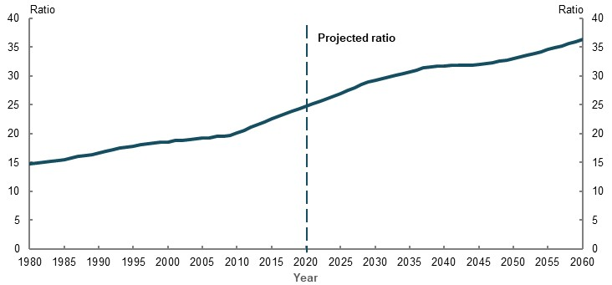
Note: The old-age dependency ratio represents the number of people aged 65 and over per 100 working-age (15-64) people. Source: Analysis of (ABS, 2019c), population projections by Centre for Population, The Treasury as at December 2019.
These projections do not account for possible short- to medium-term demographic changes associated with the COVID-19 Pandemic. There may be a significant fall in net overseas migration during 2019-2021 (Prime Minister of Australia, 2020), which could see the old-age dependency ratio increase more sharply over this period. There may also be a further short-term decline in the fertility rate.

Life expectancy and longevity
Improvements in longevity and life expectancy mean people spend more time in retirement if working lives are not similarly extended. As a consequence, retirement incomes need to last longer. 2C. Maintaining standards of living in retirement and 4. Sustainability explore these issues.
Over the past 40 years, life expectancy has increased significantly. Women continue to have longer life expectancy than men, despite the gap closing over time and reducing with age (Chart 1D-2).
    - Life expectancy
At birth | At age 65
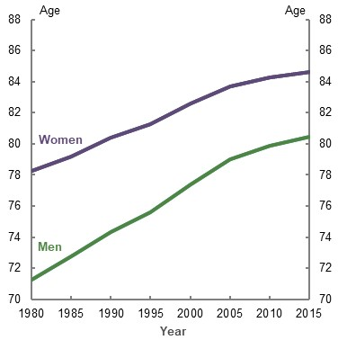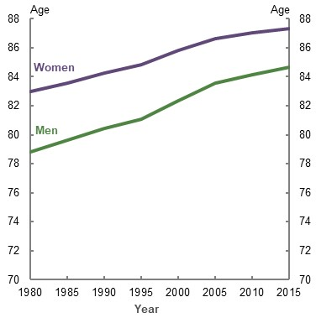
Note: Years at age 65 represents total expected years of life, not just expected years remaining. Source: (ABS, 2019c).
Aboriginal and Torres Strait Islander people have lower life expectancies than the total population. This affects their outcomes in the retirement income system. Aboriginal and Torres Strait Islander demographics and outcomes are explored in greater detail in 3F. Aboriginal and Torres Strait Islander people.
Life expectancies are a measure of the average number of years someone could be expected to live (Australian Government Actuary, 2019, p. 10). They show a simple probability of longevity, not actual longevity. Projected cohort life expectancies factor in long-term trends in improvements to mortality rates, but they cannot capture unforeseen future changes in living conditions and technology that may extend longevity.
Life expectancies are also unable to provide information on the diversity of longevity outcomes (Australian Government Actuary, 2014, p. 12). Factors such as lifestyle, health and disability status, technology and exposure to hazardous events all affect how long people live. As a result, a significant proportion of the population lives beyond life expectancy (Table 1D-2).
      - Longevity for those born in 1932-34
 | Total life expectancy at birth (years) | Total life expectancy at age 65 (years) | Per cent who lived to at least life expectancy at birth | Per cent who lived to at least life expectancy at age 65
Women | 68 | 86 | 88.8 | *
Men | 64 | 82 | 84.4 | 56.6
Note: Total life expectancy is rounded up to nearest whole year. *Cohort has not reached life expectancy yet. In 2015-17, 67.1 per cent of these women had reached age 83. Source: Analysis of (ABS, 2019c).
Over the past 40 years, average lifespans have increased, particularly for men as a result of improvements in health outcomes and workplace safety. The proportion of men who live to 65 years increased at more than twice the rate of women from 1980 to 2015. This means men are now more likely to reach retirement age than in the past (ABS, 2019c).
Women still generally live longer than men. In 2015, approximately 61 per cent of women born in 1930 lived to 85 years, compared with 46.5 per cent of men (Australian Government Actuary, 2019). Variances in longevity affect outcomes across genders, as explored in greater detail in 3B. Gender and partnered status.
Increased life expectancies and longevity are correlated with other lifetime trends. The median age people achieve milestones, such as finishing education, entering and leaving the workforce, home ownership and marriage, is higher than it was 50 years ago (CEPAR, 2019, p. 9).

Labour force trends
The retirement income system’s performance is directly related to labour force trends. As employers pay the SG, higher levels of workforce participation generally lead to greater superannuation coverage and higher superannuation balances at retirement. Greater superannuation coverage reduces reliance on the Age Pension. This reduces Age Pension expenditure but increases superannuation tax concessions.

General labour force trends
Total labour force participation has increased from around 61 per cent in 1980 to a high of around 66 per cent in early 2020 (ABS, 2020k). The increase is due to greater female participation, partly offset by lower male participation (Chart 1D-3).
    - Total labour force participation rate, by gender
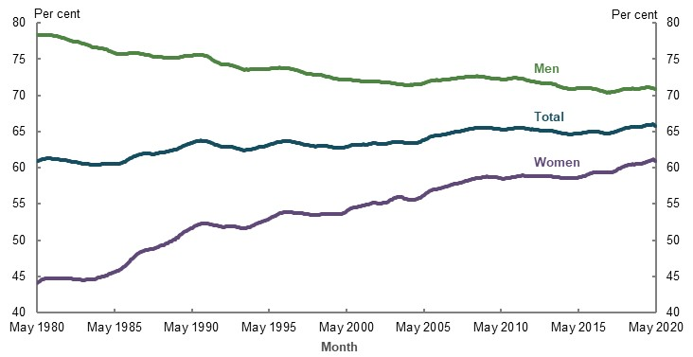
Note: Rolling 12-month average. Source: Analysis of (ABS, 2020k).
Changes to the societal role of women, flexible working arrangements and childcare access have likely contributed to greater female participation. Women are more likely than men to participate in education (ABS, 2019j), suggesting female participation rates may continue to converge on male rates in future. Differences in male and female workforce participation leads to different outcomes during retirement. These effects are explored in more detail in 3B. Gender and partnered status.
Labour force participation represents the pool of potential workers — not the pool of actual workers. Employment rates affect the retirement income system’s sustainability and outcomes. Over the past 40 years, unemployment has averaged 6.8 per cent (Chart 1D-4). Over the same period, underemployment has averaged 6.2 per cent, despite being persistently above this average since the early 1990s (ABS, 2020k). How long it may take for the unemployment and underemployment rates to fall following the COVID-19 Pandemic is uncertain.
    - Historical unemployment and underemployment rates
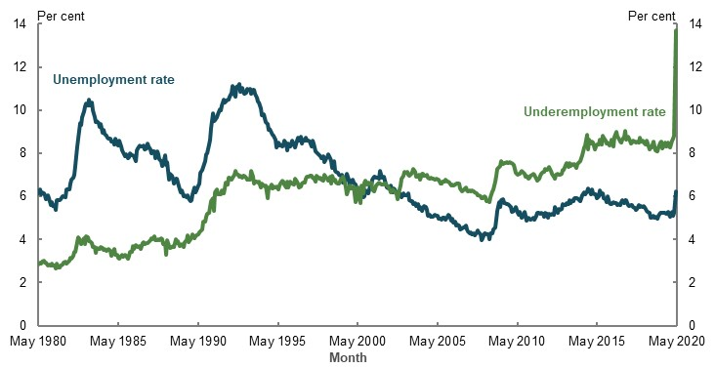
Source: (ABS, 2020k).

Labour force trends across age groups
Improved health outcomes, greater flexibility in working arrangements and increasing rates of education, especially for women, have likely increased older people’s labour force participation (Chart 1D-5). Increasing household debt and the later age people pay it off may also be behind this increased participation (discussed under Household wealth and debt, below).
Retirement income system policy settings are strongly correlated with labour force participation. As the women’s Age Pension eligibility age rose from 60 in 1995 to 66 in 2019, the peak age for women leaving the labour force shifted in parallel, from 63 to 65 between 2006 and 2016 (ABS, 2006a; ABS, 2011a). Over the same period, the men’s peak was maintained at 65 years — the men’s Age Pension eligibility age. Increasing labour force participation among older Australians may continue as the Age Pension eligibility age rises to 67 on 1 July 2023.
Participation rates of men and women aged 15-24 are now similar. As the number of jobs requiring formal qualifications has increased, time spent studying means younger generations are entering the workforce at older ages than in the past. The median age for completing education has increased from 17 in 1981, to 22 in 2016 (CEPAR, 2019, p. 10).
The median age of people entering full-time employment has increased more quickly than the median age of exiting the labour force (CEPAR, 2019, p. 9), reflecting generational differences in working lives. People who have delayed their workforce entry may delay their exit from the workforce in future. However, if they do not, they will spend less time working and more in retirement. How shorter and interrupted working lives affect retirement outcomes is explored in 2C. Maintaining standards of living in retirement and 3E. Age of retirement.
    - Labour force participation, by age
Women | Men
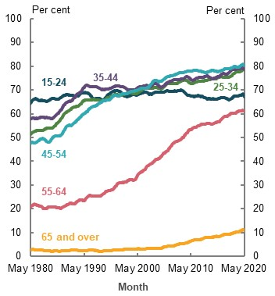 | 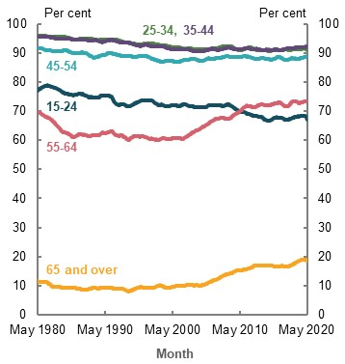
Note: Rolling 12-month average. Source: Analysis of (ABS, 2020k).

Wage growth
Wage growth affects the outcomes and sustainability of the retirement income system. Real wage growth boosts savings capacity and higher superannuation contributions, increasing superannuation balances.
Over the past 20 years, annual nominal growth in average weekly earnings averaged 3.7 per cent (1.0 per cent real) but only 2.8 per cent (0.7 per cent real) over the past ten years since the end of the GFC (Chart 1D-6). A number of factors have weighed on wage growth, with possible causes including reduced rates of job switching and changing market conditions, with lower growth noted in other developed economies (Andrews, et al., 2019).
    - Average annual growth in average weekly earnings
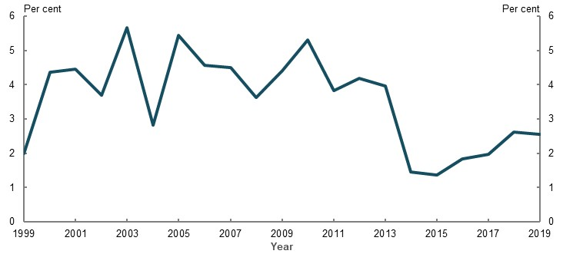
Note: Change in nominal average weekly earnings. Source: (ABS, 2020d).
In the long term, real wage growth is driven by productivity. Over the past decade, productivity growth has fallen from its long-term average of 1.7 per cent to an average of 1.2 per cent, partly because of low capital investment (Productivity Commission, 2019a, pp. 3-9).
The possible effects of sustained lower wage growth on the retirement income system and its outcomes are explored in 2C. Maintaining standards of living in retirement and 4. Sustainability.

Economic growth and returns on investments
Economic growth and returns on investments heavily influence the retirement income system’s sustainability and outcomes.

Economic growth
Economic growth generally leads to higher superannuation coverage through greater employment. It also influences the Government’s ability to maintain spending on the Age Pension.
Australia’s real GDP growth has averaged 3.1 per cent over the past 40 years (Chart 1D-7). Negative economic growth during the early 1980s and 1990s coincided with global recessions. Since 2010, the economy has been growing below the long-term trend. The effect of the COVID-19 Pandemic on global economic growth remains uncertain, with some suggestions of a global recession (OECD, 2020a).
    - Annual through the year real GDP growth
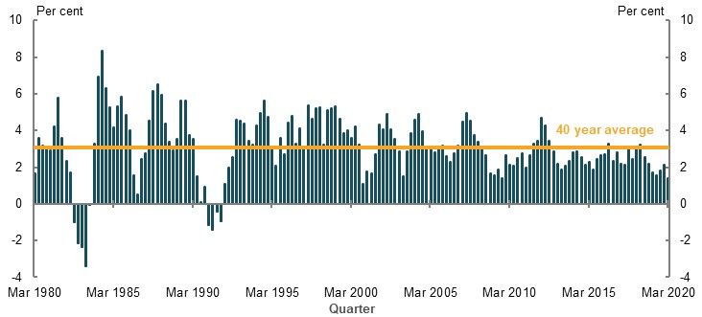
Note: Per cent growth rate through the year. Average 40 year growth rate calculated using compound average growth rate. Source: Analysis of (ABS, 2020b).

Return on investments
Economic growth, market interest rates and movements in equity markets influence investment returns, which affect the value of superannuation and voluntary savings.
Higher investment returns increase the value of superannuation and voluntary savings more quickly. This generally lowers reliance on the Age Pension. Conversely, the value of savings increases more slowly during periods of lower returns, increasing or maintaining reliance on the Age Pension.
Equities have grown strongly over the past 40 years (Chart 1D-8), but experience volatility and potential decline during economic shocks, such as the GFC and the COVID-19 Pandemic. Superannuation funds are heavily invested in equities, holding an estimated 35 per cent of the total market capitalisation of the Australian Stock Exchange (ASX). On current trends, this will increase to more than 60 per cent in 2038 (Deloitte Actuaries & Consultants, 2019, p. 18).
The effect of these investments on the superannuation system is discussed under Maturity of the superannuation system below.
    - Equity market indices
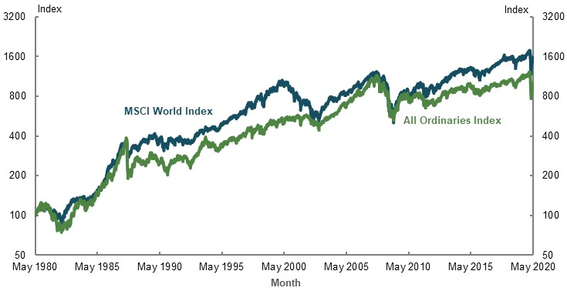
Note: Indices to log scale, end May 1980 = 100. The All Ordinaries Index is made up of the largest 500 companies as measured by market capitalisation that are listed on the ASX. The MSCI World Index represents approximately 85 per cent of the free float-adjusted market capitalisation of 23 developed markets. Source: Analysis of (Bloomberg L.P., 2020).
Market interest rates influence the returns on generally low-risk, fixed-interest investments, such as term deposits. Interest rates are currently at historic lows, both in Australia and globally. The RBA cash rate target has fallen from 4.75 per cent in November 2010 to a record low of 0.25 per cent in March 2020 (Chart 1D-9). As a result, investors holding fixed-interest investments have seen investment returns decline and risk-averse retirees, who rely on these investments for income, have received lower incomes.
    - Monthly interbank overnight cash rate
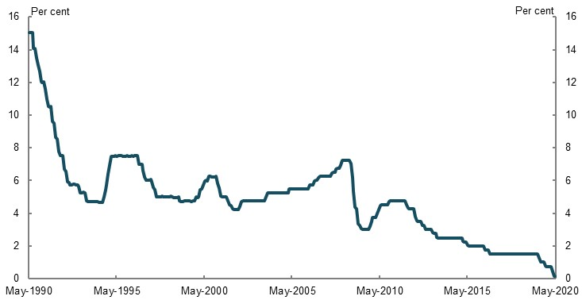
Source: (RBA, 2020c).
Interest rates in developed economies have steadily fallen since the 1980s (Negro, et al., 2018). These lower rates are the result of increased global savings brought on by weaker investment, demographic changes and debt repayment (House of Representatives, 2019).
From March 2020, the RBA has begun purchasing government bonds to further reduce market interest rates (RBA, 2020d). This suggests interest rates may remain relatively low for the foreseeable future.
Low interest rates mean lower returns on fixed-interest investments, such as term deposits, but not necessarily lower returns on overall savings. Superannuation funds and people may respond to lower interest rates by investing more in higher yielding assets, such as equities and property.
The effect of persistently lower or negative overall returns on investments on the system and its outcomes are explored further in 2C. Maintaining standards of living in retirement and 4. Sustainability.

Maturity of the superannuation system
The maturity of the superannuation system influences the level of assets people hold when they reach retirement and how much they rely on the Age Pension. Australia’s superannuation system will have matured by the 2040s, when the SG will have been at least 9 per cent for 40 years (the average length of a working life — see 2C. Maintaining standards of living in retirement). Most people entering retirement over the past five years have only had around 20 years of superannuation accumulating at relatively low rates.
Compulsory superannuation was introduced in 1992 through the SG, expanding superannuation coverage from those working in professional, government and executive positions to a much broader range of employees. Superannuation coverage for those aged 15 and over rose from 63.9 per cent in 2003-04 to 71.9 per cent in 2017-18 (ABS, 2019k). Superannuation coverage is explored further in 3D. SG coverage.
In 1992, the SG rate was set at 3 per cent, increasing over time to 9.5 per cent from 1 July 2014. Total contributions made to superannuation accounts increased from $67 billion in 2004-05 to $130 billion in 2018-19 (Australian Prudential Regulation Authority, 2020a). Member contributions spiked in 2006-07, coinciding with policy reform announcements, which included a one-off opportunity to contribute up to $1 million to superannuation in some situations (Chart 1D-10). The spike in 2016-17 and subsequent decline reflects the impact of changes to tighten contributions caps that took effect from 1 July 2017. Growth in wages and the SG rate have increased the share of employer contributions relative to total contributions from 58 per cent in 2004-05, to 75 per cent in 2018-19.
    - Annual superannuation contributions, by contribution type
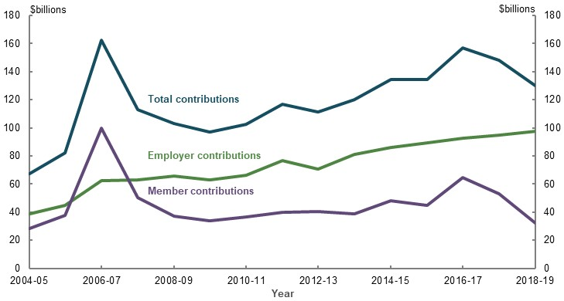
Note: Employer contribution represents contributions made by an employer on behalf of the member. Includes SG, award or other obligations; salary sacrifice arrangements; transfers from consolidated revenue funds for exempt public sector superannuation schemes and constitutionally protected funds; and SG charge and the taxable component of any super holding accounts special account amounts that the ATO transferred to the provider on behalf of the member. Member contributions represents contributions made by a member including non-excluded capital gains or capital proceeds and personal injury payments, direct termination payments, other third party contributions (government contributions and other family and friend contributions) and other contributions made by a person other than the employer. Total contributions represents employer and member contributions. Values are in nominal dollars. Source: (Australian Prudential Regulation Authority, 2020a).
Assets under management have grown from $750.5 billion in June 2005 (81 per cent of GDP) to nearly $2.9 trillion in June 2019 (148 per cent of GDP) (Australian Prudential Regulation Authority, 2020a). Strong investment returns and total contributions after tax and surcharge added nearly $3.2 trillion over the period, partially offset by benefit payments (Chart 1D-11).
    - Growth in assets under management, by flow type
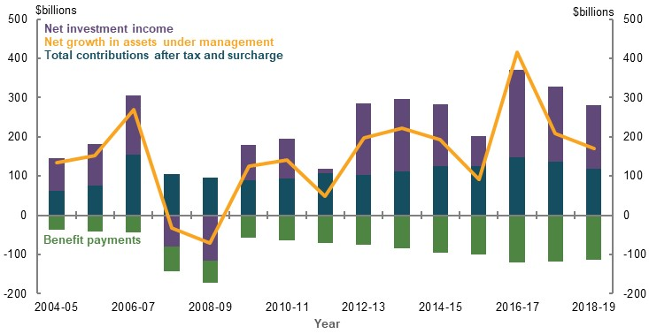
Note: Total contributions after tax and surcharge represents total contributions less tax expenses relating to taxable contributions made to the superannuation entity and contributions surcharge tax. See note in Chart 1D-10 for more information on how total contributions is calculated. Net investment income represents gross revenue in the form of income or distributions from investments, including interest, dividends, rental income, trust distributions, less expenses that relate to the investment of the assets of the entity, including expenses for which investment fees are charged and expenses associated with generating income on investments. Benefit payments includes lump-sum benefit payments and pension benefits paid directly to members, but excludes rollovers and successor fund transfers. Net growth in assets under management is the figure published by APRA and may include items and amounts not represented in the other chart series. Values are in nominal dollars. Source: Analysis of (Australian Prudential Regulation Authority, 2020a).
Most of the growth in assets under management occurs in the pre-retirement phase. Assets held in the pre-retirement phase by institutional funds rose from $992 billion in 2015 to $1,600 billion in 2019 (Chart 1D-12). Assets in the retirement phase by institutional funds increased more slowly, from $374 billion in 2015 to $472 billion in 2019.
    - Allocation of assets under management by institutional funds, at June year-end
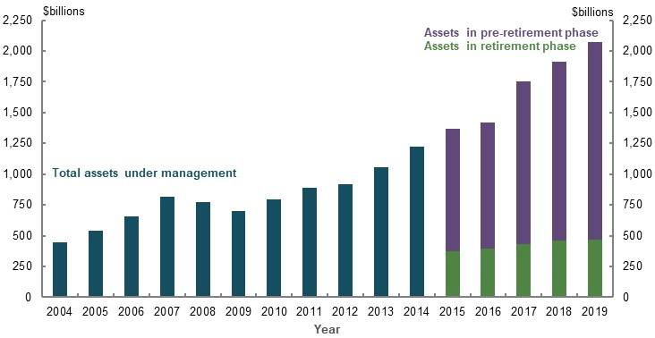
Note: Data excludes SMSFs and only includes entities with more than four members. APRA commenced collecting retirement phase data from June year-ending 2015. Values are in nominal dollars. Source: Analysis of (Australian Prudential Regulation Authority, 2020a).
Future projections of the superannuation system and its effects on Age Pension expenditure are explored in 4. Sustainability.

Household wealth and debt
The size and composition of household wealth influences retirement incomes. Households with more financial assets at retirement are generally less likely to rely on the Age Pension for retirement income. Less liquid wealth, such as housing, can also support people in retirement, providing accommodation as well as a potential source of income.
However, if households are diverting their income to pay down large mortgage debts, they could struggle to build retirement savings outside the home. This could delay when some households retire.
Australian household net wealth has increased over the past 30 years (Chart 1D-13). Most of the increase can be attributed to growth in the value of housing and superannuation, with superannuation asset values as a percentage of household disposable income more than tripling over this period. In 2017-18, on average, the family home continued to be a household’s largest asset in dollar terms, followed by superannuation (ABS, 2019k).
Growth in the value of these assets is uncertain in the short- to medium-term because of the lower economic and population growth and higher unemployment caused by the COVID-19 Pandemic.
    - Household wealth as a percentage of disposable income
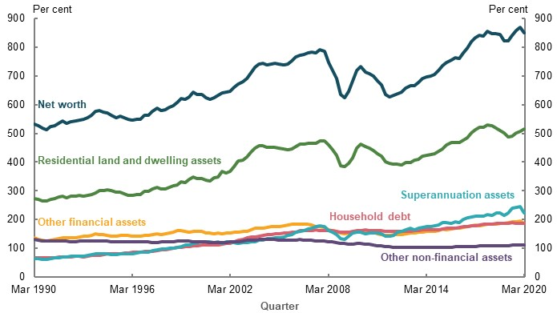
Note: Income is annualised gross disposable income before the deduction of interest payments. Net worth is all household assets series less household debt. Includes debt and assets held by unincorporated enterprises. Non-financial assets includes consumer durables. Residential land and dwelling assets includes all residential property, not just owner-occupied. Source: Analysis of (ABS, 2020a; ABS, 2020b).

Housing wealth
The value of housing has significantly increased since the 1990s, nearly doubling relative to household disposable income. Existing home owners have benefited from increases in their net worth.
However, the share of working-life income required to service a mortgage has more than tripled since 1980 (Chart 1D-14). Increases in home values mean prospective home owners need to spend more of their working-life incomes to finance their purchase. As a result, people have less income available to either spend during working life or invest in other savings vehicles.
    - Total home deposit and mortgage costs as a percentage of household
working-life income
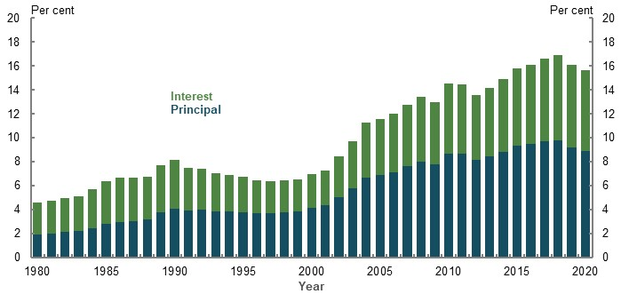
Note: This chart is a hypothetical comparison between different generations of households with the median income, who pay 20% deposit and service a 25-year mortgage for a median-value dwelling at the market variable rate. Working-life income is calculated post-tax, and assumes a 40-year period (ages 27-66). Analysis factors in deferral of first home purchase for recent generations. Analysis also assumes interest rates and wages move to a long-run average consistent with cameo modelling undertaken for the review. More information on these assumptions can be found in Appendix 6A. Detailed modelling methods and assumptions. Source: Analysis of (ABS, 2019c), (ABS, 2019k), (CEPAR, 2019), (ABS, 2020c), CoreLogic home price data and RBA Statistical Tables — Indicator Lending Rates F5.
Increased home values have coincided with rising housing debt. Household debt is now at historically high levels, mainly relating to increases in housing debt (Chart 1D-15) (RBA, 2020a). Studies note a correlation between increased national net household debt and pension assets as a per cent of GDP (Mercer, 2019b, p. 10). Increasing superannuation wealth, particularly as a result of the SG, may be increasing households’ confidence about their finances and wealth, encouraging them to take on more debt as net wealth rises (Ruthbah & Pham, 2020a, p. 27).
    - Household debt as a percentage of disposable income
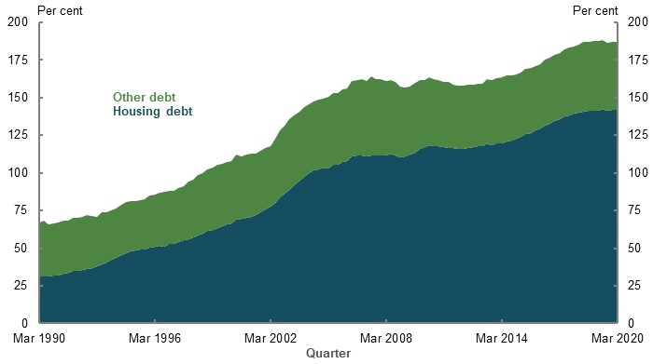
Note: Income is annualised gross disposable income before the deduction of interest payments. Other debt includes personal debt, student loans and other household liabilities. Includes debt owed by unincorporated enterprises. Housing debt includes all debt financing for residential property, not just owner-occupied. Source: Analysis of (ABS, 2020a; ABS, 2020b).
Increasing mortgage commitments have coincided with more owner-occupied households holding a mortgage at older ages. The median age for paying off a mortgage increased from 52 in 1981 to 62 in 2016 (CEPAR, 2019, p. 9). The rate of owner-occupied households aged 55 and over with mortgage debt has increased over the past 20 years (Chart 1D-16).
    - Percentage of owner-occupied households with mortgage debt, by age group
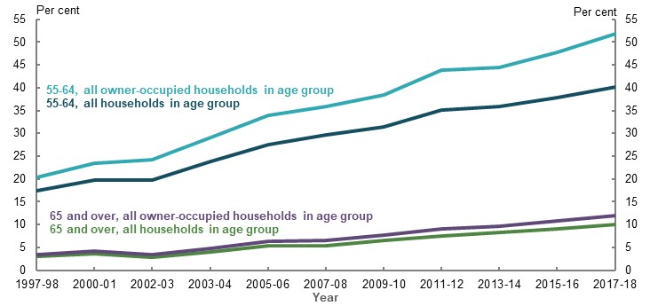
Note: Age refers to age of household reference person. Series was conducted continuously by the ABS from 1994-95 to 1997-98, and then in 1999-2000, 2000-01 and 2002-03. From 2003-04 the series has been conducted every two years. Source: Analysis of Housing Occupancy and Costs 1997-98 to 2017-2018 (ABS, 2019n).
Indebtedness increases the likelihood of labour market participation (Belkar, et al., 2007), meaning households with mortgage debt at older ages are more likely to continue working.
Older owner-occupied households with mortgage debt are more vulnerable to negative economic and market shocks, especially if they retire. Declines in income or asset values could impede their ability to service mortgage repayments and push some households into financial hardship. The effects of wealth and debt on outcomes for retired households are explored further in 2C. Maintaining standards of living in retirement.

Housing
Housing status is a strong determinant of retirement outcomes. People who own their home outright have generally lower housing costs compared with renters, as well as a store of wealth that can be drawn on in retirement. People who rent may require incomes similar to working life to maintain living standards in retirement. This is further explored in 2C. Maintaining standards of living in retirement.

Home ownership
Over the past 40 years, increases in home values and delayed workforce entry have contributed to falling home ownership rates. These factors have particularly affected lower-income and younger households.
Overall, home ownership rates have declined slightly from 70 per cent in 1981 to 67 per cent in 2016 (ABS, 2007, p. 13; ABS, 2016a). Among people aged 55 and over, rates of home ownership have been consistently high. Home ownership has fallen among younger age groups (Chart 1D-17).
    - Home ownership rates, by age group
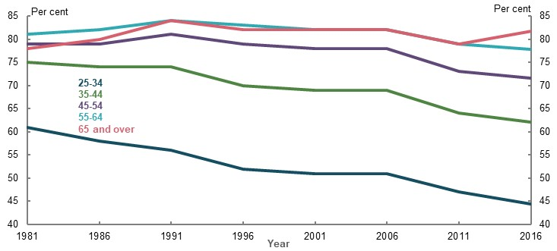
Note: Per cent of occupied private dwellings. Age refers to age of household reference person. Excludes households with tenure type not stated. Source: (Daley, et al., 2018a).
Since 1981, ownership rates for lower- to middle-income households have fallen more for those aged under 65 than for those aged 65 and over (Chart 1D-18). In comparison, higher-income households have been relatively stable.
    - Change in home ownership rates from 1981 to 2016, by age group
and equivalised income quintile
 | 25-34 | 35-44 | 45-54 | 55-64 | 65 and older
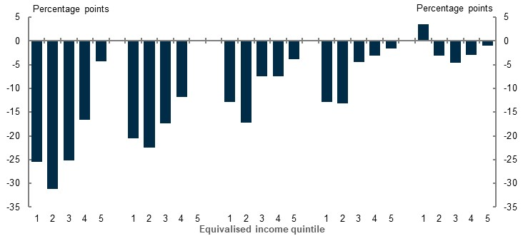
Note: Age refers to age of household reference person. Equivalised means that income quintiles are adjusted for household size. Source: Analysis of (ABS, 1983) and (ABS, 2016a), based on previous analysis by (Daley, et al., 2018a).
The median age of people buying their first home increased from 24 in 1981, to 33 in 2016 (CEPAR, 2019, p. 9). Deferred workforce entry for younger generations delays their ability to start earning and save a deposit for a house. Increasing home values means younger generations not only start saving later in life, but also need to save more and contribute more of their incomes. Delays in household and family formation may also delay some people’s home ownership intentions. While declines in home ownership among younger people may lead to lower rates of home ownership at retirement in future, the extent of this impact is not clear (Box 1D-4).
Home ownership is further explored in 3C. Home ownership status.
          - Future of home ownership at retirement
Submissions highlighted the drop in home ownership rates among younger generations (Chart 1D-17), and raised concerns about potential future declines in home ownership among retirees. It is debatable, however, how much falls in home ownership rates at younger ages will flow through to future retirees.
- ‘Catch up’ at older ages. Current falls in home ownership rates in younger age cohorts may be less pronounced if these cohorts ‘catch up’ and achieve home ownership similar to current retirees. However, evidence of such a catch up is mixed. One study suggested delayed home ownership was correlated with people marrying later in life (Baxter & McDonald, 2005). Conversely, a later study found that falls in home ownership rates among younger generations were driven by affordability and that significant catch up was unlikely (Stebbing & Spies-Butcher, 2015).
- Effects of temporary migration. Sustained net arrivals of migrants on temporary visas over the past decade has increased the number of migrants in Australia (ABS, 2020m). Their inclusion in the ABS Census may lower home ownership rates, particularly among younger people, as temporary migrants are generally of working age and less likely to purchase homes. Excluding temporary migrants from the calculations increases the rate of home ownership for people aged 25-34 by 6 percentage points in 2016. Nevertheless, even after this adjustment, the rate fell 7 percentage points between 2006 and 2016.
- Renters who own other residential property. A significant number of residential property owners choose to rent another property. In 2017-18, 12 per cent of households that rented their principal place of residence owned residential property elsewhere (ABS, 2019n). Over the past decade the proportion of renters who own other residential property has remained stable.

Renters
Current rates of home ownership for households aged 65 and over may not be maintained in future, particularly for lower- to middle-income households. If these households are unable to save enough to cover rents in retirement, their retirement incomes will likely be inadequate to maintain living standards.
The Government provides additional payments through Commonwealth Rent Assistance to age pensioners who rent, as they generally face higher housing costs than home owners. Commonwealth Rent Assistance is explored further in 2B. Policy scenario: Implications of increasing Commonwealth Rent Assistance.
Renting through public housing has fallen. But renting in the private market has risen for households aged 65 and over, despite overall rates of renting remaining stable over the past 10 years (Chart 1D-19).
    - Proportion of households aged 65 and over that rent, by landlord type
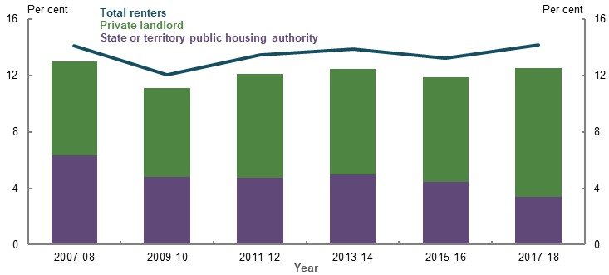
Note: Age refers to age of household reference person. Private landlord includes real estate agent, person not in same household — parent/other relative, or other person. Total renters includes those with other landlord type, which includes owner/manager of caravan park, employer — Defence Housing Authority, government or other employer, housing co-operative/community/church group, and other. Source: Analysis of Housing Occupancy and Costs 2007-08 to 2017-18 (ABS, 2019n).
Over the past 10 years, the ratio of rents to household income have been consistently higher in the private market compared with public housing for households aged 65 and over that rent. In future, greater renting through the private market could see more renters aged 65 and over facing higher housing costs as a proportion of their income.

- Adequacy

Outline of this chapter
This chapter examines whether the retirement income system is achieving the objective of delivering adequate outcomes, against two elements (see 1C. The objective of the system and the roles of the pillars). The system should:
- Ensure a minimum standard of living for retirees with limited financial means that is consistent with prevailing community standards
- Facilitate people to reasonably maintain their standard of living in retirement
First, it considers the performance of the system, especially the Age Pension and in-kind support, in providing a minimum standard of living. As the community lacks consensus on a suitable metric for a minimum standard of living in retirement, this issue is considered by looking at a range of measures.
Second, it explores the implications of increasing Commonwealth Rent Assistance on performance of the retirement income system, including on the minimum standard of living in retirement.
Third, the chapter considers the system’s ability to facilitate people to reasonably maintain living standards between working life and retirement.
Finally, the chapter considers the implications of maintaining the Superannuation Guarantee (SG) rate at 9.5 per cent on the performance of the system, including the impact on facilitating people to reasonably maintain living standards between working life and retirement.

Achieving a minimum standard of living in retirement
          - Section summary
- The level of income delivered through the Age Pension and government services provides a minimum standard of living in retirement for retirees with limited financial means that is consistent with community standards.
- The Age Pension has grown faster than both wages and prices since 2009. The maximum rate compares favourably internationally and is above available absolute poverty benchmarks. Rates of financial stress for people with few other means drop substantially when entering retirement. Older Australians:
  - Generally have lower levels of financial stress compared to the working-age population.
  - In lower-income households, experience improved living standards on entering retirement as the Age Pension is higher than some working-age welfare payments and income levels.
  - Have experienced reduced income poverty rates over the past decade, especially singles and renters, although poverty rates remain elevated for some retirees who rent.
  - Receive significant support from non-income sources. Governments meet many of the health and aged care needs of older Australians. In 2015-16, households aged 65 and over accessed government services worth more than the Age Pension, with this value growing faster for retirees than any other age group. Reduced housing costs through high home ownership rates and higher levels of assets than working-age households are also significant forms of support for most retirees.
- Renters and those who retire before Age Pension eligibility age are at higher risk of poor outcomes in retirement. These groups experience higher levels of financial stress and poverty than the working-age population and other retirees. The additional support Commonwealth Rent Assistance provides is far below the additional housing cost private renters face compared to home owners.
- Retirees still paying a mortgage are also at risk of poorer outcomes in retirement. They experience higher levels of income poverty than the working-age population and are more exposed to interest rate and investment shocks than home owners.

Outline of this section
This section analyses the evidence whether the retirement income system, especially the Age Pension, provides a minimum standard of living. The section focuses on:
- The adequacy of the minimum standard of living provided by the Age Pension
- Wellbeing and poverty outcomes for recent retirees
          - Stakeholder views on achieving a minimum standard of living in retirement
Many submissions agreed that measuring adequacy required balancing a number of outcomes, particularly the need for an appropriate minimum level of income.
A number of submissions suggested no one should live in poverty in retirement, but opinions differed on how best to measure poverty. Submissions also recognised a need to achieve a standard of living above a basic level; however, different views emerged about how this should be defined and measured.
‘The purpose of the social security pillar should be to prevent poverty. This means that minimum rates of payment should be adequate to cover the costs of essentials, including for those who face the higher costs associated with renting privately.’
(Australian Council of Social Service, 2020, p. 17)
Submissions took two main approaches for measuring poverty. Some discussed poverty with reference to a dollar-based budget standard or the poverty line, which they noted are easier for people to understand. Others discussed poverty relative to the living standards in the broader community.
‘ … budget standards may be used as an indicator of poverty and to assess the adequacy of social security payments to retired Australians.’ (Super Consumers Australia, 2020, p. 5)
Some submissions argued that the Age Pension should be set based on alternative measures of wages. The Age Pension is currently benchmarked to male total average weekly earnings, which is unlikely to be a contemporary measure of wages for the broader community.
‘It would be reasonable to start setting it (the Age Pension rate) against all full-time wages (males and females combined).’ (Rice Warner, 2020, p. 8)

Assessing minimum standards
No single measure is available to determine whether the system delivers a minimum standard of living in retirement for those with limited financial means. Judgement is required, ultimately by the community as a whole.
A basket of indicators has been used to assess whether retirees are achieving minimum standards of living in line with prevailing community standards. This assessment is informed by the approach in the 2009 Pension Review (Harmer Review), international practices and submissions.
Looking at income alone will underestimate the adequacy of the retirement income system in providing a minimum standard of living in retirement. This is because a retiree’s standard of living depends on whether they own their home, what government services they receive and if they have assets to draw on in retirement.
Two perspectives have been considered in assessing whether the system is delivering a minimum standard of living in retirement.
- Support provided by the maximum rate of the Age Pension. Whether income from the Age Pension alone delivers a minimum standard of living and how the Age Pension has kept pace with community standards since the reforms in 2009 (Box 2A-3).
- Comparing outcomes for the working-age population with those of retirees.

Assessing the adequacy of the Age Pension
Following the Harmer Review, the Age Pension was increased to better reflect community standards (Box 2A-3). The following is an assessment of whether the maximum rate of the Age Pension remains in line with community standards, based on considering a range of wage metrics, international pension systems, price changes and measures of absolute poverty.
          - The Harmer Review and the 2009-10 Secure and Sustainable Pensions Budget measures
The Harmer Review was the last major review to examine whether the level of the Age Pension was appropriate. To assess the adequacy of the Age Pension, the Harmer Review examined a range of indicators, including the value of the pension compared with prices and wages; comparisons with budget standards, international pension systems and poverty standards; and indicators of revealed wellbeing.
The Harmer Review found that:
- Pension rates did not fully recognise the costs faced by single pensioners living alone and that the approach of paying ad hoc bonuses did not provide financial security
- Many pensioners who rented privately had high costs and poor outcomes
- Indexation arrangements for pensions needed to link pensions more transparently to community living standards and better respond to the price changes experienced by pensioners (Harmer, 2009)
In response to the Harmer Review, the then Government implemented a suite of reforms (the Secure and Sustainable Pensions budget measure), which included:
- A one-off increase to the maximum value of the single Age Pension by just over $30 per week. The maximum value for couples was also increased by around $10 per week (see below).
- Changing the indexation arrangements of the Age Pension. A new cost-of-living index, the Pensioner and Beneficiary Living Cost Index, was introduced to more closely measure the living costs faced by these households. Since these changes, the Age Pension has been adjusted in line with either the Consumer Price Index (CPI) or Pensioner and Beneficiary Living Cost Index, whichever is the higher.
- Changing how the Age Pension is benchmarked to wages. The maximum combined couple rate of pension was benchmarked to 41.76 per cent of male total average weekly earnings. The rate of the single pension was increased to 27.7 per cent of male total average weekly earnings — up from 25 per cent of male total average weekly earnings.
- Merging pension supplements into a single supplement. The total value of the supplements also increased by around $2.50 a week for singles and $10 a week for couples combined.
The extra support offered to age pensioners whose rent was not changed, despite the Harmer Review identifying this group as having poorer outcomes than other pensioners.

Social benchmarks
Given wages growth is commonly used as a proxy for changes in community living standards, the Age Pension should increase in line with worker incomes to maintain basic living standards in retirement.

The Age Pension compared with wages
Since the 2009 reforms, the Age Pension has grown faster than wages (Chart 2A-1) due to its indexation arrangements, which consist of two components:
- The Age Pension base rate is increased using whichever is higher of the Pensioner and Beneficiary Living Cost Index or the CPI. The rate of the Age Pension is then set based on the higher of this indexed amount or the wages benchmark, which is 27.7 per cent of male total average weekly earnings for the single rate of the Age Pension.
- The Pension Supplement is provided in addition to the base rate and is indexed to the CPI.
Combined with low wages growth, these indexation arrangements have resulted in the Age Pension rising faster than wages from early 2014 (Chart 2A-1). The base rate of the Age Pension is currently about 4 per cent above the wages benchmark. The increase above the wages benchmark is not permanent and the Age Pension is expected to return to its benchmark rate in the long run.
For many retirees, the Age Pension provides a higher level of income than they receive during working life after adjusting for tax. For example, the maximum-rate Age Pension is higher than wages for 21 per cent of people, and 15 per cent of households, aged 25-64.
    - Maximum rate of the single Age Pension as a proportion of wage benchmarks
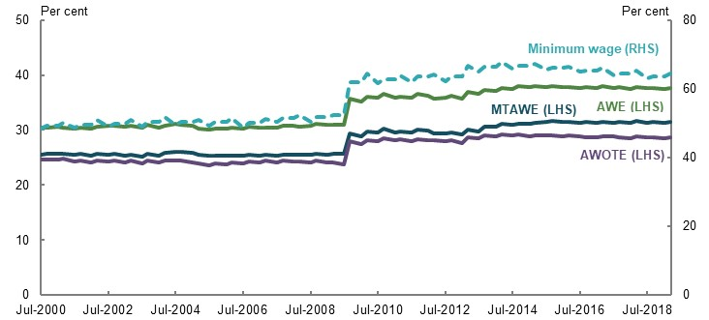
Note: AWE: average weekly earnings, measures the total earnings of all workers. AWOTE: average weekly ordinary time earnings, measures earnings based on award, standard or agreed hours of work and excludes overtime and salary sacrificed income. MTAWE: male total average weekly earnings, measures total earnings of all male workers. AWOTE is in seasonally adjusted terms. Source: Analysis of data provided by The Treasury and (ABS, 2020d; Fair Work Commission, 2019c).

The Age Pension compared with prices
The real value of the Age Pension has increased since the 2009 reforms, up 10 per cent since 2010. In nominal (unadjusted) terms, the Age Pension has increased by 32 per cent while the CPI has increased by 20 per cent.
The ABS has three living cost indices to reflect the goods and services used by older Australians.
- The Pensioner and Beneficiary Living Cost Index measures the effect of changes in prices on the out-of-pocket living expenses experienced by age pensioner households and households receiving other social security benefits. Housing, food and non-alcoholic beverages are the highest weighted spending categories under this index.
- The self-funded retiree living cost index measures the effect of changes in prices on the out-of-pocket expenses of self-funded retirees. This index weights expenditure on recreation and culture, and alcohol and tobacco more highly than other indices. Housing costs have a relatively lower weight, reflecting high levels of home ownership among self-funded retirees.
- The age pensioner living cost index measures the effect of price changes on the out-of-pocket expenses of all age pensioners. This index has a similar composition to the Pensioner and Beneficiary Living Cost Index, but it places greater weight on recreation and health spending, and slightly less weight on housing costs.
These indices have all increased by around 20-21 per cent since 2010 (Chart 2A-2).
    - Increase in the value of the Age Pension, wages and price indices
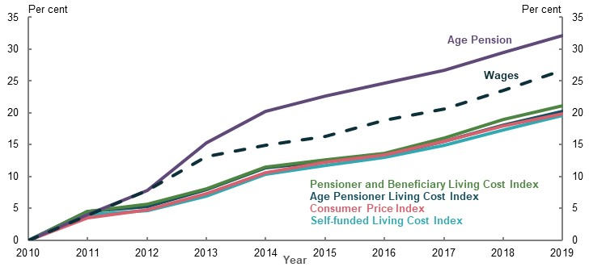
Note: Measures growth in value of indices since 1 July 2010. Wages is based on average weekly earnings, in original terms. Source: Analysis of (ABS, 2020e) (ABS, 2020q), and data provided by the Treasury.
The two largest expenses for most age pensioner households (food and housing costs) have both grown below the rate of increase in the Age Pension over the past decade (Chart 2A-3). Although alcohol and tobacco price increases have grown at a faster rate than the Age Pension, these are small areas of expense for retirees. Health prices, where spending accounts for around 10 per cent of household budgets, have also outpaced increases in the Age Pension. This is not a significant issue for many retirees as the government significantly helps age pensioners meet their health costs (see Box 2A-4).
    - Age pensioner expenses and price increases by category
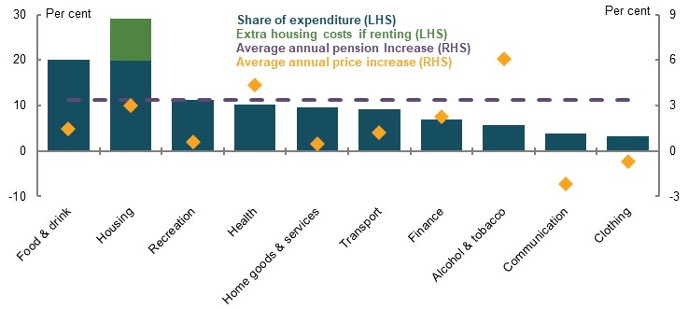
Note: Price and Age Pension increases are the average annual increase in value between 2009 and 2019. Share of expenditure is at September 2017. Source: (ABS, 2020e; ABS, 2017f; ABS, 2017e), Treasury payment parameters.

International comparison
Another indicator of the adequacy of the Age Pension is how it compares with safety net arrangements in other developed economies. Measured as a proportion of gross earnings, at 27.8 per cent, the Age Pension places Australia eighth out of 36 OECD countries (Chart 2A-4). However, this measure misses some aspects of the Australian situation, including social transfers in kind such as Medicare and the Pharmaceutical Benefits Scheme and highly subsidised aged care services.
    - Value of international safety net pensions as a proportion of average earnings
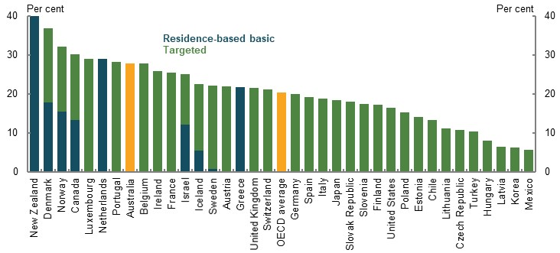
Note: Australia and OECD averaged figures highlighted in yellow. Australian system classified as ‘Targeted’ while OECD is the combined average. Figures are benefit value in 2018 as a proportion of average weekly earnings. ‘Residence based basic’ pensions typically do not apply a means test in determining eligibility for payment, though other criteria such as residency or minimum contribution requirements may apply. ‘Targeted’ pensions apply a means test in determining eligibility for payment. The Age Pension is a targeted pension scheme. Source: (OECD, 2019b).

Absolute poverty lines
Absolute poverty measures calculate the cost of a basket of goods and services to provide a certain minimum lifestyle. People with income below this level are considered to be living in poverty.
These measures are useful in determining whether households have access to the goods and services required to participate in society. But absolute benchmarks have limitations. An absolute benchmark reflects the cost of living in a particular location for a particular household type. It may not be universally applicable as some costs, especially housing, vary across locations.

The Henderson Poverty Line
In Australia, the Henderson Poverty Line is the most commonly used poverty benchmark. Developed in 1973 as part of the Commission of Inquiry into Poverty, it calculated the expenditure required to meet the basic needs of a family of four. Living costs for different households were then derived from that expenditure level.
The poverty line has since been updated for different ages and household types, and indexed regularly to per person disposable income. On this measure, the maximum rate of the Age Pension is around $80 per week above the poverty line for a couple including housing costs, and $26 per week above the poverty line for a single including housing costs (Melbourne Institute, 2019, p. 1).
Absolute poverty lines highlight where households are achieving poor minimum outcomes. But they are not designed to show whether people are keeping up with broader community living standards. Income poverty, discussed subsequently below in Assessing retirement outcomes against minimum standards, provides a clearer picture of how well groups are keeping up with changes in community living standards.

Other budget standards
Budget standards may also attempt to measure an absolute poverty line. They are an estimate of what is needed, in terms of goods, services and activities, to achieve a particular standard of living and what that costs in a particular place and time (Saunders, 1999). Budget standards are usually designed to reflect the needs of a particular household type. They have the advantage of being easy to understand and based on a clear-cut basket of goods and services.
The 2009 Harmer Review examined the value of the Age Pension compared with a Low Cost Budget Standard, originally developed by the Social Policy Research Centre in 1998 (Harmer, 2009, p. 33). This standard estimated the cost of meeting a household’s basic needs at a frugal level while maintaining social and economic participation in line with community expectations (Saunders, 1999).
The Harmer Review found the Age Pension was above the value of the Low Cost Budget Standard for couple households, but below the Low Cost Budget Standard for single households (Harmer, 2009, pp. 33-34) Following the Harmer Review, the Age Pension was increased.
The Low Cost Budget Standard has not been updated since 1998. It is no longer an appropriate benchmark given significant changes in technology and spending patterns over the last two decades. Given the Age Pension has outpaced price and wages growth since 2009, it may compare favourably, even to an updated Low Cost Budget Standard.
Some submissions suggested using the ASFA Retirement Standards, which were originally developed by the Social Policy Research Centre in 1998 and 2004. ASFA regularly reviews and updates these standards to reflect changes in prices and broader consumption patterns. The current ASFA ‘modest standard’ is described as ‘better than the Age Pension, but still only allows for the basics’ (ASFA, 2018a, p. 3). It is not appropriate to compare the value of the Age Pension to the ASFA modest standard as it is explicitly designed to exceed the Age Pension.

Assessing retirement outcomes against minimum standards
Many submissions noted poverty alleviation is a key minimum standard that should be delivered through the retirement income system. However, poverty can be measured and conceptualised in many ways. Following is an examination of a variety of measures to assess outcomes for different groups of retirees.
Retirees receive a broad range of non-monetary supports, including social transfers in kind, that reduce the level of income required to achieve a particular living standard (Box 2A-4). When assessing retiree poverty, these supports should be taken into account, including whether retirees are using their assets to fund their retirement. Otherwise, asset-rich households may be counted as ‘living in poverty’.
          - Non-income support for retirees
Non-income support that can improve a retiree’s standard of living (Chart 2A-5) include:
- Social transfers in kind. Retirees receive relatively more support from transfers in kind than working-age households. On average, households aged 65 and above access transfers in kind worth more than the maximum rate of the single Age Pension (ABS, 2018c). This reduces out-of-pocket costs as health and care needs increase with age.
- Concessions. Access to concessions reduce out-of-pocket expenses. For example, the Pensioner Concession Card gives card holders access to subsidised pharmaceuticals and bulk-billed medical appointments. Other benefits include a range of discounted services through state governments and local councils, such as discounted utilities and council rates, car registration and concessional pricing for public transport (1B. Design of Australia’s retirement income system).
- Tax concessions. Retirees typically pay less tax for a given amount of income. The higher tax-free threshold provided through the seniors and pensioners tax offset allows older Australians to keep more of their income than during working life. Superannuation earnings in the pension phase are also tax-free.
- Personal assets. Measures of income often fail to include when retirees make irregular withdrawals from superannuation; use financial assets, such as withdrawing funds from savings accounts; sell shares; or sell non-financial assets.
- Home ownership. Australians aged 65 and over have significantly higher rates of outright home ownership than working-age Australians (see 1D. The changing Australian landscape). Home ownership reduces ongoing housing expenses and can act as an asset to be drawn on in retirement.
    - Average weekly value of final household income by age range
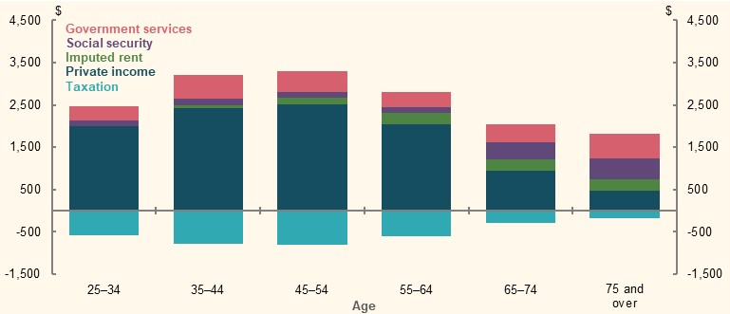
Note: 2015-16 data. Final household income includes private income from labour force participation and financial assets, such as superannuation; social security payments; the value of government services, such as education or health care; and the value provided by the home for home owners (imputed rent). Imputed rent is calculated based on the market value of the rental equivalent, less housing costs (e.g. mortgage interest, rates, water rates, building insurance and repairs and maintenance). Households aged 65 and over may continue to receive income from people participating in the labour force, which will increase private income for these age ranges. Source: (ABS, 2018c).

Assessing wellbeing and poverty outcomes for retirees

Revealed wellbeing of retirees
Measures of revealed wellbeing (Table 2A-1) not only cover the adequacy of the Age Pension; they implicitly include the value of free or subsidised government services, home ownership and assets drawn on in retirement. They capture the benefits of income and non-income supports to retirees by exploring the degree to which households:
- Feel satisfied with their circumstances, having the resources to enjoy experiences that support wellbeing
- Are under financial stresses, such as having to go without goods or services or delay bill payments due to financial circumstances
Because financial stress measures capture a broad range of experiences, no category of households (by income level or age group) has zero rates of financial stress (Wilkins, 2016, pp. 86-87).
      - Examples of revealed wellbeing indicators
Financial stress experiences | Missing out experiences
Assistance sought from welfare/community organisations due to shortage of money | Household does not have a night out once a fortnight
Sought financial help from friends/family due to shortage of money | Household does not have a special meal once a week
Unable to heat home due to shortage of money | Household does not have friends or family over for a meal once a month
Went without meals due to shortage of money | Household does not have a holiday away from home for at least one week a year
Whether could pay gas/electricity/telephone bill on time due to shortage of money | Household buys second-hand clothes most of the time
Whether could not pay registration/insurance on time due to shortage of money | Household does not spend time on leisure or hobby activities
Ability to raise emergency money
Pawned or sold something due to shortage of money
Source: (ABS, 2017d).
The ABS classifies households with four or more financial stress or ‘missing out’ experiences as being ‘in financial stress’ (ABS, 2017d). If retiree groups have higher levels of financial stress than the working-age average, this may indicate the retirement income system is not achieving adequate minimum standards for those retirees.

Financial satisfaction
Retirees generally report higher financial satisfaction than working-age people across the income distribution (Chart 2A-6). Cost pressures, such as mortgages and raising children, generally fall as people approach and enter retirement.
Government services help low-income retirees to reduce financial stress. Differences in financial satisfaction between retirees and working-age people are greatest for low-income households (Chart 2A-6). This may reflect the higher value of the Age Pension compared to working-age social security payments. For example, as at 1 May 2020 the maximum value of the single Age Pension was around $944 per fortnight compared to almost $574 for the JobSeeker Payment (including the Energy Supplement but excluding the temporary Coronavirus Supplement).
    - Financial satisfaction, by age and income
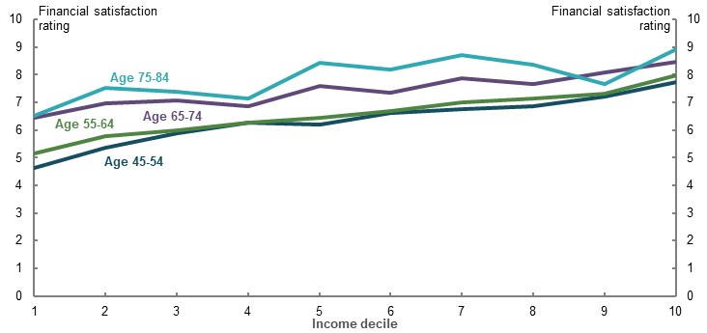
Note: Income deciles are calculated at the population level. Source: Analysis of HILDA Survey data (Wave 18).
Chart 2A-6 also suggests that income has a weaker relationship with financial satisfaction for retirees compared to working-age households. For those on higher incomes, the increase in financial wellbeing between working age and retirement is more muted.

Financial stress
Rates of financial stress decline as households approach and enter retirement. This difference is most pronounced among lower-wealth households, where rates of financial stress drop about 10 percentage points at age 65 from elevated levels between ages 40-60 (Chart 2A-7).
    - Proportion of households in financial stress, by age and wealth
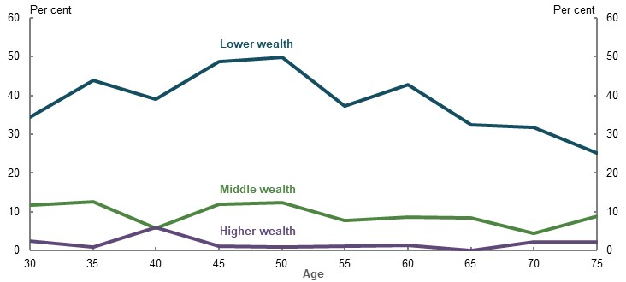
Note: Wealth deciles are calculated by age range rather than at a population level. Lower wealth is the bottom 20 per cent of households, middle wealth is the 40th to 59th percentiles, and higher wealth is the top 20 per cent, based on equivalised household wealth within age groups. Source: Analysis of ABS Household Expenditure Survey Confidentialised Unit Record File, 2015-16.
Retirees are less likely to be in financial stress than working-age households. About 11 per cent of retirees are in financial stress, compared with 16 per cent of working-age households or 11 per cent of employed working-age households. These rates are similar in the HILDA Survey, where 4 per cent of retirees and 9 per cent of working-age people experience financial stress.
Retirees are also less likely to experience any indicators of financial stress than working-age households. Around two-thirds of retirees have no financial stress indicators, compared with 56 per cent of the working-age population aged 25 and over.
These findings are supported by a measure of wellbeing derived by the Harmer Review, based on the 5 per cent of the population with the most adverse outcomes. Using this measure, retirees in 2017-18 were half as likely to be in the most financially stressed 5 per cent of the population as working-age households.

Financial stress within groups of retirees
A number of groups of retirees experience rates of financial stress significantly above the working-age average. In particular, the retirement income system does not appear to be delivering an appropriate minimum standard of living for renters and many who retire early (Chart 2A-8).
    - Financial stress rates of retiree households
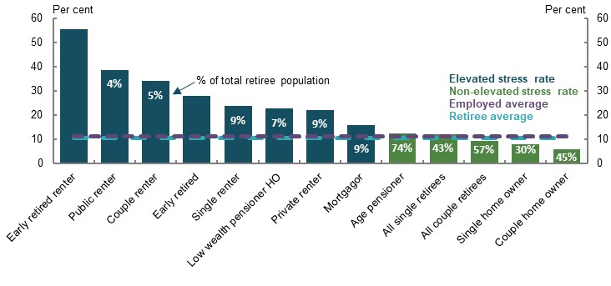
Note: Percentages in chart represent the size of the group compared with the total retired population. Some categories overlap; for example, the couple and couple renter categories. Retiree defined as household reference person being aged 65 and over. Early retired means aged 55-64 and not in the labour force. Low means households are in the bottom 20 per cent for both wealth and income. Home owner (HO) means outright home owner. Employed population includes households of working age where household reference person is in employment. Elevated stress defined as at least 5 percentage points above employed population average. Source: Analysis of ABS Household Expenditure Survey Confidentialised Unit Record File, 2015-16.

Private renters
Almost one-quarter of retirees who rent privately are in financial stress (Chart 2A-8). High housing costs are likely to be the primary driver of the financial stress experienced by this group.
Renters face higher housing costs than home owners in retirement: an additional $6,900 per year for the median single, and $12,200 per year for the median couple (Chart 2A-9).
    - Housing expenditure and rental stress
Retirees’ housing expenditure, 2017-18 | Proportion of renters in rental stress, by age
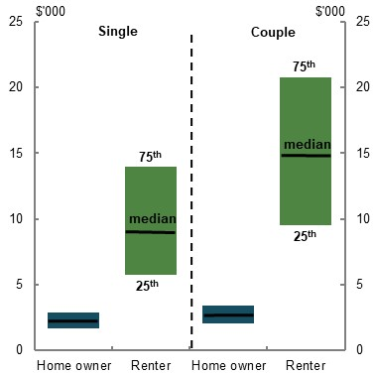  Source: Analysis of (ABS, 2019s). | 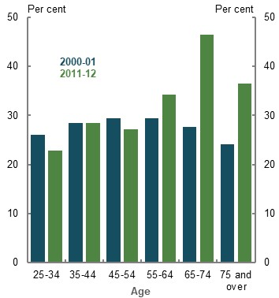  Source: (Productivity Commission, 2015a)
Note: Housing expenditure is in 2017-18 dollars, on annual terms and is a comprehensive measure of net housing costs including interest component of mortgage payments, rent, maintenance payments and other related fees such as body corporate. Commonwealth Rent Assistance has not been deducted from rent payments and is included as income.
Renters in retirement are becoming more vulnerable to rental stress compared with renters in other age groups (Chart 2A-9). Lower disposable income after housing costs contributes to higher financial stress among renters in retirement (Productivity Commission, 2019b).

Public renters
More than one-third of public renter retirees are in financial stress. Within the public rental system, rents are capped at a proportion of the renter’s income, commonly 25 per cent. This means their housing costs are generally higher than age pensioners who own their own homes, but typically lower than for those in the private market.
This group’s high rates of financial stress may also be caused by other cost of living pressures. The tight targeting of public housing means tenants may be from disadvantaged groups. About 38 per cent of households in public housing include a person with disability and 13 per cent include an Indigenous person (Australian Institute of Health and Welfare, 2019).

Retired before Age Pension eligibility age
Around 28 per cent of early retirees experience financial stress. This may be because unemployment in the lead-up to retirement forces households to draw on savings and assets that would have otherwise been saved for retirement. Early retirement may also interrupt voluntary savings that households may otherwise have made in later working years as they prepared for retirement.
People with low wealth are more likely to retire involuntarily (see 3E. Age of Retirement). These households may not have access to private financial resources. Around 10 per cent of entrants on the Age Pension between September 2018 and September 2019 were on Newstart Allowance immediately prior to qualifying for the Age Pension.
Renters who retire early have the highest levels of financial stress of any retiree group. Over half of these households are in financial stress. This may be due to a combination of low financial resources and high housing costs.

Low wealth
Low wealth by itself does not appear to be a driver of high financial stress in retirement.
Financial stress rates for low-wealth households are more closely related to housing, as two-thirds of this group are renters. Controlling for housing, 33 per cent of low-wealth renters are in stress, whereas around 22 per cent of low-wealth home owners are in stress.
Yet financial stress still drops significantly at retirement for low-wealth households (Chart 2A-7) and this group experiences low levels of income poverty. Low wealth exacerbates financial stress where other critical drivers are present, including renting and retiring prior to Age Pension eligibility age. A lack of outside resources to help meet high housing costs or make up for lower government payments appears to magnify financial stress. This suggests that the Age Pension and social transfers in kind improve wellbeing in retirement compared with working life for low-wealth households.

Gender
The proportion of single retired men and single retired women in financial stress is broadly similar: around 12 per cent. Single female retired renters are marginally more likely to be in financial stress than single male retired renters: 25 per cent and 22 per cent, respectively.

Disability status
Around 11 per cent of households with a person with disability in retirement are in financial stress, in line with the retired population average.
The proportion in financial stress only marginally changes with the severity of the disability or disabilities. Around 10 per cent of households with a person with a mild or moderate core activity limitation in retirement are in financial stress. Around 15 per cent of households with a person with a profound or severe core activity limitation in retirement are in financial stress.
Around one-third of renting households with a person with a profound or severe core activity limitation in retirement are in financial stress, above the retired renting population average of 25 per cent.

Income poverty
Poverty rates estimate the level of income inequality in a society and between different groups within society, in either absolute or relative terms. The following analysis focuses on relative poverty, or ‘income poverty’, based on wage rises and gains in community living standards. Absolute poverty is discussed in Assessing the adequacy of the Age Pension above.
Although the income poverty measure has limitations, in being solely income-based, it is useful to identify trends and where groups are falling behind (Chart 2A-10). Income poverty is measured based on the approaches used by ACOSS (Davidson, et al., 2018) and CEPAR (2018a), defined as 50 per cent of median equivalised weekly income once housing costs have been deducted.
    - Incidence of income poverty among different retiree groups, 2017-18
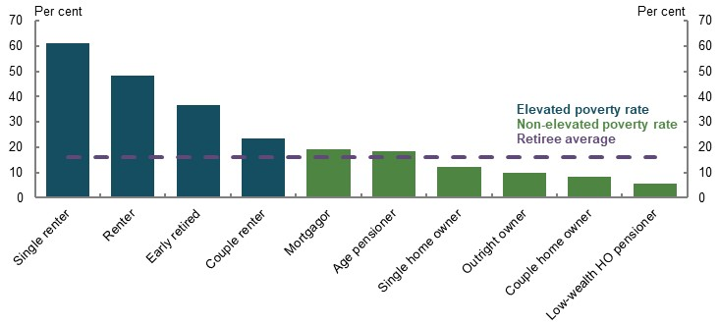
Note: Data relates to 2017-18 financial year. Elevated poverty rate defined as 5 percentage points above retiree average. Retirees are where household reference person is aged 65 and over. There is overlap between some categories; for example, the age pensioner and all couple retiree categories. Early retired means aged 55-64 and not in the labour force. Low-wealth HO pensioner means outright home owning retired households in receipt of government payments and in the bottom 20 per cent of the wealth distribution. Housing costs includes the value of both principal and interest components of mortgage repayments. Source: Analysis of ABS Survey of Income and Housing Confidentialised Unit Record File, 2017-18.
An ‘after housing cost’ measure reflects the value that many retirees gain from lower housing expenses through home ownership. Under this approach, around 16 per cent of retirees were in income poverty in 2017-18, compared with 15 per cent for the working-age population (Chart 2A-10). Under this approach the proportion of retirees who are in poverty dips substantially (Box 2A-5).

          - How the OECD measures income poverty
The OECD uses relative poverty rates to measure the outcomes delivered by different pension systems, calculating income poverty as 50 per cent of median equivalised weekly income on a ‘before housing costs’ basis (OECD, 2013, p. 65). In contrast, the European Union uses 60 per cent of median equivalised disposable income (Eurostat, 2018).
Under the OECD approach, the poverty rate of Australian retirees is high compared to other countries (Chart 2A-11). However, the OECD measure of poverty is a poor fit because high rates of home ownership among Australian retirees reduce their living expenses and boost standards of living.
    - Income poverty rate of older households, OECD countries
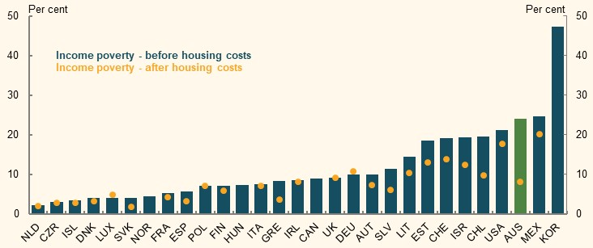
Note: Poverty rates among households aged 65 and older. Source: (CEPAR, 2018a).

Income poverty among different retiree groups
The following considers poverty rates of different groups of retirees, including those with elevated levels of stress.

Renters
One in eight households aged 65 and over are renters and around 48 per cent of renters experience income poverty (ABS, 2019n). Single renter households have even higher rates of income poverty — in excess of 60 per cent.
As renters are more likely to have lower income and wealth, they rely more on government payments such as the Age Pension and Commonwealth Rent Assistance to meet increased housing costs (see Box 2A-6 for details on Commonwealth Rent Assistance).
High levels of income poverty among these households reflects the greater housing costs incurred by renters in retirement, compared with most retirees who own their home outright.
In June 2019, the average fortnightly rent for retiree households receiving Commonwealth Rent Assistance was around $438. Maximum Commonwealth Rent Assistance covered around 34 per cent of the average single household’s fortnightly rent, and 24 per cent of rent for couples (Department of Social Services administration data). More broadly, the maximum value of Commonwealth Rent Assistance covers less than 20 per cent of average market rents (CEPAR, 2019, p. 57).
          - Commonwealth Rent Assistance and the costs of renting
Commonwealth Rent Assistance is a supplement available to retirees who are renting and is means tested with the Age Pension. The payment covers 75 per cent of rental costs above a minimum threshold and is capped at a maximum amount (around $300 per fortnight for a single). Market rents in some areas can significantly exceed the value of these caps.
The maximum value of Commonwealth Rent Assistance has not kept pace with market rents, especially for low-income renters.
- There was a one-off 10 per cent increase in Commonwealth Rent Assistance in 2000, but since then its value has fallen relative to rental costs. Rents for lower-income earners have risen particularly quickly compared to average (Chart 2A-12).
- Commonwealth Rent Assistance is covering a smaller share of rental costs now than it did two decades ago. The payment is increasingly less effective in preventing income poverty and assisting eligible renters to secure an adequate standard of living in retirement (Productivity Commission, 2019b; Australia’s Future Tax System Review, 2009).
The impact of changes to the support provided by Commonwealth Rent Assistance is considered in 2B. Policy scenario: Implications of increasing Commonwealth Rent Assistance.
    - Growth in value of Commonwealth Rent Assistance and rent costs
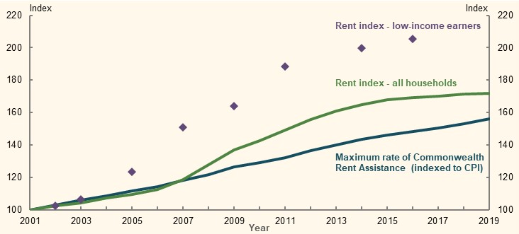
Source: (Department of Social Services, 2020c; ABS, 2020e; Productivity Commission, 2017).

Single households
In 2017-18, around 24 per cent of single-person retiree households were in poverty, above the retiree average. However, housing rather than relationship status is the main driver of poverty. More than 20 per cent of older single households rent, compared with around 8 per cent of older couples. More than 60 per cent of single renter households experience income poverty, while 12 per cent of single home owners are in income poverty.

Households with mortgages
People who enter retirement with a mortgage also have a higher level of income poverty than the average retiree. Ten per cent of households aged 65 and over have a mortgage on their home (see 1D. The changing Australian landscape). In 2017-18, around 20 per cent of these households were in income poverty.
Higher poverty for this group largely reflects the costs associated with continued mortgage repayments. Despite higher than average income poverty among mortgagors, their rates of financial stress are similar to the retiree and working-age averages. Even excluding the family home, these households have a higher net worth than renters.
Mortgagors are also are exposed to a higher level of risks, including exposure to interest rate changes and greater exposure to sequencing risk, than other retirees (see 2C. Maintaining standards of living in retirement). Higher house prices and rising mortgages in retirement could reduce standards of living even further for future retirees with a mortgage.

Gender
The proportion of single retired men and single retired women in income poverty is broadly similar: around 25 per cent for single men and 23 per cent for single women. Single retired renting women are marginally more likely to be in income poverty than single retired renting men: 63 per cent and 59 per cent, respectively.

Disability status
Those with disability are marginally less likely to be in income poverty than the retiree average. Fourteen per cent of households with a person with disability in retirement are in income poverty. This is broadly constant across the severity of disability.
A lower proportion of people with a profound or severe core activity limitation who rent in retirement are in income poverty (32 per cent), compared to renters across the retiree population (48 per cent). This may be due to a high proportion of this group having rent-free living arrangements, or who rent through public housing (13 per cent, compared to 6 per cent for the total retiree population) (ABS, 2019g).

Historical income poverty rates
The incidence of income poverty among older Australians has fallen in the past decade. Changes to the Age Pension in 2009 led to a large drop in poverty rates, which continued to decline (Chart 2A-13).
More than 40 per cent of single person retiree households and over half of renter retiree households were in income poverty in 2007-08 (Chart 2A-13). Analysis by ACOSS (Davidson, et al., 2018, p. 13) suggests poverty outcomes for most retiree groups improved following changes to the Age Pension in 2009.
Although poverty rates have improved, retiree renters continue to have income poverty levels well in excess of the average rates for retirees and working-age people, suggesting retirement incomes for renters are not meeting community standards.
Poverty measures have some limitations when comparing between groups. These differences may be due to issues with the measure itself, explored in Limitations of income poverty, below.
    - Historical income poverty rates, by retiree group
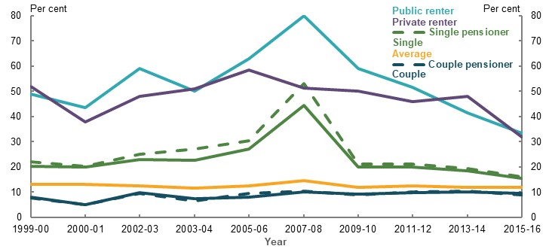
Note: Households aged 65 and over. ‘pensioner’ includes households on government social security payments. ‘Average’ refers to the entire population and is not confined to households aged 65 and older. Source: (Davidson, et al., 2018).

Limitations of income poverty
Measures of income poverty may overstate disadvantage among older Australians as they:
- Vary significantly depending on the definition of poverty used
- Fail to recognise both the wealth that retirees may draw on to fund their living standards and the value of social transfers in kind
- Depend on an absolute line that people are either above or below, without showing how far people are below the line
Retirees classified as being in poverty but not in financial stress tend to have significantly more non-housing wealth than retirees in financial stress (Chart 2A-14). Retirees in income poverty but not stress have equivalised median assets outside the home of $314,000 on average. These households may be drawing on their assets outside superannuation to help fund retirement, but these drawdowns are not classified as income in ABS surveys (ABS, 2019s).
    - Comparison of income poverty and financial stress measures for retirees
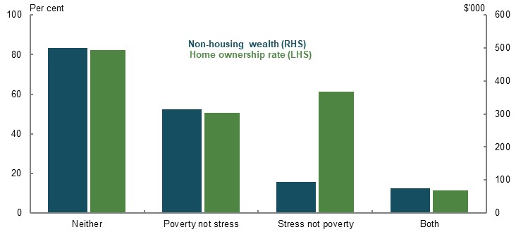
Note: Figures are in 2015-16 dollars. Retiree defined as household reference person being aged 65 and over. Home owners are outright owners. Non-housing wealth is equivalised for household size. Source: Analysis of ABS Survey of Income and Housing Confidentialised Unit Record File, 2015-16; Analysis of ABS Household Expenditure Survey Confidentialised Unit Record File, 2015-16.
          - Impacts of policy settings on the adequacy of the minimum standard
Many submissions proposed changes affecting how retirees achieve a minimum standard of living. The following outlines some implications of some of those proposals.
- Increase assistance for renters. Retirees who rent experience higher levels of financial stress and income poverty than other retirees. While the indexation of the Commonwealth Rent Assistance has not kept pace with increases in rents, even large increases in Commonwealth Rent Assistance would only be a fraction of the additional housing costs faced by retiree renters (see 2B. Policy scenario: Implications of increasing Commonwealth Rent Assistance). A new approach is required to help renters achieve a minimum standard of living in retirement and reduce levels of income poverty in retirement.
- Increase income support for involuntary retirees. Involuntary retirees experience higher levels of financial stress and income poverty than most retirees. Income support for households under Age Pension eligibility age is not considered to be part of the retirement income system. Whether people who retire involuntarily before Age Pension eligibility age achieve a minimum standard of living will depend on the level of the JobSeeker Payment. Any change in the rate of the JobSeeker Payment must consider its broader implications as it applies to all age groups and many recipients may re-enter the workforce (see 3E. Age of retirement).

Policy scenario: Implications of increasing Commonwealth Rent Assistance
          - Section summary
- Increasing Commonwealth Rent Assistance would provide some additional support to people most likely to fall below a minimum standard of living in retirement. For the typical renter, increasing the maximum rate by 40 per cent would reduce retiree renters’ housing expenditure and increase their disposable income after housing by a small amount; around $28 per week. This would marginally reduce the housing expenditure gap between renters and home owners by around 8 per cent for retirees at the median income.
- The increase in Commonwealth Rent Assistance would only reduce financial stress among renting retirees by around 1 percentage point. This would narrow the gap in financial stress rates between renters and home owners by 10 per cent. The effect on income poverty and retirement incomes would be minor, reflecting that most renters in income poverty have incomes substantially below poverty benchmarks.
- The increase in Commonwealth Rent Assistance would marginally redress retirement equity for disadvantaged groups. Some groups that experience poorer outcomes in retirement, such as women and the involuntarily retired, are more likely to rent. Increases in Commonwealth Rent Assistance would marginally benefit these groups and reduce their retirement income gap with other retirees.
- The increase in Commonwealth Rent Assistance would slightly reduce the inequity between home owners and renters. Home owner retirees would continue to receive higher Age Pension payments than renters with similar asset values.
- The fiscal cost of a 40 per cent increase in the maximum rate of Commonwealth Rent Assistance is estimated to be $370 million for Age Pension recipients and $1.7 billion for all Commonwealth Rent Assistance recipients. An increase in Commonwealth Rent Assistance is not expected to have a significant impact on market rents.
- Even if the maximum rate is increased by 40 per cent, Commonwealth Rent Assistance remains a small proportion of the housing expenses faced by retiree renters and does not significantly alleviate stress and income poverty rates for renters in retirement. The current design of Commonwealth Rent Assistance has limited capacity to help retiree renters achieve adequate retirement outcomes. A broader approach to support renters in retirement should be considered.

Outline of this section
Many submissions suggested increasing Commonwealth Rent Assistance. To improve understanding of how increasing Commonwealth Rent Assistance would affect outcomes for retiree renters, this section considers:
- The purpose of Commonwealth Rent Assistance, with reference to different housing expenses for renters and home owners
- The impact of increasing Commonwealth Rent Assistance to compensate for the disparity between the maximum Commonwealth Rent Assistance rate and market rents
- The effect of increasing Commonwealth Rent Assistance on the adequacy, equity and sustainability of the retirement income system
          - Stakeholder views on Commonwealth Rent Assistance
Many submissions highlighted the need to change the policy settings of Commonwealth Rent Assistance.
Stakeholders noted that:
- Retirement outcomes for renters were poor on average relative to home owners. Lower-income earners renting in retirement may struggle to have adequate retirement incomes. Poverty among older Australians is concentrated among private renters.
- The rate of Commonwealth Rent Assistance is low relative to market rents and does not help renters achieve adequate retirement incomes. The indexation of Commonwealth Rent Assistance to CPI erodes the adequacy of the payment over time, given that growth in market rents has outpaced growth in the CPI.
Numerous submissions argued for an increase in Commonwealth Rent Assistance to improve outcomes for renters in retirement and as a targeted measure to reduce old-age poverty.
Submissions also argued that the indexation method for Commonwealth Rent Assistance should change, but had different opinions on the appropriate benchmark.

The role of Commonwealth Rent Assistance in retirement
Commonwealth Rent Assistance is a tax-free payment made to private renters who receive social security benefits, including the Age Pension. About 22 per cent of all Commonwealth Rent Assistance recipients receive the Age Pension (Department of Social Services, 2020a). Age Pension recipients who are not private renters, such as those in public housing and residential aged care, do not receive Commonwealth Rent Assistance.
Commonwealth Rent Assistance currently covers less than half of rent expenses. It provides 75 per cent of fortnightly rental expenses between $124.60 and $310.73 for single renters, and between $201.80 and $377.27 for couple renters as at 1 May 2020. Commonwealth Rent Assistance is not paid if rent is below the lower threshold. The maximum fortnightly payment is $139.60 for singles and $131.60 combined for couples if their rental expenses are at or above the upper threshold. Rent thresholds and maximum payments are indexed in March and September each year to reflect changes in the CPI.
As outlined in 2A. Achieving a minimum standard of living in retirement, the median housing cost (mainly rent expenses) for retirees is around $350 per fortnight for single renters and around $570 for couple renters. While Commonwealth Rent Assistance covers 45 per cent of retirees’ rent expenses at most, for two-thirds of recipients it covers less than a third. This is because most renting retirees face rent expenses far above the upper rent threshold that Commonwealth Rent Assistance is paid on. For all renting retirees, Commonwealth Rent Assistance covers an average of 13 per cent of their rent expenses.
Even with Commonwealth Rent Assistance, retired households that rent still face substantially higher housing expenses than home owners. The ratio of Commonwealth Rent Assistance rate to market rent has been declining over the past three decades because Commonwealth Rent Assistance is indexed to the CPI, which has been growing more slowly than rental inflation on average over that time (see 2A. Achieving a minimum standard of living in retirement).
Because retired renters achieve poorer outcomes than most home owners, previous reviews suggested a considerable increase in Commonwealth Rent Assistance to reduce poverty and financial stress rates among retirees (Australia’s Future Tax System Review, 2009). It was argued that increases in Commonwealth Rent Assistance payments would target those who need additional support because renters in retirement are most likely to be in the bottom three income deciles and are generally full-rate age pensioners with low asset levels.
In the course of this review, some stakeholders suggested increasing Commonwealth Rent Assistance by 20-100 per cent, while others suggested increasing the maximum rate by 40 per cent. Changing the way Commonwealth Rent Assistance is indexed was also suggested to better reflect developments in the rental market and provide consistent and adequate support for renters.

Impact of an increase in the rate of Commonwealth Rent Assistance
Following is an analysis of the effect of a 40 per cent increase in the maximum rate of Commonwealth Rent Assistance on retirement outcomes for renters. This would be an increase in the maximum payment by around $28 per week or $1,450 per year. This increase reflects the difference in the increase in the rent inflation index and the CPI over the past 15 years (see Chart 2A-12 in 2A. Achieving a minimum standard of living in retirement). This scenario involves an increase in the maximum payment threshold to around $385 for single renters and to around $447 for couple renters per fortnight (Chart 2B-1).
    - Commonwealth Rent Assistance payment by fortnightly rent
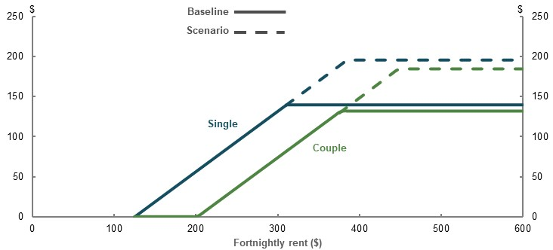
Note: Values are in 2020 dollars. Calculated based on a typical maximum-rate age pensioner household: single non-sharer and couple living together, without dependants. Solid lines represent the current policy, dashed lines represent the 40 per cent higher Commonwealth Rent Assistance scenario. Source: Calculations based on pension and Commonwealth Rent Assistance rates and thresholds as at 1 May 2020.
Given that Commonwealth Rent Assistance is a supplement to many social security payments, higher Commonwealth Rent Assistance payments would benefit many more people than just Age Pension recipients. Targeting Commonwealth Rent Assistance increases only at Age Pension recipients would also be administratively difficult. This analysis focuses only on the impact on retirees through the effect on the adequacy, equity and sustainability of the retirement income system.

Effects of higher Commonwealth Rent Assistance on the retirement income system

Effect on adequacy

Housing expenditure
A 40 per cent increase in the maximum Commonwealth Rent Assistance rate would help reduce the housing costs for lower-income earners (Chart 2B-2). On average, renters have lower incomes. Almost two-thirds are in the bottom five income deciles in retirement. For a renter with median income, on average, the increase in Commonwealth Rent Assistance would cover 17 per cent of housing expenditure, compared with 11 per cent under current policy settings. It would only close the housing expenditure gap between renters and home owners by around 8 per cent.
    - Weekly housing expenditure for retired households by income decile
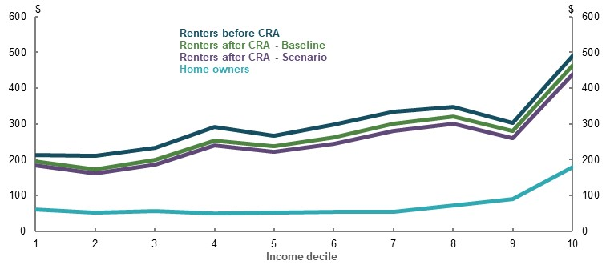
Note: CRA stands for Commonwealth Rent Assistance. Income deciles calculated using pre-Commonwealth Rent Assistance income and equivalised for household size. Population weighted. Values are in 2017-18 dollars. Source: Analysis of ABS Survey of Income and Housing Confidentialised Unit Record File, 2017-18.
Housing expenditure takes up a large share of retired renters’ disposable income. Increasing the value of Commonwealth Rent Assistance payments would increase their income, after housing expenditure, but not by a significant amount (Chart 2B-3). For a renter with median income, average weekly income after housing expenditure would increase by approximately 3 per cent, from $556 to $572. At the margin, this would reduce financial stress and income poverty for retired renters, especially those with lower incomes.
    - Weekly disposable income after housing expenditure, retired households
by income decile
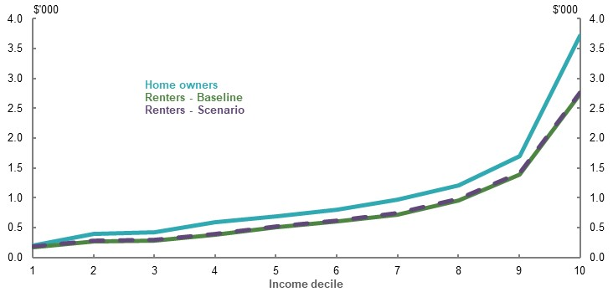
Note: Values are in 2017-18 dollars. Source: Analysis of ABS Survey of Income and Housing Confidentialised Unit Record File, 2017-18.

Financial stress
As discussed in 2A. Achieving a minimum standard of living in retirement, retired renters have much higher rates of financial stress than home owners. Increasing the maximum Commonwealth Rent Assistance rate by 40 per cent is estimated to reduce retired renters’ rate of financial stress by around 1.1 percentage points (Chart 2B-4). This would narrow the gap in financial stress rates between renters and home owners by around 10 per cent.
Because financial stress is self-assessed, the effect of reduced housing expenditure on stress can only be inferred from historical data. A statistical model was used to estimate the relationship between financial stress and income for retired renters, as well other key financial and demographic variables (see Appendix 6A. Detailed modelling methods and assumptions). The estimates should be considered suggestive as they do not control for the effects of unobserved differences across households on financial stress.
    - Financial stress rates of home owner and renter households in retirement
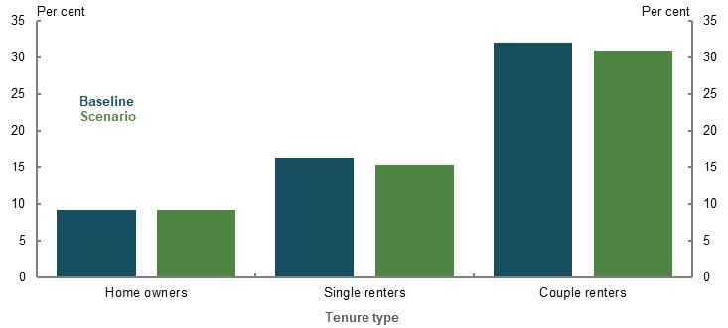
Note: This analysis uses a multinomial probit model to explain household financial stress. Marginal effects are estimated using the income of renters in 2015-16 by family type, and then applied to data in 2019-20 to calculate the effect of the Commonwealth Rent Assistance payment increase. Control variables include wealth, disability status, household and tenure type. Home owners are unaffected. Source: Analysis of ABS Household Expenditure Survey Confidentialised Unit Record File, 2015-16.
Estimates suggest higher Commonwealth Rent Assistance payments would marginally reduce stress for retirees in the first wealth quintile (Chart 2B-5), where renters experiencing financial stress are concentrated. Their rate of financial stress is estimated to fall by 1 percentage point.
    - Financial stress rates of retired households by wealth quintile
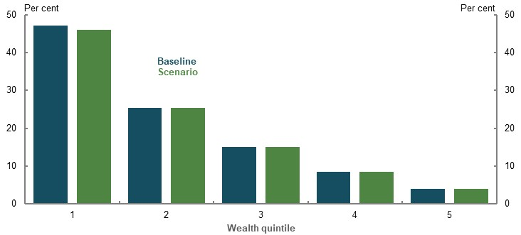
Note: Same as Chart 2B-4. Wealth is equivalised for household size. Source: Analysis of ABS Household Expenditure Survey Confidentialised Unit Record File, 2015-16.

Income poverty
Renting retirees experience high rates of income poverty. This is consistent with renting retirees generally being in the bottom half of the income and wealth distributions (see 2A. Achieving a minimum standard of living in retirement).
Increases to Commonwealth Rent Assistance would reduce these rates only moderately (Chart 2B-6). A 40 per cent increase in the maximum Commonwealth Rent Assistance rate would reduce the rate of income poverty for renting retiree households by around 3 percentage points. The largest reduction would be for single renters, with their rate of income poverty estimated to fall by almost 4 percentage points, from 57 per cent to 53 per cent.
    - Income poverty rates of home owner and renter households in retirement
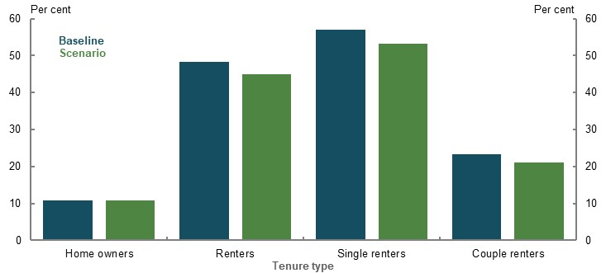
Note: Income poverty is estimated with Commonwealth Rent Assistance threshold increases in 2017-18 by family type. Home owners are unaffected. Source: Estimate based on analysis of ABS Survey of Income and Housing Confidentialised Unit Record File, 2017-18.
While the additional Commonwealth Rent Assistance would help to narrow the poverty gap between renters and owners in retirement, the increase is not sufficient to change most renters’ income poverty classification (Chart 2B-7). Estimates suggest that most renter retiree households in income poverty are below the poverty threshold (of 50 per cent of median equivalised disposable income) by more than $28 per week, which is the increase in the maximum rate of Commonwealth Rent Assistance assessed here. The gap in income poverty rates between renters and home owners would narrow by around 11 per cent.
    - Number of retired households below income poverty benchmark by wealth decile
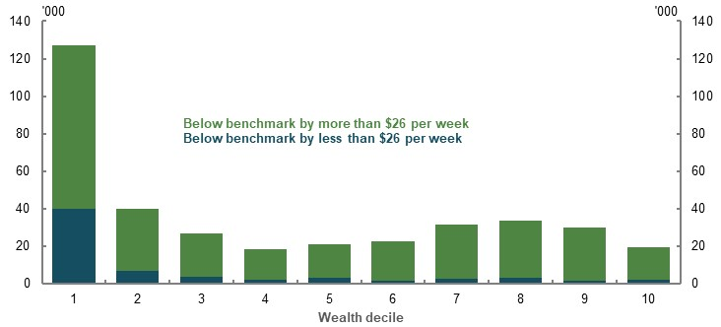
Note: The chart includes all retirees. Renters affected by the Commonwealth Rent Assistance increase are mostly in the lower-wealth decides. Due to inflation, $26 in 2017-18 dollars is equivalent to $28 in 2019-20 dollars. Source: Estimate based on analysis of ABS Survey of Income and Housing Confidentialised Unit Record File, 2017-18.
In line with the wealth status of renting retirees, the increase in maximum rate of Commonwealth Rent Assistance would reduce income poverty rates predominantly for those in the bottom two deciles of the wealth distribution (Chart 2B-8). These decreases for these deciles are estimated to be around 2 percentage points.
    - Retired household income poverty rates by wealth decile
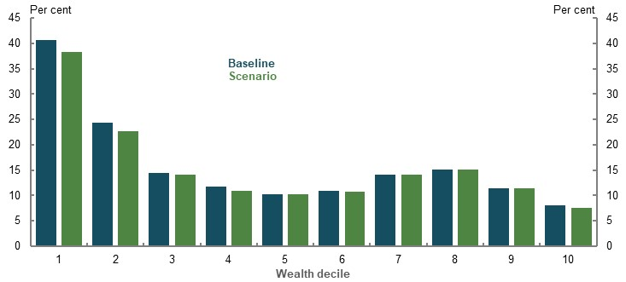
Note: Income poverty is estimated with Commonwealth Rent Assistance threshold increases in 2017-18 by family type. Wealth deciles of retired households and equivalised for household size. Home owners are unaffected. Population weighted. Source: Estimate based on analysis of ABS Survey of Income and Housing Confidentialised Unit Record File, 2017-18.

Replacement rates
Increasing the maximum rate of Commonwealth Rent Assistance would have a small effect on renters’ income replacement rates. Calculations using a hypothetical cameo model suggest those in the bottom half of the income distribution in 2060 would see their income replacement rates increase by less than 2 percentage points, with smaller increases for higher-income renters. The small size of these effects is consistent with the maximum additional payments totalling only around $1,450 per year (around 3 per cent of the median wage).
This analysis assumes Commonwealth Rent Assistance continues to be indexed to CPI after the 40 per cent increase in the maximum Commonwealth Rent Assistance rate. Changes to Commonwealth Rent Assistance indexation arrangements that resulted in higher increases would have larger effects on future income replacement rates.

Effect on equity

Home ownership status
Home owners, in general, receive higher Age Pension payments than renters with similar asset values. Commonwealth Rent Assistance provides a significantly smaller benefit than exempting the principal residence from the Age Pension assets test for all retirees, except those with very low wealth levels (see 3C. Home ownership status).
Increasing the maximum Commonwealth Rent Assistance rate by 40 per cent would not change this significantly (Chart 2B-9). Retirees with a median-valued home in retirement would continue to receive higher Age Pension payments than renters with the same total wealth, when their non-home assets are worth more than around $90,000. This gap would be reduced by the $1,450 per year increase in Commonwealth Rent Assistance for retirees with non-home asset values below around $350,000. The increase in Commonwealth Rent Assistance has little effect on reducing the inequity between home owners and renters due to the Age Pension assets test.
    - Annual value of exempting the principal residence from the Age Pension assets test
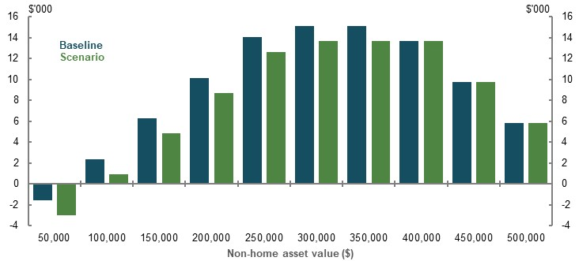
Note: Values are in 2019-20 dollars. This chart is a theoretical comparison, which shows the differential value of annual Age Pension payments in the year 2019-20 for single home owners with a $450,000 home compared with renters with the same total asset value, by non-housing deemed asset value. Based on Age Pension payment rates and thresholds as at 20 March 2020. Source: Cameo modelling undertaken for the review.

Groups affected
Increases in Commonwealth Rent Assistance would benefit those in need. Groups that experience poorer outcomes in retirement are more likely to be renters. For example, women retirees are expected to gain from Commonwealth Rent Assistance increases. As shown in 3B. Gender and partnered status, a larger number of renters in retirement are women. Higher Commonwealth Rent Assistance payments would have a small effect on improving gender equity in retirement.
Modelling suggests increasing the maximum Commonwealth Rent Assistance rate would reduce income poverty more for single women renters than it would for men (Chart 2B-10). The rate of income poverty for single women retirees is estimated to fall from 63 to 58 per cent.
    - Income poverty rates of retired renting households
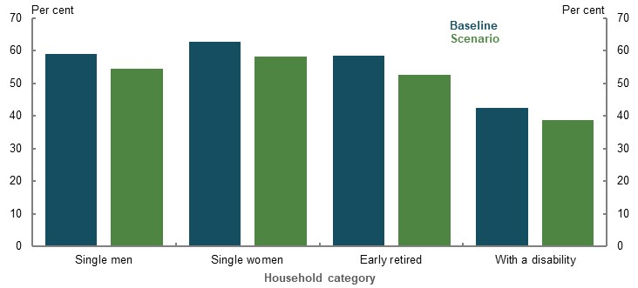
Note: Income poverty is estimated with Commonwealth Rent Assistance threshold increases in 2017-18 by family type. Population weighted. Source: Estimate based on analysis of ABS Survey of Income and Housing Confidentialised Unit Record File, 2017-18.
Early retired households, those not in the labour force aged 55-64 and retirees with disability are also likely to benefit from the Commonwealth Rent Assistance increase because they are more likely to rent. These renters have some of the highest rates of income poverty among retirees, and a significant number of them report being in financial stress. Estimates suggest a 40 per cent increase of the maximum Commonwealth Rent Assistance rate would marginally reduce income poverty rates for these groups, by around 5 percentage points (Chart 2B-10).
Similarly, Aboriginal and Torres Strait Islander retirees have a much higher rate of renting than the rest of the population (see 3F. Aboriginal and Torres Strait Islander people). Changes to Commonwealth Rent Assistance may therefore redress some equity balance in retirement for these households.

Effect on sustainability

Fiscal costs
The total fiscal costs of increasing the maximum rate of Commonwealth Rent Assistance by 40 per cent is estimated to be around $1.7 billion in 2019-20 (0.1 per cent of GDP). Most of this cost reflects additional support accruing to working-age social security payment recipients. The estimated fiscal cost of increasing the maximum Commonwealth Rent Assistance rate for Age Pension recipients by 40 per cent, or about $28 per week, is around $370 million in 2019-20.

Impact on the broader economy
When this issue has been considered on previous occasions, concerns have been raised that Commonwealth Rent Assistance increases could increase rental rates (Senate Economics Reference Committee, 2015).This would negate some of the benefits of higher payments for Commonwealth Rent Assistance recipients.
Commonwealth Rent Assistance recipients do not form a large portion of renters in the market segments where they rent. Three-quarters of Commonwealth Rent Assistance recipients are in the bottom half of the income distribution. They comprise around only 7 per cent of all renters in these income groups. Providing social security recipients with additional Commonwealth Rent Assistance in the order of $28 per week is unlikely to have a large effect on the total demand for rental properties or aggregate rents.

Implications for the retirement income system
Commonwealth Rent Assistance has a limited ability to redress differences in adequacy outcomes for renters compared to home owners. For the 40 per cent increase in the maximum rate assessed, retirement outcomes for renters would be little changed as:
- The increase covers a fraction of their additional housing costs
- Their financial stress rates are estimated to remain more than twice that of home owners
- Around 45 per cent of them would continue to be in income poverty
Alternative changes to Commonwealth Rent Assistance would not materially change these results. Estimates suggest increasing the maximum payment threshold by 60 to 100 per cent would reduce income poverty by a modest amount (Table 2B-1). Removing the lower threshold completely (to cover the 75 per cent of rent costs from the first dollar of rent) would have only slightly larger effects. Under both approaches, a significant share of renting retirees remain in income poverty.
      - Effects and indicative fiscal costs of alternative Commonwealth Rent Assistance scenarios
Change | Maximum payment increase |  | Retiree income poverty  (per cent) |  |  | Indicative fiscal cost  ($million)
 | Per cent | $ per year | All renters | Single renters | Couple renters | Total | Age  Pension recipients
Increased upper threshold | 0 | 0 | 48.3 | 56.9 | 23.2 | 0 | 0
Increased upper threshold | 20 | 730 | 46.1 | 54.2 | 22.6 | 870 | 180
Increased upper threshold | 40 | 1,450 | 45.0 | 53.2 | 21.1 | 1,740 | 370
Increased upper threshold | 60 | 2,180 | 44.0 | 51.9 | 20.9 | 2,610 | 550
Increased upper threshold | 80 | 2,900 | 42.6 | 50.3 | 20.5 | 3,470 | 740
Increased upper threshold | 100 | 3,630 | 41.8 | 49.7 | 19.0 | 4,340 | 920
Removed lower threshold | n/a | 3,730 | 40.9 | 49.2 | 16.8 | 4,080 | 960
Source: Estimate based on analysis of ABS Survey of Income and Housing Confidentialised Unit Record File, 2017-18.
This reflects that renters have significantly higher housing costs than home owners (see 2A. Achieving a minimum standard of living in retirement). While Commonwealth Rent Assistance benefits renters as a disadvantaged group, even large increases in Commonwealth Rent Assistance would only cover a small proportion of the housing expenses faced by a large number of renting retirees. In addition, a significant share (31 per cent) of renting retirees in income poverty reside in public housing and do not receive Commonwealth Rent Assistance benefits.
The alternative options outlined in Table 2B-1 involve increased fiscal costs. A significant amount of this would support working-age renters, as Commonwealth Rent Assistance is a component of the broader income support system. A change in Commonwealth Rent Assistance would have effects beyond the retirement income system, including the way the broader income support and housing support systems operate.
Even at a higher rate (e.g. an additional $3,630 per year after a 100 per cent increase in the maximum rate of Commonwealth Rent Assistance), Commonwealth Rent Assistance still provides a smaller benefit for renters than the annual value of exempting the principal residence from the Age Pension assets test for most home owners (Chart 2B-9).
In light of these considerations, a broader approach to assisting renters in retirement appears necessary.

Maintaining standards of living in retirement
          - Section summary
- The retirement income system should seek to balance working life and retirement incomes. Without government intervention, many people would not save enough for their retirement. But saving too much can reduce lifetime wellbeing, particularly for lower-income people. The aim should be to maintain a person’s living standard in their working life through into their retirement.
  - The weight of evidence suggests higher SG contributions mostly come at the cost of lower wage growth. This relationship means SG policy should aim to smooth consumption over working life and retirement.
  - Replacement rates are the most appropriate tool for assessing whether people can maintain living standards in retirement. They measure the objective directly and acknowledge the trade-offs between working life and retirement incomes.
  - Retirees can maintain their living standards with lower income than when working. Housing and other costs generally fall, while Government support increases. Therefore, to assess adequacy, a benchmark replacement rate of 65-75 per cent of pre-retirement income has been used.
- Most people who have retired in recent years appear to have adequate outcomes. Qualitative surveys suggest recent retirees generally feel happier than in working life and typically have the same level of satisfaction with their finances compared to just before retirement. They also tend to be less financially stressed than employed people.
- Projections show that, under current policy settings, including the legislated increase in the SG rate to 12 per cent, people with typical workforce patterns can achieve replacement rates that meet or exceed the 65-75 per cent benchmark. The results are consistent for different households (singles, couples and women) and across most income levels. Most lower- to middle-income workers will have replacement rates that exceed the benchmark. They may be forgoing more working-life income than is necessary to maintain living standards in retirement.
  - These outcomes assume people draw down their savings in retirement. If they only draw down their superannuation at the legislated minimum rates, which many people currently do, those in the upper half of the income distribution will not achieve the 65-75 per cent benchmark.
  - Assisting retirees to use existing assets more efficiently, and draw down their assets in retirement, can have a bigger impact on improving retirement incomes than changes to the SG rate. Without improving the way retirees draw down their assets, extra contributions to superannuation will not result in most retirees maintaining their living standards. It will lead to larger bequests. Fully drawing down superannuation can substantially boost retirement incomes, without having to increase contributions. Other options to improve retirement incomes include strategies and products to achieve greater certainty around income or drawing on equity in the principal residence.
  - The Age Pension will continue to provide significant retirement income for lower- and middle-income earners, even in a mature superannuation system.
- The focus of assessing universal policy settings like the SG should be on middle-income earners. This group needs the most assistance as they cannot rely on the Age Pension alone to maintain their living standards and they have relatively low rates of voluntary saving. The bottom 30 per cent of retirees by income have their working-life living standards maintained, or exceeded by, the Age Pension. Higher-income earners have retirement incomes that exceed the ASFA comfortable standard.
- Review projections assume retiree spending grows in line with prices, rather than wages. The weight of domestic and international evidence points to retirees’ spending falling or staying flat relative to prices, even for those who can afford to spend more.
- Offering prudent and limited access to superannuation prior to retirement is consistent with the objective of balancing living standards pre- and post-retirement. Early access in limited circumstances allows the system to respond to severe financial pressures people may face in their working lives while still achieving adequacy targets.
- The assessment that living standards can be maintained in retirement holds true under a wide range of different circumstances. Households estimated to have replacement rates below the 65-75 per cent replacement rate benchmark would typically have careers of 25 years or less and retire before superannuation preservation age. But even then, their outcomes would be adequate if they retire for disability-related reasons or to care for someone, provided they access the associated welfare payments.
- The COVID-19 Pandemic has highlighted the impact investment risk can have on retirement outcomes. Australia’s superannuation system exposes people to market risk. For most people invested in a fund with good returns, exposure to market returns is a strength of the system. Fund diversification and the Age Pension have moderated the short-term impact of market downturns on retirement incomes.
- The increase in the SG rate to 12 per cent will not reduce the gap in superannuation balances between men and women. The increase will benefit men more than women.

Outline of this section
This section analyses whether the retirement income system enables people to reasonably maintain standards of living in retirement. This measure of adequacy is appropriate because:
- A relatively stable lifetime standard of living maximises wellbeing
- It recognises the trade-off between consumption in either working life or retirement
          - Stakeholder views on helping people to reasonably maintain their standard of living in retirement
Some submissions suggested adequacy analysis should focus on maintaining people’s working-life living standards in retirement. They argued that relative measures, such as replacement rates, are the appropriate measure for assessing this goal as they recognise the trade-off between working life and retirement income. Many stakeholders agreed absolute standards were useful in assessing adequacy but suggested they should be confined to assessing if the system is delivering minimum standards.
‘Absolute and relative measures of adequacy serve different purposes. Absolute measures are often used to assess to what extent the retirement income system relieves poverty. Relative measures are often used when assessing whether the system would allow retirees to maintain the standard of living they experienced during their working years.’ (Actuaries Institute, 2020, p. 4)
Some submissions argued for achieving a particular income level in retirement and favoured using an absolute measure, such as a budget standard. They noted that replacement rates approaches are not suitable for lower-income earners and the system should aim to deliver objective levels of comfort and security in retirement. Many superannuation bodies suggested using the ASFA budget standards as they are well-known, established benchmarks.
‘ASFA Comfortable is an objective income benchmark that is consistent with community expectations.’ (ASFA, 2020a, p. 5)
Other submissions suggested further research on retiree spending needs was required to determine an appropriate standard. They also noted that people find dollar-based approaches easy to understand.
‘They [budget standards] are valuable for those planning for retirement in that they detail the quality and quantity of different consumption items a retiree will be able to afford given a certain level of expenditure.’ (Super Consumers Australia, 2020, p. 5)

Maintaining a stable lifetime standard of living maximises wellbeing
Maintaining living standards in retirement is a goal for retirement income systems in most countries (OECD, 2019b).
Achieving a similar living standard in retirement and working life involves a trade-off between consuming during working life and consuming in retirement. Economic theory suggests that people should save in periods of higher-income, such as when working, and draw on their assets in periods of lower income, including in retirement (Browning & Crossley, 2001).
In reality, complex decisions make retirement planning difficult. Apart from uncertainty about how long they will live, people have behavioural biases that mean their decisions are not always in their long-term interest (Box 2C-3). For example, without intervention retirees may fall well short of achieving the level of saving needed to maintain their standard of living in retirement (Munnell, et al., 2007). Concern that they may outlive their retirement savings may prevent them drawing down their savings to support their living standards (see 5A. Cohesion).
Policy intervention is needed because people find it difficult to make complex, long-term decisions. Without assistance, many Australians would experience a drop in their living standard when they retire. Policies that make people save, like the SG, can improve lifetime wellbeing.
Yet saving to improve retirement incomes needs to be balanced with the cost imposed during working life. Encouraging people to save too much, and reducing their standard of living in their working life, can harm their overall wellbeing. The standard of living achieved in retirement should not come at the cost of forgoing spending to an excessive degree during working life.
Many people aspire to a high standard of living in retirement. However, with compulsory superannuation adequacy targets are system-wide goals that apply to everyone and need to account for a range of incomes and preferences. Therefore, a goal based on maintaining, rather than improving, living standards in retirement is appropriate. People who aspire to higher living standards in retirement than when they were working should achieve these higher standards through voluntary savings.
          - Behavioural biases affect saving decisions
Lifetime consumption smoothing assumes that people make rational, calculated decisions about how they save for retirement. But households do not actually make decisions this way. A number of biases lead to undersaving, including:
- Bounded rationality. Lifetime decisions are complicated. People find it hard to calculate how much they would need to save to support their needs in retirement. For example, the savings someone needs will depend on how long they live. Yet people tend to underestimate how long they are likely to live, increasing the risk of a financial shortfall later in retirement (longevity bias).
- Present bias. People tend to overvalue the present and undervalue the future. They may not save enough for retirement because they (wrongly) think that whatever they do later is not as important as what they are doing now.
- Status quo bias (inertia). People tend to continue their current behaviour even when they want, or have agreed, to change. If they are unaccustomed to saving, they may find it hard to start saving for retirement, even when they know they should.
Source: Adapted from (Thaler & Benartzi, 2004).

The trade-off between working life and retirement income
The retirement income system has to accommodate the trade-off between working life and retirement living standards. Governments and individuals both facilitate this trade-off:
- The Government taxes people more during their working lives and provides higher levels of support in retirement, including income support, more services and lower taxes.
- Individuals make trade-offs when saving for retirement. They forgo spending today to increase their spending in retirement. People can be compelled to make this trade-off, such as via the SG, or choose it voluntarily.
Some stakeholders did not accept the concept that a balance must be achieved between pre- and post-retirement living standards. As outlined in 1C. The objective of the system and the roles of the pillars, some submissions advocated that an objective of the retirement income system should be to achieve an aspirational standard of living.
A key factor influencing this view was the belief that the SG does not come at a cost of wage increases and, as such, it does not involve a trade-off between pre- and post-retirement living standards.
Whether an increase to the SG is offset by forgone wages growth or results in additional compensation for workers is central to determining the adequacy objective of the retirement income system.
Reflecting policy intent and economic theory, governments, Treasury and other analysts have typically assumed full pass-through of SG increases to lower wage growth (Gallagher, 2012; Rothman, 2011; Australia’s Future Tax System Review, 2009). In 2007, Paul Keating remarked that ‘the cost of superannuation was never borne by employers. It was absorbed into the overall wage cost’ (Keating, 2007).
    - Estimates of how much increases in SG or mandated benefits reduce wages growth, 95 per cent confidence intervals
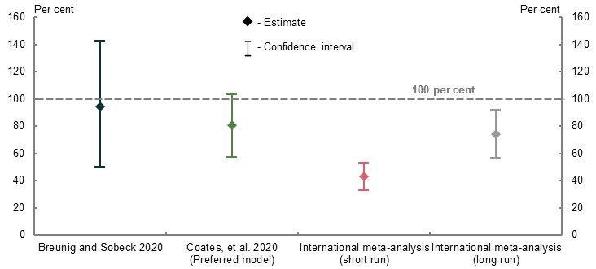
Note: 100 per cent implies all the costs of SG or mandated benefits changes are passed through as reductions in wages growth. Breunig and Sobeck’s (2020) estimate relates to the SG change for 2002-03. Coates, et al.’s (2020) estimate uses the authors’ preferred model. International meta-analysis of mandated benefits is based on 52 empirical studies looking at the incidence of labour taxes and social security contributions (Melguizo & González-Páramo, 2013). Source: Review analysis.
In addition to policy intent, the weight of evidence suggests the majority of increases in the SG come at the expense of growth in wages as outlined in detail in Appendix 6A. Detailed modelling methods and assumptions (Chart 2C-1). This result is consistent with the SG’s original policy purpose that it involved a trade-off between working life and retirement income:
‘A major challenge for retirement incomes policy is the need for current consumption to be deferred in favour of future income in retirement … Real take home pay will increase but at a correspondingly lower rate than would otherwise be the case.’ (Dawkins, 1992, pp. 17,40)
The relationship between SG rate increases and wages growth is supported by two micro-econometric studies, which use different data sources and approaches:
- Breunig and Sobeck (2020) found that changes to the SG causally lower wages growth, with a pass-through of close to 100 per cent. This study used an extensive dataset of linked taxpayer records that has only recently become available to researchers (see Appendix 6C. Outcomes of research).
- Another study found that about 80 per cent of SG increases is passed to workers through lower wage growth over a two- to three-year period (Coates, et al., 2020). This study analysed data on federal workplace agreements.
In contrast, work by Taylor (2019) and Stanford (2019) using macro-econometric approaches, found no significant pass-through of SG costs to wages. However, such approaches have difficulty estimating the long-run incidence of increases in the SG on wages (European Commission, 2015). Macroeconomic data relies on a limited number of observations and cannot identify drivers of the SG and wages relationship.
The assessments identifying a trade-off between the SG and wages growth are consistent with economic theory and international evidence of other benefits that employees receive on top of their take-home wages.
- Research shows the cost of ‘mandated benefits’ are more likely to be paid for by employees when, like compulsory superannuation, they provide strong, direct benefits (Melguizo & González-Páramo, 2013).
- Evidence across a number of countries supports this conclusion, suggesting that the trade-off is larger in the long run (Melguizo & González-Páramo, 2013). This research indicates that the costs to employees are higher for programs like superannuation where employees receive most of the benefits, but are lower for programs with weaker benefits.
Further analysis of the trade-off is in Appendix 6A. Detailed modelling methods and assumptions.

Measuring if living standards are maintained
Submissions proposed two ways of measuring adequacy: budget standards, which set a dollar value target; and replacement rates, which set targets based on working-life income. This section examines which of these is the appropriate metric for determining if the system appropriately maintains living standards in retirement.

Replacement rates
Replacement rates compare income in retirement with income while working. They are the main measure used by the OECD to assess the adequacy of retirement income systems (OECD, 2019b) and by reviews in other countries (Pensions Commission, 2004).
Replacement rates are a preferred metric because they provide adequacy targets based on the income a person earned while they were working (Chart 2C-2). Since replacement rates are a proportion of working-life income, changes in working-life income and retirement income both affect the measure. They can account for the trade-off required between working-life and retirement income. For this reason, replacement rates align with the view that the appropriate objective for adequacy in the retirement income system is maintaining living standards in retirement.
    - Projected target retirement income using replacement rates
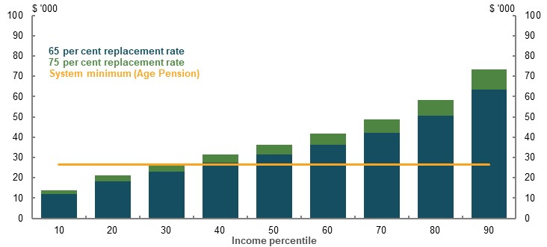
Note: Target retirement income is based on the average in the 10 years before retirement and ‘system minimum’ is the maximum Age Pension for singles. Uses the review’s adequacy benchmark replacement rate of 65-75 per cent. Deflated to 2019 dollars using wages. Source: Cameo modelling undertaken for the review.
Replacement rates do have some limitations. They are:
- Poorly suited to lower-income earners who need higher rates of replacement to avoid poverty. Replacement rates of 65 per cent, for example, would not be enough to prevent poverty for retirees at the bottom 20 per cent of the income distribution (Chart 2C-2). To address this issue, the first element of the adequacy objective of the retirement income system is that: ‘The system should ensure a minimum standard of living for retirees with limited financial means that is consistent with prevailing community standards’ (see 1C. The objective of the system and the roles of the pillars). This is provided through the Age Pension and other Government support. For some lower-income earners, the Age Pension results in them achieving replacement rates in retirement above 100 per cent.
- More difficult for people to understand than an income target (Rice Warner, 2019d). Discussing retirement targets in terms of a basket of goods or level of expenditure may be clearer to people planning their retirement. To address this issue, different tools can be used for advising individual consumers.

Budget standards
Budget standards estimate the cost of purchasing a basket of goods and services consistent with a given standard of living. Baskets of goods and services are usually constructed by analysing spending patterns of households with the relevant standard of living (Saunders & Bedford, 2017). While they are often used to estimate the income needed to avoid poverty (2A. Achieving a minimum standard of living in retirement), budget standards can also be set at higher levels for more aspirational targets.
The main benefit of budget standards is as a communication tool, helping people to plan for retirement and specifically budget for a certain living standard.
For assessing the adequacy of a retirement income system, budget standards have several weaknesses:
- They are designed for a specific cohort, in a specific location at a given point in time.
- They are subjective. A specific bundle of goods and services and the lifestyle it delivers may not be adequate or preferred for all groups.
- They do not measure the trade-off between retirement and working-life living standards. A retirement objective is not effective if achieving it requires inappropriate sacrifices during working life.
For example, the ‘comfortable’ retirement standard used by ASFA was originally designed for the top 20 per cent of income earners and exceeds the working-life living standards of 70 per cent of singles and 60 per cent of couples of working age (Chart 2C-3). ASFA’s modelling shows that middle-income earners would require significant sacrifices in working life to achieve the standard:
- A median earner starting work today would require an SG rate of 16.5 per cent to achieve the ASFA comfortable standard.
- A median-income male could only achieve the standard by working every year from age 19 to age 67. In 2018, less than half of men who had recently retired had careers of 48 years or more.
- Fewer women will achieve the standard given their lower incomes and shorter working lives (see Appendix 6A. Detailed modelling methods and assumptions).
While not appropriate as a universal target for middle-income earners, the ASFA comfortable standard may be of relevance for higher-income earners as this is the income group that the standard was originally based on.
    - Working-life annual expenditure compared with the ASFA standards
Singles | Couples
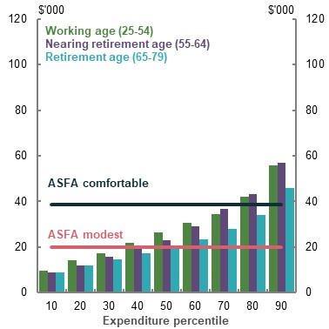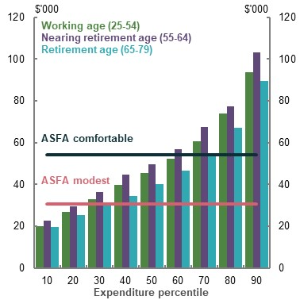
Note: Expenditure is equivalised except for partners because this spending is accounted for in their higher ASFA standard. ASFA standards are as at September 2015 to align with collection of expenditure data. Source: (Daley, et al., 2018b) based on analysis of Analysis of ABS Household Expenditure Survey Confidentialised Unit Record File, 2015-16.
Replacement rates are the preferred tool for assessing the objective of maintaining living standards in retirement. By definition, they compare income in working life and retirement, allowing for an assessment of whether the system is delivering the correct balance.

How the system maintains living standards
A retirement income system based on compulsory superannuation needs to deliver a default retirement income that is adequate for as many people as possible but does not force people to save too much in their working life.
Getting the balance right is difficult, requiring consideration of two dynamics:
- Middle-income earners are the primary target group for the default retirement income delivered by the combination of the Age Pension and the SG. Based on review projections, they will not be able to maintain their living standard in retirement by relying on the Age Pension alone, and they save for retirement mainly through compulsory superannuation (aside from their home). Lower-income earners can maintain (if not improve) their retirement living standards through the Age Pension alone. Higher-income earners are more likely to accumulate sufficient wealth through superannuation and other voluntary saving to meet their income needs in retirement.
- Universal policy settings under the Age Pension and SG are asymmetric. If default saving is too low, people can save more voluntarily; if too high, it can be hard for people to save less (Figure 2C-1). This highlights the importance of balance when setting the default level of retirement income. People with lower incomes are particularly vulnerable to compulsory savings rates set too high. These groups tend not to save voluntarily. They have limited flexibility to reduce other savings in response to higher default savings levels (see 5A. Cohesion).
        - Illustrative example of asymmetry of retirement income system policy setting
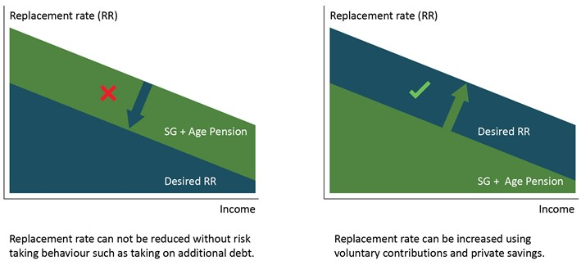
Lower-income earners are defined as those in the bottom 30 per cent of all earners, higher-income earners are in the top 20 per cent and middle-income earners are those in between. This section examines the retirement outcomes for these income groups. It uses projections based on cameo modelling under current policy settings, including legislated incremental increases in the SG rate to 12 per cent.

Lower-income earners
For lower-income earners, the Age Pension alone will maintain living standards in retirement for incomes up to the 30th percentile, with the 40th percentile marginally below the replacement rate benchmark (Chart 2C-4). The Age Pension either maintains or increases retirement living standards for groups with little or no labour market participation.
    - Projected income replacement delivered by the Age Pension alone
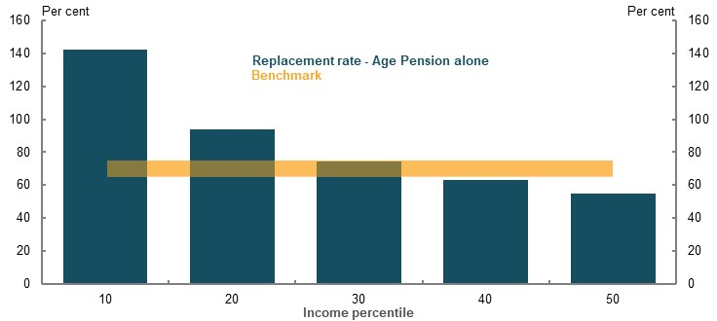
Note: Assumes only source of retirement income is the Age Pension. Source: Cameo modelling undertaken for the review.
Many lower-income earners make SG contributions. These savings supplement the Age Pension and are important for giving lower-income earners access to a lump sum of assets in retirement.
Lower-income earners make limited voluntary savings and are the least likely to own their home. They may need further support to maintain a minimum standard of living in retirement.
Given living standards in retirement are higher than in working life for many lower-income earners, this group would benefit from prudent early release of their superannuation to cover certain financial stresses. For example, those caused by periods of unemployment, illness, or for large and unexpected expenses.

Middle-income earners
Middle-income earners require a combination of superannuation, voluntary savings and the Age Pension to maintain their living standards in retirement. Their main voluntary saving is through buying a home. Home ownership rates for middle wealth retirees currently exceed 95 per cent, although rates of home ownership are declining (see 1D. The changing Australian landscape).
While the Age Pension alone is not sufficient to maintain the standard of living of middle-income earners in retirement, it does play a significant role in supplementing the retirement incomes of this group. In a mature system, middle-income earners are still expected to rely on some level of the Age Pension for much of their retirement, particularly in older ages as they draw down other assets (Chart 2C-5).
Middle-income earners have modest voluntarily savings or wealth outside of their home (1B. Design of Australia’s retirement income system). As the SG matures, this should significantly boost the non-housing wealth of this group.
Compulsory superannuation contributions are important for middle-income earners. The SG is necessary to help this group achieve adequate retirement outcomes.
    - Projected retirement income by source, median-income earner
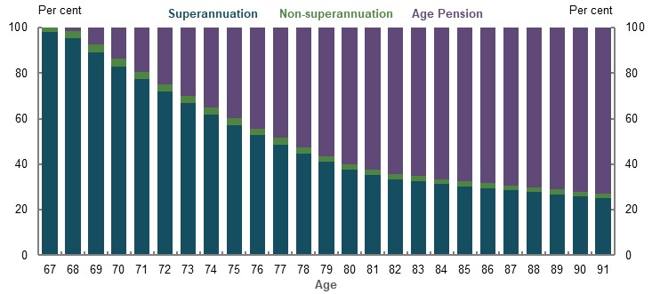
Source: Cameo modelling undertaken for the review.

Higher-income earners
Higher-income earners will generally not receive the Age Pension until late in their retirement due to the means test. They rely on the SG and voluntary contributions (including the home and other savings) for their retirement income.
Higher-income earners are more likely to make voluntary savings. Their saving rates are higher than other income groups (Chart 2C-6) and their financial literacy levels tend to be higher (Productivity Commission, 2018a). These outcomes suggest higher-income earners are better able to save for retirement without the need to rely solely on compulsory SG compared with other groups. For example, of people aged 55 with superannuation balances at the 80th percentile, 68 per cent contributed voluntarily in at least four out of eight years.
Higher-income earners are expected to have significantly higher retirement incomes than other groups. For example, the average retirement income for an 80th percentile income earner retiring in 2060 is projected to be 25 per cent higher than the median retiree and above the ASFA comfortable standard.
    - Proportion of 55-year-olds in 2010 that made a voluntary superannuation contribution over an eight-year period
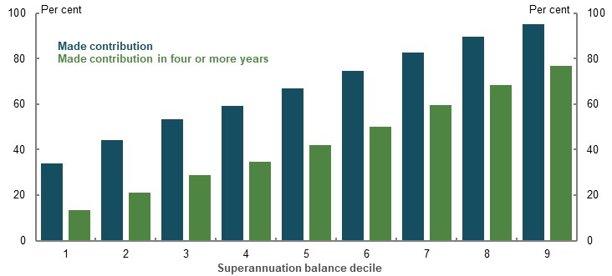
Note: Data follows a cohort who were aged 55 in 2010 over an eight-year period. Average includes men and women. Includes all voluntary contributions to superannuation. Deciles refer to superannuation balance as at 2010. Source: ATO Longitudinal Information Files (ALife), 2020.

Income needs in retirement
The adequacy of retirement incomes depends on what retirees need to spend to maintain their living standards in retirement. Estimating this has two components:
- The proportion of working-life income needed in retirement.
- How this income needs to grow during retirement.

The proportion of working-life income needed in retirement
A replacement rate benchmark of 65-75 per cent of disposable income has been used to measure the adequacy of retirement incomes. Using a range rather than a single number avoids false precision. It also reflects that no one level of retirement income is appropriate for all retirees.
Evidence suggests 65-75 per cent of working-life income will allow most retirees to maintain their standards of living in retirement. This benchmark:
- Is consistent with most industry and international benchmarks. Typical benchmarks vary from 50-85 per cent, with 70 per cent being the most common.
- Matches the share of income people spend during their working lives, excluding costs that are unlikely to be present in retirement.
- Is slightly higher than the actual replacement rates achieved by current retirees, who generally achieved adequate retirement outcomes (see Assessing outcomes for recent retirees, below).
- Reflects that future retirees will spend more of their working-life income on housing (see 1D. The changing Australian landscape). Consequently, future retirees will have reduced working-life incomes after housing costs, requiring a downward adjustment from the standard 70 per cent replacement rate benchmark, which is based on historical housing costs.
A 65-75 per cent replacement benchmark is broadly applicable for a wide group of retirees, especially middle-income earners. Nevertheless, this replacement rate range may not be appropriate for some retirees:
- Renters require higher replacement rates than most home owners because they have higher housing costs in retirement. Accounting for these costs, an appropriate benchmark for renting retirees is around 90 to 100 per cent.
- Higher-income earners save significantly more than lower- to middle-income earners and achieve higher retirement incomes. They are likely to maintain their living standard with replacement rates 10 to 20 percentage points lower than middle-income retirees.
- Lower-income earners need higher replacement rates than the benchmark to achieve a minimum standard of living in retirement. (See 2A. Achieving a minimum standard of living in retirement).
See Appendix 6A. Detailed modelling methods and assumptions for further research on the appropriate replacement rate benchmark.

How to assess replacement rate outcomes
A well-functioning system should aim for average-income earners with typical working lives to achieve replacement rates within the benchmark. Missing the benchmark in either direction implies the system is not correctly balancing incomes between working lives and retirement.
- Replacement rates below the benchmark mean retirees will experience a drop in their living standards when they reach retirement, which would be a poor outcome for lifetime wellbeing. Falling below the benchmark is more concerning than exceeding the benchmark. People tend to be loss averse, meaning negative shocks have a particularly large impact on wellbeing (Tversky & Kahneman, 1992).
- Replacement rates above the benchmark imply retirees may be better off with more income available to them during their working lives. Exceeding the benchmark means lower spending and wellbeing during around 40 years of working life. Where possible, a system based on compulsory superannuation contributions should prevent unnecessary reductions to spending in working life.
Universal policy settings (the Age Pension and the SG) mean the system cannot deliver perfect outcomes for all incomes groups and personal circumstances. Some differences in replacement rates between groups are unavoidable.

How spending needs grow in retirement
The rate of growth of spending in retirement is important in determining whether retirees’ income is adequate for all their retirement years. Domestic and international evidence points to retirees’ spending needs growing in line with prices.
On this basis, retirement income projections in the review have been deflated by the CPI. The outcomes are significantly different if retirement incomes are deflated by assumed growth in wages (Chart 2C-7).
    - Wage versus price growth in retirement, median retiree
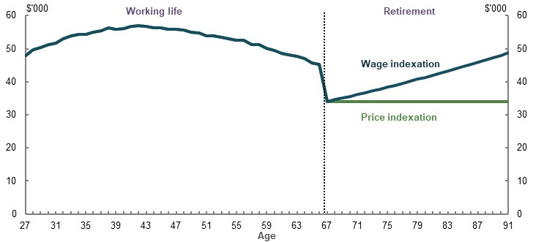
Note: Values are in 2019-20 dollars. Assumes retirement at 67. Working-life income is deflated by average weekly earnings. Replacement rate is in the middle of the 65-75 per cent benchmark. Source: Cameo modelling undertaken for the review.

Wage growth in retirement
Proponents of wage-linked growth for retirement incomes argue that adequacy should be measured relative to prevailing living standards. Under this view, growing retirement incomes using prices is problematic because of the significant changes to society’s living standards over long timeframes.
An argument sometimes raised in favour of wage-linked growth is that, because the Australian Government indexes public pensions to wages, all retirement income should be assessed on this basis (Industry Super Australia, 2020, p. 347). But the goal of helping people to maintain their living standards in retirement is different from the goal of delivering a minimum standard of living in retirement for people with limited financial means.
A minimum standard of living is a society-wide goal that no retiree should fall below and the minimum standard is set in line with prevailing community standards. This is achieved by benchmarking Age Pension to wages. In contrast, maintaining living standards in retirement is an individual-level goal, where a person aims to have a similar standard of living both pre- and post- retirement.
Basing replacement rates on wage-linked spending growth in retirement, would require a level of saving that comes at a significant cost to working-life living standards. Because of this trade-off, a system should only deliver higher spending growth if that is the preference of retirees.

Price growth in retirement
Spending in retirement that grows with prices is consistent with people having a similar standard of living in their retirement as they had in their working life.
The evidence that points to retiree spending needs rising with prices includes:
- Spending tends to fall or remain flat as people age. This pattern holds across multiple generations of retirees and is consistent with other research (CEPAR, 2020).
- Spending falls or remains flat even among higher-wealth retirees, suggesting falls in spending are due to preferences not budget constraints. Current retirees in the top 20 per cent will have a similar amount of assets to a median retiree in a mature system, suggesting they could behave in a similar way.
- Health costs in retirement increase but not enough to increase overall spending. Health expenses increase as people age but government transfers in Australia limit out-of-pocket costs. A prominent US study appeared to contradict falling expenditure by showing U-shaped expenditure patterns, under very different health policy settings compared with Australia. Yet results still showed real consumption falls at older ages, just not as fast as declines in the real spending in the middle of retirement (Blanchett, 2014).
- Most OECD countries with comparable schemes index to prices. Almost two-thirds of OECD countries index their retirement incomes predominantly to prices.
- Most financial products available to Australian retirees are indexed to prices.
See Appendix 6A. Detailed modelling methods and assumptions for further discussion of spending needs for retirees.
Using the measure of retirement incomes growing in line with prices does not mean future cohorts of retirees miss out on improvements in standards of living. Modelling by Treasury and Rice Warner shows that superannuation balances for successive cohorts of retirees will grow faster than wages. Combined with the Age Pension being indexed to wages, retirement incomes for successive cohorts of retirees will rise with living standards.
Evidence suggests that retirement incomes growing by prices does not increase financial stress. Older retirees have maintained their spending in real terms throughout retirement, despite their incomes growing significantly faster (see Appendix 6A. Detailed modelling methods and assumptions). These older retirees have the lowest rates of financial stress of any group of retirees (see 2A. Achieving a minimum standard of living in retirement).

Assessing outcomes for recent retirees
Traditionally, retirement income modelling has used long-term models to project outcomes for people starting work today and retiring in 40 or so years. Relying solely on this approach has limitations, as results depend on assumptions. In addition to projecting future retirement incomes, the adequacy of retirement outcomes for current retirees have also been assessed using two approaches:
- Income survey data to estimate replacement rates of recent retirees.
- Qualitative surveys on the impact of retirement on general and financial wellbeing.
Future reviews of the retirement income system will be able to use data-based approaches to assess retirement outcomes as superannuation matures and datasets improve.
Although outcomes for current retirees reflect previous policy settings and are affected by data limitations, they provide useful insights into retirement adequacy. With a maturing superannuation system, future retirement outcomes should generally improve compared with outcomes for current retirees. These outcomes also reflect the circumstances of retirees at a specific point in time and do not include the impact of the COVID-19 Pandemic.

Replacement rates for recent retirees
The outcomes for recent retirees can provide an indication of the performance of the retirement income system under past policy settings. Yet due to data limitations, replacement rates for recent retirees are difficult to calculate and should be considered indicative only.
Replacement rates for people born from 1943-1952 have been calculated by comparing retirement incomes for those aged 65-74 in 2017-18, with working-life income for those aged 55-64 in 2007-08. The estimates suggest that middle- to higher-income households (those in the 40th percentile and above) have replacement rates around 65 per cent or higher (Chart 2C-8). Lower-income earners have replacement rates around 100 per cent.
This analysis is informative for the outcomes of existing retirees but has significant limitations. It compares a cohort of people, rather than specific people before and after their retirement. In addition, members of the household may have already retired by age 55 to 64 or may still be working past age 65, which could create an upward bias in the estimates.
    - Replacement rates for households aged 65-74 in 2017-18
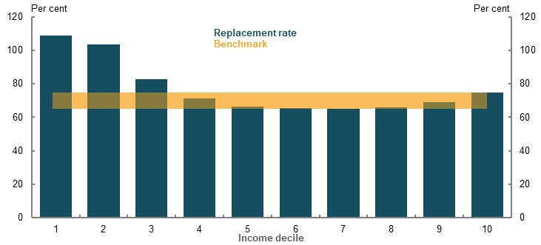
Note: Uses a cohort methodology where households aged 55-64 surveyed in 2007-08 are compared with households aged 65-74 surveyed in 2017-18. This will not be the same household but is broadly indicative given the household belongs to the same age cohort. This approach may include some people who are retired but aged 55-64 and not retired aged 65-74. Incomes from 2007-08 have been inflated using wages, consistent with the review’s mixed deflator methodology. The income measure is equivalised disposable household income, which includes actual drawdowns from superannuation. Source: Analysis of ABS Survey of Income and Housing Confidentialised Unit Record File, 2007-08 and 2017-18.
An alternative approach to calculating replacement rates of recent retirees using HILDA data shows broadly comparable results (see Appendix 6A. Detailed modelling methods and assumptions).
While the longitudinal approach better reflects the experience of people who retire, it also has data limitations. The number of years available and sample size of the HILDA Survey means that calculations are based on a small number of years before and after retirement. Longer periods would have been more accurate as they are less affected by events like transitioning to retirement or uneven drawdown of superannuation. Longitudinal surveys are also affected by people dropping out of the survey, and this could also bias results.

Qualitative surveys on retirement outcomes
Wellbeing surveys can also help to assess whether retirees maintain their standard of living in retirement, tracking self-assessed levels of general and financial satisfaction. Such surveys provide explicit feedback on how wellbeing changes due to retirement. However, responses are subjective and can be sensitive to how questions are asked. These surveys were conducted prior to the COVID-19 Pandemic and, just as the uncertainty associated from the Pandemic is impacting on all aspects of society, it will also be influencing current retirees’ perceptions around the adequacy of their retirement incomes.
Surveys undertaken prior to the COVID-19 Pandemic suggest that most people maintain or improve their wellbeing in retirement:
- General wellbeing. Most retirees feel happier in retirement, more satisfied with their lives and do better than working-age people in wellbeing indices.
- Financial wellbeing. On average, retirees assess themselves as at least as well-off financially as they were during working life. Multiple financial wellbeing indices suggest retirees are the most financially secure age group. Surveys tend to show most retirees either maintain or improve their financial security in retirement. That said, some groups suffer a loss of financial wellbeing, particularly if they retire early for reasons outside their control.

General wellbeing
HILDA data shows that people mostly feel happier when they retire: 62 per cent of surveyed retirees reported their level of happiness was ‘better’ or ‘much better’ in retirement, while only 5 per cent said they felt ‘worse’ or ‘much worse’ (Chart 2C-9).
    - Happiness in retirement compared to when working
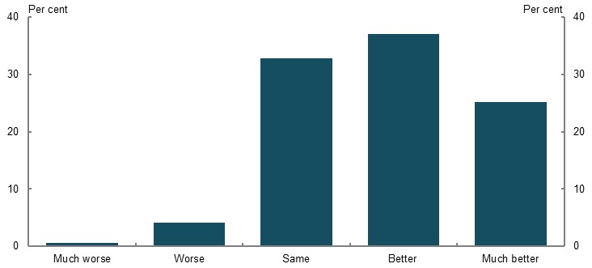
Note: Proportion of responses to ‘Better or worse since you retired — your overall happiness?’ last asked in 2015. Source: Analysis of HILDA Survey data (Wave 15).
Health and disability issues, which tend to worsen with age, may be a significant driver for those who experience worse wellbeing outcomes in retirement. For example, about half of Australians over 65 have a disability (ABS, 2019g). The Australian Unity wellbeing index also shows better life satisfaction and higher personal wellbeing for retirees in all categories except health (Khor, et al., 2019).

Financial wellbeing
Australians who recently retired are generally financially satisfied: 88 per cent were satisfied with, or neutral about, their financial circumstances (Chart 2C-10). A major drive of dissatisfaction appears to be due to renting in retirement (see 2A: Achieving a minimum standard of living in retirement).
In general, rates of financial satisfaction tend to improve as Australians age. Satisfaction is lowest for households in their 40s and then consistently increases with age from 50 onwards (Australian Centre for Financial Studies, 2016, p. 19).
    - Financial satisfaction among recent retirees
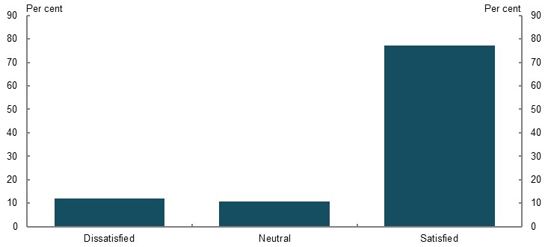
Note: Recent retirees refers to people who retired in the five years up to 2018. ‘Satisfied’ refers to retirees who reported a financial satisfaction score of 6 or greater in 2018, ‘Neutral’ is a score of 5 and ‘Dissatisfied’ is 4 or less. Source: Analysis of HILDA Survey data (Wave 18).
Multiple surveys suggest retirees tend to be more financially comfortable compared with working-age people. More retirees say they have enough money to do the things they want compared with non-retired people (Core Data, 2020). Survey data from Core Data indicates about half of Australian retirees have enough money to do the things they want to do most or all of the time compared with a third of non-retired Australians aged 45 and above. A substantial proportion of retirees, about 30 per cent, rarely or never have enough money to do the things they want. This is about 8 per cent lower than the same figure for non-retirees.
In a 2019 survey of almost 700 retirees, 67 per cent said they were either comfortable or were able to afford basic expenses, with a little left over for extras. For Australians aged over 40 but yet to retire, 52 per cent believe they would be able to do so.
Survey data from Susan Bell Research (2020) found similar results regarding financial comfort: 62 per cent of retirees had spare cash or were comfortable; 38 per cent described their circumstances as not making ends meet or on a very tight budget.
A qualitative 2019 study conducted by Challenger on behalf of National Seniors Australia found that most people considered themselves financially comfortable in retirement (McCallum, et al., 2019).
Financial wellbeing indices also point to improved levels of wellbeing as people age.
- ANZ’s financial wellbeing index suggests that Australians of retirement age are better off financially than young and middle-aged people in all the categories they measure (Russell, et al., 2018). Australians aged 65 and over had a financial wellbeing score of 71 versus 59 for people across all age categories.
- A recent survey by ME Bank found that retirees are the most well-off cohort in terms of financial wellbeing (ME Bank, 2020). This result has been consistent over the past seven years.
Most retirees maintain their level of financial comfort when they enter retirement, with 51 per cent reporting a level of financial comfort equal to before they retired (Chart 2C-11). About 26 per cent say their financial security is worse or much worse than it was before retirement. A significant portion of this is explained by involuntary retirement: 34 per cent of people who retired involuntarily said their financial security had declined (see 3E. Age of Retirement for further details).
    - Perceived change in financial security after retiring
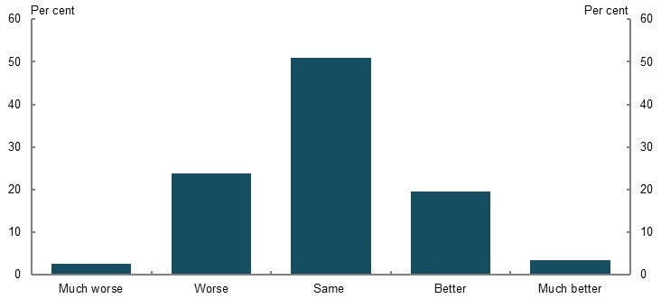
Note: Proportion of responses to ‘Better or worse since you retired — your financial security?’ last asked in 2015. Source: Analysis of HILDA Survey data (Wave 15).
Financial stress rates stay broadly constant throughout working life when comparing employed Australians with retirees (Chart 2C-12). Comparing retirees to employed people, rather than all Australians, is a better comparison for assessing whether living standards are being maintained (CEPAR, 2020, p. 8). Unemployed Australians typically experience improved wellbeing in retirement as the Age Pension provides more support than they received in working life (See 2A. Achieving a minimum standard of living in retirement).
    - Financial stress rate by age and employment status
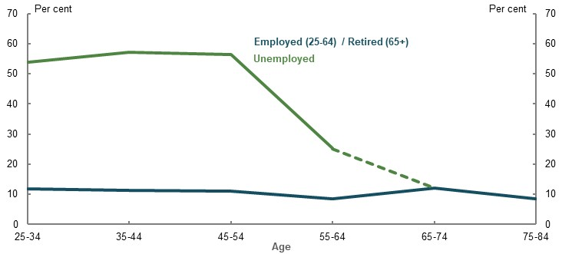
Note: All people age 65 and above classified as retired. Source: Analysis of ABS Survey of Income and Housing Confidentialised Unit Record File, 2017-18.

Early release of superannuation
The SG and superannuation tax concessions are designed to encourage people to save for their retirement. Similarly, superannuation benefits are generally preserved to provide income in retirement. But some people experience adverse events during their working lives that are difficult to foresee. Examples include unemployment, illness and unexpected large expenses.
A range of government programs assist with some of these adverse events. For example, JobSeeker Allowance provides income support for people who are unemployed and the public health system provides free health care.
People facing genuine hardship may also be able to access their superannuation before preservation age. Early release of superannuation recognises that, in some individual circumstances, the benefits of early access to superannuation will exceed the benefits of preserving balances until retirement. This is consistent with the approach that saving for retirement should not come at an excessive cost to people’s standard of living in working life, which is particularly relevant when people do not have the option to reduce their compulsory superannuation savings.
Five sets of circumstances are recognised as compassionate grounds for early release:
- Medical treatment and medical transport
- To prevent foreclosure or forced sale of home
- Modifying a home or vehicle or buying disability aids for a severe disability
- Palliative care
- Funeral expenses
Early release is also allowed on severe financial hardship grounds if a person has received qualifying Commonwealth income support payments for 26 continuous weeks and they are not able to meet reasonable and immediate family living expenses.
Accessing superannuation early has a more significant effect on superannuation balances for younger age groups due to the loss of compound returns. Although, the Age Pension ameliorates some of this effect on retirement income, particularly for the median-income earner.
For example, a person withdrawing $10,000 in two consecutive years from age 30 would lower their superannuation at retirement by $40,300 in wage-adjusted terms. The same withdrawals at age 55 would lower their superannuation balance at retirement by $24,600 (Table 2C-1).
      - Projected effect on retirement incomes of early release of superannuation, median earner retiring in 2060
Age | Early release amount ($)* | Change in superannuation balance at retirement  ($, deflated by average weekly earnings) | Change in superannuation balance at retirement  ($, deflated by CPI) | Change in retirement income (per cent)
30 | 20,000 | -40,300 | -69,300 | -2.1
35 | 20,000 | -36,300 | -62,500 | -1.9
40 | 20,000 | -33,000 | -56,700 | -1.7
45 | 20,000 | -29,900 | -51,400 | -1.7
50 | 20,000 | -27,100 | -46,600 | -1.4
55 | 20,000 | -24,600 | -42,200 | -1.2
Note: Values are in 2018-19 dollars. $20,000 early release is split between two financial years, with $10,000 withdrawn in each year. Individuals commence work in 2020 at age 27 and draw down super at specified ages. Results are rounded to the nearest $100. CPI-deflated results are presented for comparative purposes. The amount drawn down early is indexed to average weekly earnings. *Withdrawal amounts are indexed to average weekly earnings meaning more than $20,000 is withdrawn in CPI-deflated terms for later ages and impact on balances at retirement is larger as a result. Source: Cameo modelling undertaken for the review.
Recognising the unprecedented nature of the COVID-19 Pandemic on the economy and on people’s incomes, the Government allowed early release of up to $20,000 of superannuation (up to $10,000 prior to July 2020 and up to a further $10,000 from 1 July until 24 September in 2020). People requesting early release of their superannuation aligned with the age groups most affected by unemployment in the early months of the COVID-19 Pandemic (Chart 2C-13).
    - Comparison of utilisation of COVID-19 Pandemic early release of superannuation with the share of newly unemployed people, by age
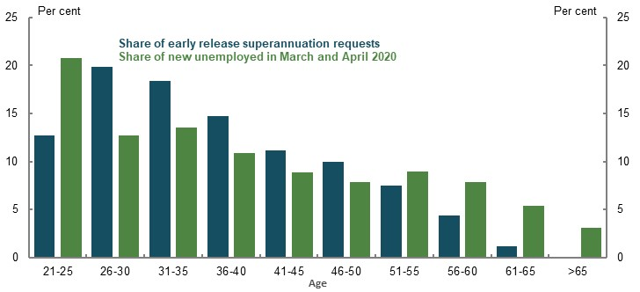
Note: Share of people applying for COVID-19 early release of superannuation who were aged 20 or over as at 11 May 2020, share of new unemployed in March and April 2020 who are aged 21 or over. Age brackets shown on the chart are for the share of early release of superannuation. Age brackets for the share of new unemployed are five-year brackets starting from age 20 (rather than 21). Source: (ABS, 2020i) and (Senate Standing Committee on COVID-19, 2020).
Other circumstances that might justify the early release of superannuation were considered as part of the Review of the early release of superannuation benefits (The Treasury, 2018c). Examples explored included paying rental arrears (as opposed to mortgage arrears) and situations of family or domestic violence.
Some countries have a more open approach to early access to retirement savings. For example, in the US there is an option to access retirement funds early without any assessment of need, but the funds released are taxed as income at marginal rates plus a 10 per cent penalty.
Offering prudent and limited access to superannuation prior to retirement is consistent with the objective of balancing living standards pre- and post-retirement. Early access allows the system to respond to financial pressures people may face while still facilitating saving for retirement. Equally, superannuation is not intended to solve every financial problem experienced in working life. Shifting the balance too far in that direction would compromise its main objective of providing retirement income.

Assessing outcomes for future retirees
Future outcome for retirees were modelled to assess whether the retirement income system is on track to deliver adequate outcomes.

How cameo modelling works

The cameo model
A hypothetical lifetime cameo retirement income model was used to measure retirement outcomes. The model incorporates current policy settings, including the legislated increase in the SG rate to 12 per cent.
The model simulates the income of hypothetical individuals or couples starting work today for each year of their working life and retirement (see Appendix 6A. Detailed modelling methods and assumptions). Income earned each year is the average for employees adjusted for age and a person’s point in the income distribution. Based on their age and income, people save over their working life to both superannuation and private savings. Upon retiring, they draw down these assets and could be eligible for the Age Pension.
The model used has been adapted from Treasury’s Excel Model of Retirement Incomes (EMORI). EMORI was extended, including by building in new data and assumptions and expanding the functionality for sensitivity analysis (see Appendix 6A. Detailed modelling methods and assumptions).
Model results were tested to ensure they capture how typical Australians save for retirement. This testing shows the model produces similar superannuation balances to people who are currently working and superannuation balances at retirement that are similar to other long-term models (see Appendix 6A. Detailed modelling methods and assumptions).

Groups analysed
The cameo modelling covered a representative range of Australians. The central case covered people with typical working lives and analysed outcomes for individuals, couples and women. Analysis was also conducted for multiple household types, including singles, couples and women.
Significant sensitivity testing was conducted as no one set of assumptions can cover Australia’s diverse population. Where possible, these sensitivity tests were informed by the actual distribution of outcomes in the population.
The cameo modelling does not include some segments of the population, such as:
- Individuals with little or no wage income. For example, people with marginal attachment to the workforce or with a disability that limits their ability to work. Data from the Department of Social Services Priority Investment Approach to Welfare Actuarial Modelling shows that around 10 per cent of the population do not work much for at least 15 years prior to retirement (Appendix 6A. Detailed modelling methods and assumptions). Assessment of adequacy outcomes compared to a minimum standard is more appropriate for this group.
- People in self-employment. Significantly different SG rules apply to people in non-standard employment. See 3D. SG coverage for a detailed explanation of the complex issues surrounding the retirement outcomes for self-employed people.

Assumptions
All retirement income models use assumptions to project future outcomes. The assumptions used in the modelling in this review are evidence-based, use leading data sources and align with the intent of government policy.
Consistent with the policy intent that superannuation is to provide income in retirement, the modelling assumes retirees use all their superannuation assets to support their living standards in retirement. This assumption shows what the system is able to deliver under current policy settings and recognises efforts to develop appropriate products to assist people to draw down their assets in retirement. The assumption that people use their assets is frequently used in retirement modelling including in Australia’s Future Tax System Review, and submissions to the review from the superannuation industry and other stakeholders. Most retirees, however, do not efficiently use their assets in retirement. This is discussed in 5A. Cohesion.
Major assumptions for the central case and associated sensitivity analysis are included below (Table 2C-2). In addition to the assumption that retirees draw down their superannuation in retirement, two other assumptions that have a big impact on replacement rates are:
- How spending needs grow in retirement (see How spending needs grow in retirement, above).
- Whether individuals retire before or after preservation age (see Years in the workforce, below).
See the Appendix 6A. Detailed modelling methods and assumptions for further details of evidence behind the assumptions.
      - Major central case modelling assumptions
Assumption | Central case | Basis | Sensitivity testing
Life expectancy | 92 years | Projections from 2015 Intergenerational Report (IGR) | Longer life expectancy
Length of working life | 40 years | Median in HILDA, checked against labour force trends and MARIA modelling. | Testing of different career lengths, checked against careers of retirees today.
Incomes | By age and income | Tax return data | N.A.
Nominal wages growth | MYEFO 2019-20 for forward estimates  Long run ~4%ⁱ | Projections from IGR 2015; average weekly ordinary time earnings growth averaged 4% over past 20 years | 0.5% lower
Investment returns (before fees and taxes) | 7.5% Accumulation phase  6.2% Retirement phase | Forward-looking investment return targets | Higher/lower investment returns
Voluntary superannuation contributions | Salary sacrifice contributions only | ATO income and tax data | No voluntary saving
Superannuation drawdowns | Optimal draw down to exhaust at life expectancy | Aligns with system purpose | Minimum and observed drawdown rates
Management of longevity risk | Purchase of a deferred pooled longevity product | Aligns with system direction | No longevity protection  Different pricing
Replacement rate calculation | Average annual whole of retirement disposable income divided by average annual disposable income 10 years before retirementⁱⁱ | Analysis of spending needs | Alternative deflators and calculation periods
Home ownership | Home owner | Home ownership rates for middle and higher-wealth retirees exceed 95 per cent | Renter
Note: Central case assumptions for review modelling. Particular settings or sensitivities are analysed as deviations from the central case. ⁱLong-run inflation of 2.5 per cent and productivity growth of 1.5 per cent gives nominal wages growth just over 4 per cent. See (Commonwealth of Australia, 2015). ⁱⁱReplacement rates are deflated using the review’s mixed deflator.

Adequacy for future retirees

Replacement rates
Replacement rates are projected to exceed or meet the 65-75 per cent benchmark for all income levels when considering employees regardless of relationship status or gender (Chart 2C-14). This widely used approach is representative, capturing the broadest population. It does not factor in the circumstances of specific groups, such as women and couples, which are covered in modelling of other household types below.
Modelling shows that people with incomes in the 60th percentile and below exceed the replacement rate benchmark, largely due to them receiving the Age Pension and income through the SG. This suggests the system may be leading people in the bottom half of the distribution to over-save for retirement.
Superannuation is projected to be a main source of income for median-income earners and above. Drawing down superannuation assets efficiently is critical for these groups to achieve replacement rate benchmarks. Non-superannuation assets are a large proportion of incomes for the 90th percentile and above.
The Age Pension is projected to contribute to retirement incomes for most income levels. Lower- and middle-income earners will receive a large proportion of their retirement income from the Age Pension.
    - Projection of replacement rates
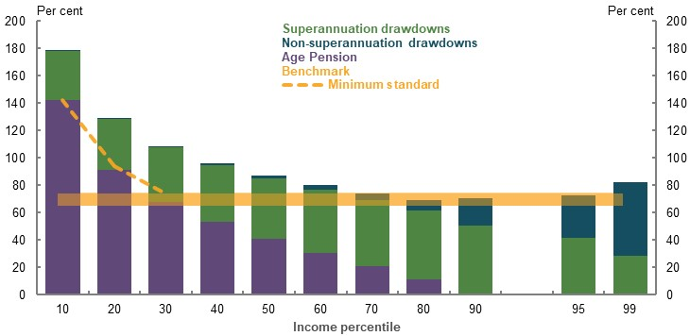
Note: Minimum standard is the maximum rate of Age Pension. Based on all-employees model. Replacement rates are projected for individuals commencing work in 2020 and retiring in 2060. Source: Cameo modelling undertaken for the review.

Replacement rates for couples
Outcomes were also modelled for couples, given their careers, savings patterns and Age Pension rules differ from singles. Outcomes are broadly similar for couples and individuals, with some differences.
The couples model captures the circumstances of people in a relationship while in retirement. Around 70 per cent of people are part of a couple at the start of retirement, although this proportion declines with age.
Couples in the central scenario are projected to exceed or meet the replacement rate benchmark across all income levels (Chart 2C-15). Outcomes tend to be lower than those for individuals, with less over-saving for some middle-income earners.
Drivers of differences between couples and other households include:
- Couples have higher incomes on average than an individual at an equivalent point in the individual income distribution (see Appendix 6A. Detailed modelling methods and assumptions)
- The couple rate of the Age Pension is less than double that for singles, meaning it makes up a smaller proportion of retirement income for couples than for individuals with similar means
- Couples have higher savings than singles at an equivalent point in the income distribution. This includes higher concessional contributions and higher savings outside of superannuation
    - Replacement rates for couples by income source
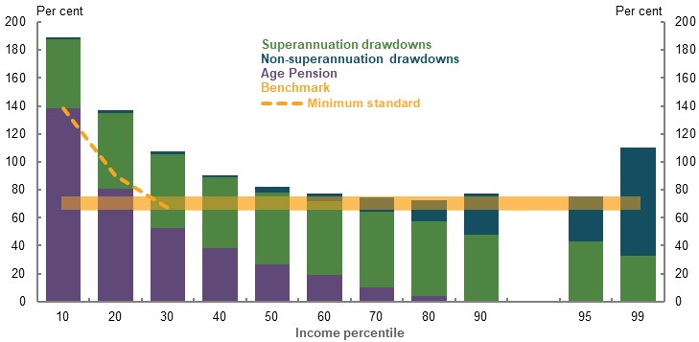
Note: Minimum standard is the maximum rate of Age Pension. Replacement rates are projected for couples commencing work in 2020 and retiring in 2060. Source: Cameo modelling undertaken for the review.

Replacement rates for women
A specific cameo model was developed for women, adjusting the default assumptions to reflect a shorter working life (38 years instead of 40), generally lower female wages, differences in rates of voluntary savings and different life expectancy (see Appendix 6A. Detailed modelling methods and assumptions).
Women have, on average, replacement rates above the benchmark across all income percentiles (Chart 2C-16). This result is due to:
- Women’s lower working-life incomes and superannuation balances mean the Age Pension replaces a larger proportion of their working-life income than for men.
  - Due to lower incomes and lower rates of workforce participation, women also benefit relatively less from the SG. For example, the increase in the SG rate to 12 per cent is expected to benefit men more than women and not reduce the gender gap in retirement incomes (see 3B. Gender and partnered status and 2D. Policy scenario: Implications of maintaining the SG rate).
- Women having relatively higher voluntary savings rates. On average, women make higher voluntary contributions to superannuation as a proportion of their incomes than men.
  - For women, voluntary contributions are largely made by those with higher balances, or those partnered to people with higher balances (see Appendix 6D. Supplementary equity charts).
  - The main form of voluntary savings for women is through non-concessional contributions and is not included in this modelling.
Higher replacement rates do not mean women have better outcomes than men in retirement, as their total retirement incomes are lower, given lower working-life incomes. Differences in retirement outcomes by gender are discussed in 3B. Gender and partnered status.
    - Replacement rates for women by income source
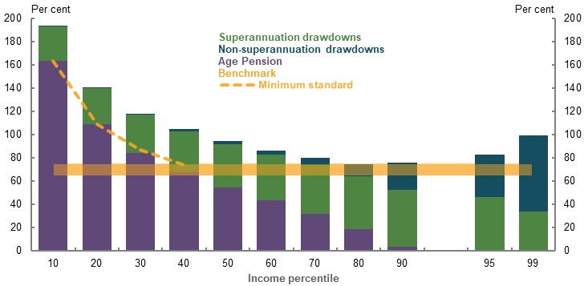
Note: Minimum standard is the maximum rate of Age Pension. Replacement rates are projected for women retiring 40 years after starting work with a two-year career break. Source: Cameo modelling undertaken for the review.
          - Options to boost adequacy
Drawing down assets efficiently is crucial for many retirees to be able to maintain their living standards in retirement. Moreover, using assets more efficiently can boost retirement incomes without the need to save more during working life.
Fully using superannuation assets
Whether retirees draw down at minimum rates or effectively use their superannuation is critical for adequacy outcomes (Chart 2C-18). Middle-income earners in the 60th and 70th percentiles have replacement rates below the benchmark if they draw down their superannuation at the statutory minimum rates.
More than half of retirees older than 65 currently draw down at the minimum rate (Rice Warner, 2019b), although retirees who do not use minimums draw down at faster rates, such as about 10 per cent a year for members aged 65-79 (First State Super, 2020b). Longevity products can help protect retirees from the risk of outliving their assets, but their take-up is low (see 5A. Cohesion).
The purpose of superannuation is to provide income in retirement. Drawing down superannuation assets throughout retirement is consistent with its policy purpose. Superannuation is not intended to provide significant bequests through a concessionally taxed environment. However, most retirees currently leave the bulk of their wealth as a bequest (see 5A. Cohesion).
    - Projected superannuation bequests at age 92; different drawdown rates
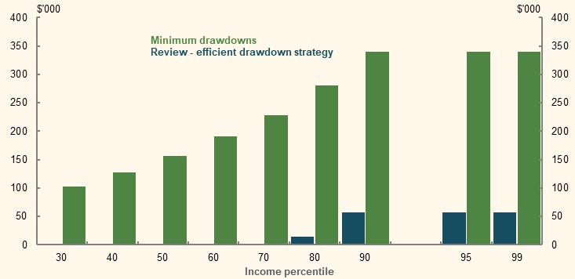
Note: Bequests estimated based on remaining superannuation balance at life expectancy. Bequests do not include non-super assets. Values are in 2019-20 dollars, deflated using the review’s mixed deflator. Minimum drawdown rates are consistent with legislated minimums by age. Minimum drawdown rate scenario does not include purchase of a longevity product. Review drawdowns exhausts superannuation balance at age 92 (with longevity protection) except for higher-income earners. Source: Cameo modelling undertaken for the review.
If drawdown rates increase from those currently observed to match those assumed in the modelling, replacement rates could rise by 11 percentage points for the median earner retiring in 2060.
    - Projected replacement rates under different drawdown rates
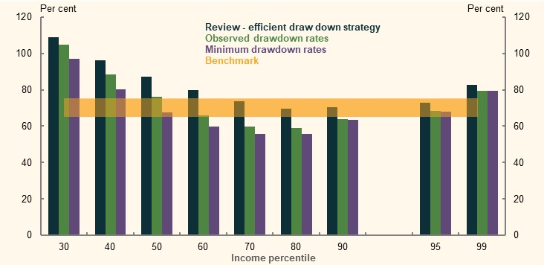
Note: Replacement rates are calculated using the review’s mixed deflator. Minimum and observed drawdown rate scenarios do not include purchase of a longevity product. Source: Cameo modelling undertaken for the review.

Achieving better after-fee returns
Improving after-fee investment returns in superannuation can significantly boost retirement incomes. A 0.5 per cent increase in after-fee returns could boost replacement rates for the median earner by 4 percentage points (Chart 2C-19).
Options for improving net returns include:
- Implementing the reforms suggested in the Productivity Commission’s report Superannuation: Assessing Efficiency and Competitiveness, intended to reduce costs for members. For example, moving from a MySuper fund in the bottom 20 per cent for fees to one in the top 20 per cent could boost after-fee returns by 0.5 percentage points (review analysis of (Australian Prudential Regulation Authority, 2020a)).
- Using investment strategies that mitigate sequencing risk, such as dynamic lifecycle strategies, to improve adequacy with lower downside risks (Drew, et al., 2014).
    - Projected impact of higher returns on replacement rates
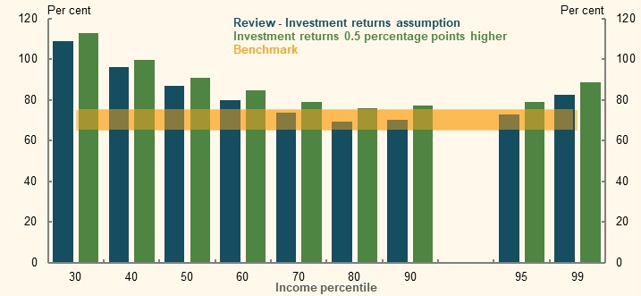
Note: Review assumption for investment returns is 7.5 per cent during the accumulation phase and 6.2 per cent in retirement. Source: Cameo modelling undertaken for the review.

Accessing equity in the home
For most retirees, the family home is their main asset. Using relatively small portions of home equity can substantially improve retirement incomes. For example, using the Pension Loans Scheme to add $5,000 to annual income increases the replacement rate of the median earner by 10 percentage points (Chart 2C-20).
Releasing home equity can boost retirement incomes with a modest impact on debt. Withdrawing $5,000 a year would mean that retirees still have about three-quarters of the value of their home at age 92, for a house worth $500,000 at retirement. Retirees with higher value homes would maintain even higher proportions of home equity while still benefiting from significant improvements in replacement rates.
    - Projected impact of home equity release on replacement rates
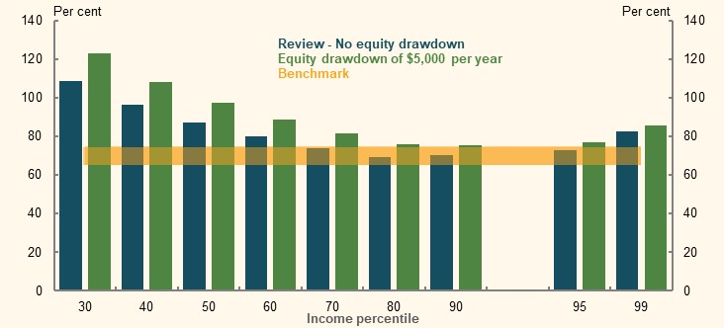
Note: Values are in 2019-20 dollars, deflated using the review’s mixed deflator. Home is worth $500,000 at retirement in wage-deflated terms and house prices are assumed to grow with wages for the purpose of this scenario. Equity drawdown assume that the Pension Loans Scheme is used to add an extra $5,000 to annual income each year of retirement. Calculations assume Pension Loans Scheme interest rate and loan-to-value ratios at 1 January 2020. Source: Cameo modelling undertaken for the review.

Impact of different assumptions
Assessing whether the system is robust to risk requires sensitivity analysis to find out what happens when assumptions deviate from those made in the central case. The following sensitivity analysis was conducted across a range of factors, such as different career lengths, investment strategies and risks, and how people save and draw down their assets. The aim was to incorporate reasonable risks faced by an average person.

Outcomes under sensitivity analysis
For median (Table 2C-3) and average (Table 2C-4) earners, outcomes remain above or within the replacement rate benchmark for many deviations from the central case. For example, median singles or couples can have a 25-year career and still achieve the benchmark provided they work to age 65. More than 80 per cent of people retiring today had careers of 25 years or longer.
The Age Pension is a major reason that retirement incomes for median-income earners remain adequate under different sensitivities. The Age Pension offsets the reduction in retirement income for middle-income earners if negative shocks affect their superannuation balances (Box 2C-5). Replacement rates for average and median earners with typical careers are also above the replacement benchmark range, providing an additional buffer should negative risks reduce their retirement incomes.
Some median- or average-income earners are below the benchmark in cases where:
- People have careers of 25 years or less and retire before superannuation preservation age, particularly for couples
- Couples only draw down their superannuation at the minimum rates
Under sensitivity analysis, replacement rates are relatively lower for couples than for individuals and higher for women compared with individuals.
Detailed modelling of sensitivity analysis is included in the Annex — detailed sensitivity analysis at the end of this section. Modelling includes the impact of different assumptions on retirement outcomes across the population.
      - Projected replacement rates, median earner sensitivity analysis (50th percentile)
 | All employees (per cent) | Female only  (per cent) | Singles only  (per cent) | Couples only  (per cent)
Review replacement rate | 87 | 94 | 88 | 82
Sensitivity analysis
Investment risks
Investment returns 1.0 ppt lower | 81 | 89 | 82 | 74
Investment returns 0.5 ppt lower | 84 | 92 | 85 | 77
Low wage growth and lower investment returnsⁱ | 87 | 95 | 89 | 82
25 per cent investment shockⁱⁱ | 82 | 90 | 83 | 74
Drawdown strategies
Minimum drawdownⁱⁱⁱ | 68 | 81 | 71 | 61
Observed drawdownⁱⁱⁱ | 76 | n/a | n/a | n/a
Voluntary saving^{iv}
No non-super savings | 88 | 95 | 89 | 82
No salary sacrificing | 85 | 93 | 87 | 78
No non-super or salary sacrificing | 85 | 93 | 87 | 78
Working career and longevity^{v}
Shorter working life
(25 years) Retirement at 67 | 78 | 87 | 79 | 70^{viii}
(30 years) Retirement at 67 | 81 | 90 | 83 | 73^{viii}
(35 years) Retirement at 67 | 84 | 93 | 86 | 77^{viii}
(25 years) Retirement at 60 | 69 | 79 | 71 | 65^{viii}
(30 years) Retirement at 60 | 73 | 81^{vii} | 73 | 68^{viii}
(35 years) Retirement at 60^{vi} | 76 | 82^{vii} | 77 | 70^{viii}
Early Retirement |  |  | Primary only/both
Job-related (57 years) | 72 | 79 | 74 | 73/68^{ix}
Job-related (62 years) | 78 | 85 | 80 | 75/72^{ix}
Disability-related (57 years) | 79 | 90 | 82 | 73/70^{ix}
Disability-related (62 years) | 80 | 90 | 82 | 75/72^{ix}
Retirement at 70 (start age 27) | 92 | 98 | 93 | 90
Low SG coverage (8 years less)^{x} | 82 | 90 | 84 | 75
Living to 102 | 88 | 99 | 89 | 83
Living to 102 no longevity productⁱⁱⁱ | 84 | 93 | 86 | 78
Calculation differences in replacement rates
5 years before/5 years after | 90 | 95 | 90 | 91
15 years before/15 years after | 84 | 91 | 86 | 75
Wage deflator | 73 | 79 | 74 | 69
CPI deflator | 95 | 103 | 96 | 89
Note: All sensitivities assume working life of 27-67, starting in 2019-20, unless otherwise specified. Income distributions are based on relevant cohorts, for example the median couple is based on the income distribution of couples. ⁱLow wage-growth scenario assumes 3.5 per cent nominal wages growth from 2032-33 and 0.5 percentage point lower investment returns. ⁱⁱA once-off 25 per cent reduction of super balances at retirement that does not recover. ⁱⁱⁱAssumes no longevity product purchase. ^{iv}Working-life income from the central case is used as the replacement rate denominator to ensure consistency between results. ^{v}Working-life income from the central case is used as the replacement rate denominator to ensure consistency between results. People who retire earlier than 67 draw down super from age 60 at the higher of the maximum Age Pension less any income support they receive or minimum legislated rates until age 67. Review drawdowns assumptions used from age 67. Age Pension eligibility is for home owners and couples based on partnered eligibility; all other household types assume the person is single. ^{vi}Assumes people start work aged 25 in 2019-20, and retire at age 60 in 2062. ^{vii}Assumes a two-year career break for women from ages 30-31. Women therefore work two years less in these scenarios. ^{viii}Assumes both members of the couple have shorter working lives. ^{ix}Coupled early retirement scenarios include: 1) the primary earner retires early, while the secondary earner works to age 67; 2) both members of the couple retire early. ^{x}Low SG coverage assumes no SG from ages 35-42. Source: Cameo modelling undertaken for the review.
      - Projected replacement rates, average earner sensitivity analysis (60th percentile)
 | All employees (per cent) | Female only  (per cent) | Singles only  (per cent) | Couples only  (per cent)
Review replacement rate | 80 | 86 | 81 | 77
Sensitivity analysis
Investment risks
Investment returns 1.0 ppt lower | 73 | 81 | 75 | 67
Investment returns 0.5 ppt lower | 76 | 83 | 78 | 72
Low wage growth and lower investment returnsⁱ | 80 | 87 | 81 | 76
25 per cent investment shockⁱⁱ | 73 | 82 | 76 | 68
Drawdown strategies
Minimum drawdownsⁱⁱⁱ | 60 | 69 | 62 | 59
Observed drawdownsⁱⁱⁱ | 66 | n/a | n/a | n/a
Voluntary saving^{iv}
No non-super savings | 80 | 87 | 81 | 76
No salary sacrificing | 76 | 84 | 79 | 71
No non-super or salary sacrificing | 77 | 84 | 80 | 70
Working career and longevity^{v}
Shorter working life
(25 years) Retirement at 67 | 70 | 80 | 72 | 63^{viii}
(30 years) Retirement at 67 | 73 | 83 | 75 | 67^{viii}
(35 years) Retirement at 67 | 77 | 85 | 78 | 72^{viii}
(25 years) Retirement at 60 | 64 | 71 | 65 | 59^{viii}
(30 years) Retirement at 60 | 67 | 73^{vii} | 69 | 62^{viii}
(35 years) Retirement at 60^{vi} | 69 | 75^{vii} | 71 | 64^{viii}
Early Retirement |  |  |  | Primary/both
Job-related (57 years) | 66 | 73 | 69 | 66/61^{ix}
Job-related (62 years) | 71 | 79 | 74 | 69/66^{ix}
Disability-related (57 years) | 70 | 81 | 74 | 66/62^{ix}
Disability-related (62 years) | 71 | 81 | 74 | 69/66^{ix}
Retirement at 70 | 87 | 91 | 88 | 87
Low SG coverage^{x} | 74 | 82 | 76 | 69
Living to 102 | 81 | 91 | 82 | 77
Living to 102 no longevity productⁱⁱⁱ | 77 | 85 | 78 | 73
Calculation differences in replacement rates
5 years before/5 years after | 82 | 87 | 78 | 82
15 years before/15 years after | 77 | 83 | 78 | 72
Wage deflator | 67 | 72 | 68 | 65
CPI deflator | 87 | 94 | 88 | 84
Note: All sensitivities assume working life of 27-67, starting in 2019-20, unless otherwise specified. Income distributions are based on relevant cohorts, for example the median couple is based on the income distribution of couples. ⁱLow wage growth scenario assumes 3.5 per cent nominal wages growth from 2032-33 and 0.5 percentage point lower investment returns. ⁱⁱA once-off 25 per cent reduction of super balances at retirement that does not recover. ⁱⁱⁱAssumes no longevity product purchase. ^{iv}Working-life income from the central case is used as the replacement rate denominator to ensure consistency between results. ^{v} Working-life income from the central case is used as the replacement rate denominator to ensure consistency between results. People who retire earlier than 67 draw down super from age 60 at the higher of the maximum Age Pension less any income support they receive or minimum legislated rates until age 67. Review drawdowns assumptions used from age 67. Age Pension eligibility is for home owners and couples based on partnered eligibility; all other household types assume the person is single. ^{vi}Assumes people start work aged 25 in 2019-20, and retire at age 60 in 2062. ^{vi}Assumes a two-year career break for women from ages 30-31. Women therefore work two years less in these scenarios. ^{viii}Assumes both members of the couple have shorter working lives. ^{ix}Coupled early retirement scenarios include: 1) the primary earner retires early, while the secondary earner works to age 67; 2) both members of the couple retire early. ^{x}Low SG coverage assumes no SG from ages 35-42. Source: Cameo modelling undertaken for the review.

          - The Age Pension means test and sensitivity analysis
Because of the Age Pension, even using different modelling assumptions, many retirees are expected to achieve adequate outcomes. This reflects that:
- The maximum rate of the Age Pension gives retirees a minimum level of support. The Age Pension alone can replace about half the income for the median earner retiring in 2060 (Chart 2C-4).
- The means test increases retirement incomes if assets (or incomes) are lower. The taper rate under the assets test compensates for a large portion of the lost income from lower asset balances.
Sensitivity analysis shows that, even when retirees have lower assets at retirement, they only experience minor changes in replacement rates. The impact of lower assets is offset by higher Age Pension payments, which can rise significantly due to the taper rate under the assets test (see 5B. Policy scenario: Implications of changing Age Pension means test settings).
For example, an investment shock that reduces the median earner’s superannuation balance from around $450,000 to $300,000 (bringing their retirement balance into the bottom 30 per cent) would only reduce their retirement income by about $5,000.
    - Projected annual retirement income by superannuation balance
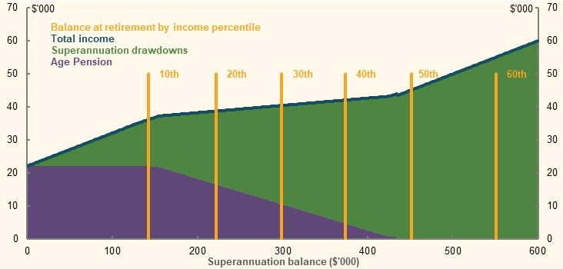
Note: Assumes people draw down 10 per cent of their superannuation assets, values are for 2060 and deflated to today’s dollars using review deflator. Assumes no non-superannuation assets for illustrative purposes. First year of retirement in 2060 only. Source: Cameo modelling undertaken for the review.
The importance of means testing in determining people’s retirement outcomes is expected to grow in the future. The proportion of age pensioners receiving part-rate Age Pensions is estimated to increase from 38 per cent of age pensioners today, to 63 per cent of age pensioners in 2060 (see 4. Sustainability).

The retirement income system and the risk of economic shocks
          - Retirement income adequacy and economic shocks
- Exposure to market returns is a strength of Australia’s superannuation income system. Most Australians are invested in a superannuation fund that yields solid market returns in the long term. But markets are vulnerable to investment and sequencing risk, which can impair retirement outcomes.
- The system provides significant protection from stock market falls.
  - Superannuation fund returns, on average, are less affected than the stock market (Chart 2C-22).
  - The Age Pension provides a risk buffer for many retirees during market downturns.
  - The benefits of home ownership are largely unchanged during market downturns.
- Stakeholders in the system can assist individuals to transition through significant market downturns. Discretionary policy changes by the Government can assist retirees during economic shocks. Superannuation funds have an important role to help guide retirees through the stress and complexity of significant financial market volatility.
- If downturns affect workforce participation, retirement incomes may fall. Yet younger people who go through periods of unemployment or underemployment can still meet or exceed the replacement rate benchmark. They may also have the option of accessing some superannuation early to tide them over the economic shock.
Market volatility can be stressful for retirees and people approaching retirement. They are forced to make decisions in market downturns that may have a permanent impact on their retirement income. These issues have become prominent in the context of the COVID-19 Pandemic.

Retirement incomes in a market downturn
Market volatility affecting retirement incomes is a fundamental feature of Australia’s defined contributions system.
Among other benefits, Australia’s defined contribution scheme lets people enjoy the benefits of higher returns available on financial markets. The retirement income system is highly regarded worldwide and was robust to risks during the GFC, largely due to the Age Pension (Bateman, 2009).
However, the same feature means Australians face greater investment risk compared to those in other retirement systems. Market downturns from economic shocks can significantly affect retirees’ asset balances. The retirement income system, through superannuation, the Age Pension and housing, provides a significant buffer for retirees from market volatility.

Superannuation funds and investment risk
Superannuation funds help protect members from investment risk through prudent and diversified investment strategies. As a result, falls in superannuation fund returns are typically significantly lower than those in equity markets.
This was seen during the GFC. Between September 2007 and March 2009, the ASX accumulation index (which incorporates total returns by including dividend payments) fell by 41 per cent. Yet the fall in superannuation fund returns over the same period was 24 per cent (Chart 2C-22).
    - Superannuation fund and share market returns
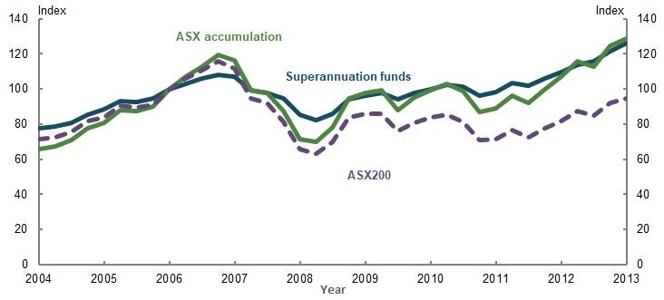
Note: The ASX accumulation series includes dividends and is more comparable to fund returns. Index 100 = Dec 2006. Source: (Australian Prudential Regulation Authority, 2020c; Market Index, 2020).

The Age Pension and net retirement incomes
The Age Pension provides significant automatic assistance during downturns. Lower incomes and asset levels in these periods increase Age Pension entitlements because of the means test.
Consider a hypothetical scenario where equity markets drop 25 per cent in the year after an individual retires and a superannuation fund’s returns fall 12.5 per cent in the same year (Chart 2C-23). Asset values are then assumed to recover to trend over the next five years, similar to the GFC.
In the case of a median-income earner who retires the year before the shock, the Age Pension provides a buffer against an immediate drop in income. The 25 per cent market fall reduces retirement income by just 5 per cent in the following year. The reduction in superannuation drawdowns (-19 per cent) is largely offset by higher pension entitlements (+14 per cent).
The permanent effect of the downturn is about a 1 per cent fall in income over the course of retirement. In this scenario, selling financial assets below their trend value means people realise losses and miss out on elevated returns in the years following the downturn. In reality, the returns following a market shock are uncertain and will depend on the specific circumstances.
In this scenario, higher-wealth retirees have a different experience than median earners. For someone in the 80th percentile, their income drops 19 per cent during the downturn with no higher Age Pension payments. Retirement income remains under pre-shock levels for longer than a median earner and does not fully recover until higher-wealth retirees begin to receive the Age Pension.
Neither outcome factors in individuals using investment risk management strategies. Permanent losses under these scenarios could be reduced through the strategies outlined in Responsibilities for managing risk below.
Long-run system-level effects from a short-run shock, including aggregate Age Pension payments, are discussed in Box 4A-4 in 4. Sustainability.
    - Impact of a 25 per cent market fall on retirement incomes
Median earner | 80th percentile earner
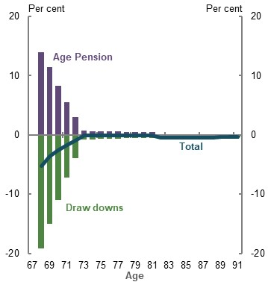 | 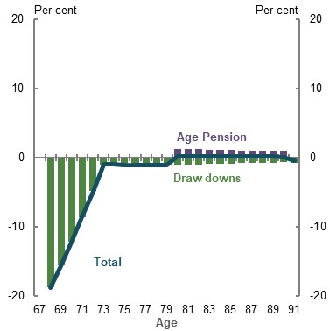
Note: Based on a 25 per cent fall in market returns in a single year, which results in a 12.5 per cent fall in superannuation balances and non-superannuation assets instead of the standard return of 6.2 per cent before fees. Asset prices recover to long-term levels in five years. Source: Cameo modelling undertaken for the review.

Owner-occupied housing
The principal residence is the most significant asset for more than 80 per cent of retirees (see 1B. Design of Australia’s retirement income system), acting as a form of risk mitigation. A mortgage is a form of forced saving and the principal residence is the largest store of wealth for most retirees.
While a downturn may affect the value of the home, the ability of retirees to enjoy the benefits of living in their home is largely unaffected. The home can also act as a source of wealth to be drawn on to cover potential shortfalls in other income sources.
          - Economic downturn: impact on retirement incomes of working-age people
The retirement incomes of young people can be affected by economic downturns, such as if they become unemployed or release their superannuation early.
The following scenario examines the impact of an illustrative economic downturn on a 32-year-old. This person is unemployed for three years and draws $20,000 from their superannuation over two years. After three years, the person finds work but is underemployed for five more years.
In this example, lower- and middle-income earners still achieve replacement rates above the benchmark (Chart 2C-24). Some higher-income earners could fall below the benchmark but would have incomes that exceed the ASFA comfortable standard.
The economic downturn reduces superannuation balances at retirement, predominantly due to lower employment income for median earners (see Table 2C-5). Age Pension payments rise as a result of lower balances.
This scenario shows that prudent early release can assist people to manage negative working-life events without significantly reducing their retirement income. The significant period between the economic downturn and retirement allows affected people to adjust their behaviour to improve their retirement incomes if they wish. For example, they could make higher voluntary contributions towards retirement to boost their retirement incomes.
      - Projected change in retirement incomes from a hypothetical economic downturn
 | 20th percentile | 50th percentile | 80th percentile
Change in replacement rate (percentage points) | -9 | -5 | -7
Change in annual average retirement income ($) | -2,500 | -2,300 | -5,800
Change in annual average working-life income ($) | -2,500 | -5,100 | -8,600
Change in superannuation balance at retirement ($) | -69,300 | -104,000 | -147,200
Change in balance due to early release only ($) | -38,600 | -38,600 | -38,600
Note: Values are in 2019-20 dollars using the review’s mixed deflator and rounded to the nearest $100. Person is eligible for JobSeeker Payment (excluding the Coronavirus Supplement) when unemployed. Lower-income earners do not have $20,000 superannuation at age 32. Around $5,000 is added to lower-income earner superannuation balances in both central case and economic downturn scenarios for comparability with other income percentiles. Underemployment in the scenario reduces incomes by 40 per cent for three years and 20 per cent for a further two years. The person re-enters employment earning the wage they received before the downturn and catches up to where their wage would have otherwise been over a five-year period. Source: Cameo modelling undertaken for the review.
    - Projected change in retirement incomes due to economic downturn
Replacement rate change | Change in annual retirement income
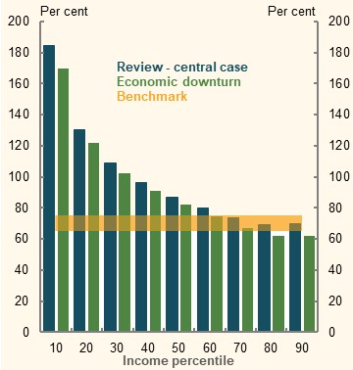 | 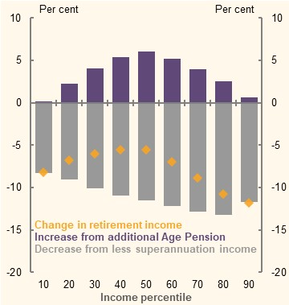
Note: Lower-income earners do not have $20,000 superannuation at age 32 under normal assumptions for review cameo modelling. Around $5,000 is added to lower-income earner superannuation balances in the central and downturn cases to examine the impact of a $20,000 withdrawal on retirement balances. Source: Cameo modelling undertaken for the review.

Responsibilities for managing risk
In addition to the automatic risk management features in the system, individuals, funds and government can all help to alleviate the impact of market shocks to retirement outcomes.
Asset prices fall in response to economic shocks and tend to recover in later years. Individual retirement incomes will suffer if people sell their assets at market lows.
Individuals can mitigate risk by using:
- Adaptable drawdown strategies where retirees draw down based on a proportion of their balance, rather than fixed amounts. For example, the 10 per cent drawdown strategy used in Industry Super Australia modelling (Industry Super Australia, 2020). Such strategies lower drawdowns if assets are lower, reducing the need to sell assets at the bottom of the market. Whereas, strategies that rely on a fixed dollar draw down could result in retirees running out of money when there is a market downturn.
- Bucketing strategies where retirees create a reserve of cash to provide income for a fixed period as part of a retiree’s portfolio. This allows people to draw down cash during market downturns, avoiding the need to sell growth assets at market lows. The effectiveness of this strategy depends on the cash bucket being sufficient to outlast the market downturn.
- Lifecycle portfolio strategies that reduce investment risk as people age, by weighting their portfolios towards cash and defensive assets. This strategy blunts the effect of negative shocks since defensive assets are less affected in market downturns. It can be effective for older retirees for whom long-term growth is less important.
Central to managing these risks is people being informed and appropriately advised where necessary.
Some people will also be able to delay retirement. Older Australians may have responded to the GFC by working longer (Plumb, et al., 2010). But delaying retirement may not be an option for people with poor health or who are made redundant in the downturn.
Government can:
- Continue to support the development of default retirement products that help retirees manage their drawdowns. Sensible retirement defaults could reduce volatility and protect retirees from longevity risk.
- Adjust policy settings in a market downturn, by:
  - Temporarily lowering minimum drawdown rates, reducing the need for retirees to sell financial assets at market lows.
  - Adjusting deeming rates to ensure they are in line with market returns.
Superannuation funds can:
- Provide guidance to people. Falling markets can be stressful and the complexity of navigating the system is an issue during downturns (Bateman, 2009). Complexity, combined with fear and uncertainty, can result in people making poor choices. Unadvised members are particularly susceptible to this risk (Sharpe, 2020).
For example, forthcoming research by First State Super points to the importance of guidance and advice in reassuring members and helping them stay the course when markets fall. The research compared largely unadvised retirees with those receiving more advice. Among the largely unadvised retirees, 7.7 per cent switched investment options between February and April 2020, moving 84 per cent of their account balance on average. This was 4.3 times higher than the level of switching observed among those receiving more advice. Only 1.8 per cent of retirees receiving advice switched and when they did, they only switched 33 per cent of their account on average. Across both groups, close to 80 per cent of switches were into a more defensive investment option, with about half of these being switches to cash.
Earlier research by First State Super found that 83 per cent of First State Super members over age 50 who switched to a more defensive option during the GFC missed the rebound in markets and had not switched back by the end of 2009-10. This suggests that members who switch during periods of market stress may not switch back without prompting, further emphasising the value in ready access to advice and guidance. Switching can protect funds from further falls, but cash performs significantly worse in the long run than balanced funds (Chart 2C-25).
    - Index of unit prices by investment strategy
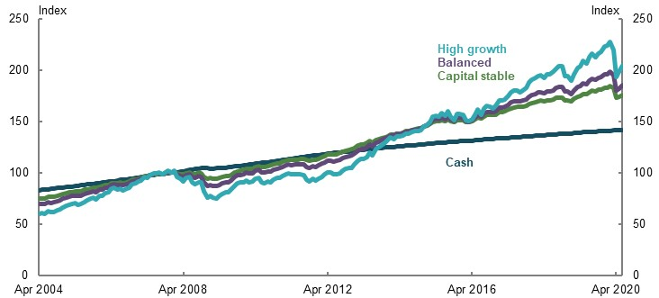
Note: Index 100 = values as at pre-GFC peak as at December 2007, value based on first day in month. Source: (Rest Super, 2020).
          - Impacts of certain policy settings on maintaining living standards in retirement
A significant number of submissions raised policy suggestions to improve people’s ability to maintain their living standards in retirement. The following outlines some implications of some of those proposals.
- Maintain the SG rate at 9.5 per cent: Whether the majority of people maintain their standard of living in retirement if the SG remains at 9.5 per cent will depend on whether they efficiently draw down their superannuation balances in retirement. If they do, they can have higher living standards in their working life while maintaining their living standards in retirement. This is further examined in 2D. Policy scenario: Implications of maintaining the SG rate.
- Lower the assets test taper rate for the Age Pension: Lowering the taper rate would increase replacement rates for most retirees. It would increase replacement rates further above the benchmark for many middle-income earners. The largest increases in replacement rates are projected to occur in the 60th to 80th income percentiles. It would reduce the incentive for retirees to draw down their assets. This is examined further in 5B. Policy scenario: Implications of changing Age Pension means test settings.
- Increase the standard payment rate and change the indexation of JobSeeker Payment: These changes would improve outcomes for many early and involuntary retirees. Any change to the payment rate of JobSeeker Payment should also consider the broader policy objectives of working-age payments (see 3E. Age of Retirement).
- Narrow the SG compliance gap: Continuing to narrow the SG compliance gap, including helping employees and the ATO to identify underpayment more quickly, will help people get the SG to which they are entitled. Improved employer compliance with the SG will particularly benefit lower-income workers and those in certain industries, such as construction, and accommodation and food services (see 3D. SG coverage).

Annex — detailed sensitivity analysis
This section includes detailed modelling on the sensitivity of replacement rates and retirement outcomes to different assumptions.

Years in the workforce
The cameo modelling focuses on people with typical working lives. It does not cover people with less than 10 years in the workforce. Australia’s contributory SG system means this group will mostly likely rely on the Age Pension and, provided they have low incomes, would experience improved living standards in retirement.
    - People working more than a certain number of years
Men  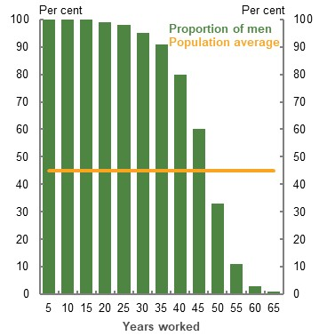 | Women  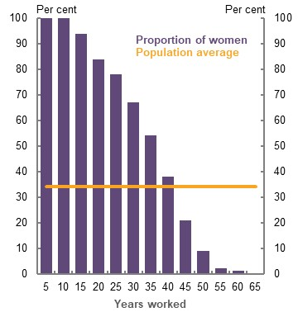
Note: Includes people aged 65 and above who work more than 10 years. Source: Analysis of HILDA Survey data (Wave 18).
The modelling assumes a career of 40 years to reflect the population average for people with significant workforce attachment (Chart 2C-26). Assumptions for gender-based modelling are 38 years for women and 42 years for men, based on the following data:
- Men aged 65 and over today worked 45 years on average. About 80 per cent worked for 40 years or more.
- Women aged 65 and over today worked 34 years on average. This figure is likely grow due to rising female workforce participation (see 1D. The changing Australian landscape). For example, a trend measure shows average female years in the workforce has increased from approximately 24 years in 1980, to 37 years in 2020 (Chart 2C-27). An average woman entering the workforce today could work around 40 years in total if female participation continues to increase.
- Treasury’s MARIA model projects median careers of 37.9 years for women and 43.5 years for men for those starting work in 2020 and retiring in 2060 (see Appendix 6A. Detailed modelling methods and assumptions).
    - Years in workforce by gender and total population
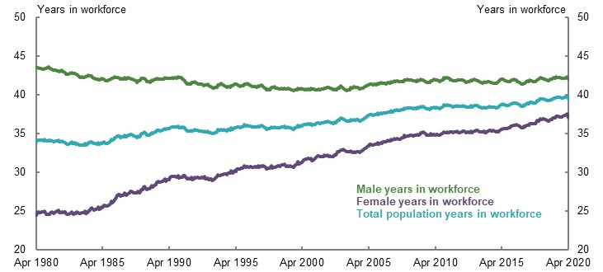
Note: Data expressed as a four-quarter moving average. Years in workforce is calculated by adding participation rates by age and gender for ages 15-70. Participation rates for ages 65-70 are based on rates for people aged 65 and over. Source: Analysis of (ABS, 2020g).

Sensitivity analysis for different career lengths
Although people starting work today expect to have a 40-year working life, some people may retire early due to:
- Personal choice. People may retire as soon as they feel they have sufficient savings or choose to trade-off a shorter working life for a relatively lower incomes in retirement.
- Involuntary retirement. People may be retrenched, acquire a disability or have to provide care. Modelling shows outcomes are adequate for those early retirees who are able to access the Disability Support Pension or Carer Payment, pointing to the importance of the broader social security system in supporting people who retire involuntarily.
See 3E. Age of Retirement for a detailed discussion of how the age, and degree of choice in the timing of retirement affects retirement outcomes.
Median-income earners with significant variation in the number of years they work can still achieve adequate retirement outcomes. Even if the median earner works only 25 years, they will still have adequate retirement income, providing they do not retire before preservation age. Someone in the 60th income percentile only has a replacement rate below the benchmark if they work 25 years to age 60.
The age that people start work does not greatly impact their replacement rate (Table 2C-6). A median earner can achieve the benchmark if they take career breaks provided they work at least 25 years.
Retirement age has a bigger impact on replacement rates than starting age. For example, a person working 40 years from 20-60 has a replacement rate of 77 per cent. This is a lower outcome than for a person who works 40 years retiring at age 67, whose replacement rate is 87 per cent. Reasons for this difference include:
- Retiring earlier means that people must make their retirement savings last longer and draw down on them at a slower rate. For example, someone retiring at 67 in 2060 can expect around 25 years in retirement, compared with 32 years for someone retiring at age 60 (see Appendix 6A. Detailed modelling methods and assumptions).
- People generally make larger voluntary contributions later in life such as in their late 50s and early 60s. Retiring early, especially involuntarily, may mean people miss out on the opportunity to make these savings.
      - Median earner replacement rates, various start and retirement ages
Starting age of work | Retirement age
Starting age of work | 55 | 60 | 65 | 67 | 70
35 | 66% | 69% | 79% | 83% | 87%
30 | 68% | 73% | 82% | 85% | 90%
27 | 71% | 76% | 83% | 87% | 92%
25 | 72% | 76% | 84% | 88% | 93%
20 | 74% | 77% | 85% | 89% | 96%
Note: Early retirement scenarios assume people receive working-life income support if eligible according to means testing and access their superannuation from preservation age. People who retire earlier than age 67 draw down superannuation from age 60 at the higher of the maximum Age Pension or minimum legislated rates until age 67 using use review drawdown rates thereafter. For comparability, the level of working-life income to be replaced is the same for sensitivities. Source: Cameo modelling undertaken for the review.

Distribution of outcomes based on working life and retirement age
If the current distributions of retirement age, working-life length and income remain stable, modelling suggests about 90 per cent of the population will have replacement rates within or above the benchmark in a mature system (Chart 2C-28). Few retirees currently have career lengths that would lead to inadequate outcomes in a mature retirement income system.
    - Projected distribution of outcomes, entire population
Population distribution by years worked | Replacement rates relative to benchmark
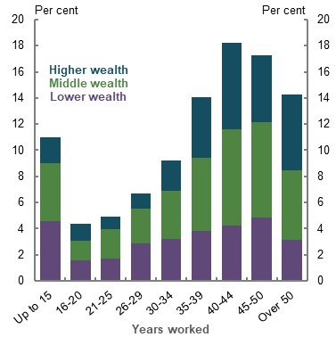 | 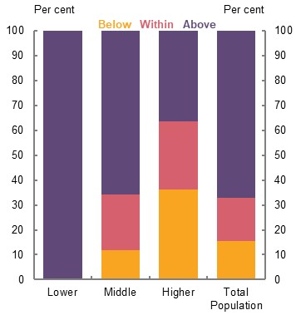
Note: Lower-income earners are in the 30th percentile and below, higher-income earners in the 80th percentile and above. Source: Review analysis of HILDA (Wave 18), cameo modelling undertaken for the review.
The population of people who would not have adequate replacement rates consists entirely of middle- and higher-income earners. Lower-income earners will always exceed the benchmark as the Age Pension provides higher-income than the amount needed to maintain their living standards in retirement.
Of the 16 per cent of people projected to have replacement rates below the benchmark:
- About a quarter are middle- and higher-income earners who work 15 years or less.
- Two-thirds are higher-income earners who work less than 40 years. Higher-income earners can maintain standards of living at replacement rates significantly lower than the benchmark and are less likely to retire involuntarily.
About three-quarters of middle-income earners are projected to exceed the benchmark, suggesting that, even taking into account variance in careers and retirement ages, this group may be over-saving for retirement. Higher-income earners are the most likely to achieve within the benchmark, with about 27 per cent projected to have retirement incomes that fall within the benchmark.

Career breaks
The central case assumes that an individual works a 40-year career from age 27-67. This is a simplifying assumption for modelling purposes. Many people would start work at a younger age but have a mid-career break.
Sensitivity analysis shows that the timing of career breaks does not substantially affect replacement rates. For example, working from age 20-67 with a career break from age 30-36 gives a replacement rate of 84 per cent, 3 percentage points lower than the central case. In this example, lower incomes earned during younger ages are offset by longer accumulation periods.

Life expectancy
The average Australian commencing work today can expect to live to age 92 (Commonwealth of Australia, 2015) and people retiring at age 67 can expect about 25 years in retirement.
Longevity risk protection is important as it allows people to confidently draw down assets to fund their retirement. Without longevity protection, concern about running out of savings may contribute to retirees undertaking costly strategies to protect against the risk of running out of money, including:
- Drawing down the minimum from their superannuation assets and lowering their potential retirement living standards
- Saving more when working, lowering their working-life living standards
To account for longevity risk (the risk of outliving savings), the modelling assumes that people purchase a deferred longevity product that starts paying an income stream at age 92 (around life expectancy) and maintains income in real terms in combination with the Age Pension.
The assumption is that people will invest 5 per cent of upfront balances to provide a consistent real income stream from age 92. A relatively small proportion of upfront balances can provide longevity protection as:
- The accumulation of investment returns is substantial over 25 years between 67 and 92, even with conservative assumptions regarding after-fee investment returns for the product
- Many people will not reach the age where the product begins to pay an income stream, leading to ‘mortality credits’ that are paid to people who did reach that age, supporting higher payments
- The Age Pension is also a substantial longevity protection product, providing a significant proportion of incomes at later ages in life
The benefit of longevity products is demonstrated by assessing the impact of longevity risk on retirement income with and without a longevity product (Chart 2C-29) (see Appendix 6A. Detailed modelling methods and assumptions for more details on the longevity product).
Even without longevity protection, retirement incomes remain within or exceed the replacement rate benchmark for median earners across all ages. For average earners in the 60th percentile, incomes drop below the benchmark after age 92. Replacement rates begin to rise after this point as the Age Pension is indexed to wages and grows in real terms.
Arguably, without longevity protection people would not have the confidence to completely use their assets. A slower drawdown strategy would reduce incomes in early retirement and boost incomes after age 91 compared to the central case assumption.
Few people in Australia purchase longevity products in retirement. To help address this, the Government has proposed the Retirement Income Covenant. The covenant would ensure funds have a strategy to provide high and stable retirement incomes for retirees, improving the market for longevity products (5A. Cohesion). The approach modelled throughout the review illustrates what the covenant could achieve.
    - Projected annual replacement rates with and without longevity protection
Median earner | 60th percentile
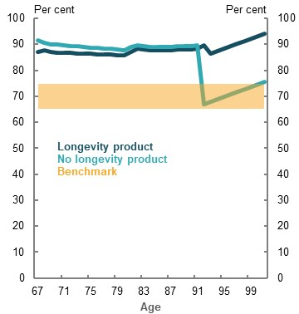 | 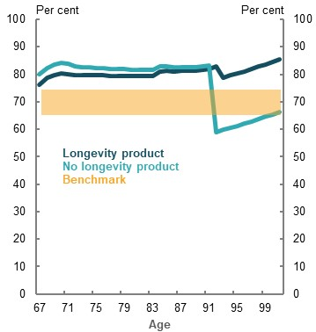
Note: Annual replacement rate refers to the proportion of working-life income replaced at that particular age. Source: Cameo modelling undertaken for the review.

Investment risk
Variations in investment returns alter retirement outcomes. The central case assumes investment returns are calibrated to how retirees typically invest their portfolios: with 40 per cent in defensive assets and 60 per cent equities. The impact of investment returns on retirement incomes is estimated using a model by the Australian Government Actuary.
The modelled portfolio has a mean return of 6.2 per cent (equal to the retirement phase earnings assumption in the review’s modelling) and a standard deviation of 8.3 per cent. This standard deviation is similar to that for the average annual superannuation return (Australian Prudential Regulation Authority, 2020a).
Even when investment returns vary, replacement rates still exceed the benchmark for the median earner. Average replacement rates at age 85 range from 77-90 per cent for the 25th and 75th percentile investment return results (compared with 87 per cent with no variability). The Age Pension means testing narrows the range of replacement rates as lower returns are partially offset by higher pension payments, and vice versa (Chart 2C-30).
    - Projected replacement rates under variable investment returns, median earner
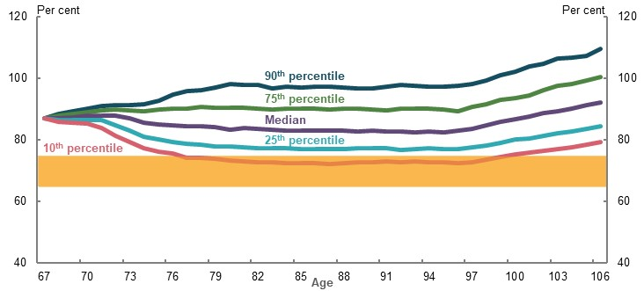
Note: Results are based on the Australian Government Actuary model calibrated to results for the median earner in 2060 under review modelling. Drawdown strategy is based on the review’s drawdown assumption with the purchase of a longevity protection product that begins to pay at age 92 and does not increase real incomes. Source: Review analysis using Australian Government Actuary modelling provided to the review.

Low Superannuation Guarantee coverage
The central case assumes employees are paid full SG contributions. But some people may not receive SG payments due to either their employment arrangements or non-compliance by their employer. The ATO estimates 3.9 per cent of superannuation was unpaid in 2016-17, down from 6.5 per cent in 2011-12 (ATO, 2020e). For further discussion of non-payment of superannuation see 3D. SG coverage.
To assess the sensitivity of SG non-payment, the modelling assumes people are not paid SG contributions for eight years, or one-fifth of their working life, between ages 35 and 42.
Under this scenario, low- and middle-income earners with low coverage can still expect replacement rates above the benchmark (Chart 2C-31). The Age Pension replaces around a third to a half of the income for middle-income earners. Higher-income earners have larger reductions in their replacement rates as they receive smaller offsets from the Age Pension.
    - Projected replacement rates with low SG coverage
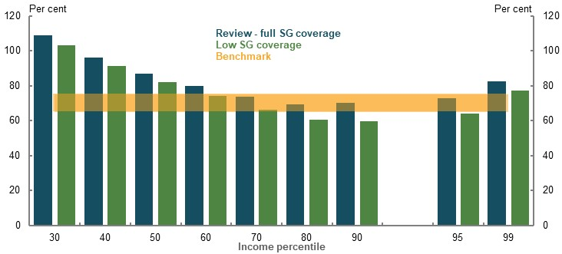
Note: Low SG coverage scenario removes SG contributions for eight years from age 35-42. Source: Cameo modelling undertaken for the review.

Salary sacrificing
The central case assumes employees make extra concessional contributions (salary sacrifice) into superannuation. ATO ALife longitudinal tax data shows that most people consistently make salary sacrifice contributions at higher incomes, where these contributions matter most to retirement incomes.
However, some people do not make voluntary contributions, whether due to choice or financial constraints. To cover this situation, a scenario is included with no salary sacrificing.
Without salary sacrificing, lower- and middle-income earners can still expect replacement rates above the 65-75 per cent replacement benchmark. For example, the median earner’s replacement rate falls about 2 percentage points but remains above the benchmark (Chart 2C-32). Salary sacrifice contributions for lower- and middle-income earners are small relative to their SG contributions. The Age Pension also partially compensates for the lower saving with higher pension payments.
The fall in replacement rates is larger for higher-income earners who tend to make larger salary sacrifice contributions. Higher-income earners are the most likely to make salary sacrifice contributions, around 68 per cent made voluntary contributions in half the years of an eight-year period. This group is also less likely to receive higher Age Pension payments to compensate for lower savings.
    - Projected replacement rates by salary sacrificing
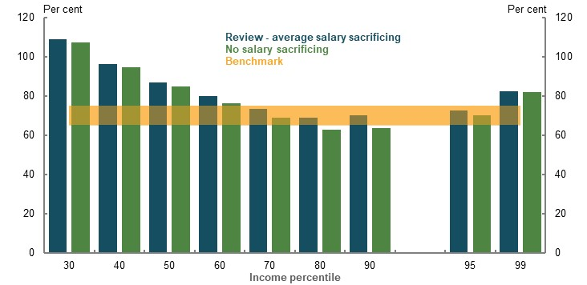
Note: Salary sacrificing based on tax file data on averages rates by age and income percentile. Source: Cameo modelling undertaken for the review.

Saving outside of superannuation
For those able to do so, voluntary savings can contribute significantly to retirement incomes. But individual circumstances mean some people will not save outside of superannuation.
Modelling shows not saving outside superannuation has little impact on projections for lower- and middle-income earners, who typically have little non-superannuation savings outside their own home on average (Chart 2C-33). Non-superannuation assets are most significant for retirees in the top wealth decile (see 1B. Design of Australia’s retirement income system). Without savings outside superannuation, some higher-income earners in the 90th percentile and above fall below the benchmark but still achieve the ASFA comfortable standard. Other percentiles are not substantially affected.
    - Projected replacement rates by saving outside of superannuation
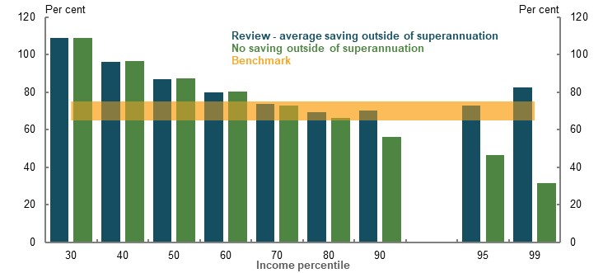
Note: Average saving outside of superannuation is applied at retirement, based on Survey of Income and Housing data (see Appendix 6A. Detailed modelling methods and assumptions). Source: Cameo modelling undertaken for the review.

Low investment returns
Modelling assumes investment returns of 7.5 per cent during the pre-retirement phase, and 6.2 per cent during the retirement phase, before fees and taxes. These returns are based on fund investment targets and fees are based on those for the average fund (see Appendix 6A. Detailed modelling methods and assumptions). These returns are around 1 percentage point lower than historic average fund returns.
But people could receive lower returns due to variety of factors. For example, an individual could be in a poorly performing fund with high fees or their investments could suffer an economic shock, as seen during the COVID-19 Pandemic, which could reduce returns for everyone.
This scenario looks at the impact of a 1.0 percentage point lower investment return in both the accumulation and retirement phases. For comparison, a reduction in net returns of 0.5 percentage points might occur by shifting from a MySuper fund with fees in the lowest 20 per cent of funds to one with fees in the highest 20 per cent (review calculations using (Australian Prudential Regulation Authority, 2019a)).
Modelling shows that middle-income earners still achieve adequate replacement rates under a low investment return scenario, partly due to higher Age Pension payments (Chart 2C-34). Higher-income earners experience the largest falls due to higher balances and a lower compensating increase from Age Pension payments.
    - Projected replacement rates when investment returns lower by 1 percentage point
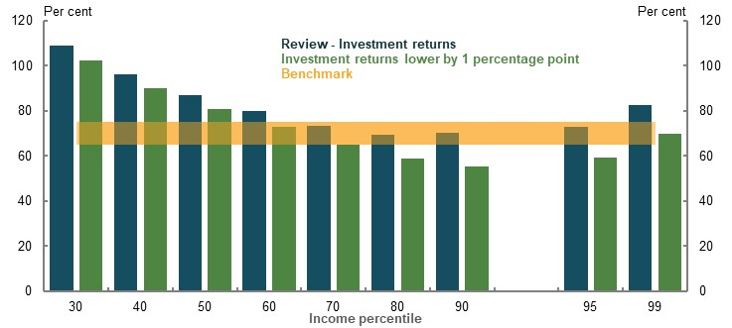
Note: Replacement rates using the review’s mixed deflator. Review assumption for investment returns is 7.5 per cent during the pre-retirement phase and 6.2 per cent in retirement. Source: Cameo modelling undertaken for the review.

Home ownership status
Home ownership rates for households above the 2nd wealth decile exceed 95 per cent. Renting is currently concentrated among retirees with the lowest wealth. Renters require higher replacement rates of around 90-100 per cent to maintain living standards as their housing costs do not fall in retirement (see the Appendix 6A. Detailed modelling methods and assumptions).
Adequacy outcomes for renters are best assessed against the minimum retirement standards. Modelling shows low-income renters are at risk of not achieving a minimum that meets community standards (see 2A. Achieving a minimum standard of living in retirement). A combination of Commonwealth Rent Assistance and more generous means-test limits improve replacement rates for renters relative to home owners.
For median-income retirees who rent, analysis indicates replacement rates would be above 90-100 per cent; enough that they should be able to maintain their standard of living in retirement.
Middle- and higher-income groups who rent are expected to have significant superannuation and other non-housing assets. They are unlikely to face the significant rates of poverty that lower-income renters do in retirement.
Although renting is currently rare for middle- and higher-income earners in retirement, these groups may rent at higher rates in future. The impact of falling home ownership on adequacy will depend on the working-life incomes of new renters and whether people save more to compensate for not purchasing a home.

Retiring with a mortgage
Most people retire as outright owners of their home, with 10 per cent of households age 65 and over having a mortgage in 2017-18 (see 1D: The changing Australian landscape). However, larger mortgages and delays in paying off a mortgage have caused concerns about using superannuation to pay off debt.
The drivers of higher mortgages are multifaceted, including higher house prices and people buying homes later in life. Some studies show a correlation between net household debt and pension assets (like superannuation) as a per cent of GDP, although the cause is unclear (Mercer, 2019b).
For example, consider someone who decides to pay off their mortgage with superannuation. This person has 10 years of mortgage repayments remaining at retirement worth about 23 per cent of the median person’s superannuation balance.
Using this example, even with mortgage worth about $100,000 outstanding at retirement, middle-income earners have retirement incomes that exceed the benchmark (Chart 2C-35). Using superannuation to pay off this mortgage only modestly reduces replacement rates for a median-income earner. In this case, the replacement rate remains well above the benchmark as Age Pension payments rise to compensate for much of the lost superannuation income.
    - Projected replacement rates after using superannuation to pay off mortgage debt
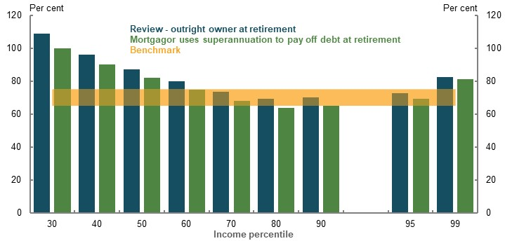
Note: Outright owner takes out a home loan of $400,000 in wage-adjusted terms at age 42, and pays off the mortgage over 25 years so that it is paid off by age 66. Mortgagor scenario is a $500,000 home loan in wage-adjusted terms, paid off over 35 years with 10 years of repayments left at retirement. Super balance is used to pay off the remaining principal with no other fees, totalling around $103,000 in wage-adjusted terms. Source: Cameo modelling undertaken for the review.
Carrying a larger mortgage into retirement has issues including:
- Increased exposure to sequencing risk. If asset values fall significantly just before retirement, then a larger proportion of their superannuation is required to pay off the debt.
- Older mortgagors have higher financial stress than outright owners, although less than renters. One study found mortgage size was less important than difficulty making repayments, which is often due to shocks, such as divorce or unemployment (Ong, et al., 2019).
That said, the more valuable homes associated with larger mortgages can have retirement benefits including:
- Allowing the transfer of wealth into housing, increasing eligibility for the Age Pension. Higher Age Pension payments help offset the impact of higher housing costs on retirement incomes.
- Creating additional home equity that can be accessed to boost income in retirement (see Box 2C-4). Accessing home equity can help offset the impact on people’s liquid assets from using superannuation to pay off a mortgage.

Policy scenario: Implications of maintaining the SG rate
          - Section summary
- Projections based on maintaining the SG rate at 9.5 per cent highlight that efficient use of savings can have a major impact on the adequacy of retirement outcomes. Efficiently drawing down assets in retirement provides people with the opportunity to save less for retirement and maintain higher working-life incomes. Insufficient attention has been given to assisting people to optimise their retirement income through the efficient use of their savings.
- Balancing people’s standard of living between working life and retirement with a universal SG is challenging. There is a diverse range of incomes and working-life experience across the population that affect how the SG will impact their retirement and working-life incomes.
- Maintaining the SG at 9.5 per cent, instead of increasing to 12 per cent, would lead to lower superannuation balances at all income levels.
- If people efficiently use their assets, then with the SG rate remaining at 9.5 per cent, most could achieve adequate retirement incomes when combined with the Age Pension. They could achieve a better balance between their working life and retirement incomes.
  - For lower- and middle-income earners, retirement incomes would be lower than with the SG going to 12 per cent, but would remain above or within the replacement rate benchmark of 65-75 per cent. If these groups draw down their savings in retirement, they could have higher incomes during their working life while still being able to maintain living standards in retirement if the SG stayed at 9.5 per cent.
  - Some higher-income earners would fall marginally below the benchmark replacement rate with a 9.5 per cent SG rate. These groups still achieve a level of retirement income that exceeds the ASFA comfortable standard.
  - Maintaining the SG rate at 9.5 per cent would allow for higher living standards in working life. Working-life income for most people would be around 2 per cent higher in the longer run.
  - Across a lifetime, the increase in total working-life income could be similar to the fall in total retirement income for middle-income earners, if people draw on their savings in retirement. Lower- and higher-income earners lose more retirement income than they gain in working-life income.
  - Many people in the top half of incomes would not achieve benchmark replacement rates under either a 9.5 per cent or 12 per cent SG rate if they drew down on superannuation at minimum legislated rates.
- Maintaining the SG at 9.5 per cent would avoid the increases in inequities associated with the SG rate rising to 12 per cent. Since increases in the SG benefit men more than women, maintaining the SG rate at 9.5 per cent would not contribute to widening the retirement income gap between men and women.
- Maintaining the SG rate at 9.5 per cent would improve the sustainability of the system. Higher tax revenues from lower superannuation tax concessions are projected to outweigh higher Age Pension expenditure until the late 2050s. The cumulative saving by 2060 of the change is projected to be about 2.0 per cent of GDP.

Outline of this section
A number of submissions advocated maintaining the SG rate 9.5 per cent. Many others supported the legislated increase in the rate to 12 per cent in five equal instalments commencing from July 2021. Towards improving understanding of the impact of increasing the SG rate, this section assesses the implications of an SG rate at 9.5 per cent compared with the legislated increase to 12 per cent.
Analysis focuses on projected retirement outcomes in 2060 for an individual commencing in the workforce in 2020. Consistent with the analysis in 2C. Maintaining living standards in retirement, it assumes people efficiently draw down their superannuation assets in retirement. The effect on the adequacy of outcomes should people draw down their superannuation at lower rates is also explored.
          - Stakeholder views on the SG rate
Many submissions noted the importance of SG in improving retirement incomes. Submissions expressed a range of views on the appropriate level of SG and the associated trade-offs.
Submissions that supported a 12 per cent or higher SG rate suggested the following range of benefits:
- Higher superannuation balances at retirement. Higher lifetime superannuation contributions increase the potential for higher retirement incomes and improved adequacy outcomes for groups who may otherwise be at risk of lower living standards in retirement.
- A higher proportion of the population achieving the ASFA comfortable standard. Several superannuation funds and unions noted that a higher SG rate would increase the proportion of the population who achieve the ASFA comfortable standard under a mature system.
‘Increasing the SG to 12 per cent will help workers in the middle‐income cohorts reach ASFA Comfortable, by the time of retirement, who otherwise might not attain that benchmark.’ (ASFA, 2020a, p. 12)
- Improve retirement outcomes for women. A range of views were put forward concerning the impact of higher SG on women. Some submissions noted that by improving retirement incomes for all lower-income earners, higher SG would improve adequacy for women. Other submissions suggested that higher SG will help women with broken work patterns to build superannuation balances, reducing the gender retirement income gap.
- Improve long-term fiscal sustainability through lower Age Pension expenditure. Submissions noted that higher SG would lead to a smaller proportion of the population relying on the Age Pension in retirement, with more pensioners relying on a part-rate rather than full-rate pension. Lower Age Pension reliance would reduce the fiscal cost to future governments.
Other submissions drew attention to:
- Replacement rates with a 9.5 per cent SG rate are adequate for most incomes. Submissions noted that for most incomes, replacement rates being delivered to retirees at least meet replacement rate targets.
- Higher SG rates may make the system relatively less equitable by amplifying income inequality experienced during working life. A higher SG could increase pressure on lower-income earners during working life through lower incomes, while providing higher-income earners with much of the benefit of an increase through higher relative tax concessions.
‘To the extent that compulsory superannuation contributions are offset by lower wage increases, a Superannuation Guarantee at 12% could exacerbate financial pressures for people with persistently low incomes during working life, including many workers with limited qualifications, women with broken employment patterns, and people with disabilities or chronic illness.’ (Australian Council of Social Service, 2020, p. 27)
- Higher SG may negatively impact the sustainability of the system. The cost of higher superannuation tax concessions may exceed the reduction in Age Pension expenditure.

The impact of maintaining the SG at its current rate

Effect on adequacy

Aggregate impact on superannuation balances
Maintaining the SG rate at 9.5 per cent would lead to lower superannuation balances in retirement at all income levels compared with a 12 per cent SG rate (Chart 2D-1). For middle- and higher-income earners, superannuation balances at retirement would be around 14-15 per cent lower than they would be with an SG rate of 12 per cent.
For lower-income earners, balances at retirement are projected to be around 16-18 per cent lower than under a 12 per cent SG rate. Impacts would be higher for this group as they:
- Keep more of their SG contributions after factoring in the low income superannuation tax offset
- Are less able to adjust voluntary savings in response to different SG rates
    - Projected superannuation balance at retirement, by SG rate
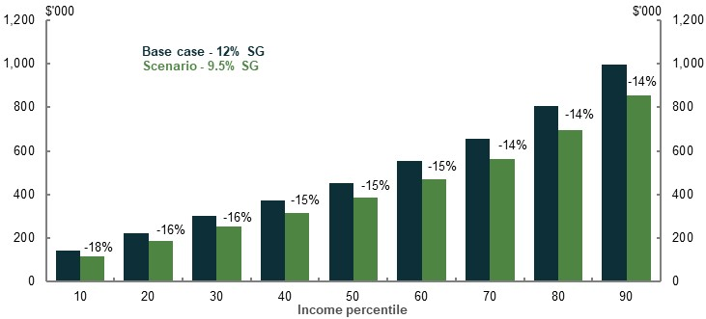
Note: Modelling is for an individual who commences work in 2020 and retires in 2060 after a 40-year career. Values are in 2019-20 dollars deflated by average weekly earnings. Percentage change in balance under 9.5 per cent SG is noted for each income percentile. Source: Cameo modelling undertaken for the review.
With a 9.5 per cent SG rate, lower balances would be offset by some other consequent changes, including likely increased voluntary contributions, lower contributions taxes and lower fees.
For example, with a 9.5 per cent SG rate, a median earner would receive around $45,000 less in SG contributions, compared with a 12 per cent SG rate (Chart 2D-2). Factors including likely higher voluntary contributions, lower fees and lower taxes would offset this decrease by about 43 per cent ($20,000). As a consequence of net lower contributions, the median earner would also forgo about $41,000 in net compounding (includes the interaction effect). This would reduce their total superannuation balance at retirement by about $67,000 (Chart 2D-2). The degree to which the above factors offset the forgone superannuation contributions would vary by income level. They are estimated to offset almost two-thirds of the forgone SG payments for income earners in the 99th percentile, falling to about 20 per cent for lower-income earners.
    - Composition of change in superannuation balance at retirement with a 9.5 per cent SG rate relative to a 12 per cent SG rate, median earner
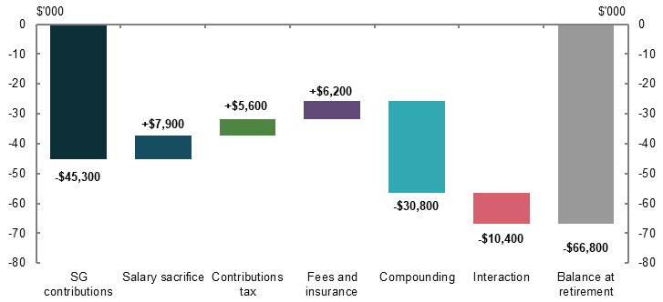
Note: Values are in 2019-20 dollars deflated by average weekly earnings and rounded to the nearest $100. Change in balance at retirement compares retirement at age 67 in 2060, under current policy settings and SG held constant at 9.5 per cent. ‘Compounding’ is the impact of real investment returns on superannuation balance accumulation during working life. The ‘Interaction’ field is the interaction between elements. Source: Cameo modelling undertaken for the review.

Impact on salary sacrifice contributions
Maintaining the SG rate at 9.5 per cent would likely result in some people making higher salary sacrifice contributions than they would have under a 12 per cent SG rate.
Research suggests that each additional dollar of compulsory contributions increases net savings by around 60-80 cents, as households reduce non-superannuation financial assets by about 20-40 cents in response to each additional dollar of compulsory contributions (Connolly, 2007; Ruthbah & Pham, 2020a). The effect is likely to be larger for higher-income households that may have greater capacity to adjust voluntary savings behaviour, and smaller for lower-income and financially constrained households (Connolly, 2007).
Research suggests that maintaining the SG rate at 9.5 per cent would mean higher voluntary savings (through salary sacrifice) relative to a 12 per cent SG rate. The effect varies depending on income level:
- People in the 10th income percentile are the least likely to make salary sacrifice contributions under any SG rate. Their estimated offsetting rise in salary sacrifice contributions is the smallest, at 4 per cent of the forgone SG.
- Median-income earners are estimated to offset about 15 per cent of the forgone SG through higher salary sacrifice contributions.
- Income earners in the 99th percentile have the greatest capacity to adjust their savings behaviour. They are estimated to offset about one-fifth of the change in SG contributions through higher salary sacrifice contributions.
For the purpose of modelling adequacy outcomes, the model does not account for any other changes in voluntary savings that may occur. Specifically, the analysis assumes no non-concessional contributions at either 9.5 per cent or 12 per cent SG, and no effect on savings outside superannuation.

Impact on working-life incomes
Maintaining the SG rate at 9.5 per cent would mean that people keep more of their total remuneration as wages instead of SG contributions. The effect on take-home pay depends on the:
- Degree to which higher SG payments are passed through to lower wage growth
- Impact of higher relative wage growth on personal income tax and payments, such as Family Tax Benefit and HELP repayments

Impact on working-life income
The weight of evidence suggests the majority of SG increases results in lower growth in wages (see Appendix 6A. Detailed modelling methods and assumptions). Cameo modelling in this section has assumed 80 per cent pass-through.
Estimates suggest that maintaining the SG at 9.5 per cent will result in working-life incomes about 2 per cent higher than under a 12 per cent SG rate in the longer term.
The current economic environment associated with COVID-19 Pandemic has resulted in elevated levels of unemployment and underemployment. This could reduce worker bargaining power in the short-term making it more likely for pass through to wages to occur.
However, given that wage levels are sticky downwards, it is not expected that nominal wage reductions would result from SG increases. Should very low wage growth occur in response to the COVID-19 Pandemic, more of the short-term incidence of SG increases legislated to occur in 2021 could, in some instances, initially fall on employers. Where employers bear more of the SG increase there could be changes to the demand for labour and/or investment.
The impact of the COVID-19 Pandemic on the economy over the next few years is uncertain. However, the modelling is aimed at assessing the long-term implications of different SG rates. Over the long term, the research suggests most of the impact of SG changes will be passed on to workers (Melguizo & González-Páramo, 2013).

Impact of personal tax and other payments
The impact on a person’s take-home pay of maintaining the SG rate at 9.5 per cent depends on their marginal tax rate. Total tax paid would increase for most people, as personal income is taxed more progressively than SG. The analysis in this chapter is based on incomes after tax.
Impacts on other government payments would reduce the extra income people receive:
- Maintaining the SG rate at 9.5 per cent means that people would have higher incomes, lowering their entitlements to Family Tax Benefit and childcare assistance (see Annex — modelling supplement, below). The impact of these payments differs over family type and how they access childcare.
  - Modelling suggests changes in these payments are most significant for dual-income families in the bottom two income deciles, and single-income families in about the middle of the income distribution. Reductions in Family Tax Benefit (FTB) payments offset between 12-22 per cent of the higher disposable income for these households (see Chart 2D-15 in Annex — modelling supplement, below).
  - If the SG rate stays at 9.5 per cent, the impact on family and childcare payments for most other groups is a 1-5 per cent offset of the increase in their income (see Chart 2D-15).
- Higher income from the SG rate staying at 9.5 per cent would increase HECS/HELP repayments. Faster repayment of debt does not affect the principal required to be repaid.

Impact on retirement income

Replacement rates
Replacement rates are considered the appropriate way to assess whether the retirement income system appropriately balances working life and retirement living standards. Modelling assumes superannuation assets are fully drawn down in retirement.
    - Replacement rates by SG rate and household type
Individuals | Couples
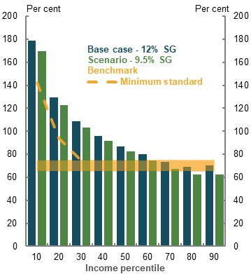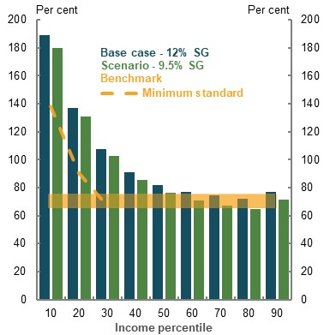
Note: Deflated using review’s mixed deflator. Source: Cameo modelling undertaken for the review.
Replacement rates are projected to be lower if the SG rate is maintained at 9.5 per cent. However, depending on how savings are used in retirement, most people starting work today with a 9.5 per cent SG rate could have a replacement rate within or above the 65-75 per cent benchmark when they retire (Chart 4). If the SG stayed at 9.5 per cent rather than increasing to 12 per cent, they would also have higher incomes in their working life.
- Lower-income earners up to the median income would have reduced replacement rates, but still exceed the 65-75 per cent benchmark. They would have higher income in their working life. Workers up to the 30th income percentile would achieve replacement rates above 100 per cent under both a 9.5 per cent and a 12 per cent SG rate due to a combination of high Age Pension eligibility and superannuation savings.
- Replacement rates for upper middle-income earners (60th and 70th percentiles) would fall but remain within the 65-75 per cent benchmark.
- The replacement rates for individuals in the 80th and 90th percentiles and 80th percentile couples are projected to fall below the benchmark range. This may be at least partly due to the conservative assumptions applied on non-concessional contributions (see Appendix 6A. Detailed modelling methods and assumptions). With the SG rate maintained at 9.5 per cent, higher-income earners are projected to receive retirement incomes that exceed the ASFA comfortable standard (see 2C. Maintaining standards of living in retirement).
Lower replacement rates from maintaining the SG rate at 9.5 per cent are not just due to people having a lower income in retirement. In the longer run, working-life income for most people would be higher, which increases the target income for replacement. For example, because disposable incomes during working life are projected to be about 2 per cent higher in the longer run under a 9.5 per cent SG rate than under a 12 per cent SG rate, the level of retirement income considered to be adequate is also about 2 per cent higher. For people in the bottom half of the income distribution, the higher working-life income accounts for about a third of the fall in replacement rates.
    - Projected change in retirement income with a 9.5 per cent SG rate
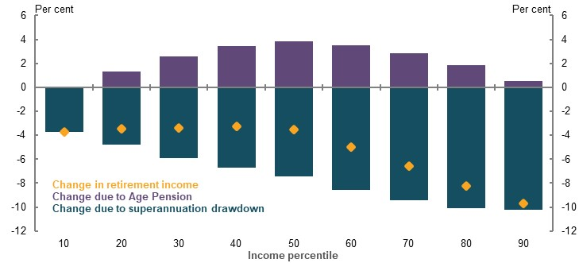
Note: Modelling assumes superannuation assets are drawn down efficiently, resulting in higher-income earners receiving some Age Pension income at the end of retirement. Source: Cameo modelling undertaken for the review.

Change in superannuation draw downs
How people draw down their superannuation balances in retirement is central to determining the adequacy of their retirement income. If they use their savings effectively in retirement, most people could achieve 65-75 per cent replacement rates with the SG rate maintained at 9.5 per cent (Chart 2D-5).
If they only draw down their superannuation at the legislated minimum rates, which many people currently do, those in the upper half of the income distribution would not achieve the 65-75 per cent replacement rates at either a 9.5 or 12 per cent SG rate (see Impact on cohesion, below).
With the SG rate maintained at 9.5 per cent, most people’s superannuation balances would be around 15 per cent lower than under a 12 per cent SG rate (Chart 2D-1). While the impact on balances is generally a reduction of around 15 per cent, the effect on retirement incomes is lower as superannuation is only one part of retirement income (along with the Age Pension and non-superannuation assets).
For example, the median-income earner has a 3.5 per cent reduction in retirement income (Chart 2D-4) comprising:
- About a 7.5 per cent reduction due to lower superannuation income. The impact is about half the 15 per cent reduction in superannuation balances as superannuation is about half of the total retirement income of the median-income earner (in combination with their Age Pension income).
- About a 4 per cent increase due to higher Age Pension payments. This impact is due to lower superannuation balances increasing people’s Age Pension entitlements.

Change in Age Pension income
Under the 9.5 per cent SG rate scenario, most income earners would receive more Age Pension income, with the size of the increases varying across the income distribution (Chart 2D-4).
- Lower-income earners would receive relatively little additional Age Pension. They are more likely to be full-rate age pensioners under either a 12 or 9.5 per cent SG rate.
- Middle-income earners would have the greatest offsetting increase in Age Pension income as lower superannuation balances would increase their eligibility for payment under the Age Pension assets test. For households in the 30th to 60th income percentiles, higher Age Pension payments offset around 40-50 per cent of the forgone superannuation income.
- Higher-income earners would have a smaller change to their Age Pension income under a 9.5 per cent SG rate compared with a 12 per cent SG rate. This group is more likely to have assets that make them ineligible for the Age Pension under either scenario.

Impact on Age Pension indexation
The Age Pension is benchmarked to 27.7 per cent of male total average weekly earnings (for singles). Higher relative wage growth under a 9.5 per cent SG rate would flow through to higher male total average weekly earnings, increasing the Age Pension rate.
The degree to which wage growth impacts male total average weekly earnings is debated. Estimates of the impact suggest the Age Pension may be between 0.51-1.44 per cent higher under a 9.5 per cent SG rate (Coates, et al., 2020; Gallagher & Bastian, 2019).
Regardless of the exact impact of changes in the SG rate on Age Pension indexation, the effect on replacement rates is less than a percentage point increase for the median earner. Given the effect on adequacy is small, the impact of higher aggregate wages on Age Pension indexation has been excluded from the analysis.

Total working life and retirement income trade-off
While replacement rates are useful in assessing whether working-life living standards can be maintained in retirement, they do not indicate the trade-off in income between working life and retirement under different SG rates. An alternative measure is to look at how much total retirement income people give up for the total increase in working-life income they receive. This measure allows the impact to be compared over a lifetime. Assuming assets were drawn down efficiently in retirement, if the SG rate did not increase:
- Working-life income would be higher because SG increases reduce wage growth
- Retirement income would be lower due to lower superannuation balances, which are only partly offset by higher Age Pension payments
Comparison over a lifetime can factor in differences in length of working life and retirement. For example, people spend roughly two-thirds as long in retirement as they do in working life (25 years and 40 years, respectively).
When making judgements around the trade-off between working-life income and retirement income, adjustments must be made for the probability that someone is alive to receive their retirement income. This is called ‘mortality weighting’. Mortality weighting adjusts the value of income received in a given year by the likelihood that an individual is alive to receive the income. Mortality weighting is used in measures that assess lifetime impacts (Khemka, et al., 2020).
From a mortality-weighted perspective, the increase in working-life income for median-income earners by maintaining the SG rate at 9.5 per cent would be around the same as the fall in their retirement income (Table 2D-1). For lower- and higher-income earners, the reduction in retirement income would be larger compared with the gain in working-life income.
For example, if the SG rate were maintained at 9.5 per cent, a median earner retiring in 2060 is projected to receive:
- $32,400 more disposable income over their working life, as in the longer run working-life income would be around 2 per cent higher for most people
- About $32,900 less income in retirement, due to the combined effect of:
  - $70,800 less income from superannuation drawdowns during retirement
  - An additional $37,900 in Age Pension income over the course of their retirement
This retirement income impact assumes efficient drawdown of superannuation assets. For example, if superannuation assets were drawn down at observed drawdown rates, retirement income would be $7,400 lower than it would have been under a 12 per cent SG rate for a median earner.
The extent to which people may wish to trade-off working-life income for retirement income may vary depending on their income level, life circumstances and replacement rates delivered in retirement. Whether an individual’s wellbeing would increase if they had a higher income in working life rather than in their retirement is a matter of judgement. Influencing this trade-off will be the drawdown approach people use and the extent to which, even with a lower income in retirement, they can maintain their living standards. However, in a system where the SG rate is compulsory, the employees it covers do not have the opportunity to make a choice regarding this trade-off.
      - Projected change in working life and retirement income under 9.5 per cent SG by income percentile, mortality weighted
Income percentile | Working-life income ($) | Retirement income
 | Working-life income ($) | Total retirement income ($) | Superannuation drawdowns ($) | Age Pension income ($)
10 | 12,200 | -28,100 | -28,200 | 200
20 | 17,300 | -27,900 | -39,600 | 11,700
30 | 22,600 | -28,500 | -52,100 | 23,600
40 | 27,500 | -29,000 | -61,900 | 32,800
50 | 32,400 | -32,900 | -70,800 | 37,900
60 | 38,100 | -50,600 | -86,500 | 36,000
70 | 45,000 | -71,800 | -102,100 | 30,400
80 | 53,900 | -101,300 | -122,300 | 21,200
90 | 58,200 | -147,400 | -142,200 | 7,800
Note: Values are in 2019-20 dollars, deflated using the review’s mixed deflator and rounded to the nearest $100. Mortality weighting derived from Australian Government Actuary projections based on a female aged 27 in 2019. Change in lifetime income is modelled for an individual living to 102 with a life expectancy of 92. ‘Superannuation drawdown’ includes the value of deferred group self-annuity product payments from age 92. All other specifications are consistent with the review’s central case. The difference in retirement income and superannuation drawdowns and Age Pension income is explained by lower drawdowns of assets outside of superannuation. Changes are sensitive to the deflator and how assets are drawn down, see Annex — modelling supplement. Source: Cameo modelling undertaken for the review and Australian Government Actuary mortality projections.
          - Balancing universal policy settings and flexibility
The universal policy settings under the Age Pension and SG deliver a default level of retirement income. Universal policy settings will not suit all Australians given the diversity in career lengths, retirement ages, incomes and voluntary savings levels.
The universal policy settings in the retirement income system are asymmetric (see 2C. Maintaining standards of living in retirement). People have flexibility to save more voluntarily if they wish to achieve a higher standard in retirement. But the compulsory nature of the SG makes it difficult for people to save below the default savings level. Lower-income earners can expect replacement rates above the benchmark under both a 9.5 and a 12 per cent SG rate. People with lower incomes are particularly vulnerable when compulsory savings rates are set too high. This highlights the importance of balance when setting the default level of retirement income.
Recognising this trade-off, several stakeholders proposed alternative mechanisms. These included an opt-out mechanism for contributions above a minimum compulsory contribution rate (Warren, et al., 2020, p. 10) or allowing members to access modest amounts of their superannuation to meet non-retirement needs (Australian Council of Social Service, 2020, pp. 32-33). The merits of any such approach would need to balance the additional flexibility and choice with appropriate protections of retirement balances. Consideration should also be given to the fiscal costs associated with the concessional taxation of savings consumed during working life.

Effect on cohesion

Effective use of superannuation balances for retirement incomes
The importance of effectively using superannuation assets to fund retirement income is discussed in 5A. Cohesion. The following analysis highlights that how people use their superannuation savings in retirement is important in determining the adequacy of their retirement incomes.
The projections assume retirees draw down all their superannuation in retirement. Drawing down superannuation assets in retirement is consistent with the policy intent of the retirement income system: to provide income in retirement (see 2C. Maintaining standards of living in retirement).
Drawing down superannuation at minimum legislated rates would result in lower replacement rates under both a 9.5 per cent and a 12 per cent SG rate (Chart 2D-5). With drawdowns at minimum rates, people above the median income fail to meet the 65-75 per cent replacement rate benchmarks at either SG rate. Drawdowns at the minimum rate would result in large bequests to dependants, rather than delivering retirement incomes for the individual.
    - Projected replacement rates by SG rate and drawdown strategy
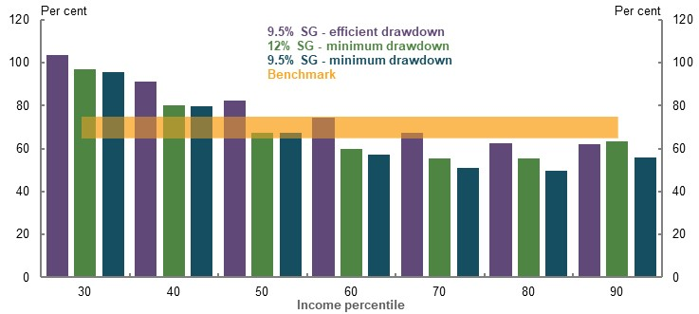
Note: Minimum drawdown based on legislated minimum rates by age. Minimum drawdown rate scenarios do not include people purchasing a longevity product. Efficient drawdown based on review strategy where superannuation assets are fully consumed by age 92 and a longevity product. Source: Cameo modelling undertaken for the review.
Higher levels of SG would have a minimal impact on lifting replacement rates if superannuation is drawn down at minimum legislated rates (Chart 2D-5). For income earners below the 90th percentile, higher replacement rates can be achieved by more efficiently drawing down superannuation assets at the 9.5 per cent contributions rate, compared with drawing superannuation at minimum rates with a 12 per cent SG rate. If the SG rate remained at 9.5 per cent rather than increasing to 12 per cent, and retirees drew down their superannuation balances efficiently, they could achieve a higher standard of living in working life while still being able to maintain living standards in retirement. The reasons why retirees may not effectively use their assets is discussed in 5A. Cohesion.

Transitional issues in maintaining the SG rate
There could be some transitional issues from maintaining the SG rate at 9.5 per cent and how these interact with already certified Enterprise Bargaining Agreements.
Some certified Enterprise Bargaining Agreements have already determined the pay and entitlements for workers based on the legislated increases to the SG taking place from July 2021. These agreements may incorporate lower wage growth based on increases to the SG rate. Subsequent policy changes to the SG rate may not be incorporated immediately into already signed agreements.
This could affect the short-term pass-through as a result of maintaining the SG rate at 9.5 per cent.

Effect on equity
The following analysis examines the impact of maintaining the SG rate at 9.5 per cent on the equity of outcomes experienced by income and wealth, gender, home ownership status and age of retirement.

Income and wealth
The increase in the SG to 12 per cent would result in higher-income earners receiving larger tax concessions. This would not occur if the SG rate remained at 9.5 per cent (Chart 2D-6). Under a 9.5 per cent SG rate:
- Higher-income earners would receive lower tax concessions on superannuation contributions and earnings, and minimal additional Age Pension payments. While Government support for higher-income groups would be lower than with a SG rate of 12 per cent, they would continue to receive more lifetime Government support than lower- or middle-income earners.
- Middle-income households would receive lower superannuation tax concessions, which would be offset with higher Age Pension payments. The net result is that maintaining the SG rate at 9.5 per cent would have little impact on the total Government lifetime support the median earner receives.
- Lower-income households would see a small reduction in lifetime Government support. Their Age Pension payments would not be significantly affected as they are typically on the maximum rate. Maintaining the SG rate at 9.5 per cent would modestly reduce their superannuation tax concessions.
    - Projected change in lifetime Government support by maintaining a
9.5 per cent SG rate
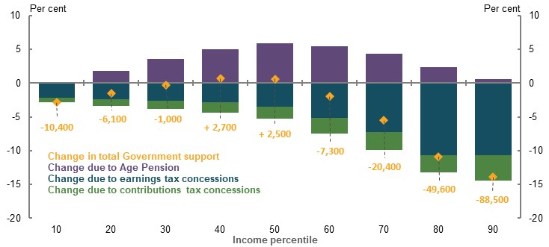
Note: Values are in 2019-20 dollars, rounded to the nearest $100 and GDP deflated. Modelling assumes people draw down superannuation assets efficiently, resulting in higher-income earners receiving some Age Pension income at the end of retirement, see Appendix 6A. Detailed modelling methods and assumptions for details. Source: Cameo modelling undertaken for the review.

Gender

Superannuation balances at retirement
The median woman’s superannuation balance at retirement would be around $54,400 (or 16.1 per cent) lower with a 9.5 per cent SG rate compared with a 12 per cent SG rate. The median man’s balance would be around $88,400 (or 15.2 per cent) lower (Chart 2D-7).
    - Projected change in superannuation balance at retirement when maintaining a 9.5 per cent SG rate, by gender and income
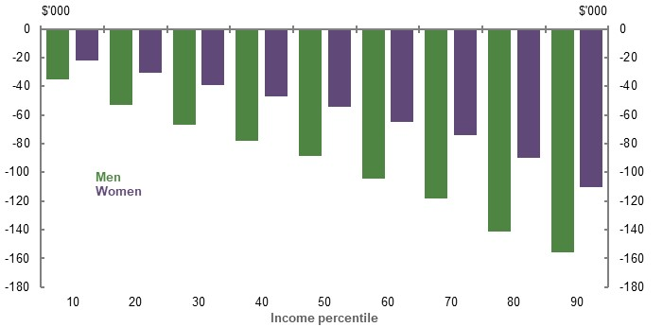
Note: Values are in 2019-20 dollars, deflated by average weekly earnings. The chart compares the 10th percentile for men to the 10th percentile for women, and so on. Gaps in superannuation balances at retirement do not factor in the effect of voluntary superannuation contributions not made through salary sacrifice. Source: Cameo modelling undertaken for the review.

Gender-based income gaps
Cameo analysis in 3B. Gender and partnered status is reproduced here to examine the effect of the SG on gender gaps in superannuation balances, retirement and working-life outcomes.
If the SG rate was maintained at 9.5 per cent instead of increasing to 12 per cent, at almost all income levels, men would experience a larger percentage reduction in retirement income than women (Chart 2D-8). This is due to men having a larger decrease in income from superannuation than women, which would only be partially offset by higher Age Pension payments. The median woman would see her average retirement income reduce by 3.0 per cent, compared with a 5.7 per cent fall for the median man.
Retirement outcomes for women are largely determined by factors outside the retirement income system, which are not affected by a change in SG rate. Women tend to have lower wages and are more likely to work part-time and take more career breaks (3B. Gender and partnered status). These factors contribute to the working-life earnings gap between men and women, which in turn drives the gender gap in superannuation balances at retirement.
    - Projected gender gap in incomes and superannuation balances at retirement, with 12 per cent SG rate (solid line) and 9.5 per cent SG rate (dotted line)
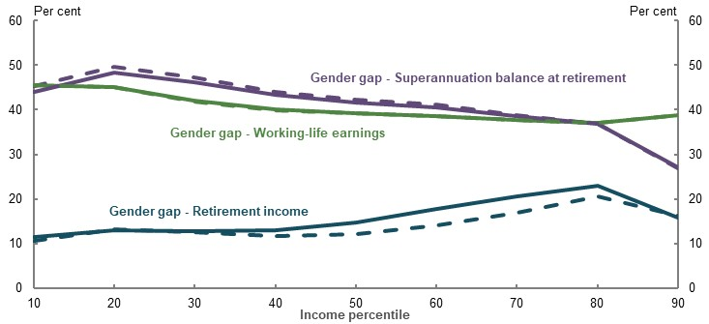
Note: Gender gaps are calculated relative to the relevant figure for men — that is, a 10 per cent gender gap in earnings means that women’s earnings are 90 per cent of men’s earnings. See 3B. Gender and partnered status. The chart compares the 10th percentile for men to the 10th percentile for women, and so on. Does not factor in voluntary superannuation contributions not made through salary sacrifice. If included, these would reduce the gaps between men and women. Source: Cameo modelling undertaken for the review.

Home ownership
Home ownership improves retirement outcomes by reducing ongoing housing costs and acting as a store of wealth that may be drawn upon to help fund retirement (see 2A. Achieving a minimum standard of living in retirement).
Maintaining the SG rate at 9.5 per cent may impact future home ownership trends in a number of ways. Ultimately the impact of a change in the SG on housing is unclear.
- Studies show a correlation between net household debt and pension assets (such as superannuation) as a per cent of GDP, although the cause of the relationship is unclear (Mercer, 2019b, p. 10). Historically, increasing levels of superannuation wealth may have increased household confidence about finances and wealth, encouraging them to take on more debt. Research commissioned for the review suggests that higher SG rates result in more investment in housing, with $1 of additional employer contributions increasing housing investment by $0.24 (Ruthbah & Pham, 2020a). These factors may cause a constant 9.5 per cent SG rate to deter borrowing compared with a higher SG rate.
- Maintaining the SG rate at 9.5 per cent could marginally increase households’ capacity to save for a home deposit as working-life income could be about 2 per cent higher than otherwise in the longer run. This additional income may support people’s ability to save for a deposit and pay down mortgage debt during their working lives. However, any effect is likely to be modest.

Age of retirement

Impact on balance at retirement
Superannuation balances of early retirees are less sensitive to maintaining the SG rate at 9.5 per cent due to this group contributing less and a shorter time period for returns to accumulate (Chart 2D-9).
Maintaining the SG rate at 9.5 per cent would lower superannuation balances at retirement for people retiring at age 55, by around $42,000 for the median-income earner. This is 64 per cent of the impact for a median-income earner retiring at age 67 ($66,000).
    - Projected change in superannuation balance, by retirement age, median earner
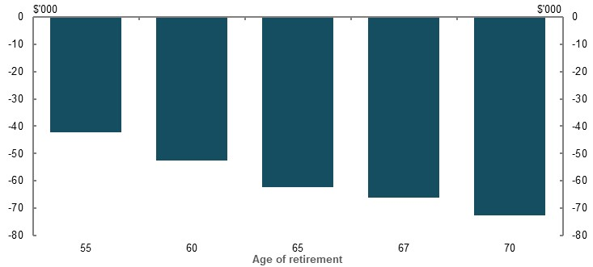
Note: Values are in 2019-20 dollars, deflated by average weekly earnings. Superannuation balance at retirement is calculated for people starting work at age 27 in 2019-20. Projected change in balance at retirement compares legislated changes to SG, and SG at 9.5 per cent. Source: Cameo modelling undertaken for the review.

Replacement rates and retirement age
For the median-income earner, maintaining the SG rate at 9.5 per cent would reduce their replacement rates. But projections suggest they would still have replacement rates within or above the 65-75 per cent benchmark for most career lengths (Table 2D-2).
Under both a 9.5 SG rate and a 12 per cent SG rate, and assuming savings are drawn down efficiently in retirement, the median-income earner retiring from preservation age would maintain their living standards in retirement (Table 2D-2).
People who work 20 years or less and retire at age 55 are projected to fall below the 65-75 per cent benchmark under a 9.5 per cent SG rate.
      - Projected replacement rates with 9.5 per cent SG for different working-life periods, median earner
Starting age | Retirement age
Starting age | 55 | 60 | 65 | 67 | 70
35 | 63% (↓ 3ppt) | 66% (↓ 3ppt) | 75% (↓ 4ppt) | 79% (↓ 4ppt) | 82% (↓ 5ppt)
30 | 66% (↓ 3ppt) | 68% (↓ 5ppt) | 78% (↓ 4ppt) | 81% (↓ 4ppt) | 85% (↓ 5ppt)
27 | 66% (↓ 4ppt) | 70% (↓ 6ppt) | 79% (↓ 4ppt) | 83% (↓ 4ppt) | 87% (↓ 6ppt)
25 | 67% (↓ 5ppt) | 71% (↓ 5ppt) | 80% (↓ 4ppt) | 83% (↓ 5ppt) | 87% (↓ 6ppt)
20 | 69% (↓ 5ppt) | 73% (↓ 5ppt) | 80% (↓ 5ppt) | 83% (↓ 6ppt) | 88% (↓ 8ppt)
Note: Early retirement scenarios assume people receive working-life income support if eligible according to means testing and access their superannuation from preservation age. People who retire earlier than age 67 draw down superannuation from age 60 at the higher of the maximum Age Pension or minimum legislated rates until age 67 using use review drawdown rates thereafter. For comparability, the level of working-life income to be replaced is the same for sensitivities. Figures in brackets are relative to a 12 per cent SG rate. Source: Cameo modelling undertaken for the review.
Workers at greater risk of early involuntary retirement are those with low wealth and low education levels (see 3E. Age of retirement). They are more likely to be lower-income workers who generally have replacement rates above the benchmark.

Effect on sustainability
Analysing the overall fiscal impact of maintaining the SG rate at 9.5 per cent over the medium- to long-term combines historical data, projections and assumptions from a range of sources to illustrate general trends. Treasury’s MARIA model was used to project the impact on some, but not all aspects, of taxation revenue. Details on the how MARIA modelling was used in this fiscal analysis are in Appendix 6A. Detailed modelling methods and assumptions.

Net fiscal impact
Maintaining the SG rate at 9.5 per cent is projected to have a positive net fiscal impact. Higher tax revenues from lower superannuation tax concessions are expected to outweigh higher Age Pension expenditure until around 2055. The cumulative saving by 2060 of the change is expected to be about 2.0 per cent of GDP (Chart 2D-10).
There would be an increasing positive fiscal impact over the coming decade if the phased increase in the SG to 12 per cent did not occur. These savings would gradually rise to about $3 billion per year in the late 2020s.
    - Projected net fiscal impact of maintaining the SG rate at 9.5 per cent
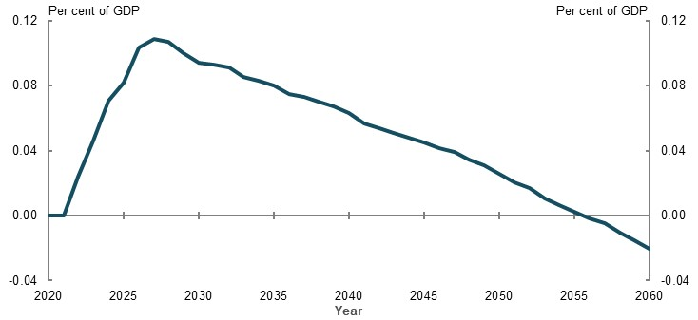
Note: Modelling assumes 100 per cent pass-through to employees. Source: Estimates prepared by the review; Treasury estimated changes in taxes on contributions, earnings and Age Pension expenditure using MARIA.

Break down of fiscal impact
Maintaining the SG rate at 9.5 per cent impacts the sustainability of the retirement income system in several ways (Chart 2D-11), including:
- Increased Age Pension expenditure due to lower assets at retirement. Initial impacts are small but grow over time as the system matures.
- Higher tax revenue would be collected immediately. Money that would have been paid as SG contributions is instead taxed at marginal income tax rates.
- Broader implications from taxing assets, as savings would likely be shifted out of superannuation into other savings vehicles. The exact impact would depend on how much people save of the extra money that would have otherwise been an SG contribution.
    - Projected budget impact of maintaining the SG rate at 9.5 per cent
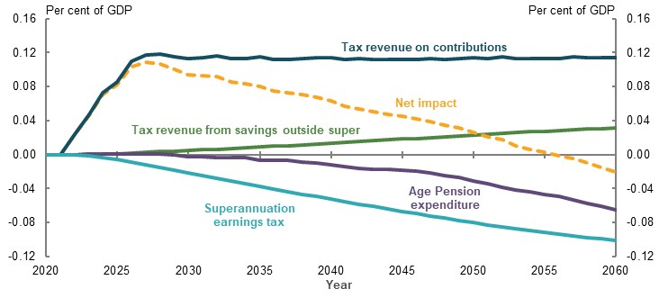
Note: ‘Tax revenue on contributions’ includes the impact on personal income tax and taxes on superannuation contributions. Modelling assumes 100 per cent pass-through to employees; Source: Estimates prepared by the review; Treasury estimated changes in taxes on contributions and earnings and Age Pension expenditure using MARIA.
          - Modelling fiscal impacts of maintaining the SG rate
To assess impacts on the adequacy of individual outcomes under a 9.5 per cent SG rate, cameo modelling assumed 80 per cent pass-through of SG to wages.
Analysis of budget impacts presented in this section requires a broader view of the economic impacts of an SG increase. Costs associated with an increase in SG can either be borne by wages, company profits, employment or prices. In the absence of broader economic effects, the remaining 20 per cent of the cost of increasing SG is most likely to be borne by companies, with flow-on impacts to company income tax.
For modelling purposes, the average tax rate paid on company profits is more similar to the average tax rate paid by workers, compared to assuming the remaining 20 per cent has no tax implications. Not assuming full pass-through is unrealistic as it would mean that 20 per cent of the impact is not passed through to any part of the economy and is untaxed in any form. Modelling of budget effects therefore assumes 100 per cent pass-through.

Age Pension reliance and costs
Under both a 12 per cent and 9.5 per cent SG rate, Age Pension reliance and expenditure decline over time as the retirement income system matures.
Over the long term, maintaining the SG rate at 9.5 per cent is projected to result in the proportion of people receiving the Age Pension increasing by around 1.8 percentage points by 2060 (Chart 2D-12). The proportion of people over Age Pension eligibility age on the full-rate Age Pension are projected to increase by 0.9 percentage points. Part-rate Age Pension recipients are expected to increase by 0.9 percentage points.
Maintaining the SG rate at 9.5 per cent is projected to increase Age Pension expenditure in 2060 by less than 0.1 percentage points of GDP compared with a 12 per cent SG rate (from 2.3 to 2.4 per cent of GDP).
    - Projected proportion of eligible population receiving the Age Pension, 12 per cent SG rate (solid line) and 9.5 per cent SG rate (dotted line)
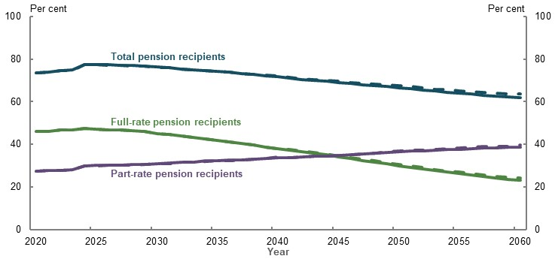
Source: Treasury estimates for the review using MARIA.

Impact of the change in contributions
Projections suggest that reduced superannuation contributions under a 9.5 per cent SG rate would increase government revenue (Chart 2D-11) due to the combined effect of:
- Lower taxes on concessional superannuation contributions
- Higher personal income tax rates on the increase in wages that would have otherwise been paid as SG contributions
Switching SG contributions to wages increases total taxes as marginal income tax rates are generally higher than contributions taxes on superannuation (as contributions are taxed concessionally). The projected annual fiscal impact of this component is 0.1 per cent of GDP, with the majority of the increase in revenue occurring during the period in which the 12 per cent SG rate is phased in, reflecting the higher income tax collections from maintaining the SG rate at 9.5 per cent.
The modelling assumes that some people would increase their voluntary concessional contributions (salary sacrifice or personal deductible contributions) as a result of the SG change. Only people who make voluntary contributions are assumed to make this adjustment. As a result, about 20 per cent of the lower SG contributions would be offset by higher voluntary contributions.
The modelling also allows for a small interaction between the SG and voluntary savings, where people may save less through non-concessional contributions. In particular, some people are expected to switch from non-concessional contributions to concessional contributions because the contributions caps will allow for more voluntary contributions under a lower SG rate. The decline in non-concessional contributions also arises due to a wealth effect in the model. That is, because people have lower assets due to a lower SG rate, they also save less through other savings mechanisms.

Impact of change in earnings
Maintaining the SG rate at 9.5 per cent would reduce the size of superannuation balances. This, in turn, would result in a lower level of concessional earnings tax. Taxes on superannuation earnings are projected to be about 0.1 per cent of GDP lower per year by 2060 (Chart 2D-11).
In addition, people would likely save more outside superannuation. An indicative estimate from higher savings outside superannuation is about a third of 0.1 per cent of GDP a year by 2060. This is affected by:
- The proportion of additional income that would otherwise have been contributed as SG.
  - Modelling in this section uses results from (Connolly, 2007) and (Ruthbah & Pham, 2020a), which show about 30 per cent of a change in SG is offset by voluntary savings. People are assumed to save 30 per cent, on average, of the change in SG contributions. In the modelling of non-superannuation savings, earners in the top two tax brackets are assumed to save 40 per cent of the forgone SG contributions, whereas lower-income earners save less than average. Differences across income are consistent with (Connolly, 2007) and how savings rates differ across income (Finlay & Price, 2014).
  - The extra income is otherwise assumed to be spent, including possibly on the family home. Where additional income is spent, consumption taxes such as the GST may apply, but these are not factored into the fiscal estimates. Revenue collected as GST is ultimately distributed to state and territory governments.
- The tax arrangements on savings vehicles and the return on those savings. For example, savings in a bank account are taxed at marginal tax rates, while savings in domestic shares may be subject to capital gains discount and receive franking credits.
  - Tax paid on investments outside superannuation are based on modified results from data provided to the review by the Tax and Transfer Policy Institute. Tax rates by investment vehicle are adjusted to be consistent with the fiscal impacts on the Commonwealth budget and assume a 15-year holding period. Investment portfolios are based on people’s actual assets. Both tax rates and investment portfolios are adjusted for income tax brackets. As a result, just over half of earnings are assumed to flow through to taxable income.

Superannuation assets and fees
Superannuation fees are a cost of the retirement income system, which is borne directly by fund members. Maintaining the SG rate at 9.5 per cent is projected to reduce superannuation fees by 0.1 per cent of GDP by 2059 as a result of lower total funds under management (Chart 2D-13). The reduction in total fees borne by members would be larger than the projected increase in Age Pension expenditure.
    - Projected superannuation fees as a percentage of GDP, with 12 per cent SG rate (solid line) and 9.5 per cent SG rate (dotted line)
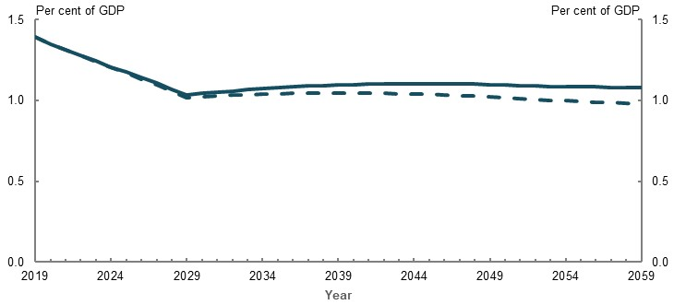
Source: Analysis of Rice Warner estimates for the review.
Over time, maintaining the SG rate at 9.5 per cent would reduce the level of superannuation assets held in defined contribution accounts (Chart 2D-14).
    - Projected value of total superannuation assets, with 12 per cent SG rate (solid line) and 9.5 per cent SG rate (dotted line)
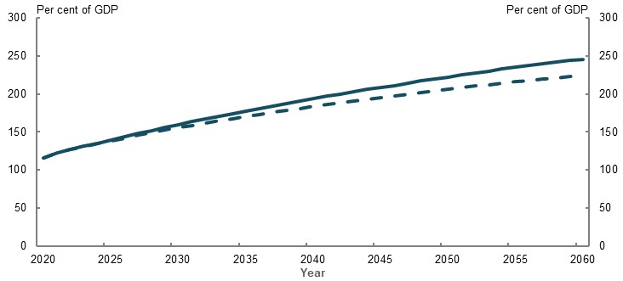
Note: Includes superannuation balances for defined contribution funds for people over 25 years. Excludes defined benefits, regulatory capital and life office statutory funds. Source: Treasury estimates for the review using MARIA.

Annex — modelling supplement
This Annex provides additional detail that extends the analysis provided in 2D. Policy scenario: Implications of maintaining the SG rate. It includes:
- Additional analysis of the impact on receipt of other payments
- Sensitivity analysis of replacement rates delivered under a range of circumstances
- Sensitivity analysis of the working life–retirement income trade-off
- Sensitivity analysis of the fiscal impact of maintaining the SG rate at 9.5 per cent
- Additional modelling by Rice Warner

Changes in other payments due to an SG change
A change to the SG can affect people’s eligibility for certain government payments. For example, FTB and HECS/HELP repayments are calculated using an alternative income definition called Adjusted Taxable Income. This definition includes wages as income, but it excludes the value of SG payments.
Maintaining the SG rate at 9.5 per cent would result in people having more wage income and, in turn, a higher Adjusted Taxable Income, which may reduce FTB and Child Care Subsidy (CCS) entitlements (Chart 2D-15). The means-testing arrangements result in different impacts across the income distribution.
- Lower-income couples in the 10th percentile would lose 22 per cent of their additional disposable income with the SG rate staying at 9.5 per cent due to lower FTB and CCS payments. The effect falls as income increases, with the 30th percentile couple having a 5 per cent offset through lower FTB payments. Lower-income single parents would be less affected as their incomes are more likely to be below thresholds where payments begin to withdraw.
- Middle-income couples would have a small reduction in FTB and CCS income as a result of higher relative working-life income over the longer run, equivalent to 1-2 per cent of the increase in disposable income. Middle-income single parents would have 5-21 per cent of the SG impact offset through lower family payments.
- Higher-income families would have little impact on their family payments as they only access family payments for a limited number of years.
The rate at which family payments are withdrawn can exceed 40 per cent when combined across FTB Part A and B, and the Child Care Subsidy. In practice, actual impacts on working-life income are lower as:
- Families only access payments for about half of their careers when their children meet qualifying ages for the benefits (typically under 18 for family payments, and below school age for childcare).
- Across certain income ranges, families can earn more without reducing their childcare or family payments. For example, families can earn up to $54,677 a year before having their FTB Part A payment affected. Parents can earn up to $68,163, or $173,163-$252,453 without having their Child Care Subsidy payment affected.
- Families may not receive all payments depending on their circumstances. For example, dual-income families typically do not receive FTB Part B.
    - Projected increase in working-life income offset by lower family payments
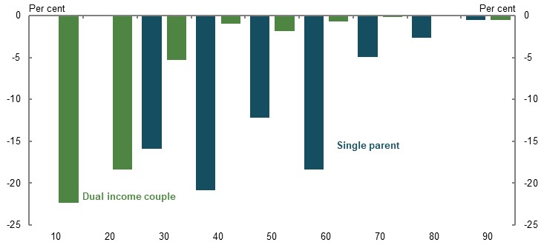
Note: Offset is calculated as the reduction in family payments across working life due to higher incomes under a 9.5 per cent SG, divided by the increase in disposable income across working life under a 9.5 per cent SG. Both families have two children, born when the secondary earner/single parent is 30 and 33. The secondary earner/single parent takes two years off work after each birth. The secondary earner/single parent then earns 60 per cent of their normal wages, and accesses two days a week of childcare, until the youngest child turns five. For the couple, the primary earner has no change in earnings. All family payment parameters are indexed according to current policy. Child care costs assumed to increase by CPI consistent with indexation of the hourly Child Care Subsidy cap. Increase in offset for single parents at the 60th percentile is due to the increase in income making them ineligible for FTB Part B in one additional year. Source: Cameo modelling undertaken for the review.

Sensitivity analysis

Replacement rates
Replacement rate sensitivity analysis presented in 2C. Maintaining standards of living in retirement is reproduced below under a 9.5 per cent SG rate to demonstrate the potential impact on people in a range of circumstances.
      - Sensitivity analysis of replacement rates, with 9.5 per cent SG rate, median-income earner
 | All employees(per cent) | Female only  (per cent) | Singles only  (per cent) | Couples only  (per cent)
Replacement rate | 83 | 90 | 84 | 76
Sensitivity analysis
Investment risks
Investment returns 1.0 ppt lower | 77 | 85 | 79 | 69
Investment returns 0.5 ppt lower | 80 | 87 | 81 | 72
Low wage growth and lower investment returnsⁱ | 83 | 90 | 84 | 76
25 per cent negative investment shockⁱⁱ | 78 | 86 | 79 | 70
Draw down strategies
Minimum drawdownⁱⁱⁱ | 67 | 81 | 71 | 57
Observed drawdownⁱⁱⁱ | 74 | n/a | n/a | n/a
Voluntary saving^{iv}
No non-superannuation savings | 83 | 90 | 84 | 77
No salary sacrificing | 80 | 88 | 82 | 72
No non-superannuation or salary sacrificing | 80 | 87 | 82 | 73
Working career and longevity^{v}
Shorter working life
(25 years) Retire at 67 | 75 | 83 | 75 | 67^{viii}
(30 years) Retire at 67 | 77 | 86 | 78 | 70^{viii}
(35 years) Retire at 67 | 80 | 89 | 81 | 72^{viii}
(25 years) Retire at 60 | 66 | 75 | 67 | 62^{viii}
(30 years) Retirement at 60 | 68 | 77^{vii} | 70 | 64^{viii}
(35 years) Retirement at 60^{vi} | 71 | 77^{vii} | 71 | 66^{viii}
Early retirement |  |  | Primary only/both
Job-related reason (57 years) | 68 | 75 | 70 | 69/64^{ix}
Job-related reason (62 years) | 74 | 80 | 75 | 71/68^{ix}
Disability-related reason (57 years) | 76 | 86 | 79 | 69/67^{ix}
Disability-related reason (62 years) | 77 | 86 | 79 | 71/68^{ix}
Retirement at 70 (start age 27) | 87 | 93 | 88 | 82
Low SG coverage (8 years less)^{x} | 79 | 86 | 80 | 71
Living to age 102 | 84 | 94 | 85 | 77
Living to age 102, no longevity productⁱⁱⁱ | 80 | 89 | 82 | 74
Calculation differences
5 years before / 5 years after retirement | 85 | 91 | 85 | 78
15 years before / 15 years after retirement | 80 | 87 | 82 | 69
Wage deflator | 69 | 75 | 70 | 64
CPI deflator | 90 | 98 | 91 | 83
Note: All sensitivities assume working life of 27-67, starting in 2019-20, unless otherwise specified. Income distributions are based on relevant cohorts, for example the median couple is based on the income distribution of couples. ⁱLow wage growth scenario assumes 3.5 per cent nominal wages growth from 2032-33 and 0.5 percentage point lower investment returns. ⁱⁱA once-off 25 per cent reduction of super balances at retirement that does not recover. ⁱⁱⁱAssumes no longevity product purchase. ^{iv}Working-life income from the central case is used as the replacement rate denominator to ensure consistency between results. ^{v}Working-life income from the central case is used as the replacement rate denominator to ensure consistency between results. People who retire earlier than 67 draw down super from age 60 at the higher of the maximum Age Pension less any income support they receive or minimum legislated rates until age 67. Review drawdowns assumptions used from age 67. Age Pension eligibility is for home owners and couples based on partnered eligibility; all other household types assume the person is single. ^{vi}Assumes people start work aged 25 in 2019-20, and retire at age 60 in 2062. ^{vii}Assumes a two-year career break for women from ages 30-31. Women therefore work two years less in these scenarios. ^{viii}Assumes both members of the couple have shorter working lives. ^{ix}Coupled early retirement scenarios include 1) the primary earner retires early, while the secondary earner works to age 67, 2) both members of the couple retire early. ^{x}Low SG coverage assumes no SG from ages 35-42. Source: Cameo modelling undertaken for the review.

Fiscal impact and earnings tax sensitivities
The projected fiscal impact of a 9.5 per cent SG rate is sensitive to assumptions regarding how people use the additional disposable income that would otherwise have been contributed to superannuation.
Modelling in Net fiscal impact presents a central estimate based on likely savings behaviour. People are assumed to offset 30 per cent of the change in their SG contributions through higher voluntary savings. Higher voluntary savings are partly assumed to occur within superannuation through additional superannuation contributions such as salary sacrifice contributions. Modelling then assumes voluntary non-superannuation savings offsets the shortfall between the 30 per cent assumption and the change in voluntary superannuation contributions.
Chart 2D-16 presents the upper and lower bounds of the potential net fiscal impact, in addition to the central estimate. The upper bound assumes that all additional disposable income is saved, with earnings taxed at marginal personal income tax rates. The lower bound assumes that all additional income is consumed or saved in a tax-exempt vehicle, such as the family home.
    - Fiscal impact of maintaining the SG rate at 9.5 per cent
Annual | Cumulative
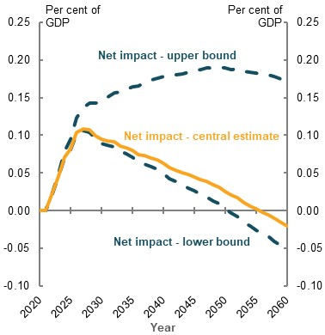 | 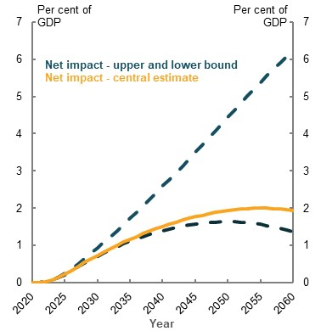
Note: Assumes 100 per cent pass-through from the SG to wages over the longer term. Source: Estimates prepared by the review; Treasury estimated changes in taxes on contributions and earnings and Age Pension expenditure using MARIA.

Working life–retirement income trade-off
Assessments of changes to working life and retirement income are sensitive to choice of deflator. Analysis in Table 2D-1 presents results based on a mixed deflator (see Appendix 6A. Detailed modelling methods and assumptions). Results under different deflators are presented in Table 2D-4 to demonstrate the impact of deflators on projected income.
      - Change in working-life and retirement income with a 9.5 per cent SG rate, by income and deflator type, mortality weighted
Income percentile | Mixed deflator |  | CPI |  | Average Weekly Earnings
Income percentile | Working-life ($) | Retirement  ($) | Working-life ($) | Retirement  ($) | Working-life ($) | Retirement  ($)
10 | 12,200 | -28,100 | 16,100 | -49,000 | 12,200 | -24,500
20 | 17,300 | -27,900 | 22,900 | -48,700 | 17,300 | -23,300
30 | 22,600 | -28,500 | 30,000 | -49,700 | 22,600 | -23,300
40 | 27,500 | -29,000 | 36,500 | -50,600 | 27,500 | -23,700
50 | 32,400 | -32,900 | 43,000 | -57,400 | 32,400 | -27,600
60 | 38,100 | -50,600 | 50,500 | -88,100 | 38,100 | -44,300
70 | 45,000 | -71,800 | 59,700 | -125,200 | 45,000 | -63,500
80 | 53,900 | -101,300 | 71,600 | -176,600 | 53,900 | -88,800
90 | 58,200 | -147,400 | 77,700 | -256,900 | 58,200 | -124,600
Note: Values are in 2019-20 dollars, rounded to the nearest $100. Mortality weighting derived from Australian Government Actuary projections based on a female aged 27 in 2019. Change in lifetime income is for an individual living to 102. Modelling assumes draw down of all assets during retirement. See Appendix 6A. Detailed modelling methods and assumptions for more. Source: Cameo modelling undertaken for the review and Australian Government Actuary mortality projections.
Non-mortality-weighted projections of the change in working life and retirement income earner are presented below. Under this scenario, income received in retirement is weighted more heavily than in Table 2D-4, which discounts income by the probability a person is alive to receive it.
      - Change in working-life and retirement income with 9.5 per cent SG rate, by income and deflator type
Income percentile | Mixed deflator |  | CPI |  | Average weekly earnings
Income percentile | Working-life ($) | Retirement  ($) | Working-life  ($) | Retirement  ($) | Working-life ($) | Retirement  ($)
10 | 12,400 | -30,800 | 16,500 | -53,700 | 12,400 | -26,900
20 | 17,600 | -31,800 | 23,400 | -55,400 | 17,600 | -26,500
30 | 23,100 | -32,600 | 30,600 | -56,900 | 23,100 | -26,800
40 | 28,000 | -33,200 | 37,300 | -57,900 | 28,000 | -27,200
50 | 33,100 | -37,200 | 44,000 | -64,800 | 33,100 | -31,200
60 | 38,800 | -55,900 | 51,600 | -97,400 | 38,800 | -48,900
70 | 45,900 | -78,700 | 61,000 | -137,100 | 45,900 | -69,600
80 | 54,900 | -110,200 | 73,200 | -192,200 | 54,900 | -96,900
90 | 59,400 | -165,800 | 79,400 | -289,100 | 59,400 | -140,300
Note: Values are in 2019-20 dollars, rounded to the nearest $100. Assumes death at age 92 and draw down of all assets during retirement. Source: Cameo modelling undertaken for the review.

Different modelling approaches
The net fiscal projections in this chapter have been prepared by the review. Some components of the fiscal analysis in this section use Treasury’s MARIA model. For the purposes of comparison, modelling was commissioned from Rice Warner on maintaining the SG rate at 9.5 per cent. Detailed discussion of differences in methodology are at Appendix 6A. Detailed modelling methods and assumptions.

Age Pension reliance
Modelling from Rice Warner suggests a lower level of Age Pension reliance under both 12 per cent and 9.5 per cent SG rates. Rice Warner modelling suggests that the proportion of retirees on the Age Pension increases by 2.1 percentage points under a 9.5 per cent SG rate by 2059 (52.4 per cent compared with 50.3 per cent under a 12 per cent SG rate (Chart 2D-17)).
    - Projected proportion of eligible population receiving the Age Pension with a 12 per cent SG rate (solid line) and a 9.5 per cent SG rate (dashed line)
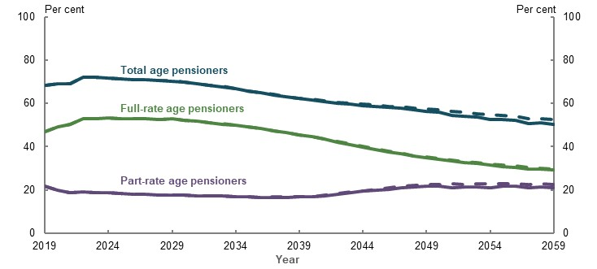
Source: Analysis of Rice Warner estimates for the review.
Age Pension expenditure is projected to increase by 0.06 per cent of GDP by 2059 (Chart 2D-18).
    - Change in Age Pension expenditure with a 9.5 per cent SG rate
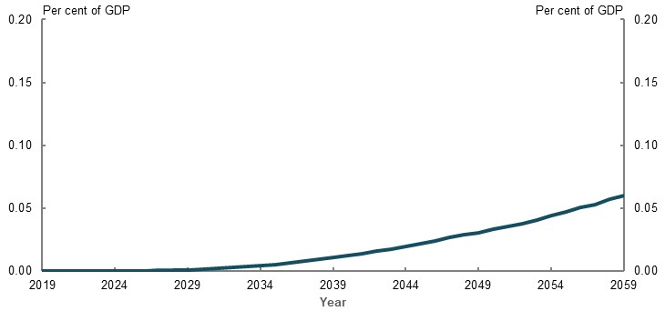
Source: Analysis of Rice Warner estimates for the review.

Change in tax concessions
Rice Warner estimated the impact on superannuation tax concessions, which are projected to be lower under a 9.5 per cent SG rate. Contributions concessions are projected to decrease by 0.1 per cent of GDP by 2059, while earnings concessions are projected to be about 0.1 per cent of GDP lower (Chart 2D-19).
Superannuation tax concessions are not the same as the impact on the budget, as they do not estimate all behavioural changes that people may undertake in response to a change in policy. For this reason, fiscal modelling presented in the Net fiscal impact section above is a better indicator of the impact on the budget of the Australian Government than the impact on tax concessions presented here.
    - Projected change in superannuation tax concessions with a 9.5 per cent SG rate
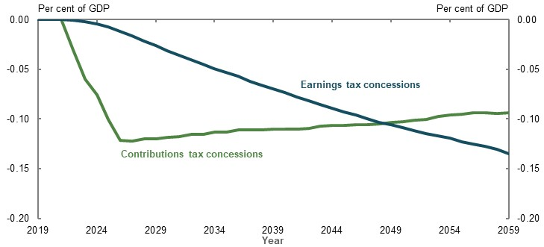
Source: Analysis of Rice Warner estimates for the review.

Change in value of superannuation assets
Rice Warner modelling suggests a smaller change in the value of funds under management, with projections suggesting that a 9.5 per cent SG rate will result in superannuation assets declining by 10 per cent by 2059 (Chart 2D-20).
    - Projected change in value of total superannuation funds under management
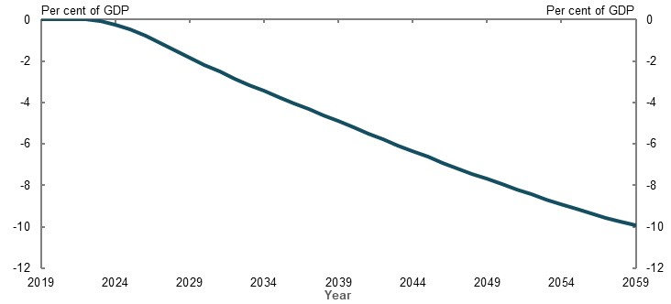
Source: Analysis of Rice Warner estimates for the review.

- Equity

Outline of this chapter
This chapter examines whether the retirement income system is delivering equitable outcomes. When discussing the objective of the retirement income system (see 1C. The objective of the system and the roles of the pillars), two aspects of equity highlighted were to:
- Target Government support to those in need
- Provide similar outcomes for people in similar circumstances
Submissions focused on whether particular groups in the population receive equitable outcomes from the retirement income system (see Appendix 6E. Consultation process).
This chapter analyses internal and external influences on the retirement income system that deliver retirement outcomes for:
- Those with different lifetime incomes and levels of wealth
- Men and women, and singles and couples
- Home owners and non-home owners
- Those covered by the Superannuation Guarantee (SG), and those who are not
- Those who retire at different ages, voluntarily and involuntarily
- Aboriginal and Torres Strait Islander people and the total population
- Those with and without disability
- Different generations (intergenerational equity)
          - Approaches to measuring equity
Equity has no universal measure. Whether an outcome is equitable is a value judgement based on subjective notions of fairness and justice, which may vary from person to person or over time. Any assessment of the equity of the retirement income system depends on the value judgement of the community as a whole.
Some submissions stated or inferred how equity should be measured, referring to factors including:
- Distributions of income and wealth, such as the relative size of superannuation balances or retirement incomes
- Distributions of Government support at points in time and over a lifetime, such as the average value of superannuation tax concessions or income support payments different groups receive
- Proportions of people meeting minimum standards of living, such as the number in poverty or financial stress
- System coverage, such as the proportion who receive the Age Pension or compulsory superannuation
- Qualitative factors, including survey responses and anecdotal evidence, such as how easy it is to engage with the system
All these factors were considered in assessing the equity of the retirement income system settings and the outcomes they delivers to different groups.

Income and wealth distribution
          - Section summary
- The Age Pension reduces income inequality among retirees, as it provides a greater proportion of retirement incomes to lower-income earners. Income inequality among retirees is similar to that of working-age people. The Age Pension more than offsets the increased income inequality due to superannuation tax concessions. As the superannuation system matures, retirement incomes from the Age Pension and superannuation are expected to be more equally distributed as superannuation balances become more equally distributed.
- Full-time, higher-income and continuously employed people receive more lifetime Government support within the retirement income system than lower- and middle-income earners, in dollar terms. As superannuation is an employment-based scheme, full-time and continuously employed people and those at the higher end of the income distribution make more superannuation contributions and receive more superannuation tax concessions. People with the lowest lifetime incomes generally receive most of the Age Pension payments. Reforms, such as lowering the threshold for Division 293 tax and introducing the low income superannuation tax offset, have to some extent reduced the difference in the size of superannuation tax concessions received by lower- and higher-income earners.
- A large proportion of voluntary superannuation contributions are made by people aged 55 and over and higher-income earners. Compulsory superannuation contributions are more evenly spread across ages and incomes than voluntary contributions.
- Many of the very large superannuation balances, which were built up under higher previous contributions caps, are expected to remain in the superannuation system for several decades. In June 2018, over 11,000 people had a superannuation balance over $5 million. These accounts can receive very large superannuation earnings tax concessions.
- Lower-wealth households with people aged 65 and over generally receive more social transfers in kind than higher-wealth households. Means-tested concession cards for seniors provide lower-wealth households more social transfers in kind than higher-wealth households. Middle-income earners receive the largest benefit from the seniors and pensioners tax offset, as lower-income earners are unable to use the entire value of the offset. Some people with large superannuation balances also receive a significant benefit from the seniors and pensioners tax offset, as tax-free superannuation is excluded from the seniors and pensioners tax offset income test.
- Retirees with the same level of savings can receive different retirement incomes depending on the composition of those savings. Different types of retirement savings produce different incomes due to tax variations and the Age Pension means test.

Outline of this section
This section analyses:
- The tax advantage of saving through superannuation across income levels and the size of superannuation contributions and balances
- Income inequality among people aged 65 and over compared with people aged 25-64
- The lifetime Government support the retirement income system provides to people with different income levels
- The size of social transfers in kind and age-based tax concessions received by retirees with different levels of income and wealth
- Whether retirees with similar levels of savings receive similar retirement incomes
          - Stakeholder views on equity of Government support provided through the retirement income system
Stakeholders had divergent views about the equity of Government support through the retirement income system. Many considered the system provides disproportionate levels of Government support to full-time, male, continuously employed and higher-income earners. This was the most common theme raised in submissions made by individuals. One stakeholder noted:
‘The poor design of superannuation tax concessions is the greatest weakness of our retirement income system…’ (Australian Council of Social Service, 2020, p. 35)
A few stakeholders expressed concern about superannuation accounts with very large balances. Many recommended changes to superannuation tax arrangements to reduce the proportion of Government support provided to higher-income earners. One stakeholder stated:
‘Tax concessions for high net worth individuals should be reviewed, with an emphasis on existing superannuation accounts exceeding $10 million.’ (Australian Institute of Superannuation Trustees, 2020, p. 8)
Some stakeholders challenged the way the consultation paper analysed lifetime Government support provided through the retirement income system. These stakeholders considered the analysis overstated the proportion of superannuation tax concessions received by higher-income earners. Most of these stakeholders were not concerned with the current superannuation tax arrangements. One stated:
‘…we consider there is a strong case for concluding that the tax system for superannuation is equitable and does not provide unfair benefits to higher-income earners.’ (Financial Services Council, 2020, p. 64)
Some stakeholders raised concerns about current deeming rates for the Age Pension means test. One stated:
‘It is worth noting that the lower Deeming rate is now, for the first time since 1996, higher than the Reserve Bank Cash Rate.’
(Western Australia Self Funded Retirees Inc., 2020, p. 1)

Tax advantage of saving through superannuation
Most people pay less tax when they save through superannuation compared with other savings vehicles. This is because, even after the reforms of the last 10 years, the superannuation tax system has a relatively flat structure, while the individual income tax system is progressive (see 1B. Design of Australia’s retirement income system).

Superannuation contributions tax
Superannuation contributions tax is applied to superannuation contributions that have not been otherwise taxed. For very high income earners, Division 293 tax means people with annual incomes of $250,000 and over receive a 17 per cent tax concession on contributions above this threshold, lowering their tax advantage (Chart 3A-1).
For people whose income is below the effective tax-free threshold of $21,884, the low income superannuation tax offset removes the tax penalty on superannuation contributions, ensuring the tax on contributions is zero but does not create a tax advantage.

Superannuation earnings tax
Superannuation earnings are taxed at 15 per cent in the pre-retirement phase but are tax-free in the retirement phase. The low income superannuation tax offset and Division 293 tax do not apply to superannuation earnings. This means people with higher annual incomes receive larger tax advantages on superannuation earnings (Chart 3A-1).
    - Tax saving per dollar of concessional superannuation contributions and earnings, by income
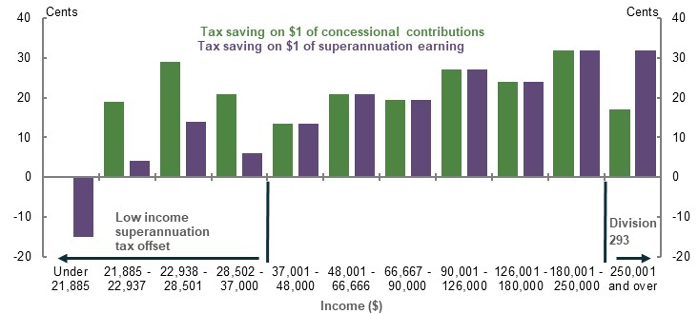
Note: Results for superannuation earnings only apply to assets held in the pre-retirement phase. Applies to the 2019-20 financial year. Tax saving includes the Medicare Levy. Assumes the person is single, has no dependants, is not eligible for the seniors and pensioners tax offset and has private health insurance. Marginal tax rates vary significantly across income levels due to the low income tax offset, low and middle income tax offset, Medicare Levy and Private Health Insurance Rebate. Source: Calculations using 2019-20 income and superannuation tax thresholds.
Over their lifetime, cameo modelling shows higher-income earners receive more superannuation tax concessions than lower-income earners as a percentage of superannuation contributions (Chart 3A-2).
Several stakeholders suggested superannuation savings should be taxed more progressively. Some focused on equalising the tax advantage of superannuation contributions. If this is achieved, less superannuation contributions tax concessions would be received by higher-income earners. However, even if the tax advantage was equalised, higher-income earners would continue to receive larger lifetime contributions tax concessions than lower-income earners as, on average, they make larger contributions than lower-income earners.
A few stakeholders also proposed reducing the tax advantage on superannuation earnings for people on higher incomes. But, given the way this tax is administered, options to equalise the tax advantage on superannuation earnings would pose a number of challenges. This is because superannuation funds currently administer superannuation earnings tax, but the ATO holds information about people’s marginal tax rates.
    - Projected superannuation tax concessions as a percentage of lifetime contributions
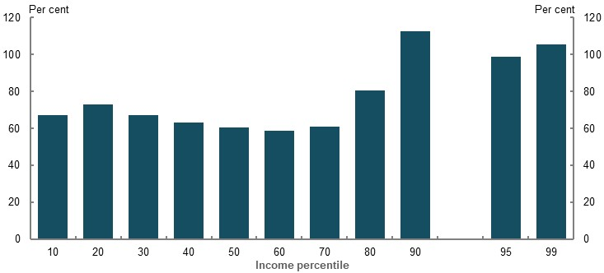
Note: Values are in 2019-20 dollars, deflated using the review’s mixed deflator (see Appendix 6A. Detailed modelling methods and assumptions) and results are similar if deflated by wages. Superannuation tax concessions include those on contributions and earnings. Superannuation tax concessions received as a proportion of contributions can be high as, over a lifetime, earnings tax concessions tend to be the larger component as they are received every year and compound over time along with earnings (see Chart 3A-11 for the make-up of lifetime superannuation tax concessions). Superannuation contributions include all compulsory and salary sacrifice contributions made over a lifetime. Source: Cameo modelling undertaken for the review.

Superannuation contributions

Average annual superannuation contributions
Superannuation contributions vary significantly by income, age, superannuation balance and gender (see 3B. Gender and partnered status). On average, annual superannuation contributions vary more by income than age. Higher-income earners make larger contributions than lower-income earners (Chart 3A-3). However, even the highest-income earners contribute less than the contributions caps, on average.
Before age 65, older people generally make larger contributions than younger people (Chart 3A-3). Contributions begin decreasing after age 65. However, people who continue to work after age 65 continue to increase their contribution amounts until age 75, when they can no longer make voluntary superannuation contributions (Polidano, et al., 2020, p. 21).
    - Average annual superannuation contributions
Income | Age
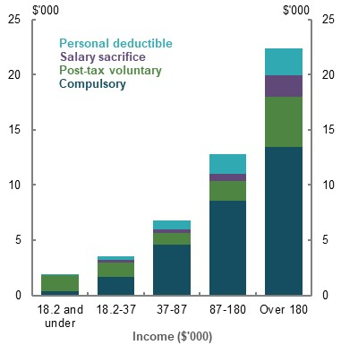 | 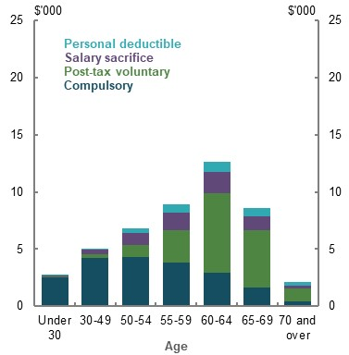
Note: 2017-18 data. Does not include Government co-contributions and spouse contributions. Source: Analysis of ATO individual income tax returns and member contributions statements, 2017-18.

Compulsory superannuation contributions
The size of compulsory superannuation contributions relates directly to a person’s ordinary time earnings. In 2017-18, the top 15 per cent of income earners made 42 per cent of the total compulsory contributions. Average annual compulsory contributions peak around ages 50-54, within the age bracket where average weekly total cash earnings peak (ABS, 2019h).

Pre-tax voluntary superannuation contributions
Average pre-tax voluntary superannuation contributions increase with age and peak just before age 65 (Chart 3A-4). In 2017-18, more than 60 per cent of pre-tax voluntary contributions were made by people aged 55 and over. Pre-tax voluntary contributions also rise with income and superannuation balances. The role of pre-tax voluntary contributions in the Government support provided through the retirement income system is explored in 4. Sustainability.
    - Average annual pre-tax voluntary superannuation contributions
Income | Age
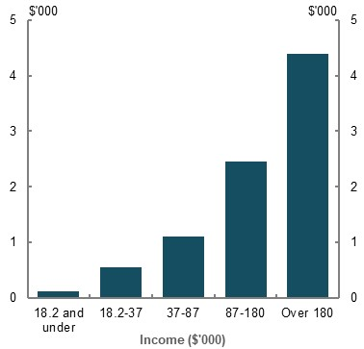 | 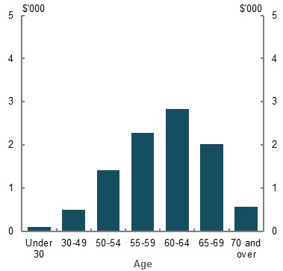
Note: 2017-18 data. Pre-tax voluntary superannuation contributions are equal to the sum of personal deductible and salary sacrifice superannuation contributions. Source: Analysis of ATO individual income tax returns and member contributions statements, 2017-18.

Post-tax voluntary superannuation contributions
Average post-tax voluntary contributions differ significantly depending on a person’s superannuation balance and age. These contributions are highest for people aged 60-64 and those with a superannuation balance between $1 million and $2 million (Chart 3A-5). Contributions fall significantly for people with balances above $2 million, likely because the 1 July 2017 reforms generally prevent people with a total superannuation balance above $1.6 million from making post-tax voluntary contributions (see 1B. Design of Australia’s retirement income system). For example, people with balances exceeding $1.6 million made around $11 billion in post-tax voluntary contributions in 2016-17, but around $900 million in 2017-18. Despite this, people with superannuation balances over $500,000 (around the top 5 per cent of balances) still made 46 per cent of post-tax voluntary contributions in 2017-18.
As post-tax voluntary contributions are typically made at older ages, when people often work reduced hours, income is not the best indicator of whether post-tax voluntary contributions are primarily made by people who were higher-income earners during their working life. Even so, the top 15 per cent of income earners made 28 per cent of post-tax voluntary contributions in 2017-18.
In future, as the superannuation system matures, the proportion of post-tax voluntary contributions made by higher-income earners is expected to reduce. Cameo modelling projects the superannuation balances of the top 5 per cent of income earners would exceed the $1.6 million (in real dollars) balance limit on making non-concessional contributions during working life, generally preventing post-tax voluntary contributions in the years leading up to retirement.
    - Average annual post-tax voluntary superannuation contributions
Age | Superannuation balance
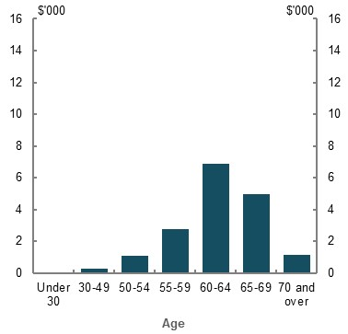 | 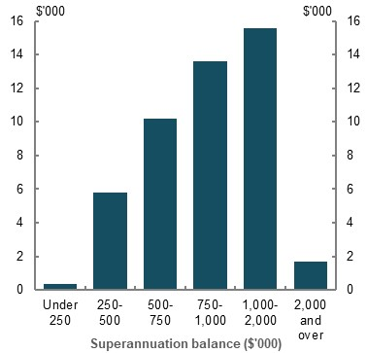
Note: 2017-18 data. Source: Analysis of ATO individual income tax returns and member contributions statements, 2017-18.

Annual caps and contribution flexibility
The annual concessional (compulsory and pre-tax voluntary) contributions cap is $25,000. The annual non-concessional (post-tax voluntary) contributions cap is $100,000 (see 1B. Design of Australia’s retirement income system).
A few stakeholders considered these annual limits may prevent people with variable incomes from building a sufficient superannuation balance at retirement. While this may be an issue for some people, contributions caps are most likely to bind for higher-income earners, for whom income mobility is low (Productivity Commission, 2018b, pp. 95-98). Longitudinal data also suggests most people tend to remain in similar income percentiles, on average, during their entire working life.
In 2017-18, most people did not make voluntary (pre- and post-tax) contributions of more than $25,000. Of the just under 2 per cent who did, the vast majority were aged 55 and over or had a superannuation balance of more than $300,000 (the top 11 per cent of balances) (Chart 3A-6). This suggests most people do not come close to using the full non-concessional contributions cap.
    - Population making annual voluntary (pre- and post-tax) superannuation contributions over $25,000
Age | Superannuation balance
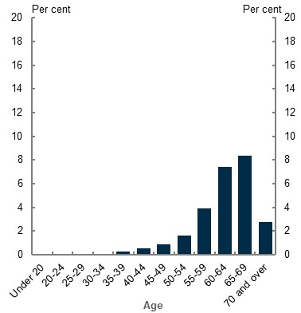 | 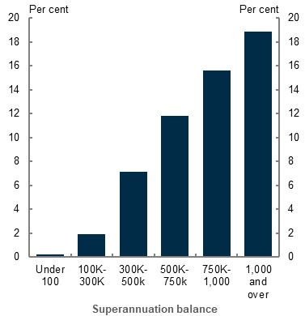
Note: 2017-18 data. Population is limited to people who lodged an income tax return in 2017-18. Source: Analysis of ATO individual income tax returns and member contributions statements, 2 per cent sample, 2017-18.
To support those with variable incomes and interrupted careers, from 1 July 2019, people with a superannuation balance of less than $500,000 have been able to make ‘catch-up’ concessional superannuation contributions. This allows eligible people to make more than $25,000 of concessional contributions in a year. Of the people who made concessional contributions of more than $25,000 in 2017-18, 64 per cent were male and 67 per cent were in the top 16 per cent of income earners. Higher-income women who take a break from the workforce are also likely to benefit from the ability to make catch-up contributions.

The distribution of superannuation balances
There are large differences in the superannuation balances of people aged 60-64 (Chart 3A-7).
Superannuation contributions caps were more generous or non-existent in the past. This allowed some very large superannuation balances to build up.
    - Average superannuation balances for people aged 60-64, by balance decile
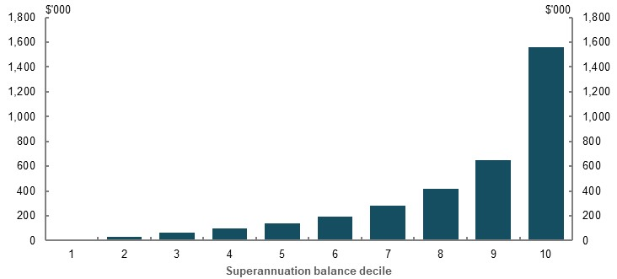
Note: June 2017 data. Superannuation balance is the average balance of all people in the decile. Excludes people with zero balances and people who did not lodge an income tax return in 2016-17. Around 10 per cent of people aged 60-64 recorded in the tax file have no superannuation. A significant number of people not captured by the tax file also would have no superannuation. Source: Analysis of ATO individual income tax returns and member contributions statements, 2 per cent sample, 2016-17.
Since 1 July 2017, superannuation balances greater than $1.6 million cannot be transferred into the retirement phase. This ensures a person with a very large superannuation balance cannot hold all of their assets in the retirement phase, where earnings are tax-free. In addition, people with total superannuation balances above $1.6 million generally cannot make post-tax voluntary contributions (see 1B. Design of Australia’s retirement income system). Despite this, balances above $1.6 million can continue to grow though compulsory and pre-tax voluntary contributions and investment earnings. Between June 2005 and June 2017, the number of people with a superannuation balance larger than $10 million increased from 151 to 1,839 (Chart 3A-8).
    - Number of people with superannuation balances above selected thresholds
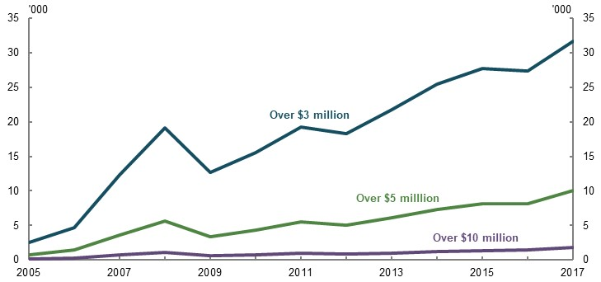
Note: Thresholds use 2017 dollars. Historical balances have been inflated using average weekly ordinary time earnings to 2017 dollars, to be comparable to the 2017 figures. Source: Analysis using data provided by the ATO for the review.
People with very large superannuation balances can receive very large superannuation earnings tax concessions. In 2018-19, a person with a superannuation balance of $5 million would have received, assuming a net earnings rate of 6 per cent, around $70,000 in earnings tax concessions. Using the same assumptions, a person with a superannuation balance of $10 million would have received more than $165,000 in earnings tax concessions. As at June 2017, there was over $90 billion in superannuation accounts with balances of over $5 million. As a person’s superannuation balance increases over time due to earnings growth, so will the value of their earnings tax concessions. Provision of tax concessions for very large superannuation balances are not required for retirement income purposes, as they are unlikely to encourage additional savings (see 5A. Cohesion). It appears that large balances are held in the superannuation system mainly as a tax minimisation strategy, separate to any retirement income goals.
In June 2018, the average age of a person with a superannuation balance above $10 million was 69. Just under 30 per cent (or 576) of these people were aged 65 or younger. Based on life expectancy projections, around 30 per cent of these existing accounts are still likely to be in the superannuation system in two decades’ time. Additionally, in the short to medium term, the number of people with a very large balance may continue to grow.

The distribution of retirement incomes

Equality of retirement incomes compared to working-life incomes
Income inequality (based on disposable incomes plus imputed rent) among people aged 65 and over is similar to people aged 25-64 (Chart 3A-9). This is due to welfare payments, particularly the Age Pension, offsetting the greater inequality in private incomes among people aged 65 and over compared to people aged 25-64. Private income is more inequitable in retirement as:
- Compared to those aged 25-64, people aged 65 and over derive a greater proportion of their private income from their savings than employment. Across the population, savings are less equally distributed than income (ABS, 2019k)
- People with higher lifetime incomes receive more superannuation tax concessions than people with lower lifetime incomes. This results in superannuation tax concessions making up a larger proportion of retirement incomes for higher-income earners than lower-income earners
Welfare payments have a larger effect on income inequality in retirement, compared to their effect during working life, as:
- A greater proportion of people aged 65 and over receive welfare payments than people aged 25-64. In addition, the Age Pension is higher than some working-age payments, such as JobSeeker Payment (excluding the temporary Coronavirus Supplement). Welfare payments reduce income inequality for both age groups as welfare payments are generally means tested. For example, the Age Pension is projected to make up a higher proportion of the total retirement incomes of lower-income earners than higher-income earners.
For both age groups, taxes reduce income inequality. This is because individual income taxes are progressive. Imputed rent also improves income equality for both age groups as:
- The family home is a greater proportion of lower-income than higher-income earners’ wealth (ABS, 2019k)
- Lower-income households are more likely to pay subsidised rent or occupy their dwelling rent-free. Imputed rent includes these subsidies
    - Income inequality in 2017-18
People aged 25-64 | People aged 65 and over
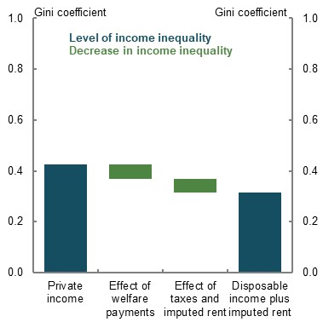 | 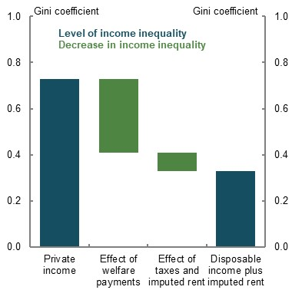
Note: Income inequality is measured by calculating the Gini coefficient. The Gini coefficient is a value between 0 and 1. A value of 0 means that all people have the same incomes (i.e. complete equality), while a value of 1 means all income is received by one person (i.e. complete inequality). Private income refers to income from employment, businesses and investments, such as rent, dividends, royalties and superannuation earnings. Welfare payments include pensions and allowances received by the aged, disabled, unemployed and sick persons, families and children, veterans or their survivors, study allowances for students and all overseas pensions and benefits. Taxes include individual income taxes. Disposable income is equal to private income plus welfare payments less taxes. All income definitions are equivalised for household size. Age of household is the age of the household’s reference person. Source: Analysis of ABS Survey of Income and Housing Confidentialised Unit Record File, 2017-18.
For people aged 65 and over, the income inequality due to superannuation tax concessions is more than offset by the Age Pension. For example, without the Age Pension or superannuation tax concessions, a person at the 90th lifetime income percentile would earn more than eight times the retirement income of a person at the 10th lifetime income percentile. Once the Age Pension and superannuation tax concessions are both accounted for, a person at the 90th lifetime income percentile would earn over twice the retirement income of a person at the 10th lifetime income percentile.
Incomes would be more equally distributed in Chart 3A-9 if social transfers in kind were included. This is because retirees with lower incomes receive greater social transfers in kind than retirees with higher incomes (see Other government benefits provided to people aged 65 and over, below).

Equality of retirement incomes in the future
By 2060, superannuation balances of new retirees are on average projected to be higher than those who retired before them. Future superannuation balances at retirement will also be more equally distributed between retirees compared with those in 2020 (Chart 3A-10). Such a change is projected to decrease the Gini coefficient of superannuation balances at retirement from around 0.7 in 2020 to around 0.5 in 2060 (a lower Gini coefficient represents greater equality). The Age Pension is also expected to continue to play an important role in reducing inequality.
    - Projected distribution of superannuation balances at retirement
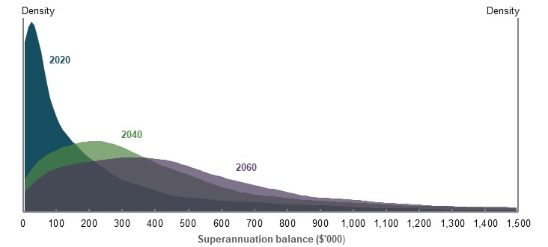
Note: Values are in 2020 dollars, combined for the three trailing years, and deflated by average weekly earnings. SG rates in the future will increase as per the relevant legislation. This involves the SG rate rising to 12 per cent by July 2025. Source: Treasury estimates for the review using MARIA.
The future impact of voluntary savings on the equality of retirement incomes is unclear. In 2017-18, people with higher income and wealth had larger non-superannuation voluntary savings, on average (ABS, 2019k). Rice Warner modelling, which assumes future savings rates reflect long-term averages and investment returns will be aligned with long-term expectations, projects that retirement incomes will be more equally distributed in future. Specifically, it finds the top 20 per cent of retirees by income will receive just over two times the retirement incomes of the bottom 20 per cent of retirees in 2059, compared with just under four times in 2020.

Lifetime Government support provided through the retirement income system
The previous paragraphs considered Government support as a proportion of total retirement income to help assess the effect Government support has on income inequality. To understand the quantum of support provided to people with different lifetime incomes, Government support should be expressed in dollar terms.
People with lower lifetime incomes generally receive the most Age Pension entitlements. Situations where this may not be the case are discussed later in this section and in 3C. Home ownership status and 3B. Gender and partnered status.
In contrast, superannuation tax concessions increase significantly as lifetime income increases due to higher superannuation contributions and balances and a larger tax advantage. As the SG is an employment-based scheme, full-time and continuously employed people are able to make more contributions and receive more tax concessions. The impact of earnings tax concessions means higher-income earners receive more lifetime Government support in dollar terms than lower- and middle-income earners (Chart 3A-11).
Projected lifetime Government support provided through the retirement income system for couples is identified in 3B. Gender and partnered status. Similar to the analysis for individuals (Chart 3A-11), higher-income couples receive more lifetime Government support in dollar terms than lower- and middle-income couples.
Middle- and higher-income individuals may receive an even greater proportion of Government support than is shown in Chart 3A-11 as they:
- Typically have higher life expectancies than people with lower lifetime income (Lawrence, 1999)
- Make larger post-tax voluntary contributions on average than lower-income earners (Chart 3A-3) — these contributions are not included in the modelling
    - Projected lifetime Government support provided through the retirement income system
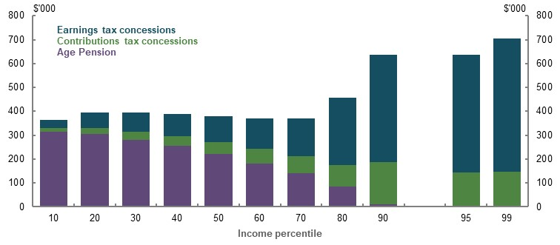
Note: Values are in 2019-20 dollars, deflated using the review’s GDP deflator and uses review assumptions (see Appendix 6A. Detailed modelling methods and assumptions). Middle-income earners receive less support when superannuation is drawn down in line with the minimum legislated rates (see Annex — stakeholders’ issues with lifetime Government support analysis, below). Source: Cameo modelling undertaken for the review.
Higher-income earners receive substantial earnings tax concessions, including from the exemption from tax for earnings in the retirement phase. Superannuation tax concessions in the retirement phase represent a much higher proportion of lifetime tax concessions for higher-income earners than middle-income earners (Chart 3A-12). The earnings tax exemption is projected to provide the largest boost to retirement incomes for higher-income earners.
    - Projected lifetime Government support provided from the retirement income system
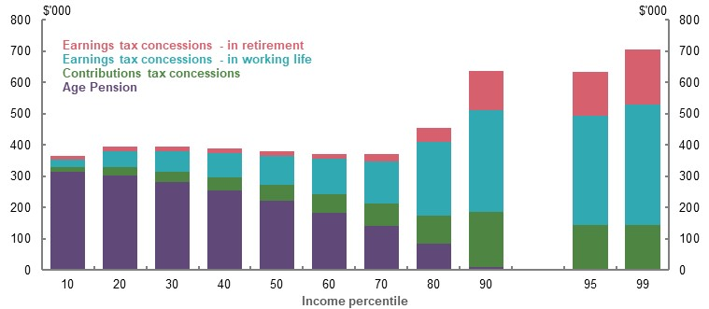
Note: Values are in 2019-20 dollars, deflated using the review’s GDP deflator and uses review assumptions (see Appendix 6A. Detailed modelling methods and assumptions). Source: Cameo modelling undertaken for the review.

Methodology for calculating lifetime Government support
Both Chart 3A-11 and Chart 3A-12 are based on the same methodology as the analysis presented in the consultation paper to calculate lifetime Government support. Some stakeholders raised issues with the methodology, arguing that it overstates the size of superannuation tax concessions that higher-income earners receive relative to lower-income earners. A few stakeholders suggested the analysis should recognise that superannuation tax concessions reduce Age Pension expenditure (see 4. Sustainability).
These issues are discussed in detail in the Annex — stakeholders’ issues with lifetime Government support analysis. It is still considered that the best way to express lifetime Government support provided through the retirement income system is through the methodology used in Chart 3A-11 and Chart 3A-12. Moreover, even when stakeholders’ issues are taken into account, these charts do not change significantly.

Other government benefits provided to people aged 65 and over

Social transfers in kind
Social transfers in kind generally decrease as income and wealth increase (Chart 3A-13). Households in the lower quintiles for income or wealth receive more social transfers in kind than those in the highest quintile for income and wealth. This is because households in lower quintiles are likely to receive the Pensioner Concession Card (see 1B. Design of Australia’s retirement income system for more information about the eligibility criteria and concessions provided by concession cards).
Households in the highest quintile for income and wealth still receive substantial social transfers in kind because some aspects of both the Medicare Benefits Scheme and Pharmaceutical Benefits Scheme are available to everyone. Some of these households may also benefit from concession cards, which in June 2019 were held by around 81 per cent of people over Age Pension eligibility age. Social transfers in kind are likely to be less significant, as a proportion of income, for households in the highest quintile of income or wealth than those in lower quintiles.
Average social transfers in kind received by households vary based on the state or territory of residence. For example, they are 46 per cent higher than the national average in the Northern Territory, and 8 per cent lower in Victoria (ABS, 2018c) (see Chart 6D-1). This may partly explain why social transfers in kind do not always decline as household wealth rises.
    - Average weekly social transfers in kind for households aged 65 and over
Private income | Net wealth
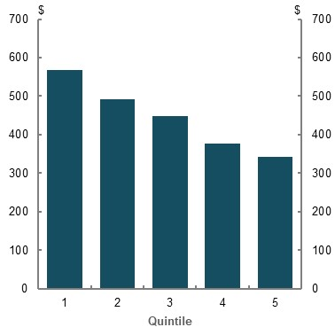 | 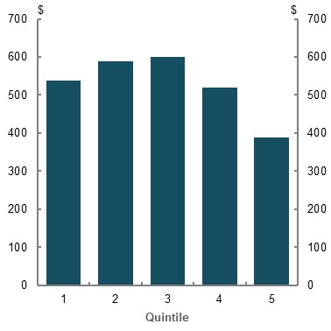
Note: Captures social transfers in kind in 2017-18. Uses ‘equivalised’ social transfers in kind so results are not biased due to differences in the size of households. Age of household is equal to the age of the household’s reference person. Source: Analysis of Survey of Income and Housing, 2017-18.

Concessions for older Australians through the personal income tax system
The seniors and pensioners tax offset results in some older Australians paying less income tax than a working-age Australian on the same income. For example, a single senior Australian eligible for the seniors and pensioners tax offset who earns $35,000 in 2018-19 would pay $602 in income tax. Yet, a single working-age Australian not eligible for the seniors and pensioners tax offset who earns the same income would pay $2,492.
As the seniors and pensioners tax offset is non-refundable, people with low levels of retirement savings — and who receive the maximum rate of Age Pension — cannot use the maximum value of the offset. As a result, people with higher levels of retirement savings, and who are in the 6th and 7th deciles of the taxable income distribution, receive the largest benefit from the seniors and pensioners tax offset (Chart 3A-14). The total cost of the seniors and pensioners tax offset is estimated in 4. Sustainability.
    - Average taxable income of people aged 65 and over, by taxable income decile
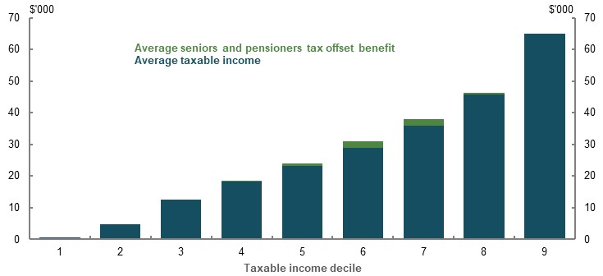
Note: Excludes the tenth decile due to scale. Only captures people who lodged an income tax return in 2013-14. Data provided by the ATO for the review highlights that in 2017-18, around 2.5 million people aged 65 and over did not lodge an income tax return as their income was less than the effective tax-free threshold. As the tax-free threshold is higher due to the seniors and pensioners tax offset, this means many people who benefited from the seniors and pensioners tax offset may not lodge a tax return. Source: Replication of (Daley, et al., 2016), which is derived from taxation statistics 2013-14 individuals’ sample file.
Superannuation benefits that are tax-free are excluded from the seniors and pensioners tax offset’s income test. This meant just under 30 per cent of people with a superannuation balance of $2 million and over accessed the seniors and pensioners tax offset in 2017-18 (Chart 3A-15). In 2017-18, the average superannuation balance of people aged 65-69 who lodged a tax return and accessed the seniors and pensioners tax offset was about $230,000. In future, as the superannuation system matures, the average superannuation balance of people accessing the seniors and pensioners tax offset is expected to be higher.
Through the personal income tax system, older Australians also benefit from the Medicare Levy thresholds. These thresholds mean that older Australians who do not pay income tax also do not pay any Medicare Levy (Costello, 2001, p. 4). As older Australians have a higher effective tax-free threshold due to the seniors and pensioners tax offset, they benefit from a higher Medicare Levy threshold.
For example, in 2018-19, single older Australians did not pay the full rate of the Medicare Levy until their taxable income exceeded $45,069. In comparison, most single working-age Australians paid the full rate of the Medicare Levy once their taxable income exceeded $28,501.
    - Proportion of people aged 65 and over who received the seniors and pensioners tax offset recipients, by superannuation balance
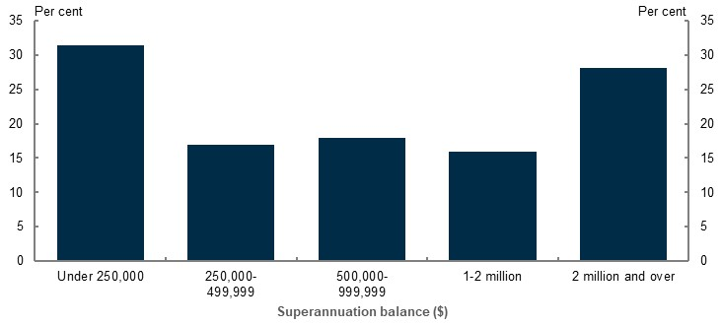
Note: 2017-18 data. Population is limited to people who lodged a tax return and had a positive superannuation balance in 2017-18. Includes people expected to be eligible for the seniors and pensioners tax offset as they are aged 65 and over, have a rebate income below the threshold amount and have a positive income tax liability after the tax-free threshold and low income tax offset are applied. See (ATO, 2019c) for an explanation of how rebate income is calculated. Source: Analysis of ATO individual income tax returns and member contributions statements, 2 per cent sample and complete sample, 2017-18.
Like the seniors and pensioners tax offset, the income test for the Medicare Levy excludes tax-free superannuation benefits. This means people with high superannuation balances and incomes do not necessarily pay higher amounts of Medicare Levy than people with low superannuation balances and incomes.

Do retirees with similar levels of savings receive similar retirement incomes?
Retirees with the same level, but a different composition, of savings can receive different retirement incomes. This is partly because different assets receive different rates of return, and partly a result of different tax treatments and Age Pension means test settings (see Section 3C. Home ownership status).

Different tax treatment
Superannuation earnings are taxed at concessional rates. This means the annual tax liabilities of retirees with the same level of savings can vary, depending on how much of their savings is held inside and outside superannuation. This variance is currently only significant for people with savings greater than $1 million, excluding the family home (Table 3A-1).
      - Income tax paid by retirement savings and composition of assets
Retirement savings  ($’000) | 80 per cent in superannuation and 20 per cent in other assets ($) | 20 per cent in superannuation and 80 per cent in other assets ($)
200 | 0 | 0
500 | 0 | 0
1,000 | 0 | 7,147
5,000 | 34,967 | 93,997
10,000 | 99,622 | 218,797
Note: Calculations apply to 2018-19 financial year. Retirement savings are equal to superannuation plus other assets, excluding the family home. Assumes the person is single, is eligible for the seniors and pensioners tax offset, did not receive an Australian Government pension or allowance during the year, nominal investment returns are 6.5 per cent per year, the first $1.6 million of superannuation assets are held in the tax-free retirement phase and all earnings from other savings vehicles are taxed at the person’s marginal tax rate. As the latter assumption may be unrealistic for people with high levels of wealth, the results in this table can be interpreted as an upper boundary for the effect of asset allocation on a person’s income tax liability. Source: Calculations using (ATO, 2018; ATO, 2019a).

Age Pension means test
The Age Pension means test separately assesses a person’s level of assets and income (see 1B. Design of Australia’s retirement income system). The operation of the means test can result in people with different levels of assets and/or income receiving the same Age Pension income in some circumstances. This is because, when the assets test determines a person’s Age Pension payment amount, their income level does not affect their Age Pension payment amount. The result can be that someone with a higher annual income can receive the same Age Pension as someone with a lower annual income (Table 3A-2).
Similarly, when the income test determines a person’s Age Pension payment amount, the value of a person’s assets does not affect their Age Pension payment amount. The result can be that someone with greater assets can receive the same amount of Age Pension as someone with fewer assets. Different types of potential means-test arrangements are discussed in 5A. Cohesion. The trade-offs involved in merging the means tests are identified in Appendix 6B. An example to illustrate the trade-offs of merging the means test.
      - Cameo: Annual Age Pension payment for people with different means
 | Person 1 | Person 2
Age | 67 | 67
Account-based pension income ($) ($500,000 with 5 per cent drawdown) | 25,000 | 25,000
Employment income ($) | 0 | 20,000
Total income ($) | 25,000 | 45,000
Age Pension ($) | 6,085 | 6,085
Note: Values are in 2019-20 dollars. The Age Pension assets test determines the Age Pension payment amount for both person 1 and 2. Source: Calculations based on Age Pension rates and thresholds as at 1 May 2020.
Deeming rules may result in the Age Pension income test assessing a higher or lower amount of income than the person actually received in the period. The current lower and upper deeming rates, of 0.25 and 2.25 per cent respectively, are lower than returns on some market-linked investments, such as superannuation from conservative investment strategies and the ASX 200 dividend yield on average over recent years. Around 68 per cent of age pensioners affected by the upper deeming rate of 2.25 per cent hold some market-linked investments, which generally attract higher returns than term deposits or bank accounts. This proportion can be expected to increase as the superannuation system matures and becomes the main financial asset held by age pensioners. This may allow some retirees to be deemed to earn a return on their financial investments of between 0.25 per cent and 2.25 per cent, while actually earning much higher rates of return on these assets. Nevertheless, deeming, rather than assessing, the actual income received from financial investments has merits (see 1B. Design of Australia’s retirement income system).
          - Impact of changes to certain policy settings on lifetime Government support provided through the retirement income system
A significant number of submissions raised policy proposals affecting the size of lifetime Government support provided to people with different income and wealth levels. The following summary outlines some implications of some of those proposals.
- Changes to superannuation tax arrangements. Higher-income earners receive the majority of lifetime Government support through superannuation tax concessions. Lower-income earners receive the majority of lifetime Government support through the Age Pension. Tightening superannuation tax concessions would therefore affect higher-income earners the most (see 4. Sustainability).
- Raising the SG rate. Higher-income earners make the largest compulsory superannuation contributions and therefore receive more superannuation contributions tax concessions. Additionally, they either do not qualify for, or lose minimal, Age Pension if they retire with higher superannuation balances. Increases in the SG rate would make the distribution of Government support provided by the retirement income system more inequitable (see 2D. Policy scenario: Implications of maintaining the SG rate).
- Including tax-free superannuation income in the income test for the seniors and pensioners tax offset and the Medicare Levy. Such a change would ensure that retirees with large superannuation balances are not able to access these age-based tax breaks.
- Introduce a merged means test for the Age Pension. A merged means that replaces the assets test with a capital consumption component in the income test would ensure a person’s Age Pension payment is consistently determined on the totality of their means. In some situations, this does not occur under the current dual means tests (see 5B. Policy scenario: Implications of changing Age Pension means test settings).

Annex — stakeholders’ issues with lifetime Government support analysis
The consultation paper presented the review’s estimates of the size of lifetime Government support for people with different income levels (see 3A. Income and wealth distribution, above). Submissions raised issues about the reliability of these estimates. Issues raised about the total cost of the superannuation tax concessions are discussed in 4. Sustainability. This Annex discusses issues raised about the size of lifetime Government support that higher-income earners receive relative to lower-income earners.

Stakeholder suggestions for updating the analysis
- Calculate the cost of superannuation tax concessions using an expenditure tax benchmark.
  - While 4. Sustainability discusses this alternative benchmark, it concludes the comprehensive income tax benchmark is the most appropriate benchmark for the review. Although adopting an expenditure tax benchmark may reduce the apparent cost of superannuation tax concessions, it is not clear the distribution of those concessions would be different to the analysis presented in 3A. Income and wealth distribution.
- Recognise that voluntary contributions would be saved through other concessionally taxed savings vehicles in the absence of superannuation tax concessions.
  - Cameo modelling suggests the earnings tax concessions resulting from voluntary pre-tax contributions are only a small proportion of the lifetime Government support the retirement income system gives to higher-income earners (Chart 3A-16). This is because most of the earnings tax concessions higher-income earners receive come from their compulsory superannuation contributions.
- Reflect that people move between income deciles during their working lives.
  - The income profiles generated by the cameo model used for the review were tested against longitudinal income data from ALife. Comparisons show lifetime income is broadly similar between the cross-sectional income profiles used in the cameo model and the longitudinal ALife data (see Appendix 6A. Detailed modelling methods and assumptions).
- Use inflation, wage growth or the Government’s borrowing rate, rather than nominal GDP (i.e. 5 per cent per year), as the discount rate for Age Pension expenditure and superannuation tax concessions.
  - The Government can fund the cost of Age Pension expenditure and superannuation tax concessions through borrowing or future tax receipts. The same factors drive nominal GDP growth and bond rates, and as such are broadly comparable over the long term. Economic theory suggests that in the long run government bond rates will be marginally higher than nominal GDP growth (Romer, 2019) and the IMF uses nominal GDP growth as the lower bound for the discount rate in some applications (Kozac, 2005, p. 18). The 40-year average of the Australian Government 10-year bond is 7.7 per cent compared with 7.3 per cent for average annual nominal GDP growth.
  - Public Sector Superannuation Scheme and Commonwealth Superannuation Scheme Long Term Cost Report 2017, prepared for the Commonwealth Government by Mercer, considered the expected return on government bonds over the long term is the appropriate discount rate for funding future benefit payments via borrowings. However, it also suggested expected long-term nominal GDP growth provides a ‘…useful check on the long term bond yield assumption…’ as it represents the earnings of the Government and therefore ‘…sets a reasonable limit on the rate that can be paid on any debt (all other things being equal).’ (Department of Finance, 2018, p. 14)
  - It is identified in 1C. The objective of the system and the roles of the pillars that delivering adequate outcomes from the system should be cost-effective for taxpayers. Discounting Age Pension expenditure and the cost of superannuation tax concessions by the inflation rate or wages growth would not correctly present the cost of the system to taxpayers.
- Express superannuation tax concessions as a proportion of superannuation contributions, rather than in dollar terms.
  - This approach would only aid understanding of the proportion of superannuation balances attributable to public support, not the actual quantum of support provided to people with different means. Expressing lifetime Government support in dollar terms aids understanding of:
    - The quantum of support provided to people with different means
    - Whether Government support is allocated to people who already have adequate retirement outcomes
    - Government’s ability to absorb the costs of the retirement income system
- Include social transfers in kind provided to retirees.
  - Chart 3A-13 in 3A. Income and wealth distribution highlights that although higher-wealth households generally receive less social transfers in kind than lower-wealth households, they still receive substantial transfers. As a result, including social transfers in kind in the lifetime Government support analysis is unlikely to substantially change the results of the analysis presented in this report.
    - Projected proportion of lifetime Government support provided through earnings tax concessions on voluntary pre-tax superannuation contributions
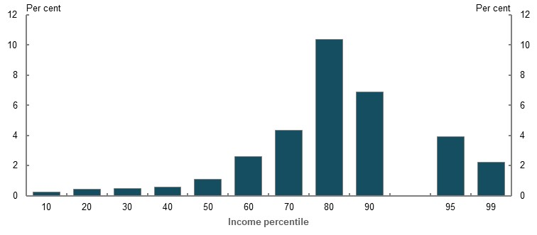
Note: Values are in 2019-20 dollars, deflated using the review’s GDP deflator and uses review assumptions (see Appendix 6A. Detailed modelling methods and assumptions). Earnings tax concessions on voluntary pre-tax contributions is estimated by comparing total earnings tax concessions with and without making salary sacrifice contributions. Does not include personal deductible pre-tax voluntary contributions. Source: Cameo modelling undertaken for the review.

Superannuation drawdown rate
The lifetime Government support analysis presented in 3A. Income and wealth distribution assumes superannuation savings are drawn down to exhaust people’s superannuation savings at life expectancy. However, many retirees draw down at the minimum drawdown rates (see 5A. Cohesion), which are lower than those required to exhaust superannuation savings at life expectancy. Lower drawdown rates increase the amount of superannuation tax concessions obtained in retirement and decrease the Age Pension entitlements for some people. The distribution of lifetime Government support does not significantly change under the minimum drawdown rates, compared with drawing down superannuation to exhaust at life expectancy (Chart 3A-17). This is because:
- Most superannuation tax concessions are earned prior to retirement (see 4. Sustainability)
- For middle-income earners, the increase in the amount of superannuation tax concessions received is offset by receiving less Age Pension (see 4. Sustainability)
    - Projected lifetime Government support provided through the retirement income system, by drawdown strategy
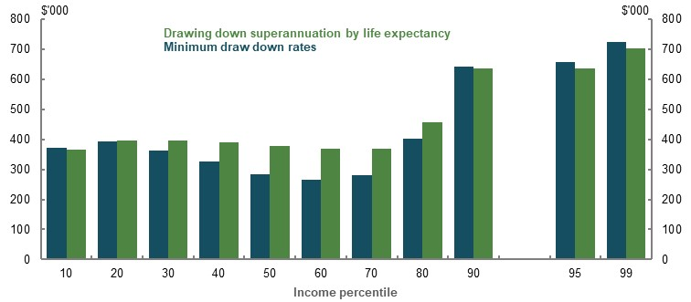
Note: Values are in 2019-20 dollars, deflated using the review’s GDP deflator and review assumptions (see Appendix 6A. Detailed modelling methods and assumptions). Minimum drawdown rates are the legislated rates for superannuation income streams. Source: Cameo modelling undertaken for the review.

Gender and partnered status
          - Section summary
- Differences in retirement savings between men and women reflect the accumulated economic disadvantages faced by women in working life. On average, compared with men, women have lower wages, are more likely to work part-time, take more career breaks, and experience worse financial impacts from divorce. These factors contribute to the gender gap in superannuation balances at retirement.
- The working-life earnings gap between men and women, rather than retirement income system settings, is the main driver of the gender gap in superannuation balances at retirement. Some elements of the retirement income system have a small effect on the gender gap in superannuation balances. Fixed fees and insurance premiums, and exclusions from the SG — such as the $450-a-month threshold and paid parental leave — increase the gap in balances, although their net effect on retirement incomes is small. System features, such as the low income superannuation tax offset for lower-income earners and the Division 293 tax on contributions for very high income earners, marginally reduce the average gender gap in superannuation balances and retirement incomes.
- Women retire earlier and live longer than men, meaning their savings have to last longer.
- In future, the gap between men’s and women’s superannuation balances and coverage is expected to narrow substantially, but not close. This is due to the maturing superannuation system, higher voluntary contributions made by women, and the lag effects of previous increases in female labour force participation on superannuation balances at retirement. However, gaps are likely to remain if women continue to have lower workforce participation and earnings than men.
- Women make more voluntary superannuation contributions than men — both in number and in value. These contributions are largely made by women with higher superannuation balances, or those whose partners have relatively high balances (compared with the total population). However, as men have greater lifetime earnings than women, they tend to benefit more from superannuation tax concessions.
- Income inequality between women and men is lower in retirement than in working life, particularly for lower- and middle-income earners. This is due to the Age Pension, which women are more likely to receive, and for longer, than men.
- Most people enter retirement as a couple, although this trend is falling. Women are more likely than men to enter retirement single, and they are more likely to become single in retirement. Women who are coupled generally expect to retire earlier than coupled men.
- Couples are significantly better off in retirement than single men and women. Couples in retirement have lower rates of poverty and financial stress, higher rates of home ownership and higher levels of wealth than single people in retirement. Single men are most likely to be asset poor, while single women are more likely to have more of their wealth held in their home compared with single men and couples.

Outline of this section
This section considers both the relative differences between men’s and women’s retirement incomes, as well as the absolute poverty and financial stress some women face in retirement.
It analyses factors internal and external to the retirement income system that improve or worsen inequities between men and women:
- In working life, such as the gender pay gap, career breaks, SG coverage and voluntary superannuation contributions.
- In retirement, such as life expectancy, drawdown behaviour and the Age Pension.
It also analyses retirement trends for, and characteristics of, singles and couples in retirement.
          - Stakeholder views on gender and partnered status equity
Many submissions and stakeholders were concerned about differences between men’s and women’s retirement outcomes.
Stakeholders noted that women:
- Face many working-life inequities, including the gender pay gap, gendered discrimination in the workforce, more part-time work, time out of the workforce to care for others, significant financial impacts from divorce and family and domestic violence, and lower rates of financial literacy
- Have lower private savings and lower superannuation balances and coverage than men; in particular, women’s superannuation balances are more affected by the $450-a-month threshold and the exclusion of SG on paid parental leave
- Rely more on the Age Pension in retirement, due to their lower savings and longer lives
Most stakeholders noted the inequities experienced by women in retirement are caused by the inequities they face in working life. One submission stated:
‘The retirement income system cannot solve the primary reason why women generally retire with lower balances — their lower lifetime earnings overall.’
(Financial Services Council, 2020, p. 10)
Some stakeholders suggested retirement income system settings should be used to ameliorate these working-life differences between men and women — for example, that legislated increases to the SG rate, or a higher SG rate for women than men, could improve outcomes for women.
Some stakeholders stressed the importance of the Age Pension in levelling outcomes between men and women, as it does not depend on working-life earnings. Some stakeholders also noted the significant proportion of retirees who are coupled in retirement, the ability of couples to share resources and the poorer retirement outcomes faced by singles compared to couples.

Gender gaps in retirement outcomes
The gender earnings gap in working life has a significant bearing on the gender gap in superannuation balances at retirement. This, combined with other savings and income sources, such as the Age Pension, affects the gender retirement income gap.
Women experience a gender earnings gap in working life for many reasons, including that women are more likely to:
- Work in lower paid roles
- Work in lower paid industries
- Work part-time or casually
- Take career breaks from paid employment to care for others, including raising children
- Experience discrimination and harassment in the workforce
- Experience family and domestic violence
Box 3B-3 sets out how gender gaps have been calculated.

          - Measuring gender gaps
Gender gaps have been calculated as follows:
$$Gap \left(\%\right)= \frac{Male value-Female value}{Male value}×100$$
The ‘value’ in question can be a variety of indicators, as set out below.

Earnings gap
Most stakeholders defined the gender earnings gap as the gap in full-time adult average weekly ordinary time earnings. In November 2019, this gap was 14 per cent (ABS, 2020d). However, this metric is not the most appropriate to use when considering the impact of earnings differences between men and women on retirement incomes. It does not take into account a person’s entire earnings (e.g. it excludes overtime), or the many women who work part-time or casually.
This section uses different measurements of the earnings gap, depending on whether it is analysing the total population or hypothetical individuals.
- Total population analysis uses ATO data of annual taxable wages/salaries. ATO data allows for robust distributional analysis across earnings percentiles, as it is drawn from the whole population.
- Cameo analysis of individuals uses ABS weekly earnings data. This allows for comparisons of gender earnings gaps between all full-time workers, and between all workers including those working part-time and casually.
Earnings gap analysis does not include those who have no earnings. Women are more likely to have no earnings than men.

Superannuation balances at retirement gap
The media and other stakeholders often report the gender superannuation gap using data on superannuation balances from the ABS Survey of Income and Housing. In contrast, this section uses data from the ATO, which is at a population level, not a sample. ATO data is also collected directly from superannuation funds. It is therefore more accurate than the ABS figures, which are self-reported by individuals.

Retirement income gap
When assessing the gender retirement income gap, this section takes into account income from all sources, including the Age Pension, superannuation and other income from work or investments.

Cameo modelling was used to project gender gaps in working-life earnings, superannuation balances at retirement and retirement incomes for individuals with different incomes (Chart 3B-1). This was supplemented by additional modelling of the individual drivers of differences in retirement outcomes between men and women, including full-time and part-time pay gaps and career breaks, in addition to modelling of outcomes for those who are coupled.
    - Projected gender gaps in working-life earnings, superannuation balances at retirement and retirement incomes, by income percentile
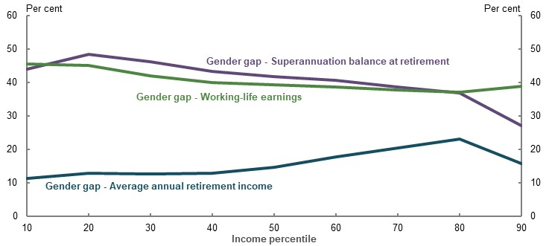
Note: Gender gaps are calculated relative to the relevant figure for men — that is, a 10 per cent gender gap in earnings means that women’s earnings are 90 per cent of men’s earnings. See Box 3B-3 for details. The chart compares the 10th percentile for men to the 10th percentile for women, and so on. Gaps in superannuation balances at retirement and retirement incomes do not factor in the effect of voluntary superannuation contributions not made through salary sacrifice. If included, these would reduce the gaps in balances and retirement incomes between men and women. Calculations are based on values deflated using the review’s mixed deflator. Disaggregation of these gaps can be found in Appendix 6D. Supplementary equity charts. Source: Cameo modelling undertaken for the review.
The gender gaps in working-life earnings, superannuation balances at retirement and retirement incomes are a result of drivers in both working life and retirement. These drivers can be further separated into those external to the retirement income system, such as the gender pay gap and divorce, and drivers within the retirement income system’s settings, such as superannuation tax concessions, fees and insurance premiums, and exclusions from the SG.

Working-life drivers of gender gaps outside the retirement income system

Gender pay gap
A key reason for the gender gap in working-life total earnings is the gender pay gap, which can be separated into the effect of:
- Women generally being paid less than men — the full-time pay gap
- Women being more likely than men to work part-time — the total pay gap
Across all men and women working full-time (excluding part-time and self-employed workers), the gender pay gap is 16.9 per cent. Cameo modelling projects that this results in a 17.4 per cent gender gap in superannuation balances at retirement (Table 3B-1). The difference between the two is largely due to the effect of fees and insurance premiums. The equivalent annual retirement income gender pay gap is lower, at 8.4 per cent, largely due to the levelling effect of the Age Pension.
      - Projected gaps between men and women
 | Working-life earnings gap  (per cent) | Superannuation balance at retirement gap (per cent) | Average annual retirement income gap (per cent)
Full-time workers | 16.9 | 17.4 | 8.4
All workers (including part-time and casual) | 31.4 | 32.6 | 9.6
Note: Working-life earnings are calculated using total average weekly earnings, seasonally adjusted, November 2019 (ABS, 2020d). Men and women are modelled to receive constant wages in real terms for their entire working life, based on total average weekly earnings. Assumes no non-superannuation savings and no salary sacrifice. Superannuation balance gap is based on values deflated by average weekly earnings. Earnings and income calculations are based on values deflated using the review’s mixed deflator. Source: Cameo modelling undertaken for the review.
The gender pay gap for all workers is significantly larger than the full-time pay gap because women are over-represented in part-time and casual work. This leads to a larger gender gap in superannuation balances at retirement. But, the average annual retirement income pay gap for all workers reduces to 9.6 per cent because the Age Pension plays a larger role in the retirement of those with lower working-life incomes, such as part-time and casual workers (see 3A. Income and wealth distribution).

Career breaks
Of those currently retired, women are likely to have been in the labour force for fewer years than men (see 2C. Maintaining standards of living in retirement). Women are more likely to be carers, with 93.5 per cent of all primary carer’s leave taken by women (Workplace Gender Equality Agency, 2019). In 2018-19, among parents of children aged five and under, 64.2 per cent of women were in the labour force, compared to 94.6 per cent of men (ABS, 2019j).
Caring for children reduces women’s lifetime earnings. One study showed that women with a child aged two or younger in 2001 experienced an average 77.5 per cent reduction in earnings over the subsequent 15 years, compared with those without children. Men with young children faced no significant earnings penalty (Austen & Mavisakalyan, 2018, p. 502).
The average superannuation balances of men and women significantly diverge when accounting for whether the person has children (Chart 3B-2).
The average superannuation balances of men and women without children are broadly similar until ages 45-54. Lower labour force participation and earnings — taking career breaks and working part-time to care for children — contribute to women with children having lower superannuation balances than women without children. Conversely, men with children have higher average superannuation balances than men without children. One reason for this may be that men with lower incomes are less likely to have children (Hopcroft, 2018).
    - Average superannuation balances by age, gender and whether a person has children
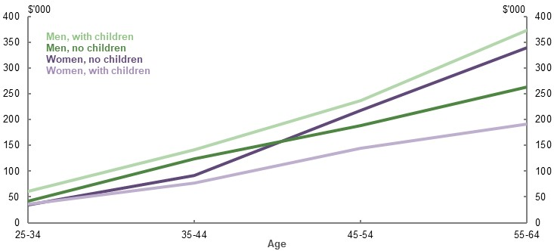
Note: 2018 data. Balances are for those not retired. These figures are not controlled for other variables like income or socio-economic status. As such, the results above do not represent the isolated effect of having children on a person’s superannuation balance (i.e. it cannot be concluded that the gender gap in superannuation balances is caused by having children). Rather, this shows the distribution of average balances by age, gender and whether a person has children. Source: Analysis of HILDA Survey data (Wave 18).
Table 3B-2 models five career break scenarios:
- One child at age 30, taking two years off work before returning to work full-time.
- One child at age 30, taking two years off work and then working part-time until the child is five years old, before returning to working full-time.
- Two children at ages 30 and 33, taking two years off work for each child, before returning to work full-time.
- Two children at ages 30 and 33, taking two years off work for each child and working part-time until the youngest child is five years old, before returning to work full-time.
- Working part-time from age 55 to retirement (age 67) to care for a parent.
The modelling shows that when women take more time out of the workforce, the gender gaps in superannuation balances and retirement incomes increase. However, the effect on retirement incomes is less pronounced because of the Age Pension.

      - Projected effect of career breaks on gender gaps
 | Working-life earnings gap  (per cent) | Superannuation balance at retirement gap  (per cent) | Average annual retirement income gap  (per cent)
Full-time, no career break | 16.9 | 17.4 | 8.4
1. One child, no part-time | 28.0 | 29.6 | 10.3
2. One child, part-time | 30.2 | 32.6 | 11.1
3. Two children, no part-time | 38.5 | 41.2 | 13.4
4. Two children, part-time | 41.2 | 44.7 | 14.5
5. Part-time to care for parent | 26.8 | 25.2 | 9.5
Note: Gaps compare the outcomes for a woman with a career break with a man who works full-time. Working-life earnings are calculated using total average weekly earnings, seasonally adjusted November 2019 (ABS, 2020d). Men and women are modelled to receive constant wages in real terms, for their entire working life excluding the effect of career breaks. Part-time workers are assumed to have 60 per cent of the earnings of full-time workers. In years off from the workforce, women are assumed not to benefit from wage growth — earnings in the year after a career break are the same in nominal terms as the year prior to the career break, implying a wage decrease in real terms. Wages remain constant relative to average weekly earnings post-career break and do not return to pre-career break levels. Assumes no non-superannuation savings and no salary sacrifice. Superannuation balance gap based on values deflated by average weekly earnings. Earnings and income calculations are based on values deflated using the review’s mixed deflator. Source: Cameo modelling undertaken for the review.
Taking a career break early in working life reduces superannuation balances at retirement more than a career break later in working life. Scenario 2 (taking two years off, and working part-time from ages 32-34) and scenario 5 (working part-time from ages 55-67) have similar average annual retirement incomes, even though the woman with the child took almost half the time off work.
The impact of children on the gender earnings gap has gradually diminished over time. For women born in 1980-81, the gender gap in earnings was significantly lower during the typical child-rearing years of late 20s to late 30s, compared with those born in earlier years (Chart 3B-3). Women are spending longer in the workforce, from an average working life of around 24 years in 1980 to around 38 years in 2019 (see 2C. Maintaining standards of living in retirement). This increase in women’s labour force participation and earnings may mean that, in future, having children or taking career breaks will not have as significant an effect on women’s superannuation balances as in the past.
    - Gender gap in median annual earnings, for those with typical earnings in child-rearing years, by age and year of birth
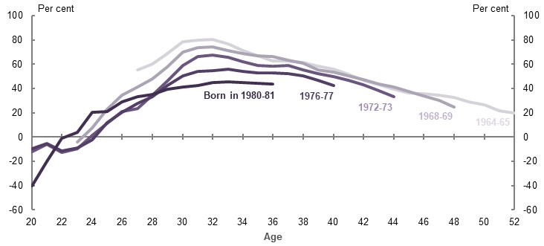
Note: Chart is created by sorting the population, for each gender and year of birth, into deciles based on cumulative income across ages 27 to 36. For each decile, gender and year of birth, the median income from salary/wages is calculated at each age. Gender gaps are calculated for each age. The chart shows results for the 5th decile. Analysis excludes those with less than three cumulative years of wage/salary income, to remove the effect of temporary migrants. Historic wage/salary income is inflated using average weekly ordinary time earnings. Source: Data provided by the ATO for the review.

Divorce
Since the early 1980s, rates of divorce have steadily increased among older age groups (ABS, 2019q). In 2016, around 19 per cent of women and 15.4 per cent of men aged 60-64 were divorced and single (ABS, 2016a), compared with 6.7 and 6.3 per cent of women and men, respectively, of the same age group in 1991 (ABS, 1993).
In 2018, the median age of divorce was 45.9 years for men and 43.2 years for women (ABS, 2019q), up from 35.3 years and 32.7 years, respectively, in 1980 (ABS, 1997, p. 36). This age increase has reduced the amount of time a divorcee has to recover financially before retirement.
Since 2002, superannuation has generally been able to be divided up in family law property settlement decisions. But, significant challenges and complexity exist that hinder fair outcomes when superannuation is split under family law.
A study of property splits of parents separating between 2006 and 2012 found only 34 per cent of splits included superannuation assets (Kaspiew & Lixia, 2016). This is below the rate of superannuation coverage (for those aged 25-64 in 2012, it was at least 81 per cent for men and 70 per cent for women) (ABS, 2019k). Those with superannuation assets included in their property settlement tended to be older and have higher incomes. This suggests, when relationships break down, many people — and particularly those with lower incomes — are not enforcing their entitlement to their former partner’s superannuation. This particularly disadvantages women, who generally have lower superannuation than their former partner, particularly if they have children (Brown, 2016, p. 18).
A recent small study of property settlements in Victoria offered insight as to why superannuation is not a part of many property splits:
‘Women’s access to superannuation in property settlements is impacted by many of the issues associated with parties failing to make full and frank disclosure. The legal and administrative complexities associated with obtaining orders over superannuation also inhibit women’s access to it after separation.’ (Women's Legal Service Victoria, 2018, p. 25)
These factors, and other reasons why superannuation is not included in many property splits, merit further study.
In 2018, the Government announced a measure to increase the visibility of superannuation assets in family law proceedings. This would allow the ATO to provide accurate and timely superannuation data to courts during family law proceedings. This measure is yet to be legislated or implemented.
Divorce reduces both parties’ savings, and hence their retirement incomes, but has a stronger and longer lasting effect on women, especially those with dependent children (Brown, 2016, p. 10).
For the average divorced man and woman without dependent children, five years after divorce their superannuation was the same level as married couples without children. In contrast, the average superannuation assets of divorced women with dependent children five years after divorce were substantially lower than married women with children. Recently divorced men with dependent children had more superannuation assets, on average, than married men.
Divorced women without dependent children had lower earnings, on average, than married women without dependent children. Divorced men without dependent children saw no impact on their earnings.
Divorce can lead home-owning couples to become renters, as they often cannot afford to maintain existing mortgage payments or buy a new property once single. Nearly a quarter of divorces result in home ownership loss (CEPAR, 2019, p. 9). Divorced people, particularly divorced women approaching retirement, are over-represented among older renters (Dockery, et al., 2015, p. 43). Men with children are slightly more likely to be home owners five years after divorce than women with children (Brown, 2016). Additional research is required to determine conclusively how divorce impacts the assets of men and women.
          - Family and domestic violence and retirement incomes
Family and domestic violence is overwhelmingly perpetrated against women, affecting their economic participation and security, private savings and preparedness for retirement. Family and domestic violence can also be experienced in retirement (Australian Institute of Health and Welfare, 2018a). This is a major reason why women become homeless, particularly in later age (Australian Human Rights Commission, 2019).
For women experiencing physical, sexual or emotional abuse, the average victim incurs costs of around $27,000 (in 2015 dollars) in the year the violence is experienced. The long-run implications may be larger (PwC, 2015).
In 2018, the Government announced a measure to allow victims of family and domestic violence to gain early access to part of their superannuation. This measure, which would help victims address the immediate costs of family and domestic violence, is yet to be legislated or implemented.

Financial literacy
In aggregate, women have lower financial literacy than men: 50 per cent of men were able to answer five standard financial literacy questions correctly, compared to 35 per cent of women (Wilkins & Lass, 2018, p. 118). Lower financial literacy is correlated with a range of factors that reduce retirement incomes (see 5A. Cohesion).
Despite this, men and women have similar proportions of superannuation invested in growth assets during the pre-retirement phase (Chart 3B-4), as expected in a system with strong defaults. This accords with evidence from the UK and US showing limited differences in investment behaviour by gender in defined contribution schemes (Allport, et al., 2019, p. 5) (Vanguard, 2019, p. 5).
    - Average proportion of superannuation invested in growth assets in the pre-retirement phase, by age and gender
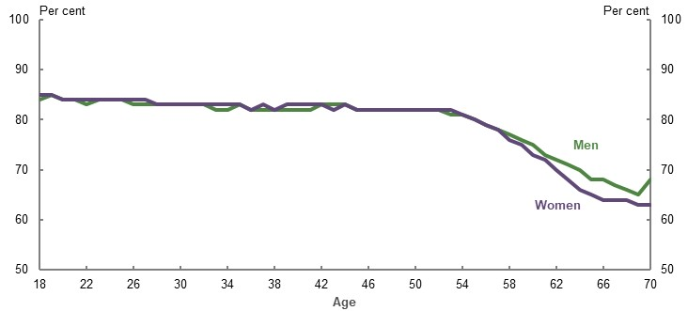
Source: (Rice Warner, 2019b).

Working-life drivers of gender gaps inside the retirement income system

Current and future superannuation balances
In 2017-18, the average balance for those with superannuation at age 60-64 was $279,167 for women and $344,718 for men — a gap of 19 per cent. The median balance was $128,507 for women and $163,985 for men — a gap of 22 per cent (Chart 3B-5).
The gender gap in superannuation balances, both average and median, increases in the late-20s to mid- to late-50s age group, when women’s labour force participation is significantly lower than men’s. The gap begins to close sharply from around ages 55-59, likely due to two factors:
- Superannuation coverage decreases with age, particularly for women. Because average and median superannuation balances do not include people without superannuation, this creates a selection bias. This raises the average and median balances of women at older ages compared with younger ages. If the calculation of the gender gap included those with zero balances, the gap would not close as much. This effect will become less prominent over time as more women retire with superannuation (see Superannuation coverage, below).
- Women make more voluntary superannuation contributions than men in later age (see Voluntary superannuation contributions, below).
The narrowing of the gender gap at older ages is due to increased balances for single women and for women with a partner with a high superannuation balance (see Appendix 6D. Supplementary equity charts).
    - Superannuation balances and gender gap, by age and gender
Average | Median
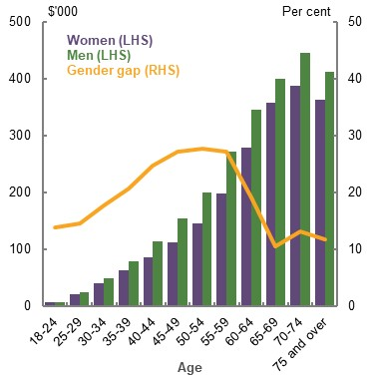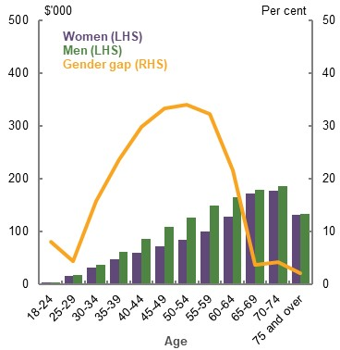
Source: Analysis of ATO individual income tax returns and member contributions statements, 2017-18.
Over the past decade, the gender gap in superannuation balances for those approaching retirement has reduced (Chart 3B-6).
    - Gender gap in superannuation balances at ages 55-64
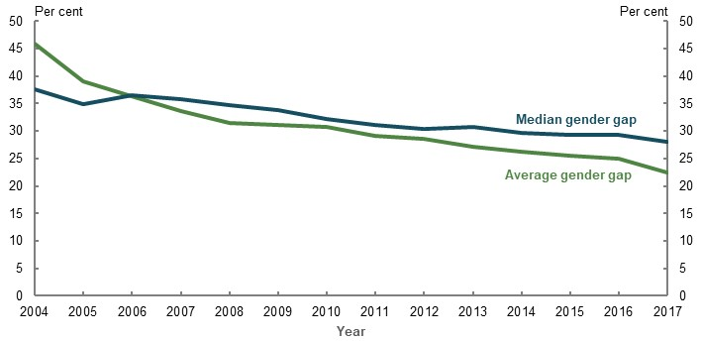
Note: Averages and medians are for those with non-zero balances. Source: Data provided by the ATO for the review.
Most men and women retiring now have low superannuation balances (Chart 3B-7). Those with higher balances are more likely to be men. The long ‘tail’ of men with higher superannuation balances also exacerbates the gender gap in balances at retirement today. This gap is expected to narrow substantially as the superannuation system matures and women benefit from greater labour force participation (see 1D. The changing Australian landscape). In future, more women will have superannuation and spend more years contributing to their superannuation, including through higher voluntary contributions (see Voluntary superannuation contributions, below).
    - Projected superannuation balances at retirement by gender
2020 | 2060
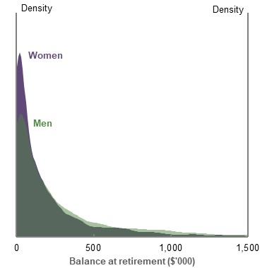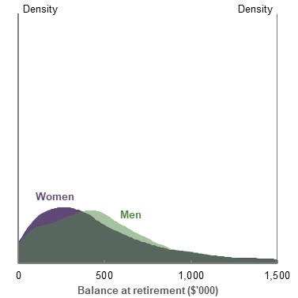
Note: Values in 2019-20 dollars, combined for the three trailing years, and deflated by average weekly earnings. Source: Treasury estimates for the review using MARIA.

Superannuation coverage
Over time, women’s superannuation coverage has increased with greater labour force participation. The gap between men’s and women’s coverage has also narrowed (Chart 3B-8), but the gender gap in superannuation coverage at retirement will not close completely while a participation gap persists.
    - Superannuation coverage, by age and gender
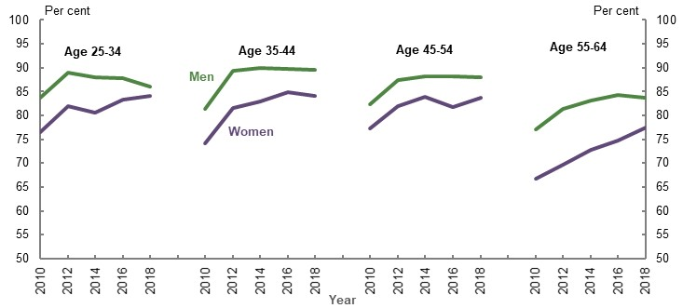
Note: A person is considered to have superannuation coverage if they have a superannuation balance above zero, receive regular income from superannuation, or have received a lump sum superannuation payment in the past two years. Source: (ABS, 2019k).

The $450-a-month threshold
Employers are not obligated to pay the SG to employees who earn less than $450 per month. The ATO Single Touch Payroll data for July 2019 suggests women were more likely than men to earn less than $450 and not receive the SG — around 197,000 women, compared to around 114,000 men (see Table 3D-1 in 3D. SG coverage). Based on the current SG rate of 9.5 per cent, this implies women did not receive around $4.7 million in superannuation in July 2019 because of the $450-a-month threshold, compared to $2.7 million in superannuation forgone by men.
For both men and women, removing the $450-a-month threshold has a small effect on average annual retirement incomes (see 3D. SG coverage).

Superannuation on employer paid parental leave
Unlike most other leave entitlements, employers are not required to pay superannuation to those taking paid parental leave. Some stakeholders suggested this should be amended to reduce the impact of child-related career breaks on superannuation balances at retirement.
Around half of employers offer paid parental leave (Workplace Gender Equality Agency, 2019). Those offered paid parental leave are more likely to work full-time and have higher weekly earnings (ABS, 2014). A 2013 evaluation of paid parental leave found more than half of employers who provide paid parental leave or carer’s leave also pay superannuation on that leave, especially in the public sector (Martin, et al., 2013, p. 95). Since then, this practice has likely increased as more family-friendly workplace strategies have been implemented.
For the median female earner, receiving superannuation on the average period of employer paid parental leave (11 weeks in 2019 (Workplace Gender Equality Agency, 2020)) increases her balance at retirement by around 0.8 per cent. This translates into a 0.14 per cent increase in retirement income, after accounting for reduced Age Pension income due to the Age Pension assets test (Chart 3B-9). Even for those not impacted by the assets test, the increases in retirement income are small. Consequently, while it would improve gender equity in SG coverage, paying superannuation on paid parental leave has a limited impact on closing the retirement income gap at most earnings percentiles.
    - Projected effect on women’s retirement incomes of receiving superannuation for one term of employer paid parental leave
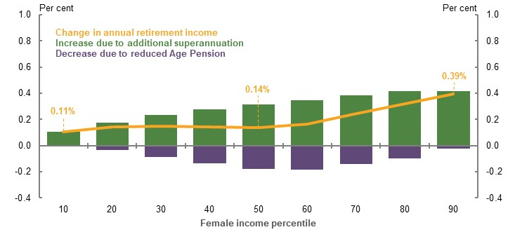
Note: Assumes one 11-week term of paid parental leave at age 30, based on the woman’s salary for the previous year. All other assumptions are consistent with the standard gender cameo model. Women who access paid parental leave multiple times across their life could have greater changes in annual retirement income if superannuation was paid on the leave. Calculations are based on values deflated using the review’s mixed deflator. Source: Cameo modelling undertaken for the review.

Superannuation on Government Parental Leave Pay
Government-offered Parental Leave Pay is paid at the minimum wage for up to 18 weeks for people on incomes below $150,000 a year. Superannuation is not paid on top of Government Parental Leave Pay.
If superannuation was paid on Government Parental Leave Pay, the median female earner would receive an additional 0.17 per cent in annual retirement income (Chart 3B-10). For middle-income earners in particular, the Age Pension assets test reduces the small gains in annual superannuation income. Most Government Parental Leave Pay recipients are in the middle of the income distribution.
    - Projected effect on women’s retirement incomes of receiving superannuation for one term of Government Parental Leave Pay
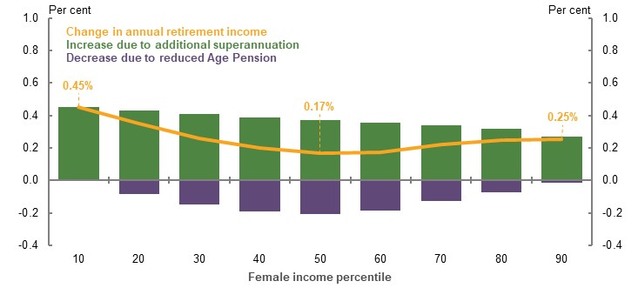
Note: Assumes one 18-week term of Parental Leave Pay at age 30, paid at the minimum wage, provided her salary for the previous year is below the income test threshold ($150,000, indexed to CPI from 1 July 2021). Minimum wage is indexed to average weekly earnings. All other assumptions are consistent with the standard gender cameo model. Women who access Parental Leave Pay multiple times across their life could have greater changes in annual retirement income if superannuation was paid on the leave. Calculations are based on values deflated using the review’s mixed deflator. Source: Cameo modelling undertaken for the review.
In 2018-19, around 178,800 people accessed Government Parental Leave Pay at a cost of $2.2 billion (Department of Social Services, 2019). If superannuation was paid on these payments, it would cost the Government around $200 million a year, increasing as the SG rate rises.

Carers and the retirement income system
Women are more likely to be primary carers than men, making up:
- 92 per cent of primary carers of children with disability
- 70 per cent of primary carers of parents
- 52 per cent of primary carers of partners (Australian Human Rights Commission, 2013)
One submission noted that carers have lower earnings and lower superannuation balances than non-carers (Carers NSW, 2020). The lifetime earnings of a woman caring for a child with disability are estimated as 25 to 50 per cent lower than a woman with no caring role (Nepal, et al., 2008). Caring for others can also result in involuntary retirement, more so for women (see 3E. Age of retirement).
Some stakeholders suggested the superannuation system should explicitly recognise unpaid caring work. One submission noted that the superannuation system ‘…neglects the fundamental productive importance of unpaid care work’ and this threatens the sustainability of the system as it ‘…may cause some key care roles to not be performed at all, as is the case when people decide that they cannot afford to have children due to the risks this poses to their retirement savings’ (Women in Social and Economic Research, 2020, p. 3).
A number of countries, including the UK, Sweden, Finland and Germany, recognise unpaid caring work in their pension systems through ‘carer credits’. Carer credits are used to factor in the time taken out of the workforce to care for others when determining a person’s retirement income benefit.
However, these international retirement income systems operate differently to Australia’s. For example, many public pension rates in schemes overseas depend on a person’s time in the workforce, and carer credits are used in these calculations. As the Age Pension is non-contributory and does not depend on workforce participation, a carer credit system would need to be adapted to work in the Australian context. A carer credit paid through superannuation would likely interact with the Age Pension, and its effect would be moderated by the means test.

Voluntary superannuation contributions
At most ages, women are more likely to make voluntary contributions to their superannuation than men (Chart 3B-11). On average, from age 50, women make larger voluntary contributions than men (Chart 3B-12). This makes voluntary contributions a particularly important part of the retirement income system for women.
- Proportion making voluntary superannuation contributions, by age and gender | - Average voluntary superannuation contribution, by age and gender
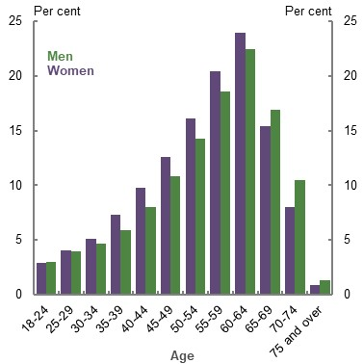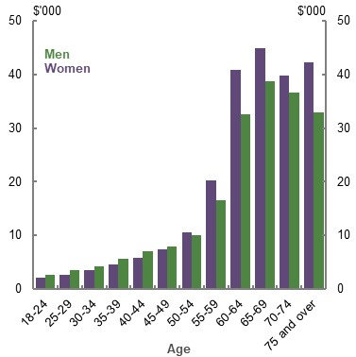
Note: Chart 3B-12 shows the average total voluntary contribution amounts for those who made contributions to a superannuation account in 2017-18. ‘Voluntary contributions’ in these charts does not include salary sacrifice. Source: Analysis of ATO individual income tax returns and member contributions statements, 2017-18.
Voluntary contributions play a role in narrowing the gender gap in superannuation balances at ages 55-64 (Chart 3B-5). On average, women at these ages make significantly larger voluntary contributions to their superannuation than men, helping to counteract their lower contributions through the SG. This trend holds regardless of balance size (see Appendix 6D. Supplementary equity charts).
Women and men make voluntary contributions through different methods. Women are more likely to make after-tax contributions. Men are more likely to salary sacrifice or make tax-deductible personal contributions (see Appendix 6D. Supplementary equity charts for additional charts breaking down contributions by balance decile and contribution type). This difference may mean that, compared to men, women are missing out on the tax concessions offered to particular types of contributions. Given men are also more likely to be employed, they may have greater access to salary sacrifice arrangements. Historical superannuation rules may have also prevented women from making deductible personal superannuation contributions (see 1B. Design of Australia’s retirement income system).
In the lead-up to retirement, those partnered with a person with a relatively high superannuation balance (i.e. in balance deciles 6 to 10) are more likely to make voluntary contributions, and make higher value voluntary contributions, than single people or those partnered with a person with a relatively low superannuation balance (i.e. in balance deciles 1 to 5). This is particularly true for lower-balance women who are partnered with a person with a high superannuation balance. At all superannuation balance deciles, single women are more likely to make voluntary superannuation contributions than single men (see Appendix 6D. Supplementary equity charts for additional charts breaking down contributions by partnered status, partner’s superannuation and gender).
Women benefit more than men from the Government co-contribution for lower- and middle-income earners who voluntarily contribute to their superannuation. In 2018-19, around 244,700 women received co-contributions, compared to around 131,700 men.

Superannuation tax concessions
The generally flat tax rate on superannuation concessions and earnings benefits higher-income earners the most. Given men’s earnings are, on average, greater than women’s, men are expected to receive more superannuation tax concessions across their lives than women (Chart 3B-13).
    - Projected lifetime Government support provided through the retirement income system, by gender and earnings percentile
Women | Men
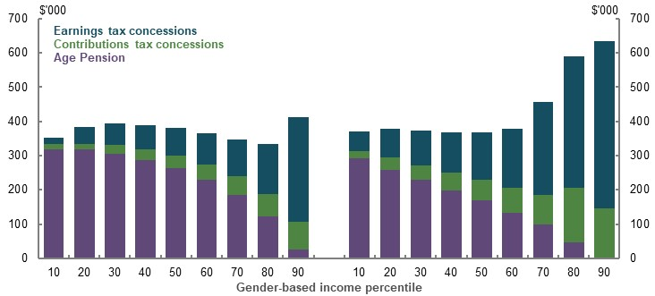
Note: Values are in 2019-20 dollars, deflated using the review’s GDP deflator. Source: Cameo modelling undertaken for the review.
In 2019, women were estimated to receive around 40 per cent of all superannuation tax concessions. The proportion of tax concessions received by women depends on women’s incomes and superannuation balances. Under current system settings, men and women will not receive equal concessions until they have similar incomes, time in the workforce and superannuation balances.

Cameo modelling of working-life factors that drive gender gaps
The earnings gap is the main cause of the gender gap in superannuation balances at retirement. Some features of the superannuation system can either increase or decrease the gap, but their effect is minor (Chart 3B-14 and Appendix 6D. Supplementary equity charts).
    - Factors affecting how the gender earnings gap translates into a gender gap in superannuation balances at retirement
50th income percentile
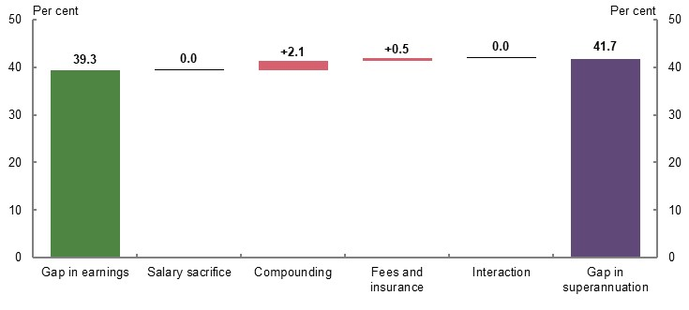
Note: This chart shows the impact of removing individual factors on the gender gap in superannuation balances at retirement (e.g. comparing a world where the fees and insurance costs do not exist to standard gender cameo model specifications) for the 50th income percentile. Removing all the factors listed results in a gender gap in superannuation balances at retirement equal to the gender gap in working-life earnings. ‘Compounding’ isolates the impact of real investment returns on superannuation balance accumulation during working life. The ‘interaction’ field indicates the impact of the interaction between elements (e.g. the interaction between removing fees and compounding returns, which is not captured in removing only fees or only compounding returns). This analysis does not include voluntary contributions other than salary sacrifice. Including these contributions would likely reduce the gender gap in superannuation balances at retirement. Calculations are based on values deflated using the review’s mixed deflator. Results for the 10th, 30th, 70th and 90th income percentiles are in Appendix 6D. Supplementary equity charts. Source: Cameo modelling undertaken for the review.
- Compounding returns increase the gender gap in superannuation balances at retirement. Compounding returns make early working-life contributions more significant, where the gender gap is greatest. Men’s longer working lives, on average, also mean they benefit more from compounding.
- Fees and insurance premiums slightly increase the gender gap in superannuation balances at retirement, especially at lower income levels. Fees and insurance premiums have a fixed component, eroding lower superannuation balances (which are more likely to be women’s) more than higher superannuation balances (which are more likely to be men’s).
- At higher incomes, women salary sacrifice a greater proportion of their incomes than men, reducing the gender gap in superannuation balances at retirement. This effect is not seen at lower incomes.
- The low income superannuation tax offset reduces the gender gap in superannuation balances at retirement at lower income percentiles. Women, on average, receive the low income superannuation tax offset for more of their working lives than men (see 1B. Design of Australia’s retirement income system).
- The Division 293 tax reduces the gender gap in superannuation balances at retirement for those with very high incomes. Men are more likely to be subject to the Division 293 tax (see 1B. Design of Australia’s retirement income system).

Causes of gender gaps in retirement
The causes of gender gaps in retirement occur both outside and inside the retirement income system.

Life expectancy differences
Historically, differences in life expectancy mean more women have been in retirement than men, although this trend is declining (Chart 3B-15).
    - Proportion of women in retired age groups
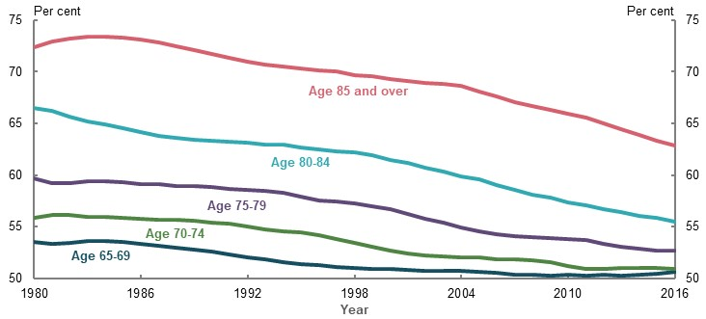
Source: Analysis of (ABS, 2019c).
Increased longevity means women’s retirement savings need to last longer than men’s, reducing their relative retirement income (Table 3B-3). The Age Pension helps reduce the impact of higher life expectancy, particularly for women with lower superannuation balances at retirement. The effect of longer life expectancy is more pronounced for higher-wealth women as more of their retirement income is funded by their superannuation.
      - Projected retirement income effect of women living two years longer than men
Superannuation balance at retirement  ($) | Gender gap in average annual retirement income (per cent)
200,000 | 0.6
400,000 | 2.1
600,000 | 3.4
800,000 | 4.0
Note: Values are in 2019-20 dollars. Superannuation balances are deflated by average weekly earnings. Retirement incomes are deflated using the review’s mixed deflator. Results reflect outcomes under an annuitised drawdown method that exhausts all superannuation assets by death, for a person retiring in 2060 at age 67. Assumes no purchase of a longevity product. Men are projected to live for 24 years in retirement; women are projected to live for 26 years in retirement. For the purposes of this cameo, non-superannuation wealth has not been included. Source: Cameo modelling undertaken for the review.

Drawdown behaviour
Women are more likely than men to draw down their superannuation at the minimum rate in an account-based pension (Chart 3B-16). This effect is small but statistically significant (Balnozan, 2018, pp. 87-88), although the cause is unknown. Potentially, slower drawdown could reflect gender-specific factors, such as being more financially conservative (Charness & Gneezy, 2012), having lower financial literacy (as discussed above) or women self-managing their longer life expectancies.
    - Proportion of people drawing down from account-based pensions at the minimum rate, by age and gender
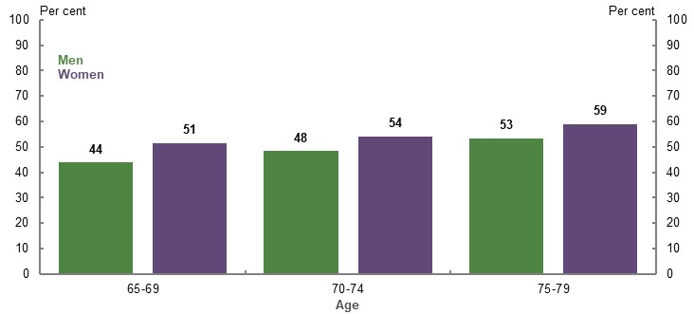
Note: 2019 data. Source: (Rice Warner, 2019b).

Age Pension
Women are more likely than men to receive the Age Pension, particularly early in retirement, and are more likely to receive the maximum rate of Age Pension (Chart 3B-17). The gap in Age Pension coverage closes around age 85, with men more likely than women to receive the Age Pension in later life. This may be due to a significant number of widows not being eligible for income support once they inherit their partner’s assets (see Becoming single in retirement, below). It may also reflect the significant number of women over age 85 who receive Department of Veterans’ Affairs war widow pensions, and are not recorded in the Department of Social Services’ data (DVA, 2020).
    - Age Pension coverage, by gender and age
Women | Men
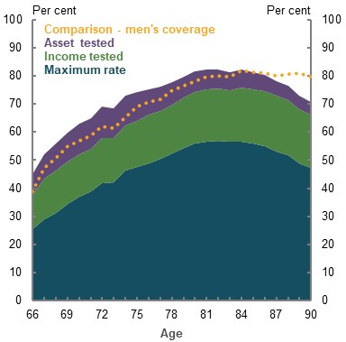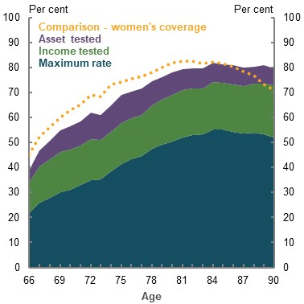
Source: Department of Social Services payment data, 30 June 2019, (ABS, 2018g).
For current retirees, the Age Pension makes up a higher proportion of the incomes of women than men (Chart 3B-18).
    - Average proportional source of income in retirement, by age, gender and partnered status
Single men | Single women | Coupled men | Coupled women
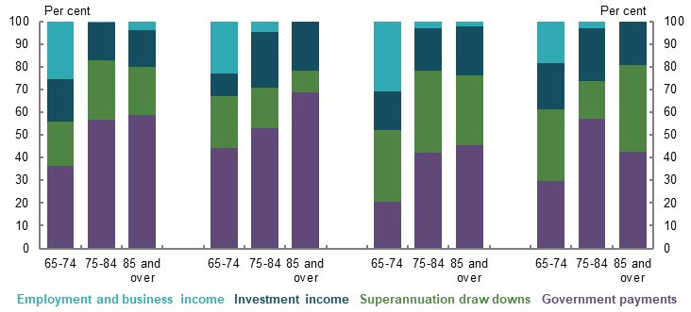
Note: Data is from 2017-18. ‘Government’ income includes all welfare payments (including non-income support payments, such as Family Tax Benefit (FTB)) but does not include social transfers in kind. Sample sizes are small for older cohorts, and results should be used with caution. Calculations are based on values deflated using the review’s mixed deflator. Source: Analysis of (ABS, 2019s).
As the superannuation system matures and balances grow, fewer men and women will likely qualify for the Age Pension, particularly earlier in retirement. However, with their lower working-life earnings and greater longevity, women are projected to continue to derive more of their income in retirement from the Age Pension than men (Chart 3B-19).
    - Proportional source of projected total retirement income, by gender and earnings percentile
Women | Men
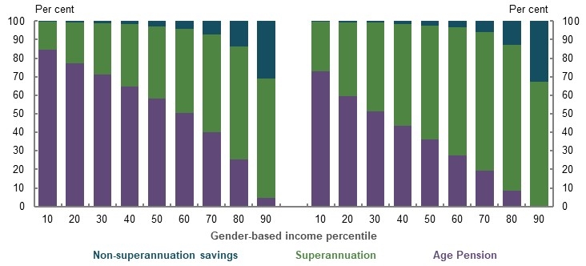
Note: Calculations are based on values deflated using the review’s mixed deflator. Source: Cameo modelling undertaken for the review.

Cameo modelling of retirement factors that cause gender gaps
Other than at higher-income levels, the gender gap in average retirement incomes is significantly smaller than both the gender gaps in working-life earnings and in superannuation balances at retirement (Chart 3B-20). This is primarily due to the Age Pension, which helps offset inequities experienced in working life.
- The Age Pension reduces the gender gap in average retirement incomes because:
  - With lower superannuation balances, women receive higher rates of Age Pension under the means test compared to men at the same earnings percentile.
  - Even when men and women are receiving the same rate of Age Pension, it provides a base income that makes differences in private income less significant.
- Higher life expectancies for women reduce the average retirement incomes of women relative to men, particularly for those with high balances who receive less, or no, Age Pension.
- Compounding returns increase the gender gap in retirement incomes, as women tend to have lower superannuation balances from which to benefit from compounding.
- Fees reduce the gender gap in retirement incomes, as men, on average, have higher balances in retirement. This means they pay higher fees than women, as most fees in retirement are a proportion of the superannuation balance (Productivity Commission, 2018a, p. 168).
- At very high incomes, the transfer balance cap reduces the gender gap in retirement incomes, as higher-balance men have more of their savings subject to tax than higher-balance women (see 1B. Design of Australia’s retirement income system).
    - Factors that affect how the gender gap in superannuation balances at retirement translates into the gender gap in retirement incomes
50th income percentile
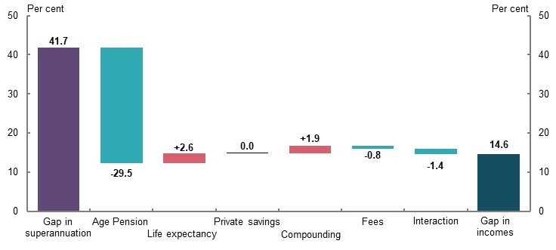
Note: Chart shows the impact of removing individual factors on the gender gap in retirement incomes (e.g. comparing a world where fees in retirement do not exist to standard gender cameo model specifications) for the 50th income percentile. Removing all the factors listed results in a gender gap in retirement incomes equal to the gender gap in superannuation balances at retirement. ‘Compounding’ isolates the impact of real investment returns on superannuation balance during retirement. ‘Life expectancy’ isolates the effect of different life expectancies for men and women on retirement income by assuming both genders have the same life expectancy of 92. ‘Private savings’ refers to non-superannuation wealth. The ‘interaction’ field indicates the impact of the interaction between elements (e.g. the interaction between removing fees and compounding returns, which is not captured in removing only fees or only compounding returns). The interaction field is larger in this chart than in Chart 3B-14, given the significant interaction each factor has with Age Pension receipt. This analysis does not include voluntary contributions other than salary sacrifice. Including these contributions would likely reduce the gender gap in superannuation balances at retirement. Calculations are based on values deflated using the review’s mixed deflator. Results for the 10th, 30th, 70th and 90th income percentiles are in Appendix 6D. Supplementary equity charts. Source: Cameo modelling undertaken for the review.

Empirical analysis of the gender gap in retirement incomes
Pre-retirement, the gender gap in disposable income is more prevalent for coupled women than single women (Chart 3B-21). For those in retirement, the disposable income gap between median coupled men and women is significantly less.
    - Gender gap in median disposable income, by age and partnered status
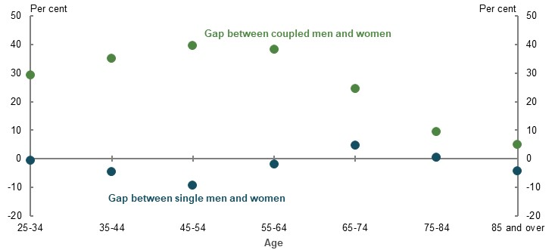
Note: Data from 2017-18. A negative gender gap means women have more disposable income than men. Source: Analysis of ABS Survey of Income and Housing Confidentialised Unit Record File, 2017-18.

Retirement trends and characteristics by partnered status

Distribution of assets for singles and couples
In retirement, a greater proportion of single people, particularly men, are asset poor compared to couples. The lowest wealth decile has a higher number and proportion of single men and women compared to couples. However, in absolute terms, asset-poor, single women outnumber asset-poor, single men, as there are a greater total number of single women in retirement (see Becoming single in retirement, below).
Across most of the wealth distribution, single women in retirement are more likely to have a higher proportion of their wealth in housing and less in superannuation than single men or couples (Chart 3B-22).
    - Composition of retirees’ assets by partnered status, gender and wealth decile
Couple | Single women | Single men
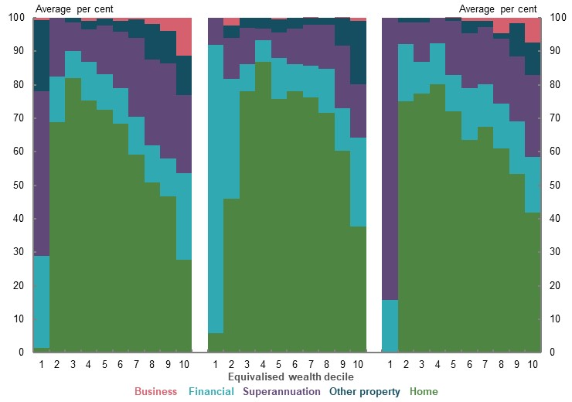
Note: 2017-18 data. This chart shows, for example, retired couples in the 2nd wealth decile held, on average, 69 per cent of their wealth in housing, 14 per cent in financial assets and 17 per cent in superannuation. Equivalised means that the results are adjusted for household size. Negative net asset values not included for presentational purposes. Source: Analysis of ABS Survey of Income and Housing Confidentialised Unit Record File, 2017-18.

Entering retirement as a couple
Most people enter retirement as a couple, although the rate has been falling since 1991. In 2016, 62 per cent of women and 67 per cent of men entered retirement married (ABS, 2016a).
Women tend to retire one to three years earlier than men (see 1A. What is retirement?). This difference is largely due to coupled women retiring with their older partner. Partnered women tend to marry men two years older than them (ABS, 2019q) and expect to retire 1.5 years earlier than partnered men (ABS, 2020n). Conversely, single women expect to retire marginally later than single men.

Sources of income in retirement for couples
People who are partnered in retirement can share resources. Women rely more on their partner for income in retirement, with 14 per cent of those retired reporting ‘partner’s income’ as their main income source for meeting living costs, compared to 6 per cent of men (ABS, 2020n).
Cameo modelling projects that, in future, around two-thirds of a couple’s income in retirement will come from the primary earner’s superannuation, savings or Age Pension payments, and one-third from the secondary earner’s (Chart 3B-23). The proportion contributed by the primary earner generally increases as working-life earnings increase. The proportion of retirement income contributed by the secondary earner increases over the course of a couple’s retirement as the couple exhausts their superannuation and receives more Age Pension.
    - Proportional source of projected total retirement income for couples by income percentile
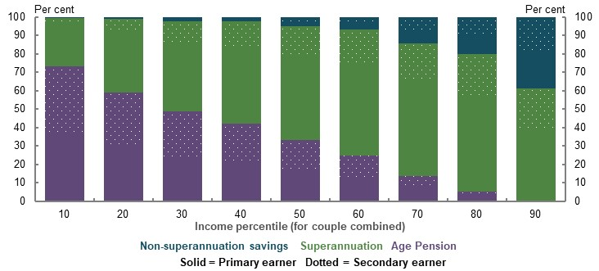
Note: Calculations are based on values deflated using the review’s mixed deflator. Classification as ‘primary earner’ is based on income distribution within the couple, and includes both male and female primary earners. Source: Cameo modelling undertaken for the review.

Lifetime Government support provided through the retirement income system for couples
As with individuals, the distribution of lifetime Government support differs for couples across the income distribution (Chart 3B-24) (see Section 3A. Income and wealth distribution for analysis of individuals). The gap between lower- and higher-income couples is less than double the gap between lower- and higher-income individuals because:
- Lower-income couples receive more Age Pension than lower-income individuals, as the couple combined rate of Age Pension is higher than the singles rate of Age Pension.
- Higher-income couples receive less than double the superannuation tax concessions than higher-income individuals, likely due to some higher-income earners partnering with a lower-income earner.
    - Projected lifetime Government support from the retirement income system for couples, by income percentile
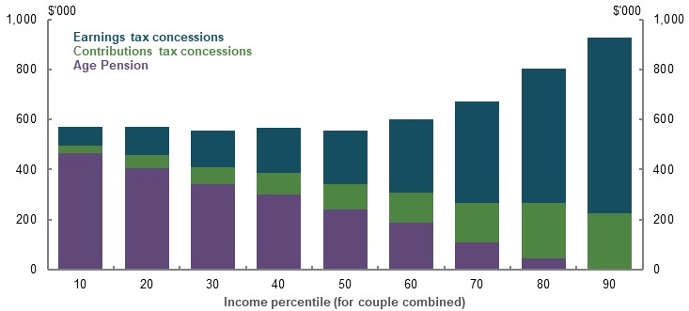
Note: Values are in 2019-20 dollars, deflated using the review’s GDP deflator. Income percentiles are based on the incomes of couples only. Source: Cameo modelling undertaken for the review.

Becoming single in retirement
Women are more likely to become single during retirement (Chart 3B-25). This means income support for singles in retirement, such as the single rate of the Age Pension, are more important for women than men.
    - Proportion of single people in retirement by marital status, age and gender
Women | Men
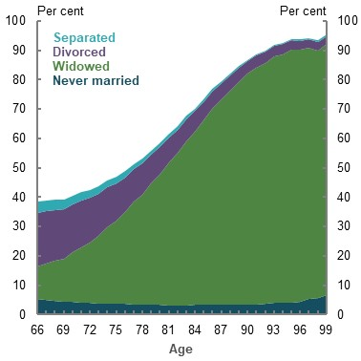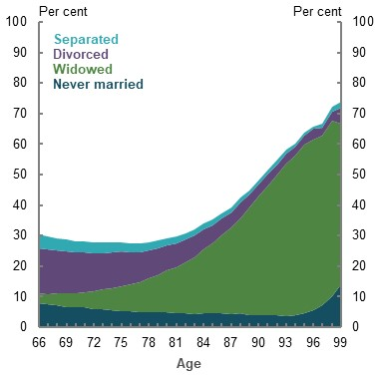
Note: 2016 data. Source: Analysis of (ABS, 2016a).
The larger proportion of women widowed may also mean the inheritance of a partner’s wealth is a larger part of the average woman’s retirement than the average man’s.
The profile of single women and single men changes significantly over retirement. Early in retirement, single women are predominantly divorcees, while single men are mainly divorcees or those never married. Later in retirement, single men and single women are predominantly widowed.

Not all singles are the same
The way a person becomes single impacts their retirement outcomes (Table 3B-4).
- Retirement income — Those never married, and divorced single men, have higher median incomes than other cohorts of single retirees.
- Wealth — Those separated generally have significantly lower wealth. Whereas, those widowed, and women who have never married, generally have higher wealth. For those aged 65 and over, the median single-woman household has higher wealth than the median single-man household. Members of a couple have higher median incomes and wealth than any single group.
      - Median annual household disposable income and net wealth, aged 65 and over, by gender and partnered status
Cohort | Disposable income ($) | Net wealth ($)
Couple (combined) | 38,600 | 655,700
Single women | 28,900 | 460,000
Separated | 31,600 | 205,000
Divorced | 28,900 | 396,000
Widowed | 28,100 | 477,500
Never married | 32,100 | 530,700
Single men | 33,700 | 404,300
Separated | 27,400 | 311,000
Divorced | 32,900 | 359,200
Widowed | 28,900 | 552,500
Never married | 34,000 | 372,500
Note: Figures are in 2018 dollars and are rounded to nearest $100. Net wealth includes housing. Includes households with any member aged 65 and over. Results are equivalised (i.e. adjusted for household size). Source: Analysis of HILDA Survey data (Wave 18).

Poverty and financial stress
Single retirees are far more likely to experience disadvantage than couples. Singles are more likely to be in poverty and financial stress than couples. Around 23 per cent of retired single women and 25 per cent of retired single men are in poverty, while around 12 per cent of both single men and women are in financial stress in retirement. Around 10 per cent of coupled retirees are in poverty, and 9 per cent are in financial stress (see 2A. Achieving a minimum standard of living in retirement). Because there are more women in retirement, there are a greater absolute number of single women than single men in poverty and financial stress in retirement.

Renting in retirement
Similar proportions of men and women rent in retirement. Because there are more women than men in retirement, an absolute greater number of women are renters and more women rent in later retirement (ABS, 2016a).
Single people are far more likely than married people to rent in retirement, particularly at younger ages. People who are separated or divorced are the most likely group of singles to rent in retirement (Chart 3B-26). Single renters, both men and women, are at particular risk of poverty and financial stress in retirement (see 2A. Achieving a minimum standard of living in retirement).
    - Proportion renting in retirement, by age and marital status
Women | Men
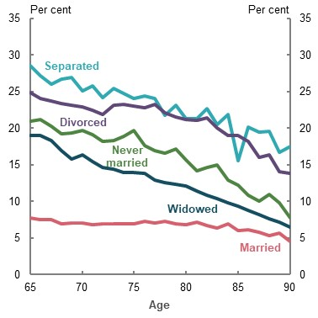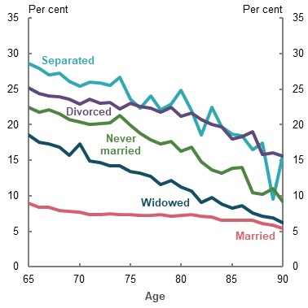
Note: 2016 data. Given the small size of the separated and divorced cohorts, particularly at older ages, these charts should be used with caution. Source: Analysis of (ABS, 2016a).
More single women receive the Commonwealth Rent Assistance supplement in retirement than single men (see 1B. Design of Australia’s retirement income system), particularly at older ages. Homelessness among older women is also an area of increasing concern (see 3C. Home ownership status).

          - Impact of changes to certain policy settings on women’s retirement outcomes
A significant number of submissions raised policy proposals to improve retirement outcomes for women. The following summary outlines some implications of some of the proposed policy changes.
- Remove the $450-a-month threshold and pay superannuation on paid parental leave and Parental Leave Pay. These changes would marginally improve retirement income equality between men and women. These exclusions predominantly disadvantage women. However, the additional superannuation savings gained from removing these exclusions would not offset the impact of the significant working-life earnings gap between men and women (see 3D. SG coverage).
- Increase the incentive for additional voluntary ‘catch-up’ superannuation contributions later in working life. Such a change would mostly benefit women with higher superannuation balances or those whose partner has higher superannuation balances. Single women with lower balances are the least likely group of women to make voluntary contributions and the least likely to benefit from incentives to voluntarily contribute to superannuation.
- Increase the SG rate. This would not reduce the gender gap in superannuation balances and would boost retirement incomes slightly more for men than women. A higher SG rate would come at the expense of working-life income, reducing the already lower working-life earnings of women relative to men. A higher rate would amplify the effect of the earnings gap on retirement outcomes, as men would benefit from the higher compulsory contributions more than women (see 2D. Policy scenario: Implications of maintaining the SG rate).
- Boost lower-income earners’ superannuation without trading off working-life income. Changes that achieve this outcome would help reduce the gender gap in superannuation balances. Women are over-represented at lower incomes. Policy settings that support lower-income earners to boost their superannuation balances without trading off working-life income include the low income superannuation tax offset (lower tax) and the Government superannuation co-contribution for lower- to middle-income earners (up to $500 boost). These measures benefit more women than men.
- Reduce superannuation tax concessions for very high income earners. This would reduce the degree to which the working-life earnings gender gap translates into the gap in superannuation balances. Because men are, on average, higher earners than women, superannuation tax concessions benefit men more than women. The Division 293 tax marginally decreases the gender gap in superannuation balances at retirement. If superannuation taxation was more progressive, it would further reduce the superannuation balances of very high income earners. This would reduce the gender gap in superannuation balances (see 3A. Income and wealth distribution).
- Increase the rate of the Age Pension and provide additional assistance to renters on the Age Pension. These changes would reduce the retirement income gap between men and women, as more women receive the Age Pension and are renters. The Age Pension is an important equaliser in retirement outcomes between men and women, as it is not influenced by the working-life gender earnings gap. Although, the Age Pension rate is set such that all older Australians, both men and women, achieve a minimum standard of living in Australia. Since more women rent in retirement, increased support for lower-income retirees who rent would help reduce the retirement income gender gap (see 2B. Policy scenario: Implications of increasing Commonwealth Rent Assistance).
- Improve the visibility of superannuation assets in family law property settlements. Not all parties to a family law dispute are forthcoming about their, potentially multiple, superannuation accounts. The process of discovering a former partner’s superannuation assets can be costly and time-consuming. Simplifying this process would deliver better superannuation splitting outcomes, particularly for vulnerable women. The measure announced by the Government in 2018, but yet to be legislated, would deliver fairer and more equitable outcomes for those going through a divorce.

Home ownership status
          - Section summary
- The treatment of housing in the Age Pension assets test provides more support to home owners compared to non-home owners. The exemption of the principal residence in the assets test particularly benefits age pensioners with high-value homes. Around 15 per cent of retirees on the Age Pension own homes worth more than $1 million.
- The larger free areas in the assets test for non-home owners benefits only a small share of retirees who are renting. About 6 per cent of non-home owner Age Pension recipients have a level of total assets above the home owner thresholds and below the non-home owner thresholds and could benefit from this preferential treatment.
- Even the limited number of renters who benefit from the higher assets test free areas and hold their wealth in forms other than a home are still at a disadvantage relative to home owners. Compared to a home owner with identical total wealth, a renter receives about $4,000 less Age Pension per year.
- Compared with the Age Pension, Commonwealth Rent Assistance is more targeted to lower-wealth households. About 20 per cent of Age Pension expenditure goes to the top two wealth quintiles, while close to 90 per cent of Commonwealth Rent Assistance expenditure goes to the bottom wealth quintile.

Outline of this section
This section considers the effects of the Age Pension assets test on retirees who are home owners compared to non-home owners. It analyses how the preferential treatment of the principal residence (i.e. family home) benefits home owners and leads to inequity in the retirement income system. It also examines how the Age Pension is distributed among retirees compared to Commonwealth Rent Assistance.
          - Stakeholder views on retirement income equity for home owners and renters
A number of stakeholders raised issues about over-investment in housing and housing being used for estate planning. Several submissions focused on the exemption of the principal residence from the Age Pension assets test.
Some submissions suggested the principal residence should be partially assessed in the assets test when the value exceeds a certain threshold.
One stakeholder reported that a poll of its constituents found an even split on the prospect of including some value of the home in means testing.
‘While there is little support for inclusion of the full value of the residence in the means test, views on whether some or all of the value above median house prices (overall or geographically moderated) should be taken into account. In two successive surveys of our constituency for Federal Elections we have found support and opposition to that proposition fairly evenly divided in the forty plus percent’s, with the rest undecided.’ (COTA, 2020, pp. 37-38)
Several submissions said there should be no change to principal residence exemptions, noting the non-financial benefits to retirees from home ownership.

Home ownership and equity in retirement outcomes
Many older Australians are home owners. About 76 per cent of people aged 65 and over are home owners,, with 12 per cent renters and the remaining 11 per cent in other tenure arrangements, such as living rent-free with family and friends or in residential care (ABS, 2016a). Around 0.2 per cent of people aged over 65 are homeless; a lower rate than younger age groups (ABS, 2018b).
Factors contributing to high home ownership rates among older Australians include:
- From a retirement income perspective, the family home is a unique investment vehicle that both pre-funds most housing needs in retirement and is an asset that can be drawn on in retirement.
- Preferential treatment in the tax and retirement income system have made home ownership a desirable savings vehicle (see 5A. Cohesion).
Home owners and renters have large differences in their income and wealth accumulation in working life (see 2A. Achieving a minimum standard of living in retirement). While working, home owners generally have higher incomes than renters. They typically have higher educational attainment and longer employment history, in part due to the requirements for downpayment and ongoing servicing of mortgages (Kohler & Rossiter, 2005). Home ownership also serves as a savings commitment device.
Working-life differences result in different retirement outcomes for home owners and renters. Although home owners and renters have approximately the same income in retirement due to Government payments to lower-income households, home owners have lower housing expenditure and therefore higher disposable incomes. Home owners are less likely to face financial stress and poverty in retirement (see 2A. Achieving a minimum standard of living in retirement).
Apart from working-life differences, some government policies affect home owners and renters differently. The Age Pension assets test treats retirees in similar economic circumstances differently based on their home ownership status (see Age Pension and the assets test, below).
          - Homelessness
Stakeholders were concerned about the increase in homelessness among older people. Particular attention has been drawn to women aged 65 and over, who were the fastest growing homeless group, increasing by around 30 per cent between the 2011 and 2016 Census. This increase is largely a product of population ageing. The likelihood of homelessness for older Australians has not changed significantly, as measured in the Census, over the past 15 years (Chart 3C-1).
    - Change in the likelihood of homelessness by age, from 2001 to 2016
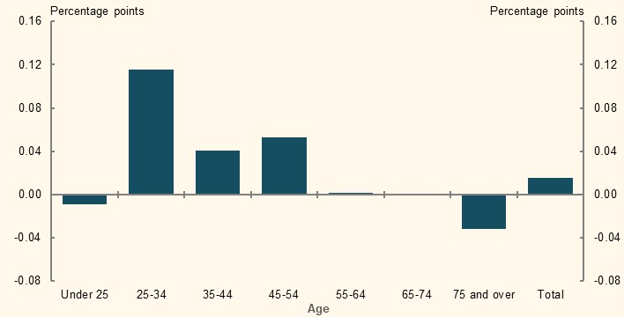
Source: Analysis of (ABS, 2018b).
The measure of homelessness from the Census may not capture all forms of insecure housing. The Australian Human Rights Commission (2019, p. 8) noted that older women and men experience homelessness differently, suggesting some data may underestimate how many older women are homeless. One study found the increased number of older women accessing homelessness services over five years to 2017-18 exceeded population growth (Australian Institute of Health and Welfare, 2018b).
The likelihood of homelessness declines with age (ABS, 2018b). Many of the major risk factors such as poverty, unemployment or lack of affordable housing are less prevalent among retirees, who have higher home ownership rates, greater representation in public housing and access to the Age Pension. As noted in 2A. Achieving a minimum standard of living in retirement, a significant proportion of renters in retirement are facing financial stress due to high housing costs. Worsening housing affordability may present a risk factor for increased homelessness among retirees.

Age Pension and the assets test

Concessional treatment for the principal residence
A person’s principal residence is exempt from the Age Pension assets test while non-home owners are allowed a higher assets test free area to qualify for the maximum rate of the Age Pension (Table 3C-1). This implies that the effective value of the principal residence for the assets test is currently $210,500. In contrast, the estimated median value of an age pensioner’s principal residence in 2019 was $560,000.
      - Assets test free areas for a maximum-rate Age Pension
 | Single ($) | Couple ($)
Home owner | 263,250 | 394,500
Non-home owner | 473,750 | 605,000
Difference (effective value of the home) | 210,500 | 210,500
Source: Age Pension rates and thresholds as at 1 May 2020.
    - Distribution of home values among age pensioners who own their home
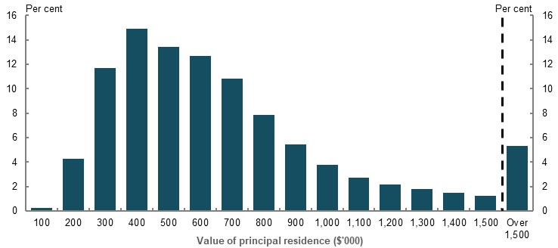
Note: Horizontal axis labels indicate home values up to that amount (e.g. $200,000 includes homes over $100,000 up to $200,000). Source: Department of Social Services analysis of payment data, June 2018.

Higher assets test free areas for non-home owners
The higher assets test free areas for renters benefit only a small proportion of retirees who do not own a home. About 36,000 non-home owner Age Pension recipients (around 6 per cent of this group) have a level of total assets above the home owner assets test free areas and below the non-home owner assets test free areas (Department of Social Services, 2020a). If these retirees are assets tested, they may benefit from this preferential treatment to qualify for a full-rate Age Pension. Around 16,000 non-home owner Age Pension recipients (less than 3 per cent of this group) have total assets above the assets test free areas but below the assets test cut-offs. These retirees may benefit from this preferential treatment to qualify for a part-rate Age Pension.
Of those non-home owners who receive a part-rate Age Pension, the majority (94 per cent) are affected by the income test. As the income test is not adjusted by home ownership status, these retirees do not benefit from the higher assets test free areas.

Equity implications of the Age Pension assets test
Even the limited number of renters who benefit from the higher assets test free areas and hold their wealth in forms other than a home are still at a disadvantage relative to home owners (Table 3C-2). Compared to home owners with identical total wealth, renters receive less Age Pension per person per year despite the Commonwealth Rent Assistance supplement (about $4,000 less in this example). This creates an inequity between home owners and renters in similar economic circumstances.
      - Annual Age Pension payment of a home owner and a renter with identical total wealth
 | Home asset  ($) | Income-generating assets ($) | Total wealth  ($) | Base Age Pension  ($) | Commonwealth Rent Assistance ($) | Total Age Pension  ($)
Home owner 1 | 560,000 | 210,000 | 770,000 | 18,506 | 0 | 18,506
Home owner 2 | 360,000 | 410,000 | 770,000 | 17,865 | 0 | 17,865
Renter | 0 | 770,000 | 770,000 | 12,072 | 1,711 | 13,783
Note: Values are in 2019-20 dollars for an individual that is part of a couple. Asset values are representative of a typical coupled Age Pension recipient based on payment data from Department of Social Services. The renter is eligible for the maximum rate of Commonwealth Rent Assistance. Source: Calculation based on pension rates and thresholds as at 1 May 2020.
Some stakeholders suggested home ownership rates will fall in future among older Australians (Ong ViforJ, 2020, p. 2; Coates, 2020) although the extent of this is uncertain (see 1D. The changing Australian landscape). If home ownership rates do fall, an increasing proportion of retirees will be impacted by the inequity in the Age Pension payment between home owners and renters. As the superannuation system matures, increasingly more renters will have larger superannuation balances. This will lower their Age Pension payments as a result of the assets test. Meanwhile, the exemption of the principal residence will continue to benefit home owners.
Cameo modelling illustrates the retirement outcome of lower-income people starting work today who become a renter in a scenario of falling home ownership rates (Table 3C-3). Compared to a home owner with the same superannuation balance, it depicts two renters: Renter 1 who saves an amount equivalent to buying a modest home, and Renter 2 who saves less.
      - Projected annual retirement incomes for a home owner versus a renter over 25 years of retirement
 | Family home  ($) | Other financial assets at retirement ($) | Superannuation balance at retirement ($) | Average retirement income ($) | Income after housing costs ($) | Average Age Pension ($)
Home owner | 350,000 | 0 | 222,300 | 36,400 | 34,400 | 25,900
Renter 1 | 0 | 350,000 | 222,300 | 42,700 | 30,500 | 20,700
Renter 2 | 0 | 233,300 | 222,300 | 42,300 | 30,200 | 25,100
Note: Values are in 2019-20 dollars, rounded to the nearest $100. Values are deflated using the review’s mixed deflator. Housing costs in retirement are assumed to remain proportional to income. Housing costs are calculated by age and tenure type at 28.5 per cent for renters and 5.5 per cent for renters and home owners respectively. See Housing costs in Appendix 6A: Detailed modelling methods and assumptions for details. Age Pension amounts include Commonwealth Rent Assistance. $350,000 is the approximate mode of Age Pension home owners’ value of home. The relative value of Commonwealth Rent Assistance to the renter’s housing costs is assumed to decline because Commonwealth Rent Assistance is indexed to CPI, the growth of which is consistently lower than that of market rents. All three people are single for the purpose of Age Pension receipt and at the 20th income percentile. Renter 1 has savings in other assets that are equivalent to the value of a family home. Renter 2 has reduced savings due to the lack of investment opportunities or a reduced incentive to save in the absence of a savings commitment device. The home owner is assumed to have no assets outside of superannuation other than the family home. Source: Cameo modelling undertaken for the review.
While both renters have higher incomes in retirement due to receiving income from their non-housing assets, their disposable incomes after housing costs and the Commonwealth Rent Assistance supplement are lower than the home owner. In particular, the renters receive less Age Pension from the Government over their 25-year retirement than the home owner.
This results in an inequity in retirement outcomes. The home owner who has more means is less self-reliant in retirement and draws on more Government support than renters with the same superannuation balance.
          - Exemption of the principal residence from the Age Pension assets test
A number of submissions referred to the exemption of the principal residence in the Age Pension assets test. Several called for its removal or adjustment due to the inequities it causes. Other stakeholders argued for it not to be changed due to the disruption and potential income poverty that would result if it was removed.
Factors to be considered regarding the exemption of the principal residence include:
- Over-investment in housing. Exempting the principal residence may incentivise people to put too much money into their home (Productivity Commission, 2015a), which may not be optimal for the person or the nation. Little evidence is available to determine the effect of this incentive, partly reflecting that other incentives are also at play. There are other reasons effecting people’s housing investment decisions during working life, including exemptions from capital gains tax and the non-monetary factors driving home ownership.
The incentive to invest in housing at retirement could become more significant in future as the superannuation system matures and balances at retirement increase. Those renting or with mortgage debt at retirement could be incentivised to convert their superannuation funds into housing to maximise their Age Pension payment.
- Constraining ‘right-sizing’ and equity release. Selling or downsizing the family home in retirement to convert home equity into financial assets can reduce a retiree’s Age Pension payment due to the assets test. This can deter retirees who may want to move to more suitable accommodation and/or release equity from their home to increase their income. The significance of this disincentive is not clear. Retirees report the impact on Age Pension has a limited effect on their decision to downsize (Productivity Commission, 2015a). Retirees also face significant transaction costs to right-size, such as moving costs and stamp duty.
At present, the majority of age pensioners are home owners, so removing the assets test exemption for housing could have a significant impact on the adequacy of retirement outcomes.
Maintaining the exemption, but including a high-value cap, could reduce inequitable outcomes. It would have a limited effect on Age Pension expenditure and would reduce incentives to invest in housing among those affected. Studies found that even setting a cap at the median home value would not affect the majority of age pensioners whose pension is determined by the income test, rather than the assets test (Productivity Commission, 2015a). This reflects that most age pensioners currently have few assets outside their principal residence.
Including the full value of the home in the Age Pension assets test would remove the inequities between renters and home owners and remove the incentive to invest in housing due to the exemption. However, it would have significant adequacy impacts on retirees. Channels to mitigate this impact include changes to the rate of Age Pension or providing increased access to equity release (e.g. the Pension Loans Scheme).
The inequity of maintaining the assets exemption will change over time. The possible decline in home ownership among older people will mean more enter retirement as renters. As the superannuation system matures, future renters are expected to enter retirement with more assets and will be more likely to have their Age Pension entitlement determined by the assets test. If this occurs, the unequal distribution of Government support shown in Table 3C-3 will increase under the existing assets test exemption.

Distribution of Age Pension expenditure
For most Australians, the principal residence is their primary savings asset (see 1B. Design of Australia’s retirement income system).
Many current retirees spent the majority of their working life without compulsory superannuation. As a result, despite having significant housing wealth, many home-owning retirees have little voluntary savings or superannuation when they retire. Given the exemption of the principal residence reduces their assets assessable under the Age Pension assets test, a large number of home owners are relying on the Age Pension (Chart 3C-3).
    - Number of age pensioners, by value of the principal residence
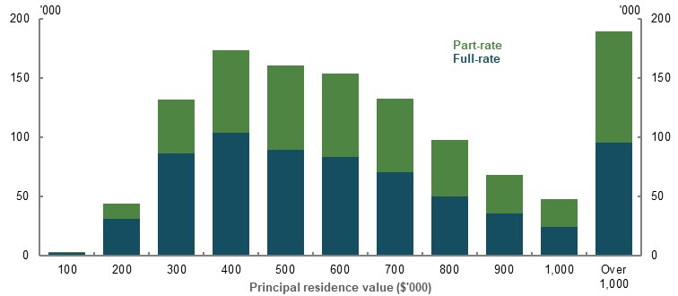
Note: Horizontal axis labels indicate home values up to that amount (i.e. $200,000 includes homes worth more than $100,000 up to $200,000). ‘Full-rate’ indicates a person receiving a full-rate Age Pension; ‘part-rate’ means a person is either asset- or income-tested. Source: Department of Social Services analysis of payment data, June 2018.
Around 63 per cent of home owners receiving the Age Pension have assessable assets below the full-rate threshold. The median value of assessable assets does not seem to vary proportionately with the value of the retiree’s principal residence (Chart 3C-4).
    - Median assessable assets of home owners receiving the Age Pension
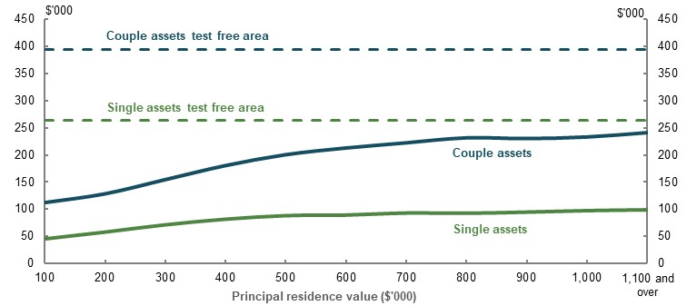
Note: Total assessable assets include all assets recorded for the purpose of the Age Pension assets test. Source: Department of Social Services analysis of payment data, June 2018.
Because equity in the principal residence represents the largest share of net wealth for Australians aged 65 and over on average and is exempted from the Age Pension assets test, the distribution of Age Pension expenditure is less skewed to lower-wealth quintiles than Commonwealth Rent Assistance expenditure.
In 2017-18, about 20 per cent of Age Pension expenditure went to the top two wealth quintiles (Chart 3C-5). In contrast, in 2017-18, about 90 per cent of the Commonwealth Rent Assistance expenditure went to the bottom wealth quintile, reflecting that renting retirees tend to have lower after-housing disposable income and wealth.
    - Government support for retired households, by wealth quintile
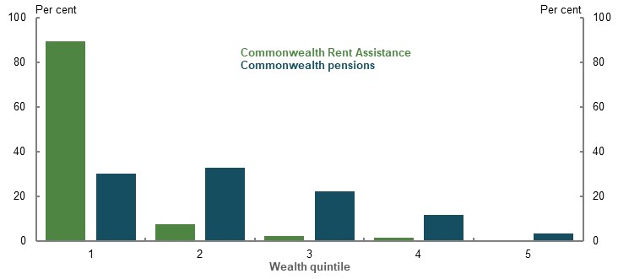
Note: Commonwealth pension expenditure includes all pension payments (e.g. Age Pension, Disability Support Pension, Carer Payment and Veterans’ pensions). The Age Pension represents the majority of the expenditure. Source: Analysis of ABS Survey of Income and Housing Confidentialised Unit Record File, 2017-18.
          - Impact of changes to certain policy settings on the retirement outcomes of home owners and renters
Several submissions proposed policy changes to narrow the gaps in retirement outcomes between home owners and renters. The following summary outlines some implications of some of those proposals.
- Include the principal residence in the Age Pension assets test. Age pensioners with housing assets would no longer receive the Age Pension or receive less Age Pension. This would encourage people to release home equity to fund their retirement and reduce the cost of the Age Pension. This would also help ensure the Age Pension is acting as a safety net for those in need (Cowan & Taylor, 2015). Depending on how the home was included in the Age Pension assets test it could have significant adequacy impacts on retirees.
- Increase Commonwealth Rent Assistance. Increasing rent assistance would benefit retirees who are most likely to be in financial stress and poverty (see 2A. Achieving a minimum standard of living in retirement). However, even large increases to Commonwealth Rent Assistance would not be sufficient to significantly improve retirement outcomes for renters. This reflects the depth of poverty the majority of renters face and that Commonwealth Rent Assistance, even if it increased by 40 per cent, is a fraction of the additional housing costs faced by retiree renters. Commonwealth Rent Assistance is limited in its ability to deliver adequacy outcomes for renters comparable to those achieved by home owners. More holistic consideration of how to provide income support for renters in retirement is required (see 2B. Policy scenario: Implications of increasing Commonwealth Rent Assistance).

SG coverage
          - Section summary
- Coverage of the SG has remained high, but not universal, at around 90 per cent of employees since compulsory superannuation was introduced in 1992. Around 17 per cent of the workforce are self-employed and not covered by the SG.
- The $450-a-month threshold exemption from the SG is inequitable for those missing out on the SG but has a small effect on their retirement incomes. This exemption affects around 300,000 employees per month, particularly young, lower-income, female and part-time workers. The exemption means affected workers receive less remuneration for the same hour of work as unaffected colleagues, although not receiving SG has only a small impact on their retirement incomes. The policy rationale for the $450-a-month threshold has diminished since payroll systems were digitised.
- Employees who are paid overtime receive less SG per dollar earned than those not doing overtime. Overtime pay is not included in the definition of earnings that receive the SG. For most employees, overtime represents a small percentage of their total pay. However, in industries such as mining, manufacturing and construction, overtime pay is more common. For employees in these industries, the forgone SG on overtime significantly reduces both their potential superannuation balances at retirement and their retirement incomes.
- In 2016-17, $2.3 billion of SG was unpaid, typically for lower-income employees, particularly in the accommodation and food services, and construction industries. The impact is worse for younger employees due to missing out on the benefits of compounding. SG underpayment is most common in businesses with annual turnover of less than $2 million. Employers’ efforts to improve compliance have helped to narrow the SG payment gap in recent years. Reforms such as the rollout of Single Touch Payroll are improving ATO oversight of SG compliance, helping to identify non-compliance more quickly.
- Because the self-employed are not covered by the SG they generally have lower superannuation balances than employees. They may, however, have other assets, such as their business, which results in similar wealth profiles approaching retirement. The self-employed are not required to contribute to their superannuation. Only about a quarter of self-employed people make voluntary contributions in a given year. However, small business owners benefit from capital gains tax concessions, allowing them to put the proceeds of selling their business into superannuation.
- ‘Sham contracting’ may see some employees misclassified as contractors and missing out on the SG. Employers may avoid paying the SG by misclassifying employees as contractors. These workers receive lower total remuneration compared with a similar employee receiving the SG. They may be financially constrained from voluntary saving for retirement, resulting in poorer retirement outcomes.
- Superannuation balances of gig economy workers may be lower than an equivalent employee due to forgone SG. However, the difference is likely to be small as gig economy work is generally not the primary source of income for most people. Data is inconclusive on the growth of the gig economy.

Outline of this section
This section considers:
- Which workers are and are not covered by the SG and the impact on their retirement incomes.
- The prevalence and impact of an employee not receiving the SG they are owed by their employer (the ‘SG gap’).
- Retirement outcomes of self-employed people who are not covered by the SG.
          - Stakeholder views on retirement income equity for those who are and are not covered by the SG
A few submissions identified the differential coverage of superannuation between workers as an inequity. In particular, stakeholders drew attention to:
- Those earning under $450 per month, noting this exemption disproportionately affects women and results in lower superannuation balances
- Those required to work regular overtime, arguing this results in them effectively receiving a lower SG rate
- Those receiving Government payments under the Community Development Program (CDP) and Parental Leave Pay, arguing these payments should attract the SG given their connection with employment. One submission noted:
‘CDP workers are no different to any other Australian worker and should be afforded the same rights and protections as other Australians in the workforce.’
(Australian Institute of Superannuation Trustees, 2020, p. 59)
- The impact of unpaid superannuation. One submission noted:
‘Unpaid super is the easiest form of wage theft to get away with and one of the most prevalent.’ (Australian Council of Trade Unions, 2020, p. 49)
Stakeholders also expressed concern over the rise of the gig economy, noting that, although it provides work flexibility, its growth has implications for the level of SG coverage. Most stakeholders on this topic suggested expanding SG coverage. For example, one submission stated:
‘Going forward, universal coverage for all workers should be a goal of the SG system whether people are employees, self-employed or participate as part of the growing gig economy.’ (Actuaries Institute, 2020, p. 16)

Coverage of employees by the SG
The SG is a mandatory entitlement for most employees. Although its coverage lacks a standard measure, a range of indicators suggest the rate of coverage has remained broadly stable since its introduction. In 2013, when the ABS last surveyed SG coverage, about 90 per cent of employees received superannuation from their then employer (Chart 3D-1), with male and female employees having equal coverage. The SG coverage rate for full-time employees was 94 per cent; for part-time employees it was 80 per cent (ABS, 2014).
Taxation statistics for 2017-18 show 91 per cent of those on a salary in that year received a superannuation contribution from an employer. This fell to 86 per cent when including all people who reported income from work (i.e. salary and wages or business income).
Some employees receive more than the legislated SG rate based on their employment agreement. Employees with defined benefit schemes may receive notional employer contributions that are broadly equivalent to the SG rate.
    - Superannuation coverage of employees
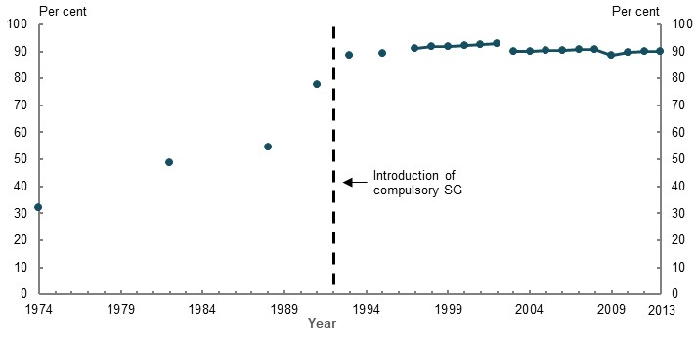
Note: Data is from different surveys and may not be directly comparable, but the trend can be observed. Source: Analysis of (ABS, 1994), (ABS, 2003), and (ABS, 2014).
In future, Single Touch Payroll reporting should allow the rate of SG coverage to be measured more accurately.

Employee exemptions from the SG
The main exemption categories from the SG are those employees:
- Earning less than $450 before tax in a calendar month from a single employer (the ‘$450-a-month threshold’). This is the most significant employee exemption from the SG, affecting around 300,000 employees in July 2019
- Under 18 years old and working no more than 30 hours a week
- Working as a private or domestic worker and no more than 30 hours a week. The 30-hour threshold aims to ensure workers, such as full-time housekeepers or nannies, receive the SG. Although difficult to measure, the domestic or private nature work exemption likely affects relatively few employees. Often, people working part-time in private work may not attract the SG because they are operating as contractors or being paid in cash
Other employee exemptions from the SG include: non-residents being paid for work done outside Australia; those temporarily working in Australia and covered by a bilateral superannuation agreement with another country; and members of the Defence Reserves.

The $450-a-month threshold
The $450-a-month threshold exempts an employer from paying the SG to employees earning below the threshold in a month. The original purpose of the $450-a-month threshold was to reduce employers’ administrative burden to comply with the SG for their casual and temporary employees (Senate Economics References Committee, 2017).
The threshold has not increased since its introduction in 1992, when it was set at one month of the annual tax-free threshold of $5,400. Then, it represented approximately 50 hours per month at the national minimum wage, compared with 23 hours in 2020 (Bray, 2013) (Fair Work Commission, 2019b). In future, with wage rises, fewer people will earn less than $450 per month and be affected by the threshold.
A 2017 Senate Inquiry recommended removing the exemption on the basis that the original rationale had become irrelevant in light of technological advances (Senate Economics References Committee, 2017). Relevant changes include:
- Digitising payroll systems, which have simplified the process of complying with the SG
- The Small Business Superannuation Clearing House, which provides a free service to small businesses to distribute payments to employees’ superannuation funds
- Single Touch Payroll, which automates tax and superannuation reporting to the ATO
The Senate Inquiry also considered the adverse effects of the exemption felt by ‘ … particular categories of employees, such as women and employees who work in multiple, low paid jobs’ as reason for its removal (Senate Economics References Committee, 2017).
Another concern was that paying these employees superannuation would result in accounts with small balances being eroded by fees and insurance premiums (The Treasury, 2019). However, recent policy changes have reduced the impact of fees and insurance on low superannuation balance accounts. For example, in 2019 a 3 per cent cap on administration and investment fees by superannuation funds was introduced for accounts with balances below $6,000. From 1 April 2020, new members of superannuation funds who are younger than 25, or have balances of less than $6,000, must opt in to insurance coverage within the fund.

Effects on employees
Annual data makes it difficult to estimate the number of people affected by the $450-a-month threshold (i.e. they were not paid the SG) and how many months their earnings fall below the threshold in a year. Previous estimates included:
- 400,000 employees per year, with $50 million of the SG forgone in 2014-15 (The Treasury, 2019)
- 365,000 employees per year, with $125 million of the SG forgone in 2017 (ASFA, 2019)
More recent ATO data from Single Touch Payroll reporting enables a more accurate estimate of the SG forgone in a month. Single Touch Payroll data for the month of July 2019 shows about 3 per cent of employees — or around 300,000 people — were affected by the $450-a-month threshold. Notably, around 30 per cent of those earning under $450 in that month were paid the SG by their employer (Table 3D-1).
The data also shows a significantly greater number of employees are affected by the threshold across the course of a whole year, but many are only impacted a few months of the year. The review has estimated the SG forgone is about $90 million per year — within the bounds of previous estimates.
Of affected employees in July 2019, 63 per cent were women (Table 3D-1) (see 3B. Gender and partnered status).
      - Number of employees earning under $450 in July 2019
 | Received the SG | Did not receive the SG
Female | 82,000 | 197,000
Male | 52,000 | 114,000
Total | 134,000 | 311,000
Proportion of total employees (per cent) | 1.3 | 3.0
Note: Based on earnings per job. Single Touch Payroll reporting is not yet used by all employers and there is significant uncertainty around these estimates. Source: Estimates based on ATO Single Touch Payroll data for July 2019, provided to the review.
Younger employees, who are more likely to work part-time and in casual employment, are more likely to be affected by the threshold (Chart 3D-2).
    - Prevalence of employees earning under $450 in July 2019, by age
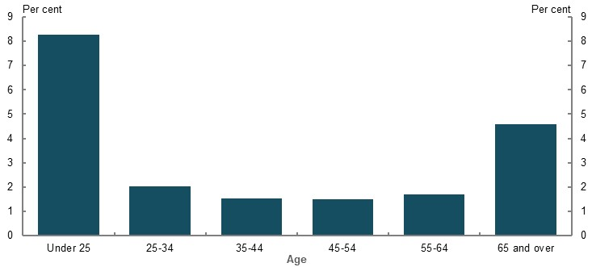
Note: Estimate is based on only one representative month. Single Touch Payroll reporting is not yet used by all employers and there is significant uncertainty around these estimates. Source: Analysis based on ATO Single Touch Payroll data for July 2019 provided to the review; (ABS, 2019c), (ABS, 2020f).
Cameo modelling illustrates the retirement income effects of the $450-a-month threshold for two employee scenarios (Table 3D-2).
- Scenario 1: A student who earns $9,000 per year and works casually, depending on their availability, resulting in the $450-a-month threshold applying to their wage for six months of the year. They work in this manner for five years before taking up full-time work at a median salary.
The threshold has a small impact on their superannuation balance at retirement and on their retirement income. The overall time spent with earnings under $450 per month is intermittent and only makes up a small part of their total working-life earnings.
- Scenario 2: A person who works multiple jobs part-time for their entire career, earning income at the 30th percentile. They have one job that does not pay the SG due to the $450-a-month threshold for half (20 years) of their working life.
This much less common scenario results in a greater, but still small, reduction in the person’s superannuation balance at retirement and in their annual retirement income.
      - Projected effect of the $450-a-month threshold on retirement incomes
 | Superannuation balance at retirement ($) | Average annual retirement income ($) | Replacement rate (percentage point)
Scenario 1 | -2,700 (-0.7% decrease) | -100 (-0.2% decrease) | -0.1
Scenario 2 | -12,000 (-4.0% decrease) | -300 (-0.8% decrease) | -0.9
Note: Values are in 2019-20 dollars using the review’s mixed deflator rounded to the nearest $100. Individual in Scenario 1 does not salary sacrifice during five years working part-time. Source: Cameo modelling undertaken for the review.
Employees earning under $450 per month are likely to be earning an award wage, so their hourly pay is not generally increased to compensate for the SG forgone. This results in those employees receiving less total remuneration than an identical employee who works enough hours to be over the $450-a-month threshold.

Ordinary time earnings
The salary base for the SG is a legacy from occupational superannuation arrangements that existed before compulsory superannuation was introduced (Parliament of Australia, 2004). The SG is paid on a percentage of ordinary time earnings, which includes most wage definitions such as over-award payments, shift loadings and allowances (ATO, 2020f). The major exclusion category from ordinary time earnings is overtime pay.
The difference between total cash earnings and ordinary time earnings for full-time employees averages around 5 per cent (ABS, 2019h). This gap is not consistent across all industries. Non-ordinary time earnings (e.g. overtime pay) represents a significant proportion of earnings for about 20 per cent of employees (Superannuation Guarantee Cross Agency Working Group, 2017), particularly those in mining, manufacturing and construction (ABS, 2019h). For employees who receive overtime, it typically makes up around 12.5 per cent of their earnings, on which they do not receive the SG.
Cameo analysis shows that a person receiving 12.5 per cent of earnings as overtime, instead of ordinary time earnings, results in them having a substantially lower superannuation balance at retirement and a lower retirement income (Table 3D-3).
      - Projected effect on retirement incomes of receiving 12.5 per cent of earnings as overtime payments instead of as ordinary time earnings
 | Superannuation balance at retirement ($) | Average annual retirement income ($) | Replacement rate (percentage point)
Median income earner | -53,100 (12% decrease) | -1,200 (3% decrease) | -2.5
Note: Values are in 2019-20 dollars using the review’s mixed deflator and rounded to the nearest $100. Source: Cameo modelling undertaken for the review.

Other payments exempt from the SG
A few submissions suggested Government Parental Leave Pay, employer paid parental leave and the Community Development Program should attract the SG due to their connection to employment (see 3B. Gender and partnered status and 3F. Aboriginal and Torres Strait Islander people).

Unpaid SG (the ‘SG gap’)
The SG gap is a measurement of the total amount of the SG owed to employees that has not been paid by their employer. The ATO has measured the gap ‘top-down’, using economy-wide data to provide a national figure. In the most recent estimate (2016-17 financial year), the net gap (i.e. after accounting for the amount of SG repaid due to ATO audits) was $2.3 billion or 3.9 per cent of the total SG employees earned for the year (Table 3D-4).
The top-down measurement does not indicate the number of employees affected or the average amount of superannuation lost per person. It is most useful for analysing the trend in the gap. Over six years, the net SG gap has fallen from 6.5 per cent to 3.9 per cent of the total SG, as employers’ voluntary compliance has improved.
      - Estimate of the SG gap
 | 2011-12 | 2012-13 | 2013-14 | 2014-15 | 2015-16 | 2016-17
Gross gap ($millions) | 3,592 | 3,135 | 3,329 | 3,319 | 3,221 | 2,875
Gross gap (per cent of total SG) | 7.6 | 6.4 | 6.3 | 6.0 | 5.6 | 4.9
ATO compliance activities and voluntary disclosures ($millions) | 500 | 523 | 504 | 452 | 476 | 577
Net gap ($millions) | 3,092 | 2,612 | 2,824 | 2,867 | 2,745 | 2,298
Net gap (per cent of total SG) | 6.5 | 5.3 | 5.3 | 5.1 | 4.8 | 3.9
Source: (ATO, 2020e).
Industry Super Australia (ISA) has produced a ‘bottom-up’ measurement of the SG gap at $5.9 billion for 2016-17 (Industry Super Australia, 2019). The methodology has limitations due to using a 2 per cent sample of individuals’ tax returns (Superannuation Guarantee Cross Agency Working Group, 2017). Significantly, it identifies many employees under defined benefit schemes as being underpaid SG, which potentially overstates the gap. When the ATO examined the ISA approach using the full dataset, it estimated the impact of defined benefit amounts to around $2.5 billion, reducing the gap to around $3.4 billion.

Who is affected by unpaid SG?
Data from ATO compliance activity suggests employees more likely to have unpaid SG are:
- Working for businesses with annual turnover of less than $2 million, which account for most cases of SG underpayment
- Working in the accommodation and food services, and construction industries, which are over-represented in SG non-compliance relative to their proportion of total employment
- On lower incomes
- Working for insolvent businesses, which are responsible for about half of superannuation debt (Superannuation Guarantee Cross Agency Working Group, 2017), especially those engaging in ‘phoenix activity’.
Since the SG is not required to be paid at the same time as wages, employees may find it difficult to monitor if they are being paid the SG to which they are entitled. The average length of unpaid SG is 18 months and non-payment is twice as likely as underpayment (Superannuation Guarantee Cross Agency Working Group, 2017).
Under superannuation law, unpaid SG becomes a debt — the SG charge — to the Commonwealth. If employees believe they have unpaid superannuation, they can apply to the ATO, which can use its compliance powers to pursue the debt.
One submission advocated for the private right to pursue unpaid superannuation:
‘Individual workers should have a legal avenue for recovery of unpaid super, as already exists for recovery of unpaid or underpaid wages. The Government should empower workers and their representatives, such as their superannuation fund, to take action against employers for the non-payment of the superannuation guarantee or superannuation contributions.’ (Cbus, 2020, p. 13)

Impact on retirement incomes of unpaid SG
Cameo modelling shows that a lower-income, younger employee who is not paid the SG for two years experiences a larger decrease in their superannuation balance and retirement income than an older worker who is not paid the SG for the same period. This is because the younger employee misses out on the benefits of compounding returns (Table 3D-5).
      - Projected effect of unpaid SG for a lower-income earner
 | Superannuation balance at retirement ($) | Average annual retirement income ($) | Replacement rate (percentage point)
Early in career (age 30) | -17,500 (-6% decrease) | -500 (-1% decrease) | -1.3
Later in career (age 60) | -13,000 (-4% decrease) | -300 (-1% decrease) | -0.9
Note: Values are in 2019-20 dollars using the review’s mixed deflator and rounded to the nearest $100. Modelling assumes no SG or salary sacrifice contributions are paid in relevant years. Employees are at the 30th income percentile. Source: Cameo modelling undertaken for the review.
Another consequence of unpaid superannuation can be the employee unknowingly losing disability or income protection insurance. Insurance cover provided through superannuation can lapse if contributions are not regular (Senate Economics References Committee, 2017).

Policy related to unpaid superannuation
Historically, the ATO relied on employee notifications of unpaid superannuation and could not monitor SG compliance in a timely way (Senate Economics References Committee, 2017, pp. 83-84). However, recent developments are improving transparency of SG compliance and helping to identify non-compliance more quickly. This includes:
- Single Touch Payroll requiring employers to automatically report tax and SG information to the ATO when they pay their employees’ salaries and wages
- Superannuation funds reporting contributions data more regularly to the ATO
- myGov allowing people to see employer contributions to their superannuation fund and the related pay period
- Allowing the ATO to disclose to employees when they have identified unpaid SG
- Fixing a loophole in SG legislation where an employer could use an employee’s salary sacrificed amounts to reduce their SG liability
- Increased penalties for non-compliance
- A temporary amnesty from penalties to encourage employers to correct past SG non-payment

Retirement outcomes for self-employed people
In 2019, around 2.2 million people, or 17 per cent of workers, were self-employed in their main job (ABS, 2019f). A self-employed person does not have to make contributions on their behalf to a superannuation fund. Similarly, employers do not have to pay the SG to independent contractors. The SG has not been applied to self-employed people since its inception due to concerns about restricting capital and liquidity management for small businesses.
Several submissions were concerned that the lack of compulsory superannuation can lead to poorer retirement outcomes for the self-employed. Evidence to support this concern is difficult to assess as self-employed people have diverse characteristics and circumstances, as illustrated in these generalised scenarios:
- A small business owner with business assets and who uses these assets as a retirement ‘nest egg’. This is facilitated by tax concessions for moving business assets into superannuation (see below). However, the owner takes on risk by not diversifying their retirement assets.
- A high-skilled sole trader/independent contractor who does not have significant business assets to sell at retirement but receives remuneration that they consider compensates them for the entitlements (e.g. the SG) they miss out on by not being an employee. This person may make voluntary contributions to superannuation or build up other assets.
- A dependent contractor who is misclassified as an independent contractor so they do not receive the SG, but has working arrangements more akin to an employee. They may lack the bargaining power to receive higher payments to compensate for the lack of SG compared with a similar employee. This may represent a ‘sham contracting’ arrangement, used by employers to save on wage costs (see below).
Data limitations also prevent comprehensive and conclusive analysis of self-employed people’s retirement outcomes, partly because ‘self-employed’ is not an identifier in retirement data.

Characteristics of self-employed people
Self-employment is more common among men and older people (ABS, 2019f). A Productivity Commission report found that self-employed (independent) contractors are more likely to be male, older and in higher skilled occupations. Whereas, dependent contractors are more likely to be younger and working in lower skilled jobs (Waite & Will, 2001, p. 53).
In 2019, around 12 per cent of workers aged 25-34 were self-employed, increasing to a quarter of workers aged 55-64 (ABS, 2019f). Studies found that older workers may prefer more flexible forms of work, including self-employment, as part of transitioning out of the labour force (Shomos, et al., 2013b).

Superannuation and total wealth
Self-employed people generally have lower superannuation balances than employees (Chart 3D-3). However, employees and self-employed people have similar total levels of wealth, on average, with the typical household using the family home as the primary savings vehicle (Chart 3D-4 and Chart 3D-5). Tax concessions available to small business owners may incentivise them to hold wealth in the form of their business assets until closer to retirement.
    - Median superannuation balances, by form of employment and age
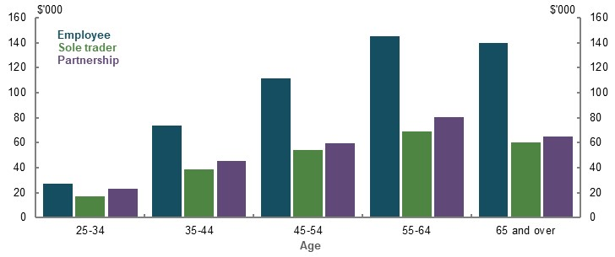
Note: Balances from 2017-18 taxation data. ‘Employee’ indicates those who solely earned salary and wage income. ‘Sole trader’ and ‘partnership’ income includes any person who earned income from running a non-primary production business as an individual or in a partnership. Source: Data provided by the ATO for the review.
- Total wealth of households aged 55-64, by form of employment and household (25th to 75th percentile)  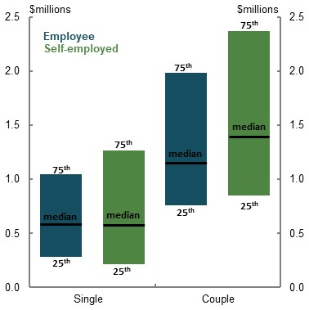 | - Breakdown of average wealth of households aged 55-64 by form of employment  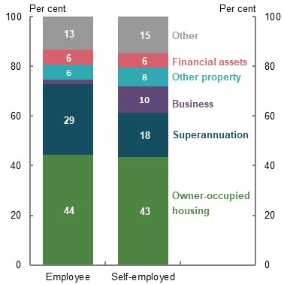
Note: Age is based on age of the household reference person. The top and bottom decile of households by wealth has been removed as outliers from Chart 3D-5 to make the average more representative. Form of employment indicates the primary source of income of the household. The wealth of older self-employed people may be higher on average due to survivorship bias, as those with profitable small businesses may be more likely to operate them into older age. Source: Analysis of ABS Survey of Income and Housing Confidentialised Unit Record File, 2017-18.

Contributions to superannuation by self-employed people
Self-employed people have opportunities beyond those of employees to fund their retirement. For example, as well as making tax-deductible personal superannuation contributions, they have the options of setting up their business assets, such as the commercial property, within a self-managed superannuation fund; and accessing significant capital gains tax concessions from selling business assets and putting the proceeds into superannuation.

Voluntary superannuation contributions
Self-employed people have access to the same superannuation tax concessions as employees. However, this has not always been the case, which may have suppressed use of superannuation by the self-employed (see 1B. Design of Australia’s retirement income system).
A small proportion of self-employed people make voluntary superannuation contributions. Between 2013-14 and 2017-18, about a quarter of those with business income made voluntary contributions in a given year and 40 per cent made a contribution at any point over the five years. Of those who made contributions, the average total contribution over five years was about $80,000 for sole traders and $100,000 for those in a partnership. One superannuation fund noted that some of their self-employed members said they regretted not making voluntary superannuation contributions while working (Cbus, 2020).

Small business owners and capital gains tax concessions
The ability to use a small business for retirement planning will depend significantly on having realisable assets. Two types of capital gains tax concessions are available for businesses with net assets up to $6 million or turnover up to $2 million:
- The ‘15-year’ exemption. This provides a full capital gains tax exemption when someone disposes of assets held for at least 15 years when the disposal happens in connection with the retirement of a person aged 55 or over.
- The ‘retirement’ exemption. This exempts up to $500,000 in assets from capital gains tax and, if the person is aged under 55, it must be contributed to superannuation.
Proceeds from selling business assets under these two exemptions can be contributed to superannuation without paying any tax (capital gains tax or 15 per cent contributions tax) and without regard for the standard annual contributions caps. Contributions under these exemptions have a separate lifetime cap. In 2020-21, this is $1.565 million, indexed annually to wages. These exemptions are not available to any other group.
The total value of capital gains claimed against these concessions was $3.8 billion in 2016-17, resulting in $1.7 billion being contributed to superannuation. More money was contributed to superannuation under the 15-year exemption compared to the retirement exemption (Table 3D-6). The predominant use of the 15-year CGT exemption was for the sale of business property (70 per cent), followed by ‘goodwill’ (13 per cent).
The policy rationale for these capital gains tax exemptions was to improve retirement outcomes for small business owners who invest funds in their business and treat it as their retirement ‘nest egg’ (The Board of Taxation, 2019). The Board of Taxation (2019) considered the concessions may represent a reward for risk-taking. However, the concessions may incentivise over-investment in a person’s small business, which carries a risk of failure, rather than making more regular contributions to superannuation and diversifying risk.
      - Annual superannuation contributions using the capital gains tax business exemptions
 | Fund type | Number of individuals | Average contribution ($) | Median contribution ($)
Retirement exemption | APRA | 1,720 | 122,219 | 73,529
Retirement exemption | SMSF | 3,685 | 180,626 | 121,729
15-year exemption | APRA | 434 | 587,259 | 450,225
15-year exemption | SMSF | 1,122 | 546,517 | 450,000
Note: Contributions made during the 2016-17 financial year. An individual may make use of both exemptions in a year. Source: Analysis of ATO individual income tax returns and member contributions statements, 2016-17.

Dependent contractors and sham contracting
Independent contractors do not receive the SG. However, superannuation law extends the definition of employee to include ‘dependent contractors’ who are hired ‘wholly or principally for their labour’ so they receive the SG. Despite this protection, some employers may misclassify workers as independent contractors to avoid paying them entitlements, including the SG. This is referred to as ‘sham contracting’.
The effect of sham contracting falls more heavily on lower skilled workers (Legal Aid Commission of NSW, 2017, p. 11). A worker may be willing to, or unknowingly accept lower remuneration than they could receive as an employee, if they have more limited employment options.
By its nature, sham contracting is difficult to quantify (The Treasury, 2017b). A 2012 Fair Work Building and Construction report indicated that possibly 5 per cent of the workforce in the building and construction industry (or 13 per cent of contractors in the industry) were misclassified as contractors (Fair Work Building and Construction, 2012).
Protections in the Fair Work Act 2009 apply penalties for sham contracting. The 2019-20 Budget included a measure to establish a sham contracting unit under the Fair Work Ombudsman and increase penalties for sham contracting.
However, business groups have claimed that employee–contractor definitions are too complex and even employers acting in good faith may inadvertently misclassify employees. One complication is that the definition of a contractor can vary between different regulatory schemes. For example, a person could be legally defined as a contractor for tax withholding purposes and an employee for SG purposes.
Cameo modelling shows the retirement outcomes for a lower-income earner who transitions every 10 years between roles classified as an employee and as a dependent contractor who does not receive SG, for their entire working life (Table 3D-7). Due to the forgone SG and not receiving higher wages as compensation, the person has a substantially lower superannuation balance and retirement income compared with an equivalent employee receiving the SG for their entire working life.
      - Projected effect on retirement outcomes of intermittent contracting
 | Superannuation balance at retirement ($) | Average annual retirement income ($) | Replacement rate (percentage point)
30th percentile income earner | -138,200 (49% decrease) | -4,700 (12% decrease) | -13.3
Note: Values are in 2019-20 dollars using the review’s mixed deflator and rounded to the nearest $100. This scenario assumes an individual works for 40 years between ages 27-67. The first 10 are as an employee, alternating every 10 years between employee and dependent contractor work. Full SG is paid during periods as an employee. To isolate the effect of contract work on retirement outcomes, the individual does not salary sacrifice either as an intermittent contractor or full-time employee. All other model specifications align with standard review assumptions. Source: Cameo modelling undertaken for the review.

Gig economy and the changing nature of work
Several stakeholders expressed concern about the effects of the ‘gig economy’ on accumulating superannuation. Gig economy workers are generally classified as contractors and do not attract the SG. The status of gig economy workers being in a true versus sham contracting arrangement has been contested. The Senate Education and Employment References Committee (2016, p. 104) stated:
‘Having looked at sham contracting … the committee can only conclude that ‘gig economy’ is just a more discrete and sanitised way for companies to abrogate their obligations by requiring workers to be contractors.’
Australia lacks official statistics on the size of the gig economy, partly due to the difficulty of defining gig workers and the nascent nature of the industry. Anecdotal evidence points to a rising gig economy, but the limited data available is not conclusive. Available data includes the following points:
- The level of independent contractors has fallen in recent years (ABS, 2019f). However, gig economy workers will not be captured in this data if it is not their main job. Even in the US, where the gig economy is more advanced, gig economy work appears to rarely be used as a primary income source (Federal Reserve, 2019).
- The number of multiple job holders has been increasing in recent years but is not unusually high (Chart 3D-6).
- Several studies suggest the gig economy represents less than 1 per cent of all Australian workers. In contrast, a large increase in people registering for Australian Business Numbers (Chart 3D-7) may be partially due to those seeking work on a digital platform.
- Some gig economy work may be substituting for other self-employment. For example, taxi drivers shifting to ‘ride share’ platforms (Lab & Wooden, 2019, p. 11) — although neither are generally covered by the SG.
- Proportion of the labour force with multiple jobs  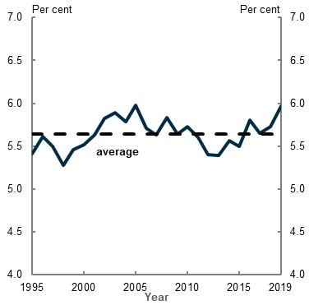  Source: Analysis of (ABS, 2020f). | - New Australian Business Number registrations  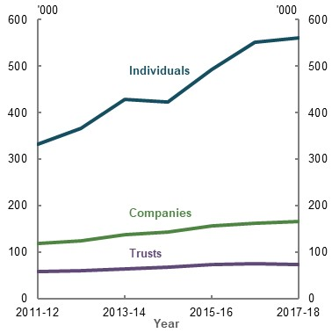  Source: (The Treasury, 2017b).
Preliminary results from a study commissioned by the Victorian Government found:
- Gig economy workers are most likely to be aged 18-34 and two-thirds are male
- The most common work was transport and food delivery
- Gig work is more common among students, people living with disability, temporary residents and the unemployed (Victorian Government, 2020, p. 18)
To the extent gig economy work is used as a second job for supplementary income, or by people who may otherwise have encountered difficulties in finding work, the effect on retirement incomes of forgoing the SG is expected to be small. Even so, the superannuation balances of gig economy workers will generally be lower than an equivalent employee.
The role of the superannuation system in delivering retirement outcomes is expected to continue to be challenged by ongoing technological disruptions to the nature of work.

Mandating the SG for the self-employed
Internationally, self-employed people are often required to contribute to retirement schemes. Most OECD countries require self-employed people to make some contribution to an earnings-related pension scheme. However, only 10 countries mandate an equivalent level of contributions from self-employed people to that of employees (OECD, 2019b, p. 82). This demonstrates the difficulty in harmonising employment schemes between employees and self-employed people.
Mandating contributions for self-employed Australians to boost their superannuation savings, as some stakeholders advocated, would present the following issues.
- The obligation to pay superannuation falling on individuals (not employers) and affecting incentives to contract. This could reduce incentives to engage in sham contracting as many contractors who realise they are liable to pay additional superannuation will negotiate for equivalent income as an employee. However, this is less likely to be an option for lower skilled contractors with weak bargaining power, or those who lack other job opportunities.
- Determining the ‘contribution base’ for self-employed people. Finding the equivalent ordinary time earnings would be challenging as self-employed workers generally do not have an equivalent gross wage. They may have significant operating costs, and income from self-employment may also be split between labour and capital shares.
- Cash flow issues for small businesses who may have otherwise reinvested the SG amount back into the business. Australia’s Future Tax System Review (2009) argued the SG should not be extended to self-employed people because ‘ … the diverse and varying risks and circumstances of business and entrepreneurship argue for allowing full flexibility in their saving and investment decisions’.
- A separate SG rate may be needed for equivalence. Paying superannuation contributions from after-tax income requires a larger contribution to match equivalent employer contributions, which are paid on an employee’s before-tax income.
          - Impact of changes to certain policy settings on the retirement outcomes of those who are and are not covered by the SG
A significant number of submissions raised policy proposals affecting SG coverage. The following summary outlines some implications of some of the proposed policy changes.
- Removing SG employee exemptions. Removing the $450-a-month threshold would not materially improve retirement outcomes, but it would improve equity in the retirement income system. This would increase hourly remuneration for impacted workers, who are generally young, low-income and female. The change would be unlikely to affect the wage rates of these employees as their total wages represent less than 0.1 per cent of the national wage bill and they are predominantly on award wages. Removing the threshold would likely remove incentives to restrict employees’ monthly hours.
- Expand the earnings base that attracts the SG. Such a change would equalise the SG received per dollar of earnings between employees, regardless of their working arrangements. This would boost the superannuation balances and retirement incomes of about 20 per cent of employees, particularly those in mining, manufacturing and construction jobs, who typically receive a greater proportion of their earnings as overtime. This may have significant labour market impacts in sectors where overtime represents a large share of remuneration.
- Continue to narrow the SG compliance gap. Facilitating employees and the ATO to identify underpayment more quickly would help people get the SG to which they are entitled. Unpaid SG has a larger effect on superannuation balances when it occurs early in working lives due to people missing out on the benefits of compounding. Improved employer compliance with the SG would particularly benefit lower-income workers and those in certain industries, such as construction, and accommodation and food services.
- Pay the SG at the same time as wages. This would make it easier for employees to monitor SG compliance but it may create cash flow issues for employers. It would effectively reduce the terms of payment on SG liabilities from up to four months to potentially one week.
- Require the self-employed to make compulsory superannuation contributions. Such a change would boost their superannuation balances and diversify the retirement savings of the self-employed, but it would create new compliance burdens and risks. It would be harder for the self-employed to invest in their business and may affect their other saving behaviour. Other challenges include determining the equivalent contribution base for the self-employed and whether the compulsory rate is set at an equivalent level to employees.
- Better enforce sham contracting laws or expand coverage of the SG for vulnerable ‘dependent contractors’. This would improve the retirement outcomes of people subject to sham contracting and would equalise total remuneration between dependent contractors and employees.

Age of retirement
          - Section summary
- Despite declining rates over the past few decades, a significant number of people still retire involuntarily. The high prevalence of involuntary retirement means many Australians retire abruptly and with fewer savings than planned. This runs counter to policies that seek to encourage older workforce participation. People who retire at younger ages tend to do so involuntarily. The most common reason for involuntary retirement is own ill health, followed by job-related issues and caring responsibilities. Involuntary retirement may increase due to the financial and labour market effects of the COVID-19 Pandemic.
- Involuntary retirement is more common among people with lower wealth and lower education levels, and in certain occupations. On average, people with higher education levels and in higher skilled occupations remain in the workforce until later ages. More highly educated people are also more likely to work part-time in the years preceding retirement. Although around the same proportion of blue- and white-collar workers retire before age 65, blue-collar workers are more likely to retire involuntarily than white-collar workers.
- People aged 55 and over have experienced unemployment or underemployment at similar rates to people aged 25-54, but for longer periods. This reduces their ability to save for retirement and may increase reliance on the Age Pension.
- Although early retirement (i.e. retirement before Age Pension eligibility age) leads to lower superannuation balances, retirement incomes and replacement rates, Government pensions and allowances, especially the Age Pension, provide a safety net. When retiring 5 or 10 years before Age Pension eligibility age, replacement rates of lower- and middle-income earners remain within or above the benchmark replacement rate of 65-75 per cent. However, early retirees may receive much lower income before preservation age compared with the remainder of their retirement. Payment rate differences between JobSeeker Payment (formerly Newstart Allowance), Disability Support Pension and Carer Payment mean people who retire early due to job-related reasons may have lower retirement incomes than those who retire early due to own ill health or caring responsibilities.
- Retiring beyond Age Pension eligibility age, for those who can, is an effective way to increase retirement incomes and replacement rates. This increase is primarily due to investment returns, the benefits of compounding and fewer years in retirement rather than additional SG contributions. Late retirement benefits higher-income earners the most, generating more SG in dollar terms, more earnings on their larger superannuation balances and the least, if any, reduction in Age Pension.

Outline of this section
This section considers how the age and degree of choice in the timing of retirement significantly affects retirement outcomes. It focuses on:
- The reasons for retirement, how they differ across subsets of the population and the support available for people who retire before Age Pension eligibility age (‘early retirement’).
- The effect involuntary and early retirement has on retirement incomes.
- The effect retirement after Age Pension eligibility age (‘late retirement’) has on retirement incomes.
          - Stakeholder views on early, late, voluntary and involuntary retirement
Many stakeholders noted the large number of people who are involuntarily retired and receive JobSeeker Payment (formerly Newstart Allowance) until they reach Age Pension eligibility age. They expressed concern with the adequacy of JobSeeker Payment. One submission stated:
‘…55% of people relying on Newstart Allowance are living in poverty. In the context of retirement planning it needs to [be] taken into consideration that a quarter of Newstart recipients (184,000 people) are aged 55 years or older.’ (Mission Australia, 2020, p. 4)
Another submission said:
‘While on the surface this is a problem of Newstart and not the Retirement Incomes System, clearly government policy settings in Newstart are having an impact on retirement savings. Due to the inadequacy of Newstart as a payment to live on (or ineligibility to even access Newstart payments), early and involuntary retirement means that too many older Australians not only miss the opportunity to further contribute to their retirement savings due to their exclusion from the workforce, but are required to prematurely spend their existing savings in order to meet the cost of even basic living standards.’ (Fix Pension Poverty campaign, 2020, p. 7)
Stakeholders had mixed views on the preservation and Age Pension eligibility ages. Some noted these universal ages disadvantage those who retire early and involuntarily. Others argued that higher ages deliver fiscal benefits and encourage older workforce participation. One stakeholder stated:
‘Some systems in other countries have industry-based retirement ages, reflecting the reality that blue-collar workers typically retire earlier than white-collar workers. There is merit in exploring the potential application of this approach in
Australia.’ (Cbus, 2020, p. 19).

          - How ‘Newstart Allowance’ became ‘JobSeeker Payment’
On 20 March 2020, JobSeeker Payment replaced Newstart Allowance as the main working-age payment for those aged 22 to Age Pension eligibility age with capacity to work now or in the near future. JobSeeker Payment has the same basic qualification, payment arrangements and means-testing rules as Newstart Allowance (Department of Social Services, 2020d).
From 27 April 2020, JobSeeker Payment included a temporary Coronavirus Supplement of $550 per fortnight. The combined payment rate of the JobSeeker Payment and Coronavirus Supplement is higher than the Disability Support Pension, Carer Payment and Age Pension. As the Coronavirus Supplement is temporary, the review’s analysis and modelling uses the standard rate of JobSeeker Payment.

Prevalence of voluntary and involuntary retirement
The length of working life, the age at which people retire and the degree of choice over when people withdraw from the workforce all have a bearing on individual retirement outcomes.
People who stop work at younger ages are more likely to do so involuntarily. The ABS and HILDA Surveys both measure the main reason for retiring. The HILDA Survey found 42 per cent of people retired involuntarily between 2012 and 2015. The ABS survey found 37 per cent of people retired involuntarily between July 2013 and June 2019, with 28 per cent retiring involuntarily before age 65 and 8 per cent retiring involuntarily after this age (ABS, 2020p) (Chart 3E-1). Both surveys found own ill health was the most common reason for involuntary retirement, followed by job-related issues and caring responsibilities.
    - Proportion of people retiring, by retirement age and reason
Note: Proportion is of people who retired between July 2013 and June 2019. Assumes the age of retirement is equal to the age of ceasing last job. The reasons for involuntary retirement are split into own ill health, job-related and caring responsibilities. Own ill health is from ‘own sickness, injury or disability’ response. Job-related is from ‘retrenched/dismissed/no work available’, ‘own business closed down for economic reasons’, and ‘unsatisfactory work arrangements’ responses. Caring responsibilities is from ‘to care for children/pregnancy’ and ‘to care for ill/disabled/elderly’ responses. Given the small sample size of the two response options that make up the ‘caring responsibilities’ category, these figures should be used with caution. Source: Analysis of (ABS, 2020p).
The surveys differed over the common reasons for voluntary retirement:
- HILDA Survey top reasons: ‘fed up with working/work stresses, demands’, ‘to have more personal/leisure time’ and ‘could afford to retire/had enough income’.
- ABS survey top reason: ‘reached retirement age/eligible for superannuation/pension’.
These divergent results may be due to differences in the way the surveys were worded. The ABS did not offer ‘could afford to retire’ as a response option. Whereas, the HILDA Survey offered both ‘could afford to retire’ and ‘became eligible for the old age pension’. Given someone may consider they can afford to retire when they become eligible for the Age Pension, these overlapping choices may have split the results.
Although involuntary retirement has gradually decreased over time, its incidence remains high. The ABS survey found around 46 per cent of retirements were involuntary between August 1984 and June 2005 — 9 percentage points higher than between July 2013 and June 2019 (ABS, 2020p; ABS, 2006b). Similarly, the HILDA Survey found the incidence of involuntary retirement was 17 percentage points higher, at 59 per cent of retirements, between 2001 and 2003 than between 2012 and 2015. This more recent trend could be due to a stronger labour market, employers becoming more willing to employ older workers, increased share of the workforce in white-collar occupations (ABS, 2011b) and/or improved health over the period. The Australian Institute of Health and Welfare found the number of expected years living without disability increased for men and women between 2003 and 2015 (Australian Institute of Health and Welfare, 2017).
The proportion of people retiring involuntarily may increase as a result of the economic and financial impact of the COVID-19 Pandemic. An increase in unemployment and more competitive labour market conditions may drive more people to retire earlier than planned. This was seen in the years following the GFC, when the HILDA Survey found the proportion of people retiring involuntarily increased.
The fall in the value of retirement savings will also likely mean some people who would have otherwise retired voluntarily will now work longer to improve their financial position.

Retirement age and reason for retirement among cohorts
Some people are more likely to retire early and for different reasons, depending on their gender, wealth, education level and occupation.

Gender
Data shows in recent years around the same proportion of men and women retired involuntarily (Chart 3E-2). A similar proportion of men and women retired involuntarily due to own ill health and job-related issues. Women were slightly more likely to retire involuntarily due to caring responsibilities. Of those men and women who retired voluntarily, the most common reason for both groups was being able to access their superannuation or the Age Pension. Additionally, relatively more women retired to have a holiday/pursue leisure activities or to coincide with their partner’s retirement than men (ABS, 2020p).
Women tend to retire one to three years earlier than men, on average (see 1A. What is retirement?).
    - Proportion of people retiring, by reason for retirement and gender
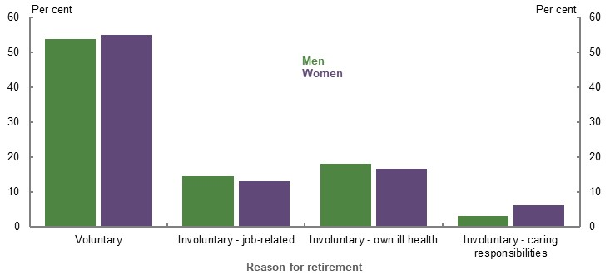
Note: Proportion is of people who retired between July 2013 and June 2019. Does not include people who selected ‘other’ reason for retirement and therefore does not sum to 100. Around 10 per cent of men and women selected ‘other’ reason for retirement. Given the small sample size of the two response options that make up the ‘caring responsibilities’ category, these figures should be used with caution. Source: Analysis of (ABS, 2020p).

Wealth
People with higher wealth are significantly less likely to retire involuntarily (Chart 3E-3). This suggests that, if the preservation or Age Pension eligibility ages were to increase, it would more likely affect people with lower wealth. Higher-wealth people are also more likely to be able to respond to incentives for older workforce participation.
    - Proportion of people involuntarily retiring, by wealth quintile
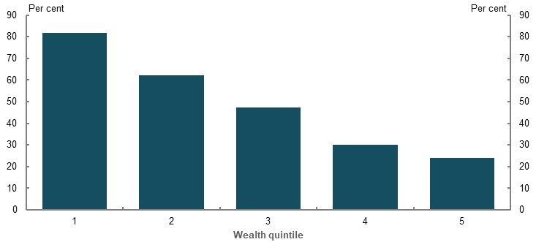
Note: Proportion is of people who retired in 2011 and 2015. These are the two most recent surveys that asked the question of the reason for retirement. Wealth quintiles are calculated using the survey’s 2010 and 2014 wealth modules. People’s wealth quintile in 2011 and 2015 are equal to their wealth quintile in 2010 and 2014, respectively. Source: Analysis of HILDA Survey data (Waves 10, 11, 14 and 15).

Education
People with higher education levels remain in the labour force until later ages, on average (Chart 3E-4). They are also more likely to work part-time if they are employed past age 65, compared to people with no post-school qualification. However, as people with a university degree are likely to have entered the labour force at a later age, their working life may not be any longer than people with no post-school qualification.
    - Proportion of people in the labour force, by age and level of
highest educational attainment
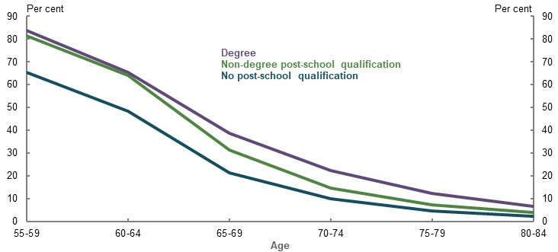
Note: 2016 data. Degree includes postgraduate degree, graduate diploma and graduate certificate and bachelor degree. Non-degree post-school qualification includes advanced diploma and certificate 3 and 4. No post-school qualification includes year 12 or equivalent, secondary education — years 10 and above, secondary education — years 9 and below, and certificate 1 and 2. Source: Analysis of (ABS, 2016a).
A greater proportion of people with university degrees retire voluntarily than people with non-degree post-school qualifications, and no post-school qualification. People without a degree are more likely to retire involuntarily due to job-related issues or own ill health (Chart 3E-5).
    - Proportion of people retiring, by level of highest educational attainment and reason for retirement
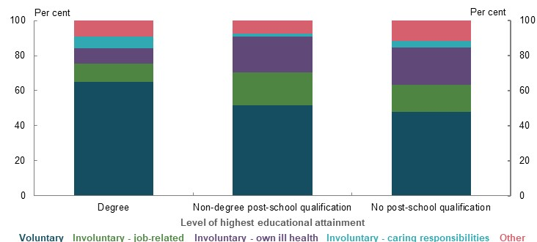
Note: Proportion is of people who retired between July 2013 and June 2019. Degree and non-degree post-school qualification includes the same categories as in Chart 3E-4. No post-school qualification includes year 12 or equivalent, year 11, year 10, certificate 1 and 2, year 9 and below and no educational attainment. While the chart uses a relatively small sample size and therefore some categories have high relative standard errors, the results are consistent with earlier surveys. Source: Analysis of (ABS, 2020p).

Occupation
On average, blue- and white-collar workers have similar retirement ages (ABS, 2020n). Around the same proportion of blue- and white-collar workers retire before age 65 (Chart 3E-6). The proportion of blue- and white-collar workers retiring before age 65 has significantly decreased over time, especially among blue-collar workers (ABS, 2020p). Even so, on average, blue-collar workers may have longer working lives than white-collar workers. One superannuation fund noted how its members — mostly blue-collar workers — typically started their working lives earlier than the general population (Cbus, 2020).
A greater proportion of white-collar workers retire voluntarily than blue-collar workers, who are more likely to experience health issues (Chart 3E-6). One stakeholder pointed to how the blue-collar occupations of technicians and trade workers, machinery operators, and drivers and labourers comprise around 30 per cent of the workforce, yet almost 60 per cent of WorkCover injury and illness claims (Cbus, 2020). This suggests any increases to preservation or Age Pension eligibility ages would more acutely affect some blue-collar workers, who have less choice in when they retire. Government pensions and allowances, and the early release of superannuation benefits, can help mitigate the adverse effect of retiring involuntarily before either the preservation age or Age Pension eligibility age.
    - Retirement characteristics of blue-collar and white-collar workers
Retirement age | Reason for retirement
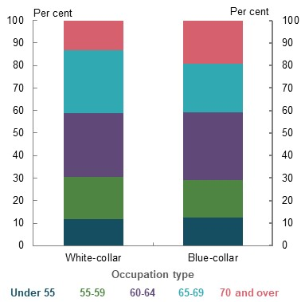 | 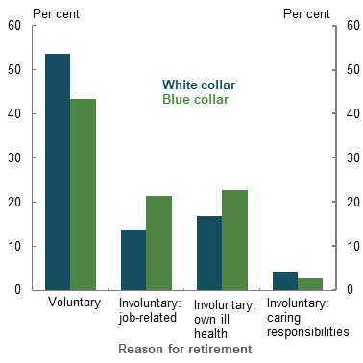
Note: Proportion is of people who retired between July 2013 and June 2019. Right-hand side chart does not include people who selected ‘other’ reason for retiring and therefore does not sum to 100. Around 10 per cent of white- and blue-collar workers selected ‘other’ reason for retiring. While the charts use a relatively small sample size and therefore some categories have high relative standard errors, the results are consistent with earlier surveys. Source: Analysis of (ABS, 2020p).
Consistent with previous research (Australian Centre for Financial Studies, 2014, p. 19), recent data confirms that occupations predisposed to early retirement are not necessarily those typically associated with manual labour. There appears to be some correlation between the level of occupational skill and retirement age. For example, recent ABS data shows the occupation where retirement before age 65 is least common — ‘professionals’ — is a higher skilled occupation. In contrast, ‘sales workers’ are more likely to retire before age 65 and tend to be classified as a lower skilled occupation. However, the level of skill may not always influence the age of retirement, as the lower skilled occupation of ‘labourers’ has some of the lowest rates of retirement before age 65 among recent retirees (Chart 3E-7).
    - Proportion of people retiring, by occupation of last job and age of retirement
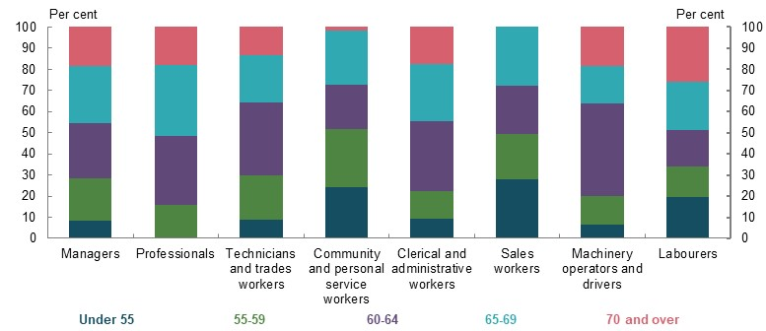
Note: Proportion is of people who retired between July 2013 and June 2019. While the chart uses a relatively small sample size and therefore some categories have high relative standard errors, the correlation between the level of occupational skill and retirement age are consistent with earlier surveys. Source: Analysis of (ABS, 2020p).

Unemployment, underemployment and discouraged job seekers
Many stakeholders suggested that unemployment and underemployment among Australians aged 55 and over make it harder for them to accumulate retirement savings.
ABS data over a long period shows people aged 55-64 have experienced unemployment (Chart 3E-8), underemployment or have been ‘discouraged job seekers’ at rates broadly similar to other working-age Australians aged 25-54. However, people aged 55 and over experience unemployment and underemployment for longer periods than younger age groups. Between 2010 and 2019, for people aged 55 and over who were unemployed, the average typical length of time searching for a job was 22 weeks compared with 16 weeks for people aged 25-54 (ABS, 2020g). Notably, these statistics may understate unemployment in older workers as this age group may be more likely than younger people to exit the labour market. If pre-retirees stop looking for work, due to their own ill health, caring responsibilities or simply giving up on finding employment, they will not be counted in these statistics.
The data in Chart 3E-8 also does not account for the impact of the COVID-19 Pandemic, and it is too early to know its full effect on unemployment and underemployment. Data to May 2020 shows the unemployment and underemployment rates among Australians aged 55 and over have increased compared with January 2020. However, these increases are generally smaller compared with younger age groups (ABS, 2020k).
See 3B. Gender and partnered status for the effect of career breaks later in life and 2C. Maintaining standards of living in retirement for the effect of shorter working lives.
    - Average unemployment rate, by age
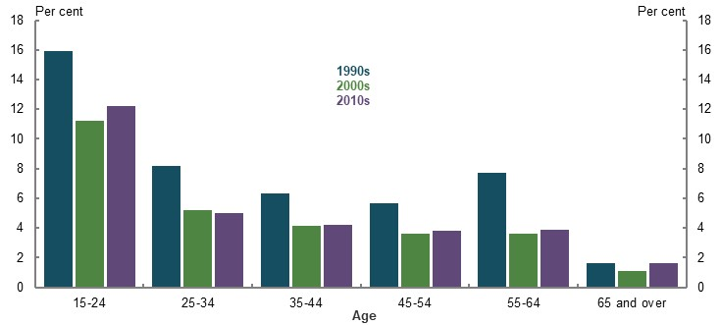
Note: Uses the average of all monthly unemployment rates in the relevant decade. Source: Analysis of (ABS, 2020h).

Support available to people who retire early

Source of income at the point of retirement
The main source of income at the point of retirement differs between people who retire voluntarily and involuntarily. People who retire involuntarily are relatively more likely to rely on a Government pension or allowance (Chart 3E-9). Whereas, people who retire voluntarily are relatively more likely to rely on superannuation (Chart 3E-10).
People’s main source of retirement income also differs based on what age they retire (Chart 3E-9 and Chart 3E-10) and their gender. Some benefits, such as superannuation and the Age Pension, are not available until the person reaches a certain age. More men than women rely on superannuation as their main source of income at retirement (ABS, 2020n). More than 30 per cent of women who retire before age 65 have no personal income at the point of retirement compared to less than 10 per cent of men (ABS, 2020p).
    - Involuntary retirees: main source of income at retirement, by age
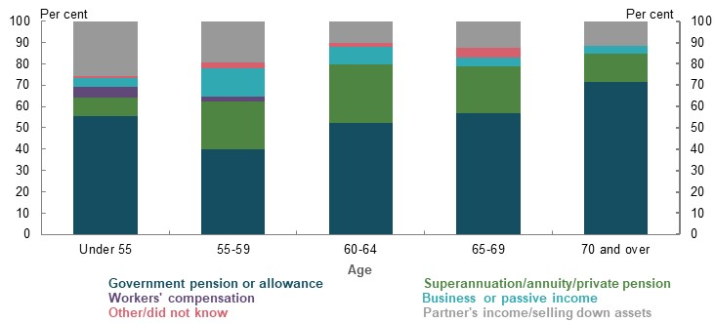
Note for Chart 3E-9 and Chart 3E-10: Includes people who involuntarily retired between July 1998 and June 2019. Captures people who retired over a longer time period than the charts on the previous few pages to account for data limitations. ‘Partner’s income/Selling down assets’ uses the ABS category ‘no personal income’, which ‘includes persons living off savings, assets and partner’s income’. While the charts use a relatively small sample size and therefore some categories have high relative standard errors, the results are consistent with earlier surveys. Source: Analysis of (ABS, 2020p).
    - Voluntary retirees: main source of income at retirement, by age
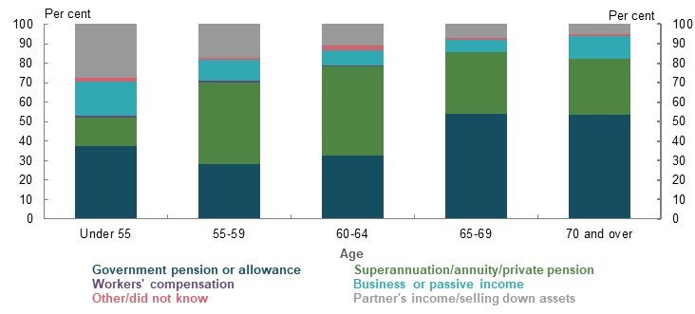
Note: See Chart 3E-9. Source: Analysis of (ABS, 2020p).

Government pensions or allowances
Many people receive income support payments in the years leading up to the Age Pension eligibility age. In September 2019, the most common Government pensions and allowances received by those aged 55-64 were the Disability Support Pension (265,090 people), JobSeeker Payment (171,098 people) and Carer Payment (79,418 people) (Department of Social Services, 2020a). Some people also received the Service Pension, administered by the Department of Veterans’ Affairs, which is payable from age 60. Many people continue to receive these income support payments until they qualify for the Age Pension, with some choosing to continue to receive them instead of the Age Pension.
The proportion of income support recipients who received payments in each of the five years before Age Pension eligibility age gradually declined up until 2013-14, but has since been increasing (Chart 3E-11). The proportion increased markedly in 2017-18. This was partly due to changes to the assets test taper rate on 1 January 2017 that prevented a number of people with higher assets from qualifying for the Age Pension. Disability Support Pension was by far the most common income support payment received in each of these five years to 2017-18 (Chart 3E-12). In future, it may be less common due to tightened eligibility criteria introduced in 2012. The most recent data shows one-third of those who reached Age Pension eligibility age and received an income support payment in 2017-18 did not receive an income support payment in any of the previous five years.
    - Proportion of people who were long-term income support recipients at Age Pension eligibility age
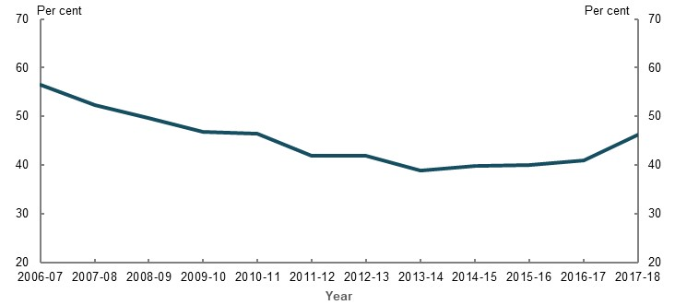
Note: Proportion is calculated as the ‘number of income support recipients at Age Pension eligibility age who received payments in each of the five years prior’ divided by the ‘total number of people who reached Age Pension eligibility age in the financial year and received an income support payment in the same year’. Income support payments include Disability Support Pension, JobSeeker Payment, Carer Payment, ABSTUDY — studying, AUSTUDY, Youth Allowance — Student, ABSTUDY — Apprentice, AUSTUDY — Apprentice, Sickness Allowance, Special Benefit, Youth Allowance — Apprentice, Youth Allowance — Other, Parenting Payment — Partnered and single, Widow B Pension, Wife Pension — Age, Wife Pension — Disability Support Pension. Source: Department of Social Services Priority Investment Approach data, 2017-18.
    - Number of people who were long-term income support recipients at Age Pension eligibility age, by type of payment
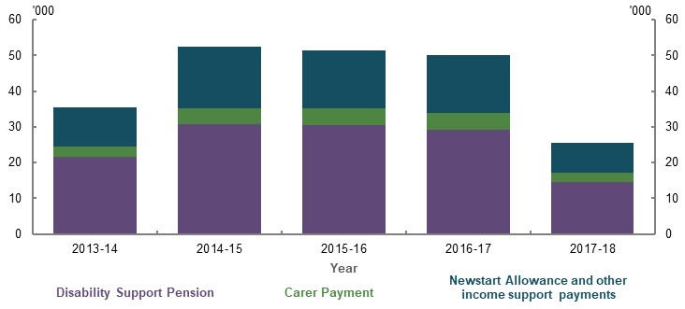
Note: In this chart, long-term income support recipients are people at Age Pension eligibility age who received payments in each of the five years prior and received an income support payment in the year they reached Age Pension eligibility age. Newstart Allowance became JobSeeker Payment on 20 March 2020. The number of people who reached Age Pension eligibility age was lower in 2013-14 and in 2017-18 than other years as the Age Pension eligibility age increased by six months on 1 July 2013 (for women only) and 1 July 2017 (for women and men). Source: Department of Social Services Priority Investment Approach data, 2017-18.
          - Government pensions or allowances available to early retirees

Pensions and allowances available
People have different, and sometimes multiple, reasons for retiring. For simplicity, the age a person ceases paid employment is assumed to be their age of retirement. However, this does not always correspond with the actual age a person ceases looking for work — or the age at which they consider themselves retired.
The income support payments available to people who retire before the age of 65 depend on their reason for retirement. In general terms:
- Disability Support Pension is available to eligible people who retire early due to a permanent physical, intellectual or psychiatric condition
- Carer Payment is available to eligible people who retire early due to caring for someone who has a severe disability, illness or an adult who is frail aged
- JobSeeker Payment is available to eligible people who retire early due to job-related issues and continue to seek work
In September 2019, just under 20 per cent of the Australian population aged 55-64 received one of these three payments (Department of Social Services, 2020a). However, not all who received one of these three payments have necessarily retired. Some recipients are required to look for work and may undertake work again in future.
The tighter eligibility criteria for Disability Support Pension means some people who cease their last job due to their own ill health may not be eligible for this payment. The stricter criteria likely accounts for the fall in the proportion of people aged 55-64 on Disability Support Pension, from 12 to 9 per cent between 2009 and 2017. This largely coincides with an increase in the number of people on Newstart Allowance (now JobSeeker Payment) (Chart 3E-13).
    - Total number of recipients of select income support payments
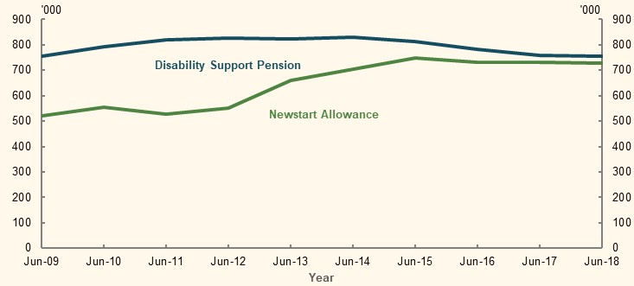
Note: Includes recipients of all ages. Source: Analysis of Department of Social Services Demographics June 2014, 2015, 2016, 2017 and 2018 (Department of Social Services, 2020c) and (Department of Social Services, 2014).

Monetary benefits
The Age Pension, Disability Support Pension and Carer Payment are classified as a pension and are therefore paid at the same rate and subject to the same means test settings. Carer Payment recipients receive extra support in the form of Carer Allowance and Carer Supplement — assistance that may also be available to recipients of other payments with caring responsibilities. In contrast, JobSeeker Payment is an allowance. The standard rate of JobSeeker Payment is around 60-73 per cent of the standard rate of Age Pension, Disability Support Pension and Carer Payment, depending on a person’s relationship status and family situation.
Recipients of Disability Support Pension or Carer Payment can have higher levels of income or assets and still qualify for these payments, compared with those on JobSeeker Payment. This means an early retiree receiving the Disability Support Pension or Carer Payment may have a higher retirement income than an early retiree who receives JobSeeker Payment (Chart 3E-16, Chart 3E-17 and Chart 3E-18).
Age Pension, Disability Support Pension and Carer Payment are indexed to the higher of the CPI and Pensioner and Beneficiary Living Cost Index, and benchmarked to male total average weekly earnings. Whereas, JobSeeker Payment is only indexed to CPI. The effect of these different indexation arrangements compound over time. For example, assuming no change in the base rate of payment, by 2050, the single rate of JobSeeker Payment rate will be around 45 per cent of the single rate of Age Pension, Disability Support Pension and Carer Payment (compared with 60 per cent in 2020).
Many stakeholders raised concerns about the proportion of older Australians receiving JobSeeker Payment who experience poverty or financial stress before they qualify for the Age Pension. For example, one stakeholder cited research by Davidson et al. (2018) that 55 per cent of households relying on JobSeeker Payment in 2015-16 were living in poverty.
In 2017-18, the average net worth of a household receiving an income support payment where the reference person was aged 55-64 was just under $250,000, with three-quarters of this wealth held in the family home. Average financial assets, excluding superannuation, were just over $20,000 (ABS, 2019k). This suggests many people aged 55-64 on income support payment do not have significant liquid assets to top up their Government pension or allowance income, unless they use a reverse mortgage or home equity release product.
JobSeeker Payment/Newstart Allowance is paid at a lower rate than pensions because it is provided on the basis that recipients are willing and able to work, and have greater capacity to supplement their income through paid employment. Whereas, Age Pension, Disability Support Pension and Carer Payment are paid to recipients who are not able or not expected to work (Australia’s Future Tax System Review, 2008). Yet, only 42 per cent of people who became unemployed at age 60 and began receiving Newstart Allowance in 2017-18 are projected to move off income support payments for one or more years before reaching Age Pension eligibility age. This suggests many people who retire early and involuntarily will continuously rely on the welfare system until reaching Age Pension eligibility age. As the superannuation system matures, superannuation may become a more important source of income for involuntary retirees.

Early release of superannuation benefits
For some people who meet the eligibility requirements, accessing superannuation through the early release regime provides a means to access funds to deal with financial emergencies before they reach preservation age (see 2C. Maintaining standards of living in retirement).

Other income sources available to people who retire early
In addition to Government pensions and allowances and superannuation benefits, other income sources may be available to people who retire early. In 2017-18, the average net wealth (excluding superannuation and the family home) of a household whose reference person was aged 55-64 was just over $550,000 (ABS, 2019k). Many households in this age range have a much lower net wealth than the average (Chart 3E-14). Some early retirees (other than those receiving income support payments) may have other non-superannuation and non-owner-occupied housing assets to draw on before they reach preservation age or Age Pension eligibility age.
    - Average assets of households aged 55-64, by wealth quintile
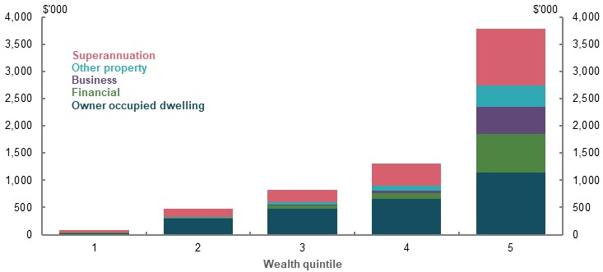
Note: Uses 2017-18 data. Age of household is the age of the household’s reference person. Does not include other assets, such as vehicles, home contents, silent partnerships and assets not covered elsewhere. Quintiles are based on net wealth. Source: Analysis of ABS Survey of Income and Housing Confidentialised Unit Record File, 2017-18.
Some early retirees also have access to total and permanent disability (TPD) insurance and income protection insurance, workers’ compensation schemes or other compensation schemes (e.g. third-party motor vehicle insurance). In 2016 and 2017, a total of 6,143 successful TPD claims were finalised across all life insurers for people aged 56-65 (0.22 per cent of those aged 56-65). For these claims, the average sum insured for people aged 56-60 was $84,826, and $54,833 for those aged 61-65. This decline reflects that TPD policies tend to pay based on years remaining in the workforce. Workers’ compensation is the main source of income at retirement for some people who retire involuntarily and for very few who retire voluntarily (Chart 3E-9 and Chart 3E-10).
          - Preservation and Age Pension eligibility ages

Universality of the Age Pension eligibility age and preservation age
Australia’s preservation and Age Pension eligibility ages apply to the entire population. This is in contrast with many other OECD countries, which have variable access ages (OECD, 2019b). For example, the Netherlands Government recently announced that workers in physically demanding jobs will be able to access their retirement savings three years before the standard retirement age (Wijk & Preesman, 2019).
Universality means people entering the workforce at younger ages will typically work for more years before reaching preservation age or Age Pension eligibility age, compared with those who enter the workforce at later ages. On average, those who begin full-time employment at younger ages tend to be less educated people.
A few stakeholders suggested people in certain industries or occupations — where they may be more exposed to health or incapacity risks — should be able to access their superannuation or the Age Pension earlier than the rest of the Australian population. Although blue-collar workers are more likely to retire involuntary due to own ill health, early and involuntarily retirement is not isolated to certain industries or occupations. And not everyone in the same industry has the same experience. The physical and psychological demands of a job are hard to categorise.
Another consideration is people change occupations/industries throughout their working lives. Allowing people in select industries or occupations to access their superannuation or the Age Pension earlier than the rest of the population may lead to inconsistent outcomes between similar people.

Increasing the preservation and Age Pension eligibility ages
According to the OECD (2019b, p. 27), only 15 of the 36 OECD countries will have a retirement age of 67 or higher in future. Australia does not have a mandated retirement age. The Age Pension eligibility age is increasing to 67 on 1 July 2023 and the superannuation preservation age is increasing to 60 on 1 July 2024.

Increasing the preservation age
The Productivity Commission (2015b) modelled the effect of a gradual increase in the preservation age to 65. Its modelling suggested:
- ‘ … there will be a modest increase in the participation rate of older workers (of around 2 percentage points in 2055) — mainly among those with higher wealth at or near retirement;
- households that delay their retirement are likely to do so by around two years and will have superannuation balances around 10 per cent larger in real terms when they retire;
- there will be an indicative annual fiscal improvement of around $7 billion (in 2015 prices) in 2055 — mainly due to tax revenue increases from wealthier households; and
- changing the preservation age will have little, if any, impact on the workforce participation of individuals who retire involuntarily — almost one-half of men and over one-third of women who retire between the ages of 60 and 64.’ (Productivity Commission, 2015b, p. 2)

Increasing the Age Pension eligibility age
Empirical research found increasing the Age Pension eligibility age in Australia from 60 to 65 for women reduced retirement probability each year by approximately 10 per cent (Atalay & Barrett, 2012). The Productivity Commission modelled gradually increasing the Age Pension eligibility age from 67 to 70 (Productivity Commission, 2013a). It found this could:
- ‘ … increase participation rates for people in the relevant ages by around 3-10 per cent, taking account of the fact that some people would be unable to work (and would transfer to the Disability Support Pension), some would be already working, and others with sufficient privately funded superannuation would largely not be affected by a change in the publicly provided pension;
- yield ongoing fiscal savings of around 0.15 per cent of GDP per annum in the late 2030s after accounting for some increase in Disability Support Pension recipients (and then falling to 0.1 per cent of GDP in the long run). Over the full period from 2025-26 to 2059-60, the accumulated (undiscounted) savings would be around $150 billion in constant 2011-12 prices.’ (Productivity Commission, 2013a, p. 15)

The effect of early and/or involuntary retirement on retirement incomes

Effect of involuntary retirement
Involuntary retirement results in people retiring before they planned and likely with fewer private savings than they planned. Studies show households that experience involuntary retirement have greater falls in expenditure at retirement than those retiring according to a long-term plan (e.g. Smith (2006) and Barrett and Brzozowski (2012)).
Involuntary retirement can have a detrimental impact on people’s sense of financial security in retirement compared to working life (Chart 3E-15). Surveys found people who are forced to retire early due to job loss or their own ill health, and have less income in retirement than expected, reported marked declines in their subjective wellbeing in retirement (Barrett & Kecmanovic, 2013). Another survey found 21 per cent of involuntary retirees stated they were ‘comfortable’ in retirement, compared to 36 per cent of those who retired voluntarily (Susan Bell Research, 2020, p. 3). Yet, most retirees, voluntary and involuntary, report being as happy or happier in retirement than in working life (Chart 3E-15).
    - Financial security and happiness in retirement compared to working life
Financial security | Happiness
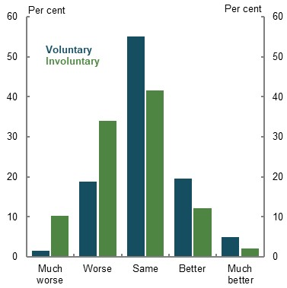 | 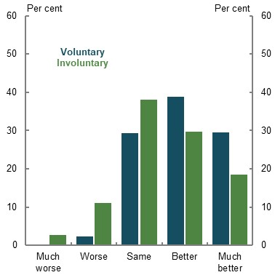
Note: Includes people who retired between 1990 and 2015. Source: Analysis of HILDA Survey data (Waves 3, 7, 11 and 15).

Effect of early retirement
Early retirement leads to lower aggregate working-life income and, consequently, lower superannuation balances at the point of retirement, lower replacement rates and lower average annual retirement income across all years of retirement. Key factors influencing this outcome include:
- Retirement age — Comparing those who enter the workforce at the same age, the earlier a person retires, the lower their superannuation balance, retirement income and replacement rate. If a person with superannuation retires before superannuation preservation age, their income may be significantly lower before than after preservation age (see Appendix 6D. Supplementary equity charts). For these people, replacement rates calculated based on all years of retirement understate this drop in income they experience before preservation age (Chart 3E-16, Chart 3E-17 and Chart 3E-18). In contrast, those early retirees with little superannuation may experience lower average income for longer, until they can access the Age Pension.
- Reason for retirement — People who retire early due to job-related issues may have lower replacement rates than people who retire early due to own ill health or caring responsibilities. This is because the maximum single rate of JobSeeker Payment is much lower than the single rate of Age Pension, while Disability Support Pension and Carer Payment provide the same income as the Age Pension (for both singles and couples). The difference in payment rates between the Age Pension and JobSeeker Payment substantially increases some people’s income when they move from JobSeeker Payment to the Age Pension.
- Income level — Early retirement reduces the replacement rates of all income earners. However, Government pensions and allowances, especially the Age Pension, significantly offset the adverse effect on replacement rates of those retiring with few private savings. Early retirement affects the retirement incomes of people at the higher end of the income distribution the most as they forgo more in wages and receive the least, if any, increase in Age Pension by retiring early compared with lower- and middle-income earners.
Chart 3E-16, Chart 3E-17 and Chart 3E-18 show the projected replacement rates for lower-, middle- and higher-income home owners who begin work at age 27, retire either 5 or 10 years before Age Pension eligibility age and receive either JobSeeker Payment, Disability Support Pension or Carer Payment if eligible in the years between retirement and age 67.
A replacement rate of 65-75 per cent generally allows people to maintain their living standards in retirement (see 2C. Maintaining standards of living in retirement). The modelling shows replacement rates of lower- and middle-income earners remain within or above the benchmark replacement rate. For higher-income earners, replacement rates are projected to fall below the benchmark. However, a person on a higher-income who retires at age 57 or 62 will, respectively, have an average retirement income more than 85 or 100 per cent higher than the maximum rate of Age Pension.
    - Lower-income earner: projected replacement rates, by retirement age and reason
20th percentile
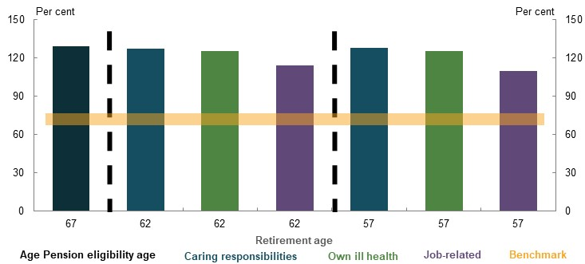
Note for Chart 3E-16, Chart 3E-17 and Chart 3E-18: Values are in 2019-20 dollars, deflated using the review’s mixed deflator. For consistency, the working life of the person who retires at age 67 is used as the replacement rate denominator for all retirement ages. People who retire due to caring responsibilities receive Carer Payment until age 67, if eligible. People who retire due to own ill health receive Disability Support Pension until age 67, if eligible. People who retire due to job-related issues receive the standard rate of JobSeeker Payment until age 67, if eligible. The cameo assumes that before age 60 (superannuation preservation age), retired people do not take actions to boost their income until they reach preservation age (such as using early release of superannuation). People who retire before age 67 draw down the equivalent of the higher of the maximum Age Pension less any JobSeeker, Disability Support Pension or Carer Payment they receive, or minimum legislated rates between preservation age and age 67. Source: Cameo modelling undertaken for the review.
    - Middle-income earner: projected replacement rates, by retirement age and reason
50th percentile
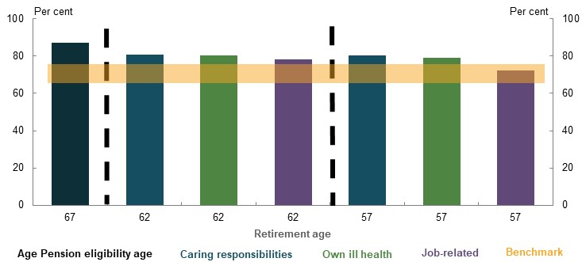
Note: See Chart 3E-16. Source: Cameo modelling undertaken for the review.
    - Higher-income earner: projected replacement rates, by retirement age and reason
80th percentile
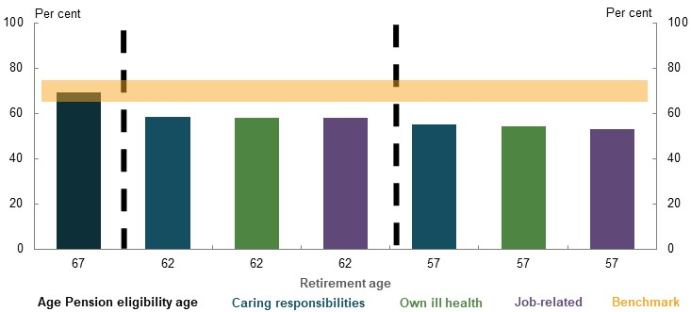
Note: See Chart 3E-16. Source: Cameo modelling undertaken for the review.

An SG rate to increase retirement incomes of early, involuntary retirees
Some stakeholders proposed increasing the SG rate to mitigate the risk that early, involuntary retirement will lead to inadequate retirement income. This has limitations, including:
- The exact increase in the SG rate required to mitigate the risk of early, involuntary retirement varies based on a person’s characteristics. The SG rate required to compensate for retiring 5 or 10 years earlier is between 14 and 26 per cent, depending on their age of, and reason for, retirement and income percentile (Table 3E-1).
- Setting the SG rate high enough to compensate for the possibility of early, involuntary retirement would result in many people saving more than is required for an adequate retirement income. The current system already delivers replacement rates within or above the 65-75 per cent benchmark used by the review for a wide range of scenarios, including when lower- and middle-income earners retire 5 or 10 years before Age Pension eligibility age (Chart 3E-16 and Chart 3E-17). For people retiring at age 67, increasing the SG rate to 16 per cent would result in a lower-income earner achieving a replacement rate of 136 per cent and a middle-income earner achieving a replacement rate of 94 per cent. Under this higher SG rate, both lower- and middle-income earners would significantly over-save for retirement. Lower-income groups would suffer most from trading off working-life income for an SG increase, as they already experience high levels of financial stress in their working life.
- The SG is universal and the rate should be set accordingly. Universal policy settings that try to cater for every possible scenario risk damaging the wellbeing of a large proportion of society to protect a smaller group of people.
      - Projected SG rates required for an early, involuntary retiree to achieve the same retirement income as someone who retires at age 67
Retirement age and reason | Lower-income earner (per cent) | Middle-income earner (per cent) | Higher-income earner (per cent)
Retire at 57
Job-related | 26 | 22 | 20.5
Own ill health | 16 | 20 | 20
Caring responsibilities | 15 | 19.5 | 20
Retire at 62
Job-related | 19 | 17.5 | 16.5
Own ill health | 15 | 17.5 | 16.5
Caring responsibilities | 14 | 17 | 16
Note: Values are in 2019-20 dollars, deflated using the review’s mixed deflator. Lower-income earner is the 20th income percentile, middle-income earner is the 50th income percentile and a higher-income earner is the 80th income percentile. The SG rate received by the person who retires at age 67 is consistent with the relevant legislation, which will see the SG rate rising to 12 per cent by July 2025. SG rate is either a whole number or to half a percentage point. For all SG rates, salary sacrifice contributions under the currently legislated SG rates are used. Assumes the concessional contributions cap also rises with the SG rate, so higher-income earners do not incur excess contributions tax under higher SG rates. Source: Cameo modelling undertaken for the review.

The effect of late retirement on retirement outcomes
If a worker delays retiring, they increase their retirement income by:
- Receiving additional SG contributions — assuming they are covered by the SG
- Receiving additional accumulated growth through compound returns on their private savings
- Drawing down on their private savings for a shorter period of time once they retire — because they spend less time in retirement relative to someone who retires earlier
Delaying retirement also has non-financial effects, including on the person’s health, social connections and leisure time. Measures to encourage people to work past Age Pension eligibility age are explored in 5A. Cohesion.
Working an additional three years to age 70 increases the replacement rates of those who are able to do so. Replacement rates and retirement incomes increase by similar amounts when the person continues to earn a wage, based on their position in the income distribution between ages 67-70, versus when they earn 25 per cent less than this wage during this time (Chart 3E-19). This suggests higher replacements rates and retirement incomes are primarily due to investment returns and a reduced length of retirement, rather than additional SG contributions.
Higher-income earners receive a larger increase in their retirement income and replacement rates when they retire later compared with lower- and middle-income earners. During these additional years of work, higher-income earners:
- Receive higher wages (relative to lower- and middle-income earners) and therefore have higher SG contributions
- Receive more compound interest from higher SG contributions and larger superannuation balances
- Generally experience a smaller reduction in Age Pension income, where they qualify, relative to lower- and middle- income earners
    - Projected increase in replacement rates when retiring at age 70 compared with age 67
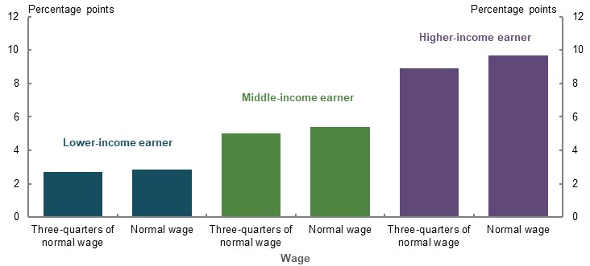
Note: Values are in 2019-20 dollars, deflated using the review’s mixed deflator. Three-quarters of normal wage assumes an individual earns 75 per cent of the average wage for their age and income percentile between the ages of 67-70. Normal wage uses average wages according central case specifications. Appendix 6A. Detailed modelling methods and assumptions includes a detailed explanation of the wage data using this methodology. Assumes people who retire at age 70 do not access superannuation and other savings until age 70 but they do receive the Age Pension from age 67 if eligible. For consistency, the working life of the person who retires at age 67 is used as the replacement rate denominator for all retirement ages. See Appendix 6D. Supplementary equity charts for projected superannuation balances and retirement incomes of people retiring at age 70. Source: Cameo modelling undertaken for the review.

          - Impact of changes to certain policy settings on the retirement outcomes of early and late retirees
A number of submissions raised policy proposals to improve retirement outcomes for early and late retirees. The following summary outlines some implications of some of those proposals.
- No increase in the superannuation preservation age or Age Pension eligibility age. Increases in these ages would adversely affect a significant number of people who retire involuntarily before preservation or Age Pension eligibility ages. People with lower wealth and blue-collar workers, who are more likely to retire involuntarily, would be disadvantaged by higher access ages. Eligibility for a Government pension or allowance would help mitigate this. Conversely, as people with higher wealth and white-collar workers are more likely to be able to choose when they retire, they are less likely to be affected by such policy changes. Higher-income earners would receive the largest increase in replacement rates from a later retirement age.
- Increase the standard payment rate and change the indexation of JobSeeker Payment. This would help ensure equity for early and involuntary retirees with similar financial resources. If the standard rate and indexation of JobSeeker Payment were similar to Disability Support Pension and Carer Payment, people who retire early due to job-related reasons would have similar replacement rates and retirement incomes to those who retire early due to caring responsibilities and own ill health. Any change to the payment rate and indexation method of JobSeeker Payment should also consider the broader policy objectives of working-age payments, as many recipients of this payment may re-enter the workforce in future.
- Setting the SG rate to compensate for the possibility of early, involuntary retirement. This would result in many people saving more than they require for an adequate retirement income. A higher SG rate would come at the expense of working-life income. The income support system provides a more targeted way of accounting for involuntary, early retirement (see 2D. Policy scenario: Implications of maintaining the SG rate).

Aboriginal and Torres Strait Islander people
          - Section summary
- Lower life expectancies for Aboriginal and Torres Strait Islander people result in shorter retirements and unspent retirement savings. Many are unlikely to reach superannuation preservation age, while those reaching retirement have less time to spend their superannuation and spend less time on the Age Pension, compared with the total population.
- Working-life disadvantages for Aboriginal and Torres Strait Islander people result in significantly lower superannuation balances and coverage, lower private savings and lower levels of home ownership than the total population. Like many in the population, Aboriginal and Torres Strait Islander people are often unaware they have superannuation and have multiple superannuation accounts.
- In retirement, the Age Pension and other income support payments significantly reduce income inequality between Aboriginal and Torres Strait Islander and non-Indigenous people, compared with working life. Aboriginal and Torres Strait Islander people are more likely to receive the Age Pension at the maximum rate than non-Indigenous people.
- Low Aboriginal and Torres Strait Islander engagement with the retirement income system is due to a retirement income system not designed for their needs. Access issues include physical distance to, and exclusion from, financial services; identification challenges; and superannuation laws that do not acknowledge kinship structures. Issues with engagement are compounded by mistrust in the system due to historical injustices, and lower levels of financial literacy.
- Retirement outcomes for Aboriginal and Torres Strait Islander people may improve as their life expectancy improves. An emerging generation of Aboriginal and Torres Strait Islander people have capacity to save for their retirement and will need support to engage with the retirement income system. But, without increases in labour force participation and wages, retirement outcomes of Aboriginal and Torres Strait Islander people will continue to lag behind the total population.
- Limited and poor-quality data prevent comprehensive analysis of Aboriginal and Torres Strait Islander people’s retirement outcomes. Analysis is limited to averages or generalisations.

Outline of this section
This section focuses on two issues in relation to Aboriginal and Torres Strait Islander retirement outcomes:
- The role of retirement income system policy settings, including how they interact with the various disadvantages Aboriginal and Torres Strait Islander people experience.
- The difficulties some Aboriginal and Torres Strait Islander people face in engaging with the retirement income system.
          - Stakeholder views on retirement income equity for Aboriginal and Torres Strait Islander people
A few submissions, and discussions with representatives of First Nations Foundation and ASIC’s Indigenous Outreach Program, identified disadvantages faced by Aboriginal and Torres Strait Islander people in retirement.
Stakeholders noted that Aboriginal and Torres Strait Islander people:
- Continue to be impacted in retirement by many working-life inequities; in particular, lower rates of home ownership, lower wages, lower rates of labour force participation, lower rates of financial literacy, higher rates of disability and involuntary retirement, and lower life expectancies. For example, lower life expectancies mean policy settings, such as the Age Pension eligibility age and the superannuation preservation age, may exacerbate inequity in retirement.
- Have limited private savings and lower superannuation balances and coverage than the wider population, including more people likely earning below the $450-a-month threshold or taking part in the Community Development Program, which do not attract the SG.
- Face issues in engaging with the retirement income system, exacerbated by factors such as remoteness, language differences, mistrust in the system stemming from historical injustices, challenges in proving identity, lower rates of financial literacy and a system that does not recognise kinship structures.
Stakeholders noted the challenges in providing quantitative evidence, given the limited superannuation and savings data available on Aboriginal and Torres Strait Islander people. Some cited anecdotal evidence of Aboriginal and Torres Strait Islander disadvantage in retirement.

Differences in life expectancies
Compared with the total Australian population, Aboriginal and Torres Strait Islander people have lower life expectancies at birth (Table 3F-1). At age 60, the difference in life expectancies is smaller but still significant. Aboriginal and Torres Strait Islander life expectancy is particularly low in remote and very remote areas, where many people are not expected to live long enough to receive the Age Pension.
      - Life expectancy at birth and at age 60, by Indigenous status and remoteness
 | Life expectancy at birth (years) |  | Life expectancy at 60 (years)
 | Men | Women | Men | Women
All people — Australia | 80.5 | 84.6 | 23.8 | 26.8
Aboriginal and Torres Strait Islander — Australia | 71.6 | 75.6 | 19.2 | 20.9
Aboriginal and Torres Strait Islander — Major cities | 72.1 | 76.5 | 19.5 | 21.2
Aboriginal and Torres Strait Islander — Inner and outer regional | 70.0 | 74.8 | 18.0 | 20.1
Aboriginal and Torres Strait Islander — Remote and very remote | 65.9 | 69.6 | 16.1 | 17.9
Note: Data from 2015-17 life tables. The figures by remoteness indicator cannot be directly compared with those for the whole population or the Australian Aboriginal and Torres Strait Islander population, but are comparable with each other (i.e. major cities can be compared to inner and outer regional and remote and very remote). Source: (ABS, 2018d) (ABS, 2018e).
The life expectancy gap at birth has closed slightly over the past decade. Between 2005-07 and 2015-17, the gap decreased from 11.8 years to 8.9 years for men, and from 10.8 years to 9 years for women (ABS, 2018d) (ABS, 2018e). At this rate of progress, the gap is likely to persist well into the latter half of this century.
Survival rates for Aboriginal and Torres Strait Islander people and the total population start to diverge significantly during working life. This divergence grows with age. At the 2016 Census, Aboriginal and Torres Strait Islander people made up around 3.3 per cent of the total population, but only 0.9 per cent of the population aged 65 and over (ABS, 2019i).
Of Aboriginal and Torres Strait Islander men born in 2016, 1 in 4 are not expected to reach age 60 (Chart 3F-1). This compares with 1 in 10 men across the total population. For Aboriginal and Torres Strait Islander women born in 2016, 3 in 20 are not expected to reach age 60, compared with 1 in 20 women across the total population.
On 1 July 2024, the superannuation preservation age will rise to 60 for all those born after 30 June 1964, including Aboriginal and Torres Strait Islander people. Given their lower survival rates, Aboriginal and Torres Strait Islander people are more likely than the general population to die before they can access their compulsory superannuation. Many of the Aboriginal and Torres Strait Islander participants in recent survey research viewed superannuation more as an inheritance, rather than a source of retirement income, as they had low expectations that they will live long enough to use it (Dockery, 2020, p. 40).
    - Projected survival rates, by gender, Indigenous status and remoteness indicator
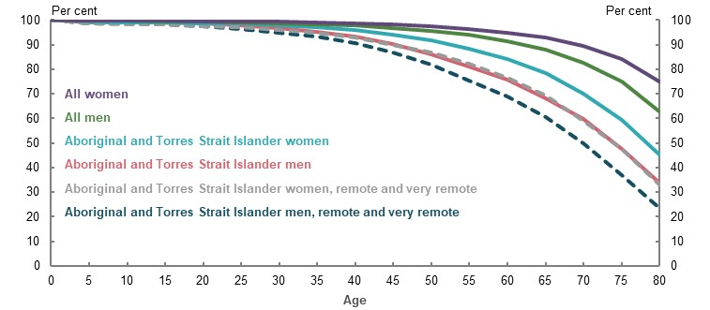
Note: Data from 2015-17 life tables. The figures by remoteness indicator cannot be directly compared with those for the whole population or the Australian Aboriginal and Torres Strait Islander population, but are comparable with each other. This chart does not factor in future improvements in life expectancy. It should be used to illustrate differences between populations only, not to estimate future populations. Source: (ABS, 2018d) (ABS, 2018e).
Many stakeholders suggested a lower superannuation preservation age for Aboriginal and Torres Strait Islander people, given that their lower life expectancies can result in shorter retirements and unspent superannuation savings. Differences in Aboriginal and Torres Strait Islander life expectancy are recognised elsewhere in Australian Government policy. Aboriginal and Torres Strait Islander people can access aged care from age 50, compared with age 65 for the rest of the population.
Given compounding returns deliver the greatest growth in superannuation members’ balances in the later stages of working life, a lower superannuation access age for Aboriginal and Torres Strait Islander people could result in lower relative retirement incomes if members choose to withdraw their superannuation savings earlier than the rest of the population (Boyle, 2018a). An alternative approach may be to change the early release of superannuation rules to give Aboriginal and Torres Strait Islander people greater flexibility to access a portion of their superannuation before preservation age.
Lower life expectancies also mean that Aboriginal and Torres Strait Islander people generally spend fewer years on the Age Pension compared with non-Indigenous people (Chart 3F-2).
Lowering the preservation age (or Age Pension eligibility age) for Aboriginal and Torres Strait Islander people would not address the underlying issue of lower life expectancy. It would simply deal with a symptom of the larger problem.
    - Projected future welfare receipt of those aged 25 in 2017-18
Aboriginal and Torres Strait Islander people | Non-Indigenous people
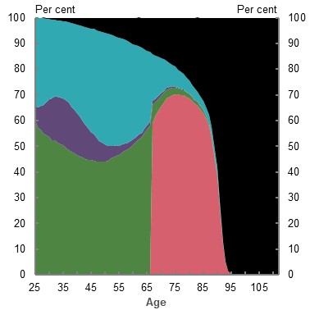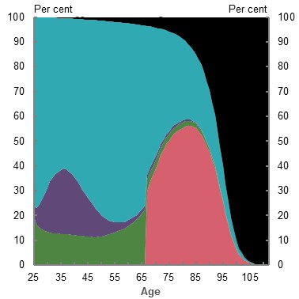
Age Pension recipient Other income support recipient (e.g. JobSeeker Payment, Disability Support Pension, Carer Payment) Non-income support recipient (e.g. FTB) Not receiving payments Deceased
Note: This chart shows the proportion of the starting population (people aged 25 in 2017-18) projected to receive welfare payments (e.g. Age Pension, Disability Support Pension), not on welfare payments, or deceased, at a given age in the future. It is based on modelling from the Priority Investment Approach to Welfare. The Priority Investment Approach to Welfare does not model superannuation balances. However, the model reflects projections of future trends in superannuation and other savings, life expectancy improvements, labour force participation and levels of home ownership, and uses these estimates to project future Age Pension utilisation. Source: Priority Investment Approach to Welfare Actuarial Modelling.

Translation of working-life economic disadvantage into retirement

Working-life income
Aboriginal and Torres Strait Islander people have lower working-life incomes than the total population (Table 3F-2), mainly due to lower rates of labour force participation and earnings gaps.
      - Median earnings and incomes of Aboriginal and Torres Strait Islander people compared with the total population
 | Aboriginal and Torres Strait Islander people ($) | Total population ($) | Gap  (per cent)
Median weekly incomes (All persons aged 15 and over) | 441 | 662 | 33.4
Median weekly earnings (Employed, aged 15 and over) | 845 | 1,012 | 16.6
Note: 2016 data. Source: Analysis of (ABS, 2016a).
In 2016, non-Indigenous people were 1.4 times more likely than Aboriginal and Torres Strait Islander people to be employed (ABS, 2018a). Aboriginal and Torres Strait Islander employment rates have not significantly increased in the past decade, other than for those aged 65 and over, where employment rates approach those of the total population (ABS, 2006a; ABS, 2011a; ABS, 2016a). In aggregate, Aboriginal and Torres Strait Islander people are also far less likely to be in the labour force than the total population, reducing their average working-life income (Chart 3F-3). Labour force participation rates and earnings for Aboriginal and Torres Strait Islander women are particularly low (ABS, 2016a). Without increases in labour force participation, the relative gap in incomes between Aboriginal and Torres Strait Islander people and the total population is likely to persist.
    - Proportion of people not in the labour force, by Indigenous status and age
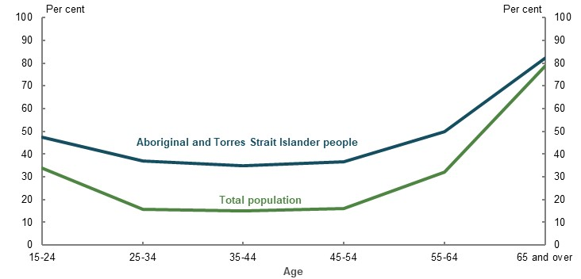
Note: 2016 data. Source: Analysis of (ABS, 2016a).
A large proportion of Aboriginal and Torres Strait Islander people receive income support as they approach retirement. Of those Aboriginal and Torres Strait Islander people reaching Age Pension eligibility age between 2013-14 and 2017-18, 52 per cent had received an income support payment in each of the 10 years prior to reaching Age Pension eligibility age. For non-Indigenous people, the figure was 28 per cent. High rates of income support receipt in the years leading up to retirement for Aboriginal and Torres Strait Islanders are projected to continue (Chart 3F-2).
A significant proportion of Aboriginal and Torres Strait Islander people receive the Disability Support Pension prior to retirement. Of those over Age Pension eligibility age receiving income support on 30 June 2019, 40 per cent received the Disability Support Pension immediately prior to Age Pension eligibility age.
This means a significantly higher proportion of Aboriginal and Torres Strait Islander people reach Age Pension eligibility age with disability, caring for others or unemployed, and with limited other means to support themselves, compared with the total population. Aboriginal and Torres Strait Islander people are over-represented in the number of people who retire involuntarily. This adversely impacts their retirement incomes (see 3E. Age of retirement).

Superannuation
Superannuation makes a limited contribution to the retirement incomes of most Aboriginal and Torres Strait Islander people. In 2018, for those not retired, the median superannuation balance of Aboriginal and Torres Strait Islander men was 59 per cent lower than that of all men (Table 3F-3). For women, the comparable figure was 50 per cent lower.
These figures do not capture those without superannuation. Aboriginal and Torres Strait Islander people are more likely to have no superannuation than the total population, as shown by lower rates of superannuation coverage (Table 3F-3). A significant proportion of Aboriginal and Torres Strait Islander people undertake part-time work and have very low incomes (ABS, 2016a), making them susceptible to falling under the $450-a-month threshold for the SG and not accruing superannuation (see 3D. SG coverage).
Aboriginal and Torres Strait Islander people are also over-represented in the Community Development Program, which does not pay superannuation. The Community Development Program is a remote-area employment and community scheme with around 30,000 participants, the majority of whom are Aboriginal or Torres Strait Islander people (National Indigenous Australians Agency, 2020) (Senate Finance and Public Administration Committees, 2017, p. 5). Participants in the scheme are receiving an income support payment, such as the JobSeeker Payment. However, the program requires 20 hours of ‘work-like activities’ by recipients to receive their payment. Similar work activities outside of the program would ordinarily attract superannuation.
      - Median superannuation balances and proportion with superannuation, by gender and Indigenous status
 | Aboriginal and Torres Strait Islander men | All men | Aboriginal and Torres Strait Islander women | All women
Median superannuation balances ($) | 25,000 | 60,635 | 19,000 | 38,000
Proportion with superannuation (per cent) | 74.0 | 85.8 | 58.6 | 83.7
Note: 2018 data. The HILDA Survey does not include households in remote Aboriginal communities (Dockery, 2020). As such, these results likely overstate the coverage and balances of the Aboriginal and Torres Strait Islander population. Source: Analysis of HILDA Survey data (Wave 18) of those not retired, provided by the Association of Superannuation Funds of Australia.
The issue of lower superannuation balances is compounded by the fact Aboriginal and Torres Strait Islander people often:
- Are unaware they have superannuation. At 1 January 2020, through its initiative ‘Big Super Day Out’, First Nations Foundation had reconnected 1,636 Aboriginal and Torres Strait Islander people to a total of $24 million in superannuation they did not know they had accrued (First Nations Foundation, 2020).
- Do not know they have multiple superannuation accounts. First Nations Foundation also noted many Aboriginal and Torres Strait Islander people have multiple superannuation accounts, with multiple fees eroding balances. This is supported by limited survey research of Aboriginal and Torres Strait Islander people (Dockery, 2020, p. 38). Recent reforms should help improve this through low balance account consolidation and fee caps. First Nations Foundation hypothesised the community sector, in which many Aboriginal and Torres Strait Islander people work, is quite transitory. Frequent job changes may be leading to superannuation account proliferation (Dockery, 2020, p. 54). The ATO and ASIC also noted many Aboriginal and Torres Strait Islander people unknowingly had more than one superannuation account (ATO, 2019g). ASIC suggested the higher number of multiple accounts is likely due to lower financial literacy, sporadic and casual employment, and the higher incidences of Aboriginal and Torres Strait Islander people having multiple names.
Data is not available to determine whether the number of superannuation accounts per Aboriginal and Torres Strait Islander person exceeds the total population average, as most superannuation funds do not record the Indigenous status of their members (see Issues accessing the retirement income system, below).

Retirement ages
The greatest reduction in workforce participation occurs at ages 65-69 for both Aboriginal and Torres Strait Islander people and the total population (Chart 3F-4), despite Aboriginal and Torres Strait Islander people having lower life expectancies. One factor may be the strong role the Age Pension eligibility age plays in influencing when people retire (see 5A. Cohesion).
But the data may not tell the full story. First, fewer Aboriginal and Torres Strait Islander people are in the labour force, creating a smaller base from which to measure their departure. This makes it difficult to identify strong retirement trends.
Second, in contrast to the ABS data, First Nations Foundation noted that, in their experience, Aboriginal and Torres Strait Islander people are not likely to retire at a given age. Instead, community responsibilities require that they continue working full- or part-time while receiving the Age Pension.
    - Change in labour force participation rate from the age 45-49 baseline, by age and Indigenous status
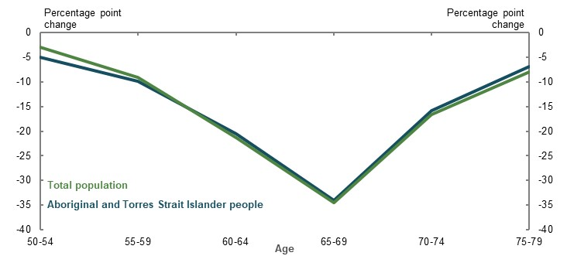
Note: 2016 data. This chart takes the proportion of people in the labour force at age 45-49 as a baseline, and then measures the percentage point reduction in labour force participation rate from this baseline at future ages (i.e. of the 100 per cent of people in the labour force across the total population at age 45-49, 3 percentage points left the labour force at ages 50-54, a further 9 percentage points left at ages 55-59, and so on). The results may be impacted by the relatively small sample size of Aboriginal and Torres Strait Islander people in the labour force at later ages. Source: Analysis of (ABS, 2016a).

Income support in retirement
Determining the actual proportion of Aboriginal and Torres Strait Islander people who receive income support over Age Pension eligibility age is challenging. Coverage rates are determined by comparing Department of Social Services payment statistics with Census data. However, the tiny population of Aboriginal and Torres Strait Islander people over Age Pension eligibility age means small differences in the number of people identifying as Aboriginal and/or Torres Strait Islander across the two datasets can create large differences in the coverage rate, resulting in misleading data.
For example, at 30 June 2016, Department of Social Services data suggests that 56.7 per cent of Aboriginal and Torres Strait Islander people received income support over Age Pension eligibility age (Table 3F-4) compared with 71.6 per cent of the total population. This seems unlikely given previous findings of disadvantage for Aboriginal and Torres Strait Islander people. Data on the means test status of recipients shows they are more likely to be maximum-rate recipients than the total population (Table 3F-5).
      - Number of Aboriginal and Torres Strait Islander people over Age Pension eligibility age on income support payments
 | 30 June 2016 | 30 June 2019
Age Pension | 18,206 | 21,667
Carer Payment | 478 | 671
Disability Support Pension | 591 | 835
Other payments | 12 | 10
Total receiving payments | 19,287 | 23,183
Total population at Census | 34,012 | n/a
Note: Age Pension eligibility age was 65 on 30 June 2016 and 65.5 on 30 June 2019. Those receiving the Disability Support Pension prior to Age Pension eligibility age can continue to receive the Disability Support Pension over Age Pension eligibility age (see 1B. Design of Australia’s retirement income system for details). Source: Department of Social Services payment data, 30 June 2016 and 30 June 2019; (ABS, 2019i).
      - Means test status of people over Age Pension eligibility age receiving income support, by Indigenous status
 | Aboriginal and Torres Strait Islander people  (per cent) | Total population  (per cent)
Full rate | 85.2 | 61.9
Income-tested | 11.0 | 24.9
Assets-tested | 3.4 | 13.0
Note: Figures may not sum to 100 per cent due to rounding and the exclusion of undetermined/manual rate recipients. Due to the relatively high proportion of Aboriginal and Torres Strait Islander people who receive payments other than the Age Pension over Age Pension eligibility age, the proportions in this table for Aboriginal and Torres Strait Islander people include all types of income support payments received over Age Pension eligibility age. Total population figure only includes Age Pension recipients. Source: Department of Social Services payment data, 30 June 2019.
It appears that a significant number of people who identified as Aboriginal and/or Torres Strait Islander in the Census did not do so when applying for income support, especially those in major cities and regional areas (Table 3F-6). First Nations Foundation suggested this could be due to distrust or misunderstanding of how Centrelink uses data on Indigenous status.
      - Number of people identifying as Aboriginal and/or Torres Strait Islander of Age Pension age, by dataset
 | ABS | Department of Social Services | Income support coverage (Department of Social Services divided by ABS) (per cent)
Major cities | 11,717 | 5,544 | 47.3
Inner regional | 8,427 | 4,170 | 49.5
Outer regional | 7,794 | 4,766 | 61.1
Remote | 2,637 | 1,825 | 69.2
Very remote | 3,437 | 2,889 | 84.1
Total | 34,012 | 19,287 | 56.7
Note: Categories may not sum to total due to observations with unknown remoteness status. Source: Department of Social Services payment data, 30 June 2016; Analysis of (ABS, 2019i).

Retirement income
Aboriginal and Torres Strait Islander people experience markedly lower working-life incomes than non-Indigenous people (Chart 3F-5). In retirement, however, income distributions are significantly more aligned, with a peak in both populations at $1-$499 a week. This coincides with the maximum rate of Age Pension, which, in August 2016, was $437 a week for singles and $329 a week for members of a couple (Services Australia, 2019). This aligns with other analysis that shows the disparity in incomes between Aboriginal and Torres Strait Islander people and non-Indigenous people narrows in retirement (Dockery, 2020, pp. 20-23).
    - Proportion of people at personal weekly income ranges, by age and Indigenous status
Age 45-54 | Age 65-74
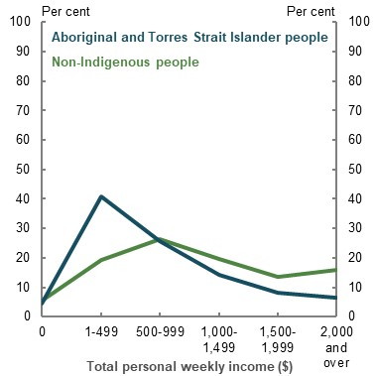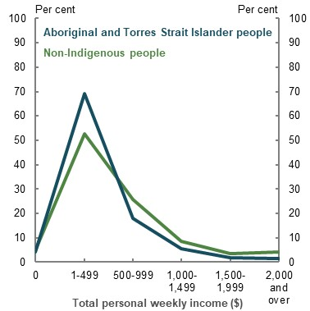
Note: 2016 data, and self-reported. Source: Analysis of (ABS, 2016a).
Cameo modelling produces similar findings. The modelling compares the total retirement income for an Aboriginal and Torres Strait Islander earner to the total population, looking at two variables: the wage gap and life expectancy differences (Table 3F-7).
The cameo modelling shows a 16.6 per cent gap in wages (Table 3F-2) would result in a 25.5 per cent gap in superannuation balances at retirement between the median Aboriginal and Torres Strait Islander earner and the median earner in the total population (Table 3F-7). The gap in superannuation balances at retirement is larger than the gap in wages because of fees, compounding and the assumption that Aboriginal and Torres Strait Islander people are not making salary sacrifice contributions to their superannuation or accumulating private wealth.
The Age Pension improves retirement income equality between Aboriginal and Torres Strait Islander people and the total population. Cameo modelling suggests that, with continuous employment, the median Aboriginal and Torres Strait Islander person is expected to have an average annual retirement income 5.5 per cent lower than the median earner in the total population. A higher proportion of the retirement income of the median Aboriginal and Torres Strait Islander person is expected to come from the Age Pension.
This gap would change if life expectancy for Aboriginal and Torres Strait Islander people improved to match the life expectancy of the general population.
      - Projected outcomes for the median Aboriginal and Torres Strait Islander earner and total population
 |  | Average annual retirement income |  |  |  |  | Superannuation balance at retirement
Aboriginal and Torres Strait Islander people ($) |  | 39,900 |  |  |  |  | 336,600
Total population ($) |  | 42,100 |  |  |  |  | 452,000
Gap (per cent) |  | 5.5 |  |  |  |  | 25.5
 | Years on Age Pension, by rate |  |  |  |  | Source of retirement income (per cent)
 | Max |  | Part | Nil |  | Age Pension |  | Superannuation | Voluntary savings
Aboriginal and Torres Strait Islander people | 9 |  | 11 | 0 |  | 56 |  | 44 | 0
Total population | 10 |  | 14 | 1 |  | 47 |  | 50 | 3
Note: Outcomes are for the median earner (i.e. the 50th percentile). Values are in 2019-20 dollars, rounded to the nearest $100. Superannuation balance is deflated by average weekly earnings, retirement income deflated using the review’s mixed deflator. This modelling imputes a 16.6 per cent gap in wages, as identified in Table 3F-2, and an expected age of death of 87 for Aboriginal and Torres Strait Islander people compared with 92 for the total population (Table 3F-1). This reflects the approximately five-year difference in life expectancy between the total population and Aboriginal and Torres Strait Islander population at age 65. The modelling assumes that the Aboriginal and Torres Strait Islander earner does not make salary sacrifice contributions to their superannuation, and have no other private wealth at retirement. All other variables have been held constant. See Appendix 6A. Detailed modelling methods and assumptions. Source: Cameo modelling undertaken for the review.

Private savings, including home ownership

Private savings
Aboriginal and Torres Strait Islander people are less likely than those in the total population to have significant private savings outside superannuation to support their retirement. Although data is limited, some surveys have found Aboriginal and Torres Strait Islander people overall have lower savings than the total population (Chart 3F-6). Aboriginal and Torres Strait Islander people are also less likely to engage in regular savings behaviour (Weier, et al., 2019) (Gerrans, et al., 2009).
For those in retirement, First Nations Foundation noted that the current generation of Aboriginal and Torres Strait Islander retirees had very little private savings. One estimate suggested that around 24 per cent of Aboriginal and Torres Strait Islander retirees aged 65-74 in 2018 experienced financial stress, compared with 8 per cent of non-Indigenous retirees (Dockery, 2020, p. 28).
Higher rates of material deprivation for Aboriginal and Torres Strait Islander people also indicate that many do not have significant private savings. Of Aboriginal and Torres Strait Islander people in 2016, 40.3 per cent were deprived of two or more essentials, and 21.5 per cent were deprived of three or more essentials. For the total population, the figures were 11.6 per cent and 6.6 per cent, respectively (Wilkins, 2016, p. 87).
Compared with older people in the total population, few older Aboriginal and Torres Strait Islander people own their own homes. Non-home owners rarely retire with significant private savings (see 2C. Maintaining standards of living in retirement).
    - Private savings, by Indigenous status
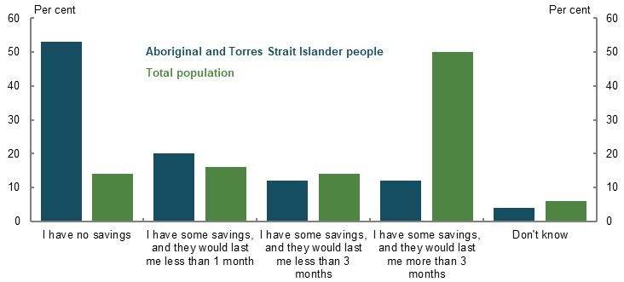
Note: Survey data from 2018. Survey question was ‘How much money do you have put away?’ Source: (Weier, et al., 2019).

Home ownership
Aboriginal and Torres Strait Islander people in retirement are less likely to be home owners and more likely to face the challenges of renting (see 2A: Achieving a minimum standard of living in retirement). At the 2016 Census, 45 per cent of Aboriginal and Torres Strait Islanders aged 65 and over owned their own home, compared with 71 per cent of the total population aged 65 and over (Table 3F-8). Around 41 per cent of Aboriginal and Torres Strait Islander people aged 65 and over were renting, almost 4 times the incidence across the total population. More than half of those renting did so through public housing.
      - Proportion aged 65 and over, by housing tenure and Indigenous status
 | Aboriginal and Torres Strait Islander  (per cent) | Total population  (per cent)
Owner without a mortgage | 35.2 | 61.0
Owner with a mortgage | 10.2 | 10.1
Renter | 41.0 | 11.8
Public housing | 22.7 | 3.2
Other | 1.2 | 1.9
Not stated/Not applicable | 12.4 | 15.2
Note: 2016 data. Source: Analysis of (ABS, 2016a).
At 30 June 2019, 32 per cent of Aboriginal and Torres Strait Islander people on income support over Age Pension eligibility age were home owners, compared with 73 per cent of the total age pensioner population.
Older Aboriginal and Torres Strait Islander people are also more likely to be homeless than older non-Indigenous people. At the 2016 Census, 3.3 per cent of those identifying as Aboriginal and/or Torres Strait Islander aged 65 and over were homeless or marginally housed, compared with 0.4 per cent of the total population. Older Aboriginal and Torres Strait Islander homelessness is most prominent in remote or very remote areas (ABS, 2016a).

Financial literacy
Aboriginal and Torres Strait Islander people generally have lower financial literacy levels than the total population (Wilkins & Lass, 2018, p. 120), making engagement with the retirement income system harder. In a study by ANZ, Aboriginal and Torres Strait Islander people scored slightly lower on planning ahead, staying informed and ‘financial control’ (making debt repayments and saving) (ANZ, 2015, p. 11).
Reconciliation Australia (2007, p. 26) suggested that the factors contributing to lower financial literacy for Aboriginal and Torres Strait Islander people are broad, but include:
- Lower educational attainment levels
- Poorer health
- Remoteness
- Cultural barriers
- Language barriers (see below)
- The complexity of product information
- Low awareness of financial literacy programs
- Limited provision of face-to-face training
Lower financial literacy is correlated with a range of factors that lower retirement incomes (see 5A. Cohesion).
Language barriers can impede engagement with, and understanding of, financial products and superannuation. One in 10 Aboriginal and Torres Strait Islander people communicate in an Indigenous language at home (Boyle, 2018b, p. 30). Of Indigenous language speakers, 16.6 per cent reported they do not speak English well or at all (KPMG, 2016).
First Nations Foundation observed an emerging generation of Aboriginal and Torres Strait Islander people who, for the first time, have incomes that allow for discretionary saving and spending. But they noted that these young people have limited inherited experience in financial management, saving or superannuation, whereas the broader population is more likely to learn these skills from family members. Improving the financial literacy of this emerging generation will be critical to growing retirement income outcomes for Aboriginal and Torres Strait Islander people.

Issues accessing the retirement income system

Physical access to, and exclusion from, services
Aboriginal and Torres Strait Islander people are nearly three times more likely to be severely or fully excluded from financial services (Connolly, et al., 2012, p. 26).
Superannuation funds are no exception. The industry has been structured to deliver superannuation services through centralised call centres, websites and administration centres, which can make access difficult for Aboriginal and Torres Strait Islander people in regional and remote areas. Very few superannuation funds provide the option of face-to-face communication, despite Aboriginal and Torres Strait Islander people preferring face-to-face communication (Gordon & Boyle, 2015, p. 11) (Indigenous Superannuation Working Group, 2015, p. 12).
The superannuation industry’s focus on delivering services online or via post, and its use of complex technical jargon, may also impede Aboriginal and Torres Strait Islander engagement with superannuation. For example, when a member calls their superannuation fund, they are usually greeted by an automated message using language that is difficult to understand for those with limited knowledge of financial products (Gordon & Boyle, 2015, p. 11) or English language barriers. Similarly, ASIC estimates Aboriginal and Torres Strait Islander people have higher rates of lost superannuation than most people, ‘…because someone becomes a lost member when their fund has tried to communicate with them twice and the letter… has been returned to sender’ (Boyle, 2018a). If the communication methods used by superannuation funds do not cater to Aboriginal and Torres Strait Islander people in rural communities, their superannuation may be transferred to the ATO as lost superannuation.
Access to Centrelink may also be more difficult for Aboriginal and Torres Strait Islander people in remote areas. In 2014, 14.3 per cent of Aboriginal and Torres Strait Islander people living in remote areas had problems accessing Centrelink, and 10.9 per cent had problems accessing banks and financial institutions (ABS, 2016b). For all people living in outer regional and remote areas, the proportions were lower, at 9.2 per cent and 5.8 per cent, respectively (ABS, 2015a).
A range of initiatives aim to improve Aboriginal and Torres Strait Islander people’s engagement with the retirement income system:
- The ATO’s helpline for Aboriginal and Torres Strait Islander people provides specialised tax and superannuation support. The helpline received 25,034 calls in 2019, an increase on previous years (ATO, 2020b).
- ASIC’s Indigenous Help Line provides assistance, information and referrals in a culturally sensitive way, receiving around 100 to 150 calls a year.
- The ATO and Centrelink take part in the Big Super Day Out, coordinated by First Nations Foundation, to provide a one-stop shop for engagement with the retirement income system.
- Services Australia’s Indigenous Customer Service Officers and Indigenous Service Officers help Aboriginal and Torres Strait Islander people and communities understand Centrelink services, and advise people of their rights and obligations.
- Centrelink has servicing teams that improve access to payments in remote areas.
- Centrelink’s Indigenous Call Centre provides assistance to Aboriginal and Torres Strait Islander people about their payments and services.
A few superannuation funds have tailored their provision of services to Aboriginal and Torres Strait Islander people. For example, QSuper is proactively working with the ATO and community organisations to reunite people in postcodes with significant Aboriginal and Torres Strait Islander populations with their superannuation (Boyle, 2018a, p. 3758). However, this is the exception rather than the rule. In 2013, only four funds surveyed by the Indigenous Superannuation Working Group had developed specific initiatives for engaging with their Aboriginal and Torres Strait Islander members, with only one producing tailored communication materials (Gordon & Boyle, 2015, p. 11).

Challenges in proving identity
Impediments to identity verification can prevent people from accessing their superannuation benefits, claiming insurance or tracking down lost superannuation. Challenges in identifying Aboriginal and Torres Strait Islander people for superannuation purposes include:
- They are more likely to adopt a more fluid approach to identity and use of names
- Births may not have been recorded or may not be accurate (particularly for older people)
- Registration of events like marriage and death may be inconsistent or inaccurate (Indigenous Superannuation Working Group, 2015) (Boyle, 2018b, p. 24)
If a person does have a set of compliant identity documents, for those living in a remote location the added steps of having these documents copied and certified can be difficult (Boyle, 2018b, p. 25). Even with help, the time required for many Aboriginal and Torres Strait Islander people to prove their identity is immense (Edwards, 2018, p. 3726). When ASIC undertook outreach efforts to provide superannuation support to Aboriginal and Torres Strait Islander communities, they found that ‘…more than half of those who received assistance could not comply with standard identification procedures.’ (Boyle, 2018b, p. 30)
In 2016, the Australian Transaction Reports and Analysis Centre (AUSTRAC) gave financial institutions, including superannuation funds, guidance for identifying customers without conventional forms of identification (Boyle, 2018b, p. 25). This aimed to promote a more flexible approach to identifying Aboriginal and Torres Strait Islander people, as well as others who may struggle to prove their identity, such as transgender people and migrants (AUSTRAC, 2020).
The Royal Commission into Misconduct in the Banking, Superannuation and Financial Services Industry (Financial Services Royal Commission) found AUSTRAC guidance had not been well implemented (Royal Commission into Misconduct in the Banking, Superannuation and Financial Services Industry, 2019).
ASIC suggested one reason may be because financial institutions cannot identify Aboriginal and Torres Strait Islander people to determine whether the guidance should be used, ‘…particularly through phone-based customer support that can be scripted or heavily optioned.’ (Boyle, 2018b, p. 25) The Financial Services Royal Commission recommended amending the voluntary 2019 Banking Code to encourage the use of the AUSTRAC guidance. However, superannuation funds are not subject to the Banking Code.

Data collection
Superannuation funds are not required to record whether their members identify as Aboriginal and/or Torres Strait Islander, limiting funds’ ability to cater to the needs of their Indigenous members. A 2013 survey of superannuation funds found only two funds collected information on Indigenous status (Indigenous Superannuation Working Group, 2015, p. 6). The Superannuation Consumers’ Centre and CHOICE have raised concerns about identification. They suggested recording identity could reduce the access and affordability of insurance within superannuation for Aboriginal and Torres Strait Islander people (CHOICE & Superannuation Consumers' Centre, 2018).

Mistrust due to historical injustices
First Nations Foundation noted some Aboriginal and Torres Strait Islander people viewed superannuation as wage garnishing, as opposed to mandatory savings. This is in the historical context of state and territory governments garnishing wages from Aboriginal and Torres Strait Islander people. Those who view the superannuation system as garnished wages never expect to see their savings again.
ASIC noted mistrust of the retirement income system is compounded by other access challenges. When Aboriginal and Torres Strait Islander people see their relatives pass away before being able to access their superannuation benefits, or encounter challenges in proving their identity so they cannot access their own superannuation, it confirms their perceptions that superannuation is the same as stolen wages (Boyle, 2018a, p. 3761).

Payment of superannuation death benefits
ASIC identified issues for those in rural areas, particularly Aboriginal and Torres Strait Islander people, in determining whether a deceased relative had superannuation. Before disclosing whether a person had any superannuation, the ATO requires evidence of authority to enquire about an estate, such as a will or letters of administration. Providing these documents can be a costly process, particularly for people in rural areas who must travel significant distances to obtain them. ASIC estimated it can be a minimum of several thousand dollars to determine whether a deceased relative has superannuation. If the person does not have superannuation, this process can be for nothing (Boyle, 2018a, p. 3756).
Superannuation law does not adequately allow for death benefits to be paid according to Aboriginal and Torres Strait Islander kinship structures. Superannuation monies do not automatically form part of a deceased person’s estate. Instead, superannuation trustees are responsible for distributing death benefits.
The Financial Services Royal Commission heard evidence that some Aboriginal and Torres Strait Islander people face difficulties accessing death benefits for these reasons and recommended the Government investigate reforms (Royal Commission into Misconduct in the Banking, Superannuation and Financial Services Industry, 2019, p. 254). The Government consulted with stakeholders on this issue in 2019, and is considering submissions received in response to the consultation.
          - Impacts of changes to certain policy settings on Aboriginal and Torres Strait Islander people’s retirement outcomes
A number of submissions raised policy proposals affecting Aboriginal and Torres Strait Islander people in retirement. The following summary outlines some implications of some of those proposals.
- Lower the superannuation preservation age for Aboriginal and Torres Strait Islander people. A high proportion of Aboriginal and Torres Strait Islander people die before accessing their superannuation. If the preservation age was lowered for Aboriginal and Torres Strait Islander people, the probability of this occurring would reduce. However, if a lower preservation age was limited to Aboriginal and Torres Strait Islander people, it may also result in those with similar life expectancy to the total population accessing their superannuation earlier, to the detriment of their retirement incomes. Other mechanisms, such as recognising Indigeneity in the rules around early release of superannuation, may be more targeted.
- Remove exclusions to the SG. Removing some of the exclusions to the SG, such as the $450-a-month threshold, would not materially improve retirement outcomes for Aboriginal and Torres Strait Islander people, but would improve equity in the retirement income system (see 3D. SG coverage). The $450-a-month threshold for SG payments, and the lack of SG payments for Community Development Program participants, disproportionately affect Aboriginal and Torres Strait Islander people.
- Increase support for Aboriginal and Torres Strait Islander people who rent. Without an increase in Aboriginal and Torres Strait Islander people’s labour force participation, superannuation and private savings will continue to be minor contributors to their retirement incomes. The Age Pension will be the main source of their retirement income. Given the high proportion of Aboriginal and Torres Strait Islander renters in retirement, additional support for renters would improve the retirement income adequacy of Aboriginal and Torres Strait Islander people who rent.
- Increase the SG rate. This would have limited impact on the retirement outcomes of Aboriginal and Torres Strait Islander people and come at the expense of working-life income. Given the substantially lower proportion of Aboriginal and Torres Strait Islander people in the labour force, the rate of the SG would only affect retirement incomes for a few. Those in the labour force are likely over-represented in the lower half of the income distribution where replacement rates are very high due to the support of the Age Pension. Any increase in the SG would reduce the already lower working-life earnings of Aboriginal and Torres Strait Islander people (see 2D. Policy scenario: Implications of maintaining the SG rate).
- Improve data collection on the Indigenous status of superannuants. This would improve analysis of Aboriginal and Torres Strait Islander retirement outcomes. Safeguards would need to be put in place to make sure the insurance coverage and premiums for Indigenous members were not adversely affected as a result of the data.

People with disability
          - Section summary
- People with disability retire with less superannuation and wealth than those without disability due to lower working-life participation and earnings. On average, the more severe a person’s disability, the lower their superannuation balance. People who acquire a disability later in life are more likely to have higher savings than those who become disabled earlier.
- The Age Pension helps improve retirement income equality compared with working life between people with and without disability.
- The median retiree with a severe disability spends less on goods and services than the median retiree without disability. Although people with a severe disability have higher medical costs, most costs are covered by the Government, particularly for those with a Pensioner Concession Card.
- Overall, retirees with disability have similar rates of poverty and financial stress as the total retired population. People with disability experience significantly less financial stress in retirement than in working life. However, retirees with disability are more likely to rent than the total population.
- The Age Pension means test exemption for people who are blind mainly benefits those who become blind in retirement but have had the same opportunities as others to accumulate retirement savings. Were the exemption not in place, a significant number of people who are currently exempt from the means test would have a reduced rate of, or not be eligible for, the Age Pension, due to their high assets or income.
- People covered by the National Disability Insurance Scheme in retirement may receive more financial support, and have lower out-of-pocket costs, than people in similar circumstances covered by the aged care system.

Outline of this section
This section considers the effect of disability on the way people accumulate superannuation or wealth and whether they have sufficient income in retirement. It also analyses how retirement income system settings affect incomes for retirees with disability.
          - Stakeholder views on equity for people with disability
A few submissions suggested people with disability are more likely to:
- Be unemployed and have lower earnings in working life, which limits their ability to build up savings and superannuation
- Rent, both in working life and in retirement
- Be in poverty and financial stress, both in working life and in retirement
Stakeholders noted that people with disability may face additional challenges in retirement, such as difficulty accessing services or additional disability-related expenses, including housing modifications. They suggested these challenges can compound working-life inequities.

          - Defining disability
Disability is a limitation, restriction or impairment that has lasted, or is likely to last, for at least six months or more and restricts everyday activities.
- ‘Profound or severe core activity limitation’ sometimes or always needing help with one or more activities of self-care, mobility or communication.
- ‘Moderate or mild core activity limitation’ having difficulty with self-care or communication, or limitations with mobility, walking or using public transport.

Prevalence of disabilities
A significant proportion of the population will be affected by disability at some point in their life. Acquiring disability pre-retirement can reduce a person’s ability to save or prepare for retirement.
The proportion of people with disability increases with age (Chart 3G-1). In 2018, around 4.4 million Australians had a disability, representing 17.7 per cent of all Australians. Of these people, around 1.9 million were aged 65 and over, representing 44.5 per cent of this group (ABS, 2019g). A woman aged 65 can expect to spend 55 per cent of her remaining life with a disability. For a man aged 65, the comparable figure is 53 per cent (Australian Institute of Health and Welfare, 2017).
    - Proportion of people with disability, by age
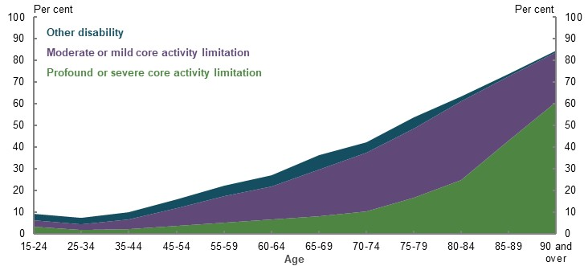
Note: 2018 data. Source: (ABS, 2019g).

Translation of working-life disadvantages into retirement

Working-life income
People with disability are more likely to have lower labour force participation, have lower earnings, work part-time and receive income support payments prior to retirement. In 2018, the median weekly income of people aged 15-64 with disability was $505, compared with $1,016 for people with no reported disability (ABS, 2019g). The more severe the disability, the more likely the person is to have a lower income (Chart 3G-2).
    - Income distribution for households aged 15-64, by disability status
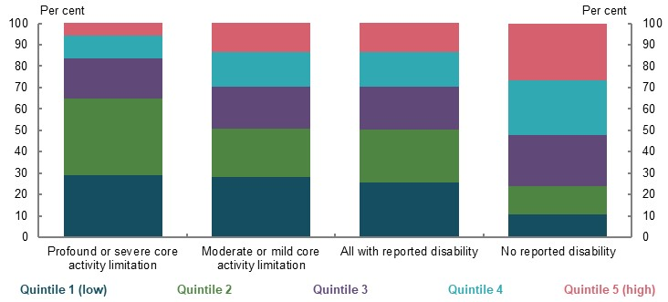
Note: 2018 data. Quintiles are based on equivalised gross household income. Equivalised means that the results are adjusted for household size. Source: (ABS, 2019g).
Government pensions or allowances are the main source of income for around 38 per cent of people with disability aged 15-64, increasing to 59 per cent for people with a profound or severe core activity limitation. This compares with 7 per cent for people without disability (ABS, 2019g).
Fewer people with disability are in the labour force: 53 per cent compared with 84 per cent of people without disability (ABS, 2019g). People with disability who are employed are more likely to work part-time: 41 per cent of people with disability, and 52 per cent of people with a profound or severe core activity limitation, compared with 32 per cent of people employed without disability (ABS, 2019g).
People may also retire involuntarily before Age Pension eligibility age due to ill health (see 3E. Age of retirement).

Superannuation balances
Lower labour force participation and lower working-life earnings make it harder for people with disability to grow their superannuation. Generally, the more severe a person’s disability, the lower their superannuation balance (Chart 3G-3). The size of the superannuation balance of a person with disability depends on when they become disabled. People who become disabled later in life have sufficient time in the workforce to build up their superannuation.
    - Household superannuation balance, by age and disability status (2017-18)
Average | Median
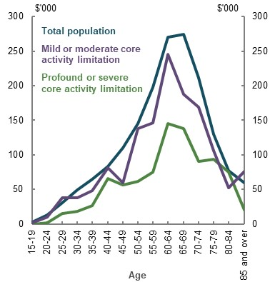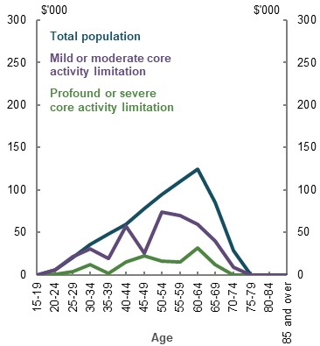
Note: Superannuation balances are in 2017-18 dollars. Results are equivalised. Equivalised means that the results are adjusted for household size. Calculations include those with zero balances. Age is determined by the reference person for the household. The significant difference in the median and average superannuation balances for people with disability shows that there are significant outliers in these cohorts, as suggested by the distributions in Chart 3G-2. Source: Analysis of ABS Survey of Income and Housing Confidentialised Unit Record File, 2017-18.

Private savings and home ownership
People with disability in retirement have lower average wealth, and lower home ownership rates, compared with the total retired population. On average, people with disability in retirement have lower value homes and less wealth in financial assets, investment properties and superannuation. People with a mild or moderate core activity limitation have 82 per cent of the average equivalised household wealth held by the total population. For people with a profound or severe core activity limitation, the comparable figure is 72 per cent.
People with disability aged 65 and over, particularly people with a profound or severe core activity limitation, are more likely to rent than the total retired population (Chart 3G-4) (see 2A. Achieving a minimum standard of living in retirement for analysis of the retirement outcomes for renters).
    - Housing tenure for people aged 65 and over, by disability status
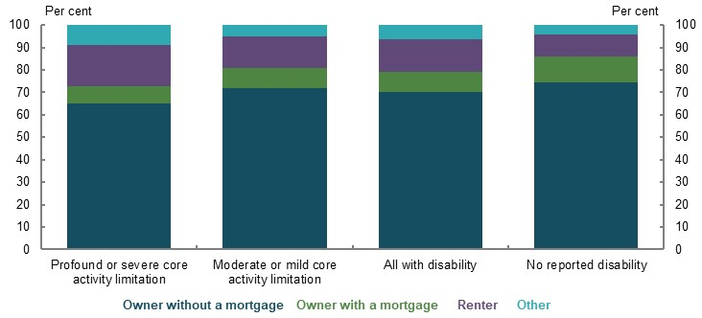
Note: 2018 data. Source: (ABS, 2019g).

Income inequality in retirement compared to working life
Compared with working life (Chart 3G-2), income inequality between people with and without disability reduces in retirement due to the Age Pension. Although people with disability aged 65 and over are likely to have lower incomes than people with no disability, the difference is smaller than in working life (Chart 3G-5). In 2018, the median weekly household income of people aged 65 and over with disability was $448, compared with $479 for people with no reported disability 65 and over. Government payments were the main source of income for 68 per cent of people with disability aged 65 and over, compared with 47 per cent of people with no disability (ABS, 2019g).
    - Income distribution for households aged 65 and over, by disability status
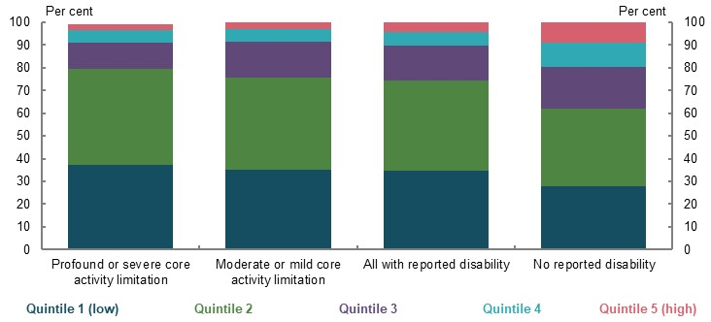
Note: 2018 data. Quintiles are based on equivalised gross household income. Equivalised means that the results are adjusted for household size. Source: (ABS, 2019g).
As superannuation becomes a growing proportion of retirement income for people without disability, this narrowing in income inequality in retirement may diminish.

Poverty and financial stress

Rates of poverty and financial stress
Poverty and financial stress rates for people with disability in retirement (14 per cent and 11 per cent in poverty and financial stress, respectively) are very similar to average poverty rates for the total retired population (see 2A. Achieving a minimum standard of living in retirement). People with a profound or severe core activity limitation in retirement have marginally higher rates of financial stress than the total population, at around 15 per cent. However, those with a profound or severe core activity limitation experience lower rates of financial stress in retirement, compared to in working life (Chart 3G-6).
Renters with a profound or severe core activity limitation in retirement have higher rates of financial stress, but lower rates of income poverty, than the total renting population. The lower rates of income poverty may be explained by the larger proportion of people with a profound or severe core activity limitation who have rent-free living arrangements, or who rent through public housing (13 per cent, compared to 6 per cent for the total retiree population) (ABS, 2019g).
    - Proportion of people in financial stress, by disability status and age
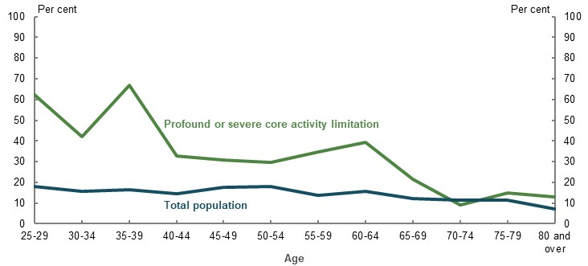
Note: 2015-16 data. Households with a profound and severe core activity limitation are determined by the status of the reference person for the household. Total population includes those with and without disability. Source: Analysis of ABS Household Expenditure Survey Confidentialised Unit Record File, 2015-16.

Expenditure in retirement
The median person aged 65 and over with disability has lower overall expenses than the median person aged 65 and over in the total population. In 2015-16, the median expense on goods and services for households with a person with a profound or severe core activity limitation aged 65-69 was $490 per week, compared with $706 per week for the total population. For those aged 80 and over, the median expense on goods and services for households with a person with a profound or severe core activity limitation was $402 per week, compared with $428 per week for the total population (Chart 3G-7).
    - Median weekly expenses on goods and services, by age and disability status
Age 65-69 | Age 80 and over
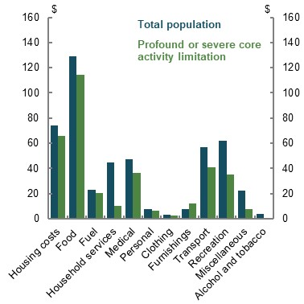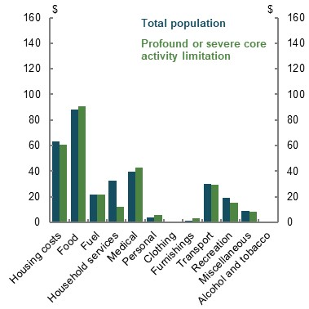
Note: 2015-16 data. Expenditure has been inflated to 2019 dollars by CPI. Households with a profound and severe core activity limitation are determined by the status of the reference person for the household. Total population includes people with and without disability. Source: Analysis of ABS Household Expenditure Survey Confidentialised Unit Record File, 2015-16.
The median person aged 65 and over with a profound or severe core activity limitation also spends less on goods and services, as a proportion of their income, compared with the total population aged 65 and over (Table 3G-1). The acquisition of disabilities at older ages may explain part of why older retirees, in aggregate, spend less than younger retirees.
      - Median weekly expenses compared to median weekly disposable income, by age and disability status
Age  (years) | Profound or severe core activity limitation |  |  | Total population
Age  (years) | Expenditure  ($) | Disposable income ($) | Proportion of income spent (per cent) | Expenditure ($) | Disposable income ($) | Proportion of income spent (per cent)
65-69 | 490 | 626 | 78 | 706 | 693 | 102
70-74 | 449 | 631 | 71 | 618 | 664 | 93
75-79 | 394 | 573 | 69 | 518 | 553 | 94
80 and over | 402 | 637 | 63 | 428 | 532 | 80
Note: 2015-16 data. Expenditure and income have been inflated to 2019 dollars by CPI. Households with a profound or severe core activity limitation are determined by the status of the reference person for the household. Total population includes people with and without disability. Source: Analysis of ABS Household Expenditure Survey Confidentialised Unit Record File, 2015-16.

Health expenditure
Of households with a person aged 65 or over, those that include someone with disability spend more of their income on health expenses than those households without a disabled person. However, most of these expenses are met by social transfers in kind from Commonwealth and state and territory governments (Chart 3G-8 and Chart 3G-9). Households with a Pensioner Concession Card have lower out-of-pocket costs for items, such as Pharmaceutical Benefits Scheme medicines, than households without a Pensioner Concession Card (see 1B. Design of Australia’s retirement income system).
    - Average weekly health expenses and social transfers in kind for households aged 65 and over
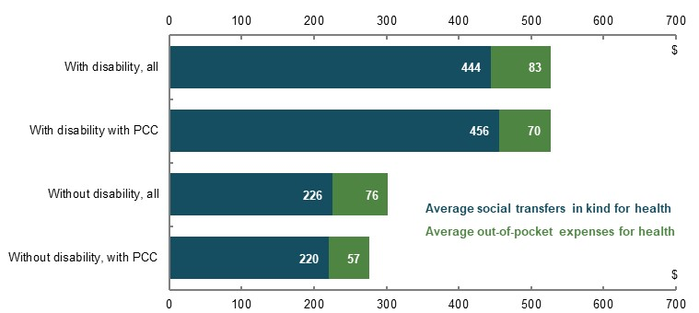
Note: 2015-16 data. Expenditure has been inflated to 2019 dollars by CPI. PCC stands for Pensioner Concession Card. Age is for the reference person of the household. Source: Analysis of ABS Household Expenditure Survey Confidentialised Unit Record File, 2015-16.
People with disability are more likely than people without disability to have more than 80 per cent of their health expenditure met by social transfers in kind. The proportion of health expenses met by social transfers in kind is even higher for households with a Pensioner Concession Card (Chart 3G-9).
    - Proportion of total health expenditure covered by social transfers in kind for households with a person aged 65 and over
 | Without disability | With disability
With PCC | 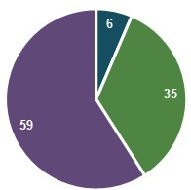 | 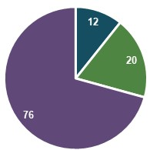 | 0-60% covered  61-80% covered  81-100% covered
All | 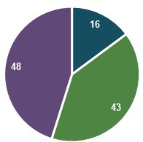 | 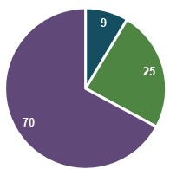 | 0-60% covered  61-80% covered  81-100% covered
Note: 2015-16 data. PCC stands for Pensioner Concession Card. This chart shows, for a group of people, the average proportion of their health expenditure that was covered by social transfers in kind. For example, for those with disability who held a Pensioner Concession Card, 76 per cent of people had more than 80 per cent of their health expenditure covered by social transfers in kind. Households are limited to those with someone in the household aged 65 and over. Source: Analysis of ABS Household Expenditure Survey Confidentialised Unit Record File, 2015-16.

Disability-specific retirement income system settings

Age Pension means test exemption for people who are blind
People who are blind are not means tested for the Age Pension or Disability Support Pension. In 1954, the means test for people who are blind was removed as part of a broader aim to remove all means testing from the Age Pension, which lasted into the 1970s (Herscovitch & Stanton, 2008). A previous rationale for the means test exemption for people who are blind was that it ‘ … helps meet the extra costs of blindness in communication, mobility, transport and daily living’ (National Federation of Blind Citizens of Australia, 1996). However, with technological advancements and greater support to reduce out-of-pocket costs for people who are blind, such as through the National Disability Insurance Scheme or aged care, this rationale may have diminished.
As people are more likely to become blind at older ages, the Age Pension means test exemption for people who are blind is received by a significant number of people who become blind later in life and have accumulated significant assets for their retirement. At 31 March 2019, of the 10,600 age pensioners who received this exemption, 65 per cent were first recorded as blind aged 65 and over, and 44 per cent were first recorded as blind aged 75 and over. Around one-quarter of those who received the exemption received a part-rate of Age Pension before they became blind. The proportion of people with significant wealth who become blind later in life is expected to increase as the superannuation system matures.

National Disability Insurance Scheme and aged care
People with disability aged 65 and over can only receive National Disability Insurance Scheme funding if they were receiving funding before age 65. People who acquire a disability from age 65 receive support through the aged care system. The two schemes are different in that:
- Funding amounts under the National Disability Insurance Scheme are not capped
- The National Disability Insurance Scheme is not means tested and has no fees (Buckmaster, 2016), unlike aged care home packages
- National Disability Insurance Scheme recipients may have a higher level of control over how funds are spent and which providers they can choose
These variations can result in retirees receiving different levels of financial support based on when they acquire their disability. Where this financial support is inadequate to deal with the disability, people may need to draw down their retirement savings more quickly to make up the shortfall.

Early release of superannuation benefits
People with disability may be eligible to release their superannuation benefits before superannuation preservation age on compassionate grounds to meet the costs associated with medical treatment or transport, or modifications to a home or vehicle due to severe disability. For most people, limited early release of superannuation is projected to have a small effect on their eventual retirement income (see 2C. Maintaining standards of living in retirement).
          - Impacts of policy settings on the retirement outcomes of people with disability
A few submissions raised policy proposals affecting the retirement outcomes of people with disability. The following summary outlines the implication of one of those proposals.
- Increase support for retirees with disability who rent. Given their lower labour force participation, particularly among people with a more severe disability, income support will comprise a large part of the retirement incomes of those with disability. The Age Pension rate is an important factor in determining whether people with disability have adequate retirement incomes. Since a higher proportion of people with disability rent in retirement, increasing support for retirees who rent would improve retirement outcomes for many people with disability (see 2B. Policy scenario: Implications of increasing Commonwealth Rent Assistance).

Intergenerational equity
          - Section summary
- The Age Pension is taxpayer-funded, which means working-age people pay for retirees’ Age Pension benefits. This forms a fundamental part of the ‘generational bargain’: working-age people expect the generation after them to fund the Age Pension in the same way they did for current retirees.
- The structure of Australia’s superannuation system broadly supports intergenerational equity by encouraging people to rely on their own savings rather than on future generations to fund their retirement. The primarily defined contribution structure of Australia’s superannuation system, combined with other voluntary savings, encourages people to fund their own retirement by saving during their working life. Retirees can receive superannuation earnings tax concessions, which are taxpayer-funded and increase the size of the generational bargain. Nevertheless, superannuation lowers the burden on working-age people to support retirees.
- For each working-age person, the cost of the Age Pension and superannuation earnings tax concessions retirees receive is projected to continue to increase over the next 40 years in dollar terms. But, depending on real wage growth, the cost may be broadly similar as a proportion of wages in 40 years’ time. For each working-age person, the maturing superannuation system will decrease the cost of the Age Pension but increase the cost of superannuation earnings tax concessions retirees receive. In contrast, the decline in the ratio of working-age people to retirees, coupled with continued benchmarking of the Age Pension to wage improvements, will increase the cost of the Age Pension per working-age person. Real wage growth will be needed to ensure the Age Pension and earnings tax concessions retirees receive do not place a growing burden on working-age people.
- Different generations have different opportunities to accumulate retirement savings and generate retirement incomes due to forces inside and outside the retirement income system. Current older Australians have benefited from higher superannuation contributions caps and strong increases in residential property values. Younger Australians will benefit from a longer period of contributing to superannuation and the higher SG rate.
- Inheritances can assist some current young people to prepare for retirement, but they come at a cost to intragenerational equity. Inheritances allow current older people to pass their wealth to current younger people. If most people continue to die with the majority of the wealth they had at retirement, the maturing superannuation system is expected to increase the size of inheritances. Inheritances are distributed unequally, with wealthier people tending to receive larger inheritances.

Outline of this section
This section assesses intergenerational equity by examining:
- How Australia’s retirement income system is funded.
- Whether the annual cost per working-age person of the Age Pension and superannuation earnings tax concessions retirees receive (‘generational transfer cost’) has changed over time — in dollar terms and as a proportion of wages.
- How opportunities to accumulate retirement savings and generate retirement incomes have changed over time.
- How inheritances affect intragenerational equity.
          - Stakeholder views on intergenerational equity
A few stakeholders noted the importance of achieving intergenerational equity in the retirement income system, but there was no consensus on how to do so.
Some stakeholders noted the Age Pension for each generation is funded by younger generations. A few stakeholders argued the burden on younger generations should not become unsustainable. They suggested increasing compulsory superannuation or encouraging self-reliance in retirement would help achieve intergenerational equity. One stakeholder noted:
‘…if younger generations are faced with an increasing burden of supporting the incomes of retired Australians (through the tax system), then this could increase pressure on the implied inter‐generational social contract.’ (ASFA, 2020a, p. 21)
A few stakeholders noted a decline in housing affordability has reduced intergenerational equity, with fewer people in younger generations able to access the benefits of home ownership. One stakeholder noted:
‘The increasing lack of housing affordability threatens inter-generational retirement income equity and the ability of the existing system to deliver dignified retirements in the future…’ (Heffron, 2020, p. 14)

          - What is intergenerational equity?
‘Intergenerational equity’ is concerned with fairness in the opportunities and outcomes between people of different generations. It differs from ‘intragenerational equity’, which is concerned with fairness in the opportunities and outcomes between people of the same generation.
Many factors outside the retirement income system contribute to outcomes and opportunities experienced by different generations. For example, in addition to economic and financial factors, one study measured intergenerational equity using environmental, social and pro-elderly bias factors (Vanhuysse, 2013).
Measures for intergenerational equity in the retirement income system include:
- Full cohort self-funding — where the retirement income benefits received by each generation throughout its lifetime largely match the amount of taxes/contributions that generation has paid to support retirement.
- Generational bargain — where working-age Australians transfer income, through their tax contributions, to support retirees by funding the Age Pension, superannuation earnings tax concessions and other benefits retirees receive. Today’s working-age Australians expect the generation after them to support them in the same way as they supported the previous generation.
Although the review measured the size of the generational transfer cost over time between generations, data limitations preclude measurement for a particular generation of the size of contributions they made during their working life compared to benefits they receive in retirement.

Funding of the pillars of the retirement income system
The taxpayer-funded Age Pension is a fundamental part of the ‘generational bargain’ (Chart 3H-1), but it does not achieve full cohort self-funding. In other countries, pensions are paid from ‘ring-fenced’ taxes, such as the UK’s National Insurance Fund (UK Government, 2019). Whereas, in Australia, the Age Pension is paid out of consolidated Government revenue. As the cost of the Age Pension increases in line with wages, its real costs will rise over time, all else being equal.
    - Total household taxes and benefits, by age
Note: 2015-16 data. Net benefits refers to all taxes paid minus all social transfers (cash and in-kind). Source: Replication of (Wood, et al., 2019), which is derived from (ABS, 2018c).
The superannuation system encourages people to rely on their own savings to a large extent, rather than on future generations to fund their retirement. Defined contribution schemes, which are common in the superannuation system, are funded primarily by the member. Income depends on factors such as how much is paid into the superannuation account, the investment performance and fees. In contrast, defined benefit schemes, which are the minority, are funded by the employer, generally with the promise of a specific income. In an unfunded defined benefit scheme, the liability may be passed to future generations to meet the obligation.
People receive significant tax concessions for making both compulsory and voluntary superannuation contributions. These reduce tax revenue, meaning that other taxes may be higher than they would otherwise be to finance Government expenditure, or Government expenditure could be lower.
In 2015-16, households where the reference person was younger than 65 paid 90 per cent of taxes (ABS, 2018c). As 84 per cent of superannuation tax concessions were received before age 65 in 2019, this suggests the same generations generally pay for and receive superannuation tax concessions. However, in 2019, around 14 per cent of all superannuation tax concessions were earnings tax concessions received by people aged 65 and over. This is expected to increase to 24 per cent in 2059, due to the maturing superannuation system. As these earnings tax concessions represent a generational transfer, superannuation does not completely achieve full cohort self-funding.
In contrast, voluntary savings outside superannuation are fully funded and therefore consistent with full cohort self-funding.

Generational transfer cost
Analysis suggests each successive generation will contribute more during their working life to fund retirees’ income than the previous generation (Chart 3H-2). In 2019, the real cost for each working-age person of the Age Pension was around 65 per cent higher than in 1979-80. This cost, together with that of earnings tax concessions, is projected to rise over future decades.
The generational transfer cost would be higher if other government benefits — including social transfers in kind — received by people aged 65 and over were included. For example, aged care and health benefits are projected to increase as a percentage of GDP through to 2054-55 (Commonwealth of Australia, 2015).
    - Past and projected generational transfer cost in dollar terms
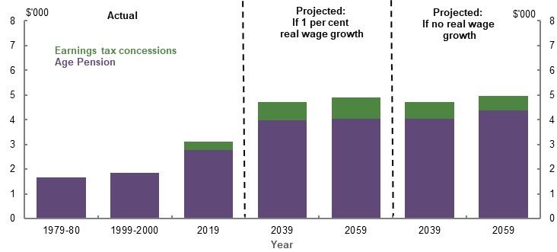
Note: Cost is per working-age person, per year. Values for 1979-80 and 1999-2000 are from Year Book 1981 and 2001 and are converted to 2018-19 dollars. Values for 2019, 2039 and 2059 are from Rice Warner estimates for the review and are in 2019 dollars, assuming CPI growth of 2.5 per cent per year in the future. The proportion of taxes, and therefore the Age Pension, working-age people pay for appears to have been stable for at least the last two decades. This is because households where the reference person was younger than 65 paid more than 90 per cent of total direct and indirect taxes in both 1988-89 (ABS, 1992b) and 2015-16 (ABS, 2018c). Earnings tax concessions are not included before 2019 due to data limitations. Data points vary between financial and calendar years to align with the time period of the underlying data. Source: Year Book 1981 and 2001 (ABS, 2001), (ABS, 2020e), (ABS, 2019b), (ABS, 2018g); Analysis of Rice Warner estimates for the review.
Although the generational transfer cost is projected to increase in dollar terms (Chart 3H-2), a better benchmark may be the generational transfer cost as a proportion of wages of the working-age population, in real terms. This approach may better represent the affordability of the generational transfer cost, as it recognises people’s capacity to pay has generally been rising over time.
The generational transfer cost as a proportion of wages marginally increased between 1979-80 and 2019 (Chart 3H-3). If future real wage growth is equal to 1 per cent per year, this cost would be broadly similar in 40 years’ time. However, if there was no real wage growth in the future, the cost is projected to increase substantially, placing a higher burden on working-age people to fund the Age Pension and earnings tax concessions of retirees. This suggests real wage growth is necessary to ensure the Age Pension and earnings tax concessions retirees receive are not an excessive burden for working-age people in the future.
    - Past and projected generational transfer cost as a proportion of wages
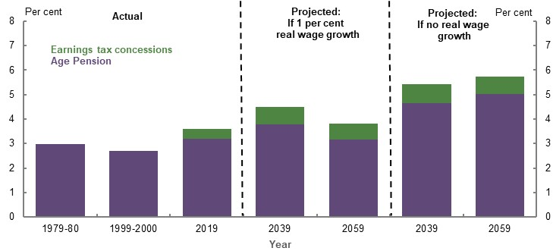
Note: Cost is per working-age person, per year. Assumes CPI growth is 2.5 per cent per year. Wages in 1979-80 refers to ‘average weekly earnings per employed male unit’ in September 1979; in 1999-2000 and 2019 it refers to ‘Earnings; Persons; Full-Time; Adult; Total earnings’ in November 1999 and November 2019, respectively. Earnings tax concessions are not included before 2019 due to data limitations. Data points vary between financial and calendar years to align with the time period of the underlying data. Source: Year Book 1981 and 2001 (ABS, 2001), (ABS, 2020e), (ABS, 2019b), (ABS, 2018g); (ABS, 2020d); Analysis of Rice Warner estimates for the review.
          - Factors that influence the generational transfer cost
The following factors have affected, and will continue to affect, the trend in the real annual cost for each working-age person of the Age Pension and retiree earnings tax concessions:
- The superannuation system. As the superannuation system matures, people are retiring with larger superannuation balances. For example, modelling projects that, by 2060, around 27 per cent of Australians will retire with a wage-deflated superannuation balance below $250,000, compared with 70 per cent in 2020. This means people are projected to fund a greater proportion of their own retirement, reducing the generational transfer cost.
- The rate at which the Age Pension and means test thresholds increase. The rate of Age Pension is benchmarked to wages, while the means test thresholds increase with prices (CPI). As wages have grown faster than prices, benchmarking the rate of Age Pension to wages has increased the cost of the Age Pension. In contrast, as long-term average returns on most assets have been greater than price increases, indexing the means test threshold to prices has decreased this cost. These effects are projected to continue, assuming wages and investment returns grow at a faster rate than prices.
- The decline in the number of working-age people to retirees (‘dependency ratio’). The dependency ratio has fallen from 7.3 in 1974-75 to 4.5 in 2014-15 (Commonwealth of Australia, 2015). This decline has increased the generational transfer cost. This cost will continue to climb as the dependency ratio is projected to fall further, to 3.2 in 2060 (see 4. Sustainability). This does not take into account the effect of a temporary reduction in immigration due to the COVID-19 Pandemic. Migration slows the rate of population ageing as migrants, on average, are younger than the average age of the resident population (Commonwealth of Australia, 2015).
- The level of real wage growth. See Chart 3H-2 and Chart 3H-3 above.
- The level of investment returns. The generational transfer cost as a proportion of wages in 2059 would increase if investment returns were 1 percentage point lower. This is because the increase in the cost of the Age Pension would more than offset the decrease in earnings tax concessions retirees receive (see Appendix 6D. Supplementary equity charts).
- The level of superannuation fees. The generational transfer cost as a proportion of wages in 2059 would decrease marginally if superannuation fees were lower (See Appendix 6D. Supplementary equity charts). This is because the decrease in the cost of the Age Pension would more than offset the increase in earnings tax concessions retirees receive.
- The Age Pension payment rate. Between 1975 and 2020, the maximum single rate of Age Pension rose as a proportion of average earnings, largely due to a substantial increase in the rate in 2009. This has increased the cost of the Age Pension.

Comparing internationally, the cost of Australia’s Age Pension at 2.6 per cent of GDP in June 2016 was much lower than the OECD average of public expenditure on pensions of 8.8 per cent of GDP in 2015-16. In future, the cost of the Age Pension is expected to fall slightly as a percentage of GDP (see 4. Sustainability), while the OECD average is projected to rise. In some countries, mainly in Europe, public expenditure on pensions is projected to rise well above 10 per cent of GDP (OECD, 2019b). Even after taking into account the cost of earnings tax concessions retirees receive, the total cost of Australian Government support as a proportion of GDP is projected to remain much lower than the OECD average of public expenditure on pensions.

Opportunities to accumulate retirement savings for different generations
The design of Australia’s retirement income system and external factors, such as asset prices, affect people’s ability to accumulate retirement savings and generate retirement incomes. When rules within the retirement income system or asset prices change, the resulting different retirement outcomes may not affect all generations equally. For example, a rule change may make it more difficult for younger people to save large amounts in superannuation, but may not affect people who are retired.
Previous changes that have affected people’s opportunities to accumulate retirement savings and generate retirement incomes include:
- Significant alterations to superannuation contribution rules and taxes — These included: unlimited non-concessional contributions before May 2006; a one-off $1 million non-concessional contributions cap between May 2006 and June 2007; and higher concessional contributions caps, especially for older people, between 2007 and 2017. This means current older generations have had an opportunity to contribute larger amounts to superannuation — and to receive much larger earnings tax concessions — than current younger generations will have under existing lower contributions caps (see 1B. Design of Australia’s retirement income system and 3A. Income and wealth distribution).
In addition, some current older Australians have benefited from changes to when superannuation taxes are incurred; for example, the change from mainly levying taxes on superannuation benefits before 1988 to the current model of levying taxes on superannuation contribution and earnings (CEPAR, 2018b, p. 39). As a result, some older Australians will have paid less tax on their superannuation savings than younger Australians will pay under the current rules.
However, lower superannuation contributions caps can improve intragenerational equity by reducing the amount of superannuation tax concessions, which higher-income earners tend to receive disproportionately.
- Continued increases in residential property values — In February 2020, residential property values in Australia’s capital cities were around 45 per cent higher than in 2012 (CoreLogic, 2020). The large asset price gains for home owners have primarily been received by current older people (Chart 3H-4). If the strong gains in residential property values are not repeated, younger home owners may not have the same opportunity to accumulate housing wealth as current older Australians.
In addition, if the trend of falling home ownership rates continues, (see 1D. The changing Australian landscape), some current young people will need to rely on other assets, such as superannuation or equities, as voluntary retirement savings. These people will forgo the benefits of home ownership in retirement, including the ability to age in a place of tenure. They may be unable to achieve the same retirement outcomes as current home owner retirees.
    - Change in average wealth per household in 2015-16, compared to households of the same age in 2003-04
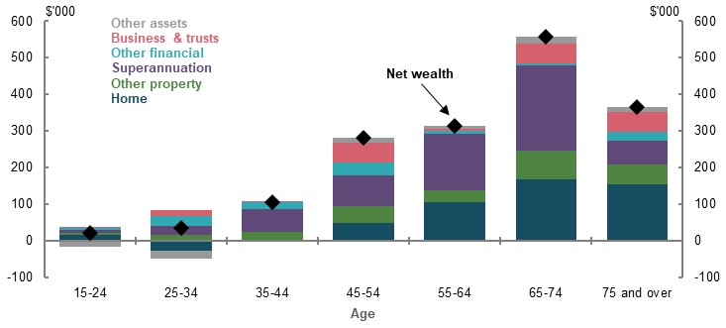
Note: Age group is the age of the household’s reference person. ‘Other financial assets’ include bank accounts, shares, and the outstanding value of loans made to other households or businesses. ‘Other assets’ include car, home contents, silent partnerships and assets not covered elsewhere. Source: Replication of (Wood, et al., 2019), which is derived from (ABS, 2018f).
- Expanded coverage and increases in the rate of the SG — Current younger generations will benefit in retirement from contributing to superannuation throughout their working life and at the higher SG rate. As such, on average, they are projected to have higher superannuation balances at retirement than current older Australians.

Inheritances
Inheritances can help rebalance intergenerational differences in opportunities to save for, and outcomes in, retirement. However, inheritances can be ineffective at equalising opportunities and outcomes between generations, as their size and timing are not guaranteed.
Most people die with the majority of the wealth they had when they retired (see 5A. Cohesion). If this continues, inheritances will increase as the superannuation system matures. For example, assuming no change in how retirees draw down their superannuation balances, superannuation death benefits are projected to increase from around $17 billion in 2019 to just under $130 billion in 2059 (Chart 3H-5).
    - Projected value of superannuation death benefits
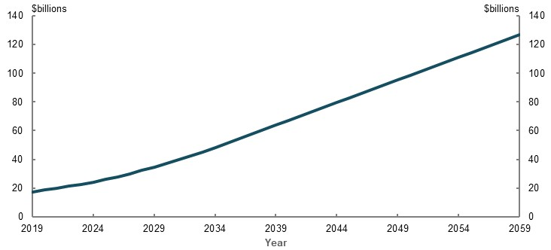
Note: In 2018-19 dollars. Superannuation death benefits include insurance payouts due to death. Source: Analysis of Rice Warner estimates for the review.
Although inheritances can help people to prepare for retirement, they are distributed unequally, with wealthier people tending to receive larger inheritances than those with lower wealth (Chart 3H-6). Inheritances therefore increase intragenerational inequity and do not help all people to prepare for retirement.
    - Size of inheritances, by wealth quintile

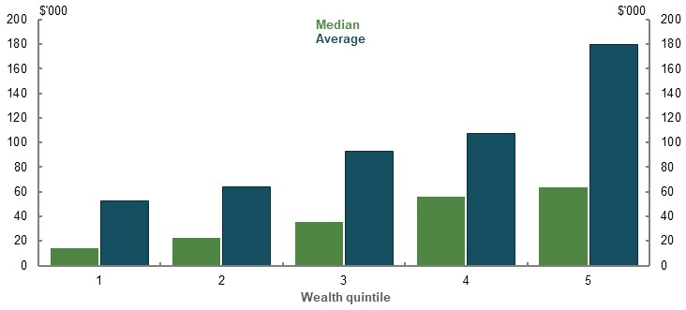
Note: In 2017-18 dollars. Median and average calculated by size of inheritance where one was received. Self-reported inheritances are captured in all HILDA Surveys between 2001 and 2017, while wealth is only captured in the 2002, 2006, 2010, and 2014 HILDA Surveys. As a result, wealth quintile is based on most recently captured wealth information for an individual. Individuals are allotted to a wealth quintile across all survey respondents. Source: Replication of (Wood, et al., 2019), which is derived from HILDA Survey data (Waves 2-17).No source specified.
Receiving an inheritance at the point of retirement boosts the annual retirement income of higher-income earners by more than lower-income earners, for the same size inheritance (Chart 3H-7). This is because receiving an inheritance increases a person’s assets and income and therefore reduces any Age Pension payments as they do not have the same need for Government support. Higher-income earners are the least affected by the assets test as, even without an inheritance, they qualify for minimal or no Age Pension in retirement.
    - Projected change in annual retirement income from a $250,000 inheritance at retirement
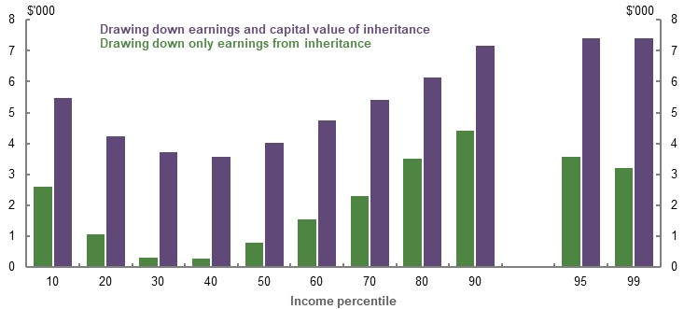
Note: Values are in 2019-20 dollars, deflated using the review’s mixed deflator. ‘Drawing down earnings and capital value of inheritance’ strategy assumes the inheritance is contributed to superannuation and drawn down consistently with other superannuation assets (see Appendix 6A. Detailed modelling methods and assumptions). Inheritance size of $250,000 is inflated by CPI and is based on the median value of a final estate of $480,000 from 2016 Victorian probate data (Wood, et al., 2019). As the fertility rate has been 1.9 births per woman since the late 1970s (Commonwealth of Australia, 2015), the inheritance is roughly split between two children. For simplicity, the inheritance is received at the point of retirement. The average size of inheritances is significantly higher in probate data than in HILDA (see Chart 3H-6). The difference may be due to the HILDA Survey relying on people self-reporting inheritance amounts and excluding some people living in aged care, and probate data excluding some small estates that do not require a probate. Probate data excludes superannuation death benefits, jointly owned assets and family trusts. Source: Cameo modelling undertaken for the review.
Most inheritances go to people over age 50 (Wood, et al., 2019, p. 42). As the timing and size of inheritances is uncertain, this makes it difficult for working-age people to plan optimally for retirement and to avoid over-saving. With life expectancy at birth projected to increase in the future (see 1D. The changing Australian landscape), inheritances are expected to increasingly go to even older Australians.
Inheritances and gifts have generally been tax-free in Australia since the late 1970s (The Sydney Morning Herald, 2018). However, superannuation death benefits are taxed in some cases, including the taxable component of lump sum benefits paid to non-dependants and income stream benefits paid to dependants (ATO, 2020d). In 2017, Australia was one of eight OECD countries without any inheritance, estate or gift taxes (OECD, 2020b).
          - Impact of changes to certain policy settings on intergenerational equity
A few submissions raised policy proposals to improve intergenerational equity. The following summary outlines some implications of some of those proposals.
- Increase the rate of SG. This would increase the extent of cohort self-funding in the system, as a smaller share of each generation’s retirement incomes would be funded by the Age Pension.
- Change superannuation tax concessions. Changes to contributions tax concessions would have little effect on intergenerational equity. Reducing tax concessions on earnings of assets held in the retirement phase would improve intergenerational equity by reducing the cost of these concessions to working-age people.
- Encourage people to spend more of their savings in retirement. This would likely reduce wealth inequality among future generations. Inheritances would be lower if retirees consumed a higher proportion of their savings during retirement, rather than dying with the majority of the wealth they had at retirement. Given inheritances are distributed unequally, this would assist in reducing intragenerational wealth inequality for future generations, but would mean some current younger people are less prepared for retirement.

- Sustainability

Outline of this chapter
This chapter considers the sustainability of the retirement income system. The costs of the system analysed include: Age Pension expenditure, superannuation tax concessions, the superannuation fees paid by members and social transfers in kind.
This chapter is organised in five parts:
- Historical system costs.
- Projected future system costs.
- The cost-effectiveness of the retirement income system, including how Government support is allocated to promote adequate retirement outcomes.
- The potential effects of alternative trends, including lower returns, lower wage growth and lower superannuation account fees.
- Public confidence, including the effects of economic and integrity shocks on confidence, as well as policy changes and how to achieve reform without undermining confidence.
The immediate (and likely ongoing) detrimental impact on financial and labour markets of the COVID-19 Pandemic is not reflected in baseline projections. However, Box 4A-4 contains analysis using Treasury’s MARIA (Model of Australian Retirement Incomes and Assets) model of a large, but short-term, shock to superannuation and how it impacts the retirement income system in the long term.

Sustainability
          - Chapter summary
- Under current policy settings, the total projected cost of Age Pension expenditure and superannuation tax concessions together is estimated to grow from 4.6 per cent of GDP today to 5 per cent by 2060. The overall increase is projected to be due to the growing future cost of earnings tax concessions.
- Age Pension spending has been stable over the past 20 years and is projected to fall moderately as a percentage of GDP over the next 40 years. This is despite growth in the maximum payment rate and the number of retirees. Higher superannuation balances driven by a maturing system, combined with means testing, will continue to constrain Government spending on the Age Pension.
- The cost of superannuation tax concessions — although difficult to measure — is projected to increase as a percentage of GDP as the superannuation system matures. This is projected to be due to growing earnings tax concessions. Recent tightening of caps on contributions should help contain superannuation contributions tax concessions into the future. Earnings tax concessions increase as the system grows and are not subject to direct caps.
- Social transfers in kind are substantial and increasing. This is mostly due to increasing Medicare and aged care expenditure.
- Superannuation tax concessions boost retirement incomes across the income distribution. They increase retirement incomes most for households at the higher end of the income distribution. Superannuation tax concessions cost more than the Age Pension savings they produce across the income distribution.
- The retirement income system is robust to changes to trends such as reductions in earnings and wages growth. Lower earnings and lower wages would reduce incomes in retirement from superannuation, but Age Pension income would cushion this impact for people. Lower fees would reduce the cost of the system and improve outcomes for people in retirement.
- Public confidence can be undermined by poorly executed policy changes, economic shocks, concerns over system integrity or a general mismatch between expectations and outcomes. Broadly, the Australian system appears to enjoy reasonable levels of public confidence.

          - Stakeholder views on sustainability
Some stakeholders suggested taking a whole-of-system perspective when analysing sustainability, incorporating public funding and private savings, alongside assessing intergenerational equity (addressed in 3H. Intergenerational equity).
‘… the sustainability of the Retirement Income System as a whole depends on the overall cost of the Age Pension, superannuation concessions and tax treatment of other assets and income.’ (COTA, 2020, p. 37)
Some stakeholders recommended assessing whether the system was ‘good value’ to taxpayers.
‘The key measure is whether taxpayers and members receive good value.’
(Rice Warner, 2020, p. 24)
Stakeholders considered means testing of the Age Pension and the compulsory nature of the Superannuation Guarantee (SG) play key roles in influencing the sustainability of the system. Tax concessions on superannuation and the concessional treatment of owner-occupied housing in the Age Pension means test were identified as policies that decreased system sustainability. Many stakeholders were concerned about the sustainability of the cost of social transfers in kind, such as health and aged care benefits. One submission argued that while the retirement income system was sustainable, the same could not be said for aged care:
‘Government support for retirement incomes is affordable now and in the future. In contrast, the Commonwealth government faces significant long-term fiscal challenges from escalating future health and aged care expenses.’ (ASFA, 2020a, p. 22)
More stakeholders raised concerns about the benefits of tax concessions being inequitably distributed, than about the sustainability of those concessions, although the two are linked. The large benefits going to higher-income earners were often framed as inequitable and unsustainable.
Stakeholders noted that public confidence was essential to the sustainability of the system. Concerns raised centred on:
- Whether complexity makes it difficult for people to understand and have confidence in the system
- The frequency of policy changes
- Misconduct and failings exposed by the Royal Commission into Misconduct in the Banking, Superannuation and Financial Services Industry, and the Productivity Commission report Superannuation: Assessing Efficiency and Competition
- A lack of trust in financial advice
‘National Seniors believes confidence in the retirement income system is impacted largely by perceptions about complexity, instability and unfairness.’
(National Seniors Australia, 2020, p. 63)
Some stakeholders suggested the review should consider the impact of shocks or alternative trends, such as lower investment returns.

Historical costs
The total cost of Age Pension expenditure and superannuation tax concessions, both contributions and earnings concessions, have risen from 3.55 per cent of GDP in June 2001 to 4.52 per cent of GDP in June 2019 (Chart 4A-1). All components increased as a percentage of GDP over the period, although tax concessions have grown by more than Age Pension expenditure (0.8 percentage points compared with 0.2 percentage points).
    - Total system cost
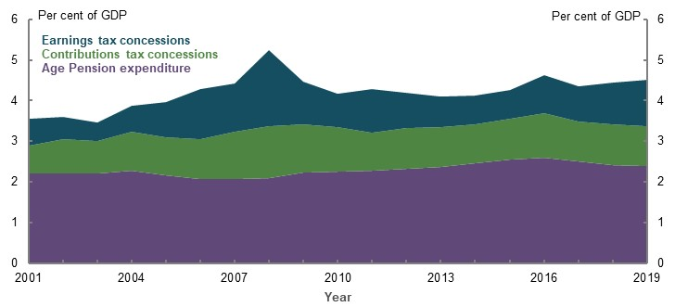
Note Age Pension expenditure includes supplementary allowances. The tax concessions time series is presented to illustrate the general trend. The cost of tax concessions is estimated independently each year (i.e. there is no dynamic impact of the removal of concessions over time), and year-to-year estimates may be subject to changes in policy benchmarks, data, assumptions and methodology. Source: Analysis of Annual Report 2000-2001 to 2018-19 (Department of Social Services, 2019); Tax Expenditures Statement 2004 to 2017 (The Treasury, 2018b); Tax Benchmarks and Variations Statement 2018 to 2019 (The Treasury, 2020); (ABS, 2019d).

Age Pension
Since 2000-01, the cost of the Age Pension (including supplementary allowances) has grown by 92 per cent in real terms, from $24 billion to $46 billion (Chart 4A-2).
Age Pension spending has been reasonably stable as a percentage of GDP, increasing by 0.2 percentage points to 2.4 per cent between June 2001 and June 2019 (Chart 4A-2). As a share of the Commonwealth Budget, Age Pension spending has increased by 0.9 percentage points over the same period. As a share of average wages, Age Pension spending per working-age person has been relatively stable over several decades (see 3H. Intergenerational equity).
    - Total Age Pension expenditure
Dollars | Percentage terms
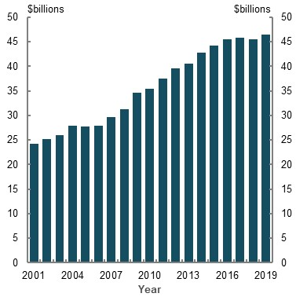 | 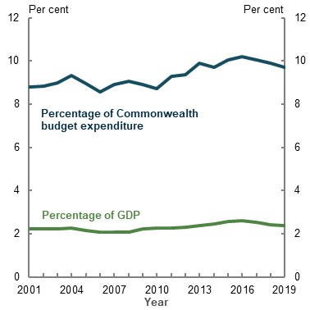
Note: Values are in 2018-19 dollars, inflated by CPI. Age Pension expenditure includes supplementary allowances. Source: Annual Reports 2000-2001 to 2018-19 (Department of Social Services, 2019) and (ABS, 2020e). | Note: Age Pension expenditure includes supplementary allowances. Source: Analysis of Annual Report 2000-2001 to 2018-19 (Department of Social Services, 2019); (ABS, 2019d); and data provided to the review by The Treasury.
Age Pension costs are affected by the size of the population of Age Pension eligibility age, the rate of payment and the impact of means testing (see 1B. Design of Australia’s retirement income system).
From June 2002 to June 2019, the size of the population over Age Pension eligibility age grew 46 per cent to 3.9 million people. Reflecting Australia’s ageing population, this exceeded the overall population growth of 32 per cent. Increases to the Age Pension eligibility age have partially moderated this growth.
From June 2001 to June 2019, the maximum rate of payment (including supplementary allowances) grew 28 per cent in real terms for couples and 37 per cent for singles (Chart 4A-3). The rate of the Age Pension is benchmarked to male total average weekly earnings, which means the value of the Age Pension generally increases in real terms over time.
From June 2001 to June 2019, male total average weekly earnings grew 19 per cent in real terms. The rate of growth in the maximum rate of the Age Pension is also influenced by:
- The changes following the Harmer review in 2009 (see 2A. Achieving a minimum standard of living in retirement)
- Recent real decreases in male total average weekly earnings (resulting in the Age Pension being increased the CPI or the Pensioners and Beneficiaries Living Cost Index, whichever is higher)
    - Maximum Age Pension rates and male total average weekly earnings (MTAWE)
Dollar terms | Indexed to 2000-01
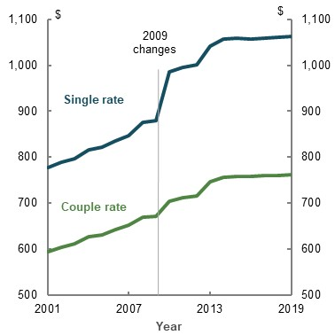 | 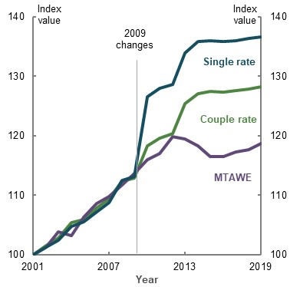
Note: Values are in 2018-19 dollars. Source: Analysis of Annual Reports 2000-2001 to 2018-19 (Department of Social Services, 2019); A guide to Australian Government payments 2015 to 2019 (Services Australia, 2019); (ABS, 2020e); (ABS, 2019d). | Note: Values indexed relative to 2000-01. Source: Analysis of Annual Reports 2000-2001 to 2018-19 (Department of Social Services, 2019); A guide to Australian Government payments 2015 to 2019 (Services Australia, 2019); (ABS, 2020e); (ABS, 2019d).
The composition of Age Pension recipients was broadly stable from June 2001 to June 2019 (Chart 4A-4). The share of part-rate age pensioners was increasing up until the Global Financial Crisis (GFC), which reduced retirees’ net worth and increased the share of retirees receiving a full-rate Age Pension. In 2017, when the assets test taper rate steepened (from $1.50 per $1,000 of assets to $3), some part-rate age pensioners moved off the Age Pension.
    - The Age Pension eligibility age population
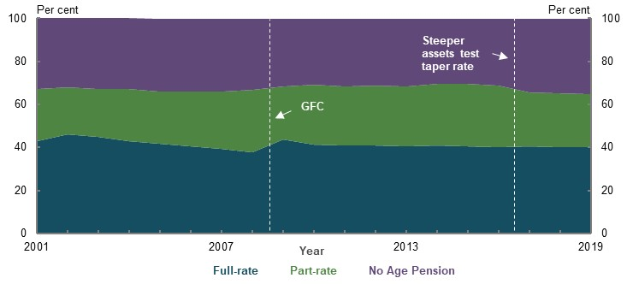
Source: Annual Reports 2000-2001 to 2018-19 (Department of Social Services, 2019).
The composition of the Age Pension population has not changed as much as superannuation balances and net worth for those over age 65. Superannuation balances (and overall net worth) for people aged over 65 have increased substantially in real terms since 2006 (Chart 4A-5). However, this growth has been from a relatively low base. The median age pensioner still has limited assets outside owner-occupied housing (see 3C. Home ownership status). The design of the means test results in people moving from full-rate Age Pensions to part-rate Age Pensions more quickly than people move off the Age Pension altogether.
    - Change in assets of people aged 65 and over compared with CPI growth
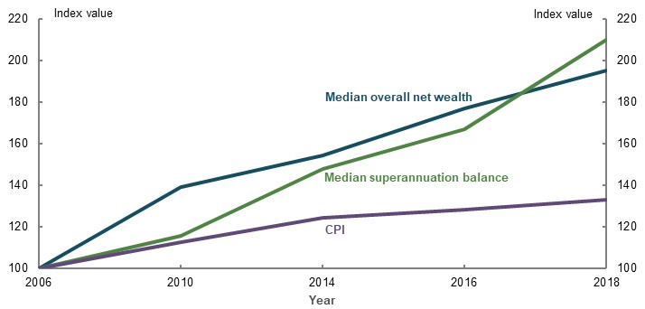
Note: Values indexed relative to 2005-06. Source: Analysis of Household Income and Wealth, 2005-06 to 2017-18 (ABS, 2019k); (ABS, 2020e).

Superannuation tax concessions
The cost of superannuation tax concessions represents forgone tax revenue for the Government, as opposed to a direct expenditure cost. The cost of tax concessions is not observed but estimated by comparing actual revenue received with what might have been collected in the absence of concessions. Constructing this counterfactual is not straightforward. Opinions differ around the appropriate tax benchmark and the potential effect of behavioural change.
This review uses a comprehensive income tax benchmark to measure the cost of superannuation tax concessions. This means tax revenue actually collected is compared with the estimated amount that would have been collected if contributions and earnings were all taxed at full marginal rates. An alternative benchmark is an expenditure tax benchmark, which taxes contributions at full marginal rates but treats earnings as tax-free. Annex — estimating superannuation tax concessions provides more detail on the tax benchmark used in this review.
Both contributions and earnings tax concessions have increased in real terms over the past 20 years (Chart 4A-6). In general, earnings tax concessions are more volatile than contributions tax concessions because earnings are closely linked to financial markets. Contributions tax concessions are linked to wage growth and employment levels. Some variation in the value of both tax concessions can be attributed to changes in the personal income tax rates and thresholds, which are the benchmark tax treatment.
    - The cost of superannuation tax concessions
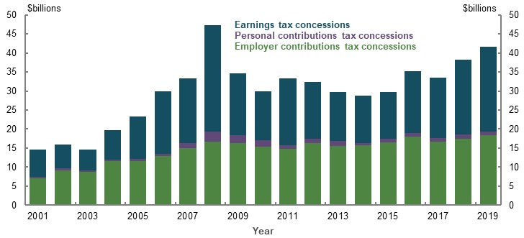
Note: Values are in 2018-19 dollars, inflated by CPI. This time series is presented to illustrate the general trend. The cost of tax concessions is estimated independently each year (i.e. there is no dynamic impact of the removal of concessions over time), and year-to-year estimates may be subject to changes in policy benchmarks, data, assumptions and methodology. Personal contributions tax concessions stem from people making contributions from post-tax income, but claiming a deduction on their tax return. Source: Tax Expenditures Statement 2004 to 2017 (The Treasury, 2018b); Tax Benchmarks and Variations Statement 2018 to 2019 (The Treasury, 2020).
Total contributions have grown faster (75 per cent from June 2004 to June 2019) in real terms than salary and wages (55 per cent), partly due to the 0.5 percentage point increase in the SG rate over 2013-15. The cost of contributions tax concessions has grown more slowly (62 per cent) than contributions, reflecting the tightening of policy settings, such as lower contributions caps and a reduced Division 293 tax threshold. Introducing the transfer balance cap, which restricts the amount that can be taken into the retirement phase where earnings are tax-free, has partly restrained growth in earnings tax concessions.
Contributions and earnings tax concessions together were estimated to cost a total of $41.55 billion in revenue forgone terms in 2018-19 (Chart 4A-6). Of this, $18.3 billion was employer contributions tax concessions (both compulsory and salary sacrifice) and $22.1 billion was earnings tax concessions. Only $1.1 billion was personal contributions tax concessions, reflecting that less than 10 per cent of personal contributions are concessional.
The cost of tax concessions peaked in 2007-08 at $46.6 billion, before declining substantially to $29.7 billion in 2009-10. They were then relatively stable in real terms until around 2015. Since then, they have grown by almost 40 per cent. The same pattern is observed as both a percentage of GDP and the Commonwealth Budget (Chart 4A-7).
Since 2000-01, the cost of superannuation tax concessions has grown faster than the Age Pension as a percentage of GDP. By 2018-19, the cost of superannuation tax concessions was only 0.25 percentage points less than the cost of the Age Pension as a percentage of GDP.
    - The cost of superannuation tax concessions
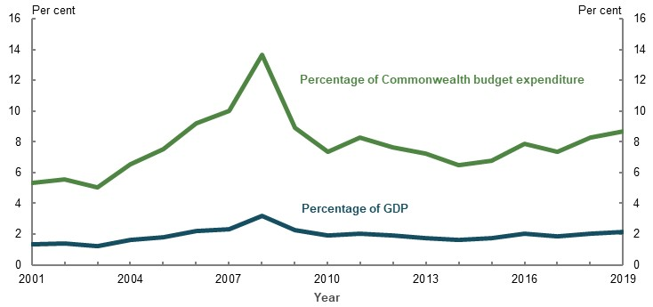
Source: Analysis of Tax Expenditures Statement 2004 to 2017 (The Treasury, 2018b), Tax Benchmarks and Variations Statement 2018 to 2019 (The Treasury, 2020), (ABS, 2019d), and data provided by The Treasury for the review.

Superannuation fees
Superannuation fees have been analysed extensively in recent years (Productivity Commission, 2018a; Minifie, et al., 2014; 2015). These studies found fees across the system have trended down as a percentage of assets in recent years but there is scope for further reductions that would improve net returns, particularly among retail funds. The Productivity Commission (2018a) noted that just 0.5 percentage points extra in fees across a working life can reduce retirement balances by 12 per cent. The projected impact of lower fees on future retirement incomes is analysed below.

Other costs of the retirement income system
A range of other costs are incurred in supporting retirement outcomes. Some of these are not large by themselves (compared to the Age Pension and superannuation tax concessions), but they are numerous and can add up to a substantial cost.
- Government superannuation co-contributions have fallen substantially in real terms, from $819 million in 2010-11 to $121 million in 2018-19. This is mostly the result of changes in 2011 that: reduced the income threshold; halved the maximum co-contribution a person could receive to $500 a year; and reduced the co-contribution rate from 100 per cent to 50 per cent of the personal contributions made (The Treasury, 2011).
- The system has several tax concessions targeted at lower-income earners, including the low income superannuation tax offset, the low income spouse contribution offset and the tax-free status of Government co-contributions. The estimated cost of these concessions is aggregated but the low income superannuation tax offset is by far the largest. The aggregate cost of all these tax concessions has been relatively stable in real terms at around $200 million a year since 2011-12.
- The seniors and pensioners tax offset reduces the tax paid for eligible seniors and pensioners. Since 2012-13, the cost of this tax concession has been relatively steady in real terms at around $800 million a year. Seniors and pensioners tax offset recipients also benefit from a higher Medicare Levy threshold, although the cost of this is not separately reported. The distribution of these benefits is covered in 3A. Income and wealth distribution.
- Since 2005, people aged over 65 have received a more generous private health insurance rebate than others. The Grattan Institute estimated the cost of this at $250 million in 2015-16 (Daley, et al., 2016, p. 34).

Social transfers in kind
Government provision of social transfers in kind improves retirement outcomes by decreasing retirees’ effective living costs (see 2A. Achieving a minimum standard of living in retirement). This may not be well understood in the community (see 5A. Cohesion). Social transfers in kind reduce or fully cover the costs people would be required to pay to access a range of essential services, such as health and aged care. Some social transfers in kind are universal and some are targeted to people and cohorts based on eligibility criteria (often based on a means assessment). Social transfers in kind are provided by all levels of government in Australia.
The most comprehensive valuation of in-kind support currently available is social transfers in kind compiled by the ABS. Social transfers in kind includes non-monetary transfers in the form of education, health, social security and welfare, housing and electricity (ABS, 2018c). The measure attributes the value of these transfers on a per household basis.
The value of social transfers in kind attributed to all households has increased in real terms, as has the share attributed to households where the reference person was aged 65 and older (Chart 4A-8). In 2003-04, almost $27 billion of social transfer in kind expenditure was attributable to households aged 65 and over compared with $55 billion in 2015-16, representing growth in real terms of 106 per cent. Social transfers in kind attributed to households aged 65 and over as a percentage of GDP has increased from 2.3 per cent in 2003-04 to 3.3 per cent in 2015-16. This is higher than the cost of the Age Pension as a percentage of GDP.
    - Social transfers in kind
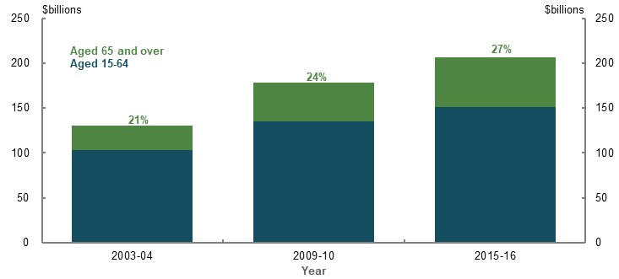
Note: Values are in 2015-16 dollars, inflated by CPI. Source: Analysis of Government Benefits, Taxes and Household Income 2003-04 to 2015-16 (ABS, 2018c).
Health and aged care comprise the largest social transfers in kind attributed to people aged 65 and over by the Commonwealth Government.

Health transfers
At the Commonwealth level, most health transfers are Medicare, the Pharmaceutical Benefits Scheme and public hospitals (Parliamentary Budget Office, 2019a). Demand for and therefore expenditure on these three health services increase as people age (Chart 4A-9).
    - Commonwealth health care costs per person
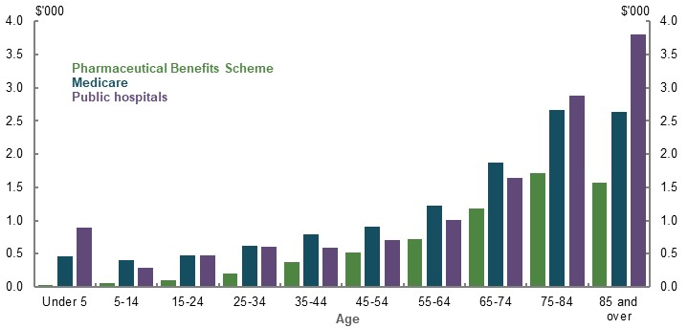
Note: 2017-18 Source: (Parliamentary Budget Office, 2019a).
Government expenditure on the Pharmaceutical Benefits Scheme for older Australians has remained relatively stable as a percentage of GDP (Chart 4A-10). People aged 65 and over account for around 50 per cent of Pharmaceutical Benefits Scheme spending, receiving more prescriptions and a greater subsidy per script (Department of Health, 2013, p. 43). Growth in the Pharmaceutical Benefits Scheme has been fairly muted over the past two decades as a result of successive reforms that reduced the price to Government of Pharmaceutical Benefits Scheme medicines (Department of Health and Ageing, 2010).
    - Commonwealth health expenditure
Pharmaceutical Benefits Scheme | Medicare
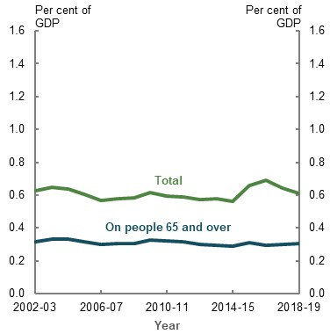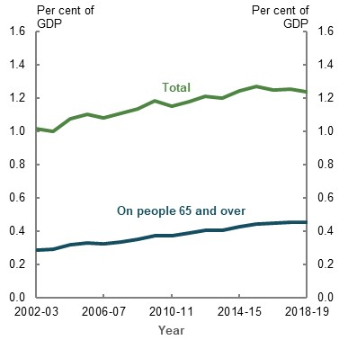
Note: The increase in total Pharmaceutical Benefits Scheme expenditure in 2015-16 and 2016-17 is due to the listing of treatments for hepatitis C on the Pharmaceutical Benefits Scheme from 1 March 2016. Source: Analysis of (Department of Health, 2019b); data provided by the Department of Health; and data provided by The Treasury for the review.
Government expenditure on Medicare has increased for Australians aged 65 and over. The share of expenditure attributed to people aged 65 and over grew from 28 per cent in 2002-03 to 37 per cent in 2018-19 (Department of Health, 2019b). Growth in Medicare spending has been suppressed since 2013, when the indexation of various listings to the Medicare Benefits Schedule was paused. Indexation recommenced in 2019.
Research suggests health costs are primarily driven by technological improvements, such as developing new treatments, rather than the ageing population (Parliamentary Budget Office, 2019a). Higher national incomes are also associated with increased health spending (Parliamentary Budget Office, 2019a). Wealthier countries show a preference for more or higher-quality health care. The extent to which these factors drive Commonwealth health spending partially depends on Government policy, such as decisions to add new listings to the Pharmaceutical Benefits Scheme or Medicare.

Aged care
Aged care is the largest social transfer in kind attributed to older Australians, at a cost of $20.1 billion in 2018-19, and a projected cost of $25.4 billion by 2022-23 (Productivity Commission, 2020b, p. 14.3; Aged Care Financing Authority, 2019). Government expenditure has increased by an average of 4.7 per cent a year since 2012-13 (Chart 4A-11). Aged care expenditure has increased as a percentage of GDP from 0.8 per cent in 2009-10 to 1.1 per cent in 2018-19.
    - Government expenditure on aged care services
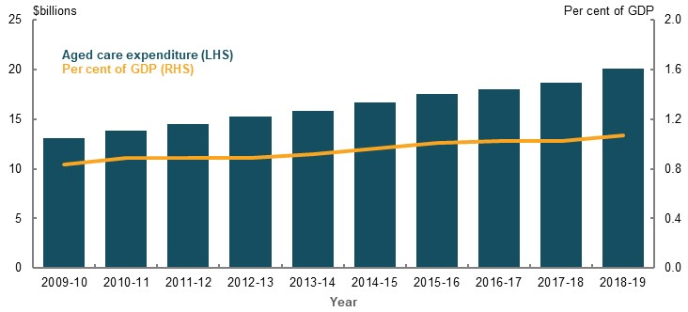
Note: Values are in 2018-19 dollars, inflated by CPI. Source: Analysis of (Productivity Commission, 2020b) and data provided by The Treasury for the review.
Most of the cost associated with aged care comes from residential care, which accounted for around 65 per cent of total expenditure in 2018-19 (Department of Health, 2019a). Most home care consumers and a large proportion of residential aged care consumers are full-rate Age Pension recipients (Tune, 2017), which reduces the amount they are required to contribute to the cost of their care (Box 4A-3), (see Box 5A-6 in 5A. Cohesion for more information about aged care means testing).
          - Aged care and the retirement income system
The aged care system is not part of the retirement income system, but the two systems interact. Aged care basic daily fees are determined by the rate of Age Pension (set at 17.5 per cent of the single rate of the Age Pension for home care and 85 per cent for residential care).
Many people find it challenging to estimate and plan for the cost of their aged care (Aged Care Financing Authority, 2018). The actual costs can vary significantly depending on the type of and length of time spent in care. People also find it difficult to estimate their likelihood of requiring care or how means testing may apply to them.
As outlined in Appendix 6A. Detailed modelling methods and assumptions, health and aged care costs do not significantly increase during retirement. Consumer costs of aged care are relatively low overall under current funding arrangements. Fees for home care and residential care are means tested. The majority of people pay only a small fraction of the total cost of the care they receive (see Box 5A-6 in 5A. Cohesion for full details of aged care means testing).
For people who pay the basic daily fee for home care (83 per cent in 2018-19), the average fee is $73 per week or $3,813 per year. Fewer than half of home care providers charge the maximum allowable daily fee. Only 11 per cent of home care consumers pay income-tested care fees, averaging an additional $70 per week or $3,675 per year. The Government contributes between 72 per cent and 93 per cent of the cost of a home care package, depending on the level of care the person needs. In total, the Government covers more than 90 per cent of the cost of all home care provided.
At age 65, the lifetime risk of admission to residential care is 39 per cent for men and 53 per cent for women. Lifetime risk is generally increasing because more people are surviving to an age (beyond 80) where they may need high-level care. Since peaking around 2011-13 (at 40 per cent for men and 55 per cent for women), lifetime risk has declined slightly. This is likely due to the increased preference for and availability of home care, rather than a reduction in overall care needs.
More than one-third of people exit residential care within 12 months, but the average length of stay is around three years (Aged Care Financing Authority, 2019).
All residential aged care consumers pay the basic daily fee set at 85 per cent of the single rate of Age Pension ($19,071.25 per year at 1 May 2020). Around half of residents pay some or all of their accommodation costs (Aged Care Financing Authority, 2019). One-third of residents also pay means-tested care fees. In 2018-19, the average weekly means-tested fee was $173 (around $9,000 per year). Overall, the Government covers up to 81 per cent of the costs of care in a residential setting, depending on the level of care needed.
      - Residential aged care subsidies and supplements
Level of assistance needed | Category or area of assistance
Level of assistance needed | Activities of daily living ($) | Behaviour ($) | Complex health care ($)
Nil | Nil | Nil | Nil
Low | 13,753.20 | 3,142.65 | 6,099.15
Medium | 29,948.25 | 6,515.25 | 17,377.65
High | 41,489.55 | 13,581.65 | 25,090.10
Note: Daily Aged Care Funding Instrument subsidy rates as at 1 May 2020. These figures have been annualised and do not include temporary additional daily amounts. Consumer assistance needs are assessed against each category, with the total Government contribution calculated accordingly. For example, the Government contribution for a consumer needing high-level assistance with activities of daily living and behaviour, but without complex health care needs, would be $55,071.20 ($41,489.55 + $13,581.65 + $0). Source: (Department of Health, 2020b).

Concession cards
Concession cards provide the basis for other forms of social transfers in kind governments provide. Concession cards are not directly linked to the retirement income system but serve a broader purpose of subsidising the living costs of lower-income earners.
Most Australians of Age Pension eligibility age (81 per cent) are eligible for a concession card, either as supplementary assistance to the Age Pension or by meeting an income test. The three types of card (Pensioner Concession Card, Commonwealth Seniors Health Card and Health Care Card) all provide similar benefits at the federal level. State and territory and local governments provide most concessions to Pensioner Concession Card and Health Care Card holders. This is because the cards are directly linked to social security payments and holders have to meet more stringent means test requirements.
Estimating the value of social transfers in kind from concession cards at a state and territory level is challenging as each government independently determines the types of concessions offered, who can access them and how benefits are reported. As a result, the concessions vary by state and territory. For example, Victoria offers a 50 per cent reduction on council rates while Tasmania offers 30 per cent (Victorian Government, 2020; Tasmanian Government, 2017). Given these differences, historical and future costs of social transfers in kind to concession-card holders have not been estimated or projected.

Projected future costs
The total projected cost of Age Pension expenditure and superannuation tax concessions together is estimated to grow from 4.6 per cent of GDP today to 5 per cent by 2060. With Age Pension expenditure falling and contributions tax expenditure stable as a percentage of GDP, the overall increase is projected to be due to growth in earnings tax concessions (Chart 4A-12). By 2047, the cost of superannuation tax concessions is projected to be greater than the cost of the Age Pension as a percentage of GDP.
    - Total projected system cost
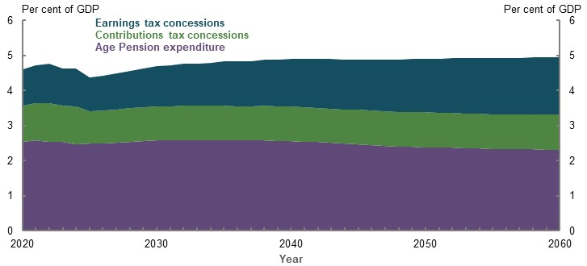
Note: Includes service pensioners. The tax concessions time series is presented to illustrate the general trend. The cost of tax concessions is estimated independently each year (i.e. there is no dynamic impact of the removal of concessions over time). Earnings tax concessions includes the concessional taxation of superannuation earnings and capital gains tax discount for superannuation funds (broadly C1 and C4 in the Tax Benchmarks and Variations Statement). Contributions tax concessions includes the concessional taxation of employer and personal contributions (broadly C2 and C3 in the Tax Benchmarks and Variations Statement). Projections in MARIA broadly follow the methodology of the Tax Benchmarks and Variations Statement but have been calculated on an additive basis. The value of superannuation tax concessions is estimated by adding contributions and earnings to taxable income in two stages and applying the progressive income tax rates at each stage. The value of the earnings tax concession is the difference between the total value of concessions and value of contributions tax concessions. Personal income tax thresholds are also indexed for movements in wages beyond the medium-term period. Source: Treasury estimates for the review using MARIA.
The projections in this chapter are long term and do not take into account the potential short-term effects of the COVID-19 Pandemic. Box 4A-4 offers an illustration of how a large, but short-term, shock to superannuation might impact the retirement income system in the long term using Treasury’s MARIA.
          - The long-run impact of a large short-term shock to the retirement income system
The models used in this review to understand long-term trends in the retirement income system are based on historical data and the economic outlook for Australia at the time of the 2019-20 Mid-Year Economic and Fiscal Outlook.
The review examined the impact of a large short-term shock to superannuation assets. The shock is not projecting the impact of the COVID-19 Pandemic, which remains uncertain, but provides a stylised path of a short-run shock on the system over the long term. The shock includes a:
- 20 per cent reduction in superannuation balances in 2020
- 50 per cent reduction in superannuation fund earnings in 2020 and 2021
- 90 per cent reduction in voluntary pre- and post-tax contributions to superannuation in 2020
Broadly, the scenario sees superannuation funds under management fall sharply, eventually leading to higher Age Pension expenditure as a percentage of GDP than the baseline (Chart 4A-13). By 2036, the gap in projected Age Pension expenditure is highest, at under 0.2 per cent of GDP. As superannuation assets converge back to the baseline path, the gap in Age Pension expenditure falls.
    - Shock analysis projections
Superannuation assets under management | Age Pension expenditure
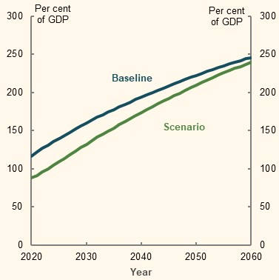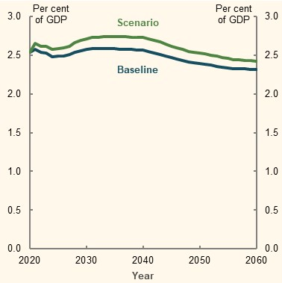
Source: Treasury estimates for the review using MARIA.

Age Pension
Age Pension expenditure as a percentage of GDP is expected to fall moderately over the next 40 years, from 2.5 per cent today to 2.3 per cent in 2060 (Chart 4A-14). This is despite the population over Age Pension eligibility age being expected to grow faster than the working-age population, leading to fewer working-age people for each person of Age Pension eligibility age.
    - Age Pension projections
Age Pension expenditure | Working-age persons to persons of Age Pension eligibility age
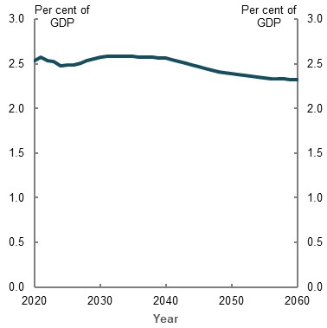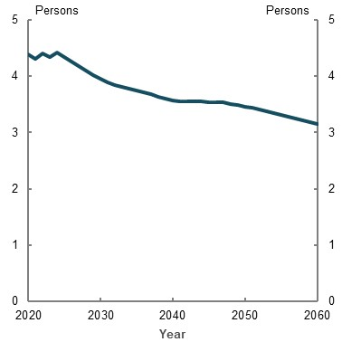
Note: Includes service pensioners. The volatility in the early years of the projection is mostly due to the legislated future increases to the Age Pension eligibility age. ‘Working-age’ refers to all persons aged 15 and over but under the Age Pension eligibility age. Source: Treasury estimates for the review using MARIA; population projections provided by the Centre for Population, The Treasury as at December 2019.
The fall in the cost of the Age Pension as a percentage of GDP is primarily driven by the maturing of the superannuation system and the effect of means testing. The share of the Age Pension age population receiving a pension (Age Pension, service, carer and disability pensions) is projected to fall from 73.5 per cent in 2020 to 62 per cent in 2060 (Chart 4A-15). Within this, the combination of the maturing superannuation system and the design of the means tests leads to a projected shift towards part-rate age pensioners: from an estimated 37.6 per cent of age pensioners today, to 62.5 per cent of age pensioners in 2060.
    - Projected Age Pension eligibility age population
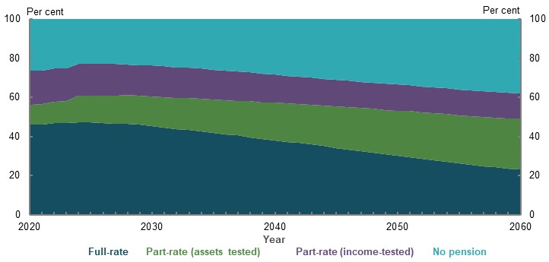
Note: Includes service, carer and disability pensioners. Source: Treasury estimates for the review using MARIA.
In future, increasing numbers of part-rate age pensioners are projected to have their payment determined by the assets test rather than the income test. In 2020, an estimated 37.3 per cent of part-rate age pensioners were asset tested. By 2060, this is projected to rise to 66.7 per cent.
These changes will be supported by growth in superannuation balances. Over the next 40 years, the average superannuation balance for a single person is projected to grow at a compound annual average real rate of 3.8 per cent a year. This outstrips projected growth in the singles means-test free areas (which increase in line with the CPI) and cut-offs (that increase faster than CPI because of growth in the maximum rate of the Age Pension) (Chart 4A-16).
    - Projected assets and Age Pension means test thresholds, single retirees
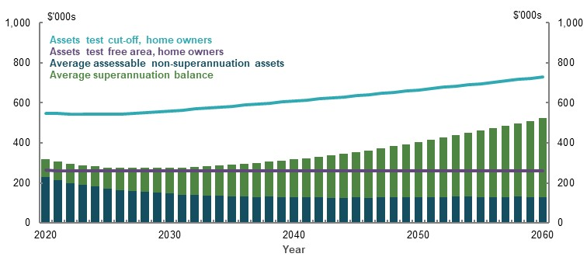
Note: Values are in 2019-20 dollars, deflated by the CPI. The single, home owner assets test parameters are chosen for illustrative purposes. Similar trends would be evident using other configurations (e.g. couple, non-home owner income test). ‘Assessable’ non-superannuation assets refers to non-superannuation assets that are assessable in the Age Pension assets test. Source: Treasury estimates for the review using MARIA.
Means testing and higher superannuation balances play an important role in reducing reliance on, and therefore the cost of, the Age Pension. If the composition of Age Pension recipients in 2060 remained the same as in 2020 (46 per cent full-rate age pensioners and 28 per cent part-rate age pensioners), Age Pension spending would be projected to be 3.6 per cent of GDP in 2060, instead of 2.3 per cent.

Superannuation tax concessions
As the superannuation system grows, the cost of contributions tax concessions as a percentage of GDP is projected to remain stable, while earnings tax concessions as a percentage of GDP are projected to grow (Chart 4A-17).
Broadly, the future cost of contributions tax concessions is a function of wage growth, contributions rates and population growth. Concessional contributions caps and the additional contributions tax paid by the top 1.8 per cent of people in employment (in the form of Division 293 tax), help to contain contributions tax concessions.
The cost of earnings tax concessions is a function of the growth in the size of the superannuation system and the projected rate of return. Both of these inputs exceed projected GDP growth. Therefore, earnings tax concessions are projected to grow as a percentage of GDP. In particular, the cost of the earnings tax exemption in the retirement phase is likely to grow as the superannuation system matures.
    - Projected cost of superannuation tax concessions
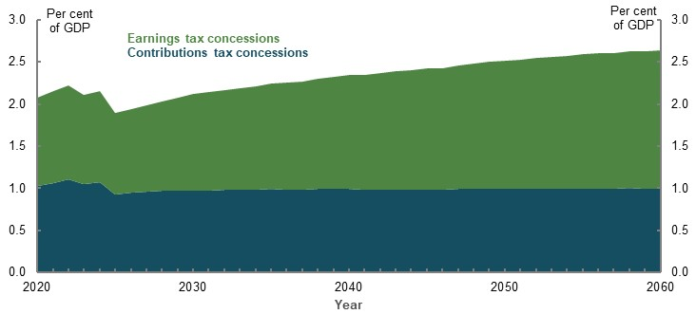
Note: The tax concessions time series is presented to illustrate the general trend. The cost of tax concessions is estimated independently each year (i.e. there is no dynamic impact of the removal of concessions over time). Earnings tax concessions includes the concessional taxation of superannuation earnings and capital gains tax discount for superannuation funds (broadly C1 and C4 in the Tax Benchmarks and Variations Statement). Contributions tax concessions includes the concessional taxation of employer and personal contributions (broadly C2 and C3 in the Tax Benchmarks and Variations Statement). Projections in MARIA broadly follow the methodology of the Tax Benchmarks and Variations Statement but have been calculated on an additive basis. The value of superannuation tax concessions is estimated by adding contributions and earnings to taxable income in two stages and applying the progressive income tax rates at each stage. The value of the earnings tax concession is the difference between the total value of concessions and value of contributions tax concessions. Personal income tax thresholds are also indexed for movements in wages beyond the medium-term period. Source: Treasury estimates for the review using MARIA.

Superannuation fees
Accurately projecting trends in superannuation fees is challenging. On balance, future decreases in fees as a per cent of assets are likely as the industry consolidates and the regulatory environment shifts. Anticipating this outcome, industry projections from Rice Warner suggest fees could fall by as much as 0.3 per cent of assets over the coming decade (Chart 4A-18). Such a fall would represent an acceleration relative to historical trends. The Productivity Commission (2018a) found that, over the decade to 2017, fees as a share of assets fell by only around 0.2 per cent of assets.
The Productivity Commission (2018a) also noted that current fee levels are unnecessarily high and that there is scope for further reductions without compromising members’ outcomes. If fee levels do not fall, total fee revenue as a percentage of GDP is projected to double to be around 2 per cent by 2060.
    - Projected superannuation fees
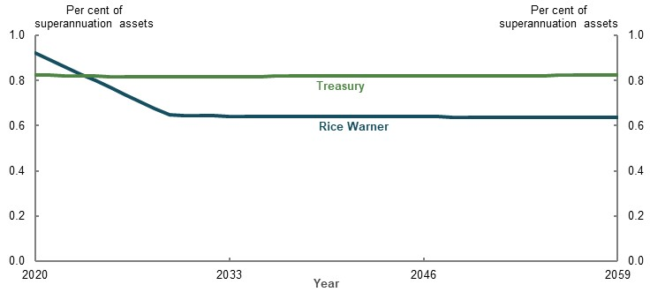
Note: Values are in 2019-20 dollars, deflated using CPI. Source: Treasury estimates for the review using MARIA; Analysis of Rice Warner estimates for the review.

Social transfers in kind
Projections of social transfers in kind have not been undertaken. However, medium-term projections of health and aged care costs under current policy settings are regularly prepared by the Parliamentary Budget Office (PBO). The latest PBO expenditure projections from 2018-19 to 2029-30 indicate that: Pharmaceutical Benefits Scheme expenditure will decline by 0.2 per cent as a proportion of GDP; and Medicare and aged care spending will increase by 0.1 per cent and 0.2 per cent of GDP, respectively.
Aged care expenditure is particularly at risk of increasing faster than GDP as it is more sensitive to the impact of ageing than health care. Over the decade to June 2029, population ageing is projected to increase annual average growth in aged care spending by around 1.8 percentage points, compared with 0.5 percentage points for health (Chart 4A-19).
The effect of ageing on aged care expenditure is projected to peak as the baby boomer generation reach their 80s, from 2030 (Parliamentary Budget Office, 2019a, p. 15).
    - Projected average annual real growth in aged care spending
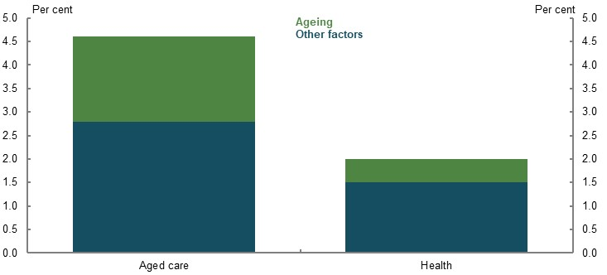
Note: Medium-term projections for the period June 2019 to June 2029. Source: (Parliamentary Budget Office, 2019a).
Stakeholders expressed concerns about the sustainability of the aged care system. This concern is raised directly in the recent Legislated Review of Aged Care 2017 (the Tune Review) stating:
‘Currently, the government provides around three-quarters of all aged care funding, with consumers meeting less than a quarter of the cost. This is likely to be unsustainable into the future and there is a strong case to increase the proportion of the costs that are met by consumers.’ (Tune, 2017, p. 8)
The Aged Care Funding Authority (ACFA) (2019) has also identified some challenges with the sustainability of the aged care system from a funding perspective, including the need for equitable contributions to costs by consumers.
The shift in consumer preferences from residential care to home care, which costs the Government less than residential care, is expected to help improve the affordability of the aged care system for taxpayers (Parliamentary Budget Office, 2019a, p. 16; Aged Care Financing Authority, 2019). The Royal Commission into Aged Care Quality and Safety is currently considering aged care costs. The final report of the Royal Commission is due to be released on 12 November 2020.

Cost-effectiveness
The cost-effectiveness of the retirement income system is best assessed by the efficiency with which Government support produces adequate retirement outcomes. The Age Pension and superannuation tax concessions make up most of the monetary support in the retirement income system. Age Pension support is based on a person’s means in retirement. Superannuation tax concessions increase with income, contributions during working life and investment earnings.
The Age Pension delivers or supports adequate retirement incomes for the bottom two-thirds to three-quarters of income distribution (see 2C. Maintaining standards of living in retirement).
Superannuation tax concessions contribute to adequate replacement rates for the top 50 per cent of households in terms of the income distribution (Chart 4A-20). However, superannuation tax concessions have the most significant impact on the retirement incomes of the top 10 per cent of the income distribution, as earnings tax concessions grow strongly. As noted in Appendix 6A. Detailed modelling methods and assumptions, stakeholders agree that higher-income earners can maintain their standard of living with lower replacement rates.
    - Projected composition of average annual retirement incomes
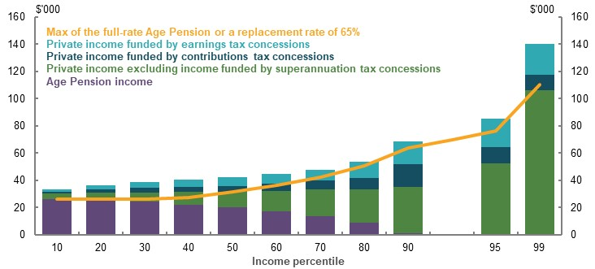
Note: Incomes are deflated in line with the review’s mixed deflator. See Appendix 6A. Detailed modelling methods and assumptions. Private income includes superannuation and non-superannuation savings. The ‘private income funded by tax concessions’ components are estimated by projecting retirement incomes with contributions and earnings taxed at marginal rates separately. Source: Cameo modelling undertaken for the review.
People with higher retirement incomes receive the most tax concessions over a lifetime (Chart 4A-21). Controls on contributions tax concessions result in lifetime support flattening as retirement incomes increase. Earnings tax concessions continue to increase as average retirement incomes increase, particularly from the 70th to 95th percentiles. These projections do not include post-tax voluntary contributions. If included, they would further increase the lifetime earnings tax concessions support provided to the upper percentiles, as they are most likely to make post-tax voluntary contributions (see 3A. Income and wealth distribution).
    - Projected average annual retirement incomes and lifetime Government support
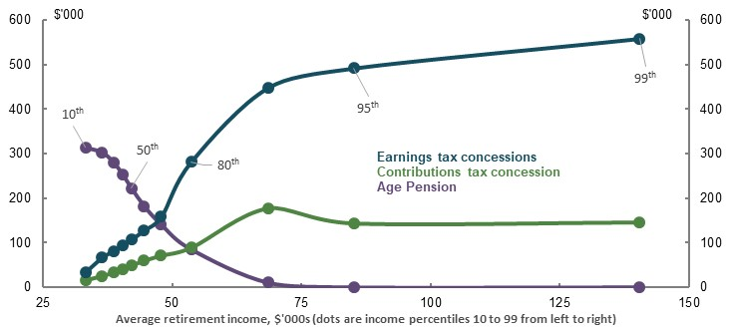
Note: Y-axis values (lifetime Government support) are deflated to 2019-20 dollars using with the review’s GDP deflator. X-axis values (average retirement incomes) are deflated using the review’s mixed deflator. See Appendix 6A. Detailed modelling methods and assumptions. Source: Cameo modelling undertaken for the review.
Aside from providing adequate retirement incomes, three other rationales for tax concessions have been proposed:
- As an incentive for additional savings. As outlined in 5A. Cohesion, the evidence suggests tax concessions are of limited effectiveness in increasing people’s overall savings. Instead, they appear to encourage people to reallocate existing savings, or savings they would have made in any case, into superannuation.
- As compensation for preservation. Tax concessions are poorly targeted as compensation for preservation. Contributions tax concessions are received disproportionately by people with higher balances, who are either close to or above the preservation age, rather than those furthest away (Chart 4A-22). These people typically make large voluntary contributions. Total superannuation contributions increase with income and age up until retirement, with the size of increases jumping most noticeably after age 50 (see 3A. Income and wealth distribution).
The result is that contributions tax concessions are accessed most by older people with higher balances as they approach retirement. From 2012-13 to 2016-17, a typical 55-year-old (59 in 2016-17) with a balance in the top decile, received more than $20,000 in contribution concessions in real terms (with more than half coming from voluntary contributions). By 2016-17, this individual’s balance was around $1.1 million.
- To reduce Age Pension spending. The cost of tax concession support over a lifetime is projected to outweigh the associated Age Pension savings (Chart 4A-23). This is true for either of the contributions and earnings tax concessions alone, and both together. This result does not alter even assuming salary sacrifice contributions are redirected to consumption in the absence of tax concessions.
    - Cumulative superannuation contribution concessions over five years, averages by age and superannuation balance decile
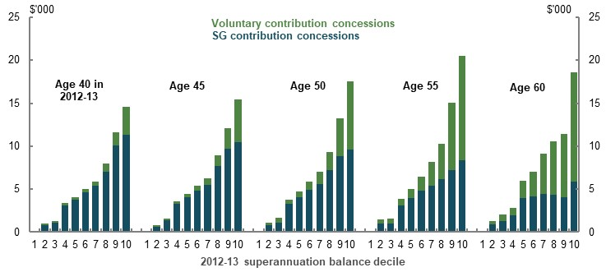
Note: Values are the average cumulative concessions for the period 2012-13 to 2016-17 and are presented in 2016-17 dollars, inflated by CPI. The review estimates concessions as the estimated increase in tax if contributions were all made from post-tax income. Cumulative refers to the total concessions received across the five years under observation. Tax settings in both scenarios are tailored to the year under observation. Data are from before the 2016-17 reforms; however, the highest average annual concessional contribution for a cohort observed in the data is below the revised $25,000 cap. The changes to the contributions caps are unlikely to have affected the trends in voluntary contributions. Source: Longitudinal data provided by the ATO for the review.
    - The interaction of tax concessions and Age Pension spending over a lifetime
 | Contributions  concessions only | Earnings  concessions only | Combined
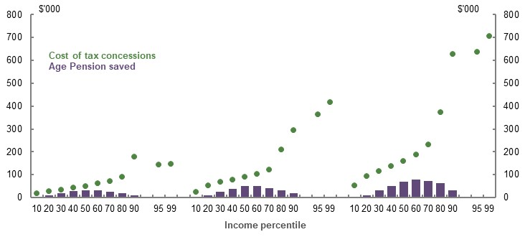
Note: Values are in 2019-20 dollars, deflated using the review’s GDP deflator. See Appendix 6A. Detailed modelling methods and assumptions. Source: Cameo modelling undertaken for the review.

Potential effects of changing trends
The system’s sustainability is affected by changes in trends. Three scenarios were modelled against the baseline to estimate the effect on Government expenditure, the Age Pension population and individual retirement outcomes:
- Lower earnings. A 1 percentage point reduction in investment returns across all asset classes.
- Lower wages. A 1 percentage point reduction in nominal wages growth.
- Lower fees. A faster (than that modelled above) reduction in annual superannuation fees charged.
These scenarios are partial and do not account for flow-on effects that would likely occur in the wider economy. For example, lower returns are likely to be accompanied by lower GDP growth.
Broader macroeconomic relationships have not been modelled. The results presented are designed to provide insight into the first-order effects of alternative assumptions.
More detail and results from these scenarios can be found in Annex — scenario analysis.

Lower earnings
The lower earnings scenario assumes superannuation earnings are one percentage point lower across all asset classes than assumed in the baseline.
Lower earnings are projected to lead to lower superannuation balances and therefore higher Age Pension expenditure. While higher Age Pension payments partially offset the impact of lower superannuation balances for lower and median percentiles, average retirement incomes fall across the population (Chart 4A-24).
    - Projected effect of lower earnings
Age Pension spending | Change in average retirement incomes  (selected percentiles)
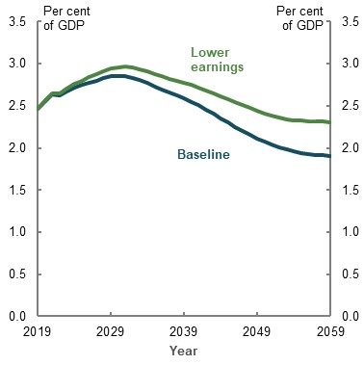 | 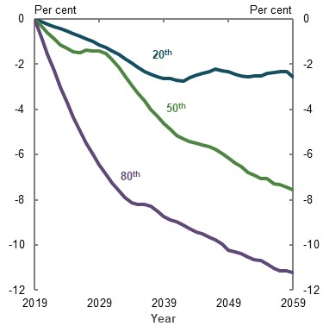
Source: Analysis of Rice Warner estimates for the review.

Lower wages growth
This scenario assesses the impact of wages growing at 2.5 per cent, instead of the baseline assumption of 3.5 per cent.
As with lower earnings, lower wages are projected to lead to lower superannuation balances, higher Age Pension expenditure and lower retirement incomes (Chart 4A-25). However, the impact of lower wages is more gradual than that of lower earnings, as lower wages lead to lower contributions, which take time to feed through to retirement outcomes.
    - Projected effect of lower wages
Age Pension spending | Change in average retirement incomes  (selected percentiles)
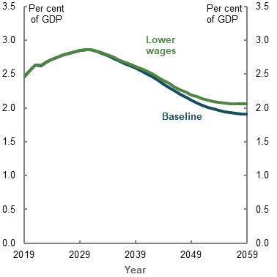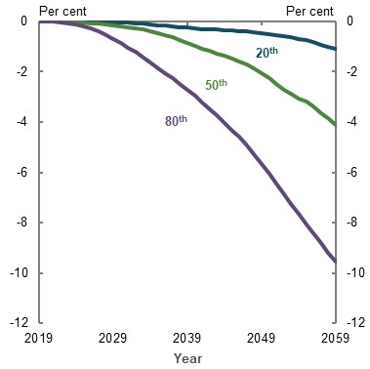
Source: Analysis of Rice Warner estimates for the review.
In this scenario, the growth in Age Pension expenditure is partially offset by the fact the lower wages assumption also affects the Age Pension indexation. With lower wages growth, growth in the maximum payment rate of Age Pension is also subdued.
More broadly, lower wages do not materially impact replacement rates, given lower wages decrease living standards across both working life and retirement.

Lower fees
This scenario considers a situation where both fixed and percentage of asset-based fees are reduced to the lowest fees of a particular sector (industry, retail and corporate), reflecting faster than expected consolidation and stronger competition within each sector. In aggregate, this leads to fees reducing to 0.53 per cent of system assets by 2059, rather than 0.64 per cent in the baseline.
Lower fees are projected to slightly reduce Age Pension expenditure as a percentage of GDP and improve retirement incomes across the population (Chart 4A-26). The effect of lower fees on overall retirement incomes is smaller than the effect on balances at retirement (the latter detailed by the Productivity Commission (2018a)). This is because the latter does not account for the offsetting impact of the Age Pension.
    - Projected effect of lower fees
Age Pension spending | Change in average retirement incomes  (selected percentiles)
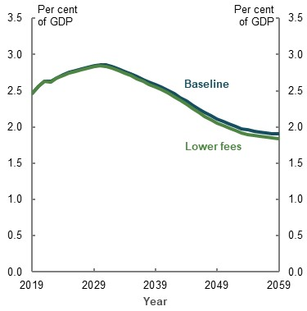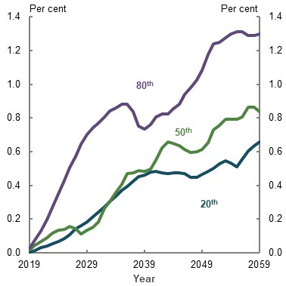
Source: Analysis of Rice Warner estimates for the review.

Public confidence
The public has to have confidence in the retirement income system for it to be sustainable. Public confidence is shaped by people’s beliefs about whether the system will both deliver an adequate retirement income for them and generate adequate outcomes across society.
Public confidence can be undermined by poor system integrity or by people experiencing, expecting or perceiving poor outcomes or uncertainty in policy settings. A lack of public confidence that policy settings are delivering on expectations could lead to public demands for reform.

System integrity
Concerns about the integrity of the retirement income system can undermine public confidence. Integrity and governance failures identified over the past decade include ‘fees for no service’, misconduct by superannuation trustees and non-payment of superannuation by employers. Concerns have led to numerous inquiries and investigations, including the Royal Commission into Misconduct in the Banking, Superannuation and Financial Service Industries (Hayne Royal Commission).
The Hayne Royal Commission report (2019) and the Productivity Commission report (2018a) also questioned the effectiveness of regulators in protecting superannuation members from harm. The Productivity Commission found a lack of transparency around fees and performance.
The period of the Hayne Royal Commission hearings was associated with large flows of funds from retail superannuation funds to industry superannuation funds (Rice Warner, 2018). For example, $10.9 billion was transferred from retail funds in 2018, up from $3.5 billion in 2017 (Australian Prudential Regulation Authority, 2019b). This suggests the misconduct aired during the hearings undermined confidence in at least part of the superannuation sector. That said, overall, most people still trust superannuation. One survey found around 60 per cent of members trust their superannuation fund to act in their best interests (Qantas Super, 2019). Another survey found most people still consider superannuation to be a stable investment for their retirement (53 per cent agreed, 17 per cent disagreed) (BETA, Forthcoming).
Stakeholders noted low public confidence in financial advisers is affecting the retirement income system. A recent ASIC report found 49 per cent of survey respondents had little or no trust in financial advisers and that this was a barrier in seeking advice (ASIC, 2019b).
As discussed in 5A. Cohesion, the financial advice industry is undergoing a period of transition. New professional standards are likely to improve the quality of financial advice and, ultimately, consumer trust in that advice. Survey results suggest consumers are aware of some of the reforms to financial advice (ASIC, 2019b, p. 35).
More broadly, the Government’s response to the Hayne Royal Commission 2019 aims to enhance trust in superannuation funds. The recommendations of the Productivity Commission (2018a) aim to improve the efficiency of the system and align the incentives of participants. Successful reforms may reduce the risk of future misconduct and scandals affecting public confidence in the system.

Economic shocks
The retirement income system is exposed to financial markets through superannuation investments. Although superannuation is a long-term investment, economic shocks can still undermine public confidence and affect people’s retirement outcomes (see 2C. Maintaining standards of living in retirement), particularly for those close to or in retirement.
The GFC provides a case study of how an economic shock can affect confidence. For many people, the GFC was the first time they experienced a significant fall in their superannuation balance, having grown accustomed to balances only increasing. Many did not realise their superannuation was invested in financial markets (Colmar Brunton Social Research, 2010). Many who had planned to retire around this time may have delayed their retirement plans (Kendig, et al., 2013).
Initial behavioural responses to the GFC were relatively small and short term. Few superannuation members switched their investments to reduce exposure to market volatility during and directly after the GFC (ASFA, 2010, p. 4; Gerrans, 2012). While some people paused and stopped making voluntary contributions to superannuation as a result of the GFC (Colmar Brunton Social Research, 2010, p. 110), aggregate voluntary contributions continued to generally trend up afterwards.
Since the GFC, research has shown some pre-retirees are more wary and distrustful of superannuation because it exposes them to market volatility (Souvlis, et al., 2016, p. 28). 2C. Maintaining standards of living in retirement provides more detail on the effect of market volatility and sequencing risk on retirement incomes. A BETA (Forthcoming) survey, undertaken as the effects of the COVID-19 Pandemic were beginning to emerge, found two-thirds of respondents were concerned about how financial markets will affect their superannuation. Survey responses may change as the effect of the COVID-19 Pandemic develops. Retirees generally have greater retirement worries about financial markets falling than those not yet retired.
Research undertaken after the GFC found people see property as an alternative, ‘safe’ investment compared with superannuation (Colmar Brunton Social Research, 2010; Melbourne Business School, 2019). It is not clear whether the GFC influenced these views. Surveys have also found retirees exposed to the GFC say they were more concerned about a future market collapse and were more conservative with their retirement income strategies (National Seniors and Challenger, 2018).
Superannuation members who switched to a more conservative investment strategy during the GFC were generally older and held higher balances, and were more likely to be women (Gerrans, 2012). SMSF members, who tend to be older, were more likely to switch to more conservative investment strategies and therefore crystallise losses, than members in default funds (Colmar Brunton Social Research, 2010, p. 9). This switching is likely to have been detrimental. Subsequent research found members who moved from balanced investment strategies to conservative investment strategies were more likely to have lower balances than those who remained in balanced investment strategies 10 years later (SuperRatings, 2018). One fund found most people who switched to more conservative investment strategies during the GFC did not switch back (First State Super, 2019).
In response to the GFC, the Government lowered superannuation minimum drawdown rates and Age Pension deeming rates, which allowed retirees to avoid using their capital and, for those on an income-tested part-rate Age Pension, increased their public income. Similar measures were undertaken in response to the COVID-19 Pandemic. By demonstrating the Government was responsive to retirees’ concerns, these measures may have improved retirees’ confidence that the system would continue to provide income into the future. However, such measures likely discouraged current consumption of retirement assets at a time when retirees could have benefited from this consumption (see 5A. Cohesion). It may take some time to assess the effect of the Government response during the COVID-19 Pandemic on public confidence in the retirement income system.
          - The COVID-19 Pandemic and public confidence
The full effect of the COVID-19 Pandemic on public confidence in the retirement income system remains to be seen. Many superannuation funds have reported spikes in member engagement, including members switching to more conservative investment strategies (Sunsuper, 2020; First State Super, 2020a). Reports note members switching around 1.5 per cent of funds held under management into more conservative investments, such as cash, since the beginning of the market volatility related to the pandemic (Chong, 2020; Mather, 2020). Some funds have noted members who have not received financial advice are more likely to switch to more conservative investment strategies. As discussed in 2C. Maintaining standards of living in retirement, forthcoming research by First State Super indicates that rates of investment switching in response to the COVID-19 Pandemic were more than four times higher among largely unadvised First State Super retirees, compared with retirees advised through the StatePlus financial planning practice. The role of advice and guidance in improving retirement outcomes is expanded in 5A. Cohesion.
In response, funds have increased their levels of member engagement, reminding members that:
- Superannuation is a long-term investment
- It is not a good time to switch to cash investments
- It is difficult to successfully time a switch to cash and a switch back to riskier investments
Funds note that people should seek advice before changing their investment strategies.

Policy changes
Elements of the retirement income system have been reviewed extensively over the past decade by the:
- 2009 Harmer Review
- 2009 Cooper Review
- 2010 Henry Review
- 2014 Financial System Inquiry
- 2016-17 Superannuation Budget Reform Package started by the 2016 Tax White Paper
- 2018 Productivity Commission Inquiry Report: Superannuation: Assessing Efficiency and Competitiveness
All of these reports recommended, and many resulted in, significant policy reforms.
Many submissions noted, and consumer surveys have consistently found, people are concerned that retirement income policy changes too much (BETA, Forthcoming). In one survey: 28 per cent of people over the age of 40 who were not retired were worried about changes to the Age Pension; and 26 per cent were worried about changes to superannuation rules. Some previous Government reviews have also raised the concern that frequent changes to policy and inconsistent policies undermine public confidence in the system (Financial System Inquiry, 2014; Super System Review, 2010).
Older people are particularly concerned about policy changes as they have less time to respond before their retirement (Souvlis, et al., 2016; Melbourne Business School, 2019), especially if changes are not grandfathered. Among those who have already retired, surveys show concern about changes to the Age Pension has increased over the past five years. Concern about changes to superannuation has slightly decreased.
Policy reform can undermine public confidence even when it improves outcomes. For example, a CHOICE consumer focus group found people were anxious about the 2016-17 Budget Superannuation Reform Package (Super Consumers Australia, 2020, p. 5). This was despite the package aiming to improve sustainability and confidence in the system by reducing the extent to which superannuation could be used for non-retirement income purposes (The Treasury, 2016a). Treasury modelling indicated the combination of measures in the package would adversely affect only 4 per cent of superannuation fund members, while benefiting more than 20 per cent (The Treasury, 2016a).
People can lose confidence in the system because they misunderstand how reforms will affect them. People are more sensitive to losses than gains (Kahneman & Tversky, 1979). Those adversely affected by policy changes may be more vocal than those who benefit from changes. People who have benefited from policy reform may not be aware they were beneficiaries, partly due to the complexity of the system. For example, the 2016-17 Budget Superannuation Reform Package contained more than 11 measures that affected different cohorts of people in different ways but people may not have understood the changes. People may be more confident if there is better or more targeted communication about the effects of policy reform.
Stakeholders noted the industry may be contributing to community concerns around reforms by attributing new fees or increases in existing fees to Government reforms when they disclose the fees to consumers (Super Consumers Australia, 2020, pp. 23-24). While policy changes can undermine public confidence, a lack of change can inhibit effective and practical reform.

Uncertainty over the future of the Age Pension
Many people are uncertain about the future of the Age Pension. Surveys suggest that less than half of all respondents (48 per cent) and only 37 per cent of people aged under 55 agreed the Age Pension will exist when they reach retirement (BETA, Forthcoming). The same survey found only 39 per cent of people agreed the Age Pension will maintain a similar value when they reach retirement. For those aged under 55, this number was 28 per cent.
One focus group found consensus for the idea that the Government intended to ‘wean’ people off the Age Pension by increasing eligibility requirements (Melbourne Business School, 2019, p. 37). Other qualitative research has found people have a deep-seated fear the Age Pension will no longer exist when they retire and their private savings will be insufficient to make up the difference (Colmar Brunton Social Research, 2010, pp. 6,7,35,96).
Some of the concerns around the future of the Age Pension may stem from the 2003 and 2007 Intergenerational Reports, which found Age and Service Pension payments were expected to rise substantially as a percentage of GDP as the population ages (Commonwealth of Australia, 2002; 2007). More recent modelling, including for the 2015 Intergenerational Report (Commonwealth of Australia, 2015) and for this review, projected the cost of the Age Pension as a percentage of GDP to decline over the next 40 years.
While the Age Pension has broad public support (McCallum & Rees, 2018) (Table 4A-2), concerns around the future of the Age Pension may stem from different views as to its role as either a:
- Safety net or poverty relief for those who do not have enough private savings
or
- Primary form of income support for most retirees
Some stakeholders supported a universal (not means tested) Age Pension to better enable people to plan for their retirement (Davis, 2020; Mercer, 2020; Murray, 2020), or because they believe the original intent of the Age Pension was to provide universal support (Australian Pensioner Voice, 2020). Some stakeholders cited historical policy statements by lawmakers as reasons for this view (Your Life Choices, 2020). The National Welfare Fund, which operated from the 1940s until the 1980s, may also have contributed to this belief. Its associated Social Services Contribution may have been perceived by some older Australians as pre-funding their Age Pension entitlement. In fact, receiving the Age Pension has always been contingent on meeting eligibility and means test criteria. Entitlement has never been based on contributions.
Others considered the role of superannuation is to reduce or replace the Age Pension. Some stakeholders argued the system should be designed to reduce reliance on the Age Pension (Business Council of Australia, 2020). Other submissions suggested people have a more dignified retirement when they are self-sufficient and not relying on the Age Pension (AMP, 2020, p. 7), and that the system should encourage people to be self-reliant (Self-managed Independent Superannuation Funds Association, 2020, p. 26).
These different views about the role of the Age Pension, in addition to concerns about its future costs, may be contributing to concerns about its future.
      - Views on who should be eligible for the Age Pension
Eligibility criteria | Per cent in agreement
Full payment for all, irrespective of other income | 15.4
At least part payment for all, irrespective of other income | 49.5
Only paid to those without other income | 28.4
Nobody should receive the Age Pension | 2.8
Don’t know | 3.9
Source: (Bray & Gray, 2016, p. 18).

Expectations and realities of retirement outcomes
Whether people have confidence the retirement income system will produce adequate outcomes depends on their expectations of retirement needs and their confidence in the system to deliver them.
Large numbers of pre-retirees fear they are not saving enough to last through their retirement (Daley, et al., 2018b). How much income people expect to have in retirement is significantly less than how much they think they would like or need (Chart 4A-27). One survey found just over half (52 per cent) of respondents think they will reach their retirement aims (BETA, Forthcoming). Similarly, people do not have confidence in the current regulatory settings. Another survey found only 31 per cent of people agreed they were confident in Government regulations for retirement, and 47 per cent disagreed (Ghafoori, et al., 2017).
    - Expected monthly retirement income and perceived income required for a comfortable retirement — averages among people who have not yet retired
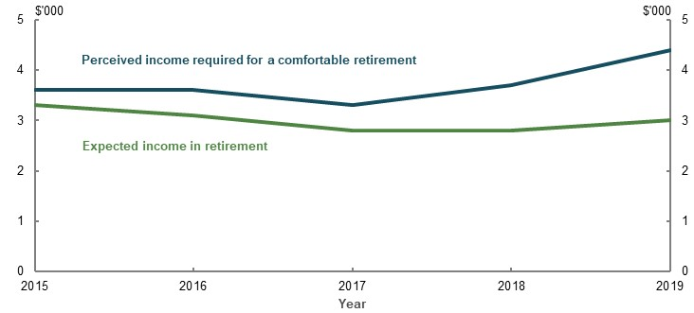
Source: Investment Trends October 2019 Retirement Income Report.
Fear of not having enough savings for a comfortable retirement may be exacerbated by industry and media estimates of what constitutes an adequate superannuation balance (Super Consumers Australia, 2020, p. 3).
People who actively prepare for their retirement feel more confident about their expected retirement incomes (Bray & Gray, 2016). The same is true of people who access financial advice, as discussed in 5A. Cohesion. This suggests if access to advice improves, confidence is also likely to improve.
Compared to people who have not yet retired, retirees are generally less worried about having enough income to meet ongoing costs in retirement. But many are concerned about running out of funds before they die (see 5A. Cohesion). Pre-retirees and retirees appear to have very different ideas about what is needed to achieve a comfortable lifestyle in retirement. One survey found pre-retiree respondents believed the average SG rate they would need for a comfortable retirement was 12.1 per cent. In contrast, retirees thought it was 10.8 per cent. This suggests that until they retire, people lack confidence that the system will deliver the level of income in retirement they are seeking. Overall, better community understanding of the system is needed.

Loss of public confidence from perceptions of unfairness
International evidence shows the public will make political demands when confidence in the retirement income system falls far enough. Events in other nations, such as the following two recent international examples, demonstrate what can happen if the public loses confidence in a retirement income system’s ability to deliver fair outcomes.

Chile
In 2019, Chile experienced rioting and mass protests over several issues, including adequacy and equity within the existing retirement system (Bloomberg, 2019).
Chile’s retirement income system is largely privately provided through a mandatory defined contribution scheme managed by a for-profit funds management industry. It also includes supplementary employer-sponsored schemes and a small means-tested social assistance pillar (Mercer, 2019b, p. 26). Chileans expected to receive 70 per cent replacement rates of their final salary if they contributed 10 per cent of their income throughout their working lives (The Economist, 2019). While Chile’s system is considered fiscally sustainable (Table 4A-3) (Mercer, 2019b, p. 26), it delivers low replacement rates (37 to 45 per cent) (OECD, 2019b). Up to one-third of Chile’s population are in irregular employment (Financial Times, 2019), meaning they are often not covered by the scheme, or may not make regular payments into the scheme.
In 2020, in response to protestors’ concerns, the Chilean Government proposed a range of reforms to improve adequacy and equity. These included increasing the defined contribution rate paid during employment and increasing current and future public pension payments (Reuters, 2020).

France
The French retirement income system may not be fiscally sustainable (Mercer, 2019b, p. 29). France’s system includes an earnings-based public pension, and mandatory and voluntary occupational pension plans. It is regarded as generous in terms of replacement rates (OECD, 2019b, p. 147; Mercer, 2019b).
Attempts by the French Government to improve its fiscal sustainability have resulted in mass protests (The Economist, 2019). The French Government is proposing reform to create a simplified pension system that encourages a longer contribution period. Protestors claim the plan undermines the economic security of women and self-employed people, as well as existing benefits and rights (France24, 2019; The Guardian, 2020).
      - Mercer Global Pension Index Scores 2019
Country | Grade | Overall score | Adequacy score | Sustainability score | Integrity score
Australia | B+ | 75.3 | 70.3 | 73.5 | 85.7
Chile | B | 68.7 | 59.4 | 71.7 | 79.2
France | C+ | 60.2 | 79.1 | 41.0 | 56.8
Source: (Mercer, 2019b, pp. 6-7).
Little robust evidence exists to explain what determines public confidence in, or the political sustainability of, a retirement income system. Nevertheless, these cases are suggestive. In Chile and France, governments faced strong public opposition as a result of widely held beliefs that retirement income systems were failing, or that reforms would fail, to achieve adequate and equitable outcomes. The protests demonstrate how difficult it can be for governments to improve fiscal sustainability if it comes at a perceived cost to the adequacy and equity of outcomes.
The example of Chile shows that a retirement income system based on significant private contributions is not necessarily more politically sustainable than systems with a large public provision of retirement benefits. In the case of Australia, compulsory superannuation was introduced with the intention of making Australia’s retirement income system more politically sustainable and giving people more control over their retirement incomes. At the time, the then Treasurer, Paul Keating, said: ‘[compulsory superannuation] is the difference between a full, active life and a life governed by budgetary exigencies and the vagaries of politics’ (Keating, 1991).
Survey results indicate most people (60 per cent) think the rules of superannuation and the Age Pension change too much. But more people see superannuation as a stable investment for retirement (53 per cent) than believe the Age Pension will still exist when they retire (48 per cent) (BETA, Forthcoming). This suggests that introducing superannuation has made Australia’s retirement income system more politically sustainable than might otherwise be the case.

Perceptions of fairness and equity in Australia
Many stakeholders raised concerns about fairness and equity in their submissions on the Australian system. Many of these issues are analysed in 3. Equity. At least one stakeholder considered inequitable tax concessions and falling home ownership rates could become a source of intergenerational conflict (National Seniors Australia, 2020, p. 67). Academic literature suggests views of intergenerational inequity are focused towards excessive benefits across life rather than just in retirement (Kendig, et al., 2019). Although some concerns about system equity may be valid, limited evidence exists to suggest they will undermine the system’s political sustainability.

How reform can be undertaken without undermining public confidence
There is a view that retirement income system reform may be more successful if it is implemented during a crisis, such as an economic shock (Lora & Olivera, 2004). This could be because public confidence in existing policy settings falls to a point where the public is willing to accept reform, or at least to accept that reform is necessary. Many foreign retirement income systems were reformed in response to the GFC and sovereign debt crises (Hassel, et al., 2019).
International literature on pension reform suggests people are more willing to accept changes to the system when: it benefits them as individuals; it is in line with their political beliefs; or they are well-informed about the system (Boeri & Tabellini, 2012; Gouveia, 2017).
Submissions suggested reform could be implemented while maintaining confidence by:
- Grandfathering existing outcomes and providing a sufficient transitional period for people to adjust to new settings (National Seniors Australia, 2020, p. 3; Alliance for a Fairer Retirement System, 2020, p. 35; Bunbury Branch of the Association of Independent Retirees, 2020, p. 2)
- Effectively communicating the benefits of reform. People are more willing to support reform if its benefits are communicated well (Super Consumers Australia, 2020)
- Aligning reforms with public attitudes toward equity. The public is more likely to accept reforms consistent with (perceived) equitable outcomes
          - Impact of changes to certain policy settings on the sustainability of the retirement income system
A significant number of submissions raised policy proposals affecting the sustainability of the retirement income system. The following summary outlines some implications of some of those proposals.
- Means testing promotes the sustainability of Age Pension spending. Over time, the SG leads to superannuation balances growing faster than the means test free areas and cut-offs. This will move some people on full-rate pensions to part-rate pensions, and some on part-rate pensions off the Age Pension. Age Pension means testing also makes the system effective at offsetting the consequences of low earnings and lower wages for lower- and middle-income earners. Sustainability of the system will depend on its overall costs and both Age Pension and superannuation tax concessions.
- Earnings tax concessions increase the cost of the system over time. While contributions tax concessions are not projected to increase the cost of the system as a proportion of GDP over time, earnings tax concessions are. Earnings tax concessions disproportionately benefit people who are already likely to achieve adequate retirement incomes. SG contributions are the main influence reducing Age Pension expenditure.

Annex — estimating superannuation tax concessions
Treasury publishes estimates of the cost of superannuation tax concessions in the annual Tax Benchmarks and Variations Statement (previously the Tax Expenditures Statement). The Tax Benchmarks and Variations Statement includes estimates for 12 different superannuation tax concessions. Of these, contributions tax concessions (both employer and personal) and earnings tax concessions make up the vast majority of the total cost.
Estimating tax concessions requires considering two issues: what the counterfactual tax benchmark should be and behavioural change.

The tax benchmark
The Tax Benchmarks and Variations Statement uses an income tax benchmark, which means the counterfactual tax treatment of contributions and earnings are the general settings of the personal income tax system.
Some stakeholders argued a better benchmark to use would be an ‘expenditure’ benchmark. An expenditure benchmark compares the revenue actually collected with the revenue that might have been collected had contributions been taxed at personal marginal rates and all earnings been tax-free. This is sometimes called a TEE benchmark, referring to fully taxed contributions (T), but exempted earnings and withdrawals (EE)Error! No bookmark name given..
Broadly speaking, two main arguments were put forward, each subject to challenge:
- The benchmark selected is inevitably an implicit judgement about what is the ‘best’ alternative tax treatment. A range of influential papers on the optimal taxation of saving — for example, Atkinson and Stiglitz (1976); Chamley (1986); and Judd (1985) — suggest that, under certain conditions, the ‘normal’ (or risk-free) return to savings should not be taxed. Drawing on such analysis, some stakeholders consider the benchmark should reflect such a structure. Some considerations that challenge this approach include:
- Estimating the cost of tax concessions is about ‘what is’ not ‘what should be’. This means estimating the cost of legislated deviations should be from the norm (whether the norm is ‘optimal’ or not), not deviations from a theoretical optimum.
- Few superannuation members receive the risk-free level of return. Most receive a ‘supernormal’ return from diversified portfolios of risky assets. The Mirrlees Review (2011) stopped short of proposing a TEE framework for returns from such portfolios (as is superannuation).
- More generally, not everyone agrees about the theoretical optimum tax treatment. For example, extensive literature surveys by Auerbach (2006), Sorensen (2007), and Diamond and Banks (2009), report a number of findings that a positive tax on the normal return to savings can be part of an optimised tax mix, and a tax rate of zero is only optimal under certain assumptions.
- A comprehensive income tax benchmark does not represent a politically sustainable option because the public would not accept compelled savings with no concessional tax treatment. However:
- Political acceptability is not relevant to the relatively narrow task of measuring Government costs. For example, removing the Age Pension would almost certainly be unacceptable to the public, yet the cost of the Age Pension is still measured in its entirety.

Behavioural change
Another issue in estimating the cost of superannuation tax concessions concerns behavioural change. People could alter their behaviour if the concessional tax treatment of superannuation was removed, perhaps by saving less or using alternative savings vehicles.
As outlined in 5A. Cohesion, tax concessions have a limited effect at encouraging additional savings or increasing people’s overall savings. Instead, they mostly encourage people to reallocate existing savings, or savings they would have made in any case, into superannuation. Compulsory superannuation is the main driver of increased household savings. This suggests people are unlikely to save less in total if tax concessions were removed. But they may choose alternative savings vehicles.
Since 2009, Treasury has produced estimates that attempt to account for this expected reallocation of savings. These estimates are called ‘revenue gain’ (RG) estimates (as opposed to the general estimates that do not account for behavioural change called ‘revenue forgone’ (RF)). They are done for the highest-cost superannuation tax concessions: employer contributions (both SG and salary sacrifice) and the earnings tax concession.
These estimates cannot be used for long-term analysis as the methodology depends on the year in which the estimates are based. Regardless, estimated behavioural change makes a relatively small difference to the estimates of total superannuation tax concessions over a four-year projection period, provided compulsion continues (Chart 4A-28).
RG estimates assume the concessional tax treatment is withdrawn at the start of the next financial year, with behavioural change assumptions made over the following three financial years.
The RG employer contributions concessions estimate is steady at around 4 per cent below the RF estimate. This is because other avenues (rather than voluntary salary sacrifice contributions) are used to reduce average tax rates on personal income.
    - Superannuation tax concessions: revenue forgone and revenue gain estimates
Employer contributions | Earnings
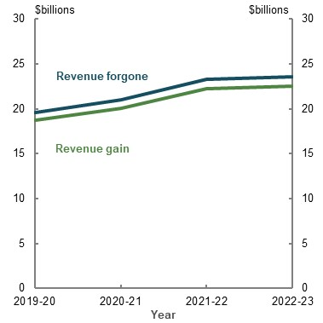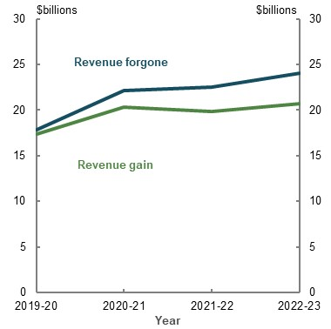
Source: Treasury (2020).
The RG earnings concession estimate assumes voluntary contributions and retirement-phase assets are gradually redirected from superannuation towards alternative tax-preferred vehicles. At the end of four years, the RG earnings estimate is 14 per cent lower than that for RF. This is because the earnings on these alternative tax-preferred vehicles are subject to lower marginal tax rates than those used in the RF estimate.
For both the earnings and contributions concessions, the difference between the RF and the RG estimate is relatively small. This is largely because the effective tax rate on superannuation is lower than other tax-preferred savings vehicles.

Annex — scenario analysis
The scenarios are:
- Lower earnings. A 1 percentage point reduction in investment returns across all asset classes
- Lower wages. A 1 percentage point reduction in nominal wages growth
- Lower fees. A faster (than that modelled above) reduction in annual superannuation fees charged
These scenarios can help inform understanding of the potential effects of alternative trends on the retirement income system. Importantly, the scenarios only allow for partial modelling. They do not account for flow-on effects that would occur in the wider economy, should these scenarios occur.

Lower earnings
The lower earnings scenario projected higher Age Pension expenditure as a percentage of GDP and lower retirement incomes. In 2059, lower earnings increases Age Pension coverage to 61 per cent of the eligible population compared with 51 per cent in the baseline (Chart 4A-29).
    - Age Pension population projection — baseline (solid line) and lower earnings scenario (dashed line)
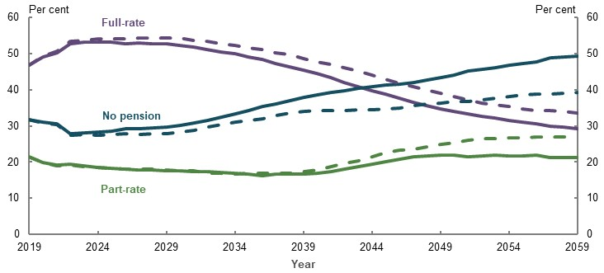
Source: Analysis of Rice Warner estimates for the review.

Lower wages growth
The lower wages scenario projected higher Age Pension expenditure as a percentage of GDP and lower retirement incomes. The proportion of the eligible population receiving the Age Pension in this scenario (56 per cent) (Chart 4A-30) is smaller than in the lower earnings scenario (61 per cent) (Chart 4A-29).
    - Age Pension population projection — baseline (solid line) and lower wages scenario (dashed line)
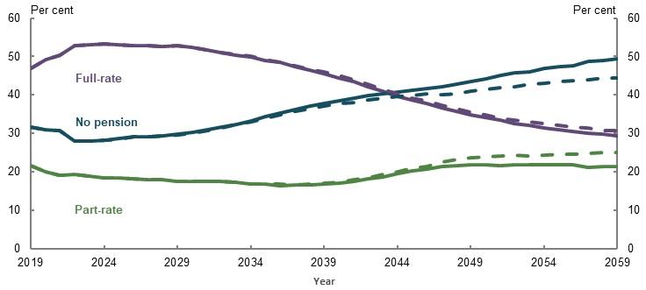
Source: Analysis of Rice Warner estimates for the review.

Lower fees
The lower fees scenario projected lower Age Pension expenditure as a percentage of GDP and higher retirement incomes. The proportion of the eligible population receiving the Age Pension is projected to be 48 per cent, compared with 51 per cent in the baseline (Chart 4A-31).
    - Age Pension population projection — baseline (solid line) and lower fees scenario (dashed line)
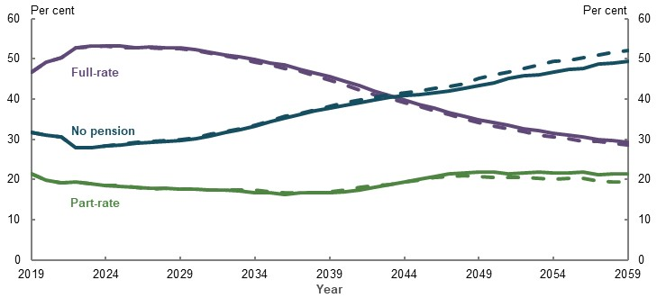
Source: Analysis of Rice Warner estimates for the review.

- Cohesion

Outline of this chapter
This chapter examines whether the retirement income system is functioning cohesively. It examines whether the three pillars are effectively integrated and the retirement income system is functioning cohesively against three of the suggested elements for the system’s objective (see 1C. The objective of the system and the roles of the pillars). That it should:
- Have effective incentives to smooth consumption and support people in taking personal responsibility for their retirement incomes
- Interact effectively with other systems
- Not be unnecessarily complex for consumers
These elements are interlinked. Unnecessary complexity can undermine the effectiveness of incentives to smooth income and consumption over a lifetime. Similarly, interaction with other systems, such as the health or aged care systems, can lead to additional complexity.
The chapter also explores the implications of changes to the Age Pension means-testing arrangements on the performance of the retirement income system. Consideration is given to the effects of changing the Age Pension assets test taper rate or merging the Age Pension assets and income tests. These issues were raised in submissions.

Cohesion
          - Section summary
- With the maturing superannuation system, compulsory superannuation is effective at helping most people save enough for an adequate retirement income, when combined with the Age Pension. The opportunity to make voluntary superannuation contributions provides sufficient flexibility to achieve a higher level of superannuation savings for those with the means to do so.
- Financial incentives to save for retirement, or to encourage older Australians to continue to work, appear to have limited effect on retirement outcomes. Tax concessions tend to lead people to reallocate rather than increase savings, and evidence that the Age Pension means test affects savings behaviour pre-retirement is weak. Incentives for people to remain in the workforce tend to benefit those who would have worked without the incentive.
  - Few middle- to lower-income earners make voluntary contributions to their superannuation.
  - Personal budget constraints are the main reason people do not save more for retirement. When deciding to retire, people mostly consider the superannuation preservation and Age Pension eligibility ages and factors outside the retirement income system, such as health.
- There is little evidence people structure their superannuation withdrawals to access the Age Pension.
- Incentives to draw down assets to finance living standards in retirement are not effective. The majority of people are not using their superannuation balances and other savings effectively to maintain their living standards in retirement. If they did so, they could achieve the same retirement outcome with a lower level of saving and higher standard of living in their working life.
  - Retirees are concerned about outliving their savings and tend to spend less rather than use products to manage this risk.
  - Prescribed minimum drawdown rates anchor behaviour and reinforce a tendency to conserve superannuation savings. Without a change to drawdown behaviour, bequests from superannuation will grow.
  - The Age Pension means test taper rate does not appear to have a strong effect on whether people draw down or consume their assets.
  - People are less likely to consume savings that are framed as assets as they have been primed during working life to save this ‘nest egg’. Expressing superannuation balances in terms of retirement income, in a similar way to working life income, may encourage people to draw down from their savings in retirement.
  - Precautionary saving for aged care costs appears to inhibit some people from drawing down assets. They appear to be unaware of the extent to which these costs are subsidised by Government.
  - Both the tax and retirement income systems encourage investment in the principal residence. But few people draw on the equity in their home to boost their retirement income.
  - Surveys suggest leaving bequests is not the highest priority of retirees. But most people leave a significant share of their retirement savings as a bequest, often unintentionally.
- System complexity prevents people optimising their retirement income. Navigating different parts of the retirement income system, combining income sources and managing the multiple risks faced in retirement is challenging. People need assistance with complex financial decisions. Interactions between the retirement income system and other systems, such as the aged care system, increase complexity.
- People lack an adequate framework to guide their decision-making in planning for retirement and when in retirement. The current financial advice regime is not meeting people’s needs. People struggle to achieve a stable income in retirement. Superannuation funds play only a limited role in informing and guiding people to get better retirement incomes from their savings. Current regulatory barriers impede funds from providing cost-effective guidance and advice about retirement. The proposed Retirement Income Covenant envisages creating a legal obligation on superannuation funds to consider their members’ needs in retirement.
- Evidence suggests the retirement income system could be more cohesive and simpler for people to engage with.

Outline of this section
This section considers the cohesiveness of the:
- Pre-retirement phase: the incentives to save and invest for retirement and the role of the Superannuation Guarantee (SG), along with the incentives to continue to work
- Retirement phase: the incentives and support for retirees to optimise their assets to fund their living standards in retirement
          - Stakeholder views on cohesion of the retirement income system
Most submissions discussed the importance of the principle of cohesion. In general, stakeholders were concerned about the lack of cohesion between the three pillars: the Age Pension, compulsory superannuation, and voluntary savings, arguing that policy and regulation for each pillar were developed in isolation. Some stakeholders expressed concern about a lack of continuity between the pre-retirement and retirement phases.
Pre-retirement phase. Many stakeholders noted the SG plays a key role in ensuring people are saving for their retirement. They had mixed views about whether tax concessions for voluntary superannuation contributions had the same effect. A few stakeholders considered tax concessions essential to the superannuation system’s design. One submission noted superannuation tax concessions are:
‘…an “incentive” to save and an “investment” that will yield future returns in terms of less pressure on the budget and productive investment of superannuation savings in the economy, in turn leading to higher tax revenue.’
(Self-managed Independent Superannuation Funds Association, 2020, p. 14)
In contrast, some stakeholders claimed the tax concessions benefit higher-income earners disproportionately and do little to encourage lower- and middle-income earners to save. One submission stated:
‘The tax incentives support groups which are already pre-disposed to take advantage of them, and it appears that they are supporting those with higher incomes who are already likely to save, rather than incentivising additional saving.’
(First State Super, 2020b, p. 29)
Most submissions discussed the impact of the Age Pension means test on savings behaviour pre-retirement. Stakeholders suggested the Age Pension assets test taper rate can be a disincentive for saving for retirement.
Retirement phase. Some stakeholders noted retirees are underspending in retirement, rarely consuming their capital and drawing down only the earnings from their assets. They are also reluctant to draw on home equity to fund retirement:
‘…the fact that the value of the family home is not included in the asset test creates an incentive for retirees to hold on to a large house and live frugally on a very modest income, trying to stay eligible for the age pension.’
(Monash Centre for Financial Studies, 2020, p. 2)
A few stakeholders suggested the fear of running out of money in retirement drives conservative drawdown behaviour for retirees. Some stakeholders attributed this behaviour to a lack of retirement income products that provide longevity risk protection along with low levels of financial literacy, which acts as a barrier to engagement.
The majority of stakeholders considered the system is too complex for people to navigate. They considered that system defaults, automation and data sharing were important to reduce complexity and achieve better retirement outcomes. One submission stated:
‘…we are in favour of strong default structures, so people don’t need to make decisions in complex areas (nor be forced by complexity to pay financial advisers to assist them within the mandatory system).’ (Rice Warner, 2020, p. 5)
Some stakeholders considered financial advice to be critical to making better decisions and reducing worry and uncertainty in retirement. However, they noted people were deterred from accessing personal financial advice because of its high cost and unclear benefits, and their distrust of the financial advice industry. Some stakeholders suggested the type of financial advice people need has changed over time and demand for financial advice will increase in future. They argued the superannuation industry should play a greater role in providing financial advice. One submission noted the benefits of superannuation funds providing ongoing information and regular updates to members on likely retirement incomes. Other submissions suggested that regulations on intra-fund advice, which limit cross-subsidising financial advice costs, are a barrier to fund involvement. Others thought appropriate defaults and system simplification would reduce the need for financial advice.

Cohesiveness of pre-retirement settings for saving and investment
For most people, the pre-retirement phase is characterised by defaults and compulsion, such as compulsory superannuation with the SG, and default enrolment into an employer’s fund and MySuper products. These defaults are highly regulated. For example, a MySuper product is ‘a simple, well‐designed product suitable for the majority of members’ (Super System Review, 2010, p. 1). Defaults in the pre-retirement phase have allowed a large proportion of the population to grow their superannuation savings in a simple product without needing to make complex choices.
Defaults and compulsion have been effective in increasing household savings. The introduction of compulsory SG increased retirement savings. Superannuation is now the second-largest asset for most people, after the home (ABS, 2019k). Studies have consistently found that the SG has increased household net wealth (Connolly, 2007; Ruthbah & Pham, 2020a).
Research commissioned by the review found the SG crowds out private savings in the short term but increases wealth in the long term. Some substitution appears to occur between compulsory superannuation and private household saving, but this effect is small. Estimates suggest that, for every dollar increase in compulsory superannuation, households reduce their private saving by 43 cents, meaning total household savings are higher overall (Ruthbah & Pham, 2020a).
The policy settings in the pre-retirement phase have changed over time to ensure they function as intended and better reflect the needs of consumers. Stakeholders have proposed further changes:
- Changes to the SG. Beyond changes to the rate (see 2D. Policy scenario: Implications of maintaining the SG rate), some stakeholders proposed introducing more flexibility around its application; for example, by allowing people to opt in or out of SG increases.
- Changes to default fund and product selection. The Productivity Commission (2018a) found the current default mechanisms for selecting superannuation funds and products are too variable and lack accountability. The Commission proposed winding back some of the default settings and encouraging members to make more active choices on these issues. It suggested members would be assisted by a ‘best in show’ shortlist of superannuation products, supported by an ‘outcomes test’ to prove product quality. Some stakeholders also suggested rolling out the Consumer Data Right to the retirement income sector and introducing more digital literacy and engagement tools to improve consumer choice (Diversa Trustees - A Sargon Business, 2020, p. 3).
By influencing behaviours and outcomes, defaults deliver reasonable outcomes to the point of retirement for most people. However, relying on defaults can lead to low engagement, which can lead to low levels of consumer-driven competition (Productivity Commission, 2018a). The Productivity Commission found that superannuation fees have not come down as much as expected, some funds are underperforming, and the default system does not deliver reliable outcomes. A sizeable minority of people are defaulted into underperforming funds, leading to worse outcomes at retirement (Productivity Commission, 2018a).
The Productivity Commission (2018a) also found that ‘choice members’ (people who choose their own superannuation product) do not get better outcomes in retirement on average. Stakeholders have suggested better financial literacy as one way to improve engagement and retirement outcomes. This is discussed below in Cohesiveness of the retirement phase.

Financial incentives to work and save
Not everyone is covered by the SG and some people may want to save more than the SG rate. The retirement income system provides incentives to encourage people to work, save and take an active role in planning for retirement. However, evidence suggests these incentives have limited effects on overall savings.

Tax concessions for superannuation
Tax concessions are offered on both compulsory and voluntary superannuation contributions, although they only operate as an incentive for voluntary contributions. Voluntary contributions can be made pre-tax (concessional) or post-tax (non-concessional) (see Box 5A-3 and 1B. Design of Australia’s retirement income system).
The tax rate on voluntary concessional contributions may be higher or lower than 15 per cent, depending on the person’s taxable income. The main way people access voluntary concessional contributions is through salary sacrificing.
Although non-concessional contributions do not receive a contributions tax concession, they benefit from investment earnings being taxed concessionally at a headline rate of 15 per cent. However, the effective concessional tax rate for earnings is often lower than 15 per cent. Dividend imputation and the 33 per cent capital gains tax concession for assets held in a superannuation fund for more than 12 months reduce the tax paid by the fund. As a result, modelling for the review assumes a 7 per cent effective earnings tax rate (see Appendix 6A. Detailed modelling methods and assumptions).
          - Tax concessions for voluntary superannuation contributions
Pre-tax (concessional) contributions
- A concessional tax rate of 15 per cent applies to both contributions and investment earnings, such as interest, dividends and rental income.
- Concessional contributions are capped at $25,000 a year. A carry forward rule allows people to make additional contributions for unused amounts from the last five years (for superannuation balances less than $500,000).
- Tax concessions are reduced for those with very high incomes through Division 293 tax, with the current threshold set at $250,000 of combined income and contributions. Division 293 charges an additional 15 per cent tax on either superannuation contributions or the amount over the threshold, whichever is lower.
- Excess contributions are taxed at the marginal tax rate.
- Contributions by lower-income earners, especially those below the tax-free threshold ($18,200 in 2018-19) are effectively tax-free. Any tax payable is offset by the low income superannuation tax offset.
Post-tax (non-concessional) contributions
- Post-tax contributions are made after income tax has been paid at the person’s marginal income tax rate. But investment earnings are taxed concessionally at 15 per cent.
- Non-concessional contributions are capped at $100,000 a year. Beyond this, they are taxed at 47 per cent if excess contributions and earnings are not withdrawn. People under 65 may be able to bring forward up to three years of non-concessional contributions, depending on their superannuation balance.
- The Government makes a 50 per cent co-payment for post-tax contributions by lower- to middle-income earners, capped at $500.
About 17 per cent of workers are self-employed. Self-employed people are not covered by the SG, and only around a quarter of them make a voluntary contribution in a given year. As a result, self-employed people generally have lower superannuation balances than employees. However, they have similar levels of overall wealth. They typically have access to other tax-effective avenues to save for retirement and hold more savings in property and business assets than employees (see 3D. SG coverage).
Around a quarter of people make voluntary superannuation contributions (ATO, 2019f). Most people make pre-tax superannuation contributions at or near the SG rate (Chart 5A-1). However, for higher-income people, older people and those with higher superannuation balances, voluntary contributions make up a large proportion of total annual contributions (Chart 5A-2) (see 3A. Income and wealth distribution).

    - Distribution of concessional superannuation contributions among taxpayers
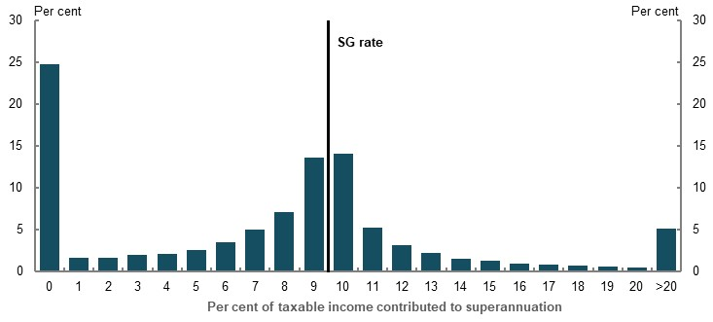
Source: Analysis of ATO individual income tax returns and member contributions statements, 2017-18.
    - Voluntary superannuation contributions as a proportion of total contributions, by superannuation balance
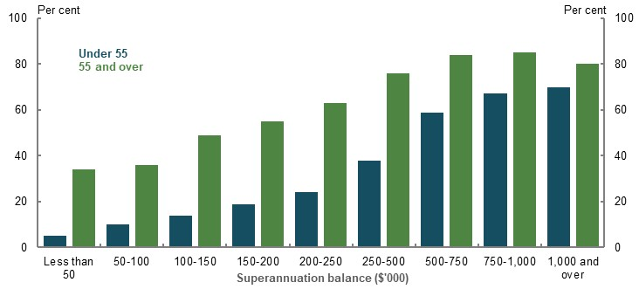
Source: Analysis of ATO individual income tax returns and member contributions statements, 2017-18.
In general, tax concessions appear to be of limited effectiveness at encouraging additional savings or increasing people’s overall savings. Instead, tax concessions appear to mostly encourage people to reallocate existing savings, or savings they would have made in any case, into superannuation. Some studies find a small, positive effect of tax incentives on overall savings. Others find no significant effect (Table 5A-1). Those finding a small positive effect generally agree that this applies only to lower- and middle-income earners: a group that makes relatively small voluntary contributions (see 3A. Income and wealth distribution). Most of the contributions are made by higher-income earners, and may represent reallocation of savings that would have probably occurred with or without the tax concessions (OECD, 2018a). Although Australian evidence on the overall effect on savings is not definitive, it suggests the impact is small.
Policy settings are particularly relevant when considering if international findings can be generalised to Australia. For example, many studies use US data on 401(k) retirement accounts to measure the combined effect of tax incentives and the offer of the plan from an employer. In Australia, most people are compelled through the SG to both open an account and contribute at a relatively high level. If Australia’s superannuation tax concessions are to generate additional savings, these savings must be voluntary on top of the additional savings that result from the SG. Many other countries’ incentives seek to elicit additional savings from a base of low or no retirement savings. Some employers offer compulsory contribution rates above the SG as part of their employment packages (Mercer, 2020). This further reduces the scope for tax concessions to generate additional savings from voluntary contributions.
      - Summary of Australian and international literature on the effect of tax concessions on generating additional retirement savings
Country/Paper | Finding
Australia
Sobeck and Breunig (2020) (commissioned by the review) | Incentives from co-contribution policy have a small, positive effect on overall savings (23 cents in the dollar).
Ruthbah and Pham (2020b)(commissioned by the review) | Incentives from co-contribution policy have small, positive effects on overall savings. Division 293 tax appears to lead to a reallocation of savings with no effect on wealth. Concessional contributions caps may have marginal effects on savings and wealth.
Feng (2014) | Tax incentives have a limited effect, if any, on the level of salary sacrifice contributions.
USA
Benjamin (2003) | A quarter of 401(k) balances represent additional private savings, mostly stemming from lower- and middle-income households.
Beshears et. al. (2017) | No evidence that contribution rates respond to the tax incentive associated with a Roth contribution option (non-deductible contributions but untaxed withdrawals, compared with deductible contributions but taxed withdrawals) on existing 401(k) plans.
Gelber (2011) | No definitive conclusion on whether 401(k) contributions generate additional savings.
Engelhardt and Kumar (2006) | Participation in 401(k) plans produces the largest additional savings for lower- and middle-wealth households.
Chernozhukov and Hansen (2004) | Participation in 401(k) plans produces additional savings, but less so for the upper end of the wealth distribution.
Engen and Gale (2000) | Savings in 401(k) accounts held by lower-income households are more likely to represent additional savings than those held by higher-earning groups.
Engen et. al. (1996) | Little, if any, of 401(k) contributions represent additional savings.
Poterba et. al (1996) | The weight of evidence is that the bulk of IRA and 401(k) contributions are net additions to savings (more recent papers have critiqued this paper — for example, Benjamin (2003) and Engen and Gale (2000)).
Other international
Chetty et. al. (2014) | Changes to subsidies for voluntary contributions in Denmark produce only 1 cent of additional savings for every $1 of Government expenditure.
Attanasio et. al (2005) | Limited evidence that either the US or UK schemes produce additional savings.
Ayuso et. al. (2019) | On average, 19 cents in each euro contributed to the Spanish scheme represent additional savings.  Contributions from households close to retirement are more likely to represent a reallocation of existing savings.
Corneo et. al. (2015) | High wealth households in Germany are much more likely to benefit from private pension subsidies.
Paiella and Tiseno (2014) | Increases in tax incentives in Italy have little, if any, effect on overall household savings.

Tax incentives have a limited effect on the decision to salary sacrifice (Feng, 2014). If tax incentives provided a strong incentive to make voluntary superannuation contributions, salary sacrifice would be expected to ‘step up’ at each of the marginal tax rate thresholds (and among all age groups) where people get the largest tax benefit from making salary sacrifice contributions. In fact, although salary sacrifice rates increase with income, they do not jump at the marginal tax rate thresholds (Feng, 2014, p. 65). More recent data confirms this result (Chart 5A-3).
    - Concessional voluntary superannuation contribution rates by income intervals and age, per $1,000
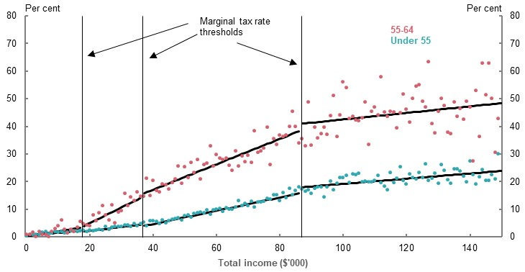
Source: (Feng, 2014) updated using ATO individual income tax returns and member contributions statements, 2017-18.
Similarly, the Division 293 tax has no impact on overall savings (Ruthbah & Pham, 2020b), suggesting either the tax rate is still concessional for very high-income earners and superannuation remains an attractive savings vehicle, and/or tax concessions have limited impact on very high-income earners’ decisions to save (Table 5A-1).
The earnings tax exemption in the retirement phase is particularly unlikely to encourage additional savings. It primarily benefits people who earned higher incomes over their lifetime (see Chart 3A-11 in 3A. Income and wealth distribution). Tax incentives that benefit higher-income earners are most likely to lead to portfolio reallocation, rather than new savings. Literature on tax salience suggests the most effective incentives are ones that affect people immediately (Chetty, 2011). As the benefit of the exemption occurs in retirement, it is less likely to influence savings decisions made years earlier while people are working.
The strongest drivers of voluntary superannuation contributions are income and age, rather than tax concessions. Superannuation contributions trend with income (CEPAR, 2018a). One study found a 10 per cent increase in income lifted the likelihood of people making pre-tax voluntary contributions by more than 1 per cent (Feng, 2018, pp. 10, 13). It also found savings were closely related to age, regardless of the type of savings, with the marginal effect higher for pre-tax contributions than post-tax contributions. Similarly, a recent study using Australian tax data found people in the top superannuation balance quartile rapidly increase their contributions before retirement (Polidano, et al., 2020).
The main reason people do not make contributions to superannuation is because they cannot afford to do so. BETA (Forthcoming) found 45 per cent of employees who do not make voluntary contributions say this is because they cannot afford to (Chart 5A-4). Survey data suggests this is particularly the case for lower-income earners (Feng, 2018, p. 14; Ralston & Feng, 2017). Findings from 2C. Maintaining living standards in retirement suggest that making voluntary contributions could contribute to some people, particularly those on lower incomes, having higher living standards in retirement than during working life.
    - Employees’ reasons for not making voluntary superannuation contributions
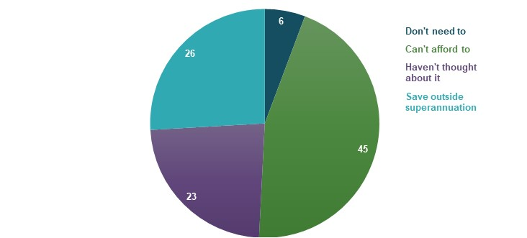
Note: Based on 2020 survey data. Source: (BETA, Forthcoming).
Other reasons people do not make voluntary superannuation contributions include that they think they will have enough savings without making additional superannuation contributions, believe the SG or their spouse’s superannuation is sufficient (Feng, 2018, pp. 14-15), or are saving outside superannuation. A recent survey showed that, for people who do not make voluntary contributions, between 3-6 per cent did not think they needed to make extra superannuation contributions, and 26-35 per cent used savings vehicles other than superannuation for their extra savings (BETA, Forthcoming). Self-employed people were more likely to think they needed to save more and were more likely to save outside superannuation (BETA, Forthcoming).
Almost a quarter of people who do not make voluntary contributions ‘haven’t thought much about saving for retirement’ (BETA, Forthcoming). People stick with default saving rates in retirement programs (Shafir, 2012). People may also disengage because the system is complex (Feng, 2018, p. 59; CEPAR, 2018b, p. 2). This is further discussed in Cohesiveness of the retirement phase below.
Tax concessions can only be an effective incentive to make additional superannuation contributions if people know about them. Survey data suggests around 21 per cent of self-employed people and 23 per cent of employees are not aware of superannuation tax concessions (BETA, Forthcoming).

Government co-contributions to superannuation
Government co-contributions have a limited impact on superannuation contribution rates. Eligible people in lower income ranges do not contribute more than those who are ineligible (Feng, 2018, p. 10). Research found a government co-contribution of $1 increased total savings by 23 cents (Sobeck & Breunig, 2020). Another study, using a different dataset and methodology, found that increases to the Government co-contribution cap had a very small positive impact on household saving (Ruthbah & Pham, 2020b).

The Age Pension means test
The Age Pension means test is designed to ensure Government support is targeted to people in need by reducing a person’s rate of Age Pension payable as their means increase. The current assets test taper reduces at a rate that generates high effective marginal tax rates for middle-income earners.
The impact of the assets test on retirement savings can most clearly be seen by modelling the effect of salary sacrificing $1,000 in the year directly before retirement for people from different income percentiles (Chart 5A-5). The model compares the additional income a person would get in retirement with their reduction in disposable income pre-retirement. For a median earner, retirement income only increases by around one-third of the disposable income they gave up, mostly due to the impact of the Age Pension means test.
    - Effect of saving an extra $1,000 immediately before retirement, by income percentile
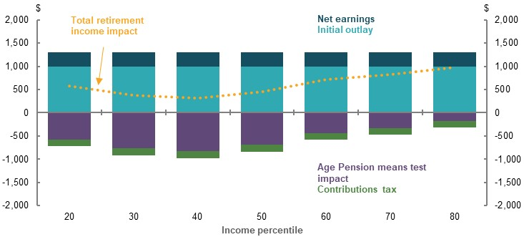
Note: The scenario assumes people salary sacrifice an additional $1,000 in the year before retirement. Superannuation is drawn down at an annuitised rate to life expectancy. The 10th income percentile is excluded from this analysis due to low asset levels in superannuation and relatively low marginal propensity to save. The 90th percentile is excluded because their projected balance is already over the transfer balance cap, and so cannot make post-tax voluntary contributions. Contributions and earnings concessions are calculated as the difference between concessional and marginal tax rates. Government concessions are deflated by the long-term Government bond rate. Net earnings are the change in lifetime superannuation draw downs, less change in total contributions tax and total initial capital outlay. Total retirement income and components are deflated by CPI. Source: Cameo modelling undertaken for the review.
A number of submissions suggested the effect of high effective marginal tax rates on middle-income earners is a disincentive to make additional superannuation savings. Submissions suggested that the assets test taper rate discourages people from continuing to save for retirement if they hold assets close to or just above the assets test free area. Submissions also suggested people rearrange their income and assets to either gain access to the Age Pension or to increase the amount of Age Pension they receive. For example, this could be achieved by reducing the amount of assessable income and assets a person holds (e.g. increasing the value of their principal residence through home renovation).
Evidence that the Age Pension means test affects savings behaviour prior to retirement is weak. For the means test to affect savings behaviour, people need to be aware of and understand it. Survey research found that, when deciding how much to contribute to superannuation, people said tax concessions were a more important factor (22 per cent) than missing out on the Age Pension (8 per cent) (BETA, Forthcoming).
Recent studies have examined whether the assets test taper rate has an impact on how people save pre-retirement by analysing the changes to the taper rate in 2007 and 2017. In 2007, the assets test taper rate was lowered from $3 per fortnight for every $1,000 of assets above the threshold, to $1.50 per $1,000 of assets. This increased the value of assets a person could hold while remaining eligible for the Age Pension. In 2017, this policy was reversed, and the assets test returned to the previous rate of $3 per $1,000 (see 1B. Design of Australia’s retirement income system).
The literature is not conclusive on the impact of the taper rate on savings behaviour. One study suggested the 2007 change may have resulted in the people subject to a lower taper rate saving more (Whelan, et al., 2018). However, the authors noted the results could have been affected by the GFC or valuation effects. This makes it difficult to attribute the difference in wealth solely to the change in the taper rate.
More recent research did not show evidence of statistical correlation between the taper rate change and savings for the 2017 taper rate change (Cassells, et al., 2020). Although this may reflect the limited time since implementation. For the 2007 taper rate change, this research found no statistical difference in the savings of people expected to be part-rate age pensioners before the taper rate change and those expected to be full-rate age pensioners. People expected to become part-rate age pensioners following the change were found to have higher savings than people not expecting to receive the Age Pension, although this result is not consistent with the theoretical predictions of how incentives from the taper rate could affect savings.
If the assets test was driving savings decisions, evidence of bunching around the assets test free area would be expected. But Department of Social Services payment data from June 2019 does not show any evidence of bunching of assets around the assets test free area, for either single or coupled age pensioners.

Other incentives to work or retire
The system can support retirement incomes by discouraging people from voluntarily retiring early, or by allowing them to earn income while retired. As outlined in 3E. Age of retirement, early retirement leads to lower retirement savings and lower replacement rates.
Signals in the system, such as the age people are eligible for the Age Pension and the preservation age, strongly influence when people retire. However, other financial incentives do not seem to have much impact, either on the timing of retirement, or the likelihood of working during retirement.
Financial incentives to continue working are ineffective for those who retire involuntarily. This group could be helped by removing barriers to work; for example, by introducing measures to reduce ageism, increasing the flexibility of work and care arrangements or encouraging lifelong learning.
That said, for a significant proportion of people, retiring before the Age Pension eligibility age is a choice: just under 40 per cent of voluntary retirements take place between the ages of 55 and 64 (ABS, 2020n).

Financial incentives to keep working
Several policies in the retirement income system are designed to encourage older workforce participation, such as:
- The Work Bonus. This increases the amount an eligible age pensioner can earn from work before it affects their Age Pension rate
- The ‘Work Test’ for superannuation contributions. To satisfy the Work Test, people must work at least 40 hours during a consecutive 30-day period each financial year. The Work Test is easy to satisfy and unlikely to encourage high levels of workforce participation
- Transition to Retirement Income Streams program. This program aims to prolong workforce participation by allowing workers who have reached preservation age and wish to continue working to access their superannuation
- Income tax reductions for those age 65 and over. For example, the seniors and pensioners tax offset (see 1B. Design of Australia’s retirement income system)
These incentives to encourage people to keep working appear to have limited impact. One study found Transition to Retirement Income Streams had small positive labour supply effects, which increased after the program’s initial years (Carter, 2020). But the stronger response was from people with higher incomes. At least half of the participants seemed to be using tax minimisation strategies. This is consistent with findings on the mature age worker tax offset: a targeted earned income tax credit of up to $500 to incentivise participation of older workers, which existed from 2004-05 to 2014-15. The mature age worker tax offset increased labour market participation by around 0.5 percentage points (Breunig & Carter, 2018).
The seniors and pensioners tax offset’s effectiveness in encouraging older workforce participation is unclear. The seniors and pensioners tax offset decreases effective marginal tax rates for seniors earning less than about $15,000 a year but increases them for those earning more than $20,000 a year, as benefits are withdrawn.
Some stakeholders argued the Age Pension income test creates disincentives to continue to work in retirement. A study from 1990 found evidence of age pensioner income ‘bunching’ below means test income thresholds (Creedy & Disney, 1990). However, these findings are inconsistent with current Age Pension payment data. This shows that, of the 4 per cent of age pensioners who reported employment income in the previous fortnight, the majority had reported less than $250 in earnings. This is well below the point at which employment earnings would impact an age pensioner’s rate of payment. As detailed above, age pensioners benefit from the Work Bonus, which allows them to keep more of the Age Pension when they have income from employment.

Financial incentives to retire
Theoretically, superannuation may create an incentive for people to retire at preservation age and live on superannuation savings until they become eligible for the Age Pension. Chart 5A-6 shows the gap between the Age Pension eligibility age and superannuation preservation age. Some people may be able to offset a limited (if any) loss of income before receiving the Age Pension with a higher Age Pension in retirement (Ingles & Stewart, 2017, pp. 424-426). However, whether people are actively trying to ‘game the system’ by retiring before Age Pension eligibility age is difficult to assess (Agnew, 2013, p. 4).
There is little evidence that people structure their superannuation withdrawals to access the Age Pension (Productivity Commission, 2015b, pp. 91-94). One study using longitudinal data found that households above Age Pension eligibility age have more non-financial assets than households just below Age Pension eligibility age, but have similar levels of home equity (Cobb-Clark & Hildebrand, 2010). Most people do not draw down their savings. Instead, they live off the income generated by their savings (see Current retirement outcomes, below). People who take lump sums have low balances and do not have enough wealth to be affected by Age Pension means testing. These people were most likely to spend their lump sum on their home, including paying down mortgage debt (Productivity Commission, 2015b, pp. 83-87).
    - Gap between Age Pension eligibility age and superannuation preservation age
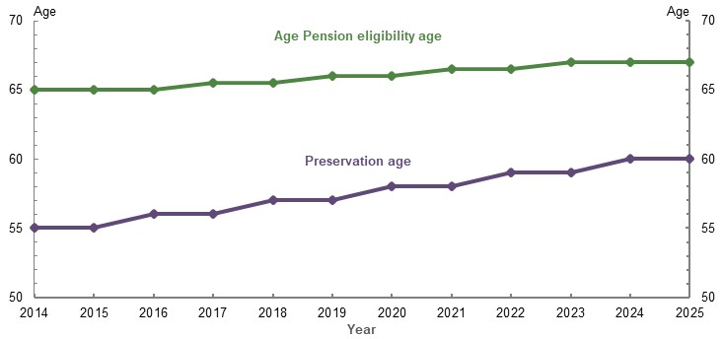
Note: Legislated increases will occur on 1 July each year. Source: (Department of Social Services, 2020e; ATO, 2020c).
In future, when people have larger balances after 40 years of compulsory superannuation, more people may choose to retire before the age they become eligible to apply for the Age Pension. Currently, most people with large balances at retirement have saved voluntarily. These people tend to have a predisposition to save and be cautious in spending. As the SG matures, this could change.
People say financial incentives do not motivate them to retire. According to Household, Income and Labour Dynamics in Australia (HILDA) data, only 4 per cent of retirees said their retirement was motivated by superannuation rules making it financially advantageous to retire.
Very few people said their decision to work less, or not at all, was to avoid losing benefits such as the Age Pension (Chart 5A-7). Most people over 55 who do not want a paid job, or who work less than 35 hours per week and do not want more hours, said this was because they had no need to or were satisfied with their current situation or were permanently retired (ABS, 2017b). Most age pensioners do not work in retirement. The proportion of age pensioners with declared earnings from employment has slightly increased from 3 per cent in 2008 to more than 4 per cent in 2019.
    - Barriers to workforce participation for people aged 55 and over
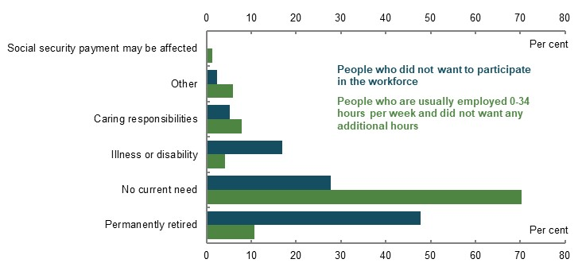
Note: Survey data is for 2016-17 and has been aggregated. ‘Social security payment may be affected’ is from ‘Welfare payments/pension/allowance may be affected’, ‘Other’ is any remaining results outside those listed in this note. ‘Caring responsibilities’ is ‘Caring for children’ and ‘Caring for ill/disabled/elderly person’. ‘Illness or disability’ is ‘Short-term sickness or injury’ and ‘Long-term sickness or disability’. ‘No current need’ is ‘No need/satisfied with current arrangements/retired from full-time work (for now)’. Permanently retired’ is ‘Permanently retired from full-time work/will not work full-time again’. Source: (ABS, 2017b).

Influence of eligibility ages for the Age Pension and superannuation
The Age Pension eligibility age is a strong signal or anchor for retirement. Retirement is concentrated around the age people are eligible to apply for the Age Pension but increases steadily beginning around preservation age (Chart 5A-8). An increasing minority choose to continue working at older ages.
    - Changes in labour force participation rate by age
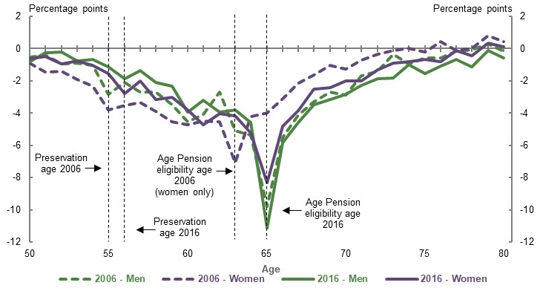
Note: This chart takes the proportion of people in the labour force at age 49, and then measures the incremental change in labour force participation rate at future ages. Source: Analysis of (ABS, 2006a; ABS, 2016a).
International evidence suggests a strong relationship between age of retirement and the ages at which social security retirement benefits become accessible (Gruber & Wise, 1997). In Australia, one study found increasing the Age Pension eligibility age by one year reduced retirement probability each year by approximately 10 per cent (Atalay & Barrett, 2012). Productivity Commission modelling showed increasing the Age Pension eligibility age from 67 to 70 increased participation rates for those at relevant ages by around 3-10 per cent (Productivity Commission, 2013a, p. 15). For further discussion on the factors that influence retirement decisions see 3E. Age of retirement.

Incentives to invest
Incentives in the retirement income system can influence how people invest their savings and whether they maximise their investment returns. Upon retirement, most people’s two largest assets are their principal residence and their superannuation (ABS, 2019k). Both have low effective marginal tax rates compared with other assets (Chart 5A-9).
    - Effective marginal tax rates for different asset classes
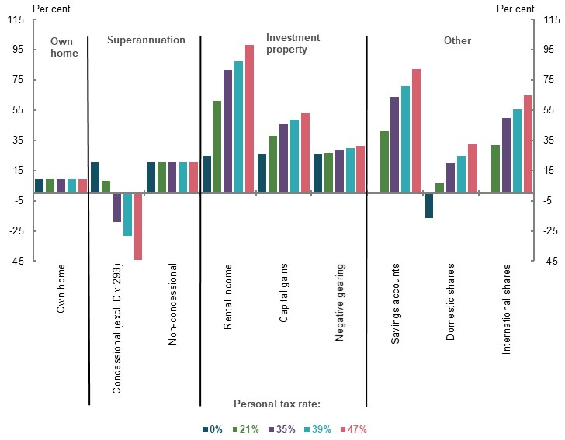
Note: This chart shows the effective marginal tax rates in Australia for several asset types for a 20-year investment. The calculation incorporates the effects of the personal income tax including imputation credit, capital gains discounts, Medicare Levy and superannuation taxes (except Division 293 tax). It also incorporates land taxes and stamp duties. It uses a baseline where people pay the full marginal tax rate on labour income but no further taxes on savings. Concessional tax rates on superannuation and annual rental losses on negatively-geared properties reduce total tax revenue and can generate negative effective marginal tax rates. For people on 47 per cent income tax for whom Division 293 tax applies, the effective marginal tax rate of concessional superannuation contributions increases from -44 per cent to -14 per cent. Effective marginal tax rates for superannuation are sensitive to the assumed length of investment, the assumed rate of inflation, and the assumed real return on investment. The effective marginal tax rate on non-concessional superannuation contributions reflects the tax rate applying to real returns, making it higher than the 15 per cent nominal tax rate. Source: Data provided by the Tax and Transfer Policy Institute for the review, 2020.

Investments in the principal residence
The retirement income system has some influence on decisions to purchase a home through both superannuation and Age Pension policy settings.
Superannuation interacts with home ownership in two ways:
- Superannuation and housing investments compete with each other for household savings, deterring investment in more liquid assets such as stocks or bonds. One study found having a mortgage marginally decreases the level of superannuation savings (Feng, 2018, p. 10). Another study and research commissioned by the review found the SG marginally decreases other household savings but has a positive effect on household net wealth (Ruthbah & Pham, 2020a; Connolly, 2007).
- The First Home Super Saver Scheme (FHSSS) allows people to save money for their first home inside their superannuation fund, using the concessional tax treatment of superannuation to save faster. This incentive’s effectiveness is unclear, with only 8,216 people accessing the FHSSS since its introduction in 2018. The average amount withdrawn was $12,882.
Several submissions said exempting the principal residence from the Age Pension assets test creates an incentive to invest more in housing than would occur if the principal residence was in the assets test. Although little evidence exists to show the significance of this incentive (see 3C. Home ownership status).
While the retirement income system affects incentives to invest in the principal residence, more influential drivers of investment in housing exist outside the system. These include financial incentives (e.g. capital gains tax concessions) that apply when most people make home purchase decisions, and non-financial factors (e.g. emotional security, stability and belonging) (Sheppard, et al., 2017).
Concentrating wealth in home ownership could lead to suboptimal outcomes. Historically, home ownership has generated good investment returns (CEPAR, 2019, p. 27). Housing inflation has contributed to wealth accumulation (Adkins, et al., 2019), benefiting retirees. However, owning a principal residence is not always the best investment option for retirement (Fox & Tulip, 2014; Masters & Price, 2019):
- Renters investing the equivalent of mortgage payments in other assets could be better off during periods when house prices are stable or falling.
- Retirees are often reluctant to sell their principal residence to fund retirement (see Consumption of housing equity, below).
- Retirees with large mortgage debt are vulnerable to negative economic shocks and more likely to cut back on spending (Price, et al., 2019) (see 2C. Maintaining standards of living in retirement).
Given most home owners have better retirement outcomes than non-home owners, many submissions raised equity concerns about excluding the principal residence from the Age Pension assets test (see 3C. Home ownership status).

Cohesiveness of the retirement phase
For the system to be cohesive, its retirement phase should support people in converting their savings into income. This is particularly important for superannuation given that compulsory savings and tax concessions exist to provide retirement income. Current retirement outcomes show savings are often not being used as income, with significant amounts left as unintentional bequests.
The complexity of decision-making at the point of retirement, relatively low levels of financial literacy and infrequent use of services such as financial advice contribute to many people making suboptimal decisions. People are more likely to rely on behavioural biases and rules of thumb when deciding how to spend their savings. This may lead to lower standards of living in retirement (see Default bias and anchoring, below).
For the retirement phase to be more effective, people need more assistance to navigate the system and get better outcomes; for example, through guided choice and system simplification.

Current retirement outcomes

Consumption of assets
In general, retirees do not consume their retirement savings. Net financial wealth (including superannuation but not housing) grows in retirement, apart from a decline associated with the GFC (Chart 5A-10). For age pensioners, this is true across all asset types (including superannuation, housing and other savings), regardless of wealth levels and whether they recently started or finished their retirement (Asher, et al., 2017). While this is a general trend, some age pensioners do consume more of their assets than others:
- Around 10 per cent of single age pensioners consumed 90 per cent of their assets in an eight-year period. A small number of them exhausted all their assets (Asher, et al., 2017, p. 585).
- Long-term singles (those who entered retirement single) and non-home owners who receive the Age Pension tend to consume their assets faster than other households (Asher, et al., 2017, pp. 600-601).
- Younger, wealthier retirees have slightly higher rates of asset consumption, decreasing with age (Asher, et al., 2017, p. 585) (see 2C. Maintaining standards of living in retirement).
    - Household net financial wealth by age cohort, excluding the family home, relative to 2005
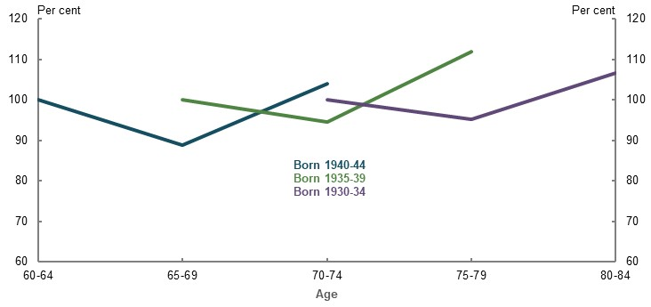
Note: Based on net financial wealth from the 2005-06, 2009-10 and 2015-16 iterations of the Survey of Income and Housing. Net financial wealth is total net wealth excluding the value of the principal place of residence (and related mortgage liabilities), personal effects and motor vehicles. Deflated by CPI. Source: (Daley, et al., 2018b).
As a result, when retirees die, most leave the majority of the wealth they had at retirement as a bequest (Daley, et al., 2018b, p. 32; Reeson, et al., 2016). Data provided by a large superannuation fund found members who died left 90 per cent of the balance they had at retirement. Another study found a similar result: at death, age pensioners leave around 90 per cent of the assessable assets they had at the point of retirement (Asher, et al., 2017, p. 585). This suggests that retirees tend to consume only the income derived from assets and not the assets themselves.
The evidence suggests the Age Pension means test taper does not have a strong effect on people drawing down or consuming their assets. Department of Social Services administrative data shows age pensioners generally maintain their assessable assets well into their later years, with a large proportion increasing or maintaining their assets holdings. This result occurred both when the assets test taper was reduced to $1.50 (from 2007 to 2016) and at its present rate of $3.
Consumer surveys and anecdotal material presented in submissions support these findings and reveal that Australian retirees are keen to preserve their savings throughout retirement. One stakeholder noted:
‘…retirees express concern or distress about the difficulty of living off the earnings from their retirement lump sums. The suggestion that they should be drawing down on the lump sum to improve their income is strongly resisted, even when they are of an advanced age and have a significant lump sum.’
(COTA, 2020, p. 28)
This lack of consumption of retirement assets is consistent with studies conducted in the US and the Netherlands (Ooijen, et al., 2015; Dynan, et al., 2004).

Draw down of superannuation assets
Maintenance or growth of balances in retirement occurs despite policy settings in the retirement phase that are designed to influence drawdown behaviour.
- The Age Pension means test. The test is designed to encourage people to use their own resources before ‘calling on the Government for support’ (Department of Social Services, 2015). This encourages use of assets in retirement by withdrawing support for people as their level of assets increase. Retirees affected by the assets test who draw down their superannuation and other financial assets more quickly receive increased Age Pension support over their retirement. Australia is unique in having two different Age Pension means tests: one based on assets and the other one is income (see 1B. Design of Australia’s retirement income system).
- Superannuation drawdown rules. Each year, people are required to withdraw a certain percentage of their superannuation, based on their age, to maintain their earnings tax exemption in retirement. The percentage that must be withdrawn each year increases with age. The purpose of these rules is to ensure that savings receiving the earnings tax exemption are used for retirement income purposes and not for estate planning purposes (The Treasury, 2016c, p. 3). The rules are not designed for people to optimise their retirement income.
The higher a person’s superannuation balance, the more likely they are to draw down at the minimum rate (Chart 5A-11). Drawing down at the minimum rate is likely to leave a large balance at life expectancy (currently around 85). The Australian Government Actuary projected the nominal superannuation balance at death for someone who died at or before age 90, and drew down at the minimum rate, would be larger than their balance when starting retirement (Treasury 2016, p. 5).
People on lower balances draw down at much higher rates than those with higher balances across all ages in retirement. This is consistent with findings that most people who take a lump sum from superannuation have low balances (Productivity Commission, 2015b).
    - Median superannuation drawdown rates, by age group and asset level
All balances | Balances over $100,000
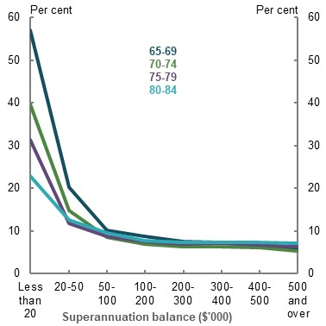 | 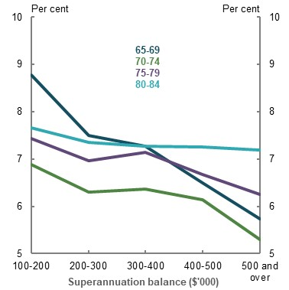
Source: Analysis of Rice Warner data, 2018.
Superannuation assets have tended to grow in retirement (Chart 5A-12), instead of declining as would be expected if assets were funding retirement. This means investments have tended to equal or exceed drawdown rates.
    - Average superannuation balances, by age cohort
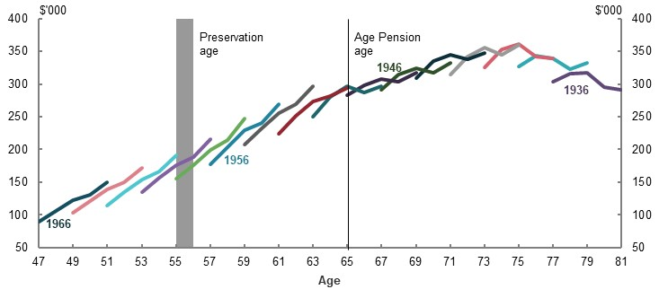
Note: Values are in 2017 dollars deflated by CPI. ALife data, 10 per cent sample. Data for 2013 to 2017, members with balances above zero dollars at 30 June 2013. Includes every second one-year birth cohort born 1936-66. Source: (Polidano, et al., 2020).
While the tax data shows a drop in the average superannuation balances of people in the oldest cohort born in 1936 (Chart 5A-12), Department of Social Services analysis of payment data relating to age pensioners does not show any significant change in assessable assets in the five years before death.
Low consumption of superannuation precludes higher living standards. People could have a higher standard of living, either in retirement (by consuming more) or during their working lives (by saving less).
Reflecting the retirement income system’s intent to generate income for retirement, most adequacy analysis assumes superannuation assets are used in full or large part in retirement (Australia’s Future Tax System Review, 2009, p. 68; Dawkins, 1992; Grattan Institute, 2020; Rice Warner, 2019c; The Treasury, 2002)
If superannuation was consumed more efficiently in retirement, most people would have higher replacement rates. The median earner’s replacement rate is up to 19 percentage points higher if they consume their superannuation assets in retirement, relative to drawing down at minimum rates (see Chart 2C-18 in 2C. Maintaining standards of living in retirement).
Drawing down and consuming assets is the most effective way for people to achieve adequate retirement incomes. It is especially important during periods of significant economic shocks and financial market volatility, such as the COVID-19 Pandemic. With ultra-low interest rates and reduced dividend payments, returns alone cannot be expected to generate sufficient income; retirees will need to draw down savings. Drawing down must be combined with strategies to effectively manage investment and sequencing risks (see 2C. Maintaining standards of living in retirement).
Without a change to retirees’ drawdown behaviour, bequests from superannuation will grow. Rice Warner projections show average death benefits from superannuation for people aged 65 and over are expected to grow in real terms from an average of $190,000 in 2019 to more than $480,000 by 2059 (Chart 5A-13). Aggregate death benefits are projected to increase from around $1 of every $5 paid from the superannuation system in 2019 to around $1 of every $3 paid out by 2059. Bequests from housing assets will also increase if housing assets continue to grow and retirees avoid drawing on their housing wealth.
    - Projected average superannuation death benefits for population aged 65 and over
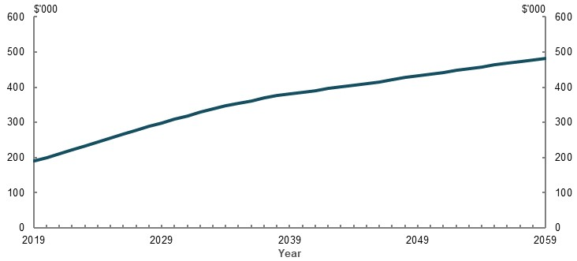
Note: Values are in 2019 dollars, deflated by CPI. Source: Analysis of Rice Warner estimates for the review.
          - Bequests and low consumption in retirement
Bequests do not appear to be a high priority for retirees. Despite the significant number of bequests, several surveys found ‘leaving a bequest’ is one of the least important retirement savings objectives for people (National Seniors Australia and Challenger, 2017; Alonso-Garcia, et al., Forthcoming; Hobman & Reeson, Forthcoming; Mercer, 2019a). One study found bequests ranked 18 out of 19 possible savings motives in retirement (Alonso-Garcia, et al., Forthcoming, p. 27). Similarly, bequests ranked last out of nine possible attributes for savings in a consumer group survey (National Seniors Australia and Challenger, 2017, p. 9). They ranked among the bottom three desired retirement income product features in another survey (Mercer, 2019a, p. 4).
The bequest motive may be different for the principal residence. Some researchers suggested the principal residence serves a dual purpose: allowing people to fund out-of-pocket aged care and health expenses as needed and, if not needed, leaving a bequest (CEPAR, 2019). In a Productivity Commission survey (2015a, p. 14), 71 per cent of respondents said they saw the family home as a safety net for adverse events, and 44 per cent said they wished to pass the family home on to their children.

Consumption of housing equity
Retirees tend to avoid using housing wealth to fund their retirement, despite it being their largest store of wealth (Whelan, et al., 2019). Yet, research shows Australians are increasingly likely to borrow against the value of their home for other purposes, such as purchasing investment property (Ong, et al., 2019).
The Government has two programs to encourage the use of housing equity to fund living costs in retirement (see 1B. Design of Australia’s retirement income system).
- Pension Loans Scheme. Take-up of this scheme, while increasing, remains low (Table 5A-2). Some stakeholders suggested the name of the scheme and the way eligibility for the scheme is described undermine take-up, as non-pensioners may not understand they are eligible.
- Downsizer contribution scheme. Between 1 July 2018 and 17 January 2020, more than 9,000 people made downsizer contributions, with an average contribution of $230,000.
The existence of many ‘asset rich, income poor’ retirees on the Age Pension suggests home equity release has significant potential to help support retirement incomes (see 3C. Home ownership status).
      - Use of the Pension Loans Scheme
 | June 2018 | March 2020
Participants | 642 | 2,288
Number of new loans | 80  (six months prior) | 1,500  (nine months prior)
Average debt | $45,366 | $18,884
Largest debt in scheme | $345,863 | $423,250
Source: Department of Social Services payment data.
Despite these Government initiatives, and the potential benefits of equity release products (Box 5A-5) especially for retirees who are asset rich and income poor, retirees still tend to draw less on home equity than other assets. This is because they:
- Want to use their home equity to fund future expenses such as aged care services (Chart 5A-14) (Productivity Commission, 2015a)
- View mortgage equity products as inherently risky (Ong, et al., 2013, p. 2) and do not understand the nature of Government programs such as the Pension Loans Scheme (Davis, 2020)
- Wish to ‘age in place’, lack suitable downsizing options or want to pass on their principal residence to heirs (CEPAR, 2019; Productivity Commission, 2015a, pp. 68-69)
- Are put off by transaction costs, such as stamp duty, and the difficulty of moving (Productivity Commission, 2015a)
    - Circumstances in which retirees would draw down the equity in their home, by age
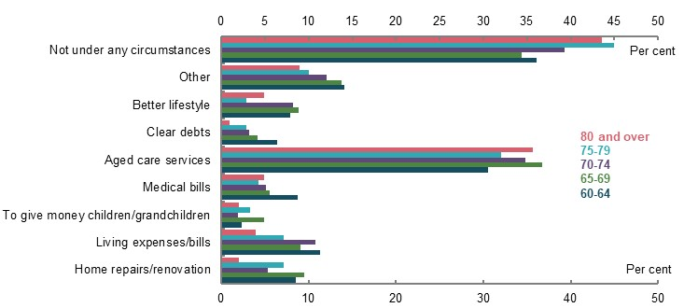
Source: (Productivity Commission, 2015a, p. 58).
          - The home equity release market
Retirees can access the equity stored in their home by downsizing or through different types of equity release products, including:
- Reverse mortgages. The most common equity release product, where the capital accessed and accumulated interest are paid back when the owner sells the home (Productivity Commission, 2015a)
- Home reversion. Where a retiree sells a proportion of the future value of their principal residence while they continue to live there. The share is sold for a discounted portion of the market value. The household receives a lump sum and keeps the remaining proportion of the home equity (Moneysmart, 2020)
- Home equity loans. This is essentially a mortgage. Traditional home equity loans have a repayment term, just like regular conventional mortgages. People make regular, fixed payments covering both principal and interest. As with any mortgage, if the loan is not paid off, the property could be sold to satisfy the remaining debt
      - Factors constraining Australia’s home equity release market
Demand factors | Supply factors
The value of the principal residence is excluded from the Age Pension means test. If accessing the equity released in the principal residence affects a retiree’s Age Pension eligibility, this option is less attractive than drawing on other assets. | Lenders have high barriers to entry, including capital adequacy regulations, difficulties in obtaining wholesale funding and low interest rates squeezing profit margins (ASIC, 2018c, p. 53).
People generally have negative perceptions about home equity release products, believing they take advantage of vulnerable people or contribute to elder abuse (ASIC, 2018c). | Anecdotal evidence suggests potential providers are concerned about reputational risks if retirees release equity in their principal residence without informing beneficiaries.
The private market for home equity release is still relatively small compared to the 1.9 million home-owning households aged over 65 in 2017-18 (ABS, 2019n). At the end of 2014, reverse mortgages totalled around 40,000 (Productivity Commission, 2015a). Anecdotal evidence suggests the market may have since dropped to less than 30,000. Australia has a limited number of reverse mortgage providers, with just two writing 80 per cent of new loans from 2013-2017 (ASIC, 2018c). Other private equity release products are available, including debt-free products such as fractional property investment, but these have even smaller take-up.
Other countries have seen stronger growth in the equity release market. In particular, the UK had rapid growth in equity release products across all regions (Equity Release Council, 2019), albeit off a low base. Market innovation has played a role in this development (Rozario, 2012), as well as policy initiatives. For example, in the UK an inheritance tax of 40 per cent of the value of an estate worth more than £325,000 (more than A$550,000) may encourage capital draw down.

Risk and uncertainty
Low consumption of assets in retirement is partly the result of people insuring themselves against risk and protecting themselves from uncertainty. Retirement involves complex risks and uncertainties, which people often struggle to understand:
- Market risk, including the risk of negative returns.
- Longevity risk. The risk of running outliving one’s savings, which tends to increase if returns are invested conservatively to manage market risk.
- Inflation risk. The risk of living expenses increasing more than expected.
- Sequencing risk. The risk of converting assets to income during an economic shock, like the GFC or the COVID-19 Pandemic.
Choosing a suitable retirement income product and drawdown pattern involves understanding and trading off these risks, as well as future and present consumption. This sort of complex risk calculation is normally done by actuaries, who are trained in understanding and calculating complex risks. Many people overestimate their likely future spending on health and aged care because they do not know or understand the value of in-kind support the Government provides for these services (see 4. Sustainability).

Longevity risk
Retirees want to be debt-free and feel financially secure in retirement (Orford Initiative, 2019).
Many retirees are concerned they will run out of money before death (Rees, et al., 2018), even though most die with a substantial proportion of their wealth intact. This could be because people misunderstand how compounding affects savings growth (savings invested in superannuation do not grow linearly, but exponentially) and do not take into account earnings when they consider their savings (McKenzie & Liersch, 2011). Emphasising that the Age Pension protects people from longevity risk could help to ease some of these concerns. However, many retirees are also concerned about the stability of Age Pension settings (see Uncertainty and precautionary savings, below).
Income streams that provide longevity risk management can be funded publicly (the Age Pension) or privately (annuitised products or defined benefit pensions). People aged 55 and over say they value longevity risk management features in retirement income products more than other retirement income product features (Chart 5A-15), but they generally do not invest in products that have these features.
    - Importance of retirement income product features
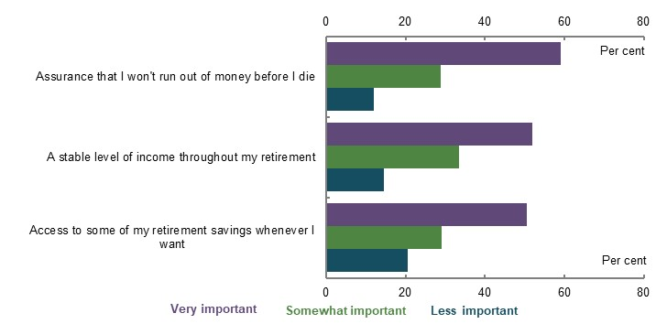
Note: More than 1,000 survey respondents aged 55 and over. Source: (Mercer, 2019a, p. 3).
At June 2019, around 83 per cent of accounts in the pension phase were invested in account-based pensions that do not manage the risk of running out of money in retirement. Most of the remaining assets are invested in term annuities, which only provide a guaranteed income stream for a limited period and therefore do not manage longevity risk beyond the term of the product.
Retirees may be self-insuring against longevity risk and only consuming the minimum necessary in order to avoid running out of savings (Financial System Inquiry, 2014, p. 120). Explanations for this behaviour include the current framing of annuities and their complexity, perceived lack of value for money, and the role of the Age Pension in providing a constant income stream (see Box 5A-15). Other contributing factors are the role of funds in only offering account-based pensions, as well as the incentives for financial advisers to recommend products that require regular monitoring and subsequent financial advice.
Longevity risk protection should encourage people to consume their other assets. However, evidence from the US suggests even people with guaranteed, constant income streams are unlikely to draw down their non-pension assets to generate income. Evidence from the US shows defined benefit recipients consume less of their non-pension assets than other retirees (Banerjee, 2018).
These findings suggest retirees are still reluctant to draw down their assets, even if they have a high degree of longevity risk protection. It appears retirees may be influenced by a desire not to spend their assets (asset-framing bias). Concern about outliving savings is unlikely the sole driver of current drawdown behaviour.

Uncertainty and precautionary saving
Retirees may also be managing the risk of the need to fund lump-sum expenditure by avoiding drawing on their retirement savings. Some academic literature and submissions suggest fears around aged care costs could hold retirees back from drawing down on their assets in retirement (Daley, et al., 2018b; Productivity Commission, 2015a; Actuaries Institute, 2019, p. 31; CEPAR, 2019; Asher, et al., 2017, p. 595). Retirees are more likely to draw down their savings in countries with greater public coverage of aged care and health care, than in countries like Australia, where retirees fund some of their own aged care costs (Daley, et al., 2018b, p. 33). However, it is unclear whether there is a causal link, or whether the difference in behaviour is a result of cultural or attitudinal factors, such as different attitudes towards relying on social security in different countries.
Health and aged care costs are heavily subsidised in Australia. Most people’s expenditure on these items does not increase significantly during retirement (see Appendix 6A. Detailed modelling methods and assumptions and 4. Sustainability). But households may not be aware of the extent of Government subsidies, especially given the complexity of aged care means-testing arrangements (Box 5A-6). Researchers have argued that many retirees do not realise the value of the aged care safety net (CEPAR, 2019, p. 34).
In contrast, aged care literacy and concern about aged care are low (Mercer, 2019a; Rees, et al., 2018; Aged Care Financing Authority, 2018, p. 35) (Chart 5A-16) and many people may not consider aged care costs when deciding whether to draw down their assets. Surveys suggest many people are not interested in finding out more to help them plan for retirement and would prefer not to think about aged care (Aged Care Financing Authority, 2018, pp. 32-33; McCallum, et al., 2019, p. 23). Another survey found only 25 per cent of respondents were concerned about covering aged care costs (Mercer, 2019a). This remained consistent even as people aged.
    - How informed people feel they are about aged care costs and the steps involved
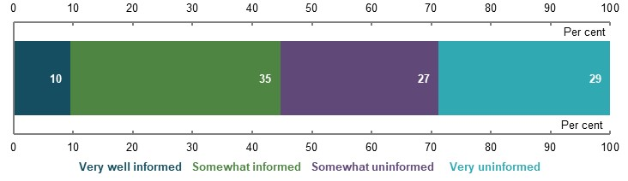
Note: Respondents aged over 40. Source: Investment Trends October 2019 Retirement Income Report.
People’s confidence in their ability to fund aged care costs appears to be linked to household income and home ownership. Households with incomes above $50,000 were more likely than those with lower incomes to have confidence in their ability to pay aged care costs (Aged Care Financing Authority, 2018, p. 34). Home owners without a mortgage were more confident than those with a mortgage or renting (Aged Care Financing Authority, 2018, p. 34).
A National Seniors survey found that, for those who had considered how to fund aged care, their principal residence was the main source of funding (McCallum, et al., 2019, p. 23). However, only a minority of retirees said they would consider drawing on the principal residence for aged care or health expenses (Productivity Commission, 2015a). Aged care costs were the most reported reason a person would draw down home equity (almost 40 per cent) (Chart 5A-14). However, the same proportion said they would not draw down under any circumstances. Some retirees may sell the principal residence to pay a Refundable Accommodation Deposit (or RAD) and/or to fund their aged care expenses (Box 5A-7).
While aged care costs might explain some of the reticence to draw down on housing assets, it is unlikely to be a major driver of the low draw down of superannuation assets.
          - Aged care — types and means testing
Aged care services and costs depend on the care type retirees choose:
- Commonwealth Home Support Program. Provides low-level support at home. Services include access to nursing, meals, home modification and transport. Care is not formally means tested. People may pay a co-contribution payment, which varies based on the services required and the fees set by providers.
- Home Care Packages. Provides higher-level home support for those with more complex care needs. Four levels of packages are available based on the person’s care needs. Most people pay a basic daily fee, depending on their package level ($9.63 to $10.75 per day). Some are required to pay an income-tested care fee of up to $30.86 per day (Chart 5A-17).
    - Income test for home care

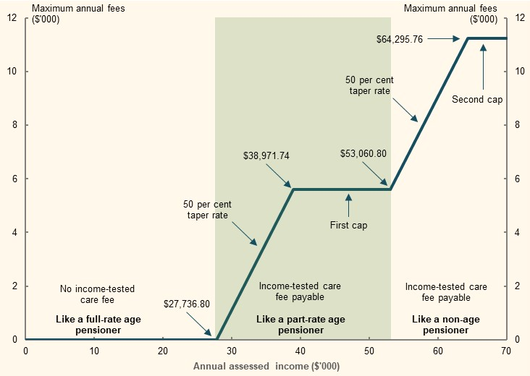
Source: Department of Health.
- Residential care. Provides full-time care and accommodation for people who are no longer able to live independently in their home. All residents pay the basic daily fee (set at 85 per cent of the single base rate of Age Pension) to cover daily living costs, such as meals, cleaning and laundry. People may also pay a means-tested care fee and/or fully or partly cover their accommodation costs (see Chart 5A-18). Many residential facilities also offer optional ‘extra’ or ‘additional’ services at a cost to the resident.
    - Means test (assets and income) for residential care
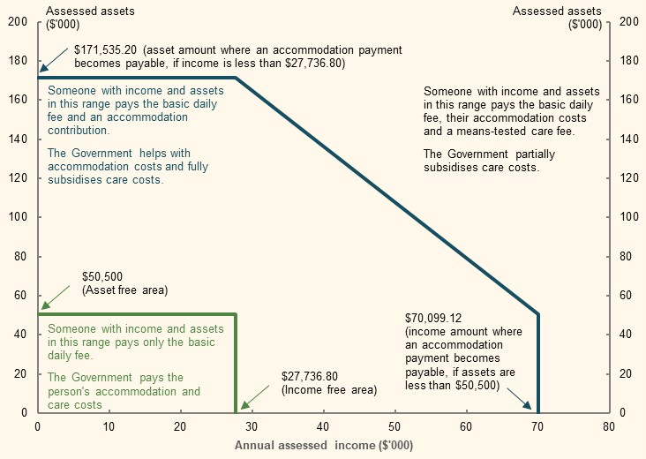
Source: Department of Health.
To assess assets for means-tested care fees, the value of the principal residence is capped under the means test unless the property is:
- Occupied by a protected person (a partner, dependent child or eligible carer living in the home with the resident for at least two years), in which case the value is not included at all
- Sold, at which point the full value is included
      - Means testing of residential aged care
Annual income ($) | Assets  ($) | Area in diagram above | Basic daily fee ($) | Means-tested care fee  ($) | Accommodation payment
Below 27,737 | Below 50,500 | Inside green box | 52.25 | Nil | Nil
27,737 to 70,099 (50% taper) | 50,500 to 171,535 (50 per cent taper) | Outside green box, inside blue line | 52.25 | Nil | Partial payment (Government subsidy available)
70,099 and above | 171,535 and above | Outside blue line | 52.25 | Up to 259.15,  up to an annual cap of 28,087.41 per year or lifetime cap of 67,409.85 home and residential care combined | Full cost payable
Source: (Department of Health, 2020a).
Fee caps
Annual ($28,087.41) and lifetime ($67,409.85) caps on combined means-tested care fees in home and residential care currently protect those who may require aged care services for long periods of time, from very high costs. These caps are a form of social insurance. Both the Aged Care Financing Authority and the Legislated Review of Aged Care 2017 recommended the caps be removed (Aged Care Financing Authority, 2019; Tune, 2017).
Currently, only a small number of people (1.8 per cent of people in residential care, 2018-19) reach the annual cap, and even fewer reach the lifetime cap (0.8 per cent of people in home and residential care in 2018-19).

          - Using retirement income and assets to cover aged care costs
The costs associated with residential care accommodation can be paid as a refundable lump-sum deposit (RAD), as a non-refundable ongoing Daily Accommodation Payment (DAP) or a combination of both. Residential aged care providers often prefer RADs because they can be used for capital financing. But providers can no longer require consumers to pay a RAD. Increasingly, people are choosing to pay their accommodation fees daily, rather than as a lump sum (Aged Care Financing Authority, 2019). In 2017-18, 73 per cent of the aged care population paid their accommodation fees by either a DAP or a combination of the DAP and RAD (Aged Care Financing Authority, 2019, p. 120).
People have a range of options for funding aged care, depending on their total means and how their assets are invested. Stakeholders considered equity release and private insurance were underutilised options that are likely to be more efficient than precautionary saving. Some academics are currently exploring the viability of long-term care insurance in Australia (National Seniors Australia, 2020; CEPAR, 2019, p. 32).
If people are able to meet all their aged care costs using regular payments, having a steady income stream may give them a greater degree of comfort that they can meet these costs. Private income streams can be created by drawing down financial assets (such as superannuation), using housing assets through equity release, or (if available) purchasing long-term care insurance.
However, most people in home and residential care are full-rate Age Pension recipients. In June 2016, 82 per cent of people in home care and 60 per cent of new residential care admissions were full-rate Age Pension recipients (Tune, 2017, p. 160). As the superannuation system matures and people retire with more savings, future generations may be better able to contribute to their aged care costs.

Complexity and defaults
As well as the risks and uncertainty already discussed, retirement involves multiple decisions and difficult trade-offs. At retirement, people face decisions around:
- When to retire
- Whether to keep their money in the superannuation system
- How to invest their savings
- How to draw down their savings
- Their future need to meet any lumpy expenditure
Retirees have very little opportunity to learn from past experience when making these decisions, and it may be some time for the consequences of decisions to be realised. This makes it almost impossible for retirees to determine an optimal retirement income strategy on their own (Box 5A-8). Very few people seek help when making decisions (see Improving outcomes, below).
Interactions with other systems make the retirement income system more complex. The retirement income system interacts with many other different systems and rules in complicated ways, including:
- The aged care system. Home support, home care and residential care each have a different means test, which is different again from the Age Pension means test (Box 5A-6)
- Housing. People may need to navigate the Age Pension means test, the Pension Loans Scheme and the downsizer contribution in addition to tax rules such as stamp duty, capital gains tax, land tax and other housing rules
- Tax rules. Many different tax rules apply, such as to Transition to Retirement Income Streams, offsets and rebates, contributions caps, different Medicare Levy thresholds and the tax-free parts of bona-fide redundancy and approved early retirement scheme payment limits.
- The social security system, including Commonwealth Rent Assistance, FTB, Mobility Allowance, Remote Area Allowance and concession cards.
          - Complexity leads to misunderstandings and misconceptions
The views below represent perspectives observed in press articles, surveys and some submissions. These concerns are real and affect how people behave. However, they are generally not supported by evidence.
Adequacy of retirement income/retirement expenditure needs
- ‘I need to preserve my assets in case I get sick or need aged care.’
- ‘I will need to pay for most of my health costs in retirement.’
- ‘I need $1,000,000 in superannuation for an adequate retirement income.’
Retirement income products and investment strategies
- ‘The best investment strategy in retirement is very low risk, such as cash.’
- ‘Investing in real estate is a better investment strategy for retirement.’
Age Pension
- ‘The Age Pension is earned during working life. Taxpayers “pre-pay” for it through their taxes.’
- ‘The Age Pension will become unaffordable. Most people in the future won’t receive it.’
Superannuation
- ‘The minimum drawdown rate is what the Government recommends.’
- ‘If I withdraw my money from superannuation, I must spend it.’
- ‘I should only draw down the income earned on my assets — not the capital.’
In complex situations, people get cognitive or choice overload and disengage or rely on shortcuts to help them make decisions, instead of assessing the options to make the best decision (Productivity Commission, 2018a). In complex situations people tend to:
- Rely on heuristics (rules of thumb) and pick options they understand (Benartzi & Thaler, 2007)
- Stick with what they know
- Stick with the default option
- Follow others
- Procrastinate, disengage or avoid making the decision
- Be prone to misleading advice (Reeson & Dunstall, 2009)
At retirement, in the face of complexity, people fall back on defaults, even if these defaults were not designed for the purpose people use them. For example, many people rely on ‘easy’ options such as selecting an account-based pension and withdrawing at minimum draw down rates, or withdrawing their superannuation and placing it in a bank account. Selecting a good option involves time, money and effort, and requires giving retirees more support. The behavioural biases particularly relevant to current decision-making in retirement are default bias, anchoring and asset or ‘nest egg’ framing.

Default bias and anchoring
Many decisions in retirement are explained by defaults and people’s reliance on rules of thumb (Bateman, et al., 2017). Research indicates retirees are strongly influenced by the statutory minimum drawdown rules:
- When people were told about minimum drawdown rates, they reduced their intended draw down from superannuation (Hobman & Reeson, Forthcoming).
- People were willing to change their spending to match minimum drawdown rates (Alonso-Garcia, et al., 2017). This is consistent with research showing decisions at retirement are influenced by defaults (Bateman, et al., 2017).
- More than half of retirees older than 65 draw down at the minimum rate (Rice Warner, 2019b), and the median withdrawal amount for all ages is just above the minimum. At age 60, drawdowns bunch around the minimum and maximum amounts (Balnozan, 2018).
- One large superannuation fund reported around half of its members on an income stream chose a fixed nominal amount above the minimum, while the other half selected the minimum drawdown amount. Studies using APRA data found a similar pattern (Balnozan, 2018).
This suggests the minimum draw down rules may be acting as a ‘default’ option for many people when they select a draw down amount. For some, it is the easiest option to pick. For others, it is an ‘anchor’; a reference point that informs their final decision on a draw down amount. The exception is the significant majority of people with low balances who withdraw larger amounts than the minimum (Chart 5A-11).
In addition to the difficulty of managing complex risks and uncertainties, most households need to combine multiple income sources to generate their retirement income. A typical retiree couple household combines at least four different income sources: the Age Pension, two superannuation accounts and assets outside of superannuation. Evidence suggests people prefer to have a stable income stream in retirement (Mercer, 2019a). To plan a stable income, people need to consider and integrate all income sources.
Current default settings in retirement contribute to income instability. The Age Pension means test, when coupled with minimum superannuation draw down requirements, does not lead to stable income for those affected by the assets test (Chart 5A-19). The income it delivers also tends to peak relatively late in retirement, at ages 85-90. This does not align with observed patterns of retiree consumption, which decline through retirement (see Appendix 6A. Detailed modelling methods and assumptions).
    - Annual retirement income if an account-based pension is drawn down at minimum drawdown rates, single home owner
$400,000 superannuation balance at retirement | $800,000 superannuation balance at retirement
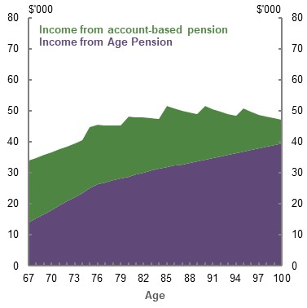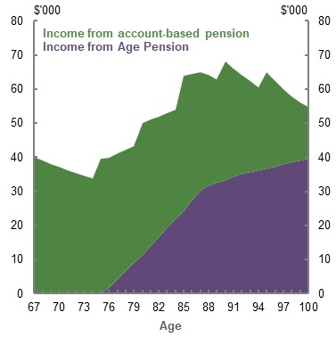
Source: Cameo modelling undertaken for the review.

‘Nest egg’ framing
People are primed to save for retirement during their working lives, such as through compulsory superannuation. But, when they retire, they struggle with the concept that their savings are meant to be consumed to fund their retirement (Banerjee, 2015; Reeson, et al., 2016). People are primed to consider their savings are for saving, and not for spending. This ‘savings mindset’ is reinforced by the fact that superannuation is often described as a savings balance or even a ‘nest egg’, instead of in income terms (e.g. $500 a week). Evidence from the US suggests retirees are more reluctant to spend savings that they see as lump sums or investments, rather than as an income stream (Brown, et al., 2008; Madamba & Utkus, 2016). Comments from an Australian consumer focus group support this finding:
‘At the moment I would be terrified to draw down on the super, I know we have a lot more super than most people, but we need it’ (female, retired 20 years).
‘Big bills, I have an overdraft with the bank and pay for it out of that and then pay that back gradually over the year. Saves using the capital’ (male, retired 22 years).
(McCallum, et al., 2019, pp. 17-18)
Another consumer focus group found people have three simple ideas to manage their finances in retirement: pay off the house, receive the Age Pension and hold on to all wealth (Orford Initiative, 2019, p. 13).

Improving outcomes
The system should support people to make good decisions and get better outcomes in retirement. System cohesion at retirement would be improved if people could:
- Combine their income sources with minimal effort
- Consume more of their savings to support their standard of living in retirement
Both of these involve helping people to make decisions in the face of risks and uncertainties, and choose more optimal outcomes rather than relying on behavioural biases or inertia.
Stakeholders suggested a number of ways retirement outcomes could be improved:
- Expressing retirement income projections as an income stream may help people overcome asset framing of retirement savings.
- Increasing financial literacy, if people are willing to engage, would help people make better decisions.
- Providing guidance and financial advice about retirement options and trade-offs would reduce the amount of complexity people have to face.
- Offering a guided choice framework to help people make decisions would improve outcomes for those who would otherwise rely on defaults, such as the minimum drawdown rates.
- Simplifying the system.

Retirement income projections
Projections or estimates of a person’s retirement income, which focus on future income streams rather than lump sums, can help people plan for their retirement. Specifically, they may help people to think about superannuation in terms of income, rather than an asset (Box 5A-9). The framing issue could also be overcome if converting savings into income was a default part of the system; for example, if people used part of their contributions to superannuation to pre-purchase an income stream, rather than to increase their savings balance. This would be similar to the situation with some defined benefit pensions, where people contribute to a right to an income stream.

          - Retirement income projections and calculators
Presenting information in a relatively simple manner can improve understanding and reduce cognitive load (Hiscox, et al., 2017).
Retirement income projections indicate the amount of income or the superannuation balance a person will have at retirement while they are in the process of saving. Projections are sent to members through periodic statements by their superannuation fund to help people plan for retirement. If presented in terms of income, projections could also overcome framing retirement savings as a ‘nest egg’.
While evidence suggests income projections increase pre-retirement engagement with superannuation (Smyrnis, et al., 2019), their impact on drawing down assets in retirement has not yet been tested.
The Government has been working on a framework to encourage the use of retirement income projections and to ensure the projections are presented on a consistent basis to avoid confusing people.
Similar to retirement income projections, retirement income calculators are available on fund websites. They allow people to calculate their retirement income by entering their own information. But current calculators are limited to calculations of expected Age Pension income and suggested superannuation withdrawals. Also, the assumptions used are not as closely regulated as retirement income projections.
Because they offer long-term estimates, assumptions are critical to the effectiveness of both calculators and projections. To help typical people balance their current and future incomes, default assumptions must be reliable and neither overly conservative nor optimistic. The assumptions needed for these calculators and projections include future rates of return on investment, expected Age Pension income and benchmark retirement income. There is a role for regulation in ensuring the assumptions used in all tools are reasonable and consistent.
The ASIC Retirement Planner on the MoneySmart website, which helps people calculate their superannuation and Age Pension income, was used by 6 per cent of the population aged 45-65 in 2019.

Financial literacy
Lower financial literacy is correlated with:
- Lower superannuation balances
- Lower willingness to take financial risk
- Shorter savings horizons
- Being less likely to set up a retirement plan
- Being less informed about pension rules
- Paying higher investment fees
- Not diversifying pension assets (Lusardi & Mitchell, 2014; Preston, 2020)
However, limited evidence exists that programs aimed at improving financial literacy are effective. One meta-analysis of the international literature found that interventions to improve financial literacy explained only 0.1 per cent of the variance in financial behaviours studied, and that even extensive education programs had negligible effects on financial behaviour 20 months on from the time of intervention (Fernandes, et al., 2005). A review of the international literature concluded that the results of financial education interventions are highly variable (Beshears, et al., 2018, p. 224). The Productivity Commission recommended Australian financial literacy initiatives be subject to formal, independent evaluation for funding to continue (Productivity Commission, 2018a). In 2018, ASIC switched from a National Financial Literacy Strategy to a National Financial Capability Strategy and is now finalising a monitoring and evaluation framework.
Qualitative research done for a consumer group indicated that people did not want to be educated about superannuation; instead, they wanted assistance in making decisions (Super Consumers Australia, 2020, p. 23). Similarly, a joint paper by ASIC and the Dutch Authority for Financial Markets found that product disclosure has not solved the complexity of financial markets. Firms providing mandatory information has not necessarily resulted in informed consumers and often does not correlate with better consumer outcomes (ASIC and the Dutch Authority for Financial Markets, 2019a).
This suggests that financial literacy initiatives should not be relied on to improve engagement and retirement outcomes, given the difficulty of improving financial literacy. Financial advice and guidance may be more likely to improve decision-making.

Financial advice and guidance
Providing assistance to people at retirement could help them understand their options, make better decisions and get better outcomes. This assistance can come in the form of regulated financial advice (see Box 5A-10 for specific definitions) offered by a financial adviser (unaligned or aligned with a superannuation fund) or through guidance.
Most people do not seek financial advice at retirement. Around 26 per cent of 55-64 year olds seek financial advice at retirement (Adviser Ratings, 2019). Barriers to seeking financial advice (Chart 5A-20) are outlined below.
    - Barriers to seeking financial advice
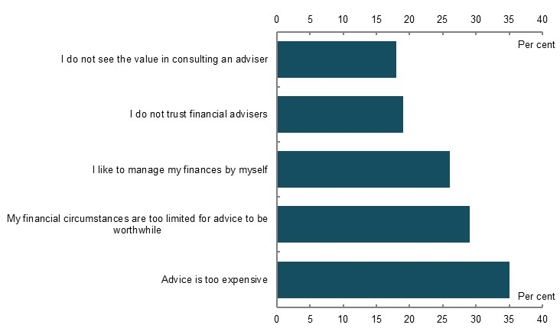
Note: 2,545 survey participants from an online survey. Source: (ASIC, 2019b, p. 7).
- Cost. People are unwilling to pay for the full cost of personal financial advice. One survey found consumers were willing to pay no more than $500 for comprehensive personal financial advice, (Rice Warner, 2019a, p. 25) but a comprehensive retirement plan costs around $2,500 to $5,000 (Rice Warner, 2020, p. 9). Personal financial advice costs may increase in future as a result of changes aimed at improving the quality of advice, including increased professional standard requirements; changes arising from implementing the Hayne Royal Commission recommendations; and higher costs of professional indemnity insurance. However, technology may drive costs down in the future.
- Limited finances. People with few assets and simple financial affairs do not consider that they need comprehensive financial advice (ASIC, 2019b).
- Lack of trust. Almost half of those surveyed by ASIC thought advisers were more interested in helping themselves than their clients. Thirty-seven per cent thought advisers did not have their best interests at heart (ASIC, 2019b, p. 8).

          - What is financial advice?
Comprehensive or full personal financial advice
Comprehensive advice, otherwise known as full personal financial advice, is provided by a registered financial adviser who is licensed or authorised to provide such advice. These financial advisers must comply with a number of obligations, including the best interests duty, giving a Statement of Advice and not accepting conflicted remuneration.
The definition of personal financial advice can be ambiguous. Technically, it is defined as financial advice that takes into account an individual’s personal circumstances or advice where a reasonable person might expect the adviser to have taken their personal circumstances into account (Commonwealth of Australia, 2001). This is generally the costliest form of advice.
Around 75 per cent of superannuation funds offer access to comprehensive financial advice, and around 50 per cent offer this advice in-house (others use related or contracted parties) (Rice Warner, 2019a, pp. 21-22). Currently, costs related to financial advice on superannuation may be deducted from the person’s superannuation account. However, the Hayne Royal Commission recommended banning the deduction of financial advice fees from MySuper accounts.
Scaled personal financial advice
Personal financial advice ranges from comprehensive to ‘scaled advice’. Scaled advice is a term often used to describe personal financial advice that is limited in scope; for example, financial advice that focuses only on whether a person should change their superannuation investment strategy (and does not, for instance, also consider whether their existing fund remains the most appropriate). The same regulations apply to scaled financial advice as full personal financial advice.
ASIC has indicated that all types of advice can be scaled, including advice about complex issues and that scaled advice can include advice on a single topic or multiple topics. Scaled advice is not lesser quality advice (ASIC, 2012a, p. 9). Around 85 per cent of superannuation funds offer single issue or scaled financial advice (Rice Warner, 2019a, p. 21).
General financial advice
General financial advice does not take into account people’s personal circumstances. In most cases, financial advisers are required to warn people that they have not taken into account personal circumstances when giving the advice. In practice, it can sometimes be difficult to distinguish general financial advice from factual information and personal financial advice. The Financial System Inquiry (2014) recommended relabelling ‘general financial advice’ to increase consumer understanding of the term (recommendation 40).
Intra-fund advice
Since 2013, in an attempt to ensure retirement savings were not eroded by excessive superannuation fees, superannuation funds have been restricted when collectively charging their membership for financial advice services. Financial advice that is collectively charged for is known as ‘intra-fund advice’. Because the advice a person receives is effectively cross-subsidised by other members, the scope of intra-fund advice is limited. It can be general or personal, non-ongoing financial advice limited to issues relating to a person’s existing superannuation account, such as insurance coverage, contribution or investment options (Commonwealth of Australia, 1993). Intra-fund advice currently cannot consider a person’s circumstances outside their interest in the superannuation fund, such as social security eligibility, health, aged care needs and assets held outside the fund. These limits on scope mean intra-fund financial advice is of limited assistance at retirement. Many stakeholders argue the intra-fund advice provisions should be expanded for the retirement phase. This would give most retirees access to personal advice they do not directly pay for.
Digital advice
Digital (or robo or automated) financial advice includes automated financial advice that uses algorithms or technology to offer financial advice. It can be provided directly to people, or a financial adviser could use the tool to assist them to give advice. As the financial advice legal framework is technology-neutral, the same requirements apply to digital financial advice, whatever category of financial advice is provided.
What is not financial advice?
Guidance
This is advice or assistance provided to people that does not relate to a financial product recommendation. For example, guidance at retirement could include assistance on:
- The best age to retire
- Their Age Pension entitlements
- Their financial position and debts and assets
- How and when to pay down debt
- Their likely future living expenses
- Their retirement income needs
While guidance of this nature is unlikely to fall with the definition of regulated financial advice, the definition of what constitutes financial advice is not always clear, and this ambiguity may explain funds’ reluctance to offer guidance.
Factual information
ASIC Regulatory Guide 244 (2012a) uses the concept of ‘factual information’. Factual information is objectively ascertainable information, the truth or accuracy of which cannot reasonably be questioned.

Potential benefits of financial advice
Stakeholders pointed out the potential benefits of financial advice, including:
- Better income management. For most people, the main barrier to receiving a predictable income stream in retirement is working out how best to combine multiple sources of income
- Increased confidence and peace of mind. One fund reported that the bulk of advised clients felt more peace of mind and confidence in making decisions (MLC Wealth, 2020, pp. 24-25). Surveys have also found positive emotional outcomes for people receiving financial advice (Vanguard, 2019). Half of respondents to another survey who had received advice said their mental health had also benefited from receiving financial advice (Fidelity International, 2019)
- Better investment decisions. One American study found that seeking financial advice may lead to better investment decisions (Kinniry Jr., et al., 2015), which may increase the likelihood of money lasting during retirement, or increase retirees’ income, allowing them to have a better standard of living. Another US study indicated retirement income could be increased by 22.6 per cent by using a better retirement income strategy, such as using annuities or choosing a better drawdown strategy (Blanchett & Kaplan, 2013). However, some of the suggestions discussed in the American literature on financial advice are already available at low cost for most people in Australia through defaults that exist in the pre-retirement phase. For example, MySuper products offer people balanced and diversified investments without seeking advice
Defaults in the retirement phase, such as the proposed Comprehensive Income Products for Retirement, combined with guidance, could lead to a better drawdown strategy and greater take-up of products that efficiently manage risks, such as longevity risk.
In Australia, the data indicates benefits from financial advice: people who did not use a financial adviser at retirement transferred a much larger proportion of their wealth into cash and equivalents (Chart 5A-21), a strategy that would likely lead to lower income during retirement. Box 5A-11 discusses evidence showing the benefits of financial advice on investment switching behaviour in an economic crisis.
    - How retirement savings were used by retirees, by use of a financial planner
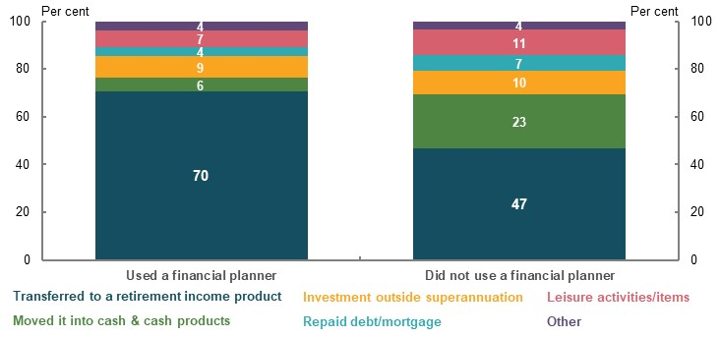
Note: 651 respondents. Source: Investment Trends October 2017 Retirement Income Report.
          - The benefits of financial advice in an economic crisis
- Falling markets can be stressful. The complexity of navigating the system is an issue, particularly during downturns (Bateman, 2009). Complexity, combined with fear and uncertainty, can lead people to make poor choices, such as switching assets to cash during periods of market volatility. Switching can protect balances from further falls in the short term, but means members are likely to miss out on any rebound in markets. As cash delivers significantly lower return than balanced funds over the long run, this behaviour typically impairs retirement outcomes.
- Forthcoming research by a large fund points to the importance of guidance and advice in reassuring members and helping them stay the course when markets fall. The fund comprised two broad groups of retirees: one where retirees were largely self-directed, while the other group typically received financial advice. Key member characteristics and aggregate asset allocations were otherwise broadly similar across the two groups. Following the sharp market downturn in March 2020, just 0.9 per cent of funds under management for the largely advised group was switched, while 11 per cent of funds under management for the self-directed group was switched. Across both groups of members, close to 80 per cent of switches were into a more defensive investment option, with around 50 per cent of these being switches to cash.
- Earlier research by the same fund found that 83 per cent of the self-directed group aged over 50 who switched to a more defensive option during the GFC, missed the rebound in markets and had not switched back by the end of June 2010. This suggests that members who switch during periods of market stress may not switch back without prompting, further emphasising the value in ready access to advice and guidance.

Outcomes from financial advice
Variable outcomes from financial advice have been well documented by ASIC and more recently by the Hayne Royal Commission, which highlighted several instances of poor consumer outcomes from financial advice.
- A 2012 ASIC shadow-shopping exercise on retirement advice found only 3 per cent of advice was good and 39 per cent was poor, with advice overly focused on the merits of particular products. ASIC found much of the advice did not help clients to develop a realistic and achievable plan for their retirement or make the most of their financial resources. This review was conducted before the Future of Financial Advice reforms (ASIC, 2018a).
- In 2016, ASIC released a report finding widespread instances of people paying for financial advice, but not being delivered any services (ASIC, 2016a). Many of these instances involved superannuation products where advice fees were being deducted directly from the product, reducing the affected client’s future retirement income.
- In 2018, ASIC reviewed the quality of financial advice and compliance provided by vertically integrated firms and found that 75 per cent failed to comply with the requirements associated with the best interests duty, but the quality of advice had improved after the Future of Financial Advice reforms. However, ASIC found only 10 per cent of files showed that consumers would be significantly worse off as a result of following the financial advice.
- In 2019, ASIC looked at financial advice offered by 25 superannuation funds and found 49 per cent complied with the best interests duty, with the member at risk of suffering detriment in 15 per cent of cases, and the other failures mostly due to disclosure and record-keeping failures (ASIC, 2019d). ASIC noted:
‘Superannuation funds play an important role in meeting the financial advice needs of Australians. Good financial advice can result in members making the most out of their superannuation savings upon their retirement. Poor financial advice, however, can significantly impact a member’s financial position and retirement plans.’ (ASIC, 2019d, p. 7)
Recent changes to financial advice regulation and further reforms in light of the Hayne Royal Commission may improve financial advice outcomes for consumers.
Changes in response to the Hayne Royal Commission, such as removing grandfathered arrangements for conflicted remuneration and introducing a Code of Ethics banning commissions are expected to lead to more strategic financial advice. In this case, advisers are paid for strategic recommendations rather than advice focused on getting consumers to take up products for which the adviser receives a commission.
Advisers are already shifting away from commissions to a fee-for-service model (Adviser Ratings, 2019), which makes the cost of advice more transparent. While the recently introduced professional standards for financial advisers are likely to improve adviser competence, these reforms may reduce the supply of financial advisers if some advisers fail or choose not to meet the new standards. The effectiveness of reforms aimed at improving the quality of financial advice will be reviewed by Government in 2022.

Technology options around financial advice
Digital financial advice offers a potential solution to make getting assistance for retirement both efficient and affordable. Depending on design, greater use of digital financial advice may also reduce costs and biases and improve outcomes. But the following barriers and limitations to digital financial advice would need to be addressed:
- Take-up of digital financial advice is low, and the tools for retirement are limited. An ASIC survey in August 2019 showed only 1 per cent of respondents had used digital advice, and only 19 per cent were open to digital advice once it was explained to them (ASIC, 2019b, p. 5). In the US, the use of digital financial advice is increasing rapidly (Statista, 2020) but anecdotal evidence suggests it is generally used to guide investment rather than retirement strategies. Current digital financial advice tools cannot calculate an appropriate retirement strategy for a household, although some are in development.
- People do not trust digital financial advice. Younger and higher-income people are more likely to welcome automated financial advice. Trust in digital financial advice and guidance improves when people experience it (Lochner, et al., 2017). This suggests trust in digital advice may increase in future. People may also trust digital financial advice tools more if outcomes are delivered by a person.
- People may not be willing to pay for digital financial advice. Consumers expect digital financial advice to be free or cheap (Lochner, et al., 2017). Rice Warner (2019a, p. 25) found consumers were willing to pay less than $250 for digital financial advice. Although ongoing costs are low, financial providers offering digital financial advice incur significant upfront software costs.
- Regulatory barriers may prevent creating and using digital financial advice tools for retirement. Some argue that there is legal uncertainty around fulfilling financial advice obligations when there is not a person involved in delivering the advice (Soljo & Blades, 2019), although ASIC has issued regulatory guidance on providing digital financial advice (ASIC, 2016b).

Guidance
The complexity of retirement means people often need assistance that may not include a recommendation relating to a financial product (Box 5A-10). Nevertheless, any legal uncertainty about whether guidance of this nature would require providers to comply with financial advice obligations would increase the costs of providing guidance. In the absence of certainty, providers are likely to comply with the obligations to avoid any risk of breaching the law. Funds may also be reluctant to provide guidance because these services are likely to require significant investment and ongoing costs.
The Financial System Inquiry envisaged a greater role for superannuation trustees in guiding retirees into retirement, including designing a pre-selected product for the member. These pre-selected products are known as a ‘Comprehensive Income Products for Retirement’. One stakeholder noted trustees should offer these services as part of offering retirement phase products (Rice Warner, 2020, p. 9).
The same technology that facilitates digital advice could be modified to help funds offer guidance to members in a cost-effective way. It could also be used by Government to offer guidance directly to individuals, through better use of tools such as calculators (Box 5A-9).
In the UK, the Financial Conduct Authority recommends making providers assess whether consumers are eligible for enhanced annuities (annuities for low life expectancy), by asking simple health and lifestyle questions, and then offering the best enhanced annuities on the market. In Australia, the Government’s proposed Retirement Income Covenant suggests a greater role for superannuation funds in guiding members at retirement (Box 5A-12). The covenant envisages a guided choice framework in the form of a retirement income strategy for fund members that provides higher and more stable income in retirement than the current ‘default’ settings.
          - The Retirement Income Covenant
To develop the retirement phase of the superannuation system, in the 2018-19 Budget the former Minister for Revenue and Financial Services, the Hon Kelly O’Dwyer MP, announced plans to create a legal obligation on superannuation funds to consider their members’ needs in retirement and develop an appropriate retirement income strategy (see the Government’s Retirement Income Covenant Position Paper). This built on the Government’s response to the 2014 Financial System Inquiry, in which the Government committed to develop legislation to allow funds to provide pre-selected products at retirement and guide members at retirement.
This would complement the current legislative framework, the Superannuation Industry (Supervision) Act 1993 (SIS Act), which has specific obligations in superannuation law that impose duties (called covenants) on trustees of superannuation funds that apply to the pre-retirement phase. (The retirement phase currently has no specific legal framework.)
Under the new obligations, trustees would be required to consider how to manage members’ retirement risks, such as longevity and inflation, their Age Pension eligibility, any need for access to capital, as well as the risk of cognitive decline. Trustees would also be required to develop and offer a Comprehensive Income Product for Retirement: a retirement income product that is likely made up of a combination of products, which provides broadly constant income for life (that is, it manages longevity risk) and some access to capital.
As part of the Retirement Income Covenant, trustees would have a legal responsibility to guide members at retirement (guided choice) by providing financial advice, information or guidance to help them understand and make choices about retirement income products.

Future roles providing guidance and financial advice
When people receive assistance it must be paid for, either by the Government, from people’s superannuation accounts or directly by the people accessing the assistance.

Role of superannuation funds
Superannuation funds are well placed to provide both guidance and financial advice at retirement (or prompt people to seek financial advice) because members have to contact their fund to transfer their assets into the tax-free retirement phase and to start accessing their savings. This guidance could relate to a product, or it could relate to another strategy, such as, for low balance holders, using their superannuation to pay down debt.
Arguably, given retirement income is the core purpose of superannuation, funds have a responsibility to provide this guidance. However, the regulatory framework does not make it easy for funds to provide such guidance. Anecdotal evidence suggests some funds are reticent to provide guidance to people at retirement as there is legal ambiguity over what is and what is not financial advice.
Under superannuation law, trustees are required to act in the best interests of their membership as a whole, which means they are focused on factors such as keeping costs for the entire membership down and trying to maximise funds under management. This may not be in the interests of an individual member. For example, funds may be inclined to offer or recommend products or strategies that involve members drawing down their retirement savings more slowly. Further, advisers associated with funds may have an incentive to recommend their fund’s products. This could dampen the already limited competitive forces in the retirement income product market. At present, this risk is likely to be small. Of note, product quality regulation has been used in the pre-retirement phase to tackle the risk of poor outcomes from the lack of competitive forces.
Overall, giving funds the confidence to provide limited and targeted guidance to members without needing to comply with the legal obligations associated with financial advice would likely improve people’s retirement outcomes. The benefits associated with drawing down more retirement savings and higher standards of living in retirement, coupled with effective regulation, would likely outweigh any potential impact from conflicts of interest.

Role of Government
The Government currently provides guidance through ASIC’s MoneySmart website and the Financial Information Service. The Government promotes these services through Financial Health Checks for 45- and 65-year-olds.
- MoneySmart provides a retirement income calculator and general information, but does not assist people to make decisions. It directs people to seek financial advice.
- Financial Information Service provides seminars and phone guidance. It was originally targeted at pensioners but now has a broader role.
Some stakeholders argued the Government should offer affordable guidance at retirement, based on the UK’s Money and Pensions Service (Box 5A-13) (Super Consumers Australia, 2020, pp. 29-30). Although the UK model gives retirees access to affordable and independent guidance at retirement, it does not guarantee people will seek this guidance or advice. Research by the UK’s Financial Conduct Authority found many of those approaching retirement had not received advice (Financial Conduct Authority, 2019).
Stakeholders suggested a number of roles the Government could play in the retirement phase, including:
- On products.
  - Regulating the quality of retirement income products
  - Introducing product standards to allow for better comparability between products (akin to its role in the pre-retirement phase for MySuper products)
  - Developing a comparison tool to encourage competition
- On guidance or financial advice.
  - Providing guidance at retirement, especially around generic retirement income strategies for people based on broad characteristics (e.g. gender, couple status, net wealth)
  - Funding/subsidising the cost of financial advice
  - Directly providing financial advice by employing financial advisers
          - The UK’s Money and Pensions Service
In the UK, providers are required to direct retirees to the service and send a ‘wake up pack’ to retirees at age 50. The service conducts research on the best way to engage with retirees. Retirees are given a free session, which could be seen as ‘simple advice’. More complicated cases are directed to a list of ‘trusted’ financial advisers. The service is funded by an industry levy.

Role of financial advisers
While the affordability of financial advice remains an issue, technology may bring down costs. ASIC has suggested industry or Government could subsidise basic financial advice services, so they can be provided at low cost (ASIC, 2018b, p. 13).
The fee-for-service model that many financial advisers now use may mean that unaligned financial advisers are less conflicted than superannuation funds when they provide financial advice. This may encourage a more competitive retirement product market. However, financial advisers may have an incentive to recommend retirement products that require an adviser’s frequent involvement, such as an account-based pension, rather than a ‘set and forget’ product, such as a lifetime annuity or other longevity risk management product.
          - Stakeholder views on the financial advice framework
Many stakeholders suggested the financial advice framework was failing to adequately meet the range of needs of people approaching and in retirement. Stakeholders suggested ways to improve the financial advice framework and/or facilitate funds to provide greater assistance to members.
Facilitating more affordable scaled and digital financial advice
The regulatory requirements are identical for scaled, digital and comprehensive financial advice regardless of how simple or complex the advice is. Although ASIC has issued material to try to promote scaled advice, affordable scaled and digital financial advice is in limited supply.
To address this gap, some stakeholders suggested providing greater regulatory certainty around providing scaled financial advice, such as developing and defining specific, limited personal circumstances (e.g. Age Pension eligibility and health status) that must be taken into consideration by financial advisers. Others suggested creating simple retirement income solutions, appropriate to most circumstances, could also facilitate the use of scaled financial advice.
Stakeholders noted that making scaled advice more affordable may mean more people are likely to seek advice. This might facilitate greater development of technology-assisted, or digital financial advice and guidance.
One stakeholder argued funds are well placed to fill the gap left by existing financial advisers (Rice Warner, 2019a).
Expanding the intra-fund advice provision
Intra-fund advice currently cannot consider an individual’s circumstances outside their interest in the superannuation fund, such as social security eligibility, health, aged care needs and assets held outside the fund. Stakeholders called for the intra-fund advice arrangements to be expanded to allow these factors to be considered to improve access to advice approaching retirement. While this could make financial advice more affordable for a given person, such changes would not make the system-wide costs of financial advice more affordable. They could lead to younger fund members subsidising members approaching retirement. As the true cost of intra-fund advice is hidden by cross-subsidisation, expanding these arrangements may lead to less transparency around costs.
Of note, funds are not restricted from providing broader personal advice individually charged to the member.
Providing greater guidance
Some stakeholders argued that clearly articulating that guidance was not subject to the financial advice framework could facilitate greater fund communication with people approaching and at retirement.
Similarly, many submissions recommended the Government implement the Retirement Income Covenant, which would encourage funds to guide their members at retirement, essentially through a ‘guided choice’ or decision-making framework (see Box 5A-12).

Guided choice and innovative retirement income products
Compared to the pre-retirement phase, the retirement phase involves more complex decisions. However, it has no default arrangements. Stakeholders proposed that a guided choice framework at retirement, offered by superannuation funds, could simplify the experience for many. It could create pathways for people to choose between, or a reference point from which they can compare different retirement strategies. It could also be accompanied by financial advice or guidance.
The literature suggests that guided choice frameworks can ‘nudge’ people where there is uncertainty around the best course of action to help them make a decision (Thaler & Sunstein, 2008). The UK, for example, will assist unengaged consumers with small balances, by mandating four investment pathways that every defined contribution pension provider must offer when someone reaches age 55. This is consistent with the concept of reducing choice overload, where people are able to engage better when the number of options are limited (Cronqvist & Thaler, 2004).
Some stakeholders pointed out the difficulty of designing retirement income strategies that would suit a group of retirees with different life expectancies, Age Pension entitlements and preferences. Defaults can reduce competition (Productivity Commission, 2018a) and need to be designed carefully to avoid adverse outcomes. However, in the absence of a strategy designed for consumers, account-based pensions at minimum drawdown rates are effectively acting as a default strategy for all retirees.
Stakeholders have indicated that an improved range of products is needed to align with people’s consumption patterns in retirement and provide longevity risk protection for those who need it (Box 5A-15). Products are needed that provide a reasonably stable income without the need for regular monitoring, flexibility to withdraw a lump sum, and longevity risk management if necessary. Retirees find it difficult to combine a portfolio of available products that provide both flexibility and longevity risk management (including the Age Pension).
          - The annuities market in Australia
Annuities take different forms, but all manage longevity risk through paying a regular income stream for the designated period, giving people confidence to spend their retirement savings. Term annuities are the most common type of annuity in Australia, (Mercer, 2014, p. 2) but they do not completely manage longevity risk as they provide an income stream only for the designated period. The two main types of products that fully manage longevity risk are:
- Life annuities, which are capital-backed, offered by a registered life insurance company and pay a guaranteed amount of income.
- Group self-annuitised products, which can be administered by superannuation funds and involve people pooling their money to create an income stream that is subject to market risk and the mortality experience of the pool.
Annuities can be immediate (i.e. they start straight away) or deferred (e.g. they may commence in 10 years).
Despite the potential for annuities to provide a stable income for life, and more efficient use of retirement income, the take-up of annuities in Australia is very low. Of pension phase accounts, around 6 per cent are invested in annuities (Australian Prudential Regulation Authority, 2020a). Attractive structuring of these products is challenging in a low interest rate environment.
Low take-up of annuities is not unique to Australia. Economists call the fact that people invest very little in annuities, even though they facilitate consumption smoothing, the ‘annuity puzzle’. It has led to many countries (such as Austria, Iceland, Ireland, Italy, the Netherlands, Norway, Sweden and Switzerland) mandating at least partial annuitisation at retirement. For an explanation of the academic literature on the annuity puzzle see (Beshears, et al., 2018, pp. 205-210).
Research shows that people would take up Comprehensive Income Products for Retirement products that combine income, risk management (e.g. longevity risk management) and flexibility (e.g. to access a lump sum) if these products were offered. A 2017 experiment by the Behavioural Economics Team of the Australian Government (BETA) on the take-up of Comprehensive Income Products for Retirement found:
‘On average members were around 50% willing to choose the CIPR if it were offered to them in the future. Given the lack of product diversity (94% of retirement assets in Australia are currently allocated to ABPs) and the fact that CIPRs are a new product, this level of interest is encouraging and suggests CIPRs may do well (in terms of customer take-up) in the market.’ (Hiscox, et al., 2017, p. 7)
More recent research suggests that while people are interested in annuity products, they find the process of choosing between specific products too difficult (Orford Initiative, 2020). This suggests there may be a role for guidance and financial advice in encouraging people to make more use of annuities.
In recent years, the Government has removed some of the barriers to people taking up products that manage longevity risk:
- In 2017, the Government passed legislation to allow eligible longevity risk management products to receive the tax exemption on earnings in the retirement phase. This was part of the 2016-17 Budget and related superannuation reforms.
- In 2019, the Age Pension means-testing rules were created for pooled lifetime income streams to clarify their means-testing treatment. This was part of the More Choices for a Longer Life 2018-19 Budget package, and was in response to stakeholder calls for the social security settings to incentivise the use of these products.
The Retirement Income Covenant (Box 5A-12) is also designed to encourage take-up of products that manage longevity risk by requiring superannuation funds to consider whether they should develop and offer a Comprehensive Income Product for Retirement.
To address these issues, some stakeholders have called for simple regulated products suitable for most people and satisfy minimum requirements (akin to MySuper products) to be developed for the retirement phase. Given these products would be standardised and regulated, funds and financial advisers could potentially provide guidance on these products outside of the financial advice framework. The Government has consulted on creating a framework for Comprehensive Income Products for Retirement that would meet minimum standards and provide income higher than an account-based pension drawn down at minimum rates, alongside flexibility and longevity risk management (The Treasury, 2016b). Under the proposal, if a financial adviser recommended another type of product they could be required to justify why that product was better for their client (The Treasury, 2016b, p. 38).
Other products that could improve retirement outcomes include long-term care insurance, for people who are uncertain if they are likely to need to fund aged care costs (Box 5A-6). If changes are made to encourage greater personal provision for aged care costs following the Aged Care Royal Commission, long-term care insurance may make aged care costs more affordable for people and give them the confidence to draw down their retirement savings. If arrangements stay the same, more information and guidance about the likely costs of aged care, and the fact that it is not necessary to fund costs through a lump sum, may negate the need for long-term care insurance.

A simpler system
A large number of stakeholders observed that simplifying the system, especially reforms to the design and administration of the Age Pension means test, would allow people to better understand their likely retirement outcomes.
Several stakeholders noted the complexity of administrative arrangements at retirement (Box 5A-16). Some noted that people experience delays in accessing the Age Pension caused by the complex nature of application requirements, poor understanding of the system, procrastination and stigma around dealing with Government agencies. After a person has been found to be eligible for the Age Pension, they face ongoing reporting requirements. An analysis of Age Pension data found 82 per cent of age pensioners had more than four variations in their pension benefit amounts each year, the majority of which were for minor amounts of less than 3 per cent of the payment (Centre for Law, Markets and Regulation, 2020, p. 21).

Age Pension means test
Submissions and stakeholders proposed various options to simplify Age Pension means testing, including:
- Removing means testing and creating a universal Age Pension. This could reduce administrative costs and create certainty for retirees. However, it could cause equity issues and, in the absence of other changes, cost significantly more than the current Age Pension
- Merging the income and assets tests. A merged means test would combine the income test and an asset consumption factor, so only one test would apply (see Appendix 6B. An example to illustrate the trade-offs of merging the income and assets tests). Some stakeholders proposed it could vary by age to be fairer between age pensioners (Centre for Law, Markets and Regulation, 2020, p. 28). In doing so, a merged means test could provide part Age Pension recipients with a flat income profile. Any change to the means test could affect equity outcomes. Depending on the test’s design, it could have a positive or negative effect on horizontal and vertical equity. While it would remove the need for two tests, a merged means test could be more complex for people to understand
- Creating a one-off means test. This would give age pensioners income certainty and reduce ongoing administrative costs. But review mechanisms would be needed to reflect significant changes in circumstances; for example, after suffering an expensive health shock or receiving an inheritance
          - Requirements to access Age Pension and superannuation benefits
To access the Age Pension, people must:
- Provide proof of identity, in person and with supporting documents, unless previously part of the social security system
- Report on their income and asset values, which are self-assessed but must be in line with a range of valuation methodologies. This often requires further supporting documents
- Continue to report changes in circumstances, including changes to income and assets
To access superannuation benefits, people must:
- Notify the superannuation fund that a condition of release has been met (usually retiring after preservation age)
- Select a retirement income product from their own or another superannuation fund. In either case, administrative processes will be involved in purchasing the product
OR
- Withdraw benefits from the superannuation system
To change a superannuation retirement income product, people must:
- Commute the ‘retirement phase’ product back to the pre-retirement (or accumulation) phase before it can be transferred to the new product
- If the new product is with a different fund, open an accumulation account in that fund before the new pension product can be purchased
These complex steps are in place because of the need to prevent fraud, the different taxation arrangements for the pre-retirement and retirement phases and the need to identify taxed and non-taxed amounts.

Superannuation tax: one product for life
Different tax arrangements for superannuation in the pre-retirement (or accumulation) phase and the retirement (or pension) phase create complexity. Some stakeholders have suggested that aligning the tax arrangements would:
- Allow people to have a single superannuation account for life. Pre-retirement and retirement phase accounts would have the same tax and administrative arrangements, making the $1.6 million transfer balance cap redundant
- Simplify the process for changing superannuation funds in retirement. People would not need to commute a retirement phase account back to the pre-retirement phase before transferring to a new fund
- Simplify superannuation for people who return to work after retiring. The SG received from employment could be deposited in the same superannuation account from which a pension is being drawn, removing the need to hold multiple accounts and pay multiple fees
However, if this change was made in the absence of other changes to assist people at retirement and encourage them to consume their retirement savings, many people would likely remain in pre-retirement products and would preserve their retirement savings. This would lower standards of living in retirement.

Administrative requirements
People must go through numerous administrative processes and requirements to access the Age Pension and superannuation benefits (Box 5A-16). Proposals to reduce this administrative burden include:
- Simplifying the system. Some of the simplification options discussed above, such as a universal Age Pension or a one-off means test, could also reduce reporting requirements for retirees. However, these changes may have equity trade-offs, require changes to other parts of the system or shift the administrative burden from one area of the system to another
- Data-sharing and pre-filling information. This could make application processes and reporting requirements easier, drawing on indirect data sources. For example, Services Australia now uses data collected from superannuation funds and income stream providers to automatically adjust pensioners’ assets and income information
- Greater integration. This could reduce inefficiencies, avoiding the need to give different Government agencies the same information. The Government is making progress towards a ‘tell us once’ capability. For example, work is underway to create a ‘Digital Pass’ for online Government services, so people do not need to prove their identity multiple times
          - Impact of changes to certain policy settings on cohesion
A significant number of submissions put forward policy suggestions to change the cohesion of the retirement income system. The following summary outlines some of the implications of some of the proposed changes to particular policy settings.
- Lower the Age Pension assets test taper rate. This would run counter to the objective of encouraging retirees to more efficiently draw down their assets. Even though it would slightly lower the effective marginal tax rate on retirement savings, they would remain high, and the overall disincentive to save would remain.
- Introduce a merged means test for the Age Pension. This may encourage people to draw down more from their assets in their later years of retirement. However, depending on the design of the merged means test, it may not significantly reduce system complexity. There would continue to be significant differences between the means tests for the Age Pension and for aged care.
- Change superannuation tax concessions and incentives to work. The SG is the main driver of retirement savings for most people, not voluntary superannuation contributions. Most voluntary contributions are made by people who would likely reallocate those savings to the next most tax-effective savings vehicle. Removing financial incentives to work would have little impact on people’s behaviour, as financial incentives are largely ineffective at changing behaviour and benefit those who would continue to work anyway.
- Encourage people to use their assets more efficiently in retirement. This would lead to a higher standard of living in retirement. Alternatively, people could save less and achieve adequate retirement incomes to maintain their standard of living in retirement while having a higher standard of living in their working life (see 2D. Policy scenario: Implications of maintaining the SG rate).
  - Implementing the Retirement Income Covenant would provide a decision-making framework to assist people at retirement. The covenant would require superannuation funds to provide guidance to their members at retirement, which would simplify the experience for people and encourage them to more efficiently draw down their savings.
  - Increasing the minimum drawdown rates would likely increase retirement incomes and may lead to higher living standards for the majority of retirees who use these rates as a ‘default drawdown strategy’. However, increasing the minimum drawdown rates without providing longevity risk protection could lead to income shock for some retirees. Retirees would likely benefit more from a more tailored drawdown strategy that accounts for factors such as Age Pension eligibility, couple status and age of retirement, instead of a one-size-fits-all drawdown rate.

Policy scenario: Implications of changing Age Pension means test settings
          - Section summary

A lower assets test taper rate
- Many stakeholders supported lowering the assets test taper rate. The short-term benefits of a lower taper rate would primarily go to retirees in the upper half of the wealth distribution. Lower wealth retirees who receive a full pension, or are means tested by income, would not be affected by changes to the assets test.
- As the superannuation system matures, most retirees would receive additional income from a lower taper rate. Almost two-thirds of retirees are projected to receive a part-pension by 2060 as a result of higher household assets.
- A lower taper rate would increase replacement rates for middle-income earners and increase fiscal costs. Projections suggest replacement rates for this group would exceed the 65-75 per cent benchmark under current policy settings. For illustrative purposes, the fiscal cost of lowering the taper rate to 2.25 per cent would be around $1 billion in 2019-20. This would grow to 0.20 per cent of GDP in the long term as the superannuation system matures and more households are affected by the assets test.
- A lower taper rate would provide more reward for additional savings. But evidence suggests savings behaviour may not change significantly in response.
- A lower taper rate would reduce incentives for retirees to draw down their assets in retirement. The impact of this incentive on drawdowns is uncertain. It may be small in the presence of other behavioural factors, such as anchoring to minimum drawdown rates.

Merged means test
- Some stakeholders proposed merging the income and assets tests to reduce the complexity of the Age Pension means test. Merging the income and assets tests would involve trade-offs between the system’s objective of adequacy, equity, sustainability and cohesion.
- Abolishing the assets test would simplify the means-testing arrangements. But this would increase Age Pension expenditure and primarily benefit retirees with significant asset levels.
- Replacing the assets test with a capital consumption component in the income test may improve equity. But, depending on the design, it may increase complexity.
- It would be challenging to design a merged means test that achieves the objective of the current dual means test but is less complex.

Outline of this section
A number of submissions called for a reduction in the Age Pension assets test taper rate. Others proposed merging the income and assets test. To improve understanding of the impact of changing the Age Pension means test settings, this section considers the implications of a lower assets test taper rate and the trade-offs of merging the Age Pension income and assets tests.
          - Stakeholder views on the Age Pension means test
Most stakeholders who raised the Age Pension means testing supported lowering the taper rate. Many said the current taper rate excessively penalises middle-income earners, with the high effective marginal tax rates discouraging saving. Others claimed it distorts incentives by encouraging spending to avoid the assets test, which may reduce self-sufficiency and increase longevity risks.
Some stakeholders said the taper rate means households with higher wealth can have lower incomes than lower-wealth households:
‘The system as it stands is perverse. For many, the more they save the worse they are, because of the assets test taper rate.’
(National Seniors Australia, 2020)
Others raised fairness concerns, noting the assets test particularly affects middle-income earners:
‘Changes to the Age Pension assets test taper rate in 2017 demonstrate how the absence of an objective for the retirement income system created significant inequities for middle Australia that threaten the integrity of the system.’ (Australian Institute of Superannuation Trustees, 2020)
Some submissions supported a high taper rate, noting it would reduce Government expenditure and improve sustainability.
Some stakeholders disagreed that the $3 taper rate would lead to lower retirement incomes, pointing out that retirees with higher wealth can consume their assets and the system should encourage this.
Some stakeholders advocated that a merged means test would be an improvement over the current dual means test as it would:
- Create a simpler means test framework, which may be easier to administer and understand
- Ensure a consistent measure of a person’s total means. The current dual means test can result in people with different levels of assets and/or income receiving the same Age Pension

Design of the Age Pension means test
Means testing in the retirement income system reduces Age Pension payments based on retirees’ income and assets. The Age Pension means test consists of two elements, applying whichever test gives the lower rate of pension.
- The income test takes account of a retiree’s income from employment and financial assets. The Age Pension payment is reduced by $0.50 a fortnight for each dollar of income over the income test free area.
- The assets test reduces a recipient’s pension payment by $3 a fortnight for every $1,000 in assessable assets over the assets test free area. This rate of reduction in the Age Pension payment is known as the ‘assets test taper rate’, which reduces the Age Pension at a rate of $7.80 for every $100 in assessable assets.
- Most people affected by the means test are income tested, with the assets test applying to those with significant wealth. This recognises the capacity of wealthy retirees to draw down their asset holdings to support their retirement (see 2A: Design of Australia’s retirement income system).
As a large number of stakeholders advocated reducing the assets test taper rate, this section outlines some of the implications of a lower taper rate.

Implications of a lower assets test taper rate
The current assets test taper rate has several strengths. It creates an incentive for retirees to use the assets they have saved for retirement, and helps ensure Age Pension payments go to those in need. Limiting eligibility contains the fiscal cost of the Age Pension.
A number of stakeholders argued the current system could distort incentives to make additional superannuation savings for retirement and, under certain assumptions, lead to lower total income for retirees with higher balances (see 5A. Cohesion). Many stakeholders pointed to high effective marginal tax rates due to the taper rate exceeding the expected return on savings.
As the superannuation system matures, an increasing number of retirees will be assessed under the assets test. The proportion of part-rate age pensioners who will be assets tested is projected to rise from about one-third in 2020 to two-thirds by 2060 (see 4. Sustainability).
To consider the implications of changes to the taper rate, a scenario with a $2.25 taper rate was chosen for illustrative purposes. This is within the $2-$2.25 range proposed by a number of stakeholders. For simplicity, the assets test free areas were maintained at their current levels.

Effect on adequacy

Short-term impact on retirement income
Sixty-one per cent of current Age Pension recipients have income and assets below the relevant free areas and receive a full Age Pension. This group would see no additional income from this change. The immediate benefits of lowering the taper rate would go to part-rate age pensioner recipients subject to the assets test, who make up 13 per cent of all age pensioners.
Retirees with assets just above the assets test cut-off who currently receive no Age Pension would also benefit by starting to receive a small part-pension. These retirees are in the top half of current retirees by wealth (Chart 5B-1).
    - Change in asset-tested area from current policy to $2.25 taper rate by wealth decile
Assessable assets
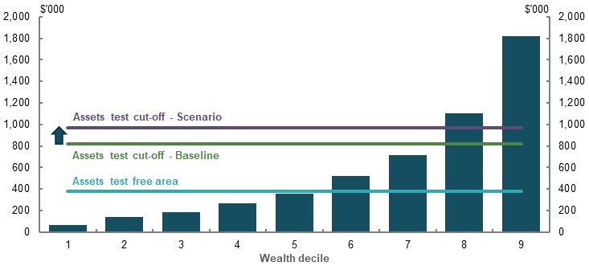
Note: Thresholds are for couples who are home owners as at June 2017. Assessable assets defined in the Survey of Income and Housing as household wealth less value of the home. Source: Analysis of ABS Survey of Income and Housing Confidentialised Unit Record File, 2017-18.

Long-term impact on retirement income
As the superannuation system matures, future retirees will have higher assets in retirement. As a result, an increasing proportion of future retirees are likely to be affected by the assets test for at least some of their retirement. A lower taper rate would benefit retirees further down the income distribution range. By 2060, only people in the lowest 10 per cent of incomes would not benefit from a lower taper rate (Chart 5B-2).
    - Projected change in total Age Pension received under a $2.25 taper rate
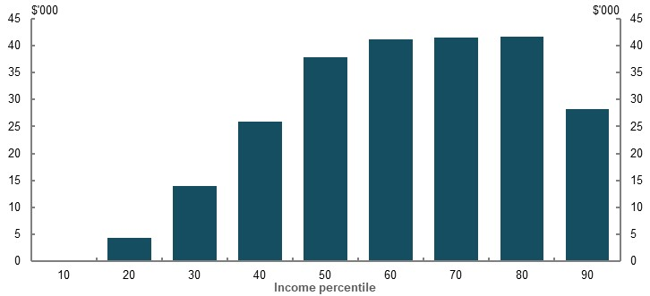
Note: Values are in 2019-20 dollars, deflated using the review’s mixed deflator. Higher-income earners benefit from the lower taper rate because they draw down their assets to levels that make them eligible for a part-rate Age Pension as they age (see Appendix 6A. Detailed modelling methods and assumptions). Source: Cameo modelling undertaken for the review.
Nevertheless, most of the benefit of a lower taper rate would go to middle- to higher-income retirees. A lower taper rate would increase eligibility for retirees with higher assets and increase income for retirees who receive part-pensions.
Retirees at the 60th to 80th income percentiles would see the largest increases in lifetime Age Pension payments from a lower taper rate. Since people in these percentiles spend more time than others in retirement receiving part-pensions, they would be most affected by a taper rate change.
For example, a retiree at the 60th percentile would receive no income from the pension when they began their retirement. Depending on the extent they draw down their assets, under a lower taper rate they would become eligible for a part-pension at an earlier age. The benefit of a lower taper rate is smaller for retirees whose assets drop below the assets test threshold earlier in retirement and, consequently, spend fewer years affected by the assets test.

Replacement rates
It is estimated that a $2.25 taper rate would increase replacement rates for most income percentiles, primarily due to higher Age Pension payments (Chart 5B-3). The improvement would be largest for middle-income retirees (40th to 70th percentiles), with replacement rates for the median-income retiree improving by around 3 percentage points. As middle-income retirees spend a significant portion of their retirement accessing a part-rate Age Pension, they are particularly affected by a change in means testing.
    - Projected replacement rates for retirees by income percentile
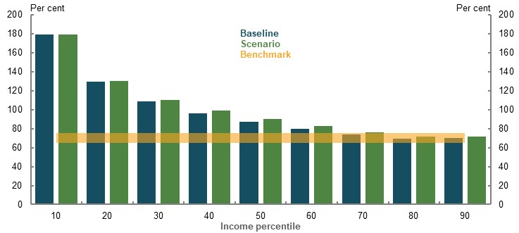
Source: Cameo modelling undertaken for the review.
For the 60th percentile and below, the increase would result in replacement rates further exceeding the 65-75 per cent benchmark for replacement rates (see 2C. Maintaining standards of living in retirement). This suggests the change is not needed for these retirees to achieve an adequate retirement income.
Lower-income retirees (30th percentile and under) would mostly be unaffected by the taper rate change. This group does not accumulate enough assets to be affected by means testing for most of their retirement. Higher-income retirees would see very little change in their replacement rates, as Age Pension payments are low compared with their retirement income. The high asset values for this group mean they do not access the Age Pension for significant portions of their retirement.
The assets test taper rate change would affect couples differently to singles. For couples, the taper rate changes increase replacement rates at lower-income deciles (Chart 5B-4).
    - Projected replacement rates for coupled retirees by income percentile
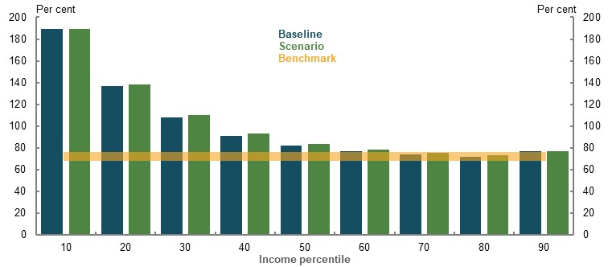
Source: Cameo modelling undertaken for the review.
The analysis for both singles and couples assumes that retirees efficiently draw down their assets in retirement (Appendix 6A. Detailed modelling methods and assumptions). If drawdowns were instead at legislated minimum rates, the taper rate change would provide a larger increase in replacement rates for middle-income earners. Under lower drawdown rates, middle-income retirees maintain higher asset values for longer and therefore spend more of their retirement affected by means testing (Chart 5B-5).
    - Projected replacement rate when assuming minimum drawdowns for retirees by income percentile
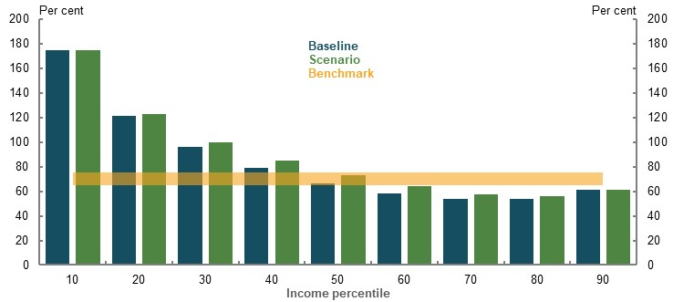
Source: Cameo modelling undertaken for the review.

Effect on equity

Income equality in retirement
A lower taper rate would have a small effect on income inequality. It would decrease the retirement income gap between middle- and higher-income retirees, and increase the retirement income gap between lower-income retirees and all other retirees.
The magnitude of these changes would be small (Chart 5B-6). For example, currently retirees in the 90th income percentile are projected to have incomes 1.63 times that of median-income retirees. With the lower taper this would reduce to 1.60.
    - Projected average annual income of retirees by income percentile
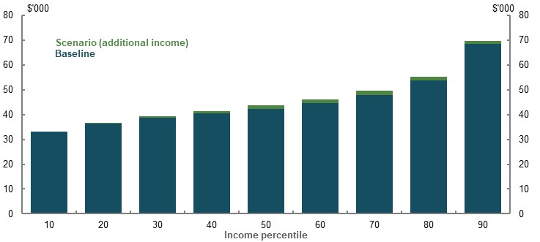
Note: Values are in 2019-20 dollars, deflated using the review’s mixed deflator. Source: Cameo modelling undertaken for the review.

Groups that would benefit less from a lower taper rate
A lower taper rate would increase the gender gap in retirement incomes at the lower end of the income distribution (Chart 5B-7). This is because men at lower percentiles receive an asset-tested rate of Age Pension for more of their retirement than women, benefiting more from a lower taper rate. In comparison, at higher percentiles, a lower taper rate would marginally narrow the gender gap in retirement incomes. Men spend more time than women not receiving any Age Pension and would therefore benefit less from the change.
    - Projected effect of a taper rate change on the gender gap in annual average retirement incomes
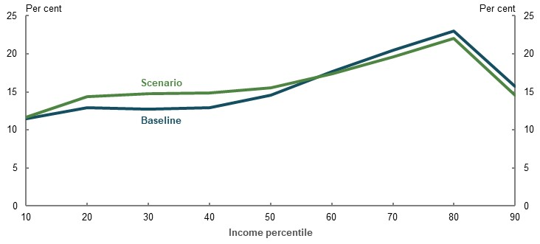
Note: Gender gaps are calculated relative to men’s retirement incomes. A 10 per cent gender gap in retirement incomes means that women’s incomes are 90 per cent of men’s incomes. For more detail on the adjustments to the cameo model for gender analysis, see Appendix 6A. Detailed modelling methods and assumptions. Source: Cameo modelling undertaken for the review.
Under the scenario assessed, the median woman would receive a 2.5 per cent increase in average annual retirement income from a lower taper rate, compared to the 3.7 per cent increase in average annual retirement income received by the median man.
Other groups that are disproportionately represented among low-wealth retirees would benefit less from a lower taper rate. These groups include early retired households, Aboriginal and Torres Strait Islanders people and people with disabilities.

Effect on sustainability

Fiscal cost
Lowering the taper rate would come with a fiscal cost. For example, the fiscal cost of lowering the taper rate to $2.25 in 2019-20 would be around $1 billion (0.05 per cent of GDP). This is projected to grow to 0.1 per cent of GDP in 2029-30 and 0.2 per cent of GDP in 2059-60 as the superannuation system matures and households accumulate more assets (Table 5B-2).
      - Indicative fiscal costs of reducing the assets test taper rate to $2.25
 | 2019-20 | 2029-30 | 2039-40 | 2049-50 | 2059-60
Total cost (per cent of GDP) | 0.05  (about $1 billion) | 0.10 | 0.12 | 0.17 | 0.20
Note: This is a counterfactual analysis as if the Age Pension assets test taper rate was reduced from 1 July 2019. Source: Department Social Services modelling for the review and analysis of Rice Warner estimates for the review.
The increased cost is due to higher Age Pension payments. More retirees would become eligible to receive a part-pension, and many would receive higher pension payments. The change would result in an increase of 8 percentage points in the proportion of people receiving a part-rate Age Pension by 2059-60 from around 21 per cent to around 29 per cent (Chart 5B-8).
If the free area of the assets test was unchanged, lowering the taper rate would have a negligible effect on the number of retirees receiving a full-rate Age Pension.
    - Projected proportion of retirees on a full- and part-rate Age Pension
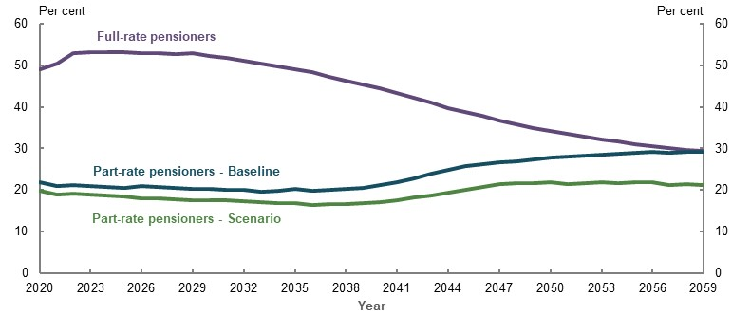
Source: Analysis of Rice Warner estimates for the review.

Effect on cohesion

Incentives to save
Lowering the taper rate would increase the marginal benefit from saving for the 20th to 40th percentiles (Chart 5B-9). These income groups would see a smaller reduction in their pension due to the increase in their assets. For the 50th percentile and above, the lower taper rate would have little effect on their return on saving.
While improving incentives to save for some, a lower taper rate may not meaningfully affect savings behaviour because:
- Even though the return from marginal savings improves, effective marginal tax rates on retirement savings remain high, maintaining the disincentive to save. Even with a taper rate as low as $1, the retirement income generated by saving $1,000 prior to retirement remains less than $1,000 of retirement income.
- Many people of working age are not aware of or do not understand the assets test (see 5A. Cohesion). Savings behaviour may not be affected if people do not understand the benefits and take them into account.
- Behavioural economics research suggests reactions to incentives are smaller when the effects are less noticeable (Varela, 2016). In the pre-retirement phase, people may not take into account the effect of the taper since it occurs many years in the future.
    - Projected effect of saving an extra $1,000 immediately before retirement, by income percentile
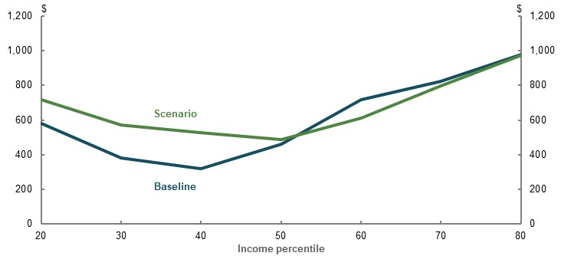
Note: The scenario assumes people salary sacrifice an additional $1,000 in the year before retirement. Superannuation is drawn down at an annuitised rate to life expectancy. The 10th income percentile is excluded from this analysis due to low asset levels in superannuation and relatively low marginal propensity to save. The 90th percentile is excluded because their projected balance is already over the transfer balance cap, and so cannot make post-tax voluntary contributions. Total retirement income and components are deflated by CPI. Source: Cameo modelling undertaken for the review.

Asset drawdowns
As outlined in 2C. Maintaining standards of living in retirement, improving retirees’ drawdowns of their superannuation assets, along with accessing the equity in their home, can significantly increase their retirement incomes.
Many retirees currently draw down their assets at low rates. This likely reflects fear of outliving their savings; saving for unexpected expenses in retirement; and relying on the statutory minimum draw down rates as a default (see 5A. Cohesion). Addressing these issues directly, including promoting greater understanding of the retirement system and broader availability of products, would help people use their assets more efficiently in retirement. It would reduce the incentive for retirees to draw down by:
- Providing higher pension payments for a given level of assets
- Increasing eligibility for a part-pension at higher incomes
In particular, a lower taper rate would give more income to middle-income retirees drawing down at the minimum rate, reducing the need to draw down their assets to support their retirement income. However, the primary drivers of drawdown rates appear to be unrelated to the taper rate, so the effect of changing the rate may be small (see 5A. Cohesion).

Merged means test
Submissions raised a series of approaches to redesign and simplify the means test arrangements. These included:
- A universal age pension. This would require a fundamental redesign of the retirement income system, including superannuation tax concessions
- Merging the income and assets tests. This was raised in submissions and past reviews
Between 1961 and 1976, Australia had a merged means test. The test reduced annual pension payments by the amount of any deemed income derived from property above an exempt amount, as well as by the amount of any income not derived from property. The merged means test was effectively abolished in 1976 when reform was introduced to make the means test an ‘income-only’ test. In 1985, assets test components were reintroduced to the means test to address fiscal pressures and ensure the Age Pension was appropriately targeted.
The final reports of (Australia’s Future Tax System Review, 2009) and (National Commission of Audit, 2014) recommended simplifying the dual means test by abolishing the assets test. In its place, they recommended introducing a single comprehensive income test that would deem income from a greater range of assets, including a proportion of the family home above a certain threshold.
In contrast, other stakeholders have proposed a merged means test by ‘combining’ the income and assets tests (e.g. Centre for Law, Markets and Regulation (2020) and Andrew Podger (2019)). Such a combined means test would include an asset capital drawdown component (in place of the assets test) to recognise that a person can draw down on their assets to provide retirement income.

Issues with the current dual means test
Stakeholders highlighted that the dual means test is complex. The complexity makes it difficult for retirees to understand how each test assesses their income and assets, and the interactions between the income and assets tests taper rates, thresholds and Age Pension payment rate. This also makes it difficult for retirees to navigate the retirement income system.
The dual means test can result in inequitable outcomes (Australia’s Future Tax System Review, 2009) as people with different levels of means can receive the same Age Pension income in some circumstances. This is because when the assets test determines a retiree’s Age Pension payment amount, their income (such as from part-time work) does not affect their Age Pension payment amount. Similarly, when the income test determines a retiree’s Age Pension payment amount, the value of a retiree’s assets does not affect their Age Pension payment amount.
Under the dual means test, people on a part-rate Age Pension typically receive substantially higher Age Pension payments later in their life (over and above the effects of indexation). This makes it difficult for people to derive stable incomes when combining their Age Pension and income from superannuation or other private sources.
This instability in incomes occurs under a range of drawdown strategies, including when a person takes up an account-based pension and draws down to have constant private income in nominal or real teams (Chart 5B-10), or draws down according to the superannuation minimum drawdown requirements (see Section 5A. Cohesion). For example, a 67-year-old single home owner with $500,000 of assessable assets, who uses an account-based pension to deliver constant private income in nominal terms, will see their Age Pension payment increase by more than 400 per cent from less than $10,000 to $30,000 at age 87.
These profiles of retirement income do not align with observed patterns of retiree consumption, which decline through retirement, partly because health and aged care are heavily subsidised by Government (see 5A. Cohesion). Under current arrangements, the profile of the Age Pension makes it difficult for people on a part-rate Age Pension to achieve a broadly constant level of total income in retirement in real terms or in nominal terms (Chart 5B-10).
    - Age Pension and private income in retirement for $500,000 of assessable assets under the current arrangements, by age
Constant nominal private income  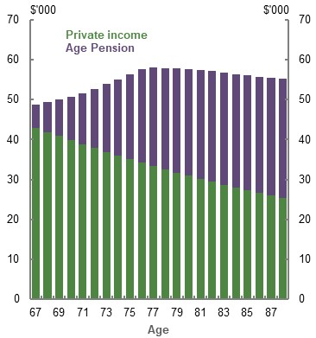 | Constant real private income  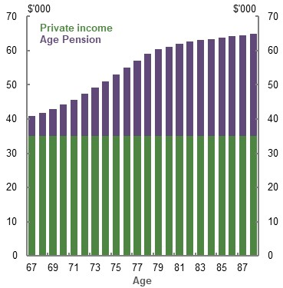
Note: Values are in 2019-20 dollars, deflated by CPI. Assumes the person is a single home owner who begins retirement on 1 July 2019. Constant nominal private income means the person consumes $43,000 of their assessable assets each year. Constant real private income means the person consumes $35,000 of their assessable assets at age 67, with the amount consumed increasing by 2.5 per cent (i.e. inflation) each year. The person has around $10,000 of assessable assets remaining at age 88 under both drawdown strategies. Source: Calculations based on Age Pension rates and thresholds as at 1 May 2020 and assumptions for the example of a merged means test. The life expectancy used to calculate the deemed capital consumption is sourced from the Australian Life Tables 2015-17 (Australian Government Actuary, 2019).

Trade-offs involved in merging the income and assets tests
Merging the current income and assets tests would represent a fundamental change to the way entitlement to the Age Pension is determined. The design of a merged means test would involve trade-offs between different aspects of the retirement system objective. It would be challenging to design a merged means test that achieves all the suggested elements of the objective for the retirement income system — particularly equity and cohesion.
For example, the proposal by Australia’s Future Tax System Review (2009) and the National Commission of Audit (2014) would significantly simplify the current dual means test. But abolishing the assets test would not fully reflect the objective of the current dual test to target Age Pension payments. It would result in means from assets being assessed only in terms of earnings they could generate, and not on the ability to draw on the capital itself.
Such a change would have adverse equity implications. It would likely involve a large fiscal cost. In addition, assessing retirees’ means by using only the income from their assets implies the objective is for retirees to maintain their assets through retirement, consuming only their income, rather than drawing on the capital itself.
One way a merged means test could achieve the intent of the assets test would be to include a capital consumption component in the income test. This would effectively assess retirees’ means by assuming they are drawing down on their assets to fund their retirement and would overcome some of the equity challenges of applying an ‘income-only’ test. This approach could also generate more stable Age Pension income across retirement for some retirees. However, this would likely require the amount assumed to be drawn down be determined by remaining life expectancy and so vary by age, as suggested in the submission by the Centre for Law, Markets and Regulation (2020).
Such an approach is likely to be complex and difficult for retirees to understand and apply, and could result in reduced transparency compared with current arrangements. Depending on design, it could raise concerns as it may result in some people on a part-rate Age Pension receiving less than they currently do. Being quite different from current arrangements may necessitate the use of transitional arrangements to avoid making some existing retirees worse off. Such arrangements would add complexity to the means test, requiring two schemes to operate simultaneously for an extended period.
A merged means test could be designed to improve some elements of the retirement system objective but it would be difficult to avoid compromising others. Ultimately, the impact of a merged means test would depend on the selected policy parameters, such as the model for assessing assets, how assets are assumed to contribute to means, the level of means a person can have without reducing their Age Pension, and the rate at which support is withdrawn.
An illustrative example of a merged means test is investigated in Appendix 6B. An example to illustrate the trade-offs of merging the income and assets tests. It provides evidence on the trade-offs involved in a merged means test. It does not represent an ideal or preferred approach.

- Appendices

Detailed modelling methods and assumptions

Outline of appendix
This appendix covers the detail of modelling methods and assumptions used as part of the review:
- Evidence on the effect of change in the Superannuation Guarantee (SG) on wages growth
- Evidence on the spending growth needed in retirement
- Evidence for the review’s adequacy benchmark
- The review’s retirement income cameo model (assumptions and methodology)
- Model of Australian Retirement Incomes and Assets (assumptions and methodology)
- SPROUT (Rice Warner model/ISA): assumptions and methodology)
- Modelling financial stress

Evidence on the effect of changes in the Superannuation Guarantee on wages growth
The SG mandates employers make contributions into employees’ personal superannuation accounts. The SG is currently at 9.5 per cent of ordinary time earnings and is legislated to increase to 10 per cent on 1 July 2021. Further increases, by 0.5 percentage points each year, will follow until the SG reaches 12 per cent on 1 July 2025. How these changes will affect living standards both during and before retirement will depend on the extent to which the costs of higher SG payments reduce wages growth.
The weight of evidence suggests the majority of SG increases are paid for through lower growth in wages. This evidence includes:
- Two domestic studies assessing the effect of the SG on wages in Australia, using different data sources and identification strategies
- Economic theory and international evidence of the effects of ‘mandated benefits’ that provide employees strong direct benefits like superannuation
- The explicit intent of the SG policy at its outset for a trade-off between wages and superannuation contributions, which has not been significantly affected by subsequent developments in Australian wage-setting arrangements.

History of the Superannuation Guarantee and wages in Australia
The forerunner of the SG, and start of compulsory superannuation, was ‘award superannuation’. Superannuation through award wages started in 1985, negotiated between the federal Labor government and the Australian Council of Trade Unions (ACTU).
Compulsory award superannuation was explicitly a trade-off with wages:
‘In return for tax cuts and 3% Award-based Superannuation the ACTU accepted a 2% discount of the wage rise based on the CPI.’ (Australian Council of Trade Unions, 1990)
This increased the coverage of superannuation to 55 per cent of employees in 1988, up from 32 per cent in 1974 (ABS, 2009a).
Part of the motivation for shifting some remuneration from current wages to superannuation was to temper inflationary pressures in the face of exchange rate depreciation and declines in the terms of trade (Australian Council of Trade Unions, 1990); (Millane, 2020). This tempering would only occur if higher superannuation resulted in reduced wages growth.
A comprehensive employer SG was pursued after the Australian Industrial Relations Commission rejected further increases to award superannuation (Millane, 2020). The Government described the introduction of the SG as ‘forgoing a faster increase in real take-home pay in return for a higher standard of living in retirement’ (Dawkins, 1992, p. 17). Starting in 1992, the payments were initially 3 per cent of ordinary time earnings (4 per cent for employers with payrolls greater than $1 million).
From its introduction, the rate of the SG was legislated to increase over time. All employees were paid a rate of 6 per cent in 1996, which increased to 9 per cent in 2002. Small increases in 2013 and 2014 brought the rate to its current level of 9.5 per cent. The next increase in the SG to 10 per cent is legislated to occur on 1 July 2021, with further increases bringing the rate to 12 per cent by mid-2025 (Chart 6A-1).
    - Rate of the SG, actual and legislated rates
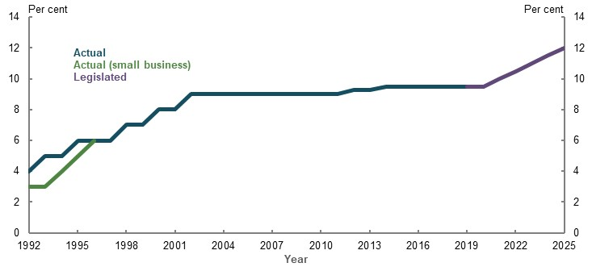
Source: (Commonwealth of Australia, 1992) (ATO, 2020g).
The explicit trade-off between superannuation and wages in the Accord ceased soon after the SG was introduced. Award wages became less common when enterprise bargaining was introduced in 1993, which promoted decentralised wage negotiation between unions and individual employers. About a fifth of employees currently have wages set under awards.
Reflecting policy intent and economic theory, governments, Treasury and other analysis has typically assumed pass-through of SG increases to lower wage growth (Gallagher, 2012; Rothman, 2011; Australia’s Future Tax System Review, 2009). For instance, in 2007, Paul Keating remarked that ‘the cost of superannuation was never borne by employers. It was absorbed into the overall wage cost’ (Keating, 2007).
This analysis assumed the trade-off was implicit, where employers and workers negotiated to maintain the same overall total pay packet, including superannuation. As a result, the debate about the incidence of the SG (who bears the cost) has shifted to being an empirical question; that is, the incidence must be inferred from observed data.

Wage setting in Australia
The wage-setting process in Australia is likely to facilitate high levels of pass-through of SG costs to wages. Since an overhaul in the early 1990s, the system of comprehensive award wages has evolved into three main wage-setting methods:
- Collective agreements, covering groups of employees at different firms
- Individual agreements, negotiated between employees and employers
- Award wages and the national minimum wage, centrally determined by the Fair Work Commission
    - Methods of employee wage setting in Australia
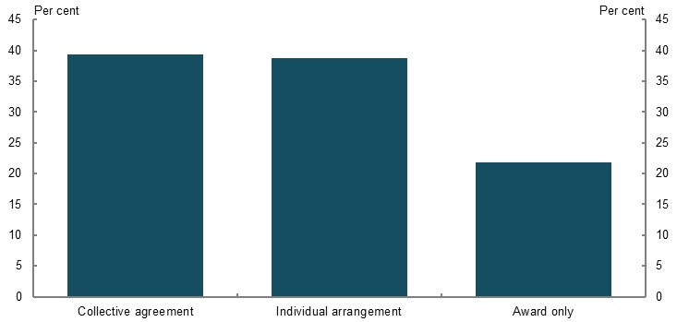
Note: Based on survey data collected in May 2018. Excludes ‘owner manager of incorporated enterprise’. Source: Analysis of (ABS, 2019h).

Individual agreements
Almost 40 per cent of employees have wages set by individual agreements with their employer (Chart 6A-2).
Since these agreements are individual, no detailed data is available on how SG costs are distributed. However, such agreements are more likely to cover higher-income workers who gain a higher value from superannuation tax concessions. About sixty per cent of employees on individual arrangements earn more than the median wage (ABS, 2019h).
Many individual agreements define a total remuneration package, which includes superannuation, suggesting that the incidence of the SG is contracted onto the employee. For such agreements, it implies full pass-through of SG changes to wages in the short run, with the potential for subsequent reallocation back to the employer through renegotiation.
Analysis also suggests that wages growth for workers on individual agreements is more responsive to changes in economic conditions (Bishop & Cassidy, 2019), which may mean it is also quite responsive to changes in labour costs. Some individual agreements are linked to award wage outcomes, which take into account changes in the SG.

Awards
Award wages are legally binding minimum wages that vary by industry and occupation, with the national minimum wage applying to any employee not covered by a specific award. These awards directly determine the wages of around 20 per cent of employees and around 13 per cent of total wages (Bishop & Cassidy, 2019). The Fair Work Commission centrally determines award wages and the minimum wage.
The Fair Work Commission has considered SG contributions a deferred benefit for employees and has taken changes in the SG into account when determining award wage outcomes. For example:
‘The SG rate increase to apply from 1 July 2013 is a moderating factor in considering the adjustment that should be made to minimum wages. As a result, though it would not be appropriate to quantify its effect, the increase in modern award minimum wages and the NMW [national minimum wage] we have awarded in this Review is lower than it otherwise would have been in the absence of the SG rate increase.’ (Fair Work Commission, 2013)
As well as explicitly considering the SG in award wages growth, the Fair Work Commission also considers average and median earnings (Fair Work Commission, 2019a). To the extent that SG increases reduce wages growth for employees using other wage-setting processes, this is likely to have second-round effects on wages growth for employees who rely on awards.

Collective agreements
Collective agreements, covering groups of employees at different firms, account for around 40 per cent of employees’ wages in Australia (Bishop & Cassidy, 2019). Union involvement in negotiating wages might lead to lower pass-through of superannuation costs to wages if unions enhance the bargaining power of employees. However, there is empirical evidence that pass-through in these agreements is strong (Coates, et al., 2020).
Some employees may be unaffected by changes to the SG, as they already receive superannuation contributions above the SG (for example, university employees). In aggregate, 14 per cent of employees reported receiving superannuation contributions above 9.5 per cent in the 2018 Household, and Labour Dynamics in Australia (HILDA) Survey.
Within these wage-setting frameworks, other factors will also matter. Bargaining power, prevailing profitability, market conditions and wage growth may affect how SG costs are distributed across industries and over time.

Submissions to the review
Submissions were mixed on the effect of the SG on wages growth. This division was most evident in research and policy institutes’ submissions, many of which presented evidence they have previously released on the subject.
Likewise, representative bodies were broadly split on whether higher SG payments were a trade-off for lower wages growth, but industry organisations generally agreed that there was a trade-off.
Submissions presented no new empirical evidence. The International literature and Australian evidence sections below assess the existing research referenced in the submissions.
One submission used a macroeconomic overlapping generations model to explore the impacts of changes to the SG. The submission referred to a paper (Kudrna & Woodland, 2013) whose central assumption resulted in a full pass-through to wages, but the submission drew attention to an alternative scenario in that paper with a much lower impact on wages. The alternative scenario assumed that higher domestic savings in Australia due to a higher SG rate could significantly reduce the domestic real interest rate. This reduced borrowing costs, increased domestic investment in the economy and in turn boosted wages.
In contrast, the paper’s central assumption that the real interest rate affecting investment in Australia is instead set internationally is more typical in similar macroeconomic models, such as (Kudrna, et al., 2015) and (Kudrna & Tran, 2018).

Economic theory
The SG is a ‘mandated benefit’ for employees. Since employers must pay SG amounts, they face the legal incidence of the payment. However, employees receive all the benefits. Superannuation therefore differs from other taxes on employment, such as payroll taxes, which provide no direct benefits to employees.
While employers bear the legal incidence of the SG, the ‘economic incidence’ (who ultimately bears the cost) will depend on how employers and employees respond to the benefit; for instance, how much employees value the superannuation benefit, how much the demand for labour changes in response to a change in wages, as well as structural features of the labour market such as minimum wages and wage-setting processes.
In general, employers will respond to an increase in employment costs with a combination of four possible changes:
- Increase the prices of their products or services
- Reduce employee wages (or wages growth)
- Reduce the amount of labour demanded
- Reduce their profits
Even if wages are unaffected, lower labour demand and higher prices are also costs borne by workers.
In a stylised labour market framework (Summers, 1989), mandated benefits increase the cost of hiring workers and therefore reduce the demand for labour. Since employers must pay the additional cost of the benefit on top of a given wage, they demand a lower quantity of labour at each wage level than previously. In addition (and by contrast to the example of payroll taxes), employees increase their supply of labour, since for a given take-home wage they now receive the additional benefit.
It is ambiguous if the new equilibrium wage rate results in more of the costs of a mandated benefit falling on employees or employers. That will depend both on how employers and employees adjust their demand and supply of labour in response to changes in the wage rate and how much employees value the benefit. In general, wages will fall more if employees’ willingness to work is unresponsive to changes in the wage rate and if they place a high value on the benefit.
Since, in practice, superannuation has strong direct benefits for employees (payments accumulate in employees’ accounts to be withdrawn in retirement), this suggests a relatively strong theoretical pass-through of SG costs to wages.
In a simple, theoretical example, with a perfectly competitive labour market and employees who are indifferent to the mix of superannuation and wages in their remuneration, there might be full pass-through; that is, wages would fall by exactly the value of superannuation payments. However, in practice, employees may value superannuation less than take-home wages, since access to superannuation is restricted, and the relative benefits of associated tax concessions will depend on employees’ time discount factors and the somewhat opaque effects of superannuation savings on pension benefits.
In addition, wages are not set according to supply and demand schedules in a perfectly competitive environment, but depend on wage-setting processes, minimum wages, bargaining power and matching considerations. Detailed analysis of the theoretical economic incidence of Australian superannuation is discussed in Freebairn (1998).

International literature
Consistent with theory, international evidence suggests that mandated benefits similar to superannuation (those with strong direct benefits for employees) have high pass-through to wages.
Of the two broad methodologies used to study such measures, those employing micro-econometric approaches, using data at the firm or employee level, are preferred in comparative studies. For instance, the European Commission’s (2015) literature survey noted that macro-econometric approaches have difficulty estimating the long-run incidence of mandated benefits. Macro-econometric studies rely on cross-country and time series variation in taxes on labour and are therefore less able to control for contemporaneous changes in other factors that might affect wages growth.
The other main difference across international studies is in the degree to which the program being studied gives a direct benefit to employees. Programs that provide weak direct benefits to employees, such as payroll taxes, are found to have lower pass-through to wages than those with strong direct benefits. (Bozio, et al., 2019) found average pass-through was only around 15 per cent across a range of studies looking at programs with weak links to employee benefits, but averaged 103 per cent across studies of programs with strong direct benefits. This is consistent with differences posited by theory that employees increase their willingness to work when mandated benefits with direct benefits for the employee are included.
Pass-through to wages tends to be larger in the long run. A meta-analysis by (Melguizo & González-Páramo, 2013), which incorporates the results of a large number of studies, found that a little less than half of the costs are passed through in the short run, but three-quarters are passed through on average in the long run. This may be because the legal incidence of these programs is on employers, and wage setting and labour demand do not adjust as much in the short run.
Wage-setting institutions are also important. Both highly centralised and highly decentralised wage-setting regimes, similar to award wages and individual agreements in Australia, tend to exhibit the highest degrees of pass-through to wages (European Commission, 2015). Employers are also found to be more able to shift costs that apply economy-wide, such as superannuation, than firm-specific costs. (Melguizo & González-Páramo, 2013) also estimate that pass-through is higher for employees in the public sector, which may reflect differences in wage negotiation for these workers.

Australian evidence
A small number of empirical studies have examined the effect of the SG on wages in Australia. High-quality micro-econometric research estimates most or all of the economic incidence of SG changes fall on employees through lower wages growth. This is consistent with both theory and international evidence of the effect of mandated benefits on wages, given superannuation has strong direct benefits for employees (Chart 6A-3).
    - Estimates of the pass-through to wages from the SG and mandated benefits, 95 per cent confidence intervals
Note: 100 per cent implies all of the costs of SG or mandated benefits changes are passed through as reductions in wages growth. Breunig and Sobeck (2020) estimate relates to the SG change for 2002-03. The Coates, et al., 2020 estimate uses the authors’ preferred model. International meta-analysis of mandated benefits is based on 52 empirical studies looking at the incidence of labour taxes and social security contributions (Melguizo & González-Páramo, 2013). Source: Review analysis.
Similar to international studies, the two broad empirical approaches are macro-econometric and micro-econometric. Micro-econometric studies are able to control for many more contemporaneous determinants of wages growth and are able to identify pass-through over longer timeframes, so these studies are preferred in the literature.
Two recent studies from research institutes used almost identical macro-econometric approaches: the McKell Institute (Taylor, 2019) and the Centre for the Future of Work at the Australia Institute (Stanford, 2019). They both found no significant pass-through of SG costs to wages. These studies use time series regressions, and assess the linear effect of SG changes on contemporaneous aggregate wages growth. Their approach raises a number of issues:
- The number of time series observations is limited. This means their estimates have low precision and they are not able to account for longer-run pass-through into wages. This is important as labour market frictions and international evidence suggests pass-through is higher in the long run.
- Only a limited number of control variables can be used. This may cause bias in their estimates of the effect of the SG if other factors that influence aggregate wage growth have not been controlled for, known as omitted variable bias. For instance, compositional factors, such as the changing industry composition of the labour force, have not been controlled for.
- The specification may be affected by reverse causation. It may have historically been easier to increase the SG when prevailing wages growth was strong, confounding their results.
- Their conclusions can change significantly with small changes in model specification. This is shown by the Grattan Institute’s replications of the time series models (Nolan, et al., 2019); (Coates, et al., 2020). Reasonable alternative specifications can support a trade-off between the SG and wages growth.
The Stanford (2019) study also presents unconditional correlation analysis between:
- average wage growth and the industry share of the wage bill paid in superannuation in Australia, and
- unit wage costs and rates of employer social contributions across countries
This unconditional correlation analysis has methodological issues. It fails to control for any differences in labour market conditions across industries and countries. It also suffers from definitional issues; for instance, superannuation is paid as a share of ordinary time earnings, not the total wage bill, and no account is made for differences in social contributions’ direct benefit to employees across countries.
Two recent papers have employed micro-econometric techniques using different data sources and conclude that the majority (70-100 per cent) of SG costs are paid for by employees through lower wages growth.
The Grattan Institute (Coates, et al., 2020) identifies the correlation between the SG and wages growth in a pooled sample of 80,000 enterprise agreements registered from 1991 to 2018. They find that 80 per cent of SG increases are passed through to lower aggregate wages within the period of the enterprise agreement, typically two to three years. The dataset does not allow for observation of long-run effects, but authors noted long-run pass-through is likely to be even higher based on similar international studies.
The data used in Coates, et al. (2020) covers those on collective agreements in the federal industrial relations system. These agreements represent an ‘intermediate’ level of wage setting, which international evidence suggests has a lower level of pass-through (European Commission, 2015).
The authors exploit significant cross-sectional and time variation in agreements and substantial amounts of data to control for additional factors that are likely to affect wages growth. This includes more macroeconomic drivers of wages growth, such as underemployment and per capita GDP growth. In addition, they account for factors that would explain differences in wage growth across agreements: fixed effects for sector and industry, along with things such as industry-level unemployment rates. This addresses concerns about omitted variable bias.
The extensive list of control variables included in Coates, et al. (2020) and the high level of robustness their results show to changes in model specification, strongly suggests the effect they identify is due to SG changes. In addition, alternative specifications that exclude agreements paying more than the SG give stronger effects, equal to full pass-through, suggesting that their partial pass-through estimates are tempered by agreements not affected by the SG.
The second micro-econometric analysis, from the Tax and Transfer Policy Institute (Breunig & Sobeck, 2020), which was commissioned by the review, estimated that changes to the SG causally lower wages growth. The authors found pass-through was between 70 and 100 per cent.
Their identification strategy compares wages growth for workers receiving more than the SG-legislated rate to those receiving the legislated rate. Increases to the legislated rate of the SG should only affect the latter group, allowing a comparison of wages growth between them.
Their data includes individual tax return data from the Australian Taxation Office (ATO) from 2002-03 to 2016-17, covering all three different wage-setting arrangements. A relative strength of this study, compared to Coates et al. (2020) study, is that the dataset covers all wage-setting agreement types.
Breunig & Sobeck (2020) find that employees receiving superannuation contributions above the SG rate have persistently lower wages growth over their sample. They identify that in years the SG was increased, the difference in wages growth narrowed, providing evidence that changes to the SG are passed through to lower wages growth.
The causality of these results relies on the assumption that the difference in wages growth between employees who receive exactly the SG and others is constant over time (in the absence of SG changes). They are able to use individual fixed effects to control for persistent differences between them over time, which accounts for substantial heterogeneity between people. Their results are robust to a number of methodological and sample selection changes, and add to the empirical evidence that the majority of SG costs are passed through to wages.

Possible future effects
In predicting future impacts of the SG on wages, the rate of pass-through would depend on workers’ bargaining power and the domestic labour market. However, there is no clear evidence that future changes to the SG will have lower pass-through to wages than previous increases.
Lower aggregate wage growth may reduce pass-through in the short run. Wages tend to be sticky; nominal wage decreases are rare and there is some evidence of clumping of wage increases around expected inflation (Debelle, 2019).
Given average wage growth has been low over recent years, it could be argued that these nominal rigidities may be more binding. In 2018, around half of wage increases were between 2 and 3 per cent, up more than 40 per cent since 2012 (Debelle, 2019).Compared to these recent wage outcomes, there is potential for even lower wage growth or even wage freezes arising in the short term resulting from the COVID-19 Pandemic. This may mean more of the short-term incidence of SG increases legislated to occur in 2021 could, in some instances, initially fall on employers. Where employers bear more of the SG increase this could lead to changes in the demand for labour and/or investment. The impact of the COVID-19 Pandemic on the economy over the next few years is very uncertain. However, the modelling undertaken for the review is aimed at assessing the long-term implications of different SG rates. Variations in the business cycle and shorter-term volatility are unlikely to impact on long-term economic trends. Over the long term, the research suggests most of the impact of SG changes will be passed on to workers.
While lower wages growth in the year of introduction could reduce pass-through of changes to the SG, evidence suggests this will not be maintained and the long-run economic incidence of the SG will be mostly on employees. This suggests any additional compensation from SG increases when nominal wages are held constant will be recouped through lower wages growth when wage freezes are lifted.
Some evidence suggests pass-through could be higher in the future. International estimates suggest labour demand has become more flexible over recent years, due to technology improvements increasing the substitutability of domestic labour and compositional shifts towards flexible contracts for low-skilled jobs (European Commission, 2015). Such factors reduce bargaining power of employees and would increase the pass-through of superannuation costs to employees. In line with this, (Breunig & Sobeck, 2020) found evidence that pass-through from the most recent changes to the SG were higher than in the past.
There is limited evidence that other changes would reduce pass-through.
- Employees will probably not value superannuation less than in the past, given tax concessions and access arrangements have remained broadly unchanged.
- Increases in employee bargaining power that could shift the costs of SG changes towards employers have not been apparent.
  - The general environment of weak wages growth is a priori evidence against this; similarly, the total share of income paid to workers has been falling for some time (La Cava, 2019).
  - Trade unions have been found to have a similar influence on aggregate wages growth as in the past (Bishop & Chan, 2019).
  - The current economic environment associated with COVID-19 Pandemic has resulted in elevated levels of unemployment and underemployment. This could reduce worker bargaining power in the short-term making it more likely for pass through to wages to occur.

Evidence on the spending growth needed in retirement
The rate of spending growth in retirement is critical to determining whether the retirement income system delivers adequate outcomes. The issue has not been addressed substantially in previous reviews, nor have governments made a goal explicit. Submissions to the review identified this as an important issue for measuring adequacy.
Projections undertaken for the review have deflated retirement income by the Consumer Price Index (CPI). This approach is based on the following evidence:
- The expenditure patterns of current retirees. While there are differing opinions within the community (Box 6A-1), the weight of evidence points to retirees’ spending being maintained or falling relative to prices.
- The indexation of available retirement income products in Australia, which mostly increase with prices.
- International practices, which, on balance, use prices for indexing retirement benefits.

Expenditure patterns of current retirees
          - Stakeholder views on expenditure patterns
Stakeholders expressed three broad positions on expenditure patterns of Australian retirees.
- Expenditure falls as people age. Some submissions noted research using the Australian Bureau of Statistics (ABS) Household Expenditure Survey and bank transaction data compiled by Milliman (an actuarial consulting firm), which suggests that, in Australia, spending by retirees falls in real terms as they age.
- Expenditure falls but is constrained by retirees’ income. Some submissions argued that it is not appropriate to use actual expenditure data to determine retirees’ spending needs as many retirees have low incomes, which places a limit on spending. These submissions argued retirees may refrain from spending due to factors such as a fear of outliving their assets.
- Expenditure increases as retirees age. Submissions that supported this view cited international evidence and spending research using HILDA data. Some international studies have suggested that increases in health spending more than offsets lower expenditure in other areas as people age. HILDA data suggests limited reduction in spending as people age. However, other stakeholders noted that HILDA is limited as it does not capture some spending categories.
Examining the expenditure patterns of current retirees provides the best evidence for determining the income needs of future retirees. The review has used a number of data sources to measure the expenditure patterns of retirees:
- Data from the ABS Household Expenditure Survey on the expenditure of the population between 1988-89 and 2015-16. This data can be used to track the spending patterns of generations as they age.
- Research from the Reserve Bank of Australia (RBA) on demographic trends and household spending (Cokis & McLoughlin, 2020).
- Spending pattern analysis compiled by Milliman, an actuarial consulting firm.
The HILDA Survey also tracks household expenditure. The review uses the HES instead of HILDA to track household expenditure because:
- HILDA records a smaller proportion of total household expenditure due to fewer expenditure categories than HES. Large areas of discretionary spending such as recreation and personal care are not surveyed in HILDA (Table 6A-1).
- ABS data can be preferable to HILDA as it is not affected by issues where people drop out of HILDA over time and includes greater span of years (Taylor, 2018).
- Survey methodology differences mean HES records some expenditure more accurately. HILDA expenditure data is based on participants’ recollection of weekly expenditure, while HES is based on recorded expenditure.
      - HILDA and HES expenditure categories
Household Expenditure Survey | HILDA
Alcoholic beverages | Alcohol
Clothing and footwear | Clothing and footwear (women/men/children)
Communication | Telephone rent and calls/internet charges
Current housing costs  Mortgage repayments principal | Rent and mortgage repayments/repairs, renovation and maintenance to home
Domestic fuel and power | Electricity, gas and other heating fuel bills
Education | Education fees
Food and non-alcoholic beverages | Groceries/Meals eaten out
Household furnishings and equipment | n/a
Household services and operation | n/a
Medical care and health expenses | Fees paid to health practitioners/medicines, prescriptions and pharmaceuticals/private health insurance
Miscellaneous goods and services | n/a
Personal care | n/a
Recreation | n/a
Tobacco products | Cigarettes and other tobacco products
Transport | Public transports and taxis/Motor vehicle repairs and maintenance/motor vehicle fuel
Note: HILDA categories are bundled by type. Source: (ABS, 2017e); HILDA Survey data (Wave 18).
Analysis suggests that retirees have flat or falling spending relative to prices as they age. Regardless of the age cohort examined, retirees show the same trend of declining spending (Chart 6A-4).
    - Median household weekly expenditure
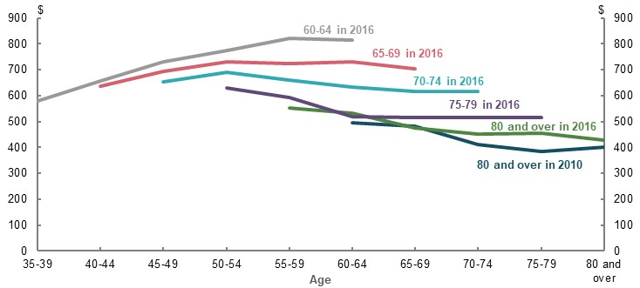
Note: Values are in 2018-19 dollars, indexed to CPI. Household expenditure is equivalised. Cohorts use five-year birth ranges based on the age of the household reference person. Household weekly expenditure excludes voluntary superannuation contributions and capital housing costs. The principal and interest components of mortgage repayments are included in weekly expenditure. Source: Analysis of ABS Household Expenditure Survey Confidentialised Unit Record File, 1988-89 to 2015-16.
Expenditure falls because retirees spend less on discretionary items. In particular, retirees spend less in real terms on transport, clothing and recreation. Falling spending in these categories is consistent with retirees being less active as they age (Chart 6A-5).
On average, total spending on essential items remains roughly constant in real terms. The main essential item on which spending falls is food, likely due to eating out less and having additional time to make food at home. International studies suggest that quality and quantity of food consumed by retirees do not decline despite reduced expenditure (Aguiar & Hurst, 2005).
Households typically spend a declining share of their budgets on discretionary items as they age. For example, for households aged 80 or older in 2015-2016, 19 per cent of their spending was on discretionary items, compared to 41 per cent in 1988-89 when they were aged 55-59.
    - Median household weekly spending, following one cohort over time
Spending on essential items | Spending on discretionary items
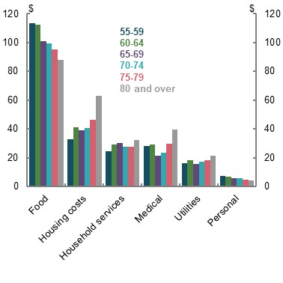 | 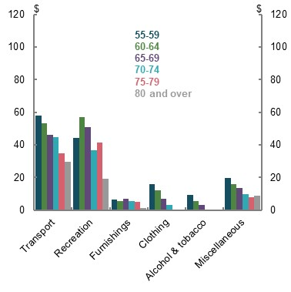
Note: Cohorts constructed using five-year birth ranges. Cohort ‘80 and over’ in 2015-16, aged ‘75-79’ in 2009-10 and so on. Values are in 2018-19 dollars, indexed to CPI. Household expenditure is equivalised. Household expenditure excludes voluntary superannuation contributions and capital housing costs. Housing includes the principal and interest components of mortgage repayments. Miscellaneous includes education costs, which were included as a separate category in the 2015-16 Household Expenditure Survey. Source: Analysis of ABS Household Expenditure Survey Confidentialised Unit Record File, 1988-89 to 2015-16.

Health expenses
Stakeholders raised concerns about health expenses increasing through retirement, and therefore requiring higher income in late retirement to meet these rising costs.
Some submissions cited a study of American retirees suggesting spending patterns in late retirement change due to medical expenses (Blanchett, 2014).
The broad findings of the study can be summarised as follows:
- As retirees age, their spending relative to prices falls for all ages older than 62.
- Spending falls fastest for retirees in the middle ages of retirement.
- Spending falls, but more slowly, for people aged in their 60s.
- People aged in their 80s still have falling expenditure, but rising health costs mean this fall is not as significant as falls in mid-retirement age spending. For example, average spending declines by about 1.5 per cent at age 85 compared to about 2 per cent at age 75 (Chart 6A-6).
    - Annual real change in total expenditure, by age
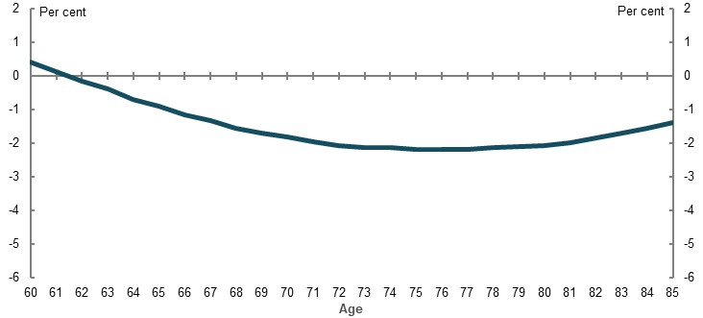
Source: (Blanchett, 2014).
In Australia, there is evidence that medical expenses grow modestly from a low level as people age. In 2015-16, medical expenses made up 9 per cent of median expenditure at ages 80 and over (or $40 per week), compared to 5 per cent of median expenditure at ages 55-59 (or $28 per week) (Chart 6A-5). Government services provide significant in-kind support to Australians as they age, limiting the increase in out-of-pocket expenses to retiree households (see 4. Sustainability). Further, the slight increases in health costs tend to be more than offset by declining expenditure in other categories of spending (Chart 6A-5). The increase in medical expenses as a share of expenditure in part reflects that overall expenditure is falling.
Evidence from other countries on health spending of retirees should be interpreted with caution. Results will depend on the health care system for the particular country. Australia’s universal health care system provides significant support to retirees (see 2A. Achieving a minimum standard of living in retirement).

Expenditure patterns of high-wealth retirees
To understand the spending retirees may wish to have, the review considered expenditure of the top 20 per cent of wealthiest retirees. These households have income that is consistently higher than their expenses. They also have wealth that is similar to the projected real wealth for median earners under a mature superannuation system.
Given these groups face fewer budget constraints, their spending patterns over time are more likely to reflect genuine preference rather than necessity.
For high-wealth retirees, spending falls or remains flat with age in a pattern broadly similar to other retirees (Chart 6A-7). Falling real spending is despite their income rising significantly in real terms (Chart 6A-8). It suggests falls in expenditure during retirement are not due to income constraints.
    - Median household weekly expenditure, top 20 per cent of households by income
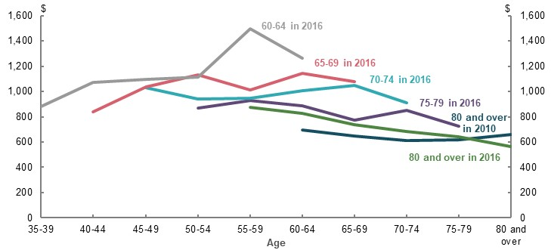
Note: Data includes Household Expenditure Survey 1988-89 to 2015-16. Household expenditure is equivalised. Includes households in the top 20 per cent of income earners. Pseudo-cohorts have been constructed using five-year birth ranges. Values are in 2018-19 dollars, indexed to CPI. Household weekly expenditure excludes voluntary superannuation contributions and capital housing costs. Principal and interest components of mortgage repayments are included in weekly expenditure. Source: Analysis of ABS Household Expenditure Survey Confidentialised Unit Record File, 1988 to 2015-16.
Total spending on essential items is stable with age for these households, with most of the decrease coming from lower discretionary spending consistent with patterns of all retirees (Chart 6A-8).
    - Median household weekly expenditure and disposable income, top 20 per cent of households by income
Cohort aged 80 and over in 2016 | Cohort aged 75-79 in 2016
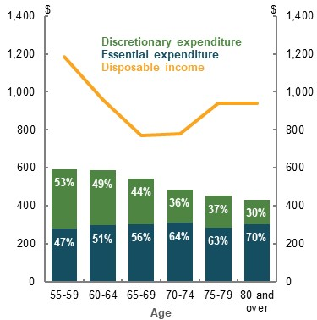 | 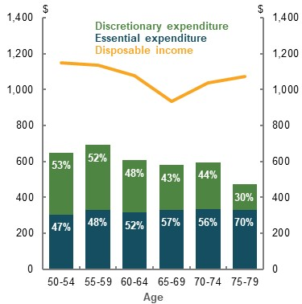
Note: This chart shows equivalised weekly household expenditure and income by age for two birth cohorts. Expenditure is split into essential and discretionary categories. Data includes Household Expenditure Survey 1988-89 to 2015-16. Includes households in the top 20 per cent of income earners. Pseudo-cohorts have been constructed using five-year birth ranges. Values are in 2018-19 dollars, indexed to CPI. Household weekly expenditure excludes voluntary superannuation contributions and capital housing costs. Principal and interest components of mortgage repayments are included in weekly expenditure. Source: Analysis of ABS Household Expenditure Survey Confidentialised Unit Record File, 1988-89 to 2015-16.

Spending patterns of future retirees
It is possible that expenditure patterns could change for future retirees. Some submissions argued that higher wealth in future or higher spending patterns among younger generations could change expenditure needs in retirement.
For example, the previous analysis showed a broad consistency in retirement spending patterns by age for retirees today, regardless of wealth. However, spending growth was faster among households aged 65 and over between 2003-04 and 2017-18 relative to the spending growth of working-age households (Chart 6A-9).
Rising living standards mean each generation has higher income and spending than the one before it. For example, households aged 65 and over in 2017-18 spent over 40 per cent more than households in the same age range in 2003-04 (Chart 6A-9).
Nevertheless, when tracking spending by a given generation as they age, the pattern of falling expenditure during retirement has remained (Chart 6A-4).
Age-based differences in income and assets growth over the last decade may also explain faster spending growth of older households:
- Income growth for older households increased faster than that for working-age households due to rising asset values combined with the 2009 Age Pension increase (see 1D. The changing Australian landscape and 4. Sustainability).
- Younger households, which typically have fewer assets, had their spending growth constrained by slow wage growth.
    - Growth in real household consumption by age
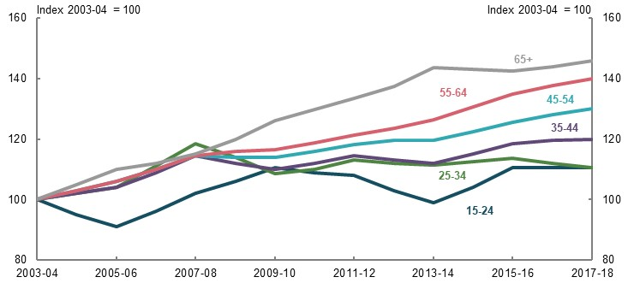
Note: Age is based on age of reference person and relates to year of survey. Household consumption is deflated with the aggregate household consumption deflator. Source: (Cokis & McLoughlin, 2020).

Indexation of international schemes
Most OECD retirement income systems index retirement income to prices rather than wages (OECD, 2019b), (OECD, 2015). Among OECD countries, 57 per cent of earnings-related indexed schemes and 59 per cent of social safety net schemes are predominantly indexed to prices (Table 6A-2).
      - Indexation of retirement income schemes, selected OECD countries
Indexation |  | Safety net  (per cent) | Earnings-relatedⁱ  (per cent)
Predominantly wages |  | 32 | 25
Predominantly prices |  | 59 | 57
Other |  | 9ⁱⁱ | 18ⁱⁱⁱ
Note: ⁱincludes defined benefits, points, notional or non-financial defined contribution schemes. Does not include countries with defined contributions schemes such as Australia or those with no mandatory earnings-related pension scheme as these are not indexed. ⁱⁱincludes 50/50 prices/wages split for Switzerland, and discretionary for Austria and Luxembourg. ⁱⁱⁱincludes 50/50 prices/wages split for Switzerland, Czech Republic and the Slovak Republic, and discretionary choice for Austria and Luxembourg. ‘Predominantly’ indicates more than 50 per cent of the indexation is weighted to the given method. Earnings-related data from 2019, Safety net data from 2015. Source: Analysis of (OECD, 2019b) (OECD, 2015).
International organisations tend to use price deflation for system-level assessments. OECD guidance is for pension plans to be indexed to prices. OECD modelling of replacement rates also uses price indexation (OECD, 2015). Likewise, the World Bank has used price deflation to calculate future retirement expenditure (World Bank, 1994).

Indexation of retirement products in Australia
Most financial retirement products in Australia are indexed to prices. This includes both private annuity products and indexation of defined benefit schemes.
The Australian market for retirement products is still developing, including only limited annuity products and existing defined benefit schemes (Table 6A-3).
      - Australian retirement income products
Provider | Product | Indexation
Annuities
Challenger | Guaranteed lifetime annuity | CPI or other fixed percentage
Challenger | Term annuity | CPI or other fixed percentage
CommInsure | Guaranteed lifetime annuity | CPI or other fixed percentage  < 8 per cent
Mercer | Group self-annuity | Approximately stable in real terms until 12 years after purchase, then growing in real terms due to a capital return and ‘living bonus’
Defined benefit schemes
Commonwealth | Commonwealth Superannuation Scheme | CPI
Commonwealth | Defence Force Retirement and Death Benefits | CPI or Pensioner and beneficiary living cost index
Commonwealth | Public Sector Superannuation Scheme | CPI option
Government social security
Commonwealth | Age Pension | Wages*
* The Age Pension is indexed to the higher growth of CPI and Pensioner and Beneficiary Living Cost Index and then benchmarked to male total average weekly earnings. Source: (Challenger, 2020), (Commonwealth Bank, 2020), (Mercer, 2017), (Commonwealth Superannuation Corporation, 2020).

Evidence for the adequacy benchmark
Following is an outline of the evidence for the replacement rate benchmark of 65-75 per cent used in the review.
Replacement rate benchmarks estimate the proportion of working-life income that allows retirees to maintain their standard of living. Retirees who meet the benchmark are assumed to have the capacity to maintain living standards between working life and retirement. Exceeding or falling below the benchmark indicates that living standards may have increased or fallen, respectively, in retirement.
Replacement rate benchmarks are less than 100 per cent because people in retirement can maintain living standards with lower income than during their working lives. This is because:
- People do not need to save when in retirement. They are in the phase of life where they can draw down their wealth and spend the income they are receiving.
- Most retirees have lower housing costs because they have paid off their mortgage (see 2A. Achieving a minimum standard of living in retirement and 1D. The changing Australian landscape).
- Other costs also fall, such as the costs associated with raising children and participating in the labour force (2A. Achieving a minimum standard of living in retirement).
- Retirees pay less tax than those with comparable incomes in working life, through targeted mechanisms such as the seniors and pensioners tax offset and tax-free superannuation.
- Government services such as health care provide more support to retirees as a proportion of their income compared to people in the workforce (2A. Achieving a minimum standard of living in retirement). These services reduce retirees’ reliance on income to fund spending.
- Retirees may also benefit modestly from producing more things at home (Been, et al., 2015); for example, cooking meals at home rather than eating out.
There is no universally agreed replacement rate benchmark. The review has used a replacement rate benchmark of 65-75 per cent, based on:
- International and domestic replacement rate benchmarks
- The proportion of income working-age people spend on consumption
- Survey data on how much income Australians say they need for retirement
- Replacement rates achieved by current retirees, where survey evidence suggests their wellbeing is maintained or improved on entering retirement

Common replacement rate benchmarks
Some of the replacement rate benchmarks used by a variety of organisations are as follows:
- The 70 per cent benchmark used by the OECD as a general rule of thumb (Antolin, 2009), although not officially endorsed.
- The Actuaries Institute suggests 65-75 per cent is the benchmark range generally applied internationally and in Australia (Actuaries Institute, 2020).
- The UK Pensions Review used a gross replacement rate benchmark of 80 per cent for the lowest income earners, 67 per cent for median earners, falling to 50 per cent for higher-income earners (Pensions Commission, 2004).
- Submissions to the review suggested benchmarks of 65 per cent or 70 per cent (Industry Super Australia, 2020) (Grattan Institute, 2020). Some submissions proposed benchmarks that varied by income, such as at least 85 per cent for lower-income earners, falling to 60 per cent for higher-income earners (Mercer, 2020).
The above rates vary due to differences in calculation methods, including the impact of tax and estimates of consumption needs in retirement. Overall, it is broadly agreed that:
- Most retirees can maintain their consumption with lower levels of income in retirement than in working life
- Lower-income earners need higher replacement rates to achieve a minimum standard of living in retirement
- Higher-income earners need lower replacement rates

Estimates using income and consumption data
Following is evidence on the proportion of working-life disposable income Australians spend, adjusting for some costs Australians tend not to have in retirement. This provides figures analogous to a net replacement rate target.
A conservative approach has been taken to calculating the proportion of working-life income Australians spend. Mortgage and education costs have been excluded but other significant costs are not accounted for, including those associated with raising children, lifestyle changes and effects from producing more at home. As the calculations use disposable income, the analysis does not account for differences in tax paid in retirement. It should therefore be considered an upper estimate of an appropriate replacement rate, as it does not factor in all areas where retirees have lower costs than working-age Australians.
On average, middle-income households spend about 75 per cent of their disposable income after excluding their mortgage and education costs, and accounting for savings (Chart 6A-10). This proportion is roughly constant for all age groups. Consistent with benchmarks used by others, results differ by income:
- Just under 100 per cent for lower-income earners.
- About 75 per cent for middle-income earners.
- About 60 per cent for higher-income earners.
    - Modified expenditure as a proportion of disposable income
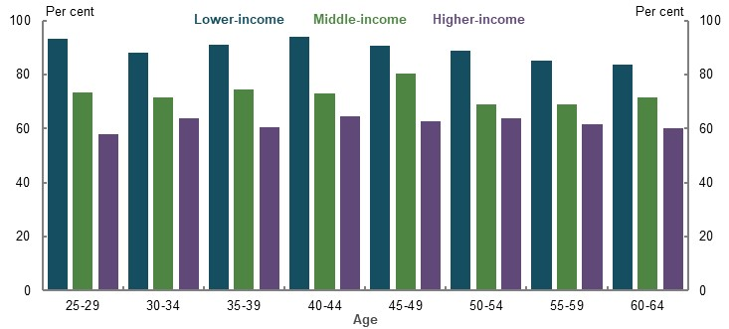
Note: Lower-income earners are defined as those in the bottom 30 per cent of all earners, higher-income earners in the top 20 per cent and middle-income earners are those in between. Modified household expenditure as a proportion of household disposable income, employed working-age population. Modified expenditure is calculated as total expenditure on goods and services, less mortgage and education costs, as a percentage of disposable income. Households with expenses greater than double household income excluded from the data. Source: Analysis of ABS Household Expenditure Survey Confidentialised Unit Record File, 2015-16.
Savings rates are higher for higher-income earners, which creates a larger wedge between income and consumption (Finlay & Price, 2014) (Chart 6A-11).
    - Household saving ratio by income quintile
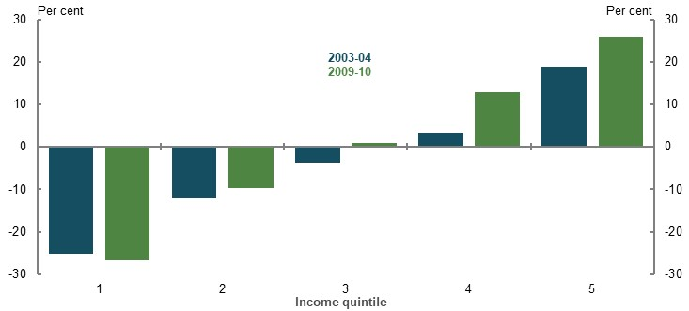
Note: Saving ratio shows the relationship between household saving and spending. Data is from 2003-04 and 2009-10 Household Expenditure Surveys. Source: (Finlay & Price, 2014).

Housing costs
The review considered the impact of housing costs, particularly given their important role in maintaining living standards between working life and retirement.
Home ownership reduces spending in working life (through repaying a mortgage) and lowers housing costs in retirement. Housing costs are about a quarter of household disposable income for home owners between ages 25-34, but only around 5 per cent of household disposable income for home owners aged 65 and over (Chart 6A-12).
Renters do not benefit from lower housing costs later in life. Housing costs remain about a quarter of a renter’s household disposable income over their lives, even increasing slightly once they reach retirement age.
    - Housing costs as a percentage of household disposable income, by age and tenure
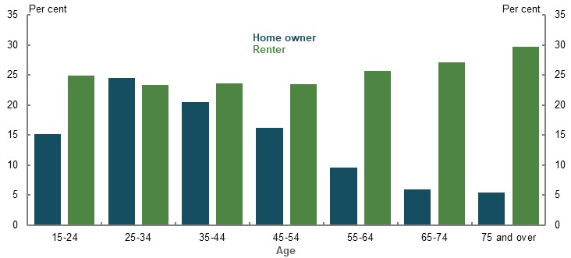
Note: Data is from 2015-16. Housing costs include mortgage interest and principal repayments and general rates for home owners, and rental payments for renters. Age refers to age of reference person in household. Source: (Daley, et al., 2018b).
The review also considered the lifetime costs of purchasing a home, particularly given increases in Australian housing prices over recent years, (see 1D. The changing Australian landscape).
The proportion of lifetime income needed to purchase a house has grown significantly. On average, households purchasing homes in 2020 will devote almost 18 per cent or their total working-life income to repaying their mortgages, an increase of around 12 percentage points since the 1980s (see 1D. The changing Australian landscape).
The higher share of lifetime income needed to buy a home has important implications for replacement rates. Increases in the proportion of working-life income required to purchase a home reduce spending during working life. Consequently, any replacement rate benchmark today should be lower than it was previously, due to rising housing costs.
Since owner-occupied housing gives benefits across someone’s life, it is appropriate that the additional costs of acquiring a home affect consumption in retirement as well as in working life.

The cost of children
The cost of raising children is an important difference between working-life and retirement spending.
Raising children is a significant lifetime expense, typically during working lives. One study estimated the weekly costs of raising children of certain ages for low-paid families was $203 for the first child or $340 a week for two children in 2016, or between $10,000-18,000 per year (Saunders & Bedford, 2018). Another study found that households need significantly less income in retirement after accounting for the costs of raising children (Scholz & Seshadri, 2009).
The working-life income target is based on the last 10 years before retirement. During this time, people are less likely to be incurring costs associated with raising children (ABS, 2019s). The review’s replacement rate benchmark therefore makes no adjustment for the costs of children.

Historical replacement rates
The outcomes for recent retirees can provide an indication of the performance of the retirement income system under past policy settings. Yet due to data limitations, replacement rates for recent retirees are difficult to calculate and should be considered indicative only. Analysis from 2C. Maintaining standards of living in retirement shows:
- Middle- and higher-income earners, on average, achieved replacement rates about 65 per cent or higher
- Most recent retirees maintain their financial wellbeing and improve their general wellbeing in retirement (although financial wellbeing of some retirees does decline, particularly due to involuntary retirement)
Taken together, these results suggest that replacement rates achieved by an average person who retired recently can be a guide for an appropriate benchmark.
2C. Maintaining standards of living in retirement presents analysis on the replacement rates of a cohort of retirees aged 65-74 in 2017-18.
Analysis following specific people over time also shows outcomes for recent retirees tend to be adequate. The longitudinal dataset, HILDA, was used to calculate the replacement rates of people who have retired since 2010. The longitudinal methodology compares incomes six and three years before and after retirement, respectively, to calculate replacement rates.
While the longitudinal approach better reflects the experience of people who retire, it also has data limitations. The number of years available and sample size of the HILDA Survey means that calculations are based on a small number of years before and after retirement. Longer periods would have been more accurate due to being less affected by events like transitioning to retirement or uneven drawdown of superannuation. Longitudinal surveys are also affected by people dropping out of the survey, and this could also bias results.
    - Longitudinal analysis of replacement rates of retirees since 2010
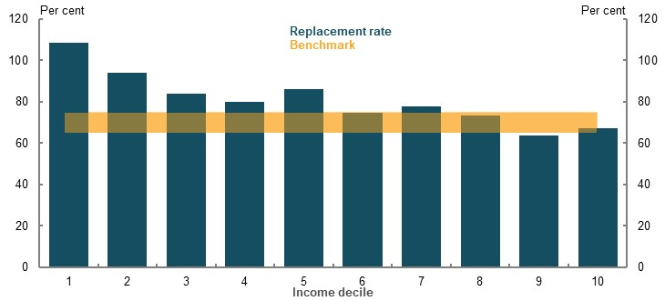
Note: Replacement rates calculated six years before retirement and three years after retirement. Includes people who retired from 2010, based on the latest observable point that people retired. Income is equivalised disposable household income. Based on median outcome within decile. Source: Analysis of HILDA Survey data (Waves 1 to 18).

Expectations for retirement
The level of income people think they will need for an adequate retirement can help determine a replacement rate benchmark (Chart 6A-14).
    - Replacement rates implied by survey data
Investment Trends  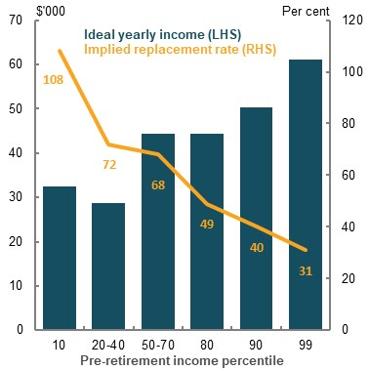 | HILDA  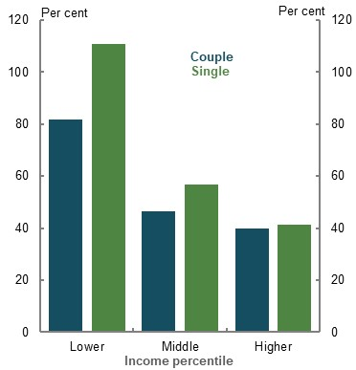
Note: Investment trends percentiles based on income of 45-year-olds in the review’s retirement income model. Income is household pre-tax income aligned with percentiles in review cameo modelling. Question is ‘When you are retired, what level of income do you think you will need to have a comfortable lifestyle in retirement?’ HILDA income percentiles are based on disposable income using the review’s categories for lower-, middle- and higher-income earners. HILDA question is ‘How much after-tax income do you think you (and your partner) will you require in retirement in order to have a standard of living which you regard as satisfactory?’ Source: Investment Trends, 2019; Analysis of HILDA Survey data (Waves 15).
In the Investment Trends survey, Australians believed an ideal retirement income was $44,000 per year for a middle-income household, equivalent to a gross replacement rate of 68 per cent. For HILDA, the response of middle income earners implies a replacement rate of about 60 per cent for singles and 46 per cent for couples.
This approach has some weaknesses:
- Surveys ask questions differently, which can influence the results.
- Retirement income planning is complicated. Australians may not know the lifestyle changes that happen in retirement or differences in taxation and social security transfers.
Overall, these results suggest replacement rates in the range of 65-75 per cent are appropriate. Lower-income earners prefer replacing about 100 per cent of their income in retirement. Higher-income earners prefer lower replacement rates than middle-income earners.

ASFA comfortable standard as an adequacy objective
The following is an overview as to why the review did not use the ASFA comfortable standard as an adequacy target. Some submissions from the superannuation industry endorsed the ASFA comfortable standard as a retirement income adequacy goal. The standard has several shortcomings as an adequacy objective:
- It was initially designed as, and continues to reflect, a standard for the top 20 per cent of income earners. Further, it constitutes a standard of living higher than that experienced by most Australians during their working lives.
- It does not account for the trade-off between working life and retirement living standards. Universal policy settings that result in a standard of living in retirement that exceeds working-life standards are unlikely to improve lifetime wellbeing. A retirement goal is not appropriate if achieving it would come at the cost of a substantially lower standard of living in working life.
- It would be difficult for a median-income earner to achieve. A median earner working a 40-year career would need the SG rate to continue escalating to 16.5 per cent to achieve the standard.

History of the ASFA standard
Contemporary budget standards were first developed in Australia in 1997 to facilitate research into the adequacy of social security payments, such as the Age Pension (Saunders, 2006). The first Australian budget standards included a ‘low-cost’ poverty avoidance measure and a ‘modest but adequate’ measure that reflected the spending of the median retiree.
In 2003, ASFA and Westpac commissioned an update to add a comfortable retirement standard, intended for wealthy, self-funded retirees. The new ‘comfortably affluent and sustainable’ standard reflected the spending patterns and lifestyles of the top 20 per cent of income earners:
‘The comfortably affluent standard reflects a standard of living among older, healthy and fully active self-retired Australians that allows them to engage actively with a broad range of leisure and recreational activities without having to require a rapid or substantial disbursement of assets. It represents a lifestyle that is common amongst those in the top (income) quintile of the aged population.’ (Saunders, et al., 2004)
Subsequent updates in 2009 and 2018 amended the standard to reflect changes in expenditure patterns and redefined it as a ‘comfortable’ standard (ASFA, 2009).

Appropriateness of the standard for current retirees
An important part of assessing if the ASFA comfortable standard is an appropriate benchmark is how it compares to the consumption (standard of living) of working Australians and current retirees.
Analysis of ABS expenditure data suggests the ASFA comfortable standard provides a higher living standard than most people in the workforce enjoy today (Daley, et al., 2018b):
- The top 30 per cent of working-age couples and the top 20 per cent of working-age singles currently spend as much as the ASFA comfortable standard.
- The top 30 per cent of retired couples and the top 10 per cent of retired singles spend as much as the ASFA comfortable standard.

Appropriateness of the standard for future retirees
Another way to assess the ASFA comfortable standard is to look at what system changes would need to be made to achieve it and the effect these changes would have.
ASFA’s modelling suggests 50 per cent of Australians can achieve the comfortable standard. They suggest women meet the ASFA standard from the 70th income percentile (ASFA, 2020a).
ASFA modelling has several assumptions that differ from those used by the review. In particular, ASFA assumes significantly longer working lives, with careers from ages 19 to 67, and a larger gap between the investment rate of return after fees and taxes, and wage growth.
They also use different income profiles than the review’s analysis of ATO data, including:
- Working-life income sourced from ATO data peaks at about age 45 and tends to decline thereafter as people transition to retirement (Chart 6A-17). However, profiles presented in (ASFA, 2020b) show income peaking about age 45 but broadly staying at these levels for later ages. This means later in life and across most deciles, incomes used in ASFA modelling can be higher on average than is observed in ATO data.
- ASFA shows the bottom-decile people earning $40,000 a year (ASFA, 2020b), approximately the national minimum wage for a full-time worker. This level of income is significantly higher than the lower-income earnings in the review’s cameo modelling, with average incomes of about $22,600 and $36,000 for people in the 10th and 20th percentiles, respectively.
Higher income assumptions make it easier to achieve a given retirement income target.
Median-income earners fall significantly short of the ASFA comfortable standard under the review’s assumptions. Specifically, a median earner has a balance $93,000 below the balance required to achieve the ASFA comfortable standard of $545,000 in wage-deflated terms (Chart 6A-15).
    - Superannuation balances at retirement, review and ASFA modelling
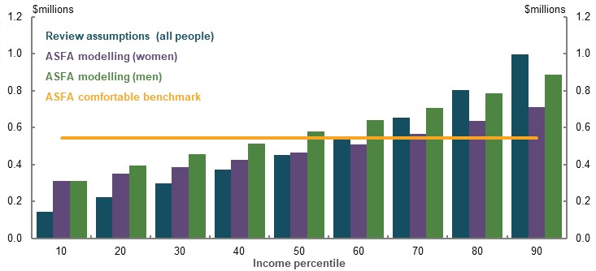
Notes: Values are 2019-20 dollars, deflated by average weekly earnings. Based on ASFA estimate of $545,000 required to reach the ‘ASFA comfortable standard’ in wage-deflated terms. Source: (ASFA, 2020a) and cameo modelling undertaken for the review.
Based on the review’s modelling, individual behaviour or system changes would be needed for the median-income earner to achieve the ASFA comfortable standard. For example, a median-income earner would need the SG rate to continue rising at 0.5 per cent per year until reaching 16.5 per cent to achieve the ASFA comfortable standard. This would provide a replacement rate of 95 per cent, well above what is necessary for people to maintain their standard of living in retirement.

Retirement income cameo model — assumptions and methodology

Overview
The review used lifetime cameo models to analyse future retirement outcomes for people starting work today. The models simulate retirement income and taxation outcomes for hypothetical individuals or couples for each year of their working life and retirement. This includes wage earnings, superannuation contributions, asset earnings and taxation across hypothetical lifetimes, as well as superannuation drawdowns, non-superannuation financial wealth and Age Pension entitlements across a hypothetical retirement period.
The lifetime cameo models used for the review were adapted from an existing Treasury model, the Excel Model of Retirement Incomes (EMORI). EMORI was extended by the review to include new data, capabilities and assumptions. Following is a description of the EMORI framework, data inputs and modelling assumptions used for the review’s analysis.
Specifications for the review’s central case cameo model are outlined below (Table 6A-4).
      - Major central case modelling assumptions
Assumption | Central case | Basis | Sensitivity testingⁱ
Life expectancy | 92 years | Projections from 2015 Intergenerational Report (IGR) | Longer life expectancy
Length of working life | 40 years | Median in HILDA, checked against labour force trends and MARIA modelling | Testing of different career lengths, checked against careers of retirees today
Incomes | By age and income | Tax return data | n/a
Nominal wages growth | MYEFO 2019-20 for forward estimates  Long run ~4%ⁱⁱ | Projections from IGR 2015; average weekly ordinary time earnings growth averaged 4% over past 20 years | 0.5% lower
Investment returns (before fees and taxes) | 7.5% pre-retirement phase  6.2% retirement phase | Forward-looking investment return targets | Higher/lower investment returns
Voluntary superannuation contributions | Salary sacrifice contributions only | ATO income and tax data | No voluntary saving
Superannuation drawdowns | Optimal drawdown to exhaust at life expectancy | Aligns with system purpose | Minimum and observed drawdown rates
Management of longevity risk | Purchase of a deferred pooled longevity product | Aligns with system direction | No longevity protection  Different pricing
Replacement rate calculation | Average annual whole of retirement disposable income divided by average annual disposable income 10 years before retirementⁱⁱⁱ | Analysis of spending needs | Alternative deflators and calculation periods
Home ownership | Home owner | Home ownership rates for middle and higher-wealth retirees exceed 95 per cent | Renter
Note: ⁱFor sensitivity testing, refer to 2C. Maintaining standards of living in retirement. ⁱⁱLong run inflation of 2.5 per cent and productivity growth of 1.5 per cent gives nominal wages growth just over 4 per cent. See (Commonwealth of Australia, 2015). ⁱⁱⁱReplacement rates are deflated using the review’s mixed deflator. Refer to Income deflation below for specifications. Particular settings or sensitivities are analysed as deviations from the central case.

Different versions of the cameo model
The review developed two extended versions of the retirement income cameo model: one that models outcomes for individual employees (the all-employees model); and one that models outcomes for singles employees and coupled employees (the household model). The all-employees version included data from both singles and couples and treats each person as an individual, regardless of their marital status.
The household version used the income profiles for couples and singles. For simplicity, members of couples were assumed to be the same age, start their career at the same age, retire at the same age and remain coupled across their adult life.
The review also created a gender-specific cameo model, given the importance of assessing retirement system outcomes by gender. This model is based on the all-employees model with inputs modified to reflect the circumstances of women, detailed in Modelling gender specifications below.

Life expectancy
People are expected to live to age 92 based on the cohort life expectancy of someone born in 2015 and similar to the expected age of death for someone aged 60 in 2055 (Commonwealth of Australia, 2015).
Sensitivity analysis of different life expectancy assumptions can be found in 2C. Maintaining standards of living in retirement.

Income, earnings and saving during working life
This section outlines the income, savings behaviour and earnings on assets used in cameo modelling.

Income over a working life
Working-life incomes were based on salary and wages across ages reported in individual tax returns. Incomes were based on all wage and salary earners with positive income in 2016-17. People who appear to be self-employed were excluded from the model because they have different contribution patterns. Outcomes for the self-employed are considered in 3D. SG coverage.
For the all-employees model, wage and salary estimates were sourced from Treasury’s microsimulation model of the personal income tax system (TAXMOD), which uses data from a 16 per cent sample of individual tax returns from 2016-17. This microsimulation model makes adjustments to future contribution patterns to account for policy changes not reflected in the 2016-17 data (such as changes in contributions caps and SG rate increases).
Wage earners were sorted into income percentiles for each single year of age. Total individual remuneration (salary and wages plus total employer superannuation contributions) was used to identify income percentiles at each age. The average wage, and average SG and salary sacrifice contribution rates, were calculated for each age and income percentile.
A person’s position in the income distribution was fixed for their whole life, as a simplifying assumption.
The household model used 2016-17 ALife data. This provided a larger dataset than the 16 per cent sample used in TAXMOD for modelling sub-populations and allowed matching of members of a couple. For the household model, households were sorted into income percentiles based on total household remuneration and the age of the primary earner. The secondary earner of the couple was assumed to be the same age as the primary earner. Wages and superannuation contributions were calculated in the same way as the whole-of-population model.
The household model was only used for specific analysis of singles and couples. If not otherwise specified, the ‘retirement income cameo model’ refers to the whole-of-population version of the model.
The cameo models create 11 representative lifetime wage profiles by income percentile. Couples have higher average incomes than individuals at an equivalent point on the individual income distribution (Chart 6A-16).
    - Projected average annual disposable income over last 10 years of working life, by income
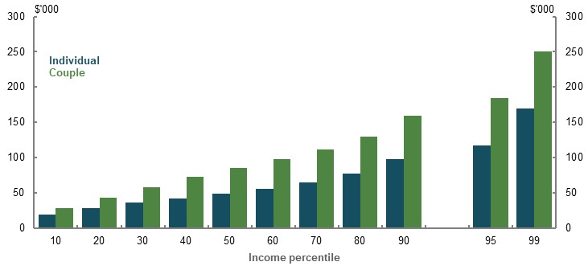
Note: Values in 2019-20 dollars, deflated using the review’s mixed deflator. Income is average annual disposable income from ages 57-66 for relevant household types. Couple income is at a household level. Source: Cameo modelling undertaken for the review.
Incomes are grown by projections of average weekly ordinary time earnings. Wage growth was based on economic parameters at the 2019-20 Mid-Year Economic and Fiscal Outlook. Nominal wages were assumed to grow by around 4 per cent per year in the medium to long term. Adjustments were made to wages growth to reflect changes to the SG rate in relevant scenarios. The interaction between changes in the SG rate and wages are explored in Evidence on the effect of changes in the Superannuation Guarantee on wages growth, above.
Data used in the retirement income cameo model shows that earnings change over a lifetime. Relative to wages, incomes grow at the start of people’s careers, peak mid-career and decline thereafter. For example, a median earner’s income at age 27 is 67 per cent of average weekly ordinary time earnings, at age 43 income peaks at around 88 per cent of average weekly ordinary time earnings , and then income gradually declines as people near retirement.
While wages decline as a proportion of average weekly ordinary time earnings as people near retirement, this does not mean wages decline in real terms (deflated by CPI). Real incomes tend to remain broadly stable in real terms from around 50, as nominal incomes grow in line with price inflation but slower than wage growth. From the 20th percentile and higher, average real income in the 57-66 age range (where the benchmark is set) exceeds real income at age 45. This suggests that the 57-66 age range represents the peak of consumption opportunities.
The income data used in the model included both full- and part-time workers. Lower income percentiles are expected to have a higher proportion of part-time workers.

Testing income profiles against longitudinal data
The retirement income cameo model uses a single year of income tax data as a basis for projecting income over a lifetime.
The review tested these income profiles against longitudinal income data from ALife (Chart 6A-17). Comparisons show that the change in income over a lifetime is broadly similar between the cross-sectional income profiles used in the review’s model and the longitudinal ALife data.
The comparison shows that the review’s model may underestimate lifetime incomes for those at lower-income percentiles, and overestimate lifetime incomes for very high income percentiles. This is because people may not earn very high or low incomes for a significant period. For example, someone working part-time to care for children may have a period of lower income followed by higher income as they return to full-time work. Alternatively, higher-income periods may be due to people earning a bonus in a particular year or period.
The impact of allowing for individuals to move across the income distribution is considered in the next section.
    - Comparison of ALife wage profiles to the review’s model, selected percentiles
20th income percentile | Median
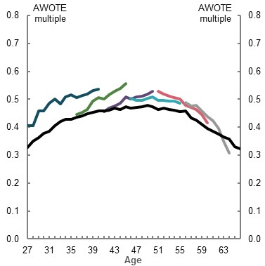 | 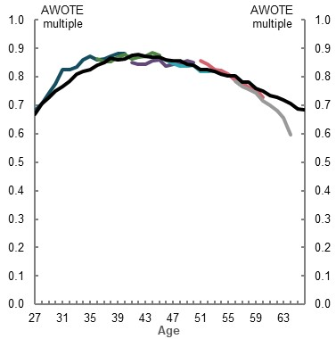
80th income percentile | 95th income percentile
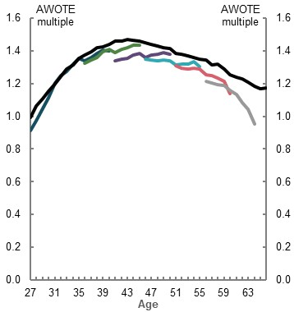 | 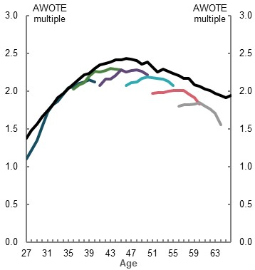
ALife — age 40 in 2017 | ALife — age 45 in 2017 | ALife — age 50 in 2017 | ALife — age 55 in 2017
ALife — age 60 in 2017 | ALife — age 64 in 2017 | Review’s model

Note: Incomes measured as a proportion of average weekly ordinary time earnings (AWOTE). Individuals in ALife with positive wage and salary income were sorted into income percentiles by age cohort. Data is median employment income by age cohort and income percentile. ALife income profiles were increased uniformly by 7 per cent so that average lifetime income is similar for a median person in both datasets. This allows for comparability between datasets which are based on slightly different populations. Source: Analysis of ATO Longitudinal Information Files, 2016-17 and cameo modelling undertaken for the review.

Allowing for movement between income percentiles
Modelling uses cross-sectional data and has a person’s position in the income distribution fixed for their whole life. This is a simplifying assumption for modelling. People can move between income percentiles due to variations in type and length of employment. For example, a person working part time while studying may go on to work full time in better paid work.
The Productivity Commission found that close to 90 per cent of people moved between at least three income deciles between 2000-01 and 2015-16. However, less movement occurs for people in the top and bottom of the income distribution. Fifty per cent of people in the bottom decile of income earners in 2000-01 ended in the bottom 20 per cent of earners in 2015-16. Similarly, 41 per cent of people in the top-income decile ended in the top 20 per cent of earners in the same period (Productivity Commission, 2018b, pp. 95-98).
A longitudinal analysis using ALife was undertaken to test the impact of assuming people do not move across the income distributions over their lifetimes. Longitudinal data in ALife follows specific people over time, allowing for analysis of incomes earned over a certain period.
ALife does not cover enough years to analyse a whole career. Lifetime incomes were estimated by combining the incomes of similar cohorts to form a representative career; for example, combining the career of median-income earners aged 27 with median earners aged 42.
ALife data showed a small effect in allowing for movement between income percentiles. Incomes of people in the 10th percentile are modestly higher in ALife compared to cross-sectional data, with the largest falls at the 90th decile and above (Chart 6A-18). As a result, replacement rates are slightly lower for lower-income earners, and slightly higher for higher-income earners when allowing for movement between income percentiles. There was little impact on middle-income earners, who are the focus of the review’s replacement rate analysis.
    - Total working-life incomes, longitudinal or cross-sectional data
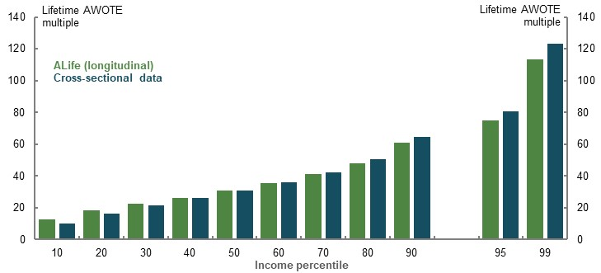
Note: ALife lifetime income is based on the age cohorts 40, 45, 50, 55, 60 and 64 in 2017. ALife income profiles were increased uniformly by 7 per cent so that average lifetime income is similar for a median person in both datasets. This allows for comparability between datasets that are based on slightly different populations. Lifetime income in cross-sectional data sums income from ages 27 to 66 for each percentile. Source: Analysis of ATO Longitudinal Information Files (ALife), 2016-17, and cameo modelling undertaken for the review.

Adjusting incomes near retirement
The review adjusted incomes near retirement to account for the likely impact of higher labour force participation in the future. Without this change, modelling would reflect current workforce participation for older Australians. Older age participation is likely to continue rising given trends, especially for women, in past years (see 1D. The changing Australian landscape).
Average annual incomes gradually decline as a proportion of average weekly ordinary time earnings as people near retirement. This fall happens as people shift to fewer hours or reduced pay during the transition to retirement.
For men, income profiles towards the end of working life are largely unchanged over time. However, evidence suggests that incomes for women near retirement are changing (Chart 6A-19).
- Over the 10 years before age 64, the total income earned by cohorts of women has fallen as a proportion of average weekly ordinary time earnings. Total incomes earned in the 10 years to 64 were about 2.8 per cent lower for the cohort of women aged 64 in 2017 than for 2007. This flattening could be due to higher participation of women with lower incomes.
- Over the five years before age 64, total income earned by cohorts of women has risen, particularly at age 64. This increase is likely due to a change in Age Pension eligibility age, which affected the retirement timing of women in the late 2000s and early 2010s. The increase in total incomes in the five-year period is about 3 per cent between 2007 and 2017 cohorts.
    - Longitudinal analysis of female incomes, median earner
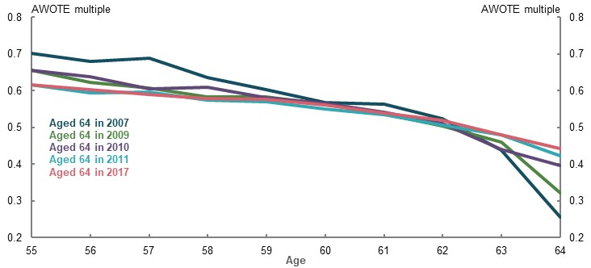
Note: Incomes measured as a proportion of average weekly ordinary time earnings. Includes people with a non-zero salary and wage at least eight times in the 10 years from 2008 to 2017. Percentiles based on the 10-year average of wages. Source: Analysis of ATO Longitudinal Information Files (ALife), 2016-17.
As the income just before retirement is important for assessing adequacy outcomes, the review used the 10 years before retirement as the basis for calculating replacement rates.
The review used cross-sectional income data from tax returns as the basis for income in modelling calculations. This data does not have as large a drop-off in incomes near retirement as longitudinal data (Chart 6A-20).
Incomes in the model are adjusted upwards after age 60 so that the rate of decline in a person’s wage as a proportion of average weekly ordinary time earnings is halved commencing at age 61 until retirement. As well as accounting for general increases in labour force participation, this upwards adjustment makes an allowance for legislated increases to the Age Pension eligibility age from 65 in 2016-17, to 67 by 2023-24.
- For median earners, this adjustment increases incomes in the given years before Age Pension eligibility age by 5 per cent; one and a half times the five-year impact experienced by median-income women explored above (of 3 per cent).
  - This adjustment is larger than historically observed but broadly appropriate as it projects anticipated increases in labour force participation over a 40-year timespan. This adjustment reduces replacement rates relative to unadjusted incomes.
- The upwards adjustment of incomes is larger for lower-income earners (Table 6A-5).
      - Incomes in years near retirement, average upwards adjustment by income percentile
Percentile | 10th | 20th | 30th | 40th | 50th | 60th | 70th | 80th | 90th
Adjustment (per cent) | 14.5 | 10.6 | 8.1 | 6.1 | 5.0 | 4.5 | 4.4 | 3.9 | 3.8
Note: Upwards adjustment compares average income earned between ages 60-66 using cross-sectional data from Treasury’s TAXMOD, which draws on the 2016-17, 16 per cent sample file and incomes modelled by the review. Source: Analysis of ATO Longitudinal Information Files (ALife), 2016-17, and cross-sectional data from the 2016-17, 16 per cent sample file and incomes modelled by the review.
    - Analysis of incomes in years before retirement, median earner
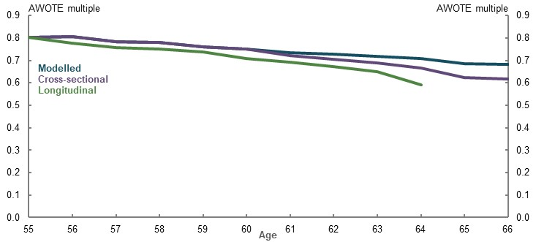
Note: Incomes measured as a proportion of average weekly ordinary time earnings (AWOTE) in the relevant year. Cohorts aged 64 in reference year. Includes people with a non-zero salary and wage at least eight times in the 10 years from 2008 to 2017. Percentiles based on the 10-year average of wages. Longitudinal data scaled uniformly to match cross-sectional income at age 55 for comparison. Source: Analysis of ATO Longitudinal Information Files (ALife), 2016-17, and cross-sectional data from the 2016-17, 16 per cent sample file and incomes modelled by the review.

Income deflation
The present value of disposable income in a given year was calculated using a mixed deflator. This methodology is referred to as the review’s mixed deflator in all applicable modelling in the report. The present value of income using the review’s mixed deflator is always given in 2019-20 dollars.
Income is deflated by wages up until retirement age. During retirement, income is deflated by prices building on wage deflation during working life.

Income for the replacement rate calculations
Replacement rates for the review were calculated as:
$$Replacement rate \left(\%\right)=\frac{Retirement income}{Workinglife income}×100$$
The above equation uses the:
- Retirement income: the present value of average annual income over the whole period of retirement
- Working-life income: the present value of average annual income in the last 10 years of working life
These incomes were deflated using the review’s mixed deflator. All values are based on disposable incomes (that is, after-tax incomes).

Retirement income
Income averaged over the whole of retirement was used to calculate retirement income for the review’s replacement rates. Using income across a person’s whole retirement is appropriate because it reflects their circumstances over all the years of their retirement.
Replacement rates are sometimes measured using only the first year of, or a fixed number of years in, retirement (Rothman, 2007, pp. 3-4). Measures based on a short period after retirement risk skewing results if incomes rise or fall significantly during retirement. For example, a short period may overstate retirement if assets were quickly drawn down during retirement.
Retirement incomes were deflated by prices. As noted previously, price increases best represent the growth in spending needs of retirees (see Evidence on the spending growth needed in retirement above).

Working-life income
Working-life income was based on the average income in the last 10 years before retirement, deflated by wages. Determining an appropriate period to use for working-life income involves balancing two issues:
- Periods closer to retirement better represent retirement expectations. The proportion of people who have sought financial advice significantly increases for those aged in their mid-50s (Snoke, et al., 2009). This is when people are likely to set expectations for the standard of living they want to maintain in retirement. People’s lives also begin to become similar to what they will experience during retirement, particularly for those with children. Incomes earned in early or mid-career are unlikely to significantly affect people’s assessment of their retirement needs.
- Periods too close to retirement include years when incomes trail off significantly in adjusted terms. Close to a given retirement age, many are transitioning to retirement. A small period close to retirement may therefore not reflect a person’s actual standard of living in working life that they wish to replace in retirement.
Some commentators suggest working-life income should be based on a period further away from retirement to reflect the peak of income in middle age. This approach was not favoured as:
- Financial stress peaks around age 50 for middle-income earners, reflecting high costs such as those related to raising children. This suggests the period is not reflective of the standard of living people will aim to replace in retirement.
- The 57-66 age range represents the peak of consumption opportunities. Real incomes tend to remain broadly stable in real terms from around 50, as nominal incomes grow in line with price inflation but slower than wage growth. From the 20th percentile and higher, average real income in the 57-66 age range (where the benchmark is set) exceeds real income at age 45.
Working-life income is deflated by wages. Most stakeholders preferred wages for pre-retirement deflation. The Actuaries Institute guidance recommends using wage-based deflation of working-life income as it is more understandable for people planning for their retirement:
‘… it is preferable for future benefits to be deflated using a wage-based deflator in order to allow plan members to assess their purchasing power at retirement relative to their salary at retirement.’ (Actuaries Institute, 2018)
For consistency, the same working-life income target is used in all sensitivity analysis of retirement ages. For example, someone retiring earlier than 67 has their working-life income target based on the incomes they would have earned in the 10 years to 67. Falling incomes in later ages can mean that average incomes in the 10 years to age 67 are lower than incomes in the 10 years to, say, age 62. This method avoids setting a higher retirement income target because someone retired earlier.

Personal income tax
People pay personal income tax according to current policy, including all legislated future tax changes out to 2024-25.
Personal income tax policies modelled include rates and thresholds; the Medicare Levy; and tax offsets including the low income tax offset, low and middle income tax offset (expiring 30 June 2022), and seniors and pensioners tax offset.
Some policy settings are not automatically indexed over time. Given this assumption is unrealistic in the long term, tax steps, thresholds and offsets are indexed to wages growth beyond the medium term (from 2030-31).
Where people are liable for personal income tax, those tax liabilities are paid from:
- Wage and salary income before retirement
- Earnings on non-superannuation wealth after retirement

Length of working life
The review assumes a career of 40 years as its central assumption. This is based on analysis of ABS and HILDA data (see 2C. Maintaining standards of living in retirement).
Analysis also compared the length of working life for those who retire in 2060 in the Model of Australian Retirement Incomes and Assets (MARIA) with the review’s cameo model assumption.
Median years in the workforce in MARIA for women retiring in 2060 is about 38 years, while median years in the workforce for men is around 44 years (Table 6A-6). The combined median years in the workforce for those retiring in 2060 is just over 40 years.
      - Years in the workforce for those retiring in 2058 to 2060, MARIA modelling
Gender | Average | Median | Standard deviation
Female | 36.4 | 38.0 | 12.7
Male | 41.9 | 44.0 | 13.8
All | 39.0 | 40.9 | 13.5
Note: Years in workforce are included part- and full-time work. Source: Treasury estimates for the review using MARIA.

Proportion of the population with little workforce attachment
Those in the population with little workforce attachment are not well captured by the income cameo modelling as they may not lodge tax returns. Given this group tends to earn low incomes over their lifetime, assessing whether the system delivers an appropriate minimum standard is a better adequacy indicator for this group.
The Priority Investment Approach (PIA) dataset and actuarial model, administered by the Department of Social Services, was used to identify the size of this cohort.
The proportion of Australians aged 27 at 30 June 2018 expected to receive no income from employment and also receive an income support payment for 15 years or more before they reach Age Pension eligibility age is 9.6 per cent (Table 6A-7).
      - Proportion of Australians projected to receive income support, aged 27 on 30 June 2018
Projected groups | Number of peopleⁱⁱ | Per cent of totalⁱⁱⁱ
Years before reaching Age Pension eligibility age and projected to receive income supportⁱ:
All people receiving income support
10 years or more | 73,256 | 20.3
15 years or more | 52,252 | 14.5
Only those projected not to have employment earnings
10 years or more | 51,035 | 14.1
15 years or more | 34,563 | 9.6
Total in age group | 361,047 | 100
Note: The analysis uses raw data extracted from the Centrelink Enterprise Data Warehouse. Results were produced using the PIA dataset ‘as at’ 30 June 2018 and ‘as known at’ 30 September 2018. ‘As at’ date is the date at which data is cut off. ⁱDoes not indicate the continuous receipt of income support. A recipient may receive income support for a full year or part of a year, which in both instances is recorded as having received income support for that year. ⁱⁱIncludes all Australians aged 27 as at 30 June 2018 who are projected to be in a particular group. This calculation excludes people expected to die before Age Pension eligibility age. ⁱⁱⁱCalculated by dividing the total number of Australians aged 27 as at 30 June 2018 who are projected to be in that group by the total number of Australians aged 27 as at 30 June 2018 who are projected to survive to Age Pension eligibility age. Source: Priority Investment Approach to Welfare Actuarial Modelling.

Superannuation accumulation
This section outlines modelling assumptions affecting the accumulation of superannuation.

Superannuation Guarantee
SG payments are modelled in line with legislated increases. The SG rate is 9.5 per cent to 2020-21, increasing half a percentage point every financial year before reaching 12 per cent in 2024-25.
Modelling assumes people receive SG payments at the legislated rate, aligned with legal requirements for paying employees.

Voluntary salary sacrifice contributions
The retirement income cameo model assumes people make voluntary salary sacrifice contributions to superannuation. Salary sacrifice rates by income percentile and age are sourced from Treasury’s microsimulation model of the personal income tax system (TAXMOD).
This microsimulation model makes adjustments to future salary sacrifice contribution patterns to account for policy changes not reflected in the 2016-17 data (such as changes in contributions caps and SG rate increases). Personal deductible contributions are not incorporated into the model.
This data shows most salary sacrifice contributions — more than three-quarters — are made after the age of 55 in the retirement income cameo model.
Analysis of the ALife shows that most people make voluntary contributions at some point in the years approaching retirement. Focusing on cohorts aged 55 and over, about two-thirds of people in the 50th percentile for superannuation balance in 2010 made a voluntary contribution in the eight-year period covered by ALife (Chart 6A-21). More than 40 per cent made voluntary contributions in four or more of the eight years.
    - Proportion of people who made voluntary contributions over an eight-year period, by age and gender
50th percentile
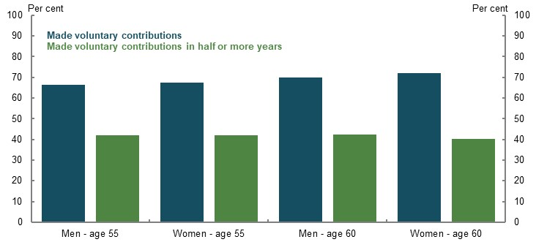
Note: 50th percentile is calculated based on superannuation balance in 2010. Contributions are over an eight-year period from 2010 to 2017 by age and gender. Age refers to age of the cohort in 2010. Source: Analysis of data provided by the ATO for the review.

Non-concessional contributions
Non-concessional contributions are those made out of after-tax income. Individuals can currently contribute after-tax income to superannuation subject to a yearly cap of $100,000, provided their total superannuation balance is under $1.6 million.
These contributions form a significant part of total contributions to superannuation. In 2016-17, more than 40 per cent of contributions to superannuation were non-concessional contributions.
However, non-concessional contributions are not modelled. The interactions between savings outside superannuation and non-concessional contributions are unclear (for example, large non-concessional contributions may come from existing savings). As modelling does not capture this interaction, a conservative approach is taken to exclude savings through non-concessional contributions.
Excluding non-concessional contributions will underestimate both the replacement rates and lifetime superannuation tax concessions, especially for higher-income earners. In 2017-18, non-concessional contributions were highly skewed to older, higher-wealth retirees (Chart 6A-22).
    - Average non-concessional contributions, by age and superannuation balance
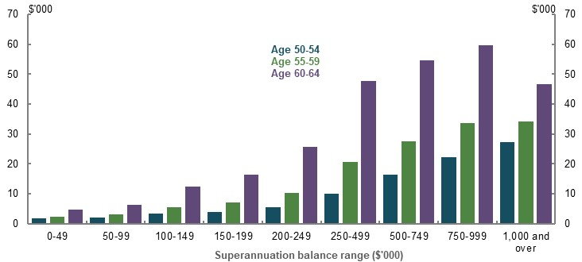
Note: Non-concessional figures are taken by subtracting personal superannuation contributions in the individual income tax returns (ITR) from the personal contributed amount in the member contribution statements (MCS). Excludes contributions where age was unknown or no MCS provided. Age as at 30 June 2018. Source: Analysis of ATO individual income tax returns and member contributions statements, 2017-18.

Superannuation policy
Following is an outline of the superannuation policy included in the modelling.

Taxation of superannuation contributions
Contributions to superannuation are taxed according to current policy, including the 15 per cent contributions tax; low income super tax offset; the Division 293 tax; and excess contributions tax.
Concessional superannuation contributions are also subject to the concessional contributions cap, and individuals may carry forward unused concessional cap if their total superannuation balance in the previous financial year was less than $500,000.
As per non-indexed personal income tax thresholds, all non-indexed superannuation tax thresholds are indexed in line with average weekly ordinary time earnings beyond the medium term (2030-31 onwards).

Taxation of superannuation earnings
In the pre-retirement phase, the tax rate on superannuation earnings is 15 per cent. However, some assets receive different tax treatment, such as net capital gains that attract a discount and franked dividends. A 7 per cent effective tax rate on superannuation earnings in the pre-retirement phase has been assumed for the retirement income cameo model. This assumption has been prepared using a top-down framework across a long-term horizon, and is intended to be broadly representative of a range of investments.
Earnings in the retirement phase are tax-free, noting that the transfer balance cap restricts the balance people are able to transfer into the pension phase.

Fees
Superannuation balances are assumed to attract a $74 fixed annual investment fee in 2019-20 indexed to average weekly earnings. An annual variable investment fee of 0.85 per cent of the account balance also applies. Superannuation fees are payable in both the accumulation and retirement phases.
These investment fees are consistent with assumptions used in Treasury’s MARIA and are based on historical data.

Insurance
Fixed annual insurance premiums are $214 in 2019-20 and indexed to average weekly earnings. Premiums are paid in the pre-retirement phase only and subtracted from superannuation balances. This premium is consistent with estimates used in Treasury’s MARIA and are based on historical data.

The transfer balance cap
From 1 July 2017, people have been able to transfer their superannuation balance into the retirement phase subject to the transfer balance cap ($1.6 million in 2019-20 and indexed periodically in $100,000 increments in line with CPI).
Modelling assumes that superannuation balances over the transfer balance cap are transferred outside superannuation. Earnings on these amounts are taxed at marginal rates. Only retirees at the 90th, 95th and 99th percentiles are affected by this assumption in the model. This assumption has a conservative impact on retirement incomes, compared to leaving assets in superannuation but in the accumulation phase, as:
- Higher-income earners affected by the cap are typically paying higher taxes outside superannuation, which reduces their retirement incomes
- Asset drawdown rates are lower outside superannuation than inside superannuation for the purposes of review modelling

Investment returns
Assets inside and outside superannuation are assumed to generate investment returns of 7.5 per cent during the accumulation phase and 6.2 per cent during the retirement phase. These returns are before fees and taxes.
These investment returns:
- Are based on advice commissioned from the Australian Government Actuary
- Are conservative relative to historical returns
- Align with, or are conservative compared to, industry growth and defensive targets
These investment return assumptions are based on fund investment objectives and typical superannuation portfolios. A lower earnings rate in the retirement phase reflects a lower risk appetite, with retirees typically holding more defensive assets (Chart 6A-23).
The Australian Government Actuary determined typical investment objectives (after fees and taxes) by examining the investment objectives of default portfolios in major Australian superannuation funds. Default investment options were used as the basis for determining fund investment objectives, as these tend to be used by a large proportion of superannuation members.
The determination of accumulation phase investment objectives took into account default portfolios from the top 10 MySuper funds, covering more than 60 per cent of MySuper assets. The investment strategies of these portfolios were checked for broad consistency with the asset allocations reported by the Productivity Commission (Table 6A-8).
The determination of retirement phase investment objectives adopted a similar approach. However, the retirement earnings rate assumption relies more on fund investment strategies, as the idea of a ‘default portfolio’ is less applicable during the pension phase.
      - Asset allocation in pre-retirement and retirement phases
Allocation type | 2007 |  | 2017
 | Pre-retirement  (per cent) | Retirement  (per cent) | Pre-retirement  (per cent) | Retirement  (per cent)
Defensive | 19.9 | 32.2 | 18.2 | 32.8
Growth | 71.6 | 63.1 | 65.3 | 49.8
Otherⁱ | 8.6 | 5.1 | 17.0 | 17.5
Totalⁱⁱ | 100.0 | 100.0 | 100.0 | 100.0
Note: Original data grouped. ‘Growth’ includes private equity, Australian and international listed equities, property and infrastructure. ‘Defensive’ includes Australian and international fixed income, and cash. ⁱ’Other’ incorporates a blend of 50 per cent Australian and international equity and 50 per cent Australian and international fixed income. ⁱⁱCategories may not sum to 100 due to rounding. Source: Analysis of (Productivity Commission, 2018a).
    - Asset allocation in pre-retirement and retirement phases
Pre-retirement phase | Retirement phase
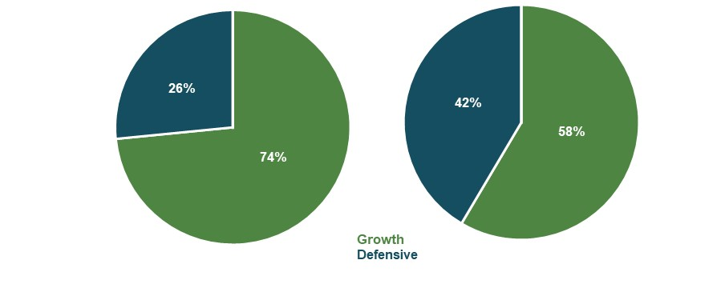
Note: Based on asset allocation in 2017. See note to Table 6A-8 for more. ‘Other’ incorporated as 50/50 growth and defensive assets. Source: Analysis of (Productivity Commission, 2018a).
The investment return assumptions in cameo modelling are broadly in line with other targets for both typical pre-retirement and retirement phase portfolios (Table 6A-9 and Table 6A-10).
      - Pre-retirement phase/growth portfolio investment returns
Organisation | Gross investment return (per cent) | Net investment return (per cent)
Review assumption | 7.5 | 6.0ⁱ
MARIA (Treasury 2019) assumption | 7.5
Rice Warner Australian shares (gross of imputation credits) assumption | 7.9 | -
Rice Warner international shares assumption | 7.5 | -
Chant West growth fund 5-year past performance | - | 8.0ⁱⁱ
Chant West growth fund 10-year past performance | - | 7.9ⁱⁱ
Chant West growth fund 15-year past performance | - | 7.0ⁱⁱ
Chant West growth fund target | - | 6.0ⁱⁱ
Future Fund target | - | 6.5-7.5
Grattan Institute assumption | 7.5 | -
Mercer assumption | - | 6.5
Note: All returns are nominal. Gross investment returns are provided before fees and taxes. Net investment returns are provided after fees and taxes. Results assume CPI of 2.5 per cent, which is in the middle of the RBA’s target. Chant West growth fund and Future Fund targets are CPI plus 3.5 per cent and CPI plus 4 to 5 per cent, respectively. ⁱ Review net investment return assumes 0.85 per cent variable investment fee, 7 per cent effective tax rate and fixed investment and insurance fees of $74 and $214, respectively, both indexed to average weekly earnings.ⁱⁱ After investment fees and taxes, before administration fees and adviser commissions. Source: Treasury estimates for the review using MARIA (see Model of Australian Retirement Incomes and Assets), Rice Warner estimates for the review (see Superannuation, Pension and other Retirement OUTcomes, below) (Chant West, 2020), (Grattan Institute, 2020), (Mercer, 2020), (Future Fund, 2020).
      - Retirement phase/defensive portfolio investment returns
Organisation | Gross investment return (per cent) | Net investment return  (per cent)
Review (including MARIA modelling for the review) assumption | 6.2 | 5.35ⁱ
MARIA (Treasury 2019) assumption | 6.5 | -
Chant West conservative fund 5-year past performance | - | 5.0^{ii}
Chant West conservative fund 10-year past performance | - | 5.7^{ii}
Chant West conservative fund 15-year past performance | - | 5.5^{ii}
Grattan Institute assumption | 6.5 | -
OECD assumption |  | 5.0^{iii}
Mercer assumption | - | 6.0
Note: All returns are nominal. Gross investment returns are provided before fees and taxes. Net investment returns are provided after fees and taxes. All results calculated assuming CPI of 2.5 per cent, which is in the middle of the RBA’s target. This may differ to individual organisation estimates for CPI. ⁱReview net investment return assumes 0.85 per cent variable investment fee. ⁱⁱAfter investment fees and taxes, before administration fees and adviser commissions. ^{iii}OECD investment returns calculated assuming a 90 per cent annuity factor, applied to 5.5 per cent gross investment returns. Source: Treasury estimates for the review using MARIA (see Model of Australian Retirement Incomes and Assets), (Chant West, 2020), (Grattan Institute, 2020), (OECD, 2019b), (Mercer, 2020).

Savings outside superannuation
This section outlines assumptions regarding savings outside superannuation.

Home ownership
For cameo analysis, it has been assumed that people own their own home at retirement. Home ownership affects Age Pension eligibility due to different means testing thresholds and renters being eligible for Commonwealth Rent Assistance.
The home ownership assumption is based on ownership rates for middle and higher-wealth retirees, which exceed 95 per cent.
Renting is highly skewed to lower-wealth groups, with three-quarters of renters in the bottom two wealth deciles. As a result, the assessment of whether retirees are meeting a basic minimum standard is the most important assessment of adequacy for renters (3A. Achieving a minimum standard of living in retirement).
Modelling includes sensitivity analysis on home ownership, given its importance for retirement outcomes (2C. Maintaining standards of living in retirement). The review also examined the impact of trends in home ownership (3C. Home ownership status).

Financial assets outside superannuation
For cameo analysis, financial assets outside superannuation were estimated at the point of retirement. Data on financial assets held outside superannuation was sourced from the 2017-18 Survey of Income and Housing. This data was used to rank individuals and households with positive wage and salary income into asset percentiles. Ratios of average financial assets outside superannuation were then calculated as a percentage of average lifetime earnings (using the historical ABS average weekly ordinary time earnings series).
For a given retiree, financial assets outside superannuation were projected in future years by multiplying the financial assets outside superannuation ratio for the relevant percentile by projected average lifetime earnings.

Personal use goods
Cameo modelling assumed that households hold personal use assets (such as cars and furniture). These assets are assumed not to generate income but may reduce Age Pension entitlements.
Data on personal use goods was sourced from 2015-16 Department of Social Services data. The level of assets was projected using the same methodology as financial wealth outside superannuation.

Income during retirement
Retirement income comprises three main sources: drawdown of superannuation, earnings from non-superannuation wealth, and the Age Pension (if eligible). The models used by the review projected average annual retirement income from these three sources by income percentile (Chart 6A-24).
    - Projected annual retirement income
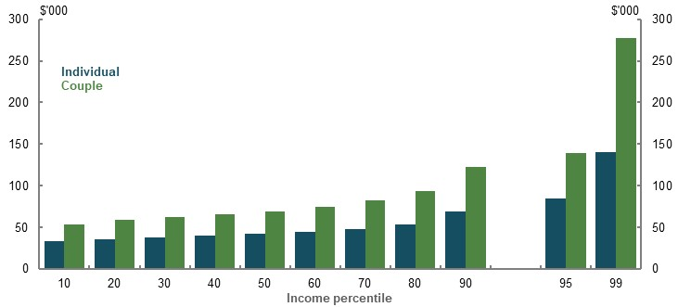
Note: Average annual retirement income averages annual disposable income from the whole of retirement. Couple income averages annual disposable income from the whole of retirement at a household level. Source: Cameo modelling undertaken for the review.

Income from superannuation
On reaching retirement, people are assumed to use their superannuation by:
- Using 5 per cent of their balance at retirement to purchase a longevity risk product (see Longevity protection product, below)
- Converting the remaining 95 per cent into an account-based pension
- Transferring superannuation assets above the transfer balance cap outside superannuation

Account-based pension
Superannuation assets are drawn down at a rate to:
- Exhaust superannuation assets (excluding their longevity protection product) at age 92, which is equal to cohort life expectancy in the 2015 Intergenerational Report averaged for men and women
- Produce a constant real income stream inclusive of any Age Pension eligibility and non-superannuation wealth income (Chart 6A-25)
Ensuring superannuation wealth is for retirement income aligns with its intended purpose and avoids leaving large bequests. Additionally, this assumption tests the capacity of the system to deliver retirement incomes rather than the incomes delivered under lower drawdown rates (for drawdown sensitivity analysis and bequests, see 2C. Maintaining standards of living in retirement).
    - Projected disposable income by age and income percentile
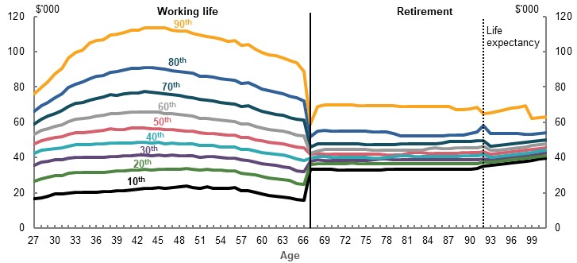
Note: Values are in 2019-20 dollars using the review’s mixed deflator. Source: Cameo modelling undertaken for the review.
The drawdown rates used by the review are just one way to achieve this goal. Individual preferences or people’s financial circumstances could mean they prefer other drawdown rates.
The drawdown rates are calculated based on the review’s modelling of wealth at retirement, expected asset returns, and Age Pension eligibility. These rates increase with age to produce constant real income as balances reduce (Table 6A-11 and Table 6A-12).
The drawdown rates are designed to exhaust superannuation balances at age 92 for most people. People in the top 80th and higher percentiles can have balances that are not completely exhausted by this age. The drawdown rates account for the Age Pension to produce a consistent income stream in real terms. The Age Pension makes up a growing proportion of retirement income with age (Chart 6A-29).

      - Individual drawdown rates by income percentile
Percentile | 10th | 20th | 30th | 40th | 50th | 60th | 70th | 80th | 90th
Assets at retirement ($’000)
Superannuation | 145 | 220 | 300 | 375 | 455 | 555 | 660 | 810 | 1,000
Other assets | 5 | 5 | 10 | 15 | 25 | 40 | 75 | 150 | 450
Drawdown rates by age (per cent)
67 | 8.4 | 9.5 | 10.0 | 10.2 | 10.0 | 8.1 | 7.3 | 6.3 | 4.9
68 | 8.6 | 9.5 | 10.0 | 10.3 | 10.5 | 8.7 | 7.7 | 6.6 | 5.1
69 | 8.8 | 9.4 | 10.0 | 10.4 | 10.6 | 9.4 | 8.1 | 6.9 | 5.3
70 | 9.0 | 9.3 | 10.0 | 10.4 | 10.7 | 10.2 | 8.5 | 7.2 | 5.5
71 | 9.2 | 9.1 | 10.0 | 10.5 | 10.8 | 11.0 | 9.1 | 7.6 | 5.7
72 | 9.5 | 9.0 | 10.0 | 10.5 | 10.9 | 11.2 | 9.7 | 8.0 | 6.0
73 | 9.8 | 9.2 | 9.9 | 10.6 | 11.1 | 11.3 | 10.4 | 8.4 | 6.2
74 | 10.2 | 9.5 | 9.9 | 10.6 | 11.2 | 11.5 | 11.3 | 9.0 | 6.5
75 | 10.6 | 9.8 | 9.8 | 10.6 | 11.3 | 11.7 | 11.9 | 9.6 | 6.8
76 | 11.1 | 10.2 | 10.0 | 10.5 | 11.4 | 12.0 | 12.2 | 10.3 | 7.2
77 | 11.6 | 10.5 | 10.3 | 10.5 | 11.5 | 12.2 | 12.6 | 11.2 | 7.6
78 | 12.2 | 11.0 | 10.8 | 10.6 | 11.6 | 12.4 | 12.9 | 12.3 | 8.1
79 | 12.9 | 11.6 | 11.2 | 11.1 | 11.7 | 12.7 | 13.3 | 13.4 | 8.6
80 | 13.6 | 12.2 | 11.8 | 11.6 | 11.7 | 13.0 | 13.8 | 13.9 | 9.2
81 | 14.5 | 13.0 | 12.5 | 12.3 | 12.3 | 13.3 | 14.3 | 14.5 | 9.9
82 | 15.6 | 14.0 | 13.4 | 13.0 | 13.1 | 13.6 | 15.0 | 15.2 | 10.8
83 | 16.8 | 15.1 | 14.6 | 14.1 | 14.1 | 14.0 | 15.7 | 16.1 | 11.8
84 | 18.3 | 16.5 | 15.9 | 15.5 | 15.3 | 15.3 | 16.5 | 17.1 | 13.1
85 | 20.2 | 18.3 | 17.7 | 17.2 | 17.0 | 16.9 | 17.5 | 18.4 | 14.8
86 | 22.7 | 20.6 | 20.0 | 19.5 | 19.3 | 19.1 | 19.2 | 20.0 | 16.9
87 | 26.1 | 23.9 | 23.3 | 22.7 | 22.6 | 22.3 | 22.4 | 22.2 | 19.9
88 | 31.0 | 28.7 | 28.1 | 27.4 | 27.5 | 27.2 | 27.0 | 25.2 | 23.2
89 | 39.0 | 36.7 | 36.1 | 35.2 | 35.5 | 35.3 | 35.1 | 29.6 | 27.0
90 | 54.5 | 52.6 | 51.9 | 50.6 | 51.7 | 51.5 | 51.3 | 39.3 | 32.9
91 | 100.0 | 100.0 | 99.0 | 95.1 | 100.0 | 100.0 | 100.0 | 60.9 | 43.5
92 |  |  | 100.0 | 100.0 |  |  |  | 25.1 | 18.1
93 |  |  |  |  |  |  |  | 28.3 | 19.7
94 |  |  |  |  |  |  |  | 32.5 | 23.0
95 |  |  |  |  |  |  |  | 38.4 | 27.8
96 |  |  |  |  |  |  |  | 47.4 | 35.9
97 |  |  |  |  |  |  |  | 62.9 | 52.0
98 |  |  |  |  |  |  |  | 100.0 | 100.0
Note: Drawdown rates by age and income percentile are based on net wealth at retirement. Net wealth is wage deflated and in 2019-20 dollars, denominated in thousands and rounded to the nearest $5,000. Rates may fall below minimum drawdown rates by age in early retirement years. The review models the maximum of minimum drawdown rates and efficient drawdown rates by year. Income percentiles 95 and 99 are assumed to draw down at the same rate as the 90th percentile. Drawdown rates are designed for individuals retiring in 2060 based on current Age Pension rates and thresholds in those years. Age Pension thresholds are indexed to CPI. Source: Cameo modelling undertaken for the review.
      - Couple drawdown rates by income percentile
Percentile | 10th | 20th | 30th | 40th | 50th | 60th | 70th | 80th | 90th
Assets at retirement ($’000s)
Superannuation | 295 | 500 | 655 | 780 | 920 | 1,075 | 1,250 | 1,485 | 1,700
Other assets | 10 | 15 | 30 | 30 | 80 | 120 | 275 | 445 | 1,170
Drawdown rates by age (per cent)
67 | 8.9 | 9.9 | 10.1 | 8.8 | 8.1 | 6.9 | 6.1 | 5.4 | 4.4
68 | 8.7 | 10.0 | 10.2 | 9.4 | 8.6 | 7.3 | 6.4 | 5.6 | 4.6
69 | 8.6 | 10.0 | 10.3 | 10.2 | 9.1 | 7.7 | 6.7 | 5.8 | 4.8
70 | 8.4 | 10.1 | 10.4 | 10.5 | 9.7 | 8.1 | 7.0 | 6.0 | 5.0
71 | 8.6 | 10.1 | 10.5 | 10.7 | 10.5 | 8.6 | 7.4 | 6.3 | 5.2
72 | 8.8 | 10.1 | 10.6 | 10.8 | 11.0 | 9.2 | 7.8 | 6.6 | 5.4
73 | 9.0 | 10.1 | 10.7 | 10.9 | 11.0 | 9.9 | 8.2 | 6.9 | 5.6
74 | 9.3 | 10.0 | 10.8 | 11.1 | 11.2 | 10.8 | 8.7 | 7.3 | 5.9
75 | 9.7 | 10.0 | 10.9 | 11.3 | 11.5 | 11.8 | 9.4 | 7.7 | 6.2
76 | 10.1 | 9.9 | 10.9 | 11.4 | 11.7 | 12.1 | 10.1 | 8.1 | 6.5
77 | 10.6 | 9.9 | 11.0 | 11.6 | 12.0 | 12.4 | 10.9 | 8.6 | 6.8
78 | 11.1 | 10.4 | 11.0 | 11.8 | 12.2 | 12.7 | 12.0 | 9.3 | 7.2
79 | 11.7 | 10.8 | 11.1 | 11.9 | 12.5 | 13.1 | 13.1 | 10.0 | 7.7
80 | 12.4 | 11.5 | 11.3 | 12.1 | 12.9 | 13.6 | 13.6 | 10.8 | 8.2
81 | 13.3 | 12.2 | 12.0 | 12.3 | 13.2 | 14.1 | 14.2 | 11.9 | 8.7
82 | 14.2 | 13.1 | 12.8 | 12.7 | 13.6 | 14.7 | 14.9 | 13.2 | 9.4
83 | 15.4 | 14.2 | 13.9 | 13.7 | 14.0 | 15.5 | 15.8 | 14.9 | 10.2
84 | 16.8 | 15.6 | 15.3 | 15.0 | 15.0 | 16.4 | 16.8 | 16.1 | 11.2
85 | 18.6 | 17.4 | 17.0 | 16.8 | 16.6 | 17.5 | 18.0 | 17.3 | 12.4
86 | 21.0 | 19.7 | 19.3 | 19.1 | 18.9 | 18.9 | 19.6 | 18.8 | 13.9
87 | 24.3 | 23.0 | 22.6 | 22.4 | 22.2 | 22.0 | 21.6 | 20.7 | 15.9
88 | 29.2 | 27.8 | 27.5 | 27.2 | 27.1 | 26.9 | 24.5 | 23.3 | 18.5
89 | 37.2 | 35.9 | 35.5 | 35.3 | 35.2 | 35.0 | 28.6 | 27.0 | 22.3
90 | 53.0 | 51.9 | 51.7 | 51.5 | 51.4 | 51.2 | 37.4 | 32.8 | 27.2
91 | 100.0 | 100.0 | 100.0 | 100.0 | 100.0 | 100.0 | 57.0 | 43.2 | 33.3
92 |  |  |  |  |  |  | 23.8 | 16.6 | 18.0
93 |  |  |  |  |  |  | 26.7 | 18.1 | 19.2
94 |  |  |  |  |  |  | 30.7 | 20.0 | 20.7
95 |  |  |  |  |  |  | 36.2 | 22.5 | 22.7
96 |  |  |  |  |  |  | 44.7 | 25.9 | 25.2
97 |  |  |  |  |  |  | 59.9 | 30.8 | 28.8
98 |  |  |  |  |  |  | 100.0 | 38.7 | 35.6
99 |  |  |  |  |  |  |  | 54.3 | 51.7
100 |  |  |  |  |  |  |  | 100.0 | 100.0
Note: Drawdown rates by age and income percentile are based on net wealth at retirement. Net wealth is wage deflated and in 2019-20 dollars, denominated in thousands and rounded to the nearest $5,000. Rates may fall below minimum drawdown rates by age in early retirement years. The review models the maximum of minimum drawdown rates and efficient drawdown rates by year. Income percentiles 95 and 99 are assumed to draw down at the same rate as the 90th percentile. Drawdown rates are designed for couples retiring in 2060 based on current Age Pension rates and thresholds in those years. Age Pension thresholds are indexed to CPI. Source: Cameo modelling undertaken for the review.

Longevity protection product
The modelling assumed retirees dedicate a small proportion of their balance at retirement (2060 in the central case) to purchase a longevity protection product. These products are more efficient for managing the risk of retirees outliving their savings than other strategies, like slowly drawing down assets (Chart 6A-26).
It was assumed that individuals allocate 5 per cent of their superannuation balance at retirement to the purchase of a longevity protection product. The product used in the modelling for the review was a deferred pooled annuity product, such as a deferred group self-annuity.
The model did not incorporate more complex features of these products, such as withdrawal options, death benefits or co-morbidity for couples.

Product payments and pricing
The longevity product commences CPI-indexed payments from age 92. The product was assumed to have investment returns of 6.2 per cent before fees and taxes.
Investment fees were assumed to be 2.5 per cent per year, which are significantly higher than the 0.85 per cent variable investment fees assumed for funds invested in a typical superannuation account. Net earnings for the longevity product (3.7 per cent) were conservatively assumed to be lower than money invested in a typical fund (5.35 per cent).
Underlying mortality rates for retirees in 2060 were calculated by the Australian Government Actuary and accounted for increases in life expectancy.
Mortality rates for women were used in all models to be conservative compared to gender-specific mortality rates. Mortality rates for women are lower than for men, and therefore result in lower mortality credits.
The product is subject to Age Pension means testing in accordance with current means test rules for lifetime income streams.
    - Projected disposable income by longevity product, median earner
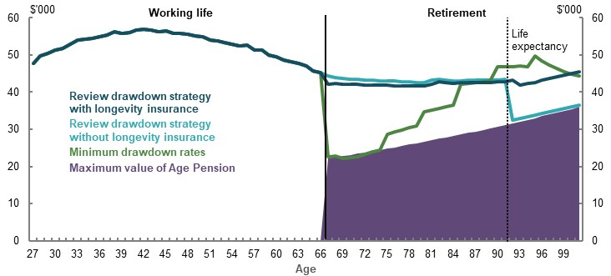
Note: Values are in 2019-20 dollars, deflated using the review’s mixed deflator. Source: Cameo modelling undertaken for the review.

Longevity product sensitivity analysis
The longevity product type used by the review was a simple hypothetical product to provide longevity protection and facilitate the drawdown of superannuation assets.
This product is one of many longevity products that could provide retirement income and longevity protection. To ensure its appropriateness, analysis compared this longevity product type to other possible retirement products, including:
- A deferred group self-annuity beginning at age 85, with 5 per cent of superannuation balance at retirement to purchase the product, and 95 per cent allocated to an account-based pension.
- A group self-annuity beginning at 67, with 40 per cent of superannuation balance at retirement to purchase the product, and 60 per cent allocated to an account-based pension.
- 100 per cent allocation of assets at retirement to a group self-annuity beginning at 67.
The review’s retirement income portfolio tends to give lower incomes than similar products (Table 6A-13). Non-deferred products provide slightly higher replacement rates and retirement outcomes, as they pay out mortality credits for longer. However, higher incomes come at the cost of reduced capital flexibility. The review’s central case assumption represents one way to balance longevity protection, high retirement incomes and capital flexibility.
      - Projected median earner retirement outcomes, different annuity products
Longevity product  (asset split) | Replacement rate  (per cent) | Average annual retirement income ($)
Review portfolio — account-based pension and deferred group self-annuity (DGSA) beginning age 92 (95/5 split) | 87 | 42,100
Account-based pension and DGSA beginning age 85 (95/5 split) | 89 | 43,100
Account-based pension and group self-annuity (60/40 split)* | 90 | 43,600
Group self-annuity (0/100 split)* | 91 | 44,000
Note: Products are hypothetical and used only for the basis of estimating retirement outcome differences. Values are in 2019-20 dollars, deflated using the review’s mixed deflator and rounded to the nearest $100. *Group self-annuities in these scenarios are not deferred, and commence at retirement. Non-deferred products are assumed to have investment fees of 0.85 per cent consistent with review central case retirement phase specifications. Source: Cameo modelling undertaken for the review.
          - Comparing review drawdown assumptions with other retirement modellers’ approaches
Consistent with the intent of the retirement income system, most retirement income projections assume superannuation assets are fully or predominantly used to generate retirement income by life expectancy (Table 6A-14). Key differences are the rate at which assets are drawn down and how longevity risk is managed.
      - Drawdown and longevity product assumptions in superannuation by organisation
Organisation | Drawdown strategy | Longevity protection on top of Age Pension
Review | Exhaust 95 per cent of superannuation by age 92, drawing at a rate to deliver stable real income (including Age Pension). | Longevity product from age 92 purchased with 5 per cent of balance at retirement.
Industry Super Australia | Draw down at rate of 10 per cent, or minimum drawdown rate once it is higher (from age 90). | Remaining superannuation balance (around 15 per cent in real terms of balance at retirement).
Grattan Institute | Exhaust 90 per of superannuation assets by age 92, generating constant real income from superannuation only. Incomes grow in real terms. Spend earnings from other 10 per cent of superannuation. | Around 10 per cent of superannuation assets remain at age 92.
Rice Warner | Exhaust all superannuation assets by age 92, drawing down at a rate to deliver stable real income (including Age Pension). | None
Source: (Rice Warner, 2019d) (Grattan Institute, 2020) (Industry Super Australia, 2020).
Different drawdown approaches by organisation yield different retirement income profiles (Chart 6A-27). Differences from the review approach are as follows.
- Longevity. Without purchase of a longevity protection product, incomes can dip sharply in later ages (see Rice Warner and Grattan retirement income profiles below). Retirees are assumed to draw down at high rates without having longevity protection (Rice Warner, 2019d) or using a self-insured approach (Industry Super Australia, 2020). Industry Super Australia’s approach generates bequests of around 15 per cent of starting balance in real terms.
- Income stability. Grattan’s approach means incomes peak in real terms immediately before life expectancy. Up to life expectancy, Rice Warner’s income is stable and the highest of all approaches, reflecting the absence of longevity protection. The Industry Super Australia’s approach generates stable incomes for lower- and middle-income earners because of the way it interacts with the Age Pension. For higher-income earners, income declines significantly over time in real terms.
    - Projected retirement income profiles with drawdown profiles by organisation
Median | 80th percentile
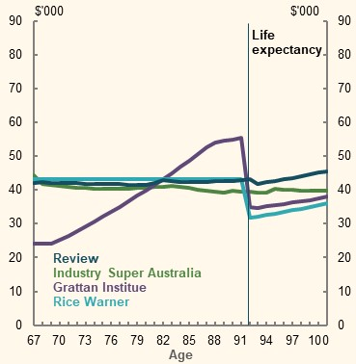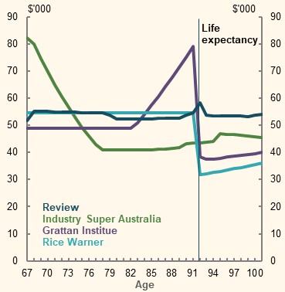
Note: Values are in 2019-20 dollars deflated using the review’s mixed deflator. Profiles have been generated using the review’s retirement income cameo model with drawdown strategy and longevity product specifications have been changed to reflect the review’s best approximation of organisation assumptions. Grattan Institute retirement income post-age 92 equal to earnings from remaining assets and Age Pension as eligible. Other assumptions are the same as used in the review, notably the level of non-superannuation assets at retirement (excluding Rice Warner who assumes no non-superannuation assets). Source: Cameo modelling undertaken for the review.

Non-superannuation income
The modelling assumed that people spend the earnings from their non-superannuation savings but do not draw down the capital (Chart 6A-28). This is based on two reasons:
- Non-superannuation savings do not receive the same concessional taxation as superannuation and are not explicitly for retirement income. The same arguments underpinning why superannuation should be used for retirement income (see 2C. Maintaining standards of living in retirement) do not necessarily apply to retirees’ assets outside superannuation.
- Many retirees maintain their level of assets over time (see 5A. Cohesion).
Non-superannuation assets are assumed to have the same investment returns as superannuation (see Investment returns above).
    - Projected non-superannuation wealth and income in retirement
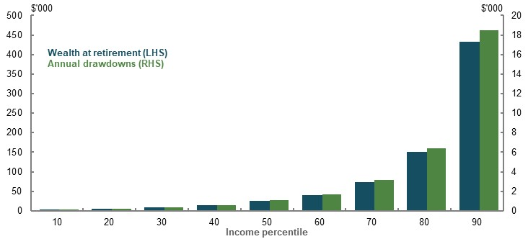
Note: Values are in 2019-20 dollars using the review’s mixed deflator. Source: Cameo modelling undertaken for the review.

Age Pension
People can receive the Age Pension according to current policy, including the scheduled increase to the Age Pension eligibility age. Future rates and thresholds in the social security system were modelled based on current indexation rules and projections for wages and prices at the 2019-20 Mid-Year Economic and Fiscal Outlook (see Economic parameters, below).
For simplicity, modelling calculated the Age Pension per year rather than per fortnight. This assumption does not substantially affect results.
Most people are modelled to receive some Age Pension during their retirement. Middle-income earners (40th-70th income percentiles) are projected to receive at least half of the maximum rate for most of their retirement (Chart 6A-29). These outcomes are due to the income, savings and drawdown assumptions incorporated in the review’s modelling.
    - Projected proportion of maximum rate of Age Pension, by age and income
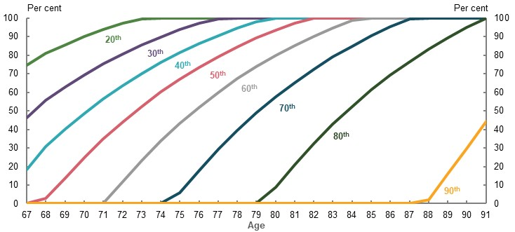
Note: 10th percentile receives 100 per cent of the maximum rate of Age Pension over their entire retirement, regardless of drawdown strategy. Income percentiles 95 and 99 do not receive any Age Pension due to high amount of non-superannuation assets. Source: Cameo modelling undertaken for the review.

Population receiving some Age Pension — current and future retirees
Analysis was undertaken to compare the proportion of current and future retirees’ Age Pension receipt by age (Chart 6A-30):
- Most income levels in review cameo modelling receive some Age Pension by age 85 under the review assumptions. In particular, percentiles up to the 90th percentile for singles and 80th percentile for couples.
- Data from the ABS Survey of Income and Housing 2017-18 shows about 85 per cent of singles and 70 per cent of couples today receive some Age Pension at age 85.
Differences between review results and data on current retirees are due to the maturing of superannuation, which is expected to result in fewer people receiving the Age Pension early on in their retirement. However, the review’s drawdown assumptions mean the proportion of people expected to receive the Age Pension in review modelling was 5-10 percentage points higher than the ABS numbers over age 85.
    - Proportion of retirees receiving some Age Pension by age group
Single | Couple
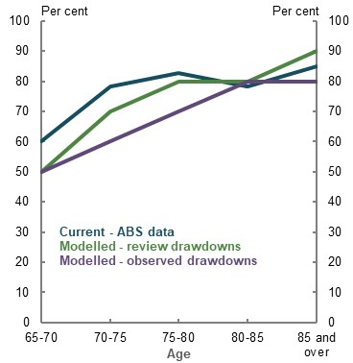 | 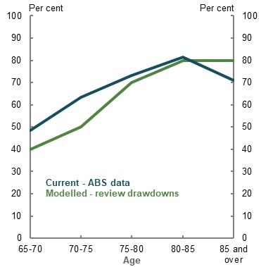
Note: ABS data estimates the proportion of retirees receiving some Age Pension by age group today. Modelled proportions for ‘single’ category based on individuals (all-employees model). Modelled proportions project the proportion of individuals within the model expected to receive some Age Pension by age and income percentile, based on drawdown strategy. For modelled proportions, reference age is taken from the end of each ABS age group (i.e. at ages 70, 75, 80, 85 and 92) for people retiring in 2060. Modelled data is not a population estimate as it only captures employees. For further information see Different versions of the cameo model. Observed drawdowns use observed average drawdown rates by superannuation balance percentile, 2010-2014.Source: Cameo modelling undertaken for the review, analysis of (ABS, 2019s).

Economic parameters
Economic parameters, including wage, GDP and CPI growth, are based on the forecasts published and projections prepared for the 2019-20 Mid-Year Economic and Fiscal Outlook.
This includes long-run growth rates for CPI of 2.5 per cent, nominal GDP of 5.25 per cent, and nominal wage growth of around 4 per cent (Commonwealth of Australia, 2015).
CPI growth of 2.5 per cent represents the middle of the RBA band for targeting inflation. In the long term, real wage growth is driven by productivity (The Treasury, 2017a, p. 16). The 45-year average of productivity growth is 1.5 per cent (Productivity Commission, 2020a, p. 3). Over the past 20 years, annual nominal wage growth in average weekly earnings averaged 3.6 per cent (ABS, 2020d).

Modelling gender
This section outlines the two cameo models used by the review to project outcomes by gender:
- a standard gender cameo model, used to analyse outcomes across the gender distribution
- an adjusted gender cameo model, used to analyse the effects of full-time and part-time work, and career breaks

Standard gender cameo model
A gender-specific cameo model was developed to examine differences in projected retirement outcomes for women and men. This model used the same underlying assumptions as the whole-of-population model used by the review, with the exception of the characteristics set out in Table 6A-15.
      - Gender model assumption differences to central case assumptions
Assumption | Central case | For men | For women
Life expectancy | 92 years | 91 years | 93 years
Length of working life | 40 years | 42 years | 38 years
Incomes | Tax return data, by age and income | Tax return data for men, by age and income | Tax return data for women, by age and income
Voluntary contributions to superannuation | Salary sacrifice contributions only | Salary sacrifice contributions made by men | Salary sacrifice contributions made by women
Superannuation drawdown strategy | Optimal drawdown to exhaust at life expectancy | Optimal drawdown, adjusted for men’s wealth and life expectancy | Optimal drawdown, adjusted for women’s wealth and life expectancy

Life expectancy
The 2015 Intergenerational Report contained life expectancy projections by gender (Table 6A-16).
      - Projected life expectancy, by gender
 | Life expectancy at birth (2015)  (years) | Further life expectancy at age 60 (2055)  (years)
Men | 91.5 | 31.5
Women | 93.6 | 33.3
Source: (Commonwealth of Australia, 2015).
The gender model used life expectancy of 91 years for men and 93 years for women, to maintain the two-year difference between men and women projected by the Intergenerational Report.

Length of working life
The average number of years in the workforce for women is currently 38 years, compared to 42 for men (Table 6A-17) (see 2C. Maintaining standards of living in retirement). This difference was incorporated into the gender model.

      - Gender model working-life assumptions, by gender
 | Starting age | Career break | Retirement age | Total working life
Men | 25 | n/a | 67 | 42 years
Women | 27* | Two years, ages 30-31 | 67 | 38 years
*To ensure consistency in system parameters, women start work at age 27 in 2021-22, while men start work at age 25 in 2019-20 to both reach retirement age in the same year.

Incomes
In constructing the gender model, incomes are based on 2016-17 ATO individual tax return data.
Men and women were sorted into percentiles based on total remuneration, age and gender. The amount of income earned at a given percentile differs significantly for men and women, with men earning more at each percentile (Chart 6A-31).
    - Average salary and wages income, by age and gender-based income percentile
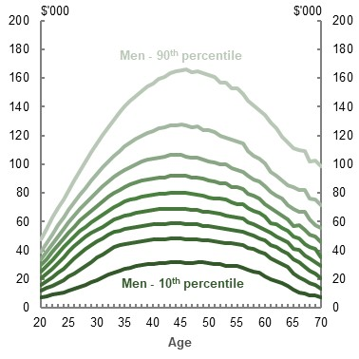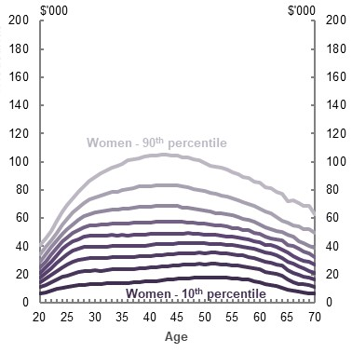
Note: Data from 2016-17. Percentiles are based on total remuneration (salary and wages, compulsory superannuation contributions and salary sacrifice contributions) at each age and gender in 2016-17. Lines show the increase in 10-percentile increments from the 10th gender-based percentile (darkest line) to the 90th gender-based percentile (lightest line). Salary and wages income is net of any salary sacrificed contributions. Source: Analysis of data provided by the ATO for the review.
When modelling gender, it was assumed that the gender gap in wages that existed across the population at a given age in 2016-17 would persist.

Voluntary superannuation contributions
As with other modelling, the gender model assumed men and women make salary sacrifice contributions to their superannuation. The proportion of salary contributed to superannuation was adjusted by gender using 2016-17 ATO individual tax return data.
The proportion of income salary sacrificed at each percentile differs between men and women (Chart 6A-32).
    - Proportion of salary and wage income that is salary sacrificed in 2016-17, by age and gender-based income percentile
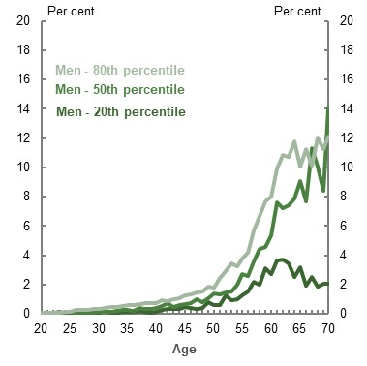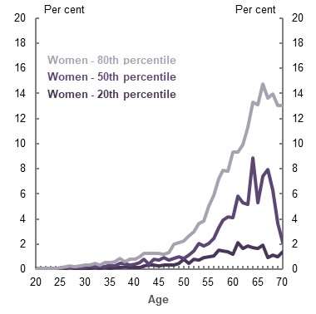
Note: Percentiles are based on total remuneration (salary and wages, compulsory superannuation contributions and salary sacrifice contributions) at each age and gender in 2016-17. Lines show the increase in 20-percentile increments from the 10th gender-based percentile (darkest line) to the 80th gender-based percentile (lightest line). Source: Analysis of data provided by the ATO for the review.
Only voluntary superannuation contributions made through salary sacrifice arrangements were modelled when analysing gender. Women are more likely to make personal deductible voluntary contributions and after-tax voluntary contributions than men, particularly in the ages approaching retirement. These contributions narrow the gender gap in superannuation balances at older ages. Excluding these types of contributions means the modelling underestimates women’s superannuation balances and retirement incomes relative to men’s (see 3B. Gender and partnered status).

Superannuation drawdowns
As men and women were assumed to have different salaries, salary sacrifice contribution rates and working-life lengths, they were also assumed to have different amounts of superannuation and wealth at retirement. This, combined with different life expectancies, means men and women were assumed to have different optimal drawdown strategies (Table 6A-18 and Table 6A-19).

      - Men’s drawdown rates by income percentile
Percentile |  | 10th | 20th | 30th | 40th | 50th | 60th | 70th | 80th | 90th
Assets at retirement ($’000)
Superannuation |  | 195 | 320 | 410 | 490 | 580 | 695 | 810 | 975 | 1,065
Other assets |  | 5 | 5 | 10 | 15 | 25 | 40 | 75 | 180 | 550
Drawdown rate by age (per cent)
67 |  | 9.1 | 10.1 | 10.3 | 9.6 | 8.6 | 7.3 | 6.7 | 5.8 | 4.6
68 |  | 9.0 | 10.2 | 10.4 | 10.3 | 9.2 | 7.7 | 7.0 | 6.0 | 4.8
69 |  | 8.8 | 10.2 | 10.4 | 10.7 | 9.8 | 8.2 | 7.3 | 6.2 | 5.0
70 |  | 8.6 | 10.3 | 10.5 | 10.7 | 10.5 | 8.7 | 7.7 | 6.5 | 5.2
71 |  | 8.7 | 10.3 | 10.6 | 10.8 | 11.2 | 9.3 | 8.2 | 6.8 | 5.4
72 |  | 8.9 | 10.3 | 10.7 | 11.0 | 11.3 | 10.1 | 8.7 | 7.1 | 5.6
73 |  | 9.2 | 10.3 | 10.8 | 11.1 | 11.4 | 10.9 | 9.3 | 7.5 | 5.9
74 |  | 9.6 | 10.3 | 10.9 | 11.3 | 11.5 | 11.9 | 10.0 | 7.9 | 6.2
75 |  | 10.0 | 10.3 | 11.0 | 11.5 | 11.8 | 12.1 | 10.8 | 8.4 | 6.5
76 |  | 10.4 | 10.2 | 11.1 | 11.6 | 12.1 | 12.4 | 11.8 | 8.9 | 6.8
77 |  | 11.0 | 10.3 | 11.1 | 11.8 | 12.3 | 12.7 | 12.7 | 9.6 | 7.2
78 |  | 11.6 | 10.7 | 11.1 | 12.0 | 12.6 | 13.1 | 13.2 | 10.4 | 7.7
79 |  | 12.3 | 11.4 | 11.2 | 12.2 | 13.0 | 13.5 | 13.7 | 11.3 | 8.2
80 |  | 13.1 | 12.1 | 11.9 | 12.3 | 13.3 | 14.0 | 14.3 | 12.4 | 8.8
81 |  | 14.0 | 13.0 | 12.8 | 12.7 | 13.7 | 14.6 | 15.0 | 13.9 | 9.5
82 |  | 15.2 | 14.1 | 13.9 | 13.7 | 14.2 | 15.3 | 15.8 | 15.5 | 10.3
83 |  | 16.6 | 15.5 | 15.2 | 15.0 | 15.0 | 16.1 | 16.8 | 16.5 | 11.3
84 |  | 18.4 | 17.3 | 17.0 | 16.8 | 16.6 | 17.1 | 18.0 | 17.8 | 12.5
85 |  | 20.8 | 19.6 | 19.3 | 19.1 | 18.9 | 18.7 | 19.6 | 19.4 | 14.0
86 |  | 24.1 | 22.9 | 22.6 | 22.4 | 22.2 | 22.0 | 21.7 | 21.5 | 16.0
87 |  | 28.9 | 27.7 | 27.4 | 27.2 | 27.0 | 26.8 | 24.7 | 24.5 | 18.8
88 |  | 36.9 | 35.8 | 35.5 | 35.3 | 35.1 | 35.0 | 31.2 | 28.8 | 22.7
89 |  | 52.8 | 51.9 | 51.7 | 51.5 | 51.4 | 51.2 | 43.3 | 36.0 | 28.6
90 |  | 100 | 100 | 100 | 100 | 100 | 100 | 73.1 | 48.6 | 35.3
91 |  |  |  |  |  |  |  | 32.2 | 17.3 | 17.3
92 |  |  |  |  |  |  |  | 38.1 | 18.8 | 18.3
93 |  |  |  |  |  |  |  | 46.9 | 20.5 | 19.4
94 |  |  |  |  |  |  |  | 62.4 | 22.7 | 20.8
95 |  |  |  |  |  |  |  | 100 | 25.5 | 22.6
96 |  |  |  |  |  |  |  |  | 29.2 | 24.7
97 |  |  |  |  |  |  |  |  | 34.5 | 27.7
98 |  |  |  |  |  |  |  |  | 42.8 | 35.6
99 |  |  |  |  |  |  |  |  | 58.0 | 51.7
100 |  |  |  |  |  |  |  |  | 100 | 100
Note: Values are in 2019-20 dollars, deflated by average weekly earnings. Figures are denominated in thousands and rounded to the nearest $5,000. Drawdown rates by age and income percentile are based on net wealth at retirement. Rates may fall below minimum drawdown rates by age in early retirement years. The review models the maximum of minimum drawdown rates and efficient drawdown rates by year. Drawdown rates are designed for people retiring in 2060 based on Age Pension rates and thresholds in those years.
      - Women’s drawdown rates by income percentile
Percentile | 10th | 20th | 30th | 40th | 50th | 60th | 70th | 80th | 90th
Assets at retirement ($’000)
Superannuation | 110 | 165 | 220 | 280 | 340 | 410 | 500 | 620 | 775
Other assets | 5 | 5 | 10 | 15 | 25 | 40 | 75 | 150 | 435
Drawdown rates by age |  |  |  |  | (per cent)
67 | 9.2 | 8.6 | 9.4 | 9.9 | 10.1 | 10.3 | 8.6 | 6.9 | 4.8
68 | 9.5 | 8.4 | 9.4 | 9.9 | 10.2 | 10.4 | 9.2 | 7.2 | 5.0
69 | 9.9 | 8.5 | 9.3 | 9.9 | 10.2 | 10.5 | 9.9 | 7.6 | 5.3
70 | 10.3 | 8.7 | 9.2 | 9.9 | 10.3 | 10.6 | 10.7 | 8.1 | 5.5
71 | 10.7 | 8.9 | 9.0 | 9.9 | 10.3 | 10.7 | 11.0 | 8.6 | 5.7
72 | 11.2 | 9.2 | 8.9 | 9.8 | 10.4 | 10.8 | 11.1 | 9.2 | 6.0
73 | 11.7 | 9.5 | 9.0 | 9.8 | 10.4 | 10.9 | 11.3 | 9.9 | 6.3
74 | 12.2 | 9.9 | 9.2 | 9.7 | 10.4 | 11.0 | 11.5 | 10.7 | 6.7
75 | 12.9 | 10.3 | 9.5 | 9.6 | 10.4 | 11.1 | 11.7 | 11.7 | 7.1
76 | 13.6 | 10.7 | 9.9 | 9.5 | 10.4 | 11.2 | 11.9 | 12.3 | 7.5
77 | 14.4 | 11.2 | 10.3 | 9.9 | 10.3 | 11.3 | 12.1 | 12.7 | 8.0
78 | 15.3 | 11.8 | 10.8 | 10.3 | 10.2 | 11.3 | 12.4 | 13.1 | 8.5
79 | 16.4 | 12.4 | 11.4 | 10.8 | 10.6 | 11.4 | 12.6 | 13.5 | 9.2
80 | 17.6 | 13.1 | 12.0 | 11.4 | 11.1 | 11.4 | 12.8 | 14.0 | 10.0
81 | 19.1 | 13.9 | 12.7 | 12.1 | 11.7 | 11.5 | 13.1 | 14.6 | 10.9
82 | 20.8 | 14.8 | 13.5 | 12.9 | 12.5 | 12.2 | 13.3 | 15.2 | 12.1
83 | 23.0 | 15.9 | 14.5 | 13.8 | 13.5 | 13.1 | 13.6 | 15.9 | 13.5
84 | 25.6 | 17.2 | 15.7 | 14.9 | 14.6 | 14.2 | 14.0 | 16.8 | 15.3
85 | 29.0 | 18.8 | 17.1 | 16.3 | 16.0 | 15.6 | 15.3 | 17.9 | 17.8
86 | 33.5 | 20.7 | 19.0 | 18.1 | 17.7 | 17.4 | 17.0 | 19.2 | 19.9
87 | 39.8 | 23.3 | 21.4 | 20.5 | 20.1 | 19.7 | 19.4 | 20.9 | 22.2
88 | 49.0 | 26.7 | 24.7 | 23.8 | 23.3 | 22.9 | 22.6 | 23.0 | 25.4
89 | 64.0 | 31.7 | 29.5 | 28.6 | 28.2 | 27.8 | 27.5 | 27.2 | 30.2
90 | 91.9 | 39.7 | 37.5 | 36.6 | 36.2 | 35.9 | 35.6 | 35.2 | 37.7
91 | 100 | 55.1 | 53.3 | 52.5 | 52.2 | 51.9 | 51.7 | 51.4 | 53.2
92 |  | 100% | 100 | 100 | 100 | 100 | 100 | 100 | 100
Note: Values are in 2019-20 dollars, deflated by average weekly earnings. Figures are denominated in thousands and rounded to the nearest $5,000. Drawdown rates by age and income percentile are based on net wealth at retirement. Rates may fall below minimum drawdown rates by age in early retirement years. The review models the maximum of minimum drawdown rates and efficient drawdown rates by year. Drawdown rates are designed for people retiring in 2060 based on Age Pension rates and thresholds in those years.

Adjustment of gender model to isolate effects of full- and part-time work and career breaks
The review’s standard gender model made no distinction between those working full-time and part-time and, as discussed above, applied a uniform career break for women at ages 30-31.
A modified version of the gender model was used to analyse the effect of gender pay gaps and career breaks (Table 6A-20). All other assumptions were held constant with the standard gender model, outlined above.
      - Variation of standard gender model assumptions for analysis of full- and part-time work and career breaks
Assumption | Population central case assumption | Male assumption | Female assumption
Start age | 27 | 27 | 27
Life expectancy | 92 years | 91 years | 93 years
Incomes | Tax return data, by age and income | Constant real income, ABS data on men’s total average weekly earnings | Constant real income, ABS data on women’s total average weekly earnings
Length of working life | 40 years | 40 years | 40 years, minus career breaks as per scenario
Superannuation drawdowns | Optimal drawdown to exhaust at life expectancy | Optimal drawdown to exhaust at male life expectancy matched to ABS average wage | Optimal drawdown to exhaust at female life expectancy matched to ABS average wage
Voluntary savings | Salary sacrifice contributions and non-superannuation wealth | No voluntary contributions to superannuation or non-superannuation wealth | No voluntary contributions to superannuation or non-superannuation wealth
Note: Working-life length for women is dependent on the number of career breaks assumed. See Box 6A-3.

Incomes
For analysis of gender pay gaps in full- and part-time work, it was assumed that men and women earn the current average total weekly earnings, in real terms, for their entire working lives. (Table 6A-21).
This is a simple assumption, and presents a different distribution of income across the life cycle than the standard gender model (Chart 6A-33). Results using this model are therefore less reliable in determining, in absolute dollar terms, the outcomes of men and women at retirement. However, the adjusted model is suitable for comparing the relative outcomes between men and women.
      - Average total weekly earnings
 | Full-time employees ($) | All employees (including part-time) ($)
Men | 1,839.00 | 1,498.20
Women | 1,528.50 | 1,028.10
Note: Data from November 2019 using seasonally adjusted figures. Source: (ABS, 2020d)
    - Comparison of average total weekly earnings (annualised) with average salary and wages income, by age and gender-based income percentile
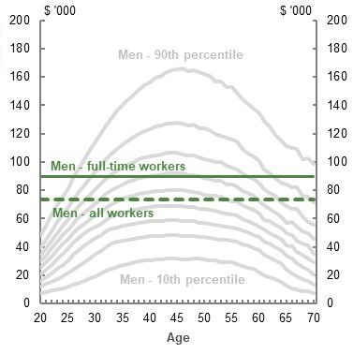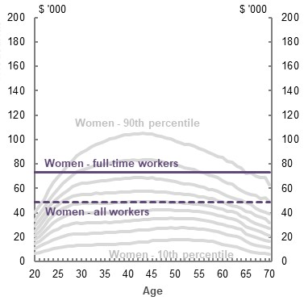
Note: Data from 2016-17. Percentiles are as per Chart 6A-31. See note in Chart 6A-31 for further explanation. Annualised incomes for full-time and all workers have been extrapolated from average weekly earnings from May 2017, to show the comparison with 2016-17 ATO data. They are different to the figures from November 2019 used in the gender version of EMORI. Annualised average total weekly earnings is inclusive of salary sacrifice contributions while average salary and wages income in 2016-17 is net of salary sacrifice contributions. Source: Data provided by the ATO for the review; analysis of (ABS, 2020d).

Length of working life
In this adjusted model, the default working life for men and women was 40 years. This allowed for a more direct comparison of the effect of pay gaps on retirement outcomes, without the related effect of different lengths of working life.
A number of career break scenarios were tested using this adjusted model. The assumptions underpinning these scenarios are in Box 6A-3. Outside of the career break adjustments, women were assumed to be working full-time (see Incomes, above).
          - Modelling career breaks
There is no one-size-fits-all approach when modelling career breaks as people’s lived experiences vary significantly. On average, women are more likely to take career breaks, take longer career breaks, take career breaks for caring reasons, and take them earlier than men (REST Super, 2017).

When do career breaks occur?
The career break modelling has assumed mothers have either one child at age 30, or two children at ages 30 and 33. This reflects population statistics that suggest, on average, women have 1.8 children and the median age of mothers giving birth is 31.4 (ABS, 2019e). This approach broadly aligns with career break cameos presented in submissions by two superannuation funds with large female memberships (HESTA, 2020, p. 29) (First State Super, 2020b, p. 40).
A career break for a woman who cares for a parent from age 55 was also modelled. One submission suggested that 25 per cent of women in their 50s care for a spouse or a parent (Carers NSW, 2020, p. 5).

How long are career breaks?
The modelling in the review has assumed women take two years off work to care for a child. Survey research by REST Super found, on average, women take 22.5 months off work for each ‘caring’ career break (REST Super, 2017). In addition, research by Wilkins found significant variability in the length of caring breaks (Table 6A-22).
      - Length of career breaks for caring
Timing of return to paid employment after birth | Proportion of mothers (per cent)
Less than 6 months | 16.7
Between 6 and 12 months | 20.9
Between 12 and 24 months | 18.3
24 months or more | 44.1
Note: Limited to women aged under 45 whose youngest child was between ages two and five at the time of the survey. Timing of return to paid employment was for most recent birth. Includes mothers who had never worked before birth, or had not returned to paid employment. Source: (Wilkins, 2017, pp. 51-57).

What effect do career breaks have on earnings?
The modelling in the review has assumed:
- Women miss out on promotions and salary increases while on leave, in line with evidence presented in submissions and other reports (e.g. (AustralianSuper, 2018, p. 17)). A 2004 study found high-school-educated women forgo around 31 per cent of their lifetime earnings when they have a child and an additional 13 per cent when they have a second child (Breusch & Gray, 2004). Women are assumed not to benefit from promotions and salary increases during years on leave — earnings in the year after a career break are the same in nominal terms as the year prior to the career break, implying a wage decrease in real terms. Wages remain constant in real terms post-career break and do not return to pre-career break levels.
- Where women work part-time to care for children, they do so until their youngest child is five years old, at 60 per cent of what their wage would otherwise have been if they were working full-time. Wilkins found women were most likely to be working two years after the birth of a child and working part-time. Two years after the birth of a child, a mother’s weekly earnings were around 55 per cent of her pre-child earnings. Part-time work is also far more common for women before and after their second child (Wilkins, 2017, pp. 51-57).

Retirement income
Retirement income incorporated Age Pension (as eligible), superannuation and non-superannuation draw downs. Superannuation drawdowns by gender were based on the standard gender cameo model drawdown strategy as per Table 6A-18 and Table 6A-19 for the income percentile with the closest average working-life wage to annualised ABS average weekly earnings as in Table 6A-22. Non-superannuation assets were also matched using this methodology.

Voluntary savings
To show the isolated effect of the gender pay gap and career breaks, voluntary contributions to superannuation and non-superannuation savings were not included in the adjusted version of the gender model.

Benchmarking the review’s cameo model
To project outcomes many decades into the future, simplifications are necessary. This makes it important to test models to see how they compare to people’s current superannuation balances and other modelling.
Testing focused on the modelled population, which included people who have:
- Wage income and are covered by the SG.
- A reasonably long attachment to the workforce.
  - The review’s cameo model did not capture the population with minimal workforce participation. The 2018 Priority Investment Approach model projects that about 10 per cent of people will have no employment income while receiving income support for 15 years or more before Age Pension eligibility age in 2058. Assessment of adequacy outcomes against the minimum standard is more appropriate for this group.
Testing shows that the model is a good fit for the balances achieved by Australians working today and produces similar results to other long-term modelling.
- Projected superannuation balances are similar to what working Australians have in their superannuation today after adjusting for historical rates of the SG.
- Projections of balances at retirement generally align with the comparable cohort in other long-term models by Treasury (MARIA) using the 2019-20 MYEFO economic parameters and Rice Warner. These similarities are despite key differences in methodology, input data and age of retirement.
- Voluntary contributions are conservative compared to what people do, mainly due to excluding non-concessional contributions, which made up more than 40 per cent of total superannuation contributions in 2016-17 at $54 billion.

Superannuation balances at retirement
The review compared the superannuation balances at retirement in its modelling to other long-term models by Treasury and Rice Warner. Each model uses different methodologies and data for its projections. Comparing different models is useful for testing the robustness of their results.
Review modelling assumed a 40-year career starting at age 27 and retiring at age 67. Evidence shows that a 40-year career is typical for a person starting work today (2C. Maintaining standards of living in retirement). While not everyone works to age 67, many people start in the workforce before age 27, so those retiring earlier may still work at least 40 years.
Treasury’s long-term population model, MARIA, dynamically models the accumulation of superannuation for the Australian population over 25 years as they move into and out of the workforce (see Model of Australian Retirement Incomes and Assets, below).
MARIA was compared to the cameo model by selecting a cohort who retire in around 40 years’ time and have some workforce participation. For this reason, the bottom 10 per cent of balances are excluded when comparing to the relevant cohort of people retiring in MARIA. This proportion is based on analysis from the 2018 Priority Investment Approach actuarial model and Department of Social Services data showing the proportion of people projected to have no employment income while receiving income support for 15 years or more before Age Pension eligibility age.
The review’s cameo model produces results similar to models with more sophisticated projections of careers and population-level outcomes (Chart 6A-34 and Chart 6A-35).
    - Comparison of superannuation balances at retirement, median income and below
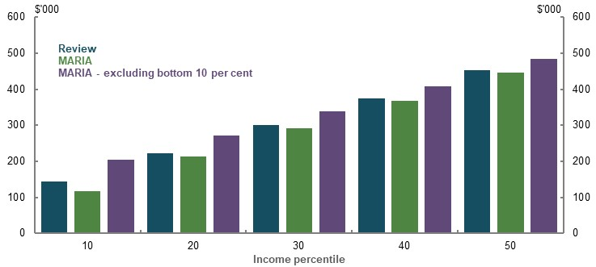
Note: Values are in 2019-20 dollars, deflated by average weekly earnings. Balances at 2058-59 for review, and 2057-58 to 2059-60 for MARIA. Source: Treasury estimates for the review using MARIA, cameo modelling undertaken for the review.
    - Comparison of superannuation balances at retirement, above median income
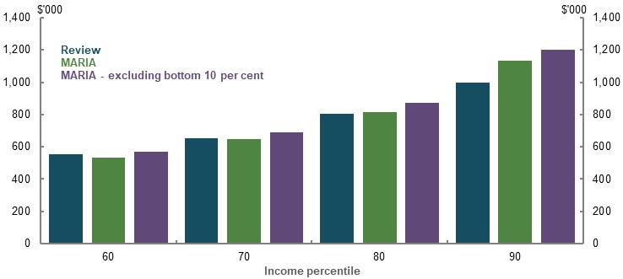
Note: Values are in 2019-20 dollars, deflated by average weekly earnings. Balances at 2058-59 for review and 2057-58 to 2059-60 for MARIA. Source: Treasury estimates for the review using MARIA, cameo modelling undertaken for the review.
Rice Warner’s long-term model SPROUT, like MARIA, is a population-based projection. Due to differences in modelling populations, analysis compares the total assets at retirement including superannuation and non-superannuation. SPROUT bases its population on the ABS Survey of Income and Housing (see Superannuation, Pension and other Retirement OUTcomes, below) while the review cameo modelling focuses on employees eligible for the SG.
Comparisons to Rice Warner results show that the total assets balances at retirement in review modelling are broadly comparable across most percentiles, although lower in the bottom 20 per cent, and higher for the top 10 per cent (Chart 6A-36).
    - Comparison of total assets at retirement
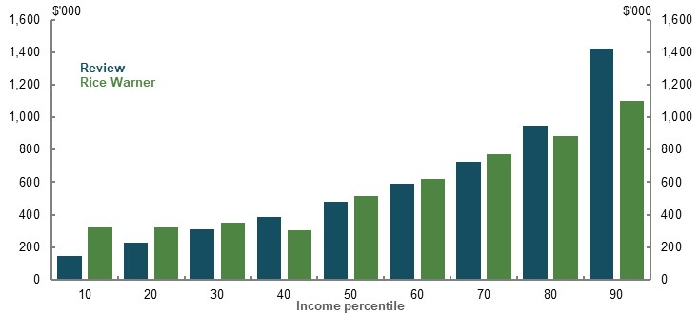
Note: Values are in 2019-20 dollars, deflated by average weekly earnings. Total assets at retirement for review and Rice Warner are for an individual aged 67 and between 65-69, respectively. Balances are for people retiring in 2058-59. Source: Analysis of Rice Warner estimates for the review and cameo modelling undertaken for the review.

Accumulation of superannuation balances
Following is a comparison of the results over different ages in the review’s retirement income model of people’s current superannuation balances. It compares:
- The superannuation balance by income percentile from the model and deflated by wages to 2016-17 dollars. Projections use historical SG rates, but otherwise use review assumptions.
- Superannuation balances by income percentile and age from ATO data for people with wage income above $5,400 (the annual value of the $450-a-month threshold) and positive superannuation balances.
It is not appropriate to compare model results to the superannuation balances of the entire population. This approach does not account for the share of the population that the model is designed to work for, because:
- Historical rates of the SG were lower.
- Comparing balances in later ages, such as age 60, ignores that some people may have withdrawn superannuation after preservation age. People with low balances often make large lump-sum withdrawals, making analysis of lower-income earners particularly fraught.
- Self-employed people have significantly different savings patterns to workers.
- Some people have little or no attachment to the workforce.
Overall, results show that the review’s cameo model produces similar results to the superannuation balances of people today (Chart 6A-37).
The late starting age assumption means that the review’s cameo model projects lower superannuation balances than those seen in the ATO data for people in their early 30s. However, this gap closes by the late 30s, when many people take career breaks, such as for raising children.
Differences in the model and data are largest for older ages at higher incomes. Recent policy changes may explain a large part of this gap. Older, richer workers were able to benefit from the much higher concessional contributions caps before changes in the 2010s and other historical policy, such as large contributions before 2007 (see 1B. Design of Australia’s retirement income system).
    - Projected and current superannuation balances, by age and income percentile
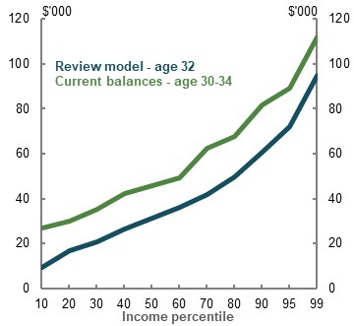 | 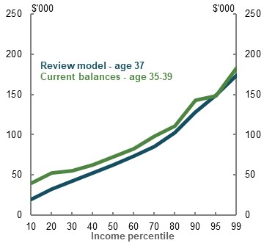
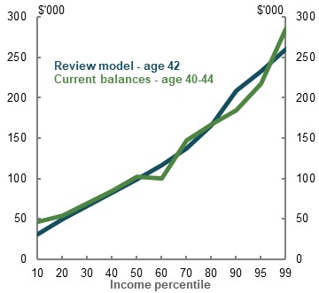 | 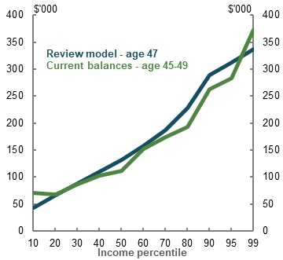
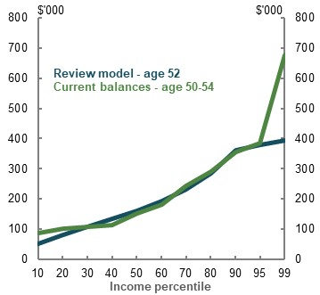 | 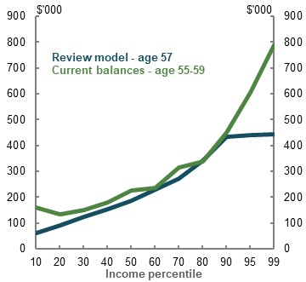
Note: Values are in 2016-17 dollars. Modelled values deflated by average weekly earnings. Current balances calculate average superannuation balance based on five-year age ranges by income percentile. Source: Analysis of ATO individual income tax returns and member contributions statements, 2 per cent sample, 2016-17; cameo modelling undertaken for the review based on historical rates of the SG received by each cohort.

Voluntary contributions
To benchmark assumptions regarding voluntary contributions, the review compared its assumptions with longitudinal data from the ATO’s ALife dataset. Average voluntary contributions in ALife over an eight-year period for the cohort aged 55 in 2010 are significantly higher than those in the review’s model (Chart 6A-38).
Review modelling only includes salary sacrifice contributions based on the latest year of tax data. ALife analysis that follows individuals over time shows salary sacrifice contributions are broadly similar between the two datasets despite different populations of analysis (ALife analysis includes everyone with incomes while the review cameo model is for employees only).
Voluntary contributions in review modelling are significantly lower than actual contributions people make, on average, because of the exclusion of personal deductible and of non-concessional contributions. These contributions are significant at about 40 per cent of all contributions to superannuation in 2016-17 (see Non-concessional contributions above).
    - Value of annual voluntary contributions by superannuation balance deciles
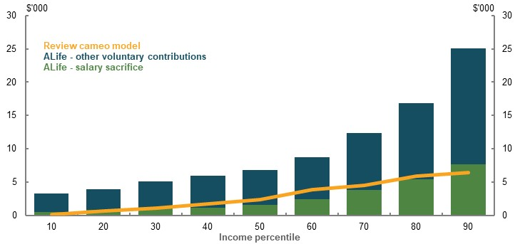
Note: Values are in 2019-20 dollars, deflated by average weekly earnings. ALife data follows cohort aged 55 in 2010 over an eight-year period. Average includes men and women. Voluntary contributions include salary sacrifice, personal deductible and non-concessional contributions. Deciles for ALife are created based on superannuation balance as at 2010. Percentiles for review model are by income. Review average annual voluntary contributions calculate average amount salary sacrificed over an eight-year period commencing in 2047-48 for people aged 55. Source: Analysis of ATO Longitudinal Information Files (ALife), cameo modelling undertaken for the review.

Model of Australian Retirement Incomes and Assets
The Model of Australian Retirement Incomes and Assets (MARIA) is Treasury’s long-term, population-level, dynamic microsimulation model of Australia’s retirement income system.
MARIA begins with 2015-16 base data, which captures the Australian population aged 25 and over at that point in time. The base data is sourced from administrative data collected by the ATO, the Department of Social Services and the Department of Veterans’ Affairs. It is supplemented with survey data from the HILDA Survey and the ABS Survey of Income and Housing. The model is run from 2015-16 to 2059-60 on a representative sample of this complete dataset. Each year, new records are randomly taken from the base data to represent new 25-year-olds and migrants entering the population.
MARIA uses Treasury analysis to develop input parameters that simulate the characteristics of each individual for every year of the model run, based on their characteristics in the previous year. These characteristics include:
- Household composition
- Labour force participation
- Income
- Compulsory and voluntary superannuation contributions
Some characteristics are not modelled dynamically year-on-year, but rather imputed at the point of retirement. These characteristics include home-ownership status and non-superannuation savings (discussed further below). The imputation is based on factors such as age, education level, work experience and superannuation balance.

Key output
MARIA’s key output is defined contribution superannuation amounts held by individuals, both accumulation throughout working life and drawdown in retirement. MARIA can therefore also project the aggregate defined contribution funds under management in the superannuation system. MARIA does not model superannuation funds themselves, or any assets held by funds to support defined benefits or for regulatory capital purposes. MARIA also does not model multiple account holdings.
MARIA projects Age Pension expenditure and coverage based on the simulated superannuation assets, imputed non-superannuation assets and deemed income of individuals and their partners.
Some modifications have been made to MARIA to support the review which include:
- Developing long-run estimates of the value of superannuation tax concessions (benchmark variations)
- Improvements to the imputation of assets outside superannuation at retirement
- Adjusting the superannuation earnings assumption to align with assumptions used in the review’s cameo modelling

Long-run estimates of Superannuation tax concessions
Long-run estimates of the value of superannuation tax concessions (benchmark variations) are estimated using MARIA on a revenue forgone basis. These estimates broadly replicate the methodology and benchmark used in the Tax Benchmarks and Variations Statement (The Treasury, 2020). The estimates include:
- Combined estimates of capital gains and earnings tax concessions provided to superannuation funds (reflecting a combined C1 and C4 estimate from the Tax Benchmarks and Variations Statement)
- Contributions tax concession estimates (reflecting a combined C2 and C3 estimate from the Tax Benchmarks and Variations Statement)
Unlike the Tax Benchmarks and Variations Statement, the long-run estimates in MARIA have been constructed on an additive basis to facilitate analysis of trends. The value of superannuation tax concessions is estimated by adding contributions and earnings to taxable income in two stages and applying the progressive income tax rates at each stage. The value of the earnings tax concession is the difference between the total value of concessions and value of contributions tax concessions. Beyond the medium term, several personal income tax thresholds and offsets that comprise the benchmark are assumed to be indexed to wage growth.

Modelling of savings outside superannuation at retirement
MARIA models the accumulation of superannuation on a dynamic basis over an individual’s working life. However, savings held outside superannuation are not projected using a dynamic model, but instead imputed at retirement using survey data. These imputed values are then used to project pension entitlements. MARIA adjusts imputed values to reflect that an increase in saving in superannuation is likely to reduce savings outside superannuation over the coming decades.
The method of imputing these assets was improved as part of the analysis provided to the review. Nominal growth in the value of financial assets outside superannuation was changed to increase in line with wages growth (rather than CPI). The factor used to reduce growth in aggregate financial savings outside superannuation as the superannuation system matures was also lowered. This change reduced the projected proportion of the eligible population receiving a pension and therefore reduced projected pension expenditure.
Adequacy analysis
MARIA is designed to model long-term trends in superannuation accumulation and the fiscal impacts of retirement income policy settings. MARIA is not suitable for analysis of replacement rates. In this review, replacement rate analysis has been undertaken using a hypothetical lifetime cameo model, as detailed above.

Baseline assumptions
Demographic and economic growth rates in MARIA have been calibrated to the assumptions prepared for the 2019-20 MYEFO. Key parameters include population growth (which is projected to gradually decline over the long-term to 2060), nominal GDP growth (also projected to gradually decline over the long-term to 2060), participation rates (which vary by age and gender), wages (assumed to grow at around 4 per cent) and prices (assumed to grow at around 2.5 per cent).
Near-term increases in the SG are assumed to pass through to people via reduced salary sacrifice contributions and wage growth. It is assumed employees who make voluntary contributions (including salary sacrifice and personal deductible contributions) will adjust these contributions in response to changes in the SG rate.
MARIA modelling for this review uses the same investment returns assumptions as the adequacy modelling, which were developed by the Australian Government Actuary. These assumptions are investment returns before fees of 7.5 per cent in the pre-retirement phase and 6.2 per cent in the retirement phase.
Fees, insurance and drawdown assumptions are based on historical data.
Modelling in MARIA is undertaken in nominal dollars. The choice of most useful deflator to present modelling results depends on the context of use.

      - MARIA assumptions
Assumption | Long-term assumption | Basis
Population growth | Compound average annual growth rate of ~ 1 ¼ per cent, trending down | 2019-20 MYEFO, historical data
Nominal GDP | Compound average annual growth of ~ 5 ¼ per cent, trending down | 2019-20 MYEFO, historical data
Nominal wages | Compound average annual growth of ~ 4 per cent | 2019-20 MYEFO, historical data
Inflation | Compound average annual growth of ~ 2 ½ per cent | 2019-20 MYEFO, historical data
Investment earnings | 7.5 per cent pre-retirement phase  6.2 per cent retirement phase | Advice from the Australian Government Actuary
Investment earnings tax | 15 per cent (accumulation only) | Legislation
Effective investment earnings tax | Variable | Calculated within model
Fees | Annual fees are calculated as $74 (indexed to average weekly earnings) plus 0.85 per cent of the account balance | Historical data
Insurance premiums | $214 (indexed to average weekly earnings) | Historical data
Superannuation drawdown rate | Observed drawdown rates | Historical administrative data from pension recipients and SMSFs.
Wage pass-through | SG increases pass-through 100 per cent to individuals via reduced salary sacrifice contributions and wage growth | Evidence base detailed above

Scenario assumptions
Three scenarios were completed to support the review:
- A scenario in which the SG rate stays constant at 9.5 per cent (rather than rising gradually to 12 per cent in the near future).
- A scenario in which superannuation drawdown is based on CPI-indexed annuitised income stream, such that people target the exhaustion of their superannuation assets at age 92.
- A scenario in which the long-run impact of a large short-run shock to the retirement income system is modelled. This scenario is covered in detail in Box 4A-4 of 4. Sustainability.

Constant Superannuation Guarantee
The SG policy scenario examined the fiscal impact of maintaining the SG rate at 9.5 per cent compared with proceeding with the legislated increase in the SG rate to 12 per cent. MARIA was used to estimate the change in Age Pension expenditure, superannuation taxes and income taxes on wages and salaries. The fiscal modelling assumed there would be full pass-through of the changes in the SG rate to employees through wages growth and reduced salary sacrifice.
Costs associated with an increase in SG can be borne by wages, company profits, employment or prices. For modelling purposes, the average tax rate paid on company profits is more similar to the average tax rate paid by workers, compared to assuming the remaining 20 per cent has no tax implications. Not assuming full pass-through in the context of the model is unrealistic as it would mean that 20 per cent of the impact is not passed through to any part of the economy and would not be taxed in any form. Modelling of budget effects therefore assumes 100 per cent pass-through (see 2D. Policy scenario: Implications of maintaining the SG rate).
MARIA is not designed to model the impact of the SG policy scenario on the broader economy. In particular, MARIA is not suitable for modelling of the impact of maintaining the SG rate at 9.5 per cent on the economy-wide measures of wage growth used to index the Age Pension payment rate. Age Pension expenditure projections from MARIA do not incorporate the impact of higher wage growth on the indexation of Age Pension amounts.
Differences between MARIA and the review’s modelling framework for savings outside superannuation meant Age Pension expenditure projections do not capture the impact of higher savings outside of superannuation on means testing. Effects are expected to be small because the extra savings are likely to be predominantly made by high-income earners.

Annuitised drawdown
Under the baseline, retired people modelled in MARIA draw down superannuation from account-based pensions at rates based on observed drawdown rates. In this scenario, all retirees are assumed to draw down using CPI-indexed, annuitised income streams to age 92. An annuitised drawdown assumption better matches that employed by the review’s cameo model (detailed above).
This scenario leads to retiree assets being depleted quicker, increasing Age Pension entitlements and therefore the share of the retiree population receiving a pension (Chart 6A-39).
    - Projected Age Pension population — baseline (solid) and annuitised drawdown scenario (dashed)
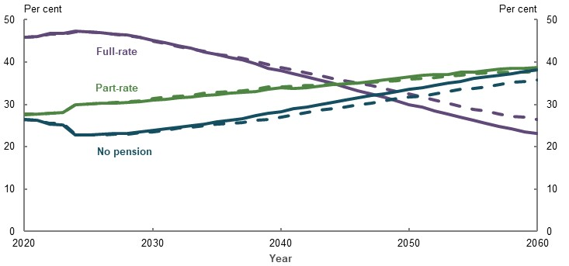
Note: Age Pension population includes those eligible for age, carer, disability support and service pensions. Source: Treasury estimates for the review using MARIA.
More age pensioners means slightly higher Age Pension spending as a percentage of GDP (Chart 6A-40). Total tax concessions are projected to be slightly lower, although the magnitude is negligible. A higher rate of drawdown reduces the stock of retiree assets producing tax-exempt earnings, which reduces earnings tax concessions.
    - Annuitised drawdown scenario — key aggregates
Age Pension expenditure | Total tax concessions
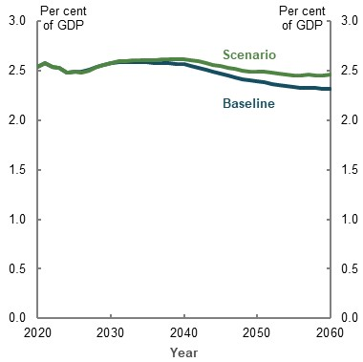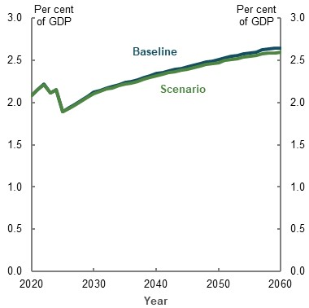
Note: Age Pension expenditure includes service pensions. Source: Treasury estimates for the review using MARIA.
The modelled income streams in this scenario do not reflect all aspects of an annuity. Rather, these income streams should be interpreted as account-based pensions that are drawn down at rates approximating an annuity.
The preferential means testing and different prices of annuities are not modelled in the scenario. This means Age Pension expenditure projections for the drawdown scenario may be lower than for an annuity product.
Further, most people in the model do not live to age 92 (when they target the exhaustion of their superannuation) because they are in a cohort that is expected to have lower life expectancy than this. These people have superannuation assets that would be left in a bequest rather than fully drawn down.

Superannuation, Pension and other Retirement OUTcomes
Superannuation, Pension and other Retirement OUTcomes (SPROUT) is a long-term, group-based, population-level microsimulation model jointly owned by Rice Warner and Industry Super Australia. SPROUT projects output for groupings of the population based on gender, quinquennial age groups (20-24, 25-29 and so on), singles and couples, and point-in-time income and wealth percentiles (10, 20, 30, 40, 50, 60, 70, 80, 90, 99 and 100). Modelling at the group level, SPROUT differs from MARIA, which models at the individual level.
SPROUT starts with base data from the 2017-18 ABS Survey of Income and Housing and comprises four sub-models: the population model, the membership model, the asset model, and the parameter and assumption model.
- The population model takes account of population growth (including migration), workforce entry and exit, and death.
- The membership model uses the population model to project the number of superannuation accounts by industry sector, age, gender, account function (primary, secondary and unneeded), membership status (active, inactive and retired) and wealth quantiles.
- The asset model projects the asset values of each account produced by the membership model.
- The parameter and assumption model drives all the above models with underlying economic and demographic assumptions.

Key output
SPROUT produces output on the following variables for each financial year:
- Total superannuation assets under management, including by accumulation and pension phase
- Annual contributions, fees and gross earnings
- Total Age Pension expenditure
- Annual withdrawals (lump sums or as income payments), and total and average death benefits
- Average superannuation balances and average assets outside superannuation
- Tax concessions on contributions and earnings
- Total retiree population, and the total population of Age Pension age (including full/part-rate proportions, and home owner/renter proportions)
- Number of people who retire and the estimated average superannuation balance at retirement
- Average drawdown in retirement (per cent and dollars), and average total retirement income

Baseline assumptions

Demographic and membership assumptions
The population aged 15 and over is projected to grow at an average annual rate of 1.2 per cent per year, with the growth rate decreasing over the projection period, consistent with ABS projections (ABS, 2018g). New entrants into the superannuation system and retirements are derived by applying participation rates from labour force projections published by the Productivity Commission (2005).
Labour force turnover is assumed to be 8.5 per cent per year, derived from the ABS (2019r). Sixty per cent of those who change employment are assumed to keep their current fund. Of those who change employment and change funds, 20 per cent are assumed to not consolidate their accounts. This assumption gradually falls to 10 per cent over the projection period.
Retirement benefit-type assumptions (e.g. lump sum, pension within the fund, Commercial Pension Product, Industry Pension Product, self-managed superannuation funds) vary by industry segment and stem from Rice Warner’s Super Insights database.
Mortality assumptions are derived from the ABS (2018g), which assumes a degree of improvement in mortality over time. Rates of permanent disablement are also assumed.

Superannuation assumptions
Investment earnings and tax assumptions are made at the asset-class level (Table 6A-24). Investment earnings assumptions are developed by considering the assumptions used by Treasury, asset consultants, superannuation funds and various other institutions. Given the current low interest rate environment, it is assumed that after 10 years, fixed interest rates will rise by 2 percentage points and the cash rate will rise by 1 percentage point. These assumptions aggregate to produce a compound annual average system-level gross return (before fees and taxes) of 6.7 per cent in 2059.
The headline tax rate on pre-retirement phase investment earnings is 15 per cent (retirement earnings are tax-free), but adjustments are made at the asset-class level for capital gains discounts and imputation credits.
      - SPROUT investment earnings and tax assumptions
Asset class | Annual gross investment return (per cent) | Annual earnings tax rate  (per cent)
Australian equities (gross of imputation credits) | 7.9 | -3.6
International equities | 7.5 | 13.4
Unlisted equities | 10.1 | 13.0
Listed property | 7.0 | 14.3
Direct property | 7.0 | 14.1
Infrastructure | 7.8 | 14.0
Australian fixed interest | 3.5 | 15.0
International fixed interest | 2.7 | 15.0
Cash | 3.0 | 15.0
Note: Fixed interest and cash asset class investment return figures do not include upward adjustments applied after 10 years. Gross investment returns before fees and taxes. Source: Rice Warner.
Asset allocations are assumed at the industry-segment level using allocations published by APRA (2020b) and the ATO (2019d). Drawdown rates are based on observed historical data.
Fee assumptions are derived from an analysis of Rice Warner’s database. Dollar-based fees increase with inflation and asset-based fees for industry funds are projected to fall to 50 basis points over the first 10 years of the projection, and stay constant thereafter. The asset-based fees for other industry segments (except retirement savings accounts, eligible rollover funds and self-managed superannuation funds) fall such that the gap to industry funds is held constant over time (Table 6A-25). These assumed reductions are due to expected economics of scale (including consolidation of funds), consolidation of accounts and general technological improvements.
      - SPROUT fees assumptions
Segment | Starting fixed fee ($) | Short-term percentage fee (per cent) | Long-term percentage fee (per cent)
Corporate | 71 | 0.76 | 0.47
Employer master trusts | 64 | 0.86 | 0.58
Industry | 88 | 0.79 | 0.50
Public sector | 32 | 0.68 | 0.39
Personal master trust | 63 | 1.33 | 1.04
Post-retirement products | 38 | 1.23 | 0.94
Retirement savings accounts | 0 | 0.88 | 0.59
Eligible rollover funds | 0 | 1.95 | 3.69
Self-managed superannuation funds | 1,800 | 0.62 | 0.33
Source: Rice Warner.
The model accounts for the legislated increase in the SG to 12 per cent by 1 July 2025. However, it is assumed that the cumulative increase of 2.5 percentage points will result in an increase of only 2.2 per cent in total employer contributions. This is due to the potential for the SG increase to be absorbed by reduced salary sacrifice contributions. Increases in the SG are not assumed to compress wage growth. Contributions are taxed at 15 per cent, with allowances made for Division 293 tax and the low income superannuation tax offset.

Economic assumptions
Nominal GDP growth assumptions vary year-to-year, with the rate of growth slowing over time (consistent with slowing population growth). Inflation and wage growth assumptions are constant over time (Table 6A-26).
      - SPROUT economic assumptions
Assumption | Parameter
Nominal GDP | Compound annual average growth of ~ 5.2 per cent per year, trending down.
Inflation | 2.5 per cent, per year
Wage growth | 3.5 per cent, per year
Source: Rice Warner.

Scenario assumptions
SPROUT was used to run a range of scenarios where assumptions differed to those used in the baseline.
- The lower earnings scenario saw earnings rates on all asset classes reduced by 1 percentage point from the baseline presented in Table 6A-24.
- The lower wages scenario saw the wage growth assumption reduced by 1 percentage point to 2.5 per cent per year.
- The constant SG scenario saw the SG held constant at 9.5 per cent, instead of increasing to 12 per cent by 1 July 2025.
- The changes to the Age Pension assets test taper rate scenario saw the assets test taper rate lowered from $3 per fortnight for every $1,000 in assets, to $2.25 per fortnight for every $1,000 in assets.
The lower fees scenario was more involved (Table 6A-27). As is the case in the baseline, fixed fees are indexed to inflation, and percentage fees for industry funds are projected to fall to 0.5 per cent over the first 10 years of the projection, and stay constant thereafter. However, unlike the baseline in which a constant gap is maintained between the percentage fees of industry funds and other segments, the fees scenario sees:
- The industry, employer Master Trust and corporate segments match the percentage fee of the public sector funds over the short term
- The public sector, employer and personal Master Trust, corporate and post-retirement product segments match the industry segments fall to 0.5 per cent (Table 6A-27)
Overall, this scenario sees aggregate fees in the superannuation system fall to around 0.52 per cent of assets by 2059 from 0.86 per cent in 2019, instead of 0.64 per cent from 0.96 per cent as in the baseline.
      - SPROUT lower-fees scenario assumptions
Segment | Starting fixed fee ($) | Modified starting fixed fee ($) | Short-term percentage fee (per cent) | Modified short-term percentage fee (per cent) | Long-term percentage fee (per cent) | Modified long-term percentage fee (per cent)
Corporate | 71 | 32 | 0.76 | 0.68 | 0.47 | 0.50
Employer master trusts | 64 | 32 | 0.86 | 0.68 | 0.58 | 0.50
Industry | 88 | 32 | 0.79 | 0.68 | 0.50 | 0.50
Public sector | 32 | 32 | 0.68 | 0.68 | 0.39 | 0.50
Personal master trust | 63 | 38 | 1.33 | 1.23 | 1.04 | 0.50
Post-retirement products | 38 | 38 | 1.23 | 1.23 | 0.94 | 0.50
Retirement savings accounts | 0 | 0 | 0.88 | 0.88 | 0.59 | 0.59
Eligible rollover funds | 0 | 0 | 1.95 | 1.95 | 3.69 | 3.69
Self-managed superannuation funds | 1800 | 1800 | 0.62 | 0.62 | 0.33 | 0.33
Source: Rice Warner.

Modified baseline scenario
A simulation of SPROUT was also run that incorporated some of the parameter inputs from MARIA. The adjustments included:
- A change in the wage growth assumption to 4 per cent from 3.5 per cent
- The same population assumptions as used in MARIA
The modified baseline sees SPROUT’s superannuation assets as a percentage of GDP higher than SPROUT’s baseline, but still much lower than MARIA (Table 6A-28).
The higher wages growth assumption in the modified baseline leads to much higher contributions, almost matching MARIA’s contributions. However, while the modified baseline lifts total earnings (as the asset base is lifted), the more conservative net earnings assumptions in SPROUT still constrain growth in superannuation assets relative to MARIA.
MARIA has higher superannuation system growth, but also higher pension expenditure as a percentage of GDP compared to SPROUT. Fundamental differences in the way non-superannuation assets are modelled partly explain these differences in results. SPROUT projects non-superannuation assets to grow much more quickly than MARIA, which acts to reduce Age Pension expenditure as a percentage of GDP more than the equivalent modelling in MARIA, in both the baseline and the modified baseline.
Other contributing factors may include the fact that MARIA includes service pensioners, and differences in participation rates.
      - SPROUT — modified baseline
Output in 2059 | MARIA | SPROUT | SPROUT — modified baseline
Superannuation assets (per cent of GDP) | 245.7 | 169.0 | 187.6
Contributions (per cent of GDP) | 7.6 | 6.2 | 7.5
Net earnings (per cent of GDP) | 13.5 | 10.0 | 11.2
Age Pension expenditure (per cent of GDP) | 2.3 | 1.9 | 2.0
Note: MARIA Age Pension expenditure estimates includes service pensions. Source: Treasury estimates for the review using MARIA, analysis of Rice Warner estimates for the review.

Modelling financial stress
2B. Policy scenario: Implications of increasing Commonwealth Rent Assistance models the impact of certain changes to the design of Commonwealth Rent Assistance on the financial stress of retired renters. Since financial stress is self-reported, and measured using answers to questions about financial hardship and ‘missing out’ experiences, the effect of changes to Commonwealth Rent Assistance on financial stress must be estimated from historical data.
The review used a statistical model to estimate the relationship between financial stress and income to predict how financial stress rates might change if Commonwealth Rent Assistance was increased. To account for other drivers of financial stress, the model includes key financial and demographic variables that also influence financial stress rates. The model is unable to control for unobserved differences across households that may affect financial stress. The limitations of this are discussed below.

Effect of higher Commonwealth Rent Assistance
Following is an outline of how the effect of a 40 per cent increase in the maximum rate of Commonwealth Rent Assistance on financial stress for households was estimated.

Data
Data is from the 2015-16 release of the ABS Household Expenditure Survey. Retired households are defined as those with the reference person 65 years or older without any earners. Financial stress is defined in the same way as the ABS: those who report four or more financial stress or ‘missing out’ experiences. All households with positive income are included in the regression.

Methodology
A cross-section multinomial probit model is estimated using observations for each household $i$:
$$Financial stress_{i}= Φ(α+ϑRetired renter income_{i}+Xβ_{i}+ε)$$
where:
- $Financial stress_{i}$ is a binary variable if a household reported financial stress, as defined as four or more financial stress or ‘missing out’ experiences.
- $Retired renter income_{i}$ is the weekly disposable income in dollars if the household rents and is classified as retired.
- $Xβ_{i}$ is a vector of control variables, which includes the weekly disposable income of other households in dollars, binary variables for household and tenure type (if the household is a single renter or a couple renter), binary variables if the household has a mortgage, dependants or anyone with a disability. Also included is household wealth in dollars, interacted with a vector of binary variables for the household wealth quintile of each household.
The coefficient of interest is $ϑ$, the conditional correlation of financial stress to changes in the income of retired renters. The regression is weighted using population weights.

Results
The coefficients all have the expected effect. Higher incomes and wealth lead to lower financial stress, while having dependants, a mortgage, or a household member with a disability are correlated with higher rates of financial stress Table 6A-29.
      - Renter retiree income and financial stress
Variable | Coefficient | Standard error | p. value
Intercept | -0.376 | 0.108 | 0.000***
Retired renter income | -0.00116 | 0.000240 | 0.000***
Other household income | -0.000353 | 0.0000511 | 0.000***
Single renter | -0.0859 | 0.0967 | 0.375
Couple renter | 0.270 | 0.0925 | 0.004***
Dependants | 0.127 | 0.0635 | 0.046**
Mortgage | 0.345 | 0.0745 | 0.000***
Disability | 0.575 | 0.0507 | 0.000***
Wealth quintile 1 | -0.00000202 | 0.00000208 | 0.332
Wealth quintile 2 | -0.00000258 | 0.000000414 | 0.000***
Wealth quintile 3 | -0.00000169 | 0.000000211 | 0.000***
Wealth quintile 4 | -0.00000130 | 0.000000140 | 0.000***
Wealth quintile 5 | -0.000000851 | 0.000000103 | 0.000***
N | 10,019
Nagelkerke Pseudo R² | 0.280

Note: Regression population weighted; ***, **, * denote statistical significance at the 1, 5 and 10 per cent levels, respectively. Source: Review estimate based on ABS Household Expenditure Survey 2016-17.
To assess the average effect of a 40 per cent increase in the maximum rate of Commonwealth Rent Assistance, the marginal effect of retired renter income on financial stress was multiplied by the additional income provided. For the scenario tested, the marginal effect was calculated using 2015-16 data by the additional income in 2020 of $27.92 per week (rounded to $28 for reporting in the rest of the review).
As probit models are not linear, marginal effects must be estimated at specific values of the other explanatory variables. Marginal effects of changes to retired renter income as a result of the Commonwealth Rent Assistance increase were estimated separately for single renters and couple renters using the median values of the other explanatory variables (Table 6A-30).
      - Effects of changes to Commonwealth Rent Assistance on financial stress
Retiree type | Marginal effect | Effect of a $28 increase
Single renter | -0.0003975 | -0.0110982
Couple renter | -0.000421 | -0.0117543
Note: Effect estimated using marginal effect multiplied by 2020 change in maximum rate of Commonwealth Rent Assistance of $27.92. Source: Review estimate based on ABS Household Expenditure Survey 2016-17.
These results suggest that the effect of $28 more weekly income from higher Commonwealth Rent Assistance payments would reduce the conditional likelihood of financial stress for both groups of renters by about 1.1 percentage points (Chart 6A-41). Effects for renters in aggregate were calculated using the weighted average of these two effects.
    - Financial stress rates of home owners and renters in retirement
Note: This analysis uses a multinomial probit model to explain household financial stress. Marginal effects were estimated using the income of renters in 2015-16 by family type, and then applied to data in 2019-20 to calculate the effect of the Commonwealth Rent Assistance rate increase. Control variables include wealth, disability status, household and tenure type. Home owners are unaffected. Source: Analysis of ABS Household Expenditure Survey Confidentialised Unit Record File, 2015-16.
These estimates are unable to account for unobserved differences across households that may affect financial stress. To the extent that these, or any other omitted variables, are correlated with income, this will bias the results. Further modelling with longitudinal data sources, such as the HILDA Survey, may allow for these factors to be controlled for.

An example to illustrate the trade-offs of merging the income and assets tests
This appendix details an example of a merged means test, which involves removing the current assets test and replacing it with an aged-based capital consumption component in the income test. This is similar to a proposal suggested by the Centre for Law, Markets and Regulation (2020).The example includes the following parameters to illustrate some of the trade-offs involved in merging the income and assets tests (see Box 6B-1 for more detail):
- Calculates deemed capital consumption as a person’s assessable assets divided by their life expectancy.
- Doubles the current income test free area to create the ‘means free area’ and exempts some personal use assets.
- Retains all other rules within the current means testing arrangements.
Adequacy and sustainability trade-offs emerge when setting parameters for the merged means test. This scenario is estimated to lead to a fiscal saving. However, it would also reduce the adequacy of retirement incomes for many people, especially those with assessable assets at middle- and higher-wealth deciles. A different design would have different impacts, including on the number of people qualifying for and the cost of the Age Pension, as well as incentives to work and save.
          - Example of a merged means test with an age-based capital consumption component
This example removes the current assets test and replaces it with an aged-based capital consumption component in the income test. It assumes the following parameters:

Deemed income and capital consumption
A component of deemed capital consumption was added to income from all assessable assets to determine a retiree’s means for a given period. This example retains the existing rules for assessing income (including deeming rates) under the current income test.
Deemed capital consumption can remain constant for all ages or vary by age. This example used an age-based approach to ensure a retiree’s assets are assessed on the basis of the period over which they are expected to be used for self-support. This is expected to change the profile of some retirees’ Age Pension payments in retirement, as well as the complexity of the means testing arrangements.
Specifically, deemed capital consumption is equal to a retiree’s assessable assets divided by their life expectancy. A minimum life expectancy of five years is imposed to ensure retirees do not face overly punitive Age Pension withdrawal rates at older ages. The example has abstracted away from other factors, such as health issues, which can reduce life expectancy and lead to high withdrawal rates in the early years of retirement.
In practice, this approach means a 67-year-old woman with $500,000 of assessable assets and a life expectancy of 21 years would have a deemed capital consumption of around $24,000 or just under 5 per cent of her assessable assets (Chart 6B-1). In contrast, an 87-year-old woman with the same level of assessable assets would have a deemed capital consumption of around $80,000 or 17 per cent of her assessable assets. As men have lower life expectancies than women, they would have a higher deemed capital consumption at all ages.
    - Deemed capital consumption for $500,000 of assessable assets, by age and gender
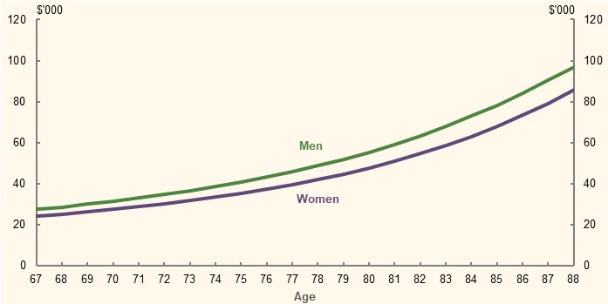
Note: Assumes the person is single. Source: Calculations using assumptions for the example of a merged means test. The life expectancy used to calculate the deemed capital consumption is sourced from the Australian Life Tables 2015-17 (Australian Government Actuary, 2019).

Merged means test free area
Abolishing the assets test means that retirees no longer have access to the ‘assets test free area’. This example increases the income test free area to ensure retirees with a relatively modest amount of assessable assets are not disadvantaged compared with the current arrangements.
The merged means test free area modelled is $9,048 per year for singles and $16,016 per year for couples, combined. This is equal to double the current income test free areas.
With the designed allowance for deemed capital consumption, the merged means test free areas imply assets free areas of around $140,000 for single retirees at age 67 and around $250,000 for coupled retirees at age 67, who are currently assets tested and have little income.

Scope of assessable assets
The scope of assessable assets will affect the number of people subject to the merged means test, as well as the extent to which retirees with similar levels of retirement savings receive similar outcomes.
This example continues to exempt the family home from the means test (see 3C. Home ownership status). Each single person would also have up to $30,000 of personal use assets (e.g. cars, household furniture and other personal items) exempt from the means test. The corresponding threshold for couples combined is $50,000. This recognises that people should not be expected to draw down on personal use assets, such as household goods, to meet their retirement income needs. While such personal use assets could be reflected in an increased free area, this approach would provide a more targeted exemption.

Merged means test taper rate
The taper rate determines the effective marginal tax rate of income earned and assets held over the merged means test free area. For consistency with the current income test taper rate, this example would reduce a recipient’s Age Pension payment by $0.50 per fortnight for every $1 of total means over the merged means test free area. As a result, the merged means test jointly determines a retiree’s effective marginal means test taper rate on assets above the free area by the rate of deemed capital consumption, deemed investment and other earnings, and $0.50 test taper rate. As deemed capital consumption is based on life expectancy, the effective marginal taper rate on assets over the free area would increase with age. Despite this, the effective marginal taper rate on assets over the free area would be lower than the current arrangements prior to age 84 for women and age 82 for men (Chart 6B-2).
For example, a woman aged 67 would have a deemed capital consumption of around 5 per cent and a deemed investment earnings of 3 per cent per year under the merged means test. With the $0.50 means test taper rate, her Age Pension payment would be reduced by 3.9 cents for every $1 of assets over the free area. In contrast, the same woman aged 87 would have a 16 per cent rate of deemed capital consumption and, their Age Pension payment would be reduced by 9.4 cents for every $1 of assets over the free area. However, in this example, the life expectancy weighted effective marginal taper rate on assets as at age 67 would be lower than the current assets test taper rate of 7.8 per cent.
    - Effective marginal taper rate for assets over the merged means test free area, by age and gender
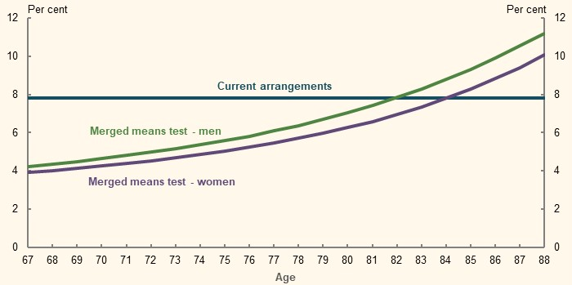
Note: Assumes a deeming rate of 3 per cent. Source: Calculations based on Age Pension rates and thresholds as at 1 May 2020 and assumptions for the example of a merged means test. The life expectancy used to calculate the deemed capital consumption is sourced from the Australian Life Tables 2015-17 (Australian Government Actuary, 2019).

Who the example applies to
The merged means test was modelled to apply to all pensions received by people over Age Pension eligibility age. This is consistent with how the current dual means test is applied. As such, the merged means test has flow-on effects to other pension payments.

Key differences from the current dual means test
Given the design of deemed capital consumption and merged means test taper rate, this example represents a combination of reducing the implied assets test free areas and making the effective marginal assets test taper rate age-dependent and lower for a significant number of retirees, as compared with the current dual means test. As a result, retirees would receive different Age Pension payments, depending on the amount of assessable assets they hold and their life expectancies.

Impact of the merged means test example

Age Pension payment for retirees of different means and age
The merged means test would consistently determine a retiree’s Age Pension payment on the totality of their means. This would ensure a retiree with a higher combined means receives less Age Pension than another person with a lower combined means (Table 6B-1).
      - Cameo: Annual Age Pension payment for two people with different means
 | Person 1 | Person 2
Age | 67 | 67
Life expectancy (years) | 20.7 | 20.7
Under current arrangements
Employment income ($) | 0 | 20,000
Assessable assets ($) | 500,000 | 500,000
Age Pension payment ($) | 6,085 | 6,085
Under a merged means test with age-based capital consumption
Assessable assets after deduction of personal use assets ($) | 470,000 | 470,000
Deemed income ($) | 9,539 | 9,539
Deemed capital consumption ($) | 22,705 | 22,705
Employment income ($) | Nil | 20,000
Less Work Bonus ($) | N/A | 7,800
Total means ($) | 32,244 | 44,444
Less free area ($) | 9,048 | 9,048
Assessable means ($) | 23,196 | 35,396
Age Pension payment ($) | 12,954 | 6,854
Note: Values are in 2019-20 dollars. Assumes the people are single home owners who each have $30,000 of personal use assets, have no other income other than employment income, and deemed income from financial assets. Source: Calculations based on Age Pension rates and thresholds as at 1 May 2020 and assumptions for the example of a merged means test. The life expectancy used to calculate the deemed capital consumption is sourced from the Australian Life Tables 2015-17 (Australian Government Actuary, 2019).
The merged means test looks beyond the current status of the retirees’ assessable assets to consider their capacity for self-support based on their life expectancies. For two retirees with the same level of assessable assets, it would ensure the older one, with a lower life expectancy and greater capacity for self-support, receives less Age Pension than the younger one with a higher life expectancy and smaller capacity for self-support (Table 6B-2).
      - Annual Age Pension payments for two people, one aged 67 and the other aged 87
 | Person 1 | Person 2
Age | 67 | 87
Life expectancy | 20.7 years | 6.3 years
Under current arrangements
Assessable assets ($) | 500,000 | 500,000
Age Pension payment ($) | 6,085 | 6,085
Under a merged means test with age-based capital consumption
Assessable assets after deduction of personal use assets ($) | 470,000 | 470,000
Deemed income ($) | 9,539 | 9,539
Deemed capital consumption ($) | 22,705 | 74,603
Total means ($) | 32,244 | 84,142
Less free area ($) | 9,048 | 9,048
Assessable means ($) | 23,196 | 75,094
Age Pension payment ($) | 12,954 | Nil
Note: Values are in 2019-20 dollars. Assumes the people are single home owners who each have $30,000 of personal use assets, have no other income other than employment income, and deemed income from financial assets. Source: Calculations based on Age Pension rates and thresholds as at 1 May 2020 and assumptions for the example of a merged means test. The life expectancy used to calculate the deemed capital consumption is sourced from the Australian Life Tables 2015-17 (Australian Government Actuary, 2019).

Consistency of Age Pension income
The merged means test would assist some retirees to achieve a more consistent profile of total income earlier in retirement. This is because deemed capital consumption increases as the retiree ages and their life expectancy decreases (Chart 6B-1). In particular, a retiree who draws down at rates using an account-based pension to have constant nominal private income would experience a more consistent/flatter profile of total income in retirement (Chart 6B-3). Whereas, a retiree who draws down at rates using an account-based pension to have constant real private income would still have an increasing profile of total income in retirement. This suggests a retiree’s drawdown strategy would be an important factor influencing the effect of a merged means test.
    - Age Pension and private income in retirement for $500,000 of assessable assets, by age
Constant nominal private income
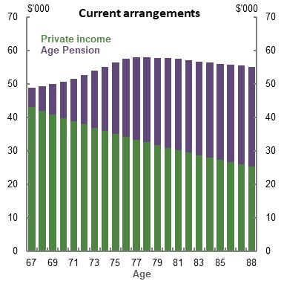 | 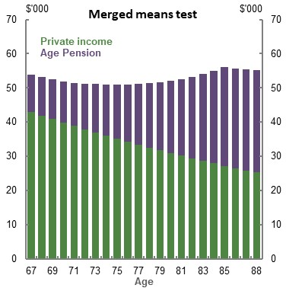
Constant real private income
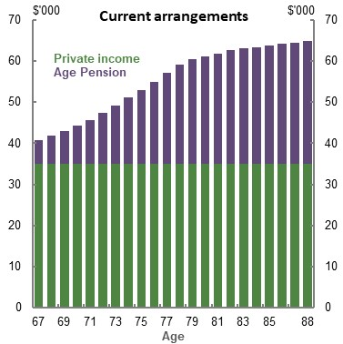 |  | 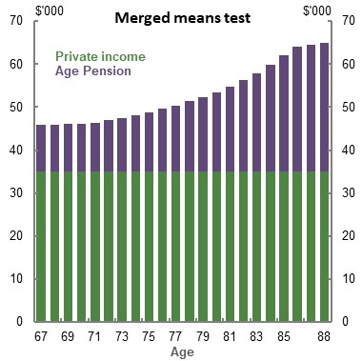
Note: Values are in 2019-20 dollars, deflated by CPI. Assumes the person is a single home owner who begins retirement on 1 July 2019. Constant nominal private income means the person consumes $43,000 of their assessable assets each year. Constant real private income means the person consumes $35,000 of their assessable assets at age 67, with the amount consumed increasing by 2.5 per cent (i.e. inflation) each year. The person has around $10,000 of assessable assets remaining at age 88 under both drawdown strategies. Source: Calculations based on Age Pension rates and thresholds as at 1 May 2020 and assumptions for the example of a merged means test. The life expectancy used to calculate the deemed capital consumption is sourced from the Australian Life Tables 2015-17 (Australian Government Actuary, 2019).

People with different levels of assessable assets
Under the modelled approach, retirees with assessable assets at the middle and higher deciles would receive less Age Pension income over their retirement (Chart 6B-4). Under this example, the age-based deemed capital consumption and the reduced assets test free area have the greatest impact on people with more assessable assets.
Design parameters determine the number of and extent to which people’s Age Pension payments are affected by introducing a merged means test. Alternative design parameters, which use a higher free area or lower income test taper rate than the example outlined, could reduce the number of people who receive fewer total Age Pension payments due to a merged means test.
    - Total Age Pension payments over 22 years with constant real private income, by assessable assets decile at retirement
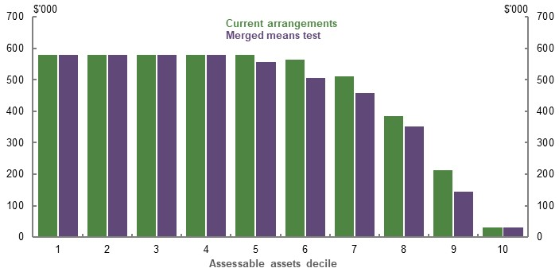
Note: Same as Chart 6B-3. Assumes assessable assets is equal to net wealth excluding the family home and $30,000 of personal use assets. Deciles calculated using assessable assets of people aged 60 to 67 in 2017-18 (ABS, 2019s). Assessable assets of each decile is equal to the average net wealth of the persons with the lowest and highest net wealth in the decile. Period of retirement is 22 years, which is roughly equal to the life expectancy of a woman aged 67 (Australian Government Actuary, 2019). Source: Calculations based on Age Pension rates and thresholds as at 1 May 2020, (ABS, 2019s) and assumptions for the example of a merged means test. The life expectancy used to calculate the deemed capital consumption is sourced from the Australian Life Tables 2015-17 (Australian Government Actuary, 2019).
If a merged means test was introduced, existing retirees would face the merged means test for only part of their retirement. The effect of the merged means test on these people would depend on their level of assessable assets and age (Chart 6B-5). Those adversely affected under this model would largely be older retirees. This is because deemed capital consumption increases with age, resulting in an older person having a greater assessable means than a younger, but otherwise equivalent, person.
Other people adversely affected under this model would be younger retirees currently captured by the means test (who effectively have some of their income or assets disregarded under the current dual means test). In contrast, younger retirees who currently just missed out on the Age Pension under the assets test may benefit from the lower effective marginal taper rate on assets. They may become eligible to receive a part-rate Age Pension in the earlier years of retirement.
    - Annual Age Pension payment in 2019-20, by assessable assets and age group
Assessable assets of $85,000  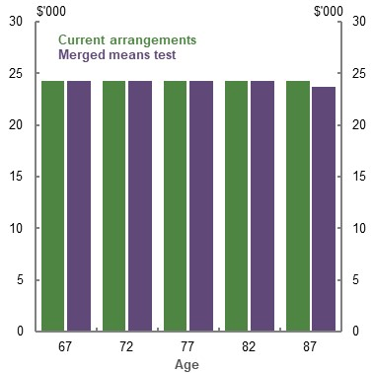 | Assessable assets of $250,000  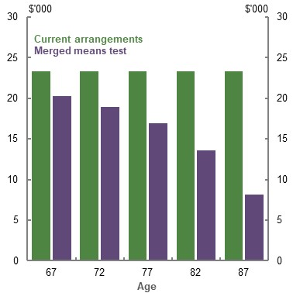
Assessable assets of $400,000  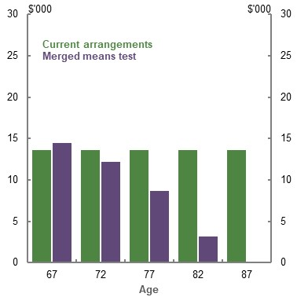 | Assessable assets of $500,000  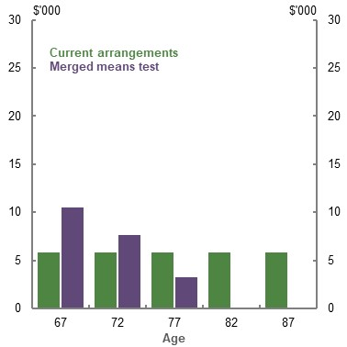
Note: Same as Chart 6B-3. For each chart, assessable assets are the same for each age group. $85,000 and $250,000 are in the 3rd and the 5th deciles, while $400,000 and $500,000 are close to the lower and upper ends of the 7th decile, in the distribution of assessable assets for people aged 60 to 67 in 2017-18 (ABS, 2019s). Retirees with assessable assets above the 7th decile currently receive little to no Age Pension payment, and are therefore not considered in the analysis. Source: Calculations based on Age Pension rates and thresholds as at 1 May 2020 and assumptions for the example of a merged means test. The life expectancy used to calculate the deemed capital consumption is sourced from the Australian Life Tables 2015-17 (Australian Government Actuary, 2019).

Sustainability of the retirement income system
This merged means test example would reduce the fiscal cost of the Age Pension by around $8.2 billion between 2019-20 and 2022-23; around $2 billion per year (Table 6B-3). This fiscal saving is largely due to reduced Age Pension expenditure to older people or people with substantial assessable assets. In future, as the average level of assessable assets at retirement increases due to the maturing superannuation system, the annual fiscal saving would increase. The fiscal saving would also reflect the flow-on effect to other payments that retirees receive from the Government.
      - Change in fiscal cost due to merging the Age Pension income and assets tests
 | 2019-20 | 2020-21 | 2021-22 | 2022-23
Fiscal cost due to current population ($ billion) | -3.9 | -4.1 | -4.4 | -4.7
Fiscal cost due to new grants ($ billion) | 2.1 | 2.2 | 2.3 | 2.4
Total cost ($ billion) | -1.9 | -2.0 | -2.1 | -2.2
Note: This is a counter-factual analysis as if the Age Pension income and assets tests were merged from 1 July 2019. Forward estimates are in nominal terms. Source: Department of Social Services (DSS) modelling for the review.

Incentives and simplicity
The merged means test would alter the taper rate on assets. The effective marginal taper rate on assets over the free area would be lower than the current effective marginal assets taper rate of 7.8 per cent for men before age 82 and for women before age 84 (Chart 6B-2). This would reduce the effective marginal tax rate and increase the incentive to save for retirement.
The merged means test’s taper rate may encourage greater asset drawdowns in the later years of retirement by:
- Nudging people to recognise the decreasing amount of time they have to consume their remaining savings
- Affecting Age Pension payments such that people respond to this incentive
A merged means test could simplify some aspects of the current dual means test. But, as the deemed capital consumption varies with age, many retirees would likely continue to find the means test complex. Another issue contributing to the complexity of the system is that there would also continue to be significant differences between this merged means test example and the means test for aged care.
Moving to a new merged means test would significantly alter arrangements for some current retirees. The impacts could be very substantial for some retirees (Chart 6B-5). It may be unfair to reduce Age Pension payments for people who did not have the opportunity to plan for such a change. As such, transitional arrangements would likely be required. Transitional arrangements would add complexity and likely come at a fiscal cost.

Outcomes of research
The review commissioned five research projects on the retirement income system. These projects covered four research questions, and were conducted by three research institutes:
Question 1: What is the relationship between wages growth and changes to the Superannuation Guarantee? — conducted by the ANU Tax and Transfer Policy Institute.
Question 2: What is the relationship between voluntary savings and changes to the Superannuation Guarantee? — conducted by Monash Centre for Financial Studies.
Question 3: How effective are superannuation tax concessions in encouraging additional savings? — conducted by Monash Centre for Financial Studies and the ANU Tax and Transfer Policy Institute.
Question 4: What is the impact of the Age Pension assets test on savings behaviour pre-retirement? — conducted by Bankwest Curtin Economic Centre.
The research papers are available on the review’s website. Following is a brief summary of the research outcomes prepared by the authors of the papers.
          - What is the relationship between wages growth and changes to the Superannuation Guarantee?
Robert Breunig and Kristen Sobeck, Crawford School of Public Policy, Australian National University.
The SG was introduced to boost people’s private retirement savings. Since its introduction, the SG rate has increased over time and currently sits at 9.5 per cent of wages. The SG is legislated to rise to 10 per cent in 2021 and then increase, in steps, to 12 per cent by mid-2025. Pausing these increases is under active debate. In particular, current debates centre around the economic incidence of an increase in the SG. Do employers bear the cost of legislated increases to the SG rate by increasing their labour costs? Alternatively, is the disposable income (take-home pay) of employees reduced to account for the increased cost to employers of the increase in the SG? This research aims to contribute to a better understanding of these questions.
While employers are legally bound to pay the SG rate, some employers, like the public service and academia, choose to pay a higher rate. This research uses administrative tax data to exploit the differences in wages paid to employees who receive different amounts of superannuation in order to estimate where the burden (the economic incidence) of the SG lies. One approach will be to compare wage growth during periods where the SG does not change. If employers bear the burden of SG, then wage growth should be the same for the two groups: those paid at SG and those paid above the SG.
We also exploit changes in the SG to estimate the incidence of SG. In particular, employees who already receive more than the SG from their employers are unaffected by legislated increases to the SG (‘above SG group’). As a result, their wage growth should not change when the SG changes. By contrast, workers employed by firms that only pay the SG are affected by increases (‘at SG group’). If workers bear the burden of the increase, then wage growth should slow down for the ‘at SG group’ when the SG increases, relative to the ‘above SG group’. We thus estimate the economic incidence of increases in the SG by comparing differences in wage growth between the two groups in: (1) periods where the SG is constant to (2) when the SG is increased.
Formally, estimation of the economic incidence is achieved by applying a difference-in-difference approach. The results show that in periods when the SG was constant, wage growth in the ‘above SG group’ is consistently lower than wage growth in ‘at SG group’. In periods when the SG is increased, wage growth for the ‘at SG group’ slows down, consistent with the idea that workers bear (at least part of) the economic incidence of increases to the SG. Further calculations show that workers bear between 71 per cent to more than 100 per cent of the cost of increases to the SG through lower wage growth, depending on the time period considered.
Our research findings align with one (Coates, et al., 2020) of the three existing Australian studies which measure the economic incidence of increases in superannuation. The two other studies, by Stanford (2019) and Taylor (2019) do not find that a trade-off exists between higher superannuation and lower wages and in some instances present the case for a positive relationship between higher superannuation and wages. They rely on time series data to establish correlation between wage growth and changes in the SG rate. As we have seen with the current debates about pausing increases to the SG, it tends to be politically easy to raise the SG rate when wage growth is robust, and convenient to pause changes to the SG rate when wage growth is slow. The correlations established in the macroeconomic studies may well be picking up the political economy of when SG increases are politically feasible and when they are not, rather than a causal relationship of SG increases on wage growth.
We argue that our approach, using microdata at the individual level, is better suited to analysing the economic incidence of increases to superannuation because focusing on changes across groups of individuals (or firms), reduces the impact of confounding macroeconomic effects (because all individuals experience the same macroeconomic conditions at the same time). Our results are also consistent with economic theory and the international, empirical economic literature.
In conclusion, policymakers will need to balance their goal of boosting superannuation balances, through an increase in the SG rate, with the costs and benefits of doing so. The current settings of the Age Pension are such that an increased superannuation balance is not directly correlated with an increase in retirement living standards. An increase in the SG rate may, however, reduce future Age Pension expenditure. At the same time, as our results suggest, workers bear the cost of increases in the SG rate through lower wage growth. Subsequently, the Government will forgo the tax revenue from labour income taxed at people’s marginal personal income tax rates, for greater superannuation contributions that are taxed concessionally. Lower wage growth also implies less disposable income available to workers and their families to consume today, or to save through alternative means.

          - What is the relationship between voluntary savings and changes to the SG?

Ummul Ruthbah and Nga Pham, Monash Centre for Financial Studies, Monash University.
The purpose of this study is to examine how the compulsory employer superannuation system interacts with voluntary savings. The study focuses in particular on the extent to which the existence of compulsory superannuation — and increases in the compulsory superannuation rate — might affect voluntary savings.
Our study, like others before it, finds evidence of substitution between compulsory and private household saving in Australia; in other words, increases in compulsory saving are associated with decreases in private household saving. However, the substitution effect is significantly less than one — hence, for every dollar increase in compulsory superannuation, the associated decrease in private saving is less than one dollar. This suggests that the compulsory superannuation system in Australia generates a net overall saving increase. By contrast, international evidence on whether savings in pension accounts create positive net saving is mixed.
In this report, we examine the impacts of the SG on private household saving(s) using three different measures of SG for comparative analysis:
- An SG dummy variable, taking the value of one if any member of the household received a compulsory superannuation contribution from employers.
- The SG policy rate in percentage terms.
- The compulsory employer contribution in dollar terms.
We use two measures of saving(s). The first is a flow concept, where saving is defined as the difference between household disposable income and final household consumption (including rental payments and mortgage repayments). The second measure uses the household’s wealth as a proxy for accumulated savings, or the stock of savings. Both are measured in terms of dollars.
Data for the study was sourced from the HILDA Survey, Restricted Release 18, which collects information about households’ disposable income and expenditure annually, and household wealth-related data at four-year intervals. Due to data availability of expenditure, our analysis period is from 2005 to 2018.
Our models control for households’ various socio-demographic-economic characteristics, and consider the possible non-linearity between household saving and household income, size and age, as reflected in prior studies. The Government’s 2007 ‘Simpler Super’ reform is included in our model as a dummy variable.
We find that the voluntary private saving of households receiving SG are not significantly lower than the voluntary private saving of households without SG. However, increasing the SG rate reduces voluntary private household saving. The findings are consistent with behavioural models, which suggest that when the SG rate increases, people have less incentive to save by themselves because they know employers are saving more on their behalf. We also find that changing the rate of SG has no significant effect on the saving behaviour of households that receive additional employer superannuation contributions over the prescribed SG rate as non-cash benefits. The signs of all other control variables are in line with the conventional saving models.
We find that increasing the SG rate from 9 per cent to 9.25 per cent increases household wealth by 17.5 per cent, and from 9 per cent to 9.5 per cent increases net household wealth by 53.7 per cent during 2006-18. These effects are larger for households where at least one member is receiving SG.
We find that each dollar of compulsory employer contributions reduces private household saving by 43 cents. This compares with the findings of Connolly (2007) of a 38-cent reduction. The difference may be explained by our contrasting methodologies and timeframes. Depending on the period under consideration, our estimated ‘crowding-out’ effect gets smaller when measured within shorter and later time windows. The substitution rate is less than one, which means SG overall increases wealth for households.
A large part of the decline in net household saving is accounted for by increased mortgage repayments — which for most people means increased savings in housing assets. Mortgage repayments increase by 24 cents in response to each additional dollar of compulsory employer contribution (Figure 6C-1).
We find that a $1 rise in compulsory employer contributions increases net household wealth by $2.21, over a four-year period. Household wealth includes superannuation balance, property (net of debt), and non-superannuation and non-property wealth.
Most of the increase in wealth associated with an increase in compulsory employer contributions occurs in superannuation and property (housing). We find that a $1 increase in compulsory employer contributions boosts the superannuation account balance by $1.51, and housing wealth by $1.21 (due to higher mortgage repayments). In contrast, there was a decline of approximately $0.51 in non-superannuation and non-housing wealth.
Our analysis of the impact of compulsory employer contributions on households’ investment in property assets supports the existence of a ‘signalling effect’ — which suggests compulsory superannuation provides a degree of confidence for households to increase debt to invest in property, resulting in lower net household saving. This occurs with the knowledge that they can access superannuation savings to extinguish debt in the future and that the residential home is not counted in the Age Pension assets test under current rules.
Our report also shows how the saving behaviour of households varies across different demographic and economic groups. We find that home owners save 26 cents less for each dollar increase in compulsory employer contributions compared to non-home owners.
We employed the Heckman sample selection model to test our findings. The results were consistent, although with slightly different magnitudes. Overall, the results suggest that households with saving(s) behave differently to those without saving(s) in response to changes in eligibility for compulsory employer contributions or changes in SG rates.
In conclusion, the study has two main findings. First, we demonstrate that compulsory superannuation, while associated with a significant reduction in private household saving, leads to net additional household wealth. Second, we find that compulsory superannuation encourages and leads to the reallocation of household wealth into property from other forms of investment.
        - The relationships between compulsory employer contributions, household saving and wealth
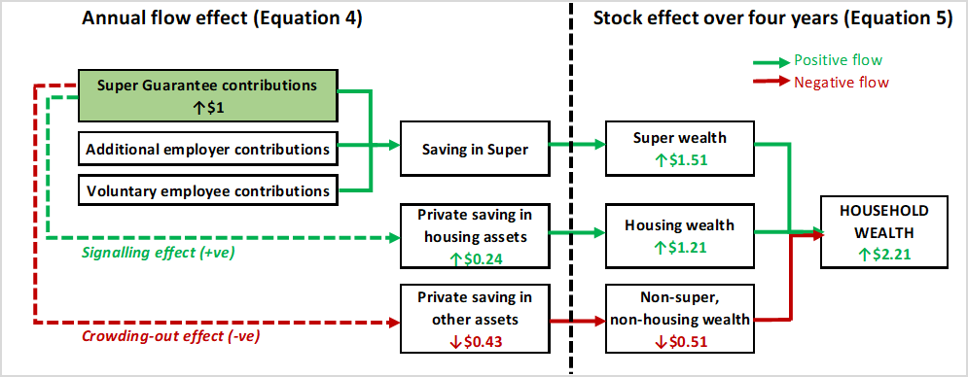

          - How effective are superannuation tax concessions in encouraging additional savings?
Kristen Sobeck and Robert Breunig, Crawford School of Public Policy, Australian National University.
Superannuation tax concessions for voluntary savings are designed to boost people’s superannuation balances. Are these policies effective at encouraging people to make larger contributions to their superannuation accounts? If so, do the larger contributions represent new savings (and reduced consumption) or a reallocation of existing savings towards more tax preferred savings instruments? This research evaluates one such policy, the Australian Government’s co-contribution policy, to contribute to a better understanding of these questions.
The Government co-contribution was introduced in the 2003-04 financial year and matches the post-tax personal superannuation contributions made by low- and middle-income earners, dollar for dollar. The income eligibility criteria for the policy have changed significantly since its introduction. In particular, in the 2012-13 financial year, the income eligibility threshold was decreased from $61,920 to $46,920. As a result, there were some people who were eligible for the policy in the 2011-12 financial year, but who no longer qualified in 2012-13 when the threshold changed. This research compares the savings behaviour of these people — who were initially eligible and then ineligible (the treatment group) — to the savings behaviour of similar people who earned slightly more, between $61,921 and $76,920, and were never eligible for the policy (the control group), in order to evaluate the policy’s effectiveness.
Formally, the comparison of the two groups’ savings behaviour was evaluated using a difference-in-difference design which considered three savings outcomes. First, the research considered the impact of reducing the eligibility threshold on the likelihood that a person would stop making contributions. The results show that decreasing the eligibility threshold reduced the percentage of people who made a contribution by 0.9 percentage points. Second, the research evaluated the impact of the change in the policy on the value of superannuation contributions made. The estimates show that the value of retirement contributions decreased by 6.2 per cent when the eligibility thresholds for the matching program were reduced. Finally, among people who made a post-tax superannuation contribution, the research considered whether the reduction in superannuation contributions resulted in lower savings levels or a reallocation of savings to other forms of savings. The results conclude that when people cease to be eligible for the matching policy, they increase other forms of personal savings by about 11 per cent. The drop in post-tax superannuation savings combined with the increase in personal savings points to a reallocation effect. However, the effect is not one-to-one and there is a drop in overall savings. The results show that a $1 increase in post-tax superannuation contributions leads to a $0.77 reduction in personal savings.
These results are consistent with the international literature and limited Australian literature available. While the literature tends to diverge with respect to the effectiveness of the matching rate for matching policies, with a few exceptions, most studies find a positive (negative) effect of the existence (elimination) of matching programs on people’s participation (consistent with the findings of this research). While the international evidence regarding the new savings versus reallocation of savings is not entirely conclusive, there is a much stronger consensus that asset reallocation in response to tax incentives occurs, particularly for voluntary (as opposed to compulsory) savings incentives (OECD, 2018b); this also aligns with the conclusions of this research.
In conclusion, the Government’s co-contribution policy has impacted the savings behaviour of a modest percentage of low- and middle-income people. While the matching program certainly increased the superannuation balances of this small minority, the majority of low- and middle-income people remained unaffected. If boosting superannuation balances is an explicit policy goal, recent international literature suggests that compulsory savings policies tend to be more effective than tax subsidies for retirement savings. While the Australian literature in this area is limited — and more is required — this research provides some evidence in support of this hypothesis and of its relevance in Australia.

          - How effective are superannuation tax concessions in encouraging additional savings?

Ummul Ruthbah and Nga Pham, Monash Centre for Financial Studies, Monash University.
This report examines empirical evidence on the impact of the superannuation tax concessions on voluntary private savings in Australia. Do superannuation tax concessions lead to reductions in other forms of savings? And what are the net outcomes?
We have investigated the impacts of three aspects of Australia’s policies on household saving(s).
- Government co-contributions to superannuation for low-income earners, in terms of both the co-contribution rate and the dollar cap for the maximum co-contribution paid by the Government.
- The concessional contributions cap, which places a ceiling on the amount contributed to a person’s superannuation account at a concessional tax rate.
- Division 293 tax policy, which introduces an additional tax charged at 15 per cent of a person’s taxable contributions for people whose earnings (including contributions) are greater than the Division 293 tax threshold.
We also examined whether these policies had heterogeneous effects across different groups — by age, gender, education, employment status and age group of the household head and location of the household.
The report draws on data from the HILDA Survey, Restricted Release 18. We estimate a panel fixed effect model and a Heckman sample selection model, using data from 2005-2018. In all our models, the unit of analysis is the household as defined by the Australian Bureau of Statistics (ABS).
We use two different measures of saving(s). The first defines saving (a flow variable) as the difference between household disposable income and household final consumption expenditure, available annually in the HILDA Survey. The second measure uses household wealth as a proxy for savings (as a stock variable), collected every four years by the HILDA Survey. Both are in terms of dollars.
We find:
- The Government co-contribution to superannuation for low- and middle-income earners has an insignificant impact on private household saving. Increases in the Government co-contribution rate and dollar cap have led to a marginal rise in the superannuation balance of households, without reducing other savings. However, the effects are small. As a result, there is no significant impact on household wealth.
- The concessional contributions cap has marginal impacts on household saving and wealth. Although a $1 increase in this cap reduces private saving by a small amount, it does not reduce overall household wealth. Increases in the concessional contributions cap improve household superannuation balances, though there is some delay in the response.
- While the Division 293 tax reduces private saving by 12.7 per cent for households that are paying the tax, it does not significantly affect the accumulated wealth of these households. These households have significantly higher superannuation balances than others because an additional 15 per cent tax on individual taxable contributions is still less than what these households would have paid had they saved that amount outside the superannuation account.
- Households that pay the Division 293 tax have 12.7 per cent less private savings than those who are not liable for paying the tax. But households that pay the Division 293 tax have significantly higher superannuation balances than others because these are the wealthier households and an additional 15 per cent tax on individual taxable contributions is still less than what these households would have paid had they saved that amount outside the superannuation account. When compared to households with individual income marginally below the Division 293 tax threshold, we do not find any significant effect of this tax on the wealth or superannuation balances of households who pay the Division 293 tax.
We also find that the effects of the Government co-contribution and concessional contributions cap on household saving vary by the household head’s education, marital status, labour force participation status, age and income quantile. Among the findings:
- Households with married heads save less than households with unmarried heads.
- Households whose heads have at least a diploma save more than households with less-educated heads when they are eligible for superannuation co-contributions and concessions.
- Households in the 3rd and 4th quantiles save more than those in the 1st quantile if they have a member eligible for the Government co-contribution. Nevertheless, these differences are not statistically significant at 5 per cent.
Numerous studies in the literature have examined how savings in superannuation accounts affect other forms of savings. Still, few have measured the effects of concessional tax policies on household saving(s), particularly in Australia.
Evidence of whether superannuation tax concessions generate new private savings — both from Australia and overseas — is mixed. There is evidence that some people reallocate some savings from other sources to pension saving accounts in response to tax incentives provided for pension savings. However, as the reported offset rate between pension savings and other forms of savings varies, the extent of new savings generated by pension tax concessions is unclear.
In the United States, studies in the 1990s were inconclusive on whether Individual Retirement Accounts (IRAs) and 401(k) pension accounts generated additional savings. However, later research seems to confirm evidence of new savings.
Our results show that superannuation policies do not have any significantly effect on household savings in Australia. As a whole, the tax concessions seem to improve household superannuation balances to some extent, and not at the expense of other non-super wealth. Hence, new wealth is generated. However, the impact on wealth is marginal. These findings are consistent with behavioural theories that argue most savers are passive. Holistically, tax incentives may work better when coupled with non-tax based behavioural incentives.

          - What is the impact of the Age Pension assets test on savings behaviour pre-retirement?
Rebecca Cassells, Alan Duncan Silvia Salazar and Richard Seymour, Bankwest Curtin Economics Centre, Curtin University.
The purpose of this report is to provide insights into the impact that the Age Pension assets test has on savings behaviour pre-retirement. Our approach explores the 2007 and 2017 changes in the Age Pension assets test to examine whether, and to what extent, these changes impacted asset portfolio allocation and labour supply behaviour of households approaching retirement.
Using the HILDA Survey, we compare the savings, asset allocation and labour supply behaviour of households that were directly affected by the reform, compared to similar households that remained unaffected. We apply econometric techniques to control for factors other than the introduction of the Age Pension assets test taper reforms that may coincidentally be driving behavioural changes.
Our primary evaluation approach uses a difference-in-differences method to examine the impact of the assets test reforms on behaviour around both the lower assets test threshold (which differentiates full from part-entitlement to Age Pension) and the upper threshold (which separates part-entitlement from zero entitlement). For validation, we apply a second approach using regression discontinuity to examine the degree to which asset accumulation and labour supply behaviours are affected by the lower and upper assets test taper thresholds.
To assess changes in wealth we apply a ‘flow’ measure of savings, which examines changes in net wealth before and after the reforms. This measure incorporates four separate data points. We also apply a ‘stock’ measure of changes in the value of assets between two data points.
Overall we find that reforms to the Age Pension assets test was positively correlated with changes in household asset allocation behaviour prior to retirement for households that were very close to the upper threshold of the Age Pension assets test. The upper threshold is the point at which having additional assets in excess of this value would lead to zero entitlement of the Age Pension.
Savings and wealth accumulation — 2007 Age Pension reforms
- In contextualising the impacts of the 2007 reforms it is important to note that the period of assessment coincided with the GFC. This period saw households accumulate lower net savings (change in net wealth) in the post-GFC period than they did in the pre-GFC period.
- There is no statistical difference in the pre-retirement savings of households that were eligible for part-rate Age Pension before the taper rate change as compared to those who were expected to be full-rate age pensioners.
- Households that became eligible as a result of changes to the Age Pension taper rate in 2007 saw their net savings fall by $219,200 less between 2006 and 2010 compared to those that remained ineligible for the Age Pension. This suggests an annual effect of $54,800 over the period.
- Net assessable assets increased by $154,400 more for new part-pension holders between 2006 and 2010, compared to those that remained ineligible for the Age Pension.
These findings suggest that households that became eligible to receive the Age Pension were more likely to hold higher levels of assessable assets under the Age Pension assets test. Overall, their savings in the form of assessable assets were 4.0 per cent higher per year between 2007 and 2010.
- There is no strong evidence of a change in employment propensities among pre-retirement households who fall affected by the assets test compared to those that do not.
- Average hours worked among pre-retirement households were also not significantly affected by changes in the assets test taper.
Initial indications are that the 2017 assets test reforms, which scaled back the generosity of the 2007 reforms by tightening the assets test, show a reverse pattern of reduced savings and asset accumulation, however, these results are not statistically significant. This is due to the timing of the 2017 Age Pension assets reform relative to the dates of collection of the HILDA Survey wealth modules, which provides limited information on post-reform behaviour.
The regression discontinuity estimations provide confirmation of these impacts. Specifically, the reduction in the upper assets test threshold, as a result of the higher assets test taper rate, is associated with an average reduction in household savings over the five waves of savings and wealth data between 2002 and 2018. The regression discontinuity incorporates both the 2007 and 2017 changes to the assets test.
The separation of two distinct treatment groups is a significant improvement over previous studies.
By applying tighter restrictions to the treatment and control groups, the overall treatment effects associated with the Age Pension assets test reform in our study are found to be significantly smaller than other studies. The classifications of treatment and control groups in both the Whelan et al. (2018) and Cho and Sane (2014) studies are broader and more heterogeneous, with open-ended classification of the control groups. As a result, these studies are unable to pinpoint the effects of the Age Pension assets test reforms. Instead, their models compare the savings and asset accumulation behaviour of households with wealth and savings portfolios that are very different in both size and composition. As such, their empirical findings are likely to overestimate the effects of the Age Pension assets test reforms.
The separation of two distinct treatment groups also allows us to test the empirical outcomes from the difference-in-difference analysis more accurately against the predictions of a simplistic two-period savings model, such as used in Whelan et al. (2018). For example, the model would predict savings to be disincentivised among people expected to become eligible for the Age Pension through the taper rate reduction in 2007, as their assets became subject to the taper (substitution effect) and because of increased pension payments (income effect). This report shows that the impact of changes to the Age Pension taper rate on pre-retirement savings behaviour cannot be explained by this model.
To rationalise the empirical findings requires the underlying theoretical framework to be expanded to accommodate other explanations of savings behaviour. This includes the role of compulsory superannuation as opposed to voluntary savings; the degree to which people have uncertainty or misperception regarding their future pension entitlement, and the drivers of asset portfolio allocation between assessable and non-assessable assets. As such, it warrants further investigation to understand how the change in the assets test taper affects pre-retirement savings.

Supplementary equity charts

Income and wealth distribution
    - Average weekly social transfers in kind per household, by state and territory
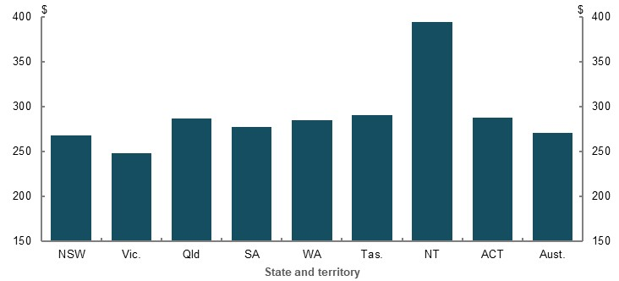
Note: Uses 2015-16 data. Uses ‘equivalised’ social transfers in kind so results are not biased due to differences in the size of households. Source: (ABS, 2018c).

Gender and partnered status

Cameo modelling of factors in working life that drive gender gaps
    - Factors affecting how the gender earnings gap translates into a gender gap in superannuation balances at retirement
10th income percentile
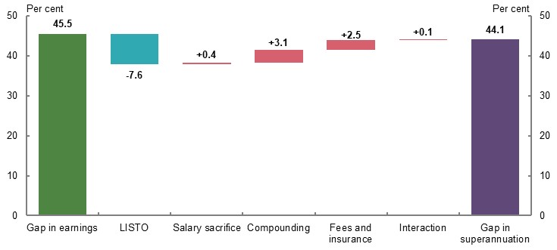
30th income percentile
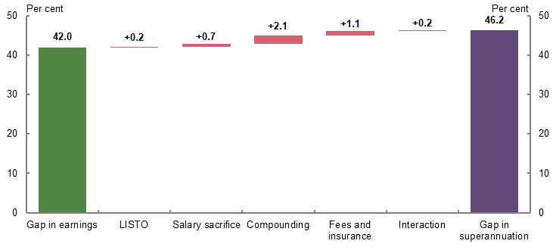
50th income percentile
70th income percentile
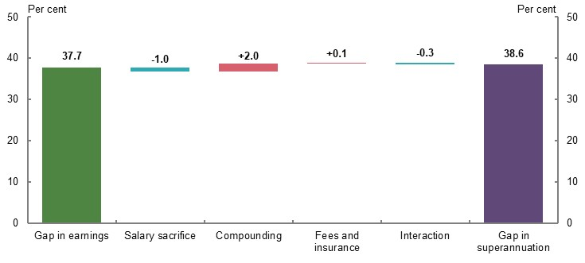

90th income percentile
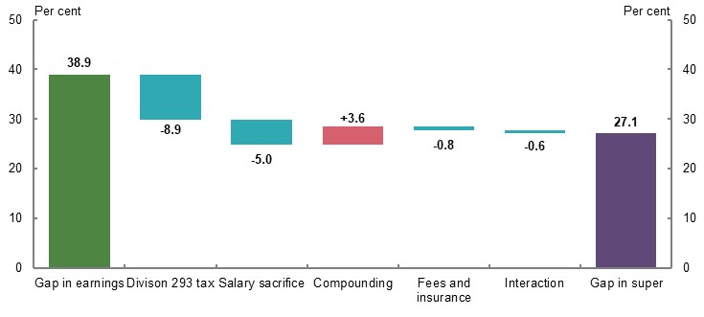
Note: Charts show the impact of removing individual factors on the gender gap in superannuation balances at retirement (e.g. comparing a world where the fees and insurance costs do not exist to standard gender cameo model specifications). ‘LISTO’ is the low income superannuation tax offset. Removing all the factors listed results in a gender gap in superannuation balances at retirement equal to the gender gap in working-life earnings. ‘Compounding’ isolates the impact of real investment returns on superannuation balance accumulation during working life. The ‘interaction’ field indicates the impact of the interaction between elements (e.g. the interaction between removing fees and compounding returns, which is not captured in removing only fees or only compounding returns). This analysis does not include voluntary contributions other than salary sacrifice. Including these contributions would likely reduce the gender gap in superannuation balances at retirement. Calculations are based on values deflated using the review’s mixed deflator. Source: Cameo modelling undertaken for the review.

Cameo modelling of factors in retirement that drive gender gaps
    - Factors that affect how the gender gap in superannuation balances at retirement translates into the gender gap in retirement incomes
10th income percentile
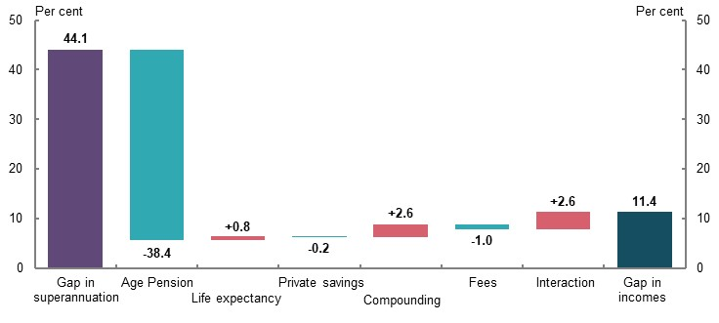

30th income percentile
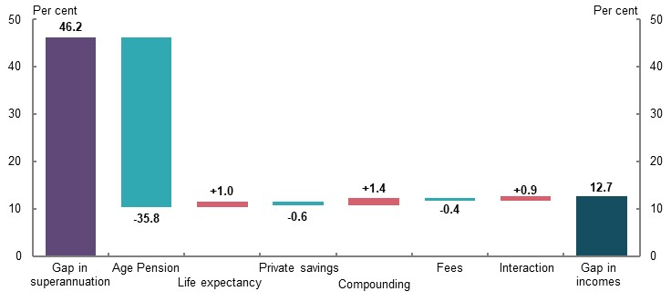
50th income percentile
70th income percentile
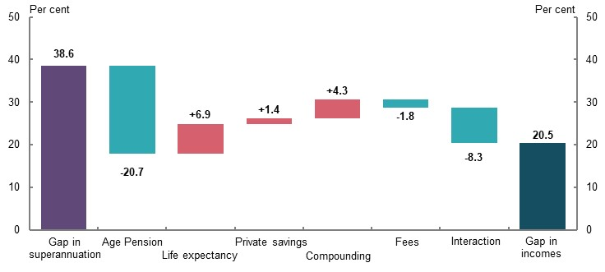

90th income percentile
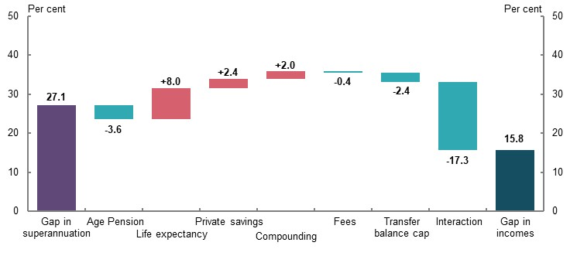
Note: Charts show the impact of removing individual factors on the gender gap in retirement incomes (e.g. comparing a world where the fees in retirement do not exist to standard gender cameo model specifications). ‘TBC’ is the transfer balance cap. Removing all the factors listed results in a gender gap in retirement incomes equal to the gender gap in superannuation balances at retirement. ‘Compounding’ isolates the impact of real investment returns on superannuation balance during retirement. ‘Life expectancy’ isolates the effect of different life expectancies for men and women on retirement income by assuming both genders have the same life expectancy of 92. ‘Private savings’ refers to non-superannuation wealth. The ‘interaction’ field indicates the impact of the interaction between elements (e.g. the interaction between removing fees and compounding returns, which is not captured in removing only fees or only compounding returns). The interaction field is larger in these charts than in Chart 6D-2, given the significant interaction each factor has with Age Pension receipt. This analysis does not include voluntary contributions other than salary sacrifice. Including these contributions would likely reduce the gender gap in superannuation balances at retirement. Calculations are based on values deflated using the review’s mixed deflator. Source: Cameo modelling undertaken for the review.

Gender gap in superannuation balances
    - Gender gap in average superannuation balances, by balance decile and age, 2012-13 to 2016-17
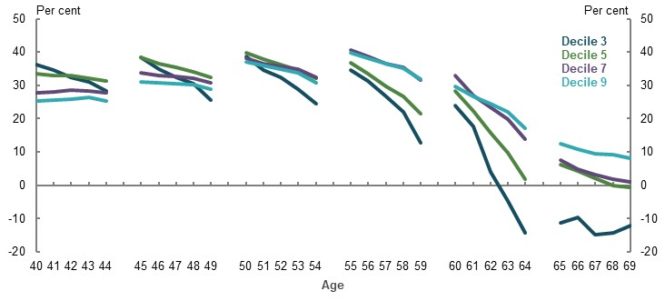
Note: Men and women aged 40, 45, 50, 55, 60, and 65 at 30 June 2013 were sorted into gender-based deciles based on their superannuation balance and age (those with zero balances were excluded). Their balances were then tracked over the following four years to 2016-17. The chart compares the average balance for each male decile with the average balance for each female decile in each year (e.g. comparing men aged 40 in the third balance decile for men, with women aged 40 in the third balance decile for women). Those whose balances reduced to zero in later years are included in the average calculation. A ‘negative gap’ means that women have higher average superannuation balances than men for that cohort at that age. Calculations of gender gaps are based on nominal superannuation balances from 2012-13 to 2016-17. Source: Data provided by the ATO for the review.
    - Gender gap in average superannuation balances, by balance decile, age, partnered status, and partner’s balance decile, 2012-13 to 2016-17
Decile 3 | Decile 5
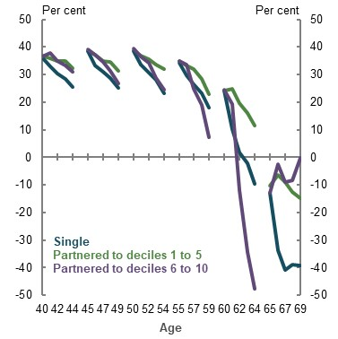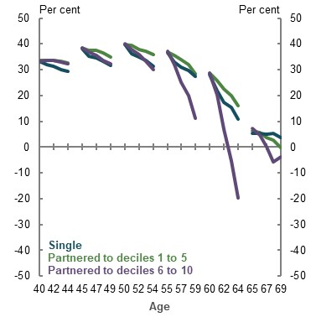
Decile 7 | Decile 9
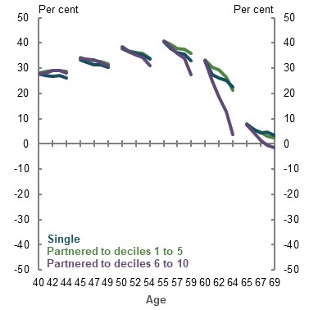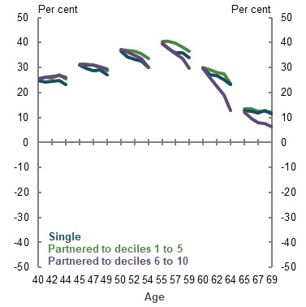
Note: Men and women aged 40, 45, 50, 55, 60, and 65 at 30 June 2013 were sorted into gender-based deciles based on their superannuation balance and age (those with zero balances were excluded). People were then further sorted into whether they were single, partnered to a person of gender-based balance decile 1 to 5, or partnered to a person of gender-based balance decile 6 to 10. Persons partnered to a person with zero superannuation were excluded. Their balances were then tracked over the following four years to 2016-17. The chart compares the average balance for each male decile with the average balance for each female decile in each year (e.g. comparing single men aged 40 in the third balance decile for men, with single women aged 40 in the third balance decile for women). Those whose balances reduced to zero in later years are included in the average calculation. A ‘negative gap’ means that women have higher average superannuation balances than men for that cohort at that age. Calculations of gender gaps are based off nominal superannuation balances from 2012-13 to 2016-17. Source: Data provided by the ATO for the review.

Superannuation contributions by gender
    - Employer superannuation contributions (excluding salary sacrifice), by gender-based balance decile and age, 2012-13 to 2016-17
Decile 3 | Decile 5
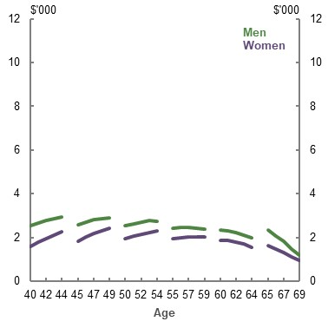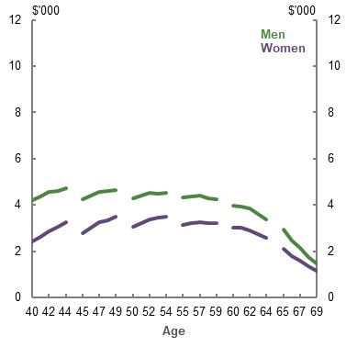
Decile 7 | Decile 9
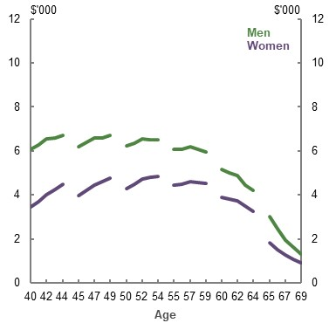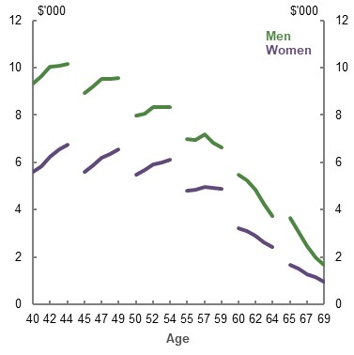
Note for Chart 6D-6, Chart 6D-7, Chart 6D-8, Chart 6D-9 and Chart 6D-10: Men and women aged 40, 45, 50, 55, 60, and 65 at 30 June 2013 were sorted into gender-based deciles based on their superannuation balance and age (those with zero balances were excluded). Their annual superannuation contributions were then tracked over the following four years to 2016-17. The charts compare the relevant type of superannuation contribution in each year for each male and female superannuation balance decile (e.g. comparing employer contributions made by men aged 40 in the third balance decile for men, with employer contributions made by women aged 40 in the third balance decile for women). Those with zero contributions of the relevant type in any given year are included in the calculation of the average contribution amount. Data collection period coincides with changes to superannuation contributions caps during the 2012-13 to 2016-17 period. The ‘10 per cent rule’ for deductible personal superannuation contributions prior to 1 July 2017 also applied across this period (see 1B. Design of Australia’s retirement income system). This may influence the results presented. Contribution amounts are in nominal dollars, from 2012-13 to 2016-17. Source: Data provided by the ATO for the review.
    - Total voluntary superannuation contributions, by gender-based balance decile and age, 2012-13 to 2016-17
Decile 3 | Decile 5
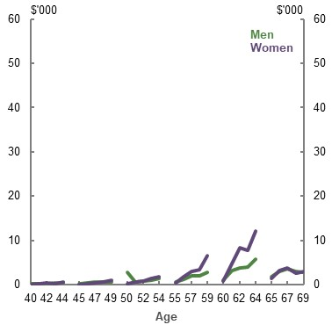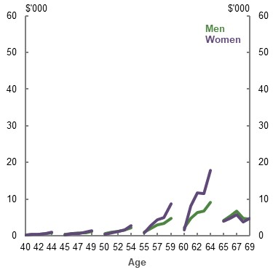
Decile 7 | Decile 9
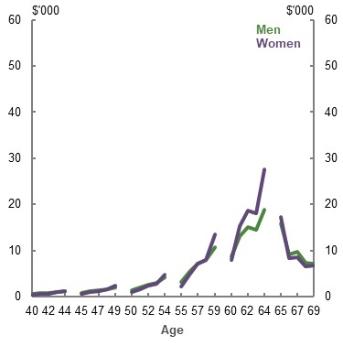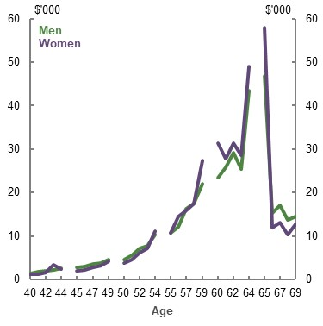
Note: See Chart 6D-6. Source: Data provided by the ATO for the review.

    - Salary sacrifice superannuation contributions, by gender-based balance decile and age, 2012-13 to 2016-17
Decile 3 | Decile 5
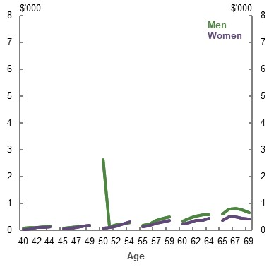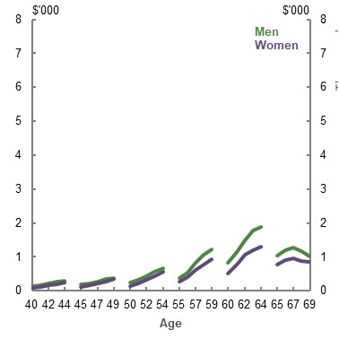
Decile 7 | Decile 9
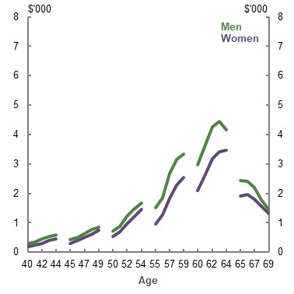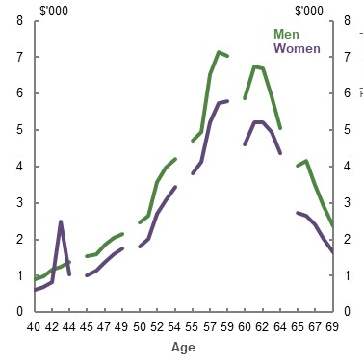
Note: See Chart 6D-6. Source: Data provided by the ATO for the review.
    - Deductible personal superannuation contributions, by gender-based balance decile and age, 2012-13 to 2016-17
Decile 3 | Decile 5
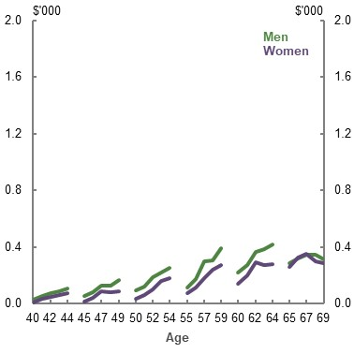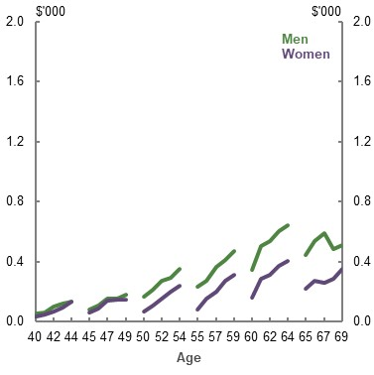
Decile 7 | Decile 9
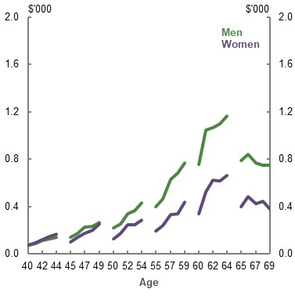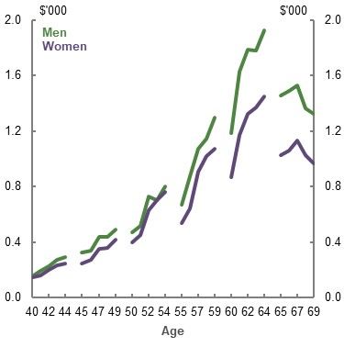
Note: See Chart 6D-6. Source: Data provided by the ATO for the review.
    - After-tax personal superannuation contributions, by gender-based balance decile and age, 2012-13 to 2016-17
Decile 3 | Decile 5
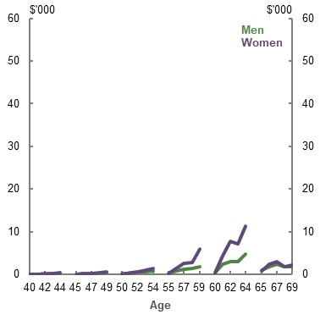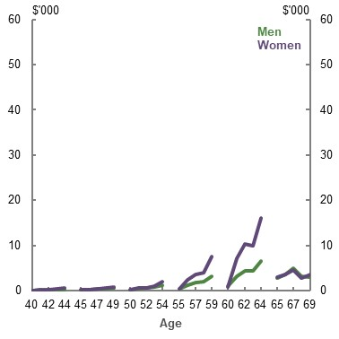
Decile 7 | Decile 9
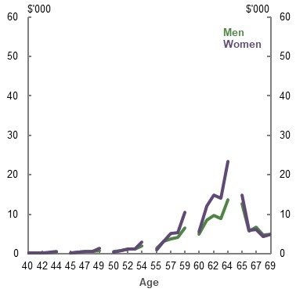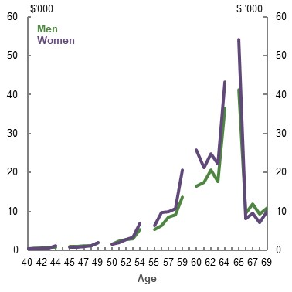
Note: See Chart 6D-6. Source: Data provided by the ATO for the review.
    - Voluntary superannuation contributions for those in superannuation balance decile 3, by gender, partnered status, and partner’s superannuation balance decile, 2012-13 to 2016-17
Average total voluntary contributions
Women | Men
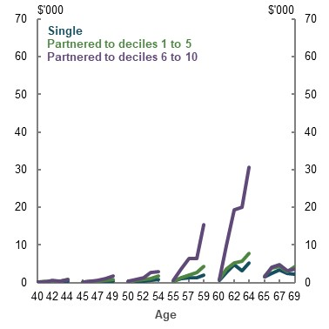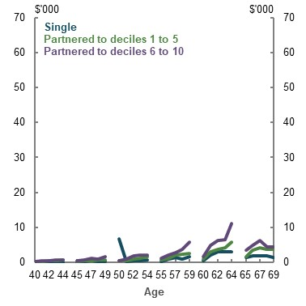
Proportion making voluntary contributions
Women | Men
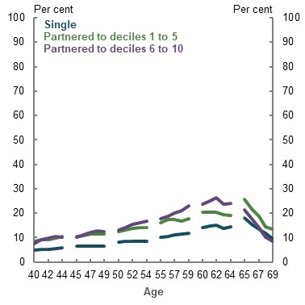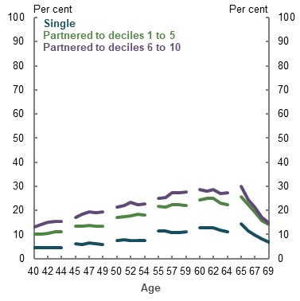
Note for Chart 6D-11, Chart 6D-12, Chart 6D-13 and Chart 6D-14: Men and women aged 40, 45, 50, 55, 60, and 65 at 30 June 2013 were sorted into gender-based deciles based on their superannuation balance and age (those with zero balances were excluded). People were then further sorted into whether they were single, partnered to a person of gender-wise balance decile 1 to 5, or partnered to a person of gender-wise balance decile 6 to 10. Those partnered to a person with zero superannuation were excluded. Balances were then tracked over the following four years to 2016-17. The first set of charts compare the average total voluntary contributions for men and women at the relevant gender-based decile of superannuation balances across singles, those partnered to a person of gender-wise balance decile 1 to 5, and those partnered to a person of gender-wise balance decile 6 to 10. The second set of charts compare the proportion making any voluntary contributions at the relevant decile of superannuation balances across those same categories. Data collection period coincides with changes to superannuation contributions caps across the 2012-13 to 2016-17 period. The ‘10 per cent rule’ for deductible personal superannuation contributions prior to 1 July 2017 also applied across this period (see 1B. Design of Australia’s retirement income system). This may influence the results presented. Contribution amounts are in nominal dollars, from 2012-13 to 2016-17. Source: Data provided by the ATO for the review.
    - Voluntary superannuation contributions for those in superannuation balance decile 5, by gender, partnered status, and partner’s superannuation balance decile, 2012-13 to 2016-17
Average total voluntary contributions
Women | Men
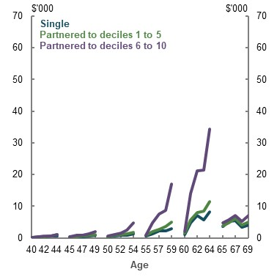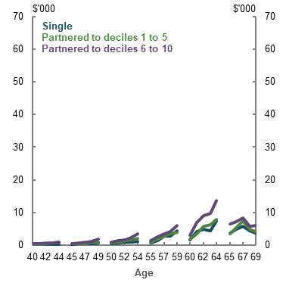
Proportion making voluntary contributions
Women | Men
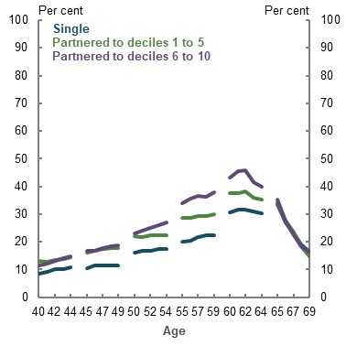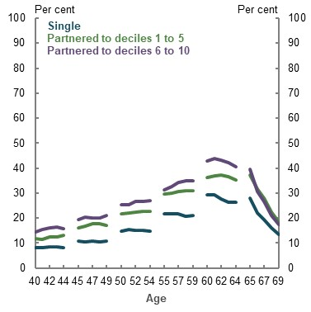
Note: See Chart 6D-11. Source: Data provided by the ATO for the review.
    - Voluntary superannuation contributions for those in superannuation balance decile 7, by gender, partnered status, and partner’s superannuation balance decile, 2012-13 to 2016-17
Average total voluntary contributions
Women | Men
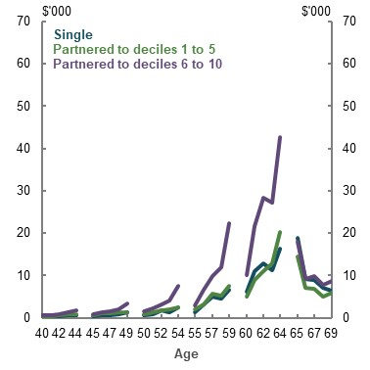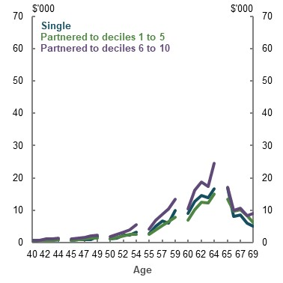
Proportion making voluntary contributions
Women | Men
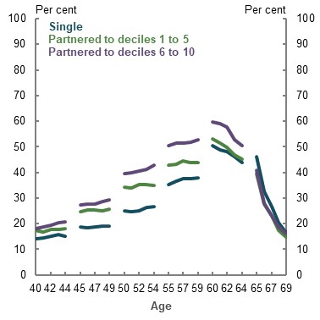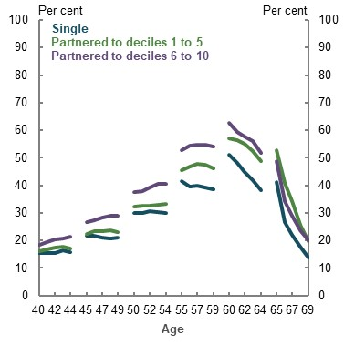
Note: See Chart 6D-11. Source: Data provided by the ATO for the review.
    - Voluntary superannuation contributions for those in superannuation balance decile 9, by gender, partnered status, and partner’s superannuation balance decile, 2012-13 to 2016-17
Average total voluntary contributions
Women | Men
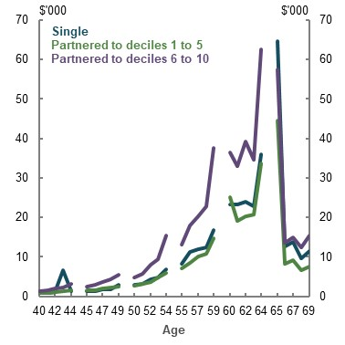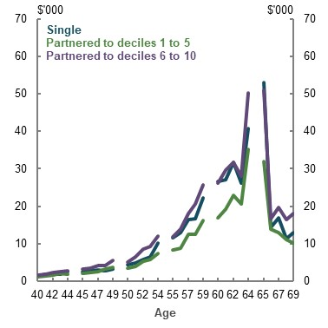
Proportion making voluntary contributions
Women | Men
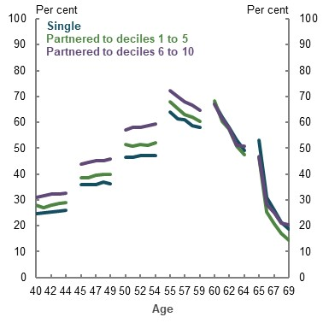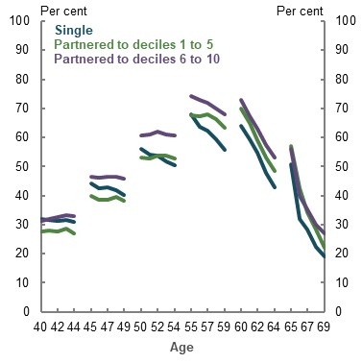
Note: See Chart 6D-11. Source: Data provided by the ATO for the review.

Age of retirement
    - Per cent of people retiring, by level of highest educational attainment and age
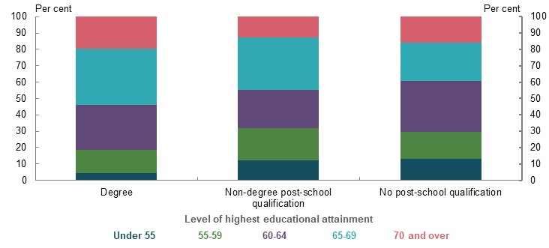
Note: Includes people who retired between July 2013 and June 2019. Degree includes postgraduate degree, graduate diploma and graduate certificate and bachelor degree. Non-degree post-school qualification includes advanced diploma and diploma and certificate 3 and 4. No post-school qualification includes year 12 or equivalent, year 11, year 10, certificate 1 and 2, and year 9 and below. While the chart uses a relatively small sample size and therefore some categories have high relative standard errors, the differences between the three categories of educational attainment are consistent with earlier surveys. Source: Analysis of (ABS, 2020p).
    - Proportion of employed people working part-time, by level of highest educational attainment and age
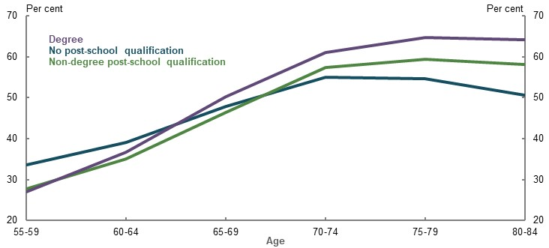
Note: Uses 2016 data. Degree includes postgraduate degree, graduate diploma and graduate certificate and bachelor degree. Non-degree post-school qualification includes advanced diploma and certificate 3 and 4. No post-school qualification includes year 12 or equivalent, secondary education — years 10 and above, secondary education — years 9 and below, and certificate 1 and 2. Source: Analysis of (ABS, 2016a).
    - Average underemployment rate, by age
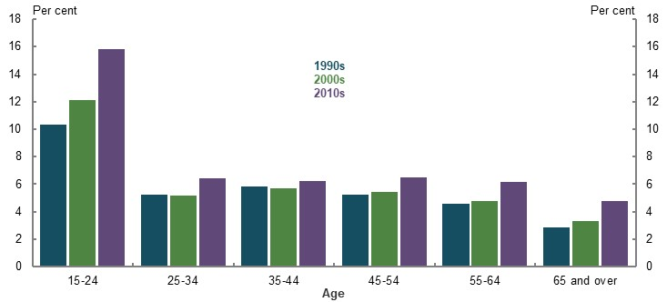
Note: Underemployment rate is calculated as the number of underemployed people divided by the number of people in the labour force. Uses the average of all monthly underemployment rates in the relevant decade. Source: Analysis of (ABS, 2020q).

      - Projected outcomes of retiring at ages 57 and 62 compared to age 67 for a lower-income earner (20th percentile)
Retirement age and reason for retirement | Income support payment received before age 67 | Replacement rate from age of retirement  (per cent) | Superannuation balance at retirement  ($) | Average annual income — all years of retirement  ($) | Average annual income — retirement to age 60  ($) | Average annual income — age 60 and over  ($)
Retire at 67
Age Pension eligibility age | N/A | 129 | 222,300 | 36,400 | N/A | 36,400
Retire at 62
Job-related | JobSeeker Payment between ages 64-66 | 114 | 185,700 | 32,100 | N/A | 32,100
Own ill health | DSP until age 67 | 126 | 185,700 | 35,400 | N/A | 35,400
Caring responsibilities | Carer Payment until age 67 | 127 | 185,700 | 35,700 | N/A | 35,700
Retire at 57
Job-related | JobSeeker Payment until age 67 | 110 | 149,500 | 30,800 | 10,100 | 32,800
Own ill health | DSP until age 67 | 125 | 149,500 | 35,300 | 23,000 | 36,400
Caring responsibilities | Carer Payment until age 67 | 128 | 149,500 | 35,900 | 25,400 | 36,900
Note for Table 6D-1, Table 6D-2 and Table 6D-3: Values are in 2019-20 dollars and rounded to the nearest $100. Superannuation balance at retirement is deflated by average weekly earnings. Retirement income is deflated using the review’s mixed deflator. Replacement rate uses average income of the last 10 years of working life and average lifetime retirement income. For consistency, the working life of the person who retires at age 67 is used as the replacement rate denominator for all retirement ages. ‘Average annual income –age 60 and over’ averages retirement income at ages 60 and over provided an individual is retired in those years. ‘Average annual income — retirement age to age 60’ averages retirement income at ages 57-59 provided an individual is retired in those years. The cameo assumes that before age 60 (superannuation preservation age), people do not take actions to boost their income until they reach preservation age (such as using early release of superannuation). People who retire before age 67 draw down at the higher of the maximum Age Pension less any JobSeeker Payment, Disability Support Pension (‘DSP’ on chart) or Carer Payment, plus supplements, they receive, or minimum legislated rates between preservation age and age 67. Superannuation is not assessable in the social security means test prior to Age Pension eligibility age until it is converted into an income stream. This modelling assumes this occurs at age 60 for people who retire before age 60. This results in the middle- and higher-income earner who retires at age 57 not receiving the JobSeeker Payment after age 60. The higher thresholds for the income and assets tests for Disability Support Pension and Carer Payment mean most early retirees continue to receive Disability Support Pension and Carer Payment after age 60. Source: Cameo modelling undertaken for the review.
      - Projected outcomes of retiring at ages 57 and 62 compared to age 67 for a middle-income earner (50th percentile)
Retirement age and reason for retirement | Income support payment received before age 67 | Replacement rate from average of retirement  (per cent) | Superannuation balance at retirement  ($) | Average annual income — all years of retirement ($) | Average annual income — retirement to age 60  ($) | Average annual income — age 60 and over age  ($)
Retire at 67
Age Pension eligibility age | N/A | 87 | 452,000 | 42,100 | N/A | 42,100
Retire at 62
Job-related | None | 78 | 367,700 | 38,000 | N/A | 38,000
Own ill health | DSP until age 67 | 80 | 367,700 | 38,900 | N/A | 38,900
Caring responsibilities | Carer Payment until age 67 | 81 | 367,700 | 39,100 | N/A | 39,100
Retire at 57
Job-related | JobSeeker Payment until age 60 | 72 | 292,400 | 35,000 | 11,200 | 37,200
Own ill health | DSP until age 67 | 79 | 292,400 | 38,300 | 24,100 | 39,700
Caring responsibilities | Carer Payment until age 67 | 80 | 292,400 | 38,900 | 26,500 | 40,100
Note: See Table 6D-1. Source: Cameo modelling undertaken for the review.

      - Projected outcomes of retiring at ages 57 and 62 compared to age 67 for a higher-income earner (80th percentile)
Retirement age and reason for retirement | Income support payment received before age 67 | Replacement rate from age of retirement (per cent) | Superannuation balance at retirement  ($) | Average annual income — all years of retirement  ($) | Average annual income –retirement to age 60  ($) | Average annual income — age 60 and over  ($)
Retire at 67
Age Pension eligibility age | N/A | 69 | 804,700 | 53,700 | N/A | 53,700
Retire at 62
Job-related | None | 58 | 646,900 | 45,000 | N/A | 45,000
Own ill health | None | 58 | 646,900 | 45,000 | N/A | 45,000
Caring responsibilities | Carer Payment until age 67 | 58 | 646,900 | 45,400 | N/A | 45,400
Retire at 57
Job-related | JobSeeker Payment until age 60 | 53 | 506,600 | 41,000 | 16,800 | 43,200
Own ill health | DSP until age 60 | 54 | 506,600 | 42,100 | 30,000 | 43,300
Caring responsibilities | Carer Payment until age 67 | 55 | 506,600 | 42,800 | 32,500 | 43,800
Note: See Table 6D-1. Source: Cameo modelling undertaken for the review.
      - Projected outcomes of retiring at age 70 compared to age 67 for a lower-income earner (20th percentile)
Retirement age | Employment status from ages 67 to 70 | Replacement rate from age of retirement (per cent) | Superannuation balance at retirement  ($) | Average annual retirement income  ($)
67 | Retired | 129 | 222,300 | 36,400
70 | Receive three-quarters of normal wage | 132 | 242,100 | 37,200
70 | Receive normal wage | 132 | 244,600 | 37,200
Note for Table 6D-4, Table 6D-5 and Table 6D-6: Values are in 2019-20 dollars, rounded to the nearest $100. Superannuation balance at retirement is deflated by average weekly earnings. Retirement income is deflated using the review’s mixed deflator. Assumes for people who retire at age 70, they do not access superannuation and other savings until age 70 but they receive the Age Pension from age 67 if they are eligible. Most people who continue to work between ages 67-70 will not qualify for the Age Pension at these ages due to the income test. Three-quarters of normal wage assumes an individual earns 75 per cent of the average wage for their age and income percentile between the ages of 67-70. Normal wage uses average wages according central case specifications. Appendix 6A. Detailed modelling methods and assumptions includes a detailed explanation of the wage data using this methodology. For consistency, the working life of the person who retires at age 67 is used as the replacement rate denominator for all retirement ages. Source: Cameo modelling undertaken for the review.
      - Projected outcomes of retiring at age 70 compared to age 67 for a middle-income earner (50th percentile)
Retirement age | Employment status from ages 67 to 70 | Replacement rate from age of retirement (per cent) | Superannuation balance at retirement  ($) | Average annual retirement income ($)
67 | Retired | 87 | 452,000 | 42,100
70 | Receive three-quarters of normal wage | 92 | 499,100 | 44,600
70 | Receive normal wage | 92 | 506,000 | 44,800
Note: See Table 6D-4. Source: Cameo modelling undertaken for the review.
      - Projected outcomes of retiring at age 70 compared to age 67 for a higher-income earner (80th percentile)
Retirement age | Employment status from ages 67 to 70 | Replacement rate from age of retirement (per cent) | Superannuation balance at retirement  ($) | Average annual retirement income  ($)
67 | Retired | 69 | 804,700 | 53,700
70 | Receive three-quarters of normal wage | 78 | 891,500 | 60,600
70 | Receive normal wage | 79 | 904,400 | 61,200
Note: See Table 6D-4. Source: Cameo modelling undertaken for the review.

Intergenerational equity
    - Past and projected generational transfer cost as a proportion of wages
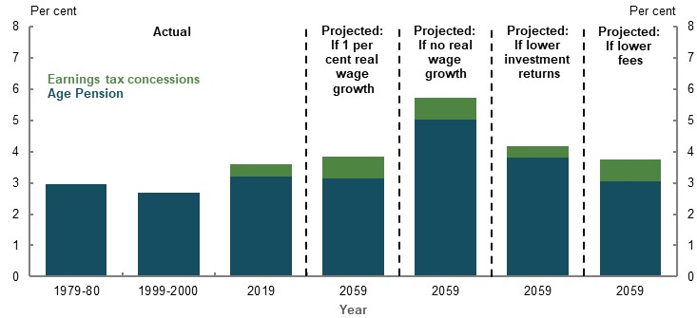
Note: Generational transfer cost is the annual cost per working-age person of the Age Pension and superannuation earnings tax concessions retirees receive. Assumes CPI growth is 2.5 per cent per year. Wages in 1979-80 refers to ‘average weekly earnings per employed male unit’ in September 1979; in 1999-2000 and 2019 it refers to ‘Earnings; Persons; Full-Time; Adult; Total earnings’ in November 1999 and November 2019, respectively. Earnings tax concessions are not included before 2019 due to data limitations. Data points vary between financial and calendar years to align with the time period of the underlying data. See Appendix 6A. Detailed modelling methods and assumptions for additional assumptions used in the lower investment returns and lower fees scenarios. Source: Year Book 1981 and 2001 (ABS, 2018g) (ABS, 2019b), (ABS, 2020d); Analysis of Rice Warner estimates for the review.

Consultation process

Approach to the review
The panel has taken a consultative approach to the Retirement Income Review (the review).
A consultation paper was released on 22 November 2019, with the panel inviting public submissions until 3 February 2020. The review received over 430 submissions in response to the consultation paper.
In addition to formal submissions, the panel held two information sessions early in the consultation process. Panel members conducted numerous meetings with key stakeholders and held a technical roundtable to consider the results of scenario modelling.

Consultation

Panel and secretariat meetings
The panel met with the secretariat on over 40 occasions, with meetings being held both face-to-face and via video conference.

Stakeholder meetings
After releasing the consultation paper on 22 November 2019, the panel hosted two information sessions attended by representative bodies, academics and policy and research entities as well as representatives from the financial services industry (Table 6E-1).
      - Information session attendees
Melbourne information session  9 December 2019 | Sydney information session  10 December 2019
ASIC | Aberdeen Standard Investments | QSuper
Australian Institute of Superannuation Trustees (AIST) | Australian Council of Trade Unions (ACTU) | Rest
Cbus | Actuaries Institute | Rice Warner
COTA | AI Group | Self Managed Super Fund Association
EY | AMP | SunSuper
First State Super | ARC Centre of Excellence in Population Ageing Research (CEPAR) | Super Consumers Australia
Grattan Institute | Association of Independent Retirees | UNSW Business School
HESTA | Business Council of Australia
Hostplus | Challenger
Industry Super Australia | Chartered Accountants Australia & New Zealand (CAANZ)
Mercer | Commonwealth Superannuation Corporation
Milliman | Conexus Institute
National Seniors Australia | COTA
SunSuper | Financial Planning Association
Togethr Trustees | Financial Services Council
Vanguard | First State Super
VicSuper | Milliman
Women in Super | MLC Wealth
More than 140 meetings were held over the life of the review. Around 100 of these were external meetings (Chart 6E-1), conducted by either the panel or secretariat with stakeholders.
    - External meetings by stakeholder type
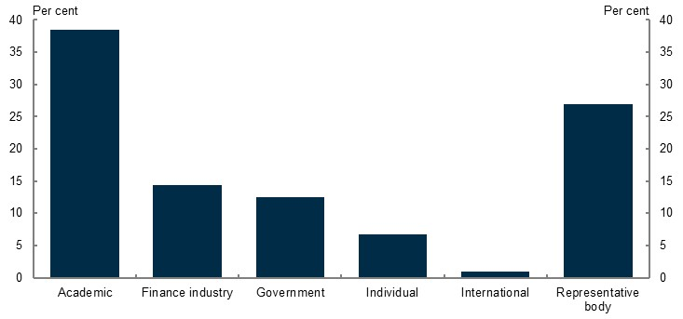
Note: Meetings included those conducted by either the panel or secretariat where they met with an external stakeholder/s on each occasion they met. Source: Data collected by the review.
During the consultation period, the panel conducted more than 40 meetings directly with stakeholders (Table 6E-2).
      - Panel meetings with stakeholders
Stakeholder category | Number
Representative bodies | 14
Academics or policy research groups | 5
Finance industry entities | 8
Regulators or government entities | 4
Individuals | 10
TOTAL | 41
In addition to consultation meetings conducted by the panel, the secretariat formally met separately with over 50 stakeholders (Table 6E-3).
      - Secretariat meetings with stakeholders
Stakeholder category | Number
Representative bodies | 9
Academics or policy research groups | 31
Finance industry entities | 1
Regulator or government entities | 9
Individuals | 1
International organisation | 1
TOTAL | 52

Technical roundtable
On 13 March 2020, the panel conducted a technical roundtable with a number of experts in modelling of the retirement income system (Table 6E-4).
      - Roundtable attendees
Name | Organisation
Hazel Bateman | CEPAR
Nathan Bonarius | PwC
Ross Clare | ASFA
Brendan Coates | Grattan Institute
Jacki Ellis | First State Super
Phil Gallagher, PSM | ISA
Dr David Knox | Mercer
Matthias Oldham | Super Consumers Australia
Michael Rice | Rice Warner
Geoff Warren | ANU

Submissions
Over 430 submissions made to the review, covering a number of key topics (Chart 6E-3), came from both individuals and various organisations (Chart 6E-3).
    - Submissions, by topic category
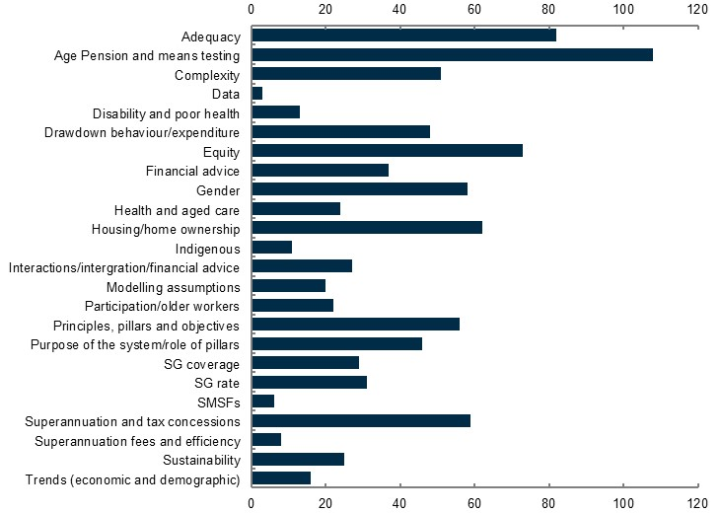
Source: Data collected by the review.
    - Submissions by stakeholder category
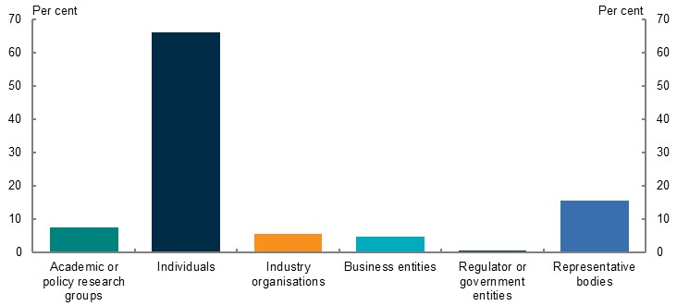
Note: The above chart shows the entities that have made a submission rather than the number of submissions received. In some instances, the one entity provided more than one submission.
Of all submissions received, 143 were made in a confidential capacity and were not published. All non-confidential submissions were published on the Treasury website (Table 6E-5) including 13 submissions that requested anonymous publication.
      - Non-confidential published submissions
Submitters | Submitters
Actuaries Institute | Australian Unity
AIA Australia | Australian Women Against Violence Alliance
Amabile, Peter | Ballantyne, John
AMP Services Ltd | Bartus, Zoltan
Association of Independent Retirees | Bell, Charlie
Association of Independent Retirees — Bunbury Branch | Benson, Graeme
Association of Independent Retirees — Noosa Branch | Berrill and Watson Lawyers
Association of Independent Retirees — Sydney Hills District Branch | Berry, Denise
Australian Council of Public Sector Retiree Organisations | BetaShares Capital Ltd
Australian Council of Social Service (ACOSS) | Birch, Denver
Australian Council of Trade Unions | Brander, Jim
Australian Housing and Urban Research Institute | Brotherhood of St Laurence
Australian Human Rights Commission | Buchanan, James
Australian Institute of Superannuation Trustees | Burt, Dan
Australian Investment Council | Business Council of Australia
Australian Manufacturing Workers’ Union | Cain, David
Australian Nursing and Midwifery Federation | Carers NSW
Australian Pensioners’ Voice | Carroll, Linda
Australian Services Union | Cbus
Australian Shareholders’ Association | CDI Consulting Pty Ltd
Australian Super | Centre for Future Work (Australian Institute)
Australian Taxpayers’ Alliance | Centre for Law, Markets and Regulation (UNSW)
Centre for Excellence in Population Ageing Branch | Financial Equity Alliance
Challenger Limited | Financial Planning Association of Australia
Chartered Accountants Australia and New Zealand | Financial Services Council
Cherian, George | First State Super
Chief Executive Women | Fix Pension Poverty Campaign
Codron FIAA, Richard | Ford, Christine
Colonial First State | Ford, Frank
Combined Pensioners and Superannuants Australia | Franklin, Simon
Committee for Sustainable Retirement Incomes | Freeman FACS, Andrew
Connecting Every Dot Pty Ltd | Fridman, Boris
Considine, Vera | Fitzpatrick, Sean
Constantinou, Georgia | GA Cossar and Co Pty Ltd
Cook, Chris | Gilligan, Dr Mike and Craig, Dr Stuart
Cook, Chris | Goodrick, Sue
COTA Australia | Gorecki, Piotr
Cottrell, Rob | Graham, Lorraine
Country Press Australia | Grant, Dr Will J
Cox, Andy | Grattan Institute
Cox, David | Grieves, Daniel
CPA Australia | Griffith Centre for Personal Finance and Superannuation (Griffith University)
Cranford, Alex | Gryostat Capital Management
Daniel, Hugh | Hackett-Jones, Richard
Dapre, Robert | Harrison, Ian
Davis AM, Kevin | Hart, Michael
Davis, David | Hawkins, Dr John
de Jong, Piet | Health Services Union
Devitt, Neil | Hebden, Mark
Dines, John | Heffron SMSF Solutions
Diversa Trustees Limited (Sargon) | HESTA Super fund
Dockery, Prof Michael (Bankwest Curtin Economics Centre) | Hewitson, Gillian
DomaCom | Hodgkinson, Norman
Echter, Michael | Holding, Anne
economic Security4Women | Horan, David
Edmonds, David | Household Capital
Edsall, Jem | Housing Industry Association
EveryAGE Counts | Howe PhD, Anna
EY | Hristoforidis, Ian
Fair Go For Pensioners — Coalition Victoria | Hull, Crispin
Fair Go For Pensioners — Newcastle Branch | Hunter, Andrew
Fair Go For Pensioners Queensland | Industrial Relations Victoria (VIC State Government)
Fairweather, John and Shirley | Industry Super Australia
Financial Services Council | IOOF Holdings Ltd
Finance Sector Union | Johnson, Rob

Submitters | Submitters
Johnston, Kerry | Paton, Rob
Kahmann, Ron | Pauley, John
Kalkman, Hendrikus J | Plain English Economics Pty Ltd
Kent, John | Plato Investment Management
Khemka, Dr Gaurav, and Warren, Associate professor Geoff, ANU | Police Federation of Australia
KPMG Australia | Positive Life NSW
Lacey, Jan | Preston, Professor Alison (University of Western Australia)
Langsam, David | PricewaterhouseCoopers
Layt, Mick | Prime Super
Leite, Natalie | Property Council of Australia
Lewington, Geoff | Queensland Nurses and Midwives’ Unions
Lewis, Evan | Rasmussen, Lisbeth
Leys, David | Rea, David
Maurice Blackburn Lawyers | Reason, Jenny
Mayo, Wayne | Reid, Robert
McCall, Grant | Rest
McGarrity, Ian | Reynolds Peter
McIntosh, John | Rhodes, Julie
Mercer | Rice Warner
Mission Australia | Richards, Barnard M
MLC Wealth | Ritchens, Denise (Northeast Health Wangaratta)
Monash Centre for Financial Studies (Monash University) | Rohan, Geoff
Money Farms Pty Ltd | Rossiter, Janis
Moore, Chris | Rush FIAA, David
Murray, Dr Cameron K | SA Superannuants
Mutual Pensions Pty Ltd | Sanders, Anthony
National Council of Women Australia | Save Our Super
National Foundation for Australian Women | Scheiwe, Dan
National Council of Women Australia | Seccombe, John
National Foundation for Australian Women | Self-managed Independent Superannuation Funds Association (SISFA)
National Seniors Australia | Selwood, Annie
Norton, Lachlan | Shop, Distributive and Allied Employees’ Association (SDA National)
Nurses Professional Association of Queensland | Simpson, Dave
O’Connell, Justin | Skelton, Johnathan
Olenich, Sergio | Skepper, Flynis
O’Neill, Christopher | SMSF Association
Ong ViforJ, Rachel | Social Ventures Australia
Optimum Pensions Pty Ltd | Southam, Paul
Spivey, Richard, and Goodman, Russlyn | Superannuated Commonwealth Officers’ Assn (WA) Inc
Stafford, John | SuperEd
Stockbrokers and Financial Advisers Association | Sustainable Australia Party
Pantlin, Tony | Super Consumers Australia
Parker, Roger | Swanson, Bruce
Swincer, David | Wareing, Graham
Tailored Superannuation Solutions Pty Ltd | Watts, Charlene
TAL Life Limited | Waugh, Madonna
Tasmanian Association of State Superannuants Inc | Weir, Pat
TelstraSuper | Western Australia Self Funded Retirees Inc
The Alliance for a Fairer Retirement System | Western Australian Government
The Association of Superannuation Funds of Australia Limited | White, Alan
The Centre for Independent Studies | White, Eugene
The Conexus Institute | White, Greg
The Housewives of Western Sydney | Whitely, Zac
The McKell Institute Victoria | Wilkinson, Mrs J
Thomas, Ian | Williams, Graham
Thompson, Mark | Winterson, Joshua
Thorp, Dr David | Women in Social and Economic Research
Tietze, Karl | Women in Super
Tindale, Roger | Work and Family Policy Roundtable
Turner | Workplace Gender Equality Agency
UniSuper | Yasmineh, John
van Dyk, Leonota | Yazdani
Van Wyk, Brnic | Young, Donald
Vanguard Investments Australia Ltd | YourLifeChoices
Walta, Ed | Women’s Electoral Lobby
Walters, Arthur | Woodhead, Maggie
Wanders, Wayne (The Wealth Navigator) | Woodruff, John

References
ABS, 1983. Census of Population and Housing, 1981, cat. no. 2103.0. [Online]
Available at: https://www.abs.gov.au/AUSSTATS/abs@.nsf/Lookup/2103.0Main+Features11981?OpenDocument
[Accessed 27 April 2020].
ABS, 1992b. Household Expenditure Survey, Australia: the Effects of Government Benefits and Taxes on Household Income, 1988-89, cat. no. 6537.0. [Online]
Available at: https://www.abs.gov.au/AUSSTATS/abs@.nsf/DetailsPage/6537.01988-89?OpenDocument
[Accessed 18 November 2019].
ABS, 1993. Census of Population and Housing, 1991, cat. no. 2101.0. [Online]
Available at: https://www.ausstats.abs.gov.au/ausstats/free.nsf/0/792BBD9457634FFECA2574BE00826627/$File/27100_1991_20_Census_Characteristics_of_Australia.pdf
[Accessed 17 March 2020].
ABS, 1994. Superannuation, Australia, Nov 1993, cat. no. 6319.0. [Online]
Available at: https://www.abs.gov.au/AUSSTATS/abs@.nsf/Lookup/6319.0Main+Features1Nov%201993?OpenDocument
[Accessed 3 March 2020].
ABS, 1997. Marriages and Divorces, Australia, 1996, cat. no. 3310.0. [Online]
Available at: https://www.abs.gov.au/AUSSTATS/abs@.nsf/allprimarymainfeatures/1DE879602B6C1BB1CA25722E001A3A09?opendocument
[Accessed 10 February 2020].
ABS, 1998. Year Book Australia, 1988, cat. no. 1310.0. [Online]
Available at: https://www.abs.gov.au/ausstats/abs@.nsf/94713ad445ff1425ca25682000192af2/8e72c4526a94aaedca2569de00296978!opendocument
[Accessed 20 May 2020].
ABS, 2001. Year Book Australia, 2001, cat. no. 1301.0. [Online]
Available at: https://www.abs.gov.au/AUSSTATS/abs@.nsf/allprimarymainfeatures/E31D22BD8EC6BC16CA2570B000368E96?opendocument
[Accessed 17 March 2020].
ABS, 2003. Employee Earnings, Benefits and Trade Union Membership, Australia, Aug 2002, cat. no. 6310.0. [Online]
Available at: https://www.abs.gov.au/AUSSTATS/abs@.nsf/second+level+view?ReadForm&prodno=6310.0&viewtitle=Weekly%20Earnings%20of%20Employees%20(Distribution),%20Australia~Aug%201997~Previous~10/01/1998&&tabname=Past%20Future%20Issues&prodno=6310.0&issue=Aug%201997&num=
[Accessed 3 March 2020].
ABS, 2006a. 2006 Census of Population and Housing, s.l.: TableBuilder. Findings based on use of ABS TableBuilder data.
ABS, 2006b. Retirement and Retirement Intentions, Australia, Aug 2004 to Jun 2005, cat. no. 6238.0. [Online]
Available at: https://www.abs.gov.au/AUSSTATS/abs@.nsf/allprimarymainfeatures/93714AE404FA1484CA2573D7001786B1?opendocument
[Accessed 15 February 2020].
ABS, 2007. Housing occupancy and costs, 2005-06, cat. no. 4130.0.55.001. [Online]
Available at: https://www.abs.gov.au/AUSSTATS/abs@.nsf/DetailsPage/4130.0.55.0012005-06?OpenDocument
[Accessed 24 April 2020].
ABS, 2009a. Australian Social Trends, March 2009, cat. no. 4102.0. [Online]
Available at: https://www.abs.gov.au/AUSSTATS/abs@.nsf/Lookup/4102.0Main+Features70March%202009
[Accessed 5 March 2020].
ABS, 2011a. 2011 Census of Population and Housing, s.l.: TableBuilder. Findings based on use of ABS TableBuilder data.
ABS, 2011b. Australian Labour Market Statistics, Oct 2011, cat. no. 6105.0. [Online]
Available at: https://www.abs.gov.au/ausstats/abs@.nsf/Latestproducts/DB1BFFF6CB753F05CA257922000E2865?opendocument
[Accessed 10 January 2020].
ABS, 2011c. Australian Social Trends, Dec 2011, cat. no. 4102.0. [Online]
Available at: https://www.abs.gov.au/AUSSTATS/abs@.nsf/Lookup/4102.0Main+Features30Dec+2011
[Accessed 10 January 2020].
ABS, 2014. Employee Earnings, Benefits and Trade Union Membership, Australia, August 2013, 6310.0. [Online]
Available at: https://www.abs.gov.au/AUSSTATS/abs@.nsf/DetailsPage/6310.0August%202013?OpenDocument
[Accessed 20 February 2020].
ABS, 2015a. General Social Survey: Summary Results, Australia, 2014, cat. no. 4159.0. [Online]
Available at: https://www.abs.gov.au/ausstats/abs@.nsf/mf/4159.0
[Accessed 21 February 2020].
ABS, 2016a. 2016 Census of Population and Housing, s.l.: TableBuilder. Findings based on use of ABS TableBuilder data.
ABS, 2016b. National Aboriginal and Torres Strait Islander Social Survey, 2014-15, cat. no. 4714.0. [Online]
Available at: https://www.abs.gov.au/ausstats/abs@.nsf/mf/4714.0
[Accessed 21 February 2020].
ABS, 2017a. Australians pursuing higher education in record numbers. [Online]
Available at: https://www.abs.gov.au/AUSSTATS/abs@.nsf/mediareleasesbyReleaseDate/1533FE5A8541D66CCA2581BF00362D1D
[Accessed 28 May 2020].
ABS, 2017b. Barriers and Incentives to Labour Force Participation, Australia, July 2016 to June 2017, cat. no. 6239.0. [Online]
Available at: https://www.abs.gov.au/ausstats/abs@.nsf/mf/6239.0
[Accessed 19 November 2019].
ABS, 2017d. Financial stress and spending. [Online]
Available at: https://www.abs.gov.au/ausstats/abs@.nsf/Latestproducts/6530.0Main%20Features72015-16?opendocument&ta
[Accessed 13 January 2020].
ABS, 2017e. Household Expenditure Survey, Australia, 2015-16, cat. no. 6530.0. [Online]
Available at: https://www.abs.gov.au/AUSSTATS/abs@.nsf/Lookup/6530.0Main+Features12015-16?OpenDocument
[Accessed 12 February 2020].
ABS, 2017f. Selected Living Cost Indexes: 17th Series Weighting Pattern, Sep 2017, cat. no. 6474.0. [Online]
Available at: https://www.abs.gov.au/AUSSTATS/abs@.nsf/Lookup/6474.0Main+Features1Sep%202017?OpenDocument
[Accessed 10 January 2020].
ABS, 2018a. Census of Population and Housing: Characteristics of Aboriginal and Torres Strait Islander Australians, 2016, cat. no. 2076.0. [Online]
Available at: https://www.abs.gov.au/AUSSTATS/abs@.nsf/Latestproducts/2076.0Main%20Features512016?opendocument&tabname=Summary&prodno=2076.0&issue=2016&num=&view=
[Accessed 21 February 2020].
ABS, 2018b. Census of Population and Housing: Estimating homelessness, 2016, cat. no. 2049.0. [Online]
Available at: https://www.abs.gov.au/AUSSTATS/abs@.nsf/Lookup/2049.0Main+Features12016?OpenDocument
[Accessed 13 May 2020].
ABS, 2018c. Government Benefits, Taxes and Household Income, Australia, 2015-16, cat. no. 6537.0. [Online]
Available at: https://www.abs.gov.au/ausstats/abs@.nsf/mf/6537.0/
[Accessed 18 November 2019].
ABS, 2018d. Life Tables for Aboriginal and Torres Strait Islander Australians, 2015-17, cat. no. 3302.0.55.003. [Online]
Available at: https://www.abs.gov.au/ausstats/abs@.nsf/Lookup/by%20Subject/3302.0.55.003~2015-2017~Media%20Release~Life%20expectancy%20lowest%20in%20remote%20and%20very%20remote%20areas%20(Media%20Release)~15
[Accessed 21 February 2020].
ABS, 2018e. Life Tables, States, Territories and Australia, 2015-2017, cat. no. 3302.0.55.001. [Online]
Available at: https://www.abs.gov.au/AUSSTATS/abs@.nsf/allprimarymainfeatures/123B67D527F36A63CA2584A20012C43C?opendocument
[Accessed 21 February 2020].
ABS, 2018f. Microdata: Household Expenditure, Income and Housing, 2015-16, cat. no. 6540.0. [Online]
Available at: https://www.abs.gov.au/AUSSTATS/abs@.nsf/Lookup/6540.0Main+Features32015-16?OpenDocument
[Accessed 3 July 2020].
ABS, 2018g. Population Projections, Australia, 2017 (base) - 2066, cat. no. 3222.0. [Online]
Available at: https://www.abs.gov.au/AUSSTATS/abs@.nsf/DetailsPage/3222.02017%20(base)%20-%202066?OpenDocument
[Accessed 10 February 2020].
ABS, 2019a. ANZSCO - Australian and New Zealand Standard Classification of Occupations, 2013, Version 1.3, cat. no. 1220.0. [Online]
Available at: https://www.abs.gov.au/AUSSTATS/abs@.nsf/DetailsPage/1220.02013,%20Version%201.3?OpenDocument
[Accessed 10 April 2020].
ABS, 2019b. Australian Demographic Statistics, Jun 2019, cat. no. 3101.0. [Online]
Available at: https://www.abs.gov.au/AUSSTATS/abs@.nsf/Lookup/3101.0Main+Features1Jun%202019?OpenDocument
[Accessed 4 February 2020].
ABS, 2019c. Australian Historical Population Statistics, 2016, cat. no. 3105.0.65.001. [Online]
Available at: https://www.abs.gov.au/AUSSTATS/abs@.nsf/mf/3105.0.65.001
[Accessed 10 February 2020].
ABS, 2019d. Australian National Accounts: National Income, Expenditure and Product, Sep 2019, cat. no. 5206.0. [Online]
Available at: https://www.abs.gov.au/AUSSTATS/abs@.nsf/allprimarymainfeatures/A8B6127A1F11485ACA258520000C23B9?opendocument
[Accessed 18 March 2020].
ABS, 2019e. Births, 2018, cat. no. 3301.0. [Online]
Available at: https://www.abs.gov.au/ausstats/abs@.nsf/PrimaryMainFeatures/3301.0?OpenDocument
[Accessed 24 April 2020].
ABS, 2019f. Characteristics of Employment, Australia, August 2019, cat. no. 6333.0. [Online]
Available at: https://www.abs.gov.au/AUSSTATS/abs@.nsf/DetailsPage/6333.0August%202019?OpenDocument
[Accessed 10 February 2020].
ABS, 2019g. Disability, Ageing and Carers, Australia, 2018, cat. no 4430.0. [Online]
Available at: https://www.abs.gov.au/ausstats/abs@.nsf/mf/4430.0
[Accessed 10 December 2019].
ABS, 2019h. Employee Earnings and Hours, Australia, May 2018, cat. no. 6306.0. [Online]
Available at: https://www.abs.gov.au/AUSSTATS/abs@.nsf/second+level+view?ReadForm&prodno=6306.0&viewtitle=Employee%20Earnings%20and%20Hours,%20Australia~May%202018~Latest~22/01/2019&&tabname=Past%20Future%20Issues&prodno=6306.0&issue=May%202018&num=&view=&
[Accessed 11 February 2020].
ABS, 2019i. Estimates of Aboriginal and Torres Strait Islander Australians, June 2016 cat. no. 3238.0.55.001. [Online]
Available at: https://www.abs.gov.au/AUSSTATS/abs@.nsf/DetailsPage/3238.0.55.001June%202016?OpenDocument
[Accessed 29 June 2020].
ABS, 2019j. Gender Indicators, Australia, Nov 2019, cat. no. 4125.0. [Online]
Available at: https://www.abs.gov.au/AUSSTATS/abs@.nsf/DetailsPage/4125.0Nov%202019?OpenDocument
[Accessed 16 December 2019].
ABS, 2019k. Household Income and Wealth, Australia, 2017-18, cat. no. 6523.0. [Online]
Available at: https://www.abs.gov.au/ausstats/abs@.nsf/Lookup/by%20Subject/6523.0~2017-18~Main%20Features~Key%20Findings~1
[Accessed 13 December 2019].
ABS, 2019n. Housing Occupancy and Costs, 2017-18, cat. no. 4130.0. [Online]
Available at: https://www.abs.gov.au/AUSSTATS/abs@.nsf/Lookup/4130.0Explanatory%20Notes12017-18?OpenDocument
[Accessed 18 May 2020].
ABS, 2019q. Marriages and Divorces, Australia, 2018, cat. no. 3310.0. [Online]
Available at: https://www.abs.gov.au/AUSSTATS/abs@.nsf/DetailsPage/3310.02018?OpenDocument
[Accessed 10 February 2020].
ABS, 2019r. Participation, Job Search and Mobility, Australia, Feb 2019, cat. no. 6226.0. [Online]
Available at: https://www.abs.gov.au/Ausstats/abs@.nsf/0/6A38AB9379F0EFF9CA257FD8001293DE?OpenDocument
[Accessed 18 March 2020].
ABS, 2019s. Survey of Income and Housing, Australia, 2017-18, cat. no. 6553.0. [Online]
Available at: https://www.abs.gov.au/ausstats/abs@.nsf/mf/6553.0
[Accessed 18 November 2019].
ABS, 2020a. Australian National Accounts: Finance and Wealth, Mar 2020, cat. no. 5232.0. [Online]
Available at: https://www.abs.gov.au/AUSSTATS/abs@.nsf/allprimarymainfeatures/F667A926CE831C21CA257695001CB7E3?opendocument
[Accessed 3 July 2020].
ABS, 2020b. Australian National Accounts: National Income, Expenditure and Product, Mar 2020, cat. no. 5206.0. [Online]
Available at: https://www.abs.gov.au/AUSSTATS/abs@.nsf/DetailsPage/5206.0Mar%202020?OpenDocument
[Accessed 3 July 2020].
ABS, 2020c. Australian National Accounts: National Income, Expenditure and Product, Dec 2019, cat. no. 5206.0. [Online]
Available at: https://www.abs.gov.au/ausstats/abs%40.nsf/mediareleasesbyCatalogue/C9973AC780DDFD3FCA257F690011045C?OpenDocument
[Accessed 22 April 2020].
ABS, 2020d. Average Weekly Earnings, Australia, Nov 2019, cat. no. 6302.0. [Online]
Available at: https://www.abs.gov.au/ausstats/abs@.nsf/lookup/6302.0Media%20Release0Nov%202019
[Accessed 20 February 2020].
ABS, 2020e. Consumer Price Index, Australia, Dec 2019, cat. no. 6401.0. [Online]
Available at: https://www.abs.gov.au/ausstats/abs@.nsf/lookup/6401.0Media%20Release1Dec%202019
[Accessed 20 February 2020].
ABS, 2020f. Labour Account Australia, Quarterly Experimental Estimates, December 2019, cat. no. 6150.0.55.003. [Online]
Available at: https://www.abs.gov.au/AUSSTATS/abs@.nsf/Lookup/6150.0.55.003Explanatory%20Notes1December%202018?OpenDocument
[Accessed 20 March 2020].
ABS, 2020g. Labour Force, Australia, Detailed - Electronic Delivery, Jan 2020, cat. no. 6291.0.55.001. [Online]
Available at: https://www.abs.gov.au/AUSSTATS/abs@.nsf/allprimarymainfeatures/78973101C025B7C3CA2585360017E12E?opendocument
[Accessed 20 March 2020].
ABS, 2020h. Labour Force, Australia, Jan 2020, cat. no. 6202.0. [Online]
Available at: https://www.abs.gov.au/AUSSTATS/abs@.nsf/allprimarymainfeatures/3FA36ACAA0D90D66CA25852F001E10C4?opendocument
[Accessed 2 March 2020].
ABS, 2020i. Labour Force, Australia, Apr 2020, cat. no. 6202.0. [Online]
Available at: https://www.abs.gov.au/AUSSTATS/abs@.nsf/DetailsPage/6202.0Apr%202020?OpenDocument
[Accessed 14 May 2020].
ABS, 2020j. Labour Force, Australia, Detailed - Electronic Delivery, Apr 2020, cat. no. 6291.0.55.001. [Online]
Available at: https://www.abs.gov.au/AUSSTATS/abs@.nsf/DetailsPage/6291.0.55.001Apr%202020?OpenDocument
[Accessed 25 May 2020].
ABS, 2020k. Labour Force, Australia, May 2020, cat. no, 6202.0. [Online]
Available at: https://www.abs.gov.au/AUSSTATS/abs@.nsf/Lookup/6202.0Main+Features1May%202020?OpenDocument
[Accessed 3 July 2020].
ABS, 2020m. Migration, Australia, 2018-19, cat. no. 3412.0. [Online]
Available at: https://www.abs.gov.au/AUSSTATS/abs@.nsf/Latestproducts/3412.0Main%20Features52018-19?opendocument&tabname=Summary&prodno=3412.0&issue=2018-19&num=&view=
[Accessed 8 May 2020].
ABS, 2020n. Retirement and Retirement Intentions, Australia, 2018-19, cat. no. 6238.0. [Online]
Available at: https://www.abs.gov.au/AUSSTATS/abs@.nsf/Lookup/6238.0Main+Features12018-19?OpenDocument
[Accessed 25 May 2020].
ABS, 2020p. Retirement and Retirement Intentions, Australia, 2018-19, cat. no. 6238.0, s.l.: TableBuilder. Findings based on use of ABS TableBuilder data.
ABS, 2020q. Selected Living Cost Indexes, Australia, Dec 2019, cat. no. 6467.0. [Online]
Available at: https://www.abs.gov.au/AUSSTATS/abs@.nsf/allprimarymainfeatures/8A87AA80C7CE5445CA25855F00211B90?opendocument
[Accessed 18 March 2020].
Actuaries Institute, 2018. Practice Guideline 499.02 Projected Retirement Benefit Illustrations. [Online]
Available at: https://www.actuaries.asn.au/Library/Standards/SuperannuationEmployeeBenefits/2017/PG49902Jan18.pdf
[Accessed 8 June 2020].
Actuaries Institute, 2019. Options for an Improved and Integrated System of Retirement, Green Paper. [Online]
Available at: https://actuaries.asn.au/Library/Opinion/2019/RETIREMENTINCOMESGREENPAPERFINALWEB.pdf
[Accessed 18 March 2020].
Actuaries Institute, 2020. Retirement Income Review submissions. [Online]
Available at: https://treasury.gov.au/consultation/c2019-36292/submissions
Adkins, L., Cooper, M. & Konings, M., 2019. Class in the 21st Century: Asset inflation and the new logic of inequality. Environment and planning A: economy and space.
Adviser Ratings, 2019. 2019 Australian Financial Advice Landscape, Sydney: Adviser Ratings.
Aged Care Financing Authority, 2018. How Consumers Plan and Finance Aged Care, Canberra: Aged Care Financing Authority.
Aged Care Financing Authority, 2019. Seventh Report on the Funding and Financing of the Aged Care Industry, Canberra: Aged Care Financing Authority.
Agnew, J., 2013. Australia's Retirement System: Strengths, Weaknesses, and Reforms. Centre for Retirement Research, Issue 13-5.
Aguiar, M. & Hurst, E., 2005. Consumption versus Expenditure. Journal of Political Economy, 113(5), pp. 919-948.
AIA Australia, 2020. Retirement Income Review submissions. [Online]
Available at: https://treasury.gov.au/consultation/c2019-36292/submissions
Alliance for a Fairer Retirement System, 2020. Retirement Income Review submissions. [Online]
Available at: https://treasury.gov.au/consultation/c2019-36292/submissions
Allport, W., Pagilaro, C., Sandbrook, W. & Blakstad, M., 2019. How the UK Saves: Effects of Gender on retirement savings behaviour. [Online]
Available at: https://www.nestinsight.org.uk/wp-content/uploads/2019/11/How-the-UK-Saves-effects-of-gender-on-retirement-savings-behaviour.pdf
[Accessed 21 February 2020].
Alonso-Garcia, J., Bateman, H., Bonekamp, J. & Stevens, R., 2017. Retirement drawdown defaults: the role of implied endorsement, s.l.: Working Paper 2017/20, ARC Centre of Excellence in Population Ageing.
Alonso-Garcia, J. et al., Forthcoming. Saving Preferences After Retirement, s.l.: s.n.
AMP, 2020. Retirement Income Review submissions. [Online]
Available at: https://treasury.gov.au/consultation/c2019-36292/submissions
Andrews, D., Deutscher, N., Hambur, J. & Hansell, D., 2019. Wage Growth in Australia: Lessons from Longitudinal Microdata, Canberra: Department of the Treasury, Commonwealth of Australia.
Antolin, P., 2009. Private Pensions and the Financial Crisis: How to Ensure Adequate Retirement Income from DC Pension Plans. OECD Journal: Financial Market Trends, Issue 2.
ANZ, 2015. ANZ Survey of Adult Financial Literacy in Australia. [Online]
Available at: https://www.anz.com/resources/3/1/31cbc1fd-9491-4a22-91dc-4c803e4c34ab/adult-financial-literacy-survey-full-results.pdf
[Accessed 21 February 2020].
ASFA, 2009. Updating and extending indicative budget standards for older Australians in 2009, Sydney: ASFA.
ASFA, 2010. Community attitudes to superannuation, retirement income adequacy and government policies on superannuation, Sydney: ASFA.
ASFA, 2018a. ASFA Retirement Standard, Sydney: ASFA.
ASFA, 2018b. Superannuation balances of the self-employed, Sydney: ASFA.
ASFA, 2019. Strengthening Australia’s superannuation system - ASFA's proposed toolkit for Government, Sydney: ASFA.
ASFA, 2020a. Retirement Income Review submissions. [Online]
Available at: https://treasury.gov.au/consultation/c2019-36292/submissions
ASFA, 2020b. The Benefits of Australia's Compulsory Superannuation System, Sydney: ASFA.
Asher, A., Meyricke, R., Thorp, S. & Wu, S., 2017. Age Pensioner Decumulation: Responses to Incentives, Uncertainty and Family Need. Australian Journal of Management, 42(4), pp. 583-607.
ASIC and the Dutch Authority for Financial Markets, 2019a. Disclosure: Why it shouldn't be the default, s.l.: ASIC.
ASIC, 2012a. Regulatory Guide 244: Giving information, general advice and scaled advice, s.l.: ASIC.
ASIC, 2016a. REP 499 Financial advice: Fees for no service, s.l.: ASIC.
ASIC, 2016b. Regulatory Guide 255: Providing digital financial product advice to retail clients, s.l.: ASIC.
ASIC, 2018a. REP 562 Financial advice: Vertically integrated institutions and conflicts of interest, s.l.: ASIC.
ASIC, 2018b. ASIC Submission to the Financial Services Royal Commission - Round 2: Financial Advice, s.l.: ASIC.
ASIC, 2018c. REP 586 Review of reverse mortgage lending in Australia, s.l.: ASIC.
ASIC, 2019b. REP 627 Financial advice: What consumers really think, s.l.: ASIC.
ASIC, 2019d. REP 639 Financial advice by superannuation funds, s.l.: ASIC.
Association of Independent Retirees, 2020. Retirement Income Review submissions. [Online]
Available at: https://treasury.gov.au/consultation/c2019-36292/submissions
Atalay, K. & Barrett, G., 2012. The Impact of Age Pension Eligibility Age on Retirement and Program Dependence: Evidence from an Australian Experiment. Review of Economics and Statistics, 97(1), pp. 71-87.
Atkinson, A. B. & Stiglitz, J. E., 1976. The Design of Tax Structure: Direct Verses Indirect Taxation. Journal of Public Economics, Volume 6, pp. 55-75.
ATO, 2018. Beneficiary tax offset and seniors and pensioners tax offset calculator. [Online]
Available at: https://www.ato.gov.au/calculators-and-tools/beneficiary-tax-offset-and-seniors-and-pensioner-tax-offset-calculator/
[Accessed 18 May 2020].
ATO, 2019a. Income tax estimator. [Online]
Available at: https://www.ato.gov.au/Calculators-and-tools/Income-tax-estimator/
[Accessed 18 May 2020].
ATO, 2019c. Rebate income 2019. [Online]
Available at: https://www.ato.gov.au/Individuals/Tax-Return/2019/Tax-return/Tax-offset-questions-T1-T2/Rebate-income-2019/
[Accessed 18 May 2020].
ATO, 2019d. Self-managed super fund quarterly statistical report - June 2019. [Online]
Available at: https://www.ato.gov.au/About-ATO/Research-and-statistics/In-detail/Super-statistics/SMSF/Self-managed-super-fund-quarterly-statistical-report---June-2019/
[Accessed 18 March 2020].
ATO, 2019e. Taxation statistics 2016-17: Table 15 Average and median taxable income, salary or wages, and total income, by occupation and sex, 2016–17 income year. [Online]
Available at: https://www.ato.gov.au/About-ATO/Research-and-statistics/In-detail/Taxation-statistics/Taxation-statistics-2016-17/?page=9#Individuals_detailed_tables
[Accessed 18 March 2020].
ATO, 2019f. Taxation statistics 2016-17: Table 22 Superannuation contributions, by total superannuation member accounts balance range, taxable income range and age range, 2016–17 financial year. [Online]
Available at: https://www.ato.gov.au/About-ATO/Research-and-statistics/In-detail/Taxation-statistics/Taxation-statistics-2016-17/?page=9#Individuals_detailed_tables
[Accessed 18 March 2020].
ATO, 2019g. ATO support for Indigenous Peoples superannuation. [Online]
Available at: https://www.ato.gov.au/Media-centre/Speeches/Other/ATO-support-for-Indigenous-Peoples-superannuation/
[Accessed 3 July 2020].
ATO, 2020a. Annual Reports - Super co-contributions. [Online]
Available at: https://www.ato.gov.au/About-ATO/Research-and-statistics/In-detail/Super-statistics/Super-co-contribution/Annual-reports---Super-co-contribution/
[Accessed 18 March 2020].
ATO, 2020b. ATO continues to strengthen our support for Aboriginal and Torres Strait Islander people. [Online]
Available at: https://www.ato.gov.au/Media-centre/Media-releases/ATO-continues-to-strengthen-our-support-for-Aboriginal-and-Torres-Strait-Islander-people/
[Accessed 30 June 2020].
ATO, 2020c. Key superannuation rates and thresholds, Preservation age. [Online]
Available at: https://www.ato.gov.au/Rates/Key-superannuation-rates-and-thresholds/?page=11
[Accessed 8 April 2020].
ATO, 2020d. Super death benefits. [Online]
Available at: https://www.ato.gov.au/Individuals/Super/In-detail/Withdrawing-and-using-your-super/Withdrawing-your-super-and-paying-tax/?page=6
[Accessed 25 May 2020].
ATO, 2020e. Superannuation guarantee gap. [Online]
Available at: https://www.ato.gov.au/About-ATO/Research-and-statistics/In-detail/Tax-gap/Superannuation-guarantee-gap/
[Accessed 20 March 2020].
ATO, 2020f. Superannuation Guarantee Ruling. [Online]
Available at: https://www.ato.gov.au/law/view/document?DocID=%22SGR%2FSGR20092%2FNAT%2FATO%2F00001%22&PiT=99991231235958
[Accessed 20 March 2020].
ATO, 2020g. Super guarantee percentage. [Online]
Available at: https://www.ato.gov.au/Rates/Key-superannuation-rates-and-thresholds/?anchor=Superguaranteepercentage#Superguaranteepercentage
[Accessed 18 March 2020].
Attanasio, O., Bank, J. & Wakefield, M., 2005. Effectiveness of Tax Incentives to Boost Retirement Savings: Theoretical Motivation and Empirical Evidence. OECD Economic Studies, Volume 39.
Attorney-General's Department, 2019. De facto property regime. [Online]
Available at: https://www.ag.gov.au/FamiliesAndMarriage/Families/Pages/DeFactoPropertyRegime.aspx
[Accessed 10 February 2020].
Auerbach, A., 2006. The Future of Capital Income Taxation. Fiscal Studies, Volume 27, pp. 399-420.
Austen, S. & Mavisakalyan, A., 2018. Gender gaps in long-term earnings and retirement wealth: The effects of education and parenthood. Journal of Industrial Relations, 60(4), pp. 492-516.
AUSTRAC, 2020. Identifying customers who don't have conventional forms of ID. [Online]
Available at: https://www.austrac.gov.au/business/how-comply-and-report-guidance-and-resources/customer-identification-and-verification/identifying-customers-who-dont-have-conventional-forms-id
[Accessed 20 May 2020].
Australia’s Future Tax System Review, 2008. Architecture of Australia’s Tax and Transfer System, Canberra: Commonwealth of Australia.
Australia’s Future Tax System Review, 2009. Australia's Future Tax System - The Retirement Income System: Report on Strategic Issues, Canberra: Commonwealth of Australia.
Australian Centre for Financial Studies, 2014. Involuntary Retirement: Characteristics and implications, Melbourne: Australian Institute of Superannuation Trustees.
Australian Centre for Financial Studies, 2016. Expenditure Patterns in Retirement, Melbourne: Australian Institute of Superannuation Trustees.
Australian Council of Social Service, 2016. Submission to the Superannuation (Objective) Bill 2016. [Online]
Available at: https://www.acoss.org.au/wp-content/uploads/2017/01/ACOSS-submission-purpose-of-super16.pdf
[Accessed 18 March 2020].
Australian Council of Social Service, 2020. Retirement Income Review submissions. [Online]
Available at: https://treasury.gov.au/consultation/c2019-36292/submissions
Australian Council of Trade Unions, 1990. The Accord: Background Information on the Accord. [Online]
Available at: https://www.actu.org.au/our-work/publications/archives/the-accord-background-information-on-the-accord
[Accessed 18 March 2020].
Australian Council of Trade Unions, 2020. Retirement Income Review submissions. [Online]
Available at: https://treasury.gov.au/consultation/c2019-36292/submissions
Australian Government Actuary, 2014. Australian Life Tables 2010-12. [Online]
Available at: http://www.aga.gov.au/publications/life_table_2010-12/downloads/Australian_Life_Tables_2010-12_Final_V2.pdf
[Accessed 18 March 2020].
Australian Government Actuary, 2019. Australian Life Tables 2015-17. [Online]
Available at: http://www.aga.gov.au/publications/life_table_2015-17/downloads/Australian%20Life%20Tables%202015-17%20v5.pdf
[Accessed 18 March 2020].
Australian Housing and Urban Research Institute, 2020. Retirement Income Review submissions. [Online]
Available at: https://treasury.gov.au/consultation/c2019-36292/submissions
Australian Human Rights Commission, 2013. Investing in care: Recognising and valuing those who care, Volume 1: Research Report, Sydney: Australian Human Rights Commission.
Australian Human Rights Commission, 2019. Older Women's Risk of Homelessness: Background Paper, Sydney: Australian Human Rights Commission.
Australian Institute of Health and Welfare, 2017. Life expectancy and disability in Australia: expected years living with and without disability. [Online]
Available at: https://www.aihw.gov.au/getmedia/7b986857-7b41-4aae-b7ff-eab57eb20f13/20457.pdf.aspx?inline=true
[Accessed 3 July 2020].
Australian Institute of Health and Welfare, 2018a. Family, domestic and sexual violence in Australia 2018, cat. no. FDV 2, Canberra: AIHW.
Australian Institute of Health and Welfare, 2018b. Older Australia at a glance. [Online]
Available at: https://www.aihw.gov.au/reports/older-people/older-australia-at-a-glance/contents/diverse-groups-of-older-australians/people-at-risk-of-homelessness
[Accessed 21 February 2020].
Australian Institute of Health and Welfare, 2019. Housing Assistance in Australia 2019, cat. no. HOU 315. [Online]
Available at: https://www.aihw.gov.au/reports/housing-assistance/housing-assistance-in-australia-2019/contents/social-housing-tenants#ten3
[Accessed 20 March 2020].
Australian Institute of Superannuation Trustees, 2020. Retirement Income Review submissions. [Online]
Available at: https://treasury.gov.au/consultation/c2019-36292/submissions
Australian Pensioner Voice, 2020. Retirement Income Review Submissions. [Online]
Available at: https://treasury.gov.au/consultation/c2019-36292/submissions
Australian Prudential Regulation Authority, 2019a. MySuper Product Heatmap. [Online]
Available at: https://www.apra.gov.au/mysuper-product-heatmap
[Accessed 21 May 2020].
Australian Prudential Regulation Authority, 2019b. Quarterly Superannuation Performance Statistics, December 2018. [Online]
Available at: https://www.apra.gov.au/sites/default/files/quarterly_superannuation_performance_statistics_december_2018.pdf
[Accessed 21 February 2020].
Australian Prudential Regulation Authority, 2020a. Annual Superannuation Bulletin June 2019. [Online]
Available at: https://www.apra.gov.au/annual-superannuation-bulletin
[Accessed 4 April 2020].
Australian Prudential Regulation Authority, 2020b. Quarterly Superannuation Performance Statistics, June 2019. [Online]
Available at: https://www.apra.gov.au/sites/default/files/quarterly_superannuation_performance_statistics_june_2019.pdf
[Accessed 3 July 2020].
Australian Prudential Regulation Authority, 2020c. Quarterly Superannuation Performance Statistics, March 2020. [Online]
Available at: https://www.apra.gov.au/quarterly-superannuation-statistics
[Accessed 3 July 2020].
AustralianSuper, 2018. The Future Face of Poverty is Female: Stories behind Australian Women's Superannuation Poverty in Retirement, s.l.: s.n.
AustralianSuper, 2020. Retirement Income Review submissions. [Online]
Available at: https://treasury.gov.au/consultation/c2019-36292/submissions
Ayuso, J., Jimeno, J. & Villanueva, E., 2019. The Effects of the Introduction of Tax Incentives on Retirement Savings. Journal of the Spainish Economic Association, 10(3), pp. 211-249.
Balnozan, I., 2018. Slow and Steady: Drawdown Behaviours in Phased Withdrawal Retirement Income Products, Sydney: Business School, UNSW Sydney.
Banerjee, S., 2015. Change in Household Spending After Retirement: Results from a Longitudinal Sample. EBRI, Volume 420, pp. 1-19.
Banerjee, S., 2018. Asset Decumulation or Asset Preservation? What Guides Retirement Spending?. EBRI Issue Brief 447, Volume 447.
Barrett, G. F. & Brzozowski, M., 2012. Food Expenditure and Involuntary Retirement: Resolving the Retirement-Consumption Puzzle. American Journal of Agricultural Economics, pp. 945-955.
Barrett, G. F. & Kecmanovic, M., 2013. Changes in subjective well-being with retirement: assessing savings adequacy. Applied Economics, 45(35), pp. 4883-4893.
Bateman, H., 2009. Retirement incomes in Australia in the wake of the global financial crisis, Discussion Paper 03/10, Sydney: UNSW Sydney.
Bateman, H. et al., 2017. Default and naive diversification heuristics in annuity choice. Australian Journal of Management, 42(1), pp. 32-57.
Baxter, J. & McDonald, P., 2005. Why is the rate of home ownership falling in Austalia?. AHURI Research & Policy Bulletin, Issue 52.
Been, J., Rohwedder, S. & Hurd, M., 2015. Home production as a substitute to market consumption? Estimating the elasticity using houseprice shocks from the Great Recession. Netspar Discussion Paper No. 10/2015-081.
Belkar, R., Cockerell, L. & Edwards, R., 2007. Labour Force Participation and Household Debt, Research Discussion Paper 2007-05, Sydney: Reserve Bank of Australia.
Benartzi, S. & Thaler, R., 2007. Heuristics and biases in retirement savings behavior. Journal of Economic perspectives, 21(3), pp. 81-104.
Benjamin, D., 2003. Does 401(k) eligibility increase saving? Evidence from propensity score subclassification. Journal of Public Economics, Volume 87, pp. 1259-1290.
Beshears, J., Choi, J., Laibson, D. & Madrian, B., 2017. Does front-loading taxation increase savings? Evidence from Roth 401(k) introductions. Journal of Public Economics, Volume 151, pp. 84-95.
Beshears, J., Choi, J., Laibson, D. & Madrian, B., 2018. Chapter 3 - Behavioral Household Finance. In: B. Bernheim, S. DellaVigna & D. Laibson, eds. Handbook of Behavioural Economics - Foundations and Applications 1, Volume 1. s.l.:Elsevier, pp. 177-276.
BETA, Forthcoming. Retirement planning, saving and attitudes – Survey results, Canberra: Department of Prime Minister and Cabinet, Commonwealth of Australia.
Bickerdyke, I., Lattimore, R. & Madge, A., 2000. Business failure and change: An Australian perspective, Productivity Commission Staff Research Paper, Canberra: Productivity Commission.
Bishop, J. & Cassidy, N., 2019. Wages Growth by Pay-setting Method. [Online]
Available at: https://www.rba.gov.au/publications/bulletin/2019/jun/wages-growth-by-pay-setting-method.html
[Accessed 16 March 2020].
Bishop, J. & Chan, I., 2019. Is Declining Union Membership Contributing to Low Wages Growth?. [Online]
Available at: https://www.rba.gov.au/publications/rdp/2019/pdf/rdp2019-02.pdf
[Accessed 16 March 2020].
Blanchett, D., 2014. Exploring the Retirement Consumption Puzzle. Journal of Financial Planning, 27(5), pp. 34-42.
Blanchett, D. & Kaplan, P., 2013. Alpha, Beta, and Now…Gamma. The Journal of Retirement, Volume 1, pp. 29-45.
Bloomberg L.P., 2020. Index movements for MSCI World Index MXWO Index December 1969 to May 2020. [Online]
Available at: Bloomberg database
Bloomberg, 2019. How Chile Went From an Economic Star to an Angry Mess. [Online]
Available at: https://www.bloomberg.com/news/articles/2019-10-23/how-chile-went-from-an-economic-star-to-an-angry-mess-quicktake
[Accessed 1 May 2020].
Boeri, T. & Tabellini, G., 2012. Does information increase political support for pension reform?. Public Choice, Volume 150, pp. 327-362.
Boyle, N., 2018a. Royal Commission into Misconduct in the Banking, Superannuation and Financial Services Industry [Interview] (3 July 2018a).
Boyle, N., 2018b. Royal Commission into Misconduct in the Banking, Superannuation and Financial Services Industry: Witness statement of Mr Nathan Boyle, ASIC.0800.00007.0001. s.l.:s.n.
Bozio, A., Breda, T. & Grenet, J., 2019. Does Tax-Benefit Linkage Matter for the Incidence of Social Security Contributions?, Bonn: IZA Institute of Labor Economics.
Bray, J. R., 2013. Reflections on the evolution of the minimum wage in Australia: Options for the future, Canberra: ANU Research School of Economics.
Bray, J. R. & Gray, M., 2016. ANUpoll Ageing and money, ANUpoll No 20, Canberra: ANU College of Arts and Social Sciences.
Breunig, R. & Carter, A., 2018. Do Earned Income Tax Credits for Older Workers Prolong Labor Market Participation and Boost Earned Income? Evidence from Australia's Mature Age Worker Tax Offset. Tax and Transfer Policy Institute - Working Paper(15).
Breunig, R. & Sobeck, K., 2020. The Economic Incidence of Superannuation, Canberra: Crawford School of Public Policy, Australian National University.
Breusch, T. & Gray, E., 2004. New Estimates of Mothers' Forgone Earnings Using HILDA Data. Australian Journal of Labour Economics, 7(2), pp. 125-150.
Browning, M. & Crossley, T. F., 2001. The Life-Cycle Model of Consumption and Saving. Journal of Economic Perspectives, 15(3), pp. 3-22.
Brown, J. R., Kling, J. R., Mullainathan, S. & Wrobel, M. V., 2008. Why don’t people insure late-life consumption? A framing explanation of the under-annuitization puzzle. American Economic Review, 98(2), pp. 304-09.
Brown, L., 2016. Divorce: For Richer, For Poorer, AMP.NATSEM Income and Wealth Report, No. 39, Sydney: AMP.
Buckmaster, L., 2016. The National Disability Insurance Scheme: a quick guide. [Online]
Available at: https://www.aph.gov.au/About_Parliament/Parliamentary_Departments/Parliamentary_Library/pubs/rp/rp1617/Quick_Guides/DisabilityInsuranceScheme
[Accessed 25 June 2020].
Bunbury Branch of the Association of Independent Retirees, 2020. Retirement Income Review submissions. [Online]
Available at: https://treasury.gov.au/consultation/c2019-36292/submissions
Business Council of Australia, 2020. Retirement Income Review Submissions. [Online]
Available at: https://treasury.gov.au/consultation/c2019-36292/submissions
Carers NSW, 2020. Retirement Income Review submissions. [Online]
Available at: https://treasury.gov.au/consultation/c2019-36292/submissions
Carter, A., 2020. Does early access to retirement income prolong labour market participation for workers approaching retirement? Evidence from Australia's 'Transition to Retirement Income Streams' program. Crawford School of Public Policy, Australian National University.
Cassells, R., Duncan, A., Salazar, S. & Seymour, R., 2020. What is the impact of the Age Pension assets test on savings behaviour pre-retirement, Perth: Bankwest Curtin Economics Centre, Curtin University.
Cbus, 2020. Retirement Income Review submissions. [Online]
Available at: https://treasury.gov.au/consultation/c2019-36292/submissions
Centre for Law, Markets and Regulation, 2020. Retirement Income Review submissions. [Online]
Available at: https://treasury.gov.au/consultation/c2019-36292/submissions
CEPAR, 2018a. Retirement Income in Australia: Part II - Public Support, Sydney: ARC Centre of Excellence in Population in Population Ageing Research.
CEPAR, 2018b. Retirement income in Australia: Part III – Private resources, Sydney: ARC Centre of Excellence in Population and Ageing Research.
CEPAR, 2019. Housing in an ageing Australia: Nest and nest egg?, Sydney: ARC Centre of Excellence in Population and Ageing Research.
CEPAR, 2020. Retirement Income Review submissions. [Online]
Available at: https://treasury.gov.au/consultation/c2019-36292/submissions
Challenger, 2020. Products. [Online]
Available at: https://www.challenger.com.au/personal/products
[Accessed 19 June 2020].
Chamley, C., 1986. Optimal Taxation of Capital Income in General Equilibrium with Infinite Lives. Econometrica, Volume 54, pp. pp. 607-622.
Chant West, 2020. 2019 A Standout Year for Super Funds. [Online]
Available at: https://www.chantwest.com.au/resources/2019-a-standout-year-for-super-funds
[Accessed 8 June 2020].
Charness, G. & Gneezy, U., 2012. Strong Evidence for Gender Differences in Risk Taking. Journal of Economic Behaviour & Organization, 83(1), pp. 50-58.
Chartered Accountants Australia and New Zealand, 2020. Retirement Income Review submissions. [Online]
Available at: https://treasury.gov.au/consultation/c2019-36292/submissions
Chernozhukov, V. & Hansen, C., 2004. The Effects of 401(k) Participation on the Wealth Distribution: An Intrumental Quantile Regression Analysis. Review of Economics and Statistics, 86(3), pp. 735-751.
Chetty, R., 2011. Salience and Taxation: Evidence and Policy Implications. [Online]
Available at: http://www.rajchetty.com/chettyfiles/taxsalience_testimony.pdf
[Accessed 1 June 2020].
Chetty, R. et al., 2014. Active vs. Passive Decisions and Crowdout in Retirement Savings Accounts: Evidence from Denmark. Quarterly Journal of Economics, 129(3), pp. 1141-1219.
CHOICE & Superannuation Consumers' Centre, 2018. Submission to the Royal Commission into Misconduct in the Banking, Superannuation and Financial Services Industry (POL.9000.2000.0004_0001). [Online]
Available at: https://financialservices.royalcommission.gov.au/Submissions/Documents/round-5/POL.9000.2000.0004.pdf
[Accessed 20 May 2020].
Chomik, R, 2020. COVID-19 and the demographic distribution of health and economic risks. [Online]
Available at: http://cepar.edu.au/sites/default/files/COVID-19-and-populations-at-risk.pdf
[Accessed 3 July 2020].
Chong, F., 2020. Super industry sees liquidity challenge as members switch to cash. [Online]
Available at: https://www.ipe.com/news/super-industry-sees-liquidity-challenge-as-members-switch-to-cash/10045211.article
[Accessed 2 May 2020].
Cho, S. & Sane, R., 2014. Means-tested Age Pension and Saving, Discussion Papers, 2014-03, Sydney: School of Economics, UNSW Sydney.
Coates, B., 2020. Unaffordable housing is the biggest threat to a comfortable retirement. [Online]
Available at: https://nationalseniors.com.au/news/latest/unaffordable-housing-is-the-biggest-threat-to-a-comfortable-retirement
[Accessed 3 July 2020].
Coates, B., Mackey, W. & Cowgill, M., 2020. No free lunch: Higher superannuation means lower wages, s.l.: Grattan Institute.
Cobb-Clark, D. A. & Hildebrand, V. A., 2010. The asset portfolios of older Australian households. Australian Social Policy Journal, Volume 9, pp. 1-41.
Cokis, T. & McLoughlin, K., 2020. Demographic Trends, Household Finances and Spending. [Online]
Available at: https://www.rba.gov.au/publications/bulletin/2020/mar/demographic-trends-household-finances-and-spending.html
[Accessed 17 April 2020].
Colmar Brunton Social Research, 2010. Understanding Superannuation Preliminary Report: Qualitative Investigation with Employers, Consumers and Industry, Prepared for Australian Taxation Office, Canberra: Commonwealth of Australia.
Combined Pensioners & Superannuants Association, 2020. Retirement Income Review submissions. [Online]
Available at: https://treasury.gov.au/consultation/c2019-36292/submissions
Committee for Sustainable Retirement Incomes, 2020. Retirement Income Review submissions. [Online]
Available at: https://treasury.gov.au/consultation/c2019-36292/submissions
Commonwealth Bank, 2020. Guaranteed annuities. [Online]
Available at: https://www.commbank.com.au/super-retiring/annuities.html
[Accessed 19 June 2020].
Commonwealth of Australia, 1992. Superannuation Guarantee (Administration) Act 11992, s.l.: s.n.
Commonwealth of Australia, 1993. Superannuation Industry (Supervision) Act 1993 - Section 99F. Canberra: Commonwealth of Australia.
Commonwealth of Australia, 2001. Corporations Act 2001 - Section 766B. Canberra: Commonwealth of Australia.
Commonwealth of Australia, 2002. 2002 Intergenerational Report, Canberra: Commonwealth of Australia.
Commonwealth of Australia, 2007. 2007 Intergenerational Report, Canberra: Commonwealth of Australia.
Commonwealth of Australia, 2015. 2015 Intergenerational Report: Australia in 2055, Canberra: Commonwealth of Australia.
Commonwealth Superannuation Corporation, 2020. Product Disclosure Statement. [Online]
Available at: https://www.csc.gov.au/Members/Advice-and-resources/Product-Disclosure-Statement/
[Accessed 19 June 2020].
Connolly, C., Georgouras, M. & Hems, L., 2012. Measuring Financial Exclusion in Australia, s.l.: Centre for Social Impact (CSI) – University of New South Wales, 2012, for National Australia Bank.
Connolly, E., 2007. The Effect of the Australian Superannuation Guarantee on Household Saving Behaviour, s.l.: Reserve Bank of Australia.
Core Data, 2020. Best Possible Retirement 2020, s.l.: Core Data.
CoreLogic, 2020. CoreLogic Home Property Value Index - Monthly Indices. [Online]
Available at: https://www.corelogic.com.au/research/monthly-indices
[Accessed 2 March 2020].
Corneo, G., Konig, J. & Shroder, C., 2015. Distribution Effects of Subsidising Retirement Savings Accounts: Evidence from Germany. FinanzArchiv: Public Finance Analysis, 74(4), pp. 415-445.
Costello, P., 2001. Budget Speech 2001-02. [Online]
Available at: https://archive.budget.gov.au/2001-02/speech/speech.pdf
[Accessed 5 February 2020].
COTA, 2020. Retirement Income Review submissions. [Online]
Available at: https://treasury.gov.au/consultation/c2019-36292/submissions
Cowan, S. & Taylor, M., 2015. The Age Old Problem of Old Age: Fixing the Pension, Research Report 3. St Leonards, Australia: The Centre for Independent Studies.
Creedy, J. & Disney, R., 1990. Pension schemes and incentives: case studies from Australia and the United Kingdom. Australian Economic Review, 23(1), pp. 23-32.
Cronqvist, H. & Thaler, R., 2004. Design choices in privatized social security systems: Learning from the Swedish experience. American Economic Review, 98(2), pp. 424-8.
Daley, J., Coates, B. & Wiltshire, T., 2018a. Housing affordability: re-imagining the Australian dream, s.l.: Grattan Institute.
Daley, J. et al., 2018b. Money in retirement: More than enough, s.l.: Grattan Institute.
Daley, J., Coates, B., Young, W. & Parsonage, H., 2016. Age of Entitlement: Age-Based Tax Breaks, s.l.: Grattan Institute.
Davidson, P., Saunders, P., Bradbury, B. & Wong, M., 2018. Poverty in Australian 2018, ACOSS/UNSW Poverty and Inequality Partnership Report No. 2, Sydney: ACOSS.
Davis, K., 2020. Retirement Income Review submissions. [Online]
Available at: https://treasury.gov.au/consultation/c2019-36292/submissions
Dawkins, J., 1992. Security in Retirement: Planning for Tomorrow Today. Canberra: Australian Government Publishing Service.
Debelle, G., 2019. Speech: Australian Council of Social Service (ACOSS) National Conference 2019. [Online]
Available at: https://www.rba.gov.au/speeches/2019/sp-dg-2019-11-26.html
[Accessed 16 March 2020].
Deloitte Actuaries & Consultants, 2019. Dynamics of the Australian Superannuation System: The next 20 years to 2038, s.l.: Deloitte.
Department of Finance, 2018. PSS and CSS Long Term Cost Report 2017, Canberra: Department of Finance, Commonwealth of Australia.
Department of Health and Ageing, 2010. The Impact of PBS Reform - Report to Parliament. [Online]
Available at: https://www1.health.gov.au/internet/main/publishing.nsf/Content/pbs-reform-report
[Accessed 10 December 2019].
Department of Health, 2013. Trends in and drivers of Pharmaceutical Benefits Scheme expenditure. [Online]
Available at: https://www.pbs.gov.au/info/news/2013/05/report-trends-in-and-drivers-of-pbs-expenditure
[Accessed 18 March 2020].
Department of Health, 2019a. Aged care data snapshot 2019. [Online]
Available at: https://gen-agedcaredata.gov.au/Resources/Access-data/2019/September/Aged-care-data-snapshot%E2%80%942019
[Accessed 18 November 2019].
Department of Health, 2019b. Annual Medicare Statistics. [Online]
Available at: https://www1.health.gov.au/internet/main/publishing.nsf/Content/Annual-Medicare-Statistics
[Accessed 10 December 2019].
Department of Health, 2020a. Schedule of Fees and Charges for Residential and Home Care. [Online]
Available at: https://www.myagedcare.gov.au/aged-care-home-costs-and-fees
[Accessed 23 January 2020].
Department of Health, 2020b. Schedule of Subsidies and Supplements for Aged Care. [Online]
Available at: https://www.health.gov.au/resources/publications/schedule-of-subsidies-and-supplements-for-aged-care
[Accessed 28 May 2020].
Department of Skills, Education and Employment, 2019. National Agreement for Skills and Workforce Development. [Online]
Available at: https://www.employment.gov.au/national-agreement-skills-and-workforce-development
[Accessed 28 May 2020].
Department of Social Services, 2014. Income support customers: a statistical overview 2013. [Online]
Available at: https://www.dss.gov.au/sites/default/files/documents/01_2015/sp12_accessible_pdf_final.pdf
[Accessed 25 April 2020].
Department of Social Services, 2015. Social Security Guide, 4 Income and Assets. [Online]
Available at: https://guides.dss.gov.au/guide-social-security-law/4
[Accessed 9 June 2020].
Department of Social Services, 2019. Annual Reports. [Online]
Available at: https://www.dss.gov.au/about-the-department/publications-articles/corporate-publications/annual-reports
[Accessed 18 March 2020].
Department of Social Services, 2020a. DSS Demographics September 2019. [Online]
Available at: https://data.gov.au/data/dataset/dss-payment-demographic-data/resource/1fb71211-4e8a-4bf2-b659-148cd4d6972d
[Accessed 4 February 2020].
Department of Social Services, 2020b. DSS Demographics December 2019. [Online]
Available at: https://data.gov.au/data/dataset/dss-payment-demographic-data
[Accessed 4 June 2020].
Department of Social Services, 2020c. DSS Payment Demographic Data. [Online]
Available at: https://data.gov.au/data/dataset/dss-payment-demographic-data
[Accessed 25 April 2020].
Department of Social Services, 2020d. Fact Sheet – Creation of the JobSeeker Payment. [Online]
Available at: https://www.dss.gov.au/sites/default/files/documents/03_2020/atd_jobseeker-payment_20200320_0.pdf
[Accessed 19 May 2020].
Department of Social Services, 2020e. Social Security Guide, 3.4.1.10 Qualification for Age. [Online]
Available at: https://guides.dss.gov.au/guide-social-security-law/3/4/1/10
[Accessed 8 April 2020].
Diamond, P. & Banks, J., 2009. The Base for Direct Taxation, s.l.: MIT Department of Economics Working Paper No. 08-11.
Diversa Trustees - A Sargon Business, 2020. Retirement Income Review submissions. [Online]
Available at: https://treasury.gov.au/consultation/c2019-36292/submissions
Dockery, A. M., 2020. Aboriginal and Torres Strait Islander Australians and the superannuation system, Perth: Bankwest Curtin Economics Centre and UniSuper.
Dockery, A. M., Duncan, A., Nguyen, H. & Ong, R., 2015. Securing Our Future: Meeting the Challenges of WA's Ageing Population. Bankwest Curtin Economics Centre. Focus on Western Australia Series, Issue 6.
Drew, M., Stoltz, P., Walk, A. & West, J., 2014. Retirement Adequacy Through Higher Contributions: Is This the Only Way?. The Journal of Retirement Income, Volume 1, pp. 57-74.
DVA, 2020. Statistics about the veteran population. [Online]
Available at: https://www.dva.gov.au/about-us/overview/research/statistics-about-veteran-population
[Accessed 25 May 2020].
Dynan, K. E., Skinner, J. & Zeldes, S. P., 2004. Do the Rich Save More?. Journal of Political Economy, 112(2), pp. 397-444.
Edwards, L., 2018. Royal Commission into Misconduct in the Banking, Superannuation and Financial Services Industry Hearings [Interview] (3 July 2018).
Engelhardt, G. & Kumar, A., 2006. Pensions and Household Wealth Accumulation. The Journal of Human Resources, 46(1), pp. 203-236.
Engen, E. & Gale, W., 2000. The Effects of 401(k) Plans on Household Wealth. NBER Working Paper.
Engen, E., Scholtz, J. K. & Gale, W., 1996. The Effects of Tax-Based Savings Incentives on Saving and Wealth. NBER Working Paper.
Equal Opportunity Commission, 2020. Retirement. [Online]
Available at: https://eoc.sa.gov.au/about-equal-opportunity/employment/dismissing-retrenching-retiring-staff/retirement
[Accessed 28 May 2020].
Equity Release Council, 2019. Equity Release Council Autumn 2019 Market Report, London: Equity Release Council.
European Commission, 2015. Study on the effects and incidence of labour taxation, Paris: European Commission.
Eurostat, 2018. Glossary: At-risk-of-poverty rate. [Online]
Available at: https://ec.europa.eu/eurostat/statistics-explained/index.php/Glossary:At-risk-of-poverty_rate
[Accessed 18 May 2020].
Fair Work Building and Construction, 2012. Working arrangements in the building and construction industry: Further research resulting from the 2011 Sham Contracting Inquiry, Canberra: Commonwealth of Australia.
Fair Work Commission, 2013. Annual Wage Review 2012–13. [Online]
Available at: https://www.fwc.gov.au/documents/decisionssigned/html/2013fwcfb4000.htm
[Accessed 16 March 2020].
Fair Work Commission, 2019a. Annual Wage Review 2018–19. [Online]
Available at: https://www.fwc.gov.au/documents/decisionssigned/html/2019fwcfb3500.htm
[Accessed 16 March 2020].
Fair Work Commission, 2019b. National Minimum Wage Orders. [Online]
Available at: https://www.fwc.gov.au/awards-and-agreements/minimum-wages-conditions/national-minimum-wage-orders
[Accessed 19 May 2020].
Fair Work Commission, 2019c. The Australian minimum wage from 1906. [Online]
Available at: https://www.fwc.gov.au/waltzing-matilda-and-the-sunshine-harvester-factory/historical-material/the-australian-minimum-wage
[Accessed 3 July 2020].
Federal Reserve, 2019. Report on the economic well-being of U.S. households in 2018, New York: Board of Governors of the Federal Reserve System.
Feng, J., 2014. The Effect of Superannuation Tax Incentives on Salary Sacrifice Participation. Economic Record, Volume 90, pp. 59-73.
Feng, J., 2018. Voluntary Retirement Savings: The Case of Australia. Journal of Family and Economic Issues, 39(1), pp. 2-18.
Feng, J. & Gerrans, P., 2016. Patterns of voluntary contributions to superannuation: A longitudinal analysis. JASSA: The Finsia Journal of Applied Finance, Issue 2, pp. 63-71.
Fernandes, D., Lynch Jr, J. G. & Netemeyer, R. G., 2005. Financial Literacy, Financial Education and Downstream Financial Behaviors. Review of Finance, 9(3), pp. 305-351.
Fidelity International, 2019. The value of advice. [Online]
Available at: https://www.fidelity.com.au/insights/investment-articles/the-value-of-advice/
[Accessed 3 March 2020].
Financial Conduct Authority, 2019. Retirement income market data 2018/19. [Online]
Available at: https://www.fca.org.uk/data/retirement-income-market-data#advice
[Accessed 3 July 2020].
Financial Services Council, 2020. Retirement Income Review submissions. [Online]
Available at: https://treasury.gov.au/consultation/c2019-36292/submissions
Financial System Inquiry, 2014. Financial System Inquiry Final Report, Canberra: Commonwealth of Australia.
Financial Times, 2019. The death of Chile’s pension promise. [Online]
Available at: https://www.ft.com/content/4f8107f8-0fd4-11ea-a7e6-62bf4f9e548a
[Accessed 1 May 2020].
Finlay, R. & Price, F., 2014. Household Saving in Australia, Research Discussion Paper 2014-03, Sydney: Reserve Bank of Australia.
First Nations Foundation, 2020. Super Outreach. [Online]
Available at: https://firstnationsfoundation.org.au/big-super-day-out/
[Accessed 11 February 2020].
First State Super, 2019. Should you switch to cash when markets are volatile?. [Online]
Available at: https://firststatesuper.com.au/blog/should-you-switch-to-cash-when-markets-are-volatile
[Accessed 1 May 2020].
First State Super, 2020a. Supporting our members and clients during COVID-19. [Online]
Available at: https://firststatesuper.com.au/blog/supporting-our-members-during-coronavirus-videos
[Accessed 1 May 2020].
First State Super, 2020b. Retirement Income Review submissions. [Online]
Available at: https://treasury.gov.au/consultation/c2019-36292/submissions
Fitzgerald, V., 1993. National Saving: A Report to the Treasurer, Canberra: Commonwealth of Australia.
Fix Pension Poverty campaign, 2020. Retirement Income Review submissions. [Online]
Available at: https://treasury.gov.au/consultation/c2019-36292/submissions
Fox, R. & Tulip, P., 2014. Is Housing Overvalued?, s.l.: Research Discussion Papers, Reserve Bank of Australia.
France24, 2019. French women may be the biggest losers under Macron’s pension reform plan. [Online]
Available at: https://www.france24.com/en/20191210-french-women-may-be-the-big-losers-under-macron-s-pension-reform-plan-france-1
[Accessed 1 May 2020].
Freebairn, J., 1998. Compulsory Superannuation and Labour Market Responses. Australian Economic Papers, 37(1), pp. 58-70.
Future Fund, 2020. Investment Performance. [Online]
Available at: https://www.futurefund.gov.au/investment/investment-performance
[Accessed 3 July 2020].
Gallagher, P., 2012. The distribution of Government support for retirement income - Point-in-time and lifecycle estimates, Canberra: Department of the Treasury, Commonwealth of Australia.
Gallagher, P. & Bastian, B., 2019. ISA Briefing Note: Errors in Grattan Cameos on the Impact of a Rise in the SG on Living, s.l.: Industry Super Australia.
Gelber, A., 2011. How do 401(k)s Affect Saving? Evidence from Changes in 401(k) Eligibility. American Economic Journal: Economic Policy, Volume 3, pp. 103-122.
Gerrans, P., 2012. Retirement Savings Investment Choices in Response to the Global Financial Crisis: Australian Evidence. Australian Journal of Management, 37(3), pp. 415-439.
Gerrans, P., Clark-Murphy, M. & Truscott, K., 2009. Financial Literacy and Superannuation Awareness of Indigenous Australians: Pilot Study Results. The Australian Journal of Social Issues, 44(4), pp. 417-439.
Ghafoori, E., Ralston, D. & Smith, L., 2017. Retirement Confidence Index: Measuring subjective predictors and pillars of confidence towards and during retirement., s.l.: Monash University.
Gordon, A. & Boyle, N., 2015. Superannuation: A more collaborative approach needed to overcome Indigenous disadvantage. Indigenous Law Bulletin, 8(21), pp. 10-15.
Gouveia, A. F., 2017. Political support for reforms of the pension system: two experiments. Journal of Pension Economics & Finance, 16(3), pp. 371-394.
Grattan Institute, 2020. Retirement Income Review submissions. [Online]
Available at: https://treasury.gov.au/consultation/c2019-36292/submissions
Griffith Centre for Personal Finance and Superannuation, 2020. Retirement Income Review submissions. [Online]
Available at: https://treasury.gov.au/consultation/c2019-36292/submissions
Groom, L., 1908. House of Representatives, Invalid and old age pensions bill, second reading speech, 3 June 1908. [Online]
Available at: https://parlinfo.aph.gov.au/parlInfo/genpdf/hansard80/hansardr80/1908-06-03/0087/hansard_frag.pdf;fileType=application%2Fpdf
[Accessed 28 June 2020].
Gruber, J. & Wise, D., 1997. Social Security Programs and Retirement Around the World, s.l.: NBER Working Paper No. 9407.
Gruen, D. & Soding, L., 2011. Compulsory Superannuation and National Saving, Economic Roundup Issue 3, 2011. Canberra, Commonwealth of Australia.
Harmer, D. J., 2009. Pension Review Report, Canberra: Commonwealth of Australia.
Hassel, A., Naczyk, M. & Wiss, T., 2019. The political economy of pension financialisation: public policy responses to the crisis. Journal of European Public Policy , 26(4), pp. 483-500.
Heffron, M., 2020. Retirement Income Review submissions. [Online]
Available at: https://treasury.gov.au/consultation/c2019-36292/submissions
Herscovitch, A. & Stanton, D., 2008. History of social security in Australia. Family Matters, Volume 80, pp. 55-59.
HESTA, 2020. Retirement Income Review submissions. [Online]
Available at: https://treasury.gov.au/consultation/c2019-36292/submissions
Hiscox, P. M., Hobman, D. E., Daffey, M. M. & Reeson, D. A., 2017. Supporting retirees in retirement income planning, Canberra: Department of the Prime Minister and Cabinet, Commonwealth of Australia, .
Hobman, E. R. & Reeson, A., Forthcoming. Understanding Superannuation Drawdown Behaviour, s.l.: s.n.
Hopcroft, R. L., 2018. Number of Childbearing Partners, Status and the Fertility of Men and Women in the U.S.. Frontiers in Sociology, 3(22).
House of Representatives, 1992. Superannuation Guarantee (Administration) Bill 1992, Second Reading, 2 April 1992 (The Hon. John Sydney Dawkins). [Online]
Available at: https://parlinfo.aph.gov.au/parlInfo/search/display/display.w3p;query=Id:%22chamber/hansardr/1992-04-02/0105%22;src1=sm1
[Accessed 15 May 2020].
House of Representatives, 2019. Standing Committee on Economics, 09/08/2019, Reserve Bank of Australia annual report. [Online]
Available at: https://parlinfo.aph.gov.au/parlInfo/search/display/display.w3p;query=Id%3A%22committees%2Fcommrep%2Feea5d0b8-72e9-4b5e-acf8-52ed46888ced%2F0001%22
[Accessed 14 April 2020].
House Standing Committee on Economics, Finance and Public Administration, 2005. Improving the superannuation savings of people under 40, Canberra: Commonwealth of Australia.
Indigenous Superannuation Working Group, 2015. Building better superannuation outcomes for Aboriginal and Torres Strait Islander people. [Online]
Available at: https://www.aist.asn.au/AIST/media/General/Indigenous%20Super/Docs/Indigenous-Working-Group-Discussion-Paper.pdf
[Accessed 21 February 2020].
Industry Super Australia, 2019. Super scandal: Unpaid super guarantee in 2016-17, s.l.: Industry Super Australia.
Industry Super Australia, 2020. Retirement Income Review submissions. [Online]
Available at: https://treasury.gov.au/consultation/c2019-36292/submissions
Ingles, D. & Stewart, M., 2017. Reforming Australia's Superannuation Tax System and the Age Pension to Improve Work and Savings Incentives. Asia & the Pacific Policy Studies, 4(3), pp. 417-436.
IOOF, 2020. Retirement Income Review submissions. [Online]
Available at: https://treasury.gov.au/consultation/c2019-36292/submissions
Judd, K., 1985. Redistributive Taxation in a Simple Perfect Foresight Model. Journal of Public Economics, Volume 28, pp. 401-418.
Kahneman, D. & Tversky, A., 1979. Prospect Theory: An Analysis of Decision under Risk. Econometrica, 47(2), p. 263–291.
Kaspiew, R. & Lixia, Q., 2016. Property division after separation: Recent research evidence. Australian Journal of Family Law, 30(3), pp. 1-27.
Keating, P., 1991. A Retirement Incomes Policy: Address to the Australia Graduate School of Management, Canberra: Parliament of the Commonwealth of Australia.
Keating, P., 2007. The Story of Modern Superannuation. [Online]
Available at: http://www.keating.org.au/shop/item/the-story-of-modern-superannuation-31-october-2007
[Accessed 5 March 2020].
Kendig, H., Hussain, R., O’Loughlin, K. & Cannon, L., 2019. Australian attitudes to intergenerational equity: impacts of social and policy change. Ageing & Society, Issue 39, p. 2671–2698.
Kendig, H., Wells, Y., O’Loughlin, K. & Heese, K., 2013. Australian baby boomers face retirement during the Global Financial Crisis. Journal of Aging and Social Policy, 25(3), pp. 264-280.
Khemka, G., Tang, Y. & Warren, G., 2020. The 'Right' level for the Superannuation Guarantee: A straightforward issue by no means. SSRN Electronic Journal, May.
Khemka, G. & Warren, G., 2020. Retirement Income Review submissions. [Online]
Available at: https://treasury.gov.au/consultation/c2019-36292/submissions
Khor, S. et al., 2019. Australian Unity Wellbeing Index: Report 35.1 Ageing Well: Healthy Transitions to Retirement, Geelong, Victoria: Australian Centre on Quality of Life, School of Psychology, Deakin University.
Kinniry Jr., F. M. et al., 2015. Putting a value on your value: Quantifying Vanguard Adviser's Alpha. [Online]
Available at: https://static.vgcontent.info/crp/intl/auw/docs/literature/research/quantifying-advisers-alpha.pdf
[Accessed 11 December 2019].
Kohler, M. & Rossiter, A., 2005. Property owners in Australia: A Snapshot, Research Discussion Paper 2005-03, Sydney: Economic Research, Department Reserve Bank of Australia.
Kozac, J., 2005. IMF Policy Discussion Paper: Considerations in the Choice of the Appropriate Discount Rate for Evaluating Sovereign Debt Restructurings, s.l.: International Monetary Fund.
KPMG, 2016. Superannuation: Breaking down the barriers to Indigenous Australia. [Online]
Available at: https://home.kpmg/au/en/home/insights/2016/10/indigenous-economy-superannuation.html
[Accessed 21 February 2020].
Kudrna, G. & Tran, C., 2018. Comparing Budget Repair Measures for a Small Open Economy with Growing Debt. Journal of Macroeconomics, Volume 55, pp. 162-183.
Kudrna, G., Tran, C. & Woodland, A., 2015. The Dynamic Fiscal Effects of Demographic Shift: The Case of Australia. Economic Modelling, Volume 50, pp. 105-122.
Kudrna, G. & Woodland, A., 2013. Macroeconomic and Welfare Effects of the 2010 Changes to Mandatory Superannuation. Economic Record, 89(287), pp. 445-468.
La Cava, G., 2019. The Labour and Capital Shares of Income in Australia. [Online]
Available at: https://www.rba.gov.au/publications/bulletin/2019/mar/the-labour-and-capital-shares-of-income-in-australia.html
[Accessed 16 March 2020].
Lab, I. & Wooden, M., 2019. Non-standard Employment and Wages in Australia. [Online]
Available at: https://www.rba.gov.au/publications/confs/2019/pdf/rba-conference-2019-lass-wooden.pdf
[Accessed 3 March 2020].
Lawrence, C., 1999. The effects of income inequality on health. Australian Health Review, 22(1), pp. 97-106.
Legal Aid Commission of NSW, 2017. Legal Aid NSW submission to the Senate Education and Employment References Committee: Inquiry into corporate evasion of the Fair Work Act. [Online]
Available at: https://www.legalaid.nsw.gov.au/__data/assets/pdf_file/0005/26447/Corporate-evasion-of-the-Fair-Work-Act-submission-by-Legal-Aid-NSW.pdf
[Accessed 10 March 2020].
Lochner, M., Duenser, A. & Reeson, A., 2017. Automated Financial Advice for Superannuation: A Randomised Controlled Experimental Test of Engagement and Motivation Impacts, s.l.: CSIRO.
Lora, E. & Olivera, M., 2004. What makes reforms likely: Political economy determinants of reforms in Latin America. Journal of Applied Economics, Volume 7, pp. 99-135.
Lusardi, A. & Mitchell, O. S., 2014. The Economic Importance of Financial Literacy: Theory and Evidence. Journal of Economic Literature, 52(1), pp. 5-44.
Madamba, A. & Utkus, S. P., 2016. Spending and saving in retirement. [Online]
Available at: https://www.nasdaq.com/articles/spending-and-saving-retirement-2016-01-06
[Accessed 23 January 2020].
Market Index, 2020. Market Overview. [Online]
Available at: https://www.marketindex.com.au/
[Accessed 3 July 2020].
Martin, B. et al., 2013. Paid Parental Leave Evaluation: Phase 2 Report, Canberra: Department of Families, Housing, Community Services and Indigenous, Commonwealth of Australia.
Masters, J. & Price, A., 2019. Is renting really dead money? Changing the narrative around rent vs buy. [Online]
Available at: https://www.ey.com/en_au/economics/housing-affordability
[Accessed 23 January 2020].
Mather, J., 2020. Panicked super savers flee to cash. [Online]
Available at: https://www.afr.com/policy/economy/panicked-super-savers-flee-to-cash-20200313-p549qo
[Accessed 2 March 2020].
McCallum, J., Hosking, D. & Rahn, A., 2019. Feeling financially comfortable? What retirees say, Brisbane: National Seniors.
McCallum, J. & Rees, K., 2018. Respect for age: Going, going or gone? Views of Older Australians, Brisbane: National Seniors.
McKenzie, C. R. & Liersch, M. J., 2011. Misunderstanding savings growth: Implications for retirement savings behavior. Journal of Marketing Research, 48(SPL), pp. S1-S13.
ME Bank, 2020. Household Financial Comfort Report, Melbourne: ME Bank.
Melbourne Business School, 2019. The Customer Journey through Retirement Planning: Mapping the Complexity of the Australian Retirement Planning Ecosystem, Melbourne: University of Melbourne.
Melbourne Institute, 2019. Poverty Lines: Australia - December Quarter 2019, Melbourne: Melbourne Institute of Applied Economic and Social Research.
Melguizo, Á. & González-Páramo, J., 2013. Who bears labour taxes and social contributions? A meta-analysis approach. SERIEs: Journal of the Spanish Economic Association, 4(3), pp. 247-271.
Mercer, 2014. Post-retirement market trends in Australia, June 2014, s.l.: Mercer.
Mercer, 2017. How Mercer LifetimePlus works. [Online]
Available at: https://www.mercer.com.au/our-thinking/mercer-lifetimeplus/how-it-works.html
[Accessed 19 June 2020].
Mercer, 2019a. Great Expectations – Attitudes and Behaviours amongst Australian Retirees, s.l.: Mercer.
Mercer, 2019b. Melbourne Mercer Global Pension Index, Melbourne: Monash Centre for Financial Studies, Monash University.
Mercer, 2020. Retirement Income Review submissions. [Online]
Available at: https://treasury.gov.au/consultation/c2019-36292/submissions
Millane, E., 2020. The Ghost of National Superannuation, PhD thesis, Canberra: Australian National University.
Minifie, J., 2016. Peer-to-peer pressure: Policy for the sharing economy, Melbourne: Grattan Institute.
Minifie, J., Cameron, T. & Savage, J., 2014. Super Sting: how to stop Australian's paying too much for superannuation, Melbourne: Grattan Institute.
Minifie, J., Savage, J. & Cameron, T., 2015. Super savings, Melbourne: Grattan Institute.
Mirrlees, J. et al., 2011. Tax by Design, London: Institute of Fiscal Studies.
Mission Australia, 2020. Retirement Income Review submissions. [Online]
Available at: https://treasury.gov.au/consultation/c2019-36292/submissions
MLC Wealth, 2020. Submission to the Retirement Income Review. [Online]
Available at: https://treasury.gov.au/consultation/c2019-36292/submissions
Monash Centre for Financial Studies, 2020. Retirement Income Review submissions. [Online]
Available at: https://treasury.gov.au/consultation/c2019-36292/submissions
Moneysmart, 2020. Reverse mortgage and home equity release. [Online]
Available at: https://moneysmart.gov.au/retirement-income/reverse-mortgage-and-home-equity-release
[Accessed 29 May 2020].
Munnell, A., Webb, A. & Golub-Sass, F., 2007. Is There Really a Retirement Savings Crisis? An NRRI Analysis. Centre for Retirement Research, 7(11).
Murray, C., 2020. Retirement Income Review submissions. [Online]
Available at: https://treasury.gov.au/consultation/c2019-36292/submissions
National Commission of Audit, 2014. Towards Responsible Government: The Report of the National Commission of Audit, Canberra: National Commission of Audit.
National Federation of Blind Citizens of Australia, 1996. Rumours scare blind pensioners. National Federation of Blind Citizens of Australia Press Release.
National Indigenous Australians Agency, 2020. The Community Development Program (CDP). [Online]
Available at: https://www.niaa.gov.au/indigenous-affairs/employment/cdp
[Accessed 30 June 2020].
National Seniors and Challenger, 2018. Once bitten twice shy: GFC concerns linger for Australian seniors, Brisbane: National Seniors.
National Seniors Australia and Challenger, 2017. Seniors more savvy about retirement income, Brisbane: National Seniors Australia.
National Seniors Australia, 2020. Retirement Income Review submissions. [Online]
Available at: https://treasury.gov.au/consultation/c2019-36292/submissions
Negro, M. D., Giannone, D., Giannoni, M. P. & Tambalotti, A., 2018. Global Trends in Interest Rates, Staff Reports 866, New York: Federal Reserve Bank of New York.
Nepal, B., Brown, L., Ranmuthugala, G. & Percival, R., 2008. Women Carers in Financial Stress Report: Lifetime health and economic consequences of caring, modelling health and economic prospects of female carers in Australia, Canberra: National Centre for Social and Economic Modelling, University of Canberra.
Nielson, L. & Harris, B., 2010. Chronology of superannuation and retirement income in Australia. [Online]
Available at: https://www.aph.gov.au/About_Parliament/Parliamentary_Departments/Parliamentary_Library/pubs/BN/0910/ChronSuperannuation
[Accessed 9 June 2020].
Nolan, J., Mackey, W. & Coates, B., 2019. McKell makes unsupportable claims about superannuation and wages. [Online]
Available at: https://blog.grattan.edu.au/2019/09/mckell-makes-unsupportable-claims-about-superannuation-and-wages/
[Accessed 16 March 2020].
OECD, 2013. Pensions at a Glance 2013: OECD and G20 Indicators, Paris: OECD Publishing.
OECD, 2015. Pensions at a Glance 2015: OECD and G20 Indicators, Paris: OECD Publishing.
OECD, 2018a. OECD Pensions Outlook 2018, Paris: OECD Publishing.
OECD, 2018b. Taxation of Household Savings, OECD Tax Policy Studies, No. 25, Paris: OECD Publishing.
OECD, 2019a. Ageing and Employment Policies - Statistics on average effective age of retirement. [Online]
Available at: https://www.oecd.org/els/emp/average-effective-age-of-retirement.htm
[Accessed 28 May 2020].
OECD, 2019b. Pensions at a Glance 2019: OECD and G20 indicators, Paris: OECD Publishing.
OECD, 2020a. OECD Economic Outlook, June 2020: The world economy on a tightrope, Paris: OECD Publishing.
OECD, 2020b. Revenue Statistics - OECD countries: Comparative tables. [Online]
Available at: https://stats.oecd.org/index.aspx?DataSetCode=REV
[Accessed 3 July 2020].
Ong ViforJ, R., 2020. Submission the Retirement Income Review. [Online]
Available at: https://treasury.gov.au/consultation/c2019-36292/submissions
Ong, R. et al., 2013. Housing Equity Withdrawal: Uses, Risks, and Barriers to Alternative Mechanisms in Later Life, Melbourne: Australian Housing and Urban Research Institute Limited.
Ong, R., Wood, G., Cigdem, M. & Salazar, S., 2019. Mortgage stress and precarious home ownership: implications for older Australians, Melbourne: Australian Housing and Urban Research Institute.
Ooijen, R., Alessie, R. & Kalwij, A., 2015. Saving Behavior and Portfolio Choice after Retirement. De Economist, 163(3), pp. 353-404.
Orford Initiative, 2019. How do people make decisions at retirement about organising their financial affairs?, s.l.: Melbourne Business School, University of Melbourne.
Orford Initiative, 2020. There's demand for annuities, but consumers are paralysed by choice. [Online]
Available at: https://www.mbs.edu/news/There-is-demand-for-annuities-but-consumers-are-paralysed-by-choice
[Accessed 11 June 2020].
Paiella, M. & Tiseno, A., 2014. Evaluating the Impact on Saving of Tax-Favored Retirement Plans. Journal of Pension Economics and Finance, 13(1), pp. 62-87.
Palisi, P., 2017. Tax Expenditure Analysis - Origins, Debates and Future Prospects, Canberra: Department of the Treasury, Commonwealth of Australia.
Parliament of Australia, 1983. Statement of accord by the Australian Labor Party and the Australian Council of Trade Unions regarding economic policy. [Online]
Available at: https://parlinfo.aph.gov.au/parlInfo/search/display/display.w3p;query=Id:%22library/partypol/992745%22
[Accessed 3 March 2020].
Parliament of Australia, 2004. Explanatory Memorandum to Superannuation Laws Amendment (2004 Measures No. 2) Bill 2004. [Online]
Available at: https://parlinfo.aph.gov.au/parlInfo/download/legislation/ems/r2050_ems_833cd592-270c-4d2f-bf63-02eac38aef3d/upload_pdf/64811.pdf;fileType=application%2Fpdf
[Accessed 19 March 2020].
Parliament of Australia, 2009. Explanatory Memorandum to Social Security and Other Legislation Amendment (Pension Reform and Other 2009 Budget Measures) Bill 2009. [Online]
Available at: hhttps://parlinfo.aph.gov.au/parlInfo/download/legislation/ems/r4155_ems_741e6245-292e-4299-8ffa-01cca6ba17ec/upload_pdf/330671.pdf;fileType=application%2Fpdf
[Accessed 10 June 2020].
Parliamentary Budget Office, 2019a. Australia’s ageing population: Understanding the fiscal impacts over the next decade, Canberra: Parliamentary Budget Office, Commonwealth of Australia.
Parliamentary Library, 2011. Social security payments for the aged, people with disabilities and carers 1901 to 2010. [Online]
Available at: https://www.aph.gov.au/About_Parliament/Parliamentary_Departments/Parliamentary_Library/pubs/BN/1011/SSPayments1#_Toc286050315
[Accessed 2 March 2020].
Parliamentary Library, 2014. Major superannuation and retirement income changes in Australia: a chronology. [Online]
Available at: https://www.aph.gov.au/About_Parliament/Parliamentary_Departments/Parliamentary_Library/pubs/rp/rp1314/SuperChron
[Accessed 18 March 2020].
Pensions Commission, 2004. Pensions: Challenges and Choices, Norwich: The Stationary Office.
Plumb, M., Baker, M. & Spence, G., 2010. The Labour Market during the 2008-2009 Downturn, s.l.: Reserve Bank of Australia.
Podger, A., 2019. No Case for Tightening the Age Pension Means Test: A Response to Michael Keane’s Analysis. [Online]
Available at: https://www.austaxpolicy.com/no-case-for-further-tightening-the-age-pension-means-test-a-response-to-michael-keanes-analysis/
[Accessed 18 March 2020].
Polidano, C. et al., 2020. The ATO Longitudinal Information Files (ALife): A New Resource for Retirement Policy Research, Working Paper 2/2020, Canberra: Tax and Transfer Policy Institute.
Poterba, J., Venti, S. & Wise, D., 1996. How Retirement Saving Programs Increase Saving. Journal of Economic Perspectives, 10(4), pp. 91-112.
Preston, A., 2020. Retirement Income Review Submissions. [Online]
Available at: https://treasury.gov.au/consultation/c2019-36292/submissions
Price, F., Beckers, B. & La Cava, G., 2019. The Effect of Mortgage Debt on Consumer Spending: Evidence from Household-level Data, s.l.: Research Discussion Paper 2019-06, Economic Research Department, Reserve Bank of Australia.
Prime Minister of Australia, 2020. Press Conference - Australian Parliament House, ACT 1 May 2020. [Online]
Available at: https://www.pm.gov.au/media/press-conference-australian-parliament-house-act-1may20
[Accessed 7 May 2020].
Productivity Commission, 2013a. An Ageing Australia: Preparing for the Future, Commission Research Paper, Canberra: Productivity Commission.
Productivity Commission, 2015a. Housing decisions of older Australians, Commission Research Paper, Canberra: Productivity Commission.
Productivity Commission, 2015b. Superannuation Policy for Post-Retirement, Commission Research Paper, Canberra: Productivity Commission.
Productivity Commission, 2016. How to Assess the Competitiveness and Efficiency of the Superannuation System, Research Report, Canberra: Productivity Commission.
Productivity Commission, 2017. Introducing Competition and Informed User Choice into Human Services: Reforms to Human Services, Report No. 85, Canberra: Productivity Commission.
Productivity Commission, 2018a. Superannuation: Assessing Efficiency and Competitiveness, Report No. 91, Canberra: Productivity Commission.
Productivity Commission, 2018b. Rising inequality? A stocktake of the evidence, Commission Research Paper, Canberra: Productivity Commission.
Productivity Commission, 2019a. PC Productivity Bulletin, May, Canberra: Productivity Commission.
Productivity Commission, 2019b. Vulnerable Private Renters: Evidence and Options, Commission Research Paper, Canberra: Productivity Commission.
Productivity Commission, 2020a. PC Productivity Insights: Recent Productivity Trends, Canberra: Productivity Commission.
Productivity Commission, 2020b. Report on Government Services 2020: Part F, Chapter 14, Aged Care, Canberra: Productivity Commission.
PwC, 2015. A high price to pay: The economic case for preventing violence against women. [Online]
Available at: https://www.pwc.com.au/pdf/a-high-price-to-pay.pdf
[Accessed 3 March 2020].
Qantas Super, 2019. Qantas Super CSBA Retirement Confidence Index. [Online]
Available at: https://www.qantassuper.com.au/news/less-wealthy-australians-lack-confidence-in-retirement
[Accessed 5 May 2020].
Ralston, D. & Feng, J., 2016. The Evolution of Australian Superannuation, its Policy Objectives and Tax Treatment, Melbourne: Monash Business School, University of Melbourne.
Ralston, D. & Feng, J., 2017. Towards a Self-Funded Retirement: Will Superannuation Substitute for the Age Pension. Australian Tax Forum, 32(3), p. 607.
RBA, 2018. Statement on Monetary Policy May 2018: Box B - The Recent Increase in Labour Force Participation. [Online]
Available at: https://www.rba.gov.au/publications/smp/2018/may/box-b-the-recent-increase-in-labour-force-participation.html
[Accessed 28 May 2020].
RBA, 2020a. Financial Stability Review - October 2019. [Online]
Available at: https://www.rba.gov.au/publications/fsr/2019/oct/household-business-finances.html
[Accessed 20 April 2020].
RBA, 2020b. Statistical Tables: Capital Market Yields – Government Bonds – Daily – F2. [Online]
Available at: https://www.rba.gov.au/statistics/tables/
[Accessed 22 May 2020].
RBA, 2020c. Statistical Tables - Interest Rates. [Online]
Available at: https://www.rba.gov.au/statistics/tables/#interest-rates
[Accessed 29 June 2020].
RBA, 2020d. Statement by Philip Lowe, Governor: Monetary Policy Decision. [Online]
Available at: https://www.rba.gov.au/media-releases/2020/mr-20-08.html
[Accessed 20 April 2020].
Reconciliation Australia, 2007. Banking for the future: A background paper on financial literacy and financial services for Indigenous Australians, s.l.: s.n.
Rees, K., Maccora, J. & McCallum, J., 2018. You don't know what you don't know: The current state of Australian aged care service literacy, Brisbane: National Seniors.
Reeson, A. & Dunstall, S., 2009. Behavioural Economics and Complex Decision-Making: Implications for the Australian Tax and Transfer System, s.l.: CSIRO.
Reeson, A. et al., 2016. Superannuation Drawdown Behaviour: An Analysis of Longitudinal Data. Jassa, Issue 2, pp. 42-53.
REST Super, 2017. Making a Break, s.l.: REST Super.
Rest Super, 2020. Compare your super investment options. [Online]
Available at: https://rest.com.au/member/investments/compare-super#
[Accessed 17 June 2020].
Reuters, 2020. Chile's Pinera proposes reform of pension system that has fueled protests. [Online]
Available at: https://www.reuters.com/article/us-chile-pensions/chiles-pinera-proposes-reform-of-pension-system-that-has-fueled-protests-idUSKBN1ZF075
[Accessed 1 May 2020].
Rice Warner, 2018. Superannuation Market Projections Report, s.l.: Rice Warner Client Research Portal.
Rice Warner, 2019a. Financial Advice within Superannuation Funds 2019 report, s.l.: Rice Warner Client Research Portal.
Rice Warner, 2019b. Super Insights 2019, s.l.: Rice Warner Client Research Portal.
Rice Warner, 2019c. Superannuation Market Projections Report 2019, s.l.: Rice Warner Client Research Portal.
Rice Warner, 2019d. What is the right level of superannuation guarantee?. [Online]
Available at: https://www.ricewarner.com/wp-content/uploads/2019/06/Rpt-What-is-the-right-level-of-SG-Actuaries-Institute-June-2019.pdf
[Accessed 8 June 2020].
Rice Warner, 2020. Retirement Income Review submissions. [Online]
Available at: https://treasury.gov.au/consultation/c2019-36292/submissions
Romer, P., 2019. Advanced Macroeconomics. 5th ed. New York: McGraw-Hill.
Rothman, G., 2007. The Adequacy of Australian Retirement Incomes- New Estimates. s.l., Paper presented to the Fifteenth Colloquium of Superannuation Researchers, University of Sydney.
Rothman, G., 2011. Projecting the Adequacy of Australian Retirement Incomes - for whole of population, income and gender groups, Canberra: Retirement & Intergenerational Modelling & Analysis Unit, Department of the Treasury, Commonwealth of Australia.
Royal Commission into Misconduct in the Banking, Superannuation and Financial Services Industry, 2019. Royal Commission into Misconduct in the Banking, Superannuation and Financial Services Industry Final Report, Canberra: Commonwealth of Australia.
Rozario, A., 2012. Making the most of equity release: perspectives from key players. In: G. Lord, ed. Making the most of equity release: perspectives from key players. London: The Smith Institute, pp. 12-16.
Russell, R., Kutin, J., Stewart, M. & Cai, R. Y., 2018. Financial Wellbeing: Older Australians, s.l.: ANZ and School of Economics, Finance and Marketing, RMIT University.
Ruthbah, U. & Pham, N., 2020a. Household Savings and the Superannuation Guarantee, Melbourne: Monash Centre for Financial Studies, Monash University.
Ruthbah, U. & Pham, N., 2020b. The Effects of Superannuation Tax Concessions on Private Savings, Melbourne: Monash Centre for Financial Studies, Monash University.
Saunders, P., 1999. Budget Standards and the Poverty Line. The Australian Economic Review, 32(1), pp. 43-61.
Saunders, P., 2006. The Historical Development of Budget Standards for Australian Working Families. Journal of Industrial Relations, 48(2), pp. 155-173.
Saunders, P. & Bedford, M., 2017. New Minimum Income for Healthy Living Budget Standards for Low-Paid and Unemployed Australians: Summary Report, Sydney: Social Policy Research Centre, UNSW Sydney.
Saunders, P. & Bedford, M., 2018. New estimates of the costs of children. Family Matters, pp. 19-27.
Saunders, P., Lee, A. & Patulny, R., 2004. Updating and Extending Indicative Budget Standards for Older Australians, Sydney: Social Policy Research Centre, University of New South Wales.
Save Our Super, 2020. Retirement Income Review submissions. [Online]
Available at: https://treasury.gov.au/consultation/c2019-36292/submissions
Scholz, J. C. & Seshadri, A., 2009. Children and Household Wealth. Michigan Retirement Research Center Research Paper No. WP 2007-158.
Self-managed Independent Superannuation Funds Association, 2020. Retirement Income Review submissions. [Online]
Available at: https://treasury.gov.au/consultation/c2019-36292/submissions
Senate Economics Reference Committee, 2015. Out of reach? The Australian housing affordability challenge, Canberra: Commonwealth of Australia.
Senate Economics References Committee, 2017. Superbad – Wage theft and non-compliance of the Superannuation Guarantee, Canberra: Commonwealth of Australia.
Senate Education and Employment References Committee, 2016. Corporate avoidance of the Fair Work Act, Canberra: Commonwealth of Australia.
Senate Finance and Public Administration Committees, 2017. The appropriateness and effectiveness of the objectives, design, implementation and evaluation of the Community Development Program (CDP), Canberra: Commonwealth of Australia.
Senate Select Committee on Superannuation, 1992. Super Guarantee Bills, Canberra: Parliament of the Commonwealth of Australia.
Senate Standing Committee on COVID-19, 2020. QoN 51 - Answers to written questions on notice by Treasury, asked by Senators Sheldon, Siewert and Gallagher on 8 May 2020. [Online]
Available at: https://www.aph.gov.au/Parliamentary_Business/Committees/Senate/COVID-19/COVID19/Additional_Documents?docType=Answer%20to%20Question%20on%20Notice
[Accessed 18 May 2020].
Services Australia, 2019. Historical versions of A guide to Australian Government payments. [Online]
Available at: https://www.servicesaustralia.gov.au/organisations/about-us/publications-and-resources/guide-australian-government-payments/historical-versions-guide-australian-government-payments
[Accessed 16 April 2020].
Shafir, E., ed., 2012. The Behavioral Foundations of Public Policy. Princeton, Oxford: Princeton University Press.
Sharpe, T., 2020. Sunsuper sees ‘overwhelming flow’ of unadvised members flocking to cash. [Online]
Available at: https://www.professionalplanner.com.au/2020/03/sunsuper-sees-overwhelming-flow-of-unadvised-members-flocking-to-cash/
[Accessed 18 May 2020].
Sheppard, J., Gray, M. & Phillips, B., 2017. ANU Poll 24, Attitudes to Housing Affordability: Pressures, Problems and Solutions, Canberra: Australian Data Archive, Australian National University.
Shomos, A., Turner, E. & Will, L., 2013b. Forms of work in Australia, Productivity Commision Staff Working Paper, Canberra: Productivity Commission.
Shultz, K. S. & Wang, M., 2011. Psychological Perspectives on the Changing Nature of Retirement. The American Psychologist, 66(3), pp. 170-179.
Smith, S., 2006. The Retirement Consumption Puzzle and Involuntary Early Retirement: Evidence from the British Household Panel Survey. The Economic Journal, 116(510), p. C130–C148.
Smyrnis, G. et al., 2019. The impact of projections on superannuation contributions, investment choice and engagement, Sydney: ARC Centre of Excellence in Population Ageing Research.
Snoke, M., Kendig, H., O'Loughlin, K. & Black, D., 2009. Baby Boomers and retirement advice: what are the charecteristics of those that are seeking advice?, Sydney: Faculty of Health Sciences, University of Sydney.
Sobeck, K. & Breunig, R., 2020. The Impact of Government Funded Retirement Contributions (Matching) on the Retirement Savings Behaviour of Low and Middle Income Individuals, Canberra: Crawford School of Public Policy, Australian National University.
Soljo, S. & Blades, G., 2019. Considering Robo-Advice. [Online]
Available at: https://www.allens.com.au/insights-news/insights/2019/04/unravelled-considering-robo-advice/
[Accessed 3 May 2020].
Sorensen, P. B., 2007. Can Capital Income Taxes Survive? And Should They?. CESinfo Economic Studies, Volume 53, pp. 172-288.
Souvlis, P. P., Siva, S., Hacker, A. & Parry-Husbands, H., 2016. Project Superpower: Informing a strategy to engage people with their superannuation, s.l.: Choice.
Stanford, D. J., 2019. The Relationship Between Superannuation Contributions and Wages in Australia, s.l.: The Centre for Future Work at the Australian Institute.
Statista, 2020. Robo-Advisors. [Online]
Available at: https://www.statista.com/outlook/337/109/robo-advisors/united-states
[Accessed 14 January 2020].
Stebbing, A. & Spies-Butcher, B., 2015. The decline of a homeowning society? Asset-based welfare, retirement and intergenerational equity in Australia. Housing Studies, pp. 1-18.
Summers, L., 1989. Some Simple Economics of Mandated Benefits. The American Economic Review, 79(2), pp. 117-183.
Sunsuper, 2020. COVID-19 - what should you do with your super?. [Online]
Available at: https://www.sunsuper.com.au/covid19/superannuation
[Accessed 1 May 2020].
Super Consumers Australia, 2020. Retirement Income Review submissions. [Online]
Available at: https://treasury.gov.au/consultation/c2019-36292/submissions
Super System Review, 2010. Super System Review Final Report, Canberra: Commonwealth of Australia.
Superannuation Charter Group, 2013. A Super Charter: Fewer Changes, Better Outcomes, Canberra: Commonwealth of Australia.
Superannuation Guarantee Cross Agency Working Group, 2017. Superannuation Guarantee Non-compliance Report, Canberra: Commonwealth of Australia.
SuperRatings, 2018. Don’t panic! What superannuation is teaching the post-GFC world. [Online]
Available at: https://www.superratings.com.au/2018/09/20/dont-panic-what-superannuation-is-teaching-the-post-gfc-world/
[Accessed 18 March 2020].
Susan Bell Research, 2020. Australians' experiences and expectations of retirement, s.l.: Industry Super Australia.
Tasmanian Government, 2017. Discounts and Concessions. [Online]
Available at: http://www.concessions.tas.gov.au/search?queries_concessions_card_query%5B2%5D=PCC&x=37&y=5
[Accessed 3 July 2020].
Taylor, K., 2019. Does Higher Superannuation Reduce Workers' Wages?, Sydney: McKell Institute.
Taylor, M., 2018. The Survey of Income and Housing. The Australian Economic Review, 51(2), pp. 276-285.
Thaler, R. & Benartzi, S., 2004. Save more tomorrow: Using behavioral economics to increase employee saving. Journal of political Economy, Volume 112, pp. 164-187.
Thaler, R. & Sunstein, C., 2008. Nudge: Improving decisions about health, wealth and happiness. New Haven: Yale University Press.
The Board of Taxation, 2019. Review of Small Business Tax Concessions: A Report to the Treasurer, Canberra: Commonwealth of Australia.
The Economist, 2019. Chile tinkers with its ground-breaking pensions system. [Online]
Available at: https://www.economist.com/the-americas/2019/06/08/chile-tinkers-with-its-ground-breaking-pensions-system
[Accessed 1 May 2020].
The Economist, 2019. The Economist. [Online]
Available at: https://www.economist.com/europe/2019/09/12/another-french-president-tries-pension-reform
[Accessed 1 April 2020].
The Guardian, 2020. Lawyers and doctors protest in Paris as pensions row deepens. [Online]
Available at: https://www.theguardian.com/world/2020/feb/03/self-employed-workers-protest-paris-france-pensions-row-deepens-strike
[Accessed 1 May 2020].
The Sydney Morning Herald, 2018. Taxing inheritances might be unpopular, but it's fair. [Online]
Available at: https://www.smh.com.au/national/taxing-inheritances-might-be-unpopular-but-it-s-fair-20181219-p50n5b.html
[Accessed 27 May 2020].
The Treasury, 1991. Budget Statements, 1991-92, Canberra: Department of the Treasury, Commonwealth of Australia.
The Treasury, 2002. Treasury submission to the inquiry into superannuation and standards of living in retirement. [Online]
Available at: https://treasury.gov.au/publication/treasury-submission-to-the-inquiry-into-superannuation-and-standards-of-living-in-retirement
[Accessed 28 May 2020].
The Treasury, 2011. 2011-12 Mid-Year Economic and Fiscal Outlook, Canberra: Department of the Treasury, Commonwealth of Australia.
The Treasury, 2016a. Budget 2016: Making a fairer and more sustainable Superannuation System Fact sheets and Q&As. [Online]
Available at: https://archive.budget.gov.au/2016-17/factsheets/super/SFS-Combined-161209.pdf
[Accessed 1 May 2020].
The Treasury, 2016b. Development of the framework for Comprehensive Income Products for Retirement, Discussion Paper, Canberra: Department of the Treasury, Commonwealth of Australia.
The Treasury, 2016c. Retirement Income Streams Review. [Online]
Available at: https://treasury.gov.au/publication/retirement-income-streams-review
[Accessed 28 May 2020].
The Treasury, 2017a. Analysis of wage growth. [Online]
Available at: https://treasury.gov.au/sites/default/files/2019-03/p2017-t237966.pdf
[Accessed 3 July 2020].
The Treasury, 2017b. Black Economy Taskforce Final Report, Canberra: Department of the Treasury, Commonwealth of Australia.
The Treasury, 2018a. Retirement Income Disclosure Consultation Paper. [Online]
Available at: https://treasury.gov.au/consultation/c2018-t347107
[Accessed 28 May 2020].
The Treasury, 2018b. Tax Expenditures Statement. [Online]
Available at: https://treasury.gov.au/publication
[Accessed 18 March 2020].
The Treasury, 2018c. Review of Early Release of Superannuation Benefits, Canberra: Department of the Treasury, Commonwealth of Australia.
The Treasury, 2019. Superannuation Guarantee '$450' rule - FOI 2524. [Online]
Available at: https://treasury.gov.au/foi/2524
[Accessed 18 May 2020].
The Treasury, 2020. Tax Benchmarks and Variations Statement 2019. [Online]
Available at: https://treasury.gov.au/publication
[Accessed 18 March 2020].
The University of Melbourne, 2018. HILDA Online Data Dictionary Release. [Online]
Available at: https://www.online.fbe.unimelb.edu.au/HILDAodd/VariableDetails.aspx?varn=rtmrea&varw=15
[Accessed 20 January 2020].
Thorp, S. et al., 2018. Flicking the Switch: Simplifying Disclosures to Improve Retirement Plan Choices, Sydney: ARC Centre of Excellence in Population in Population Ageing Research.
Tune, D., 2017. Legislated Review of Aged Care 2017, Canberra: Department of Health, Commonwealth of Australia.
Tversky, A. & Kahneman, D., 1992. Advances in Prospect theory: Cumulative Representation of Uncertainty. Journal of risk and uncertainty, Volume 5 (4), pp. 294-323.
UK Government, 2019. National Insurance Fund Accounts. [Online]
Available at: https://www.gov.uk/government/publications/national-insurance-fund-accounts
[Accessed 5 March 2020].
Vanguard, 2019. How America Saves 2019: The retirement savings behavior of 5 million participants. [Online]
Available at: https://institutional.vanguard.com/iam/pdf/HAS2019.pdf
[Accessed 3 March 2020].
Vanhuysse, P., 2013. Intergenerational Justice in Aging Societies: A Cross-National Comparison of 29 OECD Countries. [Online]
Available at: https://news.sgi-network.org/uploads/tx_amsgistudies/Intergenerational_Justice_OECD.pdf
[Accessed 3 March 2020].
Varela, P., 2016. What is tax salience?, TTPI – Policy Brief 4/2016, Canberra: Crawford School of Public Policy, Australian National University.
Victorian Government, 2020. Retirement Income Review submissions. [Online]
Available at: https://treasury.gov.au/consultation/c2019-36292/submissions
Waite, M. & Will, L., 2001. Self-employment in Australia: Incidence and characteristics, Productivity Commission Staff Research Paper, Canberra: Productivity Commission.
Warren, D. A., 2015. Pathways to Retirement in Australia: Evidence from the HILDA Survey. Work, Aging and Retirement, 1(2), pp. 144-165.
Warren, G., Khemka, G. & Tang, Y., 2020. The 'Right' Level for the Superannuation Guarantee: A Straightforward Issue by No Means. Working Paper.
Weier, M. et al., 2019. Money Stories: Financial resilience among Aboriginal and Torres Strait Islander Australians, s.l.: Centre for Social Impact – UNSW Sydney, for National Australia Bank.
Western Australia Self Funded Retirees Inc., 2020. Retirement Income Review submissions. [Online]
Available at: https://treasury.gov.au/consultation/c2019-36292/submissions
Whelan, S., Atalay, K., Barrett, G. & Edwards, R., 2019. Moving, downsizing and housing equity consumption choices of older Australians, Final Report No. 321, Melbourne: Australian Housing and Urban Research Institute Limited.
Whelan, S., Dynan, L. & Atalay, K., 2018. Asset portfolio retirement decisions: the Role of the Tax and Transfer System, Melbourne, Australia: Australian Housing and Urban Research Institute Limited.
Whiteford, P., 2015. The Tax-Transfer System, Progressivity and Redistribution: How Progressive is the Australian Transfer System?. [Online]
Available at: https://www.austaxpolicy.com/the-tax-transfer-system-progressivity-and-redistribution-part-1-how-progressive-is-the-australian-transfer-system/
[Accessed 15 March 2020].
Wijk, M. V. & Preesman, L., 2019. Dutch social partners and government reach agreement on retirement age. [Online]
Available at: https://www.ipe.com/dutch-social-partners-and-government-reach-agreement-on-retirement-age/10031526.article
[Accessed 20 May 2020].
Wilkins, R., 2016. The Household, Income and Labour Dynamics in Australia Survey: Selected Findings from Waves 1 to 14, Melbourne: Melbourne Institute of Applied Economic and Social Research.
Wilkins, R., 2017. The Household, Income and Labour Dynamics in Australia Survey: Selected Findings from Waves 1 to 15, Melbourne: Melbourne Institute of Applied Economic and Social Research.
Wilkins, R. & Lass, I., 2018. The Household, Income and Labour Dynamics in Australia Survey: Selected Findings from Waves 1 to 16, Melbourne: Melbourne Institute of Applied Economic and Social Research.
Willis, L. E., 2017. Performance-based remedies: ordering firms to eradicate their own fraud. Law & Contemporary Problems, 80(3), pp. 7-41.
Women in Social and Economic Research, 2020. Retirement Income Review submissions. [Online]
Available at: https://treasury.gov.au/consultation/c2019-36292/submissions
Women in Super, 2020. Retirement Income Review submissions. [Online]
Available at: https://treasury.gov.au/consultation/c2019-36292/submissions
Women's Legal Service Victoria, 2018. Small Claims, Large Battles: Achieving Economic Equality in the Family Law System. [Online]
Available at: https://womenslegal.org.au/files/file/WLSV%20Small%20Claims,%20Large%20Battles%20Research%20Report%202018.pdf
[Accessed 3 March 2020].
Wood, D., Griffiths, K. & Emslie, O., 2019. Generation Gap: ensuring a fair go for younger Australians, Melbourne: Grattan Institute.
Workplace Gender Equality Agency, 2019. Parental leave and support for caring. [Online]
Available at: https://www.wgea.gov.au/data/wgea-research/australias-gender-equality-scorecard/2018-2019-gender-equality-scorecard/employer-action-on-gender-equality/parental-leave-and-support-for-caring
[Accessed 2 March 2020].
Workplace Gender Equality Agency, 2020. WGEA Data Explorer. [Online]
Available at: https://data.wgea.gov.au/industries/1#carers_content
[Accessed 2 March 2020].
World Bank, 1994. Averting the Old Age Crisis: policies to protect the old and promote growth, Washington DC: World Bank.
World Bank, 2008. The World Bank Pension Conceptual Framework, Washington DC: World Bank.
Yeend, P., 2009. Welfare payments - reforms to pensions. [Online]
Available at: https://www.aph.gov.au/About_Parliament/Parliamentary_Departments/Parliamentary_Library/pubs/rp/BudgetReview200910/WelfarePensionReforms
[Accessed 15 May 2020].
Your Life Choices, 2020. Retirement Income Review submissions. [Online]
Available at: https://treasury.gov.au/consultation/c2019-36292/submissions

Over the past 20 years, annual real growth of average weekly earnings averaged 1.0 per cent.
There is an exception for a small number of people for whom retirement is mandated at a particular age. For example, Australian Defence Force personnel must retire at age 65 and judges and magistrates must retire at age 70 (Equal Opportunity Commission, 2020).
Calculations using (OECD, 2019a), HILDA Survey data (Waves 16-17) and data provided by the ABS for the review. For females, the Age Pension eligibility age increased from 60 years in 1995 to 65 years in 2013. For males, the Age Pension eligibility age has been 65 years since the inception of the Age Pension in 1909 (ABS, 1998). For all persons, the Age Pension eligibility age increased to 65 years and six months on 1 July 2017 and to 66 years on 1 July 2019.
Calculations using (OECD, 2019a) and data provided by the ABS for the review.
Higher levels of educational attainment are associated with a later average age of retirement (see 3E. Age of retirement).
This may understate the expected age, as it does not include people who indicated they do not intend to retire from the workforce in the future.
Investment Trends October 2019 Retirement Income Report.
Calculations using (ABS, 2016a).
Those who do not qualify for the Age Pension but are over Age Pension eligibility age may qualify for other income support, such as the Disability Support Pension, Carer Payment or Special Benefit.
Pending the passage of legislation, to qualify for the Age Pension or Disability Support Pension a person will be required to have 10 years continuous Australian residence, with either five years of this residence being during their working life (16 years of age to Age Pension eligibility age), or not have been in receipt of an activity-tested income support payment for a cumulative period of greater than five years. In circumstances where the person does not meet the requirements set out above, they will be required to have 15 years’ continuous Australian residence before being eligible to receive the Age Pension or Disability Support Pension. Some age pensioners meet the residency requirements under the terms of international social security agreements.
The combined couple base rate of Age Pension is benchmarked to 41.76 per cent of male total average weekly earnings. The single base rate of Age Pension is 66.33 per cent of the couple combined rate.
Age pensioners must pay enough rent to reach the minimum rent threshold to receive Commonwealth Rent Assistance. As a result, there may be more age pensioners who live in private rentals that are not counted by this proportion, if they do not pay enough rent to receive Commonwealth Rent Assistance.
Department of Social Services payment data, June 2019.
Department of Social Services payment data, 28 June 2019. Calculation uses the maximum rate for those without dependent children.
Department of Social Services payment data, 28 June 2019. Couples includes all couples with at least one person on the Age Pension.
Department of Social Services payment data, June 2019.
Financial assets include: cash, bank accounts, term deposits, shares, managed investments, loans, superannuation accounts and some income stream products. Most non-financial assets are not subject to deeming. For example, investment properties are not deemed; the actual income is used instead. To calculate the income assessed under deeming, deeming rates are applied to the total market value of an income support recipient’s financial assets. Deeming has upper and lower rates. Effective from 1 May 2020, the first $51,800 of a person’s financial assets (for an age pensioner couple combined, the first $86,200; and for each member of a couple receiving an allowance payment, the first $43,100) is assumed to earn a return of 0.25 per cent. For amounts above these thresholds, the assumed rate of return is 2.25 per cent. The thresholds are indexed in line with the CPI every July. The deeming rates are set by the Minister for Social Services.
Review calculation using Department of Social Services Payment data, 30 June 2019; (ABS, 2018g).
Review calculation using Department of Social Services Payment data, 30 June 2019; (ABS, 2018g).
Department of Social Services Payment data, 30 June 2019.
As at 1 May 2020. The Pension Loans Scheme interest rate is set by the Minister for Social Services.
While a ‘balanced’ product suggests a balance between growth and defensive assets, typically 60 per cent growth and 40 per cent defensive assets, there is no standard definition, and the composition of balanced product may vary considerably.
A change to allow people aged 65 and 66 to access the bring-forward arrangements was announced in the 2019-20 Budget, but at July 2020 is yet to be legislated.
A change to the work test allowing those aged 65 and 66 to make voluntary superannuation contributions without meeting the test commenced from 1 July 2020.
The Tax Laws Amendment (Simplified Superannuation) Act 2007 introduced a permanent cap of $150,000 on non-concessional contributions and the temporary cap of $1 million.
Non-concessional contributions made by a person with a total superannuation balance above $1.6 million are classified as excess contributions, which are taxed at the top marginal tax rate unless they are withdrawn from the superannuation system. However, under the downsizer and small business CGT concession measures, such non-concessional contributions are not treated as excess contributions.
Data provided to the review by the ATO.
Data provided to the review by the ATO.
The offset is 18 per cent of the value of contributions, up to a total of $3,000 in contributions.
The minimum drawdown rates are found in Schedule 7 of the Superannuation Industry (Supervision) Regulations 1994.
Balance of life office statutory funds are assets held for superannuation or retirement purposes in statutory funds of life insurance companies, regulated under the Life Insurance Act 1995. Exempt Public Sector Superannuation Schemes provide defined benefit pensions and abide by the relevant provisions of the SIS Act.
Adjusted income for Division 293 tax purposes is similar to the income used for Medicare Levy surcharge purposes.
Department of Social Services payment data, 30 June 2019.
Equivalisation is a way to compare households of differences sizes and compositions. Further information explaining how the review has defined equivalisation can be found in the Glossary.
(Mercer, 2020; Actuaries Institute, 2020).
(AustralianSuper, 2020; Australian Institute of Superannuation Trustees, 2020; COTA, 2020; National Seniors Australia, 2020).
(Mercer, 2020; AustralianSuper, 2020; Business Council of Australia, 2020; AIA Australia, 2020; First State Super, 2020b; Cbus, 2020; COTA, 2020; Actuaries Institute, 2020).
(COTA, 2020; National Seniors Australia, 2020; Actuaries Institute, 2019).
(Bunbury Branch of the Association of Independent Retirees, 2020; Save Our Super, 2020).
(Fitzgerald, 1993; World Bank, 2008; OECD, 2018a; Actuaries Institute, 2019; Mercer, 2020; Committee for Sustainable Retirement Incomes, 2020; Grattan Institute, 2020).
(Harmer, 2009).
(Australian Council of Trade Unions, 2020; Australian Institute of Superannuation Trustees, 2020; Australian Council of Social Service, 2020; ASFA, 2020a; Financial Services Council, 2020; Grattan Institute, 2020; CEPAR, 2020).
(Committee for Sustainable Retirement Incomes, 2020; Grattan Institute, 2020).
(Australian Institute of Superannuation Trustees, 2020; Australian Council of Trade Unions, 2020; ASFA, 2020a; Women in Super, 2020).
(Australian Institute of Superannuation Trustees, 2020; AustralianSuper, 2020; First State Super, 2020b; ASFA, 2020a).
(Grattan Institute, 2020).
(Save Our Super, 2020; Business Council of Australia, 2020; AMP, 2020).
(Business Council of Australia, 2020; Chartered Accountants Australia and New Zealand, 2020).
(COTA, 2020; National Seniors Australia, 2020; Chartered Accountants Australia and New Zealand, 2020).
(Chartered Accountants Australia and New Zealand, 2020).
(Australian Council of Social Service, 2020).
(Chartered Accountants Australia and New Zealand, 2020).
(COTA, 2020; Australian Council of Social Service, 2020).
(Australian Council of Trade Unions, 2020; Business Council of Australia, 2020; Ralston & Feng, 2016).
(Australian Council of Social Service, 2020; AustralianSuper, 2020; COTA, 2020; Actuaries Institute, 2020).
Age Pension supplements such as Commonwealth Rent Assistance are considered part of Pillar 1.
(Australian Institute of Superannuation Trustees, 2020; Grattan Institute, 2020).
(Australian Institute of Superannuation Trustees, 2020; Business Council of Australia, 2020; First State Super, 2020b; Grattan Institute, 2020; Mercer, 2020).
A lot of input on the role of superannuation is about the superannuation system as a whole (the compulsory and voluntary components), whereas this discussion pertains to the role of only the compulsory component. That said, these contributions can still provide relevant insights.
(Australian Council of Social Service, 2020; Grattan Institute, 2020).
(Australian Council of Social Service, 2020).
(Australian Institute of Superannuation Trustees, 2020; Business Council of Australia, 2020; Actuaries Institute, 2020).
(Australian Council of Trade Unions, 2020; Australian Institute of Superannuation Trustees, 2020).
(Committee for Sustainable Retirement Incomes, 2020; IOOF, 2020).
(Australian Institute of Superannuation Trustees, 2020; Chartered Accountants Australia and New Zealand, 2020; Australian Council of Trade Unions, 2020; Australian Housing and Urban Research Institute, 2020; National Seniors Australia, 2020; Combined Pensioners & Superannuants Association, 2020; Grattan Institute, 2020; Association of Independent Retirees, 2020; CEPAR, 2020).
Population projections by Centre for Population, The Treasury as at December 2019.
Defined as ‘having a superannuation balance above zero, receiving regular income from superannuation, or having received a lump-sum superannuation payment in the last two years’.
As a percentage of all occupied private dwellings. Ownership rate includes all owner-occupied tenures. 2016 figure excludes dwellings with ‘not stated’ or ‘not applicable’ tenures.
Defined as visas permitting persons to come to Australia on a temporary basis for specific purposes. Main contributors are tourists, international students, those on temporary work visas, business visitors and working holiday makers (ABS, 2020m).
Analysis of (ABS, 2006a); (ABS, 2016a).
Analysis of Housing Occupancy and Costs 2007-08 to 2017-18 (ABS, 2019n).
Housing Occupancy and Costs 2007-08 to 2017-18 (ABS, 2019n).
These measures were enacted in the Social Security and Other Legislation Amendment (Pension Reform and Other 2009 Budget Measures) Bill 2009.
Henderson Poverty Line assumes households are renting and experience relatively high housing costs. Calculations exclude the value of any Commonwealth Rent Assistance that renter age pensioners may be eligible to receive.
Analysis of HILDA Survey data (Wave 18).
Review analysis of HILDA Survey data also found these groups experience elevated levels of financial stress.
Lower-income earners are considered to be in ‘rental stress’ when they spend over 30 per cent of their gross income on rents (ABS, 2019n).
Early retirement is defined as households where the reference person is unemployed and aged between 55 and Age Pension eligibility age.
Department of Social Services payment data.
Analysis of ABS Survey of Income and Housing Confidentialised Unit Record File, 2017-18.
Housing costs include both interest and principal of a mortgage, general and water rates for owners, rent payments, and any rates and body corporate payments for renters. Equivalising adjusts income for household size.
Analysis of ABS Survey of Income and Housing Confidentialised Unit Record File, 2017-18. Working age is defined as people aged between 18 and 64, regardless of labour force participation status.
Analysis of ABS Survey of Income and Housing Confidentialised Unit Record File, 2017-18.
Sequence risk is the danger that the timing of withdrawals from a retirement account will damage the investor’s overall return.
This section uses the maximum fortnightly payment rate for those without dependent children, which is received by the majority of people receiving the Commonwealth Rent Assistance in retirement. Those with dependent children (e.g. grandparent carers) may receive a higher rate.
Analysis of ABS Survey of Income and Housing Confidentialised Unit Record File, 2017-18.
Analysis of ABS Survey of Income and Housing Confidentialised Unit Record File, 2017-18.
Analysis of ABS Survey of Income and Housing Confidentialised Unit Record File, 2017-18.
The ABS classifies households in financial stress as those who report four or more financial stress or ‘missing out’ experiences. See 2A. Achieving a minimum standard of living in retirement.
This is the weighted average of single and couple retirees.
To best identify the effect on households experiencing financial stress, this analysis defines retired households as those with the household reference person aged 65 and over with no earners in the household.
Analysis of ABS Household Expenditure Survey Confidentialised Unit Record File, 2015-16.
The income definition of poverty used in the review is equivalised disposable income below half of the median, once housing costs have been deducted. See 2A. Achieving a minimum standard of living in retirement for further details.
Analysis of ABS Survey of Income and Housing Confidentialised Unit Record File, 2017-18.
Analysis of ABS Survey of Income and Housing Confidentialised Unit Record File, 2017-18. These estimates assume current Commonwealth Rent Assistance recipients receiving the maximum payment — around 92 per cent — receive the full additional payment.
Analysis of ABS Household Expenditure Survey Confidentialised Unit Record File, 2015-16.
Cameo modelling undertaken for the review using ASFA assumptions from (ASFA, 2020a).
Assumes the current rate of SG rises by 0.5 per cent per year and otherwise uses review assumptions.
This is based on HILDA General Release 18: average years in the workforce for men aged over 65.
Adjusted by the review’s deflator to 2019 dollars, lower-income earners have average annual earnings over their working life of up to $48,000, while higher-income earners have average annual earnings of $112,900 and above.
Less than half of retirees in the bottom three wealth deciles own a home (ABS, 2019s).
Treasury estimates for the review using MARIA and analysis of Rice Warner estimates for the review.
Examples of using this approach include (OECD, 2019b), (Rice Warner, 2019d), (ASFA, 2020a).
Investment Trends October 2019 Retirement Income Report.
People could access their superannuation as a result of the COVID-19 Pandemic if they were unemployed, receiving a specified Government income support payment, experiencing a 20 per cent reduction in working hours, or a sole trader whose business has been suspended or had turnover reduced by more than 20 per cent.
(Rice Warner, 2019d; Grattan Institute, 2020, p. 50; Australia’s Future Tax System Review, 2009, p. 68; Dawkins, 1992; The Treasury, 2002, p. 25).
Note: the impact of the scenario on superannuation drawdowns is larger than the market fall of 12.5 per cent as returns would have be positive 6.2 per cent without the fall.
The advised group is retirees who typically invest through the StatePlus financial planning practice. Unadvised group includes retirees in First State Super who are largely self-directed and invest in the First State Super Retirement Income Stream and Transition to Retirement Income Stream products. Key member characteristics and aggregate asset allocations are otherwise broadly similar across the two groups.
Further information on the Australian Government Actuary model is available at https://treasury.gov.au/sites/default/files/2019-03/Retirement-Income-Risk-Measure-FINAL-Consultation-1.pdf.
See also methodology used by (Gruen & Soding, 2011) in estimating the effect of SG on private savings.
Includes the value of payments from a deferred group self-annuity product from age 92 to death at 102. The lower superannuation balance and drawdowns are similar as the earnings on superannuation are similar to the discount rate when combining the mortality discount and the discount rate.
People are assumed to save 30 per cent of the forgone SG payments in total. The 30 per cent is the total impact from extra savings in salary sacrifice contributions, non-concessional contributions and savings outside superannuation.
Analysis of ABS Survey of Income and Housing Confidentialised Unit Record File, 2017-18.
For the 2019-20 financial year.
Lower-income earners are defined as those in the bottom 30 per cent of all earners, higher-income earners in the top 20 per cent and middle-income earners are those in between. Adjusted by the review’s deflator to 2019 dollars, lower-income earners have average annual earnings over their working life of up to $48,000, while higher-income earners have average annual earnings of $112,900 and above.
Analysis of ATO individual income tax returns and member contributions statements, 2017-18.
Analysis of ATO individual income tax returns and member contributions statements, 2017-18.
Analysis of ATO individual income tax returns and member contributions statements, 2 per cent sample, 2016-17 and 2017-18.
Analysis of ATO individual income tax returns and member contributions statements, 2017-18.
Analysis of ATO individual income tax returns and member contributions statements, 2017-18.
Cameo modelling undertaken for the review.
In 2017-18, people making concessional contributions of $22,500 or more had taxable incomes in the top 3 per cent of contributors.
Analysis using data provided by the ATO for the review.
Analysis of ATO individual income tax returns and member contributions statements, 2 per cent sample, 2017-18.
Assumes all superannuation assets are held in the accumulation phase, the assets would be taxed at the person’s marginal tax rate including the Medicare Levy if they were not held in superannuation and there are no unrealised capital gains. Analysis using (ATO, 2019a).
Analysis using data provided by the ATO for the review.
Analysis using data provided by the ATO for the review.
Analysis using (Australian Government Actuary, 2019), which highlights the average life expectancy of both men and women under age 65 is greater than 20 years.
Cameo modelling undertaken for the review.
Analysis using (ABS, 2019b; Department of Social Services, 2020a).
Cameo modelling undertaken for the review.
Imputed rent is the amount that a home owner saves by not having to pay rent for accommodation (see 2A. Achieving a minimum standard of living in retirement). It is calculated using ABS methodology, which is explained here: <https://www.abs.gov.au/ausstats/abs@.nsf/Lookup/by%20Subject/6503.0~2015-16~Main%20Features~Imputed%20rent~9>
Cameo modelling undertaken for the review. Retirement income without Age Pension or superannuation tax concessions reflects differences in working-life income and savings rates.
Treasury estimates for the review using MARIA. Estimates combine projected balances of modelled individuals at retirement in the three years up to 2019-20 and 2059-60 reflecting the small samples of modelled individuals retiring in a given year.
Analysis of Rice Warner estimates for the review.
The analysis focuses on people aged 65 and over as this generally corresponds with the age ranges used by statistical agencies, such as the ABS. It is also roughly equal to the Age Pension eligibility age, which 1A. What is retirement? defines as the reference point for the ‘standard’ retirement age.
The most common concession cards for people aged 65 and over are the Pensioner Concession Card and Commonwealth Seniors Health Card (see 1B. Design of Australia’s retirement income system).
Calculations using Department of Social Services payment data at 30 June 2019 and ABS population projections for people over Age Pension eligibility age. Includes Department of Veterans’ Affairs recipients.
Calculations using (ATO, 2019a; ATO, 2018). Assumes the person is single and has no dependants. Income tax liability excludes the Medicare Levy.
The seniors and pensioners tax offset only reduces a person’s tax liability to zero. Any unused offset amount cannot be refunded.
Analysis of ATO individual income tax returns and member contributions statements, 2 per cent sample, 2017-18.
People over Age Pension eligibility age have a higher tax-free threshold due to the seniors and pensioners tax offset. This means a single retiree with retirement savings, excluding the family home, of less than $1 million is unlikely to generate annual earnings significantly above the tax-free threshold, regardless of how their retirement savings are distributed across superannuation and other savings vehicles.
As at 1 May 2020.
This is a result from the benchmark neoclassical growth model, called the Ramsey-Cass-Koopmans model (see (Romer, 2019) for an exposition of this result).
Calculations using (ABS, 2020c) and (RBA, 2020b). Uses the period of December 1979 to December 2019.
A study by the Tax and Transfer Policy Institute found the gender gap in superannuation balances, calculated using ATO data, was 26 per cent in 2014, compared with 41 per cent using HILDA Survey data and 44 per cent using ABS survey data (Polidano, et al., 2020, p. 12). This difference is partly because HILDA and ABS data have a greater number of women with zero superannuation balances. The researchers also hypothesised the difference is likely due to men in surveys being more likely to overestimate their wealth (hence the HILDA and ABS survey results), and that the ATO data captures working-age, short-term residents, who are more likely to be men and have low balances.
For assumptions underpinning gender pay gap modelling, see Appendix 6A. Detailed modelling methods and assumptions.
For assumptions underpinning the career break scenarios, see Appendix 6A. Detailed modelling methods and assumptions.
Prior to 2002, superannuation was treated as property in separation settlements of married persons only in the retirement phase. Superannuation in the pre-retirement phase was not treated as property. From 1 March 2009, separation of property was aligned for de facto couples in most states and territories, and included superannuation. De facto couples in South Australia were able to split superannuation assets from 1 July 2010. Legislation is currently before Parliament to allow superannuation splitting for de facto couples in Western Australia (Attorney-General's Department, 2019).
Announced by former Minister for Women, the Hon Kelly O’Dwyer, as part of the 2018 Women’s Economic Security Statement.
Brown’s analysis was limited to women aged 25 to 55. Those with children were defined as those with a child under the age of 16. Analysis of superannuation balances was adjusted for age, socio-economic status, employment status, income status and family structure. Analysis of home ownership did not adjust for any factors.
Announced by former Minister for Women, the Hon Kelly O’Dwyer, as part of the 2018 Women’s Economic Security Statement.
Analysis based on ATO Single Touch Payroll data for July 2019 provided to the review. Calculation using an average income of $250 per month.
Cameo modelling undertaken for the review.
As at 1 May 2020.
Department of Social Services payment data, 2016-17.
Review calculation based on an annual cost of $2.2 billion, and an SG rate of 9.5 per cent, accounting for taxes on contributions.
Data provided by the ATO for the review.
Analysis of Rice Warner estimates for the review. This estimate aligns with previous estimates by Industry Super Australia (2020).
Premiums can vary by gender. This modelling assumes fees and premiums are the same for men and women. The effect of fees and premiums on balances was covered by the Productivity Commission in their 2018 report Superannuation: Assessing Efficiency and Competitiveness.
Analysis of (ABS, 2019s).
This statistic relates to the age that people expect to retire, which is different from the age they actually retire.
Differences in the incomes of individuals and couples may also drive the differences between Chart 3B-24 and the analysis in Section 3A. Income and wealth distribution. For example, the 10th percentile of individuals may have a different income to the 10th percentile of couples.
Department of Social Services payment data, 28 June 2019.
Home ownership rate reported here is measured at the individual level by the Census. It is lower than the home ownership rate measured at the household level by the Survey of Income and Housing (see 1D. The changing Australian landscape). This is due to differences in the design of the Census and the Survey of Income and Housing.
Around 12 per cent of home owner households in retirement have mortgages (ABS, 2019n).
Analysis of (ABS, 2019n).
A maturing superannuation system will see the average balances for retirees (in 2019 present value) approaching $500,000 by 2060. As such, the higher assets test free areas are expected to benefit more renters in the future.
Department of Social Services payments data at June 2019.
These retirees are sometimes referred to as ‘asset rich but income poor’.
Department of Social Services analysis of payment data, June 2019.
Coverage here means received any amount of SG during the year. For example, a self-employed person may earn some income as an employee.
Data provided by the ATO for the review.
Analysis based on ATO Single Touch Payroll data for July 2019 provided to the review. As Single Touch Payroll is still being rolled out, a reliable annual estimate cannot yet be determined.
The annual estimate of SG forgone is based on the average number of employees per month affected by the $450-a-month threshold multiplied by their average wage of $250 with 9.5 per cent SG rate. These are preliminary figures as Single Touch Payroll reporting is not yet universal. In future, longer term Single Touch Payroll reporting will allow for more accurate estimates of the number of people affected by the $450-a-month threshold and the SG forgone in a given year.
This means earning an hourly wage at the legal minimum as determined by the National Minimum Wage or an industry or occupational award agreement. At May 2018, around 20 per cent of all employees were paid at an award wage (ABS, 2019h).
Analysis of Survey of Income and Housing, 2017-18 (ABS, 2019s).
The International Monetary Fund and the OECD consider top-down methods to be best practice in estimating theoretical tax collections (ATO, 2020e).
Analysis provided by the ATO for the review. The 2 per cent sample of individuals’ tax returns is a dataset provided to researchers. The ATO’s full dataset allows the identification of defined benefit recipients.
When a new company is created to continue a business that has been deliberately liquidated to avoid paying its debts and employee entitlements.
Data provided by the ATO for the review.
An employee can also pursue unpaid SG by an employer if the superannuation entitlement is included in their contract or enterprise agreement (Senate Economics References Committee, 2017, p. 64).
Data provided by the ATO for the review.
2016-17 data provided by the ATO for the review.
The rate of failure of small businesses is lower than often thought, looking at rates of closures or exits (House Standing Committee on Economics, Finance and Public Administration, 2005, pp. 98-99). The Productivity Commission measured the failure rate of unincorporated businesses from 1991-92 to 1999-2000 at just 0.36 per cent of businesses per year (Bickerdyke, et al., 2000, p. 39). Failure rates of business are tied to the business cycle and will increase during downturns, such as the COVID-19 Pandemic.
Sham contracting is an illegal method of employment under section 357 of the Fair Work Act 2009. Not all workers considered in this section necessarily represent sham contracting.
One study estimated about 80,000 worked on a gig economy platform more than once a month in 2016 (Minifie, 2016). Another study estimated 150,000 people were in the gig economy workforce in 2018, increasing from 100,000 estimated in 2017 (ASFA, 2018b).
Review calculation based on (ABS, 2020c).
This analysis is based on the standard rate of JobSeeker Payment, which does not include the temporary Coronavirus Supplement.
Standard rate as at 26 April 2020.
Some subtle differences exist between the two surveys. The ABS survey measures the main reason for ceasing last job, while the HILDA Survey measures the main reason for retiring. The HILDA Survey also allows people to self-assess when they retired. This may mean the point of retirement is not when the person ceases their last job. The ABS survey does not account for people who have retired being able to re-enter the workforce after completing this survey.
Analysis of HILDA Survey data (Waves 12-15).
(The University of Melbourne, 2018).
(ABS, 2020n).
Analysis of HILDA Survey data (Waves 1, 2, 3, 12, 13, 14 and 15).
Analysis of HILDA Survey data (Waves 1-11).
These are not the only factors associated with early and/or involuntary retirement. For example, the Australian Centre for Financial Studies (2014) found that people with poor English language proficiency are more likely to retire before age 60.
Wealth over the five years before retirement is a better proxy for lifetime income and socio-economic status than income leading into retirement. Part-time work pre-retirement is more common among people with high income and wealth, who are able to reduce their working hours and still maintain their lifestyle (Warren, 2015).
Between July 2013 and June 2019, 61 per cent of people with no post-school qualification retired by age 65 compared with 46 per cent of people with a degree (see Appendix 6D. Supplementary equity charts).
Calculations using (ABS, 2016a).
According to the 2016 Census, people between ages 15 and 30 attending an educational institution were less likely to be in the labour force and in full-time work.
The ABS definition of ‘blue collar’ and ‘white collar’ is used (ABS, 2011c). Under this definition, blue collar includes ‘technicians and trades workers’, ‘machinery operators and drivers’, and ‘labourers’, while white collar includes ‘managers’, ‘professionals’, ‘community and personal service workers’, ‘clerical and administrative workers’, and ‘sales workers’.
For example, among people who retired between July 2003 and June 2008, 83 per cent of blue-collar workers and 75 per cent of white-collar workers retired before age 65. Whereas, among people who retired between July 2013 and June 2019, just under 60 per cent of both blue- and white-collar workers retired before age 65. Analysis of (ABS, 2020p).
Analysis of (ABS, 2020p; ABS, 2019a). Australian and New Zealand Standard Classification of Occupations is used to assign skill levels to occupations. Under this classification, ‘managers’ and ‘professionals’ are the highest skilled occupations, while ‘labourers’ and ‘sales workers’ are the lowest skilled occupations.
Population is limited to those who received an income support payment in the year they reached Age Pension eligibility age.
The one-third is calculated by dividing by the total number of people who reached Age Pension eligibility age and received an income support payment in 2017-18. Department of Social Services Priority Investment Approach data, 2017-18.
Not all Disability Support Pension recipients will have necessarily retired due to their own ill health.
To receive JobSeeker Payment, early retirees need to be able to complete 30 hours per fortnight of suitable paid work, self-employment or approved voluntary work.
Cameo modelling undertaken for the review.
Modelling using the Priority Investment Approach to Welfare Actuarial Model. This model takes the starting population and projects forward what welfare payments each person in that starting population are likely to receive in future years. Not all people who become unemployed at age 60 will receive the JobSeeker Payment due to the income and assets tests and the liquid assets waiting period.
Analysis using data provided by ASIC for the review and (ABS, 2018g). Data is based on the same seven insurers included in the following report: <https://asic.gov.au/regulatory-resources/find-a-document/reports/rep-633-holes-in-the-safety-net-a-review-of-tpd-insurance-claims/>
This modelling assumed the Age Pension eligibility age would increase to 70 in future. As the Government decided the Age Pension eligibility age would no longer increase beyond age 67, the increase to older workforce participation and fiscal benefits of increasing the preservation age may be lower than the Productivity Commission calculated. This is because some people may retire earlier to draw down their superannuation savings before reaching the Age Pension eligibility age.
For people who retire before and after Age Pension eligibility age, retirement income begins at the age of retirement. Replacement rates are calculated using average retirement income for that individual over all years of retirement, divided by average working-life income earned by someone in the same income percentile who retires at age 67. The latter assumption means the age of retirement does not affect the denominator in the replacement rate calculation.
This cameo modelling assumes that all social security income from the point of retirement is counted as retirement income. Notably, some stakeholders pointed out that people in receipt of JobSeeker Payment, Carer Payment or Disability Support Pension are not necessarily retired. Some recipients (including those on the Age Pension) are attached to the labour force through either undertaking work or looking for work, while others face a range of barriers to workforce participation and have never had the opportunity to work.
Assumes the SG rate applies for the person’s entire working life.
Cameo modelling undertaken for the review.
Department of Social Services Priority Investment Approach data, 2017-18.
Department of Social Services payment data, 30 June 2019.
Analysis of Department of Social Services payment data, 30 June 2016; (ABS, 2016a), (ABS, 2019i).
Material deprivation ‘…exists when people do not have and cannot afford to buy items or undertake activities that are widely regarded in society as things everyone should have’, such as warm clothes and bedding, a telephone, or dental treatment when needed (Wilkins, 2016, p. 83).
Department of Social Services payment data, 30 June 2019.
Financial exclusion exists where people lack access to appropriate and affordable financial services and products (Connolly, et al., 2012).
Information provided to the review by ASIC.
These estimates are for the whole population, including those already with disability at age 65. The expected years spent without disability for those reaching age 65 disability-free would be above these whole-of-population averages.
Analysis of ABS Survey of Income and Housing Confidentialised Unit Record File, 2017-18.
Some people who receive the Disability Support Pension prior to Age Pension age choose to remain on this payment rather than transferring to the Age Pension. The Disability Support Pension payment rate for this cohort is the same as the Age Pension.
Given the significant proportion of people with mild or moderate core activity limitations in retirement, comparisons between the total population and these groups are not overly instructive. This section therefore focuses analysis on those with profound or severe core activity limitations.
Department of Social Services payment data, 31 March 2019. ‘First recorded as blind’ refers to the date Centrelink recorded the person as blind.
For this analysis, ‘working-age people’ are people aged 15-64, while ‘retirees’ are people aged 65 and over, to align with the age ranges used in the available data.
Taxes include personal income tax and taxes on production, such as goods and services tax, stamp duty and import/export taxes. It excludes corporate taxes. For more information, see: <https://www.abs.gov.au/AUSSTATS/abs@.nsf/Lookup/6537.0Main+Features12015-16?OpenDocument>
Analysis of Rice Warner estimates for the review.
Real wage growth of 1 per cent per year is the long-run baseline assumption in the Rice Warner model.
Treasury estimates for the review using MARIA.
‘Retirees’ in the dependency ratio includes people 65 years and over in 1974-75 and 2014-15, while it includes people 67 years and over in 2060. This reflects that the Age Pension eligibility age is rising from 65 years in 2014-15 to 67 years in 2060.
Analysis of Rice Warner estimates for the review.
The tax rate for lump sum benefits paid to non-dependants varies based on whether the benefit is from a taxed or untaxed source. The tax rate for income stream benefits paid to dependants varies based on the age of the deceased person at the time of death, the age of the beneficiary and whether the benefit is from a taxed or untaxed source.
Throughout this chapter, unless stated otherwise, ‘real’ refers to inflation-adjusted figures.
Annual Reports 2000-2001 to 2018-19 (Department of Social Services, 2019); (ABS, 2019b).
From 1 July 1995, the Age Pension eligibility age for women was gradually increased from 60 to match the male age of 65, reaching parity from 1 July 2013. From 1 July 2017, a process of six-month increases in the Age Pension eligibility age (for all people) every two years began. From 1 July 2023, the Age Pension eligibility age will be 67.
Some stakeholders submitted that there may be benchmarks more suitable than male total average weekly earnings. The review has not sought to assess this.
Analysis of (ABS, 2020d; ABS, 2020e).
The cost of tax concessions is referred to as tax expenditure or tax benchmark variation. See Palisi (2017) for a historical summary of the concept and surrounding debate.
Analysis of (ABS, 2019d; Australian Prudential Regulation Authority, 2020a; ABS, 2020e).
Tax concessions are separately estimated and are not strictly additive. A minor overestimation is produced by adding contributions and earnings tax concessions together. This is because no earnings (and subsequently no earnings tax concessions) can be realised on contributions that are not invested in response to a higher contributions tax. However, this is expected to have a minor impact. The entire stock of assets at any one time are invested. The review estimates that trimming the extra tax off the flow of contributions into that stock would see earnings tax concessions fall by only around 0.5 per cent for any given year.
The 2007-08 peak was driven by the 2007 Simpler Super package, which, among other things, eliminated tax on most withdrawals in the retirement phase and allowed a one-off $1 million post-tax voluntary contribution.
Note: Values are in 2018-19 dollars, inflated by CPI. Source: Analysis of (ATO, 2020a).
Note: Values are in 2018-19 dollars, inflated by CPI. Source: Tax Expenditures Statement 2004 to 2017 (The Treasury, 2018b); Tax Benchmarks and Variations Statement 2018 to 2019 (The Treasury, 2020).
Note: Values are in 2018-19 dollars, inflated by CPI. Source: Tax Expenditures Statement 2004 to 2017 (The Treasury, 2018b); Tax Benchmarks and Variations Statement 2018 to 2019 (The Treasury, 2020).
Education includes school and tertiary, and other education benefits. Health includes acute care institutions, community health services, pharmaceuticals, private health insurance rebate and other health benefits. Social security and welfare includes childcare assistance and other social security benefits. Excludes all cash transfers.
Analysis of data provided by the Department of Health for the review, 2002-03 to 2018-19.
Analysis of data provided by the Department of Health for the review.
Analysis of data provided by the Department of Health for the review.
Analysis of data provided by the Department of Health for the review.
As at June 2019, using ABS population projections for people over Age Pension eligibility age. Includes Department of Veterans’ Affairs.
People over Age Pension eligibility age who are not eligible for the Age Pension but do meet an income test may be eligible for a Commonwealth Seniors Health Card.
Analysis of Age Pension expenditure in this section includes service pensioners.
The estimate of 74 per cent has not been re-benchmarked to either recent actuals or the 2019-20 MYEFO forward estimates.
As the maximum rate goes up, there is more payment to ‘taper through’ before the cut-off is reached. To illustrate, the single home owner assets test cut off is projected to grow at an average annual real rate of 0.7 per cent, compared to the free area, which is indexed to CPI and therefore does not grow in real terms. This means the tapered area widens over time, helping to explain why the share of part-rate pensioners is projected to increase.
This estimate implicitly assumes no changes in home ownership and couples status rates for the Age Pension eligibility age population.
Treasury estimates for the review using MARIA.
For example, where Australian shares were previously assumed to return 7.9 per cent per year, they are now assumed to return 6.9 per cent per year.
In particular, the partial nature of these scenarios makes them ill-suited to projecting the effects of alternative trends on tax concessions. Tax concessions estimates are dependent on a correctly estimated tax benchmark, which is linked to broader economic conditions.
Percentiles are calculated as a composite of income and wealth. See Appendix 6A. Detailed modelling methods and assumptions.
(COTA, 2020; Australian Institute of Superannuation Trustees, 2020; Super Consumers Australia, 2020).
Investment Trends October 2019 Retirement Income Report.
Investment Trends October 2019 Retirement Income Report
Investment Trends October 2019 Retirement Income Report
Investment Trends October 2019 Retirement Income Report.
Investment Trends October 2019 Retirement Income Report.
Investment Trends October 2019 Retirement Income Report.
Investment Trends October 2019 Retirement Income Report.
Investment Trends October 2019 Retirement Income Report.
A TEE benchmark is conceptually equivalent to an EET benchmark under certain conditions. An expenditure tax benchmark contrasts with current policy, which is best referred to as ttE. The lower-case t referring to concessional taxation; whereas, an upper-case T refers to non-concessional taxation.
For example, where Australian shares were previously assumed to return 7.9 per cent per year, they are now assumed to return 6.9 per cent per year.
Default options are pre-set courses of action that take effect if people do not make a decision (Thaler & Sunstein, 2008).
Although some concessional voluntary contributions are made via personal, deductible superannuation contributions.
Dividend imputation allows some or all of the tax paid by a company to be attributed (imputed) to shareholders as a tax credit. In Australia, the corporate tax rate for most companies is 30 per cent while superannuation investment returns are taxed at 15 per cent.
In the 2016-17 tax data, the exception is for people aged 55 and over around the tax-free threshold.
Lower-income earners are defined as those in the bottom 30 per cent of all earners, higher-income earners in the top 20 per cent and middle-income earners are those in between. Adjusted by the review’s deflator to 2019 dollars, lower-income earners have average annual earnings over their working life of up to $48,000, while higher-income earners have average annual earnings of $112,900 and above.
In the US, Thaler and Benartzi (2004) identified that inertia and present bias play a dominant role in making people stick to retirement defaults. They developed a program (‘Save More Tomorrow’) where employees commit to linking future pay rises to increased savings rates.
Assets test free area as at March 2020. Single home owner: $263,250; couple combined home owner: $394,500; single non-home owner: $473,750; and couple combined non-home owner: $605,000.
The Household, Income and Labour Dynamics in Australia (HILDA) Survey only collects information on wealth every four years. Cassells et al. (2020) were thus limited by access to only the latest HILDA Survey release (2018) to study the 2017 taper rate changes.
A simple two-period life-cycle model as in Whelan et al (2018) would predict taper rate reduction to de-incentivise savings of this group due to the exposure to taper rate (substitution effect) and increased pension payments (income effect). This suggested a better theoretical framework and better data would be required to examine the effect of taper rate on savings behaviour.
Department of Social Services analysis of 2019 payment data.
Department of Social Services analysis of payment data.
Department of Social Services payment data recipients who reported employment income in the last fortnight leading up to the reporting period: June 2015 to June 2019.
Single age pensioners can earn up to $474 per fortnight from employment before their payment is reduced, due to the operation of the income test free area and the Work Bonus. See 1B. Design of Australia’s retirement income system for details.
See 1B. Design of Australia’s retirement income system for details on the Work Bonus.
Analysis of HILDA survey data (Wave 15). Other reasons to retire in the HILDA Survey included non-financial reasons such as own or family member’s ill health, one’s partner had retired or was about to retire, a desire to have more leisure time, or job-related reasons.
Department of Social Services analysis of payment data.
Data provided by the ATO for the review. Data collected from 1 July 2018 to 29 February 2020. Eligible voluntary personal contributions for the FHSSS releasable amount are not discernible from other personal contributions. Therefore, these figures only include the contributions that were released, not the contributions made with the intention of being used for the FHSSS.
Department of Social Services payment data.
Asher et al. used a Department of Social Services random sample from 1999 to 2007.
Department of Social Services analysis of payment data, 31 December 2012 and 31 December 2017.
This group represents a very small portion of the retiree population: approximately 0.1 per cent of the population of those with superannuation balances were born in 1936. Analysis of Survey of Income and Housing 2017-18.
Department of Social Services analysis of payment data, 31 December 2012 to 31 December 2017. Captures people who died in 2018.
Data provided by the ATO for the review.
In his submission to the review, Davis (2020) noted households generally do not understand there are no repayment obligations under the Pension Loans Scheme until the property is sold and suggested it would be more attractive to retirees if presented as cash outflows associated with repayment of a loan rather than ‘pension and loan payments’.
For more information on different products available see https://moneysmart.gov.au/retirement-income/reverse-mortgage-and-home-equity-release.
Department of Social Services.
Calculations using (Australian Prudential Regulation Authority, 2020a).
All fees and caps correct as at 1 May 2020.
Data provided by the Department of Health for the review.
Complex information makes it harder for people to react to bad outcomes, such as high fees (Thorp, et al., 2018). A large fund found some of its retired members are keeping assets in accumulation, despite the tax penalty. Willis (2017) argued some financial institutions deliberately design complex products to promote disengagement.
However, people did not reduce their intended draw down when researchers focused them on the value of precautionary savings, or presented them with a scenario where people with children could leave a bequest.
The shift from defined benefit pensions towards lump-sum payouts in the US was accompanied by a decline in retirement asset consumption.
See Retirement Income Disclosure Consultation Paper (The Treasury, 2018a).
Data provided by ASIC for the review, 2020.
In 2019 the Treasury Laws Amendment (Ending Grandfathered Conflicted Remuneration) Act 2019 was passed, extending the ban on product providers paying financial advisers in relation to certain financial products that were exempt from the ban from 1 July 2021. From 1 January 2020 financial advisers have been required to comply with the Financial Adviser Standards and Ethics Authority Code of Ethics Standard, which prohibits them from receiving benefits from third parties.
The Government introduced new education (including a degree equivalent), training, exam and ethical standards for financial advisers, which commenced this year. More information on the requirements is available at the Financial Adviser Standards and Ethics Authority website: https://www.fasea.gov.au/.
One company has announced it is developing a tool for advisers to assist advisers to provide advice retirement income solutions for retirees.
Lochner et al. (2017) used a randomised control trial to assess consumers’ willingness to use automated financial advice for basic decisions.
See Media Release ‘Helping make your super work harder in retirement’, released on 17 May 2018: https://ministers.treasury.gov.au/ministers/kelly-odwyer-2016/media-releases/helping-make-your-super-work-harder-retirement.
See Retirement Income Covenant Position Paper: Stage one of the Retirement Income Framework: https://treasury.gov.au/sites/default/files/2019-03/c2018-t285219-position-paper-1.pdf.
See sections 29VN and section 52 of the Superannuation Industry (Supervision) Act 1993).
For example, ASIC has issued an example Statement of Advice for scaled advice, see https://asic.gov.au/regulatory-resources/find-a-document/regulatory-guides/rg-90-example-statement-of-advice-scaled-advice-for-a-new-client/.
A guided choice framework can be thought of as a ‘soft default’ where people are nudged towards a certain path, but have to consent to the option.
The cost of a universal pension could be more than $80 billion (in 2018-19 dollars), compared to $46 billion under the current system.
Horizontal equity: the idea that people with similar income and assets should pay the same amount in taxes. Vertical equity: the idea that people with higher incomes should pay more tax.
Both tests exempt the principal residence. See 3C. Home ownership status for discussion on the implications of this for home owner and non-home owner retirees.
The incentive to save would be actually slightly worse for the 60th percentile and above. The lower taper rate means these income groups spend more of their retirement subject to means testing and therefore lose more of the marginal $1,000 due to lower pension payments. The marginal effect of saving an extra $1,000 should not be confused with the overall increase in income that the lower taper rate delivers to these groups. All receive more income overall with a lower taper rate (Chart 5B-2).
The Accord began in 1983 and limited wage increases to the level of inflation (Parliament of Australia, 1983).
(Coates, et al., 2020) (Breunig & Sobeck, 2020).
Essential spending incorporates expenses that are essential to maintaining basic wellbeing and includes food, housing costs, household services, medical expenses, utilities and personal care. Discretionary spending incorporates items over which households have a greater degree of choice and includes transport, recreation, furnishings, clothing, alcohol and tobacco, and other miscellaneous spending.
Analysis of ABS Household Expenditure Survey Confidentialised Unit Record File, 1988-89 to 2015-16.
Analysis of ABS Household Expenditure Survey Confidentialised Unit Record File, 1988-89 to 2015-16.
Net replacement rates are calculated using disposable, or after-tax, income. Gross replacement rates take into account the effect of lower taxes in retirement by comparing pre-retirement income (before tax) with retirement income. Since retirement income is generally taxed at lower rates, gross replacement rate benchmarks tend to be lower.
First child costs were calculated based on a 10-year-old boy, second child costs on a 6-year-old girl.
The cameo model commences in 2019-20 for people aged 27.
ALife is the ATO longitudinal information files prepared by the ATO. It includes data from personal income tax returns, superannuation member contribution statements and self-managed superannuation fund annual returns. This data started with all individuals who lodged a tax return in 2016-17, excluding the self-employed.
Cameo modelling undertaken for the review.
Employment may include both wage earners and self-employed people.
This is partially offset by lower tax rates during the pension phase.
Higher-income earners have a small amount of superannuation remaining after age 92.
This does not apply to income percentile 95 and 99, for whom Age Pension eligibility remains zero over the entire retirement period. This is due to high assets outside superannuation, which are not drawn down.
MARIA takes into account the concessional tax treatment of earnings, such as the CGT discount, and that some capital gains are not realised. This means the effective earnings tax is around half of the statutory 15 per cent tax rate. However, it varies slightly because fees are tax-deductible and have a fixed component.
Data are cumulative to the top of the percentile, exclusive. For example, percentile 100 includes individuals ≥ the 99th percentile but < the 100th.
This comparison is aided by the similarity in the models’ GDP assumptions. By 2059, there is only a 0.4% difference in nominal GDP assumptions.
Submissions can be found at <https://treasury.gov.au/consultation/c2019-36292/submissions>.

