The employment effects of JobKeeper receipt
Natasha Bradshaw, Nathan Deutscher,, Lachlan Vass

Treasury Working Paper

2023–04
Date created: December 2023

© Commonwealth of Australia 2023
ISBN 978-1-925832-84-6
This publication is available for your use under a Creative Commons BY Attribution 3.0 Australia licence, with the exception of the Commonwealth Coat of Arms, the Treasury logo, photographs, images, signatures and where otherwise stated. The full licence terms are available from http://creativecommons.org/licenses/by/3.0/au/legalcode.
Use of Treasury material under a Creative Commons BY Attribution 3.0 Australia licence requires you to attribute the work (but not in any way that suggests that the Treasury endorses you or your use of the work).
Treasury material used ‘as supplied’
Provided you have not modified or transformed Treasury material in any way including, for example, by changing the Treasury text; calculating percentage changes; graphing or charting data; or deriving new statistics from published Treasury statistics – then Treasury prefers the following attribution:
Source: The Australian Government the Treasury
Derivative material
If you have modified or transformed Treasury material, or derived new material from those of the Treasury in any way, then Treasury prefers the following attribution:
Based on The Australian Government the Treasury data
Use of the Coat of Arms
The terms under which the Coat of Arms can be used are set out on the Department of the Prime Minister and Cabinet website (see www.pmc.gov.au/government/commonwealth-coat-arms).
Other uses
Enquiries regarding this licence and any other use of this document are welcome at:
Manager
Media Unit
The Treasury
Langton Crescent
Parkes ACT 2600
Email: media@treasury.gov.au

The employment effects of JobKeeper receipt
Natasha Bradshaw, Nathan Deutscher and Lachlan Vass
2023–04
December 2023

Abstract
We estimate the employment effects of the first 6 months of the JobKeeper program over the following year, which includes the height of the COVID-19 recession in Australia and subsequent rapid recovery. The design of the program allows us to use a fuzzy regression discontinuity design – comparing workers just either side of start date thresholds for eligibility – to credibly identify the effects of the program on employment. At the height of the recession, JobKeeper lifted the probability of employment for casual workers by around 40 percentage points, an effect that fell away to zero as health restrictions were lifted and aggregate employment rebounded. Smaller but more enduring effects are found for newly recruited permanent workers, suggesting the program may have played a more important role in ameliorating labour market scarring for these workers in the medium term. Finally, we rule out large within-firm ‘spillover’ effects that may have supported or suppressed the employment of ineligible workers, as firm-level estimates of the effect of JobKeeper on employment closely mirror individual-level estimates. Our findings suggest that at its height in early 2020 JobKeeper directly preserved between 300,000 to 700,000 jobs.
JEL Classification Numbers: H20, J08, J20
Keywords: JobKeeper; wage subsidy; job retention scheme; COVID-19

Nathan Deutscher
Macroeconomic Analysis and Policy Division
Macroeconomic Group
The Treasury
Langton Crescent
Parkes ACT 2600

Introduction
The COVID-19 pandemic brought about a swift contraction in global economic activity: within the OECD gross domestic product fell by over 10 per cent between the first 2 quarters of 2020. Wage subsidies and job retention schemes were a common policy response, introduced in the face of temporary government-mandated restrictions on activity to support viable firms and retain valuable connections between these firms and their employees. By May 2020 such schemes supported over 50 million jobs across the OECD, including around 3.6 million jobs in Australia (OECD 2020; Australian Government 2021). There has been substantial variation in the design of these programs, reflecting both institutional settings but also uncertainty regarding the most effective response.
In this paper we examine the employment effects of Australia’s job retention scheme – the JobKeeper program (‘JobKeeper’). We make 3 contributions to the literature. First, we identify the employment effects of a job retention scheme during the COVID-19 pandemic using a well-established and highly credible research design – fuzzy regression discontinuity – which leverages the design features of the Australian program. Second, we highlight important heterogeneities in the effect of JobKeeper, with treatment effects varying by employment type, and as health restrictions wax and wane and the labour market recovers. Finally, we show that these individual-level results are also observed at a firm-level, allowing us to rule out any meaningful tendency for firms to provide more or less work to ineligible workers due to the presence of eligible workers within the firm.
Throughout this paper we focus on the direct effect of JobKeeper on recipient workers and firms. There were likely very sizeable indirect effects of JobKeeper that played a role, alongside other support measures, in the rapid recovery of the economy following the lockdowns of 2020. These would flow from the generous support to business and household balance sheets and confidence effects and the like. Macroeconomic modelling at the time suggested the suite of support measures introduced in response to the pandemic would lower the peak measured unemployment rate by 5 percentage points, preventing the loss of around 700,000 jobs (Australian Government 2020a). Examining how these general equilibrium effects played out in practice is an important element of any comprehensive assessment of the costs and benefits of JobKeeper, but outside the scope of this paper. It is also an incredibly challenging exercise to estimate a credible macroeconomic counterfactual, as noted in Kennedy (2022).
Like its international peers, JobKeeper provided support for firms to retain employees amid widespread restrictions on economic activity. However, it also had important features that distinguish it from other programs. Unlike many European schemes, the program provided not just income support – compensating workers for their lost hours of work – but also subsidised wages. This benefited firms that could put eligible workers to productive uses, potentially alongside ineligible workers. Further, unlike the Paycheck Protection Program of the United States of America, the program supported established firm-worker pairs rather than simply targeting aggregate employment and wages in the firm. It is these employee eligibility criteria that create exogenous variation in JobKeeper receipt by individuals and in the intensity of treatment received by firms. We leverage start date thresholds that determined eligibility for permanent and casual employees through a fuzzy regression discontinuity design to estimate credible employment effects for the JobKeeper program.
We find JobKeeper had large employment effects, lifting the probability of remaining employed for recipient casual workers by around 40 percentage points at the height of the recession. This was driven by employees being kept ‘on the books’, as we fail to find effects on the probability of working non-zero hours. However, this employment effect dissipated rapidly as restrictions were lifted and aggregate employment rebounded. In contrast, more modest but enduring effects are found for recently recruited permanent workers, whose probability of employment was lifted by around 20 percentage points. These were not driven by employees being kept ‘on the books’, with large effects on the probability of working positive hours. By the end of the program in the second quarter of 2021 the direct effects of JobKeeper had largely dissipated for both groups, though permanent workers who received JobKeeper were more likely to have remained with their original employer than those who did not.
Our findings highlight important heterogeneities in how job retention schemes ameliorate labour market scarring. While JobKeeper kept those on temporary work contracts on the books, these workers may have been less susceptible to scarring, as their employment relationships are already designed to flexibly respond to short-lived economic shocks. The effects on permanent workers were more lasting, though the strength of the economic recovery has since seen those not covered by JobKeeper find employment, albeit it often with a different employer. This job-switching is not necessarily undesirable. As shown by Andrews et al (2020), as the economy recovered JobKeeper appears to have become more distortionary, slowing the flow of labour to more productive uses. At the end of the first phase in September, there was a burst of reallocation of labour to more productive job matches, particularly in industries where more labour flowed off the program.
Depending on how we scale up our estimates, the aggregate number of jobs directly saved by the JobKeeper program ranges from between 300,000 to 700,000 at the height of the recession, to up to around 400,000 at the end of the first 6 months. Following the end of the program in March 2021, this direct effect has dissipated entirely. As noted above, in confining ourselves to these direct effects we potentially understate the importance of JobKeeper in supporting employment. For a program of this size ($89 billion), general equilibrium and confidence effects will be material and are likely reflected in the strong recovery that allowed individuals not in receipt of JobKeeper to return to work. Additionally, a range of significant complementary economic supports were provided around the same time. We leave it for future research to consider the indirect effects of JobKeeper and role of other supports. A final caveat is that the JobKeeper program was designed at a point when it was envisaged that health restrictions would be ‘flattening the curve’ in Australia, rather than successfully eliminating the virus as occurred in Australia until the Delta and Omicron waves. The direct effects of JobKeeper may have been more persistent had the pandemic played out differently through 2020 and 2021.
In the last part of the paper, we show that the sizeable employment effects for JobKeeper-receiving workers did not come at the expense of workers not receiving JobKeeper (or, conversely, benefit them). We examine the effects on firm-level employment outcomes by instrumenting for the intensity of treatment for a firm – the share of their workforce receiving JobKeeper – by the proportion of their workforce in various tenure categories. This can be thought of as the firm-level equivalent of the individual-level fuzzy regression discontinuity design. We find that lifting the proportion of a firm’s baseline workforce covered by JobKeeper by 10 percentage points lifted the firm’s paid employment as a proportion of their baseline workforce by around 40 percentage points at the height of the recession. This is very similar to the individual-level effects estimated earlier. This result suggests that neither substitution away from ineligible labour towards eligible labour within the firm or complementary use of ineligible labour biased the earlier results.
Our regression discontinuity design estimates are robust to many of the common concerns in the literature. The running variable – a worker’s start date with the firm – was unable to be manipulated as it had already been reported to the Australian Taxation Office well ahead of the policy announcement. While there are some statistically significant imbalances in covariates either side of the thresholds, these are modest in size and do not result in any discontinuities in outcomes prior to JobKeeper taking effect. We find no effect of JobKeeper in the 3 fortnights prior to its announcement: the last of which included the sharpest drops weekly payrolls observed during the crisis.
Our paper adds to the growing literature on the effects of job retention schemes. These schemes have numerous goals. During downturns, they allow firms to reduce their labour costs and retain high-quality matches and firm-specific human capital, while simultaneously supporting the incomes of employees. As the economy recovers, firms are then able to rapidly increase their economic activity, without facing search and training costs of new employees. In the longer run, retaining employment relationships can also help to prevent economic scarring (Andrews et al 2020).
Much of the existing literature concerns experiences with short-time work schemes implemented in Europe during the Global Financial Crisis (GFC). Cross-country studies suggest such schemes helped to reduce job-loss during the peak of the crisis but had zero or negative effects once the economy recovered (Boeri and Bruecker, 2011; Hijzen and Martin, 2013). It has also been suggested that the benefits were significantly less for temporary employees compared with permanents (Hijzen and Venn, 2011; Lydon, Matha and Millard, 2018). A benefit of cross-country studies is the ability to capture indirect effects of the schemes on aggregate demand, however, causality can be challenging to establish. Other studies have instead examined firm-level outcomes, where a key challenge is removing selection bias driven by differences between firms in and out of such schemes. Studies using propensity score matching have pointed to negative effects of schemes in France (Calavrezo et al, 2009; 2010) and no effect in Germany (Kruppe and Scholz, 2014). However, some papers, mostly using instrumental variable (IV) approaches, have found positive effects of short-term work schemes for Switzerland (Hyytinen et al, 2017; Kopp Siegenthaler, 2018), Germany (Baeller et al, 2016) and Luxembourg (Efstathiou et al, 2018). Despite this large literature, the different nature of the COVID-19 shock, and scale of the policy response, as well as questions arising from identification challenges, mean much more remains to be learnt.
Recently, researchers have begun to examine subsidies introduced in the wake of the COVID-19 pandemic. This includes studies examining the impact of the US Paycheck Protection Program (PPP), a forgivable loan scheme for businesses who meet certain criteria. Studies so far have found mixed results, with some suggesting very small or no effects of the program on employment, working hours and firm closure (Autor et al 2020; Chetty, Friedman, Hendren and Stepner, 2020), while others suggest more sizeable effects (Hubbard and Strain, 2020). The most notable causal study of the JobKeeper program to date, Bishop and Day (2020), also finds evidence for sizeable employment effects for casual employees based on labour force survey microdata. Drawing on a larger and longer panel of administrative tax data, we are able to investigate the effect of the program for permanent employees and at a firm level – accounting for any spillovers within the firm – as well as over a longer time horizon. These questions are important to a full assessment of the direct employment effects of the JobKeeper program.
We proceed with some institutional background, describing the first year of the COVID-19 pandemic in Australia and the policy response (Section 2), before turning to the data (Section 3) and empirical framework (Section 4). We then present results for the effect of JobKeeper on individual-level outcomes (Section 5) and firm-level outcomes (Section 6).

Institutional background
The first cases of COVID-19 in Australia were reported on 25 January 2020, with more than 100 cases reported by 11 March 2020. As the health crisis escalated, significant public health restrictions were introduced, leading to a sharp contraction in economic activity. The unemployment rate climbed to a peak of 7.5 per cent in July 2020, with sectors such as Accommodation and Food Services, and Arts and Recreation particularly hard hit (ABS 2020).
The JobKeeper program was announced by the Australian Government on 30 March 2020 and took immediate effect. It followed a range of other measures designed to support both businesses and households, including measures to improve business cashflow and access to loans, and increased access to and rates of income support for households. Amid ongoing job losses, the JobKeeper program was introduced with 3 stated objectives: preserving employment relationships; supporting business and job survival; and providing income support to business owners and employees. Our work focuses on employment outcomes, and therefore does not capture all the intended benefits of the program.
In its first 6 months, JobKeeper paid eligible businesses $1,500 a fortnight for each eligible employee, with the employer required to ensure the employee was paid at least this amount for each fortnight. Employees previously earning less than $1,500 still received the full amount, resulting in income increases for this group. The self-employed were also potentially eligible as ‘eligible business participants’. The payment thus acted as a 100 per cent wage subsidy up to this fortnightly cap, but also as income support to the extent it ‘topped-up’ underlying fortnightly pay to $1,500. Payments were made to the employee by their employer, with employers reimbursed from early in the following month by the Australian Taxation Office (ATO).
Eligibility for JobKeeper was 2-sided. Firms qualified on the basis that they expected a year-on-year turnover decline in a month or quarter of the program of 15, 30 or 50 per cent (for charities, and businesses with turnover below or above $1 billion respectively). Government entities were excluded and many universities were ineligible. Employees had to be an Australian resident (though some New Zealanders were also eligible), over 18 years of age (or over 16 years of age and otherwise independent), and satisfy tenure requirements. Of particular interest, permanent employees were required to be employed at an eligible firm on or before 1 March 2020 and casual employees were effectively required to have been employed by an eligible firm on or before 2 March 2019. Both of these start dates would have been captured in regular payroll reporting to the ATO prior to the announcement of the policy, making it difficult for employers to manipulate employee tenure.
JobKeeper was accompanied by changes to industrial relations legislation that made it easier for employers both to put eligible workers to work – reassigning work duties or locations – and reduce their hours or days of work. Our estimated JobKeeper effects will include the effects of the payment and these provisions for increased flexibility.
JobKeeper has been both adjusted and extended since its initial announcement. From 3 August 2020 the start date thresholds were changed to 2 July 2019 for casuals and 1 July 2020 for permanents. This was in response to a desire to support more workers, namely those hired after the initial wave of lockdowns, as a second wave of cases hit Australia’s second largest city and state (Melbourne, Victoria). An extension to JobKeeper was announced on 21 July 2020, which extended the payment until end March 2021, with changes to payment rates and eligibility criteria. We leave analysis of the extension to future work, as the change in reference dates makes the interpretation of the treatment effects around either threshold complicated.
A wide range of wage subsidy schemes have been introduced or extended across OECD countries in response to the COVID-19 shock. Australia’s scheme differed from others in terms of design, generosity and coverage. While many countries have subsidies which are proportional to prior wages, Australia and New Zealand are unique in introducing lump sum subsidies that effectively act as a wage floor for all employees: in the Australian scheme this resulted in some individuals receiving large pay increases under the program. In May 2020, Australia’s scheme covered around 30 per cent of employees, similar to Germany, Belgium, Austria and Portugal, but lower than countries such as New Zealand and France whose programs covered more than half of all employees (OECD 2020; Australian Government 2020). Subsidies also differed in the types of jobs supported – many schemes only supported hours not worked, or furloughed employees, while Australia’s scheme subsidised both hours worked and not worked.

Data
We draw on high frequency linked employer-employee administrative data. This is created by linking ATO data spanning JobKeeper program data, Single Touch Payroll (STP) reporting by employers, personal income tax returns and business client information. The large sample sizes provided by this administrative data enable us to use more data-demanding methods and provide more precise estimates of the direct effects of JobKeeper than earlier work (Bishop and Day 2020).
Our key outcome variables, and our running variable for the regression discontinuity design, come from the STP data. The same data source underlies the Weekly Payroll Jobs and Wages release by the ABS (ABS 2021): this has been the primary high-frequency read on the labour market during the pandemic in Australia. STP data is typically reported to the ATO directly via employer payroll software and includes information on the pay period, pay amount, allowances (including JobKeeper), employee relationship start and finish dates, and basic demographic information. STP does not distinguish between full-time, part-time and casual employees and does not record hours worked. For the firm-level analysis we draw on a proxy for casual status reported by some employees when providing/ their tax file numbers to employers and on to the ATO. As of early 2020, STP covered around 99 per cent of large employers and 77 per cent of small employers (ABS, 2020). Missing businesses are typically small or micro-businesses, partially due to concessions made by the ATO to decrease the reporting burden. Owner-managers are also not recorded in STP.
We follow the ABS STP methodology in defining an individual as being in paid employment if they accrued any pay from any job in a given fortnight. To account for any short periods of leave by casual employees we define employees as employed unless we observe 3 consecutive fortnights of nil pay. In the main analysis this pay can comprise solely of JobKeeper income support, that is the employee may be working no hours and earning no underlying wages. We also examine an alternative where this pay must include some component earned through non-zero hours (even if entirely subsidised by JobKeeper). A more precise definition of employment is challenging – end dates are less reliably reported in STP than start dates, with many employees appearing to stay ‘on the books’ until the end of financial year. This definition differs from employment concepts used in the ABS Longitudinal Labour Force Survey, where a person can be observed if they are not working due to being on leave from their job, or are not working any hours for economic reasons, but remain attached to a job.
Our treatment variable comes from JobKeeper program data. For each JobKeeper fortnight, this identifies all employer-employee pairs that were enrolled in the program, and all disbursements by ATO to employers. We link the STP and JobKeeper datasets using a unique de-identified linking key provided by the ATO. We also link in personal income tax return and business client data to provide us with further demographic information on individuals and businesses.

Sample selection and employee start dates
As STP coverage is growing over time, we restrict our dataset to employees who are observed in paid employment in an STP-enabled firm in the fortnight ending 1 March 2020 (for our analysis of casual workers) or the fortnight ending 29 March 2020 (for our analysis of permanent employees). This ensures we analyse outcomes for the same people over time and allows us to observe casual employees 3 fortnights prior to the policy’s implementation, and permanent employees for one fortnight prior.
An employee’s start date with an employer is an integral part of our research design (see Section 4). We define this on an employee basis by their earliest start date of any job held in the fortnights noted above – ending 1 March 2020 for analysis of casuals or ending 29 March 2020 for analysis of permanents. In both instances, these start dates are recorded prior to the announcement of the JobKeeper policy, making manipulation highly unlikely.
Start dates exhibit weekly, monthly, and quarterly cycles, as well as seasonal patterns. Employees are more likely to have start dates recorded on Mondays, the start of the month and the start of the quarter, but are less likely to have start dates on public holidays (Figure 1, left panel). It is unclear whether the heaping of start dates reflects that people are more likely to start work on these days, or if businesses record start dates imprecisely (or both). Further, heaping is correlated with differences in characteristics and outcomes. For example, employees who start on a Monday have better employment outcomes, on average, during the peak of the crisis (Figure 1, right panel). The issues arising from non-random heaping, and strategies to address them, have been discussed previously in the literature (Barreca et al 2011). Note that heaping on 1 March 2019 and 2020 is similar in magnitude to usual first of month heaping, so does not seem to indicate any manipulation in response to the policy design. We discuss our approach to dealing with these issues in the next section.
Figure 1: Count of observed employees (left panel), and share of sample in employment in fortnight ending 12 April (right panel), by start date
Note: Illustrates heaping in the running variable (left panel) that is non-random (right panel), by showing the distribution of employee start dates (left) and probability of employment in the fortnight ending 12 April 2020 by start date (right).

Empirical framework
By tying eligibility to employee start dates, the JobKeeper program created a discontinuous increase in the probability of receiving JobKeeper for workers starting on or before 2 March 2019 for casual employees and 1 March 2020 for permanent employees. These discontinuous increases provide exogenous variation in JobKeeper enrolment. We can therefore identify the impact of JobKeeper on employment by comparing individuals with start dates just before and just after the cut-off.
In addition to employee start date, there are other factors that determine an individual’s eligibility for JobKeeper, including the firm they work at being eligible for the program. Our data does not allow us to observe whether an individual is employed on a permanent or casual basis, and thus what their relevant eligibility cut-off is (additional tax file data does enable us to identify casual and permanent status for around 45 per cent of the sample). These factors mean that the discontinuity in eligibility we observe is not ‘sharp’. That is, passing the cut-off does not perfectly determine enrolment into the program.
Therefore, we employ a ‘fuzzy’ regression discontinuity design (RDD), using a 2-step procedure that scales the estimated difference in outcomes at the cut-off by the estimated difference in the probability of JobKeeper enrolment at the cut-off. The running variable is employee start date, which we measure in days either side of the cut-off ($days=employee start date-eligibility cutoff$). We estimate this separately for the casual and permanent eligibility cut-offs. Individuals with $days≤0$ meet the relevant start date cut-off, and therefore are more likely to be eligible for the JobKeeper payment.
The first stage in our fuzzy regression discontinuity design is to estimate JobKeeper enrolment$JK_{i}$ for individual $i$ as a function of the running variable:
- $JK_{i}= β_{0}+ β_{1}1[{days}_{i}≤0]+ β_{2}{days}_{i}*D_{i}^{'}+ β_{3}{days}_{i}* 1[{days}_{i}≤0]*D_{i}^{'}+β_{4} D_{i}^{'}+β_{5}M_{i}^{'}+ε_{i}$
where $D_{i}^{'}$ is a vector of start date day of week fixed effects, and $M_{i}^{'}$ is a vector of dummy variables for the start date falling on the first of the month, quarter and financial year; on national public holidays on Mondays over this period (Australia Day, Easter Monday); or on the Tuesday following such a public holiday. These additional control variables, and particularly the day of week fixed effects, are used to deal with the non-random heaping described in the data section. Here, we follow a recommendation of Barreca et al (2011) to flexibly control for trends and intercepts for the heaped and unheaped data. Their preferred approach is to estimate the discontinuities separately on the heap points, but the complex and overlapping nature of the heaping here precludes that approach.
We can separately estimate the reduced form relationship between employment $E_{i}$ and the running variable as:
- $E_{i} = β_{0}+ β_{1}1[{days}_{i}≤0]+ β_{2}{days}_{i}*D_{i}^{'}+ β_{3}{days}_{i}* 1[{days}_{i}≤0]*D_{i}^{'}+β_{4} D_{i}^{'}+β_{5}M_{i}+ε_{i}$
The ratio of the estimated jumps ${\hat{β}}_{1}$ at the threshold – the jump in employment divided by the jump in probability of JobKeeper receipt – then gives an estimate of the treatment effect of JobKeeper. We can implement this in a 2-stage least squares framework using the Stata command rdrobust, where our second stage models employment as a function of the predicted JobKeeper enrolment probability ${\hat{JK}}_{i}$ from the first stage estimated in equation (1). The second stage is:
- $E_{i} = β_{0}+ β_{1}{\hat{JK}}_{i}+ β_{2}{days}_{i}*D_{i}^{'}+ β_{3}{days}_{i}* 1[{days}_{i}≤0]*D_{i}^{'}+β_{4} D_{i}^{'}+β_{5}M_{i}^{'}+ε_{i}$
The estimated JobKeeper effect ${\hat{β}}_{1}$ can be interpreted as the local average treatment effect of the policy for compliers – that is, employees who meet all other eligibility requirements and with just enough tenure to qualify for the JobKeeper program. In effect, we repeatedly estimate this equation separately for each fortnight just prior to, and following from, the inception of the JobKeeper program.
We use local linear regressions with a triangular kernel, and robust, bias-corrected confidence intervals, as recommended by Calonico et al (2014) and Cattaneo et al (2019). This approach produces confidence intervals and p-values for the purposes of inference rather than standard errors. For our casual estimates, we employ 2-sided MSE optimal data-driven bandwidths. We present results for multiple bandwidths in Appendix Figure A2, which shows the robustness of the headline result across different bandwidth choices. For our permanent estimates, we impose a bandwidth of 15 days either side of the cut-off. This constraint is due to the 1 March 2020 cut-off for permanents providing a limited period before government-imposed restrictions and health concerns reduced hiring significantly. We would expect the types of individuals with start dates after mid-March 2020 to be substantially different to those with earlier start dates. The 15-day bandwidth is chosen as it is the minimum required to implement controls to deal with the data heaping described in the data section.
Causal interpretation of the results relies on the assumption that other determinants of employment are continuous at our chosen cut-off points. This could be violated, for example, if individuals were able to adjust their start dates to before the cut-off to gain eligibility for the program. This is unlikely given that the program began on the day of announcement, with the start date cut-offs well before this time. We present tests for discontinuities in potential confounding variables in the robustness section.
Our fuzzy design requires 2 additional assumptions for causal interpretation. The monotonicity assumption requires that a start date crossing the cut-off cannot simultaneously cause some units to take up and others to reject the treatment. Given there are no other eligibility criteria which change at the start date eligibility cut-offs, meeting the cut-off should make some individuals eligible for the payment, but not cause anyone to become ineligible. The excludability assumption requires that a start date crossing the cut-off cannot impact the probability of employment except through its impact on the probability of receiving JobKeeper. Employee start date may be related to employment outcomes, for example if firms apply first-in-last-out policies when laying off employees. However, this should not vary discontinuously at the cut-off. There are 3 changes that occur at one year of employee tenure which may discontinuously impact employment outcomes, which relate to unfair dismissal policies, the right to request permanent employment, and redundancy pay. However, these changes apply to tenure rather than start date, which is our running variable. In particular, while the casual start date cut-off coincides with one year of tenure on 1 March 2020, it aligns with longer periods of tenure when the policy takes effect and we begin to estimate our treatment effects.

The effect of start date on JobKeeper enrolment and employment
In Figure 2 we show how the probability of JobKeeper enrolment varies with start date – the first stage in our research design. The first panel shows the raw probability of enrolment, the second panel shows the residual probability after controlling for day of week, first of month and public holiday effects. The charts focus on the start dates around the eligibility thresholds for casual and permanent workers, and hence include a break in the x-axis.
Beginning with Panel A, we see that the probability of JobKeeper enrolment for those with start dates prior to 1 March 2019 is a little over 0.3. This is broadly consistent with previously reported coverage rates of around 30 per cent of employment for the full population (Australian Government 2021), which is what we would expect given most workers have more than a year of tenure with their employers. The probability of JobKeeper enrolment then falls sharply as we cross the start date thresholds for casual and permanent employees. These discontinuous falls underpin our fuzzy regression discontinuity design. Note that the proportion of those with start dates after 1 March 2020 who are enrolled in JobKeeper is not zero, as one might expect based on policy design. This likely reflects various forms of measurement error in the start date. For example, someone on rolling contracts may have an earlier start date for the purposes of JobKeeper (their original start date) and hence may be eligible despite a recent contract renewal.
In Table 1 we formally estimate the discontinuity in JobKeeper enrolment using the approach outlined in the preceding section. Our results show that crossing the casual and permanent start date thresholds results in a 6.2 and 16.5 percentage point reduction in the probability of receiving JobKeeper, respectively. These are broadly in line with the visual impression from Figure 2Figure 2. Table 1 also presents the standard instrumental variables F-test, suggesting both cut-offs are strong instruments – the standard rule of thumb is to require an F-statistic more than ten, and ours are orders of magnitude above this (Stock et al 2002).
Our reduced form results show the relationship between employee start date and employment probability in the fortnight ending 10 May 2020 – around the peak in the downturn in payroll jobs. We present this visually in Figure 3 and provide formal estimates of the discontinuity in Table 1. In this fortnight, crossing the casual and permanent start date thresholds results in a 2.5 and 2.7 percentage point reduction in the probability of employment, respectively. Given the jump in probability of JobKeeper receipt at these thresholds, these are consistent with JobKeeper increasing the probability of employment by around 40 percentage points for casuals and 17 percentage points for newly hired permanent employees at this point, findings that will be echoed when we estimate the effects of JobKeeper directly in the following section.
Figure 2: Discontinuities in probability of JobKeeper enrolment by start date
Panel A: Raw data
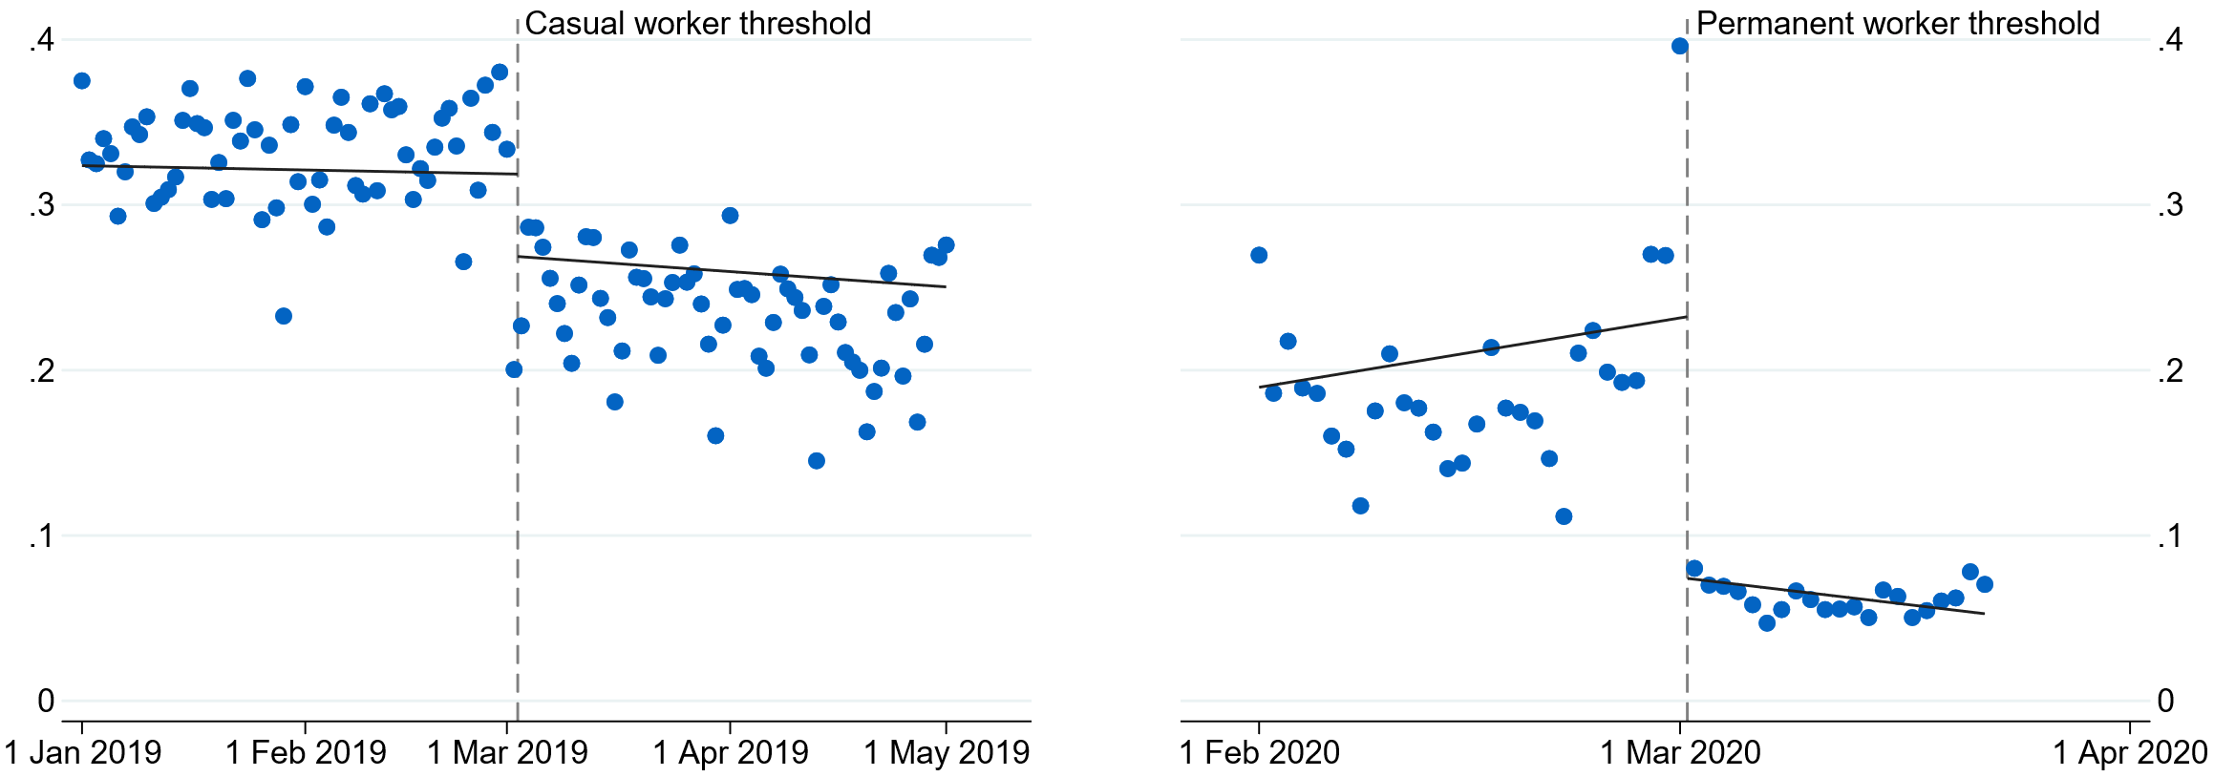
Panel B: Data after controlling for heaping
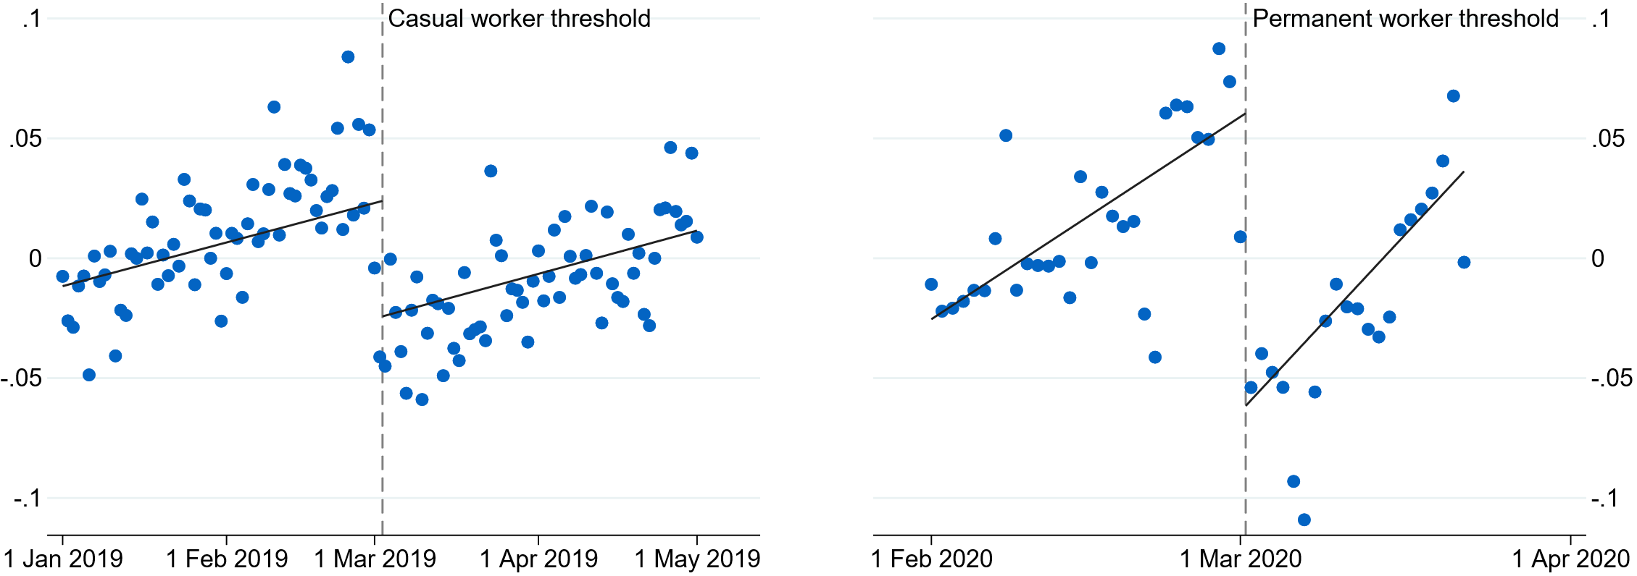
Note: Points represent one-day bins. Lines here are illustrative and not estimated for MSE-two optimal bandwidths, and therefore will not align perfectly with results reported in Table 1. In Panel B, data are residualised to control for heaping-induced bias, that is regressed against day of week, start of month and public holidays, with mean residuals plotted.

Figure 3: Discontinuities in employment probability during peak of crisis by start date
Panel A: Raw data
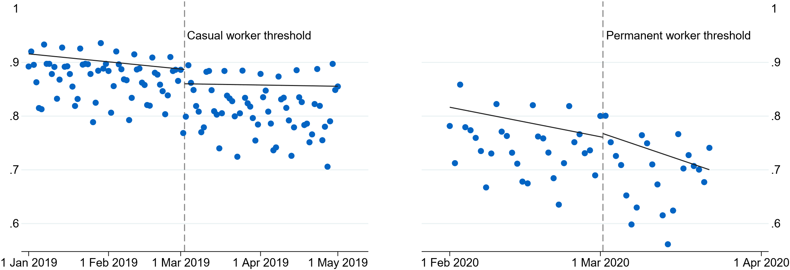
Panel B: Data after controlling for heaping
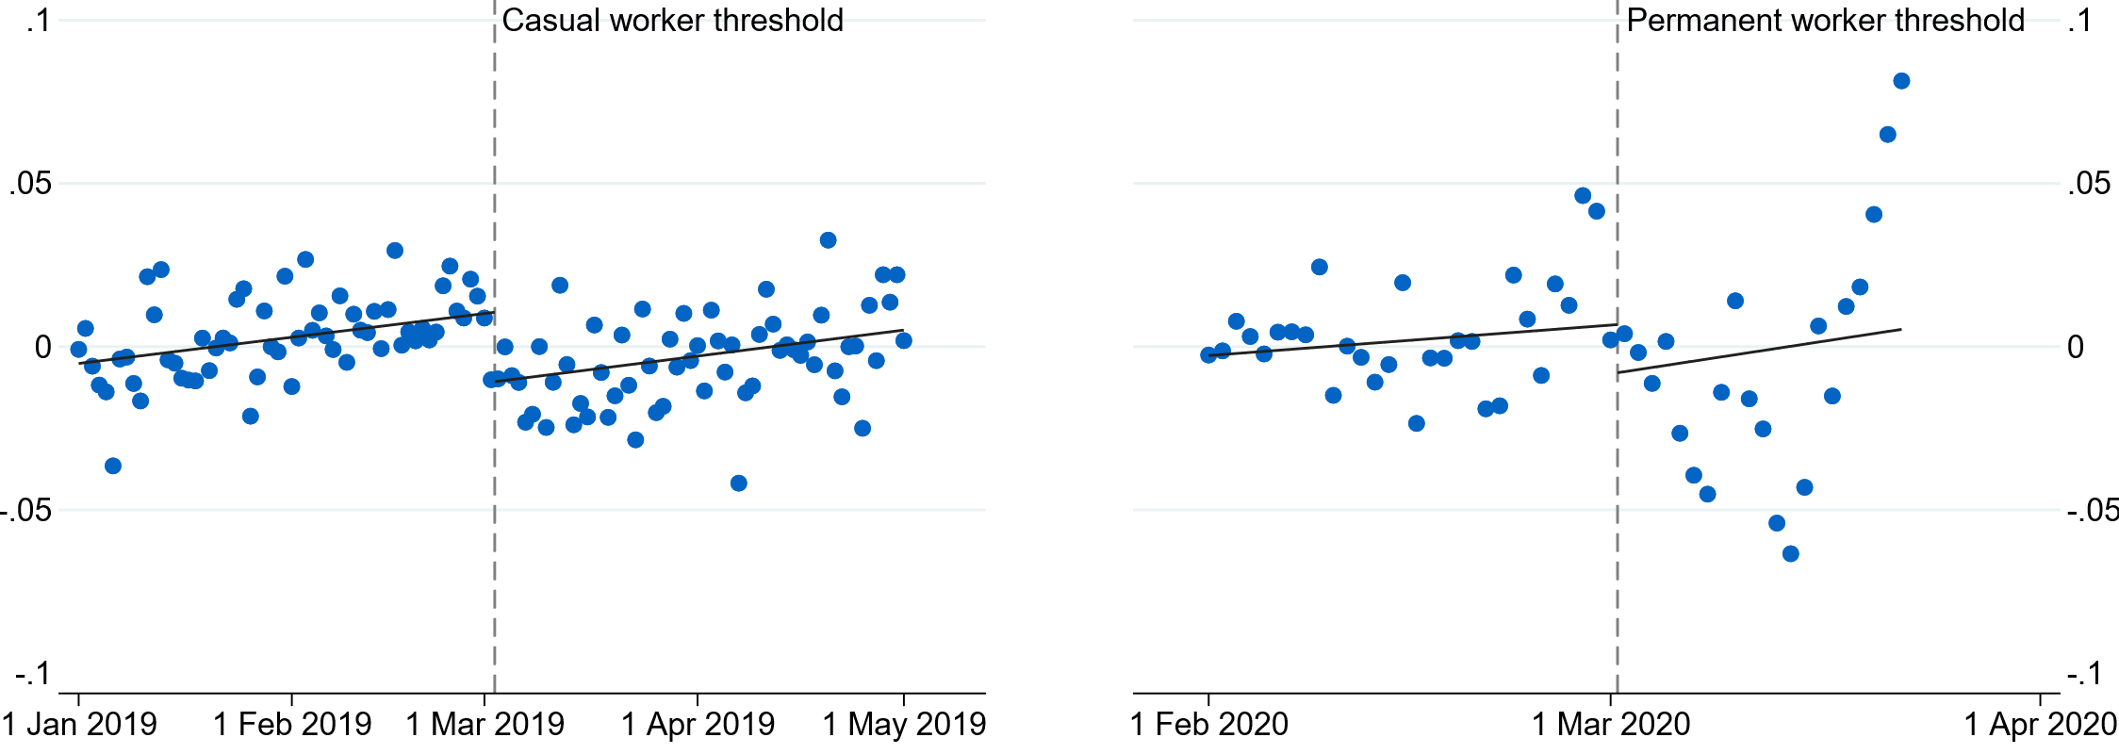

Note: Points represent one-day bins. Lines here are illustrative and not estimated for MSE-two optimal bandwidths, and therefore will not align perfectly with results reported in Table 1. In Panel B, data are residualised to control for heaping-induced bias, that is regressed against day of week, start of month and public holidays, with mean residuals plotted.

Table 1: Effect of having a start date after the casual or permanent cut-off on probability of JobKeeper receipt (first stage) and employment (reduced form)
 | Casual Cut-off | Permanent Cut-off
First Stage Estimate | -0.06156***  [0.000] | -0.16463***  [0.000]
F-Statistic (Cragg-Donald Wald) | 196.11 | 2573.29
Reduced Form Estimate (peak of crisis) | -0.02468***  [0.000] | -0.02771***  [0.000]
Number of observations | 2,292,101 | 281,382
Effective number of observations | 302,386 | 273,643
Note: Robust, bias-corrected p-values reported in square brackets. Optimal bandwidths for the casual cut off are 16 days to the left of the cut-off and 39 days to the right. For the permanent cut-off we impose bandwidths of 15 days either side. Statistical significance indicated as follows: * 10% level, ** 5% level, *** 1% level.

The effect of JobKeeper receipt on employees

The effect of JobKeeper receipt on employment
FigureFigure 3 4 shows the estimated treatment effects of JobKeeper receipt on the probability of being in paid employment in each JobKeeper fortnight for casual (left panel) and permanent (right panel) employees. This probability can be interpreted as the local average treatment effect of the policy for compliers – that is, employees otherwise eligible for JobKeeper whose start date just makes them eligible for the JobKeeper program.
Figure 4: Effect of JobKeeper receipt on probability of paid employment for casual (left panel) and permanent (right panel) employees, by fortnight
Notes: Dotted lines represent 95 per cent confidence intervals. Note that point estimates may not be perfectly centred within these intervals. The estimation begins 3 fortnights prior to JobKeeper implementation for our analysis of casual workers, and one fortnight prior for permanent workers. Optimal bandwidths for casual employees average 17 days to the left of the cut-off and 38 days to the right. For the permanent employees we impose bandwidths of 15 days either side.
For casual employees, we present the estimates for the 3 fortnights prior to the implementation of the program. These results show similar outcomes for eligible and non-eligible employees prior to the implementation of the program. However, we start to see a small effect on employment the fortnight before the policy was announced and implemented. This reflects the leading nature of our employment definition, with the effect disappearing when we use a simpler definition of paid employment (see Appendix Figure A1).
The effect of receiving JobKeeper on the probability of employment for casual employees peaks at 40 percentage points in the second fortnight of the JobKeeper program (Figure 4, left panel). This effect falls over the course of the program and by the ninth fortnight (starting 20 July 2020), it is no longer statistically different from zero. The decline in the effect of JobKeeper receipt likely reflects non-JobKeeper eligible employees returning to work as public health restrictions eased, businesses adapted and employment levels rebounded (Appendix Figure A7). By looking at an alternative definition of paid employment that excludes those working zero hours, we can further see that the effects were driven by employees being kept ‘on the books’. These results are shown in Appendix Figure A3.
The headline results are largely driven by strong initial effects in hard-hit industries, including Accommodation and Food Services, Arts and Recreation Services, and Retail (Figure 5, left panel). For Arts and Recreation Services, the peak estimate is in the range of 100 percentage points, with a lower bound of around 70 percentage points. This implies that very few to no casual ‘compliers’ in this sector who were ineligible for JobKeeper were in paid employment at the height of the national lockdown, though most regained employment relatively quickly as health restrictions eased. This is consistent with the closure of cultural institutions and suspension of sporting events and live music over this period, as the number of casual employees in Arts and Recreation Services fell by almost 70 per cent between March and May 2020 (see Appendix Figure A4).
Figure 5: Effect of JobKeeper receipt on probability of paid employment for casuals, by industry (left panel) and state (right panel)
Notes: Dotted lines indicate where the robust, bias corrected 95 per cent confidence intervals for the illustrated point estimates include zero.
Drilling down to a state level, we estimate that the effect of JobKeeper receipt remained elevated for a longer period in Victoria relative to the rest of Australia (Figure 5, right panel). This is likely due to the second lockdown implemented in Victoria (and not elsewhere in Australia), amongst other factors. When Victoria is excluded from the estimates, the effect of JobKeeper receipt on employment falls more sharply over the course of the program. This suggests that a strong effect of JobKeeper receipt during government-imposed lockdowns that wanes when economic activity is closer to typical levels.
Note that our peak estimate of the effect of JobKeeper receipt on the employment of casual employees of around 40 percentage points is higher than that in Bishop and Day (2020) of around 30 percentage points. It does, however, fall well within their estimated confidence interval of roughly 10 to 50 percentage points. Perhaps a more notable point of departure is our finding that the effect of JobKeeper receipt on non-zero hours worked is relatively modest: their effect is similar to their headline results, though again has a wide confidence interval that contains our more modest estimates. Past Treasury analysis has suggested that only a small proportion of JobKeeper recipient workers were employed on zero hours at the height of the recession (11.5 per cent, see Figure 15b, Australian Government 2021), yet among casual employees this proportion was plausibly much higher.
For permanent employees, we are unable to capture pre-trends because the cut-off point is so close to the policy’s announcement. The effect of JobKeeper receipt on the probability of employment reached 17 percentage points by mid-May 2020, a lower impact than that on casuals. However, the estimated impact on permanents remained significant over the remaining fortnights (Figure 4, right panel). The estimates increase slightly from mid-July 2020, primarily driven by Victoria (Appendix Figure A5). These were not driven by employees being kept ‘on the books’, with large effects on the probability of working positive hours (Appendix Figure A3). The more modest but prolonged effects for permanent employees may reflect the less flexible nature of these employment contracts, and their lower concentration in hard-hit industries, particularly Arts and Recreation and Accommodation and Food Services.
An important note of caution is that the findings for permanent employees are identified using employees who had very short tenures – mere weeks – when the COVID-19 pandemic escalated and restrictions on economic activity were introduced in Australia. These employees may have been in probationary stages of their employment contracts and would have been more vulnerable – we might expect JobKeeper to have had less of a direct effect when it came to preserving the jobs of longstanding permanent employees, who firms may have been reluctant to let go of.
A further concern with the permanent estimates may be that workers on the right-side of the cut-off had start dates up to 15 March 2020, around the time when the economic environment was changing rapidly. The Australian government announced the first social distancing measures on 18 March 2020 and closed borders to non-residents on 19 March 2020. Given these timelines, we set the bandwidth cut-off at 15 March 2020, to avoid contaminating our results. Visual inspection of mean outcomes in this window provides comfort that it is beyond this point that the characteristics of those employed change drastically (Figure 3).
To provide some sense of the size of these effects we scale up our estimates to provide an illustrative number of ‘jobs saved’, that is, the number of people in employment who would not have been employed but for their receipt of JobKeeper. JobKeeper was estimated to have covered some 3.1 million employees on average over its first 6 months. Based on a small subsample in the tax data for whom we can observe permanent and casual status, around 76 per cent of these appear to be permanent employees while 24 per cent appear to be casual employees. As a back-of-the-envelope exercise, we estimate lower and upper bounds on the jobs saved by JobKeeper by assuming either no effect on permanent employees (the vast majority of whom would not have been recent hires) and or an effect that is equal to that felt by recent hires. This yields an estimate of the jobs saved by JobKeeper that ranges from 300,000 to 700,000 in mid-to-late April 2020, before falling to zero to 400,000 by late September 2020. This is consistent with the estimate of at least 700,000 jobs saved during the early stages of JobKeeper from Bishop and Day (2020), but also picks up the subsequent falls in the effect of JobKeeper as restrictions were lifted and the economy rebounded.

Long-run effects of JobKeeper receipt
We now provide a preliminary view on the long-run direct effects of JobKeeper receipt on an individual’s probability of employment. Estimating the employment effects of JobKeeper receipt in its later phases is complicated by the shift in the start date thresholds for employee eligibility, as noted in Section 2. Hence we examine effects in one of 2 fortnights following the end of the program – either the fortnight ending 24 April 2021 or the fortnight ending 22 May 2021. These fortnights were chosen as the only 2 fortnights following the end of the program and before Australia’s Delta wave that were not affected by idiosyncratic state lockdowns.
We explore 2 outcome variables – indicators for an individual being in paid employment and for remaining with their original pre-COVID-19 employer. This allows us to examine the effects of JobKeeper receipt on employment and job mobility. The specification is as in the earlier regressions – a fuzzy regression discontinuity design – and will identify the local average treatment effect of the first phase of JobKeeper. Some of those treated by JobKeeper in its first 6 months will not have been in receipt of JobKeeper over the subsequent 6 months and similarly some not treated will have received JobKeeper subsequently. Table 2 presents the results of this exercise, shown for each of the 2 fortnights, for casual and permanent workers and each of the 2 outcome variables.
While the employment effects of JobKeeper receipt in the preceding subsection appeared more lasting for permanent workers, they had dissipated by the end of the program. In both fortnights the effect of JobKeeper on the employment of permanent employees is small and not statistically different from zero. This is a precisely estimated null result: in particular, we can rule out with 95 per cent confidence that JobKeeper receipt increased the probability of employment of these newly hired permanents by more than 4 percentage points for the fortnight ending 24 April 2021 (and 3 percentage points for the fortnight ending 22 May 2021).
JobKeeper receipt has, however, had a lasting effect on the jobs held by permanent workers – they are around 9–12 percentage points less likely to have a new job. The consequences of this reduced mobility are unclear, hinging on the extent to which JobKeeper acted to preserve relatively more productive matches more than it preserved relatively unproductive ones. For example, Andrews et al (2020) showed that the policy disproportionately protected highly productive jobs and firms in initials stages, though likely became more distortionary over time as the economy recovered and firms adjusted. Of course, this lost mobility may subsequently be unwound through ‘catch-up’ mobility and would be valuable to revisit after more time has passed.
Interestingly, for casuals there is, if anything, suggestive evidence that JobKeeper led to a lower probability of employment following the end of the program. This could potentially reflect an income effect due to the effective wage floor introduced by the program – the above-replacement rate of JobKeeper income support was noted in early reviews of the program and (partially) addressed in its later phases (Australian Government 2020). Indeed, Treasury analysis of administrative data has highlighted that incomes for the bottom quintile of the income distribution were around 20 per cent higher than their March 2020 levels over the final 3 quarters of 2020 (Australian Government 2021). This reflected JobKeeper and other welfare payments more than replacing lost earnings for this group. Further examination of the robustness of this finding and the potential income effect it highlights would be a valuable extension to this paper.

Table 2: Effect of JobKeeper receipt on paid employment and job mobility for casual and permanent employees, for given post-JobKeeper fortnights
 | Employed | New job
Casual employees
Apr-21 | -0.1320  [0.1112] | 0.0544  [0.2768]
May-21 | -0.1470**  [0.0408] | 0.0436  [0.4344]
Number of observations | 2,292,101 | 2,292,101
Permanent employees
Apr-21 | -0.0436  [0.463] | -0.0947***  [0.000]
May-21 | -0.0568  [0.243] | -0.116***  [0.000]
Number of observations | 275,291 | 275,291
Note: Robust, bias-corrected p-values reported in square brackets. Optimal bandwidths for the casual employees range from 17–19 days to the left of the cut-off and 37–45 days to the right of the cut off. For the permanent cut-off we impose bandwidths of 15 days either side. Statistical significance indicated as follows: * 10% level, ** 5% level, *** 1% level.

Robustness tests
A common concern in regression discontinuity settings is whether agents can manipulate the running variable and hence select in or out of treatment. As has been noted, the institutional setting and design of JobKeeper make this kind of manipulation highly unlikely. JobKeeper was announced on 30 March 2020, well after the start date thresholds for permanent and casual employees. The vast majority of firms in our data had already reported the start dates of their potentially eligible employees through the STP system by the time the policy was announced.
The standard test for manipulation in regression discontinuity designs – based on density discontinuity – is not well suited to our setting due to the heaping in the running variable. Strong day of week effects make the density of the running variable inherently discontinuous. Despite some first-of-month and seasonal impacts remaining, aggregating to start-weeks provides visual evidence that there is no discontinuity in start-dates around the start date threshold for casuals (See Appendix Figure A6).
While manipulation thus seems unlikely to be a concern, other factors may result in discontinuities in background characteristics around the thresholds. For example, if employees with more secure occupations had preferences to start new jobs towards either end of months or quarters then this could create discontinuities not apparent in the heaping. This would be somewhat analogous to the non-random variation in parental characteristics by season of birth observed in Buckles and Hungerman (2013), driven by women differing in their preferences for season of birth. A range of factors could drive such preferences, such as a desire for a salient break between workplaces or to be present for (or avoid) particular peaks or troughs in work. To examine whether this is a cause for concern, we conduct balancing tests where we look for evidence of discontinuities in a wide range of predetermined outcomes.
The results of the balancing test are in Appendix B. While most covariates are not statistically different either side of the cut-off, there is some evidence of modest imbalances. For example, workers starting just on or after 2 March 2020 are slightly less likely to be employed in Accommodation and Food Services, which might contribute to some upward bias in our estimates of the effect of JobKeeper given this was a harder-hit industry. While the imbalance in covariates around the threshold is a potential concern, we take comfort from the relatively modest size of these discontinuities. We also see strong effects of the program when we limit our analysis to specific industries, including Accommodation and Food Services. Further, while the COVID-19 pandemic began to weigh on employment levels through March 2020 (Appendix Figure A7), the discontinuity around the threshold only opens up once JobKeeper takes effect. Thus, to the extent there is any imbalance either side of the panel, it seems unlikely to significantly bias our estimates.
A more fundamental question around our results concerns their external validity. As discussed in preceding sections, our estimates are inherently local. It could be that our estimates are an accurate estimate of the treatment effect for casual workers with around a year’s tenure and newly hired permanent workers, but not suitable for application to newly hired casual workers or longstanding permanent employees. The latter concern in particular seems relevant and has been reflected in our bounding of the number of jobs saved by the program.
Another concern is that there might be substantial spillovers, violating the stable unit treatment value assumption (SUTVA). It certainly seems plausible that worker outcomes might depend not just on their JobKeeper treatment status, but on that of their colleagues. Having more colleagues receiving JobKeeper could either worsen or improve an individual’s employment outcomes, depending on whether their labour is substitutable or complementary to the subsidised labour of their colleagues. SUTVA concerns can arise in numerous settings, and there several ways of addressing them (see Morgan and Winship 2007). For example, we can maintain the validity of our earlier results if we consider them as relating to only small changes in treatment status. But for our purposes, where it is the aggregate impact of JobKeeper that is of most interest, this is too restrictive. Hence we turn to firm-level data to explore whether substantial spillovers are present. While this still leaves broader confidence and general equilibrium effects unexamined, we expect these to be positive.

The effect of JobKeeper receipt on firm employment
A notable feature of the JobKeeper program over its first 6 months is that the support provided to a firm was directly proportional to their number of eligible employees: firms received a flat $1,500 a fortnight for each eligible employee. Thus, we can consider the effect of JobKeeper at a firm level by looking at the intensity of treatment. The idea is to establish whether the worker-level results earlier also play out at a firm level. Do firms with a greater share of employees in JobKeeper have even higher employment levels than the earlier results might suggest due to positive spillovers? Or are their employment levels lower than expected, as they substitute from ineligible to eligible employees? If our results have reasonable external validity, we should see similar results to those obtained in the previous section. In this analysis we draw on variation in firm employment levels, including those firms that cease employing, and hence also capture the effect of firm closures.

Empirical framework
The fuzzy RDD used earlier for assessing the impact of JobKeeper treatment for individuals has a natural instrumental variable equivalent at the firm level. In the individual-level fuzzy RDD analysis, we exploited a sharp change in the individual probability of JobKeeper treatment as individual start date crossed the relevant thresholds and looked for a corresponding change in employment outcomes at the same thresholds. In a firm-level analysis, we can similarly exploit a sharp change in the relationship between the intensity of JobKeeper treatment and the proportion of a firm’s workforce with given start weeks and again look for a change in employment outcomes at the same threshold. We focus on the casuals threshold, given this allows us to consider start weeks over a much wider window, lifting our ability to detect any effects of JobKeeper relative to the much narrower windows over which the permanents threshold can be examined.
Our target regression is of the form:
- $y_{j}=α_{j}+β JK_{j}+γX_{j}+ε_{j}$
where $y_{j}$ is the headcount of firm j, expressed as a proportion of baseline headcount in the fortnight ending 1 March 2020. To reduce the influence of extreme growth driven by firms with low baseline headcount we drop observations where headcount more than doubles (around 3 per cent of observations). This headcount is regressed on fixed effects for the interaction between firm industry (at the ANZSIC 4-digit level) and baseline headcount, and a set of control variables capturing the characteristics of the baseline headcount – namely the proportions casual, part-time, full-time, in various age groups (in years: 15–19; 20–24; 25–64; 65–99), female, with children and primary or secondary earners (as well as the proportions missing this information). Our key independent variable is the proportion of the firm’s baseline headcount that later receive JobKeeper ($JK_{j}$), which we refer to as JobKeeper intensity. Again, we repeatedly estimate this equation across JobKeeper fortnights to estimate impacts over time.
A straightforward estimation of (4) via OLS is likely to be biased due to the endogeneity of a firm’s JobKeeper intensity. Namely, JobKeeper intensity will be a function of some features of a firm’s workforce – such as their share of casual status employees – that we do not observe here, but that may also matter for employment outcomes during a downturn. As such we instrument for JobKeeper intensity as follows:
- ${JK}_{j}=α_{j}+β_{1} π_{cas,[-T,T]}+β_{2} π_{cas,[0,T]}+β_{3} μ_{ cas,[-T,0)}+β_{4} μ_{ cas,[0,T]}+γX_{j}+ε_{j}$
where $π_{cas,[-T,T]}$ is the proportion of the firm’s baseline headcount that are casuals with start dates in the window [-T,T] (where the tenure threshold is at 0); and we also control for a linear trend in the relationship between tenure and JobKeeper eligibility by including the mean tenure of casual workers in the window, and allowing it to vary either side of the threshold ($μ_{ cas,[-T,0)}$, $μ_{ cas,[0,T]}$). Our exogenous instrument is $π_{cas,[0,T]}$, the proportion of the firm’s baseline headcount that are casuals with start dates that would exclude them from JobKeeper. Following this first stage regression, the second stage regression is simply:
- $y_{j}=α_{j}+β\hat{ JK_{j}}+γ{\tilde{X}}_{j}+ε_{j}$
where ${\tilde{X}}_{j}$ includes the baseline workforce characteristics described earlier, as well as the included instruments introduced above (but not the excluded instrument is $π_{cas,[0,T]}$). We estimate (6) via 2-stage least squares. To make the results more comparable to those of the earlier individual-level results, we weight by the baseline headcount of the firm.

Results – the effects of JobKeeper on firm employment
We begin with an illustration of the first stage and reduced form results that mimics the binned scatter plots motivating a traditional RDD analysis, like those in the last section. First, we regress firm JobKeeper intensity $JK_{j}$ (and subsequently headcount $y_{j}$) on the same set of industry-size fixed effects and baseline workforce characteristics ($X_{j}$) noted above, but also the proportion of the baseline headcount identified as casual and with a start date in week t, where t=0 is the week beginning 2 March 2019. We allow t to extend to 26 weeks either side of the threshold. This regression is simply:
- $JK_{j}=α_{j}+\sum_{t=-26}^{25}{β_{t}}π_{cas,t}+γX_{j}+ε_{j}$
In Figure 6 we present the $β_{t}$ coefficients for the fortnight ending 10 May 2020, the peak of the individual-level JobKeeper effects. We also show a line of best fit either side of the threshold.
Figure 6: Association between firm JobKeeper intensity (left) or headcount relative to pre-COVID levels (right) and employee start dates: fortnight ending 10 May 2020
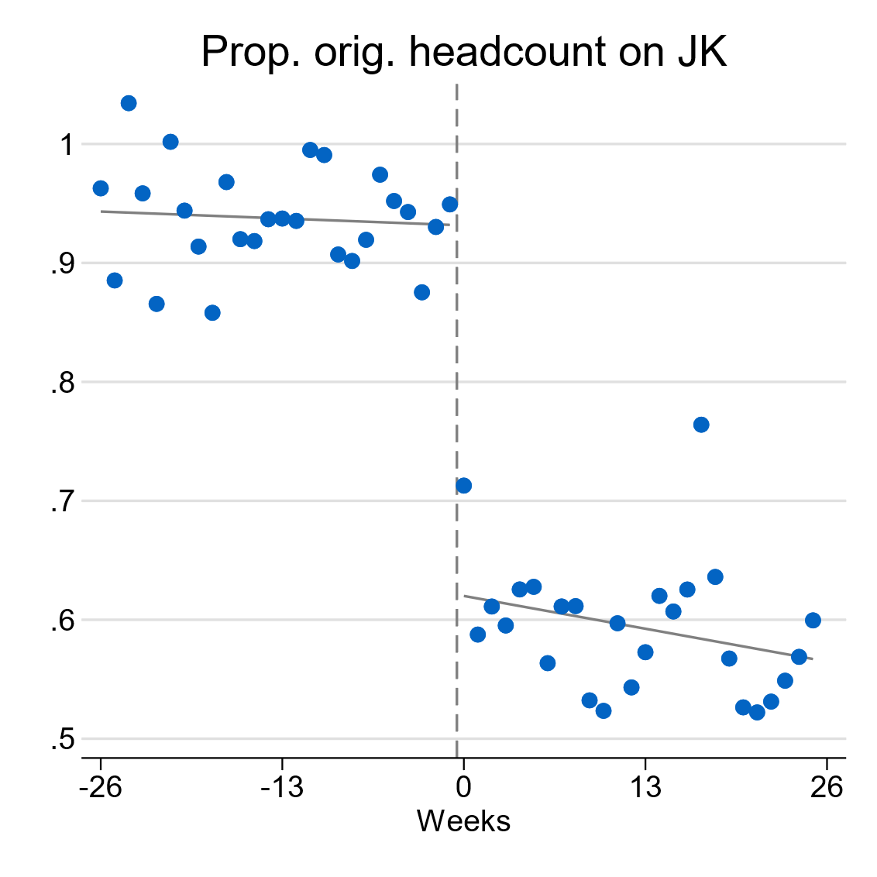 | 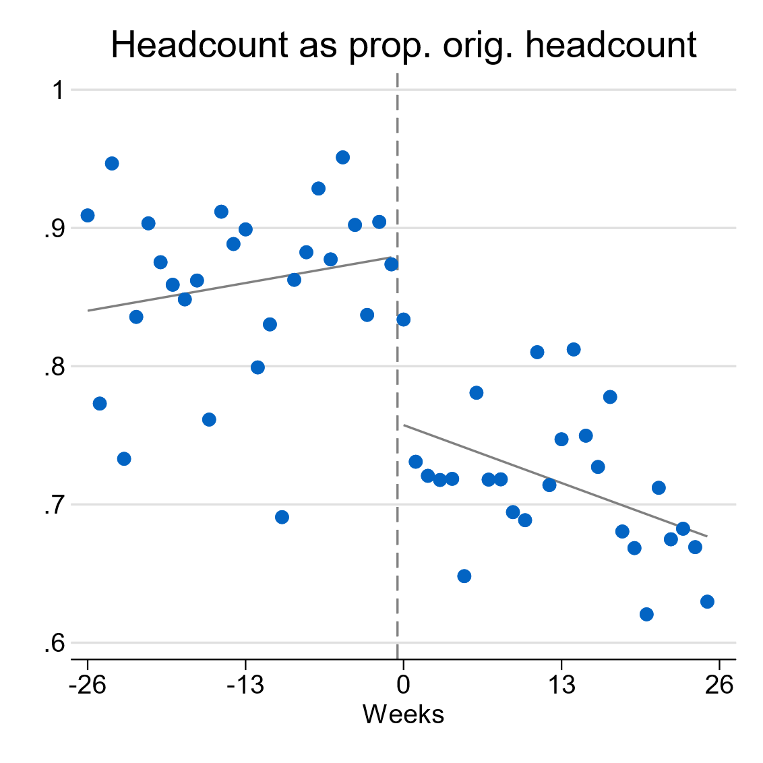
Note: Shows the $β_{t}$ coefficients from equation (7). This can be interpreted as the expected firm outcome from having all its workforce identifying as casual and employed in the given week. These expected outcomes may lie outside the domain of observed outcomes, for example, no firm has a proportion of more than one of its original headcount on JobKeeper in the underlying data. Week zero is the week beginning 2 March 2019.
Figure 6 shows that employee start dates had a large effect on a firm’s JobKeeper intensity (left panel). For a firm with all its workforce reporting as casuals with start dates in the week ending 1 March 2019, we would expect a JobKeeper intensity of a little over 90 per cent. That is, 90 per cent of the firm’s baseline headcount would end up receiving JobKeeper. This falls sharply to 60 per cent for the same firm with the same workforce starting in the following week. The fall is not sharp (from 100 to 0 per cent) as some casuals eligible on the basis of their start date will not be eligible on other grounds, while measurement error in reported casual status might mean some of those with start dates after the cut-off did receive JobKeeper (as they were actually eligible permanent employees).
Figure 6 also shows evidence of a discontinuity in the association between start dates and firm headcounts at the threshold at the height of the crisis. Firm headcounts fall from about 87 per cent to about 75 per cent of their baseline levels as we cross the start date threshold. In Appendix Figures A8 and A9 we replicate Figure 6 for the fortnight before the introduction of JobKeeper (the fortnight ending 30 March 2020) and the last fortnight of the program (ending 28 September 2020). In both cases there is little evidence of a discontinuity in firm headcount. This is despite the fact that employment levels had already begun to fall in the fortnight ending 30 March 2020.
We now switch to the IV estimates of the effect of JobKeeper intensity on firm-level employment. Figure 7 shows these estimates, alongside the individual-level results explored earlier (Figure 4). There is little effect of JobKeeper before the program begins, but a large effect subsequently emerges that is broadly consistent with the individual level effects estimated earlier. At its peak, a firm with all its baseline workforce eligible for JobKeeper is estimated to have had a headcount as a percentage of baseline headcount that was around 40 percentage points higher. This is only somewhat below the individual-level results, and well within the confidence bands. Following the height of the crisis, the firm-level effects of JobKeeper also fall away and lose statistical significance by the end of the period.
Figure 7: Individual- and firm-level effects of JobKeeper on employment
Note: Shows the estimated coefficient and 95% confidence interval on JobKeeper intensity in equation (6) when instrumented as in equation (7). Individual-level effects are from Figure 4.
In Appendix Figure A10 we show this pattern of findings is not particularly sensitive to the bandwidth chosen – across a range of choices the firm-level effects peak at 40–50 percentage points before falling away towards the end of the program.
In summary, while the individual-level results could in theory have been substantially over- or under-stated in the presence of spillovers to ineligible workers, firm-level results suggest these spillovers are likely modest at best. While the 2 approaches have, by necessity, somewhat different methods and will be estimating different local average treatment effects, the fact that they broadly align over a variety of specifications provides some comfort with respect to this finding.

Conclusion
Job retention schemes have been a ubiquitous policy response to the COVID-19 pandemic and will likely be revisited in the face of future economic shocks. Understanding their effects is important to inform such policy responses. In this paper, we provide highly credible evidence on the effect of one such scheme – Australia’s JobKeeper program – by drawing on design features that lend themselves to a fuzzy discontinuity design and broader instrumental variables approach.
We find that JobKeeper had a substantial effect on employment, lifting the probability of employment for casuals by around 40 percentage points and for newly hired permanent workers by around 20 percentage points at the height of the recession. These effects were even more pronounced in states and industries most affected by lockdowns during the program’s first 6 months. Depending on how we map these results to the broader population, our findings suggest that JobKeeper directly preserved between 300,000 to 700,000 jobs in early 2020.
Despite these findings, the direct effect of JobKeeper receipt in preventing labour market scarring is more nuanced. It is only for permanent employees that JobKeeper receipt had a detectable effect on employment probabilities 6 months into the program, and even this effect dissipated by the end of the program one year later, though these workers are more likely to be with their original employer. In short, the strength of the economic recovery saw ineligible casual workers return to employment in their old jobs relatively quickly, while ineligible permanent workers were able to find new roles over the course of the year. Future work could examine the indirect role of JobKeeper in supporting these outcomes via supporting viable firms and a strong labour market recovery.
Finally, for a program of the scale and generosity of JobKeeper broader general equilibrium effects need to be considered: we consider only effects within the firm in this paper. Firms faced strong incentives to productively employ JobKeeper workers rather than simply furloughing them – an incentive that could have either lifted or lowered the hours of ineligible workers, depending on their complementarity with eligible workers. We find little evidence for large spillovers in either direction. When estimated at a firm-level, the effect of JobKeeper on casual employment is within the range of estimates derived from individual-level results. Broader general equilibrium effects are likely substantial but are left for future work: they would likely depend more on the general incidence of the fiscal stimulus provided by the program rather than its design as a job retention scheme which is the focus of this paper’s evaluation.

References
Andrews, D, E Bahar and J Hambur (2021), “The COVID-19 shock and productivity-enhancing reallocation in Australia: Real-time evidence from Single Touch Payroll”, OECD Economics Department Working Paper No. 1677.
Autor, D., Cho, D., Crane, L.D., Goldar, M., Lutz, B., Montes, J., Peterman, W.B., Ratner, D., Villar, D., and Yildirmaz, A., 2020. An Evaluation of the Paycheck Protection Program Using Administrative Payroll Microdata. MIT Working Paper, July 22, 2020.
Australian Bureau of Statistics, July 2020. Labour Force, Australia, ABS website, accessed 3 December 2021.
Australian Bureau of Statistics, May 2021. Weekly Payroll Jobs and Wages in Australia, ABS website, accessed 27 May 2021.
Australian Bureau of Statics, September 2020. Weekly Payroll Jobs and Wages in Australia methodology, ABS website, accessed 25 November 2021.
Australian Government, 2020a. Economic and Fiscal Update, Australian Government, Canberra.
Australian Government, 2020b. The JobKeeper Payment: Three-month review, The Treasury, Canberra.
Australian Government, 2021. Insights from the first six months of JobKeeper, The Treasury, Canberra.
Balleer A, B Gehrke, B., Lechthaler, W. and Merkl, C., 2016. Does Short-Time Work Save Jobs? A Business Cycle Analysis. European Economic Review, 84, pp. 99–122.
Barreca, A.I., Guldi, M., Lindo, J.M. and Waddell, G.R., 2011. Saving babies? Revisiting the effect of very low birth weight classification. The Quarterly Journal of Economics, 126(4), pp.2117–2123.
Barreca, A.I., Lindo, J.M. and Waddell, G.R., 2016. Heaping‐induced bias in regression‐discontinuity designs. Economic Inquiry, 54(1), pp.268–293.
Bishop, J., and Day, I. (2020) “How Many Jobs Did JobKeeper Keep”, Reserve Bank of Australia, Research Discussion Paper 2020–07.
Boeri, T., Bruecker, H., Fuchs-Schündein, N., & Mayer, T. (2011). Short-time work benefits revisited: Some lessons from the Great Recession. Economic Policy, 26(68), 697–765.
Buckles, K.S. and Hungerman, D.M., 2013. Season of birth and later outcomes: Old questions, new answers. Review of Economics and Statistics, 95(3), pp.711–724.
Calonico, S., M. Cattaneo, and R. Titiunik (2014). Robust Nonparametric Confidence Intervals for Regression-Discontinuity Designs. Econometrica 82 (6), 2295–2326.
Calavrezo, O., Duhautois, R. and Walkowiak, E., 2009. The Short-Time Compensation Program in France: An Efficient Measure against Redundancies?
Calavrezo, O., Duhautois, R. and Walkowiak, E., 2010. Short-time compensation and establishment exit: an empirical analysis with French data.
Cattaneo, M.D., Idrobo, N. and Titiunik, R., 2019. A practical introduction to regression discontinuity designs: Foundations. Cambridge University Press.
Chetty R., Friedman, J.N., Hendren, N., Stepner, M., and The Opportunity Insights Team, 2020. How Did COVID-19 and Stabilization Policies Affect Spending and Employment? A New Real-Time Economic Tracker Based on Private Sector Data. NBER Working Paper No 27431.
Hijzen, A. and Martin, S., 2013. The Role of Short-Time Work Schemes during the Global Financial Crisis and Early Recovery: A Cross-Country Analysis. Institute for the Study of Labor, IZA Discussion Paper No 7291.
Hijzen, A and Venn, D., 2011. The role of short-time work schemes during the 2008–09 recession. OECD Social, Employment and Migration Working Papers, 2011(115).
Hubbard, G. and Strain, R. M., 2020. Has the Paycheck Protection Program Succeeded? BPEA Conference Draft, Fall.
Kennedy, S. 2022. A tale of two crises: reflections on macroeconomic policy responses to the GFC and the pandemic. The 2022 Sir Leslie Melville Lecture. ANU, Canberra.
Kopp, D. and Siegenthaler, M. 2018. Does Short-Time Work Prevent Unemployment? Swiss Economic Institute, KOF Studies No 106.
Kruppe, T. and Scholz, T., 2014. Labour hoarding in Germany: employment effects of short-time work during the crises,” Technical Report, IAB Discussion Paper.
Lydon R., Mathä, T.Y. and Millard, S., 2018. Short-Time Work in the Great Recession: Firm-Level Evidence from 20 EU Countries. Central Bank of Ireland Research Technical Paper, 2018(13).
Organisation for Economic Co-operation and Development (OECD), 2020. Job retention schemes during the COVID-19 lockdown and beyond.
Watson, T., Tervala, J. and Sainsbury, T. 2022 The JobKeeper payment: How good are wage subsidies? Centre for Applied Macroeconomic Analysis Working Paper 2022–36.

Appendix A: Additional charts
Figure A1: Effect of JobKeeper receipt on probability of paid employment for casual employees, by fortnight: simple and adjusted employment definitions
Note: Dotted lines represent statistical insignificance at 95% confidence intervals for robust, bias corrected standard errors. Simple definition considers someone as in paid employment if they accrued any pay from any job in a fortnight. The adjusted definition, which underlies our baseline results, counts someone as employed if this is not the case but pay is subsequently accrued in one of the following 2 fortnights.
Figure A2: Employment effects for casuals: by fortnight, by bandwidth in weeks (LHS); and in fortnight ending 10 May 2020, by bandwidth in days (RHS)
Note: Dotted lines on left panel represent statistical insignificance at 95% confidence intervals for robust, bias corrected standard errors. Dotted lines on right panel represent conventional 95% confidence intervals.
Figure A3: Effect of JobKeeper receipt on probability of working non-zero hours for casual (left panel) and permanent (right panel) employees, by fortnight
Notes: Dotted lines represent 95 per cent confidence intervals. Note that point estimates may not be perfectly centred within these intervals. The estimation begins 3 fortnights prior to JobKeeper implementation for our analysis of casual workers, and one fortnight prior for permanent workers. Optimal bandwidths for casual employees average 17 days to the left of the cut-off and 38 days to the right. For the permanent employees we impose bandwidths of 15 days either side.
Figure A4: Persons employed in Arts and Recreation Services in February and May 2020, by casual employee status
Source: ABS Labour Force, Australia, Detailed
Figure A5: Effect of JobKeeper on probability of paid employment for permanent employees, by state
Note: All estimates statistically significant at the 5% level. Bandwidths of 15 days either side of the cut-off.
Figure A6: Count (‘000s) of observed employees by start week either side of the casual employee cut-off for JobKeeper eligibility
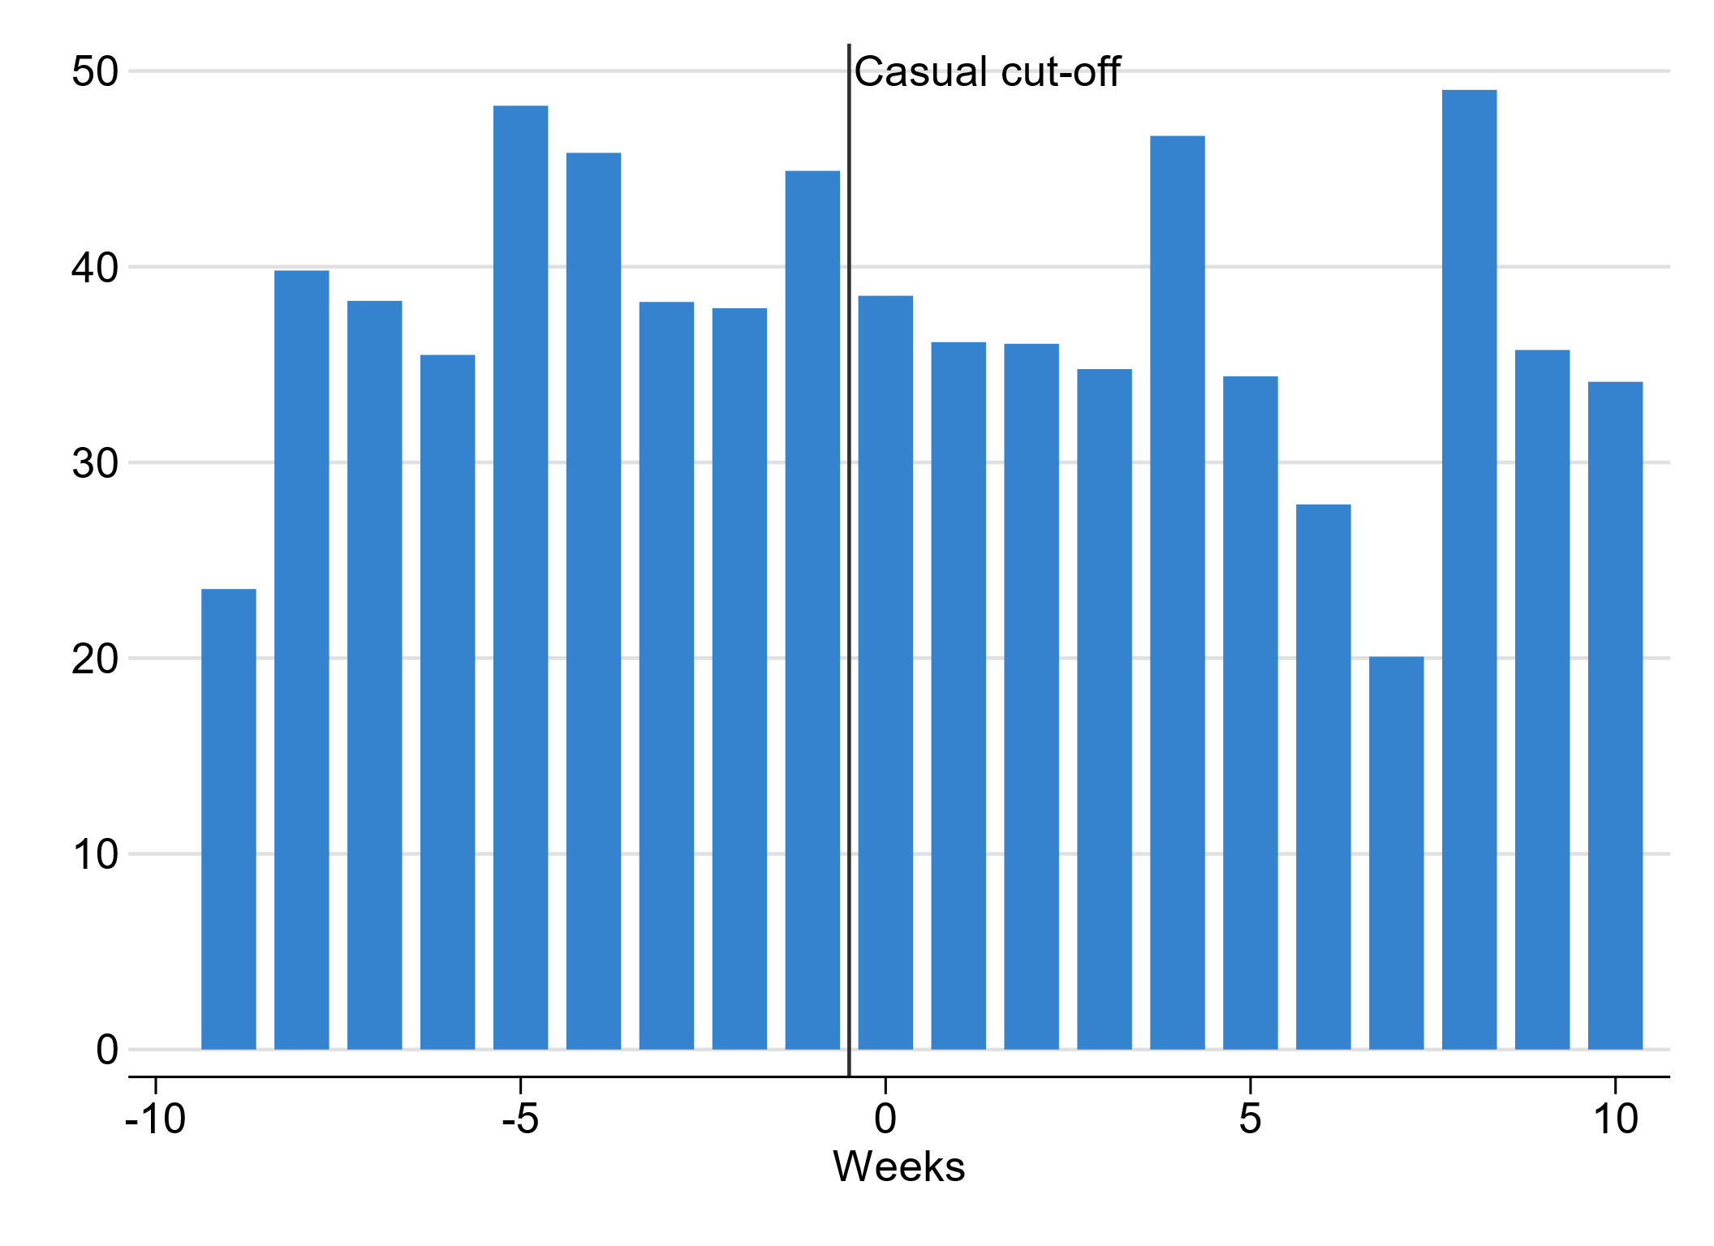
Note: While there is a modest peak in the density to the left of the cut off, this is associated with the regular first of the month peak in start dates, and is no more pronounced than other weeks containing such firsts of the month.
Figure A7: Payroll jobs as a percentage of pre-COVID-19 levels
Source: ABS Weekly Payroll Jobs and Wages in Australia; ABS Labour Force, Australia
Note: ABS Labour Force reflects employment levels, while ABS Weekly Payroll and Jobs reflects number of jobs.
Figure A8: Association between firm JobKeeper intensity (left) or headcount relative to pre-COVID levels (right) and start dates: fortnight ending 30 March 2020
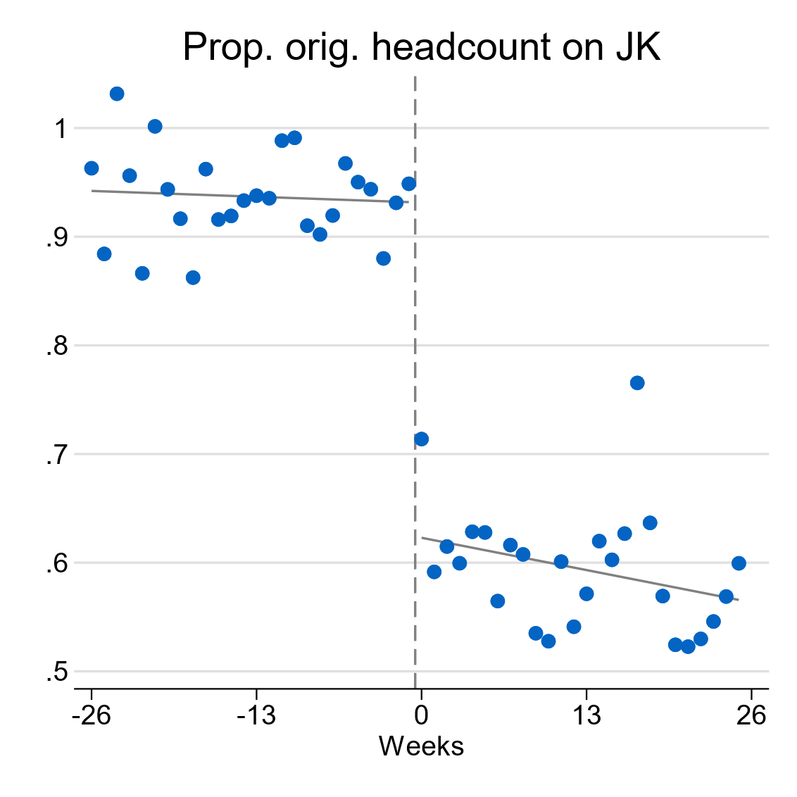 | 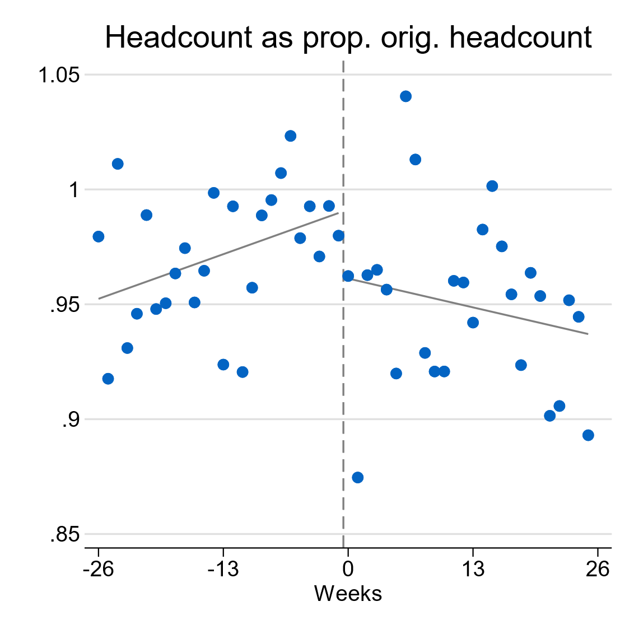
Note: Shows the predicted values from estimation of equation (7) for a typical firm that has all its workforce as casuals in the given start week. Week zero is the week beginning 2 March 2019.
Figure A9: Association between firm JobKeeper intensity (left) or headcount relative to pre-COVID levels (right) and start dates: fortnight ending 28 September 2020
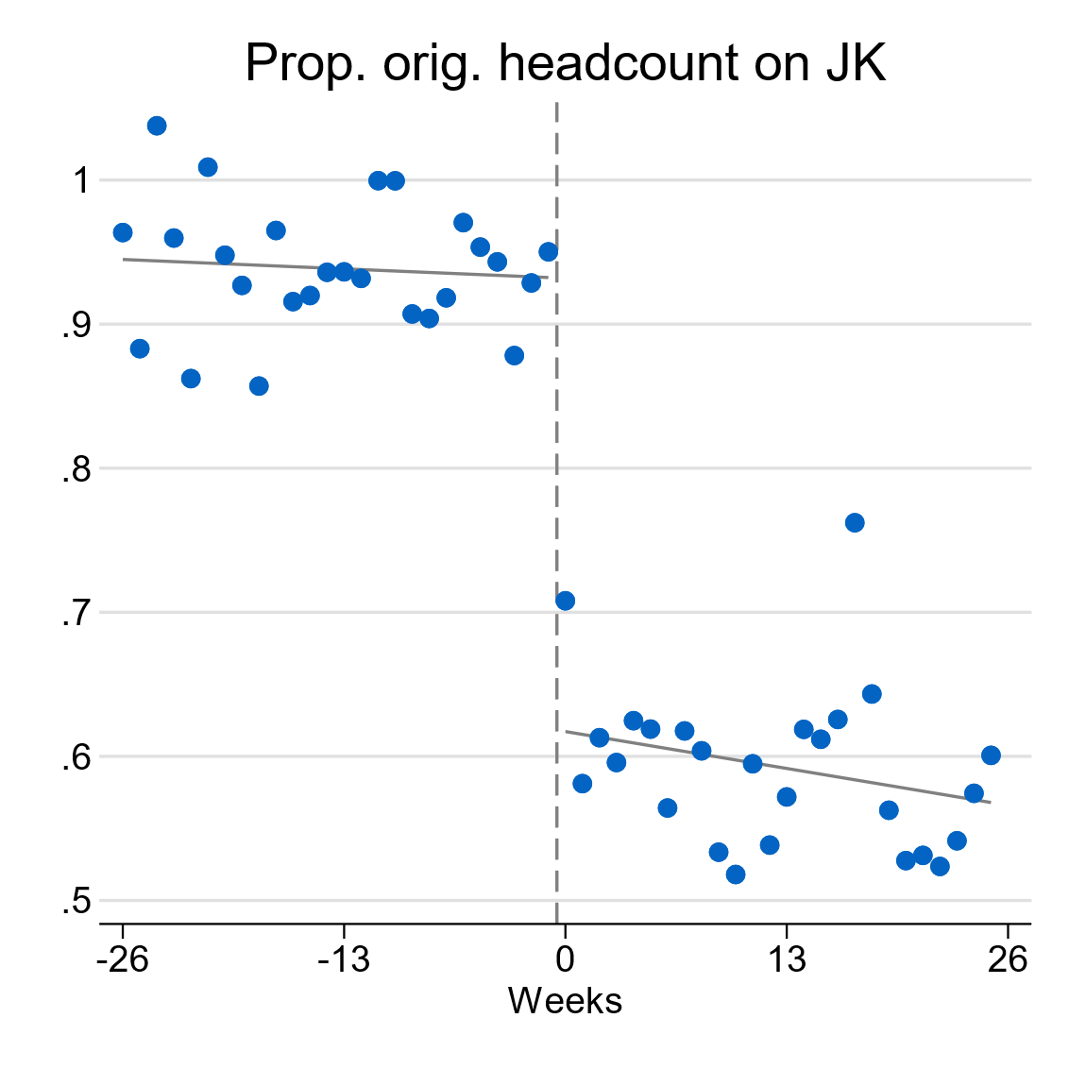 | 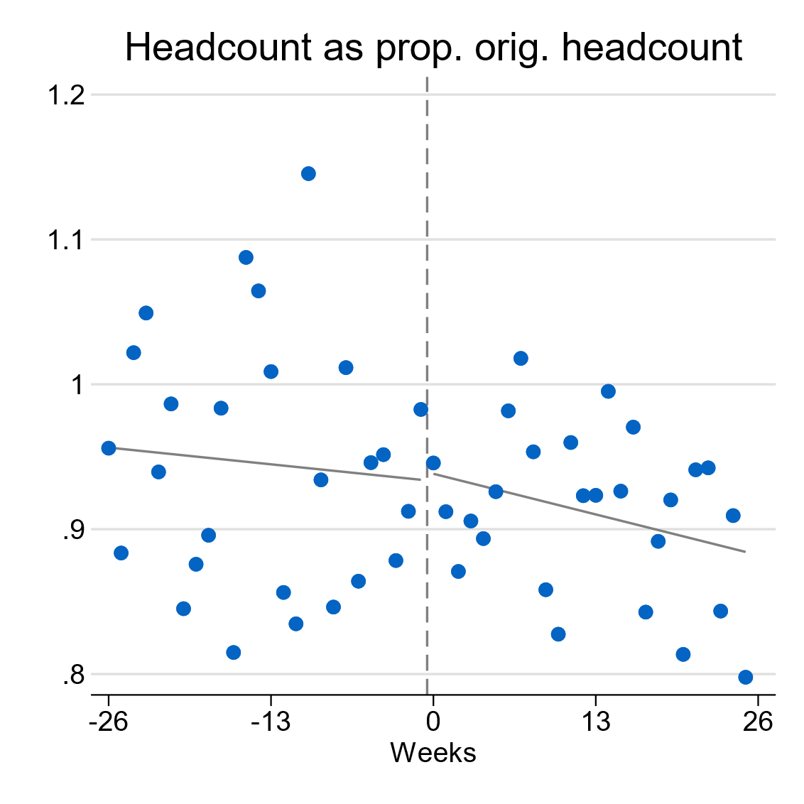
Note: Shows the predicted values from estimation of equation (7) for a typical firm that has all its workforce as casuals in the given start week. Week zero is the week beginning 2 March 2019.
Figure A10: Firm-level effects of JobKeeper on employment, by various bandwidths
Note: Shows the estimated effect of JobKeeper intensity on firm headcount relative to baseline. Estimates derived from a regression of relative headcount on industry-size fixed effects, controls for baseline workforce characteristics and JobKeeper intensity is instrumented for using the proportion of the baseline workforce that is casual and has a start date to the right of the cut off. Point estimates shown over JobKeeper fortnights and for varying bandwidths.

Appendix B: Additional tables
Table A1: Balance tests – ‘effect’ of JobKeeper on predetermined covariates
Outcomes | Casual cut-off | Permanent cut-off
Sex (Female=1) | -0.0113 | -0.0060
 | (-0.0217,-0.0028) | (-0.025,0.0063)
Industry
Agriculture, Forestry and Fishing | 0.0006 | 0.00530
 | (-0.0011,0.0036) | (-0.0009,0.0108)
Mining | -0.0041 | -0.0025
 | (-0.007,-0.0024) | (-0.004,0.0032)
Manufacturing | 0.0009 | 0.0030
 | (-0.0036,0.0056) | (-0.0073,0.0073)
Electricity, Gas, Water and Waste Services | 0.0003 | -0.0002
 | (-0.001,0.0018) | (-0.0027,0.0021)
Construction | 0.0009 | -0.0065
 | (-0.0021,0.0092) | (-0.0172,-0.0001)
Wholesale Trade | 0.0076 | 0.0049
 | (0.0048,0.0124) | (0.0001,0.013)
Retail Trade | -0.0081 | -0.0061
 | (-0.0163,-0.0057) | (-0.016,0.0012)
Accommodation and Food Services | -0.0108 | -0.0054
 | (-0.0124,-0.0028) | (-0.0143,0.0048)
Transport, Postal and Warehousing | -0.0016 | 0.0063
 | (-0.0064,0.0009) | (0.0023,0.0131)
Information Media and Telecommunications | 0.0020 | -0.0027
 | (-0.0001,0.0038) | (-0.0071,0.002)
Financial and Insurance Services | 0.0069 | -0.0046
 | (0.003,0.0101) | (-0.0097,0.0019)
Rental, Hiring and Real Estate Services | 0.0025 | -0.0032
 | (0.0006,0.0055) | (-0.0095,0.0015)
Professional, Scientific and Technical Services | 0.0149 | -0.0014
 | (0.0078,0.0243) | (-0.0152,0.007)
Administrative and Support Service | -0.0105 | 0.0106
 | (-0.0171,-0.0035) | (0.0083,0.0284)
Public Administration and Safety | 0.0062 | 0.0072
 | (0.0052,0.0144) | (0.0024,0.012)
Education and Training | 0.0039 | -0.0006
 | (0.0004,0.0131) | (-0.0051,0.0065)
Health Care and Social Assistance | 0.0099 | -0.0018
 | (0.0013,0.0154) | (-0.0145,0.0017)
Arts and Recreation Services | -0.0047 | -0.0001
 | (-0.0078,-0.0025) | (-0.0049,0.0043)
Other Services | -0.0013 | -0.0024
 | (-0.0042,0.0026) | (-0.0097,0.0038)
Table A2: Balance tests – ‘effect’ of JobKeeper on predetermined covariates (continued)
Outcomes | Casual cut-off | Permanent cut-off
State
NSW | 0.0072 | -0.0082
 | (0.008,0.0244) | (-0.0371,-0.0077)
ACT | 0.0014 | 0.0032
 | (-0.0006,0.0041) | (-0.0001,0.0085)
VIC | 0.0040 | -0.0179
 | (-0.0131,0.0041) | (-0.0227,0.0057)
QLD | 0.0009 | -0.0081
 | (-0.0082,0.0076) | (-0.0275,-0.0026)
SA | -0.0022 | 0.0003
 | (-0.0057,0.0025) | (-0.0049,0.0089)
WA | -0.0088 | 0.0289
 | (-0.0137,-0.0003) | (0.0296,0.0479)
TAS | -0.0025 | 0.0023
 | (-0.0029,0.0017) | (-0.0024,0.0067)
NT | -0.0004 | -0.0004
 | (-0.0024,0.0012) | (-0.0045,0.0021)
Primary earner in relationship
Primary | -0.0098 | -0.0003
 | (-0.0181,-0.0005) | (-0.0118,0.0194)
Secondary | -0.0004 | -0.0125
 | (-0.007,0.0074) | (-0.0296,-0.0037)
Single | 0.0085 | 0.0128
 | (0.0007,0.0158) | (-0.0009,0.0265)
Firm Size (No. Employees)
<10 | 0.0016 | -0.0123
 | (-0.0014,0.0053) | (-0.0257,-0.0049)
10–50 | 0.0008 | -0.0180
 | (-0.0052,0.009) | (-0.0357,-0.0084)
50–200 | -0.0004 | -0.0026
 | (-0.0084,0.0091) | (-0.0185,0.0077)
200–500 | 0.0009 | -0.0024
 | (-0.0066,0.0065) | (-0.0095,0.0079)
500+ | 0.0109 | 0.0354
 | (0.0001,0.0228) | (0.0295,0.0577)
Age | 0.3510 | 0.1160
 | (0.0867,0.5393) | (-0.3669,0.3865)
Note: Bias corrected, robust 95% confidence intervals reported in brackets.

Appendix C: Data appendix

Covariates
Single Touch Payroll (STP) provides a way for employers to streamline reporting to the ATO, by sending information on employee salary and wages, tax withheld, allowances (including JobKeeper) and superannuation, each time they pay their employees. STP also contains demographic information, including the employee’s residential location and date of birth.
In addition, we construct firm-level covariates using STP data, including size and share of employees who go on to receive JobKeeper payments. To obtain information on industry of employment we link in the ATO Business Market Table. These firm-level variables are based on pre-crisis employment, measured in the fortnight ending 1 March 2020 for the casual cut-off analysis, and 30 March 2020 for the permanent cut-off analysis.
For additional demographic information, including sex and dependent children, we link STP to ATO Personal Income Tax data.

Defining JobKeeper recipients
To define JobKeeper eligible employees, we link STP data to JobKeeper enrolment data. During the period 30 March 2020 to 2 August 2020, employees had to satisfy several requirements, including on tenure, as at 1 March 2020. From 3 August 2020, this reference date changed to 1 July 2020, meaning additional employees became eligible for the payment. All employees who met the 1 March 2020 test also remained eligible.
We define someone as being a “JobKeeper employee” based on whether they receive JobKeeper at any point over the first JobKeeper period (30 March – 23 September 2020). However, we make an adjustment for employees who became eligible for the payment when the reference date changed on 3 August 2020. These employees are not defined as a JobKeeper employee between the period 30 March 2020 – 2 August 2020), but are defined as a JobKeeper employee between 3 August 2020 – 23 September 2020, if they receive any payments in this period.

Pay period standardisation
Employers pay their employees on varying pay cycles (for example weekly, fortnightly, monthly) and on different days of the week or month. We standardise the data to generate consistent fortnightly pay amounts which align to the JobKeeper fortnights. This involves apportioning the pay equally across days within a pay period, and then summing the daily amounts across each JobKeeper fortnight. This is a similar process to that used by the ABS to publish their weekly STP payroll and wages indexes.

Appendix D: JobKeeper eligibility criteria

Employee eligibility criteria
An eligible employee must satisfy 2 tests at different times:
- either the 1 July 2020 test or the 1 March 2020 test (depending on the JobKeeper fortnight for which their employer is claiming), and
- the JobKeeper fortnight test.
For JobKeeper fortnights ended on or before 2 August 2020, they must satisfy the 1 March test (and other eligibility criteria) to be an eligible employee.
For JobKeeper fortnights starting on or after 3 August 2020, they must satisfy other eligibility criteria and either:
- have been an eligible employee for a JobKeeper fortnight ended on or before 2 August 2020 using the 1 March 2020 test, or
- satisfy the 1 July 2020 test.
Employees also had to provide their employer with a JobKeeper employee nomination notice.

Fortnight test
Eligible employees must satisfy each of these requirements for the relevant JobKeeper fortnight.
- They are an employee of an eligible employer (including if stood down or re-hired) at any time during the fortnight. This is usually the same employer as had on 1 March or 1 July 2020 (as applicable), however there are exceptions. These include:
  - being employed by another entity within the same wholly owned business structure
  - a change in ownership of a business, or
  - a structural change in a not-for-profit entity.
- They provided a JobKeeper employee nomination notice.
- They did not have any of these types of payments:
  - parental leave pay by the government under the Paid Parental Leave Act 2010 for a period that overlaps with or includes the fortnight
  - Dad and Partner pay under the Paid Parental Leave Act 2010 at any time during the fortnight
  - certain workers’ compensation payments in respect of a total incapacity for work for a period that overlaps with, or includes, the fortnight.

1 March 2020 test
To satisfy this test an eligible employee must have met all of the following on 1 March 2020.
- They were either a:
  - non-casual employee (full-time, part-time, or fixed term)
  - long-term casual employee (employed on a regular and systematic basis during the 12-month period that ended 1 March) and, at the time they provide their employee nomination notice, they were not a permanent employee of any other employer
  - they were aged 18 years or older at 1 March 2020. If they were 16 or 17 they can also qualify for fortnights before 11 May 2020 and continue to qualify after that if they are
    - independent, or
    - not undertaking full-time study.
- They were an Australian resident within the meaning of section 7 of the Social Security Act 1991 or they were both:
  - a tax resident of Australia for the purposes of the Income Tax Assessment Act 1936, and
  - the holder of a Subclass 444 (Special Category) visa.
If they didn’t satisfy these requirements on 1 March 2020, they are not considered to be an eligible employee for fortnights ending on, or before, 2 August 2020.

1 July 2020 test
To satisfy this test an eligible employee must have met all of the following on 1 July 2020.
- They were either a
  - non-casual employee (full-time, part-time or fixed term)
  - long-term casual employee (employed on a regular and systematic basis during the 12 month period that ended 1 July) and, at the time they provide their employee nomination notice, they were not a permanent employee of any other employer.
- They were 18 years or older (if they were 16 or 17 they can also qualify if they were independent or not studying full-time on 1 July 2020).
- They are an Australian resident within the meaning of section 7 of the Social Security Act 1991 or they were both
  - a tax resident of Australia for the purposes of the Income Tax Assessment Act 1936, and
  - the holder of a Subclass 444 (Special Category) visa.

Eligible business participant eligibility criteria
Individuals who are not employees may have been eligible for the JobKeeper Payment under the business participation entitlement if there is:
- an eligible business entity, and
- it has an eligible business participant.
An eligible business participant is an individual who is actively engaged in the operation of the business and is not an employee of the business. There can only be one eligible business participant for the entity.
If your entity is eligible, it can claim one JobKeeper payment per fortnight for the eligible business participant. The entity, not the eligible business participant, receives the JobKeeper payment.

Eligible business entity
To claim JobKeeper payments for an eligible business participant, an entity must satisfy certain eligibility requirements. Their entity may be eligible to claim JobKeeper payments for an eligible business participant if:
- on 1 March 2020, it carried on a business in Australia
- it satisfies the relevant decline in turnover tests
- it satisfied certain conditions at 12 March 2020, being
  - it had an ABN on 12 March 2020, and
  - it had lodged, on or before 12 March 2020, at least one of
    - a 2018–19 income tax return showing it had an amount included in its assessable income in relation to carrying on a business, or
    - an activity statement or GST return for any tax period that applies to it that started after 1 July 2018 and ended before 12 March 2020 showing it made a taxable, GST-free or input-taxed sale.

Eligible business participant
An individual may be an eligible business participant of their entity for a JobKeeper fortnight if they meet all the following:
- were not employed by their entity
- were actively engaged in the business carried on by their entity (at 1 March 2020 and for the fortnight they’re claiming)
- were one of the following (at 1 March 2020 and for the fortnight they are claiming)
  - a sole trader
  - a partner in the partnership
  - an adult beneficiary of the trust
  - a shareholder in or director of the company
- were on 1 March 2020
  - at least 18 years old. If they were 16 or 17 they can also qualify if they’re independent or not studying full time, and
  - an Australian resident (under section 7 of the Social Security Act 1991) or a resident for income tax purposes and the holder of a Special Category (Subclass 444) visa
- were not receiving government parental leave or Dad and Partner Pay
- were not totally incapacitated for work and receiving payments under an Australian workers’ compensation law in respect of their total incapacity to work
- were not an employee (other than a casual employee) of another entity
- have not previously given another entity, or the ATO, a JobKeeper nomination notice
- if they’re a partner, an adult beneficiary of a trust, or a shareholder in or director of a company, they’ve provided a completed eligible business participant nomination notice (excluding sole traders) to the entity to record they’ve agreed to be nominated to receive JobKeeper payments through an eligible business
- if they’re a sole trader, have given the ATO a JobKeeper nomination notice.

Grattan Institute, formerly Macroeconomic Analysis and Policy Division, The Treasury.
Macroeconomic Analysis and Policy Division, Macroeconomic Group, The Treasury, Langton Crescent, Parkes ACT 2600, Australia. Correspondence: Nathan Deutscher, nathan.deutscher@treasury.gov.au. This paper has benefited from helpful comments and suggestions from: colleagues in Data and Structural Analysis Branch; seminar participants at the Treasury, the Tax and Transfer Policy Institute and Reserve Bank of Australia; and workshop participants at the 24th annual Australia-New Zealand Labour Econometrics Workshop. We would also like to thank Laura Berger-Thomson, James Bishop, Robert Breunig, Matias Cattaneo, Iris Day, Kate Fernandes, Lisa Magnani, Stephanie Parsons and Anna Zhu for detailed comments at various stages of this work.
The Australian National University, Crawford School of Public Policy, Tax and Transfer Policy Institute.
e61 Institute, formerly Macroeconomic Analysis and Policy Division, The Treasury.
The views expressed in this paper are those of the authors and do not necessarily reflect those of The Australian Treasury or the Australian Government.
Percentage change in GDP between second and first quarters of 2020. OECD (2021), Quarterly GDP (indicator). doi: 10.1787/b86d1fc8-en [Accessed on 27 May 2021]
We also find suggestive evidence that JobKeeper receipt made casual workers less likely to be employed over a year later. These effects are far smaller and less statistically significant than the positive effects found during early 2020 but are not implausible – they could reflect income effects on labour force participation given JobKeeper led to some workers having substantially higher incomes than they otherwise would have.
Heaping in the running variable, driven by a tendency to start new jobs on Mondays, precludes traditional density tests such as that in McCrary (2008).
The Australian Bureau of Statistics (ABS) payroll jobs index fell 3.5 per cent in the week ending 28 March 2020 (ABS 2021).
Loans are forgiven as long as 60% is spent on payroll, the business does not reduce headcount, and each employee’s pay is not reduced by more than 25%.
Watson et al (2022) draw on administrative data to estimate the employment effects of JobKeeper by comparing firms that received JobKeeper to those that did not in a difference-in-differences approach. They find large and remarkably persistent results, that are stable from mid-2020 on and do not respond to lockdowns or the end of the program itself. Given the many differences between eligible and ineligible firms it is, in our view, unlikely that they would have had similar employment trajectories through the pandemic in the absence of JobKeeper, even after conditioning on observables, which would result in significant bias in these results.
This was approximately equal to the full-time national minimum wage.
From 1 May 2020, many universities were subject to an alternative turnover test. In determining their eligibility for JobKeeper, these universities were directed to include Commonwealth grants when assessing their turnover decline and compare their turnover over a 6-month period (instead of a one month or one quarter period) to a year earlier.
Casuals are required to “have been with their employer on a regular and systematic basis for at least the previous 12 months as at 1 March 2020”.
For further information see: https://coronavirus.fairwork.gov.au/coronavirus-and-australian-workplace-laws/changes-to-workplace-laws-during-coronavirus/jobkeeper-wage-subsidy-scheme [Accessed 28 May 2021]
This data has been provided to Treasury under the Tax Administration Act 1953. The Treasury has worked with the ABS and ATO to make the same data available for research purposes through the ABS DataLab, consistent with the commitment in the JobKeeper review (Australian Government 2020b).
See Appendix C for a brief overview of the process used to convert pay cycle data into an accrual measure of earnings.
Appendix Figure A1 shows the difference this makes to our estimate of the employment effects of JobKeeper relative to a definition that does not make this adjustment.
Enrolment data reflects eligible individuals whose business registered for JobKeeper. Some businesses who registered did not go on to receive JobKeeper payments. We use data on disbursements to businesses to help correct for this, by adjusting the JobKeeper eligibility of firms who never received payments.
The cut-off for permanents starts to approach the economic impact of the pandemic in Australia. However, to address start date heaping we require two fortnights of data from the cut-off threshold and are thus unable to test alternative dates.
One limitation of this approach is that when employees move to firms that are not STP-enabled then we will observe them as unemployed.
The slightly later date for permanent employees is required to allow sufficient observations either side of the relevant start date threshold (1 March 2020).
See Appendix D for detailed criteria.
This is their preferred approach due to the potential bias arising if the treatment effects differ between those heaping and those not heaping, in which case separate estimation followed by averaging can ensure the correct weighting is applied to arrive at a population average local treatment effect. This concern is less relevant in this context due to the dominant heaping (day of week) being relatively high frequency. The fact that treatment effects are relatively stable with bandwidth supports this claim. In contrast the low frequency heaping observed with the first of month and public holiday heaping leads us to include them only as fixed effects.
Australia closed its border to non-residents from 20 March 2020, and social distancing rules were imposed from 21 March 2020.
Employees at businesses with less than 15 employees become covered by unfair dismissal protections after they have been employed for 12 months, and several modern awards contain a right for casual employees who have worked a pattern of hours on an ongoing basis for 12 months to request to have their contract converted to full-time or part-time permanent position. Permanent employees at businesses with over 15v employees also become entitled to redundancy pay after 12 months of service.
Appendix D explains changes to the JobKeeper eligibility criteria which occur from 3 August 2020. First stage estimates using this updated criteria are similar in magnitude and significance. We have also explored this first stage result using the subsample with a casual/permanent status proxy. This leads to larger jumps in the first stage, but does not deliver a sharp regression discontinuity design due to the presence of other eligibility criteria and measurement error in the casual/permanent status proxy.
This can be seen by dividing the reduced form result by the first stage result in Table 1.
This is consistent with the findings of Andrews et al (2020) when examining the potential effects of JobKeeper on productivity-enhancing reallocation.
This is plausible given ABS figures indicating around 16% of all potentially eligible employees in August 2019 (that is, employees excluding casuals with less than 12 months tenure) were casual employees, but that this was higher in harder hit industries.
These fortnights were selected to avoid dates when parts of the country were under lockdown restrictions.
Another example is whether the employment of casual workers meets the ‘regular and systematic’ test – namely sporadic employment, even if of the required ‘tenure’, disqualified individuals from JobKeeper. Regular and systematic employment has a legal meaning in Australia arising from industrial relations law.
As in the individual-level effects this reflects the leading nature of our employment variable, which disappears if we switch to a definition that references only the fortnight in question.

