**

Merger Reform:  
A Faster, Stronger and Simpler System for a More Competitive Economy

10 April 2024

© Commonwealth of Australia 2024

This publication is available for your use under a [Creative Commons Attribution 3.0 Australia](http://creativecommons.org/licenses/by/3.0/au/deed.en) licence, with the exception of the Commonwealth Coat of Arms, the Treasury logo, photographs, images, signatures and where otherwise stated. The full licence terms are available from <http://creativecommons.org/licenses/by/3.0/au/legalcode>.

Creative Commons attribution licence 3.0 icon. 

Use of Treasury material under a [Creative Commons Attribution 3.0 Australia](http://creativecommons.org/licenses/by/3.0/au/deed.en) licence requires you to attribute the work (but not in any way that suggests that the Treasury endorses you or your use of the work).

**Treasury material used ‘as supplied’**

Provided you have not modified or transformed Treasury material in any way including, for example, by changing the Treasury text; calculating percentage changes; graphing or charting data; or deriving new statistics from published Treasury statistics — then Treasury prefers the following attribution:

*Source: The Australian Government the Treasury*

**Derivative** **material**

If you have modified or transformed Treasury material, or derived new material from those of the Treasury in any way, then Treasury prefers the following attribution:

*Based on The Australian Government the Treasury data*.

**Use of the Coat of Arms**

The terms under which the Coat of Arms can be used are set out on the Department of the Prime Minister and Cabinet website (see <https://www.pmc.gov.au/honours-and-symbols/commonwealth-coat-arms>).

**Other uses**

Enquiries regarding this licence and any other use of this document are welcome at:

Manager  
Media Unit  
The Treasury  
Langton Crescent   
Parkes ACT 2600  
Email: [media@treasury.gov.au](mailto:media@treasury.gov.au)

# Contents

A faster, stronger and simpler merger system 1

A mandatory and suspensory administrative merger control system 4

A stronger, expert administrative decision-maker 5

Faster, targeted merger review 5

Targeted mandatory notification thresholds 5

Suspensory timelines supporting prompt review 6

Simpler, clearer merger review process 8

Upfront notification requirements 8

Fees 8

Transparency 8

Empowering the ACCC to protect competition and consumers 9

Competition test 9

Substantial Public Benefits test 10

Conditions 11

A stronger system 11

Review of ACCC determinations and procedural safeguards 11

Penalties 13

Attachment A: A faster, stronger and simpler merger system 14

Attachment B: Merger reform consultation — stakeholder feedback and Australian Government response 15

# A faster, stronger and simpler merger system

Mergers and acquisitions are important for building a more productive and dynamic economy. They allow businesses to achieve greater economies of scale, and to access new resources, technology and expertise. In doing so, mergers can help businesses maximise the benefits of the big shifts in our economy, such as the transformation to net zero, the emergence of new digital technologies and the growth of the care economy. Importantly, mergers can benefit consumers through lower prices, more choice, and higher quality goods and services, as well as help support sustainable wage growth for workers.

While most mergers are unlikely to raise competition concerns, some can harm competition, allowing businesses to raise prices and not pass economic gains on to consumers. Australia’s merger control system plays a crucial gatekeeper role in focusing on the small number of mergers that could substantially lessen competition, harming consumers and the wider economy. Discouraging such mergers, and stopping those that try to proceed, is crucial for maintaining downward pressure on the cost of living.

The Government asked the Competition Review to assess whether Australia’s merger control system is fit for purpose.

The Review consulted a diverse range of stakeholders. An Expert Panel, comprising Kerry Schott, David Gonski, John Asker, Sharon Henrick, John Fingleton, Danielle Wood and Rod Sims, contributed their views. Feedback from stakeholders was clear: Australia’s current ‘ad hoc’ merger process is unfit for a modern economy, lagging best practice in comparable countries. For business, some uncontentious mergers are subject to delays, uncertainty, and added costs – with only limited guidance provided. For the wider community, engaging with the Australian Competition and Consumer Commission’s (ACCC) merger reviews is often difficult. And for the ACCC itself, the current merger approval process can impede its ability to effectively and efficiently detect and prevent anti‑competitive mergers. It often has to deal with inadequate notification of mergers, insufficient information, and a reactive, adversarial approach from some businesses, with limited capacity for economic evidence to be presented in court.

In response to these problems, the Albanese Government will reform Australia’s merger rules to promote competition, protect consumers and provide greater certainty by streamlining the approvals process. The changes will make our merger approval system faster, stronger, simpler, more targeted and more transparent. The reforms will simplify and speed up the process for mergers, consistent with the national interest, and give the ACCC stronger powers to identify and scrutinise transactions that pose a risk to competition, consumers and the economy. This will mean more clarity and certainty for businesses, and better safeguarding of consumers.

The Government’s reformed merger system will be:

|  |  |
| --- | --- |
|  | **Stronger**: A mandatory and suspensory administrative system for mergers will be introduced, with the ACCC the expert, first instance decision-maker. A merger may proceed, unless the ACCC reasonably believes it is likely to substantially lessen competition, including if it creates, strengthens, or entrenches substantial market power. If the ACCC does not make a decision within a certain time, the merger will be permitted to proceed. Review of decisions will be available in the Australian Competition Tribunal (Tribunal). |
|  | **Simpler**: The ACCC will be responsible for a single merger control pathway, replacing the current three, ad hoc, voluntary and fragmented pathways. All mergers above a threshold will be subject to the system. A single pathway will strengthen system integrity by removing the ability for merger proponents to ‘cherry pick’ the path best able to avoid detection. Mergers will be differentiated by the risk they pose to the community. |
|  | **Targeted**: ACCC merger reviews will be risk-based. With clear information requirements upfront, the ACCC will be able to quickly differentiate (and approve) benign mergers from those requiring greater scrutiny. Mergers subject to review will be charged cost recovery fees, scaled to reflect the complexity and risk of the merger. Consistent with comparable jurisdictions overseas, fees are likely to be in the range of $50,000-100,000. There will be additional fees for Tribunal review. An exemption from fees will be available for small business. |
|  | **Faster**: Mergers may proceed within 30 working days where no competition concerns are raised by the ACCC, with the option of ‘fast-track’ determination if no concerns are identified after 15 working days. The vast majority of mergers will either not have to be notified (because they fall below the notification thresholds) or can proceed within three to six weeks. Where competition concerns are raised, the ACCC will undertake an in-depth assessment within a 4‑and-a-half-month period. A fast-track procedure will also be available for Tribunal review. |
|  | **Transparent**: The ACCC will identify the up-front information needed for mergers, maintain a public register of all merger reviews setting out details of notified mergers and publish reasons for determinations. |

The new merger control system will apply from 1 January 2026.

Greater certainty and speed will reduce cost and facilitate valuable investment in pro-competitive and benign mergers. Consumers and businesses, along with the broader community, will be better informed and more confident that the ACCC has the toolkit to perform its gatekeeper role and effectively review mergers, including serial acquisitions and mergers by businesses with substantial market power. Maintaining competition in the marketplace and encouraging business dynamism through an efficient and effective risk-based merger system will lead to better outcomes for Australians.

The Government recognises this new, streamlined merger system involves significant change, including for business, advisors, the ACCC and the Tribunal. The ACCC will be given the resources and mandate to act as merger system steward to promote and maintain competitive markets in Australia. A shift in capabilities and practice will be required to support the change from enforcement action in court to more data- and economics-led administrative decision-making. To facilitate this change, new performance standards will be set for the ACCC for merger assessments, including timeliness, guidance and reasons for determinations.

The Government will not be proceeding with the ACCC’s proposal that merger parties need to satisfy the ACCC that a merger is not likely to substantially lessen competition before approving a merger. Many stakeholders objected to the perception that this ‘reversed the onus of proof’; effectively introducing a presumptive ‘ban’ on mergers. Treasury heard from stakeholders that this element of the ACCC’s proposal could introduce systematic bias, increasing the number of rejected mergers every year. Some stakeholders also raised concern that ‘reversing the onus’ may undermine the use of the detailed legal and economic analysis required to assess the inherent risks and uncertainty associated with a merger. The Government considers that with a stronger, better-equipped ACCC under the new system, there are insufficient grounds for adopting the ACCC’s proposed approach in merger assessment. However, the ‘satisfaction’ test will be maintained for the ACCC’s assessment of whether a merger should be allowed because it brings substantial offsetting public benefits.

The Government will review the new system three years after commencement, informed by evidence around the impact of mergers on the economy and the performance of the ACCC.

The remainder of this paper details the new system (Attachment A visualises the new system). Attachment B outlines stakeholder feedback and the Government’s response to the options presented in the merger reform consultation paper.

# A mandatory and suspensory administrative merger control system

From 1 January 2026, the Australian Government will simplify and strengthen the current approach to merger control in Australia. A single mandatory and suspensory administrative merger control system will replace sections 50 and 50A of the *Competition and Consumer Act 2010* (CCA) and the current merger authorisation process in sections 88 and 90(7) of the CCA.

A single, streamlined merger control system will enhance efficiency, predictability and transparency for businesses, stakeholders and the community, and removes the scope for strategic behaviour by merger parties. It will ensure the ACCC is significantly better equipped to detect, review and act against those mergers that substantially lessen competition.

**Australia’s merger control system**

|  |  |  |
| --- | --- | --- |
|  |  |  |
| **Empowering the ACCC to protect competition and consumers from anti-competitive mergers** | **Greater scope for economic and evidence-based analysis with an administrative decision-maker** | **A simpler single process with faster administrative decision-making** |
|  |  |  |
| **Targeted as ACCC must review higher risk mergers in advance** | **Aligned with international best practice** | **More accessible and transparent for consumers and business** |

Treasury will undertake a statutory review to evaluate the functioning of the system, three years after commencement. This will be supported by annual ACCC reporting on merger activity, ex-post merger analysis and data analytics. Ex-post merger analysis will permit insights into the impacts of mergers, helping to refine and improve merger assessments and decision-making by the ACCC.

|  |  |
| --- | --- |
|  | Treasury will consult on exposure draft legislation to implement the reforms in 2024. |

## A stronger, expert administrative decision-maker

The ACCC will be the expert first instance administrative decision-maker. The ACCC will determine whether a merger may or may not be put into effect, with or without conditions. In doing so, the ACCC will assess whether a merger would have the effect, or be likely to have the effect, of substantially lessening competition, which includes if it creates, strengthens or entrenches a position of substantial market power in any market.

The shift to administrative decision-making, rather than judicial enforcement, will ensure the ACCC is better placed to protect consumers and competition in our economy. As an administrative decision‑maker the ACCC will gather all relevant information and evidence, analyse this material, weigh up relevant considerations and set out objective, factual findings and other considerations in its reasons for decision. This involves engaging with the merger parties and consulting widely with third parties – consumers, suppliers, competitors – affected by the merger. The ACCC, as an administrative decision-maker, rather than the Federal Court, is best placed to undertake this consideration. It will enhance accountability, accessibility and transparency of merger review. Necessary economic rigour will be applied to the assessment of mergers, supported by information and evidence without being limited by the rules of admissibility under the *Evidence Act 1995* (Cth). This, in conjunction with review by the Tribunal, will improve merger outcomes. This will mitigate the risk of harmful mergers being cleared and benign mergers not proceeding, delivering better outcomes for merger parties, consumers, suppliers and the Australian economy.

Information provided to the ACCC on competition issues by foreign merger proponents should be sufficient for the consideration of competition issues under the *Foreign Acquisitions and Takeovers Act 1975*. Foreign investors will not be required to notify below-the-threshold mergers to the ACCC. The Government will also explore opportunities to streamline the competition assessment of mergers in sectors subject to separate national interest considerations, including under the *Financial Sector (Shareholdings Act) 1998* and *Insurance Acquisitions and Takeovers Act 1991*.

## Faster, targeted merger review

The new system will enhance the ACCC’s ability to effectively assess and consider mergers. It responds to the ACCC’s concerns that it is not adequately notified of mergers and is given insufficient information and evidence to complete its review.

### Targeted mandatory notification thresholds

A merger can occur when there is a change of control of a business or asset. The competitive structure of a market can be affected by mergers which involve both an acquisition of outright control, but also minority acquisitions which may provide de facto control or the ability to materially influence the acquired business.

The person or people acquiring control of the business or assets will be required to notify the ACCC of a merger that meets the thresholds.

A merger must not be put into effect until the ACCC has determined that it may be (with or without conditions). Any merger or contract, arrangement or understanding related to the merger, which purports to be put into effect otherwise than in accordance with the ACCC’s determination, or the time period has otherwise elapsed, will be void.

To ensure the system is risk-based and targeted at those mergers most likely to result in harm to competition and consumers, notification thresholds will be both monetary and share of supply or market share-based. This will mean that the ACCC is apprised of those mergers most likely to impact Australian consumers if they are anti-competitive, while reducing the overall compliance burden on businesses.

Monetary thresholds will be subject to consultation and set by reference to typical business metrics such as turnover (sales revenue), profitability or transaction value. Share of supply or market-share thresholds will ensure mergers below the monetary thresholds but which otherwise present risks to competition will be notified to the ACCC. Market share thresholds are familiar to businesses in Australia given they are a feature of the ACCC’s current merger review approach. A Treasury Minister will be given the power to introduce additional targeted notification obligations in response to evidence-based concerns regarding certain high-risk mergers. The merger notification thresholds will be subject to periodic review.

In addition, to respond to concerns regarding serial or creeping acquisitions and roll up strategies, all mergers within the previous three years by the acquirer or the target will be aggregated for the purposes of assessing whether a merger meets the notification thresholds, irrespective of whether those mergers were themselves individually notifiable.

To promote predictability for businesses, the ACCC will be required to issue, following consultation, guidance to assist merger parties to determine if their combined market share is in excess of a particular threshold. The publication of reasons for its determinations (see below), will also guide businesses as to the ACCC’s approach to market definition in past mergers.

It will be important that the thresholds are not easily strategically circumvented and can address the risks of serial acquisitions and ‘midnight mergers’. Anti-avoidance measures will prevent merger parties from evading merger control obligations by transaction structuring, for example, dividing or staggering the merger into several smaller transactions.

Treasury will also consult on the interaction of the new system with the obligations associated with hostile takeovers.

Treasury anticipates that the thresholds will be set such that the overall volume of notifications to the ACCC will be similar to current volumes (approximately 300 a year). The mergers notified are projected to be different; instead focused on those mergers which, if anti-competitive, would have the greatest impact on consumers.

Mergers below the threshold may also be voluntarily notified to the ACCC. Such mergers would be subject to the same administrative system as above-the-threshold mergers. The ACCC will not have the ability to ‘call-in’ mergers below the thresholds for review, but the ACCC may investigate a below-the-threshold merger for breach of any other relevant provisions of the CCA.

|  |  |
| --- | --- |
|  | Treasury will consult on merger notification thresholds, including what is a notifiable ‘merger’ in 2024. |

### Suspensory timelines supporting prompt review

Mergers are time sensitive, and prompt decision-making is critical. Clear review timelines are an important procedural safeguard and will assist merger parties in transaction planning and interested stakeholders to engage with the ACCC’s review. Time periods are predicated on the ACCC having the information and evidence needed to efficiently and effectively assess a merger.

The system will provide for set timelines for the ACCC’s merger review. Treasury will set the merger review timelines following consultation in 2024. However, to assist stakeholders understand the new system, Treasury has outlined an indicative timeline below.

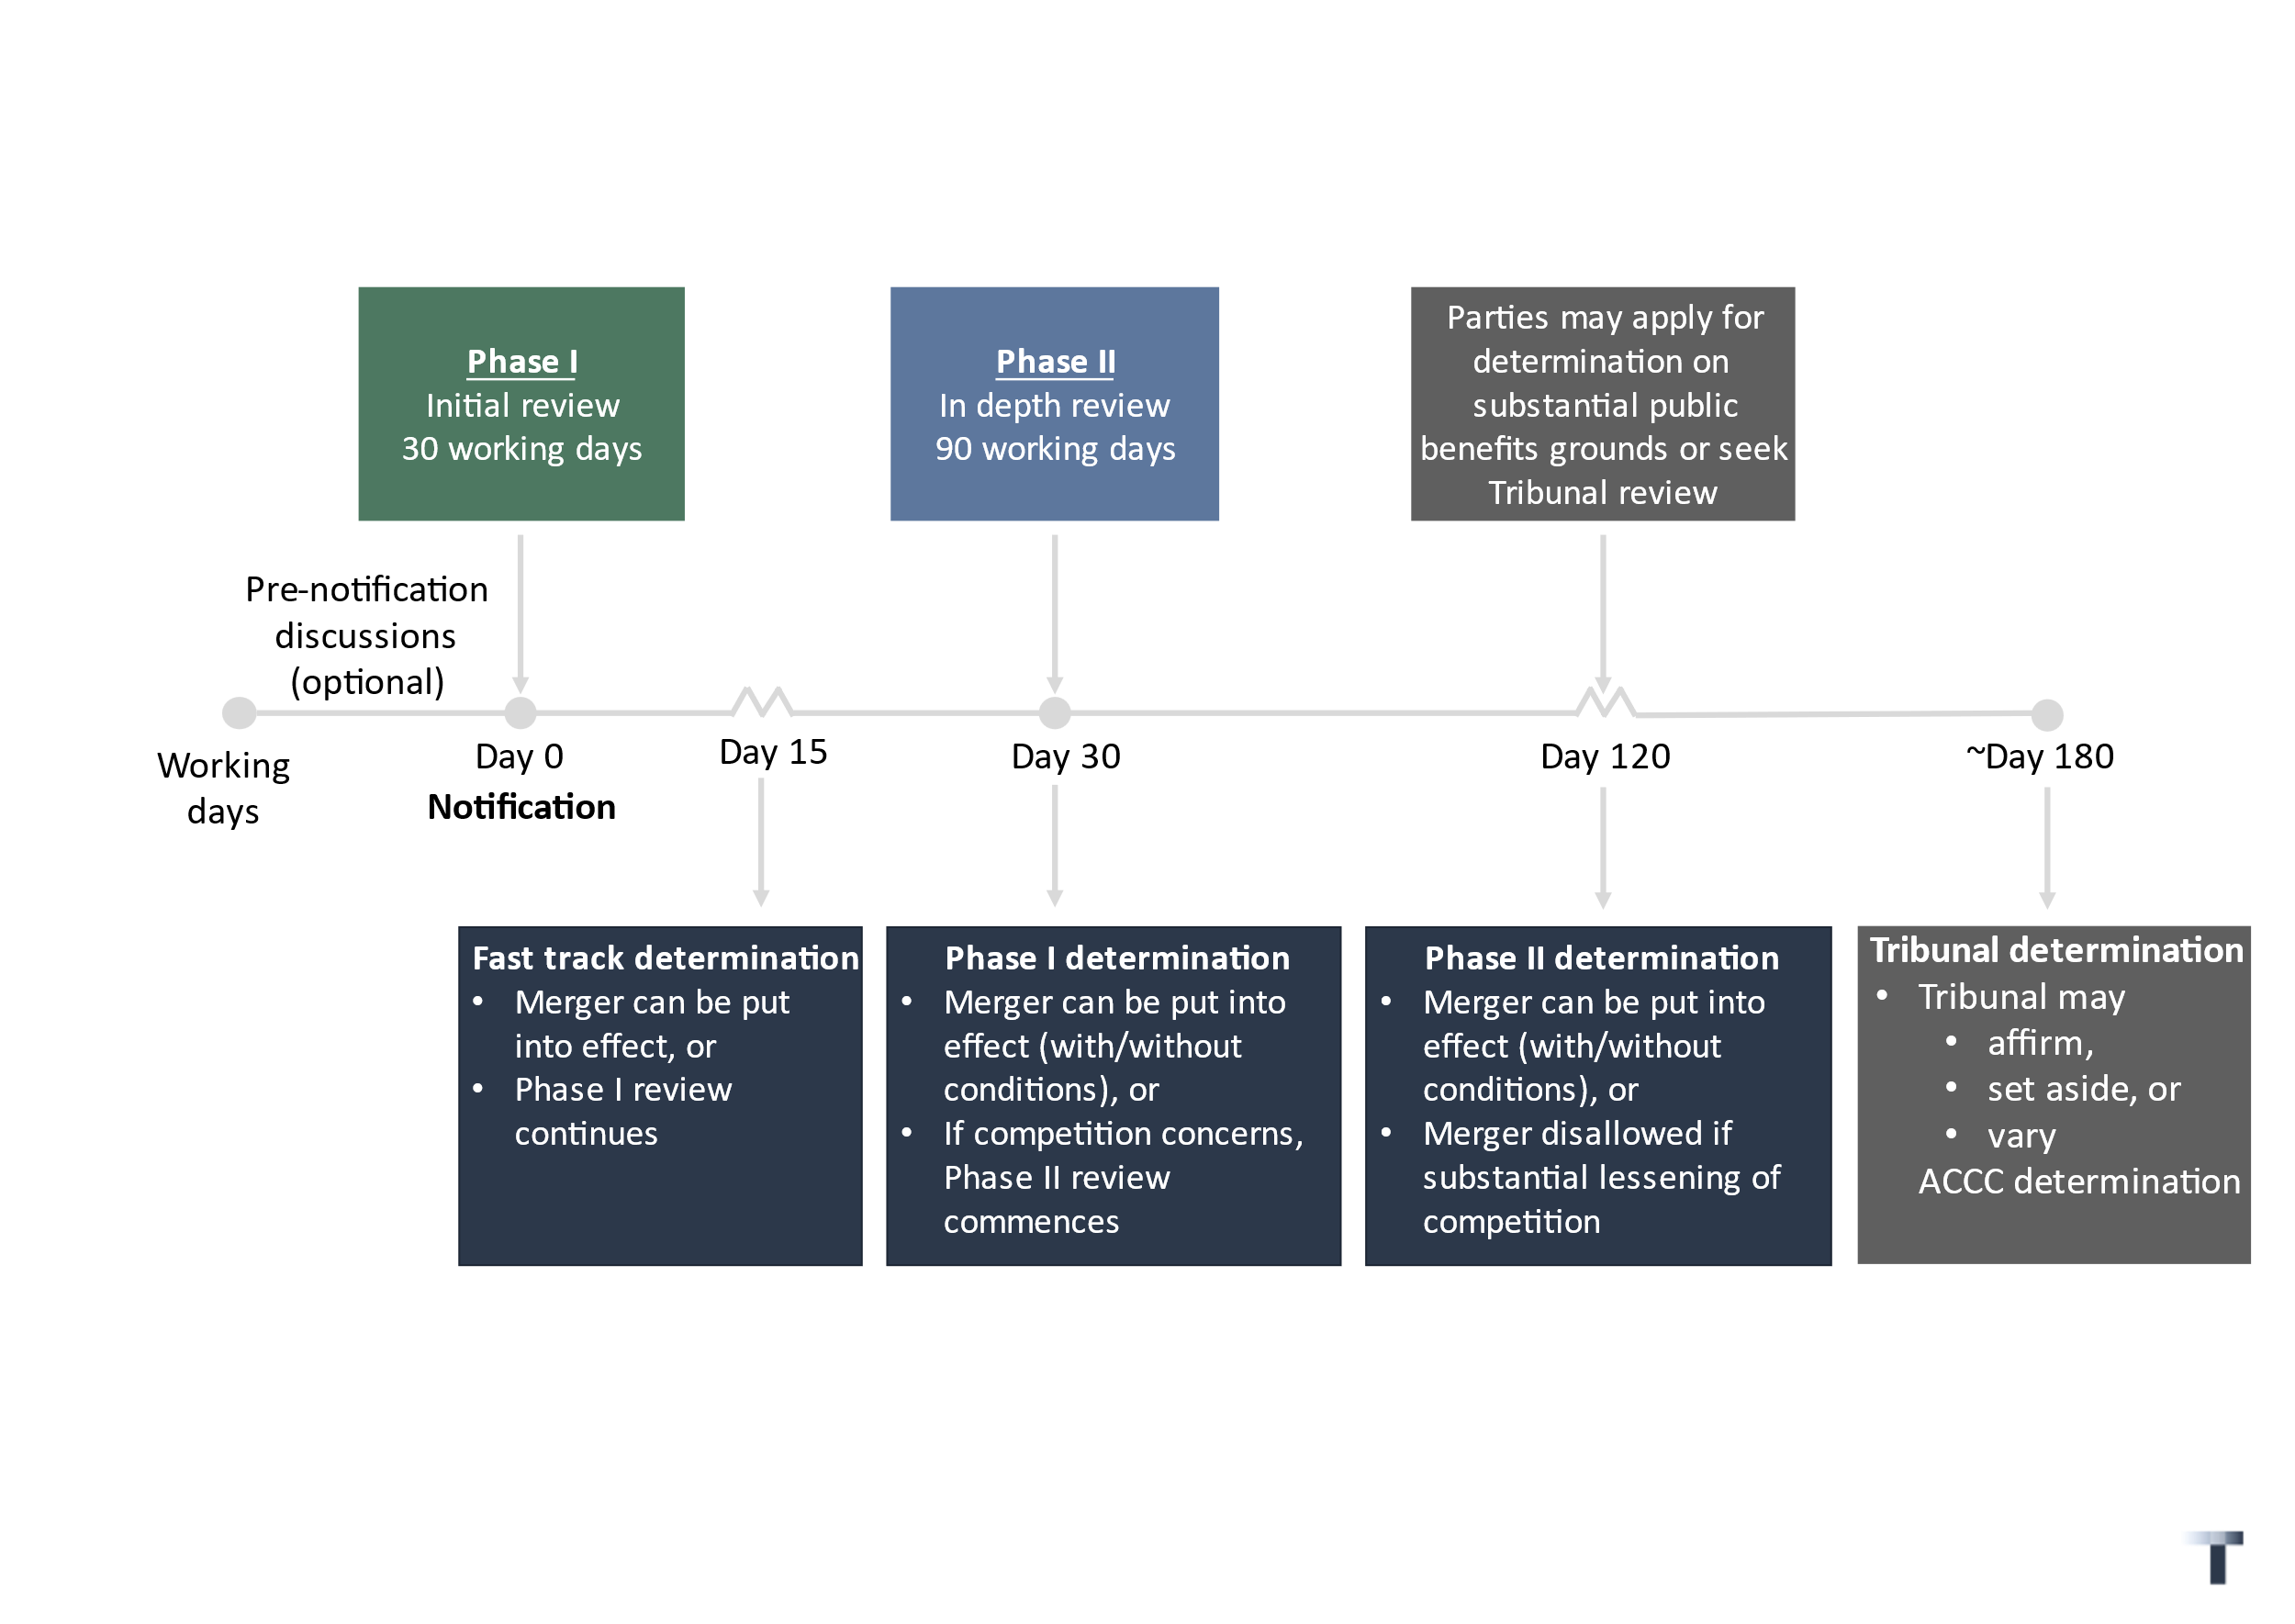Indicative timelines, broadly consistent with international best practice, would be a ‘Phase I’ review period of 30 working days and a more in-depth ‘Phase II’ review period of 90 working days, with the option of fast-track determination after at least 15 working days only if no concerns are identified by the ACCC. It is expected that the ACCC will determine that the vast majority of mergers may be put into effect within the Phase I period of around 15-30 working days.

These time periods may be extended by the ACCC, in appropriate circumstances and subject to procedural safeguards, for example if remedies are offered by the merger parties, by mutual agreement or if requested information is not promptly provided. Treasury will consult on the rules as to how the ‘clock’ can start and stop and the associated procedural safeguards in 2024.

The Phase I review period would commence upon receipt by the ACCC of a complete notification. Merger parties will be able to engage in optional confidential pre-notification discussions with the ACCC to facilitate prompt notification of a merger if they wish to do so.

The ACCC will only commit a merger to a Phase II review if it has a reasonable basis to consider the merger raises competition concerns. The Phase II process is intended for in-depth economic and legal analysis of mergers identified as most likely to be anti-competitive following the Phase I review. During the Phase II review, merger parties will receive a notice of competition concerns setting out material facts, evidence, and other information which explains the ACCC’s analysis of potential harms. Merger parties will have the opportunity to respond in writing and/or orally, ahead of the ACCC’s determination, and the ability to request additional time, to ensure procedural fairness. As an administrative decision-maker, there are a range of obligations that will apply to the ACCC under Australian law.

The ACCC will publicly announce when it commences a Phase II review, issue a notice of competition concerns, and issue a determination (including reasons, commensurate with the substantive review undertaken).

If the ACCC does not make a determination in relation to a merger within a certain time period, the merger may be put into effect.

|  |  |
| --- | --- |
|  | Treasury will consult on merger review timelines in 2024. |

## Simpler, clearer merger review process

The ACCC requires sufficient information about a merger to properly undertake its review, and to efficiently and expeditiously differentiate benign mergers. Merger parties are best placed to provide information about their business, future plans and the industry.

### Upfront notification requirements

Calibrated upfront information requirements will ensure merger parties provide relevant information to the ACCC and mitigate the need for subsequent requests and possible delay. Merger parties will be required to submit a ‘simple’ shorter notification form for mergers unlikely to raise competition concerns; and a more detailed longer notification form for others. As administrative expert bodies, the ACCC, and the Tribunal on review, will not require information to be presented in a legally admissible form. This promotes focus on the substance rather than form and reduces cost.

Senior executives or directors of merger parties will need to certify or attest that the information provided is true, accurate, complete and correct. Civil and criminal penalties will apply, including director disqualification.

The ACCC will consult on the form of notification to be required in 2025. The ACCC will also issue, following consultation, process guidelines to assist merger parties and interested stakeholders to engage with the merger review process (including pre-notification) and associated procedural safeguards.

#### Evidence gathering powers

The ACCC will be able to request further evidence and information from merger parties and relevant third parties during its review. Consequential amendments will be made so that the ACCC’s formal information gathering powers (currently mainly in section 155 of the CCA) will also be available to enable the ACCC to gather all relevant information and evidence, including from people carrying on a business in Australia but who are not present in Australia.

### Fees

All merger notifications will be accompanied by a fee. Cost recovery principles prescribe that, as an identifiable group creating a specific demand for a specific regulatory activity, merger parties should pay fees. The fees should reflect the resources required by the ACCC to efficiently carry out the review of a merger. Indicatively, Treasury expects this to be around $50,000–100,000 for most mergers. An exemption from fees will be available for small business so that the fees are not a disproportionate burden for those businesses. The fees will ensure the ACCC is properly resourced to undertake its expert administrative decision-making role.

|  |  |
| --- | --- |
|  | Treasury will consult on fees in 2024. |

### Transparency

Transparency is important for ensuring fairness, balancing the interests of the merger parties, interested stakeholders and the ACCC. Transparency also reduces uncertainty, assisting the predictability around processes and public understanding of how merger laws are applied.

The ACCC is accountable to the Australian community for its review of mergers: it must do so having regard not only to the interests of merger parties, but also interested stakeholders, consumers and the broader community.

All mergers considered by the ACCC will be listed on an ACCC public register, with brief information including the names of the merger parties, a short description of the transaction and affected products and/or services, and review timeline. Merger parties will be able to engage in confidential pre-notification discussions as to the information to be provided to the ACCC but will no longer be able to receive an ‘informal view’ on a proposed merger. The ACCC’s ability to engage with stakeholders and the ability for stakeholders to bring their concerns about a merger to the attention of the ACCC is significantly impacted if merger reviews are confidential.

The ACCC will set out its findings on material facts, with reference to the evidence or other material on which those findings were based, and the reasons for all determinations, commensurate with the substantive review undertaken. While the ACCC will not be bound by previous determinations, this will facilitate transparency and predictability in the administrative system. It will also shape the boundaries of merger control over time as a body of previous determinations, including the economic and legal reasoning, will develop to guide stakeholders. Provision will also be made to ensure confidential information is appropriately protected.

## Empowering the ACCC to protect competition and consumers

### Competition test

The ACCC must permit a merger to be put into effect unless the ACCC reasonably believes that the merger would have the effect, or be likely to have the effect, of substantially lessening competition in any market, including (but not exclusively) if the merger creates, strengthens or entrenches a position of substantial market power in any market.

The substantive ‘substantial lessening of competition’ analysis requires consideration of the closeness of competition between the merger parties, to understand what is lost as a result of the merger. The inclusion of ‘creates, strengthens or entrenches a position of substantial market power’ emphasises the importance of considering the competitive structure of the market, in the context of the overall assessment of the effects of the merger on competition.

To respond to concerns regarding serial or creeping acquisitions and roll up strategies, the cumulative effect of all mergers within the previous three years by the merger parties may be considered as part of the assessment of the notified merger, whether or not those mergers were themselves individually notifiable. This is a targeted measure to address concerns that some businesses are engaging in anti-competitive roll up strategies that increase prices and reduce quality and choice for consumers yet minimise unintended impacts on Australia’s vibrant start-up and small-and-medium enterprise sector. Three years is considered an appropriate reference period to capture strategic business behaviour and take account of dynamic conditions of competition in markets.

The test will also be supplemented by principles, replacing the ‘merger factors’ currently in section 50(3) of the CCA. In making its determination the ACCC will be required, to the extent possible, to give effect to the object of the Act and take into account considerations such as:

* the need to maintain and develop effective competition within markets in view of, among other things, the structure of all the markets concerned and the conditions for competition, and the actual or potential competition from businesses carrying on business in Australia whether located in Australia or elsewhere; and
* the market position of the businesses concerned and their economic and financial power, including commercial relationships, the alternatives available to suppliers and users, their access to supplies, inputs including data, or markets, any barriers to entry, supply and demand trends for the relevant goods and services, the interests of the intermediate and ultimate consumers, and the development of technical and economic progress provided that it is to consumers' advantage and does not form an obstacle to competition.

The principles are intended to assist the ACCC in its role as an administrative decision-maker and ensure explicit emphasis is placed on economic methodology and analysis of competitive effects. The principles also ensure the competitive effects of related agreements by the merger parties may be taken into account in the ACCC’s assessment. The specific conditions of competition that would prevail absent the merger will be considered as part of the substantive competitive assessment. This recognises both the limitations of inherently uncertain counterfactuals and their use as a tool to consider prospective effects.

The ACCC will be expected to consult on, issue and periodically update substantive guidance on its assessment of mergers.

### Substantial Public Benefits test

Merger parties may, following the ACCC’s Phase II determination, seek approval from the ACCC for the merger if the ACCC is satisfied the merger would result, or be likely to result, in a *substantial* benefit to the public which outweighs the anti-competitive detriment of the merger.

The Australian economy is undergoing significant structural shifts including the rise of the care economy, rapid transformation to net zero and the growth of the digital economy. Allowing the ACCC to consider whether an otherwise anti-competitive merger raises substantial and meaningful net public benefits is important as our economy responds to these challenges. The ACCC is currently given broad discretion to consider what constitutes a public benefit, providing flexibility to enhance the welfare of Australians by approving mergers that are net desirable to the economy.

The sequential approach provides more exit points for merger parties and will ensure the substantive analysis and timeframes for the ACCC’s determination on competition considerations are robust and consistent with international best practice.

The system will provide for clear timelines for the ACCC to accept a notification for approval based on substantial public benefits and subsequently undertake its review. An indicative review timeline would be 50 working days. Treasury will consult on merger review timelines in 2024.

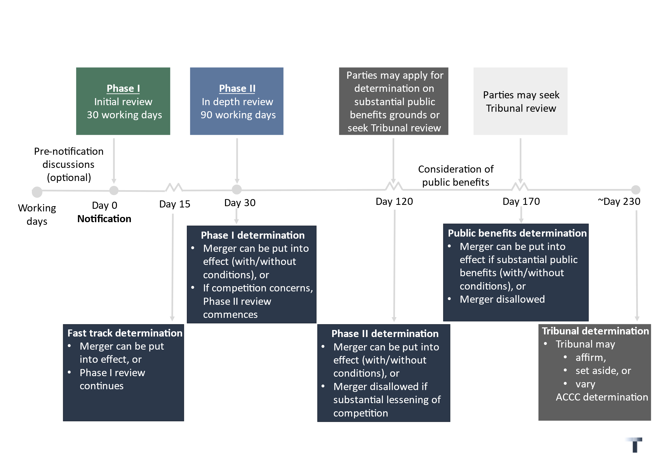

Any proceedings before the Tribunal seeking review of the ACCC’s Phase II determination would be stayed, pending the outcome of the application for approval based on substantial public benefits.

All applications for approval based on substantial public benefits will be accompanied by a fee, based on cost-recovery principles. Treasury intends to consult on the specific fees in 2024.

### Conditions

The ACCC may make a determination that a merger may be put into effect subject to conditions. This will include, but not be limited to, a condition that a person may give and comply with an undertaking under section 87B of the CCA in connection with a matter.

Merger parties will be able to offer commitments or remedies in the form of a section 87B of the CCA undertaking to address competition concerns identified by the ACCC in either Phase I, if the competition concerns are readily identifiable and can be easily remedied, or Phase II. During the ACCC’s review of the substantial public benefits afforded by the merger, the remedies will need to address concerns relevant to that assessment. If remedies are offered, the timeline will be extended to permit consideration by the ACCC and, if appropriate, engagement with market participants.

The ACCC may determine the nature, form and scope of any conditions imposed to comprehensively address the substantial lessening of competition and any adverse effects resulting from it. The ACCC will also have regard to its effect on consumers and any resulting consumer benefits. Similar provision will also be made for remedies offered in relation to the substantial public benefits assessment.

## A stronger system

### Review of ACCC determinations and procedural safeguards

ACCC determinations will be subject to review by the Tribunal upon application by the merger parties, or third parties (subject to having standing). Judicial review of decisions by Tribunal will be available in the Federal Court.

The ability to seek Tribunal review represents an important safeguard for merger parties and interested third parties and promotes the integrity of the merger system. The Tribunal, with its independent economic, business and legal expertise, will improve the quality and consistency of ACCC decisions and promote good decision-making by the ACCC based on sound economic and legal principles. The Tribunal is able to conduct proceedings expeditiously and with as little formality as required for proper consideration of the issues which will minimise cost and facilitate participation by affected stakeholders, including supporting consumer groups.

Merits review means the Tribunal can substitute the ACCC’s decision for a correct or preferable decision. The Tribunal may make a determination affirming, setting aside or varying the ACCC’s determination and, for the purposes of the review, may perform all the functions and exercise all the powers of the ACCC. The scope and basis for the Tribunal’s review will be consistent with the current approach for merger authorisation, that is, on review the Tribunal will apply the same test as the ACCC and it will not be a rehearing.

The Tribunal’s review of ACCC determinations will be limited as it will be based on the material before the ACCC. However, the Tribunal may seek clarifying information, and the Tribunal may allow the parties to present new information or evidence which was not in existence at the time of the ACCC’s determination. Alternatively, a fast-track review by the Tribunal may be sought, based only on the material before the ACCC. With a fast-track review, the Tribunal would be bound by the findings of fact made by the ACCC.

Tribunal review will allow for reconsideration of the ACCC’s determination, subjecting it to scrutiny and review. Limited merits review, rather than full merits review, appropriately balances procedural fairness by allowing for a change of circumstances to be taken into account and ensures merger parties have the incentive to place relevant information before the ACCC. This mitigates the risk of strategic behaviour. Limited merits review also, importantly in a merger situation, reduces the time required to review an ACCC determination.

As mergers are time-critical, the Tribunal’s review should be subject to a time limit of 90 calendar days (approximately 60 working days), which could be extended by a further 90 calendar days where necessary – this is the same time period as currently applies for review of ACCC merger authorisation decisions. This will ensure that, even for mergers considered by the ACCC and the Tribunal on review, the process could be expected to be complete in around 12 months. If a fast-track review by the Tribunal is sought, the Tribunal’s review will be subject to a time limit of 60 calendar days (approximately 40 working days), with no option for extension. The Tribunal will also have a discretion to extend its time limits if excessively voluminous material is placed before it.

At present, the Tribunal has no general power to award costs in relation to merger authorisation proceedings. However, given the time and commercial imperatives associated with mergers, the Tribunal should have a power to award costs where an application for review is frivolous or vexatious. There will also be fees for Tribunal review. An exemption from fees will be available for small business.

The Government will also consider the institutional and procedural arrangements of the Tribunal to ensure it is fit for the purpose of reviewing ACCC merger determinations. Treasury will consult on any potential reforms.

Merger parties will be able to address complaints about the conduct of the ACCC’s merger review, which are unable to be resolved directly with the ACCC staff involved in the matter, to an identified senior executive, such as the Chief Executive Officer, uninvolved in the merger review. This is in addition to the availability of the Commonwealth Ombudsman.

The ACCC is also subject to the Regulator Performance Guide, which is part of the Australian Government’s commitment to boosting productivity by cutting red tape, reducing duplicative processes, modernising regulation and improving regulator performance to improve the quality of regulation and ease cost of living pressures for Australians. Treasury will review the role of the ACCC Performance Consultative Committee, which consists of business, legal and consumer representatives, to promote regulatory best practice.

|  |  |
| --- | --- |
|  | Treasury intends to consult on procedural safeguards in 2024. |

### Penalties

A failure to notify a notifiable merger or proceeding with the merger ahead of the ACCC’s determination or otherwise than in accordance with the ACCC’s determination will result in substantial penalties for the entity concerned and executives or officers responsible for the merger. Penalties will also apply for the provision of false or misleading information. The ACCC will be able to seek such penalties in the Federal Court, subject to limitation periods.

In addition to civil and criminal penalties, any merger or contract, arrangement or understanding related to the merger, which purports to be put into effect otherwise than in accordance with the ACCC’s determination (or when the time period has otherwise elapsed), will be void.

Consistent with existing provisions, the ACCC may make an application for divestiture, or the court may declare the merger void, if false or misleading information was provided, or there was a material omission by the merger parties, in the making of the ACCC’s determination.

|  |  |
| --- | --- |
|  | Treasury will consult on penalties in 2024. |

# The diagram visualises the Government's merger reform, including Phase 1, Phase 2 and the consideration of public benefit.Attachment A: A faster, stronger and simpler merger system

Attachment B: Merger reform consultation — stakeholder feedback and Australian Government response

| **Elements of a merger control system adopted** | | |
| --- | --- | --- |
| **Element** | **Stakeholder consultation feedback** | **Australian Government response** |
| ****Notification**** | | |
| **Targeted mandatory notification thresholds** | **Current approach gives rise to uncertainty for businesses about when to notify; concern that the ACCC is not adequately notified of mergers.**  **Clear thresholds would provide more certainty but must be calibrated.** | **The person or people acquiring control of the business or assets will – if the thresholds are met – be required to notify the ACCC of a ‘merger’.**  **Thresholds will be monetary and supply/market share-based, balancing regulatory burden with potential harm to competition.**  **There will also be a Ministerial power to introduce additional targeted notification thresholds in response to evidence-based concerns regarding certain high-risk mergers.**  **Mergers below the thresholds may also be voluntarily notified to the** **ACCC. Such mergers would be subject to the same administrative system as above-the-threshold mergers.**  **The ACCC will not have the ability to ‘call-in’ mergers below the thresholds for review, but the ACCC may investigate a below-the-threshold merger for breach of any other relevant provisions of the CCA as only notified mergers will receive the benefit of anti-overlap provisions.** |
| **Upfront notification requirements** | **Information requirements should be clearer and proportionate, and merger parties are best placed to provide information to facilitate efficient and effective assessment.** | **Notification requirements calibrated to likelihood that transaction raises competition concerns; enables ACCC to properly undertake its review and to efficiently and promptly differentiate benign mergers.** |
| **Fees** | **Cost is currently borne by the public and ACCC needs to be appropriately resourced.** | **All merger notifications accompanied by a fee (subject to consultation). An exemption from fees will be available for small business. This ensures ACCC is appropriately resourced and funding is responsive to need.** |
| **Suspensory timelines supporting prompt review** | **ACCC should have sufficient time to review mergers before completion.**  **ACCC currently not bound by timelines in informal review process which creates significant uncertainty for businesses and for market participants to engage.**  **Delays in merger reviews can be very costly for businesses.**  **Robust, clear time frames would provide more certainty.** | **Mergers are time sensitive, and prompt decision-making is critical. Clear review timelines are an important procedural safeguard and will assist merger parties in transaction planning and interested stakeholders to engage with the ACCC’s review.**  **Acquirer must receive determination from the ACCC before closing notifiable transaction.**  **Indicative timelines (subject to consultation):**   * **Phase I: 30 working days** * **Phase II: 90 working days** * **Option of fast-track determination if no concerns identified after 15 working days** * **Approval for substantial public benefits: 50 working days**   **Time periods may be extended in limited circumstances.**  **If no ACCC determination within a certain time period, transaction will be permitted to proceed.** |
| ****Assessment**** | | |
| **A stronger, expert administrative decision-maker** | **Administrative decision-making can be quicker, more accessible for third parties, more transparent and draw on economic expertise more easily than judicial enforcement.** | **ACCC will be the expert first-instance administrative decision-maker with responsibility to determine whether a merger may be put into effect, with or without conditions.**  **Delivering better outcomes: mergers will be assessed by an expert agency, with engagement and information from stakeholders and supported by rigorous legal and economic analysis. It will enhance accountability, accessibility and transparency of merger review.** |
| **Transparency and predictability** | **Current informal approach is not transparent.**  **Publishing information about mergers reviewed by the ACCC would lead to greater predictability, confidence in ACCC decision-making and broader community awareness.** | **Information about all mergers considered by the ACCC will be listed on a public register.**  **The ACCC will set out the findings on material facts, with reference to the evidence or other material on which those findings were based, and the reasons for all decisions commensurate with the substantive review undertaken. This will facilitate transparency and predictability in the administrative system and shape the boundaries of merger control over time as a body of previous determinations, including the economic and legal reasoning, will develop.** |
| **Test for decision-maker to apply including ‘merger factors’** | **‘Substantial lessening of competition’ test is the appropriate framework, but concerns with the requirement to ‘prove’ the counterfactual in forward-looking merger assessments.**  **Reviews could substantially benefit from more rigorous economic and legal analysis.**  **Usefulness of the ‘merger factors’ is somewhat limited; updating guidance to reflect current economic thinking would be more helpful for businesses, advisors and others.** | **The ACCC will be empowered to protect competition and consumers.**  **ACCC must determine that a merger can be put into effect (with or without conditions) unless it considers the merger would have the effect, or be likely to have the effect, of substantially lessening competition in any market, including (but not exclusively) if the merger creates, strengthens or entrenches a position of substantial market power in any market.**  **Merger factors to be replaced with principles, focused on the conditions for competition, also to address concerns with the counterfactual.**  **ACCC will be expected to update and periodically review its guidance.** |
| **Substantial market power amendment to ‘substantial lessening of competition’ test** | **Concerns about market power in concentrated sectors, such as supply chains.**  **Acquisitions by firms with substantial market power should be captured by the ‘substantial lessening of competition’ test.** | **The ACCC will be empowered to protect competition and consumers.**  **Clarify that the existing ‘substantial lessening of competition’ test includes if the merger creates, strengthens or entrenches a position of substantial market power in any market.** |
| **Related agreements** | **Related agreements by the merger parties should be taken into account.** | **The principles ensure related agreements by the merger parties may be taken into account in the ACCC’s assessment.** |
| **Substantial public benefits** | **Ability to consider public benefits should be retained.** | **If ACCC disallows the merger, approval may be sought if the merger would result, or be likely to result, in a substantial public benefit which outweighs anti-competitive impact.**  **Allowing the ACCC to consider whether an otherwise anti-competitive merger raises substantial and meaningful net public benefits is important as our economy responds to significant structural shifts including the rise of the care economy, rapid transformation to net zero and the growth of the digital economy.** |
| **Serial acquisitions** | **Concerns about whether a single acquisition, which does not result in material changes in market concentration or competitive dynamics but over time forms part of a strategy of consolidation, can be appropriately assessed under the current law.** | **All ‘mergers’ within the previous three years by the merger parties may be considered as part of the review of the notifiable merger (and will be aggregated for the purpose of assessing whether a merger meets the notification thresholds).**  **This is a targeted measure to address concerns that some businesses are engaging in anti-competitive roll up strategies that increase prices and reduce quality and choice for consumers yet minimise unintended impacts on Australia’s vibrant start-up and small-and-medium enterprise sector.** |
| ****Review and penalties**** | | |
| **Review of administrative decisions and procedural safeguards** | **Reviews of decisions would benefit from greater economic and business expertise; it is important that review processes are accessible to stakeholders likely to be affected by a merger such as consumer groups.**  **Reviews of merger decisions are time-sensitive.** | **ACCC decisions subject to limited merits review by the Australian Competition Tribunal with time limits.**  **The Tribunal, with its independent economic, business and legal expertise, will improve the quality and consistency of ACCCC decisions and promote good decision-making by the ACCC based on sound economic and legal principles.**  **The Tribunal is able to conduct proceedings expeditiously and with as little formality as required for proper consideration of the issues which will minimise cost and facilitate participation by affected stakeholders, including supporting consumer groups.**  **The fair, accountable and improved administration of the merger system benefits merger parties, interested stakeholders and the Australian community. In addition to the availability of complaints mechanisms, the ACCC is subject to the Regulator Performance Guide.** |
| **Penalties** | **Significant penalties would deter strategic behaviour and encourage compliance.** | **Substantial penalties (monetary and/or divestiture) for non-compliance for entities concerned/officers responsible for merger, on application by the ACCC in Federal Court.** |

| Elements of a merger control system not adopted | | |
| --- | --- | --- |
| **Element** | **Consultation feedback** | **Australian Government response** |
| ****Notification**** | | |
| **Informal system** | **Current system provides flexibility but creates significant uncertainty about timing and outcome, is costly for businesses due to time delay, less transparent and information requirements can be unclear.** | **Clear timeframes and performance metrics to hold the ACCC accountable.**  **Information requirements to ensure the ACCC is provided with information to facilitate the efficient and effective review of mergers.** |
| **Voluntary notification** | **Allows self-assessment but gives rise to more uncertainty than overseas systems that have clear mandatory notification requirements; risk is that the ACCC is not notified of potentially anti-competitive mergers** | **Unclear that it would address concerns about non-notification of mergers.**  **Merger parties would have minimal incentives to cooperate in a judicial enforcement system.** |
| **Call-in power** | **A call-in power would create uncertainty for businesses; the current system allows the ACCC to investigate any merger in Australia; smaller transactions or mergers in local markets may still raise competition concerns.** | **Targeted notification thresholds to provide clarity for businesses and target mergers most likely to raise risks to competition.** |
| **Section 50 and declarations in the Federal Court** | **Multiple pathways facilitate strategic behaviour.** | **Streamline into a single simpler mandatory and suspensory administrative system.**  **Retain the substantial lessening of competition test, incorporated into a stronger administrative system.** |
| ****Assessment**** | | |
| **Decision-maker must not grant approval unless satisfied the merger is not likely to substantially lessen competition** | **Merger parties would have the incentive to promptly provide relevant information to the ACCC.**  **However, this test would substantially increase the burden of proof on merger parties, even mergers that are unlikely to pose risks to the community, imposing additional risks and costs on all mergers.**  **Disproving the existence of a substantial lessening of competition may be difficult and impractical for businesses to satisfy, particularly those in emerging markets.** | **The ACCC will need to reasonably believe certain facts exist before disallowing the merger.** |
| ****Review**** | | |
| **Judicial enforcement** | **Federal Court proceedings have significant cost and timing implications for merger parties, third parties and the ACCC.**  **Less transparent than an administrative system with less precedent available.**  **Third parties may be affected by a merger but are currently deterred from participation due to reluctance to appear in court, fear of retribution, or cost.** | **Replace the current ad hoc approach with a stronger, simpler, more efficient, risk-based and transparent administrative system that enables market participants, such as customers and small businesses, to be heard in merger reviews.** |
| **Full merits review** | **It is important to incentivise parties to provide information upfront to the ACCC.**  **Not limiting reviews of ACCC decisions to the investigatory record that was before the ACCC would ensure quality and robust regulatory processes.**  **Full merits review would take longer than limited merits review and mergers are time-sensitive.** | **The Tribunal’s review of ACCC determinations is limited as it will be based on the material before the ACCC. However, the Tribunal may seek clarifying information, and the Tribunal may allow the parties to present new information or evidence which was not in existence at the time of the ACCC’s determination.**  **A fast-track review by the Tribunal may alternatively be sought, based only on the material before the ACCC. With a fast-track review, the Tribunal would be bound by the findings of fact made by the ACCC.**  **Limited merits review will allow for reconsideration of the ACCC’s determination, subjecting it to scrutiny and review. Limited merits review, rather than full merits review, appropriately balances procedural fairness by allowing for a change of circumstances to be taken into account and ensures merger parties have the incentive to place relevant information before the ACCC. This mitigates the risk of strategic behaviour. Limited merits review also, importantly in a merger situation, reduces the time required to review an ACCC determination.** |